
Impress Guide 7.4

Appendix B,
Toolbars

Copyright
This document is Copyright © 2022 by the LibreOffice Documentation Team. Contributors are listed below. This document maybe distributed and/or modified under the terms of either the GNU General Public License (https://www.gnu.org/licenses/gpl.html), version 3 or later, or the Creative Commons Attribution License (https://creativecommons.org/licenses/by/4.0/), version 4.0 or later. All trademarks within this guide belong to their legitimate owners.

Contributors
Contributors for this edition:
Peter Schofield
Kees Kriek

Contributors for previous editions:
Peter Schofield
Kees Kriek
Dave Barton
Felipe Viggiano

Feedback
Please direct any comments or suggestions about this document to the Documentation Team mailing list: loguides@community.documentfoundation.org.
- Note
Everything sent to a mailing list, including email addresses and any other personal information that is written in the message, is publicly archived and cannot be deleted.

Publication date and software version
Published October 2022. Based on LibreOffice 7,4 Community.
Other versions of LibreOffice may differ in appearance and functionality.

Using LibreOffice on macOS
Some keystrokes and menu items are different on macOS from those used in Windows and Linux. The table below gives some common substitutions used in this document. For a detailed list, see LibreOffice Help.
Windows or Linux | macOS equivalent | Effect
Tools > Options  menu selection | LibreOffice > Preferences | Access setup options
Right-click | Control+click, Ctrl+click, or right-click depending on computer setup | Open a context menu
Ctrl or Control | ⌘ and/or Cmd or Command, depending on keyboard | Used with other keys
Alt | ⌥ and/or Alt or Option depending on keyboard | Used with other keys
F11 | ⌘+T | Open the Styles deck in the Sidebar

Contents
Copyright 2
Contributors 2
Feedback 2
Publication date and software version 2
Using LibreOffice on macOS 2
Introduction 5
Using toolbars 5
Displaying toolbars 5
Closing toolbars 5
Moving toolbars 6
Docked toolbars 6
Floating toolbars 6
Floating sub-toolbars 6
Docking toolbar 7
Locking toolbars 7
Docked toolbars 7
Locking sub-toolbars 7
Editing toolbars 8
Adding tools 8
Deleting tools 8
Customizing toolbars 8
Toolbars 9
3D-Objects 9
3D-Settings 9
Align Objects 10
Comments 10
Distribute Selection 10
Drawing 11
Edit Points 13
Find 13
Fontwork 13
Form Controls 14
Form Design 14
Form Navigation 14
Glue Points 15
Image 15
Insert 16
Legacy Circles and Ovals 16
Legacy Rectangles 16
Line and Filling 17
Master View 17
Media Playback 17
Options 18
Outline 18
Presentation 18
Slide Sorter 19
Slide View 19
Standard 19
Standard (Single Mode) 20
Standard (Viewing Mode) 21
Table 21
Text 21
Text Formatting 22
Transformations 22
TSCP Classification 23
Zoom 23

Introduction
In Impress there are several toolbars available to help in creating a presentation. Each toolbar has a default set of tools and the option to add additional tools to a toolbar.
- Note
The icons displayed in the Impress toolbars illustrated in this appendix may differ from what is displayed on a computer screen. Toolbar icons depend on the computer operating system being used and how LibreOffice has been set up. For more information on customizing LibreOffice and the toolbars, see the Getting Started Guide.

Using toolbars

Displaying toolbars
To display and make a toolbar active, go to View > Toolbars on the Menu bar. A submenu opens with an alphabetical list of toolbars available for creating presentations in LibreOffice Impress. Click on a toolbar name to display it and make it active. Active toolbars are indicated by highlighting or a check mark next to the toolbar name.
Impress toolbars available
3D-Objects
3D-Settings
Align Objects
Comments
Distribute Selection
Drawing
Edit Points
Find
Fontwork
Form Controls
Form Design
Form Navigation
Glue Points
Image
Insert
Legacy Circles and Ovals
Legacy Rectangles
Line and Filling
Master View
Media Playback
Options
Outline
Presentation
Slide Sorter
Slide View
Standard
Standard (Single Mode)
Standard (Viewing Mode)
Table
Text
Text Formatting
Transformations
TSCP Classification
Zoom
- Note
Some toolbars when selected in View > Toolbars on the Menu bar do not display until an object of the correct type is selected in a presentation. For example, the Image toolbar only displays when an image is selected.

Closing toolbars
To close a toolbar, use one of the following methods:
- Go to View > Toolbars on the Menu bar and deselect the toolbar.
- Right-click in a blank area on a toolbar and select Close Toolbar from the context menu.
- Click on the X in the right corner of the title bar of a floating toolbar.
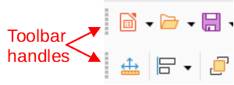
Figure 1: Toolbar moving handles

Moving toolbars

Docked toolbars
By default, some toolbars are docked into position in the Impress main window. For example, the Standard toolbar is docked at the top of the main window. Docked toolbars can be undocked and moved to a new docked position on the main window or left as a floating toolbar.
- Move the cursor over the small vertical handle at the left end of the toolbar, as shown in Figure 1. The cursor changes to the moving cursor used for the computer system and setup.
- Click and drag the toolbar to a new location. This can be a new docked position or a floating toolbar. A hashed border appears around the toolbar indicating the toolbar position as it is dragged.
- Release the cursor when the required position is reached.
- Note
If the small vertical bar is not visible at the left end of a docked toolbar, then the toolbar is locked into position. A docked toolbar must be unlocked before it can be moved to a new position in the Impress main window. See “Locking toolbars” on page 7 for more information.

Floating toolbars
- To move a floating toolbar, click on its title bar and drag it to a new floating location.
- Release the cursor when the toolbar is in the required position.
- Note
A floating toolbar does not have to be positioned on the Impress main window for it to function.

Floating sub-toolbars
Some tools on a toolbar have a triangle ▼ to the right of the tool indicating that more tools are available on a sub-toolbar, for example Basic Shapes on the Drawing toolbar. Sub-toolbars can be turned into floating toolbars and moved into a new position as follows:
- Move the cursor over the horizontal handle at the top of the toolbar, as shown in Figure 2. The cursor changes to the moving cursor used for the computer system and setup.
- Click and drag the toolbar to a new location to create a floating sub-toolbar.
- Release the cursor when the required position is reached.
- To close the floating sub-toolbar, right-click on the triangle ▼ in the sub-toolbar title bar and select Close Toolbar from the context menu, or click on the X at the right end of the sub-toolbar title bar.
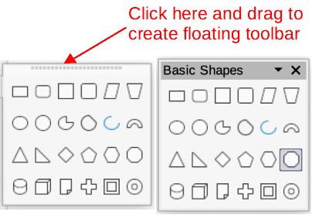
Figure 2: Creating floating toolbar

Docking toolbar
To dock a floating toolbar, use one of the following methods:
- Click on the title bar and drag it to the top, bottom, left side, or right side of the main window. When the toolbar reaches a docking position, a hashed border appears at the docked position. Release the cursor and the toolbar is docked.
- Right-click on the toolbar and select Dock Toolbar from the context menu. The toolbar moves into a docked position. If the position is not suitable, move the toolbar to a new docked position.
- To dock all floating toolbars that are active, right-click on the toolbar and select Dock All Toolbars from the context menu.

Locking toolbars

Docked toolbars
When a toolbar has been docked into position on the Impress main window, the toolbar can also be locked into position preventing the toolbar from becoming a floating toolbar.
- To lock a toolbar into a docked position, right-click in a blank area on the toolbar and select Lock Toolbar Position from the context menu. A check mark appears against this option indicating the toolbar is now locked.
- To unlock a toolbar, right-click in a blank area on the toolbar and click on Lock Toolbar Position in the context menu. The check mark next to this option disappears indicating the toolbar is now unlocked. A small vertical or horizontal bar appears at the left end or top of the toolbar indicating that the toolbar is unlocked. This bar is also is used to move the toolbar.
- Note
Some toolbars cannot be docked or locked into position. This is indicated by the options Dock Toolbar and/or Lock Toolbar Position being grayed out, making the options unavailable.

Locking sub-toolbars
To prevent sub-toolbars from becoming floating sub-toolbars, sub-toolbars have to be locked as follows:
- Save the presentation that is open in Impress.
- Go to View > Toolbars on the Menu bar and select Lock Toolbars from the submenu.
- Select Restart Now in the Restart LibreOffice dialog that opens to activate the Lock Toolbars option.
- To unlock sub-toolbars so they can become floating sub-toolbars, repeat Steps 1 thru 3. The Lock Toolbars option is an on/off switch.
- Note
Using the Lock Toolbars option affects ALL toolbars and sub-toolbars available in all LibreOffice modules.

Editing toolbars
When LibreOffice is installed on a computer, it includes a set of toolbars suitable for each LibreOffice component. Each toolbar has a default set of visible tools. Tools can be added or deleted, and toolbars can be customized.

Adding tools
- Right-click in a blank area on a toolbar, or click on the triangle ▼ on the right of the toolbar title bar.
- Select Visible Buttons from the context menu to display a list of available tools.
- Click on the tool required and the tool appears in the toolbar. The list of available tools closes automatically. If there is a highlight or check mark next to the tool, then that tool is already installed on the toolbar.
- Note
When adding tools using Visible Buttons, the tool is added to the toolbar at the same position as the tool appears in the Visible Buttons list. That is, the top tool in Visible Buttons appears at the left end of the toolbar and the bottom tool appears at the right end of the toolbar. Tool positions cannot be changed using Visible Buttons.

Deleting tools
- Right-click in a blank area on a toolbar, or click on the triangle ▼ on the right of the toolbar title bar.
- Select Visible Buttons from the context menu to display a list of available tools.
- Click on the tool no longer required and the tool is removed from the toolbar. The highlight or check mark next to the tool is also removed. The list of available tools closes automatically.

Customizing toolbars
Extra tools and commands that are not available in Visible Buttons can be added to a toolbar using customization. Customization also allows the creation of new toolbars if a specific set of tools are required for a specific task. For information on customizing toolbars, see the Getting Started Guide.

Toolbars
- Notes
The available tools listed for each toolbar below are all available for installation on a toolbar when Visible Buttons is opened in the context menu for each toolbar. The tools already installed on a toolbar are indicated in Visible Buttons either by the tool icon being highlighted or by a check mark. This install indication depends on computer setup and computer operating system being used.
On some toolbars, the icons have a triangle ▼ to the right of an icon. Click on this triangle to open further options that are available for use.
Some of the tools in the toolbars also have the option of using a keyboard shortcut instead of clicking on the tool. For a full list of keyboard shortcuts that are available in Impress, see Appendix A, Keyboard Shortcuts.

3D-Objects
The 3D-Objects toolbar (Figure 3) provides tools to create 3D objects in a slide. It is activated by going to View > Toolbars > 3D-Objects on the Menu bar. Alternatively, click on the triangle ▼ next to the 3D-Objects icon displayed on the Drawing toolbar to open a submenu giving access to the available 3D objects.
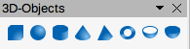
Figure 3: 3D-Objects toolbar
Available tools numbered from left to right
- Cube
- Sphere
- Cylinder
- Cone
- Pyramid
- Torus
- Shell
- Half Sphere
- Note
The 3D-Objects toolbar is also available as a sub-toolbar on the Drawing toolbar. See “Drawing” on page 11 for more information.

3D-Settings
The 3D-Settings toolbar (Figure 4) and its tools only become active when an object has been converted to 3D using the tool Toggle Extrusion and the converted object is selected.
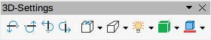
Figure 4: 3D-Settings toolbar
Available tools numbered from left to right
- Toggle Extrusion
- Tilt Down
- Tilt Up
- Tilt Left
- Tilt Right
- Depth
- Direction
- Lighting
- Surface
- 3D Color
The following tools on the 3D-Settings toolbar have a triangle ▼ on the right of the icon. Click on this triangle to open a drop-down menu giving access to various options as follows:
Depth
3D extrusion depth — 0cm; 1cm; 2.5cm; 5cm; 10cm; Infinity; Custom. The measurement unit depends on the ruler settings in Tools > Options > LibreOffice Impress > General (macOS LibreOffice > Preferences > LibreOffice Impress > General).
Direction
3D extrusion direction and type — Parallel; Perspective.
Lighting
Lighting direction and lighting level of 3D extrusion — Bright; Normal; Dim.
Surface
Surface type of 3D extrusion — Wire Frame; Matt; Plastic; Metal.
3D Color
Color of 3D extrusion. Select a color from one of the available color palettes.

Align Objects
The Align Objects toolbar (Figure 5) provides tools for aligning several objects in a slide to improve the visual impact of objects on a slide.
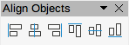
Figure 5: Align Objects toolbar
Available tools numbered from left to right
- Left
- Centered
- Right
- Top
- Center
- Bottom

Comments
The Comments toolbar (Figure 6) provides tools for adding, deletion, and navigation of comments in a presentation. To use comments, it is recommended to add the name and initials of all users in Tools > Options > LibreOffice > User Data (macOS LibreOffice > Preferences > LibreOffice > User Data) so that comments can be easily identified.
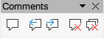
Figure 6: Comments toolbar
Available tools numbered from left to right
- Comment
- Previous Comment
- Next Comment
- Delete Comment
- Delete All Comments

Distribute Selection
The Distribute Selection toolbar (Figure 7) provides tools to distribute three or more selected objects evenly along the horizontal axis or vertical axis. Also, the spacing between objects can be evenly distributed.
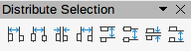
Figure 7: Distribute Selection toolbar
Available tools numbered from left to right
- Horizontally Left
- Horizontally Center
- Horizontally Spacing
- Horizontally Right
- Vertically Top
- Vertically Center
- Vertically Spacing
- Vertically Bottom

Drawing
The Drawing toolbar (Figure 8) provides the majority of the tools normally used to create graphic objects on slides in a presentation. By default, this toolbar is normally docked on the left side of the Workspace.
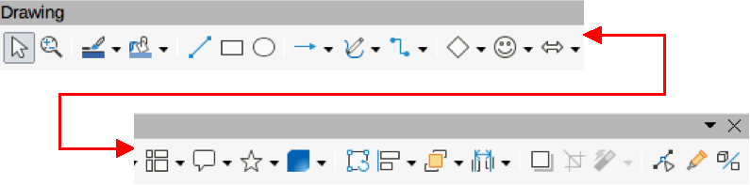
Figure 8: Drawing toolbar
Available tools numbered from left to right
- Select
- Zoom & Pan
- Zoom
- Text Box
- Vertical Text
- Insert Fontwork
- Line Color
- Fill Color
- Line
- Rectangle
- Ellipse
- Line Ends with Arrow
- Lines and Arrows
- Curves and Polygons
- Connectors
- Basic Shapes
- Symbol Shapes
- Block Arrows (Arrow Shapes in Visible Buttons))
- Flowchart (Flowchart Shapes in Visible Buttons)
- Callouts (Callout Shapes in Visible Buttons)
- Stars and Banners (Star Shapes in Visible Buttons)
- 3D Objects
- Position and Size
- Rotate
- Flip
- Align Objects
- Arrange
- Select at least three objects to distribute (Distribution in visible Buttons)
- Shadow
- Crop Image (Crop in Visible Buttons)
- Filter
- Points F8 (Edit Points in Visible Buttons)
- Show Glue Points Function (Glue Points in Visible Buttons)
- To Curve
- To Polygon
- To 3D
- T0 3D Rotation Object
- Toggle Extrusion
- Insert
- Controls
Some tool shapes on the Drawing toolbar change depending on the last tool that was previously selected and used.
- Click on the triangle ▼ to the right of a tool to open a sub-toolbar. Select the required shape to add to a drawing.
- To create a floating sub-toolbar, click and drag at the top of the pop-up toolbar to an empty area on the main window. The sub-toolbars for these object types and the various shapes available are shown in Figures 9 to 16.
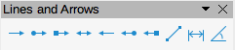
Figure 9: Lines and Arrows sub-toolbar
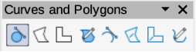
Figure 10: Curves and Polygons sub-toolbar
Figure 11: Basic Shapes sub-toolbar
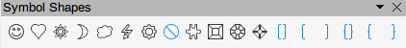
Figure 12: Symbol Shapes sub-toolbar
Figure 13: Block Arrows sub-toolbar
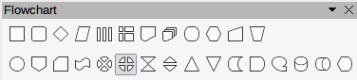
Figure 14: Flowchart sub-toolbar
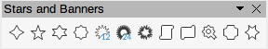
Figure 15: Stars and Banners sub-toolbar
Figure 16: 3D-Objects sub-toolbar
- Note
The 3D-Objects sub-toolbar is the same as the 3D-Objects toolbar, which is available at View > Toolbars on the Menu bar.

Edit Points
The Edit Points toolbar (Figure 17) provides tools for editing the points of a curve or an object that has been converted to a curve. The toolbar only becomes active when an object is selected and one of the following methods is used to open the toolbar:
- Click on Edit Points on the Drawing or Standard toolbar.
- Use the keyboard shortcut F8.
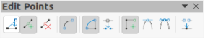
Figure 17: Edit Points toolbar
Available tools numbered from left to right
- Edit Points
- Move Points
- Insert Points
- Delete Points
- Convert to Curve
- Close Bezier
- Split Curve
- Corner Point
- Smooth Transition
- Symmetric Transition
- Eliminate Points

Find
The Find toolbar (Figure 18) opens by default and is docked in the bottom left corner of the Impress main window above the Status bar. However, it can be undocked and made into a floating toolbar.
Figure 18: Find toolbar
Available tools numbered from left to right
- Close Find Bar
- Find Text
- Find Previous
- Find Next
- Find All
- Match Case
- Find and Replace

Fontwork
The Fontwork toolbar (Figure 19) is used to create graphical text objects in a slide and provide the tools for editing the graphical text object. This toolbar only becomes active when a Fontwork graphical text object in a slide has been selected.
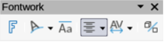
Figure 19: Fontwork toolbar
Available tools numbered from left to right
- Insert Fontwork Text
- Fontwork Shape
- Fontwork Same Letter Heights
- Fontwork Alignment
- Fontwork Character Spacing
- Toggle Extrusion
Some tools on the Fontwork toolbar have a triangle ▼ to the right of the tool. Click on the triangle to open a pop-up toolbar or drop-down option list.
Fontwork Shape
Select the required shape for the Fontwork graphical text object from the options available.
Fontwork Alignment
Select the paragraph alignment from the options available.
Fontwork Character Spacing
Select the required character spacing from the options available.

Form Controls
The Form Controls toolbar (Figure 20) provides the tools required to create an interactive form. This allows controls to be added to a form in a text, drawing, spreadsheet, presentation, or HTML document (for example a button that opens another presentation or slide).
Figure 20: Form Controls toolbar
Available tools numbered from left to right
- Select
- Design Mode
- Toggle Form Control Wizards
- Form Design
- Control Properties
- Form Properties
- Label
- Text Box
- Check Box
- Option Button
- List Box
- Combo Box
- Push Button
- Image Button
- Formatted Field
- Date Field
- Numerical Field
- Group Box
- Time Field
- Currency Field
- Pattern Field
- Table Control
- Navigation Bar
- Image Control
- File Selection
- Spin Button
- Scrollbar

Form Design
The Form Design toolbar (Figure 21) opens a form in Design Mode so that it can be edited. Controls of the form cannot be activated or its contents edited when in Design Mode. However, the position and size of the controls can be changed, other properties edited, and added or deleted controls in Design Mode.
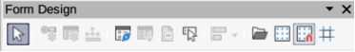
Figure 21: Form Design toolbar
Available tools numbered from left to right
- Select
- Control Properties
- Form Properties
- Position and Size
- Form Navigator
- Activation Order
- Add Field
- Automatic Control Focus
- Bring to Front
- Send to Back
- Group
- Ungroup
- Enter Group
- Exit Group
- Align Objects
- Open in Design Mode
- Display Grid
- Snap to Grid
- Helplines While Moving

Form Navigation
The Form Navigation toolbar (Figure 22) provides tools to edit a database table or control the data view. The toolbar is normally displayed at the bottom of a document that contains fields that are linked to a database. This toolbar is only active when forms are connected to a database, which is why an inactivate toolbar is shown in Figure 22.
The Form Navigation toolbar also allows movement within records as well as inserting and deleting records. If data is saved in a form, the changes are transferred to the database. This toolbar also provides tools providing sort, filter, and search functions for data records.
Figure 22: Form Navigation toolbar
Available tools numbered from left to right
- Find Record
- Record
- Absolute Record
- Text -> Record
- Total No. of Records
- First Record
- Previous Record
- Next Record
- Last Record
- New Record
- Save Record
- Undo: Data entry
- Delete Record
- Refresh
- Refresh Control
- Sort
- Sort Ascending
- Sort Descending
- AutoFilter
- Apply Filter
- Form-Based Filters
- Reset Filter/Sort
- Data source as Table

Glue Points
The Gluepoints toolbar (Figure 23) provides tools to insert a glue point or modify the properties of a glue point. A glue point is a point where a connector is attached to an object. By default, LibreOffice automatically places a glue point at the center of each side of the bounding rectangle for every object created.
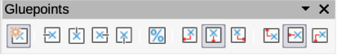
Figure 23: Gluepoints toolbar
Available tools numbered from left to right
- Insert Glue Point
- Exit Direction Left
- Exit Direction Top
- Exit Direction Right
- Exit Direction Bottom
- Glue Point Relative
- Glue Point Horizontal Left
- Glue Point Horizontal Center
- Glue Point Horizontal Right
- Glue Point Vertical Top
- Glue Point Vertical Center
- Glue Point Vertical Bottom

Image
The Image toolbar (Figure 24) provides tools to edit, modify, align, reposition and resize images. The toolbar only becomes active and available when an image is selected in a presentation. The Image toolbar automatically replaces the Line and Filling toolbar when it becomes active.
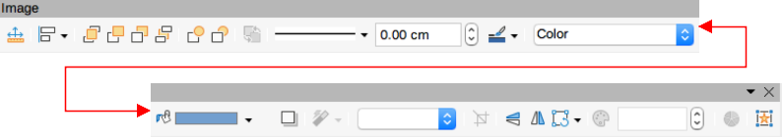
Figure 24: Image toolbar
Available tools numbered from left to right
- Position and Size
- Align Objects
- Left
- Centered
- Right
- Top
- Center
- Bottom
- Arrange
- Bring to Front
- Bring Forward
- Send Backward
- Send to Back
- In Front of Object
- Behind Object
- Reverse
- Line Style
- Line Width
- Line Color
- Area Style/Filling
- Fill Color
- Shadow
- Filter
- Image Mode
- Crop
- Vertically
- Horizontally
- Transformations
- Transparency
- Color
- Line
- Area
- Animation
- Interaction

Insert
The Insert toolbar (Figure 25) provides tools to insert different types of objects into a slide.
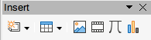
Figure 25: Insert toolbar
Available tools numbered from left to right
- New Page
- Floating Frame
- Insert Page from File
- Table
- Image
- Insert Audio or Video (Media in Visible Buttons)
- Formula Object
- Chart
- OLE Object

Legacy Circles and Ovals
The Legacy Circles and Ovals toolbar (Figure 26) provides tools to insert different types of circles and ovals into a drawing.
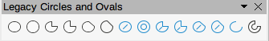
Figure 26: Legacy Circles and Ovals toolbar
Available tools numbered from left to right
- Insert Ellipse
- Circle
- Ellipse Pie
- Circle Pie
- Ellipse Segment
- Circle Segment
- Ellipse, Unfilled
- Circle, Unfilled
- Ellipse Pie, Unfilled
- Circle Pie, Unfilled
- Ellipse Segment, Unfilled
- Circle Segment, Unfilled
- Arc
- Circle Arc

Legacy Rectangles
The Legacy Rectangles toolbar (Figure 27) provides tools to insert different types of rectangles and squares into a slide.
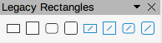
Figure 27: Legacy Rectangles toolbar
Available tools numbered from left to right
- Insert Rectangle
- Square
- Rectangle, Rounded
- Rounded Square
- Rectangle, Unfilled
- Square, Unfilled
- Rounded Rectangle, Unfilled
- Rounded Square, Unfilled

Line and Filling
The Line and Filling toolbar (Figure 28) provides tools and drop-down lists for editing lines, arrows, and object borders. The tools available vary depending on the type of object selected for editing.
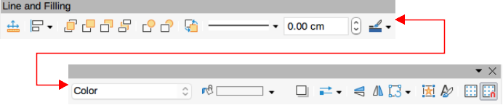
Figure 28: Line and Filling toolbar
Available tools numbered from left to right
- Position and Size
- Align Objects
- Left
- Centered
- Right
- Top
- Center
- Bottom
- Arrange
- Bring to Front
- Bring Forward
- Send Backward
- Send to Back
- In Front of Object
- Behind Object
- Reverse
- Line Style
- Line Width
- Line Color
- Area Style/Filling
- Fill Color
- Shadow
- Arrow Style
- Vertically
- Horizontally
- Transformations
- Line
- Area
- 3D Effects
- Image Map
- Animation
- Interaction
- Show the Styles Sidebar
- Display Grid
- Helplines While Moving

Master View
The Master View toolbar (Figure 29) provides tools to create a new master slide, rename a master slide, delete a master slide, and close master view. This toolbar is only active when Impress is in master view.
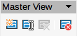
Figure 29: Master View toolbar
Available tools numbered from left to right
- New Master
- Rename Master
- Delete Master
- Close Master View

Media Playback
The Media Playback toolbar (Figure 30) provides the tools required to insert, view, play, and listen to audio and video files. The toolbar only becomes active when an audio or video file is selected. Impress supports many different media formats depending on the computer operating system being used.
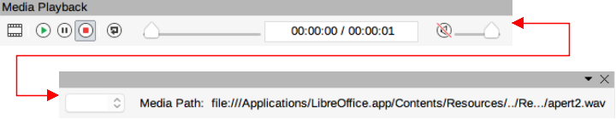
Figure 30: Media Playback toolbar
Available tools numbered from left to right
- Insert Audio or Video
- Play
- Pause
- Stop
- Repeat
- Position
- Mute
- Volume
- View

Options
The Options toolbar (Figure 31) provides tools for editing various settings for newly created presentations, for example how objects snap to the grid when being moved or resized.
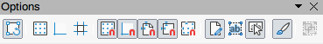
Figure 31: Options toolbar
Available tools numbered from left to right
- Rotation Mode after Clicking Object
- Display Grid
- Display Snap Guides
- Helplines While Moving
- Snap to Grid
- Snap to Snap Guides
- Snap to Page Margins
- Snap to Object Borders
- Snap to Object Points
- Allow Quick Editing
- Select Text Area Only
- Double-click to edit Text
- Modify Object with Attributes
- Exit All Groups

Outline
The Outline toolbar (Figure 32) provides tools for working with outlines.
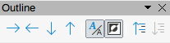
Figure 32: Outline toolbar
Available tools numbered from left to right
- Demote
- Promote
- Move Down
- Move Up
- Show Formatting
- Black & White View
- Show Only First Level
- Show All Levels
- Hide Subpoints
- Show Subpoints

Presentation
The Presentation toolbar (Figure 33) provides tools for working with presentations.
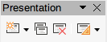
Figure 33: Presentation toolbar
Available tools numbered from left to right
- New Slide
- Duplicate Slide
- Rename Slide
- Delete Slide
- Slide Layout
- Change Slide Master
- Expand Slide
- Go to First Slide
- Go to Previous Slide
- Go to Next Slide
- Go to Last Slide
- Move Slide to Start
- Move Slide Up
- Move Slide Down
- Move Slide to End

Slide Sorter
The Slide Sorter toolbar (Figure 34) allows selection of slides in the current presentation and start a presentation from the first slide.
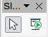
Figure 34: Slide Sorter toolbar
Available tools numbered from left to right
- Select
- Start from First Slide

Slide View
The Slide View toolbar (Figure 35) opens with the Slide Sorter view and provides tools to rehearse timings of a slide show; hide and show slides, and change the number of slides displayed in Slide Sorter view.
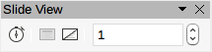
Figure 35: Slide View toolbar
Available tools numbered from left to right
- Rehearse Timings
- Show Slide
- Hide Slide
- Slides per Row

Standard
The Standard toolbar (Figure 36) is common to all LibreOffice modules and provides tools for creating and editing documents using LibreOffice. The Standard toolbar differs between different LO modules to allow for different toolsets used in creating the different types of documents.
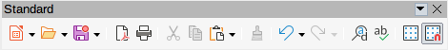
Figure 36: Standard toolbar
Available tools numbered from left to right
- Load URL
- New
- Templates
- Open
- Open Remote
- Save
- Save As
- Email
- Edit Mode
- Export Directly as PDF
- Print Directly
- Print
- Cut
- Copy
- Paste
- Clone Formatting (Clone in Visible Buttons)
- Clear
- Undo
- Redo
- Find and Replace
- Spelling)
- Auto Spellcheck
- Zoom & Pan
- Zoom
- Display Grid (Grid in Visible Buttons)
- Helplines While Moving
- Display Views
- Views Tab Bar
- Format Slide
- Master Slide
- Start from First Slide
- Start from Current Slide
- Table
- Insert Image (Image in Visible Buttons)
- Insert Audio or Video (Media in visible Buttons)
- Insert Chart (Chart in Visible Buttons)
- Text Box
- Insert Special Characters (Symbol in Visible Buttons)
- Vertical Text
- Insert Fontwork Text
- Insert Hyperlink (Hyperlink in Visible Buttons)
- Show Draw Functions (Draw Functions in Visible Buttons)
- Interaction
- LibreOffice Help
- What’s That

Standard (Single Mode)
The Standard (Single Mode) toolbar (Figure 37) can be used instead of the Standard toolbar if necessary. The Standard (Single Mode) toolbar is normally used when the user interface is switched to single mode. For more information on selecting and using user interface variants, see Chapter 12, User Interface Variants.
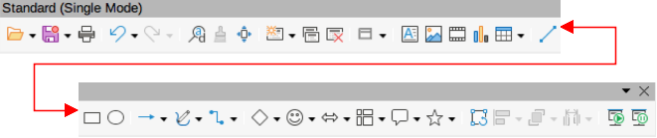
Figure 37: Standard (Single Mode) toolbar
Available tools numbered from left to right
- New
- Open
- Save
- Export Directly as PDF
- Print
- Print Preview
- Undo
- Redo
- Find and Replace
- Clone Formatting (Clone in Visible Buttons)
- Spelling
- Entire Page
- New Slide
- Duplicate Slide
- Rename Slide
- Delete Slide
- Slide Layout
- Display Views
- Text Box
- Vertical Text
- Insert Image (Image in Visible Buttons)
- Insert Audio or Video (Media in visible Buttons)
- Insert Chart (Chart in Visible Buttons)
- Table
- Insert Fontwork
- Insert Line (Line in visible Buttons)
- Rectangle
- Ellipse
- Lines and Arrows
- Curves and Polygons
- Connectors
- Basic Shapes
- Symbol Shapes
- Block Arrows (Arrow Shapes in Visible Buttons)
- Flowchart (Flowchart Shapes in Visible Buttons)
- Callouts (Callout Shapes in Visible Buttons)
- Stars and Banners (Star Shapes in Visible Buttons
- 3D Objects
- Position and Size
- Rotate
- Flip
- Align Objects
- Arrange
- Select at least three objects to distribute (Distribution in Visible Buttons)
- Group
- Ungroup
- Enter Group
- Exit Group
- Select
- Entire Page
- Zoom & Pan
- Zoom
- Start from First Slide
- Start from Current Slide
- Standard (Viewing Mode)
- The Standard (Viewing Mode) toolbar (Figure 40) provides tools to save, edit and distribute a document.
- Available tools numbered from left to right
- Save As
- Edit Mode
- Read Only Mode
- Attach to Email (Email in Visible Buttons)
- Export Directly as PDF
- EPUB
- Print Directly
- Print
- Copy
- Find and Replace
- Zoom
- Start from First Slide

Standard (Viewing Mode)
The Standard (Viewing Mode) toolbar (Figure 38) provides tools to save, edit and distribute a document.
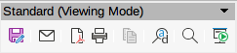
Figure 38: Standard (Viewing Mode) toolbar
Available tools from left to right
- Save As
- Edit Mode
- Read Only Mode
- Attach to Email (Email in Visible Buttons)
- Export Directly as PDF
- EPUB
- Print Directly
- Print
- Copy
- Find and Replace
- Zoom
- Start from First Slide

Table
The Table toolbar (Figure 39) provides tools and options to edit and format a table placed on a slide. This toolbar only becomes active when a table is selected.
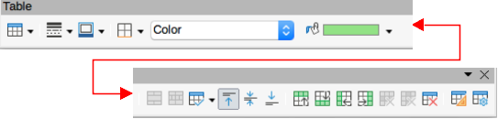
Figure 39: Table toolbar
Available tools numbered from left to right
- Table
- Border Style
- Border Color
- Borders (Shift to overwrite)
- Area Style/Filling
- Fill Color
- Merge Cells
- Split Cells
- Optimize
- Align Top (Top in Visible Buttons)
- Center Vertically (Center in Visible Buttons)
- Align Bottom (Bottom in Visible Buttons)
- Insert Row Above
- Insert Row Below
- Insert Column Before
- Insert Column After
- Delete Row
- Delete Column
- Delete Table
- Select Table
- Select Column
- Select Row
- Table Design
- Table Properties

Text
The Text toolbar (Figure 40) provides tools to insert text boxes and callouts into a slide.
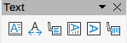
Figure 40: Text toolbar
Available tools numbered from left to right
- Insert Text Box (Text Box in Visible Buttons)
- Fit Text in Textbox Size
- Callouts
- Insert Vertical Text (Vertical Text in Visible Buttons)
- Fit Vertical Text to Frame
- Vertical Callouts

Text Formatting
The Text Formatting toolbar (Figure 41) provides tools for formatting text and alignment commands. This toolbar becomes active when text in a text box or graphic object has been selected and it automatically replaces the Line and Filling toolbar.
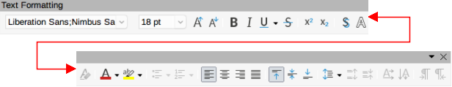
Figure 41: Text Formatting toolbar
Available tools numbered from left to right
- Font Name
- Font Size
- Increase Font Size (Increase in Visible Buttons)
- Decrease Font Size (Decrease in Visible Buttons)
- Bold
- Italic
- Underline
- Double Underline
- Strikethrough
- Overline
- Superscript
- Subscript
- Toggle Shadow (Shadow in Visible Buttons)
- Apply outline attribute to font (Outline Font Effect in Visible Buttons)
- Clear Direct Formatting (Clear in Visible Buttons)
- lowercase
- UPPERCASE
- small capitals
- Font Color
- Character Highlighting Color
- Toggle Unordered List (Unordered List in Visible Buttons)
- Toggle Ordered List (Ordered List in Visible Buttons)
- Outline Format
- Align Left (Left in Visible Buttons)
- Align Center (Center in Visible Buttons)
- Align Right (Right in Visible Buttons)
- Justified
- Align Top (Top in Visible Buttons)
- Center Vertically (Center in Visible Buttons)
- Align Bottom (Bottom in Visible Buttons)
- Set Line Spacing (Line Spacing in Visible Buttons)
- Character Spacing
- Increase Paragraph Spacing (Increase in Visible Buttons)
- Decrease Paragraph Spacing (Decrease in Visible Buttons)
- Text direction from left to right
- Text direction from top to bottom
- Left-To-Right
- Right-To-Left
- Select All
- Character
- Paragraph

Transformations
The Transformations toolbar (Figure 42) provides tools to modify the shape, orientation, or fill of selected objects.
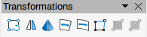
Figure 42: Transformations toolbar
Available tools numbered from left to right
- Rotate
- Flip
- In 3D Rotation Object
- Set in Circle (perspective)
- Set to circle (slant)
- Distort
- Interactive transparency tool (Transparency tool in Visible Buttons)
- Interactive gradient tool (Gradient tool in Visible Buttons)

TSCP Classification
The TSCP Classification toolbar (Figure 43) provides tools to help in selecting the security of a document. LibreOffice adds custom fields in the document properties (File > Properties > Custom Properties on the Menu bar) to store the classification policy as document metadata. TSCP stands for Transglobal Secure Collaboration Participation.
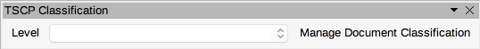
Figure 43: TSCP Classification toolbar
Available tools numbered from left to right
- Apply document classification (Level)
- Manage Document Classification

Zoom
The Zoom toolbar (Figure 44) provides tools to reduce or enlarge the screen display of the current presentation.
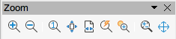
Figure 44: Zoom toolbar
Available tools numbered from left to right
- Zoom In
- Zoom Out
- 100%
- Zoom Previous
- Zoom Next
- Entire Page
- Page Width
- Optimal View (Optimal in Visible Buttons)
- Object Zoom
- Zoom & Pan
- Shift

