
Base Handbook
Chapter 2
Creating a Database
How to create a new database

Copyright
This document is Copyright © 2013 by its contributors as listed below. You may distribute it and/or modify it under the terms of either the GNU General Public License (http://www.gnu.org/licenses/gpl.html), version 3 or later, or the Creative Commons Attribution License (http://creativecommons.org/licenses/by/3.0/), version 3.0 or later.
All trademarks within this guide belong to their legitimate owners.

Contributors
Jochen Schiffers  Martin Fox | Robert Großkopf | Jost Lange

Feedback
Please direct any comments or suggestions about this document to: documentation@global.libreoffice.org.

Acknowledgments
This chapter is based on an original German document and was translated by Martin Fox.

Publication date and software version
Published 11 April 2013. Based on LibreOffice 3.5.

Note for Mac users
Some keystrokes and menu items are different on a Mac from those used in Windows and Linux. The table below gives some common substitutions for the instructions in this chapter. For a more detailed list, see the application Help.
Windows or Linux | Mac equivalent | Effect
Tools > Options menu selection | LibreOffice > Preferences | Access setup options
Right-click | Control+click | Open a context menu
Ctrl (Control) | z (Command) | Used with other keys
F5 | Shift+z+F5 | Open the Navigator
F11 | z+T | Open the Styles and Formatting window

Contents
Copyright 2
Contributors 2
Feedback 2
Acknowledgments 2
Publication date and software version 2
Note for Mac users 2
General notes on the creation of a database 4
New database using the internal HSQL engine 4
Accessing external databases 4
MySQL databases 5
dBase databases 12
Spreadsheets 13
Thunderbird address book 14

General notes on the creation of a database
The basics of creating a database in LibreOffice are described in Chapter 8 of the Getting Started guide, Getting Started with Base.
The database component of LibreOffice, called Base, provides a graphical interface for working with databases. In addition, LibreOffice contains a version of the HSQL database engine. This HSQLDB database can only be used by a single user. The entire data set is stored in an ODB file which has no file locking mechanism when opened by a user.

New database using the internal HSQL engine
If a database with multiple users is not planned, or the user wishes to gain some initial experience with a database, the internal database engine will suffice. It is possible at some later stage to transfer the database to an external HSQLDB environment, where multiple users can have concurrent access to the database on the HSQLDB server. This is described in the Appendix to this Handbook.
The creation of a new internal database is described in detail in Getting Started with Base.
A database which is registered in LibreOffice can be accessed by other program components as a data source (for example, mail merge). This registration process can be carried out at a later stage if desired.

Accessing external databases
An external database must exist before it can be accessed. Assuming that access to a database is desired, the database must be set up to allow network connections with a specific user name and password before external programs can connect to it.
When such a database is properly set up, a user may, depending on the available connection software (the database driver), create tables, input data, and query data.
Click on File > New > Database to open the Database Wizard and allow a connection to an existing database to be made. The list of available database types varies according to operating system and user interface, but the following should always be available:
- dBase
- JDBC
- MySQL
- ODBC
- Oracle JDBC
- PostgreSQL
- Spreadsheet
- Text
- as well as various types of address books.
The connection options will vary according to the type of database selected. These can in any case be corrected later, after the *.odb file is created.
Some database types (for example spreadsheets) do not allow new data to be entered. These are used only to search for or report on existing data.

MySQL databases
There was an extension for MySQL, the MySQL Native Connector, which should allow Base to connect directly to a MySQL database. The extension was in the LibreOffice Extensions center under the Base Category but is not being developed at present.
General access to MySQL for versions of LibreOffice from 3.5 onwads is via JDBC or ODBC. To be able to use JDBC, it is necessary to install mysql-connector-java.jar. This Java Archive file is best copied into the same folder where the current java version used in LibreOffice is located. This is likely to be a subfolder like ...javapath.../lib/ext for a Linux installation.
Alternatively the appropriate folder containing the Java archive can be set through Tools > Options > Java > ClassPath.
The method of access to an existing MySQL database is shown in the following steps.
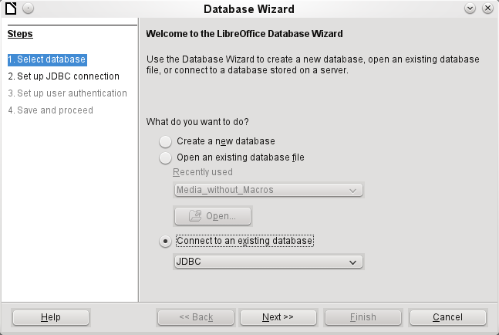
Creation of a new database is only possible in the internal HSQLDB format. Connection to an external database is only possible when the database already exists.
Select the Connect to an existing database option. A list of database formats is contained on the pull-down menu. Select MySQL.
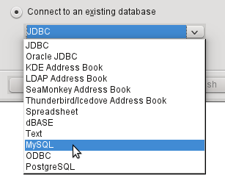
Connection to MySQL can be via ODBC or JDBC unless a native MySQL connector has been installed. In this case a direct connection to MySQL is possible.
In this example, select the Java connector JDBC.
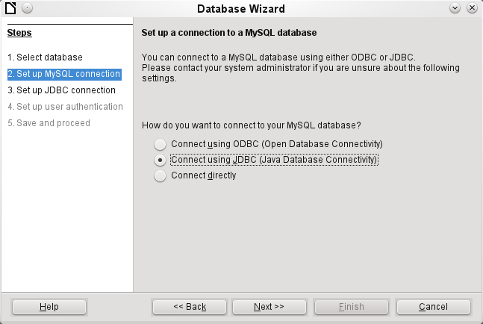
The database name must be known and input.
If the MySQL server is on the same computer as LibreOffice, then the Server name can be set as localhost. Otherwise the IP address of the server or its hostname on the network or internet must be input. It is also possible to access a database with Base where the database is located on the website of an Internet Service Provider.
The default port number will usually be correct.
Type in the JDBC driver class and click the Test class button. A dialog should pop up confirming that the connector is loaded and accessible using Java. The mysql-connector-java.jar file must either be in the same path as the version of Java in use in LibreOffice or directly linked in to LibreOffice.
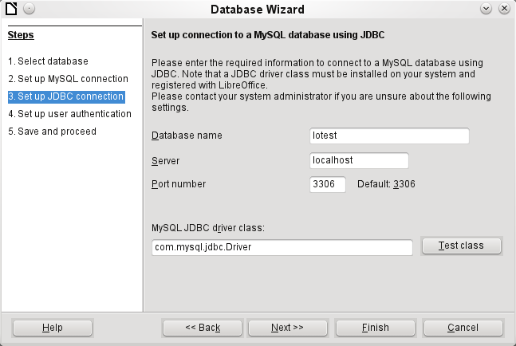
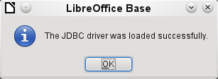
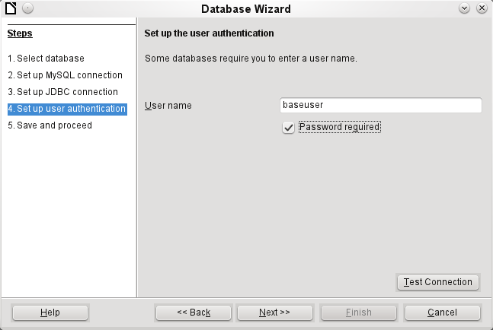
The database on the network should be protected with a user name and password. Again a connection test may be carried out.
Note | If a direct connection was selected, this test will generate error messages. Without testing, Base will, at the end of the Assistant, open the database window and connection to MySQL.
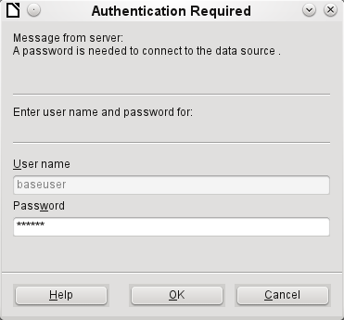
The connection test starts the authentication process using the user name previously input. After the correct password is input, a dialog announces the result of the test. If MySQL is not running at this time, an error message is shown.
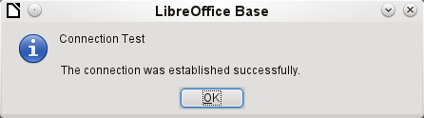
The final step is registering the database. The database can, if necessary, be registered at a later time to allow its use with Writer or Calc.
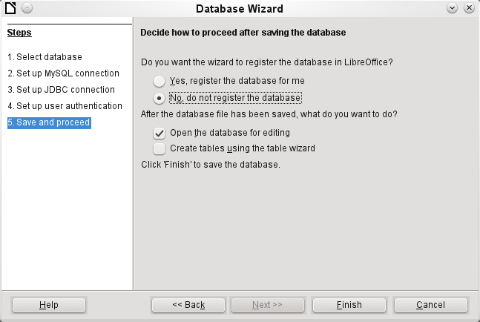
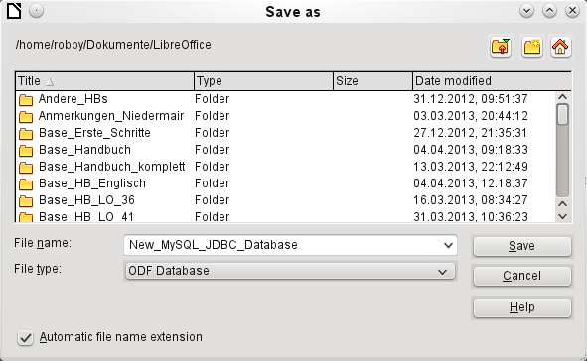
The Assistant ends the connection process with the storage of the ODB database. The ODB database contains all the connection information needed to allow tables in the database to be accessed whenever the database is opened.
At this stage choose a name for the ODB database file and save it. The next picture is a view of the Base interface.
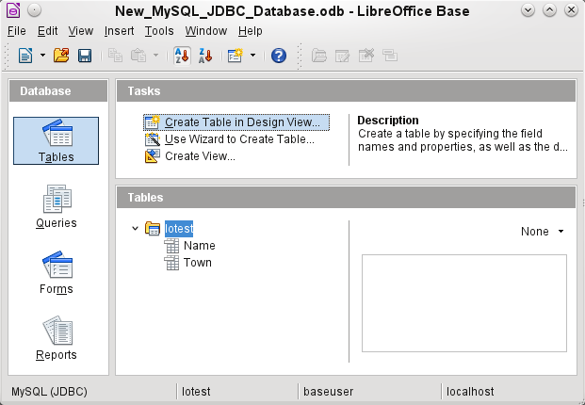
The tables in the database are contained in the tree under the name of the database.
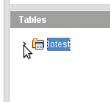
The view of the table tree can be closed by clicking on the database name. For a single database connection this does not make much sense, but it does give a visible indication of the direct connection.
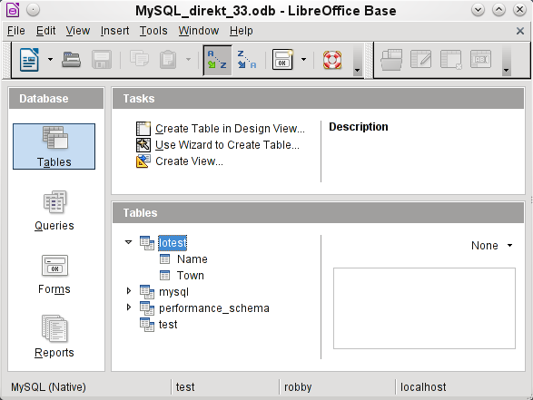
Instead of only the database input in Step 3 of the Wizard (see lower status bar), LibreOffice opens all databases that are available in MySQL to the user “robby”.
Queries must include in the MySQL syntax not only the table name but also the database which contains, for example, the following code:
… FROM "myphplib"."ASB" AS "ASB", "myphplib"."Kategorien" AS "Kategorien"
It is also possible in every such case to specify an alias, made up from the database and table names. More details are given in the chapter on Queries.
Tables can be created and deleted in a database. Fields with auto values may be created when setting up the structure of tables. In MySQL the starting value of such fields defaults to 1.

dBase databases
dBase databases have a format where all data is contained in separate, previously initialized tables. Links between the tables must be made in program code. Relations are not supported.
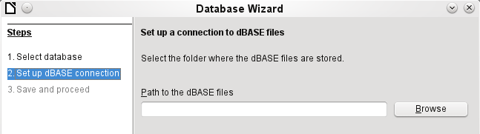
The connection is made to a specific folder. All DBF files in this folder will be included and shown in the ODB database and can be linked together using queries.
Tables in dBase have no primary key. They can in principle be described as corresponding to the worksheets in Calc.
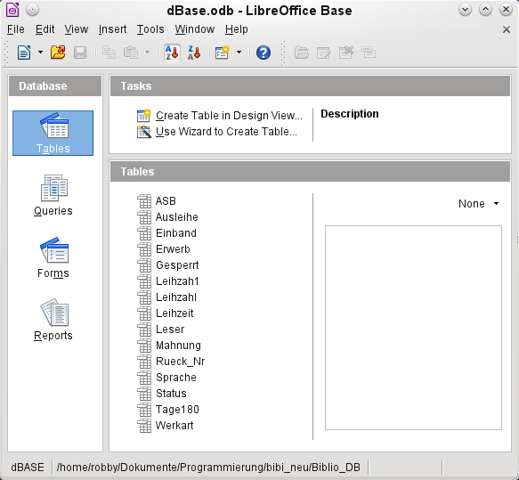
Tables can be created and will then be copied as new files in the folder previously selected.
The number of different field types for a new dBase table is clearly less than when the internal HSQLDB format is used. In the following figure there are still some field types with the same type name.
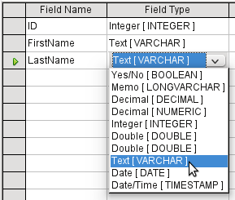
The dBase format is especially suitable for the exchange and extensive editing of data. In addition, spreadsheet calculations can directly access dBase tables. It may be better to manipulate the data in Base because Calc requires the input of the type of character encoding, whereas Base simply takes the appropriate encoding provided by the operating system. Old dBase files may exhibit small decoding errors where special characters have been used.

Spreadsheets
Calc or Excel spreadsheets can also be used as the table source for databases. If, however, a Calc spreadsheet is used, no editing of the table data will be possible. If the Calc document is still open, it will be write protected.
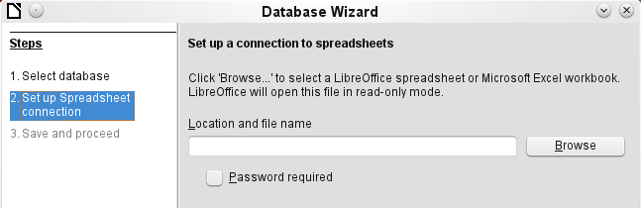
The only questions to be answered are the location of the spreadsheet file and whether or not it is password protected. Base then opens the spreadsheet and includes all worksheets in the document. The first row is used for the field names and the worksheet names become the table names.
Relationships between spreadsheets cannot be set up in Base, as Calc is not suitable for use as a relational database.

Thunderbird address book
The Assistant will automatically seek a connection to an address book, for example as used in Thunderbird. The assistant will prompt for the location of the ODB file that will be produced.
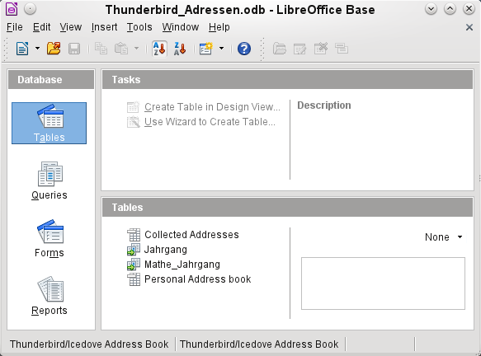
All tables are shown. As in Calc, the tables are not editable. Base uses the table data only for queries and mail merge applications.

