
Writer Guide
Chapter 1
Introducing Writer

Copyright
This document is Copyright © 2005–2010 by its contributors as listed below. You may distribute it and/or modify it under the terms of either the GNU General Public License (http://www.gnu.org/licenses/gpl.html), version 3 or later, or the Creative Commons Attribution License (http://creativecommons.org/licenses/by/3.0/), version 3.0 or later.
All trademarks within this guide belong to their legitimate owners.
Contributors
Agnes Belzunce
Daniel Carrera
Laurent Duperval
Stefan A. Keel
Peter Kupfer
Carol Roberts
Gary Schnabl
Janet M. Swisher
Jean Hollis Weber
Linda Worthington
Michele Zarri
Feedback
Please direct any comments or suggestions about this document to: ??
Publication date and software version
Published 20 October 2010. Based on LibreOffice 3.3.
Contents
Copyright 2
What is Writer? 5
Starting Writer 5
Starting from the system menu 6
Note for Mac users 6
Starting from an existing document 6
Note for Windows users 6
Using the Quickstarter under Windows 7
Using the Quickstarter icon 7
Disabling the Quickstarter 7
Reactivating the Quickstarter 8
Using the Quickstarter under Linux 8
Preloading OOo under Linux/KDE 8
Starting from the command line 8
The Writer interface 9
Menus 10
Toolbars 10
Displaying or hiding toolbars 11
Submenus and tear-off toolbars 11
Moving toolbars 11
Floating toolbars 12
Docking/floating windows and toolbars 12
Customizing toolbars 13
Right-click (context) menus 14
Rulers 14
Status bar 14
Changing document views 17
Using the Navigator 17
Moving quickly through a document 19
Using the Navigation toolbar 20
Rearranging chapters using the Navigator 21
Setting reminders 21
Choosing drag mode 22
Starting a new document 22
Creating a blank document 22
Creating a document from a template 23
Opening an existing document 24
Saving a document 25
Password protection 25
Saving a document automatically 26
Saving as a Microsoft Word document 26
Getting help 27
Undoing and redoing changes 28
Closing a document 28
Closing Writer 29

What is Writer?
Writer is the word processor component of LibreOffice (LibO). In addition to the usual features of a word processor (spelling check, thesaurus, hyphenation, autocorrect, find and replace, automatic generation of tables of contents and indexes, mail merge, and others), Writer provides these important features:
- Templates and styles
- Page-layout methods, including frames, columns, and tables
- Embedding or linking of graphics, spreadsheets, and other objects
- Built-in drawing tools
- Master documents—to group a collection of documents into a single document
- Change tracking during revisions
- Database integration, including a bibliography database
- Export to PDF, including bookmarks
- And many more
Styles are central to using Writer. Using styles, you can easily format your document consistently and change the format with minimal effort. A style is a named set of formatting options. Writer defines several types of styles, for different types of elements: characters, paragraphs, pages, frames, and lists. Often, you are using styles whether you realize it or not. The use of styles is described in more detail in Chapter 6 (Introduction to Styles) and Chapter 7 (Working with Styles).
The other features of Writer listed above are also covered in detail in other chapters of this guide.

Starting Writer
If you are reading this document in LibreOffice, you already know how to start Writer. However, if this is a printed version or a PDF version, you may not know how to start Writer. So let’s look at three ways to do that:
- From the system menu
- From an existing document
- From the command line

Starting from the system menu
The most common way to start Writer is by using the system menu, the standard menu from which most applications are started. On Windows, it is called the Start menu. On GNOME, it is called the Applications menu. On KDE, it is identified by the KDE logo. On Mac OS X, it is the Applications menu.
When LibreOffice was installed on your computer, in most cases a menu entry for each component was added to your system menu. (If you are using a Mac, see note below.) The exact name and location of these menu entries depends on the operating system and graphical environment.
Note for Mac users
You should see the LibreOffice icon in the Applications folder. When you double-click this icon, a text document opens in Writer. To open the other components (Draw, Calc, Impress, Base), go to the File menu of the Writer window and select the component you want.
LibreOffice does not automatically put a shortcut icon on the desktop, but you can add one if you wish. If you don’t know how to add shortcut icons for launching programs, please consult the help for your operating system.

Starting from an existing document
All Writer documents are associated with the Writer application. This means that you can start LibreOffice automatically, simply by double-clicking a Writer document in a file manager such as Windows Explorer.
Note for Windows users
If you have associated Microsoft Office file types with LibreOffice, then when you double-click on a *.doc (Word) file, it opens in LibreOffice Writer.
If you did not associate the file types, then when you double-click on a Microsoft Word document, it opens in Microsoft Word (if Word is installed on your computer).
You can use another method to open *.doc files in LibreOffice and save in the *.doc format from LibreOffice. See “Opening an existing document” on page 22 for more information.

Using the Quickstarter under Windows
The Quickstarter is an icon that is placed in the Windows system tray during system startup. It indicates that LibreOffice has been loaded and is ready to use. (The Quickstarter loads library *.DLL files required by LibreOffice, thus shortening the startup time for LibreOffice components by about half.) If the Quickstarter is disabled, see “Reactivating the Quickstarter” on page 7 if you want to enable it.

Using the Quickstarter icon
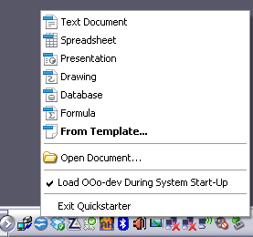
Figure 1: Quickstarter pop-up menu
Right-click the Quickstarter icon in the system tray to open a pop-up menu from which you can open a new document, open the Templates and Documents dialog box, or choose an existing document to open. You can also double-click the Quickstarter icon to display the Templates and Documents dialog box.

Disabling the Quickstarter
To close the Quickstarter, right-click on the icon in the system tray and then click Exit Quickstarter on the pop-up menu. The next time the computer is restarted, the Quickstarter will be loaded again.
To prevent LibreOffice from loading during system startup, deselect the Load LibreOffice During System Start-Up item on the pop-up menu. You might want to do this if your computer has insufficient memory, for example.

Reactivating the Quickstarter
If the Quickstarter has been disabled, you can reactivate it by selecting the Load LibreOffice during system start-up option in Tools > Options > LibreOffice > Memory.

Using the Quickstarter under Linux
Some installations of LibreOffice under Linux have a Quickstarter that looks and acts like the one described above for Windows (the option on the Memory page is labeled Enable systray quickstarter).

Preloading LibreOffice under Linux/KDE
In Linux/KDE, you can use KDocker to have LibreOffice loaded and ready for use at startup. KDocker is not part of LibO; it is a generic “systray app docker” that is helpful if you open LibO often.

Starting from the command line
You may want to start Writer from the command line (using the keyboard instead of the mouse). Why? Well, by using the command line, you have more control over what happens when Writer is started. For example, using the command line, you can tell Writer to load a document and print it immediately, or to start without showing the splash screen.
Note | Most users will never need to do this.
There is more than one way to start Writer from the command line, depending on whether you have installed a customized version or the standard download from the LibreOffice web site.
If you installed using the download on the LibreOffice web site, you can start Writer by typing at the command line:
soffice -writer
or
swriter
Writer will start and create a new document.
To see a list of options you can use when starting Writer at the command line, type:
soffice -?
Below is a list of some of the more popular options.
Option | Description
-help | Get a complete list of options.
-nologo | Do not show the startup screen.
-show <odp-file> | Start presentation immediately.
-view <documents ...> | Open documents in viewer (read-only) mode.
-minimized | Start LibreOffice minimized.
-norestore | Suppress restart/restore after fatal errors.
-invisible | No startup screen, no default document and no UI. This is useful for third-party applications that use functionality provided by LibreOffice.
If you have a customized version of LibreOffice (such as the one provided by Linux Mandrake or Gentoo), you can start Writer by typing at the command line:
oowriter
Although the command syntax differs, the effect is identical: it starts LibreOffice with an empty Writer document.

Parts of the main Writer window
The main Writer workspace is shown in Figure 2.
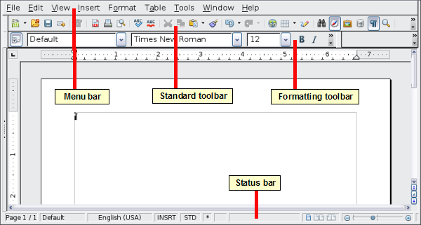
Figure 2: The main Writer workspace in Print Layout view

Menus
The Menu bar is located across the top of the Writer window, just below the Title bar. When you choose one of the menus listed below, a submenu drops down to show commands.
- File contains commands that apply to the entire document such as Open..., Save, and Export as PDF....
- Edit contains commands for editing the document such as Undo: xxx (where xxx is the command to undo) and Find & Replace.... It also contains commands to cut, copy, and paste selected parts of your document.
- View contains commands for controlling the display of the document such as Zoom... and Web Layout.
- Insert contains commands for inserting elements into your document such as headers, footers, and pictures.
- Format contains commands for formatting the layout of your document, such as Styles and Formatting, Paragraph, and Bullets and Numbering.
- Table shows all commands to insert and edit a table in a text document.
- Tools contains functions such as Spelling and Grammar, Customize..., and Options....
- Window contains commands for the display window.
- Help contains links to the LibreOffice Help file, What’s This?, and information about the program. See “Getting help” on page 25.

Toolbars
Writer has several types of toolbars: docked, floating, and tear-off. Docked toolbars can be moved to different locations or made to float, and floating toolbars can be docked.
The top docked toolbar (default position) is called the Standard toolbar. The Standard toolbar is consistent across the LibreOffice applications (Writer, Calc, Draw, Impress, Base).
The second toolbar across the top (default location) is the Formatting toolbar. It is a context-sensitive bar that shows the relevant tools in response to the cursor’s current position or selection. For example, when the cursor is on a graphic, the Formatting bar provides tools for formatting graphics; when the cursor is in text, the tools are for formatting text.

Displaying or hiding toolbars
To display or hide toolbars, choose View > Toolbars, then click on the name of a toolbar in the list. An active toolbar shows a check mark beside its name. Tear-off toolbars are not listed in the View menu.

Submenus and tear-off toolbars
Toolbar icons with a small triangle to the right will display submenus, tear-off toolbars, and other ways of selecting things, depending on the icon. Figure 3 shows a tear-off toolbar from the Drawing toolbar.
Tear-off toolbars can be floating or docked along an edge of the screen or in one of the existing toolbar areas. To move a floating tear-off toolbar, drag it by the title bar. See “Moving toolbars” below.
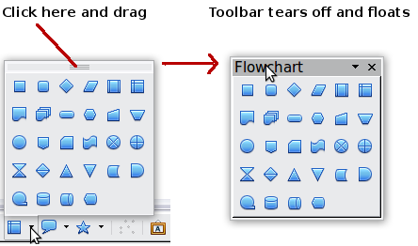
Figure 3: Example of a tear-off toolbar

Moving toolbars
To move a docked toolbar, place the mouse pointer over the toolbar handle, hold down the left mouse button, drag the toolbar to the new location, and then release the mouse button (Figure 4).
To move a floating toolbar, click on its title bar and drag it to a new location (Figure 5).
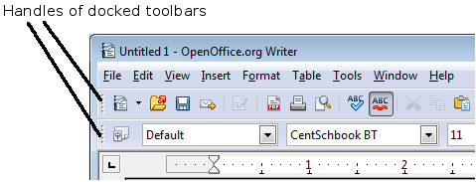
Figure 4: Moving a docked toolbar
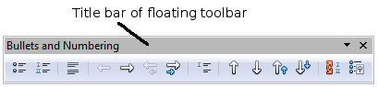
Figure 5: Moving a floating toolbar

Floating toolbars
Writer includes several additional context-sensitive toolbars, whose defaults appear as floating toolbars in response to the cursor’s current position or selection. For example, when the cursor is in a table, a floating Table toolbar appears, and when the cursor is in a numbered or bullet list, the Bullets and Numbering toolbar appears. You can dock these toolbars to the top, bottom, or side of the window, if you wish (see “Moving toolbars” on page 10).

Docking/floating windows and toolbars
Toolbars and some windows, such as the Navigator and the Styles and Formatting window, are dockable. You can move, resize, or dock them to an edge.
To dock a window or toolbar, hold down the Control key and double-click on the frame of the floating window (or in a vacant area near the icons at the top of the floating window) to dock it in its last position.
To undock a window, hold down the Control key and double-click on the frame (or a vacant area near the icons at the top) of the docked window.

Customizing toolbars
You can customize toolbars in several ways, including choosing which icons are visible and locking the position of a docked toolbar. You can also add icons and create new toolbars, as described in Appendix B.
To access a toolbar’s customization options, use the down-arrow at the end of the toolbar or on its title bar.
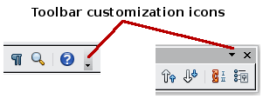
Figure 6: Customizing toolbars
To show or hide icons defined for the selected toolbar, choose Visible Buttons from the drop-down menu. Visible icons have a checkmark next to them. Click on icons to select or deselect them.
Figure 7: Selection of visible toolbar icons

Right-click (context) menus
You can quickly access many menu functions by right-clicking on a paragraph, graphic, or other object. A context menu will pop up. Often the context menu is the fastest and easiest way to reach a function. If you’re not sure where in the menus or toolbars a function is located, you can often find it by right-clicking.

Rulers
To show or hide rulers, choose View > Ruler. To enable the vertical ruler, choose Tools > Options > LibreOffice Writer > View and select Vertical ruler.
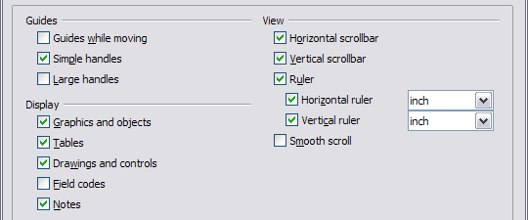
Figure 8. Turning on the vertical ruler

Status bar
The Writer status bar is located at the bottom of the workspace. It provides information about the document and convenient ways to quickly change some document features. From left to right, the fields are as follows.
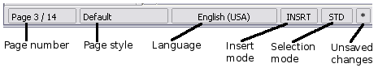Figure 9: Left end of status bar
Page number
Shows the current page number, the sequence number of the current page (if different), and the total number of pages in the document. For example, if you restarted page numbering at 1 on the third page, its page number is 1 and its sequence number is 3.
If any bookmarks have been defined in the document, a right-click on this field pops up a list of bookmarks; click on the required one.
To jump to a specific page in the document, double-click on this field. The Navigator opens (see page 16). Click in the Page Number field and type the sequence number of the required page. After a brief delay, the display jumps to the selected page.
Page style
Shows the style of the current page. To change the page style, right-click on this field. A list of page styles pops up; choose a different style by clicking on it.
To edit the current page style, double-click on this field. The Page Style dialog box opens.
Language
Shows the language for the selected text.
Click to open a menu where you can choose another language for the selected text or for the paragraph where the cursor is located. You can also choose None (Do not check spelling) to exclude the text from a spelling check or choose More... to open the Character dialog box.
Insert mode
Click to toggle between Insert and Overwrite modes when typing.
Selection mode
Click to toggle between STD (Standard), EXT (Extend), ADD (Add) and BLK (Block) selection. EXT is an alternative to Shift+click when selecting text. See Chapter 3 (Working with Text) for more information about ADD and BLK.
Unsaved changes
An asterisk (*) appears here if changes to the document have not been saved.
Figure 10: Right end of status bar
Digital signature
If the document has been digitally signed, an icon shows here. You can double-click the icon to view the certificate.
Section or object information
When the cursor is on a section, heading, or list item, or when an object (such as a picture or table) is selected, information about that item appears in this field. Double-clicking in this area opens a relevant dialog box.
Object | Information shown | Dialog box opened
Picture | Size and position | Format Picture
List item | Level and list style | Bullets and Numbering
Heading | Outline numbering level | Bullets and Numbering1
Table | Name or number and cell reference of cursor | Table Format
Section | Name of section | Edit Sections
Other | (Blank) | Fields (Cross References page)
View layout
Click an icon to change between single page, side-by-side, and book layout views (Figure 11). You can edit the document in any view.
Figure 11. View layouts: single, side-by-side, book
Zoom
To change the view magnification, drag the Zoom slider, or click on the + and – signs, or right-click on the zoom level percent to pop up a list of magnification values from which to choose. Zoom interacts with the selected view layout to determine how many pages are visible in the document window.

Changing document views
Writer has several ways to view a document: Print Layout, Web Layout, and Full Screen. To access these and other choices, go to the View menu and click on the required view. (When in Full Screen view, press the Esc key to return to either Print or Web Layout view.)
When in Print Layout, you can use both the Zoom slider and the View Layout icons on the Status bar. In Web Layout, you can use the Zoom slider.
You can also choose View > Zoom from the menu bar to display the Zoom & View Layout dialog box (see Figure 12), where you can set the same options as on the Status bar. In Web Layout view, most of the choices are not available.
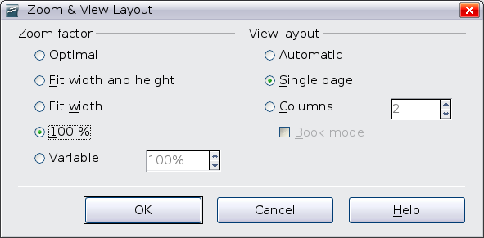Figure 12. Choosing Zoom and View Layout options

What are all these things called?
The terms used in LibreOffice for most parts of the user interface (the parts of the program you see and use, in contrast to the behind-the-scenes code that actually makes it work) are the same as for most other programs.
A dialog is a special type of window. Its purpose is to inform you of something, or request input from you, or both. It provides controls for you to use to specify how to carry out an action. The technical names for common controls are shown in Figure 13; not shown is the list box (from which you select an item). In most cases we do not use the technical terms in this book, but it is useful to know them because the Help and other sources of information often use them.
In most cases, you can interact only with the dialog (not the document itself) as long as the dialog remains open. When you close the dialog after use (usually, clicking OK or another button saves your changes and closes the dialog), then you can again work with your document.
Some dialogs can be left open as you work, so you can switch back and forth between the dialog and your document. An example of this type is the Find & Replace dialog.
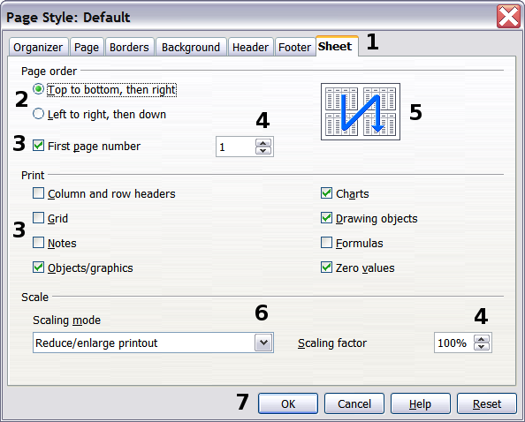
Figure 13: Dialog showing common controls:
1=Tabbed page (not strictly speaking a control)
2=Radio buttons (only one can be selected at a time)
3=Checkbox (more than one can be selected at a time)
4=Spin box (click the up and down arrows to change the number shown in the text box next to it, or type in the text box)
5=Thumbnail or preview
6=Drop-down list from which to select an item
7=Push buttons

Using the Navigator
In addition to the Page Number field on the Status bar (described on page 12), Writer provides other ways to move quickly through a document and find specific items by using the many features of the Navigator, the Navigation toolbar, and related icons.
The Navigator lists all of the headings, tables, text frames, graphics, bookmarks, and other objects contained in a document.
To open the Navigator, click its icon on the Standard toolbar, or press F5, or choose View > Navigator on the menu bar, or double-click on the Page number field on the status bar. You can dock the Navigator to either side of the main Writer window or leave it floating (see “Docking/floating windows and toolbars” on page 11).
To hide the list of categories and show only the icons at the top, click the List Box On/Off icon . Click this icon again to show the list. Click the + sign by any of the lists to display the contents of the list.
Table 1 summarizes the functions of the icons at the top of the Navigator.
Note | The Navigator has different functions in a master document. See Chapter 13 (Working with Master Documents).
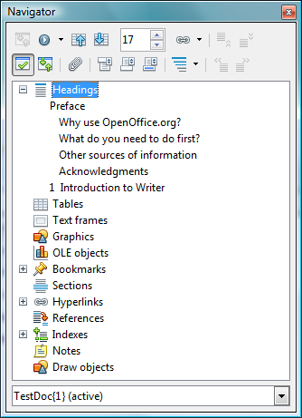
Figure 14. The Navigator
Table 1: Function of icons in the Navigator
 | Not active in ordinary documents. In a master document, switches between the master document file and its subdocuments.
 | Opens the Navigation toolbar (see page 19).
 | Jumps to the previous or next item in the document. To select the category of items, see “Using the Navigation toolbar“ on page 19.
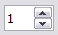 | Jumps to the page number in the box. Type the page number or select it using the up and down arrows.
 | Drag Mode. Select hyperlink, link, or copy. See “Choosing drag mode” on page 20 for details.
 | List Box On/Off. Shows or hides the list of categories.
 | Content View. Switches between showing all categories and showing only the selected category.
 | Inserts a reminder (see page 20).
 | Jumps between the text area and the header or footer area (if the page has them).
 | Jumps between a footnote anchor and the corresponding footnote text.
 | Choose the number of heading levels to be shown.

Moving quickly through a document
The Navigator provides several convenient ways to move around a document and find items in it:
- To jump to a specific page in the document, type its sequence number in the box at the top of the Navigator.
- When a category is showing the list of objects in it, double-click on an object to jump directly to that object’s location in the document.
To see the content in only one category, highlight that category and click the Content View icon. Click the icon again to display all the categories. You can also change the number of heading levels shown when viewing Headings.
- Use the Previous and Next icons to jump to other objects of the type selected in the Navigation toolbar. (See below for details.)
Tip | Objects are much easier to find if you have given them names when creating them, instead of keeping LibO’s default names of graphics1, graphics2, Table1, Table2, and so on—which may not correspond to the position of the object in the document.
Note | A hidden section (or other hidden object) in a document appears gray in the Navigator, and displays the word “hidden” as a tooltip.

Using the Navigation toolbar
To display the Navigation toolbar, click the Navigation icon (second icon from the left at the top of the Navigator. Figure 14) or the small Navigation icon near the lower right-hand corner of the window below the vertical scroll bar (Figure 15).
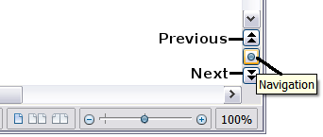
Figure 15: Previous, Navigation, and Next icons
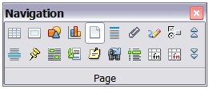Figure 16: Navigation toolbar
The Navigation toolbar (Figure 16) shows icons for all the object types shown in the Navigator, plus some extras (for example, the results of a Find command).
Click an icon to select that object type. Now all the Previous and Next icons (in the Navigator itself, in the Navigation Toolbar, and on the scroll bar) will jump to the next object of the selected type. This is particularly helpful for finding items like index entries, which can be difficult to see in the text. The names of the icons (shown in the tooltips) change to match the selected category; for example, Next Graphic or Next Bookmark.

Rearranging chapters using the Navigator
You can arrange chapters and move headings in the document by using the Navigator.
- Click the Content View icon to expand the headings, if necessary.
- (Optional) If you have several subheading levels, you can more easily find the headings you want, by changing the Heading Levels Shown selection to show only 1 or 2 levels of headings.
- Click on the heading of the block of text that you want to move and drag the heading to a new location on the Navigator, or click the heading in the Navigator list, and then click either the Promote Chapter or Demote Chapter icon. All of the text and subsections under the selected heading move with it.
To move only the selected heading and not the text associated with the heading, hold down Control, and then click the icon.
Tip | The tooltips (Promote Chapter and Demote Chapter) are misleading; all headings defined in Tools > Outline Numbering can be rearranged using this function.
- To quickly change the outline level of a heading and its associated subheadings, select the heading in the Navigator, and then click either the Promote Level or Demote Level icon. This action does not change the location of the heading, only its level.
To increase the outline level of only the selected heading, but not its associated subheadings, hold down Control, and then click the icon.
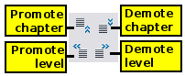
Figure 17. Reorganizing with the Navigator
Note | Users of MS Office Word will note the similarity between this functionality and Word's Outline View.

Setting reminders
One of the little known features of Writer which you may find quite useful is the possibility of jumping between reminders. Reminders let you mark places in your document that you want to return to later on, to add or correct information, make some other change, or simply mark where you finished editing. The possible uses of reminders are limited only by your imagination.
To set a reminder at the cursor's current location, click on the icon in the Navigator. You can set up to 5 reminders in a document (setting another causes the first to be deleted).
Reminders are not highlighted in any way in the document, so you cannot see where they are, except when you jump from one to the next—the location of the cursor then shows the location of the reminder.
To jump between reminders, first select the Reminder icon on the Navigation toolbar. Then click the Previous and Next icons.

Choosing drag mode
Sets the drag and drop options for inserting items into a document using the Navigator.
Insert As Hyperlink
Creates a hyperlink when you drag and drop an item into the current document.
Insert As Link
Inserts the selected item as a link where you drag and drop in the current document. Text is inserted as protected sections. However, you cannot create links for graphics, OLE objects, references, or indexes using this method.
Insert As Copy
Inserts a copy of the selected item where you drag and drop in the current document. You cannot drag and drop copies of graphics, OLE objects, or indexes.

Starting a new document

Creating a blank document
You can create a new, blank document in Writer in several ways.
When LibreOffice is open but no document is open (for example, if you close all the open documents but leave the program running), a Start Center is shown. Click one of the icons to open a new document of that type, or click the Templates icon to start a new document using a template.
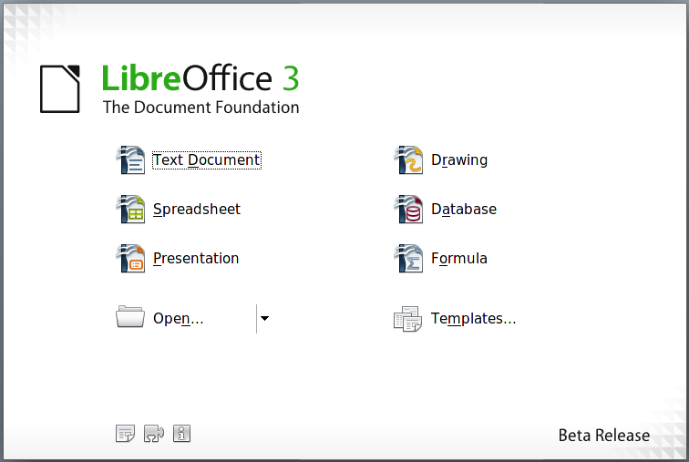
Figure 18: LibreOffice Start Center
You can also start a new document in one of the following ways. If a document is already open in LibreOffice, the new document opens in a new window.
- Press the Control+N keys. A new empty document opens.
- Use File > New > Text Document.
- Click the New button on the main toolbar.

Creating a document from a template
You can use templates to create new documents in Writer. Templates serve as the foundation of a set of documents, to make sure they all have a similar layout. For example, all the documents of the Writer Guide are based on the same template. As a result, all the documents look alike; they have the same headers and footers, use the same fonts, and so on.
A new LibreOffice installation does not contain many templates. It is possible for you to add new templates to your installation and use them for new documents. This is explained in Chapter 10 (Working with Templates). Many more templates can be downloaded from http://extensions.services.openoffice.org/ and other websites.
Once you do have templates on your system, you can create new documents based on them by using File > New > Templates and Documents. This opens a window where you can choose the template you want to use for your document.
The example shown in Figure 19 uses a template called “Book” in the My Templates folder. Select it, then click the Open button. A new document is created based on the formats defined in the template.
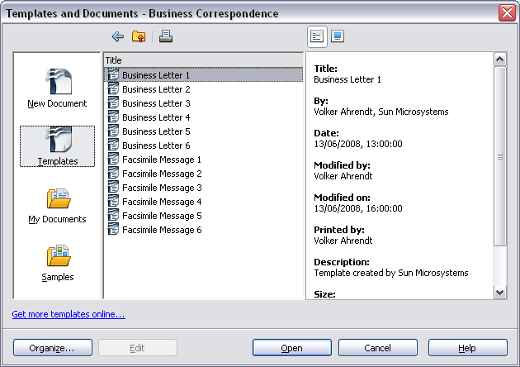
Figure 19. Creating a document from a template

Opening an existing document
When no document is open, the Start Center provides an icon for opening an existing document.
You can also open an existing document in one of the following ways. If a document is already open in LibreOffice, the second document opens in a new window.
- Choose File > Open....
- Click the Open button on the main toolbar.
- Press Control+O on the keyboard.
In each case, the Open dialog box appears. Select the file you want, and then click Open. If a document is already open in LibreOffice, the second document opens in a new window.
In the Open dialog box, you can reduce the list of files by selecting the type of file you are looking for. For example, if you choose Text documents as the file type, you will only see documents Writer can open (including *.odt, *.doc, *.txt). This method opens Word (*.doc) files, as well as LibreOffice files and other formats.
You can also open an existing Writer document using the same methods you would use to open any document in your operating system.
If you have associated Microsoft Office file formats with LibreOffice, you can also open these files by double-clicking on them.
Note | Under Microsoft Windows you can use either the LibreOffice Open and Save As dialogs or the ones provided by Microsoft Windows. See “Error: Reference source not found” on page Error: Reference source not found.

Saving a document
To save a new document in Writer, do one of the following:
- Press Control+S.
- Choose File > Save.
- Click the Save button on the main toolbar.
When the Save As dialog box appears, enter the file name, verify the file type (if applicable), and click Save.
To save an open document with the current file name, choose File > Save. This will overwrite the last saved state of the file.

Password protection
To protect an entire document from being viewable without a password, use the option on the Save As dialog box to enter a password. This option is only available for files saved in OpenDocument formats or the older OpenOffice.org 1.x formats.
- On the Save As dialog box, select the Save with password option, and then click Save. You will receive a prompt.
- Type the same password in the two fields, and then click OK. If the passwords match, the document is saved password protected. If the passwords do not match, you receive the prompt to enter the password again.
Caution   | LibreOffice uses a very strong encryption mechanism that makes it almost impossible to recover the contents of a document in case you lose the password.
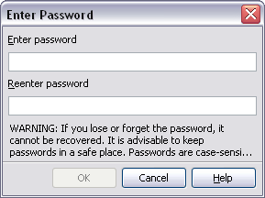

Saving a document automatically
You can choose to have Writer save your document automatically at regular intervals. Automatic saving, like manual saving, overwrites the last saved state of the file. To set up automatic file saving:
- Select Tools > Options > Load/Save > General.
- Click on Save AutoRecovery information every and set the time interval. The default value is 15 minutes. Enter the value you want by typing it or by pressing the up or down arrow keys.

Saving as a Microsoft Word document
If you need to exchange files with users of Microsoft Word, they may not know how to open and save .odt files. Microsoft Word 2007 with Service Pack 2 (SP2) can do this. Users of Word 2007, 2003, XP, and 2000 can also download and install a free OpenDocument Format (ODF) plugin from Sun Microsystems.
Some users of Microsoft Word may be unwilling or unable to receive *.odt files. (Perhaps their employer won’t allow them to install the plug-in.) In this case, you can save a document as a Microsoft Word file.
- Important—First save your document in the file format used by LibreOffice Writer, *.odt. If you do not, any changes you made since the last time you saved will only appear in the Microsoft Word version of the document.
- Then click File > Save As.
- On the Save As dialog box, in the File type (or Save as type) drop-down menu, select the type of Word format you need.
- Click Save.
From this point on, all changes you make to the document will occur only in the Microsoft Word document. You have changed the name and file type of your document. If you want to go back to working with the *.odt version of your document, you must open it again.
Tip | To have Writer save documents by default in the Microsoft Word file format, go to Tools > Options > Load/Save > General. In the section named Default file format, under Document type, select Text document, then under Always save as, select your preferred file format.
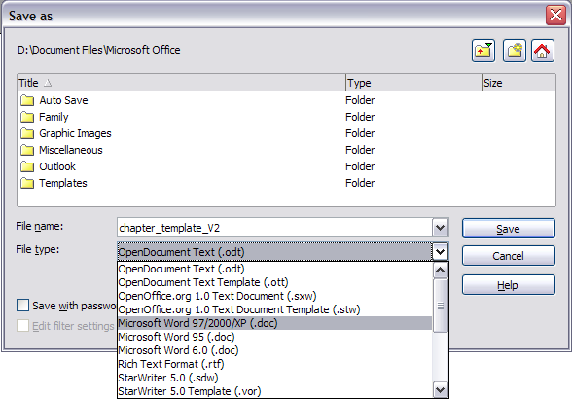Figure 20. Saving a file in Microsoft Word format

Getting help
Writer provides several forms of help. In addition to a full Help file (reached by pressing F1 or choosing Help > LibreOffice Help from the menu bar), you can choose whether to activate tooltips, extended tips, and the Help Agent from Tools > Options > LibreOffice > General.
Placing the mouse pointer over any of the icons displays a small box, called a tooltip. It gives a brief explanation of the icon’s function. For a more detailed explanation, select Help > What’s This? and hold the mouse pointer over the icon you need more help with.

Undoing and redoing changes
When a document is open, you can undo the most recent change by pressing Control+Z, or clicking the Undo icon on the Standard toolbar, or choosing Edit > Undo from the menu bar.
The Edit menu shows the latest change that can be undone.
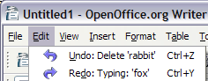
Figure 21: Edit > Undo last action
Click the small triangle to the right of the Undo icon to get a list of all the changes that can be undone. You can select multiple changes and undo them at the same time.
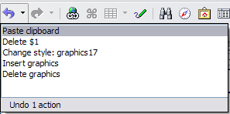
Figure 22: List of actions that can be undone
After changes have been undone, Redo becomes active. To redo a change, select Edit > Redo, or press Control+Y or click on the Redo icon . As with Undo, click on the triangle to the right of the arrow to get a list of the changes that can be reapplied.

Closing a document
To close a document, click File > Close.
You can also close a document by clicking on the Close icon on the document window. In Windows XP, this button looks like the X in the red box shown in Figure 23.
If more than one LibreOffice window is open, each window looks like the sample shown on the left in Figure 23. Closing this window leaves the other LibreOffice windows open.
If only one LibreOffice window is open, it looks like the sample shown on the right in Figure 23. Notice the small black X below the larger X in the red box. Clicking the small black X closes the document but leaves LibreOffice open. Clicking the larger X closes LibreOffice completely.

Figure 23. Close icons
If the document has not been saved since the last change, a message box is displayed. Choose whether to save or discard your changes.
- Save: The document is saved and then closed.
- Discard: The document is closed, and all modifications since the last save are lost.
- Cancel: Nothing happens, and you return to the document.
Caution | Not saving your document could result in the loss of recently made changes, or worse still, your entire file.

Closing LibreOffice
To close LibreOffice completely, click File > Exit, or close the last open document as described in “Closing a document” above.
If all the documents have been saved, Writer closes immediately. If any documents have been modified but not saved, a warning message appears. Follow the procedure in “Closing a document” to save or discard your changes.

If a list style was used with a list item or heading, no dialog box appears.

