
Writer Guide
Chapter 5
Printing, Exporting, Faxing, and E-Mailing

Copyright
This document is Copyright © 2010 by its contributors as listed below. You may distribute it and/or modify it under the terms of either the GNU General Public License (http://www.gnu.org/licenses/gpl.html), version 3 or later, or the Creative Commons Attribution License (http://creativecommons.org/licenses/by/3.0/), version 3.0 or later.
All trademarks within this guide belong to their legitimate owners.
Contributors
Ron Faile Jr.
Hal Parker
Feedback
Please direct any comments or suggestions about this document to: documentation@libreoffice.org
Acknowledgments
This chapter is based on Chapter 5 of the Writer Guide for OpenOffice.org. The contributors to that chapter are:
Jean Hollis Weber
Michele Zarri
Agnes Belzunce
Peter Kupfer
Robert Scott
Janet M. Swisher
Publication date and software version
Published 30 January 2011. Based on LibreOffice 3.3.

Note for Mac users
Some keystrokes and menu items are different on a Mac from those used in Windows and Linux. The table below gives some common substitutions for the instructions in this chapter. For a more detailed list, see the application Help.
Windows/Linux | Mac equivalent | Effect
Tools → Options menu selection | LibreOffice → Preferences | Access setup options
Right-click | Control+click | Open context menu
Ctrl (Control) | z (Command) | Used with other keys
F5 | Shift+z+F5 | Open the Navigator
F11 | z+T | Open Styles & Formatting window

Contents
Copyright 2
Note for Mac users 2
Introduction 4
Quick printing 4
Controlling printing 4
Selecting general printing options for a document 5
Printing multiple pages on a single sheet of paper 5
Selecting what to print 7
Printing a brochure 8
Printing in black and white (on a color printer) 9
Previewing pages before printing 10
Printing envelopes 10
Printing labels 13
Sending a fax 14
Exporting to PDF 15
Quick export to PDF 15
Controlling PDF content and quality 15
General page of PDF Options dialog box 15
Initial View page of PDF Options dialog box 17
User Interface page of PDF Options dialog box 17
Links page of PDF Options dialog box 18
Security page of PDF Options dialog box 19
Exporting to XHTML 21
E-mailing Writer documents 21
E-mailing a document to several recipients 21
Digital signing of documents 24
Removing personal data 25

Introduction
General information about printing and faxing documents from LibreOffice is provided in the Getting Started guide. This chapter describes some items of particular interest to users of Writer.

Quick printing
Click the Print File Directly icon to send the entire document to the default printer defined for your computer.
Note | You can change the action of the Print File Directly icon to send the document to the printer defined for the document instead of the default printer for the computer. Go to Tools → Options → Load/Save → General and select the Load printer settings with the document option.

Controlling printing
For more control over printing, use the Print dialog box (File → Print or Ctrl+P).
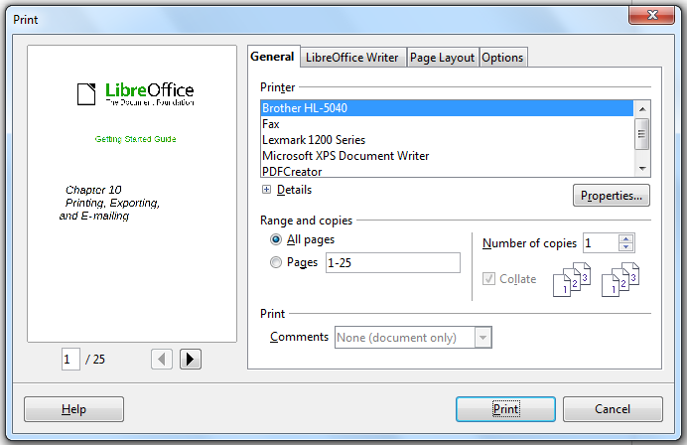
Figure 1: The Print dialog box
Note | The options selected on the Print dialog box apply to this printing of this document only.  To specify default printing settings for LibreOffice, go to Tools → Options → LibreOffice – Print and Tools → Options → LibreOffice Writer – Print. See Chapter 2, Setting Up Writer, for more details.
The Print dialog box has four tabs, from which you can choose a range of options, as described in the following sections.

Selecting general printing options for a document
On the General tab of the Print dialog box, you can choose:
- The printer (from the printers available)
- Which pages to print, the number of copies to print, and whether to collate multiple copies (Range and copies section)
- Whether to print any comments that are in the document, and where to print the comments.
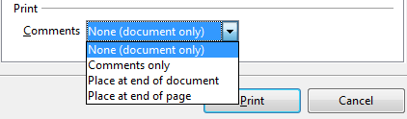
Figure 2: Choosing whether and where to print comments
Click the Properties button to display a dialog box where you can choose portrait or landscape orientation, which paper tray to use, and the paper size to print on.
On the Options tab of the Print dialog box, you can choose various other options for printing.
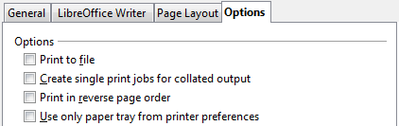
Figure 3: General print options

Printing multiple pages on a single sheet of paper
You can print multiple pages of a document on one sheet of paper. To do this:
- In the Print dialog box, select the Page Layout tab (Figure 4).
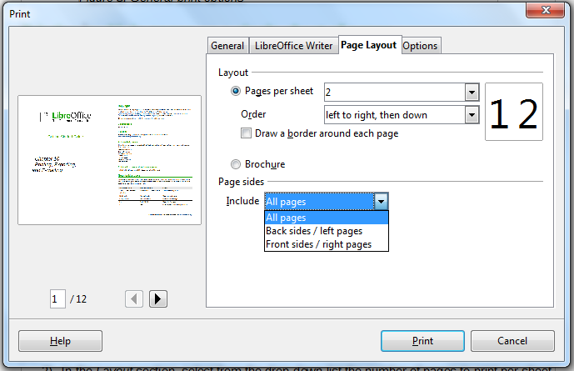
Figure 4: Printing multiple page per sheet of paper
- In the Layout section, select from the drop-down list the number of pages to print per sheet. The preview panel on the left of the Print dialog box shows how the printed document will look.
When printing more than 2 pages per sheet, you can choose the order in which they are printing across and down the paper. The two pictures below show the difference.
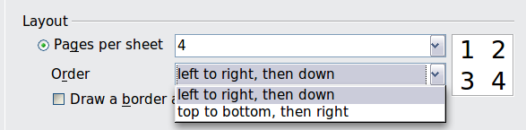
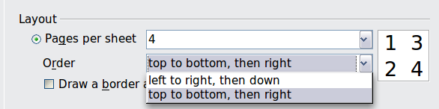
- In the Page sides section, select whether to print all pages or only some pages.
- Click the Print button.
Tip | To print two pages per sheet in “facing pages” (book layout) style, print from Print Preview instead. See page 10.

Selecting what to print
In addition to printing a full document, you can choose to print individual pages, ranges of pages, or a selection of a document, as described in this section.
Printing an individual page:
- Choose File → Print from the menu bar.
- On the Print dialog box, select the page to print.
  - In the Ranges and copies section of the General page, select the Pages option.
  - Enter the sequence number of the page you want to print. The preview box changes to show the selected page.
If you have restarted page numbering within the document, the sequence number is not the same as the page number.
- Click the Print button.
Printing a range of pages:
- Choose File → Print from the menu bar.
- On the Print dialog box, select the range of pages to print.
  - In the Ranges and copies section of the General page, select the Pages option.
  - Enter the sequence numbers of the pages to print (for example, 1–4 or 1,3,7,11).
- Click the Print button.
Printing a selection of text:
- In the document, select the material (text and graphics) to print.
- Choose File → Print from the menu bar.
- The Ranges and copies section of the Print dialog box now includes a Selection option and the preview box shows the selected material. See Figure 5.
- Click the Print button.
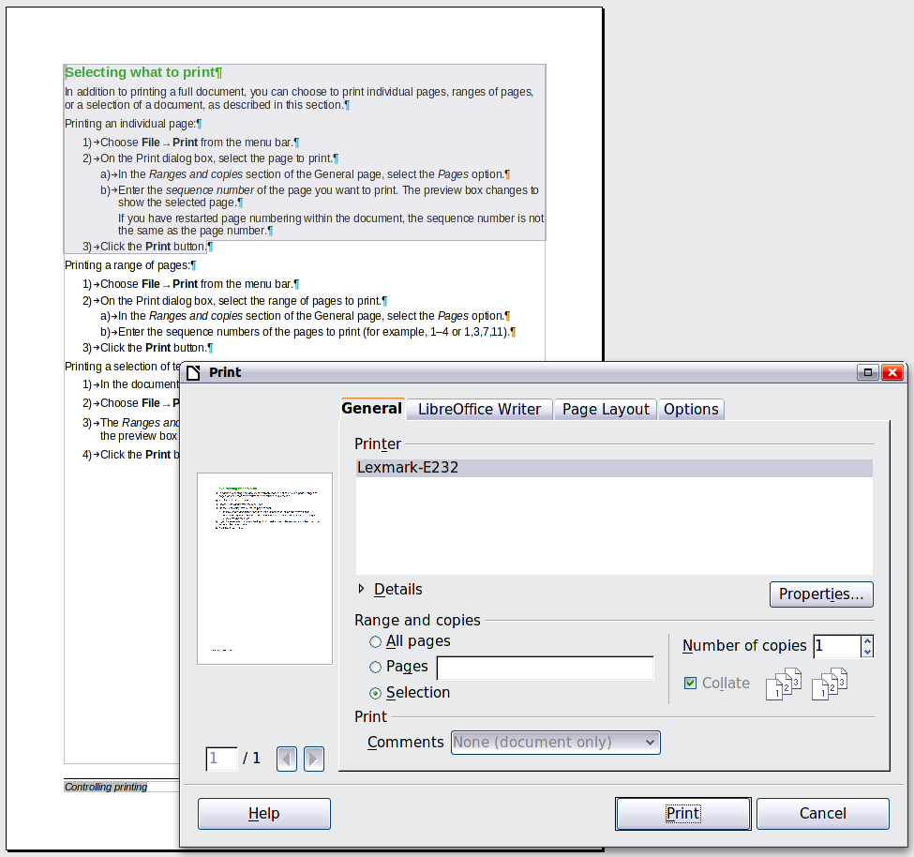
Figure 5: Printing a selection of text

Printing a brochure
In Writer, Impress, and Draw, you can print a document with two pages on each side of a sheet of paper, arranged so that when the printed pages are folded in half, the pages are in the correct order to form a booklet or brochure.
Tip | Plan your document so it will look good when printed half size; choose appropriate margins, font sizes, and so on. You may need to experiment.
To print a brochure on a single-sided printer:
- Choose File → Print.
- In the Print dialog box, click Properties.
- Check the printer is set to the same orientation (portrait or landscape) as specified in the page setup for your document. Usually the orientation does not matter, but it does for brochures. Click OK to return to the Print dialog box.
- Select the Page layout tab in the Print dialog box.
- Select the Brochure option.
- In the Page sides section, select Back sides / left pages option from the Include drop-down list.
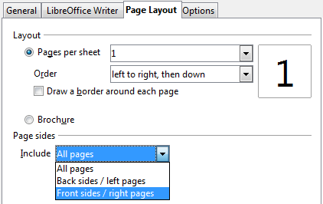
- Click the Print button.
- Take the printed pages out of the printer, turn the pages over, and put them back into the printer in the correct orientation to print on the blank side. You may need to experiment a bit to find out what the correct arrangement is for your printer.
- On the Print dialog box, in the Page sides section, select Front sides / right pages option from the Include drop down box.
- Click the Print button.
Tip | If your printer can print double-sided automatically, choose All pages.

Printing in black and white (on a color printer)
You may wish to print documents in black and white on a color printer. Several choices are available. Please note that some color printers may print in color regardless of the settings you choose.
Change the printer settings to print in black and white or grayscale:
- Choose File → Print to open the Print dialog box.
- Click Properties to open the Properties dialog box for the printer. The available choices vary from one printer to another, but you should find options for the Color settings. See your printer’s help or user manual for more information.
- The choices for color might include black and white or grayscale. Choose the required setting.
- Click OK to confirm your choice and return to the Print dialog box,
- Click the Print button to print the document.
Tip | Grayscale is best if you have any graphics in the document.
Change the LibreOffice settings to print all color text and graphics as grayscale:
- Choose Tools → Options → LibreOffice → Print.
- Select the Convert colors to grayscale option. Click OK to save the change.
- Open the Print dialog box (File → Print).
- Click the Print button to print the document.
Change the LibreOffice Writer settings to print all color text as black, and all graphics as grayscale:
- Choose Tools → Options → LibreOffice [Component] → Print.
- Under Contents, select the Print text in black option. Click OK to save the change.
- Open the Print dialog box (File → Print).
- Click the Print button to print the document.

Previewing pages before printing
The normal page view in Writer shows you what each page will look like when printed and you can edit the pages in that view. If you are designing a document to be printed double-sided, you may want to see what facing pages look like. Writer provides two ways to do this:
- View Layout (editable view): use the Facing Pages (Book Preview) button on the status bar.

- Page Preview (read-only view).
To use Page Preview:
- Choose File → Page Preview (or click the Page Preview button on the Standard toolbar).
Writer now displays the Page Preview toolbar instead of the Formatting toolbar.
Figure 6. Page Preview toolbar (Writer)
- Select the required preview icon: Two Pages (), Multiple Pages () or Book Preview ().
- To print the document from this view, click the Print document icon () to open the Print dialog box.
- Choose the print options and click the Print button.

Printing envelopes
Printing envelopes involves two steps: setup and printing.
To set up an envelope to be printed by itself or with your document:
- Click Insert → Envelope from the menu bar.
- In the Envelope dialog box, start with the Envelope tab. Verify, add, or edit the information in the Addressee and Sender boxes (the “from” on the envelope).
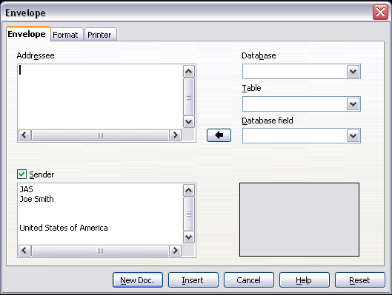
Figure 7. Choosing addressee and sender information for an envelope
You can type information directly into the Addressee and Sender boxes, or use the right-hand drop-down lists to select the database or table from which you can draw the envelope information, if desired. See Chapter 11, Using Mail Merge, for details on how to print envelopes from a database.
- On the Format page, verify or edit the positioning of the addressee and the sender information. The preview area on the lower right shows the effect of your positioning choices.
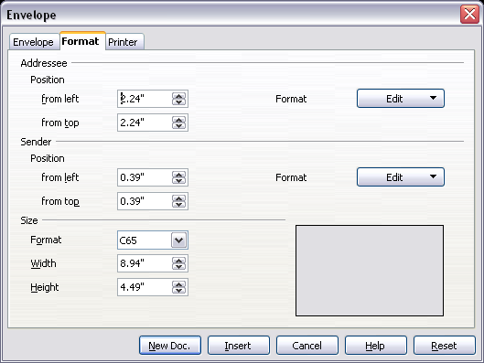
Figure 8. Choosing positioning and size of elements for an envelope
- To format the text of these blocks, click the Edit buttons to the right. In the drop-down list you have two choices: Character and Paragraph.
- In Character, you can choose Fonts (Sizes...), Fonts Effects (Underlining, Color...), Position (Rotating/scaling...), Hyperlink, Background and more.
- In Paragraph, you can choose Indents & Spacing, Alignment, Text Flow, Tabs, Drop Caps, Borders and Backgrounds.
- In the lower left of this page, choose the envelope format from the drop-down list. The width and height of the selected envelope then show in the boxes below the selected format. If you chose a pre-existing format, just verify these sizes. If you chose User defined in the Format list, then you can edit the sizes.
- After formatting, go to the Printer page to choose printer options such as envelope orientation and shifting. You may need to experiment a bit to see what works best for your printer.
You can also choose a different printer or alter printer setup (for example, specify the tray that holds envelopes) for this print job.
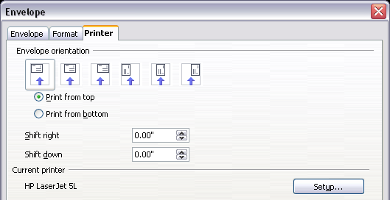
Figure 9. Choosing printer options for an envelope
- When you have finished formatting and are ready to print, click either the New Doc or Insert button to finish. New Doc makes only an envelope or starts a new document with the envelope. Insert puts the envelope into your existing document as page 1.
To not proceed with this envelope, click Cancel or press the Esc key. You can also click Reset to remove your changes and return to the original settings when the dialog box opened.
When the Envelope dialog box closes, you are returned to your document, which now has the envelope in the same file as the document. Save this file before you do anything else.
To print the envelope:
- Choose File → Print from the menu bar.
- On the Print dialog box, under Print range, choose Pages and type 1 in the box. Click OK to print.

Printing labels
Labels are commonly used for printing address lists (where each label shows a different address), but they can also be used for making multiple copies of one label only, for example return-address stickers.
To print labels:
- Choose File → New → Labels on the menu bar. The Labels dialog box opens.
- On the Labels page, fill in your own label text in the Inscription box, or use the Database and Table drop-down lists to choose the required information, as described in Chapter 11, Using Mail Merge.
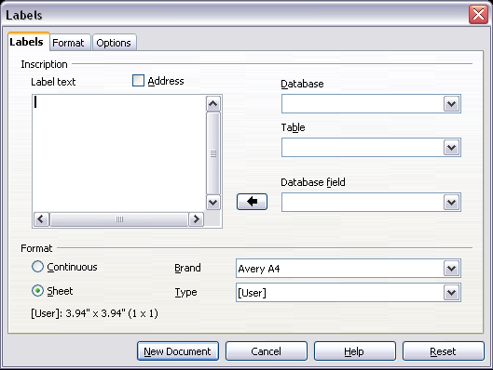
Figure 10. Labels dialog box, Labels page
- Select the label stock in the Brand drop-down list. The types for that brand then appear in the Type drop-down list. Select the size and type of labels required. You can also select User in the Type drop-down list and then make specific selections on the Format page.
- On the Format page, choose the pitch, sizes, margins, columns and rows for user-defined labels, or just verify with a brand of label stock you have loaded into the printer.
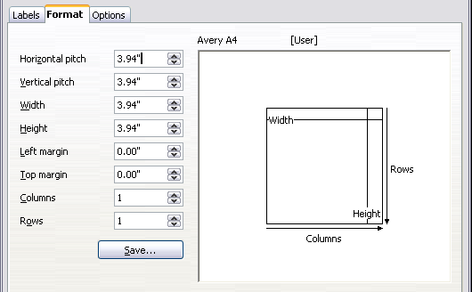
Figure 11. Labels dialog box, Format page
- Click Save to save your new format.
- On the Options page, choose to print the entire page of labels or one single label, then select which one by the column and row. You can also change printer setup.
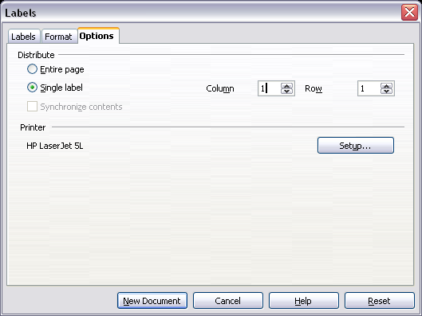
Figure 12. Labels dialog box, Options page
- When you have finished formatting, click New Document to make your sheet of labels or click Cancel (or press the Esc key). You can also click Reset to remove your changes and return to the original settings when the dialog box opened.
- You can print using the Print File Directly icon on the toolbar or by choosing File → Print from the menu bar, or you can save the file to print later.

Sending a fax
To send a fax directly from LibreOffice, you need a fax modem and a fax driver that allows applications to communicate with the fax modem.
- Open the Print dialog box (Figure 1) by choosing File → Print and select the fax driver in the Name list.
- Click OK to open the dialog box for your fax driver, where you can select the fax recipient.
You can set up a toolbar icon so that a single click sends the current document as a fax. To add an icon for this purpose to a toolbar, see Chapter 17, Customizing Writer.

Exporting to PDF
LibreOffice can export documents to PDF (Portable Document Format). This industry-standard file format for file viewing is ideal for sending the file to someone else to view using Acrobat Reader or other PDF viewers. Unlike exporting to other formats, PDF documents will look exactly as the document appears on your screen. The only limitation of PDF is that the recipient will not be able to edit the document.

Quick export to PDF
Click the Export Directly as PDF icon to export the entire document using the default PDF settings. You are asked to enter the file name and location for the PDF file, but you do not get a chance to choose a page range, the image compression, or other options.

Controlling PDF content and quality
For more control over the content and quality of the resulting PDF, use File → Export as PDF. The PDF Options dialog box opens. This dialog box has five pages (General, Initial View, User Interface, Links, and Security). Make your selections, and then click Export. Then you are asked to enter the location and file name of the PDF to be created, and click Save to export the file.

General page of PDF Options dialog box
On the General page (Figure 13), you can choose which document pages to include in the PDF, the type of compression to use for images (which affects the quality of images in the PDF), and other options.
Range section
- All: Exports the entire document.
- Pages: To export a range of pages, use the format 3-6 (pages 3 to 6). To export single pages, use the format 7;9;11 (pages 7, 9, and 11). You can also export a combination of page ranges and single pages, by using a format like 3-6;8;12.
- Selection: Exports whatever material is selected.
Images section
- Lossless compression: Images are stored without any loss of quality. Tends to make large files when used with photographs. Recommended for other kinds of images or graphics.
- JPEG compression: Allows for varying degrees of quality. A setting of 90% works well with photographs (small file size, little perceptible loss of quality).
- Reduce image resolution: Lower-DPI (dots per inch) images have lower quality. For viewing on a computer screen generally a resolution of 72dpi (for Windows) or 96dpi (GNU/Linux) is sufficient, while for printing it is generally preferable to use at least 300 or 600 dpi, depending on the capability of the printer. Higher dpi settings greatly increase the size of the exported file.
Note | EPS images with embedded previews are exported only as previews. EPS images without embedded previews are exported as empty placeholders.
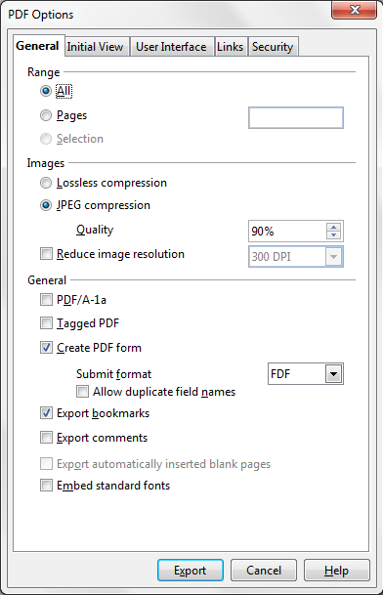
Figure 13: General page of PDF Options dialog box
General section
- PDF/A-1: PDF/A is an ISO standard for long-term preservation of documents, by embedding all the information necessary for faithful reproduction (such as fonts) while forbidding other elements (including forms, security, and encryption). PDF tags are written. If you select PDF/A-1a, the forbidden elements are greyed-out (not available).
- Tagged PDF: Tagged PDF contains information about the structure of the document’s contents. This can help to display the document on devices with different screens, and when using screen reader software. Some tags that are exported are table of contents, hyperlinks, and controls. This option can increase file sizes significantly.
- Create PDF form - Submit format: Choose the format of submitting forms from within the PDF file. This setting overrides the control’s URL property that you set in the document. There is only one common setting valid for the whole PDF document: PDF (sends the whole document), FDF (sends the control contents), HTML, and XML. Most often you will choose the PDF format.
- Export bookmarks: Creates PDF bookmarks (a table of contents list displayed by most PDF viewers) for all outline paragraphs and for all table of contents entries for which you assigned hyperlinks.
- Export comments: Exports comments as PDF notes.
- Export automatically inserted blank pages: If selected, automatically inserted blank pages are exported to the PDF. This is best if you are printing the PDF double-sided. For example, books usually have chapters set to always start on an odd-numbered (right-hand) page. When the previous chapter ends on an odd page, LibreOffice inserts a blank page between the two odd pages. This option controls whether to export that blank page.
- Embed standard fonts: In previous versions, the standard fonts (Times, Helvetica, Courier, Symbol, and ZapfDingbats) were only embedded into the PDF when the resulting file was of the PDF/A type, since the PDF/A standards requires this. In version 3.3, you can choose to embed these fonts in all PDF documents created by LibreOffice to enhance display accuracy in PDF viewers.

Initial View page of PDF Options dialog box
On the Initial View page (Figure 14), you can choose how the PDF opens by default in a PDF viewer. The selections should be self-explanatory.

Figure 14: Initial View page of PDF Options dialog box

User Interface page of PDF Options dialog box
On the User Interface page (Figure 15), you can choose more settings to control how a PDF viewer displays the file. Some of these choices are particularly useful when you are creating a PDF to be used as a presentation or a kiosk-type display.
Window options section
- Resize window to initial page. Causes the PDF viewer window to resize to fit the first page of the PDF.
- Center window on screen. Causes the PDF viewer window to be centered on the computer screen.
- Open in full screen mode. Causes the PDF viewer to open full-screen instead of in a smaller window.
- Display document title. Causes the PDF viewer to display the document’s title in the title bar.
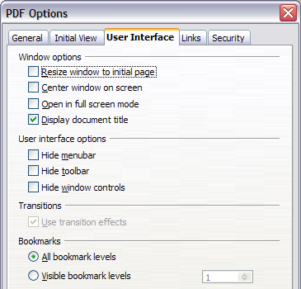
Figure 15: User Interface page of PDF Options dialog box
User interface options section
- Hide menubar. Causes the PDF viewer to hide the menu bar.
- Hide toolbar. Causes the PDF viewer to hide the toolbar.
- Hide window controls. Causes the PDF viewer to hide other window controls.
Bookmarks
Select how many heading levels are displayed as bookmarks, if Export bookmarks is selected on the General page.

Links page of PDF Options dialog box
On this page you can choose how links in documents are exported to PDF.
Export bookmarks as named destinations
If you have defined Writer bookmarks, this option exports them as “named destinations” to which Web pages and PDF documents can link.
Convert document references to PDF targets
If you have defined links to other documents with OpenDocument extensions (such as .ODT, .ODS, and .ODP), this option converts the files names to .PDF in the exported PDF document.

Figure 16: Links page of PDF Options dialog box
Export URLs relative to the file system
If you have defined relative links in a document, this option exports those links to the PDF.
Cross-document links
Set up the behavior of the PDF links to other files. Select one among the following alternatives:
- Default mode: The PDF links will be handled as specified in your operating system.
- Open with PDF reader application: Use the same application used to display the PDF document to open linked PDF documents.
- Open with Internet browser: Use the default Internet browser to display linked PDF documents.

Security page of PDF Options dialog box
PDF export includes options to encrypt the PDF (so it cannot be opened without a password) and apply some digital rights management (DRM) features.
- With an open password set, the PDF can only be opened with the password. Once opened, there are no restrictions on what the user can do with the document (for example, print, copy, or change it).
- With a permissions password set, the PDF can be opened by anyone, but its permissions can be restricted. See Figure 17.
- With both the open password and permission password set, the PDF can only be opened with the correct password, and its permissions can be restricted.
Note | Permissions settings are effective only if the user’s PDF viewer respects the settings.

Figure 17: Security page of PDF Options dialog box
Figure 18 shows the pop-up dialog box displayed when you click the Set open password button on the Security page of the PDF Options dialog box.
After you set a password for permissions, the other choices on the Security page (shown in Figure 17) become available. These selections should be self-explanatory.
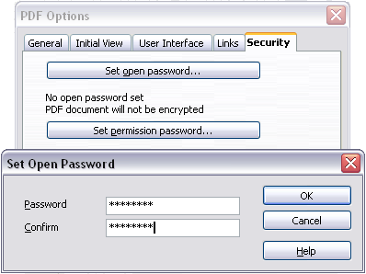
Figure 18: Setting a password to encrypt a PDF

Exporting to XHTML
LibreOffice uses the term “export” for some file operations involving a change of file type. LibreOffice can export files to XHTML. Other formats may be made available through extensions.
To export to XHTML, choose File → Export. On the Export dialog box, specify a file name for the exported document, then select the XHTML in the File format list and click the Export button.

E-mailing Writer documents
LibreOffice provides several ways to quickly and easily send a Writer document as an e-mail attachment in one of three formats: .ODT (OpenDocument Text, Writer’s default format), .DOC (Microsoft Word format), or PDF.
To send the current document in .ODT format:
- Choose File → Send → Document as E-mail. Writer opens your default e-mail program. The document is attached.
- In your e-mail program, enter the recipient, subject, and any text you want to add, then send the e-mail.
File → Send → E-mail as OpenDocument Text has the same effect.
If you choose E-mail as Microsoft Word, Writer first creates a .DOC file and then opens your e-mail program with the .DOC file attached. Similarly, if you choose E-mail as PDF, Writer first creates a PDF using your default PDF settings (as when using the Export Directly as PDF toolbar button) and then opens your email program with the .PDF file attached.

E-mailing a document to several recipients
To e-mail a document to several recipients, you can use the features in your e-mail program or you can use LibreOffice’s mail merge facilities to extract email addresses from an address book.
Note | Documents can only be sent from the LibreOffice mail merge wizard if a mail profile has been set up in Tools → Options → LibreOffice Writer → Mail Merge E-mail.
You can use LibreOffice’s mail merge to send e-mail in two ways:
- Use the Mail Merge Wizard to create the document and send it. See Chapter 11, Using Mail Merge, for details.
- Create the document in Writer without using the Wizard, then use the Wizard to send it. This method is described here.
To use the Mail Merge Wizard to send a previously-created Writer document:
- Open the document in Writer. Click Tools → Mail Merge Wizard. On the first page of the wizard, select Use the current document and click Next.
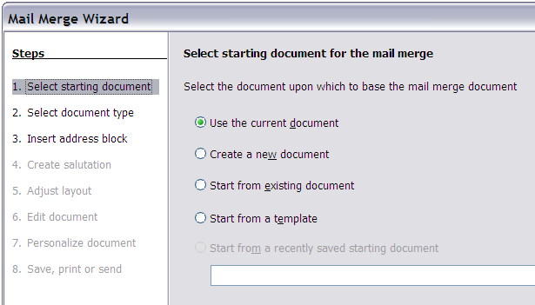Figure 19: Select starting document
- On the second page, select E-mail message and click Next.
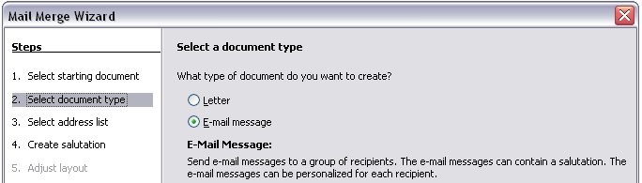
Figure 20: Select document type
- On the third page, click the Select Address List button. Select the required address list (even if only one is shown) and then click OK. (If the address list you need is not shown here, you can click Add to find and add it to the list.)
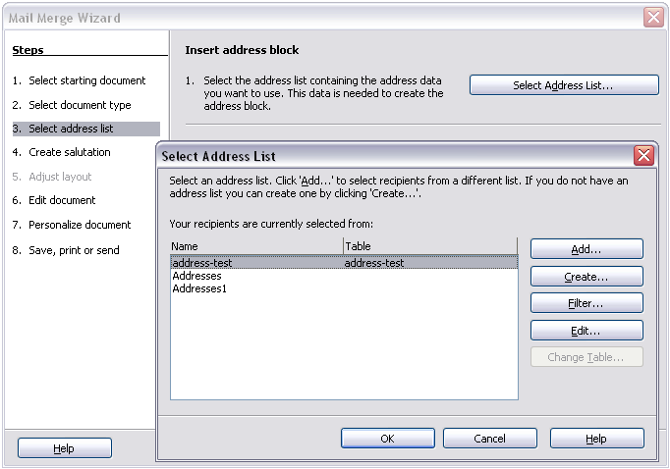Figure 21: Selecting an address list
- Back on the Select address list page, click Next. On the Create salutation page, deselect the checkbox by This document should contain a salutation.
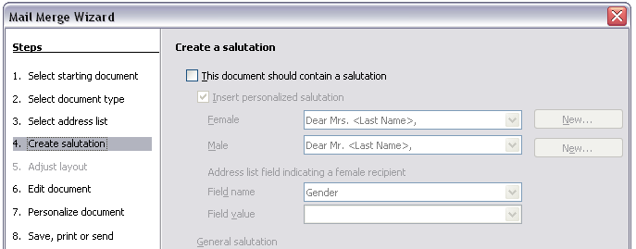Figure 22: Deselecting a salutation
- In the left-hand list, click 8. Save, print or send. LibreOffice displays a “Creating documents” message and then displays the Save, print or send page of the Wizard.
- Select Send merged document as E-Mail. The lower part of the page changes to show e-mail settings choices.
- Type a subject for your email and click Send documents. LibreOffice sends the e-mails.
Figure 23: Sending a document as an email message

Digital signing of documents
To sign a document digitally, you need a personal key, also known as a certificate. A personal key is stored on your computer as a combination of a private key, which must be kept secret, and a public key, which you add to your documents when you sign them. You can get a certificate from a certification authority, which may be a private company or a governmental institution.
When you apply a digital signature to a document, a kind of checksum is computed from the document’s content plus your personal key. The checksum and your public key are stored together with the document.
When someone later opens the document on any computer with a recent version of LibreOffice, the program will compute the checksum again and compare it with the stored checksum. If both are the same, the program will signal that you see the original, unchanged document. In addition, the program can show you the public key information from the certificate. You can compare the public key with the public key that is published on the web site of the certificate authority.
Whenever someone changes something in the document, this change breaks the digital signature.
On Windows operating systems, the Windows features of validating a signature are used. On Solaris and Linux systems, files that are supplied by Thunderbird, Mozilla or Firefox are used. For a more detailed description of how to get and manage a certificate, and signature validation, see “Using Digital Signatures” in the LibreOffice Help.
To sign a document:
- Choose File → Digital Signatures.
- If you have not saved the document since the last change, a message box appears. Click Yes to save the file.
- After saving, you see the Digital Signatures dialog box. Click Add to add a public key to the document.
- In the Select Certificate dialog box, select your certificate and click OK.
- You see again the Digital Signatures dialog box, where you can add more certificates if you want. Click OK to add the public key to the saved file.
A signed document shows an icon in the status bar. You can double-click the icon to view the certificate.

Removing personal data
You may wish to ensure that personal data, versions, notes, hidden information, or recorded changes are removed from files before you send them to other people or create PDFs from them.
In Tools → Options → LibreOffice → Security → Options, you can set LibreOffice to remind (warn) you when files contain certain information and remove personal information automatically on saving.
To remove personal and some other data from a file, go to File → Properties. On the General tab, uncheck Apply user data and then click the Reset button. This removes any names in the created and modified fields, deletes the modification and printing dates, and resets the editing time to zero, the creation date to the current date and time, and the version number to 1.
To remove version information, either go to File → Versions, select the versions from the list and click Delete, or use Save As and save the file with a different name.

