
Draw Guide
Chapter 9
Adding and Formatting Text

Copyright
This document is Copyright © 2013 by its contributors as listed below. You may distribute it and/or modify it under the terms of either the GNU General Public License (http://www.gnu.org/licenses/gpl.html), version 3 or later, or the Creative Commons Attribution License (http://creativecommons.org/licenses/by/3.0/), version 3.0 or later.
All trademarks within this guide belong to their legitimate owners.

Contributors
Martin Saffron Michele Zarri T. Elliot Turner
Jean Hollis Weber Low Song Chuan Peter Schofield

Feedback
Please direct any comments or suggestions about this document to: documentation@global.libreoffice.org.

Acknowledgments
This chapter is adapted from Chapter 3 of the OpenOffice.org 3.3 Impress Guide. The contributors to that chapter are:
Nicole Cairns Martin J Fox Peter Hillier-Brook
Jean Hollis Weber Michele Zarri

Publication date and software version
Published 19 November 2013. Based on LibreOffice 4.1.

Note for Mac users
Some keystrokes and menu items are different on a Mac from those used in Windows and Linux. The table below gives some common substitutions for the instructions in this chapter. For a more detailed list, see the application Help.
Windows or Linux | Mac equivalent | Effect
Tools > Options menu selection | LibreOffice > Preferences | Access setup options
Right-click | Control+click or right-click depending on computer setup | Open a context menu
Ctrl (Control) | ⌘ (Command) | Used with other keys
F5 | Shift+⌘+F5 | Open the Navigator
F11 | ⌘+T | Open the Styles and Formatting window

Contents
Copyright 2
Contributors 2
Feedback 2
Acknowledgments 2
Publication date and software version 2
Note for Mac users 2
Introduction 5
Using the text tool 5
Using text boxes 5
Creating a text box 6
Moving a text box 6
Resizing a text box 6
Using the Position and Size dialog 7
Deleting a text box 8
Using text with Draw objects 9
Inserting text 9
Pasting text 9
Pasting unformatted text 9
Formatting pasted text 9
Inserting special characters 10
Inserting non-breaking spaces and hyphens 11
Formatting text 11
Selecting text 12
Using styles 12
Creating styles 13
Modifying styles 13
Formatting characters 13
Formatting paragraphs 15
Creating bulleted and numbered lists 16
Creating lists 17
Editing and customizing a list 17
Editing a list 17
Changing position 17
Customizing 18
Using tables 19
Creating a table 19
Modifying a table 20
Table toolbar 20
Position and size 23
Deleting a table 23
Using fields 23
Inserting a field 23
Customizing fields 24
Using hyperlinks 24
Editing text hyperlinks 25
Working with hyperlink buttons 26

Introduction
When text is used in drawings, it is contained in text boxes. This chapter describes how to create, format, use, and delete text. It also discusses the various types of text that can be inserted into a drawing. Finally, it provides information on how to insert special forms of text such as numbered or bulleted lists, tables, fields, and hyperlinks.

Using the text tool
To activate the text tool, click the Text icon for horizontal text or the Vertical Text icon for vertical text on the Drawing toolbar.
If the Vertical Text icon is not visible, select the option Show UI elements for East Asian writings in Tools > Options > Language Settings > Languages. Right-click on the Drawing toolbar and go to Visible Buttons > Vertical Text and the icon will be placed on the toolbar.
After activating the text tool, the Text Formatting toolbar (Figure 1) replaces the Line and Filling toolbar at the top of the drawing workspace. Click at the location where you want to position the text and a small text frame appears containing only the cursor.
When the Text icon is selected, you can select font type, font size, and other text properties before you start typing text. As you type the text, the left corner of the status bar indicates that you are in text edit mode and the position of your cursor (Figure 2).
Once you have finished typing your text and clicked outside the text frame or selected another tool from the Drawing toolbar, the Text Formatting toolbar is replaced by the default Line and Filling toolbar.
Figure 1: Text Formatting toolbar
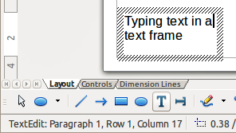
Figure 2: Text information on the status bar

Using text boxes
Using text boxes, you can place text anywhere on your drawing; for example, a caption for a shape; an explanatory note; a title block for the drawing similar to those used in engineering drawings.

Creating a text box
- Click the Text icon or the Vertical Text icon on the Drawing toolbar.
- Click and drag to draw a text box on the drawing. This sets the width. The height of the text box automatically increases as you type or add text.
- Release the mouse button when you have reached the desired width for your text box. The cursor appears in the text box and the text box has a hashed border indicating edit mode (Figure 3).
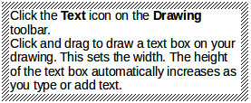
Figure 3: Text box in edit mode
- Type or paste your text in the text box. The status bar at the bottom of your drawing workspace will indicate that you are in text edit mode and the cursor position within the text box.
- Click outside the text box to deselect it.
- To reposition the text box to a different location in your drawing, see “Moving a text box” below and to change the width, see “Resizing a text box” below.

Moving a text box
- Click on the text to switch the text box into edit mode. The text box has a hashed border visible around the edges (Figure 3).
- Move the cursor over the hashed border. The cursor changes shape to the move symbol for your computer setup (for example, a clenched hand).
- When the move symbol appears, click once again on the hashed border and selection handles appear.
- With the cursor on the hashed border (but not on a selection handle), click and drag to move the text box to a new position. A semi-transparent copy of the text box shows where your text box will be placed (Figure 4). Also, depending on computer setup, guide lines may appear while you move the text box.
- Release the mouse button when the text box is in the desired position.
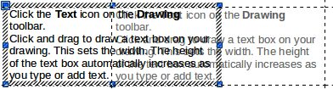
Figure 4: Moving a text box

Resizing a text box
- Click on the text to switch the text box into edit mode. The text box has a hashed border visible around the edges (Figure 3).
- Move the cursor over the hashed border. The cursor changes shape to the move symbol for your computer setup (for example, a clenched hand).
- When the move symbol appears, click once again on the hashed border and selection handles appear.
- Move the cursor over one of the selection handles and the cursor changes shape to the resizing symbol for your computer setup (for example, a double headed arrow).
- Click and drag the border to a new position to resize the text box (Figure 5). Depending on computer setup, guide lines may appear while you move the text box.
- Release the mouse button when the text box reaches the desired size.
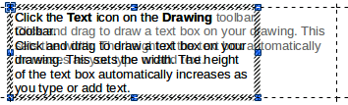
Figure 5: Resizing a text box
Note | Use the selection handles at the top and bottom of the text box to resize the text box height.  Use the selection handles at the left and right side of the text box to resize the text box width.  Use the corner selection handles to resize the height and width of the text box while maintaining the aspect ratio of the text box.
Tip | To maintain the aspect ratio of a text box while resizing, press and hold the Shift key, then click and drag. Make sure to release the mouse button before releasing the Shift key.

Using the Position and Size dialog
For more accurate control over the size and position of a text box you can use the Position and Size dialog.
- Click on the text to switch the text box into edit mode.
- Press the F4 key or select Format > Position and Size from the menu bar to open the Position and Size dialog (Figure 6).
The options available on the Position and Size dialog are as follows:
- Position – specifies the location of the selected object on the page.
- Position X – enter the horizontal distance that you want to move the object relative to the base point selected in the grid.
- Position Y – enter the vertical distance that you want to move the object relative to the base point selected in the grid.
- Base point – click a base point in the grid and then enter the amount that you want to shift the object relative to the base point that you selected in the Position Y and Position X boxes. The base points correspond to the selection handles on an object.
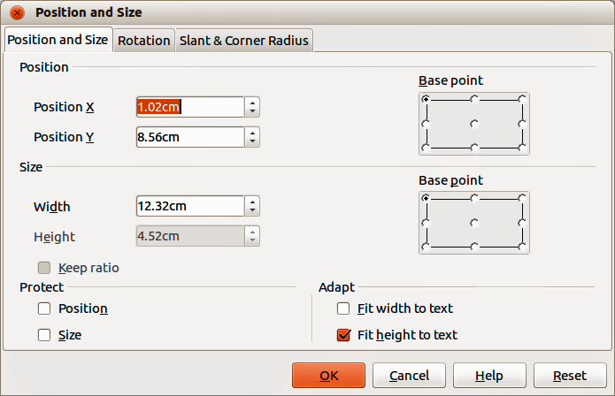
Figure 6: Position and Size dialog
- Size – specifies the amount by which you want to resize the selected object with respect to the selected base point.
- Width – enter a width for the selected object.
- Height – enter a height for the selected object.
- Keep ratio – maintains proportions when you resize the selected object.
- Base point – click a base point in the grid and then enter the new size dimensions for the selected object in the Width and Height boxes.
- Protect – prevents any editing of an object.
- Position – prevents changes to the position or the size of the selected object.
- Size – prevents you from resizing the object.
- Adapt – resizes text in a drawing object with respect to the borders of the selected object.
- Fit width to text – resizes the text to fit the width of the selected object.
- Fit height to text – resizes the text to fit the height of the selected object.

Deleting a text box
- Click on the text to switch the text box into edit mode.
- Move the cursor over the hashed border. The cursor changes shape to the move symbol for your computer setup (for example, a clenched hand).
- When the move symbol appears, click once again on the hashed border and selection handles appear.
- Press the Delete key.
Tip | Sometimes it is quicker to to delete a text box by dragging a selection rectangle around the text box and then hitting the Delete key. Take care to avoid selecting and accidentally deleting other text boxes or shapes.

Using text with Draw objects
Text can be added to most Draw objects. The exceptions are control elements like buttons, list boxes, or 3D objects. An object is not dynamic and does not behave like a text frame. To keep text within the borders of the object, you have to use paragraphs, line breaks, smaller text size, increasing the object size, or a combination of all four methods.
To add text to an object:
- Select the object.
- Select the Text icon on the Drawing toolbar and a text cursor starts flashing in the center of the selected object.
- Start typing your text (Figure 7). The status bar will indicate that you are editing text, as shown in Figure 2.
- Alternatively, double click on an object to enter text editing mode. If double clicking does not work, then open the Options toolbar and select the Double-click to edit Text icon .
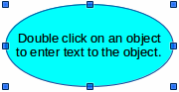
Figure 7: Adding text to an object

Inserting text

Pasting text
Text may be inserted into a text box or object by copying it from another document and pasting it into a text box or object on your drawing. However, pasted text may not match the formatting of the text that has already been included on your drawing. This may be what you want on some occasions, but in most cases it is better to make sure that text format is consistent throughout your drawing.

Pasting unformatted text
It is good practice to paste text without formatting and apply the formatting later so it matches the text already in your drawing or make the text fit within the borders of an object.
- Copy the text you want to use, then move your cursor into position on your drawing.
- Go to Edit > Paste Special on the main menu bar or use the keyboard shortcut Control+Shift+V or click on the small triangle next on the right of the Paste icon on the Standard toolbar.
- Select Unformatted text from the dialog or context menu that appears. The text will be pasted at the cursor position and formatted to the default paragraph style of the text box or object.

Formatting pasted text
- Select the text you have just pasted (see “Selecting text” on page 12 for more information).
- Use the formatting tools that are available on the Text Formatting toolbar, or go to Format on the main menu bar and select a formatting tool from the drop down menu, or right-click on the text and select a formatting tool from the context menu.
- Alternatively, go to Format > Styles and Formatting or press the F11 key to open the Styles and Formatting dialog. See “Using styles” on page 12 for more information.

Inserting special characters
To insert special characters, such as copyright, math, geometric, monetary symbols, or characters from another language:
- Click on the Text icon and then click in the text where you want to insert the character.
- Go to Insert > Special Character on the main menu bar or right-click and select Special Characters from the context menu to open the Special Characters dialog (Figure 8).
- Alternatively, click on the Special Character icon on the Text Formatting toolbar to open the Special Characters dialog. If this icon is not visible, right click in an empty on the toolbar and select Visible Buttons > Special Character from the context menu and the icon will be placed on the toolbar.
- Select the font and character subset from the Font and Subset options in the Special Characters dialog.
- Select the character you want to insert. You may have to scroll to find the character you want.
- Click OK.
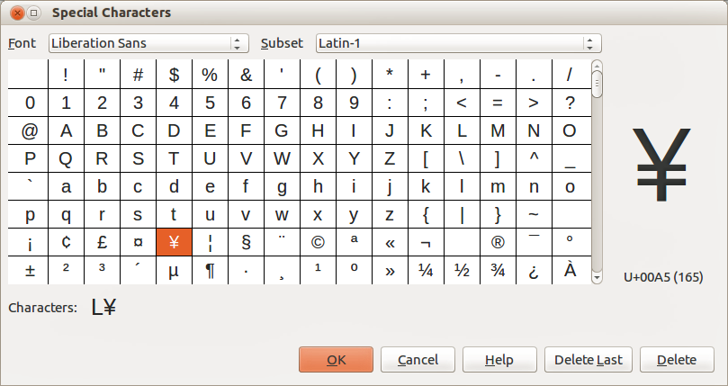
Figure 8: Special Characters dialog
Note | Characters you select will be inserted in the order they were selected, even if you accidentally click on the wrong character. Clicking on another character will only add it to the ones being inserted. Click Delete to delete all the characters selected, then click on the correct characters.

Inserting non-breaking spaces and hyphens
Where it is not desirable for words that are separated by a space or a hyphen to span over two lines, or where an optional hyphen is desired, you can insert a special formatting mark. Draw supports the following formatting marks:
- Non-breaking space – inserts a space that will keep bordering characters together on line breaks.
- Non-breaking hyphen – inserts a hyphen that will keep bordering characters together on line breaks.
- Optional hyphen – inserts an invisible hyphen within a word that will appear and create a line break once it becomes the last character in a line.
- No-width optional break – inserts an invisible space within a word that will insert a line break once it becomes the last character in a line. Only available when complex text layout (CTL) is enabled.
- No-width no break – inserts an invisible space within a word that will keep the word together at the end of a line. Only available when complex text layout (CTL) is enabled.
- Left-to-right mark – inserts a text direction mark that affects the text direction of any text following the mark. Only available when complex text layout (CTL) is enabled.
- Right-to-left mark – inserts a text direction mark that affects the text direction of any text following the mark. Only available when complex text layout (CTL) is enabled.
To insert a non-breaking space, or hyphens, or access the formatting marks:
- Click on the Text icon and place the cursor in the text where you want to use formatting marks.
- Go to Insert > Formatting Mark on the main menu bar.
- Select the formatting mark you want to use from the context menu that opens. A non-breaking space can be inserted using the keyboard shortcut is Ctrl+Shift+Space. A no-width-optional break can be inserted using the keyboard shortcut is Ctrl+Slash.

Formatting text
The appropriate use of text formatting can give text in a drawing a consistent look, making your drawing look more professional without any distracting elements.
Tip | Sometimes it is very useful to re-apply the default style to a selection of text removing any manual formatting applied to it, especially if a mistake has been made and you are not sure how to undo it. To revert back to the default style, select the manually formatted text and then select Format > Default formatting from the main menu bar.
Formatting text may require some intervention in three areas:
- Character attributes (for example, font color or emphasis)
- Paragraph attributes (for example, alignment or spacing)
- List attributes (for example, type of bullet or indent spacing)
In some cases it is quicker and more efficient to apply manual formatting; but in situations where you need to perform the same modifications to many different parts of the drawing, the use of styles is recommended.

Selecting text
Text must be selected before it can be formatted.
To format all the text in a text box:
- Click on the Text icon and then click once on the text.
- Click once on the border of the text box. The selection handles are displayed.
- Go to Format on the main menu bar or right click in the text box and select the type of formatting required, for example Character or Paragraph.
- Any formatting changes will apply to all the text in the text box.
To format only part of the text in a text box or object:
- Click on the Text icon and then click once on the text.
- Select the text to be formatted by clicking and dragging over it (highlighting). You can also use the following keyboard shortcut combinations to select text after positioning the cursor where you want to begin your selection:
- Press Shift then use the arrow keys to extend your selection.
- Press Shift+Ctrl then use the arrow keys to select whole words.
- Press Shift+Home to select to the beginning of the line.
- Press Shift+End to select to the end of the line.
- Go to Format on the main menu bar or right click in the text box and select the type of formatting required, for example Character or Text.
- Alternatively, use the tools on the Text Formatting toolbar to format the text.
- Any formatting changes will apply only to the selected text.

Using styles
Only graphic styles are available in Draw to format text. Each graphic style listed in the Styles and Formatting dialog (Figure 9) has default settings for formatting and layout. You can create new styles and modify the styles supplied with Draw.
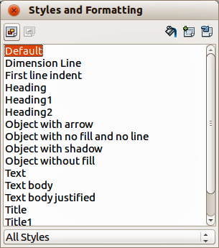
Figure 9: Styles and Formatting dialog
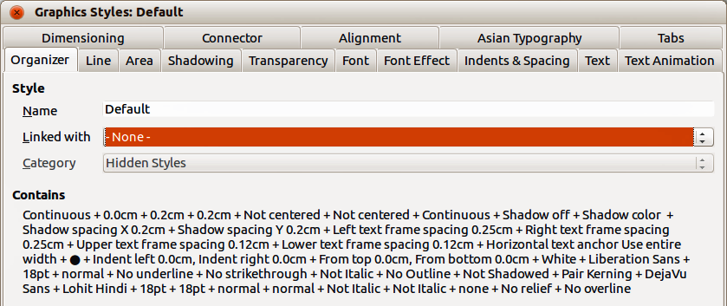
Figure 10: Graphic Styles dialog

Creating styles
- Go to Format > Styles and Formatting on the main menu bar or press the F11 key to open the Styles and Formatting dialog (Figure 9).
- Right-click on a style name and select New from the context menu to open the Graphic Styles dialog (Figure 10).
- Using the Graphic Styles dialog, set all the attributes for your text and paragraph by clicking on the various tabbed pages that are available.
- Click OK when finished and your new style is added to the list in the Styles and Formatting dialog.
- Alternatively, select your text and perform all the changes to format, then click on the New Style from Selection icon to open the Create Style dialog.
- Type a unique style name and click OK. This closes the Create Style dialog and your new style is added to the list in the Styles and Formatting dialog.

Modifying styles
- Go to Format > Styles and Formatting on the main menu bar or press the F11 key to open the Styles and Formatting dialog (Figure 9).
- Right-click on the style to be modified and select Modify from the context menu to open the Graphic Styles dialog (Figure 10).
- Using the Graphic Styles dialog, modify all the attributes for your text and paragraph by clicking on the various tabbed pages that are available.
- Click OK when finished making changes and the style is saved with the new format attributes.
- Alternatively, select your text and perform all the changes to format, then select a style in the Styles and Formatting dialog.
- Click on the Update Style icon and the style is saved with the new format attributes.

Formatting characters
Text characters can be independently formatted from the format used for a paragraph of text. This character formatting will also override any formatting that has been applied using a graphic style. Note that character styles are not available in Draw.
- Click on the Text icon, then select the characters you want to format.
- Go to Format > Character on the main menu bar, or click the Character icon on the Text Formatting toolbar, or right-click on the selected character and select Character to open the Character dialog (Figure 11).
- Make your changes to the character formatting using the tabbed pages, then click OK to save your changes.
- Click Reset to cancel any changes you have made to the character format and the characters revert back to the original paragraph formatting.
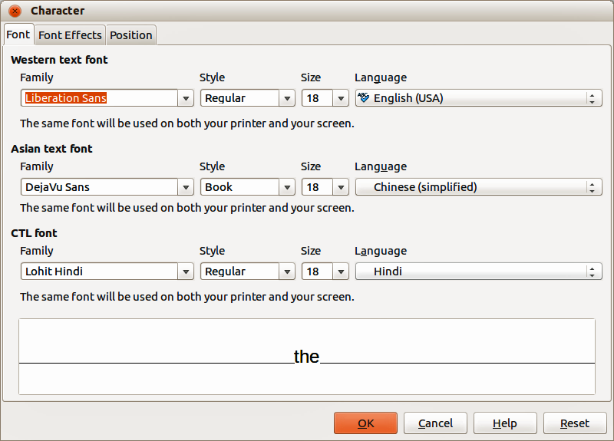
Figure 11: Character dialog
The tabbed pages in the Character dialog are used as follows:
- Font – select the desired font type, its base attributes (Italic, Bold, Language and so on) as well as the size. A sample of the font is displayed in the lower part of the dialog. This font page is also available when creating or modifying a graphics style. If support for Asian language and Complex Text Layout (CTL) font has been enabled (Tools > Options > Language Settings > Languages), then the Font page is divided into three parts for Western, Asian and CTL text fonts allowing you to specify text fonts and their attributes for the majority of font families.
- Font Effects – apply special effects to the text, such as over lining and underlining, color, shadow and so on. A sample of the text is displayed in the lower part of the dialog as a quick visual check of the effects applied. This page is also available when creating or modifying a graphics style.
- Position – sets the text position relative to the baseline when you need to insert subscripts or superscripts. This page is not available when creating or modifying a graphics style.
- Scaling – specifies the percentage of the font width by which to compress or expand the individual characters of the selected text.
- Spacing – sets the spacing between the characters of the font, which can be defined in number of points.
- Pair kerning – automatically adjusts the spacing between certain pairs of characters to visually improve the appearance.

Formatting paragraphs
Paragraph formatting will override any formatting that has been applied using a graphic style.
- Click on the Text icon then select the paragraph you want to format.
- Go to Format > Paragraph on the main menu bar, or click the Paragraph icon on the Text Formatting toolbar, or right-click on the selected text and select Paragraph to open the Paragraph dialog (Figure 12).
- Make your changes to the paragraph formatting using the tabbed pages then click OK to save your changes.
- Click Reset to cancel any changes you have made to the paragraph format and the text reverts back to its original formatting.
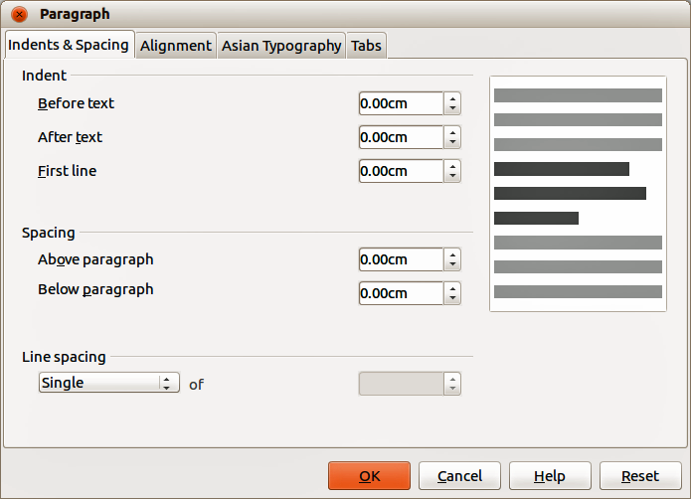
Figure 12: Paragraph dialog
The tabbed pages in the Paragraph dialog are used as follows:
- Indents and Spacing – determines the indents and spacing used in a paragraph.
- Indent – modifies the indentation of the text (before and after) as well as the indentation of the first line.
- Spacing – defines the space before and after each paragraph formatted with the style.
- Line spacing – determines the spacing between two lines formatted with the style. Note that selecting Proportional spacing requires specifying the percentage of a line to be used as spacing; 100% single line, 200% double line, 50% half a line. If Leading is selected, specify the amount of line spacing in your default unit of measurement.
Tip | Setting line spacing to less than 100% is a good method to cram a lot of text into a text box, however care must be taken as too small a value will make the text hard to read.
Tip | You can change the default unit of measurement by going to Tools > Options > LibreOffice Draw > General.
- Alignment – determines the paragraph alignment: Left, Right, Center, or Justified. A preview shows the effects of the changes. This page is also available in the graphics styles dialog. The same alignment options can be accessed using the paragraph alignment icons on the Text Formatting toolbar.
Note | If you have Complex Text Layout enabled in Tools > Options > Language Settings > Languages, an extra selection — Text Direction — appears at the bottom of the dialog; you can choose Left-to-right or Right-to-left.
- Tabs – determines the tab stops. This page is also available in the graphics styles dialog.
- Asian Typography – sets the following properties relative to line changes and is only available if Enabled for Asian Languages is selected in Tools > Options > Language Settings > Languages. This page is also available in the graphics styles dialog.
- Apply list of forbidden characters to the beginning and end of lines.
- Allow hanging punctuation.
- Apply spacing between Asian, Latin and Complex text.

Creating bulleted and numbered lists
Bulleted and numbered lists can be created in text boxes, shapes and objects. When creating lists in shapes and objects, remember that shapes and objects are not dynamic and do not expand as you create a list.
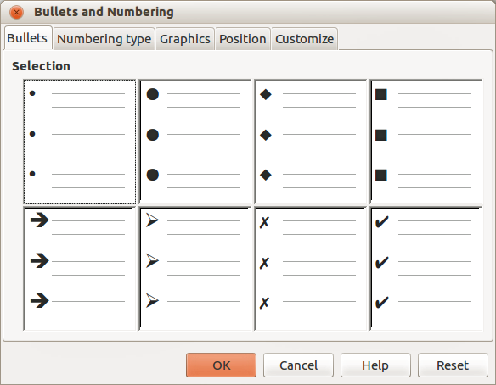
Figure 13: Bullets and Numbering dialog

Creating lists
- Click on the Text icon then select the text you want to use for a bulleted list.
- Go to Format > Bullets and Numbering on the main menu bar, or right-click on the selected text and select Bullets and Numbering to open the Bullets and Numbering dialog (Figure 13).
- Select the list style from the Bullets, Numbering or Graphics pages then click OK to save your changes.
- Alternatively, click the Bullets On/Off icon on the Text Formatting toolbar. This quickly creates a list using the previously selected settings in the Bullets and Numbering dialog.
- Click Reset to cancel any changes you have made and the text reverts back to its original formatting.

Editing and customizing a list
You can edit and customize the appearance of a list by changing the bullet type or numbering for the entire list or single entry or the outline level of a list item. All changes are made using the Bullets and Numbering dialog.

Editing a list
- Click on the Text icon, then select the list or the items in the list that you want to edit and customize.
- Go to Format > Bullets and Numbering, or right-click on the selected text and select Bullets and Numbering to open the Bullets and Numbering dialog (Figure 13).
- Select a new list style from the Bullets, Numbering or Graphics pages.
- Click OK to save your changes.

Changing position
Use the Position page (Figure 14) to adjust the outline level, indentation and spacing of bullet points and the associated text. This page is particularly effective when used in combination with the Customize page.
To set up an outline level:
- Select an outline level from the list on the left hand side of the page or select levels 1 – 10 to modify all levels simultaneously.
- Set the Indent, which is the spacing between the bullet or number and the text. If you select the Relative option, the indent value will be measured relative to the previous level and not from the margin.
- Set the measurement for Width of numbering. This is the space to leave between the numbering or bullet point and the text.
- Set the Numbering alignment and is normally only used on a numbered list. Setting this option does not set the alignment of the text.
- Select Left to align the numbering at the left edge of the alignment space for numbering.
- Select Right to align the numbering at the right edge of the alignment space for numbering.
- Select Centered to align the numbering in the center of the alignment space for numbering.
- Click OK to save your changes.
- To revert back to the default values of the list, click Reset.
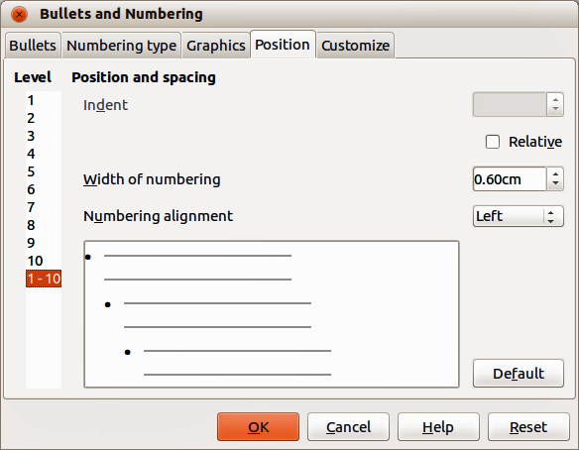
Figure 14: Bullets and Numbering – Position page
Tip | To fully appreciate how Numbering alignment works, create a numbered list with more than ten elements, making sure there is enough room for two (or more) numerical characters using the Width of numbering field. Select Right alignment and the right edge of the numbers will form a neat, straight line before the text.

Customizing
Use the Customize page (Figure 15) to customize the style of all the outline levels. The options available on this page depend on the type of marker selected for the list.
To customize a bullet or numbered list:
- Select first the level you want to modify on the left hand side of the box. To modify all levels at once, select 1 – 10 as the level. With levels being arranged in a hierarchical structure, changing, for example, the font attribute of one of the levels ripples through all the lower levels.
- Make your changes to your list using the options on this page. The preview on the right hand side of the dialog shows the effect of the changes.
- Click OK to save your changes.
- To revert back to the default values of the list, click Reset.
Depending on the bullet style selected (bullet, numbering; graphic), some of the following options may not be available on the Customize page:
- Before – enter any text to appear before the number (for example, Step).
- After – enter any text to appear after the number (for example, a punctuation mark).
- Color – pick the color for the list marker (number or bullet character).
- Relative size – specify the size of the number relative to the size of the characters in the paragraph of the list.
- Start at – enter the first value of the list (for example, you might want the list to start at 4 instead of 1).
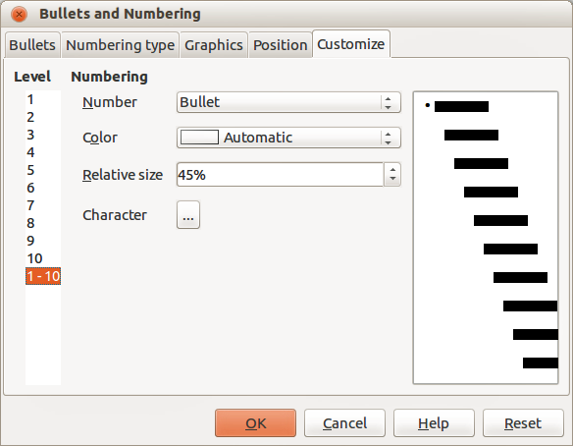
Figure 15: Bullets and Numbering – Customize page
- Character button – click this button to select the special character for the bullet.
- Graphics – opens a gallery of available graphics or allows the selection of a graphic file used as a marker.
- Width and Height: – specify the dimensions of the graphic marker.
- Keep ratio checkbox – if selected, the ratio between the width and the height of the graphic marker is fixed.

Using tables
Tables are useful when you want to show structured information in your drawing, for example a specification list or drawing title block. You can create tables directly in Draw, eliminating any need to embed a Calc spreadsheet or a Writer text table in your drawing. The tables provided by Draw do have a limited functionality.

Creating a table
When working with tables, it is useful to know the number of rows and columns needed as well as the appearance. Tables are placed on a drawing in a text box and cannot be placed into objects or shapes. Also, unlike text boxes and other graphic objects, tables cannot be rotated.
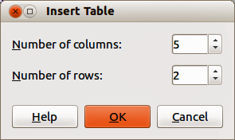
Figure 16: Insert Table dialog
To insert a table, proceed as follows:
- Go to Insert > Table on the main menu bar to open the Insert Table dialog (Figure 16).
- Select the number of columns and number of rows for your table.
- Click OK and a table is placed in the center of your drawing inside its own text box.
- Move your table into position by dragging it to its new position, or using the method in “Using the Position and Size dialog” on page 7.

Modifying a table
Once the table is added to your drawing, you can control its appearance, size, position and so on using a combination of the tools on the Table toolbar (Figure 17) and the Format Cells dialog (Figure 21). The Table toolbar is only active when a table has been selected. If the Table toolbar does not display when you select a table, go to View > Toolbars > Table. If it is appended to the Drawing toolbar, the Table toolbar can be expanded by detaching and moving it.
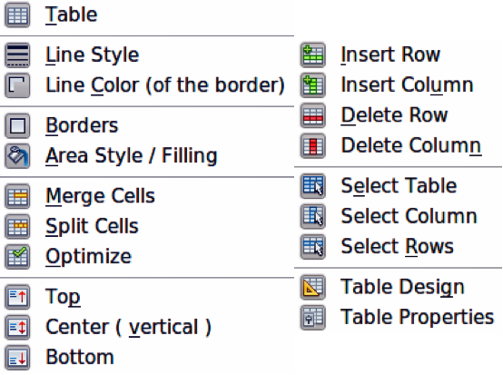
Figure 17: Table toolbar and table tools
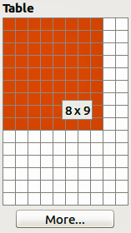
Figure 18: Table graphic tool

Table toolbar
The Table toolbar contains the majority of the tools you need to manipulate a table. These tools are shown in Figure 17 and described below.
- Table – creates a new table in a drawing. Opens the Insert Table dialog (Figure 16) where you can select the required number of rows and columns. Alternatively, click on the small triangle next to the Table icon to open a graphic representation for creating a table (Figure 18). To use this tool, move the mouse to the right and down in the grid until you have the columns and rows you require and click the left mouse button.
- Line Style – changes the line style of the borders of selected cells. Opens a new dialog where you can choose from a range of predefined styles.
- Line color (of the border) – opens a color selection dialog where you can choose the color of the borders around selected cells.
- Borders – selects predefined border configurations. The borders are applied to the selected cells. If the desired border pattern is not available, you will need to use the Format Cells dialog.
- Area Style/Filling – select the cells to be filled, then select the type of fill from the drop down list: Invisible (no color), Color, Gradient, Hatching, or Bitmap. Depending on the fill type selected, the fillings drop-down menu is populated with the available fillings for the fill type selected.
- Merge Cells – merges the selected cells into one cell. Note that the contents of the merged cells are also merged. You can also merge cells by right-clicking in the selected cells and using the context menu that opens.
- Split Cells – opposite operation of merging cells. Make sure that the cursor is positioned on the cell you want to split, then click to open the Split Cells dialog (Figure 19). Select the number of cells required from the split as well as whether the cell should be split horizontally or vertically. When splitting horizontally, you can select the Into equal proportions option to get all cells of equal size. The contents of the split cell remain in the original cell (the one on the left or top). You can also split cells by right-clicking in the cell and using the context menu that opens.
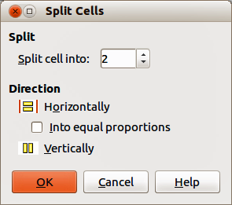
Figure 19: Split Cells dialog
- Optimize – evenly distributes the selected cells either horizontally or vertically. If you want to optimize the whole table, you can evenly distribute columns or rows by clicking on the small triangle next to the icon and selecting Distribute Columns Evenly or Distribute Rows Equally.
- Top, Center (vertical), Bottom– you can select the vertical alignment of text in a cell by selecting the required cells and clicking on one of these tools.
- Insert Row, Insert Column, Delete Row, Delete Column – select a row or column and use these four tools to insert or delete rows and columns into or from your table. Rows and columns are inserted/deleted below and to the right of the selected cell. You can also select, insert or delete rows and columns by right-clicking a cell and using the context menu that opens.
- Select Table, Select Column, Select Row – Use these tools to select a table, column or row if you want to perform the same change to attributes for a table, column or row.
- Table Design – opens the Table Design dialog (Figure 20) where you can select a table style and display options.
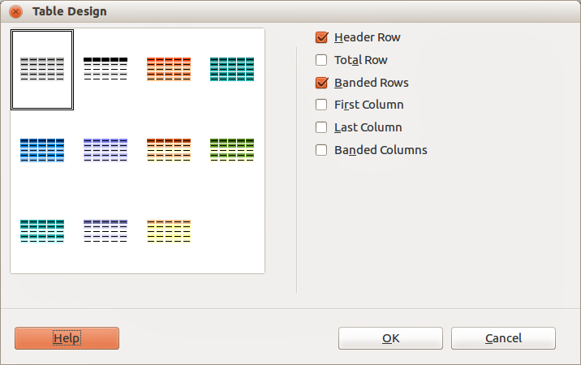
Figure 20: Table Design dialog
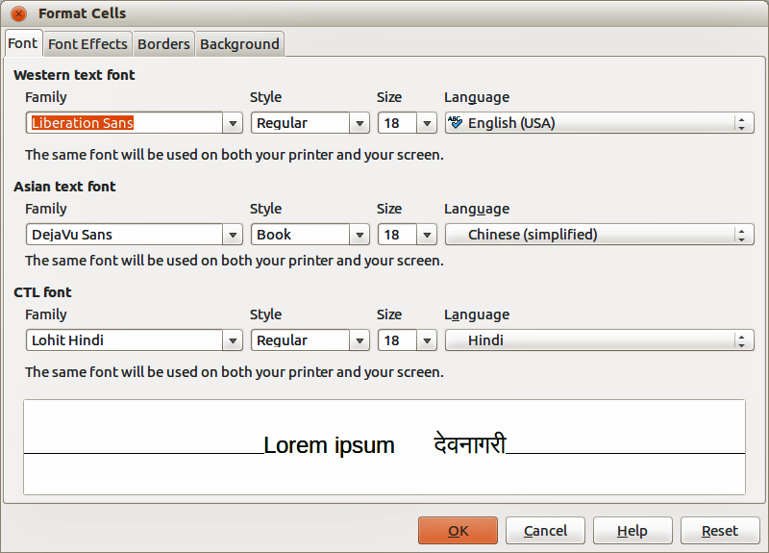
Figure 21: Format Cells dialog
- Table Properties – opens the Format Cells dialog (Figure 21), which contains the following tabbed pages. You can also open this dialog by right-clicking on the table and selecting Table from the context menu.
- Font – use to select the desired font type and family, style (Italic, Bold, etc.), size and language. A sample of the font is displayed in the lower part of the dialog.
- Font Effects – use to apply effects to the text: font color; relief; overlining; strikethrough; underlining and emphasis mark.
- Borders – use to set borders and border properties not available when using the Borders tool on the Table toolbar; line arrangement (default or user defined), line (style, width, and color) and spacing to contents (cell margins).
- Background – changes the background of the selected cells and provides the same functions as the Area Style/Filling tool on the Table toolbar.
- Reset – clicking this button resets the table back to default values.

Position and size
You can change table position and size on a drawing by using the mouse or, for more accurate control, with the Position and Size dialog (Figure 6 on page 8). When the table is selected, right-click on the table and select Position and Size from the context menu or go to Format > Position and Size on the main menu bar or press the F4 key to open the dialog. See “Using the Position and Size dialog” on page 7 for more information.
Note | Unlike text boxes and other graphic objects, tables cannot be rotated.

Deleting a table
To delete a table:
- Click and drag over the table to select it or select the table then click on the text box border around the table.
- Press the Delete key.

Using fields
Fields allow the automatic insertion of text into a drawing. You can think of a field as a kind of formula which is calculated when the drawing is loaded or printed and the result is written in the drawing.

Inserting a field
To insert a field into a drawing:
- Move the cursor where the field will be positioned. The text box created when you insert a field can be repositioned just like a text box.
- Go to Insert > Fields on the main menu bar.
- Select a field from the options shown in the context menu.
The fields available in Draw are as follows:
- Date (fixed) – inserts the date at the date of inserting the field.
- Date (variable) – inserts a field that is updated with the date at the time of opening the file.
- Time (fixed) – inserts a field displaying the time at the time of insertion.
- Time (variable) – inserts a field which is updated with the time at the time of opening the file.
- Author – inserts the author of the drawing. This information is derived from the value recorded in the general options. To modify this information go to Tools > Options > LibreOffice > User Data.
- Page Number – inserts the page number of the slide.
- Page Count – inserts the total number of slides.
- File Name – inserts a field that contains the name of the file.

Customizing fields
The appearance of fields can be customized as follows. The Page Number, Page Count, and File Name fields cannot be customized.
- Place the cursor at the start of the field data and go to Edit > Fields
- Select the desired format from the options available in the Edit Field dialog (Figure 22).
- Click OK.
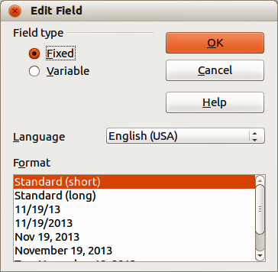
Figure 22: Edit Field dialog

Using hyperlinks
When inserting text (for example website address or URL) that can be used as a hyperlink, Draw formats it automatically, creating the hyperlink and applying color and underlining.
To insert a hyperlink, or to customize the appearance of a hyperlink, go to Insert > Hyperlinks on the main menu bar or click on the Hyperlink icon on the Standard toolbar to open Hyperlink dialog (Figure 23).
On the left side, select one of the four types of hyperlinks. The dialog changes according to the type of hyperlink selected.
- Internet – select whether the link is Web or FTP. Enter the required web address (URL).
- Mail & News – select whether the link is an E-mail or news link. Enter the receiver address and for email, also the subject.
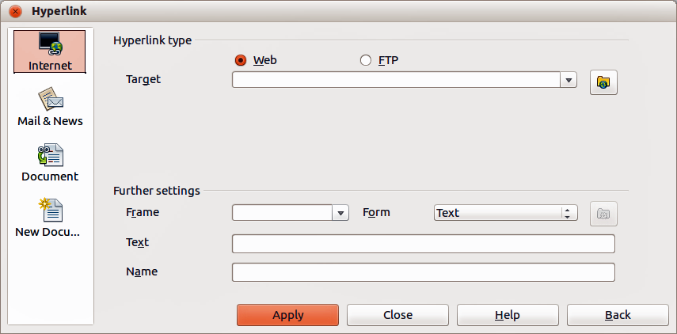
Figure 23: Hyperlink dialog
- Document – creates a hyperlink to another document or to another place in the drawing, commonly referred to as a bookmark. Enter the document path, or click on the Open File icon to open a file browser; leave this blank if you want to link to a target in the same drawing. Optionally, you can specify a target (for example. a specific slide). Click on the Target icon to open the Target in Document dialog, where you can select the target; or, if you know the name of the target, you can type it into the box.
- New Document – creates a hyperlink to a new document. Choose whether to edit the newly created document immediately (Edit now) or just create it to edit later (Edit later). Choose the type of document to create (text, spreadsheet, etc.). The Select path button opens a file browser so that you can choose the directory for the new document.
Tips | To prevent LibreOffice from automatically turning website addresses (URLs) into hyperlinks, go to Tools > AutoCorrect > Options and deselect the URL Recognition checkbox.  To change the color of hyperlinks, go to Tools > Options > LibreOffice > Appearance, scroll to Unvisited links and/or Visited links, select the checkboxes, pick the new colors and click OK. Caution: this will change the color for all hyperlinks in all components of LibreOffice which may not be what you want.
The Further settings section on the Hyperlink dialog is common to all the hyperlink types, although some choices are more relevant to some types of links.
- Frame – determines how the hyperlink will open. This applies to documents that open in a Web browser.
- Form – specifies if the link is to be presented as text or as a button. See “Working with hyperlink buttons” on page 26 for more information.
- Text – specifies the text that will be visible to the user.
- Name – applicable to HTML documents. It specifies text that will be added as a NAME attribute in the HTML code behind the hyperlink.

Editing text hyperlinks
- Select the hyperlink by dragging across the text, not clicking on it.
- Go to Edit > Hyperlink from the main menu bar.
- Make changes as needed and click Apply when done. If you need to edit several hyperlinks, click Apply after each one.
- When you are finished editing hyperlinks, click Close.

Working with hyperlink buttons
A hyperlink button is inserted in the center of the current drawing. In most cases, that is not where you want it to appear. To edit the text or size of a hyperlink button, or to move it to another place on the drawing:
- Go to View > Toolbars > Form Controls on the main menu bar to open the toolbar (Figure 24).
- Select the Design Mode On/Off icon.
- Now click on the hyperlink button and drag it to another position, or right-click to open a dialog where you can change the text on the button, the size of the button, and other properties.
- When you have finished editing the button, click the Design Mode On/Off icon again to make the button inactive. For a more detailed description of the properties and how to work with Form Controls, refer to the Writer Guide.
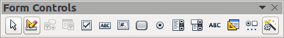
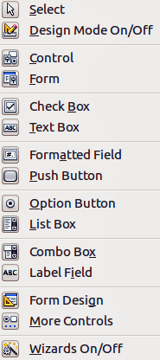
Figure 24: Form Control toolbar and tools

