
Writer 5.4 Guide

Chapter 6
Formatting Pages: Advanced
Using columns, frames, tables, and sections

Copyright
This document is Copyright © 2017 by the LibreOffice Documentation Team. Contributors are listed below. You may distribute it and/or modify it under the terms of either the GNU General Public License (http://www.gnu.org/licenses/gpl.html), version 3 or later, or the Creative Commons Attribution License (http://creativecommons.org/licenses/by/4.0/), version 4.0 or later.
All trademarks within this guide belong to their legitimate owners.

Contributors
Jean Hollis Weber

Feedback
Please direct any comments or suggestions about this document to the Documentation Team’s mailing list: documentation@global.libreoffice.org
Note: Everything you send to a mailing list, including your email address and any other personal information that is written in the message, is publicly archived and cannot be deleted.

Acknowledgments
This chapter is updated from part of previous versions of Chapter 4 in the LibreOffice Writer Guide. Contributors to earlier versions are:
Jean Hollis Weber | John A Smith | Ron Faile Jr.
Jamie Eby
This chapter is adapted from part of Chapter 4 of the OpenOffice.org 3.3 Writer Guide. The contributors to that chapter are:
Agnes Belzunce | Ken Byars | Daniel Carrera
Peter Hillier-Brook | Lou Iorio | Sigrid Kronenberger
Peter Kupfer | Ian Laurenson | Iain Roberts
Gary Schnabl | Janet Swisher | Jean Hollis Weber
Claire Wood | Michele Zarri

Publication date and software version
Published 28 December 2017. Based on LibreOffice 5.4.

Note for Mac users
Some keystrokes and menu items are different on a Mac from those used in Windows and Linux. The table below gives some common substitutions for the instructions in this chapter. For a more detailed list, see the application Help.
Windows or Linux | Mac equivalent | Effect
Tools > Options menu selection | LibreOffice > Preferences | Access setup options
Right-click | Control+click or right-click depending on computer setup | Opens a context menu
Ctrl (Control) | ⌘ (Command) | Used with other keys
F5 | Shift+⌘+F5 | Open the Navigator
F11 | ⌘+T | Open the Styles and Formatting window

Contents
Copyright 2
Contributors 2
Feedback 2
Acknowledgments 2
Publication date and software version 2
Note for Mac users 2
Introduction 5
Choosing a layout method 5
Using columns to define the page layout 7
Defining the columns on a page 7
Specifying the number of columns 7
Formatting column width and spacing 8
Formatting separator lines 8
Reverting to a single-column layout 8
Changing the number of columns for existing text 8
Distributing text across columns 9
Using frames for page layout 10
Creating frames 10
Moving, resizing, and changing frame attributes 11
Anchoring frames 12
Linking frames 13
Using tables for page layout 14
Positioning information in headers or footers 14
Creating sideheads using tables 14
Example 15
Using sections for page layout 17
Creating sections 17
Naming sections 18
Linking sections 18
Write-protecting sections 18
Password-protecting sections 19
Hiding sections 19
Formatting a section into columns 20
Indenting the section from margins 20
Changing the background of the section 20
Customizing footnotes and endnotes in a section 20
Customizing footnotes 21
Customizing endnotes 21
Saving a new section 21
Editing and deleting sections 21
Editing section attributes 21
Editing the format of a section 22
Deleting sections 22
Updating links 22
Updating links automatically 22
Updating links manually 23
Removing links 23
Changing page orientation within a document 23
Setting up a landscape page style 23
Inserting a landscape page into a portrait document 24
Portrait headers on landscape pages 25

Introduction
Writer provides several ways for you to control page layouts. This chapter covers the use of:
- Columns
- Frames
- Tables
- Sections
- Changing page orientation within a document
Chapter 5 described the use of page styles and some associated functions.
- Note
All pages in a Writer document are based on page styles. The other layout methods described in this chapter build upon the underlying page style.
- Tip
Page layout is usually easier if you select the options to show text, object, table, and section boundaries in Tools > Options > LibreOffice > Application Colors and the options for paragraph ends, tabs, breaks, and other items in Tools > Options > LibreOffice Writer > Formatting Aids.

Choosing a layout method
The best layout method depends on what the final document should look like and what sort of information will be in the document. Here are some examples. The techniques mentioned are all described in this chapter.
For a book similar to this user guide with one column of text, some figures without text beside them, and some other figures with descriptive text, use page styles for basic layout, and use tables to place figures beside descriptive text, where necessary. | 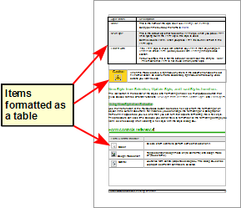
Use page styles (with two columns) for an index or other document with two columns of text where the text continues from the left-hand column to the right-hand column and then to the next page, all in sequence (also known as snaking columns of text). If the title of the document (on the first page) is full-page width, put it in a single-column section. | 
For a newsletter with a complex layout, two or three columns on the page, and some articles that continue from one page to some place several pages later, use page styles for basic layout. Place articles in linked frames and anchor graphics to fixed positions on the page, if necessary. | 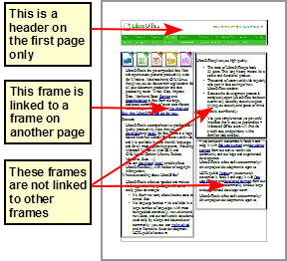
For a document with terms and translations to appear side-by-side, use a table to keep items lined up. | 

Using columns to define the page layout
You can use columns for page layout in these ways:
- By defining the number of columns and their layout on a page, using page styles.
- By changing the number of columns for existing text.

Defining the columns on a page
It is a good idea to define your basic page style (such as Default) with the most common layout to be used in your document, either single-column or multiple-column. You can then either define extra page styles for pages with different numbers of columns or use sections (described in “Using sections for page layout” starting on page 17) for pages or parts of pages with different numbers of columns.
To define the number of columns on a page:
- Choose Format > Columns to go to the Columns dialog (see Figure 1), or go to the Columns page of the Page Style dialog, or click the More Options button on the Page panel of the Properties deck of the Sidebar.
- In the Settings section, choose the number of columns and specify any spacing between the columns and whether you want a vertical separator line to appear between the columns. You can use one of Writer’s predefined column layouts, or you can create a customized column layout. The preview pane on the right of the Settings section shows how the column layout will look.
Notice the Apply to box in the dialog of Figure 1. In this instance, the changes are being applied to the Default page style.
- Click OK to save the changes.
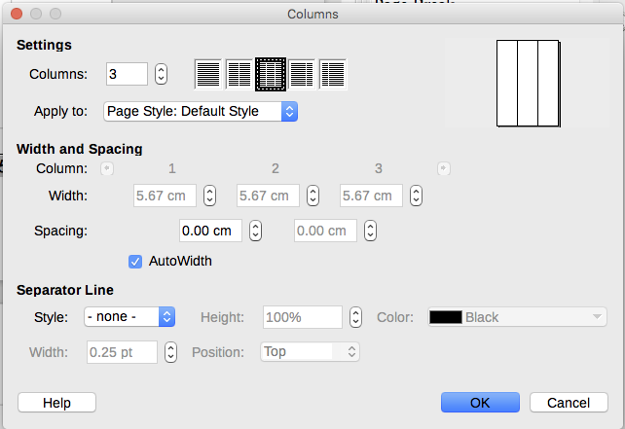
Figure 1: Defining the number of columns on a page

Specifying the number of columns
In the Settings section, enter the number of columns into the Columns selection box, or select one of the column layout icons.

Formatting column width and spacing
Select the AutoWidth option in the Width and spacing section to create columns of equal width.
To customize the width and spacing of the columns:
- In the Width and spacing section, deselect the AutoWidth option.
- In the Width selection boxes, enter a width for each column.
- On the Spacing line, enter the amount of space that you want between each pair of columns.
If you specify more than three columns, use the arrow keys on the Column line to scroll among the columns.

Formatting separator lines
To display separator lines between the columns:
- Using the Style drop-down list, select the line style from the three styles available.
- Using the Width control, select the width of line to use, settable from 0.25pt to 9.0pt. (1 pt = 1 point = 1/12 pica = 1/72 inch = 127/360 mm = 0.3527 mm.)
- Using the Height control, select the height of line required, as a percentage of the column height. Variable from 25% to 100%.
- If you entered a height of less than 100%, use the Position drop-down list to select a vertical alignment for the separator lines. The vertical-positioning options are Top, Centered, or Bottom.
- The line color can be selected from the Color drop-down list.
- Tip
To quickly input the maximum or minimum allowed value in an input box, click the current value and press Page Up or Page Down respectively.

Reverting to a single-column layout
To revert to a single-column layout for the page style, go to the Settings section and either reset the number in the Columns box to 1 or click the single-column layout icon.

Changing the number of columns for existing text
You might want some parts of a page to have one column and other parts of the page to have two or more columns. For example, you might have a page-width headline over a three-column news story.
You can create columns and then type or paste text into them, or you can select some existing text and change the number of columns for displaying it.
When you select text and change the number of columns for that text (Format > Columns), Writer turns the selected text into a section, as described in “Using sections for page layout” on page 17.
Figure 2 shows the Columns dialog for a selection. The Apply to box has Selection selected and an extra option (Evenly distribute contents to all columns) appears.
- Tip
You cannot select text on a two-column formatted page and change it to a single column using this method. Instead, you need to define a single-column page and then select the text you want to be in a two-column section on that page.
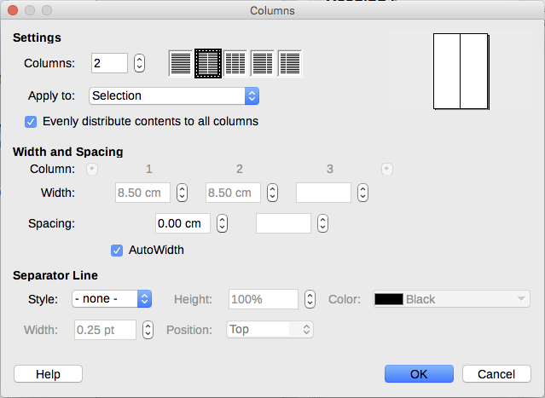
Figure 2: Specifying columns for a selection

Distributing text across columns
As you add text to the section, you will see that the text flows from one column to the next. You can distribute text across the columns in one of two ways, as shown in Figure 3:
Evenly—Writer adjusts the length of the columns to the amount of text, so that all the columns are approximately the same height. As you add or delete text, the columns readjust.
Newspaper-style—Writer fills the columns one at a time, beginning with the first column. The last column may be shorter than the others.
To distribute text evenly, select the Evenly distribute contents to all columns option in the Settings area (Figure 2). Deselect this option if you want to distribute text newspaper-style.
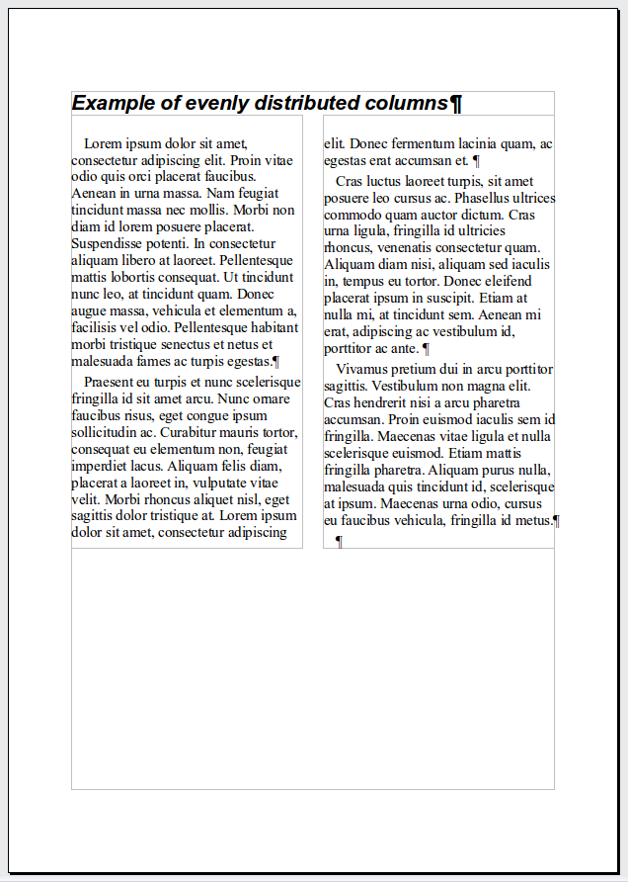 | 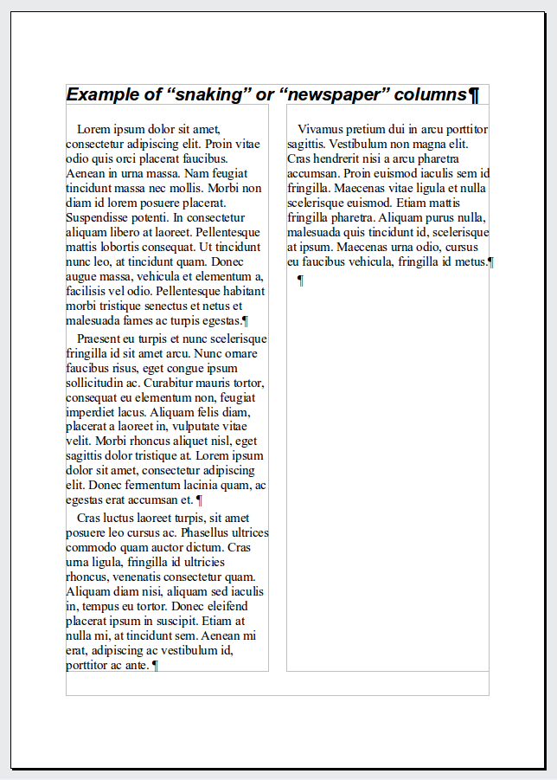
Figure 3: (Left) Evenly distributed columns; (Right) Newspaper-style columns.
- Tip
Choose View > Nonprinting Characters (or press Ctrl+F10) to display end of paragraph markers (¶). Often, unexpected behavior of columns is due to extra paragraphs that are normally invisible but are taking up space.

Using frames for page layout
Frames can be very useful when producing newsletters or other layout-intensive documents. Frames can contain text, tables, multiple columns, pictures, and other objects.
Use frames when you need to:
- Position something in a particular place on a page, for example, a logo or a “stop press” news box in one corner of a page.
- Allow text on one page to continue on another page, somewhere more distant than the next one, by linking the content of one frame to another so the contents flow between them as you edit the text.
- Wrap text around an object, such as a photograph.
Because LibreOffice does not allow you to define page styles with recurring frames, consider doing some quick sketches of the basic page layouts you need, indicating the approximate positions of different frames and their purposes. Try to keep the number of different page layouts as low as possible in order to avoid chaos in your design.
Pay special attention to the positioning of frames. Many of the predefined styles default to a center alignment. Although centering all frames looks reasonably good in most cases, it is rarely the best choice.
One of the most visually effective ways to position a frame is to align its left margin with that of the paragraph above it. To achieve this effect, the frame is inserted in a blank paragraph of the same style as the paragraph above. Select Insert > Frame; in the Position section of the Type page, select From Left in the Horizontal selection box to position the frame exactly where you want it.
Also, think about the type of wrap and the spacing between the frame and text. Instead of placing a frame close to the text, use the Wrap page to place some white space between them.
You can format frames individually or define and apply frame styles; see Chapter 9, Working with Styles.
Example: Using a frame to center text on a page
Although you can center text horizontally as part of a paragraph style or by using manual formatting, those methods do not work for vertical centering. To center text vertically, you need to place the text in a frame, anchor the frame to a page or a paragraph, and then center the frame vertically on the page. See “Anchoring frames” on page 12.

Creating frames
You can create a frame in several ways, depending on your needs.
- Choose Insert > Frame > Frame... to create an empty frame. The Frame dialog (Figure 4) appears. You can click OK and come back to customize it later, or you can set the frame’s characteristics at this stage.
- Select text and choose Insert > Frame > Frame... to open the Frame dialog. Customize the frame (for example, to add space between the frame and the text) and click OK. The selected text is removed from the normal text flow and inserted into the frame.
- Select Insert > Frame > Interactively. The mouse cursor changes to a plus (+) symbol. Click and drag the mouse to draw an empty frame.
- Insert a formula or OLE object by selecting Insert > Object > [type of object]. The item is inserted and appears in a frame, but the Frame dialog does not open.
- Use the Insert Frame Interactively button on the Insert toolbar to quickly draw an empty frame with several columns.
To add content to a frame, first deselect the frame by clicking somewhere else on the page. Then, click inside the frame to place the text cursor there. Now add content just like you would on the main page. When you are done, deselect the frame.
- Note
The menu item Insert > Frame > Floating Frame is for use with HTML documents.

Moving, resizing, and changing frame attributes
When an object is added to Writer, it is automatically enclosed in a frame of a predetermined type. The frame sets how the object is placed on the page, as well as how it interacts with other elements in the document. You can edit the frame by modifying the frame style it uses or by manually formatting it when you add it to the document. Frame styles are discussed in Chapter 9, Working with Styles.
To change the size or location of a frame, first select the frame, then use either the mouse or the Frame dialog (Figure 4). Using the mouse is quicker but less accurate. You might want to use the mouse for gross layout and the dialog for fine-tuning.
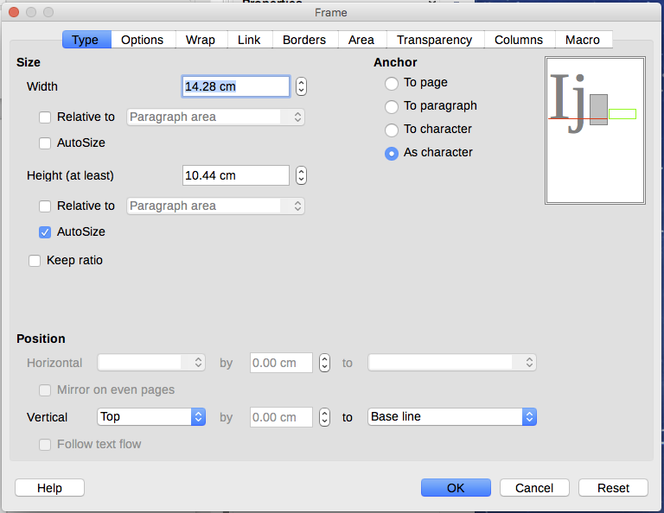
Figure 4: Frame dialog
You can re-size the frame manually by clicking on the green squares (sizing handles) and dragging to the appropriate size, or start adding content to it (the frame will re-size automatically if, for example, you add a large picture to it), or go back to the Frame dialog and set the size and other characteristics.
To change the location of the frame using the mouse, drag and drop one of the edges or put the cursor anywhere within the frame. (The I-bar cursor changes to a four-headed arrow when properly positioned for a drag-and-drop move.)
To change the size of the frame, drag one of the sizing handles. Drag a handle on one of the sides to enlarge or reduce the text frame in one dimension only; drag a corner handle to enlarge or reduce it in both dimensions.
These resizing actions distort the proportions of the frame. Holding down the Shift key while dragging one of the handles makes the frame keep the same proportions.
You can open the Frame dialog at any time by selecting the frame, right-clicking, and choosing Frame from the context menu.
To remove the default border on a newly created frame, open the Frame dialog, go to the Borders page (Figure 5), and in the Line arrangement box, select the first Present (None). Alternatively, you can assign a borderless style to the frame; see Chapter 9, Working with Styles, for information on frame styles.
- Note
Do not confuse a frame’s border with the text boundaries that are made visible using the View menu (by selecting View > Text Boundaries).
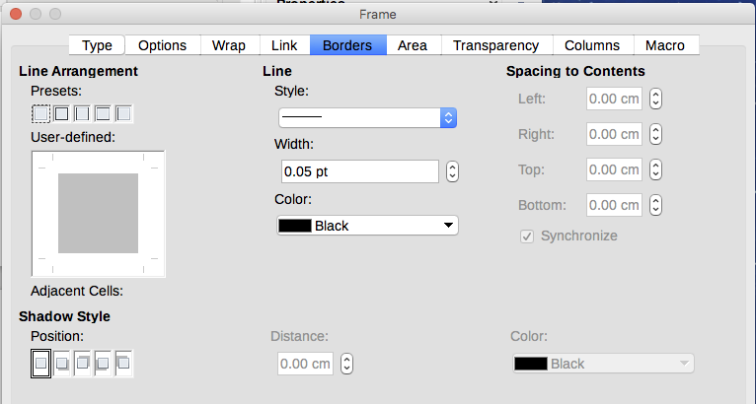
Figure 5: Removing the border from a frame

Anchoring frames
Using the Frame dialog (or by right-clicking and pointing to Anchor), you can anchor a frame to a page, paragraph, or character, or you can anchor it as a character.
To Page
The frame keeps the same position in relation to the page margins. It does not move as you add or delete text. This method is useful when the frame does not need to be visually associated with a particular piece of text. It is often used when producing newsletters or other documents that are very layout-intensive. This method is also used to center text on a page.
To Paragraph
The frame is associated with a paragraph and moves with the paragraph. It may be placed in the margin or another location. This method is useful as an alternative to a table for placing icons beside paragraphs. It is also used to center text on a page in documents which will be used in a master document (frames anchored to pages will disappear from the master document).
To Character
The frame is associated with a character but is not in the text sequence. It moves with the paragraph but may be placed in the margin or another location. This method is similar to anchoring to a paragraph.
As Character
The frame is placed in the document like any other character and, therefore, affects the height of the text line and the line break. The frame moves with the paragraph as you add or delete text before the paragraph. This method is useful for adding a small icon in sequence in a sentence. It is also the best method for anchoring a graphic to an empty paragraph so it does not move around the page in unexpected ways.

Linking frames
You can link frames to each other even when they are on different pages of a document. The contents will automatically flow from one to the next. This technique is very useful when designing newsletters, where articles may need to be continued on a different page.
- Note
You cannot link from a frame to more than one other frame.
To link one frame to another:
- Select the frame to be linked from.
- Click the Link Frames button () on the Frames toolbar.
- Click the next frame in the series (which must be empty).
When a linked frame is selected, any existing links are indicated by a faint connecting line, as shown in Figure 6. Frames can be unlinked by selecting the Unlink Frames button () on the Frames toolbar.
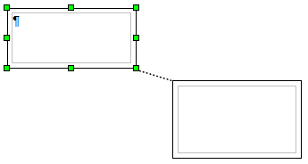
Figure 6: Linked frames
The height of a frame that is being linked from is fixed; you can change this height manually or by using the Frame dialog, but it does not automatically adjust to the size of the contents (that is, the AutoHeight attribute is disabled). Only the last frame of a chain can adapt its height to the content.
The Options page of the Frame dialog (Figure 7) shows the names of the selected frame and any frames it is linked to or from. You can change this information here. On this page, you can also select options to protect the contents, position, and size of the frame.
The Wrap, Borders, Area, Columns, Transparency, and Macro pages of the Frame dialog are the same as those for frame styles. Refer to the Chapter 9, Working with Styles, for details.
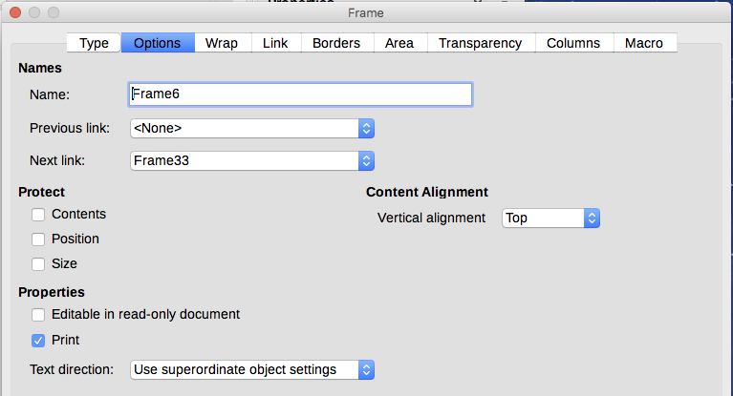
Figure 7: Options page of the Frame dialog

Using tables for page layout
Writer’s tables can serve several purposes, such as holding data as you might see it in a spreadsheet, lining up material, and creating more complex page layouts. For information about using tables of data, see Chapter 13, Tables.
This topic describes how to achieve some common layouts by using tables.

Positioning information in headers or footers
Instead of using tabs, you can use a table in a header or footer to position different elements such a page number, document title, author, and so on. These elements are often inserted using fields, as described in Chapter 17, Fields.

Creating sideheads using tables
Sideheads and marginal notes are commonly used in documents from resumes to computer user guides. The main body of the text is offset to leave white space (usually on the left-hand side) in which the sideheads or notes are placed. The first paragraph is aligned beside the sidehead, as in Figure 8.
Example of a sidehead | In some cases you may want to put only one or two paragraphs in the table itself and the rest of the text and graphics in ordinary paragraphs (formatted to line up with the paragraphs in the table) so that text and graphics will flow more easily from one page to another when you add or delete material.  In other cases, you might put each paragraph in a separate row of the table and allow the table to break between pages.
Figure 8: Example of a sidehead
- Note
Sideheads can also be created by placing text in a frame using the Marginalia frame style, as described in Chapter 9, Working with Styles.

Example
To create a table for use with a sidehead:
- Place the cursor where you want the table to appear and choose Table > Insert Table (Ctrl+F12).
- In the Insert Table dialog, define a one-row, two-column table with no border and no heading. Click Insert to create the table.
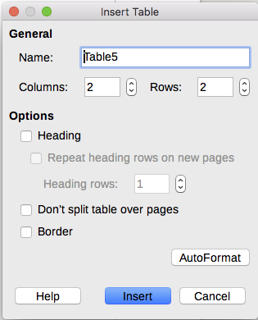
Figure 9: Defining a two-column borderless table with no header
- Right-click on the table and choose Table Properties from the context menu. On the Columns page of the Table Properties dialog, make the columns the required width.
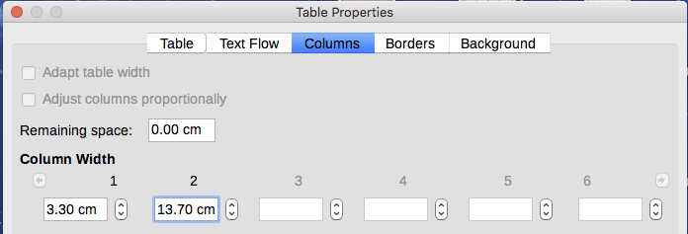
Figure 10: Defining a two-column table to line up with text offset at 3.3cm
- On the Table page of the Table Format dialog (Figure 11), in the Spacing section, make the Above and Below values the same as the Top and Bottom spacing you have defined for ordinary paragraphs of text. In the Properties section, optionally give this table a name. Click OK to save your settings.

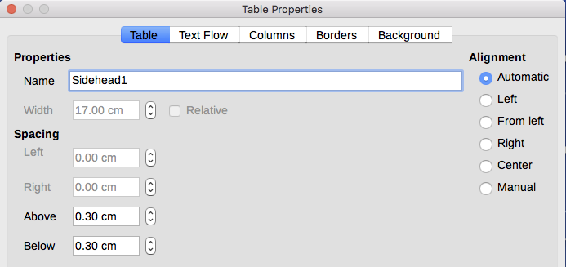
Figure 11: Defining the space above and below a table
- Tip
To check the top and bottom spacing for ordinary paragraphs:
- Position the cursor in a paragraph and press F11 (unless the Styles and Formatting window is already open). Check that the Styles and Formatting window shows paragraph styles (top left button).
- The current style should be highlighted. If no paragraph style is highlighted, select All Styles in the bottom drop-down list. Right-click on it and select Modify from the pop-up list.
- Go to the Indents & Spacing page and look in the Spacing section for the values in Above paragraph and Below paragraph.
You may also want to turn off number recognition so that Writer will not try to format numbers if you want them to be plain text. To turn number recognition off:
- Right-click in the table and then click Number Format on the context menu.
- On the Format Number dialog, make sure the Category is set to Text. Click OK.
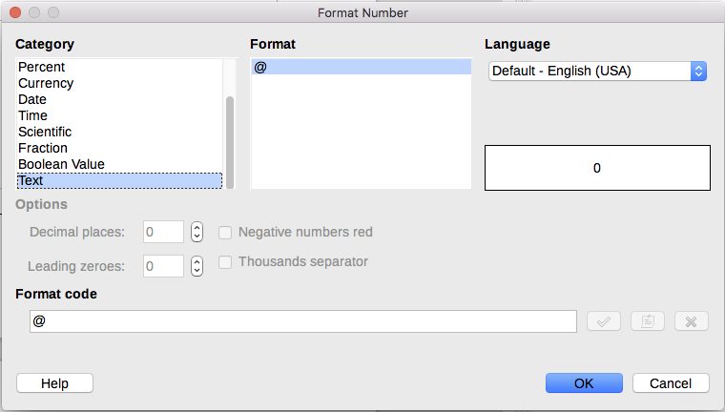
Figure 12: Setting number format to Text
- Tip
If you use this table format often, you may want to save it as AutoText, as described in Chapter 2, Working with Text: Basics. Select the table (not just the contents) to assign the shortcut.

Using sections for page layout
A section is a block of text that has special attributes and formatting. You can use sections to:
- Write-protect text
- Hide text
- Dynamically insert the contents of another document
- Add columns, margin indents, a background color, or a background graphic to a portion of your document
- Customize the footnotes and endnotes for a portion of your document

Creating sections
To create a section:
- Place the cursor at the point in your document where you want to insert the new section. Or, select the text that you want to place in the new section.
- From the Menu bar, choose Insert > Section. The Insert Section dialog (Figure 13) opens.
- Choose settings for each page of the dialog as required.
- Click Insert.
The Insert Section dialog has five tabbed pages.
- Use the Section page to set the section’s attributes.
- Use the Columns page to format the section into columns.
- Use the Indents page to set indents from the right and left margins of the section.
- Use the Background page to add color or a graphic to the section’s background.
- Use the Footnotes/Endnotes page to customize the section’s footnotes and endnotes.
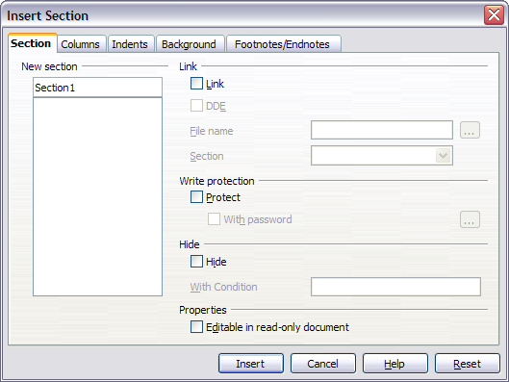
Figure 13: Inserting a section using the Insert Section dialog
At any time before closing the dialog, you can reset a tabbed page to its default settings by clicking the Reset button. (Note, however, that you cannot reset the Section page. If you wish to undo changes to the Section page, you must do so manually).

Naming sections
Writer automatically enters a name for the section in the name box of the New section list box. To change the name, select it and type over it. The name is displayed in the Sections category of the Navigator window. If you give your sections meaningful names, you can navigate to them more easily.

Linking sections
You can insert the contents of another document into the section and then have Writer update it whenever the other document is updated. This is called linking the section to the other document.
To link the section to another document, follow these steps:
- In the Link section of the dialog, select the Link option.
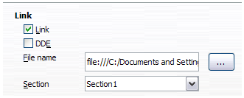
Figure 14: Linking sections
- Click the (...) button to the right of the File name field. The Insert dialog opens.
- Find and select the document you want to insert and then click the Insert button. The Insert dialog closes and the name of the selected document appears in the File name field.
- If you want to insert only a section of the selected document, select the desired section from the Section drop-down list.
- Note
The section must already exist in the selected document. You cannot create a section in the selected document at this point.
You can update links automatically or manually. See “Updating links” on page 22.

Write-protecting sections
To write-protect the section so that its contents cannot be edited, select the Protect option in the Write protection area.
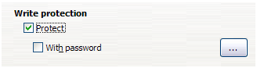
Figure 15: Write-protecting sections
- Note
Write-protection protects only the section’s contents, not its attributes or format.

Password-protecting sections
To prevent others from editing the section’s attributes or format, additionally protect the section with a password, as follows:
- Select the With password option. The Enter Password dialog opens.
- Type a password in the Password field and then confirm the password by typing it again in the Confirm field.
- Click OK. The Enter Password dialog closes. Anyone who tries to edit the section’s attributes or format will be prompted to enter the password.
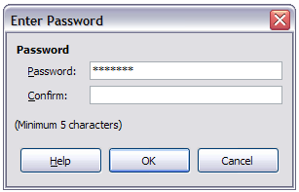
Figure 16: Password-protecting a section

Hiding sections
You can hide the section so that it will not be displayed on the screen or printed. You can also specify conditions for hiding the section. For example, you can hide the section only from certain users.
- Note
You cannot hide a section if it is the only content on the page or if the section is in a header, footer, footnote, endnote, frame, or table cell.
To hide a section, select the Hide option in the Hide section of the dialog.
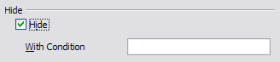
Figure 17: Hiding sections
To hide the section only under certain conditions, enter the desired conditions in the With Condition field. The syntax and operators that you use to enter conditions are the same ones that you use to enter formulas. For syntax and a list of operators, see Writer’s Help under Conditions. See also Chapter 17, Fields.
If the section is write-protected with a password, the password must be entered to hide or reveal the text.
- Note
Hiding text is not a secure way to stop someone else reading it. It will stop the casual reader but will not prevent someone who actively wants to find out what you have hidden―even if it is password protected.

Formatting a section into columns
Use the Columns page of the Insert Section dialog to format the section into columns. This page is similar to the Columns dialog shown in Figure 2 on page 9. Please refer to that topic for details.

Indenting the section from margins
Use the Indents page (Figure 18), to set indents from the right and left margins of the section.
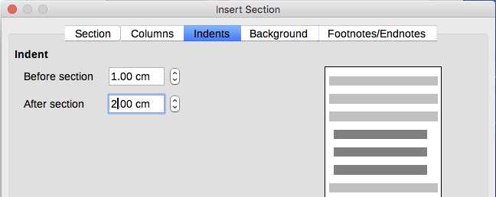
Figure 18: Indenting sections
Enter the desired left-margin indent in the Before section box. Enter the desired right-margin indent in the After section box. The preview box on the right-hand side of the page shows you how the section will look with the indents applied.

Changing the background of the section
Use the Background page to add color or a graphic to the background of the current section. This page is similar to the Background pages for paragraphs, frames, tables, and other objects in LibreOffice. For more information, refer to Chapter 9, Working with Styles.

Customizing footnotes and endnotes in a section
Use the Footnotes/Endnotes page to customize the current section’s footnotes and endnotes.
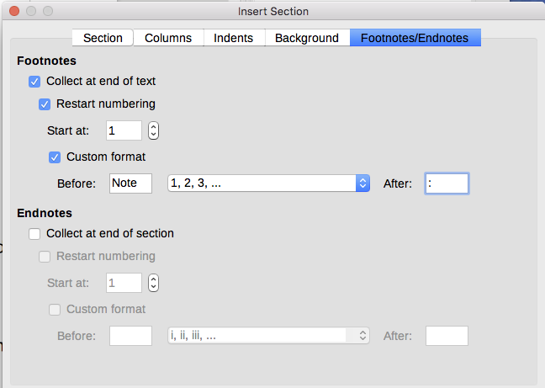
Figure 19: Setting footnotes and endnotes for sections

Customizing footnotes
If you want the section’s footnotes to appear separately from the other footnotes in the document, select the Collect at end of text option in the Footnotes area.
To number the section’s footnotes separately from the other footnotes in the document, and format the numbering, follow these steps:
- In the Footnotes section of the page, make sure that Collect at end of text is selected.
- Select Restart numbering.
- If you want the section’s footnotes to start at a number other than 1, enter the desired starting number in the Start at number box.
- Select the Custom format option.
- From the drop-down list of the Custom format option, select a numbering format for the footnotes.
To add text to the selected numbering format, use the Before and After text input boxes. For example, if you want the footnote numbers to be preceded by the word “Note” and followed by a colon, fill the Before and After fields as shown in Figure 19.

Customizing endnotes
If you want the section’s endnotes to appear at the end of the section rather than at the end of the document, select the Collect at end of section option in the Endnotes area.
To number the current section’s endnotes separately from the other endnotes in the document, and format the numbering, apply the procedures described above to the Endnotes settings.

Saving a new section
To save a new section so that it appears in your document, click the Insert button. The Insert Section dialog closes and the new section appears in your document.

Editing and deleting sections
To edit a section, follow these steps:
- From the Menu bar, choose Format > Sections. The Edit Sections dialog (Figure 20) opens.
- Select the section you want to edit by clicking its name in the list box.

Editing section attributes
To rename the selected section, simply type over its name in the Section name box.
From the Edit Sections dialog, you can also edit the selected section’s link, write-protect, and hide attributes. To learn how to edit these attributes, see:
“Linking sections” on page 18
“Write-protecting sections” on page 18
“Hiding sections” on page 19
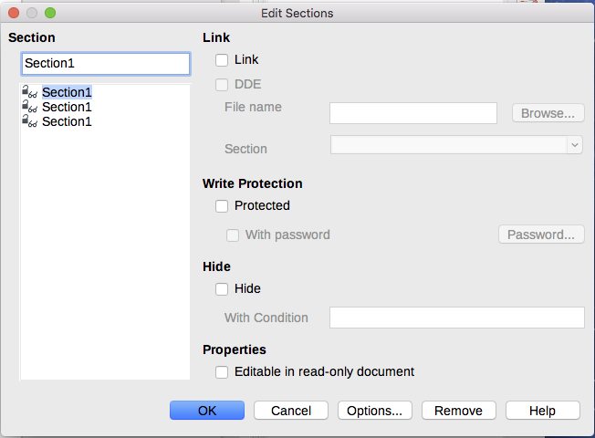
Figure 20: Edit Sections dialog

Editing the format of a section
To edit the format of the selected section, click the Options button.
The Options dialog has four pages: Columns, Indents, Background, and Footnotes/Endnotes. The use of these pages is described earlier in this topic.
To reset a page to the conditions in place when the dialog opened, click the Reset button.
To save your Options settings and return to the Edit Sections dialog, click OK.

Deleting sections
To delete the selected section, click the Remove button. This does not delete the contents of the section; the contents become part of the main document. If the contents were linked, they are now embedded.
- Note
Writer will not prompt you to confirm the deletion.

Updating links
You can set Writer to update linked sections automatically, and you can also update links manually.

Updating links automatically
To set Writer to update links without prompting you, or to turn off automatic updating, follow these steps:
- Choose Tools > Options > LibreOffice Writer > General. The dialog displays general text document settings.
- In the Update section of the dialog, under Update links when loading, select one of the following three options:
- Always if you want Writer to update links automatically, without prompting you, whenever you open a document that contains links.
- On request if you want Writer to prompt you before updating links.
- Never if you do not want Writer to update links.
- Click OK to save your settings.

Updating links manually
A protected section cannot be updated manually. It must first be unprotected.
To update a link manually:
- Open the document that contains the link.
- Choose Edit > Links. The Edit Links dialog (Figure 21) opens.
- The list in the Edit Links dialog displays the names of all the files that are linked to the current document. Click the file that corresponds to the link that you want to update.
- Click the Update button. The most recently saved contents of the linked file appear in the current document.
- To close the Edit Links dialog, click Close.
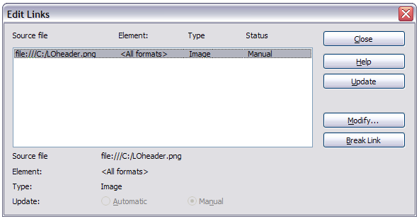
Figure 21: Edit Links dialog

Removing links
To remove a linked file, go to the Edit Links dialog (see above), click the file that corresponds to the link you want to remove, and click the Break Link button. This action embeds the contents of the linked file.

Changing page orientation within a document
A document can contain pages in more than one orientation. A common scenario is to have a landscape page in the middle of a document, whereas the other pages are in a portrait orientation. Here are the steps to achieve it.

Setting up a landscape page style
- If you wish to keep the margins the same as on other pages, then note the margin settings of the current page style. (You can find the margin settings on the Page Style dialog, by selecting the Page tab as shown in Figure 23.)
- In the Styles and Formatting window, right-click on Landscape in the list of page styles and choose Modify from the pop-up menu.
- On the Organizer page of the Page Style dialog (Figure 22), make sure the Next Style property is set to Landscape (to allow for having more than one sequential landscape page).
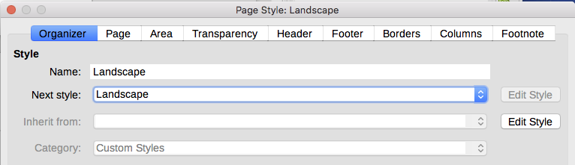
Figure 22: Set the next page style to Landscape
- On the Page page of the Page Style dialog (Figure 23), make sure the Orientation is set to Landscape. Change the margins so that they correspond with the margins of the portrait page. That is, the portrait top margin becomes the landscape left margin, and so on.
- Click OK to save the changes.
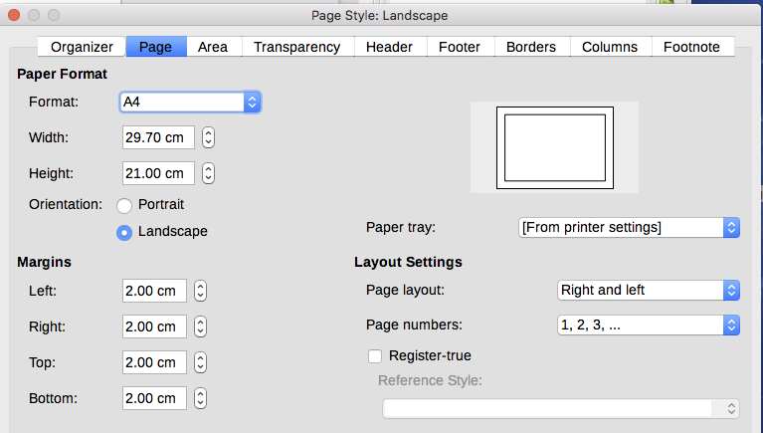
Figure 23: Set orientation and margins for a landscape page

Inserting a landscape page into a portrait document
Now that you have defined the Landscape page style, here is how to apply it.
- Position the cursor in the paragraph or table at the start of the page that is to be set to landscape. Right-click and choose Paragraph or Table Properties, respectively, in the context menu.
- On the Text Flow page of the Paragraph dialog (Figure 24) or the Table Properties dialog (Figure 25), select Insert (or Break for a table) and With Page Style. Set the Page Style property to Landscape. Click OK to close the dialog and to apply the new page style.
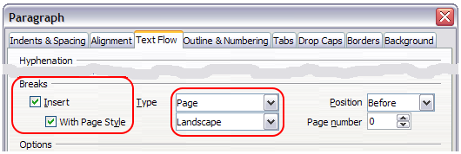
Figure 24: Specifying a page break before a paragraph
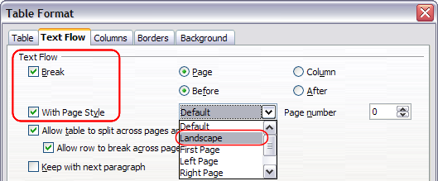
Figure 25: Specifying a page break before a table
- Position the cursor in the paragraph or table where the page is to return to portrait orientation and change the paragraph properties or table properties so that With Page Style is the portrait page style that was used before the Landscape page style.
- Click OK to return to the previous portrait page style.

Portrait headers on landscape pages
When you define a header and footer on a landscape page, they will be aligned with the long side of the page. If your landscape pages are inserted between portrait pages, you might want the headers and footers to be on the short sides of the landscape pages, so the final printed product looks like the contents of the landscape pages have been rotated 90 degrees on portrait pages.
You can set up portrait headers and footers on landscape pages by using a trick involving frames. These are a bit tedious to set up, but once you have done so, you can copy and paste them to other landscape pages. This cannot be made part of the landscape page style. In the following example we want to insert a landscape page into our printed document, to have the same header and footer, and margins, as our portrait pages. We will use an A4 page size here.
To set up portrait headers and footers on landscape pages:
- Note the margin settings for the portrait page which is the same as the landscape page will be, that is to say, for a right landscape page, the settings from a right portrait page (see the table).
We now need to make the landscape right and left margins 1 cm larger than the portrait top and bottom margins, respectively. This difference allows for the extra space used by the portrait header and footer (0.5 cm for the height of the header or footer and a 0.5 cm gap between the header or footer and the main text).
- Set the frame for the footer in the same way as for the header. Apply these margin settings in the Landscape page style.
Portrait page (right page) |  | Landscape page (right page)
Top margin | 1.5 cm | Right margin | 2.5 cm
Bottom margin | 1.5 cm | Left margin | 2.5 cm
Left (inner) margin | 2.8 cm | Top margin | 2.8 cm
Right (outer) margin | 1.8 cm | Bottom margin | 1.8 cm
- Copy and paste the footer from the portrait page into a blank paragraph in the text. Paste or move it into the landscape page. This text will then have the Footer style so the typeface, font size, and tab settings will match.
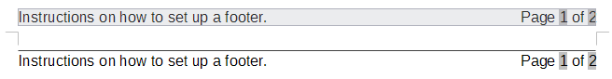
Figure 26: Copy the footer, paste, and select it
- Select the text (including the fields) you just entered. Choose Format > Character. On the Character dialog, choose the Position tab and set Rotation / scaling to 270 degrees (counterclockwise). Click OK.
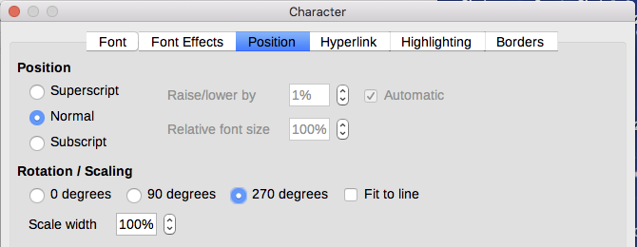
Figure 27: Rotating the footer text 270 degrees
- With the text still selected, choose Insert > Frame. In the Frame dialog, select the Type tab and enter the width, height, and horizontal and vertical position for the footer. Deselect the Automatic options in Width and Height if they are selected.
- The width is the footer height taken from the Footer page of the portrait page style dialog.
- The frame height is obtained by simple arithmetic. The A4 page-width is 21cm, minus the sum of the top and bottom margins of 2.8cm and 1.8cm resulting in a frame height of 16.4cm.
- The horizontal position is the portrait page bottom margin.
- The vertical position is the landscape page top margin.
- If your footer has a line above the text, as in this book, on the Borders page, select a right border and specify the line width and spacing to the frame’s contents.
- Click OK to save these settings. The footer will now appear in the required position and orientation. Any fields will update.
Because tabs have been removed, insert the cursor in the frame, at the end of the text where the tab was, and insert as many spaces using the keyboard space bar, as you require for the layout to match that on the portrait page.
Repeat these steps (using appropriate settings) to set up a portrait header on the landscape page.
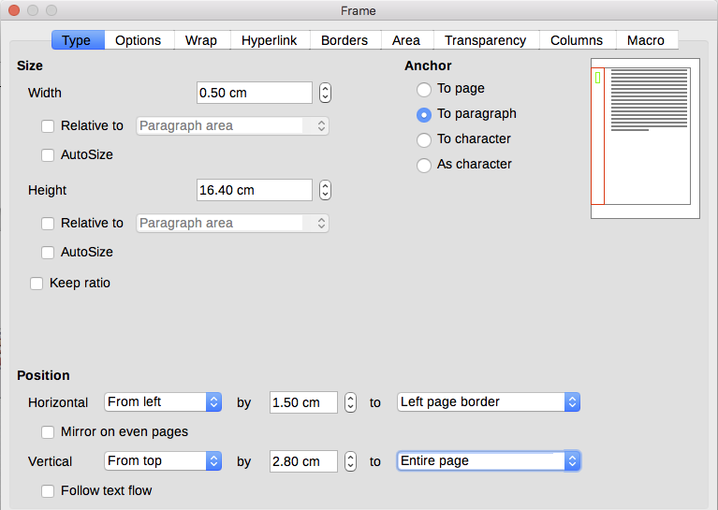
Figure 28: Defining the size and position of the footer frame
- Caution
Make sure to return to the paragraph in the document from which you rotated the text, and return it to 0 degrees, or any text typed in this location will rotate.
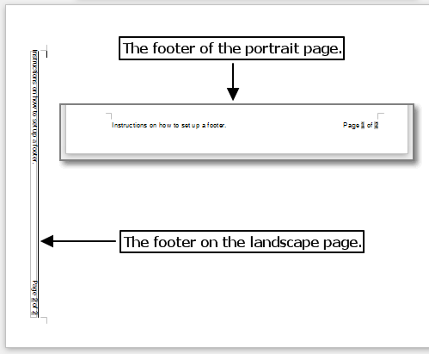
Figure 29: Footers in place for both page styles

