Dialogs In BASIC

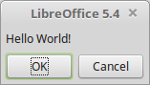Displaying A Simple Message
Print "Hello World!"
☞ The Cancel choice stops the program.

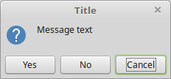Displaying Information
MsgBox(MessageText[, Dialog Code[, Title]])
☞ Line breaks in MessageText with Chr(10) or Chr(13).

Display A Message And Wait For A Response
Response = MsgBox(MessageText[, DialogCode[, Title]])
where
- Response is an integer value that reflects the user’s choice.
- DialogCode : the sum of button codes + icon + default button (as below).
Buttons to display
0 | OK | 3 | Yes, No, Cancel
1 | OK, Cancel | 4 | Yes, No
2 | Stop, Retry, Ignore | 5 | Retry, Cancel
Icon
0 | (none) | 48 |  Caution
16 |  Critical message | 64 | i Information (OK only)
32 |  Question
Default button
0 | First | 256 | Second | 512 | Last
Return values (user’s selection)
1 | OK | 3 | Stop | 5 | Ignore | 7 | No
2 | Cancel | 4 | Retry | 6 | Yes

InputBox() Function
Function InputBox(Message[, Title[, DefaultValue]])
returns a string. On cancellation, returns a zero-length string.

API Dialogs
☞ The aspect of FilePicker and FolderPicker types below depend upon
Tools > Options > LibreOffice > General, Use LibreOffice dialogs

API Dialog Types

File Selection: FilePicker Objects
com.sun.star.ui.dialogs.FilePicker | From above configuration option.
com.sun.star.ui.dialogs.OfficeFilePicker | Forces LibreOffice style.
com.sun.star.ui.dialogs.SystemFilePicker | Forces native OS style.

Directory Selection: FolderPicker Objects
com.sun.star.ui.dialogs.FolderPicker | From above configuration option.
com.sun.star.ui.dialogs.OfficeFolderPicker | Forces LibreOffice style.
com.sun.star.ui.dialogs.SystemFolderPicker | Forces native OS style.

The FilePicker Object (or OfficeFilePicker Or SystemFilePicker)
oFilePicker = CreateUnoService("com.sun.star.ui.dialogs.FilePicker")
AppendFilter() | By pairs: appendFilter("LiteralName", "*.xyz")  Ex : oFilePicker.appendFilter("ODF Documents", _ "*.odt;*.ods")
CurrentFilter | Sets the default filter from the ones added using AppendFilter (literal name) or the user’s filter selection.
DefaultName | Default name for the file to save.
DisplayDirectory | The starting directory or the user’s directory selection.
Execute | Transfers the execution stream to the dialog and reads the return code (see return constants values below).
Files | An array of selected files.
initialize() | Dialog type selection (see type constants below).  Dim FPType(0) As Integer  FPType(0) = 'a type constant  oFilePicker.initialize(FPType())
MultiSelectionMode | Disables/Enables the multi-selection mode (defaults to False).
Title | The dialog window title.

FilePicker Type Constants
com.sun.star.ui.dialogs.TemplateDescription.XXX :
FILEOPEN_SIMPLE | 0 | Simple open file dialog.
FILESAVE_SIMPLE | 1 | Simple save file dialog.
FILESAVE_AUTOEXTENSION_PASSWORD | 2 | Enhanced save dialog: automatic extension + password.
FILESAVE_AUTOEXTENSION_PASSWORD_FILTEROPTIONS | 3 | Enhanced save dialog: automatic extension + password + filter options.
FILESAVE_AUTOEXTENSION_SELECTION | 4 | Enhanced save dialog: automatic extension + selection.
FILESAVE_AUTOEXTENSION_TEMPLATE | 5 | Enhanced save dialog: automatic extension + templates.
FILEOPEN_LINK_PREVIEW_IMAGE_TEMPLATE | 6 | Enhanced open dialog: insert as link + preview + template.
FILEOPEN_PLAY | 7 | Enhanced open dialog: play.
FILEOPEN_READONLY_VERSION | 8 | Enhanced open dialog: read-only + version.
FILEOPEN_LINK_PREVIEW | 9 | Enhanced open dialog: link + preview.
FILESAVE_AUTOEXTENSION | 10 | Enhanced save dialog: automatic extension
FILEOPEN_PREVIEW | 11 | Enhanced open dialog: preview.
FILEOPEN_LINK_PLAY | 12 | Enhanced open dialog: insert as link + play.

Return Values Constants
com.sun.star.ui.dialogs.ExecutableDialogResults.XXX
CANCEL | 0 | Canceled | OK | 1 | Validated

The FolderPicker Object (Or OfficeFolderPicker Or SystemFolderPicker)
oFldrPicker = CreateUnoService("com.sun.star.ui.dialogs.FolderPicker")
Description | Help text to display on the dialog. Does nothing on an OfficeFolderPicker.
DisplayDirectory | Starting directory.
Execute | Transfers the execution stream to the dialog and reads the return code (see return code constants above).
Title | Dialog title.
Directory | User’s selection.

Opening A Unique File (FilePicker)
- Create a FilePicker. The default type usually fits (FILEOPEN_SIMPLE),
- set its properties and methods (see above),
- execute,
- read the return values in theCurrentFilter, DisplayDirectory and Files (vector) properties (Files(0) only has a value).
Dim oFilePicker As Object, FileName As String
FileName = ""
'FilePicker initialization
oFilePicker = CreateUnoService("com.sun.star.ui.dialogs.FilePicker")
oFilePicker.DisplayDirectory = ConvertToURL("C:\Path\To\SomeDir")
oFilePicker.appendFilter("Calc Documents", "*.ods")
oFilePicker.CurrentFilter = "Calc Documents"
oFilePicker.Title = "Select a Calc document"
'execution and return check (OK?)
If oFilePicker.execute = _
com.sun.star.ui.dialogs.ExecutableDialogResults.OK Then
FileName = oFilePicker.Files(0)
End If

Opening Several Files (FilePicker)
- As above,
- set its properties and methods (esp. with MultiSelectionMode = True),
- execute,
- read the Files() vector that holds the user’s choices.

Saving A File (FilePicker)
- Create a FilePicker,
- set its properties and methods (type FILESAVE_XXX) (see above),
- execute,
- read the return values in theCurrentFilter, DisplayDirectory and Files (vector) properties (Files(0) alone holds a value).

Selecting A Directory (FolderPicker)
- Create a FolderPicker,
- set its properties and methods (see above),
- execute,
- read the return value in Directory.
Dim oFP As Object, DirName As String
DirName = ""
oFP = CreateUnoService("com.sun.star.ui.dialogs.FolderPicker")
oFP.DisplayDirectory = ConvertToURL("C:\Path\To\SomeDir")
oFP.Description = "Select a directory"
oFP.Title = "Select the backup directory"
If oFP.execute = _
com.sun.star.ui.dialogs.ExecutableDialogResults.OK Then
DirName = oFP.Directory
End If

Custom Dialogs 101
A BASIC dialog = a dialog module (drawing) + (at least) one code module.

Dialog Execution Sequence
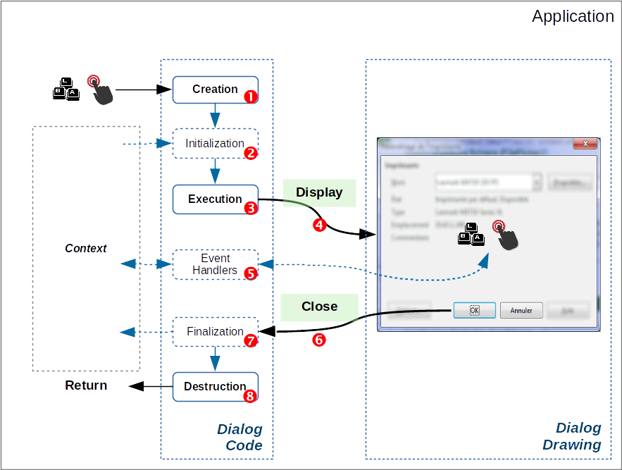The figure above illustrates a typical dialog execution sequence:
- As a response to an application event, you create the dialog,
- (initialize dialog controls from the application context if necessary),
- run the dialog that receives the execution flow:
- display,
- (dialog controls events management),
- some events imply the dialog close (OK, Cancel) ;
- (finalize to the application context if necessary),
- the dialog is destroyed and the flow returns to the calling application.

☞ Creation, initialization, execution, finalization and destruction: processed in your code.
Display, closing: automatic operations that follow the latter.
 Think to the responses to control events (“Associating an event to a macro” and RefCard #4).

Loading Dialog Libraries
☞ Much code or several dialogues? You may want to store them in dedicated libraries.
 Dialog libraries are never automatically loaded.
 Loading libraries: beware to the typecase!

Modal Vs Non-modal
Modal | A modal dialog takes full control upon the keyboard, mouse and screen, waiting for some action from the user. The underlying application is then not accessible.  ☞ By default, dialogues are modal.
Non-modal | A non-modal dialog doesn’t block access to the application.  Ex : the LibreOffice Search & replace dialogue.   Multiple calls to a non-modal dialog may block the application.

Standard Custom Dialogs (modal)
This is the most frequent use.
Given a dialog module MyDlg and a code module MyDlgCode in a MyDlgLib library. In a code module Sub, we instantiate a dialog object (oDlg) from the dialog.

Creating / Loading In Memory
DialogLibraries.loadLibrary("MyDlgLib")
oLib = DialogLibraries.getByName("MyDlgLib")
oModule = oLib.getByName("MyDlg")
oDlg = CreateUnoDialog(oModule)
'on now manipulate the oDlg object

Calling The Dialog
oDlg.execute | ☞ The execution flow is transferred to the dialog.

Calling And Testing The Return Value
If oDlg.execute = com.sun.star.ui.dialogs.ExecutableDialogResults.OK Then …
☞ The execution flow is transferred to the dialog and the return value is checked (did the user select OK?).

Terminating / Destroying The Dialog
oDlg.dispose

Wrap-up Example (Code Module)
This example doesn’t show any event management.
Sub ShowDialog()

Dim oLib As Object, oModule As Object, oDlg As Object

DialogLibraries.loadLibrary("MyDlgLib")
oLib = DialogLibraries.getByName("MyDlgLib")
oModule = oLib.getByName("MyDlg")
oDlg = CreateUnoDialog(oModule)
'InitializeDlg() 'code to initialize the dialog contents
If oDlg.execute = com.sun.star.ui.dialogs.ExecutableDialogResults.OK Then
'FinalizeDlg() 'code to do something with the user's input
End If
oDlg.dispose
End Sub

Non-modal Custom Dialogs
Given a dialog module MyNMDlg and a code module MyNMDlgCode in MyNMDlgLib library. In a Sub of the code module, we instantiate an object (oDlg) from the dialog.
Apply the same technique as above, with some subtleties:
- The dialog display is ensured using oDlg.SetVisible(True) instead of oDlg.execute,
- we set two global Boolean flags:
- gRunning that prevents multiple executions,
- gShowMe that controls the dialog display,
- events responses (controls) must set gShowMe to False to close the dialog.

Displaying The Dialog
oDlg.SetVisible(True) | ☞ The dialog is displayed.  The execution flow is not transferred to the dialog.

Wrap-up Example (Code Module)
Dim gShowMe As Boolean 'dialog display flag.
Dim gRunning As Boolean 'execution flag to prevent multiple runs.

Sub ShowNonModalDialog()
'manages the dialog creation and display

Dim oLib As Object, oModule As Object, oDlg As Object

'check for multiple runs
If Not gRunning Then
gRunning = True
gShowMe = True
DialogLibraries.loadLibrary("MyNMDlgLib")
oLib = DialogLibraries.getByName("MyNMDlgLib")
oModule = oLib.getByName("MyNMDlg")
oDlg = CreateUnoDialog(oModule)
'InitializeDlg() 'code to initialize the dialog contents

'display the dialog as long as the flag is True
Do While gShowMe
Wait 20 'allow other software execution
oDlg.SetVisible(True) 'keep on screen
Loop
'if we are here, the dialog was closed (see OnBtnOKClick)
'FinalizeDlg() 'code to do something with the user's input
oDlg.dispose
gRunning = False
End If
End Sub ' ShowNonModalDialog

Sub OnBtnOKClick(ByRef pEvt As Object)
'Response to a click on a OK button on the non-modal dialog

'set the appropriate actions
'then end with:
gShowMe = False '=> the ShowNonModalDialog while loop ends
'thus the dialog closes
End Sub 'OnBtnOKClick

Associating An Event To A Macro
A dialog communicates with the application through events ( on the figure). You thus have to write macros to respond to events occurrences. Extract from RefCard #4:
- Create the macro to call, according to this template:
Sub MacroName()
End Sub
 Hint: name the macro from the object and event type.
Example : Sub OnOKButtonClick()
That Sub may get a parameter. See below “Getting Information”,
- select the object that carries the event to intercept,
- go to its settings (differs according to the object),
- select the event to intercept,
- point to the macro that should be run when the event fires (point 1).
☞ More information about events in RefCard #4.

Getting Information About The Triggered Event
The event management macro can read the input parameter to get more information about the event itself:
Sub EventResponse(ByRef Event As Object)
End Sub
The Event input object properties and methods depend from the type of event that triggered the macro call.

Most Frequent Cases For Controls
To gain access to the calling… | Interrogate
Calling control object | Event.Source
Control model object | Event.Source.Model
Dialog object that owns the control | Event.Source.Context

Initialization And Finalization

Initialization
( in the figure) A dialog often requires information from the execution context. The initialization macro configures the dialogue contents from this data.

Finalization
( in the figure) Here, we have the opposite process: setting context data from what was input in the dialogue.

Managing Dialog Modules
LibreOffice manages dialog modules independently from code (see RefCard #1). We may copy such modules from a document to another.

Copying Modules From A Library To Another
(within the same document or between documents/containers)
- In the IDE, open both source and target documents/containers,
- open the Macro organizer ( button),
- go to the Dialogs tab, drag/drop from the source to the target.
☞ By default, modules are moved. To copy: Ctrl + drag/drop.

Saving A Dialog (Drawing Alone)
- In the IDE, open the dialog module to save,
- click the toolbar button Export Dialog,
- name the file and save it.
The document is in XML format with an .xdl extension.
☞ Import is the reciprocal process, using the Import Dialog button.
 | LibreOffice RefCard  LibreOffice BASIC  Dialogs  v. 1.05 – 12/02/2018
Advanced

Written using LibreOffice v. 5.3.3 – Platform : All

Credits
Author: Jean-François Nifenecker – jean-francois.nifenecker@laposte.net
We are like dwarves perched on the shoulders of giants, and thus we are able to see more and farther than the latter. And this is not at all because of the acuteness of our sight or the stature of our body, but because we are carried aloft and elevated by the magnitude of the giants. (Bernard of Chartres [attr.])
History
Version | Date | Comments
1.05 | 02/12/2018 | Minor updates.
License
This RefCard is distributed under the
CreativeCommons BY-SA v3 license
Information
https://creativecommons.org/licenses/by-sa/3.0/fr/

