
Getting Started
with
LibreOffice 3.3

Copyright
This document is Copyright © 2010 by its contributors as listed below. You may distribute it and/or modify it under the terms of either the GNU General Public License (http://www.gnu.org/licenses/gpl.html), version 3 or later, or the Creative Commons Attribution License (http://creativecommons.org/licenses/by/3.0/), version 3.0 or later.
Contributors
Ron Faile Jr.
Jeremy Cartwright
Hal Parker
Feedback
Please direct any comments or suggestions about this document to: documentation@libreoffice.org
Acknowledgments
This book is based on Getting Started with OpenOffice.org 3.3. The contributors to that book are:
Jean Hollis Weber Michele Zarri Magnus Adielsson
Thomas Astleitner Richard Barnes Agnes Belzunce
Chris Bonde Nicole Cairns Daniel Carrera
JiHui Choi Richard Detwiler Alexander Noël Dunne
Laurent Duperval Spencer E. Harpe Regina Henschel
Peter Hillier-Brook Richard Holt John Kane
Rachel Kartch Stefan A. Keel Jared Kobos
Michael Kotsarinis Peter Kupfer Ian Laurenson
Dan Lewis Alan Madden Michel Pinquier
Andrew Pitonyak Carol Roberts Iain Roberts
Hazel Russman Gary Schnabl Robert Scott
Joe Sellman Janet Swisher Jim Taylor
Alex Thurgood Barbara M. Tobias Claire Wood
Linda Worthington
Publication date and software version
Published 31 December 2010. Based on LibreOffice 3.3.
Contents
Copyright 2
Note for Mac users 8
Chapter 1
Introducing LibreOffice 9
What is LibreOffice? 10
The advantages of LibreOffice 11
Minimum requirements 11
How to get the software 12
How to install the software 12
Extensions and add-ons 12
How to get help 12
Paid support and training 13
Starting LibreOffice 13
Parts of the main window 15
What are all these things called? 19
Starting a new document 20
Opening an existing document 20
Saving a document 21
Renaming and deleting files 22
Using the Open and Save As dialogs 22
Using the Navigator 23
Undoing and redoing changes 25
Closing a document 26
Closing LibreOffice 26
Using LibreOffice on a Mac 26
Chapter 2
Setting up LibreOffice 27
Choosingoptions for all of LibreOffice 28
Choosing options for loading and saving documents 40
Choosing language settings 45
Choosing Internet options 47
Controlling LibreOffice’s AutoCorrect functions 48
Chapter 3
Using Styles and Templates 51
What is a template? 52
What are styles? 52
Applying styles 53
Modifying styles 55
Creating new (custom) styles 56
Copying and moving styles 57
Deleting styles 60
Using a template to create a document 60
Creating a template 61
Editing a template 63
Adding templates using the Extension Manager 64
Setting a default template 65
Associating a document with a different template 66
Organizing templates 67
Examples of style use 68
Chapter 4
Getting Started with Writer 71
What is Writer? 72
The Writer interface 72
Changing document views 74
Moving quickly through a document 75
Working with documents 76
Working with text 77
Formatting text 85
Formatting pages 88
Adding comments to a document 92
Creating a table of contents 93
Creating indexes and bibliographies 94
Working with graphics 94
Printing 94
Using mail merge 94
Tracking changes to a document 95
Using fields 95
Linking to another part of a document 95
Using master documents 98
Creating fill-in forms 98
Chapter 5
Getting Started with Calc 99
What is Calc? 100
Spreadsheets, sheets and cells 100
Parts of the main Calc window 100
Opening and saving CSV files 103
Navigating within spreadsheets 105
Selecting items in a sheet or spreadsheet 108
Working with columns and rows 110
Working with sheets 111
Viewing Calc 113
Entering data using the keyboard 116
Speeding up data entry 117
Sharing content between sheets 120
Validating cell contents 121
Editing data 121
Formatting data 122
Autoformatting cells and sheets 126
Formatting spreadsheets using themes 127
Using conditional formatting 127
Hiding and showing data 127
Sorting records 129
Printing 130
Chapter 6
Getting Started with Impress 137
What is Impress? 138
Starting Impress 138
Parts of the main Impress window 138
Workspace views 142
Creating a new presentation 146
Formatting a presentation 149
Adding and formatting text 151
Adding pictures, tables, charts and media 155
Working with slide masters and styles 157
Adding comments to a presentation 163
Setting up the slide show 163
Running the slide show 164
Chapter 7
Getting Started with Draw 165
What is Draw? 166
The Draw workspace 166
Choosing and defining colors 169
Positioning objects with snap functions 170
Positioning objects with guiding lines 172
The basic drawing shapes 172
Drawing geometric shapes 178
Selection modes 179
Selecting objects 180
Moving and dynamically adjusting an object’s size 181
Editing objects 183
Using styles 185
Special effects 185
Combining multiple objects 188
Aids for positioning objects 188
Inserting and editing pictures 189
Working with 3D objects 189
Exporting graphics 189
Adding comments to a drawing 189
Chapter 8
Getting Started with Base 191
Introduction 192
Planning a database 193
Creating a new database 193
Creating database tables 194
Defining relationships 202
Creating a database form 204
Accessing other data sources 217
Using data sources in LibreOffice 218
Entering data in a form 222
Creating queries 224
Creating reports 232
Chapter 9
Getting Started with Math 241
What is Math? 242
Entering a formula 242
Customizations 248
Formula layout 250
Numbering equations 252
Chapter 10
Printing, Exporting, and E-mailing 255
Introduction 256
Quick printing 256
Controlling printing 256
Exporting to PDF 265
Exporting to other formats 271
E-mailing documents 271
Digital signing of documents 274
Removing personal data 275
Chapter 11
Graphics, the Gallery, and Fontwork 277
Introduction 278
Adding images to a document 278
Modifying and positioning graphics 282
Managing the LibreOffice Gallery 282
Creating an image map 284
Using LibreOffice’s drawing tools 286
Using Fontwork 288
Chapter 12
Creating Web Pages 295
Introduction 296
Relative and absolute hyperlinks 296
Creating hyperlinks 296
Saving Writer documents as web pages 300
Creating web pages using a Wizard 301
Saving Calc spreadsheets as web pages 304
Saving Impress presentations as web pages 305
Saving Draw documents as web pages 308
Chapter 13
Getting Started with Macros 309
Your first macros 310
Creating a macro 315
Sometimes the macro recorder fails 318
Macro organization 319
How to run a macro 323
Extensions 327
Writing macros without the recorder 328
Finding more information 328
Chapter 14
Customizing LibreOffice 331
Introduction 332
Customizing menu content 332
Customizing toolbars 335
Assigning shortcut keys 339
Assigning macros to events 341
Adding functionality with extensions 341
Appendix A
Keyboard Shortcuts 345
Introduction 346
General keyboard shortcuts 347
Defining keyboard shortcuts 349
Further reading 349
Appendix B
Open Source, Open Standards, OpenDocument 351
Introduction 352
A short history of LibreOffice 352
The LibreOffice community 352
How is LibreOffice licensed? 353
What is “open source”? 353
What are “open standards”? 353
What is OpenDocument? 353
Frequently asked questions 354
File formats LibreOffice can open 355
File formats LibreOffice can save to 357
Exporting to other formats 358
Index 359

Note for Mac users
Some keystrokes and menu items are different on a Mac from those used in Windows and Linux. The table below gives some common substitutions for the instructions in this chapter. For a more detailed list, see the application Help.
Windows/Linux | Mac equivalent | Effect
Tools → Options menu selection | LibreOffice → Preferences | Access setup options
Right-click | Control+click | Opens a context menu
Ctrl (Control) | z (Command) | Used with other keys
F5 | Shift+z+F5 | Opens the Navigator
F11 | z+T | Opens the Styles & Formatting window

Getting Started Guide

Chapter 1
Introducing LibreOffice

What is LibreOffice?
LibreOffice is a freely available, full-featured office productivity suite. Its native file format is OpenDocument, an open standard format that is being adopted by governments worldwide as a required file format for publishing and accepting documents. LibreOffice can also open and save documents in many other formats, including those used by several versions of Microsoft Office.
LibreOffice includes the following components:

Writer (word processor)
Writer is a feature-rich tool for creating letters, books, reports, newsletters, brochures, and other documents. You can insert graphics and objects from other components into Writer documents. Writer can export files to HTML, XHTML, XML, Adobe’s Portable Document Format (PDF), and several versions of Microsoft Word files. It also connects to your email client.

Calc (spreadsheet)
Calc has all of the advanced analysis, charting, and decision-making features expected from a high-end spreadsheet. It includes over 300 functions for financial, statistical, and mathematical operations, among others. The Scenario Manager provides “what if” analysis. Calc generates 2-D and 3-D charts, which can be integrated into other LibreOffice documents. You can also open and work with Microsoft Excel workbooks and save them in Excel format. Calc can export spreadsheets to Adobe’s PDF and to HTML.

Impress (presentations)
Impress provides all the common multimedia presentation tools, such as special effects, animation, and drawing tools. It is integrated with the advanced graphics capabilities of LibreOffice’s Draw and Math components. Slide shows can be further enhanced with Fontwork’s special effects text, as well as sound and video clips. Impress is compatible with Microsoft’s PowerPoint file format and can also save your work in numerous graphics formats, including Macromedia Flash (SWF).

Draw (vector graphics)
Draw is a vector drawing tool that can produce everything from simple diagrams or flowcharts to 3-D artwork. Its Smart Connectors feature allows you to define your own connection points. You can use Draw to create drawings for use in any of LibreOffice’s other components, and you can create your own clip art and add it to the Gallery. Draw can import graphics from many common formats and save them in over 20 formats, including PNG, HTML, PDF, and Flash.

Base (database)
Base provides tools for day-to-day database work within a simple interface. It can create and edit forms, reports, queries, tables, views, and relations, so that managing a connected database is much the same as in other popular database applications. Base provides many new features, such as the ability to analyze and edit relationships from a diagram view. Base incorporates HSQLDB as its default relational database engine. It can also use dBASE, Microsoft Access, MySQL, or Oracle, or any ODBC-compliant or JDBC-compliant database. Base also provides support for a subset of ANSI-92 SQL.

Math (formula editor)
Math is LibreOffice’s formula or equation editor. You can use it to create complex equations that include symbols or characters not available in standard font sets. While it is most commonly used to create formulas in other documents, such as Writer and Impress files, Math can also work as a standalone tool. You can save formulas in the standard Mathematical Markup Language (MathML) format for inclusion in web pages and other documents not created by LibreOffice.

The advantages of LibreOffice
Here are some of the advantages of LibreOffice over other office suites:
- No licensing fees. LibreOffice is free for anyone to use and distribute at no cost. Many features that are available as extra cost add-ins in other office suites (like PDF export) are free with LibreOffice. There are no hidden charges now or in the future.
- Open source. You can distribute, copy, and modify the software as much as you wish, in accordance with either of LibreOffice’s Open Source licenses.
- Cross-platform. LibreOffice runs on several hardware architectures and under multiple operating systems, such as Microsoft Windows, Mac OS X and Linux,.
- Extensive language support. LibreOffice’s user interface is available in over 40 languages, and the LibreOffice project provides spelling, hyphenation, and thesaurus dictionaries in over 70 languages and dialects. LibreOffice also provides support for both Complex Text Layout (CTL) and Right to Left (RTL) layout languages (such as Urdu, Hebrew, and Arabic).
- Consistent user interface. All the components have a similar “look and feel,” making them easy to use and master.
- Integration. The components of LibreOffice are well integrated with one another.
  - All the components share a common spelling checker and other tools, which are used consistently across the suite. For example, the drawing tools available in Writer are also found in Calc, with similar but enhanced versions in Impress and Draw.
  - You do not need to know which application was used to create a particular file. For example, you can open a Draw file from Writer.
- Granularity. Usually, if you change an option, it affects all components. However, LibreOffice options can be set at a component level or even document level.
- File compatibility. In addition to its native OpenDocument formats, LibreOffice includes PDF and Flash export capabilities, as well as support for opening and saving files in many common formats including Microsoft Office, HTML, XML, WordPerfect, and Lotus 1-2-3 formats. Using an extension (included): the ability to import and edit some PDF files.
- No vendor lock-in. LibreOffice uses OpenDocument, an XML (eXtensible Markup Language) file format developed as an industry standard by OASIS (Organization for the Advancement of Structured Information Standards). These files can easily be unzipped and read by any text editor, and their framework is open and published.
- You have a voice. Enhancements, software fixes, and release dates are community-driven. You can join the community and affect the course of the product you use.
You can read more about LibreOffice and The Document Foundation on their websites at http://www.libreoffice.org/ and http://www.documentfoundation.org/.

Minimum requirements
LibreOffice 3.x requires one of the following operating systems:
- Microsoft Windows 2000 (Service Pack 4 or higher), XP, Vista, or 7
- GNU/Linux Kernel version 2.6.18 and glibc2 version 2.5 or higher is required
- Mac OS X 10.4 (Tiger) or higher
Some LibreOffice features (wizards and the HSQLDB database engine) require that the Java Runtime Environment (JRE) 1.6.x or higher be installed on your computer. Although LibreOffice will work without Java support, some features will not be available. If you have an older PC and do not need the features requiring the JRE, you can disable it to speed up the loading of the program.
For a more detailed listing of requirements, see the LibreOffice website, http://www.libreoffice.org/get-help/system-requirements/.

How to get the software
The software can be downloaded from http://www.libreoffice.org/. You can also download the software by using a Peer-to-Peer client, such as BitTorrent, at the same address.
Linux users will find LibreOffice included in many of the latest Linux distributions (Ubuntu is just one example).

How to install the software
Information on installing and setting up LibreOffice on the various supported operating systems is given here: http://www.libreoffice.org/get-help/installation/.

Extensions and add-ons
Extensions and add-ons are available to enhance LibreOffice. Several extensions are installed with the program and others are available from the official extensions repository, http://extensions.libreoffice.org/. See Chapter 14, Customizing LibreOffice, for more information on installing them.

How to get help
This book, the other LibreOffice user guides, the built-in Help system, and user support systems assume that you are familiar with your computer and basic functions such as starting a program, opening and saving files.

Help system
LibreOffice comes with an extensive Help system. This is your first line of support for using LibreOffice.
To display the full Help system, press F1 or select LibreOffice Help from the Help menu. In addition, you can choose whether to activate Tips, Extended tips, and the Help Agent (using Tools → Options → LibreOffice → General).
If Tips are enabled, place the mouse pointer over any of the icons to see a small box (“tooltip”) with a brief explanation of the icon’s function. For a more detailed explanation, select Help → What's This? and hold the pointer over the icon.

Free online support
The LibreOffice community not only develops software, but provides free, volunteer-based support. Users of LibreOffice can get comprehensive online support from the community through mailing lists or forums. There are also other websites run by users that offer free tips and tutorials.
Free LibreOffice support
FAQs | Answers to Frequently Asked Questions  http://www.libreoffice.org/get-help/faq/
Documentation | User guides, how-tos, and other documentation. http://www.libreoffice.org/get-help/documentation/
Mailing Lists | Free community support is provided by a network of experienced users.  http://www.libreoffice.org/get-help/mailing-lists/
International Support | The LibreOffice website in your language.  http://www.libreoffice.org/international-sites/  International mailing lists  http://wiki.documentfoundation.org/Local_Mailing_Lists
Accessibility Options | Information in accessibility options are available. http://www.libreoffice.org/get-help/accessibility/
Mac Support | Support for installing and using LibreOffice on Mac OS X. http://www.libreoffice.org/get-help/installation/

Paid support and training
Alternatively, you can pay for support services. Service contracts can be purchased from a vendor or consulting firm specializing in LibreOffice.

Starting LibreOffice
The most common way to launch any component of LibreOffice is by using the system menu, the standard menu from which most applications are started. On Windows, it is called the Start menu. On GNOME, it is called the Applications menu. On KDE it is identified by the KDE logo. On Mac OS X, it is the Applications menu.
When LibreOffice was installed on your computer, in most cases a menu entry for each component was added to your system menu. The exact name and location of these menu entries depend on the operating system and graphical user interface.

Starting from an existing document
You can start LibreOffice by double-clicking the filename of an LibreOffice document in a file manager such as Windows Explorer. The appropriate component of LibreOffice will start and the document will be loaded.
Note for Windows users
If you have associated Microsoft Office file types with LibreOffice, then when you double-click on a *.doc (Word) file, it opens in Writer; *.xls (Excel) files open in Calc, and *.ppt (PowerPoint) files open in Impress.
If you did not associate the file types, then when you double-click on a Microsoft Word document, it opens in Microsoft Word (if Word is installed on your computer), Excel files open in Excel, and PowerPoint files open in PowerPoint.
You can use another method to open Microsoft Office files in LibreOffice and save in those formats from LibreOffice. See “Opening an existing document” on page 20 for more information.

Using the Quickstarter under Windows
The Quickstarter is an icon that is placed in the Windows system tray during system startup. It indicates that LibreOffice has been loaded and is ready to use. (The Quickstarter loads library *.DLL files required by LibreOffice, shortening the startup time for LibreOffice components). If the Quickstarter is disabled, see “Reactivating the Quickstarter” if you want to enable it.

Using the Quickstarter icon
Right-click the Quickstarter icon in the system tray to open a pop-up menu (Figure 1) from which you can open a new document, open the Templates and Documents dialog, or choose an existing document to open. You can also double-click the Quickstarter icon to display the Templates and Documents dialog.
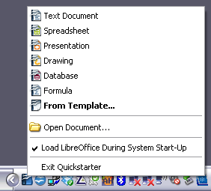
Figure 1: Quickstarter pop-up menu in Windows

Disabling the Quickstarter
To close the Quickstarter, right-click on the icon in the system tray, and then click Exit Quickstarter on the pop-up menu. The next time the computer is restarted, the Quickstarter will be loaded again.
To prevent LibreOffice.org from loading during system startup, deselect the Load LibreOffice during system start-up item on the pop-up menu. You might want to do this if your computer has insufficient memory, for example.

Reactivating the Quickstarter
If the Quickstarter has been disabled, you can reactivate it by selecting the Load LibreOffice during system start-up checkbox in Tools → Options → LibreOffice → Memory.

Using the Quickstarter in Linux and Mac OS X
LibreOffice under Linux has a Quickstarter that looks and acts like the one described above for Windows (the checkbox on the Memory page is labeled Enable systray quickstarter).
Mac OS X provides similar functionality through a popup menu from the dock.

Parts of the main window
The main window is similar in each component of LibreOffice, although some details vary. See the chapters in this book about Writer, Calc, Draw, and Impress for descriptions of those details.
Common features include the menu bar, the standard toolbar, and the formatting toolbar at the top of the window and the status bar at the bottom.

Menu bar
The Menu bar is located across the top of the LibreOffice window, just below the Title bar. When you choose one of the menus listed below, a submenu drops down to show commands.
- File contains commands that apply to the entire document such as Open, Save, and Export as PDF.
- Edit contains commands for editing the document such as Undo: xxx (where xxx is the command to undo) and Find & Replace. It also contains commands to cut, copy, and paste selected parts of your document.
- View contains commands for controlling the display of the document such as Zoom and Web Layout.
- Insert contains commands for inserting elements into your document such as Header, Footer, and Picture.
- Format contains commands, such as Styles and Formatting and AutoCorrect, for formatting the layout of your document.
- Table shows all commands to insert and edit a table in a text document.
- Tools contains functions such as Spelling and Grammar, Customize, and Options.
- Window contains commands for the display window.
- Help contains links to the LibreOffice Help file, What’s This?, and information about the program. See “How to get help“ on page 12.

Toolbars
LibreOffice has several types of toolbars: docked, floating, and tear-off. Docked toolbars can be moved to different locations or made to float, and floating toolbars can be docked.
The top docked toolbar (default position) is called the Standard toolbar. The Standard toolbar is consistent across the LibreOffice applications.
The second toolbar across the top (default location) is the Formatting toolbar. It is a context-sensitive bar that shows the relevant tools in response to the cursor’s current position or selection. For example, when the cursor is on a graphic, the Formatting bar provides tools for formatting graphics; when the cursor is in text, the tools are for formatting text.

Displaying or hiding toolbars
To display or hide toolbars, choose View → Toolbars, then click on the name of a toolbar in the list. An active toolbar shows a checkmark beside its name. Tear-off toolbars are not listed in the View menu.

Submenus and tear-off toolbars
Toolbar icons with a small triangle to the right will display submenus, tear-off toolbars, and other ways of selecting things, depending on the icon.
Figure 2 shows a tear-off toolbar from the Drawing toolbar.
The tear-off toolbars can be floating or docked along an edge of the screen or in one of the existing toolbar areas. To move a floating tear-off toolbar, drag it by the title bar. See “Moving toolbars” below.
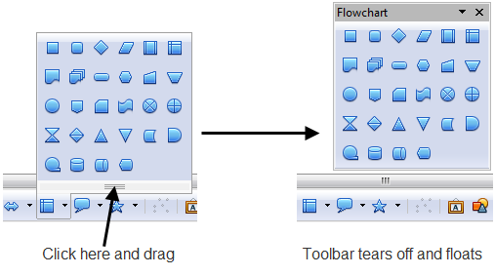
Figure 2: Example of a tear-off toolbar

Moving toolbars
To move a docked toolbar, place the mouse pointer over the toolbar handle (the small vertical bar to the left of the toolbar), hold down the left mouse button, drag the toolbar to the new location, and then release the mouse button (Figure 3). To move a floating toolbar, click on its title bar and drag it to a new location (Figure 4).
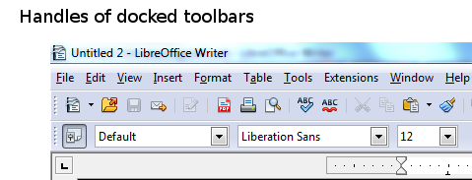
Figure 3: Moving a docked toolbar
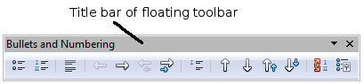
Figure 4: Moving a floating toolbar

Floating toolbars
LibreOffice includes several additional context-sensitive toolbars, whose defaults appear as floating toolbars in response to the cursor’s current position or selection. For example, when the cursor is in a table, a floating Table toolbar appears, and when the cursor is in a numbered or bullet list, the Bullets and Numbering toolbar appears. You can dock these toolbars to the top, bottom, or side of the window, if you wish (see “Moving toolbars” above).

Docking/floating windows and toolbars
Toolbars and some windows, such as the Navigator and the Styles and Formatting window, are dockable. You can move, resize, or dock them to an edge.
To dock a window or toolbar, hold down the Control key and double-click on the frame of the floating window (or in a vacant area near the icons at the top of the floating window) to dock it in its last position.
To undock a window, hold down the Control key and double-click on the frame (or a vacant area near the icons at the top) of the docked window.

Customizing toolbars
You can customize toolbars in several ways, including choosing which icons are visible and locking the position of a docked toolbar. You can also add icons and create new toolbars, as described in Chapter 14.
To access a toolbar’s customization options, use the down-arrow at the end of the toolbar or on its title bar.
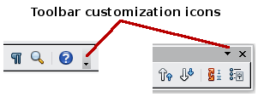
Figure 5: Customizing toolbars
To show or hide icons defined for the selected toolbar, choose Visible Buttons from the drop-down menu. Visible icons are indicated by an outline around the icon. Click on icons to select or deselect them.
Figure 6: Selection of visible toolbar icons

Right-click (context) menus
You can quickly access many menu functions by right-clicking on a paragraph, graphics, or other object. A context menu will pop up. Often the context menu is the fastest and an easier way to reach a function. If you are not sure where a function is located in the menus or toolbars , you can often find it by right-clicking.

Status bar
The status bar is located at the bottom of the workspace. It provides information about the document and convenient ways to quickly change some features. It is similar in Writer, Calc, Impress, and Draw, although each component includes some component-specific items.
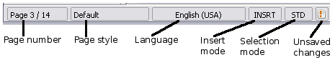
Figure 7: Left end of status bar in Writer
Figure 8: Right end of status bar in Writer
Common status bar items are described below.
Page, sheet, or slide number
Shows the current page, sheet, or slide number and the total number of pages, sheets, or slides in the document. Double-click on this field to open the Navigator. Other uses of this field depend on the component.
Page style or slide design
Shows the current page style or slide design. To edit the current page style or slide design, double-click on this field.
Unsaved changes
An icon appears here if changes to the document have not been saved.
Digital signature
If the document has been digitally signed, an icon shows here. You can double-click the icon to view the certificate.
Object information
Displays information relevant to the cursor’s position or the selected element of the document. Double-clicking in this area usually opens a relevant dialog.
Zoom slider and percent
To change the view magnification, drag the Zoom slider, or click on the + and – signs, or right-click on the zoom level percent to pop up a list of magnification values from which to choose.
Double-clicking on the zoom level percent opens the Zoom & View Layout dialog.

What are all these things called?
The terms used in LibreOffice for most parts of the user interface (the parts of the program you see and use, in contrast to the behind-the-scenes code that actually makes it work) are the same as for most other programs.
A dialog is a special type of window. Its purpose is to inform you of something, or request input from you, or both. It provides controls for you to use to specify how to carry out an action. The technical names for common controls are shown in Figure 9; not shown is the list box (from which you select an item). In most cases we do not use the technical terms in this book, but it is useful to know them because the Help and other sources of information often use them.
In most cases, you can interact only with the dialog (not the document itself) as long as the dialog remains open. When you close the dialog after use (usually, clicking OK or another button saves your changes and closes the dialog), then you can again work with your document.
Some dialogs can be left open as you work, so you can switch back and forth between the dialog and your document. An example of this type is the Find & Replace dialog.
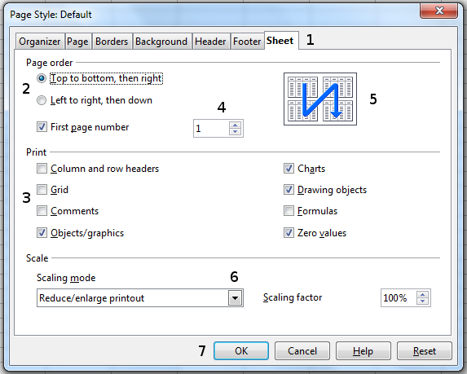
Figure 9: Dialog showing common controls:
1=Tabbed page (not strictly speaking a control)
2=Radio buttons (only one can be selected at a time)
3=Checkbox (more than one can be selected at a time)
4=Spin box (click the up and down arrows to change the number shown in the text box next to it, or type in the text box)
5=Thumbnail or preview
6=Drop-down list from which to select an item
7=Push buttons

Starting a new document
You can start a new, blank document in LibreOffice in several ways.
When LibreOffice is open but no document is open (for example if you close all the open documents but leave the program running), the Start Center is shown. Click one of the icons to open a new document of that type, or click the Templates icon to start a new document using a template.
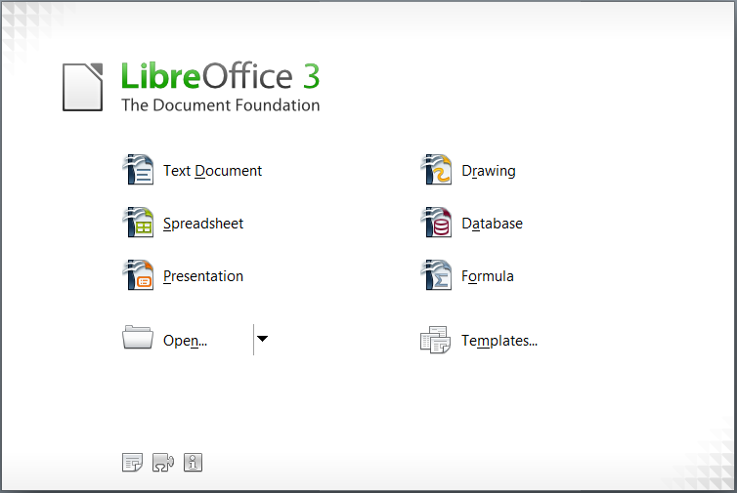
Figure 10: LibreOffice Start Center
You can also start a new document in one of the following ways.
- Use File → New and choose the type of document.
- Use the arrow next to the New button on the main toolbar. From the drop-down menu, select the type of document to be created.
- Press Control+N on the keyboard.
- Use File → Wizards for some special types of documents.
If a document is already open in LibreOffice, the new document opens in a new window.

Opening an existing document
When no document is open, the Start Center provides an icon for opening an existing document or choosing from a list of recently-edited documents.
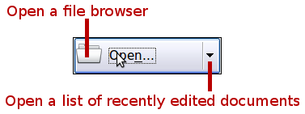
You can also open an existing document in one of the following ways.
- Choose File → Open...
- Click the Open button on the main toolbar.
- Press Control+O on the keyboard.
In each case, the Open dialog appears. Select the file you want, and then click Open. If a document is already open in LibreOffice, the second document opens in a new window.
In the Open dialog, you can reduce the list of files by selecting the type of file you are looking for. For example, if you choose Text documents as the file type, you will only see documents Writer can open (including .odt, .doc, .txt); if you choose Spreadsheets, you will see .ods, .xls, and other files that Calc opens.
You can also open an existing document that is in an OpenDocument format by double-clicking on the file’s icon on the desktop or in a file manager such as Windows Explorer.
If you have associated Microsoft Office file formats with LibreOffice, you can also open these files by double-clicking on them.
Note | Under Microsoft Windows you can use either the LibreOffice Open and Save As dialogs or the ones provided by Microsoft Windows. See “Using the Open and Save As dialogs” on page 22.

Saving a document
To save a new document, do one of the following:
- Press Control+S.
- Choose File → Save from the menu bar.
- Click the Save button on the main toolbar.
When the Save As dialog appears, enter the file name, verify the file type (if applicable), and click Save.
To save an open document with the current file name, choose File → Save. This will overwrite the last saved state of the file.

Password protection
To protect a document from being viewable without a password, use the option on the Save As dialog to enter a password.
- On the Save As dialog, select the Save with password option, and then click Save. You will receive a prompt (Figure 11).
- Type the same password in both fields, and then click OK. If the passwords match, the document is saved password protected. If the passwords do not match, you receive an error message. Close the message box to return to the Set Password dialog and enter the password again.
Caution   | LibreOffice uses a very strong encryption mechanism that makes it almost impossible to recover the contents of a document in case you lose the password.
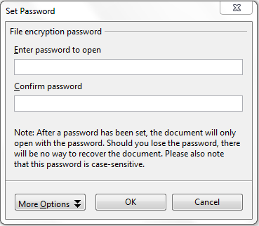
Figure 11: Entering a password for a document
Writer and Calc provide a second level of protection, which allows a file to be viewed but not changed without a password; that is, the file opens in read-only mode.
To protect a document from being changed:
- Choose More Options from the Set Password dialog.
- Enter the password in the Enter password to allow editing field. Repeat the password in the Confirm password field. Click OK.

Saving a document automatically
You can choose to have LibreOffice save files for you automatically. Automatic saving, like manual saving, overwrites the last saved state of the file. To set up automatic file saving:
- Choose Tools → Options... → Load/Save → General.
- Mark Save AutoRecovery information every, and set the time interval.

Renaming and deleting files
You can rename or delete files within the LibreOffice dialogs, just as you can in your usual file manager. However, you cannot copy or paste files within the dialogs.

Using the Open and Save As dialogs
You can choose whether to use the LibreOffice Open and Save As dialogs or the ones provided by your operating system.
To view or change which type of dialog LibreOffice uses:
- Choose Tools → Options → LibreOffice → General.
- Select the Use LibreOffice dialogs option.
This section discusses the LibreOffice Open and Save As dialogs. Figure 12 shows the Save As dialog; the Open dialog is similar.
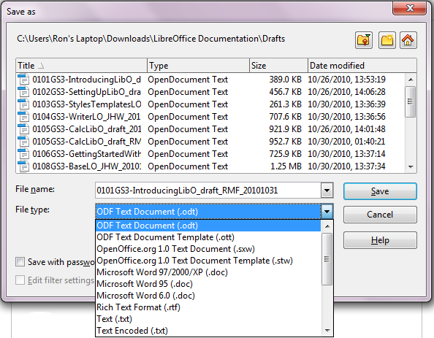
Figure 12: The LibreOffice Save as dialog
The three buttons in the top right of the LibreOffice Open and Save As dialogs are, from left to right:
- Go Up One Level in the folder (directory) hierarchy. Click and hold this button for a second to drop down a list of higher level folders; to go to one of the folders on the list, move the mouse pointer over its name and release the mouse button.
- Create New Folder.
- Default Directory.
For LibreOffice documents that have been saved with more than one version, use the Version drop-down to select which version you wish to open in read-only mode. For Microsoft Office documents, only the current version can be opened.
Use the File type field to specify the type of file to be opened or the format of the file to be saved.
The Read-only option on the Open dialog opens the file for reading and printing only. Consequently, most of the toolbars disappear, and most menu options are disabled. An Edit File button is displayed on the Standard toolbar to open the file for editing.
You can open files from the Web by typing a URL in the File name field on the Open dialog.

Using the Navigator
The Navigator lists objects contained in a document, collected into categories. For example, in Writer it shows Headings, Tables, Text frames, Comments, Graphics, Bookmarks, and other items, as shown in Figure 13. In Calc it shows Sheets, Range Names, Database Ranges, Graphics, Drawing Objects, and other items. In Impress and Draw it shows Slides, Pictures, and other items.
To open the Navigator, click its icon on the Standard toolbar, or press F5, or choose View → Navigator on the menu bar.
You can dock the Navigator to either side of the main LibreOffice window or leave it floating (see “Docking/floating windows and toolbars“ on page 17).
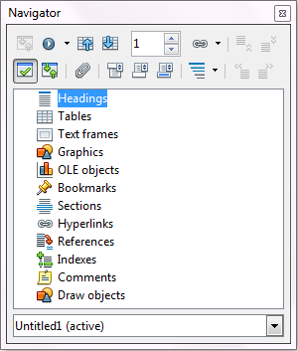
Figure 13: The Navigator
Click the marker (+ or arrow) by any of the categories to display the list of objects in that category.
To hide the list of categories and show only the toolbars at the top, click the List Box On/Off icon . Click this icon again to show the list box.
The Navigator provides several convenient ways to move around a document and find items in it:
- When a category is showing the list of objects in it, double-click on an object to jump directly to that object’s location in the document.
Objects are much easier to find if you have given them names when creating them, instead of keeping LibreOffice’s default graphics1, graphics2, Table1, Table2, and so on—which may not correspond to the position of the object in the document.
If you only want to see the content in a certain category, highlight the category and click the Content View icon . Until you click the icon again, only the objects of that category will be displayed.
- Click the Navigation icon (second icon from the left at the top of the Navigator) to display the Navigation toolbar. Here you can pick one of the categories and use the Previous and Next icons to move from one item to the next. This is particularly helpful for finding items like bookmarks and indexes, which can be difficult to see.
The names of the icons (shown in the tooltips) change to match the selected category; for example, Next Graphic or Next Bookmark.
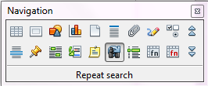
Figure 14: Navigation toolbar
- To jump to a specific page in the document, type its page number in the box at the top of the Navigator.
A bit of experimentation with the other icons will demonstrate their functions. Some component-specific uses are described in the chapters on Writer and the other components.

Undoing and redoing changes
To undo the most recent change, press Control+Z, or click the Undo icon on the Standard toolbar, or choose Edit → Undo from the menu bar.
The Edit menu shows the latest change that can be undone (see below for an example from Writer).
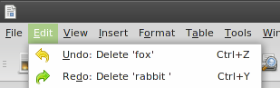
Figure 15: Edit → Undo last action
Click the small triangle to the right of the Undo icon to get a list of all the changes that can be undone. You can select multiple changes and undo them at the same time.
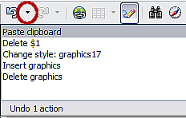
Figure 16: List of actions that can be undone
After changes have been undone, Redo becomes active. To redo a change, select Edit → Redo, or press Control+Y or click on the Redo icon . As with Undo, click on the triangle to the right of the arrow to get a list of the changes that can be reapplied.
To modify the number of changes LibreOffice.org remembers, choose Tools → Options → LibreOffice → Memory and in the Undo section change Number of steps. Be aware that asking LibreOffice to remember more changes consumes more computer memory.

Closing a document
To close a document, choose File → Close.
You can also close a document by clicking on the Close icon on the document window. This button looks like the X shown in Figure 17. It may be in a different location on your operating system.

Figure 17. Close icons
If more than one LibreOffice window is open, each window looks like the sample shown on the left in Figure 17. Closing this window leaves the other LibreOffice windows open.
If only one LibreOffice window is open, it looks like the sample shown on the right in Figure 17. Notice the small x below the large X. Clicking the small x closes the document but leaves LibreOffice open. Clicking the large X closes LibreOffice completely.
If the document has not been saved since the last change, a message box is displayed. Choose whether to save or discard your changes.
- Save: The document is saved and then closed.
- Discard: The document is closed, and all modifications since the last save are lost.
- Cancel: Nothing happens, and you return to the document.
Caution | Not saving your document could result in the loss of recently made changes, or worse still, your entire file.

Closing LibreOffice
To close LibreOffice completely, choose File → Exit, or close the last open document as described in “Closing a document” above.
If all the documents have been saved, LibreOffice closes immediately. If any documents have been modified but not saved, a warning message appears. Follow the procedure in “Closing a document” to save or discard your changes.

Using LibreOffice on a Mac
Some keystrokes and menu items are different on a Mac from those used in Windows and Linux. The table on page 8 gives some common substitutions for the instructions in this book. For a more detailed list, see the application Help.

Getting Started Guide

Chapter 2
Setting up LibreOffice
Choosing options to suit the way you work

Choosing ptions for all of LibreOffice
This section covers some of the settings that apply to all the components of LibreOffice. For information on settings not discussed here, see the online help.
Click Tools → Options. The list in the left-hand box of the Options – LibreOffice dialog varies depending on which component of LibreOffice is open. The illustrations in this chapter show the list as it appears when a Writer document is open.
Click the marker (+ or triangle) by LibreOffice on the left-hand side. A list of pages drops down. Selecting an item in the list causes the right-hand side of the dialog to display the relevant page.
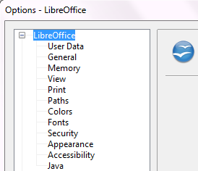
Figure 18: LibreOffice options
Note | The Back button has the same effect on all pages of the Options dialog. It resets the options to the values that were in place when you opened LibreOffice.

User Data options
Because LibreOffice uses the name or initials stored in the LibreOffice – User Data page for several things, including document properties (created by and last edited by information) and the name of the author of notes and changes, you will want to ensure that the correct information appears here.
Fill in the form (shown in Figure 19), or amend or delete any existing incorrect information.
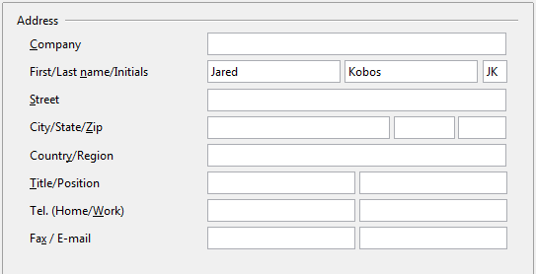
Figure 19: Filling in user data

General options
The options on the LibreOffice – General page are described below.
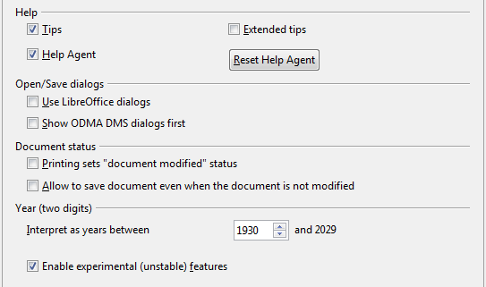
Figure 20: Setting general options for LibreOffice
Help - Tips
When Tips is active, one or two words will appear when you hold the mouse pointer over an icon or field, without clicking.
Help - Extended tips
When Extended tips is active, a brief description of the function of a particular icon or menu command or a field on a dialog appears when you hold the mouse pointer over that item.
Help Agent
To turn off the Help Agent (similar to Microsoft’s Office Assistant), deselect this option. To restore the default behavior, click Reset Help Agent.
Help formatting
High contrast is an operating system setting that changes the system color scheme to improve readability. To display Help in high contrast (if your computer’s operating system supports this), choose one of the high-contrast style sheets from the pull-down list.
High-contrast style | Visual effect
Default | Black text on white background
High Contrast #1 | Yellow text on black background
High Contrast #2 | Green text on black background
High Contrast Black | White text on black background
High Contrast White | Black text on white background
Open/Save dialogs – Use LibraOffice dialogs
To use the standard Open and Save dialogs for your operating system, deselect the Use LibreOffice dialogs option. When this option is selected, the Open and Save dialogs supplied with LibreOffice will be used. See Chapter 1, Introducing LibreOffice, for more about the LibreOffice Open and Save dialogs. This book uses the LibreOffice Open and Save dialogs in illustrations.
Open/Save dialogs - Show ODMA DMS dialogs first
(Windows only) If you have the GroupWise client installed on the computer, you can select this option to have LibreOffice.org offer to open documents from GroupWise, or save documents in GroupWise. If the GroupWise client is not installed, this option has no effect.
Print dialogs – Use LibraOffice dialogs
(Mac only) To use the standard Print dialogs for your operating system, deselect the Use LibreOffice dialogs option. When this option is selected, the Print dialogs supplied with LibreOffice will be used. This book uses the LibreOffice Print dialogs in illustrations.
Document status – Printing sets “document modified” status
If this option is selected, then the next time you close the document after printing, the print date is recorded in the document properties as a change and you will be prompted to save the document again, even if you did not make any other changes.
Document status – Allow to save document even when the document is not modified
Normally when a document has not been modified, the File > Save menu option and the Save icon on the Standard toolbar are disabled and the keyboard shortcut Ctrl+S has no effect. Select this option to allow documents to be saved even when they have not been modified.
Year (two digits)
Specifies how two-digit years are interpreted. For example, if the two-digit year is set to 1930, and you enter a date of 1/1/30 or later into your document, the date is interpreted as 1/1/1930 or later. An “earlier” date is interpreted as being in the following century; that is, 1/1/20 is interpreted as 1/1/2020.
Enable experimental (unstable) features
To try out two experimental features in LibreOffice, in-line formula editing and macro recording, select this option.

Memory options
In the Options dialog, click LibreOffice → Memory. These options control how LibreOffice uses your computer’s memory and how much memory it requires. Before changing them, you may wish to consider the following points:
- More memory can make LibreOffice faster and more convenient (for example, more undo steps require more memory); but the trade-off is less memory available for other applications and you could run out of memory altogether.
- If your documents contain a lot of objects such as images, or the objects are large, LibreOffice’s performance may improve if you increase the memory for LibreOffice or the memory per object. If you find that objects seem to disappear from a document that contains a lot of them, increase the number of objects in the cache. (The objects are still in the file even if you cannot see them on screen.)
- To load the Quickstarter (an icon on the desktop or in the system tray) when you start your computer, select the option near the bottom of the dialog. This makes LibreOffice start faster; the trade-off is LibreOffice uses some memory even when not being used. This option (called Enable systray quickstarter on Linux) is not available on Mac OS X.
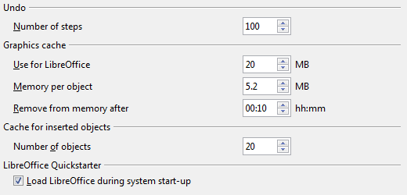
Figure 21: Choosing Memory options for the LibreOffice applications

View options
The options on the LibreOffice – View page affect the way the document window looks and behaves. Some of these options are described below. Set them to suit your personal preferences.
User Interface – Scaling
If the text in the help files or on the menus of the LibreOffice user interface is too small or too large, you can change it by specifying a scaling factor. Sometimes a change here can have unexpected results, depending on the screen fonts available on your system. However, it does not affect the actual font size of the text in your documents.
User Interface – Icon size and style
The first box specifies the display size of toolbar icons (Automatic, Small, or Large). The Automatic icon size option uses the setting for your operating system. The second box specifies the icon style (theme); here the Automatic option uses an icon set compatible with your operating system and choice of desktop: for example, KDE or Gnome on Linux.
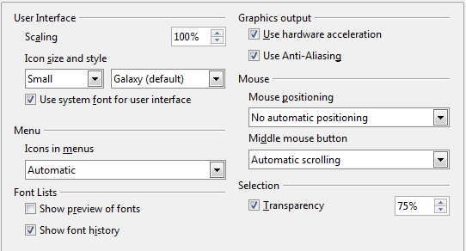
Figure 22: Choosing View options for LibreOffice applications
User Interface – Use system font for user interface
If you prefer to use the system font (the default font for your computer and operating system) instead of the font provided by LibreOffice for the user interface, select this option.
User interface – Screen font anti-aliasing
(Not available in Windows; not shown in Figure 22.) Select this option to smooth the screen appearance of text. Enter the smallest font size to apply anti-aliasing.
Menu – icons in menus
Causes icons as well as words to be visible in menus.
Font Lists - Show preview of fonts
Causes the font list to look like Figure 23, Left, with the font names shown as an example of the font; with the option deselected, the font list shows only the font names, not their formatting (Figure 23, Right). The fonts you will see listed are those that are installed on your system.
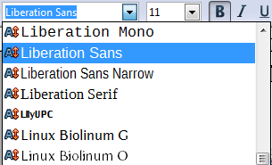 | 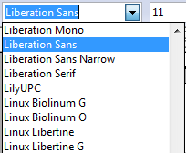
Figure 23. Font list (Left) With preview; (Right) Without preview
Font Lists - Show font history
Causes the last five fonts you have assigned to the current document to be displayed at the top of the font list. Otherwise fonts are shown in alphabetical order.
Graphics output – Use hardware acceleration
Directly accesses hardware features of the graphical display adapter to improve the screen display. Not supported on all operating systems and LibreOffice distributions.
Graphics output – Use anti-aliasing
Enables and disables anti-aliasing, which makes the display of most graphical objects look smoother and with fewer artifacts. Not supported on all operating systems and LibreOffice distributions.
Tip | Press Shift+Control+R to restore or refresh the view of the current document.
Mouse positioning
Specifies if and how the mouse pointer will be positioned in newly opened dialogs.
Middle mouse button
Defines the function of the middle mouse button.
- Automatic scrolling – dragging while pressing the middle mouse button shifts the view.
- Paste clipboard – pressing the middle mouse button inserts the contents of the “Selection clipboard” at the cursor position.
The “Selection clipboard” is independent of the normal clipboard that you use by Edit → Copy/Cut/Paste or their respective keyboard shortcuts. Clipboard and “Selection clipboard” can contain different contents at the same time.
Function | Clipboard | Selection clipboard
Copy content | Edit → Copy Control+C | Select text, table, or object.
Paste content | Edit → Paste Control+V pastes at the cursor position. | Clicking the middle mouse button pastes at the mouse pointer position.
Pasting into another document | No effect on the clipboard contents. | The last marked selection is the content of the selection clipboard.
Selection – Transparency
Determines the appearance of selected text or graphics, which appear on a shaded background. To make the shaded background more or less dark, increase or decrease the Transparency setting.
If you prefer selected material to appear in reversed color (typically white text on a black background), deselect this option.

Print options
On the LibreOffice – Print page, set the print options to suit your default printer and your most common printing method.
In the Printer warnings section near the bottom of the page, you can choose whether to be warned if the paper size or orientation specified in your document does not match the paper size or orientation available for your printer. Having these warnings turned on can be quite helpful, particularly if you work with documents produced by people in other countries where the standard paper size is different from yours.
Tip | If your printouts are incorrectly placed on the page or chopped off at the top, bottom, or sides, or the printer is refusing to print, the most likely cause is page size incompatibility.
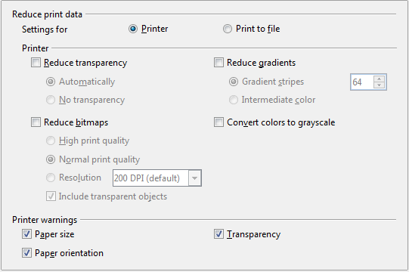
Figure 24: Choosing general printing options to apply to all LibreOffice components

Path options
On the LibreOffice – Paths page, you can change the location of files associated with, or used by, LibreOffice to suit your working situation. In a Windows system, for example, you might want to store documents by default somewhere other than My Documents.
To make changes, select an item in the list shown in Figure 25 and click Edit. On the Select Path dialog (not shown; may also be titled Edit Paths), add or delete folders as required, and then click OK to return to the Options dialog. Note that some items can have at least two paths listed: one to a shared folder (which might be on a network) and one to a user-specific folder (normally on the user’s personal computer).
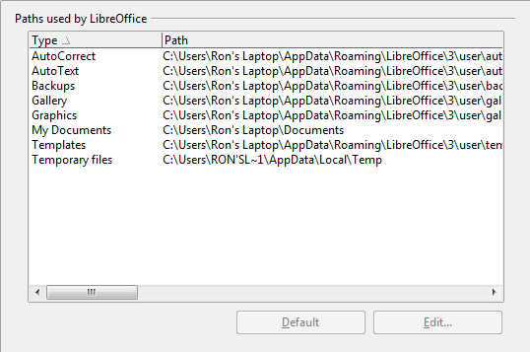
Figure 25: Viewing the paths of files used by LibreOffice
Tip | You can use the entries in the LibreOffice – Paths dialog to compile a list of files, such as those containing AutoText, that you need to back up or copy to another computer.

Color options
On the LibreOffice – Colors page, you can specify colors to use in LibreOffice documents. You can select a color from a color table, edit an existing color, and define new colors. These colors are stored in your color palette and are then available in all components of LibreOffice.

Figure 26: Defining colors to use in color palettes in LibreOffice
To modify a color:
- Select the color to modify from the list or the color table.
- Enter the new values that define the color. If necessary, change the settings from RGB (Red, Green, Blue) to CMYK (Cyan, Magenta, Yellow, Black) or vice versa. The changed color appears in the lower of the two color preview boxes at the top.
- Modify the Name as required.
- Click the Modify button. The newly defined color is now listed in the Color table.
Alternatively, click the Edit button to open the Color dialog, shown in Figure 27. Here you can select a color from one of the color windows in the upper area, or you can enter values in the lower area using your choice of RGB, CMYK, or HSB (Hue, Saturation and Brightness) values.
The upper right color window is linked directly with the color input fields in the lower area; as you choose a color in the upper window, the numbers change accordingly. The two color fields at the lower right show the value of the selected color on the left and the currently set value from the color value fields on the right.
Modify the color components as required and click OK to exit the dialog. The newly defined color now appears in the lower of the color preview boxes shown in Figure 26. Type a name for this color in the Name box, then click the Add button. A small box showing the new color is added to the Color table.
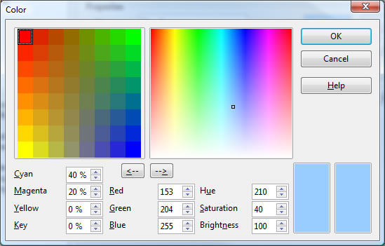
Figure 27: Editing colors
Another way to define or alter colors is through the Colors page of the Area dialog, where you can also save and load palettes, a feature that is not possible here. In Calc, draw a temporary draw object and use the context menu of this object to open the Area dialog. If you load a palette in one component of LibreOffice, it is only active in that component; the other components keep their own palettes.

Font options
You can define replacements for any fonts that might appear in your documents. If you receive from someone else a document containing fonts that you do not have on your system, LibreOffice will substitute fonts for those it does not find. You might prefer to specify a different font from the one the program chooses.
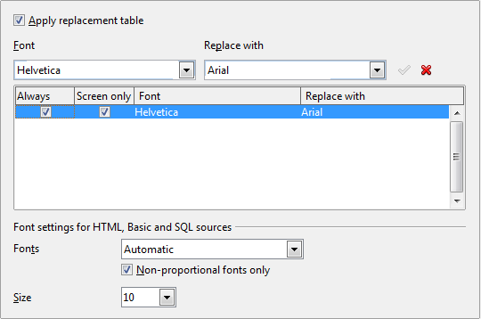
Figure 28: Defining a font to be substituted for another font
On the LibreOffice – Fonts page:
- Select the Apply Replacement Table option.
- Select or type the name of the font to be replaced in the Font box. (If you do not have this font on your system, it will not appear in the drop-down list in this box, so you need to type it in.)
- In the Replace with box, select a suitable font from the drop-down list of fonts installed on your computer.
- The checkmark to the right of the Replace with box turns green. Click on this checkmark. A row of information now appears in the larger box below the input boxes. Select the options under Always and Screen.
- In the bottom section of the page, you can change the typeface and size of the font used to display source code such as HTML and Basic (in macros).

Security options
Use the LibreOffice – Security page to choose security options for saving documents and for opening documents that contain macros.
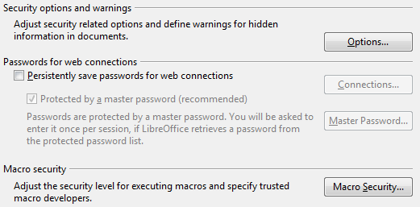Figure 29: Choosing security options for opening and saving documents
Security options and warnings
If you record changes, save multiple versions, or include hidden information or notes in your documents, and you do not want some of the recipients to see that information, you can set warnings to remind you to remove it, or you can have LibreOffice remove some of it automatically. Note that (unless removed) much of this information is retained in a file whether the file is in LibreOffice’s default OpenDocument format, or has been saved to other formats, including PDF.
Click the Options button to open a separate dialog with specific choices (Figure 30).
Macro security
Click the Macro Security button to open the Macro Security dialog (not shown here), where you can adjust the security level for executing macros and specify trusted sources.

Security options and warnings
The following options are on the Security options and warnings dialog (Figure 30).
Remove personal information on saving
Select this option to always remove user data from the file properties when saving the file. To manually remove personal information from specific documents, deselect this option and then use the Delete button under File → Properties → General.
Ctrl-click required to follow hyperlinks
In older versions of LibreOffice, clicking on a hyperlink in a document opened the linked document. Now you can choose whether to keep this behavior (by unchecking this box). Many people find creation and editing of documents easier when accidental clicks on links do not activate the links.
The other options on this dialog should be self-explanatory.
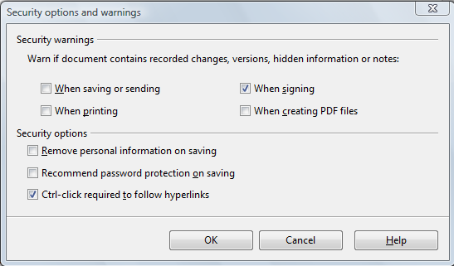
Figure 30: Security options and warnings dialog

Appearance options
Writing, editing, and (especially) page layout are often easier when you can see the page margins (text boundaries), the boundaries of tables and sections (in Writer documents), page breaks in Calc, grid lines in Draw or Writer, and other features. In addition, you might prefer to use colors that are different from LibreOffice’s defaults for such items as note indicators or field shadings.
On the LibreOffice – Appearance page, you can specify which items are visible and the colors used to display various items.
- To show or hide items such as text boundaries, select or deselect the options next to the names of the items.
- To change the default colors for items, click the down-arrow in the Color Setting column by the name of the item and select a color from the pop-up box.
- To save your color changes as a color scheme, click Save, type a name in the Scheme box; then click OK.
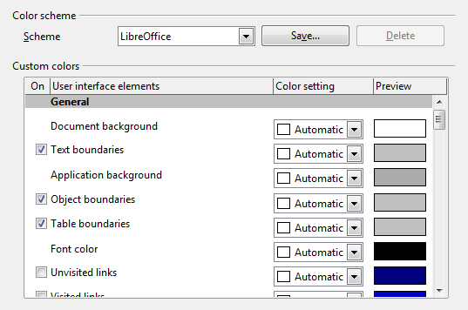
Figure 31: Showing or hiding text, object, and table boundaries

Accessibility options
Accessibility options include whether to allow animated graphics or text, how long help tips remain showing, some options for high contrast display, and a way to change the font for the user interface of the LibreOffice program.
Accessibility support relies on Sun Microsystems Java technology for communications with assistive technology tools. See “Java options“ below. The Support assistive technology tools option is not shown on all LibreOffice installations. See Assistive Tools in LibreOffice in the Help for other requirements and information.
Select or deselect the options as required.
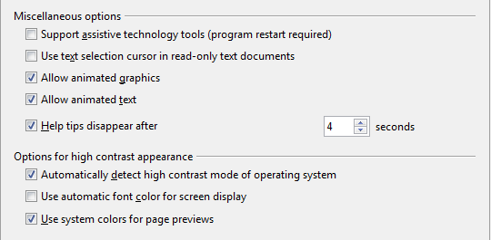
Figure 32: Choosing accessibility options

Java options
If you install or update a Java Runtime Environment (JRE) after you install LibreOffice, or if you have more than one JRE installed on your computer, you can use the LibreOffice – Java options page to choose the JRE for LibreOffice to use.
If you are a system administrator, programmer, or other person who customizes JRE installations, you can use the Parameters and Class Path pages (reached from the Java page) to specify this information.
If you do not see anything listed in the middle of the page, wait a few minutes while LibreOffice searches for JREs on the hard disk.
If LibreOffice finds one or more JREs, it will display them there. You can then select the Use a Java runtime environment option and (if necessary) choose one of the JREs listed.
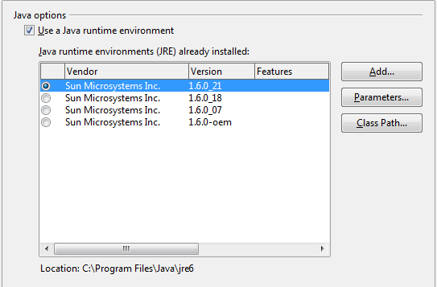
Figure 33: Choosing a Java runtime environment

Choosing options for loading and saving documents
You can set the Load/Save options to suit the way you work.
If the Options dialog is not already open, click Tools → Options. Click the expansion symbol (+ or triangle) to the left of Load/Save.
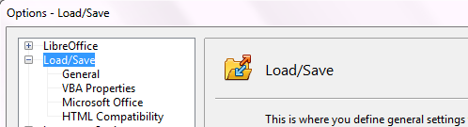
Figure 34: Load/Save options

General Load/Save options
Most of the choices on the Load/Save – General page are familiar to users of other office suites. Some items of interest are described below.
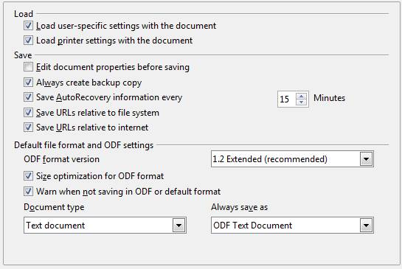
Figure 35. Choosing Load and Save options
Load user-specific settings with the document
When you save a document, certain settings are saved with it. Some settings (printer name, data source linked to the document) are always loaded with a document, whether or not this option is selected. If you select this option, these document settings are overruled by the user-specific settings of the person who opens it. If you deselect this option, the user’s personal settings do not overrule the settings in the document. For example, your choice (in the options for LibreOffice Writer) of how to update links is affected by the Load user-specific settings option.
Load printer settings with the document
If this option is not selected, the printer settings that are stored with the document are ignored when you print it using the Print File Directly icon. The default printer in your system will be used instead.
Edit document properties before saving
If you select this option, the Document Properties dialog pops up to prompt you to enter relevant information the first time you save a new document (or whenever you use Save As).
Save AutoRecovery information every
Choose whether to enable AutoRecovery and how often to save the information used by the AutoRecovery process.
AutoRecovery in LibreOffice overwrites the original file. If you also choose Always create backup copy, the original file then overwrites the backup copy. If you have this set, recovering your document after a system crash will be easier; but recovering an earlier version of the document may be harder.
Save URLs relative to file system / internet
Relative addressing to a file system is only possible if the source document and the referenced document are both on the same drive. A relative address always starts from the directory in which the current document is located. It is recommended to save relatively if you want to create a directory structure on an Internet server.
Default file format and ODF settings
ODF format version. LibreOffice by default saves documents in OpenDocument Format (ODF) version 1.2 Extended. While this allows for improved functionality, there may be backwards compatibility issues. When a file saved in ODF 1.2 Extended is opened in an editor that uses earlier versions of ODF, 1.0/1.1, some of the advanced features may be lost. Two notable examples are cross-references to headings and the formatting of numbered lists. If you plan to share documents with people who use editors which use older versions of ODF, save the document using ODF version 1.0/1.1.
Size optimization for ODF format. LibreOffice documents are XML files. When you select this option, LibreOffice writes the XML data without indents and line breaks. If you want to be able to read the XML files in a text editor in a structured form, deselect this option.
Document type. If you routinely share documents with users of Microsoft Office, you might want to change the Always save as attribute for documents to one of the Microsoft Office formats.
Note | Although LibreOffice can open and save files in the .docx and .xlsx formats produced by Microsoft Office 2007 and 2010, it does not yet save in .pptx format. This capability is planned for a future release.

VBA Properties Load/Save options
On the Load/Save – VBA Properties page, you can choose whether to keep any macros in Microsoft Office documents that are opened in LibreOffice.
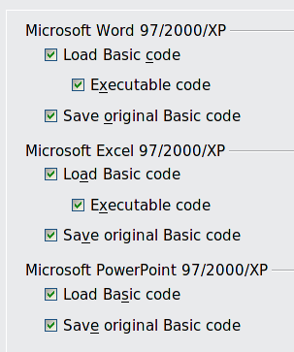
Figure 36: Choosing Load/Save VBA Properties
- If you choose Save original Basic code, the macros will not work in LibreOffice but are retained if you save the file into Microsoft Office format.
- If you choose Load Basic code to edit, the changed code is saved in an LibreOffice document but is not retained if you save into a Microsoft Office format.
- If you are importing a Microsoft Word or Excel file containing VBA code, you can select the option Executable code. Whereas normally the code is preserved but rendered inactive (if you inspect it with the StarBasic IDE you will notice that it is all commented), with this option the code is ready to be executed.

Microsoft Office Load/Save options
On the Load/Save – Microsoft Office page, you can choose what to do when importing and exporting Microsoft Office OLE objects (linked or embedded objects or documents such as spreadsheets or equations).
Select the [L] options to convert Microsoft OLE objects into the corresponding LibreOffice OLE objects when a Microsoft document is loaded into LibreOffice (mnemonic: “L” for “load”).
Select the [S] options to convert LibreOffice OLE objects into the corresponding Microsoft OLE objects when a document is saved in a Microsoft format (mnemonic: “S” for “save”).
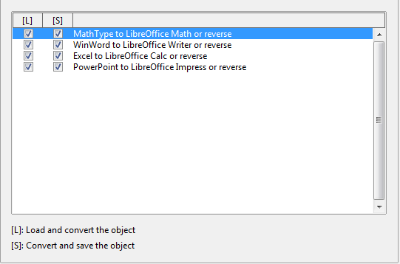
Figure 37: Choosing Load/Save Microsoft Office options

HTML compatibility Load/Save options
Choices made on the Load/Save – HTML Compatibility page affect HTML pages imported into LibreOffice and those exported from LibreOffice. See HTML documents; importing/exporting in the Help for more information.
Font sizes
Use these fields to define the respective font sizes for the HTML <font size=1> to <font size=7> tags, if they are used in the HTML pages. (Many pages no longer use these tags.)
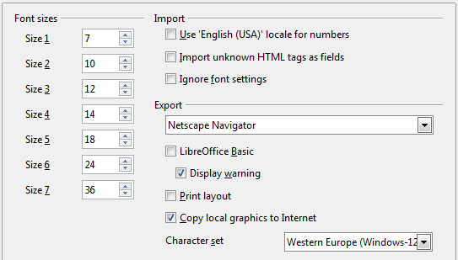
Figure 38. Choosing HTML compatibility options
Import - Use 'English (USA)' locale for numbers
When importing numbers from an HTML page, the decimal and thousands separator characters differ according to the locale of the HTML page. The clipboard, however, contains no information about the locale. If this option is not selected, numbers will be interpreted according to the Language - Locale setting in Tools → Options → Language Settings → Languages (see page 45). If this option is selected, numbers will be interpreted as for the English (USA) locale.
Import - Import unknown HTML tags as fields
Select this option if you want tags that are not recognized by LibreOffice to be imported as fields. For an opening tag, an HTML_ON field will be created with the value of the tag name. For a closing tag, an HTML_OFF will be created. These fields will be converted to tags in the HTML export.
Import - Ignore font settings
Select this option to have LibreOffice ignore all font settings when importing. The fonts that were defined in the HTML Page Style will be used.
Export
To optimize the HTML export, select a browser or HTML standard from the Export box. If LibreOffice Writer is selected, specific LibreOffice Writer instructions are exported.
Export - LibreOffice Basic
Select this option to include LibreOffice Basic macros (scripts) when exporting to HTML format. You must activate this option before you create the LibreOffice Basic macro; otherwise the script will not be inserted. LibreOffice Basic macros must be located in the header of the HTML document. Once you have created the macro in the LibreOffice Basic IDE, it appears in the source text of the HTML document in the header.
If you want the macro to run automatically when the HTML document is opened, choose Tools → Customize → Events. See Chapter 13, Getting Started with Macros, for more information.
Export - Display warning
When the LibreOffice Basic option (see above) is not selected, the Display warning option becomes available. If the Display warning option is selected, then when exporting to HTML a warning is shown that LibreOffice Basic macros will be lost.
Export - Print layout
Select this option to export the print layout of the current document as well. The HTML filter supports CSS2 (Cascading Style Sheets Level 2) for printing documents. These capabilities are only effective if print layout export is activated.
Export - Copy local graphics to Internet
Select this option to automatically upload the embedded pictures to the Internet server when uploading using FTP.
Export - Character set
Select the appropriate character set for the export.

Choosing language settings
There are several options to customize the language setting in LibreOffice:
- Install the required dictionaries
- Change some locale and language settings
- Choose spelling options

Install the required dictionaries
LibreOffice automatically installs several dictionaries with the program. To add other dictionaries, be sure you are connected to the Internet, and then use Tools → Language → More Dictionaries Online. LibreOffice will open your default web browser to a page containing links to additional dictionaries that you can install. Follow the prompts to select and install the ones you want.

Change locale and language settings
You can change some details of the locale and language settings that LibreOffice uses for all documents, or for specific documents.
In the Options dialog, click Language Settings → Languages.
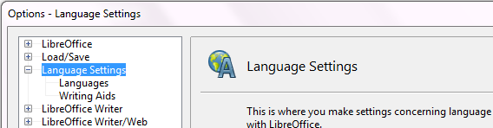
Figure 39: Language Setting Options
On the right-hand side of the Language Settings – Languages page, change the User interface, Locale setting, Default currency, and Default languages for documents as required. In the example, English (USA) has been chosen for all the appropriate settings.
If you want the language (dictionary) setting to apply to the current document only, instead of being the default for all new documents, select the option labelled For the current document only.
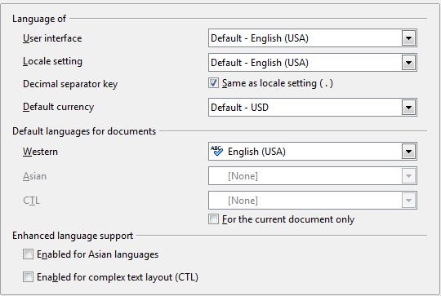Figure 40: Choosing language options
If necessary, select the options to enable support for Asian languages (Chinese, Japanese, Korean) and support for CTL (complex text layout) languages such as Urdu, Thai, Hebrew, and Arabic. If you choose either of these options, the next time you open this dialog, you will see some extra choices under Language Settings, as shown below. These choices (Searching in Japanese, Asian Layout, and Complex Text Layout) are not discussed here.
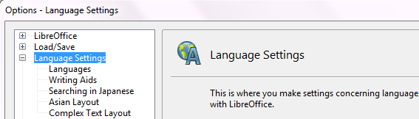
Figure 41: Extra pages available when enhanced language support options are selected

Choose spelling options
To choose the options for checking spelling, click Language Settings → Writing Aids. In the Options section of the page (Figure 42), choose the settings that are useful for you. Some considerations:
- If you do not want spelling checked while you type, deselect Check spelling as you type and select Do not mark errors. (To find the second item, scroll down in the Options list.)
- If you use a custom dictionary that includes words in all upper case and words with numbers (for example, AS/400), select Check uppercase words and Check words with numbers.
- Check special regions includes headers, footers, frames, and tables when checking spelling.
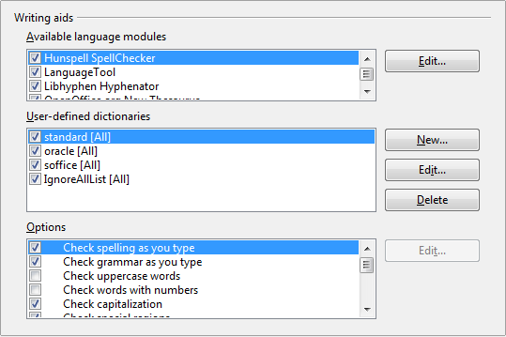Figure 42: Choosing languages, dictionaries, and options for checking spelling
Here you can also check which user-defined (custom) dictionaries are active by default, and add or remove dictionaries, by clicking the New or Delete buttons.
Note | LibreOffice has a spelling and grammar checker called Language Tool. You can access the tool from Tools → Spelling and Grammar.

Choosing Internet options
Use the Internet Options pages to define search engines and save proxy settings for use with LibreOffice.
If you are using a Mozilla browser (such as Firefox) on Windows or Linux, you can enable the Browser Plug-in so you can open LibreOffice files in your browser, print them, save them, and work with them in other ways.
If you are using a Unix- or Linux-based operating system (including Mac OS X), an additional page of E-mail options is available, where you can specify the e-mail program to use when you send the current document as e-mail. See Figure 43. Under Windows the operating system’s default e-mail program is always used.
Windows and Linux installations also have a Wiki Publisher extension included by default. Select MediaWiki in the Internet options, then click the Add button to open the dialog shown in Figure 44. Here you can specify the address (URL) and login information for a wiki. You can add several wikis to the list.
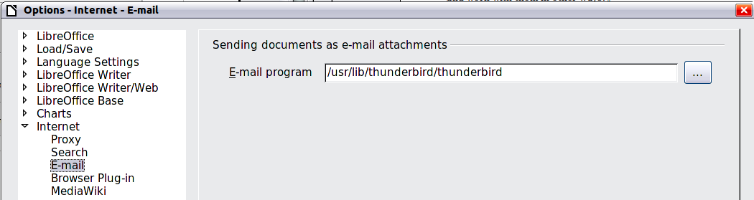
Figure 43: Internet options, showing E-mail page available to Linux users
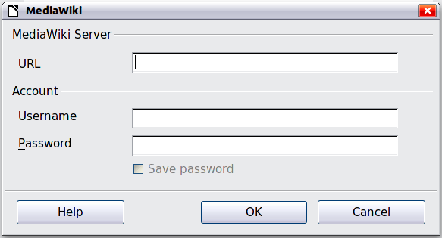Figure 44: Specifying a MediaWiki server account

Controlling LibreOffice’s AutoCorrect functions
Some people find some or all of the items in LibreOffice’s AutoCorrect function annoying because they change what you type when you do not want it changed. Many people find some of the AutoCorrect functions quite helpful; if you do, then select the relevant options. But if you find unexplained changes appearing in your document, this is a good place to look to find the cause.
To open the AutoCorrect dialog, click Tools → AutoCorrect Options. (You need to have a document open for this menu item to appear.)
In Writer, this dialog has five tabs, as shown in Figure 45. In other components of LibreOffice, the dialog has only four tabs.
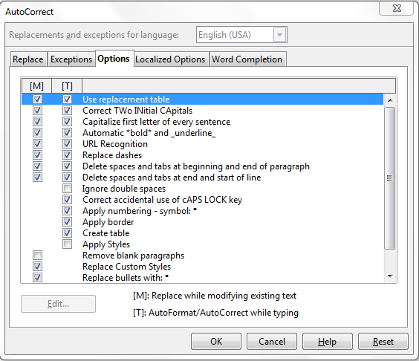
Figure 45: The AutoCorrect dialog in Writer, showing the five tabs and some of the choices

Getting Started Guide

Chapter 3
Using Styles and Templates

What is a template?
A template is a model that you use to create other documents. For example, you can create a template for business reports that has your company’s logo on the first page. New documents created from this template will all have your company’s logo on the first page.
Templates can contain anything that regular documents can contain, such as text, graphics, a set of styles, and user-specific setup information such as measurement units, language, the default printer, and toolbar and menu customization.
All documents in LibreOffice are based on templates. You can create a specific template for any document type (text, spreadsheet, drawing, presentation). If you do not specify a template when you start a new document, then the document is based on the default template for that type of document. If you have not specified a default template, LibreOffice uses the blank template for that type of document that is installed with LibreOffice. See “Setting a default template” on page 65 for more information.

What are styles?
A style is a set of formats that you can apply to selected pages, text, frames, and other elements in your document to quickly change their appearance. When you apply a style, you apply a whole group of formats at the same time.
Many people manually format paragraphs, words, tables, page layouts, and other parts of their documents without paying any attention to styles. They are used to writing documents according to physical attributes. For example, you might specify the font family, font size, and any formatting such as bold or italic.
Styles are logical attributes. Using styles means that you stop saying “font size 14pt, Times New Roman, bold, centered”, and you start saying “Title” because you have defined the “Title” style to have those characteristics. In other words, styles means that you shift the emphasis from what the text (or page, or other element) looks like, to what the text is.
Styles help improve consistency in a document. They also make major formatting changes easy. For example, you may decide to change the indentation of all paragraphs, or change the font of all titles. For a long document, this simple task can be prohibitive. Styles make the task easy.
In addition, styles are used by LibreOffice for many processes, even if you are not aware of them. For example, Writer relies on heading styles (or other styles you specify) when it compiles a table of contents. Some common examples of style use are given in “Examples of style use” on page 68.
LibreOffice supports the following types of styles:
- Page styles include margins, headers and footers, borders and backgrounds. In Calc, page styles also include the sequence for printing sheets.
- Paragraph styles control all aspects of a paragraph’s appearance, such as text alignment, tab stops, line spacing, and borders, and can include character formatting.
- Character styles affect selected text within a paragraph, such as the font and size of text, or bold and italic formats.
- Frame styles are used to format graphic and text frames, including wrapping type, borders, backgrounds, and columns.
- Numbering styles apply similar alignment, numbering or bullet characters, and fonts to numbered or bulleted lists.
- Cell styles include fonts, alignment, borders, background, number formats (for example, currency, date, number), and cell protection.
- Graphics styles in drawings and presentations include line, area, shadowing, transparency, font, connectors, dimensioning, and other attributes.
- Presentation styles include attributes for font, indents, spacing, alignment, and tabs.
Different styles are available in the various components of LibreOffice, as listed in Table 1.
LibreOffice comes with many predefined styles. You can use the styles as provided, modify them, or create new styles, as described in this chapter.
Table 1. Styles available in LibreOffice components
Style Type | Writer | Calc | Draw | Impress
Page | X | X
Paragraph | X
Character | X
Frame | X
Numbering | X
Cell |  | X
Presentation |  |  | X | X
Graphics | (included in Frame styles) |  | X | X

Applying styles
LibreOffice provides several ways for you to select styles to apply.

Using the Styles and Formatting window
- Click the Styles and Formatting icon located at the left-hand end of the object bar, or click Format → Styles and Formatting, or press F11. The Styles and Formatting window shows the types of styles available for the LibreOffice component you are using. Figure 46 shows the window for Writer, with Page Styles visible.
You can move this window to a convenient position on the screen or dock it to an edge (hold down the Ctrl key and drag it by the title bar to where you want it docked).
- Click on one of the icons at the top left of the Styles and Formatting window to display a list of styles in a particular category.
- To apply an existing style (except for character styles), position the insertion point in the paragraph, frame, or page, and then double-click on the name of the style in one of these lists. To apply a character style, select the characters first.
Tip | At the bottom of the Styles and Formatting window is a dropdown list. In Figure 46 the window shows Automatic, meaning the list includes only styles applied automatically by LibreOffice. You can choose to show all styles or other groups of styles, for example only custom styles.
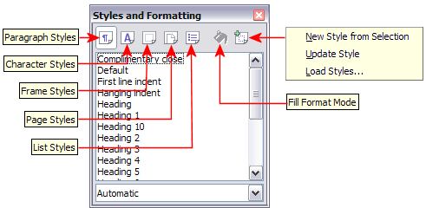
Figure 46: The Styles and Formatting window for Writer, showing paragraph styles

Using Fill Format Mode
Use Fill Format to apply a style to many different areas quickly without having to go back to the Styles and Formatting window and double-click every time. This method is quite useful when you need to format many scattered paragraphs, cells, or other items with the same style.
- Open the Styles and Formatting window and select the style you want to apply.
- Click the Fill Format Mode icon .
- To apply a paragraph, page, or frame style, hover the mouse over the paragraph, page, or frame and click. To apply a character style, hold down the mouse button while selecting the characters, Clicking on a word applies the character style for that word. Repeat step 3 until you made all the changes for that style.
- To quit Fill Format mode, click the Fill Format Mode icon again or press the Esc key.
Caution | When this mode is active, a right-click anywhere in the document undoes the last Fill Format action. Be careful not to accidentally right-click and thus undo actions you want to keep.

Using the Apply Style list
After you have used a style at least once in a document, the style name appears on the Apply Style list at the left-hand end of the Formatting toolbar, next to the Styles and Formatting icon.
You can open this list and click once on the style you want, or you can use the up and down arrow keys to move through the list and then press Enter to apply the highlighted style.
Tip | Select More... at the bottom of the Apply Style list to open the Styles and Formatting window.
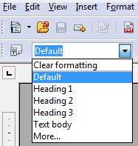
Figure 47: The Apply Style list on the Formatting toolbar

Using keyboard shortcuts
Some keyboard shortcuts for applying styles are predefined. For example, in Writer Control+0 applies the Text body style, Control+1 applies the Heading 1 style, and Control+2 applies the Heading 2 style. You can modify these shortcuts and create your own; see Chapter 14, Customizing LibreOffice, for instructions.

Modifying styles
LibreOffice provides several ways to modify styles (both the predefined styles and custom styles that you create):
- Changing a style using the Style dialog
- Updating a style from a selection
- Use AutoUpdate (paragraph and frame styles only)
- Load or copy styles from another document or template
Tip | Any changes you make to a style are effective only in the current document. To change styles in more than one document, you need to change the template or copy the styles into the other documents as described on page 57.

Changing a style using the Style dialog
To change an existing style using the Style dialog, right-click on the required style in the Styles and Formatting window and select Modify from the pop-up menu.
The Style dialog displayed depends on the type of style selected. Each style dialog has several tabs. See the chapters on styles in the user guides for details.

Updating a style from a selection
To update a style from a selection:
- Open the Styles and Formatting window.
- In the document, select an item that has the format you want to adopt as a style.
Caution | Make sure that there are unique properties in this paragraph. For example, if there are two different font sizes or font styles, that particular property will remain the same as before.
- In the Styles and Formatting window, select the style you want to update (single-click, not double-click), then long-click on the arrow next to the New Style from Selection icon and click on Update Style.
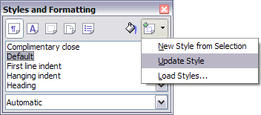Figure 48: Updating a style from a selection

Using AutoUpdate
AutoUpdate applies to paragraph and frame styles only. If the AutoUpdate option is selected on the Organizer page of the Paragraph Style or Frame Style dialog, applying direct formatting to a paragraph or frame using this style in your document automatically updates the style itself.
Tip | If you are in the habit of manually overriding styles in your document, be sure that AutoUpdate is not enabled.

Updating styles from a document or template
You can update styles by copying or loading them from a template or another document. See “Copying and moving styles” on page 57.

Creating new (custom) styles
You may want to add some new styles. You can do this in two ways:
- Creating a new style using the Style dialog
- Creating a new style from a selection

Creating a new style using the Style dialog
To create a new style using the Style dialog, right-click in the Styles and Formatting window and select New from the pop-up menu.
If you want your new style to be linked with an existing style, first select that style and then right-click and select New.
If you link styles, then when you change the base style (for example, by changing the font from Times to Helvetica), all the linked styles will change as well. Sometimes this is exactly what you want; other times you do not want the changes to apply to all the linked styles. It pays to plan ahead.
The dialogs and choices are the same for defining new styles and for modifying existing styles. See the chapters on styles in the user guides for details.

Creating a new style from a selection
You can create a new style by copying an existing manual format. This new style applies only to this document; it will not be saved in the template.
- Open the Styles and Formatting window and choose the type of style you want to create.
- In the document, select the item you want to save as a style.
- In the Styles and Formatting window, click on the New Style from Selection icon.
- In the Create Style dialog, type a name for the new style. The list shows the names of existing custom styles of the selected type. Click OK to save the new style.
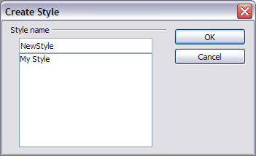
Figure 49: Naming a new style created from a selection

Dragging and dropping to create a style
You can drag and drop a text selection into the Styles and Formatting window to create a new style.
Writer
Select some text and drag it to the Styles and Formatting window. If Paragraph Styles are active, the paragraph style will be added to the list. If Character Styles are active, the character style will be added to the list.
Calc
Drag a cell selection to the Styles and Formatting window to create cell styles.
Draw/Impress
Select and drag drawing objects to the Styles and Formatting window to create graphics styles.

Copying and moving styles
You can copy or move styles from one template or document into another template or document, in two ways:
- Using the Template Management dialog
- Loading styles from a template or document

Using the Template Management dialog
To copy or move styles using the Template Management dialog:
- Click File → Templates → Organize.
- In the Template Management dialog (Figure 50), set the lists at the bottom to either Templates or Documents, as needed. The default is Templates on the left and Documents on the right.
Tip | To copy styles from a file that is not open, click the File button. When you return to this dialog, both lists show the selected file as well as all the currently open documents.
- Open the folders and find the templates from and to which you want to copy. Double-click on the name of the template or document, and then double-click the Styles icon to show the list of individual styles (Figure 51).
- To copy a style, hold down the Ctrl key and drag the name of the style from one list to the other.
Caution | If you do not hold down the Control key when dragging, the style will be moved from one list to the other. The style will be deleted from the list you are dragging it from.
- Repeat for each style you want to copy. If the receiving template or document has many styles, you may not see any change unless you scroll down in the list. When you are finished, click Close.
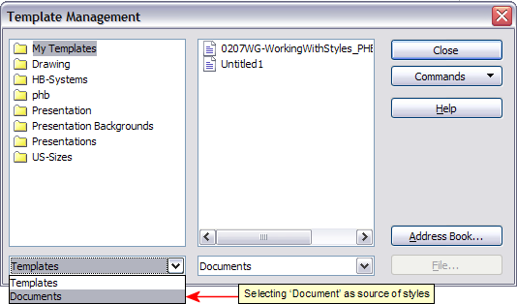
Figure 50: Choosing to copy styles from a document, not a template
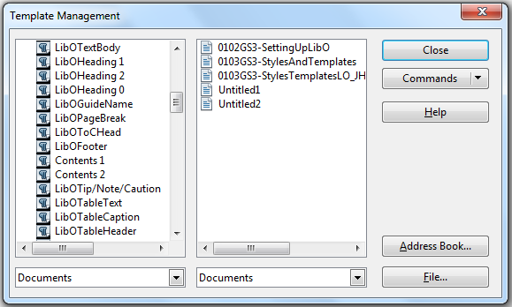
Figure 51: Copying a style from one document to another

Loading styles from a template or document
You can copy styles by loading them from a template or another document:
- Open the document you want to copy styles into.
- In the Styles and Formatting window, long-click on the arrow next to the New Style from Selection icon, and then click on Load Styles (see Figure 48).
- On the Load Styles dialog (Figure 52), find and select the template you want to copy styles from.
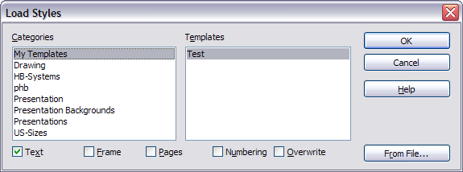
Figure 52. Copying styles from a template into the open document
- Select the categories of styles to be copied. Select Overwrite if you want the styles being copied to replace any styles of the same names in the document you are copying them into.
- Click OK to copy the styles. You will not see any change on screen.
Note | To copy the styles from another document, click the From File button to open a window from which you can select the required document.
Caution | If your document has a table of contents, and if you have used custom styles for headings, the heading levels associated with outline levels (in Tools → Outline Numbering) will revert to the defaults of Heading 1, Heading 2, and so on when you load styles this way. You will need to change these back to your custom heading styles.

Deleting styles
You cannot remove (delete) any of LibreOffice’s predefined styles from a document or template, even if they are not in use.
You can remove any user-defined (custom) styles; but before you do, you should make sure the styles are not in use. If an unwanted style is in use, you will want to replace it with a substitute style.
To delete unwanted styles, right-click on them (one at a time) in the Styles and Formatting window and click Delete on the pop-up menu.
If the style is in use, you receive a warning message.
Caution | Make sure the style is not in use before deletion. Otherwise, all objects with that style will return to the default style and retain their formatting as manual formatting.
If the style is not in use, you receive a confirmation message; click Yes to delete the style.

Using a template to create a document
To use a template to create a document:
- From the main menu, choose File → New → Templates and Documents. The Templates and Documents dialog opens.
- In the box on the left, click the Templates icon if it is not already selected. A list of template folders appears in the center box.
- Double-click the folder that contains the template that you want to use. A list of all the templates contained in that folder appears in the center box.
- Select the template that you want to use. You can preview the selected template or view the template’s properties:
  - To preview the template, click the Preview icon . A preview of the template appears in the box on the right.
  - To view the template’s properties, click the Document Properties icon . The template’s properties appear in the box on the right.
- Click Open. The Templates and Documents dialog closes and a new document based on the selected template opens in LibreOffice. You can then edit and save the new document just as you would any other document.
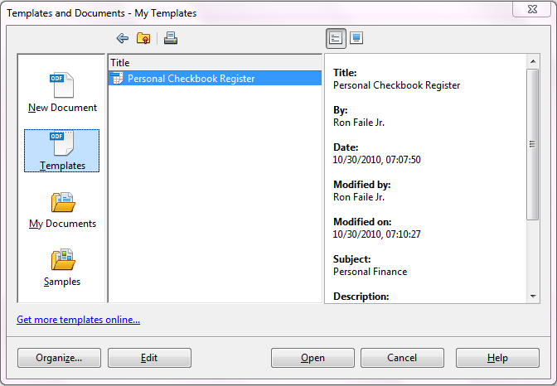
Figure 53: Templates and Documents window

Creating a template
You can create your own templates in two ways: from a document, and using a wizard.

Creating a template from a document
To create a template from a document:
- Open a new or existing document of the type you want to make into a template (text document, spreadsheet, drawing, presentation).
- Add the content and styles that you want.
- From the main menu, choose File → Templates → Save. The Templates dialog opens (see Figure 54).
- In the New template field, type a name for the new template.
- In the Categories list, click the category to which you want to assign the template. The category you choose has no effect on the template itself; it is simply the folder in which you save the template. Choosing an appropriate category makes it easier to find the template when you want to use it. For example, you might save Impress templates under the Presentations category.
To learn more about template folders, see “Organizing templates” on page 67.
- Click OK to save the new template.
Figure 54: Saving a new template
Any settings that can be added to or modified in a document can be saved in a template. For example, below are some of the settings (although not a full list) that can be included in a Writer document and then saved as a template for later use:
- Printer settings: which printer, single sided / double sided, and paper size, and so on
- Styles to be used, including character, page, frame, numbering and paragraph styles
- Format and settings regarding indexes, tables, bibliographies, table of contents
Templates can also contain predefined text, saving you from having to type it every time you create a new document. For example, a letter template may contain your name, address and salutation.
You can also save menu and toolbar customizations in templates; see Chapter 14, Customizing LibreOffice, for more information.

Creating a template using a wizard
You can use wizards to create templates for letters, faxes, agendas, presentations, and Web pages.
For example, the Fax Wizard guides you through the following choices:
- Type of fax (business or personal)
- Document elements like the date, subject line (business fax), salutation, and complementary close
- Options for sender and recipient information (business fax)
- Text to include in the footer (business fax)
To create a template using a wizard:
- From the main menu, choose File → Wizards → [type of template required] (see Figure 55).
- Follow the instructions on the pages of the wizard. This process is slightly different for each type of template, but the format is very similar.
- In the last section of the wizard, you can specify the name and location for saving the template. The default location is your user templates directory, but you can choose a different location if you prefer.
- Finally, you have the option of creating a new document from your template immediately, or manually changing the template. For future documents, you can re-use the template created by the wizard, just as you would use any other template.
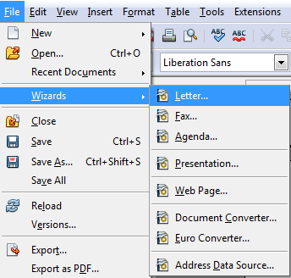
Figure 55. Creating a template using a wizard

Editing a template
You can edit a template’s styles and content, and then, if you wish, you can reapply the template’s styles to documents that were created from that template. (Note that you can only reapply styles. You cannot reapply content.)
To edit a template:
- From the main menu, choose File → Templates → Edit. A standard file browser window opens.
- Select the template that you want to edit.
- Edit the template just as you would any other document. To save your changes, choose File → Save from the main menu.

Updating a document from a changed template
The next time you open a document that was created from the changed template, the following message appears.
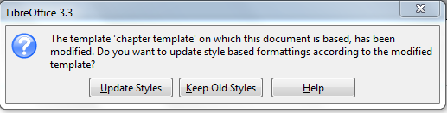
Figure 56. Update styles message
Click Update Styles to apply the template’s changed styles to the document. Click Keep Old Styles if you do not want to apply the template’s changed styles to the document (but see Caution notice below).
Caution | If you choose Keep Old Styles in the message box shown in Figure 56, that message will not appear again the next time you open the document after changing the template it is based on. You will not get another chance to update the styles from the template, although you can use the macro given in the Note below to re-enable this feature.  If you are using Writer, you can also use the Template Changer extension (see page 66) to reassign the template.
Note | To re-enable updating from a template:  - Use Tools → Macros → Organize Macros → LibreOffice Basic. Select the document from the list, click the expansion symbol (+ or triangle), and select Standard. If Standard has an expansion symbol beside it, click that and select a module.  - If the Edit button is active, click it. If the Edit button is not active, click New.  - In the Basic window, enter the following:  Sub FixDocV3  ' set UpdateFromTemplate  oDocSettings = ThisComponent.createInstance( _  "com.sun.star.document.Settings" )  oDocSettings.UpdateFromTemplate = True  End Sub 'FixDocV3  - Click the Run BASIC icon, then close the Basic window.  - Save the document.  The next time you open this document, you will be prompted to update the styles from the modified template.

Adding templates using the Extension Manager
The Extension Manager provides an easy way to install collections of templates, graphics, macros, or other add-ins that have been “packaged” into files with a .OXT extension. See Chapter 14, Customizing LibreOffice, for more about the Extension Manager.
This Web page lists many of the available extensions: http://extensions.libreoffice.org/.
To install an extension, follow these steps:
- Download an extension package and save it anywhere on your computer.
- In LibreOffice, select Tools → Extension Manager from the menu bar. In the Extension Manager dialog, click Add.
- A file browser window opens. Find and select the package of templates you want to install and click Open. The package begins installing. You may be asked to accept a license agreement.
- When the package installation is complete, the templates are available for use through File → New → Templates and Documents and the extension is listed in the Extension Manager.
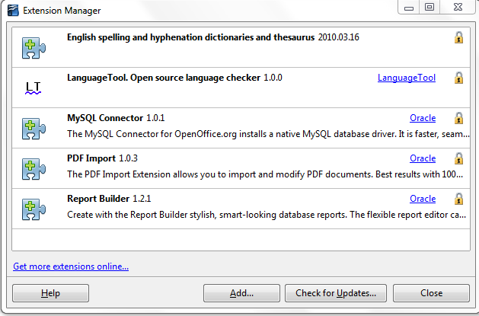
Figure 57: Newly-added package of templates

Setting a default template
If you create a document by choosing File → New → Text Document (or Spreadsheet, Presentation, or Drawing) from the main menu, LibreOffice creates the document from the Default template for that type of document. You can, however, set a custom template to be the default. You can reset the default later if you choose.

Setting a custom template as the default
You can set any template to be the default, as long as it is in one of the folders displayed in the Template Management dialog.
To set a custom template as the default:
- From the main menu, choose File → Templates → Organize. The Template Management dialog opens.
- In the box on the left, select the folder containing the template that you want to set as the default, then select the template.
- Click the Commands button and choose Set As Default Template from the drop-down menu.
The next time that you create a document by choosing File → New, the document will be created from this template.
Although many important settings can be changed in the Options dialog (see Chapter 2), for example default fonts and page size, more advanced settings (such as page margins) can only be changed by replacing the default template with a new one.

Resetting the default template
To re-enable LibreOffice’s Default template for a document type as the default:
- In the Template Management dialog, click any folder in the box on the left.
- Click the Commands button and choose Reset Default Template from the drop-down menu.
The next time that you create a document by choosing File → New, the document will be created from LibreOffice’s Default template for that document type.

Associating a document with a different template
At times you might want to associate a document with a different template, or perhaps you are working with a document that did not start from a template.
One of the major advantages of using templates is the ease of updating styles in more than one document, as described on page 63. If you update styles by loading a new set of styles from a different template (as described on page 59), the document has no association with the template from which the styles were loaded—so you cannot use this method. What you need to do is associate the document with the different template.
You can do this in two ways. In both cases, for best results the names of styles should be the same in the existing document and the new template. If they are not, you will need to use Search and Replace to replace old styles with new ones. See Chapter 4, Getting Started with Writer, for more about replacing styles using Search and Replace.
Method 1
This method includes any graphics and wording (such as legal notices) that exists in the new template, as well as including styles. If you do not want this material, you need to delete it.
- Use File → New → Templates and Documents. Choose the template you want. If the template has unwanted text or graphics in it, delete them.
- Open the document you want to change. (It opens in a new window.) Press Control+A to select everything in the document. Paste into the blank document created in step 1.
- Update the table of contents, if there is one. Save the file.
Method 2 (Writer only)
This method does not include any graphics or text from the new template; it simply includes styles from the new template and establishes an association between the template and the document.
- Download the Template Changer extension from http://extensions.libreoffice.org/ and install it as described on page 64.
- Close and reopen LibreOffice. Now the File → Templates menu has two new choices in Writer: Assign Template (current document) and Assign Template (folder). In Calc, Impress, and Draw, only the Assign Template (folder) choice is available.
- Open the document whose template you want to change. Choose File → Templates → Assign Template (current document).
- In the Select Template window, find and select the required template and click Open.
- Save the document. If you now look in File → Properties, you will see the new template listed at the bottom of the General page.

Organizing templates
LibreOffice can only use templates that are in LibreOffice template folders. You can create new LibreOffice template folders and use them to organize your templates. For example, you might have one template folder for report templates and another for letter templates. You can also import and export templates.
To begin, choose File → Templates → Organize from the main menu. The Template Management dialog opens.
Note | All the actions made by the Commands button in the Template Management dialog can be made as well by right-clicking on the templates or the folders.

Creating a template folder
To create a template folder:
- In the Template Management dialog, click any folder.
- Click the Commands button and choose New from the drop-down menu. A new folder called Untitled appears.
- Type a name for the new folder, and then press Enter. LibreOffice saves the folder with the name that you entered.

Deleting a template folder
You cannot delete template folders supplied with LibreOffice or installed using the Extension Manager; you can only delete template folders that you have created.
To delete a template folder that you have created:
- In the Template Management dialog, select the folder that you want to delete.
- Click the Commands button and choose Delete from the drop-down menu. A message box appears and asks you to confirm the deletion. Click Yes.

Moving a template
To move a template from one template folder to another template folder:
- In the Template Management dialog, double-click the folder that contains the template you want to move. A list of the templates contained in that folder appears underneath the folder name.
- Click the template that you want to move and drag it to the desired folder. If you do not have the authority to delete templates from the source folder, this action copies the template instead of moving it.

Deleting a template
You cannot delete templates supplied with LibreOffice or installed using the Extension Manager; you can only delete templates that you have created or imported.
To delete a template:
- In the Template Management dialog, double-click the folder that contains the template you want to delete. A list of the templates contained in that folder appears underneath the folder name.
- Click the template that you want to delete.
- Click the Commands button and choose Delete from the drop-down menu. A message box appears and asks you to confirm the deletion. Click Yes.

Importing a template
If the template that you want to use is in a different location, you must import it into an LibreOffice template folder.
To import a template into a template folder:
- In the Template Management dialog, select the folder into which you want to import the template.
- Click the Commands button and choose Import Template from the drop-down menu. A standard file browser window opens.
- Find and select the template that you want to import and click Open. The file browser window closes and the template appears in the selected folder.
- If you want, type a new name for the template, and then press Enter.

Exporting a template
To export a template from a template folder to another location:
- In the Template Management dialog, double-click the folder that contains the template you want to export. A list of the templates contained in that folder appears underneath the folder name.
- Click the template that you want to export.
- Click the Commands button and choose Export Template from the drop-down menu. The Save As window opens.
- Find the folder into which you want to export the template and click Save.

Examples of style use
The following examples of common use of page and paragraph styles are taken from Writer. There are many other ways to use styles; see the guides for the various components for details.

Defining a different first page for a document
Many documents, such as letters and reports, have a first page that is different from the other pages in the document. For example, the first page of a letterhead typically has a different header, or the first page of a report might have no header or footer, while the other pages do. With LibreOffice, you can define the page style for the first page and specify the style for the following pages to be applied automatically.
As an example, we can use the First Page and Default page styles that come with LibreOffice. Figure 58 shows what we want to happen: the first page is to be followed by the default page, and all the following pages are to be in the Default page style. Details are in Chapter 4, Formatting Pages, in the Writer Guide.

Figure 58: Flow of page styles

Dividing a document into chapters
In a similar way, you can divide a document into chapters. Each chapter might start with the First Page style, with the following pages using the Default page style, as above. At the end of the chapter, insert a manual page break and specify the next page to have the First Page style to start the next chapter, as shown in Figure 59.

Figure 59: Dividing a document into chapters using page styles

Changing page orientation within a document
A Writer document can contain pages in more than one orientation. A common scenario is to have a landscape page in the middle of a document, whereas the other pages are in a portrait orientation. This can also be done with page breaks and page styles.

Different headers on right and left pages
Page styles can be set up to have the facing left and right pages mirrored or only right (first pages of chapters are often defined to be right-page only) or only left. When you insert a header on a page style set up for mirrored pages or right-and-left pages, you can have the contents of the header be the same on all pages or be different on the right and left pages. For example, you can put the page number on the left-hand edge of the left pages and on the right-hand edge of the right pages, put the document title on the right-hand page only, or make other changes.

Controlling page breaks automatically
Writer automatically flows text from one page to the next. If you do not like the default settings, you can change them. For example, you can require a paragraph to start on a new page or column and specify the style of the new page. A typical use is for chapter titles to always start on a new right-hand (odd-numbered) page.

Compiling an automatic table of contents
To compile an automatic table of contents, first apply styles to the headings you want to appear in the contents list, then use Tools → Outline Numbering to tell Writer which styles go with which level in the table of contents. See Chapter 4 for more information.

Defining a sequence of styles
You can set up one paragraph style so that when you press Enter at the end of that paragraph, the following paragraph automatically has the style you wish applied to it. For example, you could define a Heading 1 paragraph to be followed by a Text Body paragraph. A more complex example would be: Title followed by Author followed by Abstract followed by Heading 1 followed by Text Body. By setting up these sequences, you can avoid manually applying styles in most cases.

Getting Started Guide

Chapter 4
Getting Started with Writer
Word Processing with LibreOffice

What is Writer?
Writer is the word processor component of LibreOffice. In addition to the usual features of a word processor (spelling check, thesaurus, hyphenation, autocorrect, find and replace, automatic generation of tables of contents and indexes, mail merge and others), Writer provides these important features:
- Templates and styles (see Chapter 3)
- Page layout methods, including frames, columns, and tables
- Embedding or linking of graphics, spreadsheets, and other objects
- Built-in drawing tools
- Master documents—to group a collection of documents into a single document
- Change tracking during revisions
- Database integration, including a bibliography database
- Export to PDF, including bookmarks (see Chapter 10)
- And many more
These features are covered in detail in the Writer Guide.

The Writer interface
The main Writer workspace is shown in Figure 60. The menus and toolbars are described in Chapter 1, Introducing LibreOffice.
Some other features of the Writer interface are covered in this chapter.
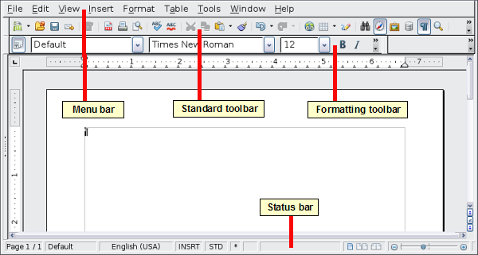Figure 60: The main Writer workspace in Print Layout view

Status bar
The Writer status bar provides information about the document and convenient ways to quickly change some document features.
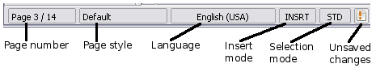
Figure 61: Left end of status bar
Page number
Shows the current page number, the sequence number of the current page (if different), and the total number of pages in the document. For example, if you restarted page numbering at 1 on the third page, its page number is 1 and its sequence number is 3.
If any bookmarks have been defined in the document, a right-click on this field pops up a list of bookmarks; click on the required one.
To jump to a specific page in the document, double-click on this field. The Navigator opens. Click in the Page Number field and type the sequence number of the required page. After a brief delay, the display jumps to the selected page.
Page style
Shows the style of the current page. To change the page style, right-click on this field. A list of page styles pops up; choose a different style by clicking on it.
To edit the current page style, double-click on this field. The Page Style dialog opens.
Language
Shows the language for the selected text.
Click to open a menu where you can choose another language for the selected text or for the paragraph where the cursor is located. You can also choose None (Do not check spelling) to exclude the text from a spelling check or choose More... to open the Character dialog.
Insert mode
Click to toggle between Insert and Overwrite modes when typing.
Selection mode
Click to toggle between STD (Standard), EXT (Extend), ADD (Add) and BLK (Block) selection. EXT is an alternative to Shift+click when selecting text. See “Working with text” on page 77 for more information about ADD and BLK.
Unsaved changes
An icon with an exclmation point appears here if changes to the document have not been saved.
Figure 62: Right end of status bar
Digital signature
If the document has been digitally signed, an icon shows here. You can double-click the icon to view the certificate.
Section or object information
When the cursor is on a section, heading, or list item, or when an object (such as a picture or table) is selected, information about that item appears in this field. Double-clicking in this area opens a relevant dialog. For details, consult the Help or the Writer Guide.
View layout
Click an icon to change between single page, side-by-side, and book layout views. You can edit the document in any view.
Figure 63: View layouts: single, side-by-side, book.
Zoom
To change the view magnification, drag the Zoom slider, or click on the + and – signs, or right-click on the zoom level percent to pop up a list of magnification values from which to choose. Zoom interacts with the selected view layout to determine how many pages are visible in the document window.

Changing document views
Writer has several ways to view a document: Print Layout, Web Layout, and Full Screen. To access these and other choices, go to the View menu and click on the required view. (When in Full Screen view, press the Esc key to return to either Print or Web Layout view.)
When in Print Layout, you can use both the Zoom slider and the View Layout icons on the status bar. In Web Layout, you can use the Zoom slider.
You can also choose View → Zoom from the menu bar to display the Zoom & View Layout dialog, where you can set the same options as on the Status bar. In Web Layout view, most of the choices are not available.
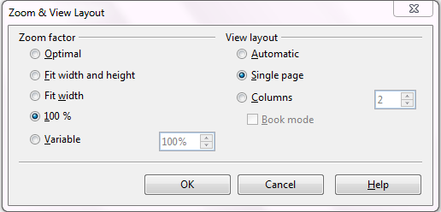Figure 64: Choosing Zoom and View Layout options.

Moving quickly through a document
In addition to the navigation features of the Status bar (described above), you can use the main Navigator window and the Navigation toolbar as described in Chapter 1, Introducing LibreOffice.
In Writer, you can also display the Navigation toolbar by clicking on the small Navigation icon near the lower right-hand corner of the window below the vertical scroll bar, as shown in Figure 65.
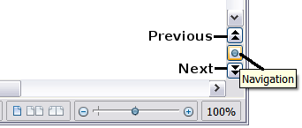
Figure 65: Navigation icons
The Navigation toolbar (Figure 66) shows icons for all the object types shown in the Navigator, plus some extras (for example, the results of a Find command).
Figure 66: Navigation toolbar
Click an icon to select that object type. Now all the Previous and Next icons (in the Navigator itself, in the Navigation Toolbar, and on the scroll bar) will jump to the next object of the selected type. This is particularly helpful for finding items like index entries, which can be difficult to see in the text. The names of the icons (shown in the tooltips) change to match the selected category; for example, Next Graphic, Next Bookmark, or Continue search forward.
For more uses of the Navigator in Writer, see the Writer Guide.

Working with documents
Chapter 1, Introducing LibreOffice, includes instructions on starting new documents, opening existing documents, and saving documents. Chapter 3, Using Styles and Templates, covers how to create a document from a template.

Saving as a Microsoft Word file
If you need to exchange files with users of Microsoft Word, they may not know how to open and save .odt files. Microsoft Word 2007 with Service Pack 2 (SP2) can do this. Users of Word 2003, XP, and 2000 can buy a plug-in from Oracle Corp or search on the Web for the free OpenDocument Format (ODF) plugin from Sun Microsystems.
Some users of Microsoft Word may be unwilling or unable to receive *.odt files. (Their employer may not allow them to install the plug-in.) In this case, you can save a document as a Microsoft Word file.
- Important—First save your document in the file format used by LibreOffice Writer (.odt). If you do not, any changes you made since the last time you saved will appear only in the Microsoft Word version of the document.
- Then choose File → Save As. On the Save As dialog, in the File type (or Save as type) drop-down menu, select the type of Word format you need. Click Save.
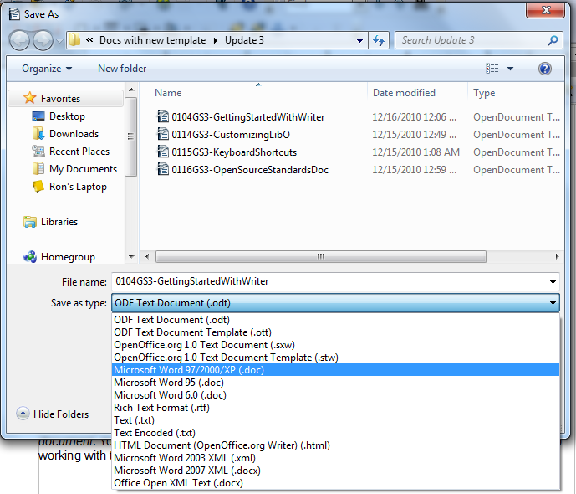Figure 67. Saving a file in Microsoft Word format
From this point on, all changes you make to the document will occur only in the new document. You have changed the name and file type of your document. If you want to go back to working with the .odt version of your document, you must open it again.
Tip | To have LibreOffice save documents by default in the Microsoft Word file format, go to Tools → Options → Load/Save. See “Choosing options for loading and saving documents” in Chapter 2, Setting up LibreOffice.

Working with text
Working with text (selecting, copying, pasting, moving) in Writer is similar to working with text in any other program. LibreOffice also has some convenient ways to select items that are not next to each other, select a vertical block of text, and paste unformatted text.

Selecting items that are not consecutive
To select nonconsecutive items (as shown in Figure 68) using the mouse:
- Select the first piece of text.
- Hold down the Control key and use the mouse to select the next piece of text.
- Repeat as often as needed.
Now you can work with the selected text (copy it, delete it, change the style, or whatever).
Note | Macintosh users: substitute the Command key when instructions in this chapter say to use the Control key.

Figure 68: Selecting items that are not next to each other
To select nonconsecutive items using the keyboard:
- Select the first piece of text. (For more information about keyboard selection of text, see the topic “Navigating and selecting with the keyboard” in the Help.)
- Press Shift+F8. This puts Writer in “Add” mode. The word ADD appears on the status bar.
- Use the arrow keys to move to the start of the next piece of text to be selected. Hold down the Shift key and select the next piece of text.
- Repeat as often as needed.
Now you can work with the selected text.
Press Esc to exit from this mode.

Selecting a vertical block of text
You can select a vertical block or “column” of text that is separated by spaces or tabs (as you might see in text pasted from e-mails, program listings, or other sources), using LibreOffice’s block selection mode. To change to block selection mode, use Edit → Selection Mode → Block Area, or click several times in the status bar on STD until it changes to BLK.
Now highlight the selection, using mouse or keyboard, as shown below.
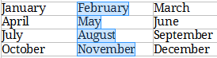
Figure 69: Selecting a vertical block of text

Cutting, copying, and pasting text
Cutting and copying text in Writer is similar to cutting and copying text in other applications. You can use the mouse or the keyboard for these operations. You can copy or move text within a document, or between documents, by dragging or by using menu selections, icons, or keyboard shortcuts. You can also copy text from other sources such as Web pages and paste it into a Writer document.
To move (cut and paste) selected text using the mouse, drag it to the new location and release it. To copy selected text, hold down the Control key while dragging. The text retains the formatting it had before dragging.
When you paste text, the result depends on the source of the text and how you paste it. If you click on the Paste icon, any formatting the text has (such as bold or italics) is retained. Text pasted from Web sites and other sources may also be placed into frames or tables. If you do not like the results, click the Undo icon or press Control+Z.
To make the pasted text take on the formatting of the surrounding text where it is being pasted, choose either:
- Edit → Paste Special, or
- Click the triangle to the right of the Paste icon, or
- Click the Paste icon without releasing the left mouse button.
Then select Unformatted text from the resulting menu.
The range of choices on the Paste Special menu varies depending on the origin and formatting of the text (or other object) to be pasted. See Figure 70 for an example with text on the clipboard.
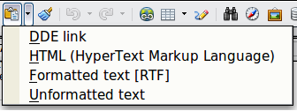
Figure 70: Paste Special menu

Finding and replacing text and formatting
Writer has two ways to find text within a document: the Find toolbar for fast searching and the Find & Replace dialog. In the dialog, you can:
- Find and replace words and phrases
- Use wildcards and regular expressions to fine-tune a search
- Find and replace specific formatting
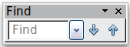
- Find and replace paragraph styles
If the Find toolbar is not visible, you can display it using View → Toolbars → Find.
To display the Find & Replace dialog, use the keyboard shortcut Control+F or choose Edit → Find & Replace from the menu bar.
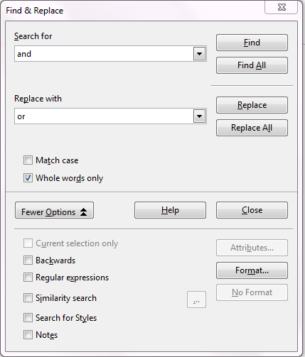
Figure 71: Expanded Find & Replace dialog
- Type the text you want to find in the Search for box.
- To replace the text with different text, type the new text in the Replace with box.
- You can select various options such as matching the case, matching whole words only, or doing a search for similar words.
- When you have set up your search, click Find. To replace text, click Replace instead.
For more information on using Find & Replace, see the Writer Guide.
Tip | If you click Find All, LibreOffice selects all instances of the search text in the document. Similarly, if you click Replace All, LibreOffice replaces all matches.
Caution | Use Replace All with caution; otherwise, you may end up with some hilarious (and highly embarrassing) mistakes. A mistake with Replace All might require a manual, word-by-word, search to fix.

Inserting special characters
A special character is one not found on a standard English keyboard. For example, © ¾ æ ç ñ ö ø ¢ are all special characters. To insert a special character:
- Place the cursor where you want the character to appear.
- Choose Insert → Special Character to open the Special Characters dialog.
- Select the characters (from any font or mixture of fonts) you wish to insert, in order, then click OK. The selected characters are shown in the lower left of the dialog. As you select a character, it is shown on the lower right, along with its numerical code.
Note | Different fonts include different special characters. If you do not find a particular special character, try changing the Font selection.
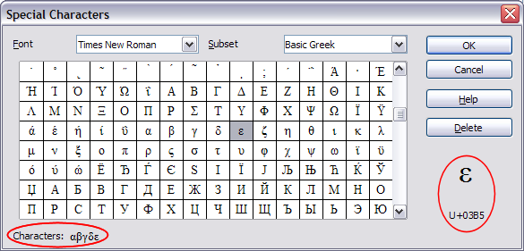
Figure 72: The Special Characters dialog, where you can insert special characters.

Inserting dashes and non-breaking spaces and hyphens
To prevent two words from being separated at the end of a line, press Control+Shift+spacebar after the first word to insert a non-breaking space.
In cases where you do not want the hyphen to appear at the end of a line, for example in a number such as 123-4567, you can press Control+Shift+minus sign to insert a non-breaking hyphen.
To enter en and em dashes, you can use the Replace dashes option on the Options tab under Tools → AutoCorrect Options. This option replaces two hyphens, under certain conditions, with the corresponding dash.
– is an en-dash; that is, a dash the width of the letter “n” in the font you are using. Type at least one character, a space, one or two hyphens, another space, and at least one more letter, then a space. The one or two hyphens will be replaced by an en-dash.
— is an em-dash; that is, a dash the width of the letter “m” in the font you are using. Type at least one character, two hyphens, and at least one more character, then a space. The two hyphens will be replaced by an em-dash.
See the Help for more details. For other methods of inserting dashes, see the Writer Guide.

Setting tab stops and indents
The horizontal ruler shows both the default tab stops and any tab stops that you have defined. Tab settings affect indentation of full paragraphs (using the Increase Indent and Decrease Indent icons on the Formatting toolbar) as well as indentation of parts of a paragraph (by pressing the Tab key on the keyboard).
Using the default tab spacing can cause formatting problems if you share documents with other people. If you use the default tab spacing and then send the document to someone else who has chosen a different default tab spacing, tabbed material will change to use the other person’s settings. This may cause major formatting problems. Instead of using the defaults, define your own tab settings, as described in this section.
To define indents and tab settings for one or more selected paragraphs, double-click on a part of the ruler that is not between the left and right indent icons to open the Indents & Spacing page of the Paragraph dialog. Double-click anywhere between the left and right indent icons on the ruler to open the Tabs page of the Paragraph dialog.
A better strategy is to define tabs for the paragraph style. See Chapters 6 and 7 in the Writer Guide for more information.
Tip | Using tabs to space out material on a page is not recommended. Depending on what you are trying to accomplish, a table is usually a better choice.

Changing the default tab stop interval
Note | Any changes to the default tab setting will affect the existing default tab stops in any document you open afterward, as well as tab stops you insert after making the change.
To set the measurement unit and the spacing of default tab stop intervals, go to Tools → Options → LibreOffice Writer → General.

Figure 73: Selecting a default tab stop interval
You can also set or change the measurement unit for rulers in the current document by right-clicking on the ruler to open a list of units. Click on one of them to change the ruler to that unit. The selected setting applies only to that ruler.
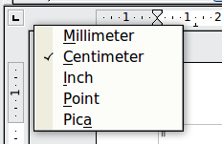
Figure 74: Changing the measurement unit for a ruler

Checking spelling and grammar
Writer provides a spelling checker, which can be used in two ways.
AutoSpellcheck checks each word as it is typed and displays a wavy red line under any misspelled words. When the word is corrected, the line disappears.
To perform a separate spelling check on the document (or a text selection) click the Spelling and Grammar button. This checks the document or selection and opens the Spelling and Grammar dialog if any misspelled words are found.
Here are some more features of the spelling checker:
- You can right-click on a word with a wavy underline to open a context menu. If you select from the suggested words on the menu, the selection will replace the misspelled word in your text. Other menu options are discussed below.
- You can change the dictionary language (for example, Spanish, French or German) on the Spelling and Grammar dialog.
- You can add a word to the dictionary. Click Add in the Spelling and Grammar dialog and pick the dictionary to add it to.
- Click the Options button on the Spelling and Grammar dialog to open a dialog similar to the one in Tools → Options → Language Settings → Writing Aids described in Chapter 2. There you can choose whether to check uppercase words and words with numbers, and you can manage custom dictionaries, that is, add or delete dictionaries and add or delete words in a dictionary.
- On the Font tab of the Paragraph Styles dialog, you can set paragraphs to be checked in a specific language (different from the rest of the document). See Chapter 7, Working with Styles, in the Writer Guide for more information.
Writer does not include a grammar checker, but you can install an extension such as Language Tool and access it from Tools → Spelling and Grammar. (See Chapter 14 for more about installing extensions.)
Language Tool adds a new menu item and submenu to the Tools menu, from which you can configure the tool and check or recheck the document.

Using built-in language tools
Writer provides some tools that make your work easier if you mix multiple languages within the same document or if you write documents in various languages.
The main advantage of changing the language is that you can then use the correct dictionaries to check spelling and apply the localized versions of Autocorrect replacement tables, thesaurus, and hyphenation rules.
You can also set the language for a paragraph or a group of characters as None. This option is especially useful when you insert text such as web addresses or programming language snippets that you do not want to check for spelling.
Specifying the language in character and paragraph styles is the preferred method, because styles allow a greater level of control and make changing the language much faster. On the Font tab of the Paragraph Styles dialog, you can specify that certain paragraphs be checked in a language that is different from the language of the rest of the document. See Chapter 7, Working with Styles, in the Writer Guide for information on how to manage the language settings of a style.
You can set the language for the whole document, for individual paragraphs, or even for individual words and characters, all from Tools → Language on the menu bar.
Another way to change the language of a whole document is to use Tools → Options → Language Settings → Languages. In the Default languages for documents section of the Options dialog, you can choose a different language for all the text.
The spelling checker works only for those languages in the list that have the symbol next to them. If you do not see the symbol next to your preferred language, you can install the additional dictionary using Tools → Languages → More dictionaries online.
The language used for checking spelling is also shown in the status bar, next to the page style in use.

Using AutoCorrect
Writer’s AutoCorrect function has a long list of common misspellings and typing errors, which it corrects automatically. For example, “hte” will be changed to “the”.
Choose Tools → AutoCorrect Options to open the AutoCorrect dialog. There you can define which strings of text are corrected and how. In most cases, the defaults are fine.
AutoCorrect is turned on when Writer is installed. To turn it off, uncheck Format → AutoCorrect → While Typing.
To stop Writer replacing a specific spelling, go to the Replace tab, highlight the word pair, and click Delete.
To add a new spelling to the list, type it into the Replace and With boxes on the Replace tab, and click New.
See the different tabs of the dialog for the wide variety of other options available to fine-tune AutoCorrect.
Tip | AutoCorrect can be used as a quick way to insert special characters. For example, (c) will be autocorrected to ©. You can add your own special characters.

Using word completion
If Word Completion is enabled, Writer tries to guess which word you are typing and offers to complete the word for you. To accept the suggestion, press Enter. Otherwise continue typing.
To turn off Word Completion, select Tools → AutoCorrect Options → Word Completion and deselect Enable word completion.
You can customize word completion from the Word Completion page of the AutoCorrect dialog:
- Add (append) a space automatically after an accepted word
- Show the suggested word as a tip (hovering over the word) rather than completing the text as you type
- Change the maximum number of words remembered for word completion and the length of the smallest words to be remembered
- Delete specific entries from the word completion list
- Change the key that accepts a suggested entry—the options are Right arrow, End key, Return (Enter), and Space bar
Note | Automatic word completion only occurs after you type a word for the second time in a document.

Using AutoText
Use AutoText to store text, tables, graphics and other items for reuse and assign them to a key combination for easy retrieval. For example, rather than typing “Senior Management” every time you use that phrase, you can set up an AutoText entry to insert those words when you type “sm” and press F3.

Creating AutoText
To store some text as AutoText:
- Type the text into your document.
- Select the text.
- Choose Edit → AutoText (or press Control+F3).
- In the AutoText dialog box, type a name for the AutoText in the Name box. Writer will suggest a one-letter shortcut, which you can change.
- In the large box to the left, choose the category for the AutoText entry, for example My AutoText.
- Click the AutoText button on the right and select New (text only) from the menu.
- Click Close to return to your document.
Tip | If the only option under the AutoText button is Import, either you have not entered a name for your AutoText or there is no text selected in the document.
AutoText is especially powerful when assigned to fields. See Chapter 14, Working with Fields, in the Writer Guide for more information.

Inserting AutoText
To insert AutoText, type the shortcut and press F3.

Formatting text

Using styles is recommended
Styles are central to using Writer. Styles enable you to easily format your document consistently, and to change the format with minimal effort. A style is a named set of formatting options. Writer defines several types of styles, for different types of elements: characters, paragraphs, pages, frames, and lists. See Chapter 3, Using Styles and Templates, in this book and Chapters 6 and 7 in the Writer Guide.

Formatting paragraphs
You can apply many formats to paragraphs using the buttons on the Formatting toolbar. Figure 75 shows the Formatting toolbar as a floating toolbar, customized to show only the icons for paragraph formatting. The appearance of the icons may vary with your operating system and the selection of icon size and style in Tools → Options → LibreOffice → View.
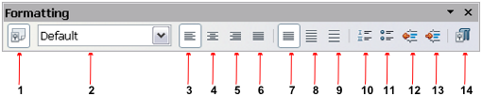
1 | Open Styles and Formatting Window | 5 | Align Right | 10 | Numbering On/Off
 | Open Styles and Formatting Window | 6 | Justified | 11 | Bullets On/Off
2 | Apply Style | 7 | Line Spacing: 1 | 12 | Decrease Indent
3 | Align Left | 8 | Line Spacing: 1.5 | 13 | Increase Indent
4 | Centered | 9 | Line Spacing: 2 | 14 | Paragraph format dialog
Figure 75: Formatting toolbar, showing icons for paragraph formatting

Formatting characters
You can apply many formats to characters using the buttons on the Formatting toolbar. Figure 76 shows the Formatting toolbar, customized to include only the icon for character formatting.
The appearance of the icons may vary with your operating system and the selection of icon size and style in Tools → Options → LibreOffice → View.
1 | Open Styles and Formatting Window | 6 | Italic | 12 | Font Color
 | Open Styles and Formatting Window | 7 | Underline | 13 | Highlighting
2 | Apply Style | 8 | Superscript | 14 | Background Color
3 | Font Name | 9 | Subscript | 15 | Open Character Format Dialog
4 | Font Size | 10 | Increase Font |  | Open Character Format Dialog
5 | Bold | 11 | Reduce Font
Figure 76: Formatting toolbar, showing icons for character formatting
Tip | To remove manual formatting, select the text and choose Format → Default Formatting, or right-click and choose Default Formatting.

Autoformatting
You can set Writer to automatically format parts of a document according to the choices made on the Options page of the AutoCorrect dialog (Tools → AutoCorrect Options).
Tip | If you notice unexpected formatting changes occurring in your document, this is the first place to look for the cause.
Some common unwanted or unexpected formatting changes include:
- Horizontal lines. If you type three or more hyphens (---), underscores (___) or equal signs (===) on a line and then press Enter, the paragraph is replaced by a horizontal line as wide as the page. The line is actually the lower border of the preceding paragraph.
- Bulleted and numbered lists. A bulleted list is created when you type a hyphen (-), star (*), or plus sign (+), followed by a space or tab at the beginning of a paragraph. A numbered list is created when you type a number followed by a period (.), followed by a space or tab at the beginning of a paragraph. Automatic numbering is only applied to paragraphs formatted with the Default, Text body or Text body indent paragraph styles.
To turn autoformatting on or off, choose Format → AutoCorrect and select or deselect the items on the list.

Creating numbered or bulleted lists
There are several ways to create numbered or bulleted lists:
- Use autoformatting, as described above.
- Use list (numbering) styles, as described in Chapter 6, Introduction to Styles, and Chapter 7, Working with Styles, in the Writer Guide.
- Use the Numbering and Bullets icons on the paragraph formatting toolbar (see Figure 75): select the paragraphs in the list, and then click the appropriate icon on the toolbar.
Note | It is a matter of personal preference whether you type your information first, then apply Numbering/Bullets, or apply them as you type.

Using the Bullets and Numbering toolbar
You can create nested lists (where one or more list items has a sub-list under it, as in an outline) by using the buttons on the Bullets and Numbering toolbar (Figure 77). You can move items up or down the list, or create sub-points, and even change the style of bullets. Use View → Toolbars → Bullets and Numbering to see the toolbar.
The appearance of the icons may vary with your operating system and the selection of icon size and style in Tools → Options → LibreOffice → View.

1 | Bullets On/Off | 6 | Promote One Level with Subpoints | 10 | Move Down
2 | Numbering On/Off | 6 | Promote One Level with Subpoints | 11 | Move Up with Subpoints
3 | Numbering Off | 7 | Demote One Level with Subpoints | 12 | Move Down with Subpoints
4 | Promote One Level | 8 | Insert Unnumbered Entry | 13 | Restart Numbering
5 | Demote One Level | 9 | Move Up | 14 | Bullets and Numbering
Figure 77: Bullets and Numbering toolbar

Hyphenating words
You have several choices regarding hyphenation: let Writer do it automatically (using its hyphenation dictionaries), insert conditional hyphens manually where necessary, or don’t hyphenate at all.

Automatic hyphenation
To turn automatic hyphenation of words on or off:
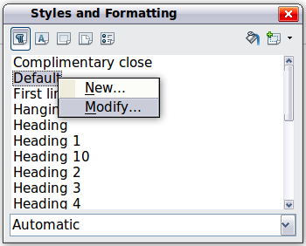
Figure 78: Modifying a style
- Press F11 (z+T on Mac) to open the Styles and Formatting window.
- On the Paragraph Styles page (Figure 78), right-click on Default and select Modify.
- On the Paragraph Style dialog (Figure 79), go to the Text Flow page.
- Under Hyphenation, select or deselect the Automatically option. Click OK to save.
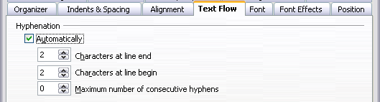
Figure 79: Turning on automatic hyphenation
Note | Turning on hyphenation for the Default paragraph style affects all other paragraph styles that are based on Default. You can individually change other styles so that hyphenation is not active; for example, you might not want headings to be hyphenated. Any styles that are not based on Default are not affected. See Chapter 3, Styles and Templates, for more about styles based on other styles)
You can also set hyphenation choices through Tools → Options → Language Settings → Writing Aids. In Options, near the bottom of the dialog, scroll down to find the hyphenation settings.

Figure 80: Setting hyphenation options
To change the minimum number of characters for hyphenation, the minimum number of characters before a line break, or the minimum number of characters after a line break, select the item, and then click the Edit button in the Options section.
Hyphenation options set on the Writing Aids dialog are effective only if hyphenation is turned on through paragraph styles.

Manual hyphenation
To manually hyphenate words, do not use a normal hyphen, which will remain visible even if the word is no longer at the end of a line when you add or delete text or change margins or font size. Instead, use a conditional hyphen, which is visible only when required.
To insert a conditional hyphen inside a word, click where you want the hyphen to appear and press Control+hyphen. The word will be hyphenated at this position when it is at the end of the line, even if automatic hyphenation for this paragraph is switched off.

Formatting pages
Writer provides several ways for you to control page layouts: page styles, columns, frames, tables, and sections. For more information, see Chapter 4, Formatting Pages, in the Writer Guide.
Tip | Page layout is usually easier if you show text, object, table, and section boundaries in Tools → Options → LibreOffice → Appearance, and paragraph ends, tabs, breaks, and other items in Tools → Options → LibreOffice Writer → Formatting Aids.

Which layout method to choose?
The best layout method varies depending on what the final document should look like and what sort of information will be in the document. Here are some examples.
For a book similar to this user guide, with one column of text, some figures without text beside them, and some other figures with descriptive text, use page styles for basic layout, and tables to place figures beside descriptive text when necessary. | 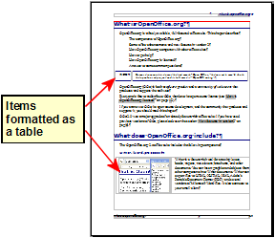
For an index or other document with two columns of text, where the text continues from the left-hand column to the right-hand column and then to the next page, all in sequence (also known as “snaking columns” of text), use page styles (with two columns). If the title of the document (on the first page) is full-page width, put it in a single-column section. | 
For a newsletter with complex layout, two or three columns on the page, and some articles that continue from one page to some place several pages later, use page styles for basic layout. Place articles in linked frames and anchor graphics to fixed positions on the page if necessary. | 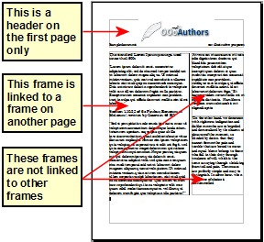
For a document with terms and translations to appear side-by-side in what appear to be columns, use a table to keep items lined up, and so you can type in both “columns”. | 

Creating headers and footers
A header is an area that appears at the top of a page. A footer appears at the bottom of the page. Information such as page numbers inserted into a header or footer displays on every page of the document with that page style.
To insert a header, choose Insert → Header → Default (or the page style, if not Default).
Other information such as document titles and chapter titles is often put into the header or footer. These items are best added as fields. That way, if something changes, the headers and footers are updated automatically. Here is one common example.
To insert the document title into the header:
- Choose File → Properties → Description and type a title for your document.
- Add a header (Insert → Header → Default).
- Place the cursor in the header part of the page.
- Choose Insert → Fields → Title. The title should appear on a gray background (which does not show when printed and can be turned off).
- To change the title for the whole document, go back to File → Properties → Description.
Fields are covered in detail in Chapter 14, Working with Fields, in the Writer Guide.
For more about headers and footers, see Chapter 4, Formatting Pages, and Chapter 6, Introduction to Styles, in the Writer Guide.

Numbering pages
To automatically number pages:
- Insert a header or footer, as described in “Creating headers and footers” on page 90.
- Place the cursor in the header or footer where you want the page number to appear and choose Insert → Fields → Page Number.

Including the total number of pages
To include the total number of pages (as in “page 1 of 12”):
- Type the word “page” and a space, then insert the page number as above.
- Press the spacebar once, type the word “of” and a space, then choose Insert → Fields → Page Count.
Note | The Page Count field inserts the total number of pages in the document, as shown on the Statistics tab of the document’s Properties window (File → Properties). If you restart page numbering anywhere in the document, then the total page count may not be what you want. See Chapter 4, Formatting Pages, in the Writer Guide for more information.

Restarting page numbering
Often you will want to restart the page numbering at 1, for example on the page following a title page or a table of contents. In addition, many documents have the “front matter” (such as the table of contents) numbered with Roman numerals and the main body of the document numbered in Arabic numerals, starting with 1.
You can restart page numbering in two ways.
Method 1:
- Place the cursor in the first paragraph of the new page.
- Choose Format → Paragraph.
- On the Text Flow tab of the Paragraph dialog, select Breaks.
- Select Insert and then With Page Style and specify the page style to use.
- Specify the page number to start from, and then click OK.
Tip | Method 1 is also useful for numbering the first page of a document with a page number greater than 1. For example, you may be writing a book, with each chapter in a separate file. Chapter 1 may start with page 1, but Chapter 2 could begin with page 25 and Chapter 3 with page 51.
Method 2:
- Insert → Manual break.
- By default, Page break is selected on the Insert Break dialog (Figure 81).
- Choose the required page Style.
- Select Change page number.
- Specify the page number to start from, and then click OK.
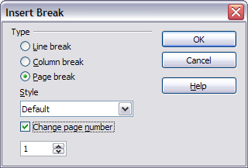
Figure 81: Restarting page numbering after a manual page break

Changing page margins
You can change page margins in two ways:
- Using the page rulers—quick and easy, but does not have fine control
- Using the Page Style dialog—can specify margins to two decimal places
Note | If you change the margins using the rulers, the new margins affect the page style and will be shown in the Page Style dialog the next time you open it.  Because the page style is affected, the changed margins apply to all pages using that style.
To change margins using the rulers:
- The gray sections of the rulers are the margins. Put the mouse cursor over the line between the gray and white sections. The pointer turns into a double-headed arrow.
- Hold down the left mouse button and drag the mouse to move the margin.

Figure 82: Moving the margins
Tip | The small arrows on the ruler are used for indenting paragraphs. They are often in the same place as the page margins, so you need to be careful to move the margin marker, not the arrows. Place the mouse pointer between the arrows and, when the pointer turns into a double-headed arrow, you can move the margin (the indent arrows will move with it).
To change margins using the Page Style dialog:
- Right-click anywhere on the page and select Page from the pop-up menu.
- On the Page tab of the dialog, type the required distances in the Margins boxes.

Adding comments to a document
Authors and reviewers often use comments (formerly called “notes”) to exchange ideas, ask for suggestions, or mark items needing attention.
To insert a comment in the text, place the cursor in the place the comment refers to and choose Insert → Comment or press Ctrl+Alt+N. The anchor point of the comment is connected by a dotted line to a box on the right-hand side of the page where you can type the text of the comment. Writer automatically adds at the bottom of the comment the author’s name and a time stamp indicating when the comment was created. Figure 83 shows an example of text with comments from two different authors.
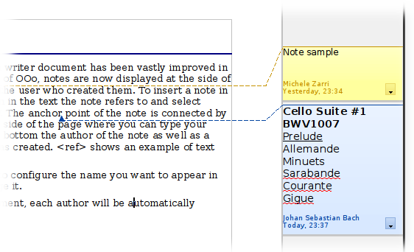Figure 83: Example of comments
Choose Tools → Options → User Data to configure the name you want to appear in the Author field of the comment, or to change it.
If more than one person edits the document, each author is automatically allocated a different background color.
Right-clicking on a comment pops up a menu where you can delete the current comment, all the comments from the same author, or all the comments in the document. From this menu, you can also apply some basic formatting to the text of the comment. You can also change the font type, size, and alignment from the main menu.
To navigate from one comment to another, open the Navigator (F5), expand the Comments section, and click on the comment text to move the cursor to the anchor point of the comment in the document. Right-click on the comment to quickly edit or delete it.
You can also navigate through the comments using the keyboard. Use Ctrl+Alt+Page Down to move to the next comment and Ctrl+Alt+Page Up to move to the previous comment.

Creating a table of contents
Writer’s table of contents feature lets you build an automated table of contents from the headings in your document. Before you start, make sure that the headings are styled consistently. For example, you can use the Heading 1 style for chapter titles and the Heading 2 and Heading 3 styles for chapter subheadings.
Although tables of contents can be customized extensively in Writer, often the default settings are all you need. Creating a quick table of contents is simple:
- When you create your document, use the following paragraph styles for different heading levels (such as chapter and section headings): Heading 1, Heading 2, Heading 3, and so on. These are what will appear in your table of contents.
- Place the cursor where you want the table of contents to be inserted.
- Choose Insert → Indexes and Tables → Indexes and Tables.
- Change nothing in the Insert Index/Table dialog. Click OK.
If you add or delete text (so that headings move to different pages) or you add, delete, or change headings, you need to update the table of contents.
To do this:
- Place the cursor within the table of contents.
- Right-click and choose Update Index/Table from the pop-up menu.
Note | If you cannot place your cursor in the table of contents, choose Tools → Options → LibreOffice Writer → Formatting Aids, and then select Enable in the Cursor in protected areas section.
You can customize an existing table of contents at any time. Right-click anywhere in it and choose Edit Index/Table from the pop-up menu. Chapter 12, Creating Tables of Contents, Indexes and Bibliographies, of the Writer Guide describes in detail all the customizations you can choose.

Creating indexes and bibliographies
Indexes and bibliographies work in a similar way to tables of contents. Chapter 12, Creating Tables of Contents, Indexes and Bibliographies, in the Writer Guide describes the process in detail.
In addition to alphabetical indexes, other types of indexes supplied with Writer include those for illustrations, tables, and objects, and you can even create a user-defined index. For example, you might want an index containing only the scientific names of species mentioned in the text, and a separate index containing only the common names of species. Before creating some types of indexes, you first need to create index entries embedded in your Writer document.

Working with graphics
Graphics in Writer are of three basic types:
- Image files, including photos, drawings, scanned images, and others
- Diagrams created using LibreOffice’s drawing tools
- Charts created using LibreOffice’s Chart component
See Chapter 11, Graphics, the Gallery, and Fontwork, in this book and Chapter 8, Working with Graphics, in the Writer Guide.

Printing
See Chapter 10, Printing, Exporting, and E-mailing, in this book and Chapter 5, Printing, Exporting, Faxing, and E-mailing, in the Writer Guide for details on previewing pages before printing, selecting print options, printing in black and white on a color printer, printing brochures, and other printing features.

Using mail merge
Writer provides very useful features to create and print:
- Multiple copies of a document to send to a list of different recipients (form letters)
- Mailing labels
- Envelopes
All these facilities use a registered data source (a spreadsheet or database containing the name and address records and other information).
Chapter 11, Using Mail Merge, in the Writer Guide describes the process.

Tracking changes to a document
You can use several methods to keep track of changes made to a document.
- Make your changes to a copy of the document (stored in a different folder, or under a different name, or both), then use Writer to combine the two files and show the differences. Choose Edit → Compare Document. This technique is particularly useful if you are the only person working on the document, as it avoids the increase in file size and complexity caused by the other methods.
- Save versions that are stored as part of the original file. However, this method can cause problems with documents of non-trivial size or complexity, especially if you save a lot of versions. Avoid this method if you can.
- Use Writer’s change marks (often called “redlines” or “revision marks”) to show where you have added or deleted material, or changed formatting. Choose Edit → Changes → Record. Later, you or another person can review and accept or reject each change. Right-click on an individual change and choose Accept Change or Reject Change from the pop-up menu, or choose Edit → Changes → Accept or Reject to view the list of changes and accept or reject them. Details are in the Writer Guide.
Tip | Not all changes are recorded. For example, changing a tab stop from align left to align right, and changes in formulas (equations) or linked graphics are not recorded.

Using fields
Fields are extremely useful features of Writer. They are used for data that changes in a document (such as the current date or the total number of pages) and for inserting document properties such as name, author, and date of last update. Fields are the basis of cross-referencing (see below); automatic numbering of figures, tables, headings, and other elements; and a wide range of other functions—far too many to describe here. See Chapter 14, Working with Fields, in the Writer Guide for details.

Linking to another part of a document
If you type in cross-references to other parts of a document, those references can easily get out of date if you reorganize the order of topics, add or remove material, or reword a heading. Writer provides two ways to ensure that your references are up to date, by inserting links to other parts of the same document or to a different document:
- Hyperlinks
- Cross-references
The two methods have the same result if you Control+click the link when the document is open in Writer: you are taken directly to the cross-referenced item. However, they also have major differences:
- The text in a hyperlink does not automatically update if you change the text of the linked item (although you can change it manually), but changed text does automatically update in a cross-reference.
- When using a hyperlink, you do not have a choice of the content of the link (for example text or page number), but when using a cross-reference, you have several choices, including bookmarks.
- To hyperlink to an object such as a graphic, and have the hyperlink show useful text such as Figure 6, you need to either give such an object a useful name instead of leaving it as the default name (Graphics6), or you need to use the Hyperlink dialog to modify the visible text. In contrast, cross-references to figures with captions automatically show useful text, and you have a choice of several variations of the name.
- If you save a Writer document to HTML, hyperlinks remain active but cross-references do not. (Both remain active when the document is exported to PDF.)

Using hyperlinks
The easiest way to insert a hyperlink to another part of the same document is by using the Navigator:
- Open the document containing the items you want to cross-reference.
- Open the Navigator by clicking its icon, choosing View → Navigator, or pressing F5.
- Click the arrow next to the Drag Mode icon, and choose Insert as Hyperlink.
- In the list at the bottom of the Navigator, select the document containing the item that you want to cross-reference.
- In the Navigator list, select the item that you want to insert as a hyperlink.
- Drag the item to where you want to insert the hyperlink in the document. The name of the item is inserted in the document as an active hyperlink.
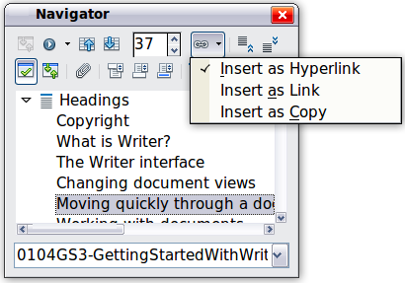
Figure 84: Inserting a hyperlink using the Navigator
You can also use the Hyperlink dialog to insert and modify hyperlinks within and between documents. See Chapter 12, Creating Web Pages.

Using cross-references
If you type in references to other parts of the document, those references can easily get out of date if you reword a heading, add or remove figures, or reorganize topics. Replace any typed cross-references with automatic ones and, when you update fields, all the references will update automatically to show the current wording or page numbers. The Cross-references tab of the Fields dialog lists some items, such as headings, bookmarks, figures, tables, and numbered items such as steps in a procedure. You can also create your own reference items; see “Setting References” in Chapter 14, Working with Fields, in the Writer Guide for instructions.
To insert a cross-reference to a heading, figure, bookmark, or other item:
- In your document, place the cursor where you want the cross-reference to appear.
- If the Fields dialog is not open, click Insert → Cross-reference. On the Cross-references tab, in the Type list, select the type of item to be referenced (for example, Heading or Figure). You can leave this page open while you insert many cross-references.
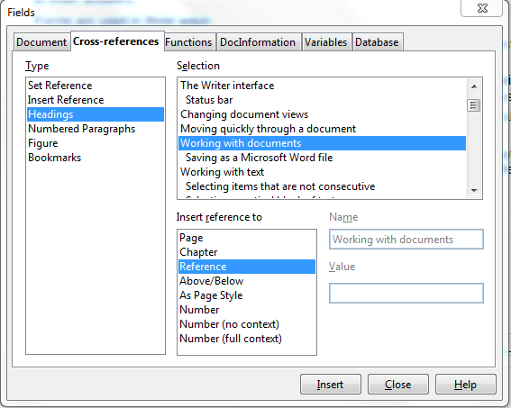
Figure 85: The Cross-references tab of the Fields dialog
- Click on the required item in the Selection list, which shows all the items of the selected type. In the Format list, choose the format required. Usually this will be Reference (to insert the full text of the heading or caption), Category and Number (to insert the word “Figure” or “Table” and its number, but without the caption text), Numbering (to insert only the figure or table number, without the word “Figure” or “Table”), or Page (to insert the number of the page the referenced text is on). Click Insert.

Using bookmarks
Bookmarks are listed in the Navigator and can be accessed directly from there with a single mouse click. You can cross-reference to bookmarks and create hyperlinks to bookmarks, as described above.
- Select the text you want to bookmark. Click Insert → Bookmark.
- On the Insert Bookmark dialog, the larger box lists any previously defined bookmarks. Type a name for this bookmark in the top box, and then click OK.
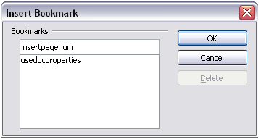Figure 86: Inserting a bookmark

Using master documents
Master documents are typically used for producing long documents such as a book, a thesis, or a long report; or when different people are writing different chapters or other parts of the full document, so you don’t need to share files. A master document joins separate text documents into one larger document, and unifies the formatting, table of contents (TOC), bibliography, index, and other tables or lists.
Yes, master documents do work in Writer. However, until you become familiar with them, you may think that master documents are unreliable or difficult to use. See Chapter 13, Working with Master Documents, in the Writer Guide.

Creating fill-in forms
A standard text document displays information: a letter, report, or brochure, for example. Typically the reader may edit everything or nothing in any way. A form has sections that are not to be edited, and other sections that are designed for the reader to make changes. For example, a questionnaire has an introduction and questions (which do not change) and spaces for the reader to enter answers.
Forms are used in three ways:
- To create a simple document for the recipient to complete, such as a questionnaire sent out to a group of people who fill it in and return it.
- To link into a database or data source and allow the user to enter information. Someone taking orders might enter the information for each order into a database using a form.
- To view information held in a database or data source. A librarian might call up information about books.
Writer offers several ways to fill information into a form, including check boxes, option buttons, text boxes, pull-down lists and spinners. See Chapter 15, Using Forms in Writer, in the Writer Guide.

Getting Started Guide

Chapter 5
Getting Started with Calc
Using Spreadsheets in LibreOffice

What is Calc?
Calc is the spreadsheet component of LibreOffice. You can enter data (usually numerical) in a spreadsheet and then manipulate this data to produce certain results.
Alternatively you can enter data and then use Calc in a ‘What if...’ manner by changing some of the data and observing the results without having to retype the entire spreadsheet.
Other features provided by Calc include:
- Functions, which can be used to create formulas to perform complex calculations on data
- Database functions, to arrange, store, and filter data
- Dynamic charts; a wide range of 2D and 3D charts
- Macros, for recording and executing repetitive tasks
- Ability to open, edit, and save Microsoft Excel spreadsheets
- Import and export of spreadsheets in multiple formats, including HTML, CSV, PDF, and PostScript
Note | If you want to use macros written in Microsoft Excel using the VBA macro code in LibreOffice, you must first edit the code in the LibreOffice Basic IDE editor. See Chapter 13, Getting Started with Macros, in this book and Chapter 12 in the Calc Guide.

Spreadsheets, sheets and cells
Calc works with documents called spreadsheets. Spreadsheets consist of a number of individual sheets, each sheet containing cells arranged in rows and columns. A particular cell is identified by its row number and column letter.
Cells hold the individual elements—text, numbers, formulas, and so on—that make up the data to display and manipulate.
Each spreadsheet can have many sheets, and each sheet can have many individual cells. In Calc 3.3, each sheet can have a maximum of 1,048,576 rows and 1024 columns.

Parts of the main Calc window
When Calc is started, the main window looks similar to Figure 87.

Title bar
The Title bar, located at the top, shows the name of the current spreadsheet. When the spreadsheet is newly created, its name is Untitled X, where X is a number. When you save a spreadsheet for the first time, you are prompted to enter a name of your choice.

Menu bar
Under the Title bar is the Menu bar. When you choose one of the menus, a submenu appears with other options. You can modify the Menu bar, as discussed in Chapter 14, Customizing LibreOffice.
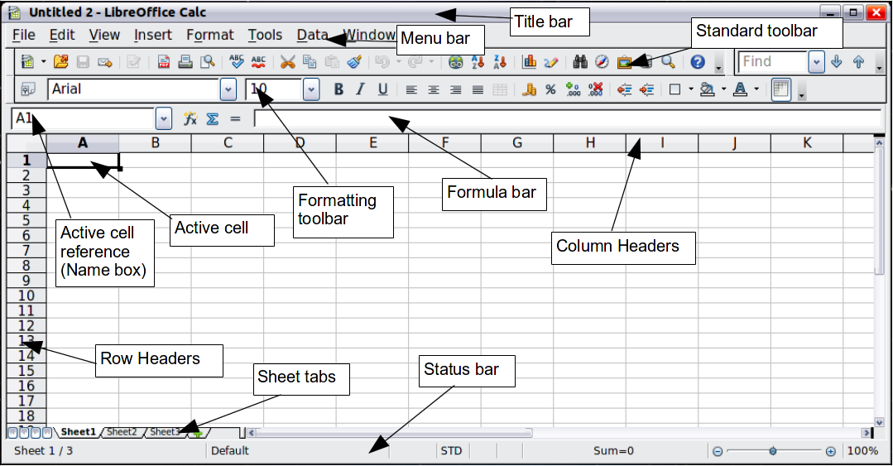
Figure 87: Parts of the Calc window

Toolbars
Three toolbars are located under the Menu bar by default: the Standard toolbar, the Formatting toolbar, and the Formula Bar.
The icons (buttons) on these toolbars provide a wide range of common commands and functions. You can also modify these toolbars, as discussed in Chapter 14, Customizing LibreOffice.
In the Formatting toolbar, the three boxes on the left are the Apply Style, Font Name, and Font Size lists. They show the current setting for the selected cell or area. (The Apply Style list may not be visible by default.) Click the down-arrow to the right of each box to open the list.
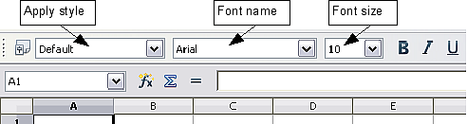
Figure 88. Apply Style, Font Name and Font Size lists

Formula bar
On the left hand side of the Formula bar is a small text box, called the Name Box, with a letter and number combination in it, such as D7. This combination, called the cell reference, is the column letter and row number of the selected cell.
To the right of the Name box are the the Function Wizard, Sum, and Function buttons.
Clicking the Function Wizard button opens a dialog from which you can search through a list of available functions This can be very useful because it also shows how the functions are formatted.
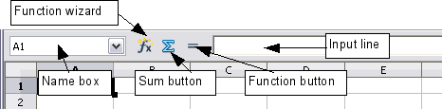
Figure 89. Formula Bar
In a spreadsheet the term function covers much more than just mathematical functions. See Chapter 7 in the Calc Guide for more details.
Clicking the Sum button inserts a formula into the current cell that totals the numbers in the cells above the current cell. If there are no numbers above the current cell, then the cells to the left are placed in the Sum formula.
Clicking the Function button inserts an equals (=) sign into the selected cell and the Input line, enabling the cell to accept a formula.
When you enter new data into a cell, the Sum and Equals buttons change to Cancel and Accept buttons .
The contents of the current cell (data, formula, or function) are displayed in the Input line, which forms the remainder of the Formula Bar. You can edit the contents of the current cell on the Input line or in the cell itself. To edit on the Input line, click in the line, then type your changes. To edit within the current cell, just double-click the cell.

Individual cells
The main section of the screen displays the cells in the form of a grid, with each cell being at the intersection of a column and a row.
At the top of the columns and at the left end of the rows are a series of gray boxes containing letters and numbers. These are the column and row headers. The columns start at A and go on to the right, and the rows start at 1 and go down.
These column and row headers form the cell references that appear in the Name Box on the Formula Bar (Figure 89). You can turn these headers off by selecting View → Column & Row Headers.

Sheet tabs
At the bottom of the grid of cells are the sheet tabs. These tabs enable access to each individual sheet, with the visible (active) sheet having a white tab. You can choose colors for the different sheet tabs.
Clicking on another sheet tab displays that sheet, and its tab turns white. You can also select multiple sheet tabs at once by holding down the Control key while you click the names.

Status bar
At the very bottom of the Calc window is the status bar, which provides information about the spreadsheet and convenient ways to quickly change some of its features. Most of the fields are similar to those in other components of LibreOffice; see Chapter 1, Introducing LibreOffice, in this book and Chapter 1, Introducing Calc, in the Calc Guide.
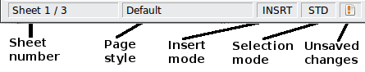
Figure 90: Left end of Calc status bar
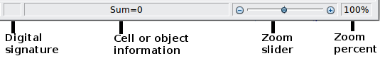
Figure 91: Right end of Calc status bar

Opening and saving CSV files
Chapter 1, Introducing LibreOffice, includes instructions on starting new Calc documents, opening existing documents, and saving documents.
A special case for Calc is opening and saving comma-separated-values (CSV) files, which are text files that contain the cell contents of a single sheet. Each line in a CSV file represents a row in a spreadsheet. Commas, semicolons, or other characters are used to separate the cells. Text is entered in quotation marks, numbers are entered without quotation marks.

Opening a CSV file
To open a CSV file in Calc:
- Choose File → Open.
- Locate the CSV file that you want to open.
- If the file has a *.csv extension, select the file and click Open.
- If the file has another extension (for example, *.txt), select the file, select Text CSV (*csv;*txt;*xls) in the File type box (scroll down into the spreadsheet section to find it) and then click Open.
- On the Text Import dialog (Figure 92), select the Separator options to divide the text in the file into columns.
You can preview the layout of the imported data at the bottom of the dialog. Right-click a column in the preview to set the format or to hide the column.
If the CSV file uses a text delimiter character that is not in the Text delimiter list, click in the box, and type the character.
- Click OK to open the file.
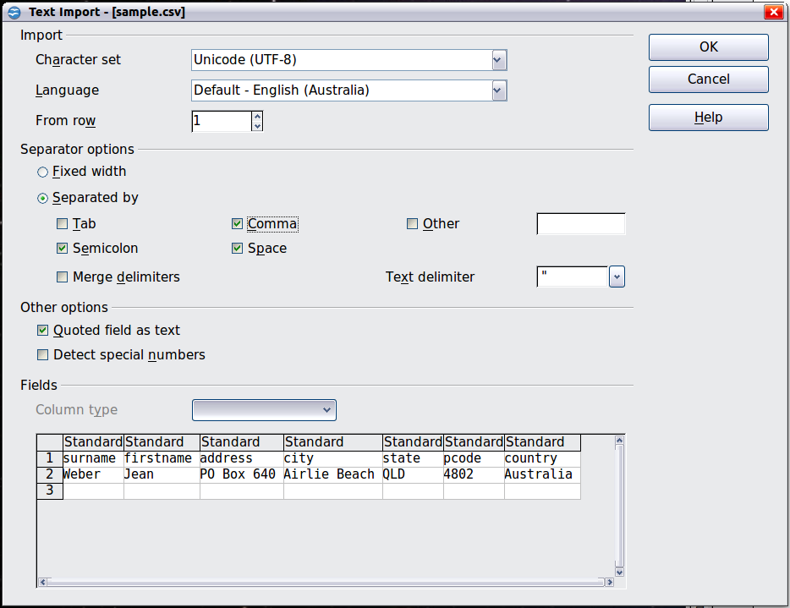
Figure 92: Text Import dialog, with Comma (,) selected as the separator and double quotation mark (“) as the text delimiter.

Saving as a CSV file
To save a spreadsheet as a comma separate value (CSV) file:
- Choose File → Save As.
- In the File name box, type a name for the file.
- In the File type list, select Text CSV (.csv) and click Save.
You may see the message box shown below. Click Keep Current Format.
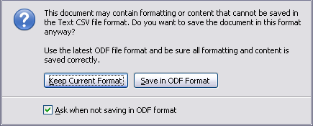
- In the Export of text files dialog, select the options you want and then click OK.
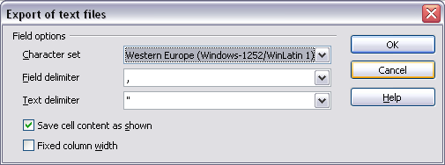
Figure 93: Choosing options when exporting to Text CSV

Navigating within spreadsheets
Calc provides many ways to navigate within a spreadsheet from cell to cell and sheet to sheet. You can generally use the method you prefer.

Going to a particular cell
Using the mouse
Place the mouse pointer over the cell and click.
Using a cell reference
Click on the little inverted black triangle just to the right of the Name Box (Figure 89). The existing cell reference will be highlighted. Type the cell reference of the cell you want to go to and press Enter. Or just click into the Name box, backspace over the existing cell reference and type in the cell reference you want and press Enter.
Using the Navigator
To open the Navigator, click its icon on the Standard toolbar, or press F5, or choose View → Navigator on the Menu bar, or double-click on the Sheet Sequence Number in the Status Bar. Type the cell reference into the top two fields, labeled Column and Row, and press Enter. In Figure 94 the Navigator would select cell A7.
You can dock the Navigator to either side of the main Calc window or leave it floating. (To dock or float the Navigator, hold down the Control key and double-click in an empty area near the icons in the Navigator dialog.)
The Navigator displays lists of all the objects in a document, grouped into categories. If an indicator (plus sign or arrow) appears next to a category, at least one object of this kind exists. To open a category and see the list of items, click on the indicator.
To hide the list of categories and show only the icons at the top, click the Contents icon . Click this icon again to show the list.
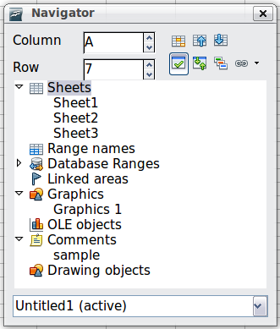
Figure 94: The Navigator in Calc

Moving from cell to cell
In the spreadsheet, one cell normally has a black border. This black border indicates where the focus is (see Figure 95). If a group of cells is selected, they are highlighted in a light blue color, with the focus cell having a black border.
Using the mouse
To move the focus using the mouse, simply move the mouse pointer to the cell where you want the focus to be and click the left mouse button. This changes the focus to the new cell. This method is most useful when the two cells are a large distance apart.
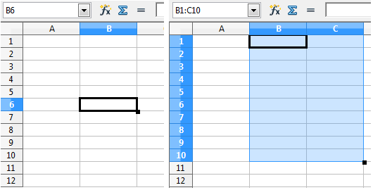
Figure 95. (Left) One selected cell and (right) a group of selected cells
Using the Tab and Enter keys
- Pressing Enter or Shift+Enter moves the focus down or up, respectively.
- Pressing Tab or Shift+Tab moves the focus to the right or to the left, respectively.
Using the arrow keys
Pressing the arrow keys on the keyboard moves the focus in the direction of the arrows.
Using Home, End, Page Up and Page Down
- Home moves the focus to the start of a row.
- End moves the focus to the column furthest to the right that contains data.
- Page Down moves the display down one complete screen and Page Up moves the display up one complete screen.
- Combinations of Control and Alt with Home, End, Page Down, Page Up, and the cursor keys move the focus of the current cell in other ways. See the Help or Appendix A, Keyboard Shortcuts, in the Calc Guide for details.
Tip | Use one of the four Alt+Arrow key combinations to resize a cell.

Customizing the Enter key
You can customize the direction in which the Enter key moves the focus, by selecting Tools → Options → LibreOffice Calc → General.
The four choices for the direction of the Enter key are shown on the right hand side of Figure 96. It can move the focus down, right, up, or left. Depending on the file being used or on the type of data being entered, setting a different direction can be useful.
The Enter key can also be used to switch into and out of editing mode. Use the first two options under Input settings in Figure 96 to change the Enter key settings.
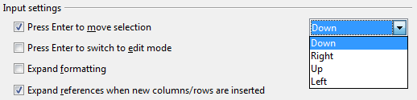
Figure 96: Customizing the effect of the Enter key

Moving from sheet to sheet
Each sheet in a spreadsheet is independent of the others, though they can be linked with references from one sheet to another. There are three ways to navigate between different sheets in a spreadsheet.
Using the Navigator
When the Navigator is open (Figure 94), double-clicking on any of the listed sheets selects the sheet.
Using the keyboard
Pressing Control+Page Down moves one sheet to the right and pressing Control+Page Up moves one sheet to the left.
Using the mouse
Clicking on one of the sheet tabs at the bottom of the spreadsheet selects that sheet.
If you have a lot of sheets, then some of the sheet tabs may be hidden behind the horizontal scroll bar at the bottom of the screen. If this is the case, then the four buttons at the left of the sheet tabs can move the tabs into view. Figure 97 shows how to do this.
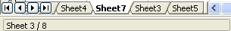

Figure 97. Sheet tab arrows
Move to the first sheet
Move left one sheet
Move right one sheet
Move to the last sheet
Sheet tabs
Notice that the sheets here are not numbered in order. Sheet numbering is arbitrary; you can name a sheet as you wish.
Note | The sheet tab arrows that appear in Figure 97 only appear if you have some sheet tabs that are hidden by the horizontal scrollbar. Otherwise, they will appear faded as in Figure 87.

Selecting items in a sheet or spreadsheet

Selecting cells
Cells can be selected in a variety of combinations and quantities.
Single cell
Left-click in the cell. The result will look like the left side of Figure 95. You can verify your selection by looking in the Name box.
Range of contiguous cells
A range of cells can be selected using the keyboard or the mouse.
To select a range of cells by dragging the mouse:
- Click in a cell.
- Press and hold down the left mouse button.
- Move the mouse around the screen.
- Once the desired block of cells is highlighted, release the left mouse button.
To select a range of cells without dragging the mouse:
- Click in the cell which is to be one corner of the range of cells.
- Move the mouse to the opposite corner of the range of cells.
- Hold down the Shift key and click.
To select a range of cells without using the mouse:
- Select the cell that will be one of the corners in the range of cells.
- While holding down the Shift key, use the cursor arrows to select the rest of the range.
The result of any of these methods looks like the right side of Figure 95.
Tip | You can also directly select a range of cells using the Name box. Click into the Name Box as described in “Using a cell reference” on page 105. To select a range of cells, enter the cell reference for the upper left-hand cell, followed by a colon (:), and then the lower right-hand cell reference. For example, to select the range that would go from A3 to C6, you would enter A3:C6.
Range of non-contiguous cells
- Select the cell or range of cells using one of the methods above.
- Move the mouse pointer to the start of the next range or single cell.
- Hold down the Control key and click or click-and-drag to select a range.
- Repeat as necessary.

Selecting columns and rows
Entire columns and rows can be selected very quickly in LibreOffice.
Single column or row
To select a single column, click on the column identifier letter (see Figure 87).
To select a single row, click on the row identifier number.
Multiple columns or rows
To select multiple columns or rows that are contiguous:
- Click on the first column or row in the group.
- Hold down the Shift key.
- Click the last column or row in the group.
To select multiple columns or rows that are not contiguous:
- Click on the first column or row in the group.
- Hold down the Control key.
- Click on all of the subsequent columns or rows while holding down the Control key.
Entire sheet
To select the entire sheet, click on the small box between the A column header and the 1 row header.
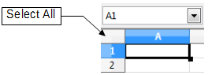
Figure 98. Select All box
You can also press Control+A to select the entire sheet.

Selecting sheets
You can select either one or multiple sheets. It can be advantageous to select multiple sheets at times when you want to make changes to many sheets at once.
Single sheet
Click on the sheet tab for the sheet you want to select. The active sheet becomes white (see Figure 99).
Multiple contiguous sheets
To select multiple contiguous sheets:
- Click on the sheet tab for the first desired sheet.
- Move the mouse pointer over the sheet tab for the last desired sheet.
- Hold down the Shift key and click on the sheet tab.
All the tabs between these two sheets will turn white. Any actions that you perform will now affect all highlighted sheets.
Multiple non-contiguous sheets
To select multiple non-contiguous sheets:
- Click on the sheet tab for the first sheet.
- Move the mouse pointer over the second sheet tab.
- Hold down the Control key and click on the sheet tab.
- Repeat as necessary.
The selected tabs will turn white. Any actions that you perform will now affect all highlighted sheets.
All sheets
Right-click any one of the sheet tabs and choose Select All Sheets from the pop-up menu.

Working with columns and rows

Inserting columns and rows
Columns and rows can be inserted individually or in groups.
Note | When you insert a single new column, it is inserted to the left of the highlighted column. When you insert a single new row, it is inserted above the highlighted row.  Cells in the new columns or rows are formatted like the corresponding cells in the column or row before (or to the left of) which the new column or row is inserted.
Single column or row
Using the Insert menu:
- Select the cell, column or row where you want the new column or row inserted.
- Choose either Insert → Columns or Insert → Rows.
Using the mouse:
- Select the cell, column or row where you want the new column or row inserted.
- Right-click the header of the column or row.
- Choose Insert Rows or Insert Columns.
Multiple columns or rows
Multiple columns or rows can be inserted at once rather than inserting them one at a time.
- Highlight the required number of columns or rows by holding down the left mouse button on the first one and then dragging across the required number of identifiers.
- Proceed as for inserting a single column or row above.

Deleting columns and rows
Columns and rows can be deleted individually or in groups.
Single column or row
A single column or row can only be deleted by using the mouse:
- Select the column or row to be deleted.
- Right-click on the column or row header.
- Select Delete Columns or Delete Rows from the pop-up menu.
Multiple columns or rows
Multiple columns or rows can be deleted at once rather than deleting them one at a time.
- Highlight the required number of columns or rows by holding down the left mouse button on the first one and then dragging across the required number of identifiers.
- Proceed as for deleting a single column or row above.

Working with sheets
Like any other Calc element, sheets can be inserted, deleted, and renamed.

Inserting new sheets
There are several ways to insert a new sheet. The fastest method is to click on the Add Sheet button . This inserts one new sheet at that point, without opening the Insert Sheet dialog.
Use one of the other methods to insert more than one sheet, to rename the sheet at the same time, or to insert the sheet somewhere else in the sequence. The first step for these methods is to select the sheet that the new sheet will be inserted next to. Then use any of the following options.
- Choose Insert → Sheet from the menu bar.
- Right-click on a sheet tab and choose Insert Sheet.
- Click in an empty space at the end of the line of sheet tabs.
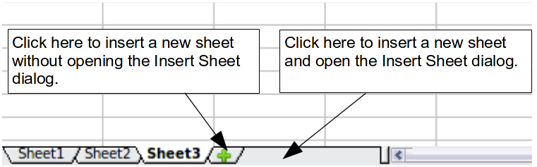
Figure 99. Creating a new sheet
Each method will open the Insert Sheet dialog (Figure 100). Here you can select whether the new sheet is to go before or after the selected sheet and how many sheets you want to insert. If you are inserting only one sheet, there is the opportunity to give the sheet a name.
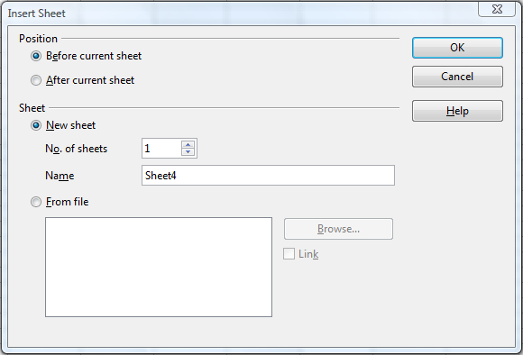
Figure 100. Insert Sheet dialog

Deleting sheets
Sheets can be deleted individually or in groups.
Single sheet
Right-click on the tab of the sheet you want to delete and choose Delete Sheet from the pop-up menu, or chose Edit → Sheet → Delete from the menu bar.
Multiple sheets
To delete multiple sheets, select them as described earlier, then either right-click over one of the tabs and select Delete Sheet from the pop-up menu, or choose Edit → Sheet → Delete from the menu bar.

Renaming sheets
The default name for the a new sheet is SheetX, where X is a number. While this works for a small spreadsheet with only a few sheets, it becomes awkward when there are many sheets.
To give a sheet a more meaningful name, you can:
- Enter the name in the Name box when you create the sheet, or
- Right-click on a sheet tab and choose Rename Sheet from the pop-up menu; replace the existing name with one of your choosing.
- Double-click on a sheet tab to pop up the Rename Sheet dialog.
Note | Sheet names must start with either a letter or a number. Apart from the first character of the sheet name, allowed characters are letters, numbers, spaces, and the underline character. Attempting to rename a sheet with an invalid name will produce an error message.

Viewing Calc

Using zoom
Use the zoom function to change the view to show more or fewer cells in the window. For more about zoom, see Chapter 1, Introducing LibreOffice, in this book.

Freezing rows and columns
Freezing locks a number of rows at the top of a spreadsheet or a number of columns on the left of a spreadsheet or both. Then when scrolling around within the sheet, any frozen columns and rows remain in view.
Figure 101 shows some frozen rows and columns. The heavier horizontal line between rows 3 and 14 and the heavier vertical line between columns C and H denote the frozen areas. Rows 4 through 13 and columns D through G have been scrolled off the page. The first three rows and columns remained because are frozen into place.
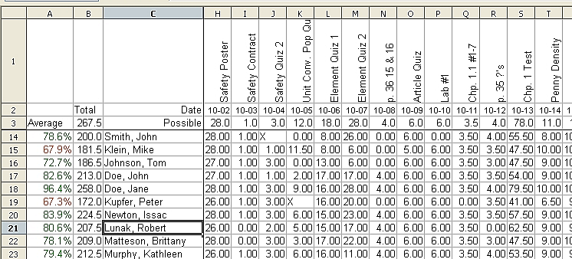
Figure 101. Frozen rows and columns
You can set the freeze point at a row, a column, or both a row and a column as in Figure 101.
Freezing single rows or columns
- Click on the header for the row below where you want the freeze or for the column to the right of where you want the freeze.
- Choose Window → Freeze.
A dark line appears, indicating where the freeze is put.
Freezing a row and a column
- Click into the cell that is immediately below the row you want frozen and immediately to the right of the column you want frozen.
- Choose Window → Freeze.
Two lines appear on the screen, a horizontal line above this cell and a vertical line to the left of this cell. Now as you scroll around the screen, everything above and to the left of these lines will remain in view.
Unfreezing
To unfreeze rows or columns, choose Window → Freeze. The check mark by Freeze will vanish.

Splitting the screen
Another way to change the view is by splitting the window, also known as splitting the screen. The screen can be split either horizontally or vertically or both. You can therefore have up to four portions of the spreadsheet in view at any one time.
Why would you want to do this? Imagine you have a large spreadsheet and one of the cells has a number in it which is used by three formulas in other cells. Using the split screen technique, you can position the cell containing the number in one section and each of the cells with formulas in the other sections. Then you can change the number in the cell and watch how it affects each of the formulas.
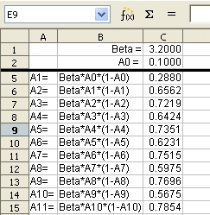
Figure 102. Split screen example

Splitting the screen horizontally
To split the screen horizontally:
- Move the mouse pointer into the vertical scroll bar, on the right-hand side of the screen, and place it over the small button at the top with the black triangle. Immediately above this button you will see a thick black line.
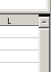

Figure 103. Split screen bar on vertical scroll bar
Split screen bar
- Move the mouse pointer over this line and it turns into a line with two arrows.

Figure 104. Split screen bar on vertical scroll bar with cursor
- Hold down the left mouse button. A gray line appears, running across the page. Drag the mouse downwards and this line follows.
- Release the mouse button and the screen splits into two views, each with its own vertical scroll bar. You can scroll the upper and lower parts independently.
Notice in Figure 102, the Beta and the A0 values are in the upper part of the window and other calculations are in the lower part. Thus you can make changes to the Beta and A0 values and watch their affects on the calculations in the lower half of the window.
Tip | You can also split the screen using a menu command. Click in a cell immediately below and to the right of where you wish the screen to be split, and choose Window → Split.

Splitting the screen vertically
To split the screen vertically:
- Move the mouse pointer into the horizontal scroll bar at the bottom of the screen and place it over the small button on the right with the black triangle. Immediately to the right of this button is a thick black line.
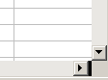

Figure 105: Split bar on horizontal scroll bar
Split screen bar
- Move the mouse pointer over this line and it turns into a line with two arrows.
- Hold down the left mouse button, and a gray line appears, running up the page. Drag the mouse to the left and this line follows.
- Release the mouse button and the screen is split into two views, each with its own horizontal scroll bar. You can scroll the left and right parts of the window independently.

Removing split views
To remove a split view, do any of the following:
- Double-click on each split line.
- Click on and drag the split lines back to their places at the ends of the scroll bars.
- Choose Window → Split to remove all split lines at the same time.

Entering data using the keyboard
Most data entry in Calc can be accomplished using the keyboard.

Entering numbers
Click in the cell and type in the number using the number keys on either the main keyboard or the numeric keypad.
To enter a negative number, either type a minus (–) sign in front of it or enclose it in parentheses (brackets), like this: (1234).
By default, numbers are right-aligned and negative numbers have a leading minus symbol.
Note | If a number beginning with 0 is entered in to a cell, Calc will drop the 0 (for example 01234 becomes 1234).
To enter a number and retain the leading 0, right-click on the cell and choose Format Cells → Numbers. In the Format Cells dialog, under Options select the required number of Leading zeros.
The number selected for leading zeros needs to be one higher than the digits in a number. For example, if the number is 1234, the number entered for the leading zero will be 5.
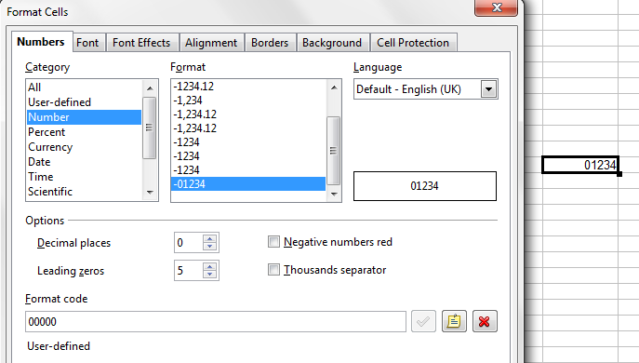
Figure 106: Adjusting leading zeros

Entering text
Click in the cell and type the text. Text is left-aligned by default.

Entering numbers as text
A number can be entered as text to preserve a leading zero by entering an apostrophe before the number, like this: '01481.
The data is now regarded as text by Calc and displayed exactly as entered. Typically, formulas will treat the entry as a zero and functions will ignore it. Take care that the cell containing the number is not used in a formula.
Note | If “smart quotes” are used for apostrophes, the apostrophe remains visible in the cell.  To choose the type of apostrophe, use Tools → AutoCorrect → Custom Quotes. The selection of the apostrophe type affects both Calc and Writer.

Entering dates and times
Select the cell and type the date or time. You can separate the date elements with a slant (/) or a hyphen (–) or use text such as 15 Oct 10. Calc recognizes a variety of date formats. You can separate time elements with colons such as 10:43:45.

Deactivating automatic changes
Calc automatically applies many changes during data input, unless you deactivate those changes. You can also immediately undo any automatic changes with Ctrl+Z.
AutoCorrect changes
Automatic correction of typing errors, replacement of straight quotation marks by curly (custom) quotes, and starting cell content with an uppercase (capital letter) are controlled by Tools → AutoCorrect Options. Go to the Custom Quotes, Options, or Replace tabs to deactivate any of the features that you do not want. On the Replace tab, you can also delete unwanted word pairs and add new ones as required.
AutoInput
When you are typing in a cell, Calc automatically suggests matching input found in the same column. To turn the AutoInput on and off, set or remove the check mark in front of Tools → Cell Contents → AutoInput.
Automatic date conversion
Calc automatically converts certain entries to dates. To ensure that an entry that looks like a date is interpreted as text, type an apostrophe at the beginning of the entry. The apostrophe is not displayed in the cell.

Speeding up data entry
Entering data into a spreadsheet can be very labor-intensive, but Calc provides several tools for removing some of the drudgery from input.
The most basic ability is to drag and drop the contents of one cell to another with a mouse. Calc also includes several other tools for automating input, especially of repetitive material. They include the Fill tool, selection lists, and the ability to input information into multiple sheets of the same document.

Using the Fill tool on cells
At its simplest, the Fill tool is a way to duplicate existing content. Start by selecting the cell to copy, then drag the mouse in any direction (or hold down the Shift key and click in the last cell you want to fill), and then choose Edit → Fill and the direction in which you want to copy: Up, Down, Left or Right.
Caution | Choices that are not available are grayed out, but you can still choose the opposite direction from what you intend, which could cause you to overwrite cells accidentally.
Tip | A shortcut way to fill cells is to grab the “handle” in the lower right-hand corner of the cell and drag it in the direction you want to fill. If the cell contains a number, the number will fill in series. If the cell contains text, the same text will fill in the direction you chose.
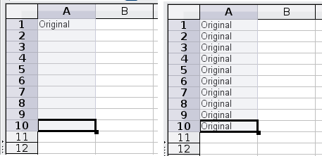
Figure 107: Using the Fill tool

Using a fill series
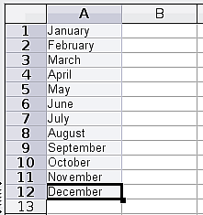
Figure 108: Result of fill series selection shown in Figure 109
A more complex use of the Fill tool is to use a fill series. The default lists are for the full and abbreviated days of the week and the months of the year, but you can create your own lists as well.
To add a fill series to a spreadsheet, select the cells to fill, choose Edit → Fill → Series. In the Fill Series dialog (Figure 109), select AutoFill as the Series type, and enter as the Start value an item from any defined series. The selected cells then fill in the other items on the list sequentially, repeating from the top of the list when they reach the end of the list.
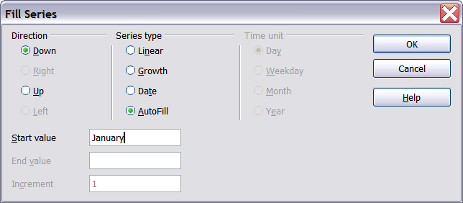
Figure 109: Specifying the start of a fill series (result is in Figure 108)
You can also use Edit → Fill → Series to create a one-time fill series for numbers by entering the start and end values and the increment. For example, if you entered start and end values of 1 and 7 with an increment of 2, you would get the sequence of 1, 3, 5, 7.
In all these cases, the Fill tool creates only a momentary connection between the cells. Once they are filled, the cells have no further connection with one another.

Defining a fill series
To define your own fill series:
- Go to Tools → Options → LibreOffice Calc → Sort Lists. This dialog shows the previously-defined series in the Lists box on the left, and the contents of the highlighted list in the Entries box.
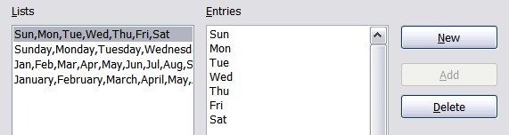
Figure 110: Predefined fill series
- Click New. The Entries box is cleared.
- Type the series for the new list in the Entries box (one entry per line). Click Add. The new list will now appear in the Lists box.
- Click OK at the bottom of the dialog to save the new list.
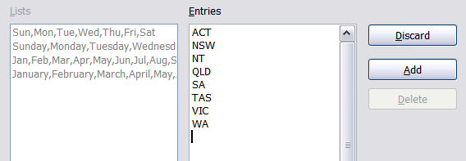
Figure 111: Defining a new fill series

Using selection lists
Selection lists are available only for text, and are limited to using only text that has already been entered in the same column.
To use a selection list, select a blank cell and press Ctrl+D. A drop-down list appears of any cell in the same column that either has at least one text character or whose format is defined as Text. Click on the entry you require.
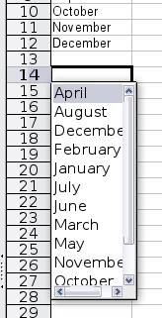

Sharing content between sheets
You might want to enter the same information in the same cell on multiple sheets, for example to set up standard listings for a group of individuals or organizations. Instead of entering the list on each sheet individually, you can enter it in all the sheets at once. To do this, select all the sheets (Edit → Sheet → Select), then enter the information in the current one.
Caution | This technique overwrites any information that is already in the cells on the other sheets—without any warning. For this reason, when you are finished, be sure to deselect all the sheets except the one you want to edit. (Ctrl+click on a sheet tab to select or deselect the sheet.)

Validating cell contents
When creating spreadsheets for other people to use, you may want to make sure they enter data that is valid or appropriate for the cell. You can also use validation in your own work as a guide to entering data that is either complex or rarely used.
Fill series and selection lists can handle some types of data, but they are limited to predefined information. To validate new data entered by a user, select a cell and use Data → Validity to define the type of contents that can be entered in that cell. For example, a cell might require a date or a whole number, with no alphabetic characters or decimal points; or a cell may not be left empty.
Depending on how validation is set up, the tool can also define the range of contents that can be entered and provide help messages that explain the content rules you have set up for the cell and what users should do when they enter invalid content. You can also set the cell to refuse invalid content, accept it with a warning, or start a macro when an error is entered.
See Chapter 2, Entering, Editing and Formatting Data, in the Calc Guide for more information.

Editing data
Editing data is done in much the same way as entering data. The first step is to select the cell containing the data to be edited.

Removing data from a cell
Data can be removed (deleted) from a cell in several ways.
Removing data only
The data alone can be removed from a cell without removing any of the formatting of the cell. Click in the cell to select it, and then press the Delete key.
Removing data and formatting
The data and the formatting can be removed from a cell at the same time. Press the Backspace key (or right-click and choose Delete Contents, or use Edit → Delete Contents) to open the Delete Contents dialog. From this dialog, the different aspects of the cell can be deleted. To delete everything in a cell (contents and format), check Delete all.
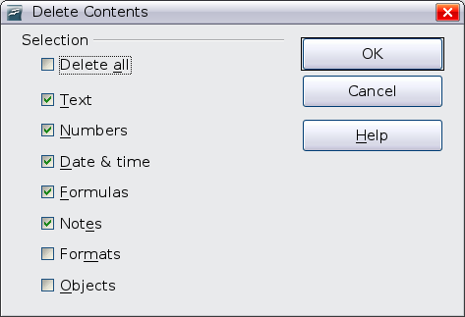
Figure 112: Delete Contents dialog

Replacing all the data in a cell
To remove data and insert new data, simply type over the old data. The new data will retain the original formatting.

Changing part of the data in a cell
Sometimes it is necessary to change the contents of cell without removing all of the contents, for example if the phrase “Sales in Qtr. 2” is in a cell and it needs to be changed to “Sales rose in Qtr. 2” It is often useful to do this without deleting the old cell contents first.
The process is the similar to the one described above, but you need to place the cursor inside the cell. You can do this in two ways.
Using the keyboard
After selecting the appropriate cell, press the F2 key and the cursor is placed at the end of the cell. Then use the keyboard arrow keys to move the cursor through the text in the cell.
Using the mouse
Using the mouse, either double-click on the appropriate cell (to select it and place the cursor in it for editing), or single-click to select the cell and then move the mouse pointer up to the input line and click into it to place the cursor for editing.

Formatting data
The data in Calc can be formatted in several ways. It can either be edited as part of a cell style so that it is automatically applied, or it can be applied manually to the cell. Some manual formatting can be applied using toolbar icons. For more control and extra options, select the appropriate cell or cells, right-click on it, and select Format Cells. All of the format options are discussed below.
Note | All the settings discussed in this section can also be set as a part of the cell style. See Chapter 4, Using Styles and Templates in Calc, in the Calc Guide for more information.

Formatting multiple lines of text
Multiple lines of text can be entered into a single cell using automatic wrapping or manual line breaks. Each method is useful for different situations.

Using automatic wrapping
To set text to wrap at the end of the cell, right-click on the cell and select Format Cells (or choose Format → Cells from the menu bar, or press Ctrl+1). On the Alignment tab (Figure 113), under Properties, select Wrap text automatically and click OK. The results are shown in Figure 114.
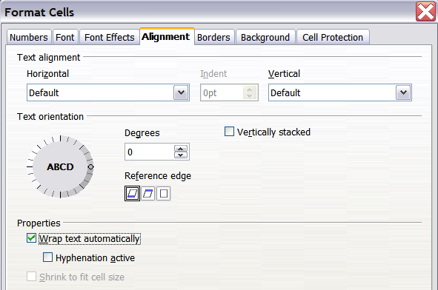
Figure 113: Format Cells → Alignment dialog
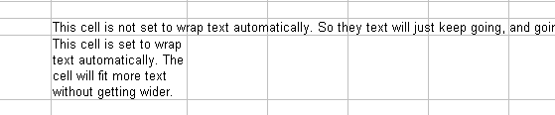
Figure 114: Automatic text wrap

Using manual line breaks
To insert a manual line break while typing in a cell, press Ctrl+Enter. This method does not work with the cursor in the input line. When editing text, first double-click the cell, then single-click at the position where you want the line break.
When a manual line break is entered, the cell width does not change. Figure 115 shows the results of using two manual line breaks after the first line of text.
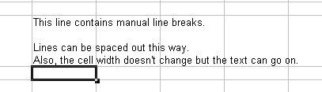
Figure 115: Cell with manual line breaks

Shrinking text to fit the cell
The font size of the data in a cell can automatically adjust to fit in a cell. To do this, select the Shrink to fit cell size option in the Format Cells dialog (Figure 113). Figure 116 shows the results.
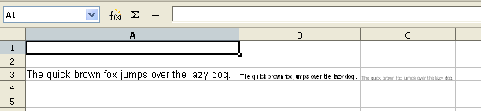
Figure 116: Shrinking font size to fit cells

Formatting numbers
Several different number formats can be applied to cells by using icons on the Formatting toolbar. Select the cell, then click the relevant icon.
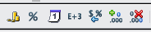
Figure 117: Number format icons. Left to right: currency, percentage, date, exponential, standard, add decimal place, delete decimal place.
For more control or to select other number formats, use the Numbers tab (Figure 118) of the Format Cells dialog:
- Apply any of the data types in the Category list to the data.
- Control the number of decimal places and leading zeros.
- Enter a custom format code.
The Language setting controls the local settings for the different formats such as the date order and the currency marker.
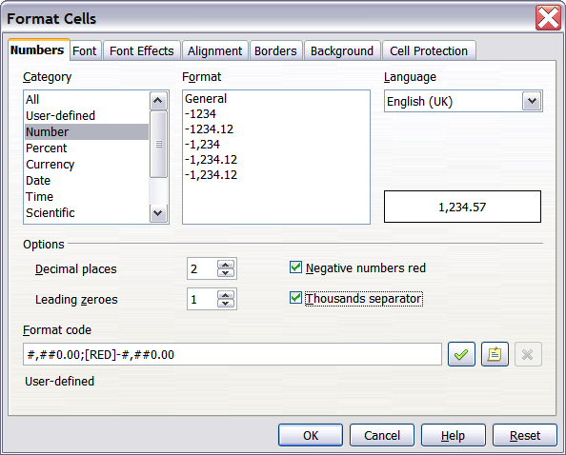
Figure 118: Format Cells → Numbers

Formatting the font
To quickly choose the font used in a cell, select the cell, then click the arrow next to the Font Name box on the Formatting toolbar and choose a font from the list.
Tip | To choose whether to show the font names in their font or in plain text, go to Tools → Options → LibreOffice → View and select or deselect the Show preview of fonts option in the Font Lists section. For more information, see Chapter 2, Setting Up LibreOffice.
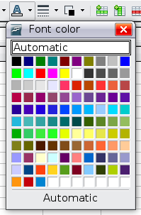
To choose the size of the font, click the arrow next to the Font Size box on the Formatting toolbar. For other formatting, you can use the Bold, Italic, or Underline icons.
To choose a font color, click the arrow next to the Font Color icon to display the color palette. Click on the desired color.
(To define custom colors, use Tools → Options → LibreOffice → Colors. See Chapter 2.)
To specify the language of the cell (useful because it allows different languages to exist in the same document and be spell checked correctly), use the Font tab of the Format Cells dialog. Use the Font Effects tab to set other font characteristics. See Chapter 4, Using Styles and Templates in Calc, of the Calc Guide for more information.

Formatting the cell borders
To add a border to a cell (or group of selected cells), click on the Borders icon on the formatting toolbar, and select one of the border options displayed in the palette.
To quickly choose a line style and color for the borders of a cell, click the small arrows next to the Line Style and Line Color icons on the Formatting toolbar. In each case, a palette of choices is displayed.
For more controls, including the spacing between the cell borders and the text, use the Borders tab of the Format Cells dialog. There you can also define a shadow. See Chapter 4, Using Styles and Templates in Calc, of the Calc Guide for details.
Note | The cell border properties apply to a cell, and can only be changed if you are editing that cell. For example, if cell C3 has a top border (which would be equivalent visually to a bottom border on C2), that border can only be removed by selecting C3. It cannot be removed in C2.

Formatting the cell background
To quickly choose a background color for a cell, click the small arrow next to the Background Color icon on the Formatting toolbar. A palette of color choices, similar to the Font Color palette, is displayed.
(To define custom colors, use Tools → Options → LibreOffice → Colors. See Chapter 2 for more information.)
You can also use the Background tab of the Format Cells dialog. See Chapter 4, Using Styles and Templates in Calc, of the Calc Guide for details.

Autoformatting cells and sheets
You can use the AutoFormat feature to quickly apply a set of cell formats to a sheet or a selected cell range.
- Select the cells, including the column and row headers, that you want to format.
- Choose Format → AutoFormat.
Note | The AutoFormat feature can only be applied if the selected set of cells consist of at least 3 columns and 3 rows and includes the column and row headers.
- To select which properties (number format, font, alignment, borders, pattern, autofit width and height) to include in an AutoFormat, click More. Select or deselect the required options.
- Click OK.
If you do not see any change in color of the cell contents, choose View → Value Highlighting from the menu bar.
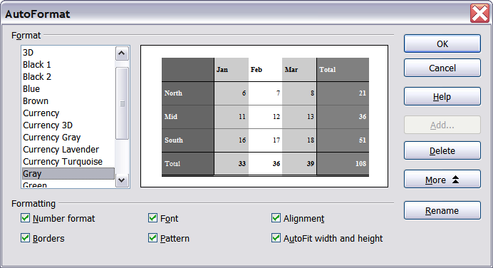
Figure 119: Choosing an AutoFormat

Defining a new AutoFormat
You can define a new AutoFormat that is available to all spreadsheets.
- Format a sheet (in the style for the new AutoFormat).
- Choose Edit → Select All.
- Choose Format → AutoFormat. The Add button is now active.
- Click Add.
- In the Name box of the Add AutoFormat dialog, type a meaningful name for the new format.
- Click OK to save. The new format is now available in the Format list in the AutoFormat dialog.

Formatting spreadsheets using themes
Calc comes with a predefined set of formatting themes that you can apply to your spreadsheets.
It is not possible to add themes to Calc, and they cannot be modified. However, you can modify their styles after you apply them to a spreadsheet.
To apply a theme to a spreadsheet:
- Click the Choose Themes icon in the Tools toolbar. If this toolbar is not visible, you can show it using View → Toolbars → Tools.
The Theme Selection dialog appears. This dialog lists the available themes for the whole spreadsheet.
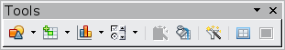
- In the Theme Selection dialog, select the theme that you want to apply to the spreadsheet.
As soon as you select a theme, some of the properties of the custom styles are applied to the open spreadsheet and are immediately visible.
- Click OK. If you wish, you can now go to the Styles and Formatting window to modify specific styles. These modifications do not change the theme; they only change the appearance of this specific spreadsheet document.

Using conditional formatting
You can set up cell formats to change depending on conditions that you specify. For example, in a table of numbers, you can show all the values above the average in green and all those below the average in red.
Conditional formatting depends upon the use of styles, and the AutoCalculate feature (Tools → Cell Contents → AutoCalculate) must be enabled. See Chapter 2, Entering, Editing, and Formatting Data, in the Calc Guide for details.

Hiding and showing data
When elements are hidden, they are neither visible nor printed, but can still be selected for copying if you select the elements around them. For example, if column B is hidden, it is copied when you select columns A and C. When you need a hidden element again, you can reverse the process, and show the element.
To hide or show sheets, rows, and columns, use the options on the Format menu or the right-click (context) menu. For example, to hide a row, first select the row, and then choose Format → Row → Hide (or right-click and choose Hide).
To hide or show selected cells, choose Format → Cells from the menu bar (or right-click and choose Format Cells). On the Format Cells dialog, go to the Cell Protection tab.
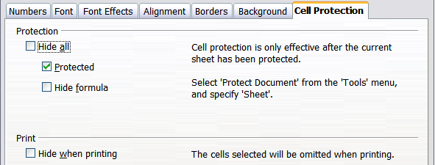
Figure 120: Hiding or showing cells

Outline group controls
If you are continually hiding and showing the same cells, you can simplify the process by creating outline groups, which add a set of controls for hiding and showing the cells in the group that are quick to use and always available.
If the contents of cells falls into a regular pattern, such as four cells followed by a total, then you can use Data → Group and Outline → AutoOutline to have Calc add outline controls based on the pattern. Otherwise, you can set outline groups manually by selecting the cells for grouping, then choosing Data → Group and Outline → Group. On the Group dialog, you can choose whether to group the selected cells by rows or columns.
When you close the dialog, the outline group controls are visible between either the row or column headers and the edges of the editing window. The controls resemble the tree-structure of a file-manager in appearance, and can be hidden by selecting Data → Outline → Hide Details. They are strictly for on screen use, and do not print.
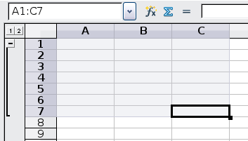
Figure 121: Outline group controls
The basic outline controls have plus or minus signs at the start of the group to show or hide hidden cells. However, if outline groups are nested, the controls have numbered buttons for hiding different levels.
If you no longer need a group, place the mouse cursor in any cell in it and select Data → Group and Outline → Ungroup. To remove all groups on a sheet, select Data → Group and Outline → Remove.

Filtering which cells are visible
A filter is a list of conditions that each entry has to meet in order to be displayed. You can set three types of filters from the Data → Filter sub-menu.
Automatic filters add a drop-down list to the top row of a column that contains commonly used filters. They are quick and convenient and are useful with text and with numbers, because the list includes every unique entry in the selected cells.
In addition to these unique entries, automatic filters include the option to display all entries, the ten highest numerical values, and all cells that are empty or not-empty, as well as a standard filter. The automatic filters are somewhat limited. In particular, they do not allow regular expressions, so you cannot use them to display cell contents that are similar, but not identical.
Standard filters are more complex than automatic filters. You can set as many as three conditions as a filter, combining them with the operators AND and OR. Standard filters are mostly useful for numbers, although a few of the conditional operators, such as = and < > can also be useful for text.
Other conditional operators for standard filters include options to display the largest or smallest values, or a percentage of them. Useful in themselves, standard filters take on added value when used to further refine automatic filters.
Advanced filters are structured similarly to standard filters. The differences are that advanced filters are not limited to three conditions, and their criteria are not entered in a dialog. Instead, advanced filters are entered in a blank area of a sheet, then referenced by the advanced filter tool to apply them.

Sorting records
Sorting arranges the visible cells on the sheet. In Calc, you can sort by up to three criteria, which are applied one after another. Sorts are handy when you are searching for a particular item, and become even more powerful after you have filtered data.
In addition, sorting is often useful when you add new information. When a list is long, it is usually easier to add new information at the bottom of the sheet, rather than adding rows in the proper places. After you have added information, you can then sort it to update the sheet.
Highlight the cells to be sorted, then select Data → Sort to open the Sort dialog (or click the Sort Ascending or Sort Descending toolbar buttons). Using the dialog, you can sort the selected cells using up to three columns, in either ascending (A-Z, 1-9) or descending (Z-A, 9-1) order.
On the Options tab of the Sort dialog, you can choose the following options:
Case sensitive
If two entries are otherwise identical, one with an upper case letter is placed before one with a lower case letter in the same position.
Range contains column labels
Does not include the column heading in the sort.
Include formats
A cell's formatting is moved with its contents. If formatting is used to distinguish different types of cells, then use this option.
Copy sort results to
Sets a spreadsheet address to which to copy the sort results. If a range is specified that does not have the necessary number of cells, then cells are added. If a range contains cells that already have content, then the sort fails.
Custom sort order
Select the box, then choose one of the sort orders defined in Tools → Options → Spreadsheet → Sort Lists from the drop-down list.
Direction
Sets whether rows or columns are sorted. The default is to sort by columns unless the selected cells are in a single column.

Printing
Printing from Calc is much the same as printing from other LibreOffice components (see Chapter 10), but some details are different, especially regarding preparation for printing.

Using print ranges
Print ranges have several uses, including printing only a specific part of the data or printing selected rows or columns on every page. For more about using print ranges, see Chapter 6, Printing, Exporting, and E-mailing, in the Calc Guide.

Defining a print range
To define a new print range or modify an existing print range:
- Highlight the range of cells that comprise the print range.
- Choose Format → Print Ranges → Define.
The page break lines display on the screen.
Tip | You can check the print range by using File → Page Preview. LibreOffice will only display the cells in the print range.

Adding to the print range
After defining a print range, you can add more cells to it. This allows multiple, separate areas of the same sheet to be printed, while not printing the whole sheet. After you have defined a print range:
- Highlight the range of cells to be added to the print range.
- Choose Format → Print Ranges → Add. This adds the extra cells to the print range.
The page break lines no longer display on the screen.
Note | The additional print range will print as a separate page, even if both ranges are on the same sheet.

Removing a print range
It may become necessary to remove a defined print range, for example if the whole sheet needs to be printed later.
Choose Format → Print Ranges → Remove. This removes all defined print ranges on the sheet. After the print range is removed, the default page break lines will appear on the screen.

Editing a print range
At any time, you can directly edit the print range, for example to remove or resize part of the print range. Choose Format → Print Ranges → Edit.

Selecting the page order, details, and scale
To select the page order, details, and scale to be printed:
- Choose Format → Page from the main menu.
- Select the Sheet tab.
- Make your selections, and then click OK.
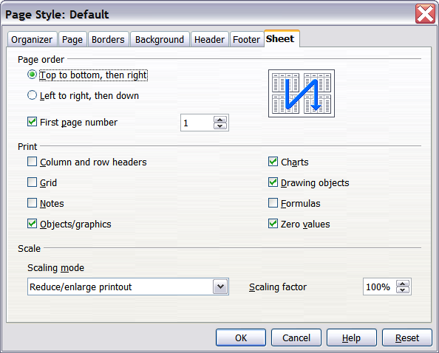
Figure 122. The Sheet tab of the Page Style dialog
Page Order
When a sheet will print on more than one page, you can set the order in which pages print. This is especially useful in a large document; for example, controlling the print order can save time if you have to collate the document a certain way. The two available options are shown below.
Top to bottom, then right | 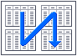
Left to right, then down | 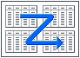
Details
You can specify which details to print. These details include:
- Row and column headers
- Sheet grid—prints the borders of the cells as a grid
- Comments—prints the comments defined in your spreadsheet on a separate page, along with the corresponding cell reference
- Objects and graphics
- Charts
- Drawing objects
- Formulas—prints the formulas contained in the cells, instead of the results
- Zero Values—prints cells with a zero value
Note | Remember that since the print detail options are a part of the page’s properties, they are also a part of the page style’s properties. Therefore, different page styles can be set up to quickly change the print properties of the sheets in the spreadsheet.
Scale
Use the scale features to control the number of pages the data will print on. This can be useful if a large amount of data needs to be printed compactly or if you want the text enlarged to make it easier to read.
- Reduce/Enlarge printout—scales the data in the printout either larger or smaller. For example if a sheet would normally print out as four pages (two high and two wide), a scaling of 50% would print as one page (both width and height are halved).
- Fit print range(s) on number of pages—defines exactly how many pages the printout will take up. This option will only reduce a printout, it will not enlarge it. To enlarge a printout, the reduce/enlarge option must be used.
- Fit print range(s) to width/height—defines how high and wide the printout will be, in pages.

Printing rows or columns on every page
If a sheet is printed on multiple pages, you can set up certain rows or columns to repeat on each printed page.
For example, if the top two rows of the sheet as well as column A need to be printed on all pages, do the following:
- Choose Format → Print Ranges → Edit. On the Edit Print Ranges dialog, type the rows in the text entry box under Rows to repeat. For example, to repeat rows 1 and 2, type $1:$2. This automatically changes Rows to repeat from, - none - to - user defined -.
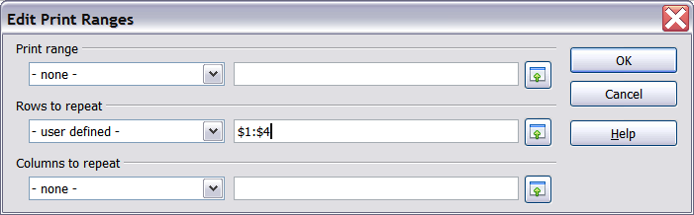
Figure 123: Specifying repeating rows
- To repeat, type the columns in the text entry box under Columns to repeat. For example, to repeat column A, type $A. In the Columns to repeat list, - none - changes to - user defined -.
- Click OK.
Note | You do not need to select the entire range of the rows to be repeated; selecting one cell in each row works.

Page breaks
While defining a print range can be a powerful tool, it may sometimes be necessary to manually adjust Calc’s printout. To do this, you can use a manual break. A manual break helps to ensure that your data prints properly. You can insert a horizontal page break above, or a vertical page break to the left of, the active cell.

Inserting a page break
To insert a page break:
- Navigate to the cell where the page break will begin.
- Select Insert → Manual Break.
- Select Row Break or Column Break depending on your need.
The break is now set.
Row break
Selecting Row Break creates a page break above the selected cell. For example, if the active cell is H15, then the break is created between rows 14 and 15.
Column break
Selecting Column Break creates a page break to the left of the selected cell. For example, if the active cell is H15, then the break is created between columns G and H.
Tip | To see page break lines more easily on screen, you can change their color. Choose Tools → Options → LibreOffice → Appearance and scroll down to the Spreadsheet section.

Deleting a page break
To remove a page break:
- Navigate to a cell that is next to the break you want to remove.
- Select Edit → Delete Manual Break.
- Select Row Break or Column Break depending on your need.
The break is now removed.
Note | Multiple manual row and column breaks can exist on the same page. When you want to remove them, you have to remove each one individually. This may be confusing at times, because although there may be a column break set on the page, when you go to Edit → Manual Break, Column break may be grayed out.  In order to remove the break, you have to be in the cell next to the break. For example, if you set the column break while you are in H15, you can not remove it if you are in cell D15. However, you can remove it from any cell in column H.

Headers and footers
Headers and footers are predefined pieces of text that are printed at the top or bottom of a sheet outside of the sheet area. Headers are set in the same way as footers.
Headers and footers are assigned to a page style. You can define more than one page style for a spreadsheet and assign different page styles to different sheets. For more about page styles, see Chapter 4, Using Styles and Templates, in the Calc Guide.

Setting a header or footer
To set a header or footer:
- Navigate to the sheet that you want to set the header or footer for. Choose Format → Page.
- On the Page Style dialog, select the Header (or Footer) tab. See Figure 124.
- Select the Header on option.
From here you can also set the margins, the spacing, and height for the header or footer. You can check the AutoFit height box to automatically adjust the height of the header or footer.
Margin
Changing the size of the left or right margin adjusts how far the header or footer is from the side of the page.
Spacing
Spacing affects how far above or below the sheet the header or footer will print. So, if spacing is set to 1.00", then there will be 1 inch between the header or footer and the sheet.
Height
Height affects how big the header or footer will be.
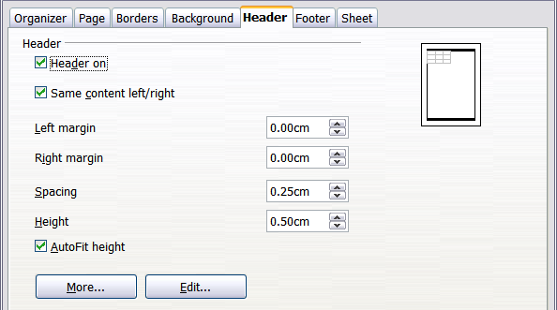
Figure 124: Header dialog

Header or footer appearance
To change the appearance of the header or footer, click the More button in the header dialog. This opens the Border/Background dialog (Figure 125).
From this dialog you can set the background and border of the header or footer. For more information see Chapter 4, Using Styles and Templates, in the Calc Guide.
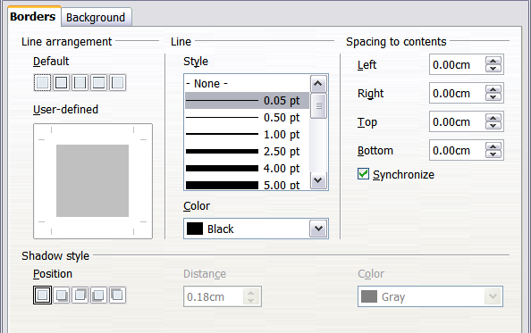
Figure 125: Header/Footer - Border/Background

Setting the contents of the header or footer
The header or footer of a Calc spreadsheet has three columns for text. Each column can have different contents.
To set the contents of the header or footer, click the Edit button in the header or footer dialog shown in Figure 124 to display the dialog shown in Figure 126.
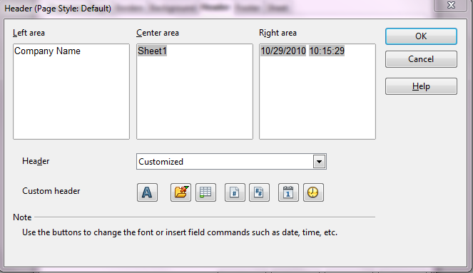
Figure 126: Edit contents of header or footer
Areas
Each area in the header or footer is independent and can have different information in it.
Header
You can select from several preset choices in the Header drop-down list, or specify a custom header using the buttons below the area boxes. (To format a footer, the choices are the same.)
Custom header
Click in the area (Left, Center, Right) that you want to customize, then use the buttons to add elements or change text attributes.
Opens the Text Attributes dialog.
Inserts the total number of pages.
Inserts the File Name field.
Inserts the Date field.
Inserts the Sheet Name field.
Inserts the Time field.
Inserts the current page number.

Getting Started Guide

Chapter 6
Getting Started with Impress
Presentations in LibreOffice

What is Impress?
Impress is LibreOffice’s presentations (slide show) program. You can create slides that contain many different elements, including text, bulleted and numbered lists, tables, charts, clip art, and a wide range of graphic objects. Impress also includes a spelling checker, a thesaurus, prepackaged text styles, and attractive background styles.
This chapter includes instructions, screenshots, and hints to guide you through the Impress environment while designing your presentations. Although more difficult designs are mentioned throughout this chapter, explanations for creating them are in the Impress Guide. If you have a working knowledge of how to create slide shows, we recommend you use the Impress Guide for your source of information.
To use Impress for more than very simple slide shows requires some knowledge of the elements which the slides contain. Slides containing text use styles to determine the appearance of that text. Graphic objects are created the same way that drawings are created in Draw. For this reason, we recommend that you also see Chapter 3, Using Styles and Templates, and Chapter 7, Getting Started with Draw, in this book. You may also wish to consult the Draw Guide for details.

Starting Impress
You can start Impress in several ways:
- From the LibreOffice Start Center, if no component is open.
- From the system menu or the LibreOffice Quickstarter. Details vary with your operating system; see Chapter 1, Introducing LibreOffice, for more information.
- From any open component of LibreOffice. Click the triangle to the right of the New icon on the main toolbar and select Presentation from the drop-down menu or choose File → New → Presentation from the menu bar.
When you start Impress for the first time, the Presentation Wizard is shown. Here you can choose from the following options:
- Empty presentation, which gives you a blank document
- From template, which is a presentation designed with a template of your choice
- Open existing presentation
If you prefer not to use the wizard in future, you can select Do not show this wizard again.
Click Create to open the main Impress window.
For detailed instructions about how to use the wizard, see “Creating a new presentation” on page 146.

Parts of the main Impress window
The main Impress window (Figure 127) has three parts: the Slides pane, Workspace, and Tasks pane. Additionally, several toolbars can be displayed or hidden during the creation of a presentation.
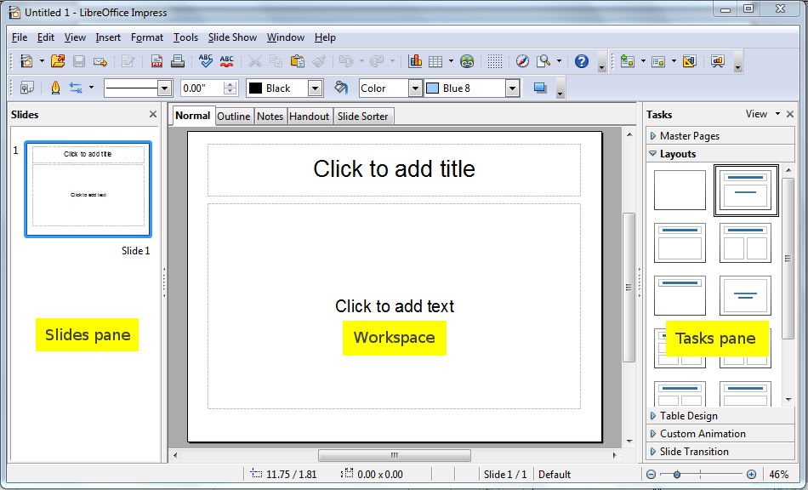
Figure 127: Main window of Impress; ovals indicate the Hide/Show markers
Tip | You can remove the Slides pane or Tasks pane from view by clicking the X in the upper right corner. You can also show or hide these panes using View → Slide Pane or View → Tasks Pane.  You can also hide these panes in order to maximize the Workspace area by clicking the Hide/Show marker in the middle of the vertical separator line and restore them by clicking again on the same area.

Slides pane
The Slides pane contains thumbnail pictures of the slides in your presentation, in the order they will be shown (unless you change the slide show order). Clicking a slide in this pane selects it and places it in the Workspace. When a slide is in the Workspace, you can apply to it any changes desired.
Several additional operations can be performed on one or more slides simultaneously in the Slides pane:
- Add new slides to the presentation.
- Mark a slide as hidden so that it will not be shown as part of the presentation.
- Delete a slide from the presentation if it is no longer needed.
- Rename a slide.
- Duplicate a slide (copy and paste) or move it to a different position in the presentation (cut and paste).
It is also possible to perform the following operations, although there are more efficient methods than using the Slides pane:
- Change the slide transition following the selected slide or after each slide in a group of slides.
- Change the sequence of slides in the presentation.
- Change the slide design.
- Change slide layout for a group of slides simultaneously.

Tasks pane
The Tasks pane has five sections. To expand the section you wish to use, click on the right-pointing triangle to the left of the caption. Only one section at a time can be expanded.
Master Pages
Here you define the page style for your presentation. Impress contains prepackaged Master Pages (slide masters). One of them—Default—is blank, and the rest have a background.
Tip | Press F11 to open the Styles and Formatting window, where you can modify the styles used in any slide master to suit your purpose. This can be done at any time.
Layout
The prepackaged layouts are shown here. You can choose the one you want, use it as it is or modify it to your own requirements. At present it is not possible to create custom layouts.
Table Design
The standard table styles are provided in this pane. You can further modify the appearance of a table with the selections to show or hide specific rows and columns, or to apply a banded appearance to the rows and columns.
Custom Animation
A variety of animations for selected elements of a slide are listed. Animation can be added to a slide, and it can also be changed or removed later.
Slide Transition
Many transitions are available, including No Transition. You can select the transition speed (slow, medium, fast), choose between an automatic or manual transition, and choose how long the selected slide will be shown.

Workspace
The Workspace has five tabs: Normal, Outline, Notes, Handout, and Slide Sorter. These five tabs are called View buttons. The Workspace below the View buttons changes depending on the chosen view.
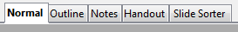Figure 128: Workspace tabs

Toolbars
Many toolbars can be used during slide creation; they can be displayed or hidden by clicking View → Toolbars and selecting from the menu.
You can also select the icons that you wish to appear on each toolbar. For more information, refer to Chapter 1, Introducing LibreOffice, in this book.
Many of the toolbars in Impress are similar to the toolbars in Draw. Refer to the Draw Guide for details on the functions available and how to use them.

Status bar
The Status bar, located at the bottom of the Impress window, contains information that you may find useful when working on a presentation. For details on the contents and use of these fields, see Chapter 1 (Introducing LibreOffice) in this book and Chapter 1 (Introducing Impress) in the Impress Guide.
Note | The sizes are given in the current measurement unit (not to be confused with the ruler units). This unit is defined in Tools → Options → LibreOffice Draw → General, where you can also change the scale of the page. Another way to change the scale is to double-click on the number shown in the status bar.
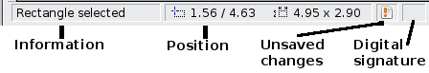
Figure 129: Left end of the Impress status bar
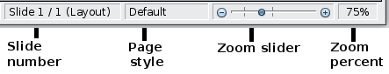
Figure 130: Right end of Impress status bar

Navigator
The Navigator displays all objects contained in a document. It provides another convenient way to move around a document and find items in it. To display the Navigator, click its icon 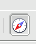 on the Standard toolbar, choose View → Navigator on the menu bar, or press Ctrl+Shift+F5.
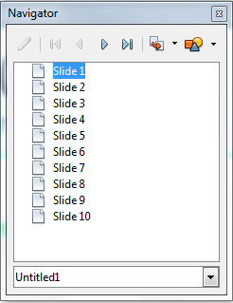
Figure 131: Navigator
The Navigator is more useful if you give your slides and objects (pictures, spreadsheets, and so on) meaningful names, instead of leaving them as the default “Slide 1” and “Slide 2” shown in Figure Figure 131.

Workspace views
Each of the workspace views is designed to ease the completion of certain tasks; it is therefore useful to familiarize yourself with them in order to quickly accomplish those tasks.

Normal view
Normal view is the main view for working with individual slides. Use this view to format and design and to add text, graphics, and animation effects.
To place a slide in the slide design area (Normal view), click the slide thumbnail in the Slides pane or double-click it in the Navigator.

Outline view
Outline view contains all the slides of the presentation in their numbered sequence. It shows topic titles, bulleted lists, and numbered lists for each slide in outline format. Only the text contained in the default text boxes in each slide is shown, so if your slide includes other text boxes or drawing objects, the text in these objects is not displayed. Slide names are also not included.
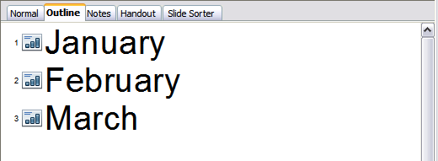
Figure 132: Outline view
Use Outline view for the following purposes.
- Making changes in the text of a slide:
  - Add and delete the text in a slide just as in the Normal view.
  - Move the paragraphs of text in the selected slide up or down by using the up and down arrow buttons (Move Up or Move Down) on the Text Formatting toolbar.
  - Change the outline level for any of the paragraphs in a slide using the left and right arrow buttons (Promote or Demote).
  - Both move a paragraph and change its outline level using a combination of these four arrow buttons.
- Comparing the slides with your outline (if you have prepared one in advance). If you notice from your outline that another slide is needed, you can create it directly in the Outline view or you can return to the Normal view to create it.

Notes view
Use the Notes view to add notes to a slide.
- Click the Notes tab in the Workspace.
- Select the slide to which you want to add notes.
  - Click the slide in the Slides pane, or
  - Double-click the slide’s name in the Navigator.
- In the text box below the slide, click on the words Click to add notes and begin typing.
You can resize the Notes text box using the green resizing handles which appear when you click on the edge of the box. You can also move the box by placing the pointer on the border, then clicking and dragging. To make changes in the text style, press the F11 key to open the Styles and Formatting window.
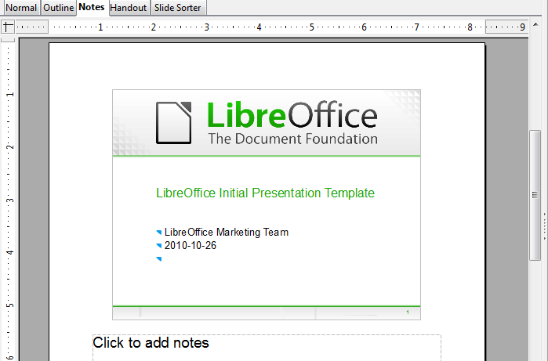
Figure 133: Notes view

Handout view
Handout view is for setting up the layout of your slide for a printed handout. Click the Handout tab in the workspace, then choose Layouts in the Tasks pane. You can then choose to print 1, 2, 3, 4, 6, or 9 slides per page.
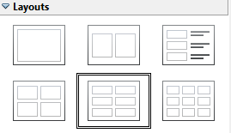
Figure 134: Handout layouts
Use this view also to customize the information printed on the handout. Refer to Chapter 10 of the Impress Guide for instructions on printing slides, handouts, and notes.
Select from the main menu Insert → Page Number or Insert → Date and Time and in the dialog box that opens click on the Notes and Handouts tab (see Figure 135). Use this dialog to select the elements you want to appear on each handout page and their contents. More details on how to use this dialog are provided in the Impress Guide.
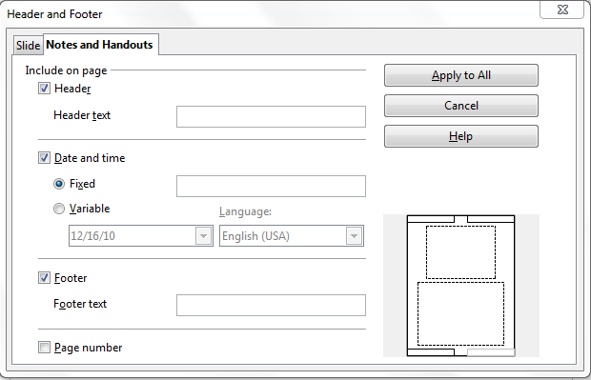Figure 135: Dialog to set the page information for handouts and notes

Slide Sorter view
Slide Sorter view contains all of the slide thumbnails. Use this view to work with a group of slides or with only one slide.
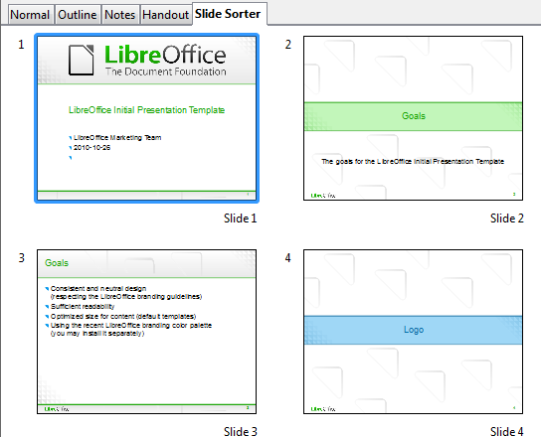
Figure 136: Slide Sorter view

Customizing Slide Sorter view
To change the number of slides per row:
- Check View → Toolbars → Slide View to make the Slide View toolbar visible.
Figure 137: Slide Sorter and Slide View toolbars
- Adjust the number of slides (up to a maximum of 15).

Moving a slide using Slide Sorter
To move a slide in a presentation in the Slide Sorter:
- Click the slide. A thick black border is drawn around it.
- Drag and drop it to the location you want.
  - As you move the slide, a black vertical line appears to one side of the slide.
  - Drag the slide until this black vertical line is located where you want the slide to be moved.

Selecting and moving groups of slides
To select a group of slides, use one of these methods:
- Use the Control (Ctrl) key: Click on the first slide and, while keeping the Control key pressed, select the other desired slides.
- Use the Shift key: Click on the first slide, and while pressing the Shift key, click on the final slide in the group. This selects all of the other slides in between the first and the last.
- Use the mouse: Click slightly to the left of the first slide to be selected. Hold down the left mouse button and drag the mouse pointer to a spot slightly to the right of the last slide to be included. (You can also do this right to left.) A dashed outline of a rectangle forms as you drag the cursor through the slide thumbnails and a thick border is drawn around each of the selected slides. Make sure the rectangle includes all the slides you want to select.
To move a group of slides:
- Select the group.
- Drag and drop the group to their new location. A vertical black line appears to show you where the group of slides will go.

Working in Slide Sorter view
You can work with slides in the Slide Sorter view just as you can in the Slide pane.
To make changes, right-click a slide and choose any of the following from the pop-up menu:
- Add a new slide after the selected slide.
- Rename or delete the selected slide.
- Change the slide layout.
- Change the slide transition.
- For one slide, click the slide to select it. Then add the desired transition.
- For more than one slide, select the group of slides and add the desired transition.
- Mark a slide as hidden. Hidden slides will not be shown in the slide show.
- Copy or cut and paste a slide.

Renaming slides
Right-click on a thumbnail in the Slides pane or the Slide Sorter and choose Rename Slide from the pop-up menu. In the Name field, delete the old name of the slide and type the new name. Click OK.

Creating a new presentation
This section describes how to start a new presentation using the Presentation Wizard.
When you start Impress, the Presentation Wizard appears.
Tip | If you do not want the wizard to start every time you launch Impress, select the Do not show this wizard again option. You can enable the wizard again later under Tools → Options → LibreOffice Impress → General → Wizard, and select the Start with wizard option.  Leave the Preview option selected, so templates, slide designs, and slide transitions appear in the preview box as you choose them.
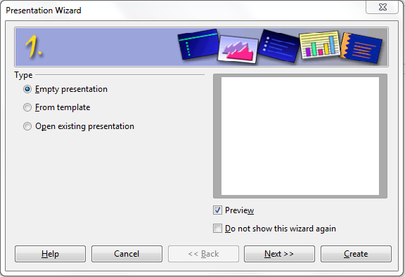
Figure 138. Choosing the type of presentation
- Select Empty Presentation under Type. It creates a presentation from scratch.
  - From template uses a template design already created as the basis for a new presentation. The wizard changes to show a list of available templates. Choose the template you want.
  - Open existing presentation continues work on a previously created presentation. The wizard changes to show a list of existing presentations. Choose the presentation you want.
Both of these options are covered in the Impress Guide.
- Click Next. Figure 139 shows the Presentation Wizard step 2 as it appears if you selected Empty Presentation at step 1. If you selected From template, an example slide is shown in the Preview box.
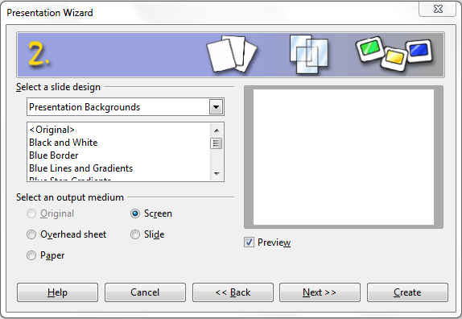
Figure 139. Selecting a slide design
- Choose a design under Select a slide design. The slide design section gives you two main choices: Presentation Backgrounds and Presentations. Each one has a list of choices for slide designs. If you want to use one of these other than <Original>, click it to select it.
  - The types of Presentation Backgrounds are shown in Figure 139. By clicking an item, you will see a preview of the slide design in the Preview window. Impress contains three choices under Presentations: <Original>, Introducing a New Product, and Recommendation of a Strategy.
  - <Original> is for a blank presentation slide design.
  - Both Introducing a New Product and Recommendation of a Strategy have their own prepackaged slide designs. Each design appears in the Preview window when its name is clicked.
Note | Introducing a New Product and Recommendation of a Strategy can also be used to create a presentation by choosing From template in the first step (Figure 138).
- Select how the presentation will be used under Select an output medium. Most often, presentations are created for computer screen display. Select Screen. You can change the page format at any time.
Note | The Screen page is optimized for a 4:3 display (28cm x 21cm) so it is not suitable for modern widescreen displays. You can change the slide size at any time switching to Normal view and selecting Format → Page.
- Click Next. The Presentation Wizard step 3 appears.
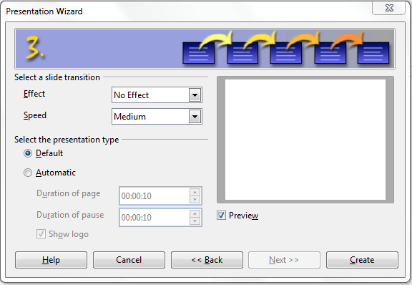
Figure 140. Selecting a slide design
  - Choose the desired slide transition from the Effect drop-down menu.
  - Select the desired speed for the transition between the different slides in the presentation from the Speed drop-down menu. Medium is a good choice for now.
- Click Create. A new presentation is created.
Tip | You might want to accept the default values for both Effect and Speed unless you are skilled at doing this. Both of these values can be changed later while working with Slide transitions and animations. These two features are explained in more detail in Chapter 9 of the Impress Guide.
Note | If you selected From template on step 1 of the Wizard, the Next button will be active on step 3 and other pages will be available. These pages are not described here.
Caution | Remember to save frequently while working on the presentation, to prevent any loss of information should something unexpected occur. You might also want to activate the AutoRecovery function (Tools → Options → Load/Save → General). Make sure Save AutoRecovery information every is selected and that you have entered a recovery frequency.

Formatting a presentation
A new presentation contains only one empty slide. In this section we will start adding new slides and preparing them for the intended contents.

Inserting slides
This can be done in a variety of ways; take your pick.
- Insert → Slide.
- Right-click on the present slide, and select Slide → New Slide from the pop-up menu.
- Click the Slide icon in the Presentation toolbar.
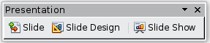
Sometimes, rather than starting from a new slide you want to duplicate a slide you have already inserted. To do so select the slide you want to duplicate from the Slides pane and then choose Insert → Duplicate Slide.

Selecting a layout
In the Tasks pane, select the Layout drawer to display the available layouts. The Layouts differ in the number of elements a slide will contain, spanning from the empty slide (Blank Slide) to a slide with 6 contents boxes and a title (Title, 6 contents).
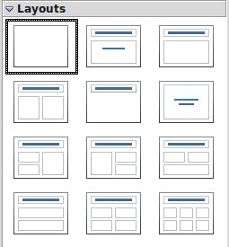
Figure 141: Available slide layouts
Note | Text and graphic elements can be readjusted at any time during the preparation of the presentation, but changing the layout of a slide that already contains some contents can have a dramatic effect. It is therefore recommended that you pay particular attention to the layout you select. If you do need to change the layout after contents have been added, the contents are not lost though they may need to be reformatted.
The Title Slide (which also contains a section for a subtitle) or Title Only are suitable layouts for the first slide, while for most of the slides you will probably use the Title, Contents layout.
Tip | If you do not know the names for the prepackaged layouts position the cursor on an icon in the Layout section and its name will be displayed in a small rectangle.  The small rectangle is called tooltip. If the tooltips are not enabled select Tools → Options → LibreOffice → General → Help and mark the Tips checkbox. If the Extended tips checkbox is also marked, you will get more detailed tooltip information, but the tooltip names themselves will not be provided.
Several layouts contain one or more content boxes. Each of these boxes can be configured to contain one of the following elements: Text, Media clip, Picture, Chart or Table.
You can choose the type of contents by clicking on the corresponding icon that is displayed in the middle of the contents box as shown in Figure 142. If instead you intend to use the contents box for text, just click anywhere on the box to get a cursor.
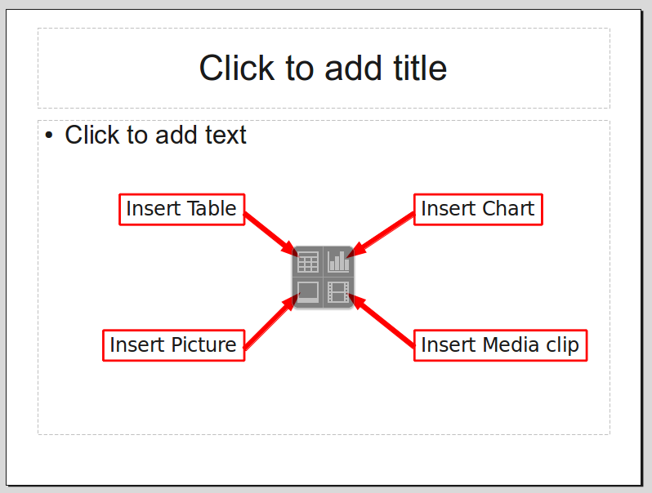Figure 142: Selecting the desired contents type for a contents box
To select or change the layout, place the slide in the work area and select the desired layout from the layout drawer in the Task Pane.
If you have selected a layout with one or more contents boxes, this is a good time to decide what type of contents you want to insert.

Modifying the slide elements
At present each slide will contain only the elements that are present in the slide master you are using such as background images, logos, header, footer and so on. It is however unlikely that the predefined layouts will suit all your needs. Although Impress does not have the functionality to create new layouts, it allows you to resize and move the layout elements. It is also possible to add slide elements without being limited to the size and position of the layout boxes.
To resize a contents box, click on the outer frame so that the 8 resizing handles are displayed. To move it place the mouse cursor on the frame so that the cursor changes shape. You can now click the left mouse button and drag the contents box to its new position on the slide.
Caution | Changes to any of the pre-packaged layouts can only be made using View → Normal, which is the default. Attempting to do this by modifying a slide master, although possible, may result in unpredictable results and requires extra care as well as a certain amount of trial and error.
At this step you may also want to remove unwanted frames. To do this:
- Click the element to highlight it. (The green resizing handles show it is highlighted.)
- Press the Delete key to remove it.

Adding text to a slide
If the slide contains text, click on Click to add an outline in the text frame and then type your text. The Outline styles from 1 to 10 are automatically applied to the text as you insert it. You can change the outline level of each paragraph as well as its position within the text using the arrow buttons on the Text Formatting toolbar. See “Adding and formatting text” on page 151 for more information.

Modifying the appearance of all slides
To change the background and other characteristics of all slides in the presentation, it is best to modify the slide master or choose a different slide master as explained in the section Working with slide masters and styles on page 157.
If all you need to do is to change the background, you can take a shortcut:
- Select Format → Page and go to the Background tab.
- Select the desired background between solid color, gradient, hatching and bitmap.
- Click OK to apply it.
A dialog box will open asking if the background should be applied to all the slides. If you click yes, Impress will automatically modify the slide master for you.
Note | Inserting and correctly formatting a background is beyond the scope of this chapter, but you can find all the information you need in Chapter 4 of the Draw Guide or in Chapter 6 of the Impress Guide.

Modifying the slide show
By default the slide show will display all the slides in the same order as they appear in the slide sorter, without any transition between slides, and you need some keyboard or mouse interaction to move from one slide to the next.
You can use the Slide Show menu to change the order of the slides, choose which ones are shown, automate moving from one slide to the next, and other settings. To change the slide transition, animate slides, add a soundtrack to the presentation, and make other enhancements, you need to use functions in the Task pane. See the Impress Guide for details on how to use all of these features.

Adding and formatting text
Many of your slides are likely to contain some text. This section gives you some guidelines on how to add text and how to change its appearance. Text in slides is contained in text boxes.
There are two types of text boxes that you can add to a slide:
- Choose a predefined layout from the Layouts section of the Tasks pane and do not select any special contents type. These text boxes are called AutoLayout text boxes.
- Create a text box using the text tool in the Drawing toolbar.

Using text boxes created from the Layout pane
In Normal view:
- Click in the text box that reads Click to add text, Click to add an outline, or a similar notation.
- Type or paste your text in the text box.

Using text boxes created from the text box tool
In Normal view:
- Click on the Text icon on the Drawing toolbar. If the toolbar with the text icon is not visible, choose View → Toolbars → Drawing.
- Click and drag to draw a box for the text on the slide. Do not worry about the vertical size and position—the text box will expand if needed as you type.
- Release the mouse button when finished. The cursor appears in the text box, which is now in edit mode (gray hashed border with green resizing handles shown in Figure 143).
- Type or paste your text in the text box.
- Click outside the text box to deselect it.
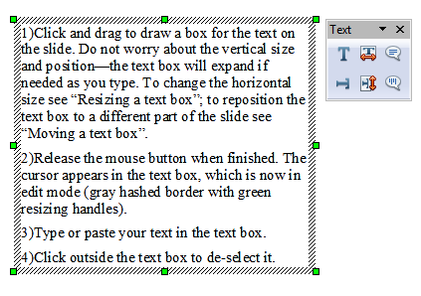
Figure 143: Selected text box showing the green resizing handles and text toolbar
You can move, resize, and delete text boxes. For more information, see Chapter 3 in the Impress Guide.
Note | In addition to the normal text boxes where text is horizontally aligned, it is possible to insert text boxes where the text is aligned vertically. This choice is available only when Asian languages are enabled in Tools → Options → Language Settings → Languages.  Click on the button in the drawing toolbar to create a vertical text box. Note that when editing the contents, the text is displayed horizontally.

Quick font resizing
Impress has convenient buttons on the Formatting toolbar to increase or decrease font size of selected text . The amount by which the font size changes depends on the standard sizes available for the font in use.

Pasting text
You can insert text into a text box by copying it from another document and pasting it into Impress. However, the pasted text will probably not match the formatting of the surrounding text or that of the other slides in the presentation. This may be what you want on some occasions; however in most cases you want to make sure that the presentation does not become a patchwork of different paragraph styles, font types, bullet points and so on. There are several ways to ensure consistency; these methods are explained below.

Pasting unformatted text
It is normally good practice to paste text without formatting and apply the formatting later. To paste without formatting, either press Control+Shift+V and then select Unformatted text from the dialog that appears, or click on the small black triangle next to the paste symbol in the standard toolbar and select Unformatted text. The unformatted text will be formatted with the outline style at the cursor position in an AutoLayout text box or with the default graphic style in a normal text box.

Formatting pasted text
If you are pasting the text into an AutoLayout area, you need to apply the appropriate outline style to the text to give it the same look and feel as the rest of the presentation.
- Paste the text in the desired position. Do not worry if it does not look right; it will in a minute.
- Select the text you have just pasted.
- Select Format → Default formatting from the menu bar.
- Use the four arrow buttons in the Text Formatting toolbar to move the text to the appropriate position and give it the appropriate outline level. The button with the arrow pointing left promotes the list entry by one level (for example from Outline 3 to Outline 2), the right arrow button demotes the list entry by one level, the up and down arrow buttons move the list entry.
- Apply manual formatting as required to sections of the text (to change font attributes, tabs, and so on).
If you are pasting text in a text box, you can still use styles to quickly format the text. Note that one and only one graphic style can be applied to the copied text. To do that:
- Paste the text in the desired position.
- Select the text you have just pasted.
- Select the desired graphic style.
- Apply manual formatting as required to sections of the text.

Creating bulleted and numbered lists
The procedure to create a bulleted or numbered list is quite different depending on the type of text box used, although the tools to manage the list and customize the appearance are the same.
In text boxes created automatically by Impress (called AutoLayout), the outline styles available are by default bulleted lists, while for normal text boxes an additional step is required to create a bulleted list.

Creating lists in AutoLayout text boxes
Every text box included in the available layouts is already formatted as a bulleted list, therefore to create a bulleted list the only necessary steps are:
- From the Layout pane, choose a slide design that contains a text box. Those are easily recognizable from the thumbnail.
- Click in the text box that reads Click to add an outline.
- Type the text, then press Enter to start a new bulleted line.
The methods for switching between bulleted and numbered lists are explained in “Changing the appearance of the list” on page 154.
Tip | Press Shift + Enter to start a new line without creating a new bullet or number. The new line will have the same indentation of the previous line. To switch off bullets altogether, click the bullets button on the text formatting toolbar. If the text formatting toolbar is not showing, enable it selecting View → Toolbar → Formatting in the menu bar.

Creating lists in other text boxes
To create a list in a text box, follow these steps:
- Place the cursor in the text box.
- Click the Bullets On/Off button on the text formatting toolbar. If the text formatting toolbar is not showing, enable it by selecting View → Toolbar → Formatting from the menu bar.
- Type the text and press Enter to start a new bulleted line.
- The default list type is a bulleted list. Methods for changing the appearance of the list are explained on page 154.

Creating a new outline level
- If necessary, press Enter to begin a new line.
- Press Tab. Each time you press Tab the line indents to the next outline level. Pressing Enter creates a new line at the same level as the previous one. To return to the previous level, press Shift+Tab.
In the AutoLayout text boxes, promoting or demoting an item in the list corresponds to applying a different outline style, so the second outline level corresponds to Outline 2 style, the third to Outline 3 style, and so on.
Note | Do not try to change the outline level by selecting the text and then clicking the desired outline style as you would in Writer. Due to the way that presentation styles work, it is not possible to apply them in this way.

Changing the appearance of the list
You can fully customize the appearance of a list, changing the bullet type or numbering for the entire list or for single entry. All of the changes can be made using the Bullets and Numbering dialog, which is accessed by selecting Format → Bullets and Numbering or by clicking on the Bullets and Numbering icon on the text formatting toolbar.
For the entire list:
- Select the entire list or click on the gray border of the text box so that the green resizing handles are displayed.
- Select Format → Bullets and Numbering or click on the Bullets and Numbering icon .
- The Bullets and Numbering dialog contains five tabs: Bullets, Numbering type, Graphics, Position, and Customize.
  - If a bullet list is needed, select the desired bullet style from the default styles available on the Bullets page.
  - If a graphics style is needed, select one from those available on the Graphics page.
  - If a numbered list is needed, select one of the default numbering styles on the Numbering type page.
For a single line in the list:
- Click anywhere in the line to place the cursor in it.
- Follow steps 2–4 of the previous instruction set.
If the list was created in an AutoLayout text box, then an alternative way to change the entire list is to modify the Outline styles. Changes made to the outline style will apply to all the slides using them. Sometimes this is what you want; sometimes it is not, so some care must be taken.

Adding pictures, tables, charts and media
As we have seen, besides text a contents box can contain also pictures, tables, charts or media clips. This section provides a quick overview of how to work with these objects, however for a more detailed description you are invited to consult the Impress Guide.

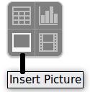
Adding pictures
To add a picture to a contents box:
- Click the Insert Picture icon.
- Use the file browser to select the picture file you want to include. To see a preview of the picture, check Preview at the bottom of the Insert picture dialog.
- Click Open.
The picture will resize itself to fill the area of the contents box. Follow the directions in the Caution note below when resizing it by hand.
Note | You can easily add a picture to a slide outside a contents box. Just select from the main menu Insert → Picture → From File and follow the same procedure as above. You will also need to move the picture to the desired location.
Caution | When resizing a graphic, right-click the picture. Select Position and Size from the context menu and make sure that Keep ratio is selected. Then adjust the height or width to the size you need. (As you adjust one dimension. both dimensions will change.) Failure to do so will cause the picture to become distorted. Remember also that resizing a bitmap image will reduce its quality; better by far to create an image of the desired size outside of Impress.

Adding tables
For displaying tabular data, you can insert basic tables directly into your slides by choosing the Table contents type. It is also possible to add a table outside a contents box in a number of ways:
- Choose Insert → Table from the menu bar
- With the Table button on the main toolbar
- With the Table Design button on the table toolbar
- Select a Style option from the Table Design section of the Tasks pane.
Each method opens the Insert Table dialog. Alternatively, clicking on the black arrow next to the Table button displays a graphic that you can drag and select the number of rows and columns for your table.
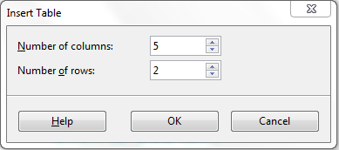
Figure 144. Creating a table with the Insert Table dialog
Note | Selecting from any of the styles in the Table Design section of the Tasks pane creates a table based on that style. If you create a table by another method, you can still apply a style of your choice later.
With the table selected, the Table toolbar should appear. If it does not, you can access it by selecting View → Toolbars → Table. The Table toolbar offers many of the same buttons as the table toolbar in Writer, with the exception of functions like Sort and Sum for performing calculations. For those functions, you need to use a spreadsheet inserted from Calc (discussed below).
After the table is created, you can modify it in much the same ways as you would modify a table in Writer: adding and deleting rows and columns, adjusting width and spacing, adding borders, background colors and so on. Detailed information on working with tables and the Table Properties dialog can be found in Chapter 9 of the Writer Guide.
By modifying the style of the table from the Table Design section of the Tasks pane, you can quickly change the appearance of the table or any newly created tables based on the Style options you select. You can choose to add emphasis to a header and total row as well as the first and last columns of the table, and apply a banded appearance to the rows and columns.
Having completed the table design, entering data into the cells is similar to working with text box objects. Click in the cell you wish to add data to, and begin typing. To move around cells quickly, use the following key options:
- The arrow keys move the cursor to the next table cell if the cell is empty, otherwise they move the cursor to the next character in the cell.
- The Tab key moves to the next cell, skipping over the contents of the cell; Shift+Tab move backwards in this manner.

Adding charts
To insert a chart in a slide you can either use the Insert Chart feature or select Chart as type for one of the contents box. In both cases Impress will insert a default chart. To modify the chart type, insert your own data and change the formatting refer to the Impress Guide.

Adding media clips
You can insert various types of music and movie clips into your slide by selecting the Insert Movie button in an empty contents box. A media player will open at the bottom of the screen and you can preview the media. In case of an audio file, the contents box will be filled with a loudspeaker image.
Caution | In Linux-based systems such as Ubuntu, media do not work straight out of the box. You need to download the Java Media Framework API (JMF) and add the path to jmf.jar to the Class Path in Tools → Options → LibreOffice → Java.

Adding graphics, spreadsheets, and other objects
Graphics such as shapes, callouts, arrows, and so on are often useful to complement the text on a slide. These objects are handled much the same as graphics in Draw. For more information, see Chapter 7, Getting Started with Draw, the Draw Guide, or Chapters 4, 5, and 6 in the Impress Guide.
Spreadsheets embedded in Impress include most of the functionality of spreadsheets in Calc and are therefore capable of performing extremely complex calculations and data analysis. If you need to analyze your data or apply formulas, these operations are best performed in a Calc spreadsheet and the results displayed in an embedded Impress spreadsheet or even better in a native Impress table.
Alternatively, choose Insert → Object → OLE Object from the menu bar. This opens a spreadsheet in the middle of the slide and the menus and toolbars change to those used in Calc so that you can start adding data, though you may first need to resize the visible area on the slide. You can also insert an already existing spreadsheet and use the viewport to select the data that you want to display on your slide.
Impress offers the capability of inserting in a slide various other types of objects such Writer documents, Math formulas, or even another presentation. For details on using these objects, refer to Chapter 7 of the Impress Guide.

Working with slide masters and styles
A slide master is a slide that is used as the starting point for other slides. It is similar to a page style in Writer: it controls the basic formatting of all slides based on it. A slide show can have more than one slide master.
Note | LibreOffice uses three terms for a slide that is used to create other slides: master slide, slide master, and master page. This book uses the term slide master, except when describing the user interface.
A slide master has a defined set of characteristics, including the background color, graphic, or gradient; objects (such as logos, decorative lines, and other graphics) in the background; headers and footers; placement and size of text frames; and the formatting of text.

Styles
All of the characteristics of slide masters are controlled by styles. The styles of any new slide you create are inherited from the slide master from which it was created. In other words, the styles of the slide master are available and applied to all slides created from that slide master. Changing a style in a slide master results in changes to all the slides based on that slide master, but you can modify individual slides without affecting the slide master.
Slide masters have two types of styles associated with them: presentation styles and graphic styles. The prepackaged presentation styles can be modified, but new presentation styles cannot be created. In the case of graphic styles, you can modify the prepackaged ones and also create new ones.
Presentation styles affect three elements of a slide master: the background, background objects (such as icons, decorative lines, and text frames), and the text placed on the slide. Text styles are further divided into Notes, Outline 1 through Outline 9, Subtitle, and Title. The outline styles are used for the different levels of the outline to which they belong. For example, Outline 2 is used for the subpoints of Outline 1, and Outline 3 is used for the subpoints of Outline 2.
Graphic styles affect many of the elements of a slide. Notice that text styles exist in both the presentation and graphic style selections.

Slide masters
Impress comes with several prepackaged slide masters. They are shown in the Master Pages section of the Tasks pane. This section has three subsections: Used in This Presentation, Recently Used, and Available for Use. Click the + sign next to the name of a subsection to expand it to show thumbnails of the slides, or click the – sign to collapse the subsection to hide the thumbnails.
Each of the slide masters shown in the Available for Use list is from a template of the same name. If you have created your own templates, or added templates from other sources, slide masters from those templates will also appear in this list.
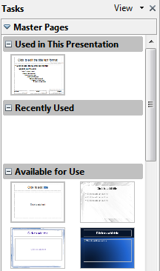
Figure 145: Available master pages (slides)

Creating a slide master
Creating a new slide master is similar to modifying the default slide master.
To start, enable editing of slide masters by View → Master → Slide Master.
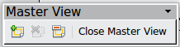
On the Master View toolbar, click the New Master icon.
A second slide master appears in the Slides pane. Modify this slide master to suit your requirements. It is also recommended that you rename this new slide master: right-click on the slide in the Slides pane and select Rename master from the pop-up menu.
When you are done, close the Master View toolbar to return to normal slide editing mode.

Applying a slide master
In the Tasks Pane, be sure the Master Pages section is showing.
To apply one of the slide masters to all slides in your presentation, click on it in the list.
To apply a different slide master to one or more selected slides:
- In the Slide Pane, select the slides you want to change.
- In the Tasks Pane, right-click on the slide master you want to apply to the selected slides, and click Apply to Selected Slides on the pop-up menu.

Loading additional slide masters
Sometimes, in the same set of slides, you may need to mix multiple slide masters that may belong to different templates. For example, you may need a completely different layout for the first slide of the presentation, or you may want to add to your presentation a slide from a different presentation (based on a template available on the hard disk).
The Slide Design dialog makes this possible. Access this dialog either from the menu bar (Format → Slide design) or by right-clicking on a slide in the Slides pane.
The main window in the dialog shows the slide masters already available for use. To add more:
- Click the Load button.
- Select in the new dialog the template containing the slide master. Click OK.
- Click OK again to close the slide design dialog.
The slide masters in the template you selected are now shown also in the Master Pages section of the Tasks pane in the Available for use subsection.
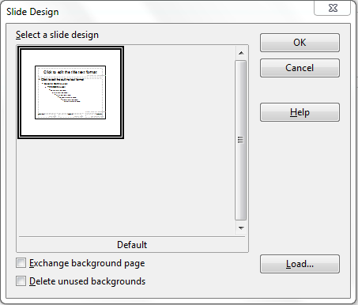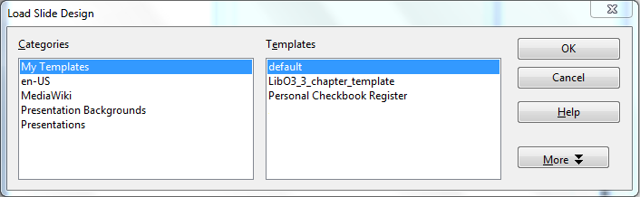
Figure 146: Loading slide masters from a presentation template
Note | The slide masters you have loaded will also be available the next time you load the presentation. If you want to delete the unused slide masters, click the corresponding checkbox in the Slide Design dialog. If the slide master was not used in the presentation, it is removed from the list of available slide masters anyway.
Tip | To limit the size of the presentation file, you may want to minimize the number of slide masters used.

Modifying a slide master
The following items can be changed on a slide master:
- Background (color, gradient, hatching, or bitmap)
- Background objects (for example, add a logo or decorative graphics)
- Size, placement, and contents of header and footer elements to appear on every slide
- Size and placement of default frames for slide titles and content
Before working on the slide master, make sure that the Styles and Formatting window is open.
To select the slide master for modification:
- Select View → Master → Slide Master from the menu bar. This unlocks the properties of the slide master so you can edit it.
- Click Master Pages in the Tasks pane. This gives you access to the pre-packaged slide masters.
- Click on the slide master you want to modify among the ones available (Figure 145).
- Make changes as required, then click the Close Master View icon on the Master View toolbar. For details, see Chapter 2 of the Impress Guide
- Save the file before continuing.
Caution | Any changes made to one slide when in Master View mode will appear on all slides using this slide master. Always make sure you close Master View and return to Normal view before working on any of the presentation slides. Select View → Normal from the menu bar, or click Close Master View in the Master View toolbar to return to the normal slide view.
The changes made to one of the slides in Normal view (for example changes to the bullet point style or the color of the title area and so on...) will not be overridden by subsequent changes to the slide master. There are cases, however, where it is desirable to revert a manually modified element of the slide to the style defined in the slide master: to do that, select that element and choose Format → Default Formatting from the menu bar.

Using a slide master to add text to all slides
Some of the supplied slide masters have text objects in the footer. You can add other text objects to the master page for your slides to act as a header or a footer.
- Choose View → Master → Slide Master from the menu bar.
- On the Drawing toolbar, select the Text icon.
- Click once and drag in the master page to draw a text object, and then type or paste your text into the object or add fields as described below.
- Choose View → Normal when you are finished.
The Impress slide master comes with three pre-configured areas for date, footer and page number.
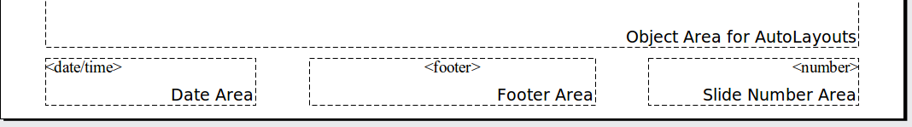
Select Insert → Page Number or Insert → Date and Time to open a dialog box where you can configure these three areas.
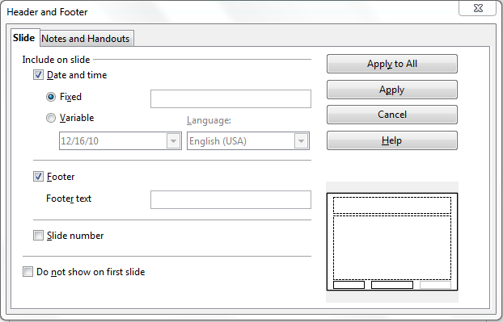
Figure 147: Configuring the slide footer areas
Tip | To change the number format (1,2,3 or a,b,c or i,ii,iii, etc.) for the page number field, choose Format → Page and then select a format from the list in the Layout Settings area.  To change the paragraph style modify the Background Objects Presentation style.
To add a other information, such as the Author of the presentation or the name of the file, choose Insert → Fields. and select the required field from the submenu. If you want to edit a field in your slide, select it and choose Edit → Fields.
The fields you can use in Impress are:
- Date (fixed)
- Date (variable)—updates automatically when you reload the file
- Time (fixed)
- Time (variable)—updates automatically when you reload the file
- Author—First and last names listed in the LibreOffice user data
- Page number (slide number)
- File name
Tip | To change the author information, go to Tools → Options → LibreOffice → User Data.

Adding comments to a presentation
Impress supports comments similar to those in Writer and Calc.
In Normal View, choose Insert → Comment from the menu bar. A small box containing your initials appears in the upper left-hand corner of the slide, with a larger text box beside it. Impress automatically adds your name and the current date at the bottom of the text box.
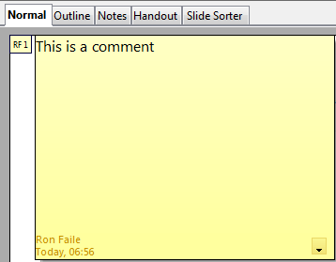
Figure 148: A comment
Type or paste your comment into the text box. You can optionally apply some basic formatting to parts of the text by selecting it, right-clicking, and choosing from the pop-up menu. (From this menu, you can also delete the current comment, all the comments from the same author, or all the comments in the document.)
You can move the small comment markers to anywhere you wish on the page. Typically you might place it on or near an object you refer to in the comment.
To show or hide the comment markers, choose View → Comments.
Select Tools → Options → User Data to configure the name you want to appear in the Author field of the comment, or to change it.
If more than one person edits the document, each author is automatically allocated a different background color.

Setting up the slide show
As mentioned in “Modifying the slide show” on page 151, Impress allocates reasonable default settings for slide shows, while at the same time allowing for customizing many aspects of the slide show experience. This section covers only some aspects; advanced techniques are explained in Chapter 9 (Slide Shows) in the Impress Guide.
Most of the tasks are best done in Slide Sorter view where you can see most of the slides simultaneously. Choose View → Slide Sorter from the menu bar or click the Slide Sorter tab at the top of the workspace.

One slide set – multiple presentations
In many situations, you may find that you have more slides than the time available to present them or you may want to provide a rapid overview without dwelling on the details. Rather than having to create a new presentation, you can use two tools that Impress offers: hiding slides and custom slide shows.
To hide a slide, right-click on the slide thumbnail either in the Slide pane or in the work area if you are using the Slide Sorter view and choose Hide Slide from the pop-up menu. Hidden slides are marked by a slashed slide number.
If you want to reorder the presentation, choose Slide Show → Custom Slide Show. Click on the New button to create a new sequence of slides and save it.
You can have as many slide shows as you want from a single slide set.

Slide transitions
Slide transition is the animation that is played when a slide is changed. You can configure the slide transition from the Slide Transition drawer in the Tasks pane. Select the desired transition, the speed of the animation, and whether the transition should happen when you click the mouse (preferred) or automatically after a certain number of seconds. Click Apply to all slides unless you prefer to have different transitions in the presentation.
Tip | The Slide transition section has a very useful choice: Automatic preview. Select its checkbox. Then when you make any changes in a slide transition, the new slide is previewed in the Slide Design area, including its transition effect.

Automatic slides advance
You can set the presentation to automatically advance to the next slide after a set amount of time (for example kiosk mode or carousel) from the Slide Show → Slide Show Settings menu or to advance automatically after a pre-set amount of time different for each slide. To set up the latter, choose Slide Show → Rehearse Timings. When using this tool, start the slide show; a small timer is displayed in the bottom left corner. When you are ready to advance to the next slide, click on the timer. Impress will memorize the timings and at the next slide show will advance automatically after the timer expires.

Running the slide show
To run the slide show, do one of the following:
- Click Slide Show → Slide Show.
- Click the Slide Show button on the Presentation toolbar.
- Press F5 or F9 on the keyboard.
If the slide transition is Automatic after x seconds, let the slide show run by itself.
If the slide transition is On mouse click, do one of the following to move from one slide to the next:
- Use the arrow keys on the keyboard to go to the next slide or to go back to the previous one.
- Click the mouse to move to the next slide.
- Press the spacebar on the keyboard to advance to the next slide.
Right-click anywhere on the screen to open a menu from which you can navigate the slides and set other options.
To exit the slide show at any time including at the end, press the Esc key.
Getting Started Guide

Chapter 7
Getting Started with Draw
Vector Drawing in LibreOffice

What is Draw?
Draw is a vector graphics drawing program, although it can also perform some operations on raster graphics (pixels). Using Draw, you can quickly create a wide variety of graphical images.
Vector graphics store and display an image as simple geometric elements such as lines, circles, and polygons rather than a collections of pixels (points on the screen). Vector graphics allow for easier storage and scaling of the image.
Draw is fully integrated into the LibreOffice suite, and this simplifies exchanging graphics with all components of the suite. For example, if you create an image in Draw, reusing it in a Writer document is as simple as copying and pasting the image. You can also work with drawings directly from within Writer or Impress, using a subset of the functions and tools from Draw.
Draw’s functionality is extensive; even though it was not designed to rival high-end graphics applications, it possesses more functions than most drawing tools that are integrated with office productivity suites.
A few examples of drawing functions are:
- Layer management
- Magnetic grid point system
- Dimensions and measurement display
- Connectors for making organization charts
- 3D functions that enable small three-dimensional drawings to be created (with texture and lighting effects)
- Drawing and page style integration
- Bézier curves
This chapter introduces some of Draw’s features, but it does not attempt to cover all of them. See the Draw Guide and the application Help for more information.

The Draw workspace
The main components of the Draw workspace are shown in Figure 149.
You can surround the drawing area with toolbars and information areas. The number and position of the visible tools vary with the task in hand and user preferences. Therefore, your setup may look different. For example, many users put the main Drawing toolbar on the left-hand side of the workspace, not at the bottom as shown here.
You can split drawings in Draw over several pages. Multipage drawings are used mainly for presentations. The Pages pane, on the left side of the Draw window in Figure 149 gives an overview of the pages that you create. If the Pages pane is not visible on your setup, you can enable it from the View menu (View → Page Pane).
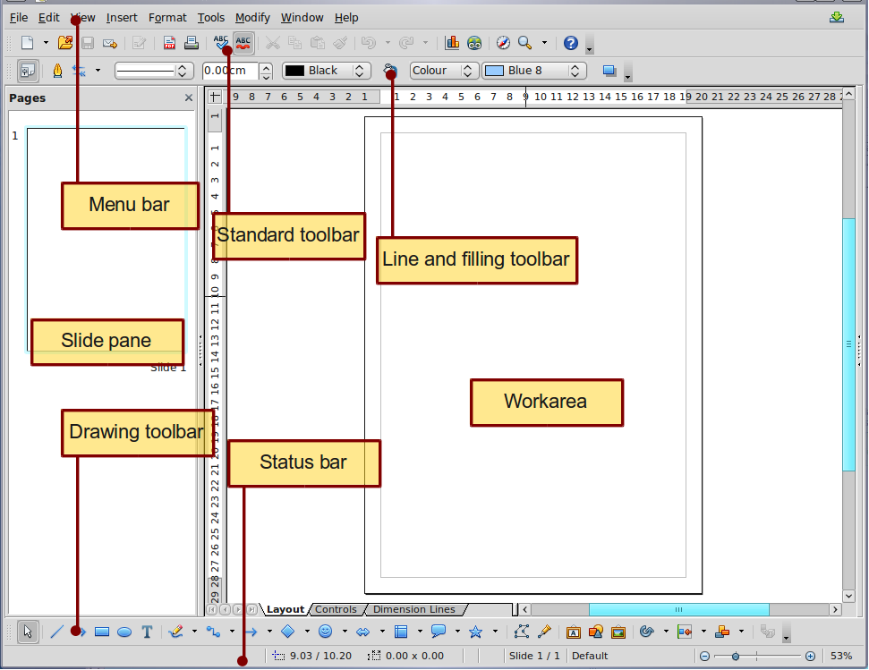
Figure 149. Initial Draw window

Rulers
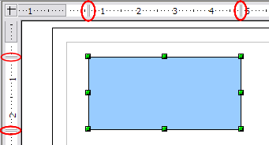
Figure 150: Rulers show the size of the selected object
You should see rulers (bars with numbers) on the upper and left-hand side of the workspace. The rulers show the size of a selected object on the page (see the gray double lines, highlighted in Figure 164Figure 150). When no object is selected, they show the location of the mouse pointer, which helps to accurately position drawing objects more accurately.
You can also use the rulers to manage object handles and guide lines, making it easier to position objects. The page margins in the drawing area are also represented on the rulers. You can change the margins directly on the rulers by dragging them with the mouse.
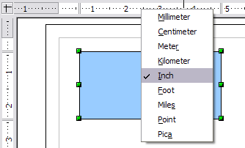Figure 151. Ruler units
To modify the unit of measurement of a ruler, right-click on the ruler and select one of the measurement units. The two rulers can have different units.

Status bar
The Status bar is located at the bottom of the screen (in all LibreOffice components); it includes several Draw-specific fields.
For details on the contents and use of these fields, see Chapter 1, Introducing LibreOffice, in this book and Chapter 1, Introducing Draw, in the Draw Guide.
Note | The sizes are given in the current measurement unit (not to be confused with the ruler units). This unit is defined in Tools → Options → LibreOffice Draw → General, where you can also change the scale of the page. Another way to change the scale is to double-click on the number shown in the status bar.
Figure 152: Left end of the Draw status bar
Figure 153: Right end of Draw status bar

Toolbars
To display or hide the various Draw toolbars. choose View → Toolbars. On the menu that appears, select which toolbars you want to display. For more about working with toolbars, see Chapter 1, Introducing LibreOffice, in this book.
The tools available in the Draw toolbars are explained in the following sections. The appearance of the toolbar icons may vary depending on your operating system and the selection of icon size and style in Tools → Options → LibreOffice → View.
Standard toolbar
The Standard toolbar is the same for all LibreOffice components and is not described in detail in this chapter.
Line and Filling toolbar
The Line and Filling toolbar lets you modify the main properties of a drawing object. See page 183 for details.
Text Formatting toolbar
If the selected object is text, the toolbar changes to the Text Formatting toolbar, which is similar to the Formatting toolbar in Writer. For more information, see Chapter 4, Getting Started with Writer, in this book.
Drawing toolbar
The Drawing toolbar is the most important toolbar in Draw. It contains all the necessary functions for drawing various geometric and freehand shapes and for organizing them on the page.
Options toolbar
Use the Options toolbar to activate or deactivate various drawing aids. To display the Options toolbar, select View → Toolbars → Options.
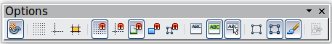
Figure 154: Options toolbar

Choosing and defining colors
Color Bar
To display the Color Bar, use View → Toolbars → Color Bar. The toolbar then appears at the bottom of the workspace.
This toolbar lets you rapidly choose the color of the objects in your drawing. The first box in the panel corresponds to transparency (no color).
You can access several specialized color palettes in Draw, as well as change individual colors to your own taste. To do this, choose Format → Area or the pouring can icon on the Line and Filling toolbar. This opens the Area dialog. Choose the Colors tab.
To load another palette, click on the Load Color List button (circled). The file selector dialog asks you to choose one of the standard LibreOffice palettes (files with the file extension *.soc). For example, web.soc is a color palette that is particularly adapted to creating drawings that are going to appear in Web pages. The colors will correctly display on workstations with screens displaying at least 256 colors.
The color selection box also lets you individually change any color by modifying the numerical values in the fields provided to the right of the color palette. You can use the color schemes known as CMYK (Cyan, Magenta, Yellow, Black), and RGB (Red, Green, Blue).
Click on the Edit button to open the Color dialog, where you can set individual colors. See “Color options” in Chapter 2, Setting Up LibreOffice, of this book. Many more input possibilities are available in this dialog.
For a more detailed description of color palettes and their options, see Chapter 8, Tips and Tricks, in the Draw Guide.
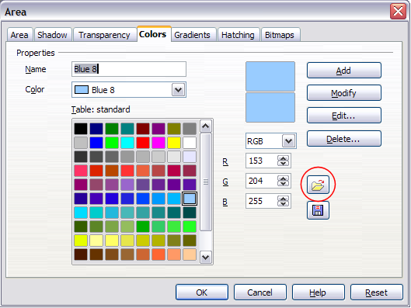
Figure 155. Changing the color palette

Positioning objects with snap functions
In Draw, objects can be accurately and consistently positioned using grid points, special snap points and lines, object frames, individual points on objects, or page edges. This function is known as Snap.
The snap function is easier to work with at the highest practical zoom value. You can use two different snap functions at the same time, for example snapping to a guide line and to the page edge. It is best, however, to activate only those functions that you really need.
This section summaries the snap-to-grid function. For more detailed information about the snap functions, see Chapter 8, Tips and Tricks, and Chapter 10, Advanced Draw Techniques, in the Draw Guide.

Snap to grid
Use this function to move an object exactly to a grid point (see Figure 156). This function can be switched on and off with View → Grid → Snap to Grid and on the Options toolbar with the icon.

Figure 156: Exact positioning with snap to grid

Showing the grid
To make the grid visible, choose View → Grid → Display Grid. Alternatively, turn the grid on (or off) with the icon on the Options toolbar.

Configuring the grid
The color, spacing, and resolution of the grid points can be individually chosen for each axis. The spacing between the lines is defined in the Grid options dialog (Tools → Options → LibreOffice Draw → Grid).
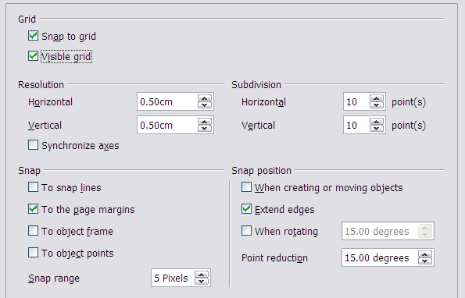
Figure 157: Setting grid options
In the dialog shown in Figure 157, you can set the following parameters:
- Vertical and horizontal spacing of the dots in the grid. You can also change the unit of measurement used in the general Draw options (Tools → Options → LibreOffice Draw → General).
- The resolution is the size of the squares or rectangles in the grid. If the resolution is Horizontal 1 cm, Vertical 2 cm, the grid consists of rectangles 2 cm high and 1 cm wide.
- Subdivisions are additional points that appear along the sides of each rectangle or square in the grid. Objects snap to subdivisions as well as to the corners of the grid.
- The pixel (pix element) size of the snap area defines how close you need to bring an object to a snap point or line before it will snap to it.

Changing the color of the grid points
The default grid dots are light gray, which can be hard to see. To change the color of the grid points, choose Tools → Options → LibreOffice → Appearance.
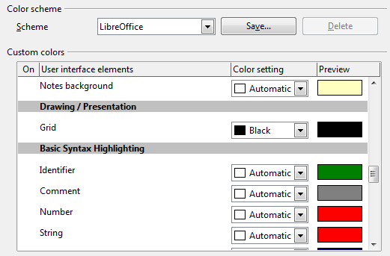
Figure 158: Changing the grid color
In the Drawing / Presentation section, you can change the color of the grid points. On the Color Settings pulldown menu, select a more suitable/visible color, for example black.

Positioning objects with guiding lines
To simplify the positioning of objects it is possible to make visible guiding lines—extensions of the edges of the object—while it is being moved. These guiding lines have no snap function.
The guiding lines can be activated or deactivated under Tools → Options → LibreOffice Draw → View → Guides when moving, or by clicking on the icon on the Options toolbar.

The basic drawing shapes
Draw provides a wide range of shapes, located in palettes accessed from the Drawing Toolbar. This section describes only a few of the basic shapes. These shapes include; rectangles and squares, circles, ellipses, and arcs, 3D objects, curves, lines and arrows, text, and connectors. All shapes in Draw are called objects. See the Draw Guide for a complete description of the shapes available.
Note | When you draw a basic shape or select one for editing, the Info field at the left side in the status bar changes to reflect the present action: Line created, Text frame xxyy selected, and so on.
Figure 159 shows part of the Drawing toolbar with the icons needed in the following sections. The Text icon is also included.
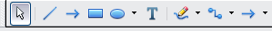
Figure 159: Part of the Drawing toolbar

Drawing a straight line
Click on the Line icon on the Drawing toolbar and position the mouse pointer where you want to start the line. Drag the mouse while keeping the button pressed. Release the mouse button at the point where you want to end the line.
A selection handle appears at each end of the line, showing that this is the currently selected object.
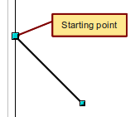
Figure 160: Drawing a straight line
To restrict the angle of the line to a multiple of 45 degrees (0, 45, 90, 135, and so on), hold down the Shift key while you draw the line.
To snap the end of the line to the nearest grid point, hold down the Control (Ctrl) key pressed while drawing the line.
Note | The effect of the Ctrl key depends on the settings of the Snap to Grid option on the View → Grid menu:  Snap to Grid on: Ctrl deactivates the snap option for this activity.  Snap to Grid off: Ctrl activates the snap option for this activity.
To extend the line symmetrically in both directions from the starting point, hold down the Alt key while drawing the line.
To change line attributes (for example, the color or line type), select the line by clicking on it, then use the tools in the Line and Filling toolbar; or for more control, right-click on the line and choose Line to open the Line dialog.

Drawing an arrow
Arrows are drawn like lines. Draw classifies arrows as a subgroup of lines: Lines with arrowheads. The information field on the status bar shows them only as lines. Click on the Line Ends with Arrow icon to draw an arrow.

Choosing line endings
Several types of line endings (arrows, circles, squares, and others) are available in Draw. Choose View → Toolbars → Arrows, or click on the small black triangle on the Lines and Arrows icon on the Drawing toolbar, to open a toolbar with ten tools for drawing lines and arrows. The last-used command is stored on the toolbar to make it quicker to call it up again.
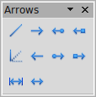

1 | Line | 5 | Line (45°) | 8 | Line with square/arrow
2 | Line Ends with Arrow | 6 | Line starts with arrow | 9 | Dimension line
3 | Line with arrow/circle | 7 | Line with circle/arrow | 10 | Line with arrows
4 | Line with arrow/square
Figure 161: Arrows toolbar
1
2
3
4
5
6
7
8
9
10

Drawing a rectangle or square
Drawing a rectangle is similar to drawing a straight line, except that you click on the Rectangle icon from the Drawing toolbar, and the (imaginary) line drawn by the mouse corresponds to a diagonal of the rectangle. The rectangle changes shape as you drag the mouse around.
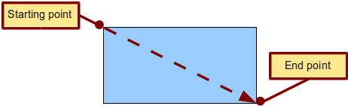
Figure 162: Drawing a rectangle
Hold down the Shift key to draw a square. Hold down the Alt key to draw a rectangle starting from its center. To combine the effects, hold down both the Shift and Alt keys simultaneously.

Drawing a circle or ellipse
To draw an ellipse (also called an oval) or a circle, use the Ellipse icon from the Drawing toolbar. (A circle is simply an ellipse with both axes the same length.) The ellipse drawn is the largest ellipse that fits inside the (imaginary) rectangle drawn with the mouse.
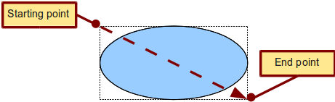
Figure 163: Drawing an ellipse
Here are some other ways to draw an ellipse or circle:
- To draw a circle, hold down the Shift key while dragging the mouse.
- To draw an ellipse with the starting point at the center (instead of the corner), hold down the Alt key while dragging the mouse.
- To draw a circle with the starting point at the center, hold down both the Alt and Shift keys while dragging the mouse.
- To draw an ellipse or circle that snaps to the nearest grid points, hold down the Ctrl key while dragging the mouse.
Note | If you first press and hold down the Ctrl key and then click on one of the icons for Line, Rectangle, Ellipse, or Text, a standard sized object is drawn automatically in the work area; the size, shape, and color are all standard values. These attributes can be changed later, if desired.

Drawing curves
The tools for drawing curves or polygons are on the toolbar that appears when you click arrow next to the Curve icon on the Drawing toolbar. This toolbar contains eight tools (Figure 164).
If you move the mouse cursor over one of the icons, a tooltip pops up with a description of the function.
Note | Hovering the mouse pointer over this icon gives a tooltip of Curve. If you convert the icon to a floating toolbar, however, the title is Lines, as shown in Figure 164.
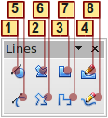
1 | Curve, filled | 4 | Freeform line, Filled | 7 | Polygon (45°)
2 | Polygon, filled | 5 | Curve | 8 | Freeform line
3 | Polygon (45°), filled | 6 | Polygon
Figure 164: Curves toolbar (incorrectly titled "Lines")
Polygons
Draw the first line from the start point with the left mouse button held down. As soon as you release the mouse button, a first corner point is drawn; move the mouse to see how the second line will look. Every mouse click sets another corner point. A double-click ends the drawing. A filled polygon automatically joins the last point to the first point to close off the figure and fills it with the current standard fill color. A polygon without filling will not be closed at the end of the drawing.
Polygon 45°
Like ordinary polygons, these are formed from lines but with angles of 45 or 90 degrees between them.
Freeform line
With this tool you can draw just like with a pencil. Press and hold the left mouse button and drag the mouse. It is not necessary to end the drawing with a double-click. Just release the mouse button and the drawing is completed. If you have selected Freeform Line, Filled, the end point is joined automatically to the start point and the object is filled with the appropriate color.
Curves and filled curves
For a description of the handling of curves and filled curves, see Chapter 10, Advanced Draw Techniques, in the Draw Guide.
1 | Curve, filled | 4 | Freeform line, Filled | 7 | Polygon (45°)
2 | Polygon, filled | 5 | Curve | 8 | Freeform line
3 | Polygon (45°), filled | 6 | Polygon
Figure 165: Curves toolbar (incorrectly titled "Lines")

Writing text
Use the Text tool to write text and select the font, color, size, and other attributes. Click at the location where you want to position the text or click and drag to create a larger text frame. Press Enter to move the cursor to the next line.
When you have finished typing text, click outside the text frame. Double-click on the text at any time to edit it.
When you use the Text tool, the Text formatting toolbar is visible; it includes the usual paragraph attributes: indents, first line, and tab stops.
You can create Graphics styles that you can reuse for other text frames. Select Format → Styles and Formatting or press F11 to open the Styles and Formatting window. Graphics styles affect all of the text within a text frame. To style parts of the text, use direct formatting with the toolbar.
Text frames can also have fill colors, shadows, and other attributes, just like any other Draw object. You can rotate the frame and write the text at any angle. These options are available by right-clicking on the object.
Use the Callout tool , located on the Drawing toolbar, to create callouts (also known as captions or figure labels).
If you double-click on an object or press F2 (or the Text icon in the Drawing toolbar) when an object is selected, text is written in the center of the object and remains within the object. Nearly any kind of object contains such an additional text element. These texts have slight differences to those in text frames concerning position and hyphenation.
For more about text, see Chapter 2, Drawing Basic Shapes, and Chapter 10, Advanced Draw Techniques, in the Draw Guide.

Gluepoints and connectors
All Draw objects have associated invisible gluepoints, which become visible when you choose any of the connectors under the Connector icon on the Drawing toolbar and then move the mouse pointer over the object.
Most objects have four gluepoints, as shown in Figure 166. You can add more gluepoints, and customize gluepoints, using the toolbar under the Gluepoint icon on the Drawing toolbar.
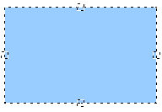
Figure 166: Four gluepoints
Gluepoints are different from handles (the small blue or green squares around an object). The handles are for moving or resizing an object. The gluepoints attach connectors to an object.
Connectors are lines or arrows whose ends automatically dock to gluepoints on an object. When you move the other object, the connector moves with it. Connectors are particularly useful for making organizational charts. You can reorganize the blocks of your chart and all the connected objects stay connected.
Figure 167 shows two Draw objects and a connector.
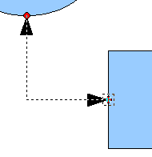
Figure 167: A connector between two objects
Draw offers a range of different connectors and connector functions. Open the floating Connector toolbar by clicking on the arrow next to the Connector icon . For more about connectors and gluepoints, see Chapter 9, Organization Charts, Flow Diagrams, and More, in the Draw Guide.

Drawing geometric shapes
Geometric shapes include basic shapes, symbol shapes, block arrows, flowcharts, callouts, and stars.
Figure 168 shows part of the Drawing toolbar with the icons referred to in the following sections. Clicking on the arrow next to the icon opens a floating toolbar with the relevant work tools.
Tip | The use of all these tools is similar to that of the Rectangle tool, even though they produce different geometric shapes.
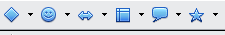
Figure 168: Part of the main Drawing toolbar
Basic shapes
The Basic Shapes icon makes available the range of tools for drawing basic shapes, including a rectangular tool identical to the one on the main toolbar.  The only differences you will see are in the information field in the status bar (in this case, “shape selected” rather than “Rectangle selected”). | 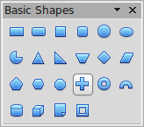
Symbol shapes
The Symbol Shapes icon provides an array of tools for drawing the various symbols. | 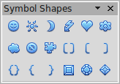
Block arrows
The Block Arrows icon opens the Block Arrows toolbar. | 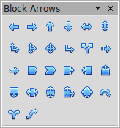
Flowcharts
The tools for drawing flowcharts are accessed by clicking on the Flowcharts icon .  The creation of flowcharts, organization charts, and similar planning tools are described in Chapter 9, Organization Charts, Flow Diagrams, and More, in the Draw Guide. | 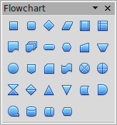
Callouts
Use the Callouts icon to open the Callouts toolbar. | 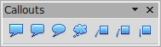
Stars and banners
These tools are associated with the Stars icon . | 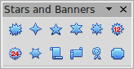
You can add text to all these shapes. See Chapter 2, Drawing Basic Shapes, and Chapter 10, Advanced Draw Techniques, in the Draw Guide for details.

Selection modes
There are three selection modes: moving and changing size, editing, and rotating points.
To set the default mode (either moving and changing sizes or editing) for selecting objects, click on the Points button from the Drawing toolbar.
In standard mode (when you begin a new drawing), the Points button is not active, and the default mode is for selections to be moved or changed in size; these selections are indicated by small green squares. | 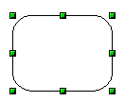
When the Points button is active, the default mode is for selections to be edited; these selections are indicated by blue squares. Some objects will have one or more extra handles, which are larger or colored differently. This is explained in more detail in Chapter 3 of the Draw Guide. | 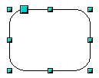
Selections for rotating objects are indicated by small red circles and a symbol representing the center of rotation. To choose these selections, click on the Effects drop-down button from the Drawing toolbar. | 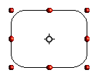

Changing the selection mode
To go from one mode to another, you can do one of the following:
- Choose the Points button from the Drawing toolbar to switch from the simple selection mode to Points mode. You can also use the keyboard shortcut F8 (Points).
- Choose the Effects drop-down button from the Drawing toolbar to activate the Rotation mode for a selected object.
- If you often work in Rotation mode, you can choose the Rotation Mode after Clicking Object button from the Options bar, you can cycle through normal and rotation modes just by clicking on the object. This can be more convenient than repeatedly clicking on the object, then clicking the Rotate button from the Drawing Toolbar.
- To stop working in Rotation mode, click the Rotation Mode after Clicking Object button again.

Selecting objects

Direct selection
To easiest way to select an object is to click directly on it. For objects that are not filled, click directly on the object's outline to select it.
Selection by framing  You can select several objects at once by using the mouse to drag a large rectangle around the objects, as shown. For this to work, the Select icon on the Drawing toolbar must be active. Only objects that lie entirely within the rectangle are selected. | 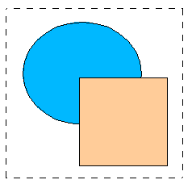

Selecting hidden objects
Even if objects are located behind others and not visible, they can still be selected. Hold down the Alt key and click where the object is located. If there are several overlapping objects, hold down the Alt key and click until you reach the object you want. To cycle through the objects in reverse order, hold down the Alt+Shift keys. The number and type of selected objects is shown at the left of the status bar to help you select the correct object.
Note | This method generally works in Windows, but on a Linux system it usually does not. If the Alt key on your system does not operate as described above, use the Tab key method described below.
To select an object that is covered by another object using the keyboard, press the Tab key to cycle through the objects, stopping at the object you wish to select. To cycle through the objects in reverse order, press Shift+Tab. This may not be practical if you have a large number of objects in your drawing.
When you click on the selected object, its outline will appear briefly through the objects covering it.  In the illustration to the right, the square located beneath the circle was selected in this way (the circle was made transparent in order to see the square). | 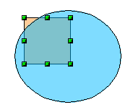

Arranging objects
In a complex drawing, several objects may be stacked on top of one another. To rearrange the stacking order (move an object to the front or to the back of the stack), select the object, choose Modify → Arrange and choose Bring Forward or Send Backward. Or right-click the object, choose Arrange from the context menu, then choose Bring Forward or Send Backward.
These options are also available from the Arrange tear-off toolbar from the button on the Drawing toolbar. A keyboard shortcut is Shift+Ctrl+plus sign to bring an object to the top, and Shift+Ctrl+minus to send an object to the bottom.
Draw also provides tools for aligning multiple objects; details are given in the Draw Guide.

Selecting several objects
To select or deselect several objects one by one, press the Shift key and click on the various objects to be selected or deselected. One click on an object selects it; a second click on the same object deselects it.

Moving and dynamically adjusting an object’s size
There are several ways of moving or changing the size of an object. The dynamic method described here uses the mouse.
When you dynamically change an object, remember to check the left-hand area of the status bar at the bottom of the Draw window. This area shows detailed information about the ongoing manipulation. This information changes when the mouse is moved.

Dynamic movement of objects
To move an object, select it and then click within the object’s border and hold down the left mouse button while dragging the mouse.  During movement, the shape of the object appears a faded version of the shape to help with repositioning.  To drop the object at its new location, release the mouse button. The new position appears immediately in the Status Bar. | 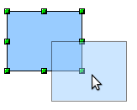

Dynamic size modification of objects
To change the size of a selected object (or group of selected objects) with the mouse, move one of the handles located around the selection. As shown in the following illustration, a faded version of the new object shape is shown. | 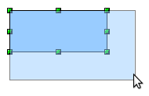
The results depend on which handle you use. To resize an object along one axis, use the appropriate side handle. To resize both axes, use a corner handle. The new size appears immediately in the status bar.
Note | If you press the Shift key while resizing an object, the change in size will be carried out symmetrically with respect to the two axes, so that the aspect (height/length) ratio of the object remains the same.

Rotation
Rotating an object lets you move the object around an axis. To do this dynamically (with the mouse), use the red handles, as you do when changing the size of the object.
Note | Rotation works in a slightly different way for 3D objects because the rotation occurs in 3D space and not in one plane. See Chapter 7, Working with 3D Objects, in the Draw Guide regarding rotation when Edit Points mode is active.
To rotate an object (or a group of objects), drag the red corner handle point of the selection with the mouse. The mouse cursor takes the shape of an arc of a circle with an arrow at each end. A faded version of the object being rotated appears and the current angle of rotation is dynamically shown in the status bar.
Rotations are made around an axis which is displayed as a small symbol, as shown in Figure 169. You can move the axis of rotation with the mouse.
If you hold down the Shift key during the rotation, the operation will be carried out in increments of 15°.
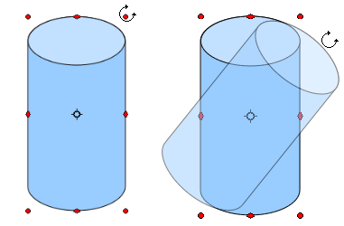Figure 169: Rotating an object

Inclination and perspective
To slant or shear objects, use the red handles located at the midpoint of an edge of the selected objects. The mouse pointer changes to a when the pointer hovers over one of these midpoint handles. Not every object can be slanted; basic shapes can be rotated but not slanted.
The slant axis is the point directly opposite the midpoint handle to be used for shearing the object. This point stays fixed in location; the other sides and edges move in relation to it as the mouse is dragged (make sure that the handle icon is showing before dragging).  As with rotation, you can set the inclination (slanting) to occur in steps of 15° by pressing the Shift key while moving the handle. | 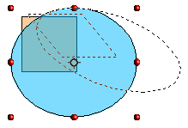

Editing objects
To change an object’s attributes (such as color and border width) you can use the Line and Filling toolbar or the context menu.
If the Line and Filling toolbar (Figure 170) is not visible, you can display it using View → Toolbars → Line and Filling. From here you can edit the most common object attributes. You can also open the Line dialog by clicking on the Line icon and the Area dialog by clicking on the Area icon to see more options.
1 Styles and Formatting  2 Line  3 Arrow Style | 4 Line Style  5 Line Width  6 Line Color | 7 Area  8–9 Area Style / Filling  10 Shadow
Figure 170: Line and Filling toolbar
When you select text, this toolbar changes to show text formatting options.

The context menu
When an object is selected, you can right-click on the object to bring up a context menu, which provides additional access to the options shown above and another way to change an object’s attributes. The entries with a small arrow on the right-hand side contain a submenu.

Editing lines and borders
Lines, arrows, and the borders of an object are managed through the Line dialog. An object’s border is just another type of line. | 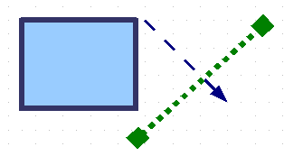
You can change some properties from the Line and Filling toolbar. To see more options, select the object and click on the Line icon or right-click on the object and choose Line from the context menu. This opens the Line dialog.

Common line properties
In most cases the property you want to change is the line’s style (solid, dashed, invisible, and so on), its color, or its width. These options are all available from the Line and Filling toolbar (Figure 170).
You can also edit these properties from the Line dialog, where you can also change the line’s transparency. Figure 171 illustrates different degrees of transparency.

Figure 171: The vertical lines have different levels of transparency (0%, 25%, and 50%).

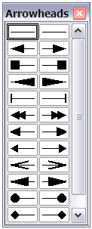
Drawing arrows
Arrowheads (and other line endings—usually referred to collectively as arrows) are a line property. Select a line and click on the Arrow Style 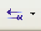 icon from the Line and Filling toolbar. This opens the Arrowheads menu.
Several types of arrowheads are available. Each end of the line can have a different arrowhead (or no arrowhead).
Arrowheads are only applicable to lines. They have no effect on an object’s border.

Customizing line and arrow styles
You can modify the line and arrow styles and create your own. See Chapter 4, Changing Object Attributes, in the Draw Guide for details.

Editing the inside (fill) of an object
The LibreOffice term for the inside of an object is Area fill. The area fill of an object can be a uniform color, a gradient, a hatching, or an image. It can be made partly or fully transparent and can throw a shadow.
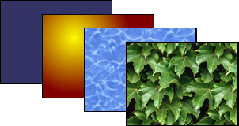
In most cases, you will choose one of the standard fill options, which are all available from the Line and Filling toolbar. You can also define your own area fills; see Chapter 4 of the Draw Guide for details.

Adding a shadow
In Draw, shadows are considered as an area property. Click on the Shadow icon on the Line and Filling toolbar.  You can customize the position, distance, color, and transparency of shadows by using Format → Area → Shadow or by right-clicking on the selected object and choosing Area → Shadow. | 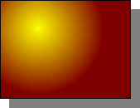

Adding transparency
You can make objects partly or fully transparent, or even with a varying degree of transparency (as a gradient).

Using styles
Suppose that you want to apply the same area fill, line thickness, and border to a set of objects. This repetitive process can be greatly simplified by the use of styles. Styles allow you to define a formatting template (a style) and then to apply that style to multiple objects. For more information about styles, see Chapter 3, Using Styles and Templates, in this book.

Special effects
With Draw, you can apply many special effects to objects and groups of objects. This section describes a few of these effects. More effects include distorting, shadows, and transparency can be found in Chapter 4, Changing Object Attributes, of the Draw Guide.

Flip an object
Select an object and click on the Flip icon . You will see a dashed line through the middle of the object. | 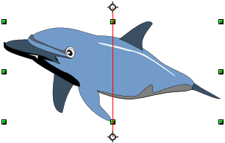
This dashed line is the axis of symmetry. The object will be flipped around this line. Move one or both ends of the line with your mouse to set the orientation of the axis. | 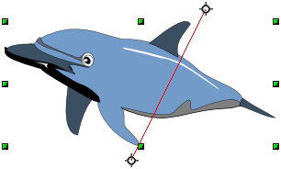
Then, grab any one of the eight green handles and move it across to the other side of the dashed line. The new position of the figure is shown dashed until the mouse is released. | 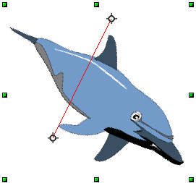
Note | If you hold down the Shift key while moving the line, the line will rotate in 45-degree increments.

Mirror copies
Move the axis of symmetry to the desired location of the mirror axis. Copy the object to the clipboard. Flip the object, then click on an empty area of the Draw screen in order to deselect the object. Paste from the clipboard to put a copy of the object in its original location and now you have a mirror copy.
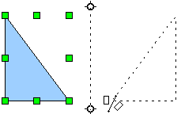 | 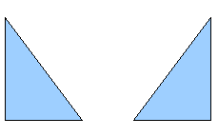

Distorting an image
There are three tools on the Effects menu that let you drag the corners and edges of an object to distort the image.
The Distort tool distorts an object in perspective, the Set to Circle (slant) and Set in Circle (perspective) tools both create a pseudo three-dimensional effect. See Chapter 4 of the Draw Guide for details.

Dynamic gradients
You can control transparency gradients in the same manner as color gradients. Both types of gradient can be used together. With a transparency gradient, the direction and degree of an object’s fill color changes from opaque to transparent (in a regular gradient, the fill changes from one color to another, but the degree of transparency remains the same). See Chapter 4 of the Draw Guide for details.

Duplication
Duplication makes copies of an object while applying a set of changes (such as color or rotation) to the duplicates. The result of a duplication is a new group of objects.
To start duplication, click on an object or group and choose Edit → Duplicate. The dialog shown in Figure 172 appears.
When the options chosen in that dialog are applied to a blue rectangle, they produce the following result.
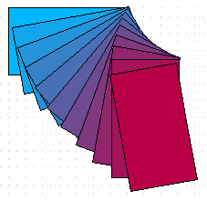
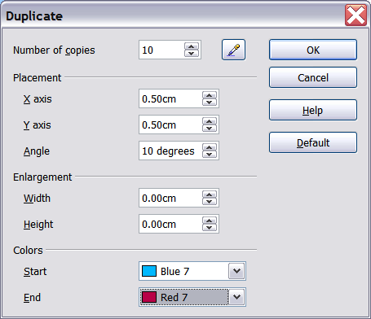
Figure 172: Duplicating an object

Cross-fading
Cross-fading transforms a shape from one form to another. The result is a new group of objects including the start and end points and the intermediate steps.
To carry out a cross-fade, first select two objects (hold the Shift key while selecting each object in turn) and then choose Edit → Cross-fading.
On the Cross-fading dialog, choose the number of increments (transition steps). You probably want to have Cross-fade attributes and Same orientation both checked. The end result is shown in Figure 174.
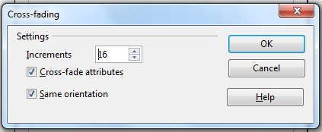
Figure 173: Choosing cross-fading settings
Figure 174: Cross-fading example

Combining multiple objects
Using Draw, you can combine drawing objects together in two distinct ways: grouping and combining. These two methods allow you to treat multiple objects as one unit, or to merge objects to form a new shape.
Grouping is like putting objects in a container. You can move them as a group and apply global changes to them. A group can always be undone and the objects that make up the group can always be manipulated separately.
A combination is a permanent fusion of objects leading to a new object. The original objects are no longer available as individual entities and the operation is not reversible.

Grouping by common selection
When several objects are selected, any operations you carry out are applied to all of the objects. For example, you can rotate a group of objects in its entirety. Groups obtained through common selection of several objects are undone as soon as you click outside the group. However, you can group objects and keep those selected objects grouped together.

Maintaining groups and undoing groups
To group objects, first select the objects, then right-click and choose Group from the pop-up menu. You can also use the keyboard shortcut Control+Shift+G or choose Modify → Group from the menu bar.
When objects are grouped, any editing operations carried out on that group are applied to all members of the group. If you click on one member of the group, the whole group is selected.
The objects of a group retain their own individual properties. To undo a group, right-click and choose Ungroup from the pop-up menu, use the keyboard shortcut Control+Alt+Shift+G or choose Modify → Ungroup from the menu bar.
You can edit a member of a group individually without breaking the group. To do this, right-click and choose Enter group or double-click on the group.

Combining objects
In contrast to grouping functions, combinations create a new object; subsequent “un-combining” in the same manner as ungrouping is not possible. Select a collection of objects, then right-click and choose Combine from the pop-up menu.
After you have selected more than one object, the Merge, Subtract, and Intersect functions can be reached in the Modify → Shapes menu or though the group’s right-click menu under the heading Shapes.

Aids for positioning objects
Draw has various tools to help you arrange the objects with respect to each other:
- Moving an object to the front or to the back
- Aligning objects with respect to each other
- Distributing the distance and space between objects
See Chapter 5, Combining Multiple Objects, in the Draw Guide for more information.

Inserting and editing pictures
Draw contains a number of functions for editing raster graphics (bitmaps)—for example, photos and scanned images—including import and and export as well as conversion from one format to another. Draw can read in all the usual range of graphic file formats.
You can add pictures from several sources:
- The Gallery—see Chapter 11, Graphics, the Gallery, and Fontwork
- Directly from a scanner (Insert → Picture → Scan)
- Images created by another program, including photographs from a digitial camera (Insert → Picture → From File)
Draw provides tools for working with bitmap images: the Picture toolbar and the bitmap image management palette. However, it does not have the same capabilities as the specialized raster graphics programs like Adobe Photoshop or The Gimp. See Chapter 6, Editing Pictures, in the Draw Guide for details and examples.

Working with 3D objects
Although Draw does not match the functionality of the leading drawing or picture editing programs, it is capable of producing and editing very good 3D drawings.
Draw offers two types of 3D objects: 3D bodies, and 3D shapes. Depending on which type you choose, there are different possibilities for further editing of the object (rotation, illumination, perspective). 3D shapes are simpler to set up and edit than 3D bodies, but 3D bodies currently allow for more customization.
See Chapter 7, Working with 3D Objects, in the Draw Guide for details.

Exporting graphics
To save a Draw image in a format other than *.odg, use File → Export. Draw can save to many graphic file formats, as listed in Appendix B (Background Information) of this book. You can export the entire file or selected objects.
You can also export Draw files to HTML, PDF, or Flash. PDF export is the same as for any part of LibreOffice, as described in Chapter 10, Printing, Exporting, and E-mailing, of this book. Flash export creates a .swf file.
HTML export uses a conversion wizard that creates as many web pages as there are pages in your Draw document. You can optionally choose to display the pages in frames with a navigator and can set an index page. For more information, see Chapter 12, Creating Web Pages: Saving Documents as HTML Files, of this book.

Adding comments to a drawing
Draw supports comments similar to those in Writer and Calc.
Choose Insert → Comment from the menu bar. A small box containing your initials appears in the upper left-hand corner of the Draw page, with a larger text box beside it. Draw has automatically added your name and the date at the bottom of this text box.
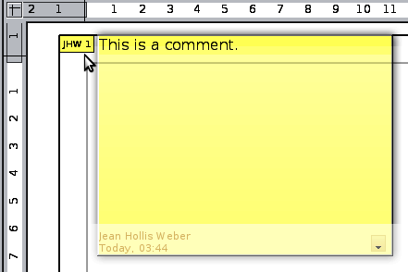
Type or paste your comment into the text box. You can optionally apply some basic formatting to parts of the text by selecting it, right-clicking, and choosing from the pop-up menu. From this menu, you can also delete the current comment, all the comments from the same author, or all the comments in the document.
You can move the small comment markers to anywhere you wish on the page. Typically you might place it on or near an object you refer to in the comment.
To show or hide the comment markers, choose View → Comments.
Choose Tools → Options → User Data to enter the name you want to appear in the Author field of the comment.
If more than one person edits the document, each author is automatically allocated a different background color.
Getting Started Guide

Chapter 8
Getting Started with Base
LibreOffice's Database Component

Introduction
A data source, or database, is a collection of pieces of information that can be accessed or managed by LibreOffice. For example, a list of names and addresses is a data source that could be used for producing a mail merge letter. A shop stock list could be a data source managed through LibreOffice.
Note | LibreOffice uses the terms “Data Source” and “Database” to refer to the same thing, which could be a database such as MySQL or dBase or a spreadsheet or text document holding data.
This chapter covers creating a database, showing what is contained in a database and how the different parts are used by LibreOffice. It also covers using the Base component of LibreOffice to register other data sources. A data source can be a database, spreadsheet, or text document.
Note | LibreOffice Base uses the HSQL database engine. All of the files created by this engine are kept in one zipped file. The database forms are included in this zipped file.
A database consists of a number of fields that contain the individual pieces of data. Each table of the database is a group of fields. When creating a table, you also determine the characteristics of each field in the table. Forms are for data entry into the fields of one or more tables associated with the form. They can also be used for viewing fields from one or more tables associated with the form. A query creates a new table from the existing tables based upon how you create the query. A report organizes the information of the fields of a query in a document according to your requirements.
Caution | The database in LibreOffice requires Java Runtime Environment (JRE). If you do not have it on your computer, you can download it from www.java.com and install it following the instructions on the site. It should be Java 6.0 or higher. In LibreOffice, use Tools → Options → LibreOffice → Java to register Java.  Windows' version of JRE can not be used, while there are other versions that can.
Base creates relational databases. This makes it fairly easy to create a database in which the fields of the database have relationships with each other.
For example: Consider a database for a library. It will contain a field for the names of the authors and another field for the names of the books. There is an obvious relationship between the authors and the books they have written. The library may contain more than one book by the same author. This is what is known as a one-to-many relationship: one author and more than one book. Most if not all the relationships in such a database are one-to-many relationships.
Consider an employment database for the same library. One of the fields contains the names of the employees while others contain the social security numbers, and other personal data. The relationship between the names and social security numbers is one-to-one: only one social security number for each name.
If you are acquainted with mathematical sets, a relational database can easily be explained in terms of sets: elements, subsets, unions, and intersections. The fields of a database are the elements. The tables are subsets. Relationships are defined in terms of unions and intersections of the subsets (tables).
To explain how to use a database, we will create one for automobile expenses. In the process, we will be explaining how a database works.

Planning a database
The first step in creating a database is to ask yourself many questions. Write them down, and leave some space between the questions to later write the answers. At least some of the answers should seem obvious after you take some time to think.
You may have to go through this process a few times before everything becomes clear in your mind and on paper. Using a text document for these questions and answers makes it easier to move the questions around, add additional questions, or change the answers.
Here are some of the questions and answers I developed before I created a database for automobile expenses. I had an idea of what I wanted before I started, but as I began asking questions and listing the answers, I discovered that I needed additional tables and fields.
What are the fields going to be? My expenses divided into three broad areas: fuel purchases, maintenance, and vacations. The annual cost for the car’s license plate and driver’s license every four years did not fit into any of these. It will be a table of its own: license fees.
What fields fit the fuel purchases area? Date purchased, odometer reading, fuel cost, fuel quantity, and payment method fit. (Fuel economy can be calculated with a query.)
What fields fit the maintenance area? Date of service, odometer reading, type of service, cost of service, and next scheduled service of this type (for example, for oil changes list when the next oil change should be). But it would be nice if there was a way to write notes. So, a field for notes was added to the list.
What fields fit the vacations area? Date, odometer reading, fuel (including all the fields of the fuel table), food (including meals and snacks), motel, total tolls, and miscellaneous. Since these purchases are made by one of two bank cards or with cash, I want a field to state which payment type was used for each item.
What fields fit into the food category? Breakfast, lunch, supper, and snacks seem to fit. Do I list all the snacks individually or list the total cost for snacks for the day? I chose to divide snacks into two fields: number of snacks and total cost of snacks. I also need a payment type for each of these: breakfast, lunch, supper, and total cost of snacks.
What are the fields that are common to more than one area? Date appears in all of the areas as does odometer reading and payment type.
How will I use this information about these three fields? While on vacation, I want the expenses for each day to be listed together. The date fields suggest a relationship between the vacation table and the dates in each of these tables: fuel and food, This means that the date fields in these tables will be linked as we create the database.
The type of payment includes two bank cards and cash. So, we will create a table with a field for the type of payment and use it in list boxes in the forms.
Tip | While we have listed fields we will create in the tables of the database, there is one more field that may be needed in a table: the field for the primary key. In some tables, the field for the primary key has already been listed. In other tables such as the payment type, an additional field for the primary key must be created.

Creating a new database
To create a new database, choose File → New → Database from the menu bar, or click the arrow next to the New icon on the Standard toolbar and select Database from the dropdown menu. Both methods open the Database Wizard.
On the first page of the Database Wizard, select Create a new database and then click Next.
The second page has two questions. Make sure the choice for the first question is Yes, register the database for me and the choice for the second question is Open the database for editing. Click Finish.
Note | If the database is not registered, it will not be accessible to the other LibreOffice components such as Writer and Calc. If the database is registered, other components can access it.
Save the new database with the name Automobile. This opens the Automobile – LibreOffice Base window. Figure 175 shows part of this window.
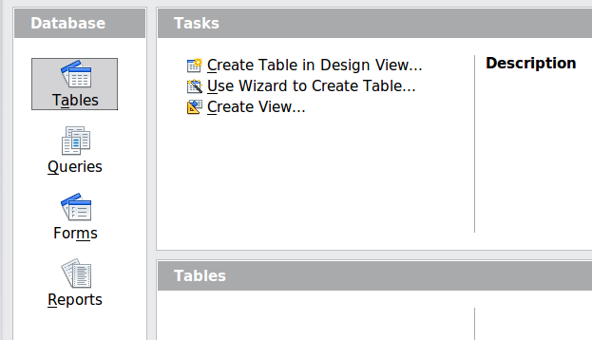
Figure 175: Creating database tables
Tip | Every time the Automobile database is opened, the Automobile – LibreOffice Base window opens. Changes can then be made to the database. The title for this window is always <database name> – LibreOffice Base.
Caution | As you create a database, you should save your work regularly. This means more than saving what you have just created. You must save the whole database as well.  For example, when you create your first table, you must save it before you can close it. When the table is first saved, it is also made part of the database.

Creating database tables
In a database, a table stores information for a group of things we call fields. For example, a table might hold an address book, a stock list, a phone book or a price list. A database can have from one to several tables.
To work with tables, click the Tables icon in the Database list, or press Alt+a. The three tasks that you can perform on a table are in the Tasks list (see Figure 175).

Using the Wizard to create a table
Wizards are designed to do the basic work. Sometimes this is not sufficient for what we want; in those cases we can use a wizard as a starting point and then build upon what it produces.
The Table Wizard in Base contains two categories of suggested tables: business and personal. Each category contains sample tables from which to choose. Each table has a list of available fields. We can delete some of these fields and add other fields.
A field in a table is one bit of information. For example, a price list table might have one field for item name, one for the description, and a third for the price.
Since none of the fields we need for our Automobile database are contained in any of the sample wizard tables, we will create a simple table using the wizard that has nothing to do with our database. This section is an exercise in explaining how the Wizard works.
The Wizard permits the fields of the table to come from more than one suggested table. We will create a table with fields from three different suggested tables in the Wizard.
Caution | Every table requires a Primary key field. (What this field does will be explained later.) We will use this field to number our entries and want that number to automatically increase as we add each entry.
Click Use Wizard to Create Table. This opens the Table Wizard (Figure 176).
Step 1: Select fields.
We will use the CD-Collection Sample table in the Personal category to select the fields we need.
- Category: Select Personal. The Sample Tables dropdown list changes to a list of personal sample tables.
- Sample tables: Select CD-Collection. The Available fields box changes to a list of available fields for this table.
- Selected fields: Using the > button, move the following fields from the Available fields window to the Selected fields window in this order: CollectionID, AlbumTitle, Artist, DatePurchased, Format, Notes, and NumberofTracks.
- Selected Fields from another sample table. Click Business as the Category. Select Employees from the dropdown list of sample tables. Use the > button to move the Photo field from the Available fields window to the Selected fields window. It will be at the bottom of the list directly below the NumberofTracks field.
- If you make a mistake in selecting fields, click on the field name in the Selected fields list and use the < button to move it from the Selected fields list back to the Available fields list.
- If you make a mistake in the order of the selected fields, click on the field name that is in the wrong order and use the Up or Down arrow on the right side of the Selected fields list to move the field name to the correct position.
- Click Next.
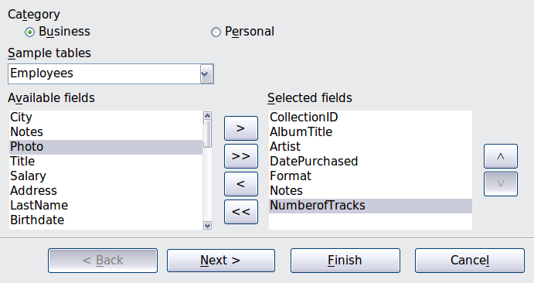
Figure 176: Selecting fields for the table
Step 2: Set field types and formats.
In this step you give the fields their properties. When you click a field, the information on the right changes. (See Figure 177.) You can then make changes to meet your needs. Click each field, one at a time, and make the changes listed below.
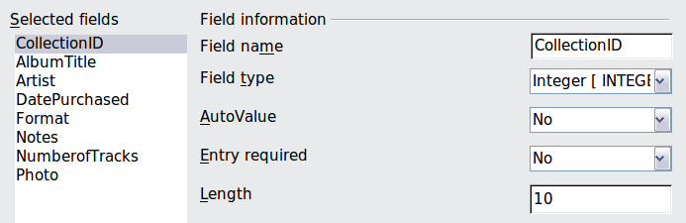
Figure 177: Changing field types
Note | If any of these fields requires an entry, set Entry required to Yes. An entry with that field blank will then not be allowed. In general, only set Entry required to Yes if something must always be put in that field. By default, Entry required is set to No.
- CollectionID: Change AutoValue from No to Yes.
- AlbumTitle:
  - Entry required: Leave Entry required as No, unless all of your music is in albums.
  - Length: Unless you have an album title that exceeds 100 characters counting the spaces, do not change the length.
Note | In Base the maximum length of each field must be specified on creation. It is not easy to change this later, so if in doubt specify a greater length. Base uses VCHAR as the field format for text fields. This format only uses the actual number of characters in a field up to the limit set. So, a field containing 20 characters will only use space for 20 characters even if the limit is set at 100. Two album titles containing 25 and 32 characters respectively will use space for 25 and 32 characters and not 100 characters.
- Artist: Use the Default setting. And since music has artists, set Entry Required to Yes.
- Date Purchased: Field type: default date setting. Entry required should be No. (You may not know the date.)
- Format: Only change the Entry Required setting: from No to Yes.
- Notes: No changes are required.
- NumberofTracks: Change the Field Type to Tiny Integer [TINYINT]. Your allowable number of tracks will be 999. Small Integer [SMALLINT] would allow 99999 tracks if you needed more than 999 tracks.
- Photo: Use the default settings.
When you have finished, click Next.
Note | Each field has a Field Type, which must be specified. Types include text, integer, date, and decimal. If the field is going to have general information in it (for example, a name or a description), use text. If the field will always contain a number (for example, a price), the type should be decimal or another numerical field. The wizard picks the right field type, so to get an idea of how this works, see what the wizard has chosen for different fields.
Step 3: Set primary key.
- Create a primary key should be checked.
- Select option Use an existing field as a primary key.
- In the Fieldname dropdown list, select CollectionID.
- Check Auto value if it is not already checked.
- Click Next.
Note | A primary key uniquely identifies an item (or record) in the table. For example, you might know two people called “Randy Herring” or three people living at the same address and the database needs to distinguish between them.  The simplest method is to assign a unique number to each one: number the first person 1, the second 2, and so on. Each entry has one number and every number is different, so it is easy to say “record ID 172”. This is the option chosen here: CollectionID is just a number assigned automatically by Base to each record of this table.
Step 4: Create the table.
- If desired, rename the table at this point. If you rename it, make the name meaningful to you. For this example, make no changes.
- Leave the option Insert data immediately checked.
- Click Finish to complete the table wizard. Close the window created by the table wizard. You are now back to the main window of the database with the listing of the tables, queries, forms, and reports. Notice that a table named “CD-Collection” is now listed in the Tables portion of the window.

Creating a table by copying an existing table
If you have a large collection of music, you might want to create a table for each type of music you have. Rather than creating each table from the wizard, you can make copies of the original table, naming each according to the type of music contained in it.
- Click on the Tables icon in the Database pane to see the existing tables.
- Right-click on the CD-Collection table icon. Choose Copy from the pop-up menu.
- Move the mouse pointer below this table, right-click, and select Paste. The Copy table dialog opens.
- Change the table name to Pop and click Next.
- Click the >> button to move all the fields from the left box to the right box and click Next.
- Since all the fields already have the proper Field type, no changes should be needed. However, this is the time and place to make any changes if they are needed. (See Caution below for the reason why.) Click Create. The new table is created.
Caution | Once tables have been created using the wizard and data has been entered, editing them should be very limited. Fields can be added or deleted, but adding a field requires taking the time to enter the data for that one field for every record having an entry for that field.  Deleting a field deletes all the data once contained in that field. Changing the field type of a field can lead to data being lost either partially or completely. When creating a new table, it pays to create the fields with the correct names, length, and format before you add any data.  Deleting a table removes all of the data contained in every field of the table. Unless you are sure, do not delete a table.

Creating tables in Design View
Design View is a more advanced method for creating a new table, in which you directly enter information about each field in the table. We will use this method for the tables of our database.
Note | While the Field type and formatting are different in Design View, the concepts are the same as in the Wizard.
The first table to be created is Fuel. Its fields are FuelID, Date, FuelCost, FuelQuantity, Odometer, and PaymentType.
- Click Create Table in Design View.
- FuelID field:
  - Type FuelID as the first Field Name. Press the Tab key to move to the Field Type column.
  - Select Integer [INTEGER] as the Field Type from the dropdown list. (The default setting is Text [VARCHAR].)
Tip | A shortcut for selecting from the Field Type dropdown list: press the key for the first letter of the choice. You can cycle through the choices for a given letter by repeatedly pressing that key.
  - Change the Field Properties in the bottom section.
Change AutoValue from No to Yes.
  - Set FuelID as the Primary key.
Right-click on the green triangle to the left of FuelID (Figure 178) and choose Primary Key from the menu. This places a key icon in front of FuelID.
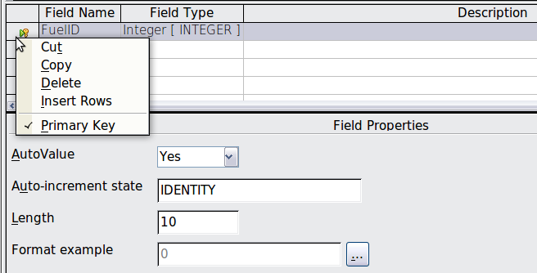Figure 178: Defining the primary key field
Note | The primary key serves only one purpose: to uniquely identify the record. Any name can be used for this field. We have used FuelID for convenience, so we know to which table it belongs.
- All other fields (Date, FuelCost, FuelQuantity, Odometer, and PaymentType):
  - Type the next field name in the Field Name column.
  - Select the Field Type for each field.
    - For Date use Date[DATE]. (Press the D key to select it.)
    - PaymentType uses Text [VARCHAR], the default setting.
    - All other fields use Number [NUMERIC]. (Press the N key once to select it.)
  - FuelCost, FuelQuantity, and Odometer need changes in the Field Properties section (Figure 179).
    - FuelQuantity: Change Length to 6 and Decimal places to 3. (Many fuel pumps measure fuel to thousands of a gallon in the USA where I live.)
    - Odometer: Change the Length to 10 and the Decimal places to 1.
    - FuelCost: Change the Length to 5 and Decimal places to 2. Click the Format example button (Figure 179). This opens the Field Format window (Figure 180). Use Currency as the Category and your currency as the Format. My currency has two decimal places. Use what is appropriate for yours.
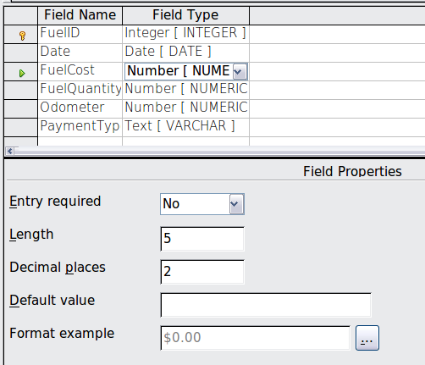Figure 179: Changing field properties
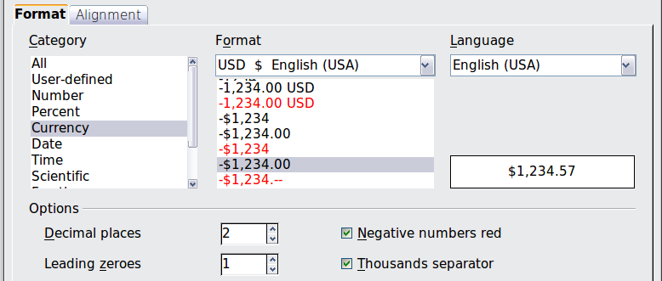
Figure 180: Field Format options
- To access additional formatting options, click the button to the right of the Format example field.
- Description can be anything, or can be left blank.
- To save and close the table, choose File → Save. Name the table Fuel. Close the Fuel table.
Follow the same steps to create the Vacations table. The fields and their field types are listed in Figure 181. Make sure you make the Date field the primary key before closing. (Right-click the gray box to the left of Date and select Primary key from the menu.) Save the table and name it Vacations. Close the Vacations table.
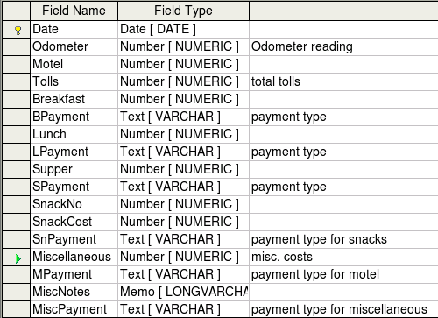
Figure 181: Fields in Vacations table

Creating tables for the list box
When the same information can be used in several fields, design a table for each type of information. Each table will contain two fields: the information field and ID, in that order.
Caution | You must create these tables with the information field listed first and the ID field listed last. Failure to do so will produce the wrong results. For my Payment table, I use Name and ID as my fields, with Dan, Kevin, and Cash being the Name entries. The corresponding ID entries are 0, 1, 2. When the Name field is listed first in the table, one of the three names will appear in the payment field of the Fuel table. If the ID field is listed first, 0, 1, or 2 appear in the payment field instead.
- Follow the directions in “Creating tables in Design View” on page 198. In the table, the two fields can be Type and PaymentID. In the Field Properties, set AutoValue to Yes for the PaymentID field. Set the PaymentID field as the primary key. (See Figure 182.)
- Save the table using the name Payment Type.
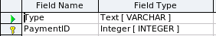
Figure 182: Table in Design View
Note | If you have several tables to create with the same fields, design one table and produce the other tables by cutting and pasting. (See “Creating a table by copying an existing table” on page 198.)

Adding data to the list table
List tables do not require a form. Instead, add their data directly to the table. In this example, use the names of the two people with a bank card and Cash for cash purchases.
- In the main database window, click on the Tables icon (Figure 175). In the list of tables, right-click on Payment Type and select Open from the pop-up menu.
  - Enter Dan in the Type column in the first row. Press the Tab key to move to the second row. Notice that the PaymentID value for this row changes from <AutoField> to 0.
  - Enter Kevin in the second row. The PaymentID changes to 1.
  - Enter Cash in the third row. The PaymentID changes to 2.
- Save and close the table window.
Tip | You can also use the Enter key to move from entry field to entry field, or use the down arrow key to move from row to row.

Defining relationships
Now that the tables have been created, what are the relationships between our tables? This is the time to define them based upon the questions we asked and answered in the beginning.
When on vacation, we want to enter all of our expenses all at one time each day. Most of these expenses are in the Vacations table, but the fuel we buy is not. So, we will relate these two tables using the Date fields. Since the Fuel table may have more than one entry per date, this relationship between the Vacations and Fuel tables is one to many. (It is designated 1:n.)
The Vacations table also contains several fields for the type of payment used. For each field listing the payment type, there is only one entry from the Payment Type table. This is a one to one relationship: one field in one table to one entry from the other table. (It is designated 1:1.) Other tables also contain fields for the type of payment. The relationship between the fields of those tables and the Payment Type table are also 1:1.
Since the Payment Type table only provides a static list, we will not be defining a relationship between the Payment Type table and the fields of the other tables which use the entries of the Payment Type table. That will be done when the forms are created.
The Fuel and Maintenance tables do not really have a relationship even though they share similar fields: Date and Odometer.
Tip | As you create your own databases, you need to also determine where tables are related and how.
- To begin defining relationships, choose Tools → Relationships. The Automobile – LibreOffice Base: Relation Design window opens and the Add Tables dialog pops up. (You can also open it by clicking the Add Tables icon on the Relation Design window.)
- On the Add Tables dialog, use either of these ways to add a table to the Relation Design window:
  - Double-click the name of the table. In our case, do this for both Vacations and Fuel.
  - Or, click the name of the table and then click Add for each table.
- Click Close to close the Add Tables dialog when you have added the tables you want.
- You can define the relationship between the Vacations and Fuel tables in two ways:
  - Click and drag the Date field in the Fuel table to the Date field in the Vacations table. When you release the mouse button, a connecting line forms between the two date fields.
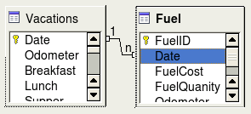
Figure 183: Designation for a 1:n relationship
  - Or, click the New Relation icon. This opens the Relations window (Figure 184). Our two tables are listed in the Tables involved section.
    - In the Fields involved section, click the dropdown list under the Fuel label.
    - Select Date from the Fuel table list.
    - Click in the cell to the right of this dropdown list. This opens a dropdown list for the Vacations table.
    - Select Date from the Vacations table list. It should now look like Figure 184.
    - Click OK.
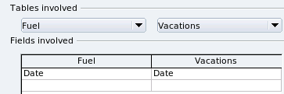Figure 184: Selected fields in a relationship
- Modifying the Update options and Delete options section of the Relation window.
  - Right-click the line connecting the Date fields in the two table lists to open a menu.
  - Select Edit to open the Relations dialog (Figure 185).
  - Select Update cascade.
  - Select Delete cascade.
  - Click OK to close the Relations dialog and choose File → Save to save the Relation Design window.
While these options are not strictly necessary, they do help. Having them selected permits you to update a table that has a relationship defined with another table. It also permits you to delete a field from the table.
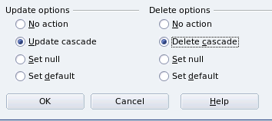Figure 185: Update options and Delete options section

Creating a database form
Databases are used to store data. But, how is the data put into the database? Forms are used to do this. In the language of databases, a form is a front end for data entry and editing.
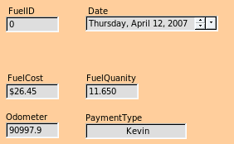Figure 186: Fields of a simple form | 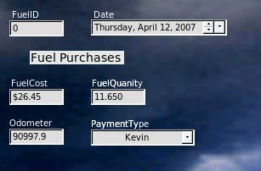Figure 187: Simple form with additions
A simple form consists of the fields from a table (Figure 186). More complex forms can contain much more, including additional text, graphics, selection boxes, and many other elements. Figure 187 is made from the same table with a text label (Fuel Purchases), a list box placed in PaymentType, and a graphic background.

Using the Wizard to create a form
We will use the Form Wizard to create a Vacations form, which will contain a form and a subform.
In the main database window (Figure 175), click the Forms icon in the left column. In the Tasks list, double-click Use Wizard to Create Form to open the Form Wizard (Figure 188). Simple forms require only some of these steps, while more complex forms may use all of them.
Step 1: Select fields.
- Under Tables or queries, select Table: Vacations. Available fields lists the fields for the Vacations table.
- Click the right double arrow to move all of these fields to the Fields in the form list. Click Next.
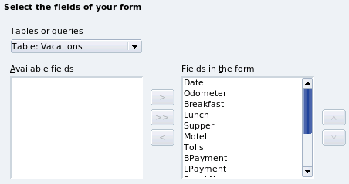Figure 188: Form Wizard steps
Step 2: Set up a subform.
Since we have already created a relationship between the Fuel and Vacations tables, we will use that relationship. If no relationship had been defined, this would be done in step 4.
- Click the box labeled Add Subform.
- Click Subform based upon existing relation.
- Fuel is listed as a relation we want to add. So, click Fuel to highlight it, as in Figure 189. Click Next.
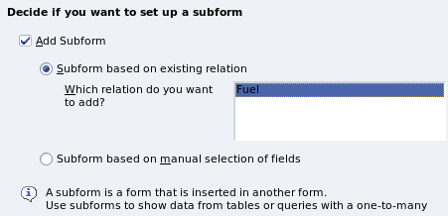Figure 189: Adding a subform
Step 3: Add subform fields.
This step is exactly the same as step 1. The only difference is that not all of the fields will be used in the subform.
- Fuel is preselected under Tables or queries.
- Use the >> button to move all the fields to the right.
- Click the FuelID field to highlight it.
- Use the < button to move the FuelID to the left (Figure 190).
- Click Next.
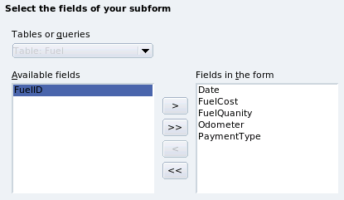Figure 190: Selecting fields of a subform
Step 4: Get joined fields.
This step is for tables or queries for which no relationship has been defined. Because we have already defined the relationship, the wizard skips this step.
Note | It is possible to create a relationship between two tables that is based upon more than one pair of fields. How to do that and why is discussed in the Base Guide.
Caution | When selecting a pair of fields from two tables to use as a relationship, they have to have the same field type. That is why we used the Date field from both tables: both their field types are Date[DATE].  Whether a single pair of fields from two tables are chosen as the relationship or two or more pairs are chosen, certain requirements must be met for the form to work.  - No field from the subform can be the Primary key for its table. (FuelID cannot be used.)  - Each pair of joined fields must have the same file type.  - One of the fields from the main form must be the Primary key for its table. (Date would have to be used.)
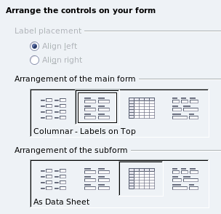
Step 5: Arrange controls.
Each control in a form consists of two parts: label and field. This step in creating the form determines where a control’s label and field are placed in relationship with each other. The four choices from left to right are Columnar left, Columnar - Labels on top, As Data Sheet, and In Blocks - Labels Above.
- Arrangement of the main form: Click the second icon (Columnar - Labels on top). The labels will be placed above their field.
- Arrangement of the subform: Click the third icon (As Data Sheet). (The labels are column headings and the field entries are in spreadsheet format.) Click Next.
Step 6: Set data entry.
Unless you have a need for any of these entries to be checked, accept the default settings. Click Next.
Step 7: Apply styles.
- Select the color you want in the Apply Styles list. (I chose the beige which is Orange 4 in the Color table.)
- Select the Field border you want. (I prefer the 3-D look. You might want to experiment with the different possible settings.)
- Click Next.
Step 8: Set name.
- Enter the name for the form. In this case, it is Fuel.
- Click Modify the form.
- Click Finish. The form opens in Edit mode.

Modifying a form
We will be moving the controls to different places in the form and changing the background to a picture. We will also modify the label for the PaymentType field as well as change the field to a list box.
First, we must decide what we want to change. The discussion will follow this ten step outline of our planned changes.
- Provide a dropdown capability for the Date field in the main form, and lengthen the field to show the day of the week, month, day, and year.
- Shorten the length of the payment fields (all fields containing the word Payment).
- Move the controls into groups: food, fuel subform, and miscellaneous.
- Change the wording of some of the labels. Some single words should be two words. Some abbreviations should be used if possible (Misc. for miscellaneous).
- Change the lengths of several fields and labels. Only Lunch, Supper, Motel, and Tolls have acceptable lengths. But for a better appearance, changes will be made to these as well.
- Replace all the fields whose label ends in Payment with a list box containing the entries from the Payment Type table.
- Lengthen the Note field vertically, add a scroll bar, and move it.
- Make changes in the Date and PaymentType columns of the subform that are similar to the changes in the main form.
- Add headings for each group in the main form.
- Change the background to a picture, then modify some of the labels so that they can be read clearly. Change the font color of the headings.
Here are some methods that we will be using in these steps. The controls in the main form consists of a label and its field. Sometimes we want to work with the entire control, other times we want to work with only the label or the field, and there are times when we want to work with a group of controls.
- Clicking a label or field selects the entire control. A border appears around the control with eight green handles. You can then drag and drop it where you want.
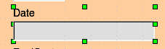
Figure 191: A selected control
- Control+click a label or field selects only the label or the field. You can press the Tab key to change the selection from the field to the label or the label to the field.
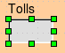Figure 192: Selecting a field of a control
- Moving a group of controls is almost as easy as moving one of them.
  - Click the field of the top left control to be moved, to select it.
  - Move the cursor to just above and to the left of the selected control.
  - Drag the cursor to the bottom right of the group of controls and release the mouse button.
As you drag the cursor, a dashed box appears showing what is contained in your selection. Make sure it is big enough to include the entire length of all the controls.
When you release the mouse button, a border with its green handles appears around the controls you selected.
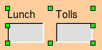Figure 193: Selecting multiple controls
Move the cursor over one of the fields. It changes to a drag icon. Drag the group of controls to where you want them.
Tip | When either changing size or moving a control, two properties of the Form Design toolbar should be selected: Snap to Grid, and Guides when Moving. Your controls will line up better, and an outline of what you are moving moves as the cursor moves.  You should also have both rulers active (View → Ruler).
Step 1: Change the Date field.
- Control+click the Date field to select it.
- Move the cursor over the middle green handle on the right side. It should change to a double-headed arrow.
- Hold the left mouse button down as you drag the cursor to the right until the length is 6 cm. The vertical dashed line is lined up with the 6. Release the mouse button.
- Click the Control icon in the Form Controls toolbar. The Properties: Date Field window opens. Each line contains a property of the field.
Figure 194: Form Controls toolbar
  - Scroll down to the Date format property. This is a dropdown list with Standard (short) as the default setting. Click it to open the list. Select the Standard (long) entry.
  - Scroll down to the Dropdown property. Its default setting is No. It is also a dropdown list. Click to open the list. Select Yes.
Tip | To see what the Date field will look like, click the Form Mode On/Off icon (the second icon from the left in Figure 194). You can do this any time you want to see the form with the changes you have made.
Step 2: Shorten the width of some fields.
All of the fields with a label containing the word payment are too wide. They need shortening before the controls are moved.
- Control+click the BPayment field.
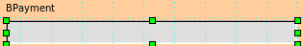Figure 195: Selecting a field
- Move the cursor over the middle green handle on the right. The cursor becomes a double-headed arrow.
- Drag the cursor to the left until the field is 2.5 cm wide (1 inch).
Tip | If you have the Snap to Grid and Guides when moving icons selected in the Design Format toolbar, you will see how wide the field is as you shorten it.
- Repeat these steps to shorten these fields: Lpayment, SPayment, SnPayment, Mpayment, and MiscPayment.
Step 3: Move the controls to group them by category.
We want to move the controls so that they look like Figure 196.
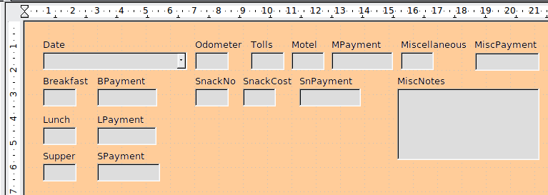
Figure 196: Positioning of controls
- Click the first control you want to move. A border appears around the control with eight green handles.
- Move the cursor over the label or field of the control. It change shape to a drag icon.
- Drag and drop the control to where you want it.
Caution | Do not use Control+click when moving a field. It moves either the field or the label but not both. To move both, use a mouse click and drag to the desired spot.
- Use the same steps to move the rest of the controls to where they belong.
Step 4: Change the label wording.
Field names have been single words for some time. However, the labels for the fields in a form can be more than one word. So, we will change them by editing the text in the label.
Note | The table wizard in Base contains suggested fields which are single words, often consisting of two separate words. Table names in the wizard have been that way also. However, you can use multiple words as the name of a field, label, or table. We will do so when we create a list box for each of the payment type controls.
- Control+click the SnackNo label. Do one of the following:
  - Right-click the SnackNo label and select Control from the pop-up menu.
  - Or, click the Control icon in the Form Control toolbar (Figure 194).
- The dialog that opens is labeled Properties: Label Field. It contains all of the properties of the selected label.
  - In the Label selection, edit the label to Snack No.
  - Close the Properties dialog.
- Use the same procedure to change these labels as well: BPayment to Payment, LPayment to Payment, SPayment to Payment, Miscellaneous to Misc., SnackCost to Snack Cost, MPayment to Payment, MiscPayment to Misc. Payment, and MiscNotes to Misc. Notes.
Tip | You can modify all of the listings in the Properties window. For example, if you change the Alignment from Left to Center, the word or words in the label are centered within the label. When you have some time, you might want to experiment with different settings just to see the results you get.
Step 5: Change the widths of the labels and fields.
We want the following controls to be 2 cm wide (0.8 inches): Breakfast, Lunch, Supper, Odometer, Snack No., Tolls, Snack Cost, Motel, and Misc. All of the payment fields were changed in step 2, but Misc. Payment needs to be changed to 3 cm (1.2 inches).
- Right-click Breakfast and choose Position and Size. On the Position and Size dialog, change Width to 2 cm.
- Repeat for the other listed controls, using 3 cm for Misc.Payment.
Caution | When changing the position or size of an entire control, use the Position and Size dialog or the drag and drop method.  When working with either the label or the field (but not both at the same time), you can use the Properties dialog to make these changes when you want to be exact. However, you need to be careful not to accidentally select the entire control for use with the Properties dialog or you will apply the exact same values to both the label and field. For example, if you enter the values for a new position, both the field and the label moves to the same position and the field is positioned on top of the label. Then you have to move each of them to where you want them.
Note | To open the Properties window, right-click a control and select Control from the pop-up menu. Or, you can click the Control icon in the Form Controls toolbar. Just be careful, and use Control+Z to undo any mistakes you may make. Detailed instructions on how to use the Properties window will be in the Base Guide.
Step 6: Replace fields with other fields.
We want to replace the PaymentType field with a List Box. Then we can choose the type of payment from the Payment Type table rather than having to manually enter the type. In my case, each of my payment types begins with a different letter. If I enter the first letter of the payment type, the rest of the word automatically appears. I can then go to the next field.
- Control+click the Payment field for Breakfast. The green handles appear around the field but not around the Label.
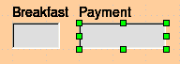
Figure 197: Selecting a field of a control
- Right-click within the green handles and select Replace with → List Box.
- Click the Control icon in the Form Controls toolbar to open the Properties: List Box dialog.
- On the General tab, scroll down to the Dropdown selection. Change the No to Yes.
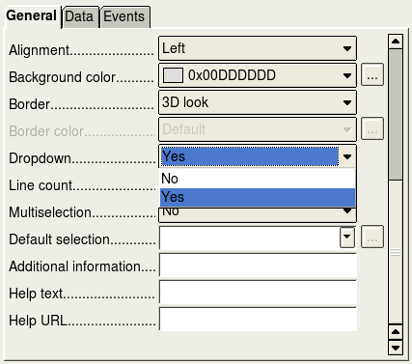
Figure 198: Dropdown list open to reveal choices
- Click the Data tab.
  - Type of list contents is a dropdown list. Change it to Sql.
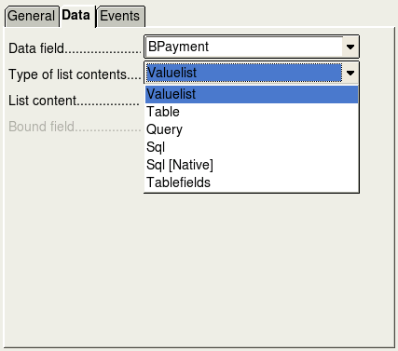
Figure 199: Type of list contents dropdown list
  - Type the following exactly as it is in the List contents box:
SELECT "Type", "Type" FROM "Payment Type"
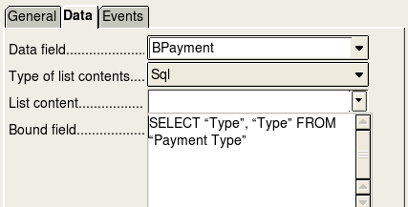

Figure 200: List content for payment type fields
Note | What you wrote is called an SQL command. The words SELECT and FROM are written in capital letters because they are commands. When the command SELECT is used, it requires a field name within quotation marks and then the field’s alias, also within quotation marks. In this case, the field and its alias are the same. The FROM command requires the name of the table which contains the field. Single-word table names do not require quotation marks, but multiple-word table names do.
  - Repeat these steps for the payment fields for Lunch, Supper, Motel, Snacks, and Misc. The main form should look like Figure 201 as far as where the controls are located. It also shows what the Note control should look like. Those changes are explained in the next step.
  - Close the Properties window.
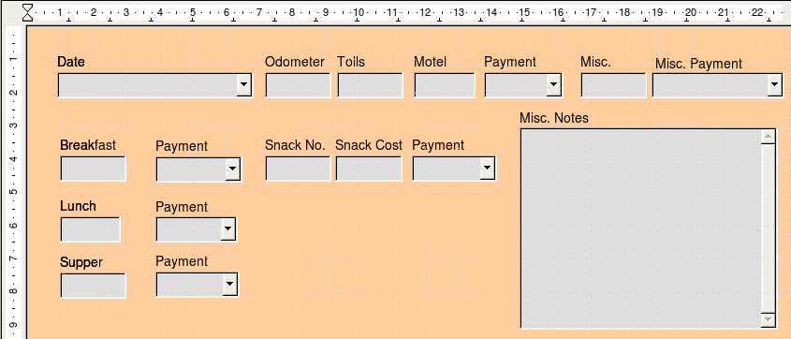Figure 201: Position of controls in main form
Step 7: Change the Misc. Notes field.
We want the Misc. Notes control, which has a field type of Memo, to have a vertical scrollbar for additional text space if desired.
- Control+click the Misc. Notes field. The green handles should surround the field but not its label.
- Click the Control icon to open the Properties window (Figure 202).
- Scroll down to the Scrollbars setting. Change the selection from None to Vertical in this dropdown list.
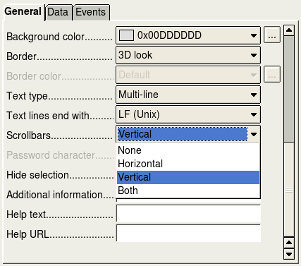
Figure 202: Scrollbar selections in the Properties window
- Close the Properties window.
- Lengthen the Misc. Notes field by moving the cursor over the middle green handle at the bottom of the field and dragging down until the length is 6 cm (2.4 inches).
Step 8: Change labels and fields in the subform.
The subform is located at the bottom of the form. We want to widen the Date column, change the field in the PaymentType column to a list box, and change the label for the PaymentType column to two words.
To widen the Date column, move the mouse pointer over the dividing line between the Date and FuelCost columns. When the pointer changes shape, click and drag to move the divider to the right.
To change the PaymentType column:
- Right-click the label PaymentType and choose Replace with → List box from the menu.
- Again right-click the label PaymentType to open the menu. Select Column to open the Properties dialog (Figure 203).
- In the Label box, change PaymentType to Payment Type.
- Click the Data tab.
- From the Type of list contents dropdown list, select Sql.
- Type the following exactly as it is written:
SELECT "Type", "Type" FROM "Payment Type"
- Close the Properties dialog.
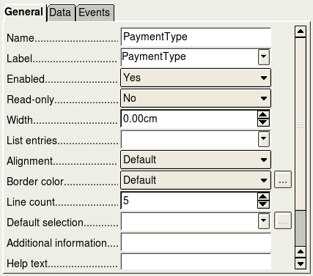
Figure 203: Properties window for control in a subform
Step 9: Add headings to groups.
This step is easier to do if you have end-of-paragraph markers visible. Choose View → Nonprinting Characters to turn them on.
- Make sure the cursor in in the upper left corner. If it is not, click in that corner to move it there.
- Press the Enter key to move the cursor down to the space between the Date field and the Breakfast field.
- Change the Apply Styles dropdown list from Default to Heading 2.
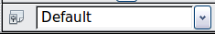
Figure 204: Apply Styles list
- Use the spacebar to move the cursor to where you want the heading to start.
- Type the heading Meals.
- Use the spacebar to move the cursor to the center of snack area.
- Type the heading Snacks.
- Use the Enter key to move the cursor between the Supper control and the subform.
- Use the spacebar to move the cursor to the center of the subform.
- Type the heading Fuel Data.
Note | If you know how to use styles, you can open the Styles and Formatting window using F11. Right-clicking the Heading 2 paragraph style allows you to modify the appearance of all three headings. See Chapter 6 of the Writer Guide for details.
Step 10: Change the background of a form.
The background for a form can be a color, or a graphic (picture). You can use any of the colors in the Color Table at Tools → Options → LibreOffice → Colors. If you know how to create custom colors, you can use them. You can also use a picture (graphic file) as the background.
If you choose a dark background, you many need to change many of the labels and headings so they can be seen.
- Select the labels of the top row of controls.
  - Control+click the Date label.
  - Control+shift+click the rest of the labels of the top row. The border will gradually grow to the right as you do this until all the labels are enclosed in it.
Figure 205: Selecting multiple labels at one time
  - Click the Control icon in the Design Form toolbar to open the Properties dialog.
  - Change the Background color selection from Default to Light cyan. (This is a dropdown list.) Close the Properties dialog.
- Select the other labels in the same way and then change their background color.
- To change the font color for the headings:
  - Open Styles and Formatting using the F11 key. Make sure the Paragraph icon is selected at the left end of the icons in Error: Reference source not found.
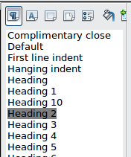
Figure 206: Styles and Formating window
  - Right-click the Heading 2 style to open a pop-up window and select Modify from this menu.
  - In the Paragraph Style Heading 2 dialog, click the Font Effects tab. Change Font color from Automatic to Light Cyan.
  - Click OK to close the dialog.
Tip | Learning how to use styles can be very helpful at times. By using styles, we changed the font color for all three headings at one time. There are other methods of changing the font color, but they require repeating the same steps for each heading.
- To add a graphic to the background:
- Right-click on the background and select Page from the pop-up menu.
- On the Page Style dialog, click the Background tab, change the As dropdown list from Color to Graphic.
- Click Browse to find and select the graphic file you want to use, and click Open. In the Type section of the Background tab, select Area.
- Click OK to close the dialog. The form should look like Figure 207.
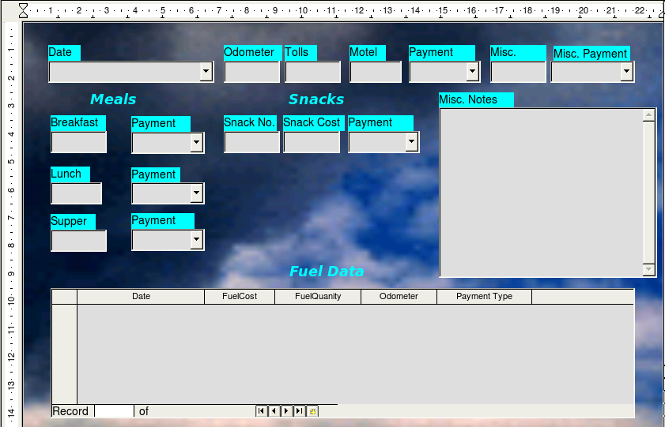Figure 207: Finished form
Step 11: Change the tab order.
The Tab key moves the cursor from field to field. This is much easier to do than to click each field to enter data into it. It also permits us to group our expenses into areas before we begin entering data. For example, all of our meal receipts can be grouped together as can our snacks and also our fuel purchases.
- Control+click the Date field.
- Click the Form Design icon in the Form Controls toolbar to open the Form Design toolbar (Figure 208), or choose View → Toolbars → Form Design to open this toolbar.
- Click the Activation Order icon (circled).
Figure 208: Form Design toolbar with Activation Order icon circled
- Rearrange the order of the fields in the Tab Order window.
  - Find the txtMPayment listing near the bottom of the list and click it.
  - Click the Move Up button until txtPayment is just below fmtMotel.
  - Use the same two steps to put the fields in the same order as in Figure 209. Click OK.
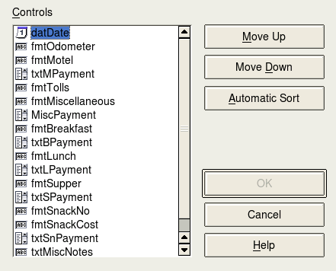Figure 209: Tab order for the main form
- Save and close the form.
- Save the database.

Creating forms and subforms in Design View
This method requires using the Form Controls and Form Design toolbars extensively. These techniques are beyond the scope of this document. Instructions for creating forms using Design view will be described in the Database Guide.

Accessing other data sources
LibreOffice allows data sources to be accessed and then linked into LibreOffice documents. For example, a mail merge links an external document containing a list of names and addresses into a letter, with one copy of the letter being generated for each entry.
To access a data source that is not a *.odb file:
- File → New → Database opens the Database Wizard window.
- Select Connect to an existing database. Click the arrow next to the Database type field and select the database type from the dropdown list. Click Next.
- Click Browse and select the database. Click Next.
- Accept the default settings: Register the database for me, and Open the database for editing. Click Finish. Name and save the database in the location of your choice.

Accessing a spreadsheet as a data source
Accessing a spreadsheet is similar to accessing other databases:
- Choose File → New → Database.
- Select Connect to an existing database. Select Spreadsheet as the Database type.
- Click Browse to locate the spreadsheet you want to access. If the spreadsheet is password protected, check the Password required box. Click Next.
- If the spreadsheet requires a user’s name, enter it. If a password is also required, check its box. Click Next.
Note | Using this method of accessing a spreadsheet, you cannot change anything in the spreadsheet. You can only view the contents of the spreadsheet, run queries, and create reports based upon the data already entered into the spreadsheet.  All changes in a spreadsheet must be made in the spreadsheet itself, using Calc. After modifying the spreadsheet and saving it, you will see the changes in the database. If you create and save an additional sheet in your spreadsheet, the database will have a new table the next time you access it.

Registering *.odb databases
Databases created by LibreOffice2.x or later are in the *.odb (OpenDocument Base) format. Other programs can also produce databases in this format. Registered a *.odb database is simple:
- Choose Tools → Options → LibreOffice Base → Databases.
- Under Registered databases, click New.
- Browse to where the database is located.
- Make sure the registered name is correct.
- Click OK.
Note | Sometimes when updating LibreOffice to a newer version, your list of registered database files disappears. When that happens, you need to use these steps to register your database files with your latest version of LibreOffice.

Using data sources in LibreOffice
Having registered the data source, whether a spreadsheet, text document, external database or other accepted data source, you can use it in other LibreOffice components including Writer and Calc.

Viewing data sources
Open a document in Writer or Calc. To view the data sources available, press F4 or select View → Data Sources from the pull-down menu. This brings up a list of registered databases, which will include Bibliography and any other database registered, such as the Automobile database created earlier in this chapter.
To view each database, click on the + to the left of the database’s name (see Figure 210). This brings up Tables and Queries. Click on the + next to Tables to view the individual tables created. Now click on a table to see all the records held in it.
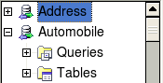
Figure 210: Databases

Editing data sources
Some data sources can be edited in the View Data Sources dialog. A spreadsheet can not. A record can be edited, added, or deleted.
The data is displayed on the right side of the screen. Click in a field to edit the value.
Beneath the records are five tiny buttons. The first four move backwards or forwards through the records, or to the beginning or end. The fifth button, with a small star, inserts a new record.

Figure 211: View Data Sources navigation buttons
Insert new record
To delete a record, right-click on the gray box to the left of a row to highlight the entire row, and select Delete Rows to remove the selected row.
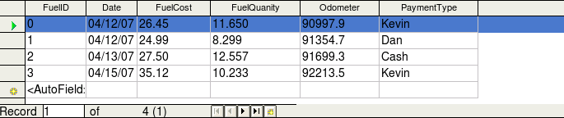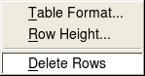

Figure 212: Deleting a row in the Data View window

Launching Base to work on data sources
You can launch LibreOffice Base at any time from the View Data Source pane. Just right-click on a database or the Tables or Queries icons and select Edit Database File. Once in Base, you can edit, add, and delete tables, queries, forms, and reports.

Using data sources in Writer and Calc
Data can be placed into Writer and Calc documents from the tables in the data source window. In Writer, values from individual fields can be inserted. Or, a complete table can be created in the Writer document. One common way to use a data source is to perform a mail merge.
Tip | Choosing Tools → Mail Merge Wizard or clicking on the Mail Merge icon on the View Data Source pane launches the Mail Merge wizard which steps you through creating a mail merge document. See Chapter 11 in the Writer Guide.

Writer documents
To insert a field from a table opened in the data source window into a Writer document, click on the field name (the gray square at the top of the field list) and, with the left mouse button held down, drag the field onto the document. In a Writer document, it will appear as <FIELD> (where FIELD is the name of the field you dragged).
For example, to enter the cost of meals and who paid for them on a certain date of a vacation:
- Open the list of data sources (F4) and select the Vacations table in the Automobile database.
- Use this sentence: “On (date), our breakfast cost (amount) paid by (name), our lunch cost (amount) paid by (name), and our supper cost (amount) paid by (name).” But only type “On , our breakfast cost paid by , our lunch cost paid by , and our supper cost paid by .”
- To replace (date), click the field name Date in the data source window and drag it to the right of the word On. The result: On <Date>. If you have Field shadings turned on (View → Field shading), <Date> has a gray background. Otherwise it does not.
- To replace first (amount), click the Breakfast field name and drag it to the right of our breakfast cost. Make sure you have the proper spacing between the field names and the words before and after them. Result: breakfast cost <Breakfast>.
- To replace the first (name), click the Bpayment field name and drag it to the right of paid by. Result: paid by <Bpayment>.
- In the same way, fill in the rest of the fields in the sentence.
  - Use <Lunch> and <LPayment> for the second set of (amount) and (name) in the sentence.
  - Use <Supper> and <SPayment> for the third set of (amount) and (name) in the sentence.
- Final result: On <Date>, our breakfast cost <Breakfast> paid by <BPayment>, our lunch cost <Lunch> paid by <LPayment>, and our supper cost <Supper> paid by <SPayment>.
- Add data to the fields of the sentence:
  - Click the gray box to the left of the row of data you want to add. That row should be highlighted like the second row of Figure 213.
  - Click the Data to Fields icon (circled). This should fill the fields with the data from the row you chose.
  - Click another row and then click this icon again. The data in the sentence changes to this selected row of data.
  - Save the document if you want to use it as an example later.
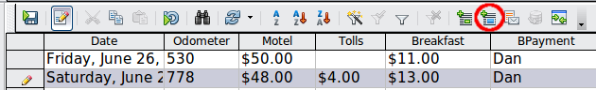
Figure 213: Selected row in data source window
Adding data in table format is a little easier and takes perhaps fewer steps. Some of the steps will be quite similar.
- Navigate to the place you want to place the table and click the location.
- Control+Click the gray box to the left of each row of the data source that you want to be a row in your table when the rows are not consecutive. To select consecutive rows, click the gray box to the left of the top desired row and Shift+click the bottom desired row.
- Click the Data to text icon to open the Insert Database Columns dialog (Figure 214). (The Data to text icon is to the left of the Data to Fields icon in Figure 213.)
- Move the fields you want in your table from the Database Columns list to the Table column(s) list.
- To place the fields in the order you select, click the field and use the single arrow to move the fields in the order you desire. You can also limit the fields you use to less than all of the fields available.
- If you want to use all of the fields, use the double arrow pointing to the right to move all of them at one time. The order of the fields in the table you create will be the same as in the data source table.
- To remove a single field from the Table Column(s) list, click the field and use the single arrow pointing to the left.
- To start over, click the double arrow pointing to the left.
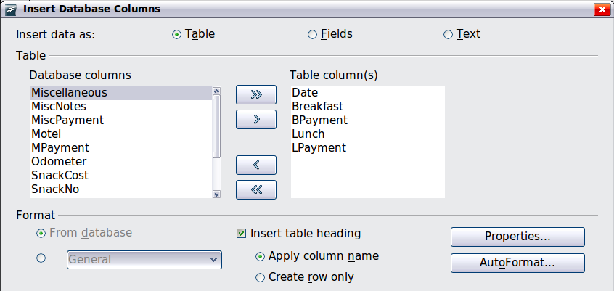
Figure 214: Insert Database Columns dialog
- Select the settings for your table. Use the default settings as in Figure 214.
- Click OK. Save the document.

Calc spreadsheets
There are two ways to enter data in a Calc spreadsheet. One enters the data into the spreadsheet cells. The other creates records in the spreadsheet just like they are done in creating a form in a database. While you can directly access the data in the spreadsheet cells, you can only see the data in the records created in the spreadsheet.
Entering data directly to the spreadsheet cells uses the Data to Text icon as we did to make a table in a Writer document. But differences exist in these two situations.
The steps are straightforward.
- Click the cell of the spreadsheet which you want to be the top left of your data including the column names.
- Use F4 to open the database source window and select the table whose data you want to use.
- Select the rows of data you want to add to the spreadsheet:
  - Click the gray box to the left of the row you want to select if only selecting one row. That row is highlighted.
  - To select multiple rows, hold down the Control key while clicking the gray box of the rows you need. Those rows are highlighted.
  - To select all the rows, click the gray box in the upper left corner. All rows are highlighted.
- Click the Data to text icon to insert the data into the spreadsheet cells.
- Save the spreadsheet.
Adding records to a spreadsheet is fairly easy. You need to have the Data Source window open, your spreadsheet open, and the table you want to use selected.
- Click the gray box above the field name for the table's ID field.
- Drop and drag the gray box for the table's ID field to where you want the record to appear in the spreadsheet.
- Repeat until you have moved all of the fields you need to where you want them.
- Name and save the spreadsheet.
- Click a row of the table in the Data Source window.
- Drag the data in the ID field in the selected row onto the ID field in the spreadsheet. The Save icon should activate.
- Click the Edit File button to make the spreadsheet read only. Click Save when asked if you want to save the file.
- The Data Source window goes blank, the fields in the spreadsheet are populated with data from the row you selected, and the Form Navigation toolbar appears at the bottom of the spreadsheet.

Figure 215: Navigation arrows of a form
- Click the arrows on the Form Navigation toolbar to view the different records of the table. (The arrows are circled in red.) The number in the box changes when you change the record number by clicking an arrow. The data in the fields changes correspondingly to the data for that particular record number.

Entering data in a form
Records are used to organize the data we enter into a form. They also organize the data we enter into a subform.
Each type of field allows a different method to enter the data. In many if not all cases, more than one method can be used.
The first step to entering data in a form is to open it from the main database window (Figure 175).
- Click the Forms icon in the Database list.
- Find the form’s name in the Forms list (Vacations).
- Double-click the form’s name.
The quickest way to enter a date in the Date field is to click the arrow that opens the dropdown calendar (Figure 216). Then click the day the you want. Then press the Tab key to go to the Odometer field.
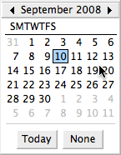Figure 216: Calendar dropdown
The Odometer, Tolls, and Motel fields are numerical fields. Enter values directly into them, or use the up and down arrows. When the value is entered, use the Tab key to go to the next field.
- Clicking the up arrow increases the value, and the down arrow decreases the value one unit.
- These two arrows only change the numerals to the left of the decimal place.
- Numerals to the right of the decimal place must be changed by deleting them and typing the desired ones.
The Motel’s Payment field is a dropdown list. If as in my case, all of the elements of the list start with different letters, typing the first letter selects the desired entry.
- If two or more elements of the list have the same first letter, repeated typing of the first letter will cycle through the elements with this same first letter.
- When the selection is correct, use the Tab key to go to the Misc. field.
The rest of the fields of the main form are either numerical fields or dropdown lists until we reach the Misc. Notes field. It is a text field. Type anything you desire in this field just as you would any simple text editor.
Note | Since the Tab key is used to move between fields, it can not be used in a text field. All spacing must be done by the spacebar. Finally, the Enter key only acts as a line break to move the cursor to the next line. While the Enter key will move from non-text fields to non-text fields, it will not do so from a text field. Use the Tab key instead.  If we did not have a subform for fuel data, pressing the Tab key in the last field would save all of the fields, clear them, and make the form ready to accept data on the second record.
Since we have a subform form, using the Tab key places the cursor in the first Date field of the subform with the date automatically entered to match the Date field of the main form.
The FuelCost, FuelQuantity, and Odometer fields are numerical fields. The Payment field is a dropdown list. Enter the data just as you did in the main form, and use the Tab key to go to the next field.
When you use the Tab key to leave the Payment field, it goes to the Date field of the next line and automatically enters the date. Now you can enter your second set of fuel data for this day.
To move to another record when the form has a subform, click any of the fields of the main form. In this case, click the Date field of the main form. Then use the directional arrows at the bottom. There are four of them from left to right: First Record, Previous Record, Next Record, and Last Record (Figure 215). To the right of these arrows is the New Record icon.
To create a new record while in another record in the main form, click either the Next Record icon or the New Record icon.
Tip | The number in the Record box is the number of the record whose data is shown in the form.  If you know the number of the record you want, you can enter it into the record box and then press Enter to take you to that record.
Figure 217 is a record with data inserted in its fields.
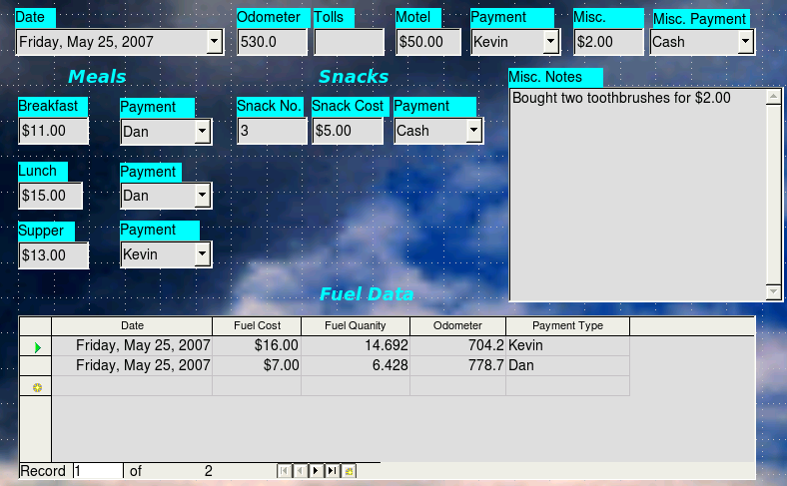
Figure 217: Sample record of the Vacation form and subform

Creating queries
Queries are used to get specific information from a database. Query results are special tables within the database.
To demonstrate the use of queries, we will use two different methods:
- Using our CD-Collection table, we will create a list of albums by a particular artist. We will do this using the Wizard.
- The information we might want from the Fuel table includes what our fuel economy is. We will do this using the Design View. (Queries that require calculations are best created with the Design view.)

Using the Wizard to create a query
Queries created by the wizard provide a list or lists of information based upon what one wants to know. It is possible to obtain a single answer or multiple answers, depending upon the circumstances.
In the main database window (Figure 175), click the Queries icon in the Databases section, then in the Tasks section, click Use Wizard to Create Query. The Query Wizard window opens (Figure 218). The information we want is what albums are by a certain musical group or individual (the album’s author). We can include when each album was bought.
Note | When working with a query, more than one table can be used. Since different tables may contain the same field names, the format for naming fields in a query is Table name.field name, with a period (.) between the table name and the field name. For example, The Lunch field of the Vacation table used in a query has the name Vacation.Lunch.
Step 1: Select the fields.
- Select the CD-Collection table from the dropdown list of tables.
- Select fields from the CD-Collection table in the Available fields list.
  - Click Artist, and use the > button to move it to the Fields in the Query list.
  - Move the AlbumTitle and DatePurchased fields in the same manner.
  - Click Next.
Tip | To change the order of the fields, select the field you want to move and click the up or down arrow.
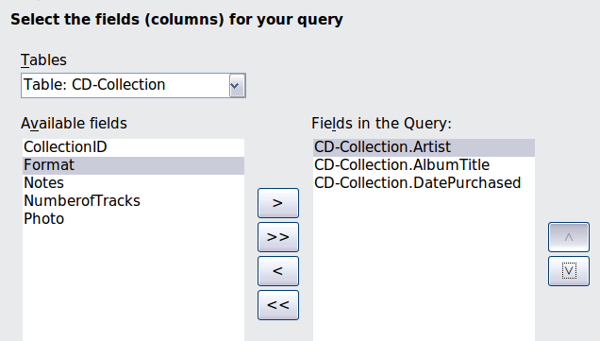
Figure 218: First page of the Query Wizard
Step 2: Select the sorting order.
Up to four fields can be used to sort the information of our query. A little simple logic helps at this point. Which field is most important?
In our query, the artist is most important. The album title is less important, and the date purchased is of least importance. Of course, if we were interested in what music we bought on a given day, the date purchased would be the most important.
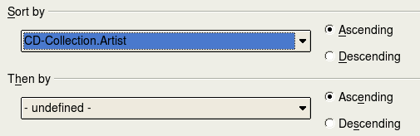Figure 219: Sorting order page
- Click the first Sort by dropdown list.
  - Click CD-Collection.Artist to select it.
  - To list the artists in alphabetical order (a-z), select Ascending on the right.
- Click the second Sort by dropdown list.
  - Click CD-Collection.ArtistTitle. and select Ascending.
- Repeat this process for CD-Collection.DatePurchased.
- Click Next.
Step 3: Select the search conditions.
The search conditions allow us to compare the name we entered with the names of the artist in our database and decide whether to include a particular artist in our query or not.
- is equal to: the same as
- is not equal to: not the same as
- is smaller than: comes before
- is greater than: comes after
- is equal or less than: the same as or comes before
- is equal or greater than: the same as or comes after
- like: similar to in some way
Note | These conditions apply to numbers, letters (using the alphabetical order), and dates.
- Since we are only searching for one thing, we will use the default setting of Match all of the following.
- We are looking for a particular artist, so select CD-Collection. Artist in the Fields list and is equal to as the Condition.
- Type the name of the artist in the Value box. Click Next.
Step 4: Select type of query.
We want simple information, so the default setting: Detailed query is what we want. Click Next at the bottom of the window.
Note | Since we have a simple query, the Grouping and Grouping conditions are not needed. Steps 5 and 6 of the wizard are skipped in our query.
Step 7: Assign aliases if desired.
We want the default settings. Click Next.
Step 8: Overview.
Name the query (suggestion: Query_Artists). To the right of this are two choices. Select Display Query. Click Finish.

Using the Design View to create a query
Creating a query using Design View is not as difficult as it may first seem. It may take multiple steps, but each step is fairly simple.
What fuel economy is our vehicle getting (miles per gallon in the USA)? This question requires creating two queries, with the first query used as part of the second query.
Step 1: Open the first query in Design View.
Click Create Query in Design View.
Step 2: Add tables.
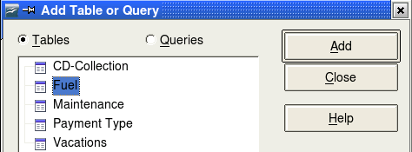Figure 220: Add Tables or Query window
- Click Fuel to highlight it.
- Click Add. Click Close.
Tip | Move the cursor over the bottom edge of the fuel table (Figure 220) and drag the to make it longer and easier to see all of the fields in the table.
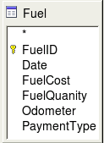
Figure 221: Fuel table in query
Step 3: Add fields to the table at the bottom.
- Double-click the FuelID field in the Fuel table.
- Double-click the Odometer field.
- Double-click the FuelQuantity field.
The table at the bottom of the query window should now have three columns.
Figure 222: Query table
Step 4: Set the criterion for the query.
We want the query’s FuelID to begin with the numeral 1.
- Type >0 in the Criterion cell under FuelID in the query table.
- Click the Run Query icon in the Query Design toolbar.
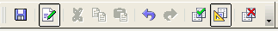
Figure 223: Query Design toolbar
Figure 224 contains the Fuel table with my entries and the query results based upon the Fuel table: the query results are in the right table.
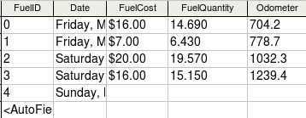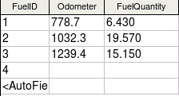Figure 224: Fuel table and query of the fuel table
Step 5: Save and close the query.
Since this query contains the ending odometer reading for our calculations, name it End-Reading when saving it. Then close the query.
Step 6: Create the query to calculate the fuel economy.
- Click Create Query in Design View to open a new query.
- Add the Fuel table to the query just as you did in step 2: Add tables But, do not close the Add Tables window.
- Add the End-Reading query to this query.
  - Click Queries to get the list of queries in the database (Figure 225).
  - Click End-Reading.
  - Click Add, and then click Close.
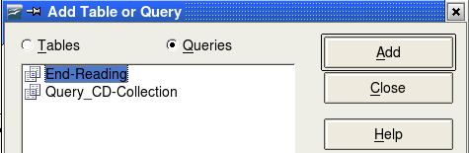Figure 225: Selecting queries to add to another query
Step 7: Add fields to the table at the bottom of the query.
We are going to calculate the fuel economy. To do this we need the FuelQuantity and distance traveled. Since the FuelQuantity we want to use is at the ending odometer reading, we will use the End-Reading query to get it. We will also use the Odometer field from the Fuel table and End-Reading query.
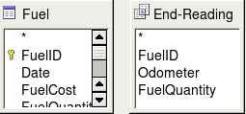
Figure 226: Tables in this query
- Double-click FuelQuantity in the End-Reading query.
- Double-click Odometer in the End-Reading query.
- Double-click Odometer in the Fuel table.
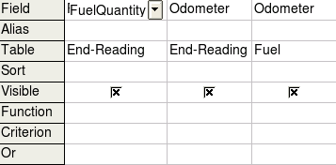
Figure 227: Added fields to the query
Step 8: Enter the FuelID difference field.
We want the difference between the FuelID value of the Fuel table and FuelID value of the End-Reading query to equal one (1).
- Type "End-Reading".FuelID - Fuel.FuelID in the field to the right of the Odometer field of the Fuel Table.
Type the numeral 1 (one) in the Criterion cell of this column.
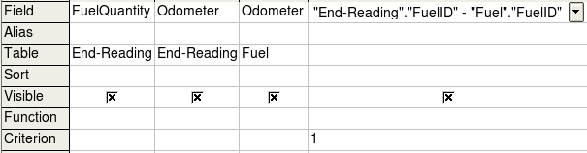Figure 228: Typing in calculation of fields
- Calculate the distance traveled:
  - Type "End-Reading".Odometer – Fuel.Odometer in the Field cell.
  - Type >0 in the Criterion cell.
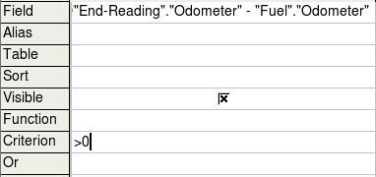Figure 229: Field for distance traveled calculations
- Calculate fuel economy:
Type ("End-Reading".Odometer – Fuel.Odometer)/"End-Reading".FuelQuantity in the next column to the right of the word Field.
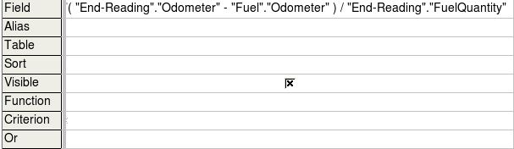Figure 230: Fuel economy calculation field
Note | When entering fields for these calculations, you must follow this format: table or query name followed by a period follow by the field name. For hyphenated or multiple-word names (table or query), use double quotes around the table or query name. The query will then add the rest of the double quotes as in Figure 230.  Use the arithmetical symbol between the two. More than one calculation can be done by using parentheses to group the arithmetical operations.
Step 9: Run the query and make some modification.
After we run the query to make sure it works correctly, we will hide all of the fields that we do not need.
- Click the Run Query icon in the Design Query toolbar (Figure 223). The results are in Figure 231.
Figure 231: Result of running the fuel economy query
Notice that not all of the last column label is visible because some of the labels are long. We can fix this problem by using an alias for many of the fields. The labels are replaced by their aliases.
- Add Aliases:
Type in the aliases as they are listed in Figure 232.
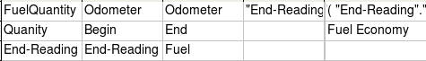Figure 232: Query table with aliases added
- Run the query again. The results are in Figure 233.
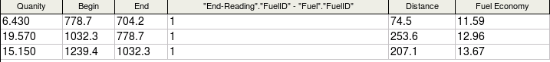Figure 233: Query run with aliases
We really do not need the column showing the difference between the FuelID fields from the table and query, so we will hide it. While it will not be visible, it will still be used in the calculations.
- Hide a field that does not need to be seen.
Remove the check in the box of the Visible cell as in Figure 234.
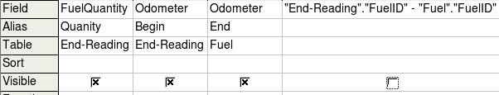Figure 234: Making a field invisible in a query run
- Rerun the query (Figure 235).
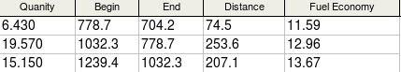Figure 235: Query run with aliases
Step 10: Close, save, and name the query.
My suggestion for a name is Fuel Economy.
There are obviously other calculations that can be made in this query such as cost per distance traveled and how much of the cost belongs to each of the payments types.
Note | To fully use queries requires a knowledge of set operations (unions, intersections, and, or, complements, and any combinations of these). Having a copy of the Hsqldb User Guide, available from http://hsqldb.org/, is also extremely useful.

Creating reports
Reports provide information found in the database in a useful way. In this they are similar to queries. Reports are generated from the database’s tables or queries. They can contain all of the fields of the table or query or just a selected group of fields. Reports can be static or dynamic. Static reports contain the data in the selected fields at the time the report was created. Dynamic reports can be updated to show the latest data.
For example, a report on expenses for a vacation in the past should probably be a static report because it is based upon specific data that does not change. However, a report on the fuel data should probably be a dynamic report, because this report depends upon data that does change.
Caution | Dynamic reports update only the data that is changed or added to a table or query. They do not show any modifications made to the table or query itself. For example, after creating the report below, open the fuel economy query created in the previous section. For the "End-Reading".”Odometer – Fuel.”Odometer” column, change the number 1 to the number 3. The report will be identical before and after you make the change.
All reports are based upon a single table or query. So you need first to decide what fields you want to use in the report. If you want to use fields from different tables, you must first combine these fields in a single query. Then you can create a report on this query.
For example, a report on vacation expenses includes both fuel costs and meal costs. These values are contained in fields of two different tables: Vacations and Fuel. So this report requires creating a query.

Creating a static report
We will create a report on vacation expenses. Certain questions need to be asked before creating the report.
- What information do we want in the report?
- How do we want the information arranged?
- What fields are required to provide this information?
- Will a query have to be created because these fields are in different tables?
- Are there any calculations required in the data before being added to the report?
The expenses for our vacation are motel, tolls, miscellaneous, breakfast, lunch, supper, snacks, and fuel. One possible report would simply list the totals of each of these expense groups. Another possible report would list the expense totals for each day of the vacation. A third possible report would list the totals for each expense group for each type of payment. (This would let us know where the money came from to pay the expenses.) The best way to create reports like these is to create the queries needed to gather the needed data, insert the query data into a spreadsheet, and use the necessary Calc functions on this data.
We will create two reports, one listing the expenses each day other than fuel and the second listing the fuel costs each day.
The fields we need for the first report from the Vacations table are: Date, Motel, Toll, Breakfast, Lunch, Supper, SnackCost, and Miscellaneous. This report will not require an additional query.
The second report involves the Fuel table. Since this table includes fuel purchases at times other than during the vacation, we need to create a query that contains only the fuel purchased during the vacation.

Vacations table report
To create a new report.
- Click the Reports icon in the Database list in the Automobile – LibreOffice Base window (Figure 175).
- In the Tasks list, click Use Wizard to Create Report. The Report Wizard opens.
Step 1: Field selection
- Select Table: Vacations in the Tables or Queries dropdown list.
- Use the > to move these fields from the Available fields list to the Fields in report list: Date, Motel, Tolls, Miscellaneous, Breakfast, Lunch, Supper, and SnackCost. Click Next.
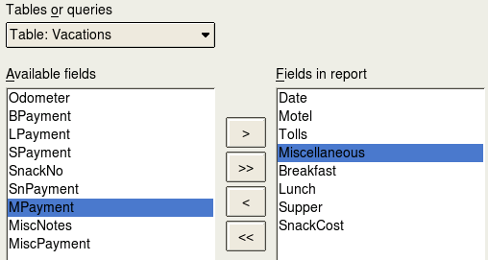Figure 236: Adding fields to a report
Step 2: Labeling fields
Change any field labels you wish. We will shorten Miscellaneous to Misc. Click Next.
Step 3: Grouping
Since we are grouping by the date, use the > button to move the Date field to the Grouping list. Click Next.
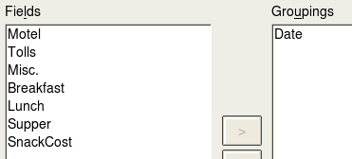
Figure 237: Selecting fields for grouping data
Step 4: Sort options
We do not want to do any additional sorting. Click Next.
Step 5: Choose layout
Use default settings for the layout. Click Next.
Step 6: Create report
  - Label the report: Vacation Expenses.
  - Select Static report.
  - Click Finish.
Note | If you feel adventurous, try selecting some of the other layout choices. After selecting a choice, drag the Report Wizard window out of the way so that you can see what you have selected. (Move the cursor over the Title Bar of the window, and then drag and drop.)

Vacation fuel report
- Create a query containing only fuel bought on the days of the vacation.
  - Open a query in Design View.
  - Follow the steps for adding tables in “Add tables” on page 227 to add the Fuel table.
  - In the Fuel table, double-click Date and FuelCost to enter them in the table at the bottom of the query.
  - In the Criterion cell of the Date field, type the following: BETWEEN #5/25/2007# AND #5/26/2007#
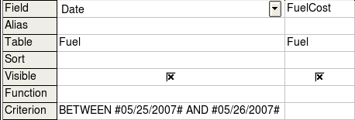
Figure 238: Setting the criterion for a query
- Save, name, and close the query. (Suggestion: Vacation Fuel Purchases.)
Tip | When using dates in a query, enter them in numerical form MM/DD/YYYY or DD/MM/YYYY depending upon your language's default setting for dates (my default setting is MM/DD/YYYY).  Each date must have a # before and after it. Hence, May 25, 2007 is written #05/25/2007# or #25/5/2007# depending upon your language’s default setting for dates.
- Open a new report.
  - Right-click the Vacation Fuel Purchases query.
  - Select Report Wizard from the pop-up menu.
Note | When a new report is opened in this way, the query used to open it is automatically selected in the Tables or queries dropdown list in the Report Wizard.
- Create the report.
Use >> to move both fields from the Available fields list to the Fields in report list. Click Next.
- Label fields.
Add a space to FuelCost to make it Fuel Cost (two words). Click Next.
- Group fields.
Click Date to highlight it. Use > to move the Date field to the Groupings list. Click Next.
- Choose layout.
We will be making no changes in the layout. Click Next.
- Create report (final settings).
  - Use the suggested name, which is the same as the query.
  - Select Static report. Click Finish.

Creating a dynamic report
Now we will create a report with some statistics on our fuel consumption. To do this, we have to modify two queries: End-Reading and Fuel Economy. We will be adding the FuelCost field to the End-Reading query. Then we will add the FuelCost field from the End-Reading query to the Fuel Economy query.
Tip | When opening a query to edit it, it might appear as in Figure 239. If you move your cursor over the black line (circled), it becomes a double headed arrow. Drag it to a lower position.
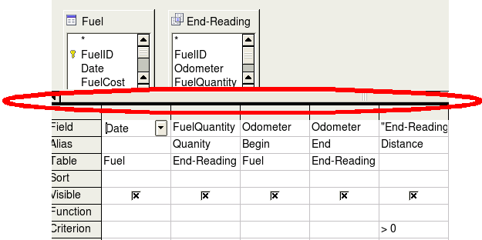
Figure 239: Appearance of query when opened for editing
- Add the FuelCost field to the End-Reading query:
  - Right-click the End-Reading query and select Edit from the pop-up menu.
  - In the Fuel table list, double-click to add FuelCost to the bottom table (Figure 240).
  - Save and close the query.
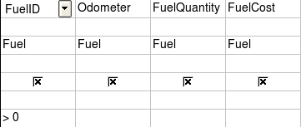
Figure 240: Adding an additional field to the query
- Add the FuelCost field from the End-Reading query to the Fuel Economy query:
  - Right-click the Fuel Economy query and select Edit from the pop-up menu.
  - Double-click the FuelCost field in the End-Reading query list to add it to the query table at the bottom.
- Add a calculation field to the right of the FuelCost field.
  - Type the following in a Field cell in the table at the bottom:
"End-Reading".FuelCost/("End-Reading".Odometer – Fuel.Odometer)
  - Type the following in its Alias cell: cost per mile.
Note | If you use the metric system, cost per km is the appropriate alias.
- Save and close the query.
- Open a new report.
Right-click the Fuel Economy query and select Report Wizard.
- Select fields.
Move all the fields from the Available fields to the Fields in report list. Use the >> to do so. Click Next.
- Label fields.
Change FuelCost to Fuel Cost by placing a space between the words. Click Next.
- Group fields.
Use > to move the Date field to the Groupings list. Click Next.
- Sort options: the wizard skipped this one.
- Choose layout: accept the default. Click Next.
- Create the report.
  - Change the report name to Fuel Statistics.
  - The default setting is Dynamic report, so no change is necessary.
  - Select Modify report layout.
  - Click Finish.

Modifying a report
At the end of the last section, we left the Fuel Statistics report open in the edit mode (Figure 241). We will be working on that report. These same steps can be used with any report that you open for editing.
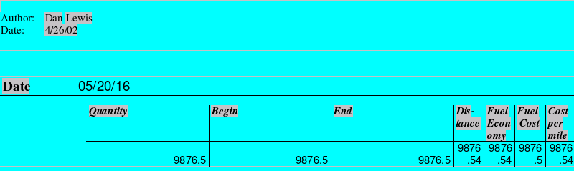
Figure 241: A report in edit mode
The Author is the name you listed in Tools → Options → LibreOffice → User Data. The date is not correct. The columns need to be moved to the left to give a better appearance. None of the numbers are correct, but their only purpose is to show the number of decimal places.
Step 1: Change the date.
- Click to the right of the date (4/26/20) so that the cursor is next to the field. Use the Backspace key to erase the date.
- Insert → Fields → Date. This places today’s date where the original date was.
- Change the date formatting:
  - Double-click the date field you just inserted. The Edit Fields: Document window opens.
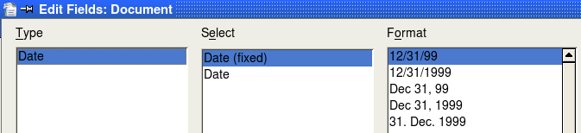
Figure 242: Modifying a date field
  - Since this is a dynamic report, change the Select field from Date (fixed) to Date.
  - Change the Format to what you desire. (I use the Friday, December 31, 1999 choice.) Click OK.
Step 2: Change the column widths.
The column widths can be changed by moving the cursor over the right border of each column so that it becomes a double-headed arrow. Then drag and drop it to where you want it. This has to be done for each column in each table in the report. This can also be done with the last column on the right even though there is no black border. It should now look something like Figure 243.
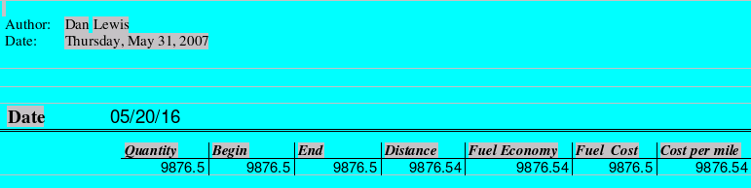

Figure 243: Realigned columns in a report
Step 3: Change the number formatting in the cells.
The fuel quantity should have three decimal places. The Begin, End, and Distance should have one decimal place. Fuel Cost should be currency and have two decimal places, and Cost per mile should have three decimal places.
- Right-click the cell below Quantity and select Number format. (The cell is circled in Figure 243.)
- In the Options section (Figure 244),
  - Change the number of Decimal places to 3.
  - Click the green checkmark. Click OK.
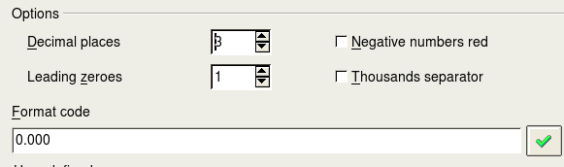
Figure 244: Option section of the Number Formating window
- Change the Cost per mile field.
  - Right-click in the cell below Fuel Cost.
  - Select Number Format.
  - In the Category list, select Currency. Click OK.
- Change the Fuel Cost field.
  - Right-click in the cell below Cost per mile.
  - Select Number Format.
  - In the Category list, select Currency.
  - In the Option section:
    - Set the number of decimal places to 3.
    - Click the green checkmark.
  - Click OK.
Step 4: Save and close the report.
Double-click the report. It should now look like Figure 245.
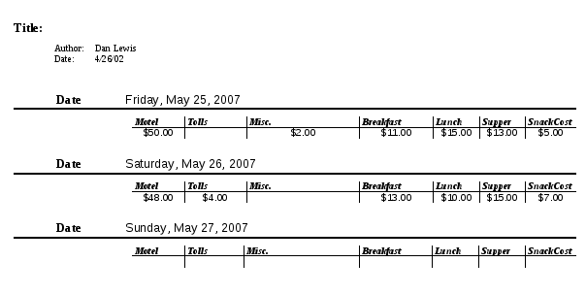
Figure 245: Final report

More ways to create reports
An extension is available to assist in report creation. Report Builder creates stylish, complex database reports. You can define group and page headers, group and page footers, and calculation fields. It is installed by default with Libreoffice.
To install this extension, follow these steps:
- Choose Tools → Extension Manager from the menu bar. In the Extension Manager dialog, click Get more extensions online....
- The LibreOffice extensions page opens in your browser. Find and select the extension you want and follow the prompts to install it. During installation, you will be asked to accept a license agreement.
- When the installation is complete, the extension is listed in the Extension Manager dialog.
For more about extensions, see Chapter 14, Customizing LibreOffice.

Getting Started Guide

Chapter 9
Getting Started with Math
LibreOffice's Equation Editor

What is Math?
Math is LibreOffice’s component for writing mathematical equations. It is most commonly used as an equation editor for text documents, but it can also be used with other types of documents or stand-alone. When used inside Writer, the equation is treated as an object inside the text document.
Note | The equation editor is for writing equations in symbolic form, as in equation 1. If you want to evaluate a numeric value, see the Calc Guide.

(1)

Getting started
To insert an equation, choose Insert → Object → Formula.
The equation editor opens at the bottom of the screen, and the floating Elements window may appear. You will also see a small box with a gray border in your document, where the formula will be displayed.
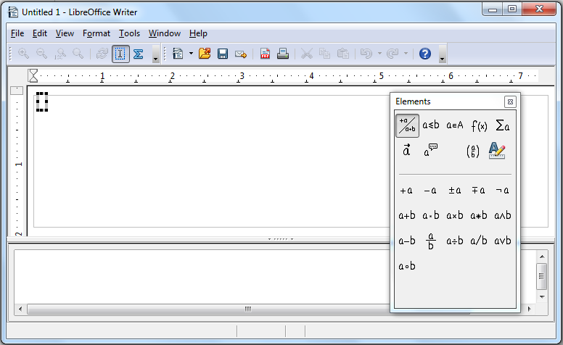
Figure 246. Equation Editor, Elements window, and location of resulting equation.

Entering a formula
The equation editor uses a markup language to represent formulas. For example, %beta creates the Greek character beta (). This markup is designed to read similar to English whenever possible. For example, a over b produces a fraction: .
You can enter a formula in three ways:
- Select a symbol from the Elements window.
- Right-click on the equation editor and select the symbol from the context menu.
- Type markup in the equation editor.
The context menu and the Elements window insert the markup corresponding to a symbol. This provides a convenient way to learn the Math markup.
Note | Click on the document body to exit the formula editor.  Double-click on a formula to enter the formula editor again.

The Elements window
The simplest method for entering a formula is to use the Elements window.
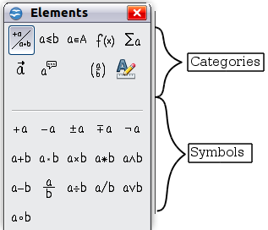
Figure 247. Symbols are divided into categories
The Elements window is divided into two main parts.
- The top shows the symbol categories. Click on these to change the list of symbols.
- The bottom shows the symbols available in the current category.
Tip | You can hide or show the Elements window with View → Elements.

Example 1:
For this example we will enter a simple formula:. On the Elements window:
- Select the top-left button of the categories (top) section.
- Click on the multiplication symbol.
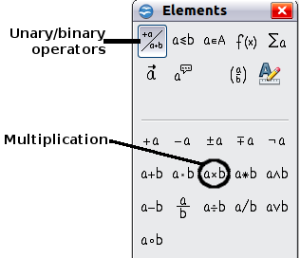
Figure 248. Selecting the multiplication symbol
When you select the multiplication symbol on the Elements window, two things happen:
- The equation editor shows the markup:
- The body of the document shows a gray box like this:

Figure 249. Result of selecting the multiplication symbol
The <?> symbols shown in Figure 249 are placeholders that you can replace by other text, for example 5 and 4. The equation will update automatically, and the result should resemble Figure 250.
Tip | To keep the equation from updating automatically, choose View → AutoUpdate display from the menu bar. To update a formula manually, press F9 or choose View → Update.

Figure 250. Result of entering 5 and 4 next to the times operator

Right-click menu
Another way to access mathematical symbols is to right-click on the equation editor. This pops up the menu shown in Figure 251. The items in this menu correspond exactly to those in the Elements window.
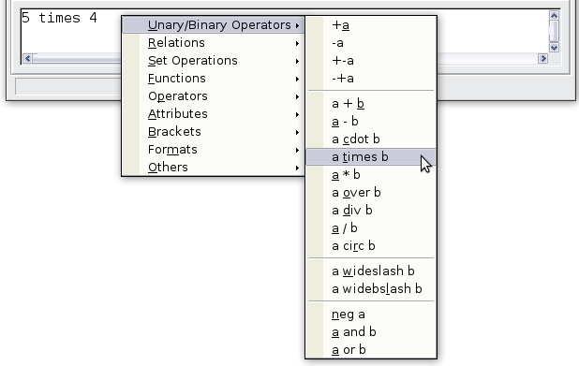
Figure 251. Right-click menu

Markup
You can type the markup directly in the equation editor. For example, you can type 5 times 4 to obtain . If you know the markup, this can be the fastest way to enter a formula.
Tip | The formula markup resembles the way the formula reads in English.
Below is a short list of common equations and their corresponding markup.
Display | Command | Display | Command
 | a = b |  | sqrt {a}
 | a^2 |  | a_n
 | int f(x) dx |  | sum a_n
 | a <= b |  | infinity
 | a times b |  | x cdot y

Greek characters
Greek characters (, and so on) are common in mathematical formulas. These characters are not available in the Elements window or on the right-click menu. Fortunately, the markup for Greek characters is simple: Type a % sign followed the name of the character, in English. (In localized versions of LibreOffice, these names are localized.)
- To write a lowercase character, type the name of the character in lowercase.
- To write an uppercase character, type the name of the character in uppercase.
See the table below for some examples.
Lowercase | Uppercase
%alpha | %ALPHA
%beta | %BETA
%gamma | %GAMMA
%psi | %PSI
%phi | %PHI
%theta | %THETA
Note | A complete table of Greek characters is provided in the Math Guide.
Another way to enter Greek characters is by using the Symbols catalog window. Choose Tools → Catalog. Under Symbol set, select Greek and double-click on a Greek letter from the list. The markup name of the character is shown below the list window.
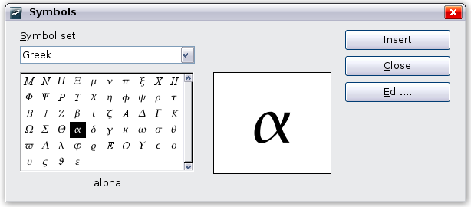
Figure 252. Symbols catalog—used for entering Greek characters and some special symbols.

Example 2:
For this example we will suppose that:
- We want to enter the above formula (the value of pi rounded to 5 decimal places).
- We know the name of the Greek character (pi).
- But we do not know the markup associated with the symbol.
Step 1: Type % followed by the text pi. This displays the Greek character .
Step 2: Open the Elements window (View → Elements).
Step 3: The symbol is a relation, so we click on the Relations button. If you hover the mouse over this button you see the tooltip Relations (Figure 253).
Figure 254 shows the Elements window after clicking the Relations button. The symbol we want is circled.
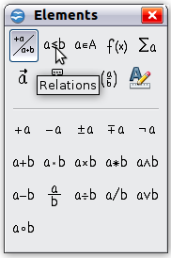  Figure 253. Tooltip indicates the  Relations button | 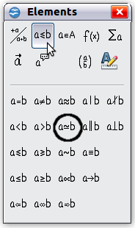  Figure 254. After selecting Relations
Step 4: Click on the ab symbol. The equation editor now shows the markup %pi<?> simeq <?>.
Step 5: Delete the <?> text and add 3.14159 at the end of the equation. We end up with the markup %pi simeq 3.14159. The result is shown in Figure 255.

Figure 255. Final result

Customizations

Formula editor as a floating window
The formula editor can cover a large part of the Writer window. To turn the formula editor into a floating window, do this:
- Hover the mouse over the editor frame, as shown in Figure 256.
- Hold down the Control key and double-click.


Figure 256. Hold down the Control key and double-click on the border of the formula editor to turn it into a floating window.
Figure 257 shows the result. You can dock the floating window again by using the same steps. Hold down the Control key and double-click the window frame.
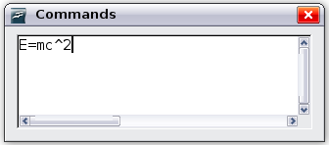
Figure 257. Formula editor as a floating window

How can I make a formula bigger?
This is one of the most common questions people ask about Math. The answer is simple:
- Start the formula editor and choose Format → Font size.
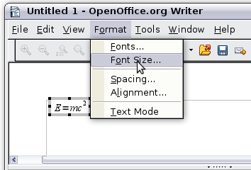
Figure 258. Changing the font size for a formula
- Select a larger font size under Base size (top-most entry).
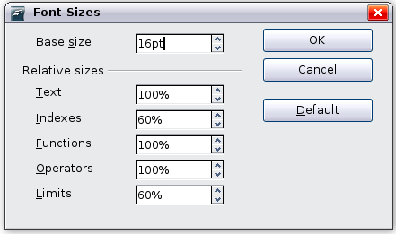
Figure 259. Edit Base size (top) to make a formula bigger.
The result of this change is illustrated in Figure 260.
Figure 260. Result of changing the base font size.

Formula layout
The most difficult part of using Math comes when writing complicated formulas. This section provides some advice.

Brackets are your friends
Math knows nothing about order of operation. You must use brackets to state the order of operations explicitly. Consider the following example.
Markup | Result
2 over x + 1
2 over {x + 1}

Equations over more than one line
Suppose you want to type an equation covering more than one line. For example:
Your first reaction would be to simply press the Enter key. However, if you press the Enter key, though the markup goes to a new line, the resulting equation does not. You must type the newline command explicitly. This is illustrated in the table below.
Markup | Result
x = 3
y = 1
x = 3 newline
y = 1

How do I add limits to my sum/integral?
The sum and int commands can (optionally) take the parameters from and to. These are used for lower and upper limits respectively. These parameters can be used singly or together. Limits for integrals are usually treated as subscripts and superscripts.
Markup | Result
sum from k = 1 to n a_k
int from 0 to x f(t) dt  or  int_0^x f(t) dt | or
int from Re f
sum to infinity 2^{-n}
Note | For more details on integrals and sums, see the Math Guide.

Brackets with matrices
For background, we start with an overview of the matrix command.
Markup | Result
matrix { a # b ## c # d }
Note | Rows are separated by two #’s and entries within each row are separated by one #.
The first problem people have with matrices is that brackets do not scale with the matrix.
Markup | Result
( matrix { a # b ## c # d } )
Math provides scalable brackets. That is, the brackets grow in size to match the size of their contents. Use the commands left( and right) to make scalable brackets.
Markup | Result
left( matrix { a # b ## c # d } right)
Tip | Use left[ and right] to obtain square brackets.

How do I make a derivative?
Making derivatives essentially comes down to one trick: Tell Math it’s a fraction.
In other words, you have to use the over command. Combine this with either the letter d (for a total derivative) or the partial command (for a partial derivative) to achieve the effect of a derivative.
Note | Notice that we have to use braces (squiggly brackets) to make the derivative.
Markup | Result
{df} over {dx}
{partial f} over {partial y}
{partial^2 f} over {partial t^2}

How do I align my equations at the equals sign?
Math does not have a command for aligning equations on a particular character, but you can use a matrix to do this, as shown below.
Markup | Result
matrix{
alignr x+y # {}={} # alignl 2 ##
alignr x # {}={} # alignl 2-y
}
The empty braces around = are necessary because = is a binary operator and thus needs an expression on each side.
You can reduce the spacing around = if you change the inter-column spacing of the matrix:
- With the equation editor open, choose Format → Spacing from the menu bar.
- In the Spacing dialog (Figure 261), click the Category button and select Matrices in the drop-down menu.
- Enter 0% for Column spacing and click OK.
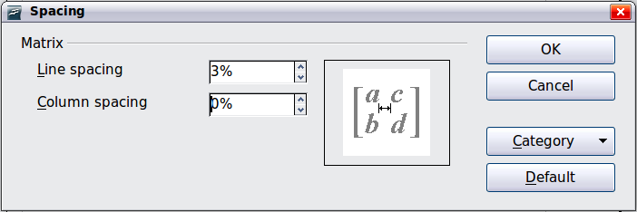
Figure 261: Changing spacing in a matrix formula

Numbering equations
Equation numbering is one of Math’s best hidden features. The steps are simple:
- Start a new line.
- Type fn and then press F3.
The fn is replaced by a numbered formula:
(2)
Now you can double-click on the formula to edit it. For example, here is the Riemann Zeta function:
(3)
You can reference an equation (“as shown in Equation (2)”) with these steps:
- Choose Insert → Cross-reference from the menu bar.
- On the Cross-references tab (Figure 262), under Type, select Text.
- Under Selection, select the equation number.
- Under Format, select Reference.
- Click Insert.
Done! If you later add more equations to the paper before the referenced equation, all the equations will automatically renumber and the cross-references will update.
Tip | To insert the equation number without parenthesis around it, choose Numbering instead of Reference under Format.
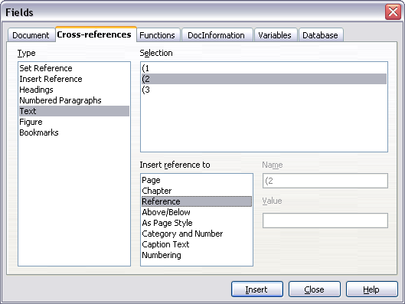
Figure 262. Inserting a cross-reference to an equation number

Getting Started Guide

Chapter 10
Printing, Exporting, and E-mailing

Introduction
This chapter provides general information about printing, exporting, and e-mailing documents from LibreOffice.

Quick printing
Click the Print File Directly icon to send the entire document to the default printer defined for your computer.
Note | You can change the action of the Print File Directly icon to send the document to the printer defined for the document instead of the default printer for the computer. Go to Tools → Options → Load/Save → General and select the Load printer settings with the document option.

Controlling printing
For more control over printing, use the Print dialog (File → Print or Ctrl+P).
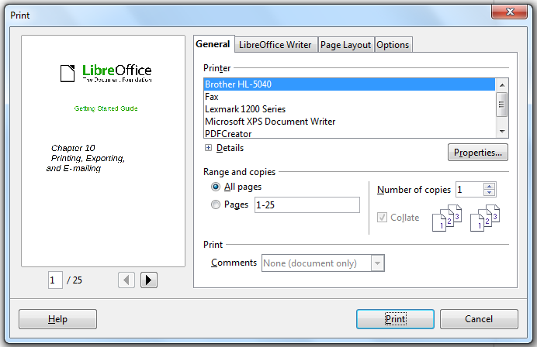
Figure 263. The Print dialog
The Print dialog has four tabs, from which you can choose a range of options, as described in the following sections.
Note | The options selected on the Print dialog apply to this printing of this document only.  To specify default printing settings for LibreOffice, go to Tools → Options → LibreOffice – Print and Tools → Options → LibreOffice Writer – Print. See Chapter 2, Setting Up LibreOffice, for more details.
The different components of LibreOffice have different available print settings, as summarized in Table 2.
Table 2: Print options in LibreOffice components
Feature | Writer | Calc | Impress | Draw
Select pages/sheets/slides to print | Yes | Yes | Yes | Yes
Print multiple pages/sheets/slides on one page | Yes | Yes | Yes | Yes
Print a brochure | Yes | No | Yes | Yes
Print envelopes | Yes | No | No | No
Print labels or business cards | Yes | No | No | No
Preview pages/sheets before printing | Yes | Yes | No | No

Selecting general printing options
On the General tab of the Print dialog, you can choose:
- The printer (from the printers available)
- Which pages to print, the number of copies to print, and whether to collate multiple copies (Range and copies section)
- Whether to print any comments that are in the document, and where to print the comments.
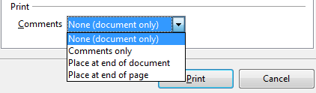Figure 264: Choosing whether and where to print comments
Select the Properties button to display a dialog where you can choose portrait or landscape orientation, which paper tray to use, and the paper size to print on.
On the Options tab of the Print dialog (Figure 265), the last item, Use only paper tray from printer preference, is not available in Calc.
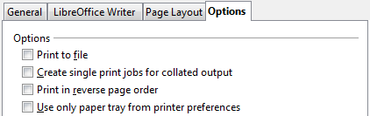Figure 265: General print options

Printing multiple pages on a single sheet of paper
You can print multiple pages of a document on one sheet of paper. To do this:
- In the Print dialog, select the Page Layout tab (Figure 266).
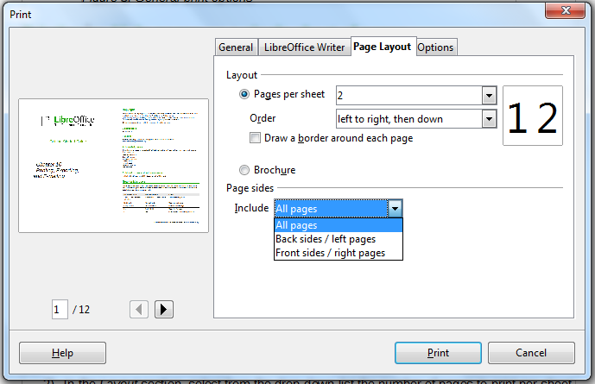
Figure 266: Printing multiple page per sheet of paper
- In the Layout section, select from the drop-down list the number of pages to print per sheet. The preview panel on the left of the Print dialog shows how the printed document will look.
When printing more than 2 pages per sheet, you can choose the order in which they are printing across and down the paper. The two pictures below show the difference.
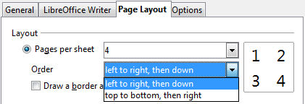
- In the Page sides section, select whether to print all pages or only some pages.
- Click the Print button.
Tip | In Writer, to print two pages per sheet in “facing pages” (book layout) style, print from Print Preview instead. See page 264.

Selecting pages/sheets/slides to print
In addition to printing a full document, you can choose to print individual pages/sheets/slides, ranges of pages/sheets/slides, or a selection of a document. The details vary slightly in Writer, Calc, Draw and Impress, as described in this section.

Writer
Printing an individual page:
- Choose File → Print from the menu bar.
- On the Print dialog, select the page to print.
  - In the Ranges and copies section of the General page, select the Pages option.
  - Enter the sequence number of the page you want to print. The preview box changes to show the selected page.
If you have restarted page numbering within the document, the sequence number is not the same as the page number.
- Click the Print button.
Printing a range of pages:
- Choose File → Print from the menu bar.
- On the Print dialog, select the range of pages to print.
  - In the Ranges and copies section of the General page, select the Pages option.
  - Enter the sequence numbers of the pages to print (for example, 1–4 or 1,3,7,11).
- Click the Print button.
Printing a selection of text:
- In the document, select the material (text and graphics) to print.
- Choose File → Print from the menu bar.
- The Ranges and copies section of the Print dialog now includes a Selection option and the preview box shows the selected material. See Figure 267.
- Click the Print button.
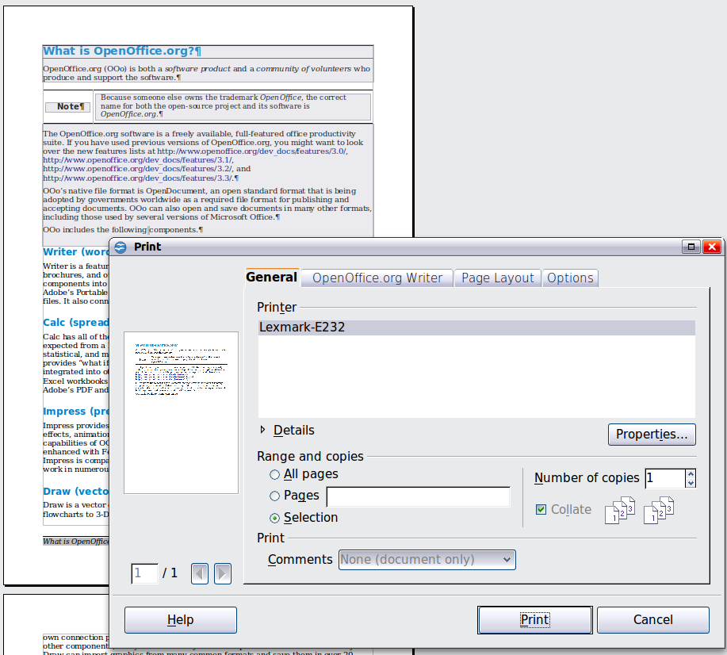
Figure 267: Printing a selection of text

Calc
You can choose single sheets, multiple sheets, and selections of cells for printing.
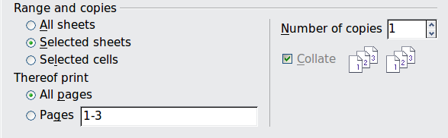
Figure 268: Choosing what to print in Calc
Printing an individual sheet:
- In the spreadsheet, click on the sheet tab to select the sheet you want to print.
- Choose File → Print from the menu bar.
- In the Ranges and copies section of the Print dialog, choose the Selected sheets option.
- Click the Print button.
Printing a range of sheets:
- In the spreadsheet, select the sheets to print.
  - Select the first sheet.
  - Hold down the Control key.
  - Click on the additional sheet tabs.
  - Release the Control key when all required sheets are selected.
- Choose File → Print from the menu bar.
- In the Ranges and copies section of the Print dialog, choose the Selected sheets option.
- Click the Print button.
Printing a selection of cells:
- In the document, select the section of cells to print.
- Choose File → Print from the menu.
- In the Ranges and copies section of the Print dialog, select the Selected cells option.
- Click the Print button.
Caution | After printing, be sure to deselect the extra sheets. If you keep them selected, the next time you enter data on one sheet, you enter data on all the selected sheets. This might not be what you want.

Impress and Draw
You can choose individual slides, ranges of slides, or selections of slides for printing.
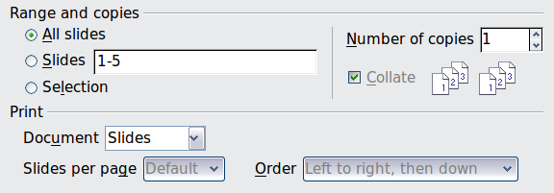
Printing an individual slide:
- Choose File → Print from the menu bar.
- Select the slide to print.
  - In the Ranges and copies section of the Print dialog, select the Slides option.
  - Enter the number of the slide to print.
- Click the Print button.
Printing a range of pages:
- Choose File → Print from the menu bar.
- Select the slides to print.
  - In the Ranges and copies section of the Print dialog, select the Slides option.
  - Enter the number of the slides to print (for example 1-4 or 1,3,7,11).
- Click the Print button.
Printing a selection of a slide, or a selection from multiple slides:
- In the document, select the section of the slide to print.
- Choose File → Print from the menu bar.
- Select the Selection option in the Ranges and copies section of the Print dialog.
- Click the Print button.

Printing handouts, notes, or outlines in Impress
Handouts prints the slides in reduced size on the page, from one to nine slides per page. The slides can be printed horizontally (landscape orientation) or vertically (portrait orientation) on the page.
Notes prints a single slide per page with any notes entered for that slide in Notes View.
Outline prints the title and headings of each slide in outline format.
To print handouts, notes, or outlines:
- Choose File → Print from the menu bar.
- In the Print section of the Print dialog, select the required option.
- For Handouts, you can then choose how many slides to print per page, and the order in which they are printed.
- Click the Print button.
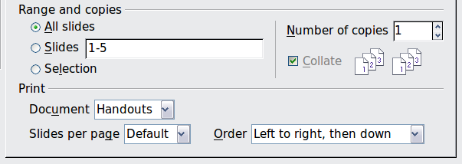

Printing a brochure
In Writer, Impress, and Draw, you can print a document with two pages on each side of a sheet of paper, arranged so that when the printed pages are folded in half, the pages are in the correct order to form a booklet or brochure.
Tip | Plan your document so it will look good when printed half size; choose appropriate margins, font sizes, and so on. You may need to experiment.
To print a brochure on a single-sided printer:
- Choose File → Print.
- In the Print dialog, click Properties.
- Check the printer is set to the same orientation (portrait or landscape) as specified in the page setup for your document. Usually the orientation does not matter, but it does for brochures. Click OK to return to the Print dialog.
- Select the Page layout tab in the Print dialog.
- Select the Brochure option.
- In the Page sides section, select Back sides / left pages option from the Include drop-down list.
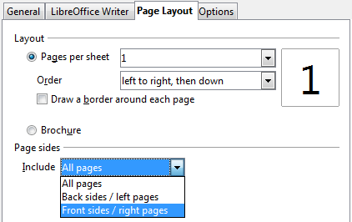
- Click the Print button.
- Take the printed pages out of the printer, turn the pages over, and put them back into the printer in the correct orientation to print on the blank side. You may need to experiment a bit to find out what the correct arrangement is for your printer.
- On the Print dialog, in the Page sides section, select Front sides / right pages option from the Include drop down box.
- Click the Print button.
Tip | If your printer can print double-sided automatically, choose All pages.

Printing envelopes, labels, business cards
Printing envelopes, labels, or business cards using Writer involves two steps: setup and printing.
For details of how to set these up, see Chapter 11, Using Mail Merge, in the Writer Guide. To print:
- Choose File → Print from the menu bar.
- On the Print dialog, under Ranges and copies, choose Pages and type 1 in the box. Click the Print button.

Printing in black and white (on a color printer)
You may wish to print documents in black and white on a color printer. Several choices are available. Please note that some color printers may print in color regardless of the settings you choose.
Change the printer settings to print in black and white or grayscale:
- Choose File → Print to open the Print dialog.
- Click Properties to open the Properties dialog for the printer. The available choices vary from one printer to another, but you should find options for the Color settings. See your printer’s help or user manual for more information.
- The choices for color might include black and white or grayscale. Choose the required setting.
- Click OK to confirm your choice and return to the Print dialog,
- Click the Print button to print the document.
Tip | Grayscale is best if you have any graphics in the document.
Change the LibreOffice settings to print all color text and graphics as grayscale:
- Choose Tools → Options → LibreOffice → Print.
- Select the Convert colors to grayscale option. Click OK to save the change.
- Open the Print dialog (File → Print).
- Click the Print button to print the document.
Change the LibreOffice Writer (or Calc, Impress, Draw) settings to print all color text as black, and all graphics as grayscale:
- Choose Tools → Options → LibreOffice Writer → Print.
- Under Contents, select the Print text in black option. Click OK to save the change.
- Open the Print dialog (File → Print).
- Click the Print button to print the document.

Previewing pages/sheets before printing
You can use the previewing options in Writer and Calc to view the document as it will be printed. Different viewing options are available.

Writer
The normal page view in Writer shows you what each page will look like when printed and you can edit the pages in that view. If you are designing a document to be printed double-sided, you may want to see what facing pages look like. Writer provides two ways to do this:
- View Layout (editable view): use the Facing Pages (Book Preview) button on the status bar.

- Page Preview (read-only view).
To use Page Preview:
- Choose File → Page Preview (or click the Page Preview button on the Standard toolbar).
Writer now displays the Page Preview toolbar instead of the Formatting toolbar.
Figure 269. Page Preview toolbar (Writer)
- Select the required preview icon: Two Pages (), Multiple Pages () or Book Preview ().
- To print the document from this view, click the Print document icon() to open the Print dialog.
- Choose the print options and click the Print button.

Calc
To preview the sheets in Calc before printing:
- Choose File → Page Preview.
The Calc window now displays the Page Preview toolbar instead of the Formatting toolbar.
Figure 270. Page Preview toolbar (Calc)
- To print the document from this view, click the Print document icon to open the Print dialog.
- Choose the print options and click the Print button.

Exporting to PDF
LibreOffice can export documents to PDF (Portable Document Format). This industry-standard file format is ideal for sending the file to someone else to view using Adobe Reader or other PDF viewers.
The process and dialogs are the same for Writer, Calc, Impress, and Draw, with a few minor differences mentioned in this section.

Quick export to PDF
Click the Export Directly as PDF icon to export the entire document using your default PDF settings. You are asked to enter the file name and location for the PDF file, but you do not get a chance to choose a page range, the image compression, or other options.

Controlling PDF content and quality
For more control over the content and quality of the resulting PDF, use File → Export as PDF. The PDF Options dialog opens. This dialog has five pages (General, Initial View, User Interface, Links, and Security). Select the appropriate settings, and then click Export. Then you are asked to enter the location and file name of the PDF to be created, and click Save to export the file.

General page of PDF Options dialog
On the General page, you can choose which pages to include in the PDF, the type of compression to use for images (which affects the quality of images in the PDF), and other options.
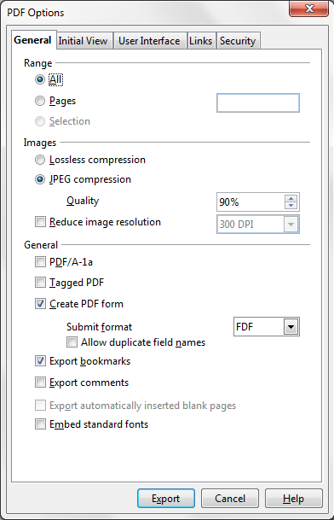
Figure 271: General page of PDF Options dialog
Range section
- All: Exports the entire document to PDF.
- Pages: To export a range of pages, use the format 3-6 (pages 3 to 6). To export single pages, use the format 7;9;11 (pages 7, 9, and 11). You can also export a combination of page ranges and single pages, by using a format like 3-6;8;10;12.
- Selection: Exports all the selected material.
Images section
- Lossless compression: Images are stored without any loss of quality. Tends to make large files when used with photographs. Recommended for other kinds of images or graphics.
- JPEG compression: Allows for varying degrees of quality. A setting of 90% works well with photographs (small file size, little perceptible loss of quality).
- Reduce image resolution: Lower-DPI (dots per inch) images have lower quality. For viewing on a computer screen generally a resolution of 72dpi (for Windows) or 96dpi (GNU/Linux) is sufficient, while for printing it is generally preferable to use at least 300 or 600 dpi, depending on the capability of the printer. Higher dpi settings greatly increase the size of the exported file.
Note | EPS (Encapsulated PostScript) images with embedded previews are exported only as previews. EPS images without embedded previews are exported as empty placeholders.
General section
- PDF/A-1a: PDF/A is an ISO standard for long-term preservation of documents, by embedding all the information necessary for faithful reproduction (such as fonts) while forbidding other elements (including forms, security, and encryption). PDF tags are written. If you select PDF/A-1a, the forbidden elements are greyed-out (not available).
- Tagged PDF: Tagged PDF contains information about the structure of the document’s contents. This can help to display the document on devices with different screens, and when using screen reader software. Some tags that are exported are table of contents, hyperlinks, and controls. This option can increase file sizes significantly.
- Create PDF form - Submit format: Choose the format of submitting forms from within the PDF file. This setting overrides the control’s URL property that you set in the document. There is only one common setting valid for the whole PDF document: PDF (sends the whole document), FDF (sends the control contents), HTML, and XML. Most often you will choose the PDF format.
- Export bookmarks: Exports headings in Writer documents, and page names in Impress and Draw documents, as “bookmarks” (a table of contents list displayed by most PDF viewers.
- Export comments: Exports comments in Writer and Calc documents as PDF notes. You may not want this! In Impress, exports a set of Comments pages following the set of slides.
- Export automatically inserted blank pages: If selected, automatically inserted blank pages are exported to the PDF. This is best if you are printing the PDF double-sided. For example, books usually have chapters set to always start on an odd-numbered (right-hand) page. When the previous chapter ends on an odd page, LibreOffice inserts a blank page between the two odd pages. This option controls whether to export that blank page.
- Embed standard fonts: In previous versions of LibreOffice, the standard fonts (Times, Helvetica, Courier, Symbol, and ZapfDingbats) were only embedded into the PDF when the resulting file was of the PDF/A type, since the PDF/A standards requires this. In version 3.3, you can choose to embed these fonts in all PDF documents created by LibreOffice to enhance display accuracy in PDF viewers.

Initial View page of PDF Options dialog
On the Initial View page, you can choose how the PDF opens by default in a PDF viewer. The selections should be self-explanatory.

Figure 272: Initial View page of PDF Options dialog

User Interface page of PDF Options dialog
On the User Interface page, you can choose more settings to control how a PDF viewer displays the file. Some of these choices are particularly useful when you are creating a PDF to be used as a presentation or a kiosk-type display.
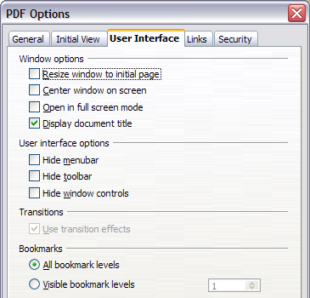
Figure 273: User Interface page of PDF Options dialog
Window options section
- Resize window to initial page. Causes the PDF viewer window to resize to fit the first page of the PDF.
- Center window on screen. Causes the PDF viewer window to be centered on the computer screen.
- Open in full screen mode. Causes the PDF viewer to open full-screen instead of in a smaller window.
- Display document title. Causes the PDF viewer to display the document’s title in the title bar.
User interface options section
- Hide menubar. Causes the PDF viewer to hide the menu bar.
- Hide toolbar. Causes the PDF viewer to hide the toolbar.
- Hide window controls. Causes the PDF viewer to hide other window controls.
Transitions
In Impress, displays slide transition effects as their respective PDF effects.
Bookmarks
Select how many heading levels are displayed as bookmarks, if Export bookmarks is selected on the General page.

Links page of PDF Options dialog
On the Links page, you can choose how links are exported to PDF.
Figure 274: Links page of PDF Options dialog
Export bookmarks as named destinations
If you have defined Writer bookmarks, Impress or Draw slide names, or Calc sheet names, this option exports them as “named destinations” to which Web pages and PDF documents can link.
Convert document references to PDF targets
If you have defined links to other documents with OpenDocument extensions (such as .ODT, .ODS, and .ODP), this option converts the files names to .PDF in the exported PDF document.
Export URLs relative to file system
If you have defined relative links in a document, this option exports those links to the PDF.
Cross-document links
Defines the behavior of links clicked in PDF files.

Security page of PDF Options dialog
PDF export includes options to encrypt the PDF (so it cannot be opened without a password) and apply some digital rights management (DRM) features.
- With an open password set, the PDF can only be opened with the password. Once opened, there are no restrictions on what the user can do with the document (for example, print, copy, or change it).
- With a permissions password set, the PDF can be opened by anyone, but its permissions can be restricted. See Figure 275. After you set a password for permissions, the other choices on the Security page become available.
- With both the open password and permission password set, the PDF can only be opened with the correct password, and its permissions can be restricted.
Note | Permissions settings are effective only if the user’s PDF viewer respects the settings.
Figure 276 shows the pop-up dialog displayed when you click the Set open password button on the Security page of the PDF Options dialog.

Figure 275: Security page of PDF Options dialog
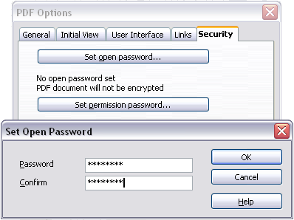
Figure 276: Setting a password to encrypt a PDF

Exporting to other formats
LibreOffice uses the term “export” for some file operations involving a change of file type. If you cannot find what you want under File → Save As, look under File → Export as well.
LibreOffice can export files to XHTML. In addition, LibreOffice Draw and LibreOffice Impress can export to Adobe Flash (.swf) and a range of image formats.
To export to one of these formats, choose File → Export. On the Export dialog, specify a file name for the exported document, then select the required format in the File format list and click the Export button.

E-mailing documents
LibreOffice provides several ways to quickly and easily send documents as an e-mail attachment in one of three formats: OpenDocument (LibreOffice’s default format), Microsoft Office formats, or PDF.
Note | Documents can only be sent from the LibreOffice menu if a mail profile has been set up.
To send the current document in OpenDocument format:
- Choose File → Send → Document as E-mail. LibreOffice opens your default e-mail program. The document is attached.
- In your e-mail program, enter the recipient, subject, and any text you want to add, then send the e-mail.
File → Send → E-mail as OpenDocument Text (or Spreadsheet or Presentation) has the same effect.
If you choose E-mail as Microsoft [Word, Excel, or Powerpoint], LibreOffice first creates a file in one of those formats and then opens your e-mail program with the file attached.
Similarly, if you choose E-mail as PDF, LibreOffice first creates a PDF using your default PDF settings (as when using the Export Directly as PDF toolbar button) and then opens your email program with the .PDF file attached.

E-mailing a document to several recipients
To e-mail a document to several recipients, you can use the features in your e-mail program or you can use LibreOffice’s mail merge facilities to extract email addresses from an address book.
You can use LibreOffice’s mail merge to send e-mail in two ways:
- Use the Mail Merge Wizard to create the document and send it. See Chapter 11, Using Mail Merge, of the Writer Guide for details.
- Create the document in Writer without using the Wizard, then use the Wizard to send it. This method is described here.
To use the Mail Merge Wizard to send a previously-created Writer document:
- Click Tools → Mail Merge Wizard. On the first page of the wizard, select Use the current document and click Next.
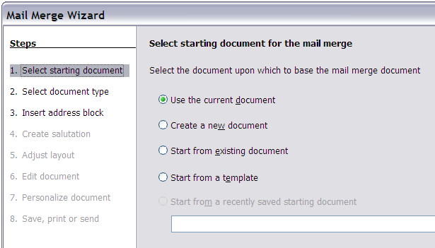
Figure 277: Select starting document
- On the second page, select E-mail message and click Next.
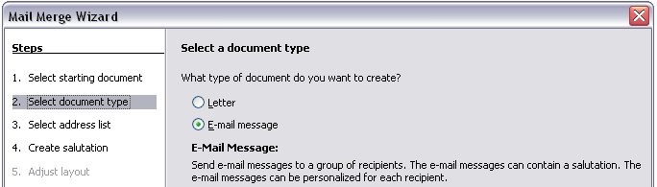
Figure 278: Select document type
- On the third page, click the Select Address List button. Select the required address list (even if only one is shown) and then click OK. (If the address list you need is not shown here, you can click Add to find it and add it to the list.)
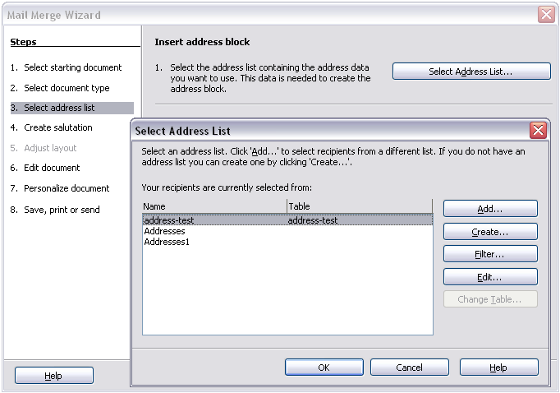
Figure 279: Selecting an address list
- Back on the Select address list page, click Next. On the Create salutation page, deselect This document should contain a salutation.
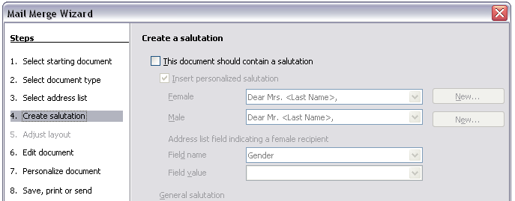Figure 280: Deselecting a salutation
- In the left-hand list, click 8. Save, print or send. LibreOffice displays a “Creating documents” message and then displays the Save, print or send page of the Wizard.
- Select Send merged document as E-Mail. The lower part of the page changes to show e-mail settings choices.
Figure 281: Sending a document as an email message
- Type a subject for your email and click Send documents. LibreOffice sends the e-mails.

Digital signing of documents
To sign a document digitally, you need a personal key, also known as a certificate. A personal key is stored on your computer as a combination of a private key, which must be kept secret, and a public key, which you add to your documents when you sign them. You can get a certificate from a certification authority, which may be a private company or a governmental institution.
When you apply a digital signature to a document, a kind of checksum is computed from the document’s content plus your personal key. The checksum and your public key are stored together with the document.
When someone later opens the document on any computer with a recent version of LibreOffice, the program will compute the checksum again and compare it with the stored checksum. If both are the same, the program will signal that you see the original, unchanged document. In addition, the program can show you the public key information from the certificate. You can compare the public key with the public key that is published on the web site of the certificate authority. Whenever someone changes something in the document, this change breaks the digital signature.
On Windows operating systems, the Windows features of validating a signature are used. On Solaris and Linux systems, files that are supplied by Thunderbird, Mozilla or Firefox are used. For a more detailed description of how to get and manage a certificate, and signature validation, see “About Digital Signatures” in the LibreOffice Help.
To sign a document:
- Choose File → Digital Signatures.
- If you have not saved the document since the last change, a message box appears. Click Yes to save the file.
- After saving, you see the Digital Signatures dialog. Click Add to add a public key to the document.
- In the Select Certificate dialog, select your certificate and click OK.
- You see again the Digital Signatures dialog, where you can add more certificates if you want. Click OK to add the public key to the saved file.
A signed document shows an icon in the status bar. You can double-click the icon to view the certificate.

Removing personal data
You may wish to ensure that personal data, versions, notes, hidden information, or recorded changes are removed from files before you send them to other people or create PDFs from them.
In Tools → Options → LibreOffice → Security → Options, you can set LibreOffice to remind (warn) you when files contain certain information and remove personal information automatically on saving.
To remove personal and some other data from a file, go to File → Properties. On the General tab, uncheck Apply user data and then click the Reset button. This removes any names in the created and modified fields, deletes the modification and printing dates, and resets the editing time to zero, the creation date to the current date and time, and the version number to 1.
To remove version information, either go to File → Versions, select the versions from the list and click Delete, or use Save As and save the file with a different name.
Getting Started Guide

Chapter 11
Graphics, the Gallery, and Fontwork

Introduction
You can add graphic and image files, including photos, drawings, scanned images, and others, to LibreOffice documents. LibreOffice can import various vector (line drawing) and raster (bitmap) file formats. The most commonly used graphic formats are GIF, JPG, PNG, and BMP. See Appendix B for a full list of the graphic formats LibreOffice can import.
Graphics in LibreOffice are of three basic types:
- Image files, such as photos, drawings, and scanned images
- Diagrams created using LibreOffice’s drawing tools
- Charts created using LibreOffice’s Chart component
This chapter covers images and diagrams.
More detailed descriptions on working with drawing tools can be found in the Draw Guide and Impress Guide. Instructions on how to create charts are given in the Calc Guide.

Adding images to a document
Images can be added to a document in several ways: by inserting an image file, directly from a graphics program or a scanner, or from the LibreOffice Gallery.

Inserting an image file
When the image is in a file stored on the computer, you can insert it into an LibreOffice document using either of the following methods.

Drag and drop
- Open a file browser window and locate the image you want to insert.
- Drag the image into the Writer document and drop it where you want it to appear. A faint vertical line marks where the image will be dropped.
This method embeds (saves a copy of) the image file in the Writer document. To link the file instead of embedding it, hold down the Control+Shift keys while dragging the image.

Insert Picture dialog
- Click in the LibreOffice document where you want the image to appear.
- Choose Insert → Picture → From File from the menu bar.
- On the Insert Picture dialog, navigate to the file to be inserted, select it, and click Open.
At the bottom of the dialog are two options, Preview and Link. Choose Preview to view a thumbnail of the selected image on the right, so you can verify that you have the correct file. See below for the use of Link.
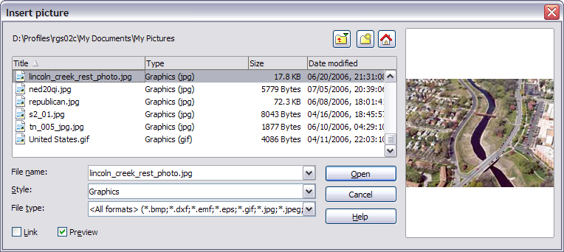
Figure 282. Insert picture dialog

Linking an image file
If the Link option in the Insert picture dialog is selected, LibreOffice creates a link to the file containing the image instead of saving a copy of the image in the document. The result is that the image is displayed in the document, but when the document is saved, it contains only a reference to the image file—not the image itself. The document and the image remain as two separate files, and they are merged together only when you open the document again.
Linking an image has two advantages and one disadvantage:
- Advantage – Linking can reduce the size of the document when it is saved, because the image file itself is not included. File size is usually not a problem on a modern computer with a reasonable amount of memory, unless the document includes many large graphics files; LibreOffice can handle quite large files.
- Advantage – You can modify the image file separately without changing the document because the link to the file remains valid, and the modified image will appear when you next open the document. This can be a big advantage if you (or someone else, perhaps a graphic artist) is updating images.
- Disadvantage – If you send the document to someone else, or move it to a different computer, you must also send the image files, or the receiver will not be able to see the linked images. You need to keep track of the location of the images and make sure the recipient knows where to put them on another machine, so the document can find them. For example, you might keep images in a subfolder named Images (under the folder containing the document); the recipient of the file needs to put the images in a subfolder with the same name (under the folder containing the document).
Note | When inserting the same image several times in the document it would appear beneficial to create links; however, this is not necessary as LibreOffice embeds in the document only one copy of the image file.

Embedding linked images
If you originally linked the images, you can easily embed one or more of them later if you wish. To do so:
- Open the document in LibreOffice and choose Edit → Links.
- The Edit Links dialog (Figure 283) shows all the linked files. In the Source file list, select the files you want to change from linked to embedded.
- Click the Break Link button.
- Save the document.
Note | Going the other way, from embedded to linked, is not so easy—you must delete and reinsert each image, one at a time, selecting the Link option when you do so.
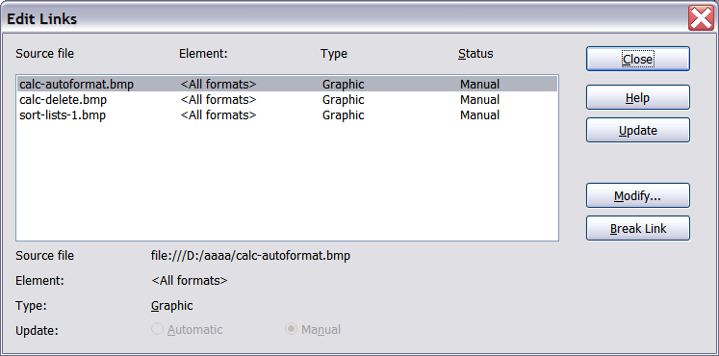
Figure 283: The Edit Links dialog

Inserting an image from the clipboard
Using the clipboard, you can copy images into an LibreOffice document from another LibreOffice document and from other programs. To do this:
- Open both the source document and the target document.
- In the source document, select the image to be copied.
- Move the mouse pointer over the selected image and press Control+C to copy the image to the clipboard.
- Switch to the target document.
- Click to place the cursor where the graphic is to be inserted.
- Press Control+V to insert the image.
Caution | If the application from which the graphic was copied is closed before the graphic is pasted into the target, the image stored on the clipboard could be lost.

Inserting an image using a scanner
If a scanner is connected to your computer, LibreOffice can call the scanning application and inserted the scanned item into the LibreOffice document as an image. To start this procedure, place the cursor where you want the graphic to be inserted and chooe Insert → Picture → Scan → Select Source.
Although this practice is quick and easy, it is unlikely to result in a high-quality image of the correct size. You may get better results by scanned material into a graphics program and cleaning it up there before inserting the resulting image into LibreOffice.

Inserting an image from the Gallery
The Gallery provides a convenient way to group reusable objects such as graphics and sounds that you can insert into your documents. The Gallery is available in all components of LibreOffice. See “Managing the LibreOffice Gallery“ on page 282. You can copy or link an object from the Gallery into a document.
To insert an object:
- Choose Tools → Gallery or click the Gallery icon on the Standard toolbar (in Writer and Calc) or the Drawing toolbar (in Impress and Draw).
- Select a theme.
- Select an object with a single click.
- Drag and drop the image into the document. (See Figure 284.)
You can also right-click on the object and choose Insert → Copy.
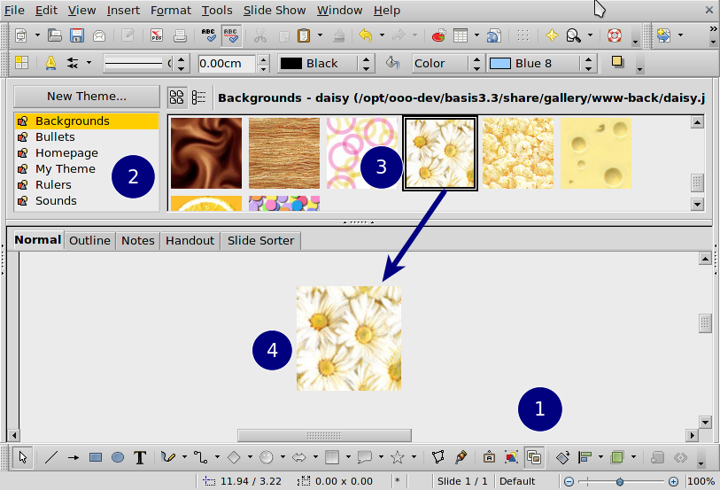
Figure 284. Copying a graphic object from the Gallery into a document
To insert an object as a link:
- Choose Tools → Gallery and select a theme.
- Select an object with a single click, then while pressing the Shift and Control keys, drag and drop the object into the document.

Inserting an image as a background
To insert an image as the background to a page or paragraph:
- Choose Tools → Gallery and select a theme.
- Select an object with a single click, right-click on the object, and choose Insert → Background → Page or → Paragraph.

Modifying and positioning graphics
LibreOffice provides many tools for resizing, modifying, filtering, and positioning graphics; wrapping text around graphics; and using graphics as backgrounds and watermarks. These tools are described in relevant chapters of the other guides. Some sophisticated adjustments of the graphics are best done in an image manipulation program and the results brought into LibreOffice, rather than using LibreOffice’s inbuilt tools.

Managing the LibreOffice Gallery
Graphics in the Gallery are grouped by themes, such as Bullets, Rulers, and Backgrounds. You can create other groups or themes and add your own pictures or find extensions containing more graphics.
The box on the left of the gallery window lists the available themes. Click on a theme to see its contents displayed in the Gallery window.
You can display the Gallery in Icon View (Figure 285) or Detailed View, and you can hide or show the Gallery by clicking on the Hide button (similar to the Hide button for the Navigator and the Styles and Formatting window when they are docked).
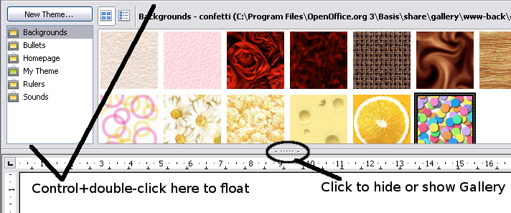
Figure 285. Icon view of one theme in the Gallery
By default, the Gallery is docked above the workspace. To expand the Gallery, position the pointer over the line that divides it from the top of the workspace. When the pointer changes to parallel lines with arrows, click and drag downward. The workspace resizes in response.
As for other docked windows, you can “float” the Gallery by moving the mouse pointer over an edge of the Gallery window, holding down the Control key, and double-clicking. Repeat this procedure to dock the Gallery again.
The default themes are locked; no items can be added to or deleted from these themes. The locked themes are easily recognizable by right-clicking on them; the only available option in the pop-up menu is Properties.
In a default installation, only the My themes theme is customizable, although new themes can be added as explained in “Adding a new theme to the Gallery” on page 284.

Adding objects to the Gallery
You may wish to add to the Gallery any images that you use frequently, for example, a company logo. You can then very easily insert these graphics into a document later. You can add images only to “My Theme” or to any other theme that you have created; these are indicated by a green icon in the list of themes. You cannot add images to the built-in themes, indicated by an icon of another color.
Method 1 (selecting a file):
- In the theme’s Properties, on the Files page, click the Find Files button. The Select path dialog opens.
- You can enter the path for the file’s directory in the Path text box, or you can navigate to locate the file’s directory. Use the File type drop-down list to help limit the search.
- Click the Select button to start the search.
- A list of graphic files is then displayed in the window. You can use the File type filter again to further limit the search.
- Select the files to add. To select more than one file, hold the Control key down while you click on each file.
- Finally, click Add.
Method 2 (drag and drop):
- Open the document containing an image you want to add to the Gallery, and display the Gallery theme to which you want to add it.
- Position the mouse pointer above the image, without clicking.
- If the mouse pointer changes to a hand symbol, the image refers to a hyperlink. In this case, press the Alt key while you click the image, to select it without activating the link. If the mouse pointer does not change to a hand symbol, you can simply click the image to select it.
- Once the image is selected, evident from the green selection handles around it, release the mouse button. Click again on the image, keeping the mouse button pressed for more than two seconds. Without releasing the mouse button, drag the image into the document.
- Release the mouse button.

Deleting images from the Gallery
To delete an image from a theme that you created:
- Right-click on the name of the image file or its thumbnail in the Gallery.
- Click Delete on the pop-up menu. A message appears, asking if you want to delete this object. Click Yes.
Note | Deleting the name of a file from the list in the Gallery does not delete the file from the hard disk or other location.

Adding a new theme to the Gallery
To add a new theme to the Gallery:
- Click the New Theme button above the list of themes (Figure 285).
- In the Properties of New Theme dialog, click the General tab and type a name for the new theme.
- Click the Files tab and add images to the theme, as described earlier.

Deleting a theme from the Gallery
You can delete only theme that you have added to the Gallery; you cannot delete any of the inbuilt themes. To delete a theme from the Gallery:
- Go to Tools → Gallery.
- In the left part of the Gallery, select in the list the theme you wish to delete.
- Right-click on the theme, then click Delete on the pop-up menu.

Location of the Gallery and the objects in it
Graphics and other objects shown in the Gallery can be located anywhere on your computer’s hard disk, on a network drive, or on a CD-ROM. Listings in the Gallery refer to the location of each object. When you add graphics to the Gallery, the files are not moved or copied; only the location of each new object is added as a reference.
In a workgroup situation, you may have access to a shared Gallery (where you cannot change the contents unless authorized to do so) and a user Gallery, where you can add, change, or delete objects.
The location of the user Gallery is specified in Tools → Options → LibreOffice → Paths. You can change this location, and you can copy your gallery files (*.sdv) to other computers.
Gallery contents provided with LibreOffice are stored in a different location. You cannot change this location.

Creating an image map
An image map defines areas of an image (called hotspots) with hyperlinks to web addresses, other files on the computer, or parts of the same document. Hotspots are the graphic equivalent of text hyperlinks (described in Chapter 12). Clicking on a hotspot causes LibreOffice to open the linked page in the appropriate program (for example, the default browser for an HTML page; LibreOffice Calc for a .ODS file; a PDF viewer for a PDF file). You can create hotspots of various shapes and include several hotspots in the same image.
To use the image map editor:
- In your LibreOffice document, select the picture where you want to define the hotspots.
- Choose Edit → ImageMap from the menu bar. The ImageMap Editor (Figure 286) opens.
- Use the tools and fields in the dialog (described on the next page) to define the hotspots and links necessary.
- Click the Apply icon to apply the settings.
- When done, click the Save icon to save the imagemap to a file, then click the X in the upper right corner to close the dialog.
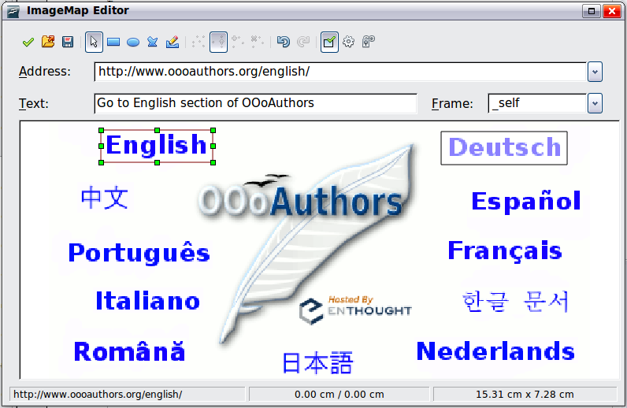
Figure 286: The dialog to create or edit an image map
The main part of the dialog shows the image on which the hotspots are defined. A hotspot is identified by a line indicating its shape.
The toolbar at the top of the dialog contains the following tools:
- Apply button: click this button to apply the changes.
- Load, Save, and Select icons.
- Tools for drawing a hotspot shape: these tools work in exactly the same way as the corresponding tools in the Drawing toolbar.
- Edit, Move, Insert, Delete Points: advanced editing tools to manipulate the shape of a polygon hotspot. Choose the Edit Points tool to activate the other tools.
- Active icon: toggles the status of a selected hotspot between active and inactive.
- Macro: associates a macro with the hotspot instead of just associating an hyperlink.
- Properties: sets the hyperlink properties and adds the Name attribute to the hyperlink.
Below the toolbar, specify for the selected hotspot:
- Address: the address pointed by the hyperlink. You can also point to an anchor in a document; to do this, write the address in this format: file:///<path>/document_name#anchor_name
- Text: type the text that you want to be displayed when the mouse pointer is moved over the hotspot.
- Frame: where the target of the hyperlink will open: pick among _blank (opens in a new browser window), _self (opens in the active browser window), _top or _parent.
Tip | The value _self for the target frame will work just fine in the vast majority of occasions. It is therefore not recommended to use the other choices unless absolutely necessary.

Using LibreOffice’s drawing tools
You can use LibreOffice’s drawing tools to create graphics such as simple diagrams using rectangles, circles, lines, text, and other predefined shapes. You can also group several drawing objects to make sure they maintain their relative position and proportion.
You can place the drawing objects directly on a page in your document, or you can insert them into a frame.
You can also use the drawing tools to annotate photographs, screen captures, or other illustrations produced by other programs, but this is not recommended because:
- You cannot include images in a group with drawing objects, so they may get out of alignment in your document.
- If you convert a document to another format, such as HTML, the drawing objects and the graphics will not remain associated; they are saved separately.
In general, if you need to create complex drawings, it is recommended to use LibreOffice Draw, which includes many more features such as layers, styles, and so on.

Creating drawing objects
To begin using the drawing tools, display the Drawing toolbar (Figure 287) by clicking View → Toolbars → Drawing.
If you are planning to use the drawing tools repeatedly, you can tear off this toolbar and move it to a convenient place on the window.
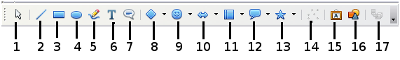
1 | Select | 5 | Freeform Line | 9 | Symbol Shapes | 13 | Stars
2 | Line | 6 | Text | 10 | Block arrows | 14 | Points
3 | Rectangle | 7 | Callouts | 11 | Flowcharts | 15 | Fontwork Gallery
4 | Ellipse | 8 | Basic Shapes | 12 | Callouts | 16 | From File
 |  |  |  |  |  | 17 | Extrusion On/Off
Figure 287. The Drawing toolbar
To use a drawing tool:
- Click in the document where you want the drawing to be anchored. You can change the anchor later, if necessary.
- Choose the tool from the Drawing toolbar (Figure 287). The mouse pointer changes to a drawing-functions pointer .
- Move the cross-hair pointer to the place in the document where you want the graphic to appear and then click and drag to create the drawing object. Release the mouse button. The selected drawing function remains active, so you can draw another object of the same type.
- To cancel the selected drawing function, press the Esc key or click on the Select icon (the arrow) on the Drawing toolbar.
- You can now change the properties (fill color, line type and weight, anchoring, and others) of the drawing object using either the Drawing Object Properties toolbar (Figure 288) or the choices and dialogs reached by right-clicking on the drawing object.

Set or change properties for drawing objects
To set the properties for a drawing object before you draw it:
- On the Drawing toolbar (Figure 287), click the Select tool.
- On the Drawing Object Properties toolbar (Figure 288), click on the icon for each property and select the value you want for that property.
- For more control, or to define new attributes, you can click on the Area or Line icons on the toolbar to display detailed dialogs.
1 | Line | 5 | Line Color | 9 | To Foreground | 13 | Alignment
2 | Arrow Style | 6 | Area | 10 | To Background | 14 | Change Anchor
3 | Line Style | 7 | Area Style / Filling | 11 | Bring to Front | 15 | Ungroup
4 | Line Width | 8 | Rotate | 12 | Send to Back | 16 | Group
Figure 288. Drawing Object Properties toolbar
The default you set applies to the current document and session. It is not retained when you close the document or close Writer, and it does not apply to any other document you open. The defaults apply to all the drawing objects except text objects.
To change the properties for an existing drawing object:
- Select the object.
- Continue as described above.
You can also specify the position and size, rotation, and slant and corner radius properties of the drawing object:
- Right-click on the drawing object and then choose Position and Size from the pop-up menu. The Position and Size dialog is displayed.
- Choose any properties, as required.

Resizing a drawing object
The same considerations for resizing an image apply also to resizing an object. Select the object, click on one of the eight handles around it and drag it to its new position. For a scaled resizing, select one of the corner handles and keep the Shift key pressed while dragging the handle to its new position.
For more sophisticated control of the size of the object, choose Format → Object → Position and Size from the menu bar. Use the Position and Size dialog to set the width and height independently. If the Keep ratio option is selected, then the two dimensions change so that the proportion is maintained, allowing for a scaled resizing.

Grouping drawing objects
To group drawing objects:
- Select one object, then hold down the Shift key and select the others you want to include in the group. The bounding box expands to include all the selected objects.
- With the objects selected, hover the mouse pointer over one of the objects and choose Format → Group → Group from the menu bar or right-click and choose Group → Group from the pop-up menu.
Note | You cannot include an embedded or linked graphic in a group with drawing objects.

Using Fontwork
With Fontwork you can create graphical text art objects for making your work more attractive. There are many different settings for text art objects (line, area, position, size, and more), so you have a large choice. You will surely find one that fits your document.
Fontwork is available with each component of LibreOffice, but you will notice small differences in the way that each component displays it.

The Fontwork toolbars
You can use two different toolbars for creating and editing a Fontwork object.
- Go to View → Toolbars → Fontwork.
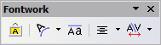
Figure 289. The floating Fontwork toolbar
- If you click on an existing Fontwork object, the Formatting toolbar changes to display the Fontwork options as shown in Figure 294. The contents of this toolbar vary depending on the LibreOffice component with which it is being used.

Creating a Fontwork object
- On the Drawing or Fontwork toolbar, click the Fontwork Gallery icon . If the Drawing toolbar is not visible, go to View → Toolbars → Drawing to display it.
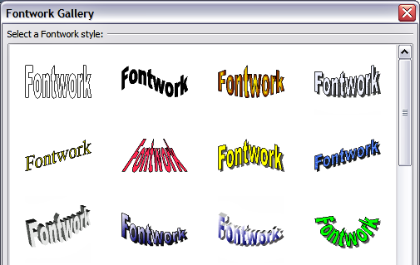
Figure 290. The Fontwork Gallery
- In the Fontwork Gallery, select a Fontwork style, then click OK. The Fontwork object will appear in your document. Notice the blue squares around the edge (indicating that the object is selected) and the yellow dot; these are discussed in “Moving and resizing Fontwork objects” on page 293.
- Double-click the object to edit the Fontwork text. Type your own text in place of the black Fontwork text that appears over the object.

Figure 291. Editing Fontwork text
- Click anywhere in a free space or press Esc to apply your changes.

Editing a Fontwork object
Now that the Fontwork object is created, you can edit some of its attributes. To do this, you can use the Fontwork toolbar, the Formatting toolbar, or menu options as described in this section. If the selected Fontwork object is a 3-D object, you can also use the 3D-Settings toolbar.

Using the Fontwork toolbar
Make sure that the Fontwork toolbar, shown in Figure 289, is visible. If you do not see it, go to View → Toolbars → Fontwork. Click on the different icons to edit Fontwork objects.
 | Fontwork Shape: Edits the shape of the selected object. You can choose from a palette of shapes. | 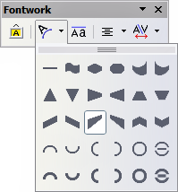  Figure 292. Fontwork toolbar showing palette of shapes
 | Fontwork Same Letter Heights: Changes the height of characters in the object. Toggles between normal height (some characters taller than others, for example capital letters, d, h, l and others) and all letters the same height.

Figure 293. Left: normal letters; right: same letter heights
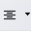 | Fontwork Alignment: Changes the alignment of characters. Choices are left align, center, right align, word justify, and stretch justify. The effects of the text alignment can only be seen if the text spans over two or more lines. In the stretch justify mode, all the lines are filled completely. | 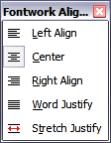
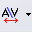 | Fontwork Character Spacing: Changes the character spacing and kerning in the object. For custom spacing, input a percentage value: 100% is normal spacing; less than 100% is tight spacing; more than 100% is expanded spacing. | 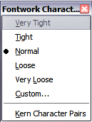

Using the Formatting toolbar
Now let us go further and customize the Fontwork object with several more attributes.
Click on the Fontwork object. The Formatting toolbar changes to show the options for editing the object. (The toolbar shown in Figure 294 appears when you use Fontwork in Writer.)
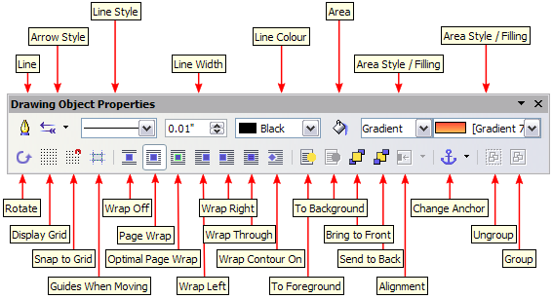
Figure 294. Formatting toolbar for a Fontwork object in Writer
This figure shows the toolbar floating. In its default, docked position it is one of the toolbars located below the menu bar. The example toolbar has also been customized to show all of the available options; by default only a subset of these options is shown.
On the Formatting toolbar you have a large choice of options for customizing your object. These choices are the same as the ones for other drawing objects. For more information, see the Draw Guide.
Line options
Line icon: Opens a dialog with three tabs: Line, Line Styles, Arrow Styles. Use the Line tab to edit the most common properties of the line around the selected Fontwork object, by choosing from previously-defined attributes including line style, line color, and arrow styles. Use the Lines Styles and Arrow Styles tabs to edit the properties of line and arrow styles, and define new styles.
Arrow Style icon: Choose from the different arrow styles.
Line Style box: Choose from the available line styles.
Line Width box: Set the width of the line.
Line Color box: Select the color of the line.
Area options
Area icon: Opens a dialog with seven tabs: Area, Shadow, Transparency, Colors, Gradients, Hatching, Bitmaps.
- Area tab: Choose from the predefined list a color, bitmap, gradient or hatching pattern to fill the selected object.
- Shadow tab: Set the shadow properties of the selected object.
- Transparency tab: Set the transparency properties of the selected object.
- Colors tab: Modify the available colors or add new ones to appear on the Area tab.
- Gradients tab: Modify the available gradients or add new ones to appear on the Area tab.
- Hatching tab: Modify the available hatching patterns or add new ones to appear on the Area tab.
- Bitmaps tab: Create simple bitmap patterns and import bitmaps, to make them available on the Area tab.
Area Style / Filling boxes: Select the type of the fill of the selected object. For more detailed settings, use the Area icon.
Positioning options
Rotate icon: Rotate the selected object manually using the mouse to drag the object.
To Foreground icon: Move the selected object in front of the text.
To Background icon: Move the selected object behind the text.
Alignment icon: Modify the alignment of the selected objects.
Bring to front icon: Move the selected object in front of the others.
Send to back icon: Move the selected object behind the others.
Change Anchor icon: Choose between anchoring options:
- To Page - The object keeps the same position in relation to the page margins. It does not move as you add or delete text.
- To Paragraph - The object is associated with a paragraph and moves with the paragraph. It may be placed in the margin or another location.
- To Character - The object is associated with a character but is not in the text sequence. It moves with the paragraph but may be placed in the margin or another location. This method is similar to anchoring to a paragraph.
- As Character - The object is placed in the document like any character and moves with the paragraph as you add or delete text before the object.
Ungroup icon: Ungroup the selected objects, so you can manage them individually.
Group icon: Group the selected objects, so you can manage them as a single object.

Using menu options
You can use some the choices on the Format menu to anchor, align, arrange and group selected Fontwork objects, wrap text around them, and flip them horizontally and vertically.
You can also right-click on a Fontwork object and choose many of the same options from the pop-up menu. The pop-up menu also provides quick access to the Line, Area, Text, and Position and Size dialogs. The Text dialog offers only a few options for Fontwork objects and is not discussed here. On the Position and Size dialog, you can enter precise values concerning size and position. For more information on all of these menu options, see the Draw Guide.

Using the 3D-Settings toolbar
If the selected Fontwork object is a 3-D object, you can also use the options on the 3D-Settings toolbar. You can also change a 2-D Fontwork object into a 3-D object (or change a 3-D object into a 2-D object) by clicking the Extrusion On/Off icon on the 3D-Settings toolbar. For more information, see the Draw Guide.
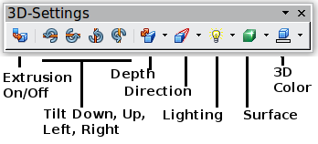
Figure 295: 3D-Settings toolbar

Moving and resizing Fontwork objects
When you select a Fontwork object, eight blue squares (known as handles) appear around the edge of the object, as shown below. You can drag these handles to resize the object.
A yellow dot also appears on the object. This dot may be along an edge of the object, or it may be somewhere else; see figure to right for an example. If you hover the pointer over this yellow dot, the pointer turns into a hand symbol. You can drag the dot in different directions to distort the object.  Hovering the pointer over other parts of the object turns the pointer into the usual symbol for dragging the object to another part of the page. | 
For precise control of the location and size of the object, use the Position and Size dialog.
Getting Started Guide

Chapter 12
Creating Web Pages
Saving Documents as HTML Files

Introduction
This chapter describes how to do the following in Writer, Calc, Draw and Impress:
- Create hyperlinks within a document and to other documents such as web pages, PDFs, and other files.
- Save documents as web pages (HTML documents).
When creating a document that you plan to deliver as a web page, you need to consider the following:
- In an HTML document, hyperlinks are active (clickable) but other cross-references inserted by LibreOffice are not active links.
- An object such as a image is saved as a separate file. However, if that object has been placed in a frame (for example, with an associated caption), it is not saved and does not appear in the HTML document; instead, the name of the frame appears.

Relative and absolute hyperlinks
Hyperlinks stored within a file can be either relative or absolute.
A relative hyperlink says, Here is how to get there starting from where you are now (meaning from the folder in which your current document is saved) while an absolute hyperlink says, Here is how to get there no matter where you start from.
An absolute link will stop working if the target is moved. A relative link will stop working if the start and target locations change relative to each other. For instance, if you have two spreadsheets in the same folder linked to each other and you move the entire folder to a new location, an absolute hyperlink will break but a relative one will not.
To change the way that LibreOffice stores the hyperlinks in your file, select Tools → Options → Load/Save → General and choose if you want URLs saved relatively when referencing the File System, or the Internet, or both.
Calc will always display an absolute hyperlink. Don’t be alarmed when it does this even when you have saved a relative hyperlink—this ‘absolute’ target address will be updated if you move the file.
Note | Make sure that the folder structure on your computer is the same as the file structure on your web server if you save your links as relative to the file system and you are going to upload pages to the Internet.
Tip | When you rest the mouse pointer on a hyperlink, a help tip displays the absolute reference, since LibreOffice uses absolute path names internally. The complete path and address can only be seen when you view the result of the HTML export (saving the spreadsheet as an HTML file), by loading the HTML file as Text, or by opening it with a text editor.

Creating hyperlinks
When you type text (such as a website addresses or URL) that can be used as a hyperlink, and then press the spacebar or the Enter key, LibreOffice automatically creates the hyperlink and applies formatting to the text (usually a color and underlining). If this does not happen, you can enable this feature using Tools → AutoCorrect Options → Options and selecting the URL Recognition option.
If you do not want LibreOffice to convert a specific URL to a hyperlink, choose Edit → Undo Insert from the menu bar or press Control+Z immediately after the formatting has been applied.
Tip | To change the color of hyperlinks, go to Tools → Options → LibreOffice → Appearance, scroll to Unvisited links and/or Visited links, pick the new colors and click OK. Caution: this will change the color for all hyperlinks in all components of LibreOffice; this may not be what you want.  In Writer and Calc (but not Draw or Impress), you can also change the Internet link character style or define and apply new styles to selected links.
You can also insert hyperlinks using the Navigator and the Hyperlink dialog, and you can modify all hyperlinks using the Hyperlink dialog as described in this section.

Using the Navigator
The easiest way to insert a hyperlink to another part of the same document is by using the Navigator:
- Open the documents containing the items you want to cross-reference.
- Open the Navigator by clicking its icon , by choosing View → Navigator, or by pressing F5.
- Click the arrow next to the Drag Mode icon, and choose Insert as Hyperlink. (See Figure 296.)
- In the list at the bottom of the Navigator, select the document containing the item that you want to cross-reference.
- In the Navigator list, select the item that you want to insert as a hyperlink.
- Drag the item to where you want to insert the hyperlink in the document. The name of the item is inserted in the document as an active hyperlink.
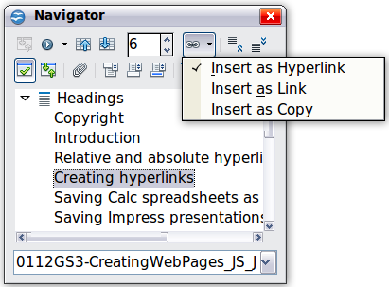
Figure 296: Inserting a hyperlink using the Navigator
When using the Navigator to hyperlink to an object such as a graphic, to have the hyperlink show useful text such as 2009 Sales Graph, you need to give such objects useful names instead of leaving them as the default names (“Graphics6”), or you need to edit the resulting link text using the Hyperlink dialog, as described below.
You can also use the Navigator to insert a hyperlink from one document (the source) to a specific place in another document (the target). Open the Navigator in the target document and drag the item to the spot in the source document where you want the hyperlink to appear.

Using the Hyperlink dialog
To display the dialog, click the Hyperlink icon on the Standard toolbar or choose Insert → Hyperlink from the menu bar. To turn existing text into a link, highlight it before opening the dialog.
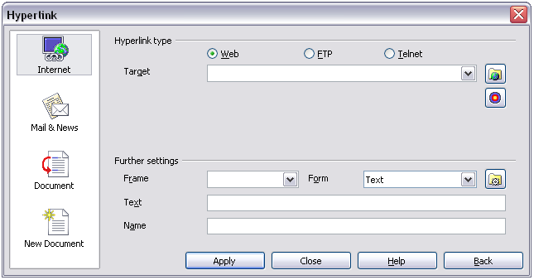
Figure 297. Hyperlink dialog showing details for Internet links
On the left side, select one of the four categories of hyperlink:
- Internet: the hyperlink points to a web address, normally starting with http://
- Mail & News: the hyperlink opens an email message that is pre-addressed to a particular recipient
- Document: the hyperlink points to another document or to another place in the current document
- New document: the hyperlink creates a new document
The top right part of the dialog changes according to the choice made for the hyperlink category in the left panel. A full description of all the choices and their interactions is beyond the scope of this chapter. Here is a summary of the most common choices.
For an Internet hyperlink, choose the type of hyperlink (Web, FTP, or Telnet), and enter the required web address (URL).
For a Mail and News hyperlink, specify whether it is a mail or news link, the receiver’s address, and for email, also the subject.
For a Document hyperlink, specify the document path (the Open File button opens a file browser) or leave this blank if you want to link to a target in the same document. Optionally specify the target in the document (for example a specific slide). Click on the Target in Document icon to open the Navigator where you can select the target; or if you know the name of the target, you can type it into the box.
For a New Document hyperlink, specify whether to edit the newly created document immediately (Edit now) or just create it (Edit later), enter the file name, and select the type of document to create (text, spreadsheet, and so on). Click the Select Path button to open a file browser and choose where to store the file.
The Further settings section in the bottom right part of the dialog is common to all the hyperlink categories, although some choices are more relevant to some types of links.
- Set the value of Frame to determine how the hyperlink will open. This applies to documents that open in a Web browser.
- Form specifies if the link is to be presented as text or as a button. Figure 298 shows a link formatted as a button. A hyperlink button is a type of form control. See Chapter 15 of the Writer Guide for more information.
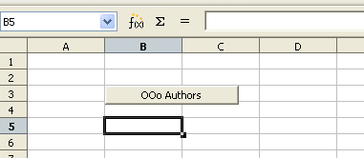Figure 298: LibreOffice Authors hyperlink as button
- Text specifies the text that will be visible to the user. If you do not enter anything here, LibreOffice uses the full URL or path as the link text. Note that if the link is relative and you move the file, this text will not change, though the target will.
- Name is applicable to HTML documents. It specifies text that will be added as a NAME attribute in the HTML code behind the hyperlink.
- Events button 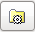: click this button to open the Assign Macro dialog and choose a macro to run when the link is clicked. See Chapter 13 (Getting Started with Macros) for more information.

Editing hyperlinks
To edit an existing link, click anywhere in the link text and then click the Hyperlink icon on the Standard toolbar or choose Edit → Hyperlink from the menu bar. The Hyperlink dialog opens. Make your changes and click Apply. If you need to edit several hyperlinks, you can leave the Hyperlink dialog open until you have edited all of them. Be sure to click Apply after each one. When you are finished, click Close.
The standard (default) behavior for activating hyperlinks within LibreOffice is to use Ctrl+click. This behavior can be changed in Tools → Options → LibreOffice → Security → Options, by deselecting the option Ctrl-click required to follow hyperlinks. If clicking in your links activates them, check that page to see if the option has been deselected.

Removing hyperlinks
You can remove the clickable link from hyperlink text—leaving just the text—by right-clicking on the link and selecting Default Formatting. This option is also available from the Format menu. You may then need to re-apply some formatting in order for the text to match the rest of your document.
To erase the link text or button from the document completely, select it and press the Backspace or Delete key.

Saving Writer documents as web pages
Writer’s HTML capabilities include saving existing documents in HTML format, creating new documents as HTML (not described here), and creating several different types of web pages using a wizard.
The easiest way to create HTML documents is to start with an existing Writer document. You can get a good idea of how it will appear as a web page by using View → Web Layout. However, web layout view will not show you which features will or won’t save correctly to HTML. Some considerations are described in the introduction to this chapter.

Saving a document as a single web page
To save a document as a single web page (HTML format), choose File → Save As and specify HTML Document as the file type.
Note | Writer does not replace multiple spaces in the original document with the HTML code for non-breaking spaces. If you want to have extra spaces in your HTML file or web page, you need to insert non-breaking spaces in LibreOffice. To do this, press Control+Spacebar instead of just Spacebar.

Saving a document as a series of web pages
Writer can save a large document as a series of web pages (HTML files) with a table of contents page. To do this:
- Decide which headings in the document should start on a new page and make sure all those headings have the same style (for example, Heading 1).
- Choose File → Send → Create HTML Document.
- In the Name and Path dialog, type the file name to save the pages under. Also specify which style indicates a new page (as decided in step 1).
- Click Save to create the multi-page HTML document. (For those who may be interested, the resulting HTML files conform to the HTML 4 Transitional.)
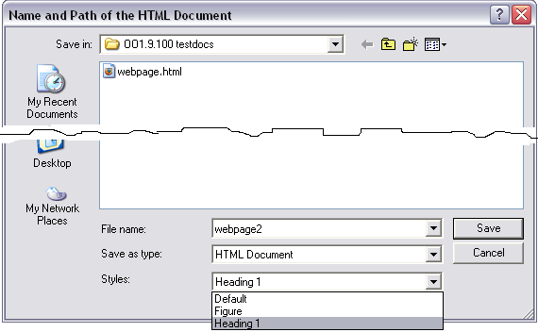
Figure 299. Creating a series of web pages from one document

Creating web pages using a Wizard
LibreOffice’s Web wizard allows you to create several types of standard web pages. To use it:
- Choose File → Wizards → Web Page. On the first page of the Wizard, choose settings and click Next. If this is your first web page, the only choice is <default>.
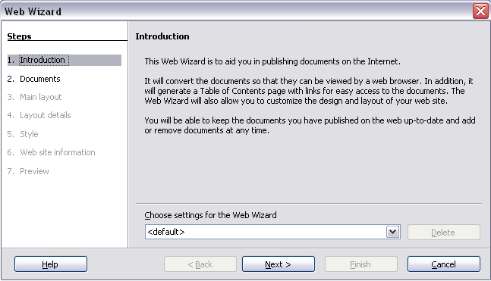
- Choose or browse to the document you would like to format. The Title, Summary and Author information is picked up from the document’s properties; if necessary, edit it. Click Next.
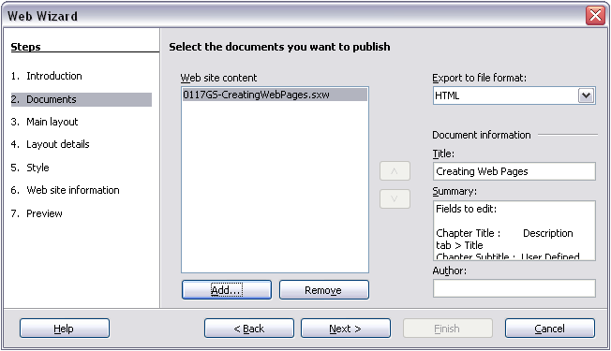
- Chose a layout for the web site by clicking on the layout boxes. Click Next.
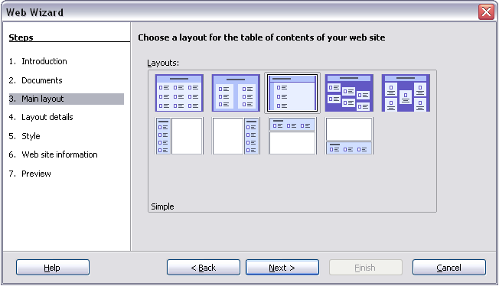
- Chose the information to be listed and the screen resolution. Click Next.
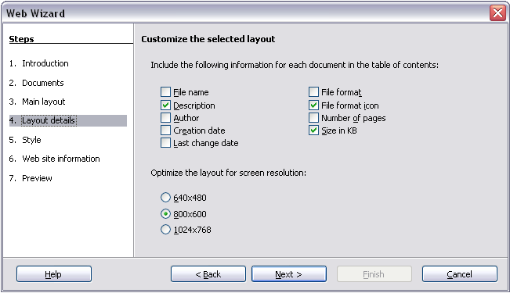
- Select a style for the page. Use the drop-down list to choose different styles and color combinations. You can browse to a background image and icon set from the Gallery. Click Next.
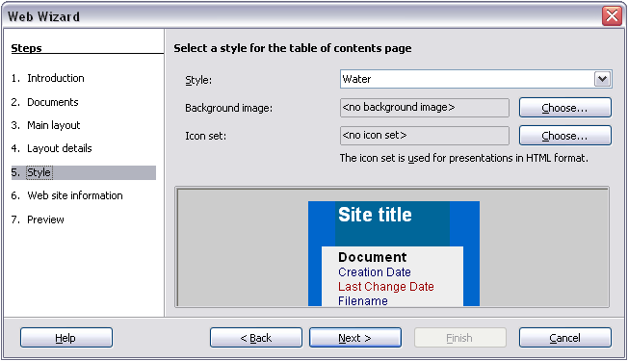
- Enter general information such as Title and HTML Metadata information. Click Next.
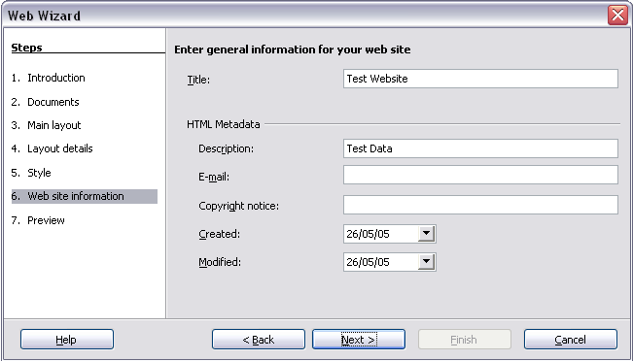
- Chose where to save the file and preview the page if you wish. Click Finish.
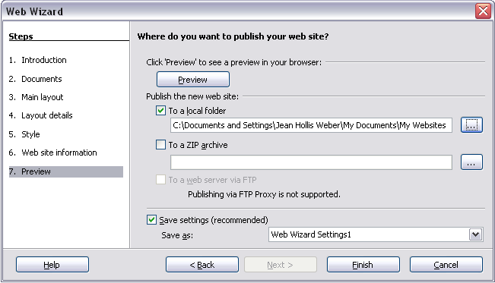
To edit or view the document’s underlying HTML code, open the document, and then choose View → HTML Source or click the HTML Source icon on the Main toolbar.

Saving Calc spreadsheets as web pages
Calc can save files as HTML documents. As for Writer, choose File → Save As and select HTML Document, or choose File → Wizards → Web Page.
If the file contains more than one sheet, the additional sheets will follow one another in the HTML file. Links to each sheet will be placed at the top of the document. Calc also allows the insertion of links directly into the spreadsheet using the Hyperlink dialog.

Saving Impress presentations as web pages
You can export presentations as Macromedia Flash files: choose File → Export and select Macromedia Flash for the file type.
You can also convert presentations into a series of web pages, as described below.
Note | Saving as web pages (HTML format) does not retain animation and slide transitions.
- To begin, choose File → Export and select HTML Document as the file type.
- Create a folder for the files, supply a name for the resulting HTML file, and click Save. The HTML Export Wizard opens.
Note | Depending on the size of your presentation and the number of graphics it contains, the HTML export function may create many HTML, JPG, and GIF files. If you simply save to your desktop (not in a specific folder), these separate HTML and graphics files will be all over your desktop. So be sure to create a folder to hold all the files.
- Choose the design for all of the pages, either from an existing design or by creating a new one. If you have not previously saved a design, the Existing Design choice is not available.
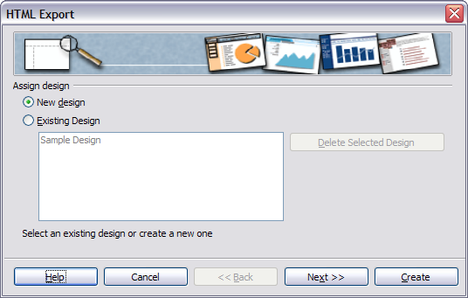
- Click Next to select the type of web pages to create.
  - Standard HTML: one page for each slide, with navigation links to move from slide to slide.
  - Standard HTML with frames: one page with a navigation bar on the left-hand side; uses slide title as navigation links. Click on links to display pages in right-hand side.
  - Automatic: one page for each slide, with each page set with the Refresh meta tag so a browser automatically cycles from one page to the next.
  - WebCast: generates an ASP or Perl application to display the slides. Unfortunately LibreOffice has no direct support for PHP yet.
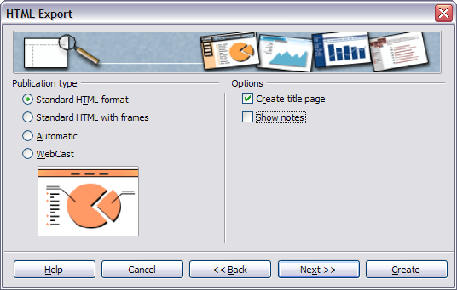
- Decide how the images will be saved (PNG, GIF, or JPG) and what resolution to use.
When choosing a resolution, consider what the majority of your viewers might be using. If you specify a high resolution, then a viewer with a medium-resolution monitor will have to scroll sideways to see the entire slide, which isprobably not desirable.
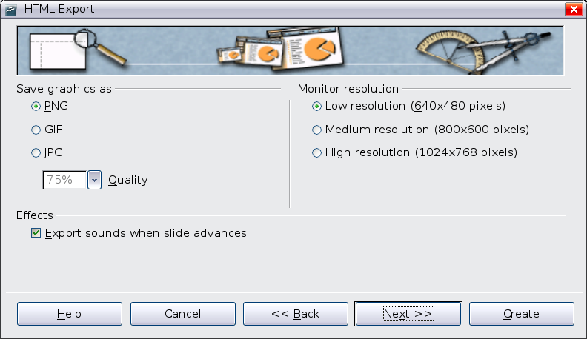
- If Create title page was chosen in step 4, supply the information for it on the next page. The title contains an author name, e-mail address and home page, along with any additional information you want to include.
This page of the Wizard does not display if Create title page was not chosen.
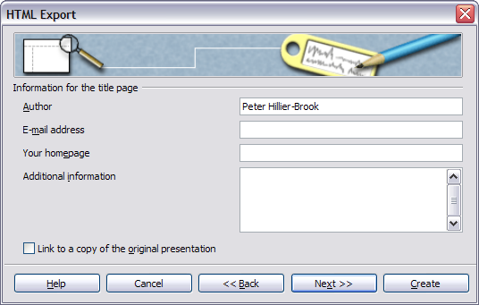
- Choose the navigation button style to use to move from one page to another. If you do not choose any, LibreOffice will create a text navigator.
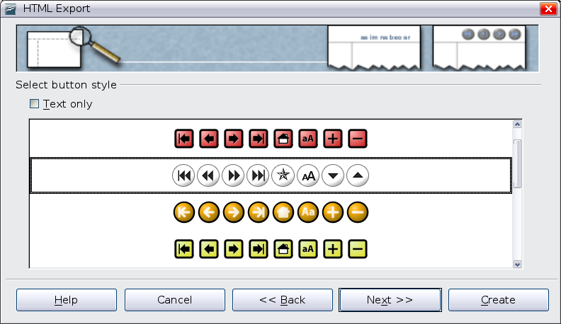
- Select the color scheme for the web pages. Available schemes include the document’s existing scheme, one based upon browser colors, and a completely user-defined scheme. You can save a new scheme so that it will appear on the first page of the HTML export wizard.
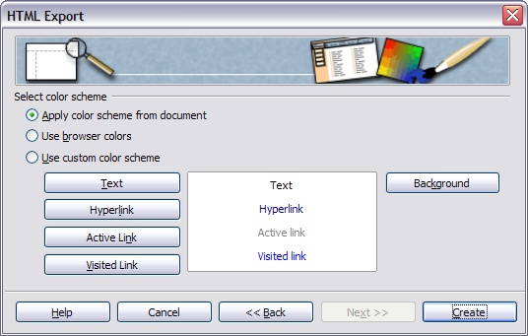
- Click Create to generate the HTML files. If this is a new design, a small dialog pops up. If you might want to reuse this design, you can give it a name and save it. Otherwise, click Do Not Save.
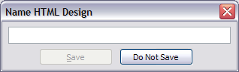

Saving Draw documents as web pages
Exporting drawings from LibreOffice’s Draw application is similar to exporting a presentation from Impress. Choose File → Export and select HTML Document as the file type.
When using the wizard, you can choose to create the web page at any time by clicking the Create button.

Getting Started Guide

Chapter 13
Getting Started with Macros
Using the Macro Recorder

Your first macros
A macro is a saved sequence of commands or keystrokes that are stored for later use. An example of a simple macro is one that “types” your address. The LibreOffice macro language is very flexible, allowing automation of both simple and complex tasks. Macros are especially useful to repeat a task the same way over and over again.
LibreOffice macros are usually written in a language called LibreOffice Basic, or just abbreviated Basic. Although you can learn Basic and write macros, there is a steep learning curve to writing macros from scratch. The usual methods for a beginner are to add macros that someone else has written and to use the built-in macro recorder, which records your keystrokes and saves them for use.
Most tasks in LibreOffice are accomplished by “dispatching a command” (sending a command), which is intercepted and used. The macro recorder works by recording the commands that are dispatched (see “The dispatch framework” on page 318).

Adding an existing macro
The first step in learning macro programming is to find and use existing macros. This section assumes that you have a macro that you want to use; the macro may be in an email, on a web page, or even in a book. For this example, use the macro in Listing 1.
Listing 1: Simple macro that says hello.
Sub HelloMacro
Print "Hello"
End Sub
You must create a library and module to contain your macro; this is covered in “Macro organization” on page 319. Use these steps to create a library to contain your macro:
- Use Tools → Macros → Organize Macros → LibreOffice Basic to open the Macro dialog (see Figure 300 and Figure 305).
- Click Organizer to open the Basic Macro Organizer dialog (see Figure 306).
- Select the Libraries tab.
- Set the Location to My Macros & Dialogs, which is the default.
- Click New to open the New Library dialog. Enter a library name such as “TestLibrary” and click OK.
- Select the Modules tab.
- In the Module list, expand My Macros and select TestLibrary. A module named Module1 already exists and can contain your macro. You can click New to create another module in TestLibrary.
- Select the Module1, or the new module that you created, and click Edit to open the Integrated Debugging Environment (IDE).
- The IDE is a text editor for macros that allows you to edit and create macros. Copy the macro into the IDE.
When a new module is created, it contains a comment and an empty macro named Main, that does nothing.
Listing 2: Contents of Module1 after it is created.
REM ***** BASIC *****

Sub Main

End Sub
Add the new macro either before Sub Main or after End Sub. In Listing 3, the new macro has been added before Sub Main.
Listing 3: Module1 after adding the new macro.
REM ***** BASIC *****

Sub HelloMacro
Print "Hello"
End Sub

Sub Main

End Sub
Click on the Run Basic button in the toolbar to run the first macro in the module. Use the Macro dialog, opened using the Select macro button or Tools → Macros → Organize Macros → LibreOffice Basic, to select and run any macro in the module.

Creating a simple macro
Imagine repeatedly entering simple information. Although you can store the information in the clipboard, if you use the clipboard for something else, the contents are changed. Storing the contents as a macro is a simple solution. (In some simple cases, including the example used here, a better solution is to use AutoText.)
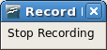
- Use Tools → Macros → Record Macro to start recording a macro.
A small window is displayed so you know that LibreOffice is recording.
- Type the desired information or perform an appropriate series of operations. In this case, I typed my name, Andrew Pitonyak.
- Click the Stop Recording button to stop recording, save the macro, and display the LibreOffice Basic Macros dialog.
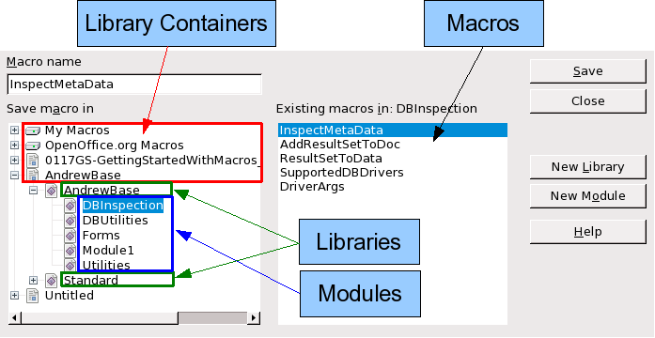
Figure 300: OOo Macro Organizer dialog, DBInspection library selected
- Be certain to open the library container named My Macros. Find the library named Standard under My Macros. Be warned, every library container has a library named Standard. Select the Standard library and click New Module to create a new module to contain the macro.
- The default module name is Module1. Type a descriptive name and click OK to create the module. The LibreOffice Basic Macros dialog is displayed again, showing the new module.
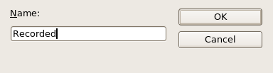
Figure 301: Give your module a meaningful name
- Highlight the newly created module. In the upper left corner, type the macro name to use, such as “EnterMyname”, and then click Save to save the macro.
If you followed all of the steps, the Standard library now contains a module named Recorded, which contains the EnterMyName macro, as shown in Figure 302. When LibreOffice creates a new module, it automatically adds the macro named Main.

Running the macro
Use Tools → Macros → Run Macro to open the Macro Selector dialog. Select the newly created macro and click Run.
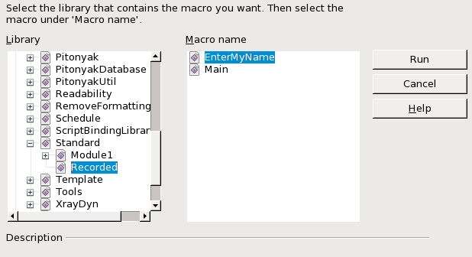Figure 302: Select your macro and click Run
There are other methods to run a macro. For example, use Tools → Macros → Organize Macros → LibreOffice Basic to open the macro organizer, which contains a Run button as well. Another method is to use the macro organizer; the dialog usually opens faster, but the selection process may be slightly slower.

Viewing and editing the macro
You can view and edit the macro that was just created. Use Tools → Macros → Organize Macros → LibreOffice Basic to open the LibreOffice Basic Macros dialog (see Figure 302). Select the new macro and click Edit to open the macro in the Basic IDE (Integrated Development Environment).
Listing 4: Generated “EnterMyname” macro.
REM ***** BASIC *****
Sub Main

End Sub

sub EnterMyName
rem -------------------------------------------------------------
rem define variables
dim document as object
dim dispatcher as object
rem -------------------------------------------------------------
rem get access to the document
document = ThisComponent.CurrentController.Frame
dispatcher = createUnoService("com.sun.star.frame.DispatchHelper")

rem -------------------------------------------------------------
dim args1(0) as new com.sun.star.beans.PropertyValue
args1(0).Name = "Text"
args1(0).Value = "Andrew Pitonyak"

dispatcher.executeDispatch(document, ".uno:InsertText", "", 0, args1())
end sub
The macro in Listing 4 is not as complicated as it first appears. Learning a few things helps significantly in understanding the generated macros. The discussion starts with features near the top of the macro listing and describes them. If you like to avoid details, then simply change the text “Andrew Pitonyak” in the macro above to what you want to insert at the current cursor position.

Comments start with REM
The keyword REM, short for remark, starts a macro comment. All text after REM (on the same line) is ignored. As a short cut, the single quote character can also be used to start a comment.
Tip | LibreOffice Basic is not case-sensitive for keywords, so REM, Rem, and rem all start a comment. If you use symbolic constants defined by the API, it is safer to assume that the names are case-sensitive—symbolic constants are an advanced topic not usually needed by people that use the macro recorder.

Defining subroutines with SUB
Individual macros are stored in subroutines defined with the keyword SUB. The end of a subroutine is indicated by the words END SUB. The code starts by defining the subroutine named Main, which is empty and does nothing. The next subroutine, EnterMyName, contains the generated code.
Tip | LibreOffice always creates an empty subroutine named Main when it creates a module.
There are advanced topics that are beyond the scope of this document, but knowing about them might be of interest:
- You can write a macro so that values can be passed to the subroutine. The values are called arguments. Recorded macros do not accept arguments.
- Another kind of subroutine is called a function. A function is a subroutine that returns a value. The keyword FUNCTION is used rather than SUB to define a function. Generated macros are always of type SUB.

Defining variables using DIM
You can write information on a piece of paper so that you can look at it later. A variable, like a piece of paper, contains information that can be changed and read. The DIM statement is similar to setting aside a piece of paper to be used to store a message or note.
The EnterMyName macro defines the variables document and dispatcher as type object. Other common variable types include string, integer, and date. A third variable, named args1, is an array of property values. A variable of type array allows a single variable to contain multiple values, similar to storing multiple pages in a single book. Values in an array are usually numbered starting from zero. The number in the parentheses indicates the highest usable number to access a storage location. In this example, there is only one value, and it is numbered zero.

Pulling the macro together
The following details are very complete; it is not important to understand all of the details. The first line defines the start of the macro.
sub EnterMyName
Declare two variables:
dim document as object
dim dispatcher as object
ThisComponent refers to the current document.
The CurrentController property of a document refers to a service that “controls” the document. For example, when you type, it is the current controller that notices. The current controller then dispatches the changes to the document’s frame.
The Frame property of a controller returns a main frame for a document. Therefore, the variable named document refers to a document’s frame, which receives dispatched commands.
document = ThisComponent.CurrentController.Frame
Most tasks in LibreOffice are accomplished by dispatching a command. LibreOffice includes a dispatch helper service, which does most of the work to use dispatches in macros. The method CreateUnoService accepts the name of a service and it tries to create an instance of that service. On completion, the dispatcher variable contains a reference to a DispatchHelper.
dispatcher = createUnoService("com.sun.star.frame.DispatchHelper")
Declare an array of properties. Each property has a name and a value. In other words, it is a name/value pair. The created array has one property at index zero.
dim args1(0) as new com.sun.star.beans.PropertyValue
Give the property the name “Text” and the value “Andrew Pitonyak”, which is the text that is inserted when the macro is run.
args1(0).Name = "Text"
args1(0).Value = "Andrew Pitonyak"
This is where the magic happens. The dispatch helper sends a dispatch to the document’s frame (stored in the variable named document) with the command .uno:InsertText. The next two arguments, frame name and search flags, are beyond the scope of this document. The last argument is the array of property values to be used while executing the command InsertText.
dispatcher.executeDispatch(document, ".uno:InsertText", "", 0, args1())
Finally, the end of the subroutine.
end sub

Creating a macro
When creating a macro, it is important to ask two questions before recording:
- Can the task be written as a simple set of commands?
- Can the steps be arranged such that the last command leaves the cursor ready for the next command?

A complicated example
I frequently copy rows and columns of data from a web site and format them as a table in a text document. First, I copy the table from the web site to the clipboard. To avoid strange formatting and fonts, I paste the text into a Writer document as unformatted text. I reformat the text with tabs between columns so that I can use Table → Convert → Text to Table to convert to a table.
I inspect the text to see if I can record a macro to format the text (remember the two questions that I ask). As an example, I copied the FontWeight constants group from the LibreOffice web site. The first column indicates the constant name. Each name is followed by a space and a tab.
DONTKNOW The font weight is not specified/known.
THIN specifies a 50% font weight.
ULTRALIGHT specifies a 60% font weight.
LIGHT specifies a 75% font weight.
SEMILIGHT specifies a 90% font weight.
NORMAL specifies a normal font weight.
SEMIBOLD specifies a 110% font weight.
BOLD specifies a 150% font weight.
ULTRABOLD specifies a 175% font weight.
BLACK specifies a 200% font weight.
I want the first column to contain the numeric value, the second column the name, and the third column the description. The desired work is easily accomplished for every row except for DONTKNOW and NORMAL, which do not contain a numeric value—but I know that the values are 0 and 100, so I will enter those manually.
The data can be cleaned in multiple ways—all of them easy. The first example uses keystrokes that assume the cursor is at the start of the line with the text THIN.
- Use Tools → Macros → Record Macro to start recording.
- Press Ctrl+Right Arrow to move the cursor to the start of “specifies”.
- Press Backspace twice to remove the tab and the space.
- Press Tab to add the tab without the space after the constant name.
- Press Delete to delete the lower case s and then press S to add an upper case S.
- Press Ctrl+Right Arrow twice to move the cursor to the start of the number.
- Press Ctrl+Shift+Right Arrow to select and move the cursor before the % sign.
- Press Ctrl+C to copy the selected text to the clipboard.
- Press End to move the cursor to the end of the line.
- Press Backspace twice to remove the two trailing spaces.
- Press Home to move the cursor to the start of the line.
- Press Ctrl+V to paste the selected number to the start of the line.
- Pasting the value also pasted an extra space, so press Backspace to remove the extra space.
- Press Tab to insert a tab between the number and the name.
- Press Home to move to the start of the line.
- Press down arrow to move to the next line.
- Stop recording the macro and save the macro.
It takes much longer to read and write the steps than to record the macro. Work slowly and think about the steps as you do them. With practice this becomes second nature.
The generated macro has been modified to contain the step number in the comments to match the code to the step above.
Listing 5: Copy the numeric value to the start of the column.

sub CopyNumToCol1
rem -------------------------------------------------------------
rem define variables
dim document as object
dim dispatcher as object
rem -------------------------------------------------------------
rem get access to the document
document = ThisComponent.CurrentController.Frame
dispatcher = createUnoService("com.sun.star.frame.DispatchHelper")

rem (2) Press Ctrl+Right Arrow to move the cursor to the start of “specifies”.
dispatcher.executeDispatch(document, ".uno:GoToNextWord", "", 0, Array())

rem (3) Press Backspace twice to remove the tab and the space.
dispatcher.executeDispatch(document, ".uno:SwBackspace", "", 0, Array())

rem -------------------------------------------------------------
dispatcher.executeDispatch(document, ".uno:SwBackspace", "", 0, Array())

rem (4) Press Tab to add the tab without the space after the constant name.
dim args4(0) as new com.sun.star.beans.PropertyValue
args4(0).Name = "Text"
args4(0).Value = CHR$(9)

dispatcher.executeDispatch(document, ".uno:InsertText", "", 0, args4())

rem (5) Press Delete to delete the lower case s ....
dispatcher.executeDispatch(document, ".uno:Delete", "", 0, Array())

rem (5) ... and then press S to add an upper case S.
dim args6(0) as new com.sun.star.beans.PropertyValue
args6(0).Name = "Text"
args6(0).Value = "S"

dispatcher.executeDispatch(document, ".uno:InsertText", "", 0, args6())

rem (6) Press Ctrl+Right Arrow twice to move the cursor to the number.
dispatcher.executeDispatch(document, ".uno:GoToNextWord", "", 0, Array())

rem -------------------------------------------------------------
dispatcher.executeDispatch(document, ".uno:GoToNextWord", "", 0, Array())

rem (7) Press Ctrl+Shift+Right Arrow to select the number.
dispatcher.executeDispatch(document, ".uno:WordRightSel", "", 0, Array())

rem (8) Press Ctrl+C to copy the selected text to the clipboard.
dispatcher.executeDispatch(document, ".uno:Copy", "", 0, Array())

rem (9) Press End to move the cursor to the end of the line.
dispatcher.executeDispatch(document, ".uno:GoToEndOfLine", "", 0, Array())

rem (10) Press Backspace twice to remove the two trailing spaces.
dispatcher.executeDispatch(document, ".uno:SwBackspace", "", 0, Array())

rem -------------------------------------------------------------
dispatcher.executeDispatch(document, ".uno:SwBackspace", "", 0, Array())

rem (11) Press Home to move the cursor to the start of the line.
dispatcher.executeDispatch(document, ".uno:GoToStartOfLine", "", 0, Array())

rem (12) Press Ctrl+V to paste the selected number to the start of the line.
dispatcher.executeDispatch(document, ".uno:Paste", "", 0, Array())

rem (13) Press Backspace to remove the extra space.
dispatcher.executeDispatch(document, ".uno:SwBackspace", "", 0, Array())

rem (14) Press Tab to insert a tab between the number and the name.
dim args17(0) as new com.sun.star.beans.PropertyValue
args17(0).Name = "Text"
args17(0).Value = CHR$(9)

dispatcher.executeDispatch(document, ".uno:InsertText", "", 0, args17())

rem (15) Press Home to move to the start of the line.
dispatcher.executeDispatch(document, ".uno:GoToStartOfLine", "", 0, Array())

rem (16) Press down arrow to move to the next line.
dim args19(1) as new com.sun.star.beans.PropertyValue
args19(0).Name = "Count"
args19(0).Value = 1
args19(1).Name = "Select"
args19(1).Value = false

dispatcher.executeDispatch(document, ".uno:GoDown", "", 0, args19())
end sub
Cursor movements are used for all operations (as opposed to searching). If run on the DONTKNOW line, the word weight is moved to the front of the line, and the first “The” is changed to “She”. This is not perfect, but I should not have run the macro on the lines that did not have the proper format; I need to do these manually.

Running the macro quickly
It is tedious to repeatedly run the macro using Tools → Macros → Run Macro (see Figure 302). The macro can be run from the IDE. Use Tools → Macros → Organize Macros → LibreOffice Basic to open the Basic Macro dialog. Select your macro and click Edit to open the macro in the IDE.
The IDE has a Run Basic icon in the toolbar that runs the first macro in the IDE. Unless you change the first macro, it is the empty macro named Main. Modify Main so that it reads as shown in Listing 6.
Listing 6: Modify Main to call CopyNumToCol1.
Sub Main
CopyNumToCol1
End Sub
Now, you can run CopyNumToCol1 by repeatedly clicking the Run Basic icon in the toolbar of the IDE. This is very fast and easy, especially for temporary macros that will be used a few times and then discarded.

Sometimes the macro recorder fails
Understanding the LibreOffice internals helps to understand how and why the macro recorder frequently fails. The primary offender is related to the dispatch framework and its relationship to the macro recorder.

The dispatch framework
The purpose of the dispatch framework is to provide a uniform access to components (documents) for commands that usually correspond to menu items. I can use File → Save from the menu, the shortcut keys Ctrl+S, or click on the Save toolbar icon. All of these commands are translated into the same “dispatch command”, which is sent to the current document.
The dispatch framework can also be used to send “commands” back to the UI (User Interface). For example, after saving the document, the File Save command is disabled. As soon as the document has been changed, the File Save command is enabled.
If we see a dispatch command, it is text such as .uno:InsertObject or .uno:GoToStartOfLine. The command is sent to the document’s frame, and the frame passes on the command until an object is found that can handle the command.

How the macro recorder uses the dispatch framework
The macro recorder records the generated dispatches. The recorder is relatively simple to implement and the same commands that are issued are recorded for later use. The problem is that not all dispatched commands are complete. For example, inserting an object generates the following code:
dispatcher.executeDispatch(document, ".uno:InsertObject", "", 0, Array())
It is not possible to specify what kind of object to create or insert. If an object is inserted from a file, you cannot specify which file to insert.
I recorded a macro and used Tools → Options to open and modify configuration items. The generated macro does not record any configuration changes; in fact, the generated code is commented so it will not even be run.
rem dispatcher.executeDispatch(document,
".uno:OptionsTreeDialog", "", 0, Array())
If a dialog is opened, the command to open the dialog is likely to be generated. Any work done inside the dialog is not usually recorded. Examples include macro organization dialogs, inserting special characters, and similar types of dialogs. Other possible problems using the macro recorder include things such as inserting a formula, setting user data, setting filters in Calc, actions in database forms, and exporting a document to an encrypted PDF file. You never know for certain what will work unless you try it, however. The actions from the search dialog are properly captured, for example.

Other options
When the macro recorder is not able to solve a specific problem, the usual solution is to write code using the LibreOffice objects. Unfortunately, there is a steep learning curve for the objects. It is usually best to start with simple examples and then branch out slowly as you learn more. Learning to read generated macros is a good place to start.
If you record Calc macros, and the recorder can correctly generate a macro, there is an add-in created by Paolo Mantovani, which converts Calc macros when they are recorded. The final code manipulates LibreOffice objects rather than generating dispatches. This can be very useful for learning the object model.
You can download the macro recorder from Paolo’s web site directly or from the OOo Macros web site. You should check both places to see which contains the latest version.
http://www.paolo-mantovani.org/downloads/ DispatchToApiRecorder/
http://www.ooomacros.org/user.php

Macro organization
In LibreOffice, macros are grouped in modules, modules are grouped in libraries, and libraries are grouped in library containers. A library is usually used as a major grouping for either an entire category of macros, or for an entire application. Modules usually split functionality, such as user interaction and calculations. Individual macros are subroutines and functions.
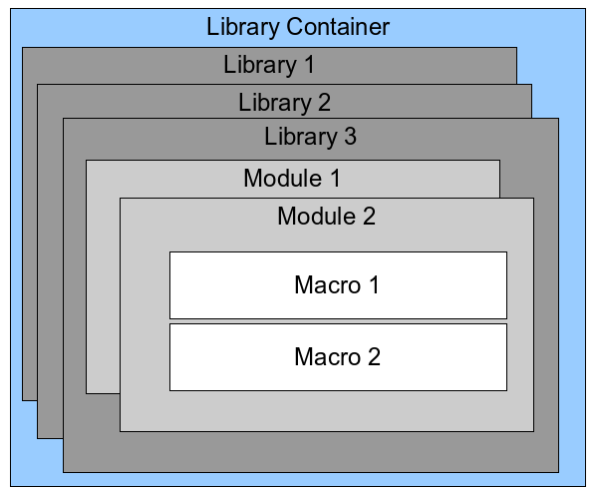
Figure 303: Macro Library hierarchy
A computer scientist would use Figure 304 to precisely describe the situation. The text “1..*” means one or more, and “0..*” means zero or more. The black triangle means composed of or contains.
- A library container contains one or more libraries, and each library is contained in one library container.
- A library contains zero or more modules, and each module is contained in one library.
- A module contains zero or more macros, and each macro is contained in one module.
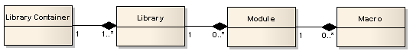Figure 304: Macro Library hierarchy
Use Tools → Macros → Organize Macros → LibreOffice Basic to open the LibreOffice Basic Macros dialog (see Figure 305). All available library containers are shown in the Macro from list. Every document is a library container, capable of containing multiple libraries. The application itself acts as two library containers, one container for macros distributed with LibreOffice called LibreOffice Macros, and one container for personal macros called My Macros. As shown in Figure 305, only two documents are currently open.
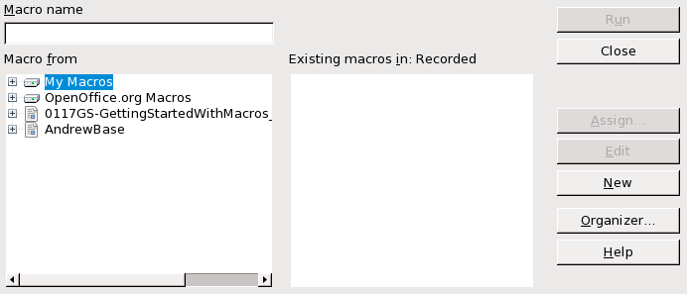Figure 305: Library containers are shown on the left
The LibreOffice Macros are stored with the application runtime code, which may not be editable to you unless you are an administrator. This is just as well since these macros should not be changed and you should not store your own macros in the LibreOffice container.
Unless your macros are applicable to a single document, and only to a single document, your macros will probably be stored in the My Macros container. The My Macros container is stored in your user area or home directory.
If a macro is contained in a document, then a recorded macro will attempt to work on that document; primarily because it uses “ThisComponent” for its actions.
Every library container contains a library named Standard. It is better to create your own libraries with meaningful names than to use the Standard library. Not only are meaningful names easier to manage, but they can also be imported into other library containers whereas the Standard library cannot.
Caution | LibreOffice allows you to import libraries into a library container, but it will not allow you to overwrite the library named Standard. Therefore, if you store your macros in the Standard library, you cannot import them into another library container.
Just as it makes good sense to give your libraries meaningful names, it is prudent to use meaningful names for your modules. By default, LibreOffice uses names such as Module1. Feel free to use your own meaningful name.
As you create your macros, you must decide where to store them. Storing a macro in a document is useful if the document will be shared and you want the macro to be included with the document. Macros stored in the application library container named My Macros, however, are globally available to all documents.
Macros are not available until the library that contains them is loaded. The Standard library and Template library, however, are automatically loaded. A loaded library is displayed differently from a library that is not loaded. To load the library and the modules it contains, double-click on the library.

Where are macros stored?
LibreOffice stores user-specific data in a directory under the user’s home directory. The location is operating system specific. Use Tools → Options → LibreOffice → Paths to view where other configuration data is stored. On Windows XP, this is C:\Documents and Settings\<name>\Application Data. User macros are stored in LibreOffice\3\user\basic. Each library is stored in its own directory off the basic directory.
It is not important to understand where macros are stored for casual use. If you know where they are stored, however, you can create a backup, share your macros, or inspect them if there is an error.
Use Tools → Macros → Organize Dialogs to open the LibreOffice Macro Organizer dialog. Another common way to open this dialog is to use Tools → Macros → Organize Macros → LibreOffice Basic to open the LibreOffice Macros dialog and then click the Organizer button.
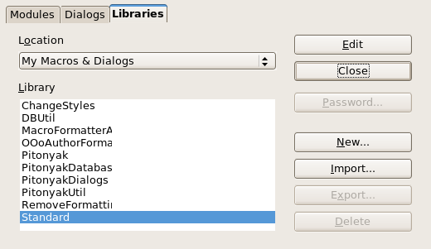
Figure 306: The macro organizer dialog

Importing macros
The LibreOffice Macro Organizer dialog provides functionality to create, delete, and rename libraries, modules, and dialogs. Select the library container to use and then click the Import button to import macro libraries (see Figure 307).
Note | You cannot import the library named Standard.
Tip | On Linux, the LibreOffice-specific files are stored in a directory whose name begins with a period. Directories and files with names beginning with a period are not shown in a normal selection dialog. To open the directory, I navigated to the parent directory, entered the name .LibreOffice\3, and then clicked Open. This opened the directory, which was not initially shown.
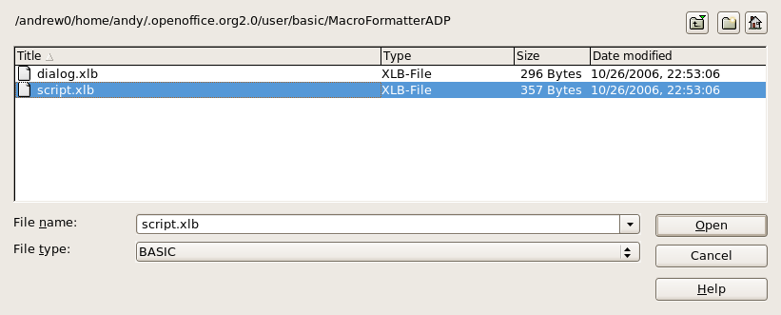Figure 307: Select a macro library to import
Navigate to the directory containing the library to import. There are usually two files from which to choose, dialog.xlb and script.xlb. It does not matter which of these two files you select; both will be imported. Select a file and click Open to continue.
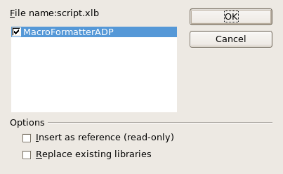Figure 308: Choose library import options
If the library already exists, it will not be replaced unless Replace existing libraries is checked. If Insert as reference is checked, the library is referenced in its current location, but you cannot edit the library. If Insert as reference is not checked, however, the library is copied to the user’s macro directory.
Macros can be stored in libraries inside LibreOffice documents. Select a document rather than a directory on disk (as shown in Figure 307) to import libraries contained in a document.

Downloading macros to import
Macros are available for download. Some macros are contained in documents, some as regular files that you must select and import, and some as macro text that should be copied and pasted into the Basic IDE; use Tools → Macros → Organize Macros → LibreOffice Basic to open the LibreOffice Macros dialog, choose the macro to edit, and then click Edit to open the macro in the Basic IDE.
Some macros are available as free downloads on the Internet (see Table 3). “Adding an existing macro“ on page 310 describes how to add these macros to your macros library.
Table 3. Places to find macro examples
Location | Description
http://www.ooomacros.org/ | Excellent collection of packaged macros.
http://www.pitonyak.org/oo.php | Reference materials regarding macros.
http://www.pitonyak.org/database/ | Reference materials regarding database macros.
http://development.LibreOffice/ | Lots of links to everything.
http://www.oooforum.org/ | Many examples and help.

How to run a macro
A typical method to run a macro is as follows:
- Use Tools → Macros → Run Macro to open the Macro Selector dialog (see Error: Reference source not found).
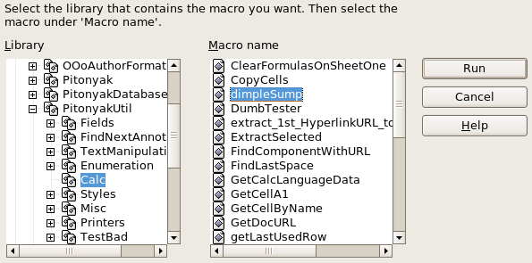Figure 309: Use the Macro Selector dialog to run macros
- Select the library and module in the Library list (left hand side).
- Select the macro in the Macro name list (right hand side).
- Click Run to run the macro.
Although you can use Tools → Macros → Run Macro to run all macros, this is not efficient for frequently run macros. A more common technique is to assign a macro to a toolbar button, menu item, keyboard shortcut, or a button embedded in a document. While choosing a method, it is also good to ask questions such as:
- Should the macro be available for only one document, or globally for all documents?
- Does the macro pertain to a specific document type, such as a Calc document?
- How frequently will the macro be used?
The answers will determine where to store the macro and how to make it available. For example, you will probably not add a rarely used macro to a toolbar. To help determine your choices, see Table 4.
Table 4. Methods for starting a macro
Type | LibreOffice | Document Type | Document
Toolbar | No | Yes | Yes
Menu | No | Yes | Yes
Shortcut | Yes | Yes | No
Event | Yes | No | Yes
To add a menu item, keyboard shortcut, or toolbar icon that calls a macro, use the Customize dialog (see Figure 310). Open this dialog in either of these ways:
- Choose Tools → Customize from the main menu bar.
- Each toolbar has an icon that opens a menu; choose the Customize Toolbar option.
Tip | Complete coverage of the Customize dialog is beyond the scope of this document. Click the Help button to access the help pages included with LibreOffice.
The Customize dialog contains tabs to configure menus, keyboard bindings, toolbars, and events.

Toolbar
Macros can be added to toolbars. For more about modifying toolbars, see Chapter 14, Customizing LibreOffice.

Menu item
Use Tools → Customize to open the Customize dialog, and select the Menus tab. You can modify an existing menu, or create new menus that call macros. For more about modifying menus, see Chapter 14.

Keyboard shortcuts
Use Tools → Customize to open the Customize dialog, and select the Keyboard tab. Assigning keyboard shortcuts is discussed in Chapter 14.
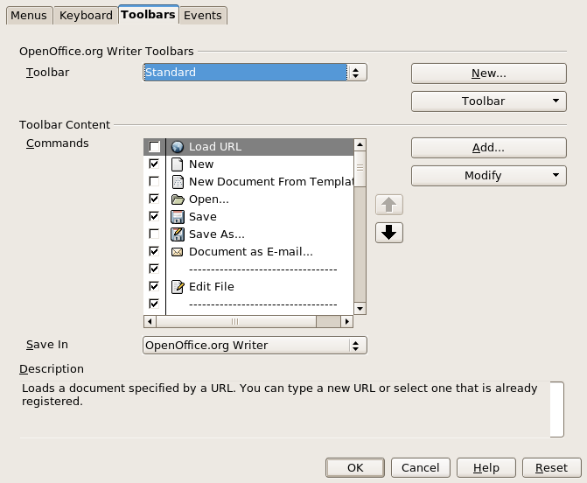Figure 310: LibreOffice Customize dialog

Event
In LibreOffice, when something happens, we say that an event occurred. For example, a document was opened, a key was pressed, or the mouse moved. LibreOffice allows events to cause a macro to be called; the macro is then called an event handler. Full coverage of event handlers is well beyond the scope of this document, but a little knowledge can accomplish much.
Caution | Be careful when you configure an event handler. For example, assume that you write an event handler that is called every time that a key is pressed, but you make a mistake so the event is not properly handled. One possible result is that your event handler will consume all key presses, forcing you to forcibly terminate LibreOffice.
Use Tools → Customize to open the Customize dialog, and select the Events tab (see Figure 311). The events in the Customize dialog are related to the entire application and specific documents. Use the Save In box to choose LibreOffice, or a specific document.
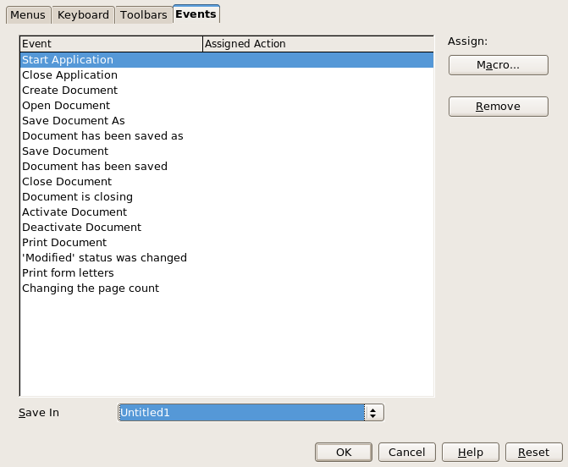Figure 311: Assign macro to an application level event
A common use is to assign the Open Document event to call a specific macro. The macro then performs certain setup tasks for the document. Select the desired event and click the Macro button to open the Macro Selector dialog (see Figure 312).
Select the desired macro and click OK to assign the macro to the event. The Events tab shows that the event has been assigned to a macro (see Figure 313). When the document opens, the PrintHello macro is run.
Many objects in a document can be set to call macros when events occur. The most common usage is to add a control, such as a button, into a document. Even double-clicking on a graphic opens a dialog with a Macros tab that allows you to assign a macro to an event.
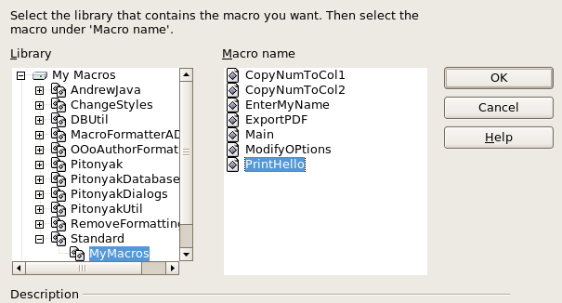
Figure 312: Assign macro to the document open event
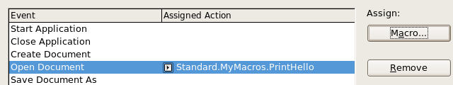
Figure 313: PrintHello is assigned to the Open Document event

Extensions
An extension is a package that can be installed into LibreOffice to add new functionality. Extensions can be written in almost any programming language and may be simple or sophisticated. Extensions can be grouped into types:
- Calc Add-Ins, which provide new functionality for Calc, including new functions that act like normal built-in functions
- New components and functionality, which normally include some level of UI integration such as new menus or toolbars
- Data pilots that are used directly in Calc
- Chart Add-Ins with new chart types
- Linguistic components such as spell checkers
- Document templates and images
Although individual extensions can be found in different places, there is an extension repository at: http://extensions.libreoffice.org/.
For more about obtaining and installing extensions, see Chapter 14, Customizing LibreOffice.

Writing macros without the recorder
The examples covered in this chapter are created using the macro recorder and the dispatcher. You can also write macros that directly access the objects that comprise LibreOffice. In other words, you can directly manipulate a document.
Directly manipulating LibreOffice's internal objects is an advanced topic that is beyond the scope of this chapter. A simple example, however, demonstrates how this works.
Listing 7: Append the text “Hello” to the current document.

Sub AppendHello
Dim oDoc
Dim sTextService$
Dim oCurs

REM ThisComponent refers to the currently active document.
oDoc = ThisComponent

REM Verify that this is a text document
sTextService = "com.sun.star.text.TextDocument"
If NOT oDoc.supportsService(sTextService) Then
MsgBox "This macro only works with a text document"
Exit Sub
End If

REM Get the view cursor from the current controller.
oCurs = oDoc.currentController.getViewCursor()

REM Move the cursor to the end of the document
oCurs.gotoEnd(False)

REM Insert text "Hello" at the end of the document
oCurs.Text.insertString(oCurs, "Hello", False)
End Sub

Finding more information
Numerous resources are available that provide help with writing macros. Use Help → LibreOffice Help to open the LibreOffice help pages. The upper left corner of the LibreOffice help system contains a drop-down list that determines which help set is displayed. To view the help for Basic, choose LibreOffice Basic from this list.

Included material
Many excellent macros are included with LibreOffice. Use Tools → Macros → Organize Macros → LibreOffice Basic to open the Macro dialog. Expand the Tools library in the LibreOffice library container. Inspect the Debug module—some good examples include WritedbgInfo(document) and printdbgInfo(sheet).

Online resources
The following links and references contain information regarding macro programming:
http://www.pitonyak.org/oo.php (Andrew Pitonyak’s macro page)
http://www.pitonyak.org/AndrewMacro.odt (numerous examples of working macros)
http://www.pitonyak.org/book/ (Andrew Pitonyak’s book on macros)
http://www.pitonyak.org/database/ (numerous macro examples using Base)
http://docs.sun.com/app/docs/doc/819-0439 (StarOffice 8 Programming Guide for BASIC)

Getting Started Guide

Chapter 14
Customizing LibreOffice

Introduction
This chapter describes some common customizations that you may wish to do.
You can customize menus, toolbars, and keyboard shortcuts in LibreOffice, add new menus and toolbars, and assign macros to events. However, you cannot customize context (right-click) menus.
Other customizations are made easy by extensions that you can install from the LibreOffice website or from other providers.
Note | Customizations to menus and toolbars can be saved in a template. To do so, first save them in a document and then save the document as a template as described in Chapter 3, Styles and Templates.

Customizing menu content
In addition to changing the menu font (described in Chapter 2), you can add and rearrange items on the menu bar, add items to menus, and make other changes.
To customize menus:
- Choose Tools → Customize.
- On the Customize dialog, pick the Menus page.
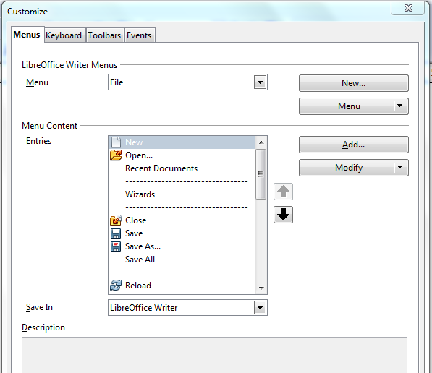
Figure 314. The Menus page of the Customize dialog
- In the Save In drop-down list, choose whether to save this changed menu for the application (for example, LibreOffice Writer) or for a selected document (for example, SampleDocument.odt).
- In the section LibreOffice [name of the program (example: Writer)] Menus, select from the Menu drop-down list the menu that you want to customize. The list includes all the main menus as well as submenus (menus that are contained under another menu). For example, in addition to File, Edit, View, and so on, there is File | Send and File |Templates. The commands available for the selected menu are shown in the central part of the dialog.
- To customize the selected menu, click on the Menu or Modify buttons. You can also add commands to a menu by clicking on the Add button. These actions are described in the following sections. Use the up and down arrows next to the Entries list to move the selected menu item to a different position.
- When you have finished making all your changes, click OK (not shown in illustration) to save them.

Creating a new menu
In the Customize dialog, click New to display the dialog shown in Figure 315.
- Type a name for your new menu in the Menu name box.
- Use the up and down arrow buttons to move the new menu into the required position on the menu bar.
- Click OK to save.
The new menu now appears on the list of menus in the Customize dialog. (It will appear on the menu bar itself after you save your customizations.)
After creating a new menu, you need to add some commands to it, as described in “Adding a command to a menu” on page 334.
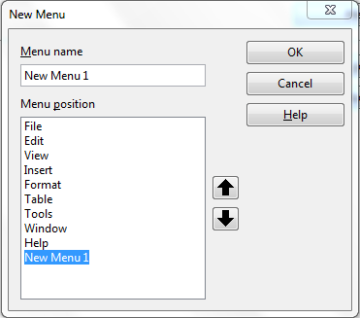Figure 315: Adding a new menu

Modifying existing menus
To modify an existing menu, select it in the Menu list and click the Menu button to drop down a list of modifications: Move, Rename, Delete. Not all of these modifications can be applied to all the entries in the Menu list. For example, Rename and Delete are not available for the menus supplied by LibreOffice.
To move a menu (such as File), choose Menu → Move. A dialog similar to the one shown in Figure 315 (but without the Menu name box) opens. Use the up and down arrow buttons to move the menu into the required position.
To move submenus (such as File | Send), select the main menu (File) in the Menu list and then, in the Menu Content section of the dialog, select the submenu (Send) in the Entries list and use the arrow keys to move it up or down in the sequence.
In addition to renaming, you can specify a keyboard shortcut that allows you to select a menu command when you press Alt+ an underlined letter in a menu command.
- Select a menu entry.
- Click the Modify button and select Rename.
- Add a tilde (~) in front of the letter that you want to use as an accelerator. For example, to select the Save All command by pressing Alt+V (after opening the File menu using Alt+F), enter Sa~ve All.
Caution | Be careful when using these shortcuts. In the example above, if the File menu is not already open, then pressing Alt+V opens the View menu; if another other menu is open, Alt+V may activate another command.

Adding a command to a menu
You can add commands to the supplied menus and to menus you have created. On the Customize dialog, select the menu in the Menu list and click the Add button in the Menu Content section of the dialog.
On the Add Commands dialog (Figure 316), select a category and then the command, and click Add. The dialog remains open, so you can select several commands. When you have finished adding commands, click Close. Back on the Customize dialog, you can use the up and down arrow buttons to arrange the commands in your preferred sequence.

Modifying menu entries
In addition to changing the sequence of entries on a menu or submenu, you can add submenus, rename or delete the entries, and add group separators.
To begin, select the menu or submenu in the Menu list near the top of the Customize page, then select the entry in the Entries list under Menu Content. Click the Modify button and choose the required action from the drop-down list of actions.
Most of the actions should be self-explanatory. Begin a group adds a separator line after the highlighted entry.
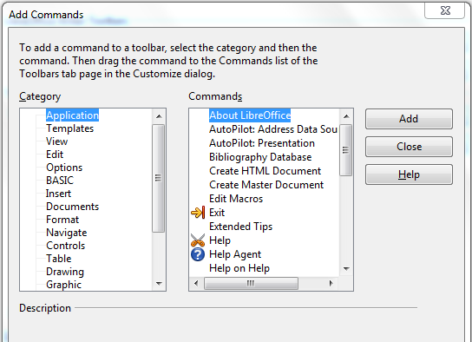Figure 316: Adding a command to a menu

Customizing toolbars
You can customize toolbars in several ways, including choosing which icons are visible and locking the position of a docked toolbar, as described in Chapter 1, Introducing LibreOffice. This section describes how to create new toolbars and add other icons (commands) to the list of those available on a toolbar.
To get to the toolbar customization dialog, do any of the following:
- On the toolbar, click the arrow at the end of the toolbar and choose Customize Toolbar.
- Choose View → Toolbars → Customize from the menu bar.
- Choose Tools → Customize from the menu bar and pick the Toolbars page (Figure 317).
To customize toolbars:
- In the Save In drop-down list, choose whether to save this changed toolbar for the application (for example, Writer) or for a selected document.
- In the section LibreOffice <name of the program (example: Writer) → Toolbars, select from the Toolbar drop-down list the toolbar that you want to customize.
- You can create a new toolbar by clicking on the New button, or customize existing toolbars by clicking on the Toolbar or Modify buttons, and add commands to a toolbar by clicking on the Add button. These actions are described below.
- When you have finished making all your changes, click OK to save them.
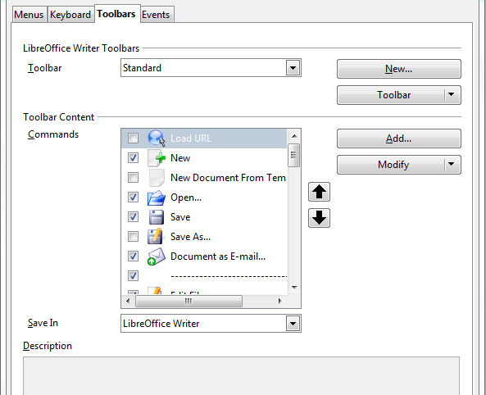
Figure 317. The Toolbars page of the Customize dialog

Creating a new toolbar
To create a new toolbar:
- Choose Tools → Customize → Toolbars from the menu bar.
- Click New. On the Name dialog, type the new toolbar's name and choose from the Save In drop-down list where to save this changed menu: for the application (for example, Writer) or for a selected document. Click OK.
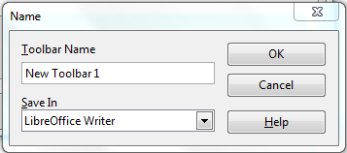
The new toolbar now appears on the list of toolbars in the Customize dialog. After creating a new toolbar, you need to add some commands to it, as described below.

Adding a command to a toolbar
If the list of available buttons for a toolbar does not include all the commands you want on that toolbar, you can add commands. When you create a new toolbar, you need to add commands to it.
- On the Toolbars page of the Customize dialog, select the toolbar in the Toolbar list and click the Add button in the Toolbar Content section of the dialog.
- The Add Commands dialog is the same as for adding commands to menus (Figure 316). Select a category and then the command, and click Add. The dialog remains open, so you can select several commands. When you have finished adding commands, click Close. If you insert an item which does not have an associated icon, the toolbar will display the full name of the item: the next section describes how to choose an icon for a toolbar command.
- Back on the Customize dialog, you can use the up and down arrow buttons to arrange the commands in your preferred sequence.
- When you are done making changes, click OK to save.

Choosing icons for toolbar commands
Toolbar buttons usually have icons, not words, on them, but not all of the commands have associated icons.
To choose an icon for a command, select the command and click Modify → Change icon. On the Change Icon dialog, you can scroll through the available icons, select one, and click OK to assign it to the command.
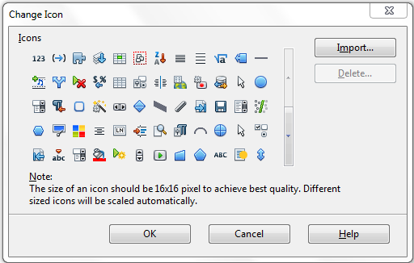Figure 318: Change Icon dialog
To use a custom icon, create it in a graphics program and import it into LibreOffice by clicking the Import button on the Change Icon dialog. Custom icons should be 16 x 16 pixels in size to achive the best quality and should not contain more than 256 colors.

Example: Adding a Fax icon to a toolbar
You can customize LibreOffice so that a single click on an icon automatically sends the current document as a fax.
- Be sure the fax driver is installed. Consult the documentation for your fax modem for more information.
- Choose Tools → Options → LibreOffice Writer → Print. The dialog shown in Figure 319 opens.
- Select the fax driver from the Fax list and click OK.
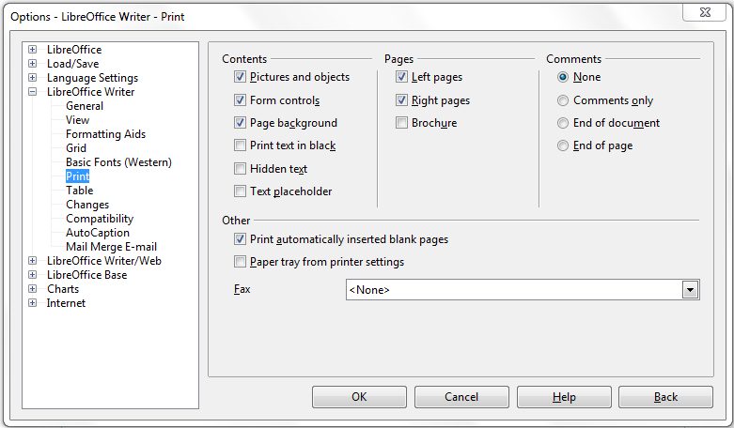Figure 319: Setting up LibreOffice for sending faxes
- Click the arrow icon at the end of the Standard toolbar. In the drop-down menu, choose Customize Toolbar. The Toolbars page of the Customize dialog appears (Figure 317). Click Add.
- On the Add Commands dialog (Figure 320), select Documents in the Category list, then select Send Default Fax in the Commands list. Click Add. Now you can see the new icon in the Commands list.
- In the Commands list, click the up or down arrow button to position the new icon where you want it. Click OK and then click Close.
Your toolbar now has a new icon to send the current document as a fax.
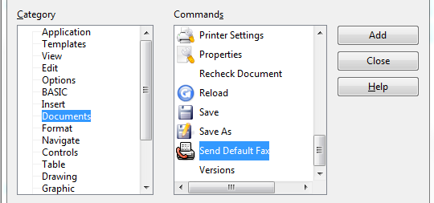
Figure 320: Adding a Send Fax command to a toolbar

Assigning shortcut keys
In addition to using the built-in keyboard shortcuts (listed in Appendix A), you can define your own. You can assign shortcuts to standard LibreOffice functions or your own macros and save them for use with the entire LibreOffice suite.
Caution | Be careful when reassigning your operating system’s or LibreOffice’s predefined shortcut keys. Many key assignments are universally understood shortcuts, such as F1 for Help, and are always expected to provide certain results. Although you can easily reset the shortcut key assignments to the LibreOffice defaults, changing some common shortcut keys can cause confusion, especially if other users share your computer.
To adapt shortcut keys to your needs, use the Customize dialog, as described below.
- Select Tools → Customize → Keyboard. The Customize dialog opens.
- To have the shortcut key assignment available in all components of LibreOffice select the LibreOffice radio button.
- Next select the required function from the Category and Function lists.
- Now select the desired shortcut keys in the Shortcut keys list and click the Modify button at the upper right.
- Click OK to accept the change. Now the chosen shortcut keys will execute the function chosen in step 3 above whenever they are pressed.
Note | All existing shortcut keys for the currently selected Function are listed in the Keys selection box. If the Keys list is empty, it indicates that the chosen key combination is free for use. If it were not, and you wanted to reassign a shortcut key combination that is already in use, you must first delete the existing key.  Shortcut keys that are greyed-out in the listing on the Customize dialog, such as F1 and F10, are not available for reassignment.

Example: Assigning styles to shortcut keys
You can configure shortcut keys to quickly assign styles in your document. Some shortcuts are predefined, such as Ctrl+0 for the Text body paragraph style, Ctrl+1 for the Heading 1 style, and Ctrl+2 for Heading 2. You can modify these shortcuts and create your own.
- Click Tools → Customize → Keyboard. The Keyboard page of the Customize dialog (Figure 321) opens.
- To have the shortcut key assignment available only with one component (for example, Writer), select that component’s name in the upper right corner of the page; otherwise select LibreOffice button to make it available to every component.
- Choose the shortcut keys you want to assign a style to. In this example, we have chosen Ctrl+9.
- In the Functions section at the bottom of the dialog, scroll down in the Category list to Styles. Click the expansion symbol (usually a + sign or triangle) to expand the list of styles.
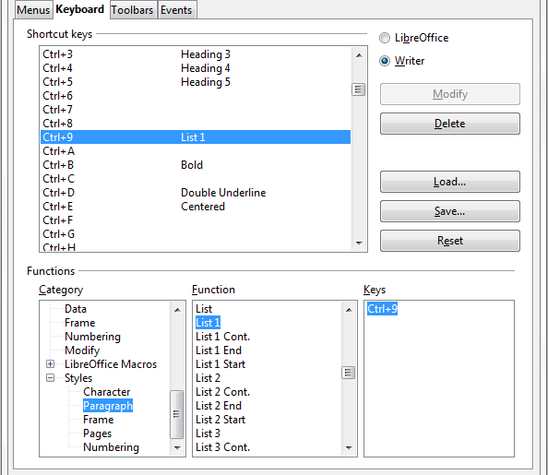
Figure 321. Defining keyboard shortcuts for applying styles
- Choose the category of style. (This example uses a paragraph style, but you can also choose character styles and others.) The Function list will display the names of the available styles for the selected category. The example shows some of LibreOffice’s predefined styles.
- To assign Ctrl+9 to be the shortcut key combination for the List 1 style, select List 1 in the Function list, and then click Modify. Ctrl+9 now appears in the Keys list on the right, and List 1 appears next to Ctrl+9 in the Shortcut keys box at the top.
- Make any other required changes, and then click OK to save these settings and close the dialog.

Saving changes to a file
Changes to the shortcut key assignments can be saved in a keyboard configuration file for use at a later time, thus permitting you to create and apply different configurations as the need arises. To save keyboard shortcuts to a file:
- After making your keyboard shortcut assignments, click the Save button at the right of the Customize dialog (Figure 321).
- In the Save Keyboard Configuration dialog, select All files from the Save as Type list.
- Next enter a name for the keyboard configuration file in the File name box, or select an existing file from the list. If you need to, browse to find a file from another location.
- Click Save. A confirmation dialog appears if you are about to overwrite an existing file, otherwise there will be no feedback and the file will be saved.

Loading a saved keyboard configuration
To load a saved keyboard configuration file and replace your existing configuration, click the Load button at the right of the Customize dialog, and then select the configuration file from the Load Keyboard Configuration dialog.

Resetting the shortcut keys
To reset all of the keyboard shortcuts to their default values, click the Reset button near the bottom right of the Customize dialog. Use this feature with care as no confirmation dialog will be displayed; the defaults will be set without any further notice or user input.

Assigning macros to events
In LibreOffice, when something happens, we say that an event occured. For example, a document was opened, a key was pressed, or the mouse moved. You can associate a macro with an event, so the macro is run when the event occurs. A common use is to assign the “open document” event to run a macro that performs certain setup tasks for the document.
To associate a macro with an event, use the Events page of the Customize dialog. For more information, see Chapter 13, Getting Started with Macros.

Adding functionality with extensions
An extension is a package that can be installed into LibreOffice to add new functionality.
The official extension repository is located at http://extensions.libreoffice.org/. These extensions are free of charge.

Installing extensions
To install an extension, follow these steps:
- Download an extension and save it anywhere on your computer.
- In LibreOffice, select Tools → Extension Manager from the menu bar. In the Extension Manager dialog (Figure 322), click Add.
- A file browser window opens. Find and select the extension you want to install and click Open. The extension begins installing. You may be asked to accept a license agreement.
- When the installation is complete, the extension is listed in the Extension Manager dialog.
Tip | To download extensions that are listed in the repository, open the Extension Manager and click the Get more extensions online... link.
Figure 322: Using the Extension Manager
Note | To install a shared extension, you will need write access to the LibreOffice installation directory.

Some popular extensions
This section describes a few of the more popular extensions to LibreOffice. Some are installed by default. If the extension is not already installed on your system, see “Installing extensions” in the previous section for step-by-step instructions. All tools listed here are open source and free of charge.
PDF Import
Enables you to make minor modifications to the text of existing PDF files when the original source files do not exist or you are unable to open the source files. (Whenever possible, modify the source and regenerate the PDF to obtain the best results.)
When the extension is installed, PDF is listed as a choice in the File Type drop-down list in the File → Open dialog.
Best results can be achieved with the PDF/ODF hybrid file format, which this extension also enables. A hybrid PDF/ODF file is a PDF file that contains an embedded ODF source file. Hybrid PDF/ODF files will be opened in LibreOffice as an ODF file without any layout changes.
Non-hybrid PDF documents open in Draw. Depending on the complexity of the layout, changes may be easy or difficult to make, and the saved result may or may not preserve the original layout. Font substitution may occur.
Documents with more sophisticated layouts, such as those created with professional desktop publishing applications that use special fonts and complex vector graphics, are not suitable for the PDF Import Extension. Similarly, importing large documents may cause performance issues.
Presenter Console
Provides extra control over Impress presentations; for example, the presenter has ability to see the upcoming slide, the slide notes, and a presentation timer—while the audience sees only the current slide. The Presenter Console displays the elements in three easily changeable views:
- The first view displays the current slide, including the effects, and the upcoming slide.
- The second view shows the speaker's notes in large, clear, and scalable type, plus the current and upcoming slide.
- The third view is a slide sorter view with the slide thumbnails.
Note | The Presenter Console works only on operating systems that support multiple displays.
Report Builder
Creates professional database reports from Base. You can define group and page headers, group and page footers, and calculation fields. Export your reports to PDF or OpenDocument formats, or send them as email attachments.
Professional Template Pack II
Provides more than 120 templates for Writer, Calc, and Impress. Available in several languages. After you have installed this extension, you will find the templates under File → New → Templates and Documents.
Template Changer (for Writer)
Adds two new items to the File → Templates menu in Writer that allow you to assign a new template to the current document or to a folder of documents. All styles and formatting will be loaded from that template and the document will behave as it was created using that template.
Solver for Nonlinear Programming (for Calc)
Calc ships with a solver engine for linear programming only. This extension adds more solvers, which are capable of handling nonlinear problems as well as linear ones:
- DEPS - Differential Evolution & Particle Swarm Optimization
- SCO - Social Cognitive Optimization
DataPilot Tools for Calc
Adds some utility functions that make using the Calc DataPilot easier:
- Display the current source range for a DataPilot
- Change the source range for a DataPilot
- Refresh all DataPilots on the current sheet
Getting Started Guide

Appendix A
Keyboard Shortcuts

Introduction
You can use LibreOffice without requiring a pointing device, such as a mouse or touchpad, by using its built-in keyboard shortcuts.
This appendix lists some of the most common built-in keyboard shortcuts that apply to all components of LibreOffice. For shortcuts specific to Writer, Calc, Impress, Draw, or Base read the relevant component guide or search the application Help.
Note | Some of the shortcuts listed here may not work if your operating system uses the same shortcuts for other tasks.  To resolve any conflicts, assign different keys to these shortcuts by reconfiguring either LibreOffice (see Chapter 14) or your operating system (see system documentation).

Tip for Macintosh users
Some keystrokes are different on a Mac from those used in Windows and Linux. The following table gives some common substitutions for the instructions in this book. For a more detailed list, see the application Help.
Windows/Linux | Mac equivalent | Effect
Right-click | Control+click | Opens a context menu
Ctrl (Control) | z (Command) | Used with other keys
F5 | Shift+z+F5 | Opens the Navigator
F11 | z+T | Opens the Styles & Formatting window

General keyboard shortcuts

Opening menus and menu items
Shortcut Keys | Result
Alt+<?> | Opens a menu where <?> is the underlined character of the menu you want to open. For example, Alt+T opens the menu Tools.
Alt+<?>+<*> | Opens a menu item where <?> is the underlined character of the menu you want to open and <*> is the item within that menu. For example, Alt+T+G opens the Gallery menu item in the menu Tools.
Esc | Closes an open menu.

Controlling dialogs
When you open any dialog, one element (such as a button, an option field, an entry in a list box, or a checkbox) is highlighted or indicated by a dotted box around the field or button name. This element is said to have the focus on it.
Shortcut Keys | Result
Enter | Activates selected button. In most cases where no button is selected, Enter is equivalent to clicking OK.
Esc | Closes dialog without saving any changes made while it was open. In most cases, Esc is equivalent to clicking Cancel. When an open drop-down list is selected, Esc closes the list.
Spacebar | Checks an empty checkbox. Clears a checked checkbox.
Up, down arrow keys | Moves focus up and down a list. Increases or decreases value of a variable. Moves focus vertically within a section of dialog.
Left, right arrow keys | Moves focus horizontally within a section of a dialog.
Tab | Advances focus to the next section or element of a dialog.
Shift+Tab | Returns focus to the previous section or element in a dialog.
Alt+Down Arrow | Shows items in a drop-down list.

Getting help
Shortcut Keys | Result
F1 | Opens the LibreOffice Help dialog. In LibreOffice Help: jumps to the first help page of the selected tab.
Shift+F1 | Turns the cursor into the What’s This? question mark. Shows the tip for an item underneath the cursor.
Shift+F2 | Shows tip for a selected item.
Esc | In LibreOffice Help: goes up one level.

Managing documents
Shortcut Keys | Result
Ctrl+F4 or Alt+F4 | Closes the current document. Closes LibreOffice when the last open document is closed.
Ctrl+O | Launches the Open dialog to open a document.
Ctrl+S | Saves the current document. If you are working on a previously unsaved file, the shortcut launches the Save As dialog.
Ctrl+N | Creates a new document.
Shift+Ctrl+N | Opens the Templates and Documents dialog.
Ctrl+P | Opens the Print dialog to print the document.
Ctrl+Q | Closes the application.
Del | In the Save and Open dialogs, deletes the selected files or folders. Items can be retrieved from the Recycle Bin (Trash).
Shift+Del | In the Save and Open dialogs, deletes the selected files or folders. Items are permanently deleted: they can not be retrieved from the Recycle Bin.
Backspace | In the Save and Open dialogs, shows contents of the current directory's parent folder.

Navigating across LibreOffice
Shortcut Keys | Result
F6 | Selects next subwindow (for example: Menu bar, Standard toolbar, document view, and so on).
Shift+F6 | Selects previous subwindow.
F10 | Selects the first menu, typically the File menu.
Shift+F10 | Opens the context menu.

Editing
Shortcut Keys | Result
Ctrl+X | Cuts selected items.
Ctrl+C | Copies selected items.
Ctrl+V | Pastes copied or cut items from the clipboard.
Ctrl+Shift+V | Opens the Paste Special dialog.
Ctrl+A | Selects all.
Ctrl+Z | Undoes last action.
Ctrl+Y | Redoes last action.
Ctrl+Shift+Y | Repeats last command.
Ctrl+F | Opens the Find & Replace dialog.
Ctrl+Shift+F | Searches for the last entered search term.
Ctrl+Shift+R | Refreshes (redraws) the document view.
Ctrl+Shift+I | Shows or hides the cursor in read-only text.

Stopping macros
Shortcut Keys | Result
Shift+Ctrl+Q | Stops a running macro.

Defining keyboard shortcuts
In addition to using the built-in keyboard shortcuts listed in this Appendix, you can define your own. See Chapter 14, Customizing LibreOffice, for instructions.

Further reading
For help with LibreOffice’s keyboard shortcuts, or using LibreOffice with a keyboard only, search the application Help using the “shortcut keys” or “accessibility” keywords.
Getting Started Guide

Appendix B
Open Source, Open Standards, OpenDocument

Introduction
LibreOffice is a productivity suite that is compatible with other major office suites, and available on a variety of platforms. It is open source software and therefore free to download, use and distribute. If you are new to LibreOffice, this appendix will provide some information regarding it's history, it's community and some of it's technical specifications.

A short history of LibreOffice
The OpenOffice.org project began when Sun Microsystems released the source code (“blueprints”) for its StarOffice® software to the open source community on October 13, 2000. OpenOffice.org 1.0, the product, was released on April 30, 2002. On January 26, 2010, Oracle Corporation acquired Sun Microsystems.
On September 28, 2010, the community of volunteers who develop and promote OpenOffice.org announce a major change in the project’s structure. After ten years’ successful growth with Sun Microsystems as founding and principle sponsor, the project launches an independent foundation called "The Document Foundation", to fulfil the promise of independence written in the original charter. This Foundation will become the cornerstone of a new ecosystem where individuals and organisations can contribute to and benefit from the availability of a truly free office suite.
Major updates to OpenOffice.org include version 2.0 in October 2005 and version 3.0 in October 2008. The release of LibreOffice 3.3, the first release by the newly formed The Document Foundation community, is expected in early 2011. Since version 2.0, OpenOffice.org has supported the open standard OASIS OpenDocument as its default file format.
You can read more about The Document Foundation at: http://www.documentfoundation.org/

The LibreOffice community
The Document Foundation's mission is:
“...to facilitate the evolution of the OpenOffice.org Community into a new open, independent, and meritocratic organizational structure within the next few months. An independent Foundation is a better match to the values of our contributors, users, and supporters, and will enable a more effective, efficient, transparent, and inclusive Community. We will protect past investments by building on the solid achievements of our first decade, encourage wide participation in the Community, and co-ordinate activity across the Community.”
Some of our corporate supporters include Canonical, The GNOME Foundation, Google, Novell and Red Hat. Additonally, over 450,000 people from nearly every part of the globe have joined this project with the idea of creating the best possible office suite that all can use. This is the essence of an “open source” community!
With its open source software licence, LibreOffice is key in the drive to provide an office suite that is available to anyone, anywhere, for commercial or personal use. The software has been translated into many languages and runs on all major operating systems. New functionality can be added in the form of extensions.
The LibreOffice community invites contributors in all areas, including translators, software developers, graphic artists, technical writers, editors, donors and end-user support. Whatever you do best, you can make a difference in LibreOffice. The Community operates internationally in all time zones and in many languages, linked through the internet at www.libreoffice.org and www.documentfoundation.org.

How is LibreOffice licensed?
LibreOffice is distributed under the Open Source Initiative (OSI) approved Lesser General Public License (LGPL).
The LGPL license is available at The Document Foundation's website at: http://www.documentfoundation.org/lgpl/

What is “open source”?
The four essential rights of open-source software are embodied within the Free Software Foundation’s General Public License (GPL):
- The right to use the software for any purpose.
- Freedom to redistribute the software for free or for a fee.
- Access to the complete source code of the program (that is, the “blueprints”).
- The right to modify any part of the source, or use portions of it in other programs.
The basic idea behind open source is very simple: When programmers can read, redistribute, and modify the source code for a piece of software, the software evolves. People improve it, people adapt it, people fix bugs.
For more information on Free and Open Source software, visit these websites:
Open Source Initiative (OSI): http://www.opensource.org
Free Software Foundation (FSF): http://www.gnu.org

What are “open standards”?
An open standard provides a means of doing something that is independent of manufacturer or vendor, thus enabling competing software programs to freely use the same file formats. HTML, XML, and ODF are examples of open standards for documents.
An open standard meets the following requirements:
- It is well documented with the complete specification publically available, either free or at a nominal charge.
- It can be freely copied, distributed and used. The intellectual property of the standard is made irrevocably available on a royalty-free basis.
- It is standardized and maintained in an independent, open forum (also called "standards organization") using an open process.

What is OpenDocument?
OpenDocument (ODF) is an XML-based file format for office documents (text documents, spreadsheets, drawings, presentations and more), developed at OASIS (http://www.oasis-open.org/who/), an independent, international standards group.
Unlike other file formats, ODF is an open standard. It is publicly available, royalty-free, and without legal or other restrictions; therefore ODF files are not tied to a specific office suite and anybody can build a program that interprets these files. For this reason ODF is quickly becoming the preferred file format for government agencies, schools and other companies who prefer not to be too dependent on any one software supplier.
LibreOffice saves documents in Open Document Format by default. LibreOffice 3 has adopted version 1.2 of the OpenDocument standard. LibreOffice can also open and save many other file formats; see “File formats LibreOffice can open” on page 355, “File formats LibreOffice can save to” on page 357, and “Exporting to other formats” on page 358.

OpenDocument filename extensions
The most common filename extensions used for OpenDocument documents are:
*.odt for word processing (text) documents
*.ods for spreadsheets
*.odp for presentations
*.odb for databases
*.odg for graphics (vector drawings)
*.odf for formulas (mathematical equations)

Frequently asked questions
May I distribute LibreOffice to anyone? | Yes.
How many computers may I install it on? | As many as you like.
May I sell it? | Yes.
May I use LibreOffice in my business? | Yes.
Is LibreOffice available in my language? | LibreOffice has been translated (localized) into over 40 languages, so your language probably is supported. Additionally, there are over 70 spelling, hyphenation, and thesaurus dictionaries available for languages, and dialects that do not have a localized program interface. The dictionaries are available from the LibreOffice website at: www.libreoffice.org or at (http://extensions.services.openoffice.org/en/dictionaries)
How can you make it for free? | LibreOffice is developed and maintained by volunteers and has the backing of several orgainzations.
What if I need technical support? | Read the section titled “How to get help” in Chapter 1 (Introducting LibreOffice).
Who owns the software?
Does that mean that they can take away the software? | No. The licenses under which LibreOffice is developed and distributed can never be revoked, so it cannot be taken away.
I am writing a software application. May I use programming code from LibreOffice in my program? | You may, within the parameters set in the LGPL. Read the license: http://www.documentfoundation.org/lgpl/
Why do I need Java to run LibreOffice? Is it written in Java? | LibreOffice is not written in Java; it is written in the C++ language. Java is one of several languages that can be used to extend the software. The Java JDK/JRE is only required for some features. The most notable one is the HSQLDB relational database engine.  Note: Java is available at no cost. If you do not want to use Java, you can still use nearly all of the features of LibreOffice.
How can I contribute to LibreOffice? | You can help with the development of LibreOffice in many ways, and you do not need to be a programmer. To start, check out this webpage: http://www.documentfoundation.org/contribution/
What’s the catch? | There really is none; you can read the licenses here: http://www.documentfoundation.org/lgpl/

File formats LibreOffice can open
LibreOffice can open a wide variety of file formats in addition to the OpenDocument formats.

Opening text documents
In addition to OpenDocument formats (.odt, .ott, .oth, and .odm), Writer 3 can open the formats used by OOo 1.x (.sxw, .stw, and .sxg) and the following text document formats:
Microsoft Word 6.0/95/97/2000/XP) (.doc and .dot)
Microsoft Word 2003 XML (.xml)
Microsoft Word 2007 XML (.docx, .docm, .dotx, .dotm)
Microsoft WinWord 5 (.doc)
WordPerfect Document (.wpd)
WPS 2000/Office 1.0 (.wps)
Rich Text Format (.rtf)
Text CSV (.csv and .txt)
StarWriter formats (.sdw, .sgl, .vor)
DocBook (.xml)
Unified Office Format text (.uot, .uof)
Ichitaro 8/9/10/11 (.jtd and .jtt)
Hangul WP 97 (.hwp)
T602 Document (.602, .txt)
AportisDoc (Palm) (.pdb)
Pocket Word (.psw)
HTML Document (.htm, .html)
Most of these file types are automatically detected by LibreOffice, so they can be opened without explicitly selecting the document type in the file picker.
When opening .htm or .html files (used for web pages), LibreOffice customizes Writer for working with these files.

Opening spreadsheets
In addition to OpenDocument formats (.ods and .ots), Calc 3 can open the formats used by OOo 1.x (.sxc and .stc) and the following spreadsheet formats:
Microsoft Excel 97/2000/XP (.xls, .xlw, and .xlt)
Microsoft Excel 4.x–5.0/95 (.xls, .xlw, and .xlt)
Microsoft Excel 2003 XML (.xml)
Microsoft Excel 2007 XML (.xlsx, .xlsm, .xlts, .xltm)
Microsoft Excel 2007 binary (.xlsb)
Lotus 1-2-3 (.wk1, .wks, and .123)
Data Interchange Format (.dif)
Rich Text Format (.rtf)
Text CSV (.csv and .txt)
StarCalc formats (.sdc and .vor)
dBASE (.dbf)
SYLK (.slk)
Unified Office Format spreadsheet (.uos, .uof)
HTML Document (.htm and .html files, including Web page queries)
Pocket Excel (pxl)
Quattro Pro 6.0 (.wb2)

Opening presentations
In addition to OpenDocument formats (.odp, .odg, and .otp), Impress 3 can open the formats used by OOo 1.x (.sxi and .sti) and the following presentation formats:
Microsoft PowerPoint 97/2000/XP (.ppt and .pot)
Microsoft PowerPoint 2007 (.pptx, .pptm, .potx, .potm)
StarDraw and StarImpress (.sda, .sdd, .sdp, and .vor)
Unified Office Format presentation (.uop, .uof)
CGM – Computer Graphics Metafile (.cgm)
Portable Document Format (.pdf)

Opening graphic files
In addition to OpenDocument formats (.odg and .otg), Draw 3 can open the formats used by OOo 1.x (.sxd and .std) and the following graphic formats:
BMP | JPEG, JPG | PCX | PSD | SGV | WMF
DXF | MET | PGM | RAS | SVM | XBM
EMF | PBM | PLT | SDA | TGA | XPM
EPS | PCD | PNG | SDD | TIF, TIFF
GIF | PCT | PPM | SGF | VOR

Opening formula files
In addition to OpenDocument Formula (.odf) files, Math 3 can open the format used by OOo 1.x (.sxm), StarMath, (.smf), and MathML (.mml) files.
When opening a Word document that contains an embedded equation editor object, if the option for it (MathType to LibreOffice Math or reverse) is checked in Tools → Options → Load/Save → Microsoft Office, the object will be automatically converted to an LibreOffice Math object.

File formats LibreOffice can save to
Saving in an OpenDocument format guarantees the correct rendering of the file when it is transferred to another person or when the file is re-opened with a later version of LibreOffice. It is strongly recommended that you use ODF as default file format. However, you can save files in other formats, if you wish.
Tip | When sharing a document that you do not expect or want the recipient to modify, the safest option is to convert the document to PDF. LibreOffice provides a very straightforward way to convert documents to PDF. See Chapter 10 (Printing, Exporting, and E-Mailing) in this book.

Saving text documents
In addition to OpenDocument formats (.odt and .ott), Writer 3 can save in these formats:
OpenOffice.org 1.x Text Document (.sxw)
OpenOffice.org 1.x Text Document Template (.stw)
Microsoft Word 6.0, 95, and 97/2000/XP (.doc)
Microsoft Word 2003 XML (.xml)
Microsoft Word 2007 (.docx)
Office Open XML Text (.docx)
Rich Text Format (.rtf)
StarWriter 3.0, 4.0, and 5.0 (.sdw)
StarWriter 3.0, 4.0, and 5.0 Template (.vor)
Text (.txt)
Text Encoded (.txt)
Unified Office Format text (.uot, .uof)
HTML Document (OpenOffice.org Writer) (.html and .htm)
DocBook (.xml)
AportisDoc (Palm) (.pdb)
Pocket Word (.psw)
Encryption support within the Microsoft Word 97/2000/XP filter allows password protected Microsoft Word documents to be saved.
Note | The .rtf format is a common format for transferring text files between applications, but you are likely to experience loss of formatting and images. For this reason, other formats should be used.

Saving spreadsheet files
In addition to OpenDocument formats (.ods and .ots), Calc 3 can save in these formats:
OpenOffice.org 1.x Spreadsheet (.sxc)
OpenOffice.org 1.x Spreadsheet Template (.stc)
Microsoft Excel 97/2000/XP (.xls and .xlw)
Microsoft Excel 97/2000/XP Template (.xlt)
Microsoft Excel 5.0 and 95 (.xls and .xlw)
Microsoft Excel 2003 XML (.xml)
Microsoft Excel 2007 (.xlsx)
Office Open XML Spreadsheet (.xlsx)
Data Interchange Format (.dif)
dBase (.dbf)
SYLK (.slk)
Text CSV (.csv and .txt)
StarCalc 3.0, 4.0, and 5.0 formats (.sdc and .vor)
Unified Office Format spreadsheet (.uos)
HTML Document (OpenOffice.org Calc) (.html and .htm)
Pocket Excel (.pxl)
Note | The Java Runtime Environment is required to use the mobile device filters for AportisDoc (Palm), Pocket Word, and Pocket Excel.

Saving presentations
In addition to OpenDocument formats (.odp, .otp, and .odg), Impress 3 can save in these formats:
OpenOffice.org 1.x Presentation (.sxi)
OpenOffice.org 1.x Presentation Template (.sti)
Microsoft PowerPoint 97/2000/XP (.ppt)
Microsoft PowerPoint 97/2000/XP Template (.pot)
Microsoft PowerPoint 2007 (.pptx, .potm)
Office Open XML Presentation (.pptx, .potm, .ppsx)
StarDraw, StarImpress (.sda, .sdd, and .vor)
Unified Office Format presentation (.uop)
Impress can also export to MacroMedia Flash (.swf) and any of the graphics formats listed for Draw.

Saving drawings
Draw 3 can only save in the OpenDocument Drawing formats (.odg and .otg), the OpenOffice.org 1.x formats (.sxd and .std) and StarDraw format (.sda, .sdd, and .vor).
However, Draw can also export to BMP, EMF, EPS, GIF, JPEG, MET, PBM, PCT, PGM, PNG, PPM, RAS, SVG, SVM, TIFF, WMF, and XPM.

Writer/Web can save in these formats
HTML document (.html and .htm), as HTML 4.0 Transitional
OpenOffice.org 1.0 HTML Template (.stw)
OpenOffice.org 2.x HTML Template (.oth)
StarWriter/Web 4.0 and 5.0 (.vor)
Text (LibreOffice Writer/Web) (.txt)
Text Encoded (LibreOffice Writer/Web) (.txt)

Exporting to other formats
LibreOffice uses the term “export” for some file operations involving a change of file type. If you cannot find the filetype you're looking for under Save As, look under Export for additional types.
LibreOffice can export files to XHTML. In addition, Draw and Impress can export to Adobe Flash (.swf) and a range of image formats.
To export to one of these formats, choose File → Export. On the Export dialog, specify a file name for the exported document, then select the desired format in the File format list and click the Export button.

Index
3
3D objects 189
A
accepting or rejecting changes 95
accessibility features 349
accessibility options 39
adding macros from other sources 310
advantages of LibreOffice 11
antialiasing screen font 32
appearance options 38
Apply Style list 54
area fill, editing 184
arranging objects 181
arrow styles, customizing 184
arrows 184
Asian language support 46
Asian languages enabled 152
AutoCorrect 48, 83
AutoFormat, Calc 126
AutoInput 117
AutoLayout 152
automatic changes 117
automatic saving 22
AutoRecovery 22, 41
AutoUpdate styles 56
B
background images from Gallery 282
Basic 310
bitmaps 189
BitTorrent 12
book preview 265
booklet printing 262
bookmarks 96
borders, editing 183
brackets (Math) 250
bring forward 181
brochure printing 262
bulleted list 153
Bullets and Numbering dialog 155
C
Calc
AutoFormat 126
editing data 121
Enter key, use of 107
features 100
filtering visible cells 129
formula bar 101
Function Wizard 101
hiding and showing data 127
Navigator 105
outline group controls 128
printing 130
sheet tabs 102
sorting records 129
splitting the screen 114
status bar 102
themes 127
viewing 113
Calc macros 319
callouts 179
cells, in Calc
formatting 122
navigating 105
selecting 108
change tracking 95
changes, undo and redo 25
charts, add to slides 157
circle, drawing 174
clipboard 33
closing a document 26
closing LibreOffice 26
CMYK 169
Color Bar 169
color options 35
color palette 170
color scheme 38
columns, in Calc
deleting 111
freezing 113
inserting 110
selecting 109
combining objects 188
comma separated values (CSV) 103, 104
comments
Draw 189
comments, adding 92
complex text layout (CTL) 11, 46
components of OpenOffice.org 10
conditional formatting 127
connectors 177
content boxes (Impress) 150
context menu 183
context menus 17
conversion 189
copy and paste 78
copying object from Gallery 281
create document from template 60
creating a document 20
cross-fading 187
cross-references
inserting references 97
overview 96
CSV file
open 103
save 104
CSV files 103, 104
Ctrl-click required to follow hyperlinks 38
curves, Draw 176
custom dictionary 46
Customize dialog 324
customizing
keyboard shortcuts 339
menus 332
toolbars 335
cut and paste 78
D
dashes 80
data editing, Calc
changing data in a cell 122
removing data from a cell 121
replacing all data in a cell 122
data entry, Calc
dates and times 117
fill series 118
Fill tool 117
numbers 116
numbers as text 116
selection lists 120
sharing content 120
speeding up 117
text 116
validating cell contents 121
data source
description 192
editing 219
linking 217
registering 217
using in OOo documents 219
viewing 218
data validity 121
database
AutoValue 199
creating 193
creating tables 194
field types and formats 196
list table 202
planning 193
primary key 195, 197, 199
registering 218
Report Wizard 233
Table Wizard 195
tables 194
database form
activation order 216
background 215
creating in Design View 217
creating using a Wizard 204
entering data 222
modifying 207
subform 205
tab order 216
database reports
creating 232
modifying 237
static 232
database table
create using wizard 195
dynamic 235
joined fields 206
relationships 202
DataPilot Tools 343
date conversion, automatic 117
default file format 42
default formatting 153, 161
default template 65
deleting files 22
derivative markup (Math) 251
Design View (Base)
creating a new table 198
creating forms 217
creating queries 227
dictionaries, installing 45
dictionary 82
different first page 68
digital rights management (DRM) 270
digital signature 274
DIM 314
dispatch framework 318
dispatch helper 314
distorting an image 186
divide document into chapters 69
dockable window 17
document
closing 26
create from template 60
creating 20
opening 20
starting new 20
document status option 30
document views 74
Documentation 13
drag and drop 278
Draw 189
Draw
features 166
status bar 168
toolbars 168
workspace 166
drawing
circle or ellipse 174
duplication 186
Flash export 189
HTML export 189
inserting pictures 189
line 173
rectangle 174
save in a foreign format 189
Drawing Object Properties toolbar 287
drawing objects
3D objects 189
grouping 288
grouping and combining 188
positioning 188
properties 287
Drawing toolbar 169, 286
drawing tools 286
duplication 186
dynamic gradients 186
E
E-mail options 47
e-mailing
Mail Merge Wizard 272
several recipients 272
Writer document as attachment 271
edit document properties before saving 41
editing data, Calc 121
ellipse, drawing 174
en-dash and em-dash 81
envelope
printing 263
envelope printing 263
EPS images in PDF 267
equation
inserting 242
numbering 252
equation editor 242
brackets 250
derivative markup 251
Elements window 243
equations over more than one line 250
floating window 248
font size 249
formula layout 250
limits to sum/integral 250
markup 245
matrix markup 251
right-click menu 245
event handling 325
export directly as PDF 265
export HTML 44
exporting
Flash 271
PDF 265
XHTML 271
extended tips 29
extension
Report Builder 239
Extension Manager 64, 239
extensions 327, 341
DataPilot Tools 343
Solver for Nonlinear Programming (for Calc) 343
extensions and addons
sources of 12
F
fax icon, adding to toolbar 337
FDF 267
features
Calc 100
Draw 166
Impress 138
Writer 72
fields 162
fields
bookmarks 96
cross-reference 96
Fields dialog box
References tab 97
file locations 34
file sharing options 37
Fill Format 54
Fill tool, Calc 117
fill, editing 184
filtering visible cells, Calc 129
Flash export 305
flip an object 185
floating toolbars 16
floating window 17
flowchart symbols 179
font
history 32
ignore settings when importing HTML 44
options 36
preview 32
replacement table 37
replacements 36
sizes for HTML 43
font resizing (Impress) 153
Fontwork
alignment 290
anchoring 292
area options 291
attributes 290
character spacing 290
creating an object 288
editing an object 289
Formatting toolbar 291
Gallery 289
grouping 292
line options 291
moving and resizing objects 293
positioning options 292
same letter heights 290
toolbar 288, 289
Form Wizard 204
formatting pages 88
Formatting toolbar 15
formatting, Calc
AutoFormat 126
conditional 127
themes 127
formula bar, Calc 101
formula editor
See: equation editor 248
formula files, opening 356
formula layout 250
Free Software Foundation (FSF) 353
freeform line, Draw 176
function key shortcuts 349
Function Wizard, Calc 101
G
Gallery
adding objects 283
creating a new theme 284
deleting images 283
deleting objects 283
hide/show 282
inserting object as background 282
location 284
opening 281
themes 282
views (icon/detailed) 282
general options 29
geometric shapes, Draw 178
gluepoints 177
GNU/Linux
system requirements 11
gradients 186
grammar checker 82
graphic files
opening 356
saving 358
graphic styles
description 158
formatting text 153
graphics
adding from file 278
adding to slides 157
linking 279
grid options 171
grid points 170
guiding lines 172
H
handouts (Impress) 143
header
different on right and left pages 69
headers and footers, Calc 134
Help Agent 29
Help system 12
Help Tips 29
hidden objects 180
hiding and showing data, Calc 127
high contrast 30
history of LibreOffice 352
HTML compatibility 43
HTML export 44
HTML Export Wizard 305
hyperlinks
absolute 296
editing 299
inserting 296
relative 296
removing 299
hyphenation
manual 88
I
icon size and style (user interface) 31
icons in menus 32
IDE 313
ignore font settings when importing HTML 44
image map 284
images
adding from file 278
linking 279
scanned 281
importing files 355
importing numbers from an HTML page 44
Impress
content boxes 150
features 138
font resizing 153
layout, selecting 149
main window 138
slide elements, modifying 150
slide show, modifying 151
starting 138
inclination 183
indents 81
indexes and bibliographies 94
Insert Bookmark dialog 97
Insert Picture dialog 278
installing and setting up 12
International Support 13
Internet options 47
J
Java options 40
Java Runtime Environment (JRE) 192
JRE (Java Runtime Environment) 12, 40
K
keyboard shortcuts
assigning 339, 349
customizing 339
function keys 349
loading from a file 341
resetting to default values 341
saving to a file 340
keyboard shortcuts (macros) 324
L
landscape pages 69
language settings 45
language support 11
layout methods 88
Layout pane 152
layout, selecting (Impress) 149
LGPL 354
libraries of macros 319
library containers 319
LibreOffice Basic 310
LibreOffice Basic Macros dialog 311
licensing of LibreOffice 353
limits to sum/integral 250
Line and Filling toolbar 168
line properties 184
line, customizing 184
line, drawing 173
lines, editing 183
linking object from gallery 282
Linux
Quickstarter 14
system requirements 11
list table (database) 202
load Basic code to edit 42
load/save options 41
loading styles 59
locale settings 45
M
Mac OS X
keystroke differences 26
support 13
system requirements 11
Macro Organizer dialog 322
macro security options 37
Macro Selector dialog 323
Macromedia Flash 305
macros 310
assigning to events 341
Calc 319
comments 313
creating 315
DIM 314
dispatch framework 318
dispatch helper 314
downloading 323
editing 313
event handling 325
example 315
functions 319
IDE 313, 318
library container 312
library containers 319
menu items 324
module 312
modules 319
organization 319
recording 311
REM 313
resources 328
running 312, 323
storage 321
subroutines 313, 319
variables 314
viewing 313
writing 328
mail merge 94
Mail Merge Wizard
e-mailing Writer document 272
Mantovani, Paolo 319
margins 167
margins (Writer) 92
Master Pages 158
master slides 157
Math formulas, inserting 157
mathematical equations 242
mathematical markup 245
mathematical symbols 243
matrix markup (Math) 251
measurement unit 81
media clips, adding to slides 157
memory options 31
menu bar 15
menus
adding commands 334
creating 333
customizing 332
modifying 334
modifying entries 334
Microsoft Office file conversion 43
Microsoft Windows
file associations 13
Quickstarter 14
system requirements 11
Microsoft Word 76
middle mouse button function 33
mirror copies 186
mouse positioning 33
MySQL 192
N
navigation
cell to cell, in Calc 106
sheet to sheet, in Calc 107
Navigation icons 75
Navigation toolbar 24, 75
Navigator 23, 141
Navigator
Calc 105
new document 20
non-breaking hyphen 80
non-breaking spaces 80
nonconsecutive items, selecting 77
Normal view (Impress) 142
Notes view (Impress) 142
numbered list 153
numbering equations 252
numbering pages 90
O
OASIS 11
objects
adjusting size 181
arranging 181
dynamic movement 181
dynamic size modification 182
framing 180
hidden 180
moving 181
rotating 182
selecting several 181
ODF format version, saving 42
ODF plugin (Sun) 76
Office Assistant (Microsoft) 29
OOo Macro Organizer dialog 311
Open and Save As dialogs 22
Open Source Initiative (OSI) 353
Open/Save dialogs 30
OpenDocument Format 11, 42
opening a document 20
Options Bar (Draw) 169
orientation of page 69
outline group controls, Calc 128
outline level 154
Outline view (Impress) 142
OXT extension 64
P
page break, Calc 133
page layout
different first page 68
landscape page 69
orientation 69
page layouts 88
page margins 92, 167
page numbering 90
parts of the main window 15
password protection 21
password-protect PDF 270
paste text 78
pasting unformatted text 153
path options 34
PDF
blank page export 267
digital rights management (DRM) 270
embed standard fonts 267
encrypt 270
EPS image 267
export documents to 265
form 267
image compression and resolution 266
initial view selection 267
pages to export 266
password-protect 270
security settings 270
tagged 267
user interface settings 268
PDF import 342
PDF Options dialog 265
PDF/A-1a 267
personal data, removing 275
pictures
adding from file 278
linking 279
pictures, add to slides 155
pixels 166
polygons, Draw 175
positioning objects 188
Powerpoint
See: Impress 138
presentation
formatting 149
output medium 147
running 164
slide design 147
transition effect 148
transitions 148
presentation styles 158
Presentation Wizard 146
presentations
saving 358
primary key 197
primary key (database) 197
Print dialog 256
print file directly 256
print options
general 33
print preview
Calc 265
Writer 264
print ranges, Calc 130
printer settings 41
printing
black and white on color printer 263
booklet 262
brochure 262
Calc 130, 260
envelopes, labels, business cards 263
general options 257
grayscale on color printer 264
handouts 262
headers and footers, Calc 134
Impress and Draw 261
multiple pages per sheet 258
notes (Impress) 262
page break, Calc 133
page order, details, scale, in Calc 131
page orientation 257
rows or columns on every page 132
selecting what to print 259
Writer 259
Professional Template Pack extension 343
Q
queries (database)
aliases 231
creating using a Wizard 224
creating using Design View 227
joined fields 206
search conditions 226
Query Wizard (database) 224
Quickstarter 14
enabling 31
quotation marks 117
R
raster graphics 189
rectangle, drawing 174
redlines 95
redo change 25
regular expressions 79
relationships (database) 202
REM 313
remove manual formatting 161
remove personal information on saving 38
removing personal data 275
renaming files 22
replacement table (font) 37
Report Builder 239
Report Builder extension 343
Report Wizard (database) 233
revision marks 95
RGB 169
right to left (RTL) layout 11
right-click (context) menus 17
rotating an object 182
rows, in Calc
deleting 111
freezing 113
inserting 110
selecting 109
rulers (Draw) 167
S
save as
web page 300
save AutoRecovery information 41
save original Basic code 42
save relative URLs 42
saving files 21
scaling factor (user interface) 31
scanner 281
screen font antialiasing 32
security 21
security options 37
selecting
nonconsecutive items 77
vertical block of text 78
selecting objects 180
selection clipboard 33
selection lists, Calc 120
selection modes 179
selection, in Calc
cells 108
columns 109
rows 109
sheets 110
send backward 181
send document as e-mail 271
sequence of styles, automatic 70
setup options 28
shadows 185
shapes, Draw 178
shared extension 342
sheet tabs, Calc 102
sheets, in Calc
deleting 112
inserting 111
renaming 112
selecting 110
shortcut keys 346
size optimization 42
slanting an object 183
Slide Design dialog 159
slide elements, modifying 150
slide master 157
adding text 161
apply 159
author information 162
Creating 159
description 157
loading additional 159
modifying 161
slide show
automatically advance 164
See: presentation 138
transitions 164
slide show, modifying 151
Slide Sorter view (Impress) 144
slides
adding charts 157
adding comments 163
adding graphics, spreadsheets, other objects 157
adding media clips 157
adding pictures 155
adding tables 156
adding text 151
layouts 149
master 157
modifying 151
rename 146
Slides pane (Impress) 139
snap functions 170
Snap to grid 170
Solver for Nonlinear Programming (for Calc) 343
sort order (database fields) 225
sorting records, Calc 129
special characters 80, 83
spelling checker 82
spelling options 46
spreadsheet
using as data source 218
spreadsheets
adding to slides 157
cell reference 105
definition 100
navigate 105
opening 356
saving 357
saving as CSV 104
Standard toolbar 15
starting a new document 20
starting LibreOffice 13
status bar 18
Calc 102
Draw 168
Impress 141
Writer 72
Style dialog 55, 56
styles 185
Apply Style list 54
assigning to shortcut keys 339
AutoUpdate 56
changing using Style dialog 55
creating by dragging and dropping 57
creating from selection 57
creating new 56
creating using Style dialog 56
custom 56
defining a sequence 70
deleting 60
description 52, 158
Fill Format 54
formatting text 153
graphic styles 158
linking 56
loading from template or document 59
modifying 55
presentation styles 158
types supported 52
updating from a selection 55
Styles and Formatting window 53
SUB 313
subroutines 319
subroutines in macros 313
Sun Microsystems 352
support 12
system font (user interface) 32
T
tab stops 81
table of contents, automated 93
tables, add to slides 156
Tasks pane (Impress) 140
tear-off toolbars 15
template
associate with document 66
create document from 60
create from document 61
create using wizard 62
deleting 67
description 52
editing 63
exporting 68
Extension Manager 64
folders 67
update document styles from 63
Template Changer extension 343
Template Management dialog 58
templates
importing 68
text
bulleted or numbered list 153
default formatting 153
formatting pasted text 153
outline level 154
pasting 153
text boundaries (show/hide) 38
text box
AutoLayout 152, 154
creating 152
moving 164
vertical alignment of text 152
text box tool 152
text documents
opening 355
Text Formatting toolbar 153
text in Draw 176
theme
deleting 284
themes 282
themes (Gallery) 284
toolbar icons (macros) 324
toolbars 140
adding commands 336
choosing icons for commands 337
Color Bar 169
creating 336
customizing 17
displaying or hiding 15
Draw 168
Drawing 169
Fontwork 288
Line and Filling toolbar 168
moving 16
Options Bar (Draw) 169
overview 15
show or hide icons 17
tooltips 29, 150
track changes 95
transparency 185, 186
two-digit years 30
typing errors, autocorrect 117
U
undo change 25
undoing groups 188
unformatted text, pasting 153
ungrouping 188
unit of measurement 167
unsaved changes flag 73
URL Recognition 297
user data options 28
User guides 13
user interface options 31
user interface, parts of 19
user-specific settings 41
V
validating cell contents, Calc 121
variables in macros 314
VBA properties load/save options 42
vector graphics 166
vertical alignment of text 152
vertical block of text, select 78
view options 31
W
Web Layout 300
web page export
Calc spreadsheets 304
Impress presentations 305
Web wizard (Writer) 301
Writer documents 300, 301
wildcards 79
windows, dockable/floating 17
wizard
form (database) 204
presentation 146
query (database) 224
report (database) 233
table (database) 195
web 301
workspace
Draw 166
workspace views (Impress) 142
Writer
document views 74
features 72
Navigation icons 75
Navigation toolbar 75
status bar 72
workspace 72
zoom 74
X
XML 42
Y
year (two digits) 30
Z
zoom 74

