 | LibreOffice RefCard  LibreOffice BASIC  Files  v. 1.14 – 12/02/2018
Inter.

Written using LibreOffice v. 5.3.3 – Platform : All

Manipulating Files And Directories

Using BASIC Instructions
Dir() | Returns a file or directory name or the names of all files and directories found on a drive or directory which correspond to the specified path.
FileCopy() | Copies a file.
FileDateTime() | Returns a file date and time of a file creation or last modification, as a string.
FileExists() | Returns True if a file or directory exists.
FileLen() | Returns a file length (in bytes).
GetAttr() | Returns a file, volume or directory type.
GetPathSeparator() | Returns the path separation character for the operating system.
Kill() | Deletes a file from a drive.
MkDir() | Creates a new directory.
Name() | Renames an existing file or directory.
RmDir() | Deletes an existing directory.
SetAttr() | Defines a given file attributes.

Using A SimpleFileAccess Object
Methods of the com.sun.star.ucb.SimpleFileAccess service :
oSFA = createUNOService("com.sun.star.ucb.SimpleFileAccess")
copy | Copies a file.
createFolder | Creates a new directory
exists | Checks whether a file or directory exists.
getContentType | Returns a file contents type.
getDateTimeModified | Returns a file last modification date.
getFolderContents | Returns a directory contents
getSize | Returns a file size.
isFolder | Checks whether an URL is a directory.
isReadOnly | Checks whether a file is set as read-only.
kill | Deletes a file or directory.  A directory is always deleted whether empty or not.
move | Moves a file.
setInteractionHandler | Declares an interaction handler for ulterior operations.
setReadOnly | Sets a file read-only flag (rights necessary).

File Paths
LibreOffice is multi-platform, thus file names are often expressed in URL form: file:///device/path/to/somefile.ext
Conversion functions
From OS to URL | UrlFileName = ConvertToURL(OSFileName)
From URL to OS | OSFileName = ConvertFromURL(URLFileName)

Importing Text Files (CSV)

Using The GUI
Here’s the Calc import dialog:

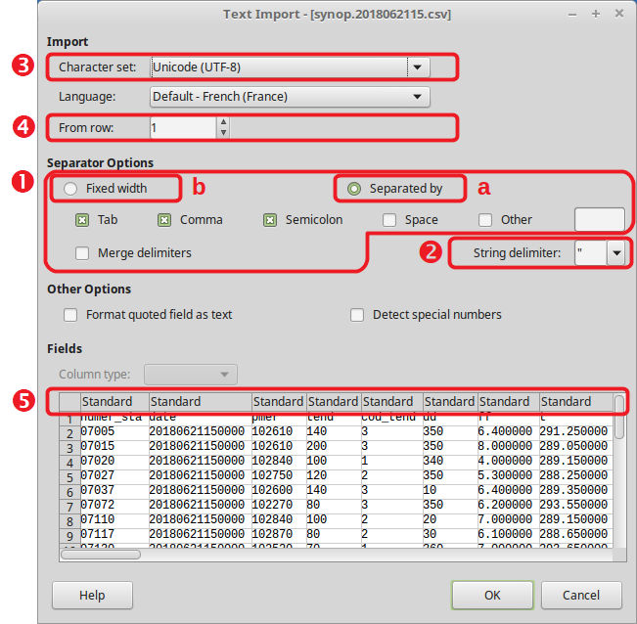CSV Filters Items
CSV filters require 5 parameters (see the above figure for reference, #1 to #5). The final filter string is a wrap-up of all 5.
- Field Separator

A. Variable Format
Separator ASCII code (see ASCII table) | "9"
Alternatives are separated with / | "9/36"
Merged characters: append /MRG | "36/36/MRG"
B. Fixed Format | "FIX"
- Text Delimiter
Delimiter ASCII code (see ASCII table) | "34" ("" if none)
- Character Set
Frequently found character sets:
Windows-1252/WinLatin1 | "ANSI" | ISO-8859-15/EURO | "22"
ISO-8859-1 | "12" | UTF-8 | "76" or ""
Up-to-date list of supported sets: service "com.sun.star.document.FilterFactory"
- First Line To Process
That line number (1-based) | "2" ("1" or "" if 1st line)
- Column Formats
a. Variable | For each column, a 4-character sequence:  #col (1-based) / format /  (see the Column Formatting Codes table) | "1/2/ 2/2/ 3/1/"  ("" when only default values)
b. Fixed | For each column, a 4-character sequence:  1st char pos. (0-based) / format /  (see the Column Formatting Codes table) | "0/1/ 8/2/ 13/1/"

CSV Import Filter
The filter to use is created by concatenating the 5 parameters, using commas as separators: | 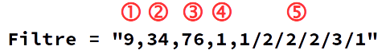
☞ Depending on the context, some values may be omitted (see parameters details) : Filter = "59,,76,,"

More Information

Frequent ASCII Codes In CSV Files (Decimal Values)
9 | Tabulation | 34 | " | 36 | $ | 44 | , | 59 | ;
32 | Space | 35 | # | 39 | ' | 58 | :

Column Formatting Codes
1 | Standard (automatic selection) | 5 | YY/MM/DD
2 | Text | 9 | (ignore column)
3 | MM/DD/YY | 10 | US Format (decimal and thousands sep.)
4 | DD/MM/YY

Importing A CSV File Into A Spreadsheet
Say we’ve got a CSV file named MyFile.csv. We want to copy its contents to Sheet1 in the current document.
The copy is made by creating a link then deleting it:
Dim CsvURL As String 'the .csv source address
Dim Filter As String
Dim oSheet As Object 'the target sheet in the document

oSheet = ThisComponent.Sheets.getByName("Sheet1")
CsvURL = ConvertToURL("C:\path\to\MyFile.csv")
'csv file read options
Filter = "9,34,ANSI,1,1/2/2/2/3/1/4/1"
'import creating a link between the sheet and the .csv source
oSheet.link(CsvURL, "", "Text - txt - csv (StarCalc)", _
Filter, com.sun.star.sheet.SheetLinkMode.VALUE)
'release link so that the document is independent
oSheet.setLinkMode(com.sun.star.sheet.SheetLinkMode.NONE)
 Any preexisting contents is replaced without warning.

Creating A Calc Spreadsheet From A CSV
We’ve got a CSV file named MyFile.csv. We want to create a new Calc document from this file contents.
Dim props1(1) As New com.sun.star.beans.PropertyValue
Dim props2()
Dim CsvURL As String 'the .csv source address
Dim DocURL As String 'the .odt target address
Dim oDoc As Object 'the target document

CsvURL = ConvertToURL("C:\path\to\MyFile.csv")
'csv file read options
props1(0).Name = "FilterName"
props1(0).Value = "Text - txt - csv (StarCalc)"
props1(1).Name = "FilterOptions"
props1(1).Value = "9,34,ANSI,1,1/2/2/2/3/1/4/1"
'load csv source file into the first sheet
oDoc = StarDesktop.loadComponentFromURL(CsvURL, "_blank", 0, props1())
'save to the ods target file
DocURL = ConvertToURL("C:\path\to\Spreadsheet.ods")
oDoc.storeAsURL(DocURL, props2())
☞ There’s only one sheet in the newly created document. The sheet is named from the source file name.
☞ In the example, we display the created document. For hiding it:
– add a Hidden option with value True in props1()
– add oDoc.close(True) in the end.
 Any preexisting document with the same URL is replaced without warning.

Managing File Contents Using Instructions In BASIC

Process
- Get an internal identifier on the file (FreeFile),
- Open the file (Open),
- Write to the file (Print, Put or Write) or read it (Get, Line Input# or Input#),
- Close the file (Close)

Accessing A File Contents Using Its Handle (identifier).
Close | Closes a file that was opened using Open.
Eof() | Checks whether the file pointer is at the end.
FileAttr() | Returns the handle of a file that was opened using Open.
FreeFile | Returns an available handle number before opening a file.
Get | Reads a record from a file and inserts it into a variable.
Input | Sequentially reads an opened file data.
Line Input | Reads a line from a file.
Loc() | Returns the current position in an opened file.
Lof() | Returns an opened file size in bytes.
Open | Opens a data channel.
Print | Writes data into a sequential file (undelimited line).
Put | Writes a record into a file.
Reset | Close all opened files and flushes the contents write to the device of all file buffers.
Seek() | Returns the next read or write position in a file opened using Open For Random instruction.
Write | Writes data into a sequential file (delimited line).
☞ Print or Write?
Print saves the text as-is. Write adds delimiters according to the information type (text: ", date or boolean: #). These delimiters are ignored when read using Input.

Opening Modes (Text Files)
Sequential write: | Open For Output | Sequential read: | Open For Input
☞ For other access modes (direct or binary access), use the stream APIs.

Sequential Read Example (Text File)
Read a file known from its FileURL address.
Dim Handle As Integer, TheLine As String
Handle = FreeFile
Open FileURL For Input As #Handle
'line reads
Do While Not Eof(Handle)
'we read the current line
Line Input #Handle, TheLine
Loop
Close #Handle

Sequential Write Example (Text File)
Write to a file known from its FileURL address.
Dim Handle As Integer
Handle = FreeFile
Open FileURL For Output As #Handle
'line writes
Print #Handle, "Some text."
Print #Handle, "More..."
Print #Handle, "The end."
Close #Handle

Managing File Contents Using The Stream APIs
We call the LibreOffice API SimpleFileAccess and Stream services.

Principle
Example : writing to a text file (the actual code is shown in the example below).

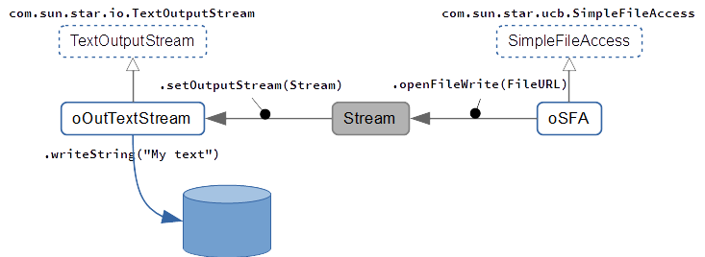Process
- Crate the object for accessing files,
oSFA = createUNOService ("com.sun.star.ucb.SimpleFileAccess")
- Connect the stream that corresponds to the process (access type),
- Write to the file or read it (according to the file type),
- In write mode, flush the stream (.flush),
- Close the file (.closeXxx).

Accessing File Contents

SimpleFileAccess Service (SFA)
openFileRead | Opens a file in read mode.
openFileWrite | Opens a file in write mode.
openFileReadWrite | Opens a file in write and read mode.

Stream Services (InputStream, OutputStream And Stream)
These are the “active” parts.
Correspondance between the SFA service and streams:
SFA methods | Stream services
openFileRead | com.sun.star.io.InputStream  com.sun.star.io.TextInputStream
openFileWrite | com.sun.star.io.OutputStream  com.sun.star.io.TextOutputStream
openFileReadWrite | com.sun.star.io.Stream

Stream Service
getInputStream | Returns the InputStream part of a read/write stream.   Closing this stream closes the OutputStream as well.
getOutputStream | Returns the OutputStream part of a read/write stream.   Closing this stream closes the InputStream as well.

InputStream Service
readBytes | Reads the specified number of bytes.
readSomeBytes | Reads the available number of bytes, with the maximum specified.
skipBytes | Skips the specified number of bytes (positive value).
available | Returns the number of bytes that can safely be read or skipped.
closeInput | Closes the stream.

TextInputStream Service
Inherits from InputStream.
readLine | Reads the text until a line break (CR, LF, or CRLF) or EOF is met. Returns the string read (without CR or LF).  The characters read are converted according to the encoding set using setEncoding. If EOF was reached before running the method, a zero-length string is returned.
readString | Reads the text until a delimiter or EOF is met. Returns the string read.   CRLF is not the default delimiter! This means that, when no delimiter is specified or found, the stream is read to EOF.  The characters read are converted according to the encoding set using setEncoding.  If EOF was reached before running the method, a zero-length string is returned.
isEOF | Returns the EOF status.   This status cannot be detected by a read attempt for an empty string because such a response may be valid when using readLine() (the line is empty) or readString() (two delimiters inline).
setEncoding | Sets the character encoding (defaults to UTF-8).  The available names are listed in this document: http://www.iana.org/assignments/character-sets (Name column).  The current supported character sets depend upon the implementation.

OutputStream Service
writeBytes | Writes a sequence of bytes in the stream (blocking call).
flush | Flushes the stream buffers.
closeOutput | Used to signal that all data have been written.

TextOutputStream Service
Inherits from OutputStream.
writeString | Writes a string to the stream using the encoding specified using setEncoding.  Line breaks and delimiters that might be necessary, have to be manually added to the string.
setEncoding | Sets the character encoding (defaults to UTF-8).  The available names are listed in this document: http://www.iana.org/assignments/character-sets (Name column).  The current supported character sets depend upon the implementation.

Example : Reading From A Text File
Dim oSFA As Object, oInText As Object
Dim FileURL As String, TheLine As String
oSFA = createUNOService("com.sun.star.ucb.SimpleFileAccess")
FileURL = ConvertToURL("C:\path\to\MyFile.txt")
oInText = createUNOService("com.sun.star.io.TextInputStream")
oInText.setInputStream(oSFA.openFileRead(FileURL))
TheLine = oInText.readLine()
oInText.closeInput()

Example : Writing To A Text File
Dim oSFA As Object, oOutText As Object
Dim FileURL As String
oSFA = createUNOService("com.sun.star.ucb.SimpleFileAccess")
FileURL = ConvertToURL("C:\path\to\MyFile.txt")
oOutText = createUNOService("com.sun.star.io.TextOutputStream")
oOutText.setOutputStream(oSFA.openFileWrite(FileURL))
'write (line delimiters must be specified)
'[here we use CRLF (Windows)]
oOutText.WriteString("Hello World" & Chr(13) & Chr(10))
oOutText.WriteString("Line #2" & Chr(13) & Chr(10))
'flush buffers ans close
oOutText.flush
oOutText.closeOutput()

Credits
Author : Jean-François Nifenecker – jean-francois.nifenecker@laposte.net
We are like dwarves perched on the shoulders of giants, and thus we are able to see more and farther than the latter. And this is not at all because of the acuteness of our sight or the stature of our body, but because we are carried aloft and elevated by the magnitude of the giants. (Bernard of Chartres [attr.])
History
Version | Date | Comments
1.12 | 20/06/2018 | First EN version.
1.14 | 02/12/2018 | Minor updates.
License
This RefCard is distributed under the
CreativeCommons BY-SA v3 license
Informations
https://creativecommons.org/licenses/by-sa/3.0/fr/

