
Base Guide
Chapter 3
Tables
Data Input and Removal

Copyright
This document is Copyright © 2013 by its contributors as listed below. You may distribute it and/or modify it under the terms of either the GNU General Public License (http://www.gnu.org/licenses/gpl.html), version 3 or later, or the Creative Commons Attribution License (http://creativecommons.org/licenses/by/3.0/), version 3.0 or later.
All trademarks within this guide belong to their legitimate owners.

Contributors
Dan Lewis
Girvin Herr
Reizinger Zoltán
Lisa Woods

Feedback
Please direct any comments or suggestions about this document to: documentation@global.libreoffice.org.

Acknowledgments
The source for this chapter includes OpenOffice.org and its user group, LibreOffice and its user group, people in ODFAuthors that are not mentioned above, and the Internet. I am grateful for the help of all of these people.

Publication date and software version
Published 27 December 2013. Based on LibreOffice 4.2.0.

Note for Mac users
Some keystrokes and menu items are different on a Mac from those used in Windows and Linux. The table below gives some common substitutions for the instructions in this chapter. For a more detailed list, see the application Help.
Windows or Linux | Mac equivalent | Effect
Tools > Options menu selection | LibreOffice > Preferences | Access setup options
right click | Control+click | Open a context menu
Ctrl (Control) | ⌘ (Command) | Used with other keys
F5 | Shift+⌘+F5 | Open the Navigator
F11 | ⌘+T | Open the Styles and Formatting window

Contents
Copyright 2
Contributors 2
Feedback 2
Acknowledgments 2
Publication date and software version 2
Note for Mac users 2
Introduction 4
Create the database file 4
Create the tables 8
Table Design View 8
Design View parts 9
Entering the field names, types, and properties 10
Use copy and paste to create a table. 20
Execute SQL Statement dialog 21
Create a table using Data Source view and a spreadsheet 21
Edit a table 21
Open the Table Data View dialog 21
Add a field 22
Change a Field Name 22
Delete a field 22
Change a Field Type 23
Change the Description 24
Data input and removal 25
Use the Table Data View dialog 25
Add data to a table 27
Modify data in a table 28
Remove records of a table 28
Using Data Source view 29
Define table relationships 29
Relations Design dialog 29
Select tables with relationships 30
Define the relationship and its properties between tables 30

Introduction
This chapter discusses the creation of tables, and then how to add, modify, or remove data.
There are three ways to create a table: use the table wizard, use the Table Design dialog, or use SQL statements. Chapter 1, Getting Started with Base, discusses how to use the table wizard, so refer to it if you need help using it to create a table. This chapter discusses how to use the second method. Creating a table using SQL statements requires opening and using the Execute SQL Statement dialog. This is discussed in chapter 8, Customize your Database Design.
The Table Data View dialog is used to show the data of a table. It is also used to add, modify, or remove data.
So the emphasis of this chapter is on the use of two dialogs: Table Design for creating the table, and Table Data View for viewing or modifying the data. Both will be discussed in depth.
Chapter 2, Planning/Designing your Database contains the plan for an example database. Tables will be created in this chapter based upon this plan. Data entered added to the table will come from the plan. Then some of this data will be modified, and some will be removed (deleted).
The plan will also be used in future chapters to create the other parts of the database. So, the database will continue to be a work in progress throughout the Base Guide.

Create the database file
The method you use to create the database file depends upon the circumstances. One method works, regardless of whether you are at the splash screen or have opened any of the components of LibreOffice (Writer, Calc, Impress, or Base). Another method works when any of the components are open. And finally, the splash screen has another method. All of these open the Database Wizard.
Use this method anytime you have LibreOffice open:
- Select File > New > Database
When you have one of the components open, use this method:
- Click the New icon's arrow (red circle) and select Database from the menu.
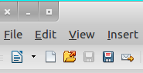

Figure 1: Opening Base using the New Icon
New Icon
When the splash screen is open, use this method:
- Click the Database icon or use Alt+A. (The splash screen has been changed for LibreOffice 4.2, so refer to the figure below that applies to your version.)
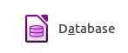
Figure 2: Opening Base using the splash screen (LibreOffice 4.1.x or before)
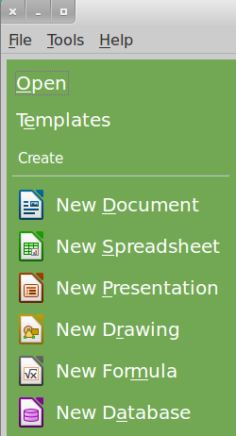
Figure 3: Splash screen for LibreOffice 4.2 and latter
When any of these methods are used, the Database Wizard opens with two steps listed on the left. The first step is selected by default. Here you have three choices:
- Create a new database.
- Open an existing database file.
- Connect to an existing database.
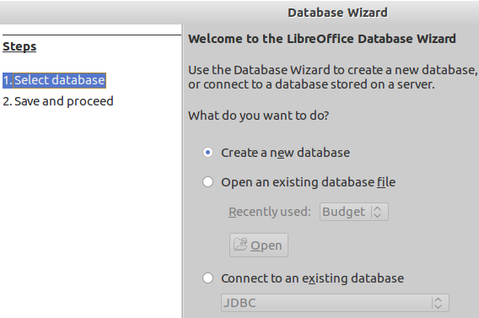Figure 4: Database Wizard window

Note | Step 1 of the database wizard has a slightly new appearance for LibreOffice 4.2. In the Create a new database section, a drop-down list has been added. This serves no purpose yet but will in the future.

What you select in this step determines what appears next. Creating a new database has a second step, opening an existing database file closes the wizard, and connecting to an existing database will have additional steps, depending upon what type of database is accessed.
- To create a new database, which is the default, click Next.
Step 2 of the Database Wizard opens.
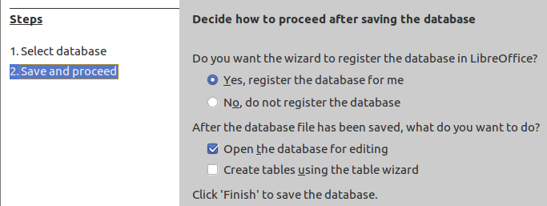
- Click Finish to register the database and open the database for editing, leaving the default selections as they are.
The Save window opens:
- Replace New Database in the Name box with the name of your new database (to continue the learning example, create one now and name it Budget).
- Verify the file type is listed as ODF Database in the bottom right corner.
- Browse to the location where you want to save the new database file.
- Click Save.
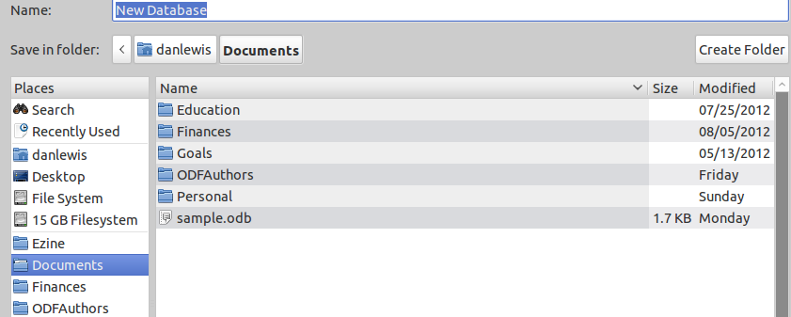

Once you have created a new database and saved it, the main database window opens. Opening a database file will open this same window. It contains three sections: Database, Tasks, and List. The latter's name matches the name of the database object selected in the Database section. Click another object in the Database section, and the name in the List section changes. Below is a screen shot of a Main Database Window when a new database is first created. The Tables object is selected in the Database section, and the List section is labeled Tables.

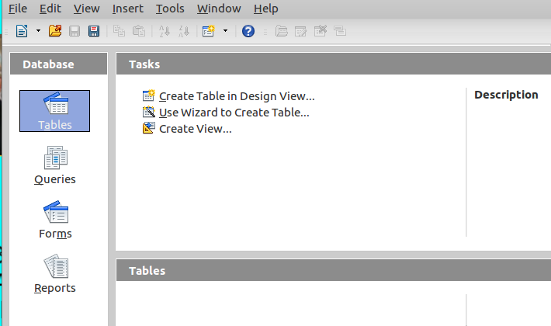
Figure 5: Open Database file window

The Database section allows you to select which object of the database to use. This chapter uses the Tables icon to work with the tables. The next chapter describes the use of Forms while chapters 5 and 6 describe the use of the Queries and Reports icons respectively.
The Tasks section shows the tasks available to the user, depending on which icon was selected in the Database section. In Figure 5, the Tables icon is selected, so the Tasks section shows the two ways to create a table and one way to create a view. Had you clicked the Forms icon, three tasks would have appeared. Click the Queries icon and three tasks appear. Click the Reports icon and two tasks appear.
The right side of the Tasks section is labeled Description. Move your cursor over any of the tasks listed to see a description of it.
The List section will vary in content and name, depending upon which icon is selected in the Database section. Click the Tables icon to see a list of your tables. Click the Queries, Forms, or Reports icon to see a list of your queries, forms, or reports, respectively.
In the upper right-hand corner of the List section is a drop-down menu offering three choices: None, Document information, and Document. None is the default setting and nothing appears below this menu. If Document information is selected, the window contains information about the selected form or report. (When Tables or Queries is selected in the Database section, Document information is not an available option.) If Document is selected, a thumbnail appears of the selected, table, query, form or report. (The thumbnail will only show part of the table, query, form, or report if there is not enough room to show it all.)
Tip | Viewing a Document thumbnail requires you to make two selections: a document object in the Database section and an item in the List section.
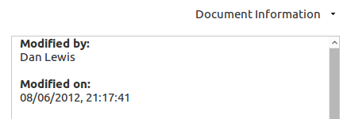
Figure 6: Document information for a selected Form
Tip | The first time a database is opened, the Tables database icon is highlighted in the Database section. Every time thereafter the Forms database icon is selected. The reason for this is that the first thing you should do with a database is create one or more tables. But after the initial steps of creating the tables, queries, forms, or reports, you are most likely to open the database to enter or remove data by using a form.
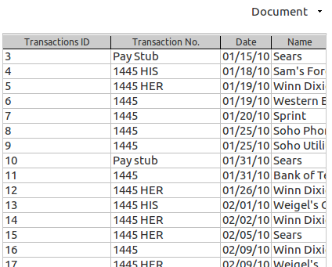
Figure 7: A table's Document thumbnail

Create the tables
As discussed in previous chapters, databases are made up of one or more tables. Have your database design ready with the list of fields and field types you will need for each of your tables. You already have the database open. If not, open the database in which you want to create a table.
There are a variety of ways to create a table. Chapter 1 describes how to use the Table Wizard. This chapter describes how to create the using the Table Design View dial and how to use copy and paste. They can also be created using SQL statements in the Execute SQL Statement dialog. (See chapter 8 of the Base Guide.)

Table Design View
When you have the main database window open, the Database section of it contains four database objects: Tables, Queries, Forms, and Reports. When you click the Tables object, three tasks appear in the Task section. (See Figure 5.) When you click Create Table in Design View, the Table Design View dialog opens.

Design View parts
The Table Design View dialog has three labeled columns at the top: Field Name, Field Type, and Description. Below them is the Field Properties section. To the left of the Field Name column is the row headers where the primary key is designated by one or more key icons. In the snapshot above, the primary key consists of three fields. In many cases, a table's primary key will contain only one field. After you select a field to be the table's primary key, this icon will appear in front of this field.
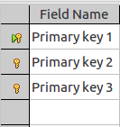Figure 8: Multiple primary key
Tip | If you have not created a plan for the tables for you database go to chapter 2, Planning/Designing your Database and follow the instructions there to create the plan. You will find in this section: The plan: the outline.

Field Name column
This is where you enter the name of your fields one row at a time. You can use lower case, uppercase, or a combination of them. You can use spaces between words, or combine them into a single word with uppercase letters at the beginning of each word within the word. For example: you can use Current Value as the name of a field, or use CurrentValue.
If you right click the row header, you can select the field as the primary key. (The row header is where the green triangle is located indicating what field has been selected.)
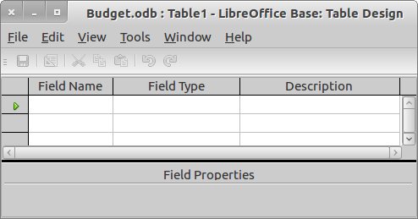Figure 9: Small screenshot of the Table Design View dialog

Field Type column
After entering a field name, select the field's type in the same row. Once the field name is entered, a drop-down list appears in this column with the Default value, Text[VARCHAR]. By clicking the Default value, the list opens from which you can select the field type of your choice.
For example, Text[VARCHAR] is for a specific text field type which can contain a variable number of characters up to the length defined for it in the Field Properties section.
The available field types and their uses are discussed when instructions for defining the field types are given.

Description column
Use this to contain information about the field that you feel is useful such as the purpose of a given field. Later when the table is opened (Table Data View dialog), you can place the cursor over that field's name revealing a tip. What you wrote in the Description column for that field is what appears in that field. But you must have Tip activated for this to happen. (Tools > Options > LibreOffice > General > Tips)

Field Properties section
This contains a wide variety of properties based upon the field type selected for the field. One of them is AutoValue which can be used automatically generate the values of the field. Another is Length which defines the maximum size for the entries of the field.

Entering the field names, types, and properties
In the database plan, part 3b contains the names of the fields, the table that they are in, the field type of each field, and the field properties of each. Now is the time to use this information to define the fields, their field types, any description needed, and the field properties for each field.
Creating a table involves a series of steps: naming a field, selecting its Field Type, entering a description of it, and selecting its properties. You go through these steps for each field of the table. Next to last, you define what field or fields will be the primary key. Finally, you name and save the table.

Add, modify, or delete a Field
- To create a field:
    - Click the top-most Field Name cell that is empty.
    - Enter the name of the field to be created.
    - Repeat these two steps for each field you name.
- To modify a field name, edit it.
- To delete a field, right click the row header for the field's name. Select Delete from the context menu.

Select the Field Type
The database plan contains the field type descriptions for the fields. The cells in the Field Type drop-down list contain anagrams. The following table will help you match the field type listed in your plan to the anagrams in the drop-down list. Look for the description you have in your plan in the right column, and select the anagram in the left column.
Table 1: Field Types and their descriptions
Anagram for the field types | Description
[TINYINT] | tiny integer
[BIGINT] | big integer
[LONGVARBINARY] | image
[VARBINARY] | binary (variable or fixed)
[LONGVARCHAR] | Memo
[CHAR] | fixed length text
[NUMERIC] | Number
[DECIMAL] | Decimal
[INTEGER] | Integer
[SMALLINT] | small integer
[FLOAT] | floating decimal
[REAL] | real number
[DOUBLE] | double accuracy
[VARCHAR] | variable length text
[VARCHAR_IGNORECASE] | variable length text (ignore case)
[BOOLEAN] | Yes/No
[DATE] | Date
[TIME] | Time
[TIMESTAMP] | date/time
[OTHER] | other
Select the field types for a field:
- Click the drop-down list in the Field Type column in the same row as the field name.
- Select the anagram from the list.
- Repeat these two steps for each field.
When you have added all of your fields, selected their field types, and added their descriptions, it should look much like this.
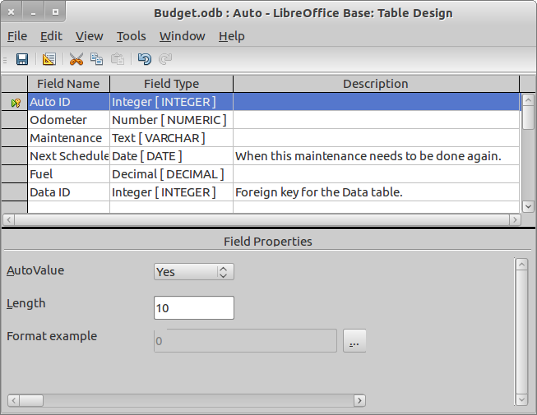Figure 10: Selecting the characteristics for the fields of a new table.

Adding a description
Doing this is straightforward.
- Click the field name to which you want to add a description.
- Click the Description cell in that row.
- Enter the information.
The table is coming closer to being created with the descriptions placed in their column as shown above.

Setting Field Properties
A field's Field Type determines what is shown in the Field Properties section for it. Below is a list of the field types and the field properties each one has. The properties are listed from left to right as they appear in the Field Properties section from top to bottom.
Table 2: Field Types and their Field Properties
Field Type | Field Properties available for this Field
Tiny Integer [TINYINT] | Entry required, Length, Default Value, Format example
BigInt [BIGINT] | AutoValue, Entry required, Length, Default Value, Format example
Image [LONGVARBINARY] | Entry required, Length, Default Value
Binary [VARBINARY] | Entry required, Length, Format example
Binary(fixed) [VARBINARY] | Entry required, Length, Format example
Memo [LONGVARCHAR] | Entry required, Length, Default Value, Format example
Text(fixed) [CHAR] | Entry required, Length, Default Value, Format example
Number [NUMERIC] | Entry required, Length, Decimal places, Default Value, Format example
Decimal [DECIMAL] | Entry required, Length, Decimal places, Default Value, Format example
Integer [INTEGER] | AutoValue, Entry required, Length, Default Value, Format example
Small Integer [SMALLINT] | Entry required, Length, Default Value, Format example
Float [FLOAT] | Entry required, Length, Decimal places, Default Value, Format example
Real [REAL] | Entry required, Length, Decimal places, Default Value, Format example
Double [DOUBLE] | Entry required, Length, Decimal places, Default Value, Format example
Text [VARCHAR] | Entry required, Length, Default Value, Format example
Text [VARACHAR_IGNORECASE] | Entry required, Length, Default Value, Format example
Yes/No [BOOLEAN] | Entry required, Length, Default Value
Date [DATE] | Entry required, Default Value, Format example
Time [TIME] | Entry required, Default Value, Format example
Date/Time [TIMESTAMP] | Entry required, Default Value, Format example
Other [OTHER] | Entry required, Default Value, Format example
Each of the field properties serve a specific purpose.
- AutoValue: This automatically generates a value for the field for each row of the field's table.
  - Only the BIGINT and INTEGER file types will have the AutoValue property available when creating an embedded database.

Note | When connecting to a database using Base, other numerical field types may have the AutoValue property available. This is determined by how you are connected to the database.

  - When AutoValue is set to Yes, the rest of the field properties are defined by AutoValue. No changes are then needed.
- Entry Required:
  - When set to Yes, an entry must exist in every row of the table that contains data. If data is entered into another field of a row but not in the one that requires an entry, Base does not permit you to go to another row until until the required entry is made.
  - The Default value for this property is No. This is what it should remain unless you have a field that requires an entry every time.
- Length:
  - This is the approximate number of characters that the field can have in any row of its table. (See Table 3 for the suggested lengths available for a given field type. The Range column tells what can actually be entered.
  - Image, Memo, and Binary field types require a large amount of memory, so their use should be greatly limited.
    - CHAR or VARACHAR can have a length up to 8000. So, depending upon the size of a field's entries, either of these two might be used instead of Memo.
  - CHAR requires that each entry of a field has a specific size regardless of what you enter. It is best used when the field entries have this characteristic. For example, a field containing the abbreviations of state names. This requires only two characters.
    - If you have CHAR with a length of 20, the entry in each field with an entry will be 20. If an entry only contains 15 characters, the entry for this row will contain 15 characters plus 5 spaces. This can cause a waste of space in memory.
    - If you have CHAR with a length of 20 and you enter 23 characters, the entry is not accepted until the number of characters is reduced to 20 or less.
  - VARACHAR:
    - With this field property, the length of a field entry varies depending upon the length of each entry. When you select the length for VARACHAR, you are selecting the maximum length for any of the field entries. Base will only use the length required in each row.
      - If you have VARACHAR with a length of 20, the maximum length for any of the entries is 20 characters. If one row's entry is 10 and another is 15, The first entry will have a length of 10, and the second entry will have a length of 15.
      - VARACHAR requires less space in memory that CHAR does when both use the same length.
  - For field types consisting of digits (numerical field types), the length is approximately the total number of digits.
- Decimal places:
  - For numerical field types, this number is the number of digits to the right of the decimal separator.
  - The number of digits to the left of the decimal separator is the difference between the length and decimals places.
- Default Value: Use this if you want to have a specific value used for the field until you change it. This value can be edited any time in the future by editing the table.
- Format example:
  - Click the ellipse (…) after Format example to open the Field Format dialog. Below shows most of the available categories. (Changing your choice of categories changes what formats are available for the new category.)
    - The fields with a text file type will have no choices under Format example.
    - All non text file types will have the categories shown below plus the following: All, User-defined, and Text.
  - You only see the format chosen here for a given field when you open the table. A date field will have the default date format when in a form, query, or report regardless of what format is selected in the Table Design dialog.. So, only format a field in the objects in which it will be used. (The Table object is usually not one of these.)
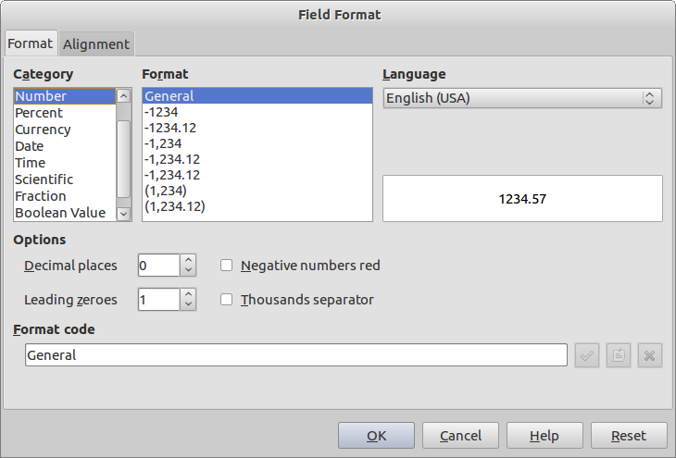Figure 11: Some of the Format Example choices
Table 3: Fields Types and their default lengths
Field Type name | Field Type | Length | Range
Tiny Integer | [TINYINT] | 3 | -128 to 127 (signed)  0 to 255
BigInt | [BIGINT] | 19 | -9,223,372,036,854,775,808 to  9,223,372,036,854,775,807
Image | [LONGVARBINARY] | 2147483647 | 2147483647
Binary | [VARBINARY] | 2147483647 | 2147483647
Binary (fix) | [BINARY] | 2147483647 | 2147483647
Memo | [LONGVARCHAR] | 2147483647 | 2147483647
Text (fix) | [CHAR] | 100 | 1 TO 8000
Number | [NUMBER] | 100 | -10³⁸ to 10³⁸
Decimal | [DECIMAL] | 100 | -10³⁸ to 10³⁸
Integer | [INTEGER] | 10 | -2,147,483,648 to 2,147,483,647
Small Integer | [SMALLINT] | 5 | -32,768 to 32,767
Float | [FLOAT] | 17 | -10³⁸ to 10³⁸
Real | [REAL] | 17 | -10³⁸ to 10³⁸
Double | [DOUBLE] | 17 | -10³⁸ to 10³⁸
Text | [VARCHAR] | 100 | 1 TO 8000
Text | [VARCHAR_IGNORECASE] | 100 | 1 TO 8000
Yes/No | [BOOLEAN] | 1 | N/A
Date | [DATE | N/A | N/A
Time | [TIME] | N/A | N/A
Date/Time | [TIMESTAMP] | N/A | N/A
OTHER | OTHER | 2147483647 | 2147483647
Selecting the field properties
- Click the field whose properties you want to select.
- Verify that the field type is correct.
- Select the field properties for this field that is written in your database plan.
- Repeat steps 1 – 3 until you have selected the field properties for all of the fields in this table.

Setting a Primary Key
A primary key can consist of one or multiple fields. Until recently, the Table Design dialog would create a primary key with only one field of the table. Now you can create multiple field primary keys for tables. There is one restriction though. None of the fields of the primary key can have the AutoValue property set to Yes: none of the fields can have its values auto-generated.
When you select AutoValue as the field property for a field, it automatically becomes the primary key for the table. Doing this also selects the rest of the field properties for this field. None of these selections need to be changed.
The other method of selecting the fields for a table's primary key is to highlight the fields for the primary key, right click the row header for one of the fields, and select Primary Key from the context menu. You can select them in a variety of ways the same way you would select some rows in any table. This includes selecting consecutive rows or nonconsecutive rows. For example, if you select one field field for the primary key, you can Control-click the other fields that should be part of it. This highlights all of them.
Tip | Figure 10 shows the top row selected, and the green arrow is in that row's row header.
Note | A SQL statement can be used to define the fields of a table including a multiple field primary key. How to do this is found in Base Tutorial: From Newbie to Advocate in a one, two... three! by Mariano Casanova.
Steps to create the table primary key:
- Select the field or fields that will be the table's primary key.
- right click the row header for one of these fields.
- Select Primary Key from the context menu.

Naming and Saving the table
This is done the same way documents are saved:
- Click the Save icon, or File > Save. This opens the Save As dialog with a suggested table name.
- Accept the suggested table name, or change it to what you want. (Use the name you gave this table in your database plan.)
- Click OK.
- Close the Table Design View dialog.
- Click the Save icon in the main database window to write the new table to the database file.

Caution   | If you did not select a primary key for the table, you will receive a warning. You can let the dialog create one, but you should use the field selected in your database plan.  You must select a primary key for a table before you can access it to input or remove data. To correct this mistake, you need to edit the table and select a primary key for the table.

Example of creating a table
As an example, consider the Budget.odb database and its plan. It contains a table, Auto. Its fields are Auto ID, Odometer, Maintenance, Next Scheduled, Fuel, and Data ID. These fields have the following characteristics:
- Auto ID
  - Primary key for table
  - Field Type: integer
  - Description: none
  - Field Properties:
    - AutoValue set to Yes (All of the other field properties are determined by this one.)
- Odometer
  - Field Type: number
  - Description: none
  - Field Properties:
    - Entry required: No
    - Length; 6
    - Decimal places: 0
    - Default value: (none)
    - Format example: (none)
- Maintenance
  - Field Type: text
  - Description: none
  - Field Properties
    - Entry required: No
    - Length: 25
    - Default value: (none)
    - Format example: (none)
- Next Scheduled
  - Field Type: date
  - Description: When this maintenance needs to be done again.
  - Field Properties:
    - Entry required: No
    - Default value: (none)
    - Format example: (none)
- Fuel
  - Field Type: decimal
  - Description: none
  - Field Properties
    - Entry required: No
    - Length: 6
    - Decimal places; 3
    - Default value: (none)
    - Format example: (none)
- Data ID
  - Field Type: integer
  - Description: Foreign key for Data table.
  - Field Properties
    - AutoValue: set to No
    - Entry required: No
    - Length: 10
    - Default value: (none)
    - Format example: (none)
Filling in the Table Design View dialog

- Open it: Click Create Table in Design View
- Create the field, Auto ID
  - Field Name
    - Enter Auto ID in the cell directly below Field Name
  - Field Type
    - Select Integer[INTEGER]
  - Description
    - (None)
  - Field Properties
    - AutoValue: set to Yes (All of the other field properties are determined by this one.)
- Create the field, Odometer
  - Field Name
    - Enter Odometer in the cell below Auto ID
  - Field Type
    - Select Number[Numeric]
  - Description
    - (None)
  - Field Properties
    - Entry required: No
    - Length: 6
    - Decimal places: 0
- Create the field, Maintenance
  - Field Name
    - Enter Maintenance in the cell directly below Odometer
  - Field Type
    - Select Text[VARCHAR]
  - Description
    - (None)
  - Field Properties
    - Entry required: No
    - Length: 25
- Create the field, Next Scheduled
  - Field Name
    - Enter Next Scheduled in the cell directly below Maintenance
  - Field Type
    - Select Date[DATE]
  - Description
    - When this maintenance needs to be done again
  - Field Properties
    - Entry required: set to No
- Create the field, Fuel
  - Field Name
    - Enter Fuel in the cell directly below Next Scheduled
  - Field Type
    - Select Decimal[DECIMAL]
  - Description
    - (none)
  - Field Properties
    - Entry required: set to No
    - Length: 6
    - Decimal places
    - When this maintenance needs to be done again
- Create the field, Data ID
  - Field Name
    - Enter Data ID in the cell directly below Next Scheduled
  - Field Type
    - Select Integer[INTEGER]
  - Description
    - Foreign key for Data table.
  - Field Properties
    - Set AutoValue to No
    - Entry required: No
    - Length: 10
- Select the primary key: Because the field property, AutoValue, was selected for the field, Auto ID, the dialog selected this field as the primary key for the table. Nothing more needs to be done.
- Name and Save the Table:
  - Click the Save icon to open the Save As dialog.
  - Enter Auto as the name for the table.
  - Click OK.
  - Close the Table Design View dialog.
  - Click the Save icon in the main database window to save your work to the database file.
In the main database window, click the Tables icon in the Database section. The list section is now labeled Tables and contains a list of one table: Auto. As you create more tables, they will be added to this list.

Use copy and paste to create a table.
If you have multiple tables with the same fields, field types, and field properties, you can create one table and then use copy and paste to create the rest of them. Each time you use this process, you are asked to name the new table.
In our database example, there are four tables that can be created using this process: Account, Budget 1, Budget 2, and Budget 3. Each of these tables contain only one field, Name. Another example is a database for music files. Assume you create a table for each type of music you have. If you want the same type of information in each table, create one of the tables. Then use copy and paste to create the rest of the tables. As you do so, name each table according to the type of music it contains.
Steps for creating a table using copy and paste
- right click the table you wish to copy in the list of tables.
- Select Copy from the context menu.
- right click below the list of tables.
- Select Paste from the context menu. (The Copy Table dialog opens.)
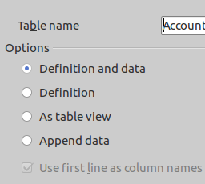Figure 12: Copy Table dialog
- Under Options, select Definition (The Default value is Definition and data when the dialog is opened.)
- Click Next
- Apply columns:
  - Use the double right arrow to move all the fields from the Existing columns to the right list.
  - Click Next.
- Type Formatting:
  - Verify that the fields listed have the same Column information as the fields in the original table. If not, make any changes needed.
    - Field name
    - Field type
    - Length
  - When the information is correct, click Create.
- Click the Save icon in the main database window.
While I have emphasized the fields being identical, you can obviously make changes from one table to another by changing any of these: field name, field type, or length.

Execute SQL Statement dialog
For those who know how to use SQL to create tables can do so. Tools > SQL opens the Execute SQL Statement dialog. Details for using this dialog is in chapter 8, Customize your Database Design.

Create a table using Data Source view and a spreadsheet
This is done with Base closed. Instead, the spreadsheet containing the data is opened in Calc. Then the Data Source view is opened using the F4 key. Complete instructions for this are in chapter 8, Exchanging data between Base and other parts of LibreOffice.

Edit a table
You use the same dialog to edit a table as you did to create one: the Table Design View dialog. So, you should already be acquainted with it.
When editing a table, you can add a field, delete a field, or modify a field. There are potential problems when doing these that you need to consider. They will be mentioned throughout the discussion.

Caution | Any time you edit a table for any reason or modify another database object because of the table edit, you must save the object first and save the database second. The latter is done in the main database window. The database file will not have the changes until you save the database.

Open the Table Data View dialog
When doing this, have the main database window open. Then click the Tables icon in the Database section. In the Table list section, you have a list of the database tables. Finally, right click the name of the table to be edited, and select Edit from the context menu. The dialog opens.

Add a field
You add an additional field the same way you created a field earlier.
- Give the field a name.
- Give it a field type.
- Give it the field properties it needs.
- Save and close the table.
- Save the database in the main database window.

Potential problems for adding a field
Caution | If you add an additional field, what selection will you make for the Entry required property? If you select No, you will not have anything special that you need to do.  Selecting Yes is a different matter. Now you have some steps you have to take.  - Select No for this property.  - Complete the rest of the editing for this table and close it.  - Enter the values for this field for every row in the table using the Table Data View dialog.  - Close and save the table.  - Save the database in the main database window.  - Follow the instructions contained below for changing field properties. (This time you will be changing the Entry required property from No to Yes.
This caution mentions one of the problems associated with adding a field: the Entry required field property. If you need the new field to have this property set to Yes, you have to add data to this field for every table row already in existence. If the number of rows are large, this will be time consuming. This is one reason for having a database plan: to avoid this potential headache.

Change a Field Name
This is fairly easy to do:
- Select the field you want to change.
- Edit the name.
- You may want to add information to the field's Description to explain what you did.
- Close the dialog and save the table.
- Save the database in the main database window.

Potential problems for changing the field name

These involves all the database objects that use the original name. This can include the queries, forms, and reports. The field's name has to be changed wherever it has been used in any of these.
Also, if the field is part of a primary or foreign key and is also used to define the field's table relationship, changes have to be made in the latter. (See Define table relationships)

Delete a field
This can be done in many cases if you no longer need the data nor the field.
- Right click the row header for the field you want to delete.
- Select Delete from the context menu.
- Close the dialog and save the table.
- Save the database in the main database window.

Potential problems for deleting the field
Caution | Deleting a field will cause a lose of data! Do not do so unless you are absolutely sure the data will never be needed again. If you delete a field and discover later that you need the data, you will have to manually add the data. But what will you do if you do not have a copy of the required data?
You may not be able to delete a primary or foreign key if it is part of a table relationship. Base will not permit this unless you had earlier defined the properties of the relationship so that such deletions are allowed. Define table relationships describes what these properties have to be to permit deletion of a primary or foreign key.
It can not be emphasized enough that great care be exercised before deleting a field. Data can be lost that might be needed later, and there is no copy of it to use to re-enter it. While fields can be deleted, the question always is this: is it really worth the potential problems that could come from doing so?

Change a Field Type
Planning needs to be done before changing one of these. The new field type should be similar to the original one. When changing the field type, the Table Design View looks at the present field type and the new one. The field types are similar if they are the same java type. (See the table below.) Even so, the field properties may have to be modified as well.
When changing the field type of a field, also check to see if its field properties are correct.
Changing the field type takes two steps. If you are going to change more than one field type, repeat the two steps. Then saving and closing the table takes three more.
- Click the field type to be changed to open the drop-down list of field types.
- Select the new field type.
- Click the Save icon.
- Close the dialog.
- Save the database in the main database window.

Potential problem
If the java type of the new field type differs from the present one, you will get an error message giving you the opportunity of creating a new field with the new field type while deleting the present field and its data. (You lose all the field's data.) Perhaps a better suggestion would be to add a field. This would maintain the data that has already been entered while allowing the entry of data with the new field type. This is part of the planning that must be done before changing field types.
Table 4: Field Types
Name | Range | Java type
INTEGER | INT | as Java type | int | java.lang.Integer
DOUBLE [PRECISION] | FLOAT | as Java type | Double | java.lang.Double
VARCHAR | as Integer.MAXVALUE | java.lang.String
VARCHAR_IGNORECASE | as Integer.MAXVALUE | java.lang.String
CHAR | CHARACTER | as Integer.MAXVALUE | java.lang.String
LONGVARCHAR | as Integer.MAXVALUE | java.lang.String
DATE | as Java type | java.sql.Date
TIME | as Java type | java.sql.Time
TIMESTAMP | DATETIME | as Java type | java.sql.Timestamp
DECIMAL | No limit | java.math.BigDecimal
NUMERIC | No limit | java.math.BigDecimal
Any field that contains characters can be changed to Text[VARCHAR] as long as the field's data does not exceed the maximum length permitted by this field type. However, changing in the other direction is another matter (from text to numerical or date formats). Data can be lost in the process.
One example is a field containing zip codes. These contain only digits which is consistent with the Integer field type. However, zip codes can contain a leading zero. But if this field is changed from Text to Integer, any entries containing a leading zero will lose it.
Now, if you have such a field and originally selected Integer as the field type, changing this field to Text makes sense. Now zip codes beginning with a zero will appear correctly. (You will have to add the leading zero.) Since the zip code contains a specific number of digits, you could use Text[CHAR] instead of Text[VARCHAR].
Another example is changing Decimal to Integer. If the field data contains some numbers with decimal places, you lose the decimal part of these numbers. In this case you change a field property when you changed the field type.
There are other potential problems that can cause data loss or generation of error message that could do the same thing. So think very carefully as to why you need to make the change. What are the potential lost of data that this could cause? Can you reverse this change if it appears reversal is necessary?

Change the Description
Doing this is matter of editing it. Then saving the changes, closing the dialog, and saving the database in the main database window.

Potential problems
There are very few problems that could occurs when making this change. But care must be taken to make sure that what is contained in this cell is understood by those who will use it later.

Change the field properties
Editing these is not different from selecting a field's field properties in the first place. Again, is you are going to do this you need to have good reasons for doing it. This means that you should plan your changes before making them. Questions such as to why the change is needed should be asked. So, you should ask yourself what are the potential problems that may occur with the change. How do you avoid these problems? Do not just verbally ask them: write them down (questions and answers). Then look carefully at both before proceeding.
When you have completed making the changes to the field properties, save the table, close the dialog, and save the database in the main database window.

Potential problems
- AutoValue
  - When the table's primary key contains multiple fields, none of these fields can have AutoValue set to Yes. If you try to do this, you get an error message.
- Entry required
  - If a field has some NULL values, you can not set Entry required to Yes unless you first replace these NULL values with data. The larger the table, the more time it will take to enter the needed data so you can select Entry required for this field.
- Length
  - Increasing the length will not affect any data that has already been entered.
  - Decreasing the length will reduce the length of any data already in the field that exceeds the new length. If you change your mind and increase the length of this field after you had earlier decreased the length, the data will have to be edited to replace what was lost when the length was decreased earlier.
- Decimal places
  - This has the same problems for fields containing numbers as the changing of the length of fields in general.
- Default values
  - If you change the default value of a field, it only begins to appear the next time a new row of the table is selected. Previous empty cells remain empty.
  - When a new row of a table is selected, the default values for fields that have them, will appear. However, something must be changed in one of the cells of the row before the data of it can be saved. The presence of the default values in one or more of the row's cells does not serve this purpose. One of the cells must have something added, edited, or deleted.

Data input and removal
Once a table has been created, you can open it to add data. And once you have added data to a table, you can reopen it to add additional data, modify data already in it, or delete data.
There is one difference between modifying data and adding or deleting data. Modifying data is done one at a time. But adding or removing data should be done one or multiple records at a time.
Opening a table is done using the List section of the main database window. First select the Tables icon in the Database section. The list section now contains the list of tables you have created. Double click the name of the table to open it. What you now see is the Table Data View dialog.
To open a table in the list of tables, you can do this in three ways:
- Double click the name of the table you wish to open.
- Click the name of the table and use the Enter key.
- OR, Right-click the name of the table and select Open from the context menu.

Use the Table Data View dialog
When you open a new table without data, it appears as below. There is the standard menu items. containing File through Help. With them you can perform all of the task that you can with the tools in the toolbar.
The column headings are the names of the fields of the table and in the same order as they were created. Also, if the primary key has the AutoValue set to Yes, you will see <AutoField> in the row below it.
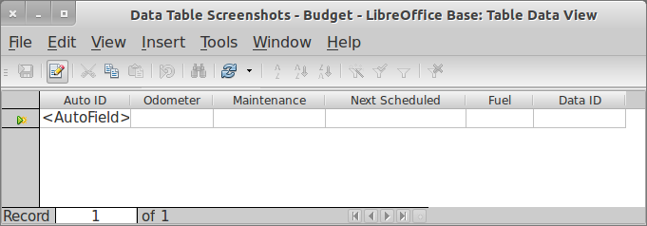Figure 13: Table Data View dialog
These are the tools that you have to work with in this dialog. Some of them are the same tools used many different places.
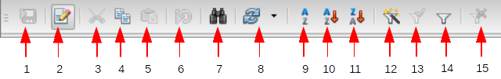
1 | Save | 6 | Undo: Data Input | 11 | Sort Descending
2 | Edit | 7 | Search | 12 | AutoFilter
3 | Cut | 8 | Refresh | 13 | Apply Filter
4 | Copy | 9 | Sort | 14 | Standard Filter
5 | Paste | 10 | Sort Ascending | 15 | Remove Filter/Sort
Figure 14: Toobar for the Table Data View dialog
- Save: This is the standard Save tool.
- Edit: When this is active, you can add, delete, or modify any of the cells of the table. It is active by default. If you only want to view the data of the table, you can click it to deactivate it. (Just make sure you reactivate it before trying to make any changes.)
- Cut: This is the standard Cut tool.
- Copy: This is the standard Copy tool.
- Paste: This is the standard Paste tool.
- Undo: Data Input: After adding to a row of the table, you can undo the additions by clicking this tool. But this only works if you are still in the same row. When you move from one row to another, you automatically save any changes made. (They have been written to memory.)
- Search: This is the standard Search tool.
- Refresh: Use this to have Base get the table's data from memory and rewrite the table in the dialog. (You will be asked if you want to save the table before refreshing it.)
- Sort: This is the standard sort tool. With this you can specify the fields to be sorted and in what direction.
- Sort Ascending: This is the standard sort ascending tool.
- Sort Descending: This is the standard descending tool.
- AutoFilter: When looking for all the rows in which a field has a specific value, use this tool. Click the value of the field that you want to use. Then click this tool. It filters out the date so that only the rows containing this value in your chosen field appear.
- Apply Filter: This acts like an on/off switch for filtering. When it is On, the filter that the table has is applied to the data. When it is Off, the data appears unfiltered.
- Standard Filter: This is the same standard filter as used elsewhere.
- Remove Filter/Sort: This is grayed out (inactive)except when a filter or sort is applied to the table. When this happens, the Remove Filter/Sort icon becomes active. (The x in the icon becomes red.) To remove a filter or sort, click this tool when it is active.

Add data to a table
The first thing to do with a table is to add the data to its records (rows). Later you may want to add more records to it. You do the latter very similar to the former.
Add data to a new table
When you open a new table, what you see will be similar to Figure 13. Where you begin depends upon the field on the left. If it contains <AutoField>, you begin in the field to its right. After you add data to the first field, use the Enter or Tab key to move the cursor to the right. When you get to the field on the right side, use of one of these keys will move the cursor to the second row in the field on the left side. If there is a field containing <AutoField> in the first row, a value will appear as soon as the cursor moves from row 1 to row 2.
Fields containing <AutoField> are different than the fields into which you enter data. But when moving the cursor one field to the one to its right (or the last field on the right to the first field on the left in the second row), there is no difference. Any time the cursor is in a field containing <AutoField>, use of either key mentioned will move it to the next field.
The only difference for adding additional data to a record of a table is that you begin in the top empty row in the field on the left. Here too, if that field contains <AutoField>, begin in next field to the right. Then use the Enter or Tab key to move from one field to the next while entering data as you do so.
Steps to add data to a new table:
- Click in the top empty field in the field on the left. (If this field contains <AutoField>, click the field to its right.)
- Enter the data for this field.
- Use the Enter or Tab key to move to the next field to the right. (Using one of these keys when the cursor is in the field at the right end of the row moves the cursor to the field on the left end in the next row.
- Repeat steps 2 and 3 until all the data has been added.
- Click any field in another row to save the data to memory.
Adding additional data to a table
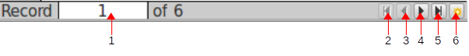
1 | Record number | 3 | Move to record above | 5 | Bottom record
2 | Top record | 4 | Move to record below | 6 | New record
Figure 15: Table navigation tools
- Record number: This is the number of the row for the cursor location.
- Top record: Click this to move the cursor to the top cell of the field in which the cursor was located.
- Move to record above: Click this more the cursor to the record above the present one.
- Move to record below: Click this to move the cursor to the record below the present one.
- Bottom record: Click this to move the cursor to the bottom record.
- New record: Click this to create a new row (record) at the bottom of the table.
If you know what record you want to access, enter this number as the record number and <Enter>. This moves the cursor to the first field (the one on the left) of that record. Using Top record through Bottom record will move the cursor to the record you have selected and into the same field it was previously in. New record will create a new record at the bottom of the table placing the cursor in the first field.
Add records
- Click the New Record icon
- Enter the data in this row.
- Repeat steps 1 and 2 for each additional row of data you need to add.
- When finished adding additional data, click one of cells above the bottom row to save the data to memory.

Modify data in a table
Modifying data in a table is almost the same as modifying data in a spreadsheet. The main difference is that you can save modified data in a table by clicking in any field of another row from the one that now contains the modified data.
- Modifying data
  - Select the cell containing the data to be modified.
    - Erase it.
    - OR, enter the new data.
- Repeat these steps until you have completed your modifications.
- Select a cell in another table row to save the change.

Remove records of a table
Caution | When you delete a record, you are permanently removing this data from the database. If you decide you need to use this data later, you will have to add it then. Without a copy of this data, it is lost forever. This is why you receive a warning message when you begin the process to delete one or more records.
There are three methods to deleting a record. One uses the Delete key, another uses the Edit menu, and the third uses a right click and a context menu.
All of these methods begin with selecting a record. To do this, click the row header of the record you wish to select. The row becomes highlighted. (The row header is the square gray box on the left side of the row.)
Multiple records can be deleted at the same time. First you select all of the records to be deleted. Then use of the three methods to delete them. Selecting multiple records uses the same methods as selecting multiple objects in many computer settings. For example, to select consecutive records, click the top or bottom record and hold down the shift key while clicking the bottom or top record respectively. To select non consecutive records, hold down the Control key while clicking them.
Delete records
- Use Delete key
  - Select the record or records to be deleted.
  - Use the Delete key.
  - Click Yes to the question posed by the context menu if you are sure you want to delete what you have selected.
  - Select another row to save the change
- Use Edit > Delete Record
  - Select the record or records to be deleted.
  - Edit > Delete Record
  - Click Yes to the question posed by the context menu if you are sure.
  - Select another row to save the change
- Use a right click
  - Right click a selected row to be deleted
  - Select Delete Record from the context menu.
  - Click Yes to the question posed by the context menu if you are sure.
  - Select another row to save the change

Using Data Source view
You do not have to have the database opened to add, modify or remove data and records from a database. You can also do this with a Writer or Calc window opened. The F4 key opens the Data Source view at the top.
When this view is opened, the left side contains a hierarchical list of the databases and their objects that have been registered with Base. Data appears on the right side of any query or table selected.
The instructions for how to do this are in Chapter 7, Exchanging data between Base and other parts of LibreOffice.

Note | People are often confused as to the purpose of registering a database when it is created. The Data Source view is the purpose.

Define table relationships
When you create a relational database, you should define the relationships that will exist between tables. Base then uses this information in any queries or views you create. So, when you create either of these, Base defines the relationships between the tables you use in the query or view for you.

Relations Design dialog
This is where you define the database relationships and select their properties. It can be used to create new relationships, delete them, or change their properties.
When the Relations design dialog opens for the first time, the Add Table dialog also opens with which you can select the tables whose relationships you want to define. You can also open this dialog to create more relationships, delete a relationship, or modify a relationship's properties.
- To open the dialog, use Tools > Relationships.
The Save icon should be used when anything is added or changed with one exception. When a relationship is modified, this is automatically saved. (The Save icon does not become active.) Any time you make a change and the Save icon becomes active, click it.
Just remember to save the database when you save the dialog especially if you have several additions or changes that require saving.
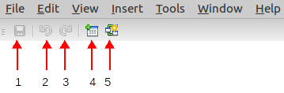
1 | Save | 4 | Add Tables
2 | Undo | 5 | New Relations
3 | Redo
Figure 16: Relations Design dialog toolbars
- Save: The standard Save tool
- Undo: The standard Undo tool
- Redo: The standard Redo tool
- Add Tables: Click this tool to open the Add Tables dialog from which you can select from any of the queries or tables of the database.
- New Relations: Click this to open the Relations dialog.
The Undo and Redo icons are only active when you change the size of one of the tables. So, these are seldom used.

Select tables with relationships
When the relations dialog is opened without an existing relationship defined, the Add table dialog automatically opens with it. Otherwise you should click the Add Tables icon to open it.
Use one of these methods to add a table, and then close the Add Table dialog.
- Click the name of the table and then click the Add button.
- Double click the name of the table.

Define the relationship and its properties between tables
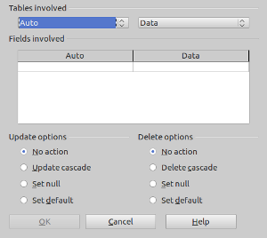
The Relations dialog is divided into four sections: Tables involved, Fields involved, Update options, and Delete options. The first two define the tables use as well as the fields contained in the primary-foreign key pair. The last two determine what happens in the table containing the foreign key when entries of the primary key of the other table are either added or removed.
The Tables Involved section contains two drop-down lists of the tables of the database. From one these lists, select the name of the table containing the foreign key of the primary-foreign key pair. From the other list select the name of the table containing the primary key of this pair.
Once the tables have been selected, the Fields Involved section has a table where you select the fields of the primary and foreign keys in the relationship. Each of the columns has a name that matches the table you selected above it. Each cell of the column has a drop-down list with the names of the fields for that column's table.
When the primary and foreign keys are single fields, you only need one row in this table. Select these fields from their respective drop-down list. When they are multiple field keys, you need one row for each field in each of the keys.
When you select the fields for a given row in this dialog, you are matching them. This selection requires that the foreign key field value is either Null or matches a value of its primary key field that is in its row. In most cases, the foreign key field will not be Null.
The bottom section which contains the options that determine what happens in the table containing the foreign key when you make changes in the values of the primary key of the primary-foreign pair. These changes fit into two categories: updating but not deleting values, and deleting a row containing the primary key of the primary-foreign key pair.
The complex form (main form and subform) in Figure 18 will be used to explain update and cascade options available. The main form contains the Transactions table, and the subform contains the Data table.
- No action
  - Update option: If you attempted to modify the primary key (Transactions ID) say from 3 to 500, you get the error message below. The foreign key of the Data table has the value 3 in at least one row. But the primary key you attempted to modify would no longer have the value 3 in it. So, Base will not allow you to do this giving you the error message.
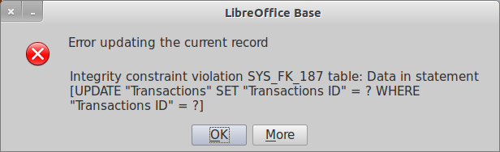Figure 17: Error message when the primary key is updated with the No Action selection.
  - Delete option: If you attempt to delete a record in the main form, you get a warning message asking if you want to delete the record. Checking Yes is required at this point. But, when you click Yes, nothing happens: Base refuses to delete the record.
Either of these options should be used in sparingly. If you do not want the primary key to ever be changed, you can use the Update No Action option. There are many people who do not want the values of the primary key to be changed.
Using the Delete No Action limits how you delete data from a form and the order in which you do it. Single or multiple visible records can be deleted from the subform. But only after you have deleted all of the records of the subform will this option permit you to delete the visible record in the main form.
In the above example, any of the five records containing the Transactions ID value of 3 can be deleted from the Data table which is in table format. However, only if you delete all five of the records in the Data table can you delete the visible record of the Transactions table that contains 3 as one of the value of the Transactions ID field.
- Cascade
- Update option: When the primary key is modified, the foreign key is automatically modified to match the primary key's new value.
- Delete option: When a primary key value is deleted, all of the rows containing this value are deleted.
Example using the figure below: Suppose we change the 3 to 2000 in the Transactions ID field (primary key for the main form) in the upper left corner. At the bottom of the form, go to the next record. Then change the record back to what it was. Now look at the column of values for the Transactions ID in the sub form. All of the 3's are now 2000.
Now suppose we delete a record from the main form that has 3 as the value of Transactions ID in the main form. When you click the Delete Record in the Form Navigation toolbar, you get the warning that you are about to delete a record. Click Yes. Base erases the main form record. It also deletes all 5 rows in the sub form that you see below. (Each one contains 3 in the Transactions ID field.)

Tip | Cascade Update and Delete options are the ones used the most often.
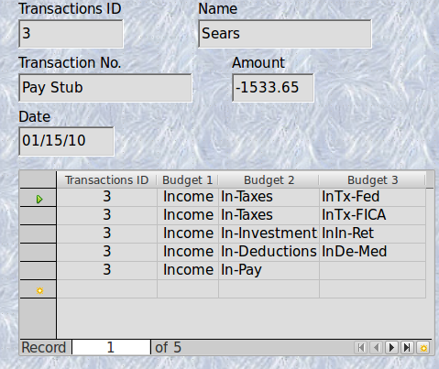
Figure 18: Example of the Cascade options.
- Set Null
  - Update option: If the conditions are right, updating the 3 in the primary key causes the five 3's in the foreign key in the Data table to be deleted and replaced with Null. However, the five 3's in the foreign key in the subform are updated to the updated value in the primary key of the main form. The records containing a 3 in the foreign key field in the subform no longer contain any data in the other fields. This is because the Data table no longer contains 3 in the Transactions ID field.
  - Delete option: If the conditions are right, deleting the 3 in the primary key causes the same action in the Data table. All five records of the subform containing the value 3 are deleted from the subform. (These records still exist in the Data table though with all the 3's replaced with Null.)

Caution | These options should only be used by people who have a need to delete a visible record from a main form without deleting the visible records from the subform. They also must know what they are doing. Otherwise, their data may seem to just disappear.
Before you can use either of these options, you must first make sure that the foreign key has Entry required set to No.
The rows of the Data table (subform) can be used later is you have a need to do so. Create a new record in the Transactions table (main form) for this purpose. Find the value for the primary key in that record. Then open the Data table and enter this value in the foreign key for the appropriate rows. The subform will now show these records when the new record is visible.
For example, the new record has the value 899. Find the rows of the Data table that you want to associate with this record. Enter 899 in the Transactions ID field in each of these rows.

- Set Default
  - Update option: If the conditions are right, modifying the 3 in the primary key causes the five records of the subform containing a 3 to be removed. They are still in the Data table, but the 3's have been replaced with the default value.
  - Delete option: If the conditions are right, deleting the 3 in the primary key causes the five 3's in the foreign key in the Data table to be deleted and replace with the default value.
To use either of these two options, you must first assign a default value to the foreign key. Only after assigning a default value to the foreign key can you select one of theses Set Default options.

Caution | The default value for the foreign key must be one of the values of the primary key in the primary-foreign key pair. Otherwise, you will have a value for the foreign key that does not have a matching value in the primary key. HSQLDB, which Base uses, permits this to happen when using default values. This can lead to what seems like the loss of data. The referential integrity of the database is destroyed if you do not use a primary key value for the default value of the foreign key.
It is not good idea to use either of these options unless you know what you are doing. The only time to use it is when you have created a record in the main form whose primary key value will be the default value of the foreign key. Then you know where the records are put if you need them at a later time. Even so, you may or may not remember what is record of the main form to which a given group of records of the subform belongs. So, it is still not a good idea to do this.

