
Impress Guide
Chapter 5
Managing Graphic Objects

Copyright
This document is Copyright © 2005–2013 by its contributors as listed below. You may distribute it and/or modify it under the terms of either the GNU General Public License (http://www.gnu.org/licenses/gpl.html), version 3 or later, or the Creative Commons Attribution License (http://creativecommons.org/licenses/by/3.0/), version 3.0 or later.
All trademarks within this guide belong to their legitimate owners.

Contributors
Michele Zarri T. Elliot Turner Jean Hollis Weber
Low Song Chuan Peter Schofield

Feedback
Please direct any comments or suggestions about this document to: documentation@global.libreoffice.org

Acknowledgments
This chapter is based on Chapter 5 of the OpenOffice.org 3.3 Impress Guide. The contributors to that chapter are:
Nicole Cairns Peter Hillier-Brook Paul Miller
Hazel Russman Jean Hollis Weber Michele Zarri

Publication date and software version
Published 27 March 2013. Based on LibreOffice 4.0.

Note for Mac users
Some keystrokes and menu items are different on a Mac from those used in Windows and Linux. The table below gives some common substitutions for the instructions in this chapter. For a more detailed list, see the application Help.
Windows or Linux | Mac equivalent | Effect
Tools > Options menu selection | LibreOffice > Preferences | Access setup options
Right-click | Control+click and/or right-click depending on computer setup | Open a context menu
Ctrl (Control) | z (Command) | Used with other keys
F5 | Shift+z+F5 | Open the Navigator
F11 | z+T | Open the Styles and Formatting window

Contents
Copyright 2
Contributors 2
Feedback 2
Acknowledgments 2
Publication date and software version 2
Note for Mac users 2
Introduction 5
Drawing toolbar 5
Default drawing tools 5
Additional drawing tools 8
Creating lines and shapes 9
Regular shapes 10
Curves, polygons and freeform lines 11
Curves 11
Polygons 11
Polygons 45° 12
Freeform lines 12
Grouping objects together 12
Grouping 12
Editing or formatting groups 12
Ungrouping 13
Moving graphic objects 13
Resizing graphic objects 14
Applying special effects 15
Rotating graphic objects 15
Flipping objects 17
Mirror copies 17
Distorting images 18
Distort tool 18
Set in circle (perspective) tool 18
Set to circle (slant) tool 19
Aligning objects 19
Snapping objects to grid or snap guides 20
Using the grid 20
Using snap guides 20
Creating a new guide 21
Editing guides 21
Deleting guides 21
Arranging objects 21
Working with connectors 22
Drawing connectors 23
Managing glue points 23
Working with 3D objects 24
Converting objects to different types 25
Setting up interaction with an object 26
Using Fontwork 27
Using the Fontwork toolbar 28
Modifying Fontwork as an object 29
Animations 29
Custom Animation 29
Custom animation section 29
Creating an animation 32
Inserting animated images 32
Creating an animation 34

Introduction
This chapter describes how to manage graphic objects and in particular how to rotate, distort, arrange, and position them on the slide. Though this chapter focuses on the shapes that can be created with the available tools in Impress, some of the techniques described in this chapter are also applicable to images imported into slides.

Drawing toolbar

Default drawing tools
The Drawing toolbar (Figure 1) contains the majority of the tools normally used to create graphic objects. If this toolbar is not visible, select View > Toolbars > Drawing from the main menu bar. Table 1 describes the default set of tools that are available on the Drawing toolbar.
Figure 1: Drawing toolbar
Note | Your Drawing toolbar may differ from the one shown in Figure 1 as this depends on how many drawing tools have been placed on the toolbar. Right-click on an empty area of the Drawing toolbar, then select Visible Buttons from the context menu to display the available tools. From this dialog you can install and remove tools to and from the toolbar. Installed tools are indicated by a border around the icon.
Table 1: Default set of drawing tools on the Drawing toolbar
Tool | Name | Purpose
 | Select | Selects objects. To select a group of objects, click above the top left object and drag the mouse below the bottom right object of the intended selection while keeping the mouse button pressed. A “marching ants” rectangle identifying the selection area is displayed. You can also select several objects by pressing and holding the Shift key while selecting the individual objects.
 | Line | Draws a straight line from the point where you click the mouse to the point where you drag the mouse pointer and release the mouse button. Press the Shift key to restrict the angle of the line to multiples of 45°. Press the Alt key to draw a line from its center. Press the Ctrl key to detach the end point of the line from the grid (see “Snapping objects to grid or snap guides” on page 20).
 | Line Ends with Arrow | Draws a straight line ending with an arrowhead. The arrowhead is placed at the end of the line where you release the mouse button. The Shift, Alt and Ctrl keys have the same effect as for the Line tool.
 | Rectangle | Draws a rectangle when you drag the mouse from the top left to the bottom right corner. Press the Shift key to draw a square. Press the Alt key to draw a rectangle or square from its center.
 | Ellipse | Draws an ellipse. Press the Shift key to draw a circle. Press the Alt key to draw an ellipse or circle from its center.
 | Text | Creates a text box with text aligned horizontally.
 | Vertical Text | Creates a text box with text aligned vertically. This tool is available only when Asian language support has been enabled in Tools > Options > Language Settings > Languages.
 | Curve | Draws a shape depending on the option that has been selected. Actual icon shown will depend on the option that has been selected. Click the triangle to the right of the tool icon to show the available options Note that the title of this submenu when undocked from the Drawing toolbar is Lines.  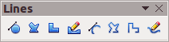
 | Connector | Draws a connector line between two figures. Actual icon shown will depend on the option that has been selected. Click the triangle to the right of the tool icon to show the available options. Each option is described in “Working with connectors” on page 22.  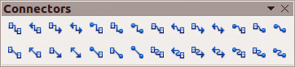
 | Lines and Arrows | Draws a line ending in an arrow. Actual icon shown will depend on the option that has been selected. Click the triangle to the right of the tool icon to show the available options. Note that the title of this submenu when undocked from the Drawing toolbar is Arrows.  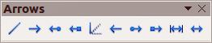
 | Basic Shapes | Click the triangle to the right of the tool icon to open a toolbar showing the available options. Actual icon shown will depend on the option that has been selected. Select the desired basic shape, then draw it by placing your cursor on the slide and dragging your mouse to define an enclosing rectangle. Keep the Shift key pressed to obtain a basic shape where the height and width are equal. Press the Alt key to draw a basic shape from its center.  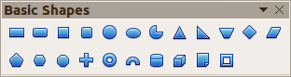
 | Symbol Shapes | Click the triangle to the right of the tool icon to open a toolbar showing the available options. Actual icon shown will depend on the option that has been selected. Select the desired symbol shape, then draw it by placing your cursor on the slide and dragging your mouse to define an enclosing rectangle. Keep the Shift key pressed to obtain a symbol shape where the height and width are equal. Press the Alt key to draw a symbol shape from its center.  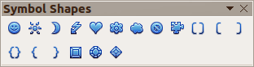
 | Block Arrows | Click the triangle to the right of the tool icon to open a toolbar showing the available options. Actual icon shown will depend on the option that has been selected. Select the desired block arrow, then draw it by placing your cursor on the slide and dragging your mouse to define an enclosing rectangle. Keep the Shift key pressed to obtain a block arrow where the height and width are equal. Press the Alt key to draw a block arrow from its center.  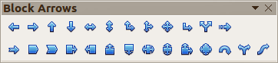
 | Flowcharts | Click the triangle to the right of the tool icon to open a toolbar showing the available options. Actual icon shown will depend on the option that has been selected. Select the desired flowchart shape, then draw it by placing your cursor on the slide and dragging your mouse to define an enclosing rectangle. Keep the Shift key pressed to obtain a flowchart where the height and width are equal. Press the Alt key to draw a flowchart shape from its center.  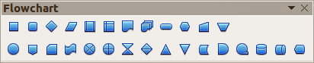
 | Callouts | Click the triangle to the right of the tool icon to open a toolbar showing the available options. Actual icon shown will depend on the option that has been selected. Select the desired callout, then draw it by placing your cursor on the slide and dragging your mouse to define an enclosing rectangle. Keep the Shift key pressed to obtain a callout where the height and width are equal. Press the Alt key to draw a callout from its center.  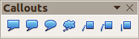
 | Stars | Click the triangle to the right of the tool icon to open a toolbar showing the available options. Actual icon shown will depend on the option that has been selected. Select the desired star, then draw it by placing your cursor on the slide and dragging your mouse to define an enclosing rectangle. Keep the Shift key pressed to obtain a star where the height and width are equal. Press the Alt key to draw a star from its center. Note that the title of this submenu when undocked from the Drawing toolbar is Stars and Banners.  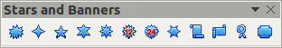
 | Points | Edits the individual points that form the shape or line. Select this tool and then select a shape or a line. You can also press the F8 key to select this tool.
 | Glue Points | Edits the glue points of a graphic object. Glue points are the positions where connector lines terminate or start. See “Managing glue points” on page 23 for instructions.
 | Fontwork Gallery | Opens the Fontwork gallery. See “Using Fontwork” on page 27 for further information.
 | From File | Equivalent to Insert > Picture > From file on the main menu bar. See Chapter 4 Adding and Formatting Pictures for details.
 | Gallery | Opens the gallery. Equivalent to Tools > Gallery on the main menu bar. See Chapter 4 Adding and Formatting Pictures for details.
 | Extrusion On/Off | Switches 3D effects on or off for the selected object. Clicking this button also opens the 3D settings toolbar. See “Working with 3D objects” on page 24 for details.

Additional drawing tools
In addition to the default set of drawing tools available on the Drawing toolbar (Figure 1), you can install additional tools. These additional tools are described in Table 2.
To install or remove additional tools onto or from the Drawing toolbar:
- Right-click on an empty area on the Drawing toolbar.
- Select Visible Buttons from the context menu to display a list of the available tools.
- To install a tool, click on it and the tool will appear in the Drawing toolbar. The list of available tools will close automatically. Installed tools are indicated by a border around the icon.
- To remove a tool, click on it and the tool is removed from the Drawing toolbar. Uninstalling a tool removes the border around the tool icon. The list of available tools will close automatically.
Table 2: Additional drawing tools
Tool | Name | Purpose
 | 3D Objects | Click the triangle to the right of the tool icon to open a toolbar showing the available options. Actual icon shown will depend on the option that has been selected. Select the desired 3D shape, then draw it by placing your cursor on the slide and dragging your mouse to define an enclosing rectangle. Keep the Shift key pressed to obtain a 3D shape where the height and width are equal. Press the Alt key to draw a 3D shape from its center.  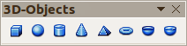
 | To Curve | Converts the selected object to a Bézier curve.
 | To Polygon | Converts the selected object to a polygon (a closed object bounded by straight lines). The appearance of the object does not change. If you want, you can right-click and choose Edit Points to view the changes.
 | To 3D | Converts the selected 2D object to a 3D object.
 | To 3D Rotation Object | Converts the selected 2D object to a 3D rotation object.
 | Insert | Allows you to insert a slide, table, from file, movie and sound, formula, or chart into your presentation. Click the triangle to the right of the tool icon to open the Insert toolbar showing the available options. Actual icon shown will depend on the option that has been selected.  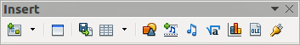
 | Controls | Allows you to insert various form controls into your presentation. Click the triangle to the right of the tool icon to open the Form Controls toolbar showing the available options.  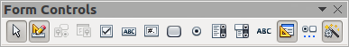
 | Animated Image | Adds animation to a selected object on a slide. Opens the Animation dialog.

Creating lines and shapes
Creating shapes and lines is basically the same procedure for all lines and shapes:
- Click on the triangle to the right of the tool you want to use on the Drawing toolbar and select the desired tool from the available selection. Note that the tools on the Drawing toolbar show the last tool shape selected.
- Position your cursor on the slide, then click and drag to create the line or shape.
- Release the mouse button when you have drawn your line or shape. You can then modify and reposition your line or shape using the procedures described later in this chapter.

Regular shapes
When creating shapes that are included in Impress, one or more dots may be displayed in a different color to the selection handles. These dots perform a different function according to the shape they are applied to, as listed below.
Basic Shapes
- Rounded rectangle and rounded square – use the dot to change the radius of the curve that replaces the angled corners of a rectangle or square.
- Circle pie – use the dots to change the size of the filled sector.
- Isosceles triangle – use the dot to modify the shape and type of the triangle.
- Trapezoid, parallelogram, hexagon, or octagon – use the dot to change the internal angles between the sides.
- Cross – use the dot to change the thickness of the four arms of the cross.
- Ring – use the dot to change the internal diameter of the ring.
- Block arc – use the dot to change both internal diameter and size of the filled area.
- Cylinder and cube – use the dot to change the perspective.
- Folded corner – use the dot to change the size of the folded corner.
- Frame – use the dot to change the thickness of the frame.
Symbol Shapes
- Smiley face – use the dot to change the smile on the face.
- Sun, moon and heart – use the dot to change the shape of the symbol.
- Prohibited symbol – use the dot to change the thickness of the ring and the diagonal bar.
- Double bracket, left bracket, right bracket and double brace – use the dot to change the curvature of the bracket.
- Left brace and right brace – use the dots to change the curvature of the brace and the position of the point.
- Square bevel, octagon bevel and diamond bevel – use the dot to change the thickness of the bevel.
Block Arrows
- Left arrow, right arrow, up arrow, down arrow, left and right arrow, up and down arrow, striped right arrow and notched right arrow – use the dot to change the shape and thickness of the arrows.
- Up and right arrow, up, right and down arrow and 4-way arrow – use the dots to change the shape and thickness of the arrows.
- Pentagon and chevron – use the dot to change the angle between the sides and the shape.
- Right arrow callout, left arrow callout, up arrow callout, down arrow callout, left and right arrow callout, up and down arrow callout, up and right arrow callout and 4-way arrow callout – use the dots to change the shape and thickness of the callouts.
- Circular arrow – use the dots to change the thickness and area of the arrow.
Callouts
- For all callouts use the dots to change the length, position and angle of the pointer.
Stars
- 4-point star, 8-point star and 24-point star – use the dot to change the thickness and shape of the star points.
- Vertical scroll and horizontal scroll – use the dot to change the width and shape of the scroll.
- Doorplate – use the dot to change the inward curvature of the corners.

Curves, polygons and freeform lines
To draw a curve, polygon or freeform line click the Curve icon on the Drawing toolbar. Note that the default action of this tool is to show the last selected tool and, by default, the last selected tool will be used. To use a different tool, click on the triangle to the right of the icon to open the tools that are available (Figure 2 and Table 3). Note that the title of this tool submenu when undocked from the Drawing toolbar is Lines.
If a filled curve, polygon or freeform line was selected, Impress draws the line connecting the last point to the start point and fills the inside area with the default color.

Figure 2: Lines (curves) toolbar
Table 3: Curve, polygon and freeform tools
Icon | Tool name | Icon | Tool name | Icon | Tool name | Icon | Tool name
 | Curve filled |  | Polygon filled |  | Polygon 45° filled |  | Freeform line filled
 | Curve |  | Polygon |  | Polygon 45° |  | Freeform line

Curves
- Select either Curve filled or Curve.
- Click and hold the left mouse button to create the starting point of your curve.
- While holding down the left mouse button, drag from the starting point to draw a line.
- Release the left mouse button and continue to drag the cursor to bend the line into a curve.
- Click to set the end point of the curve and fix the line on the page.
- To continue with your line, drag the mouse cursor to draw a straight line. Each mouse click sets a corner point and allows you to continue drawing another straight line from the corner point.
- Double click to end the drawing of your line.
Note | Holding down the Shift key when drawing lines with the Curve or Polygon tools will also restrict the angles between the lines to 45 or 90 degrees.

Polygons
- Select either Polygon filled or Polygon.
- Click and draw the first line from the start point with the left mouse button held down. As soon as you release the mouse button, a line between the first and second points is drawn.
- Move the cursor to draw the next line. Each mouse click sets a corner point and allows you to draw another line.
- Double-click to end the drawing of your polygon.

Polygons 45°
Select either Polygon (45°) filled or Polygon (45°) and these polygons are drawn in the same way as polygons above. However, the angles between line segments are restricted to 45 or 90 degrees as you draw your polygon.

Freeform lines
Using the Freeform Line tools is similar to drawing with a pencil on paper.
- Select either Freeform line filled or Freeform line.
- Press and hold the left mouse button and drag the cursor to the line shape you require.
- When you finished drawing your freeform line, release the mouse button and the drawing is completed.

Grouping objects together
It is often convenient to group objects together so that they are treated as a single object by Impress. A group of objects can be formatted as if it was a single object, moved, rotated, deleted and so on.
This section only gives a brief introduction to grouping of objects. For more information on working with grouped objects, see the Draw Guide Chapter 5 Combining Multiple Objects.

Grouping
To group objects together:
- Select the objects to be grouped using the selection tool on the Drawing toolbar and draw a rectangle around the objects to be grouped, or hold down the Shift key and click on each object. To select all the objects, go to Edit > Select All on the main menu bar or use the keyboard combination Ctrl+A.
- When the selection handles are displayed, go to Format > Group > Group on the main menu bar or use the keyboard combination Ctrl+Shift+G or right-click on an object within the selected group and select Group from the context menu.

Editing or formatting groups
To edit or format a group of objects:
- Click on any one of the objects in the group to select the group. Any editing or formatting is then carried out on all the objects within the group.
- To edit an individual object within a group:
- After selecting the group, press the F3 key or go to Format > Group > Enter Group on the main menu bar or right-click and select Enter Group from the context menu.
- Select individual objects within the group for editing or formatting.
- When you have finished editing or formatting, use the keyboard combination Ctrl+F3 or go to Format > Group > Exit group on the main menu bar or right-click and select Exit Group from the context menu. The whole group then becomes selected.

Ungrouping
To ungroup objects:
- Click on any one of the objects in the group to select the group.
- When the selection handles are displayed, go to Format > Group > Ungroup on the menu bar or use the keyboard combination Ctrl+Alt+Shift+G or right-click on the group and select Ungroup from the context menu.
Tip | If you use the group and ungroup commands often, why not add them to one of the toolbars shown by default so that the commands are readily available? To do so, you will need to customize the selected toolbar. See Chapter 11 Setting Up and Customizing Impress.

Moving graphic objects
To move a graphic object:
- Click on a graphic object or a group of objects to display the selection handles.
- Move the cursor over a selected graphic object until the cursor changes shape. For example, on most operating systems, the cursor associated with moving objects is a clenched hand or a four-headed arrow.
- Click and drag the graphic object to the desired position. You can also use the arrow keys to move the selected object or group to a new position.
- Release the mouse button.
Tip | By default Impress makes the objects snap to the grid. If you need to position the object between two points of the grid, hold down the Ctrl key, then click on the object and move it to the desired position. Alternatively, you can turn off this snap function or modify the grid resolution by going to Tools > Options > LibreOffice Impress > Grid.
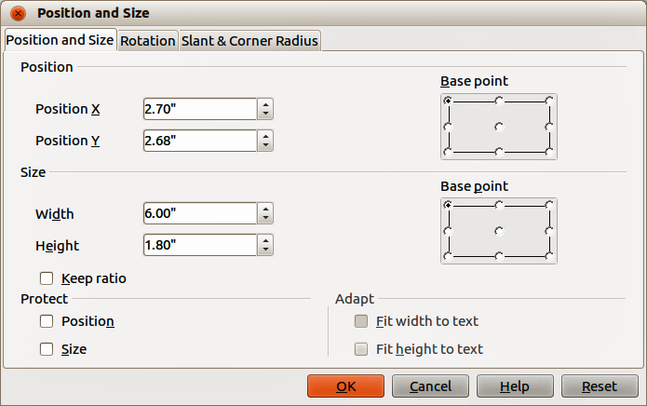
Figure 3: Position and Size dialog
For a more accurate placement of the graphic object, use the Position and Size dialog (Figure 3):
- With the object selected and the selection handles displayed, press F4 or go to Format > Position and Size on the main menu bar, or right-click on the selected object and select Position and Size from the context menu.
- Click on the Position and Size tab.
- Use the Position section of the dialog to specify the X (horizontal) and Y (vertical) position of the graphic object. The values represent the distance of the base point selected on the right hand side of the dialog. The default selection for base point is relative to the top left corner of the slide.
- To prevent accidental modification of the position of the graphic object, select the Position option in the Protect section of the dialog.
- Click OK when satisfied and to close the dialog.
The units of measurement for this dialog and other dialogs are set in Tools > Options > LibreOffice Impress > General.

Resizing graphic objects
To resize a graphic object:
- Click on a graphic object or a group of objects to display the selection handles.
- Position the pointer over one of the selection handles. The pointer changes shape giving a graphical representation of the direction of the resizing. The corner handles resize both the width and the height of the graphic object simultaneously, while the other four handles resize only one dimension at a time.
- Click and drag to resize the graphic object.
- Release the mouse button to complete resizing.
Tip | To retain the original proportions of the graphic, Shift+click one of the corner handles, then drag. Release the mouse button before releasing the Shift key.
For more accurate resizing of the graphic object, use the Position and Size dialog (Figure 3):
- With the object selected and the selection handles displayed, press F4 or go to Format > Position and Size on the main menu bar, or right-click on the selected object and select Position and Size from the context menu.
- Click on the Position and Size tab.
- Select as the base point the part of the graphic object that you would like to anchor to the page. The default selection of top left corner means, that when resizing, the position of the top left corner of the object will not change.
- Now modify either the Width value or the Height value of the object in the Size section.
- To maintain the proportions between width and height, select the Keep ratio option before modifying any value. When Keep ratio is selected, changes to one dimension results in an automatic change to the other with the ratio between width and height maintained.
- To prevent accidental modifications of the size, select the Size option in the Protect section of the dialog.
- Click OK when satisfied and to close the dialog.

Applying special effects
As well as the basic actions of moving and resizing an object, a number of special effects can also be applied to objects in Impress. Several of these effects are readily available in the Mode toolbar (Figure 4). If the Mode toolbar is not showing, select it from View > Toolbars > Mode.
This section describes how to rotate, flip, distort and two ways of setting an object in a circle. The transparency and gradient tools are more specific to formatting and are discussed in Chapter 6 Formatting Graphic Objects.
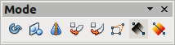
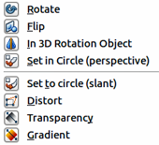
Figure 4: Mode toolbar and available options
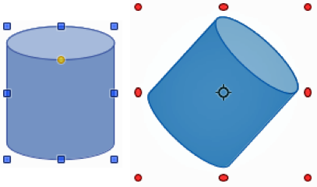
Figure 5: Object selected for rotation

Rotating graphic objects
Rotation of an object can be carried out manually or using a dedicated dialog, just like changing object position and size. To rotate a graphic manually:
- Click on a graphic object and the selection handles will show.
- Click the Rotate icon on the Line and Filling or Mode toolbars or click again on the graphic object. The square selection handles change shape and also change color (Figure 5). Also a pivot point indicating the rotation center appears in the center of the object.
- Move the mouse over one of the corner handles and the mouse cursor shape will change.
- Click the mouse and move in the direction in which you want to rotate the graphic object. Only the corner selection handles are active for rotation.
- When satisfied with the rotation, release the mouse button.
- To change the rotation center of the object, click and drag the pivot point to the desired position before rotating. The pivot point can be moved to any position on the slide, even outside of the object boundaries.
- To restrict the rotation angles to multiples of 15 degrees, press and hold the Shift key while rotating the graphic. This is very handy for rotating pictures through a right angle, for example from portrait to landscape. Remember to release the Shift key before releasing the mouse button.
Note | The icons representing the functions in the toolbars may be different depending on the operating system used and on whether LibreOffice has been customized. When in doubt, hover the mouse over an icon and wait for the tooltip to appear showing the name of the icon.
Instead of rotating a graphic object manually, you can use the Rotation dialog (Figure 6) to accurately rotate an object in degrees:
- With the object selected and the selection handles displayed, press F4 or go to Format > Position and Size on the main menu bar, or right-click on the selected object and select Position and Size from the context menu.
- Click on the Rotation tab.
- In the Pivot point section, select the position of the pivot point. The default position of the pivot point is the center of the object.
- In the Rotation angle section, enter the degrees in the Angle text box by which to rotate the graphic object. Alternatively, in Default settings, click on the Rotation Angle indicator and drag it to a new angle.
- Click OK when satisfied and to close the dialog.
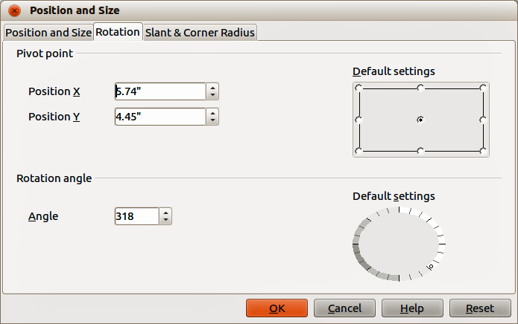
Figure 6: Rotation page of the Position and Size dialog

Flipping objects
The quickest and easiest method to flip an object horizontally or vertically is as follows:
- Click on a graphic object and the selection handles will show.
- Right-click and select Flip > Horizontally or Flip > Vertically from the context menu and the selected object will be flipped to face the other direction.
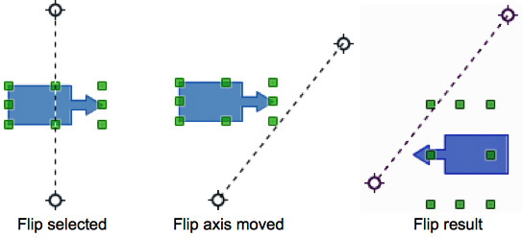
Figure 7: Using the Flip tool
The Flip tool on the Drawing or Mode toolbar can also be used. Using this tool also allows you to change the position and angle that the object flips over (Figure 7).
- Click on a graphic object and the selection handles will show.
- Click on the Flip icon on the Drawing or Mode toolbar and the axis of symmetry appears as a dashed line through the center of the object. The object will be flipped about this axis of symmetry.
- Click and drag the axis of symmetry to a new position, or position the cursor in one of the circles at each end of the axis of symmetry and drag with your mouse cursor to change the angle.
- Place the mouse cursor over one of the object selection handles until it changes shape.
- Click and drag your cursor across the axis of symmetry to flip the object. The new position of the object is shown faintly until the mouse is released.
- Release the mouse button and the object will appear flipped over. Angle and position of the flip will depend on the angle and position of the axis of symmetry.
Note | If you press the Shift key while moving the axis of symmetry, it will rotate in 45-degree increments.

Mirror copies
At the moment there is no mirror command existing in Impress. However, mirroring an object can be emulated by flipping the object:
- Select the object you want to make a mirror copy of and copy the object to the clipboard.
- Flip the object using one of the methods in “Flipping objects”, then move the flipped object to one side.
- Click on an empty area of the page to deselect the object.
- Paste from the clipboard to put a copy of the object into your slide.
- Select both images, then right-click and select Alignment from the context menu.
- Select the type of alignment you want to use. Top, Center, or Bottom if you are creating a horizontal mirror copy. Left, Centered, or Right if you are creating a vertical mirror copy.

Distorting images
Three tools on the Mode toolbar (Figure 4 on page 15) let you drag the corners and edges of an object to distort the image. The Distort icon distorts an object in perspective, the Set to Circle (slant) icon and Set in Circle (perspective) icon both create a pseudo three-dimensional effect. Note that when using these tools, you have to transform an object to a curve before distorting.

Distort tool
- Select an object and click on the Distort icon on the Mode toolbar.
- Click Yes to convert the object to a curve. If the object is already a curve, this dialog does not appear.
- Click and drag a corner selection handle to distort the object using the opposite corner selection handle as an anchor point for the distortion.
- Click and drag the vertical selection handles to distort the object using the opposite vertical side as an anchor point for the distortion.
- Click and drag the horizontal selection handles to distort the object using the opposite horizontal side as an anchor point for the distortion.
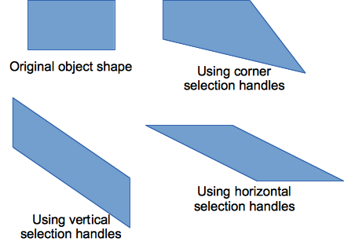
Figure 8: Distorting an object

Set in circle (perspective) tool
- Select an object and click on the Set in Circle (perspective) icon in the Mode toolbar.
- Click Yes to convert the object to a curve. If the object is already a curve, this dialog does not appear.
- Click and drag one of the selection handles to give a pseudo three-dimensional perspective using the opposite side as an anchor point (Figure 9). A ghosted image appears as you drag to give you and indication of the resulting object will look.
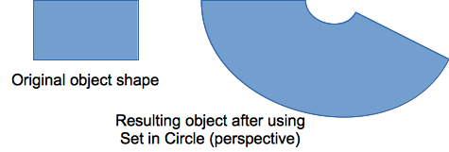
Figure 9: Setting an image to a circle with perspective

Set to circle (slant) tool
- Select an object and click on the Set to Circle (slant) icon in the Mode toolbar.
- Click Yes to convert the object to a curve. If the object is already a curve, this dialog does not appear.
- Click and drag one of the selection handles to give a pseudo three-dimensional perspective using the opposite side as an anchor point (Figure 10). A ghosted image appears as you drag to give you and indication of the resulting object will look.
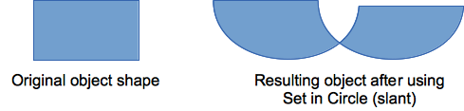
Figure 10: Setting an image to a circle with slant
Note | Transforming an object into a curve is a safe operation, but it cannot be reversed other than by using the Undo function.

Aligning objects
Use the alignment tools to adjust the relative position of a graphic object compared to another object.
Click on the triangle to the right of the Alignment icon in the Line and Filling toolbar or go to View > Toolbars > Align on the main menu bar to open the Align toolbar (Figure 11). The Alignment icon shown on the Line and Filling toolbar will depend on the alignment option that had been previously selected. The alignment options are also available when you right-click on selected objects.
If only one object is selected, the alignment options are not available.
The toolbar has six tools available:
- Left, Center, Right – determines the horizontal alignment of the selected objects.
- Top, Center, Bottom – determines the vertical alignment of the selected objects.
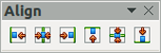
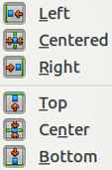
Figure 11: Align toolbar

Snapping objects to grid or snap guides
Sometimes it is important to align objects to specific points of the page or to make sure that objects that appear on multiple slides are placed in exactly the same position. For this purpose Impress provides two mechanisms: Grid and Snap Guides (also called Snap Lines).

Using the grid
Options for the grid are available by right-clicking on an empty part of the page in Normal view and choosing Grid or by selecting View > Grid from the menu bar. The options available from the context menu that opens are:
- Display Grid – displays the grid.
- Snap to Grid – the anchor points of an object will be placed on a grid when the object is moved or resized.
- Grid to Front – displays the grid in the foreground.
To set up the grid spacing and snapping options, go to Tools > Options > LibreOffice Impress > Grid on the menu bar.

Using snap guides
Options for the guides are available by right clicking on an empty part of the page in Normal view and choosing Snap Lines or by selecting View > Snap Lines from the menu bar. The options available from the context menu that opens are:
- Display Guides – the guides are shown on the slide.
- Snap to Snap Lines – the anchor points of the objects snap to the guides when the object is moved or resized.
- Snap Lines to Front – displays the guides in the foreground.
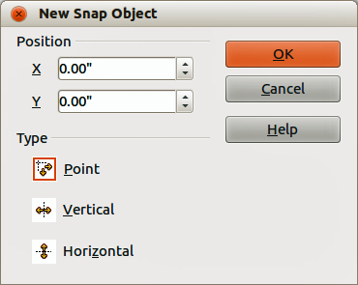
Figure 12: New Snap Object dialog

Creating a new guide
- Right-click on an empty part of the work area and select Insert Snap Point/Line from the context menu to open the New Snap Object dialog (Figure 12).
- Specify the type of snap object. Depending on the choice made determines which field becomes active:
- Point both X and Y fields become active.
- Vertical only X field becomes active.
- Horizontal only Y field become active.
- Enter the position of the guide.
- Click OK to close the dialog.
Tip | When positioning the Snap Guides, it is useful to display the rulers. To do so, select View > Rulers. Drag a Snap Guide directly onto the slide by clicking on the ruler and then dragging onto the slide.

Editing guides
- Right-click next to or on the guide to be edited.
- Select Edit Snap line from the context menu.
- Enter a new value in the X or Y field for the guide position and click OK.

Deleting guides
- Right-click next or on the guide to be deleted.
- Select Delete Snap line from the context menu.

Arranging objects
Impress organizes objects in a stack so that the objects on the top level of the stack cover the objects on lower levels if any overlapping occurs. The stack level of each object can be changed by arranging shapes on a slide or page.
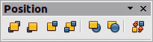

Figure 13: Position toolbar
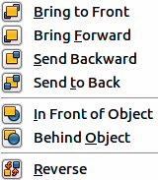
To change the stack level of an object, select an object or objects and then click the small triangle on the side of the Arrange icon on the Line and Filling toolbar to open the Position toolbar (Figure 13). The Arrange icon shown on the Line and Filling toolbar will depend on the arrange option that had been previously selected. The arrange options are also available by right-clicking on a selected object.
The first four tools determine the stack level of a selected object:
- Bring to front: – the selected object is moved in front of all other objects.
- Bring forward – the selected object is moved one level up in the stack.
- Send backwards – the selected object is moved one level down in the stack.
- Send to back – the selected object is moved behind all other objects.
The other three tools determine the relative positions of the selected objects:
- In front of object – moves the first selected object in front of the second selected object.
- Behind object – moves the first selected object behind the second selected object.
- Reverse – swaps the stacking order of two selected objects.
To use the In front of object and Behind object tools:
- Select the first object by clicking on it.
- Select In front of object or Behind object from the context menu and the mouse cursor changes to a pointing hand.
- Click on the second object and the objects swap positions.

Working with connectors
Connectors are lines that can be anchored to particular places, called glue points, on an object. The advantage of connectors is that when an object with a connector attached is moved or resized, the connector automatically adjusts to the change. When creating a flowchart, organization chart, schematics or diagrams, it is highly recommended to use connectors instead of simple lines.
When a connector is drawn or selected Impress displays selection handles which are not shown for normal lines. The termination points of a connector are square at the start of a connector and round at the end of a connector. The selection handles on a connector are used to modify the routing of a connector where applicable.
Impress offers a wide variety of predefined connectors, which differ in the termination shape (none, arrow, custom) and in the way the connector is drawn (straight, line, curved).

Drawing connectors
A simple method of drawing is as follows. For more information on how to format a connector, refer to Chapter 6 Formatting Graphic Objects.
- Click on the triangle next to the Connector icon on the Drawing toolbar and select the type of connector you want to use. The Connector icon shown on the Drawing toolbar will depend on the connector that had been previously selected and used.
- Move the mouse cursor over one of the objects to be connected and small crosses appear around the object edges which are the glue points to which a connector can be attached (Figure 14).
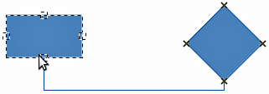
Figure 14: Example of using a connector
- Click on the required glue point to attach one end of the connector, then hold the mouse button down and drag the connector to another object.
- When the cursor is over the glue point of the target object release the mouse button and the connector is drawn.
- The selection handles that appear on the connector are used to adjust the path of the connector so that the connector does not cover another object in its path.

Managing glue points
A glue point is the attachment point for a connector on an object. Each object shape has a number of predefined glue points, but it is possible to define new ones, as well as edit them, using the Gluepoints toolbar.
- Click on the Gluepoints icon on the Drawing toolbar or go to View > Toolbars > Gluepoints on the main menu bar to open the toolbar (Figure 15).
- Select an object on your slide.
- To insert a new glue point onto the selected object, click on the Insert Glue Point icon.
- If you want to fix the direction a connector uses when connecting to a glue point, click on one of the exit direction icons. This is useful if you have multiple connectors terminating on one side of an object or the position of the default glue point is not satisfactory.
- Move the cursor to the position you require on the selected object, then click the mouse button to insert the glue point.
- Make sure that the Glue point relative icon is selected to maintain the relative position of a glue point when resizing the object.
- Deselecting the Glue point relative icon activates the remaining six icons on the toolbar. Use these tools to fix the position of the glue point during the resizing of the object.
- To delete a glue point you have inserted, select it with the cursor and press the Delete key. The default glue points on an object cannot be deleted.
- To move a glue point you have inserted, select it with the cursor and drag the glue point to a new position. The default glue points on an object cannot be moved.
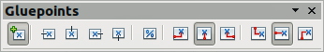

Figure 15: Gluepoints toolbar and available options
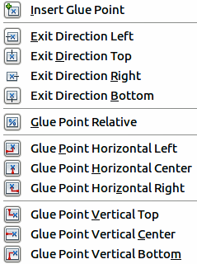
Tip | Glue points are placed by default on the grid (see “Snapping objects to grid or snap guides” on page 20 for information). However it is sometimes necessary to fine tune the position of a glue point depending on the shape of the object. To do this, press the Ctrl key to display guide lines and keep the Ctrl key pressed while dragging the glue point to the new position.

Working with 3D objects
Although Impress offers advanced functions to manipulate 3D objects, this guide describes only the 3D settings applicable to an object. For additional information on how to use advanced 3D effects such as geometry and shading, refer to the Draw Guide.
3D objects can be created in Impress in any of the following ways:
- Click on the triangle to the right of the 3D Objects icon on the Drawing toolbar and select a 3D object from the options. After selection, draw your 3D object on your slide as you would with any object. The 3D Objects icon shown on the Drawing toolbar will depend on the 3D object that had been previously selected and used.
- Go to View > Toolbars > 3D-Objects on the main menu bar to open the 3D-Objects toolbar (Figure 16). The selection and drawing of 3D objects is the same as clicking on the 3D Objects icon on the Drawing toolbar.
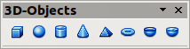
Figure 16: 3D-Objects toolbar
- Right-click on an object already on your slide and select Convert > To 3D or To 3D Rotation Object from the context menu. To 3D adds thickness to the object to create a 3D object. To 3D Rotation Object creates a 3D object by rotating the object around an axis.
- Select an object and click on the Extrusion on/off icon on the Drawing toolbar to apply a basic 3D effect and open the 3D-Settings toolbar. Select one of the options on the 3D-Settings toolbar to apply a different 3D effect (Figure 17 and Table 4).
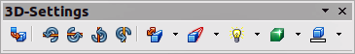
Figure 17: 3D-Settings toolbar
Table 4: 3D-Settings tools and their purpose
Tool | Name | Purpose
 | Extrusion On/Off | Adds thickness to an object and activates the 3D properties.
 | Tilt Down | Tilts the object downwards around a horizontal axis.
 | Tilt Up | Tilts the object up around a horizontal axis.
 | Tilt Left | Tilts the object left around a vertical axis.
 | Tilt Right | Tilts the object right around a vertical axis.
 | Depth | Determines the thickness of the shape. An extended toolbar opens where some default values are given. If none of the values are satisfactory, select Custom and then enter the desired thickness.
 | Direction | Opens an extended toolbar that lets you pick the direction of the perspective as well as the type (parallel or perspective).
 | Lighting | Opens an extended toolbar that lets you specify the direction and intensity of light.
 | Surface | Choose between Wire frame (useful when manipulating the object), Matt, Plastic or Metal.
 | 3D Color | Selects the color of the object thickness.
Note | Most of the Fontwork shapes (see “Using Fontwork” on page 27) have 3D properties and can be manipulated with the 3D-Settings toolbar.

Converting objects to different types
You can convert an object into a different type. Right-click on the object and select Convert from the context menu to display the following options:
- To Curve – converts the selected object to a Bézier curve. Click on the Points icon on the Drawing toolbar to edit the points after conversion to a Bézier curve.
- To Polygon – converts the selected object to a polygon. Click on the Points icon to edit the object after conversion to a polygon. A polygon always consists of straight segments.
- To Contour – for basic shapes, this is equivalent to converting to polygon. For more complex shapes (or for text objects) this conversion creates a group of polygons that you can then manipulate by pressing F3 to enter the group.
- To 3D – converts the selected object to a 3D object.
- To 3D Rotation Object – creates a three-dimensional shape by rotating the selected object around its vertical axis.
- To Bitmap – converts the selected object to a bitmap.
- To Metafile – converts the selected object to Windows Metafile Format (WMF), containing both bitmap and vector graphic data.
Note | In most cases the conversion to a different type does not produce immediately visible results.
Tip | To Curve, To Polygon, To 3D and To 3D Rotation Object can be added to the Drawing toolbar as additional tools by right-clicking in an empty area on the toolbar and selecting Visible Buttons.

Setting up interaction with an object
You can associate an object to an action that is performed when it is clicked. To create an interaction:
- Select the object for which an interaction will be created.
- Click on the Interaction icon the Line and Filling toolbar or right-click on the object and select Interaction from the context menu to open the Interaction dialog (Figure 18).
- Select the interaction type and the parameters (if applicable). The interactions are explained in Table 5 and the Interaction dialog changes depending on the type of interaction selected.
- Click OK to close the dialog.
- To remove an interaction from a graphic object follow Steps 1 to 2 and then select No action as the interaction type at Step 3.
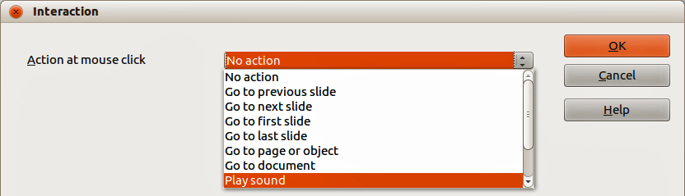
Figure 18: Interaction dialog
Table 5: Interaction types and their parameters
Interaction | Parameters
Go to previous slide | No parameters.
Go to next slide | No parameters.
Go to first slide | No parameters.
Go to last slide | No parameters.
Go to page or object | Specify the target from the list in the Target box. You can search for a specific target in the Slide/Object box at the bottom of the screen.
Go to document | Select the document in the Document box. Use the Browse button to open a File Open dialog. If the document to be opened is in Open Document Presentation format, the target list will be populated allowing selection of the specific target.
Play sound | Select the file containing the sound to be played. Use the Browse button to open a File Open dialog.
Run program | Select the program to execute. Use the Browse button to open a File Open dialog.
Run macro | Select a macro that will run during the presentation. Use the Browse button to open the Macro Selector dialog.
Exit presentation | When the mouse is clicked over the object, the presentation will terminate.

Using Fontwork
Use Fontwork to obtain special text effects. For more about this topic, see the Getting Started Guide Chapter 11 Graphics, the Gallery, and Fontwork.
To start using Fontwork:
- Click on the Fontwork Gallery icon on the Drawing toolbar or on the Fontwork toolbar to open the Fontwork Gallery dialog.
- Select the preferred style from the Fontwork Gallery dialog (Figure 19) and click OK. The text Fontwork in the selected style appears on the slide. You can modify its shape and properties after it has been placed on the slide.
- Double-click the object to edit the Fontwork text. Type your own text to replace the word Fontwork that appears over the object.
- Press the Esc key or click outside the area with the selection handles to exit.
You can edit some of its attributes by using the Fontwork toolbar or tools that are used to change attributes of objects.
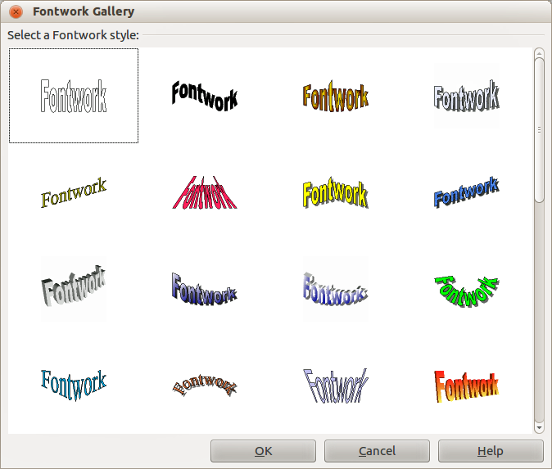
Figure 19: Fontwork Gallery

Using the Fontwork toolbar
Make sure that the Fontwork toolbar (Figure 20) is visible on the workspace. If not, select View > Toolbars > Fontwork from the main menu bar.
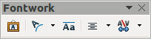
Figure 20: Fontwork toolbar
In addition to the Fontwork Gallery icon, this toolbar contains the following tools:
- Fontwork Shape – changes the shape of the selected object. Shapes are selected from the options that become available when you click on the icon.
- Fontwork Same Letter Heights – changes the height of characters in the selected object. Toggles between normal height where characters have different heights to where all characters are the same height.
- Fontwork Alignment: – specifies the text alignment within the frame from the options available.
- Fontwork Character Spacing – selects the desired spacing between characters and whether kerning pairs should be used. For custom spacing, input a percentage value: 100% is normal spacing; less than 100% is tight spacing; more than 100% is expanded spacing.

Modifying Fontwork as an object
It is possible to treat Fontwork text as an object and therefore to apply to it all the formatting that has been described in this chapter. Assign line properties only to Fontwork which does not have a 3D effect, otherwise the changes will not be visible.
You can modify some of the Fontwork shapes just as you modify the angles of trapezoid and parallelogram basic shapes by moving the dot that is displayed along with the selection handles.

Animations
Animated slide transitions can be added between slides to give your presentation a more professional look when you change to the next slide (see Chapter 9 Slide Shows for more information on transitions). However, Impress also allows you to add animations onto the slides to create more interest in your presentation.
An animation consists of a sequence of images or objects called frames that are displayed in succession when the animation runs. Each frame may contain one or more objects. For example, make bullet points appear one by one; make pictures, shapes or other objects appear singly or as a group onto a slide. Animations can be controlled using the keyboard or mouse click or automatically in a timed sequence.
There are two ways to create an animation in Impress: see “Custom Animation” below or “Inserting animated images” on page 32.
Tip | Animations can look great in a presentation, but overuse of animations can make a good presentation into a poor presentation. Always use discretion when adding animations to your presentation.

Custom Animation
The Custom Animation section (Figure 21) is located in the Tasks pane to the right of the Workspace in Impress. It is used to add an animation effect to an object on a slide, or change the animation effect of an object.
Note | Anything that can be placed onto a slide is an object. For example, an object can include a picture, clip art drawing or text and so on.

Custom animation section
The Custom Animation section allows you to control the animation.
- Add – opens the Custom Animation dialog (Figure 22) to add an animation effect to an object on the slide.
- Change – opens the Custom Animation dialog to change the animation effect of an animated object.
- Remove – removes any animation effects from an object.
- Start – displays the start property of the selected animation effect:
- On click – the animation stops at this effect until the next mouse click.
- With previous – the animation runs immediately.
- After previous – the animation runs as soon as the previous animation ends.
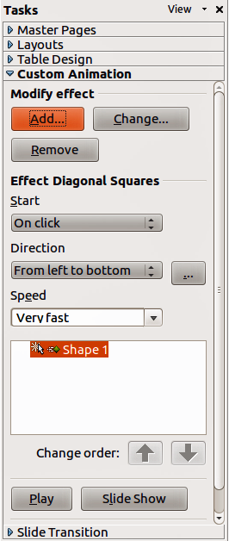
Figure 21: Custom Animation in the Tasks pane
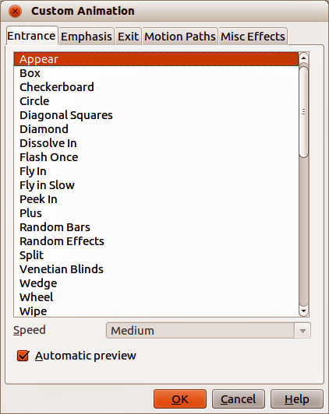
Figure 22: Custom Animation dialog
- Direction – controls how the animation appears on the slide:
- From left to bottom
- From left to top
- From right to bottom
- From right to top
- Effect Options – selects additional properties of an animation. Click the Effect Options button to open the Effect Options dialog (Figure 23) where you can select, adjust and apply options to the animation effect and timing.
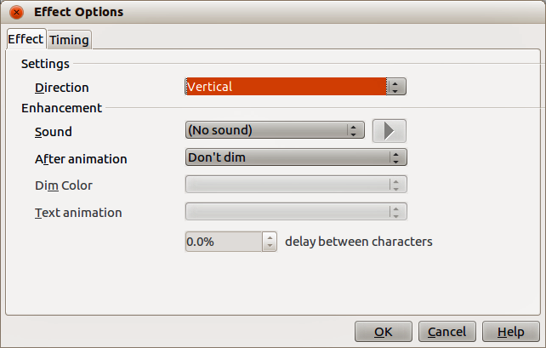
Figure 23: Effect Options dialog
- Speed – specifies the speed or duration of the selected animation effect.
- Change order – click one of the buttons to move the selected animation effect up or down in the order.
- Play – plays the selected animation effect in preview.
- Slide Show – starts the slide show from the current slide.
The Custom Animation dialog (Figure 22) also contains the following tabbed pages for creating custom animation:
- Entrance – how an animated object appears on the slide.
- Emphasis – how an animated object is emphasized when it appears on the slide.
- Exit – how an animated object leaves the slide.
- Motion Paths – how an object moves on the slide during animation.
- Misc Effects – selects media effects from the miscellaneous effects.
- Automatic preview – previews any new or edited animation effects on the slide.

Creating an animation
To create an animated object or objects using Custom Animation:
- Select an object on a slide.
- Open the Custom Animation section (Figure 21) by clicking on its name in the Tasks pane, or go to Slide Show > Custom Animation on the main menu bar, or by using the Custom Animation icon on the Drawing toolbar.
Note | The Custom Animation icon is an additional tool for the Drawing toolbar. It can be added to the Drawing toolbar by right clicking on an empty area on the Drawing toolbar and selecting Customize Toolbar from the context menu.
- Click on Add in Custom Animation to open the Custom Animation dialog (Figure 22).
- Select an effect category and the type of effect you want to apply to the selected object.
- Select how the effect starts, the direction and the speed (if available) of the effect from the various options included on the drop-down lists.
- Click Effect Options to open the Effect Options dialog (Figure 23) to set the effect options for the animation, then click OK to close the dialog.
- If necessary, change the appearance order of the objects in the animation using the Change order arrows.
- Click Play to check the animation effect.
- When you are satisfied, click Slide Show to check your presentation.

Inserting animated images
You can create an animated image and then insert it into your presentation by going to Insert > Animated Image on the main menu bar to open the Animation dialog (Figure 24). The animation controls are explained in Table 6.
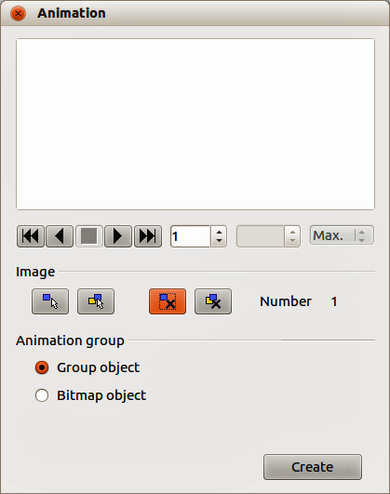
Figure 24: Animation dialog
Table 6: Animation dialog controls
Control | Control Name | Purpose
 | First image | Jumps to the first image in the animation sequence.
 | Backwards | Plays the animation backwards.
 | Stop | Stops playing the animation.
 | Play | Plays the animation.
 | Last image | Jumps to the last image in the animation sequence.
 | Image number | Indicates the position of the current image in the animation sequence. If you want to view another image, enter its number or click the up and down arrows.
 | Duration | Enter the number of seconds to display the current image. This option is only available if you select Bitmap object in Animation group.
 | Loop count | Sets the number of times that animation will play. If you want the animation to play continuously, select Max. This option is only available if you select Bitmap object in Animation group.
 | Apply Object | Adds selected object or objects as a single image.
 | Apply Objects Individually | Adds an image for each selected object. If you select a grouped object, an image is created for each object in the group.  You can also select an animation, such as an animated GIF, and click this icon to open it for editing. When you are finished editing the animation, click Create to insert a new animation into your slide.
 | Delete Current Image | Deletes the current image from the animation sequence.
 | Delete All Images | Deletes all images in the animation.
 | Number | Total number of images in the animation.
 | Group object | Assembles images into a single object so that they can be moved as a group. You can still edit individual objects by double-clicking the group in the slide.
 | Bitmap object | Combines images into a single image.
 | Create | Inserts the animation into the current slide.

Creating an animation
To create an animation using Insert > Animated Image on the menu bar:
- Create the object you intend to animate, using the drawing tools.
- Go to Insert > Animated Image on the menu bar to open the Animation dialog (Figure 24 and Table 6).
- Select the object and click on Apply Object icon to add it as the first frame of the animation.
- Apply a transformation or change to the object; for example, rotation, change color, add or remove a character(s) and so on.
- When you are ready, create the second frame of the animation and click Apply Object again to add another frame to the animation.
- Repeat steps 3, 4 and 5 until you have created all the desired frames of the animation.
- Select Bitmap object in Animation group to customize the timing of each of the frames and the number of repetitions for the animation.
- Set the duration of each frame in the animation in Duration and the number of repetitions in Max to create a loop for your animation. Selecting Max creates a continuous loop.
- Click Create and the animated image is placed in the center on your slide.
- Adjust the position of your animated object on your slide.
Note | If the image to be copied in the Animator consists of several objects, you can choose to treat each object as a separate frame. In this case, click on Apply objects individually icon. Remember that each object will be centered in the animation.

