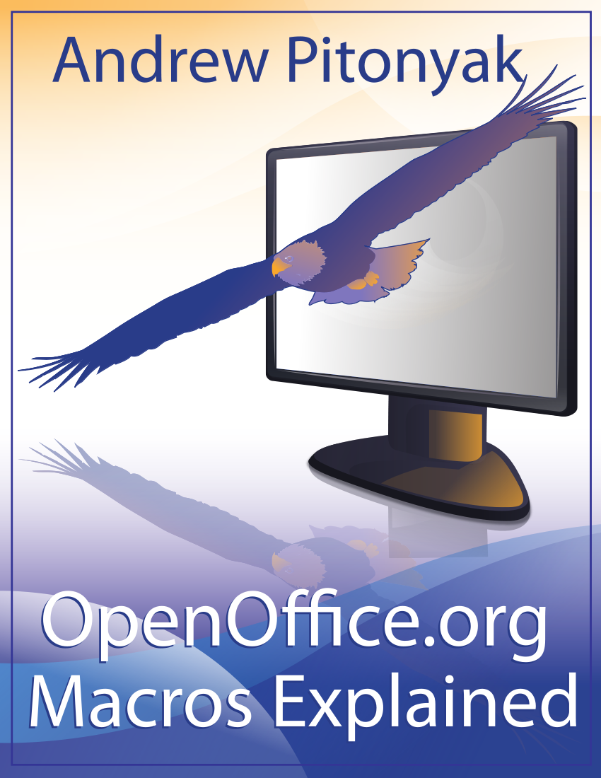
OpenOffice.org Macros Explained
OOME Third Edition

Last Modified
Monday, May 28, 2012 at 01:04:26 AM
Document Revision: 449

General Information
The contents of this document is Copyright 2011 - 2012 by Andrew D. Pitonyak. I will make a final license decision when I am finished.
I created a second edition that was never released, which is why I refer to this book as the third edition.
I have been repeatedly asked about the cover page so.... I am neither an artist nor a designer, so, I hired Amanda Barham (see http://www.amandabarham.com). She did an awesome job.

Table of Contents
General Information 1
Table of Contents i
11. The Dispatcher 2
11.1. The environment 2
11.1.1. Two different methods to control OOo 2
11.1.2. Finding dispatch commands 4
Use the WIKI 4
Probe the interface 4
Read source code 6
11.2. Writing a macro using the dispatcher 7
11.3. Conclusion 7

The Dispatcher
This chapter builds on previous coverage of the OpenOffice.org paradigm and then introduces the dispatcher. The dispatcher provides a simple mechanism for invoking internal functionality with limited knowledge of how the internals work, but it is considered the least-favored way of controlling OpenOffice.org.

The environment
OpenOffice.org separates a component’s (document's) functionality into the model, the controller, and the frame.
FRAME
Combines the pieces; it contains a model’s controller and knows all about the display window. The frame does not, however, have any display window functionality; the frame just knows that display windows exist.
Send a dispatch to the frame, because it controls things and knows how to route a dispatch.
Model
Consists of the document data and the methods to change the data.
You can update data directly using the model.

Controller
Aware of the current view and the data; it manipulates the document while receiving input from the user interface.
The controller knows things like what is selected and is able to select things.

TIP | Component almost always means an open document, but other windows are also components; for example, the Basic IDE and the help window.

Two different methods to control OOo
The most versatile method to manipulate an OOo document is to get the internal UNO objects and manipulate them. Using the model provides significant control, but you must understand much about the different services and interfaces.
Another method, which requires very little understanding of the OOo internals, is to use a UNO dispatcher. The dispatcher accepts a command such as “.uno:Undo” and takes care of the rest of the details. The frame provides the required dispatchers to perform the work. For simplicity, think of issuing a dispatch as very similar to selecting an action from the menu.
Although direct control using UNO services provides the most control and versatility, some operations are much easier to perform using the dispatcher; sometimes a dispatcher is the only way to accomplish a task. For example, the dispatcher is the best solution for handling the clipboard. Even the macro recorder performs almost all tasks using a dispatcher.
Three things are required to accomplish tasks using a dispatcher: (1) the command to dispatch, (2) arguments that control the dispatch, and (3) an object capable of performing the dispatch (a dispatch provider, which is usually a frame). Each document has a controller that, loosely speaking, acts as the interface between the outside world and the document. For example, use the current controller to select text, find the current cursor location, or determine which sheet is active in a spreadsheet. The current controller can also return the frame of the document, which supports the dispatch command.
Listing 1. The DispatchHelper service greatly simplifies executing dispatches.
oDispHelper = createUnoService("com.sun.star.frame.DispatchHelper")
The dispatch helper implements the function executeDispatch, which implements most of the functionality required to perform a dispatch. Table 1 contains a list of the arguments supported by the executeDispatch method.
While executing a dispatch, as discussed here, you cannot dispatch a command to a frame based on its name — either leave the target frame empty or enter “_self”. It is also, therefore, not important to use anything other than zero, or omit the argument completely, for the search flag. Attempting to specify another frame results in a run-time error (it seems silly to me that the arguments exist if they are not usable).
Table 1. Arguments to executeDispatch.
Argument | Description
XDispatchProvider | Dispatch provider that performs the dispatch.
URL String | The command to dispatch, as a string.
Target Frame String | Identifies the frame that will receive the dispatch. Use an empty string or “_self” to specify  the current frame (any other value is invalid).
long | Optional search flags that indicate how to find the target frame. Use zero or blank (see Listing 2), because it is not supported.
PropertyValue() | Optional arguments that are dependent on the implementation.

Listing 2. Execute the “undo” dispatch.
Sub NewUndo
Dim oDispHelper as object
Dim oProvider As Object
oProvider = ThisComponent.CurrentController.Frame
oDispHelper = createUnoService("com.sun.star.frame.DispatchHelper")
oDispHelper.executeDispatch(oProvider,".uno:Undo", "", , Array())
End Sub
The dispatch commands have both a name and a number, called a “slot.” Although a dispatch can be made based on either, the developers told me that the slot number may change in the future so it is safer to use the name. If you must use a slot, the Tools library contains a subroutine called DispatchSlot, which performs a dispatch based on a slot number alone.
Listing 3. Dispatch to a numeric slot.
'Include this library to use the DispatchSlot command.
GlobalScope.BasicLibraries.LoadLibrary("Tools")
DispatchSlot(5301) 'Load the About dialog, same as ".uno:About"
TIP | You cannot call a routine in a library unless the library is loaded. You can load a library manually from the Macro dialog and you can load it using the LoadLibrary command as shown in Listing 3. The Tools library included with OOo contains the DispatchSlot subroutine.
Some dispatch commands require arguments. The example in Listing 4 perform a dispatch with arguments. The GoToCell command needs to know which cell to go to. This macro moves the current cursor to the cell B3 in a spreadsheet document.
Listing 4. Dispatch commands can use arguments.
Dim args2(0) as new com.sun.star.beans.PropertyValue
args2(0).Name = "ToPoint"
args2(0).Value = "$B$3" ' position to B3
Dim oDispHelper as object
Dim oProvider As Object
oProvider = ThisComponent.CurrentController.Frame
oDispHelper = createUnoService("com.sun.star.frame.DispatchHelper")
oDispHelper.executeDispatch(oProvider, ".uno:GoToCell", "", 0, args2())

Finding dispatch commands
A complete list of dispatch commands is tricky to find. Previously, I assembled a complete list of all supported dispatch commands, but, the list changes and it is not clear to me that it is of much user. As such, I decided to tell you how to find the list on your own. If there is a demand for it, I may be convinced to compile a new list. Thanks to Ariel Constenla Haile for this information.

Use the WIKI
http://wiki.services.openoffice.org/wiki/Framework/Article/OpenOffice.org_3.x_Commands contains a list of commands and slots. Clearly some commands are missing, such as “.uno:ObjectTitleDescription”, but the list is fairly complete.

Probe the interface
The following macro uses the UICommandDescription service to enumerate the supported modules. A new Calc document is created and a sheet is created for each module. The commands supported by the module are placed on the sheet. Note that the macro takes a while to run because there is a lot of data to process.
Listing 5. Get commands from the ModuleManager.
Sub Print_All_Commands
' Create a new Calc document to hold the dispatch commands
Dim oDoc As Object
oDoc = StarDesktop.loadComponentFromURL("private:factory/scalc", "_default", 0, Array())

Dim oSheets As Object : oSheets = oDoc.getSheets()

'The UICommandDescription service provides access to the user interface commands that are
'part of OpenOffice.org modules, like Writer or Calc.
Dim oUICommandDescription As Object
oUICommandDescription = CreateUnoService("com.sun.star.frame.UICommandDescription")

'Identify office modules and provide read access to the configuration of office modules.
Dim oModuleIdentifier As Object
oModuleIdentifier = CreateUnoService("com.sun.star.frame.ModuleManager")

Dim oModuleUICommandDescription As Object, aModules$(),aCommand
Dim aCommands$()
Dim n&, i&

' Get a list of module names such as "com.sun.star.presentation.PresentationDocument"
' Create a sheet for each module.
aModules = oModuleIdentifier.getElementNames()
For n = 0 To UBound(aModules)
oModuleUICommandDescription = oUICommandDescription.getByName(aModules(n))

' Get the commands supported by this module.
ReDim aCommands$()
aCommands = oModuleUICommandDescription.getElementNames()

If n <= UBound(oSheets.getElementNames()) Then
oSheets.getByIndex(n).setName(aModules(n))
Else
oSheets.insertNewByName(aModules(n),n)
End If

oSheets.getCellByPosition(0, 0, n).getText().setString("Command")
oSheets.getCellByPosition(1, 0, n).getText().setString("Label")
oSheets.getCellByPosition(2, 0, n).getText().setString("Name")
oSheets.getCellByPosition(3, 0, n).getText().setString("Popup")
oSheets.getCellByPosition(4, 0, n).getText().setString("Property")

For i = 0 To UBound(aCommands)
aCommand = oModuleUICommandDescription.getByName(aCommands(i))

Dim sLabel$, sName$, bPopup as Boolean, nProperty&, k%
For k = 0 To UBound(aCommand)
If aCommand(k).Name = "Label" Then
sLabel = aCommand(k).Value
ElseIf aCommand(k).Name = "Name" Then
sName = aCommand(k).Value
ElseIf aCommand(k).Name = "Popup" Then
bPopup = aCommand(k).Value
ElseIf aCommand(k).Name = "Property" Then
nProperty = aCommand(k).Value
End If
Next

oSheets.getCellByPosition(0, i+1, n).getText().setString(aCommands(i))
oSheets.getCellByPosition(1, i+1, n).getText().setString(sLabel)
oSheets.getCellByPosition(2, i+1, n).getText().setString(sName)
If bPopup Then
oSheets.getCellByPosition(3, i+1, n).getText().setString("True")
Else
oSheets.getCellByPosition(3, i+1, n).getText().setString("False")
End If
oSheets.getCellByPosition(4, i+1, n).getText().setString(CStr(nProperty))
Next

Dim oColumns as Object
oColumns = oSheets.getByIndex(n).getColumns()
Dim j%
For j = 0 To 4
oColumns.getByIndex(j).setPropertyValue("OptimalWidth", True)
Next
Next
End Sub
XDispatchInformationProvider constructs a list of dispatch commands as returned by the current controller and displays the list in a Calc document.
Listing 6. Get commands from the current controller.
Sub XDispatchInformationProvider
Dim oDoc As Object
oDoc = StarDesktop.loadComponentFromURL("private:factory/scalc", "_default", 0, Array())

Dim oSheet As Object : oSheet = oDoc.getSheets().getByIndex(0)
oSheet.getCellByPosition(0, 0).getText().setString("Group")
oSheet.getCellByPosition(1, 0).getText().setString("Command")

Dim oController : oController = ThisComponent.getCurrentController()
If IsNull(oController) Or _
NOT HasUnoInterfaces( oController, "com.sun.star.frame.XDispatchInformationProvider") Then
'TODO: some warning
Exit Sub
End If

Dim iSupportedCmdGroups%()
iSupportedCmdGroups = oController.getSupportedCommandGroups()

Dim i%, j%
Dim k%
For i = 0 To UBound(iSupportedCmdGroups)
Dim aDispatchInfo()
aDispatchInfo = oController.getConfigurableDispatchInformation(iSupportedCmdGroups(i))

For j = 0 To UBound(aDispatchInfo)
Dim aDispatchInformation
aDispatchInformation = aDispatchInfo(j)
k = k + 1
oSheet.getCellByPosition(0, k).getText().setString(iSupportedCmdGroups(i))
oSheet.getCellByPosition(1, k).getText().setString(aDispatchInformation.Command)
Next
Next
End Sub
I exchanged email with a developer who expressed doubts as to the completeness and accuracy of the returned list; because the Bibliographic commands provided by the UICommandDescription included commands such as “.uno:ArrowShapes”, which is nonsensical in this context.

Read source code
SFX2 based components share a common base class for their Controller object implementation, SfxBaseController. For modules based on SFX2, it is possible to obtain the dispatches as well as the arguments by parsing the SDI files inside every sfx2 based module (look at the folder <module>/sdi/); or even parse the header files generated in the build environment. Consider files with names such as sfxslots.hxx, svxslots.hxx, scslots.hxx, sdslots.hxx, swslots.hxx, basslots.hxx, and smslots.hxx.
For new modules it may be easier to just browse the source code; for example, in chart2:
- chart2/source/controller/main/ChartController.cxx
- chart2/source/controller/main/DrawCommandDispatch.cxx
- chart2/source/controller/main/ShapeController.cxx
TIP | Dispatch command names are case sensitive.

Writing a macro using the dispatcher
When you can’t find a method to accomplish a task using the UNO API, the next choice is usually to use the dispatcher. Macros created by the macro recorder using dispatches; use Tools | Macros | Record Macro to start the macro recorder.
TIP | Some component types do not support the macro recorder; for example, Draw.
The macro recorder has many limitations; for example, the macro recorder usually does not track what happens when a dialog is opened. I discovered this limitation when I used the macro recorder to create a macro to import text files. The “Text (encoded)” import filter opens a dialog and asks questions about the imported file. The values entered in the dialog are not captured by the macro recorder.
If you desire to write a macro using the API, start by reading through the supported commands as generated by one of the macros shown above.
The “SendOutLineToStarImpress” command creates an Impress presentation with an outline created from the headings in the current document. No arguments are required.
Listing 7. Create an Impress document with an outline from this document.
Sub CreateOutlineInImpress
Dim oDispHelper as object
Dim oProvider As Object
oProvider = ThisComponent.CurrentController.Frame
oDispHelper = createUnoService("com.sun.star.frame.DispatchHelper")
oDispHelper.executeDispatch(oProvider,".uno:SendOutlineToStarImpress",_
"", , Array())
End Sub

Conclusion
The dispatch commands are powerful and require little knowledge of the internal workings of OOo. Although some functionality, such as the Undo command, can only be used in the dispatcher, macros that will be used for a long time are better off using the internal objects directly.

I have not verified that a named frame does not work in OOo 3.3, but it did fail when I tested around version 2.0.

