
Getting Started Guide 7.4

Chapter 12,
Configuring LibreOffice
Choosing options to suit the way you work

Copyright
This document is Copyright © 2022 by the LibreOffice Documentation Team. Contributors are listed below. You may distribute it and/or modify it under the terms of either the GNU General Public License (http://www.gnu.org/licenses/gpl.html), version 3 or later, or the Creative Commons Attribution License (http://creativecommons.org/licenses/by/4.0/), version 4.0 or later.
All trademarks within this guide belong to their legitimate owners.

Contributors
To this edition
Skip Masonsmith | Kees Kriek
To previous editions
Jean Hollis Weber | Steve Fanning | Kees Kriek | John A Smith
Paul Figueiredo | Dave Barton | Amanda Labby | Ron Faile Jr.
Jorge Rodriguez | Olivier Hallot | Hazel Russman | Martin Saffron
Steve Schwettman | Colleen Hayes

Feedback
Please direct any comments or suggestions about this document to the Documentation Team’s forum at https://community.documentfoundation.org/c/documentation/loguides/ (registration is required) or send an email to: loguides@community.documentfoundation.org.
- Note
Everything you send to a mailing list, including your email address and any other personal information that is written in the message, is publicly archived and cannot be deleted.

Publication date and software version
Published November 2022. Based on LibreOffice 7.4 Community.
Other versions of LibreOffice may differ in appearance and functionality.

Using LibreOffice on macOS
Some keystrokes and menu items are different on macOS from those used in Windows and Linux. The table below gives some common substitutions for the instructions in this document. For a detailed list, see the application Help.
Windows or Linux | macOS equivalent | Effect
Tools > Options  menu selection | LibreOffice > Preferences | Access setup options
Right-click | Control+click or right-click depending on computer setup | Open a context menu
Ctrl (Control) | ⌘ (Command) | Used with other keys
Alt | ⌥ (Option) or Alt, depending on keyboard | Used with other keys
F11 | ⌘+T | Open Styles deck in Sidebar

Contents
Copyright 2
Contributors 2
Feedback 2
Publication date and software version 2
Using LibreOffice on macOS 2
Introduction 4
Choosing options for all of LibreOffice 4
User data 5
General 5
View 7
Print 9
Paths 10
Fonts 11
Security 12
Security options and warnings 14
Personalization 14
Application colors 15
Accessibility 16
Advanced 16
Online update 18
OpenCL 18
Choosing options for loading and saving documents 18
General 18
VBA properties 21
Microsoft Office 21
HTML compatibility 22
Choosing language settings 23
Install the required dictionaries 24
Change some locale and language settings 24
Choose spelling options 26
LanguageTool Server Settings 27
English sentence checking 27
Grammar checking 27
Punctuation 27
Others 28
Sentence checking in other languages 28
Choosing Internet options 28
Controlling LibreOffice’s AutoCorrect functions 29

Introduction
This chapter briefly describes some of the setup options found under Tools > Options on the Menu bar (LibreOffice > Preferences on macOS). Additional options, and more details about the ones given here, are covered in the Help.
- Tip
Many options are intended for power users and programmers. If you do not understand what an option does, it is usually best to leave it on the default setting unless instructions in this book recommend changing the setting.

Choosing options for all of LibreOffice
This section covers some of the settings that apply to all the components of LibreOffice. For information on settings not discussed here, see the Help.
Click Tools > Options. The list in the left-hand box of the Options – LibreOffice dialog varies depending on which component of LibreOffice is open. The illustrations in this chapter show the list as it appears when a Writer document is open. If you are using a version of LibreOffice other than US English, some field labels may be different from those shown in the illustrations.
Click the expansion symbol (+ or triangle) next to LibreOffice. Select an item in the drop-down list to display the relevant page on the right-hand side of the dialog.
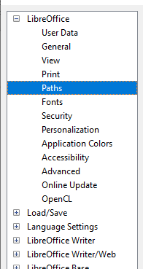
Figure 1: LibreOffice options
- Note
The Reset button, located in the lower right of the Options dialog, resets the values on that page to the values that were in place when you opened the dialog. It may be called Revert on some installations.

User data
Because LibreOffice can use the name or initials stored in the LibreOffice – User Data page for several things, including document properties (“created by” and “last edited by” information), the name of the author of comments and changes, and the sender address in mailing lists, you will want to ensure that the correct information appears here.
Fill in the form, or amend or delete any existing information. If you do not want user data to be part of the document’s properties, deselect Use data for document properties.
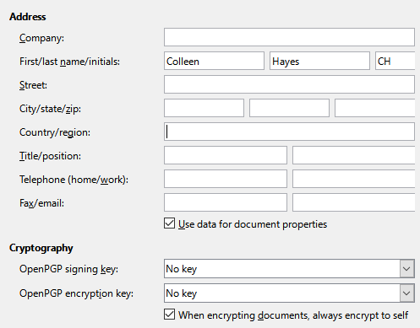
Figure 2: User Data page
In the Cryptography section, you can set the preferred public key for OpenPGP encryption and digital signature. These preferred keys will be pre-selected in the key selection dialog when you sign or encrypt a document (see Chapter 10, Working with File Formats, Security, and Exporting).

General
The options on the LibreOffice – General page (Figure 3) are described below.
Help
Extended tips
When Extended tips is active, a brief description of the function of an icon or menu command or a field on a dialog appears when you hold the mouse pointer over that item.
Show “No offline help installed” popup
Deselect to disable this popup dialog when you select Help, if offline help is not installed.
Show “Tip of the Day” dialog on start-up
Deselect to disable the “Tip of the Day” dialog. You can also disable this from the dialog.
Open/Save Dialogs – Use LibreOffice dialogs
Select this option to use the Open and Save dialogs supplied with LibreOffice. Deselect to use the standard Open and Save dialogs of your operating system. This guide uses the LibreOffice Open and Save dialogs in illustrations.
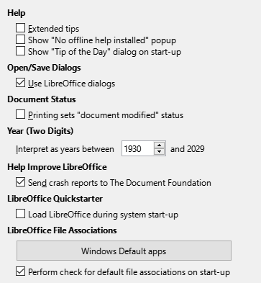
Figure 3: Setting general options for LibreOffice
Document Status – Printing sets “document modified” status
If this option is selected, then the next time you close the document after printing, the print date is recorded in the document properties as a change and you will be prompted to save the document again, even if you did not make any other changes.
Year (Two Digits)
Specifies how two-digit years are interpreted. For example, if the two-digit year is set to 1930, and you enter a date of 1/1/30 or later into your document, the date is interpreted as 1/1/1930 or later. An “earlier” date is interpreted as being in the following century; that is, 1/1/20 is interpreted as 1/1/2020.
Help Improve LibreOffice
Collect usage data and send it to The Document Foundation
(Linux only.) Send usage data to help The Document Foundation improve usability of the software. The usage data is sent anonymously and carries no document contents, only the commands used.
Send crash reports to The Document Foundation
(Windows only.) If this option is selected, the Error Report Tool starts automatically when a program crash occurs. The tool gathers all necessary information that can help the program developers to improve the code. You can include some additional information that may help the developers to localize the error. For more information, see the Help.
LibreOffice Quickstarter – Load LibreOffice during system start-up
When this option is selected, the necessary library files are loaded when the computer is started, resulting in a shorter startup time for LibreOffice components. The old menu in the system tray is no longer used. Not available on macOS.
LibreOffice File Associations – Windows Default apps button
(Windows only.) Opens Default apps dialog in Windows.
Perform check for default file associations on start-up
(Windows only.) When selected, LibreOffice checks file associations on startup and displays a message if any relevant formats are not registered to be opened by default in LibreOffice.

View
The options on the LibreOffice – View page affect how the document window looks and behaves. Some of these options are described below Figure 4. Set them to suit your personal preferences. Some of the available options vary with your computer’s operating system; the figure shows the options on Windows 10.
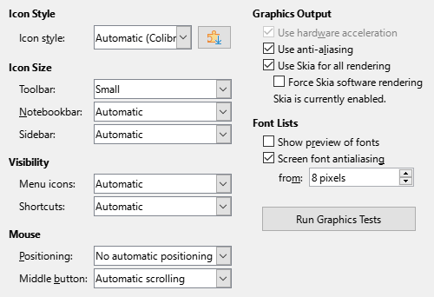
Figure 4: Choosing View options for LibreOffice applications
Icon style
Choose the icon style used in toolbars and dialogs. The Automatic option uses an icon set compatible with your operating system and choice of desktop. Several icon sets are available: Breeze, Breeze Dark, Colibre, Elementary, Karasa Jaga, Sifr, Sifr Dark, Sakapura, and others. You can add other icon sets using extensions; see Chapter 13, Customizing LibreOffice. Click the Extensions icon to display relevant extensions.
Icon size – Toolbar, Notebookbar, Sidebar
Choose the display size of toolbar icons: Automatic, Small, Large, Extra Large (only for toolbar). The Automatic icon size option uses the setting for your operating system. The toolbars, sidebar, and notebookbar (tabbed, grouped, and contextual versions) can have different settings.
Visibility – Menu icons, Shortcuts
You can choose to hide or show icons as well as text on Menu bar and context menu items.
Mouse – Positioning
Specifies if and how the mouse pointer will be positioned in newly opened dialogs.
Mouse – Middle button
Defines the function of the middle mouse button (if present).
- Automatic scrolling – dragging while pressing the middle mouse button shifts the view.
- Paste clipboard – pressing the middle mouse button inserts the contents of the Selection clipboard at the cursor position.
The Selection clipboard is independent of the normal clipboard that you use by Edit > Copy/Cut/Paste. Clipboard and Selection clipboard can contain different contents at the same time.
Function | Clipboard | Selection clipboard
Copy content | Edit > Copy Ctrl+C | Select text, table, or object.
Paste content | Edit > Paste Ctrl+V pastes at the cursor position. | Clicking the middle mouse button pastes at the mouse pointer position.
Pasting into another document | No effect on the clipboard contents. | The last marked selection is the content of the Selection clipboard.
Graphics Output
These selections are not supported on all operating systems and LibreOffice distributions.
Use hardware acceleration
Directly accesses hardware features of the graphical display adapter to improve the screen display.
Use anti-aliasing
Enables and disables anti-aliasing, which makes the display of most graphical objects look smoother and with fewer artifacts.
- Tip
Press Shift+Ctrl+R to restore or refresh the view of the current document after changing the anti-aliasing settings, to see the effect.
Use Skia for all rendering
Enables and disables the use of the 3D graphics language Skia.
Force Skia software rendering
Forces the use of Skia even if the graphics device is blacklisted. A device is blacklisted when it is buggy or may render graphics with poor quality.
Font Lists
Show preview of fonts
Causes the font list to look like Figure 5, Left, with the font names shown as an example of the font; with the option deselected, the font list shows only the font names (Figure 5, Right). The fonts listed are those that are installed on your system. Some fonts show an additional preview of some sample text.
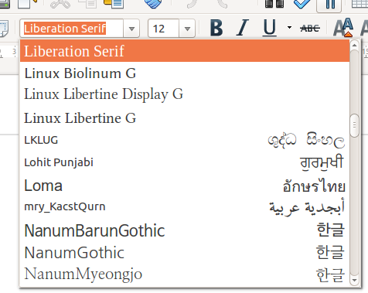 | 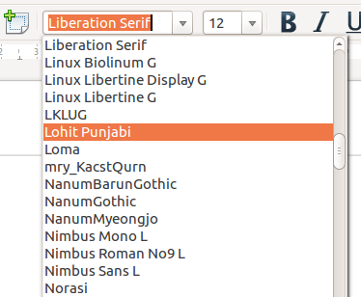
Figure 5: Font list (Left) with preview; (Right) without preview
Screen font anti-aliasing
Select this option to smooth the screen appearance of text. Enter the smallest font size to apply anti-aliasing.
Run Graphics Tests button
Click this button to run some tests to help determine the efficiency of LibreOffice’s graphics rendering. Results are saved in a log, which is displayed in a pop-up window and can be downloaded.

Print
On the LibreOffice – Print page (Figure 6), you can set the print options to suit your default printer and your most common printing method. Most of these options should be self-explanatory.
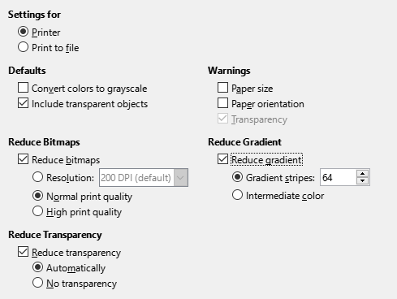
Figure 6: Choosing general printing options for all components
In the Warnings section, you can choose whether to be warned if the paper size or orientation specified in your document does not match the paper size or orientation available for your printer. Having these warnings turned on can be quite helpful, particularly if you work with documents produced by people in other countries where the standard paper size is different from yours.
- Tip
If your printouts are incorrectly placed on the page or chopped off at the top, bottom, or sides, or the printer is refusing to print, a likely cause is page size incompatibility.
- Note
Linux installations have an extra option (not shown in Figure 6): PDF as Standard Print Job Format. Select this option to change the internal print job format from a Postscript document description to a PDF description. This format has a number of advantages over Postscript. For more information, see https://www.linuxfoundation.org/collaborate/workgroups/openprinting/pdf_as_standard_print_job_format
Deselecting this option reverts to a Postscript document workflow.

Paths
On the LibreOffice – Paths page, you can change the location of files associated with, or used by, LibreOffice to suit your working situation. For example, you might want to store documents by default somewhere other than My Documents.
To make changes, select an item in the list shown in Figure Error: Reference source not found and click Edit. On the Select Path dialog (not shown; may also be titled Edit Paths), add or delete folders as required, and then click OK to return to the Options dialog.
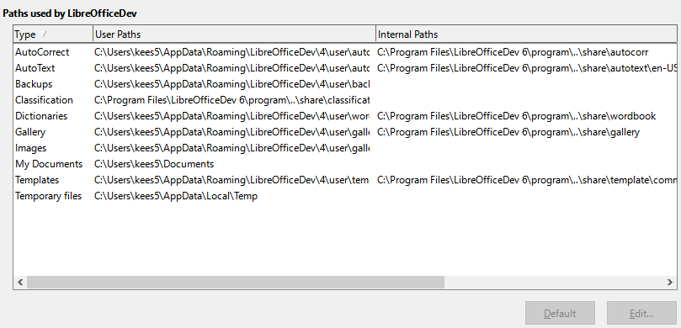
Figure 7: Viewing the paths of files used by LibreOffice
Some items can have at least two paths listed: the User Path is to a user-specific folder (normally on the user’s personal computer) and the Internal Path is to a shared folder where LibreOffice is installed (which might be on a network).
- Tip
You can use the entries on the LibreOffice – Paths page to compile a list of files, such as those containing AutoText, that you need to back up or copy to another computer.

Fonts
You can define replacements for any fonts that might appear in your documents. If you receive from someone else a document containing fonts that you do not have on your system, LibreOffice will substitute fonts for those it does not find. You might prefer to specify a different font from the one that the program chooses.
- Note
These choices do not affect the default font for your documents. To do that, you need to change the default template for documents, as described in Chapter 4, Working with Styles, Templates and Hyperlinks. In Writer, some basic fonts can be changed using the Basic Fonts options pages; see the Writer Guide or Help for more information.
On the LibreOffice – Fonts page (Figure 8):
- Select the Apply replacement table option.
- Select or type the name of the font to be replaced in the Font box. (If you do not have this font on your system, it will not appear in the drop-down list in this box, so you need to type it in.)
- In the Replace with box, select a suitable font from the drop-down list of fonts installed on your computer.
- Click on the tick (check) icon to the right of the Replace with box. A row of information now appears in the larger box below the input boxes. Select Always to replace the font, even if the original font is installed on your system. Select Screen only to replace the screen font only and never replace the font for printing. The results of combining these selections are given in Table Error: Reference source not found.
- In the bottom section of the page, you can change the typeface and size of the font used to display source code such as HTML and Basic (in macros).
Table 1. Font substitution replacement actions
Always checkbox | Screen only checkbox | Replacement action
checked | blank | Font replaced on screen and when printing, whether the font is installed or not.
checked | checked | Font replaced only on screen, whether the font is installed or not.
blank | checked | Font replaced only on screen, but only if font is not available.
blank | blank | Font replaced on screen and when printing, but only if font is not available.
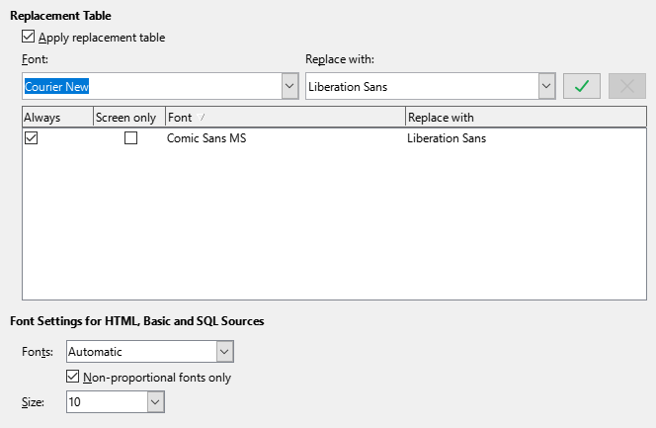
Figure 8: Defining a font to be substituted for another font

Security
Use the LibreOffice – Security page (Figure 9) to choose security options for saving documents and for opening documents that contain macros.
Security Options and Warnings
If you record changes, save multiple versions, or include hidden information or notes in your documents, and you do not want some of the recipients to see that information, you can set warnings to remind you to remove it, or you can have LibreOffice remove some of it automatically. Note that (unless removed) much of this information is retained in a file whether the file is in LibreOffice’s default OpenDocument format, or has been saved to other formats, including PDF.
Click the Options button to open a separate dialog with specific choices (Figure 10). See “Security options and warnings” on page 14.
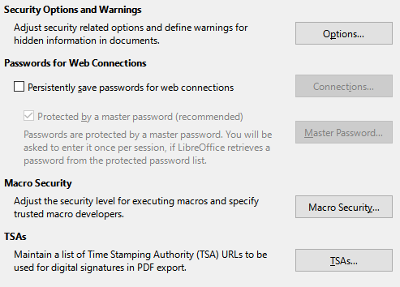
Figure 9: Choosing security options for opening and saving documents
Passwords for Web Connections
You can enter a master password to enable easy access to websites that require a user name and password. LibreOffice will securely store all passwords that you use to access files from web servers. You can retrieve the passwords from the list after you enter the master password.
Macro Security
Click the Macro Security button to open the Macro Security dialog (not shown here), where you can adjust the security level for executing macros and specify trusted sources.
Certificate Path (Not available on Windows)
Users can digitally sign documents using LibreOffice. A digital signature requires a personal signing certificate. Most operating systems can generate a self-signed certificate. However, a personal certificate issued by an outside agency (after verifying an individual’s identity) has a higher degree of trust associated with it than does a self-signed certificate. LibreOffice does not provide a secure method of storing these certificates, but it can access certificates that have been saved using other programs. Click the Certificate button and select which certificate store to use. Not available on Windows; LibreOffice uses the default Windows location for storing and retrieving certificates.
TSAs –Time Stamping Authorities
You can optionally select a Time Stamping Authority (TSA) URL for PDF documents created by LibreOffice. Recipients of PDF documents with a trusted timestamp can verify when the document was digitally or electronically signed, as well as verify that the document was not altered after the date the timestamp vouches for.

Security options and warnings
Most of the options on the Security Options and Warnings dialog (Figure 10) should be self-explanatory.
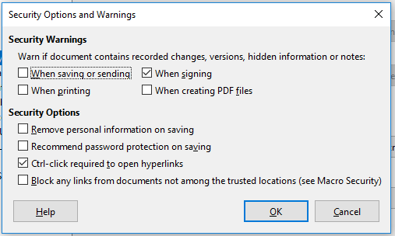
Figure 10: Security Options and Warnings dialog
Remove personal information on saving
Select this option to always remove user data from the file properties when saving the file. To save personal information with documents and still be able to manually remove personal information from specific documents, deselect this option.
Ctrl+click required to open hyperlinks
The default behavior to open a hyperlink in LibreOffice is to Ctrl+click on the hyperlink. Many people find creation and editing of documents easier when accidental clicks on links do not activate the links. To set LibreOffice to activate hyperlinks using an ordinary click, deselect this option.

Personalization
You can customize the overall appearance of LibreOffice with themes.
On the LibreOffice – Personalization page, select Preinstalled Theme and then click on a theme thumbnail and click Apply. After a brief pause the appearance of LibreOffice will refresh and reflect the selected theme.
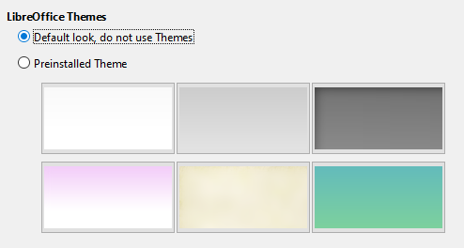
Figure 11: Selecting a preinstalled theme

Application colors
Writing, editing, and page layout are often easier when you can see the page margins (text boundaries), the boundaries of tables and sections (in Writer documents), page breaks in Calc, grid lines in Draw or Writer, and other features. In addition, you might prefer to use colors that are different from LibreOffice’s defaults for such items as comment indicators or field shadings.
On the LibreOffice – Application Colors page (Figure 12), you can specify which items are visible and the colors used to display various items.
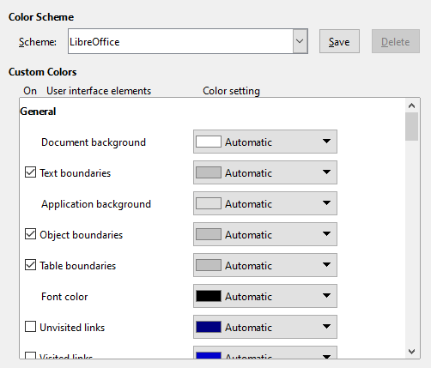
Figure 12: Showing or hiding text, object, and table boundaries
- To show or hide items such as text boundaries, select or deselect the checkboxes next to the names of the items.
- To change the default colors for items, click the down-arrow in the Color setting column by the name of the item and select a color from the list box. Note that you can change the list of available colors by selecting other available palettes from the drop-down list.
- To save your color changes as a color scheme, click Save, type a name in the Name of color scheme box in the popup dialog (not shown), and then click OK.
- Note
To change the color settings used in Track Changes mode, go to Tools > Options > LibreOffice Writer > Changes.

Accessibility
Accessibility options include whether to allow animated graphics or text, some options for high contrast display, and a way to change the font for the LibreOffice user interface.
Accessibility support relies on the Java Runtime Environment for communication with assistive technology tools. The Support assistive technology tools option is not shown on all LibreOffice installations. See Assistive Tools in LibreOffice in the Help for other requirements and information.
Select or deselect the options on the LibreOffice – Accessibility page (Figure 13) as required.
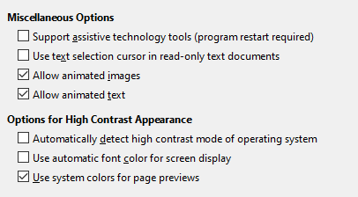
Figure 13: Choosing accessibility options

Advanced
LibreOffice needs Java to run several wizards, the Mediawiki Publisher (if available; see “Choosing Internet options” on page 28), and some functions in the Base component.
- Note
Users of Windows should find a suitable Java Runtime Environment (JRE) already installed on their machines. Linux users may need to get one from their distribution’s software repository if it is not already installed. Users of macOS need to install Oracle’s Java Development Kit (JDK), not just the JRE. To get the required JDK, select the macOS option at https://www.oracle.com/java/technologies/downloads/
Java Options
If you install or update a JRE or JDK after you install LibreOffice, or if you have more than one JRE installed on your computer, you can use the LibreOffice – Advanced options page to choose the JRE for LibreOffice to use.
If LibreOffice finds one or more JREs on your computer, it will display them in the large box. You can then choose one of the JREs listed.
If you are a system administrator, programmer, or other person who customizes JRE installations, you can use the Parameters and Class Path dialogs (reached using the buttons on the right) to specify this information.
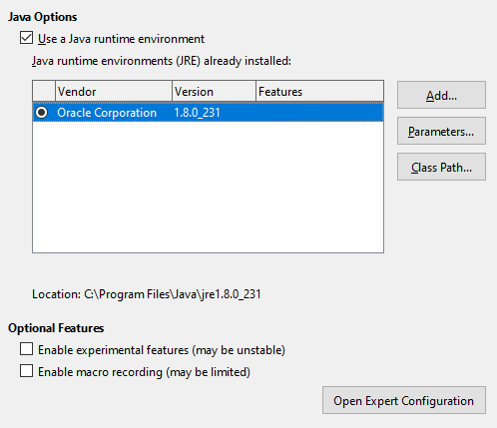
Figure 14: Choosing a Java runtime environment
Optional Features
Enable experimental features (may be unstable)
Select this option to enable features that are not yet complete or contain known bugs. The list of these features is different version by version.
Enable macro recording (may be limited)
This option enables macro recording, with some limitations. Opening a window, switching between windows, and recording in a different window to that in which the recording began, are not supported. Only actions relating to document contents are recordable, so changes in options or customizing menus are not supported. For more about macro recording, see Chapter 11, Getting Started with Macros.
Open Expert Configuration
Most users will have no need to use this. Click this button to open a new dialog in which you can fine-tune the LibreOffice installation. The dialog offers detailed configuration options for many aspects of LibreOffice’s appearance and performance. Double-click on a listed preference to enter a value to configure the preference.
- Caution
The Expert Configuration dialog lets you access, edit, and save configuration preferences that can turn the user profile of LibreOffice unstable, inconsistent, or even unusable. If you do not know what an option does, you can best leave it as the default.

Online update
On the LibreOffice – Online Update page (Figure 15), you can choose whether and how often to have the program check the LibreOffice website for program updates. If the Check for updates automatically option is selected, an icon appears at the right-hand end of the Menu bar when an update is available. Click this icon to open a dialog where you can download the update.
If the Download updates automatically option is selected, the download starts when you click the icon. To change the download destination, click the Change button and select the required folder in the file browser window.
If the Send OS version and basic hardware information option is selected, information about the computer architecture and operating system will be sent to the server for statistics collection.
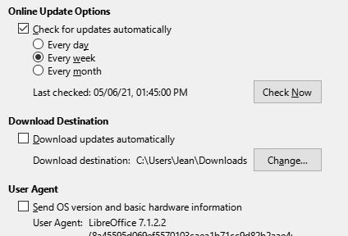
Figure 15: Online update options

OpenCL
OpenCL (Open Computing Language) is a software architecture used to write programs that run in different processors of the computer, such as the CPU and GPU (graphics processing unit) of the video card. With OpenCL enabled, LibreOffice can benefit from the very fast numerical calculations performed in the GPU, which is especially useful in very large spreadsheets with extensive calculations. The computer’s video card driver must have support for OpenCL to use this feature.

Choosing options for loading and saving documents
You can set the options for loading and saving documents to suit the way you work.
If the Options dialog is not already open, click Tools > Options. Click the expansion symbol (+ or triangle) to the left of Load/Save.

General
Most of the choices on the Load/Save – General page (Figure 16) are familiar to users of other office suites. Some items of interest are described below.
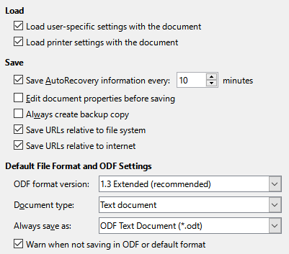
Figure 16: Choosing Load and Save options
Load user-specific settings with the document
A LibreOffice document contains settings that are read from the user’s system. When you save a document, these settings are saved with it. Select this option so that when a document loads, it ignores the stored settings in favor of the settings on your computer.
Even if you do not select this option, some settings are taken from your LibreOffice installation:
- Settings in File > Print > Options.
- Spacing options for paragraphs before text tables.
- Information about automatic updating for links, field functions, and charts.
- Information about working with Asian character formats.
- Data source linked to the document and its view.
If you deselect this option, the user’s personal settings do not overrule the settings in the document. For example, your choice (in the options for LibreOffice Writer) of how to update links is affected by the Load user-specific settings with the document option.
Load printer settings with the document
If enabled, the printer settings will be loaded with the document. This can cause a document to be printed on a distant printer (perhaps in an office setting), if you do not change the printer manually in the Print dialog. If disabled, your default printer will be used to print this document. The current printer settings will be stored with the document whether or not this option is selected.
Save AutoRecovery information every __ minutes
Choose whether to enable AutoRecovery and how often to save the information used by the AutoRecovery process. AutoRecovery in LibreOffice saves the information needed to restore all open documents in case of a crash. If you have this option set, recovering your document after a system crash will be easier.
Edit document properties before saving
If you select this option, the Document Properties dialog pops up to prompt you to enter relevant information the first time you save a new document (or whenever you use Save As).
Always create backup copy
Saves the previously-saved version of a document as a backup copy in a separate folder whenever you save a document. When LibreOffice creates a new backup copy, the previous backup copy is replaced. The backup copy gets the extension BAK. Authors whose work may be very lengthy should always consider using this option.
To see or change the backup folder, go to Tools > Options > LibreOffice > Paths. When opening a backup file, you will be prompted to specify the program to open it with; choose LibreOffice.
Save URLs relative to file system / internet
Use these options to select the default for relative addressing of URLs in the file system and on the Internet. Relative addressing is only possible if the source document and the referenced document are both on the same drive.
A relative address always starts from the directory in which the current document is located. In contrast, absolute addressing always starts from a root directory. The following table demonstrates the difference in syntax between relative and absolute referencing.
Examples | File system | Internet
relative | ../images/img.jpg | ../images/img.jpg
absolute | file:///c|/work/images/img.jpg | http://myserver.com/work/images/img.jpg
If you choose to save relatively, the references to embedded graphics or other objects in your document will be saved relative to the location in the file system. In this case, it does not matter where the referenced directory structure is recorded. The files will be found regardless of location, as long as the reference remains on the same drive or volume. This is important if you want to make the document available to other computers that may have a completely different directory structure, drive or volume names. It is also recommended to save relatively if you want to create a directory structure on an Internet server.
If you prefer absolute saving, all references to other files will also be defined as absolute, based on the respective drive, volume or root directory. The advantage is that the document containing the references can be moved to other directories or folders, and the references remain valid.
Default File Format and ODF Settings
ODF format version. LibreOffice by default saves documents in OpenDocument Format (ODF) version 1.3 Extended. While this allows for improved functionality, there may be backwards compatibility issues. When a file saved in ODF 1.3 Extended is opened in an editor that uses an earlier version of ODF, some of the advanced features may be lost. If you plan to share documents with people who use editors that use older versions of ODF (such as Apache OpenOffice or LibreOffice 3.x), you may wish to save the document using ODF 1.2 Extended (compatibility mode).
Document type. If you routinely share documents with users of Microsoft Office, you might want to change the Always save as attribute for documents to the Microsoft Office formats. Current versions of Microsoft Word can open ODT files, so this may no longer be needed.

VBA properties
On the Load/Save – VBA Properties page, you can choose whether to keep any macros in Microsoft Office documents that are opened in LibreOffice.
If you choose Load Basic code, you can edit the macros in LibreOffice. The changed code is saved in an ODF document but is not retained if you save into a Microsoft Office format.
If you choose Save original Basic code, the macros will not work in LibreOffice but are retained unchanged if you save the file into Microsoft Office format.
If you are importing a Microsoft Word or Excel file containing VBA code, you can select the option Executable code. Whereas normally the code is preserved but rendered inactive (if you inspect it with the Basic IDE you will notice that it is all commented), with this option the code is ready to be executed.
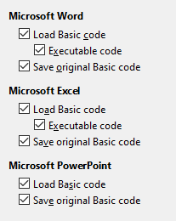
Figure 17: Choosing Load/Save VBA Properties
Save original Basic code takes precedence over Load Basic code. If both options are selected and you edit the disabled code in LibreOffice, the original Microsoft Basic code will be saved when saving in a Microsoft Office format.
To remove any possible macro viruses from the Microsoft Office document, deselect Save original Basic code. The document will be saved without the Microsoft Basic code.

Microsoft Office
On the Load/Save – Microsoft Office page (Figure 18), you can choose what to do when importing and exporting Microsoft Office OLE objects (linked or embedded objects or documents such as spreadsheets or equations).
The Embedded Objects section specifies how to import and export Microsoft Office OLE objects. These settings are valid when no Microsoft OLE server exists (for example, in UNIX) or when there is no LibreOffice OLE server ready for editing the OLE objects. If an OLE server is active for the embedded object, then the OLE server will be used to handle the object.
Select the [L] options to convert Microsoft OLE objects into the corresponding LibreOffice OLE objects when a Microsoft document is loaded into LibreOffice (mnemonic: “L” for “load”).
Select the [S] options to convert LibreOffice OLE objects into the corresponding Microsoft OLE objects when a document is saved in a Microsoft format (mnemonic: “S” for “save”). Linux installations may include selectable [S] options not shown in the illustration for the last three items.
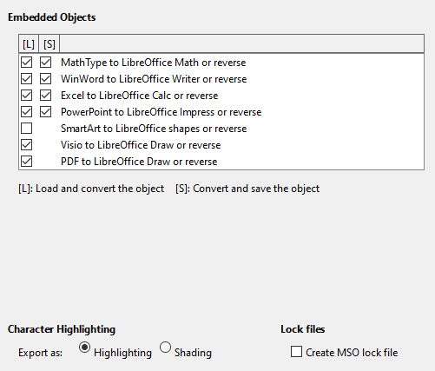
Figure 18: Choosing Load/Save Microsoft Office options
Character Highlighting – Export as
Microsoft Office has two character attributes similar to LibreOffice character background. Select the appropriate attribute (Highlighting or Shading) to use during export to Microsoft Office file formats.
Lock files – Create MSO lock file
LibreOffice can report which Microsoft Office user has locked a document by reading the lock files generated by MSO; and when the Create MSO lock file option is selected, LibreOffice will generate such files in addition to its own lock files, so MSO users can know who has locked a document.

HTML compatibility
Choices made on the Load/Save – HTML Compatibility page (Figure 19) affect HTML pages imported into LibreOffice and those exported from LibreOffice. See HTML documents; importing/exporting in the Help for more information.
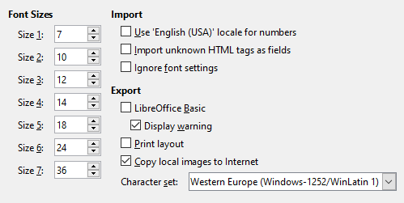
Figure 19: Choosing HTML compatibility options
Font Sizes
Use these fields to define the respective font sizes for the HTML <font size=”1”> to <font size=”7”> tags, if they are used in the HTML pages. (Many HTML pages no longer use these tags.)
Import
Use 'English (USA)' locale for numbers
When importing numbers from an HTML page, the decimal and thousands separator characters differ according to the locale of the HTML page. The clipboard, however, contains no information about the locale. If this option is not selected, numbers will be interpreted according to the Locale setting in Tools > Options > Language Settings > Languages (see “Change some locale and language settings” on page 24). If this option is selected, numbers will be interpreted as for the English (USA) locale.
Import unknown HTML tags as fields
Select this option if you want tags that are not recognized by LibreOffice to be imported as fields. For an opening tag, an HTML_ON field will be created with the value of the tag name. For a closing tag, an HTML_OFF will be created. These fields will be converted to tags in the HTML export.
Ignore font settings
Select this option to have LibreOffice ignore all font settings when importing. The fonts that were defined in the HTML page style will be used.
Export
LibreOffice Basic
Select this option to include LibreOffice Basic macros (scripts) when exporting to HTML format. You must activate this option before you create the LibreOffice Basic macro; otherwise the script will not be inserted. LibreOffice Basic macros must be located in the header of the HTML document. Once you have created the macro in the LibreOffice Basic IDE, it appears in the source text of the HTML document in the header. If you want the macro to run automatically when the HTML document is opened, choose Tools > Customize > Events. See Chapter 11, Getting Started with Macros, for more information.
Display warning
When the LibreOffice Basic option (see above) is not selected, the Display warning option becomes available. If the Display warning option is selected, then when exporting to HTML a warning is shown that LibreOffice Basic macros will be lost.
Print layout
Select this option to export the print layout of the current document as well. The HTML filter supports CSS2 (Cascading Style Sheets Level 2) for printing documents. These capabilities are only effective if print layout export is activated.
Copy local images to Internet
Select this option to automatically upload the embedded pictures to the Internet server when uploading using FTP.
Character set
Select the appropriate character set for the export.

Choosing language settings
To customize the language settings in LibreOffice, you can do any of the following:
- Install the required dictionaries
- Change some locale and language settings
- Choose spelling options

Install the required dictionaries
LibreOffice automatically installs many language modules with the program. A language module can contain up to three submodules: spelling dictionary, hyphenation dictionary, and thesaurus. These are usually referred to as “dictionaries” in LibreOffice. To add other language modules, be sure you are connected to the Internet, and then choose Tools > Language Settings > Writing Aids and click the Get more dictionaries online link (Figure 22). LibreOffice will open a window containing links to additional dictionaries. Select and install the ones you want.

Change some locale and language settings
You can change some details of the locale and language settings that LibreOffice uses for all documents, or for specific documents.
In the Options dialog, click the expansion symbol (+ or triangle) by Language Settings (Figure 20). The exact list shown depends on the language support settings (Figure 21).
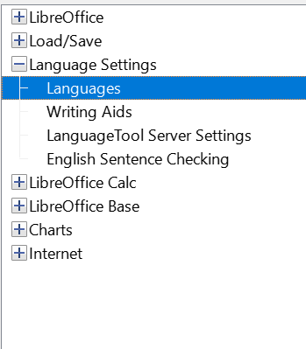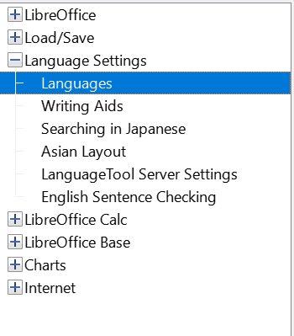
Figure 20: LibreOffice language options, without and with Asian and CTL options enabled
On the right-hand side of the Language Settings – Languages page (Figure 21), change the User interface, Locale setting, Default currency, and Default Languages for Documents as required. In the example, English (USA) has been chosen for all the appropriate settings.
Language Of
User interface
The language of the user interface is usually set at the time LibreOffice is installed to match the language of the operating system. If more than one language has been installed for LibreOffice, you can select which language will be used for menus, dialogs, and help files.
Formats
Locale setting
The locale setting is the basis for many other settings within LibreOffice, for example defaults for numbering, currency, and units of measure. Unless you select something else here, the locale of the operating system will be set as default.
Default currency
The default currency is that used in the country entered as locale. The default currency determines the proper formatting of fields formatted as currency. If the locale setting is changed, the default currency changes automatically. If the default currency is changed, all dialogs involving currency and all currency icons will be changed in all open documents. Documents that were saved with one currency as the default will open using the new currency defaults.
Decimal separator key
If the Decimal separator key – Same as locale setting option is selected, LibreOffice uses the character defined by the default locale. If this option is not selected, the keyboard driver defines the character used.
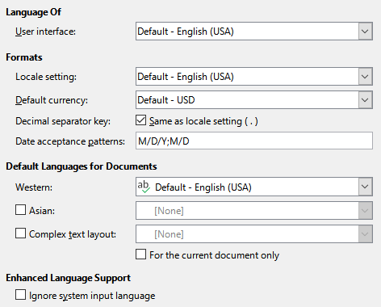
Figure 21: Choosing language options
Date acceptance patterns
Date acceptance patterns define how LibreOffice recognizes input as dates. Locale also defines the default expression of dates. You can define additional date patterns, separated by semicolons, using Y, M, & D for Year, Month, and Day. LibreOffice will always correctly interpret dates entered in ISO 8601 format as Y-M-D and YYYY-MM-DD.
- Caution
Data entered into a Calc spreadsheet or a Writer table must be entered in a format defined by locale in order to be recognized as dates.
Default Languages for Documents
Select the languages used for the spelling checker, thesaurus, and hyphenation features of LibreOffice. If these options are only for the current document, select For the current document only.
Select Asian: to enable support for Asian languages (Chinese, Japanese, Korean). Select Complex Text Layout: to enable support for languages such as Urdu, Thai, Hebrew, and Arabic. If you select either of these options, you will see some extra choices under Language Settings the next time you open this dialog, as shown in Figure 20. These choices (Searching in Japanese, Asian Layout, and Complex Text Layout) are not discussed here.
- Note
An ABC icon in front of a language indicates that a spelling dictionary, thesaurus, and hyphenation dictionary are activated for this language.
Enhanced Language Support
Ignore system input language
Default language settings depend on the locale setting. The default locale is based on that of the computer’s operating system. A keyboard layout is normally based on the language used by the operating system but can be changed by the user. If this option is not selected, and there is a change in keyboard layout, input from the keyboard will be different from what is expected.

Choose spelling options
To choose the options for checking spelling, click Language Settings > Writing Aids.
For details on using the Available Language Modules and User-defined Dictionaries sections, please see the Help.
In the Options section of the page (Figure 22), choose the settings that are useful for you.
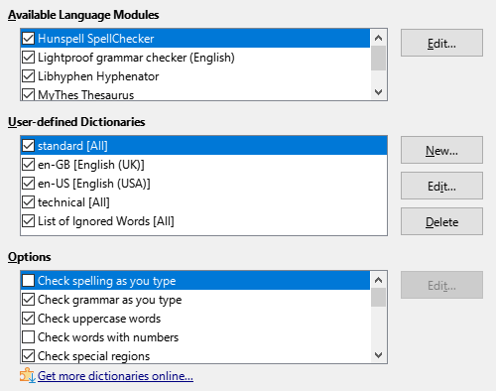
Figure 22: Choosing languages, dictionaries, and options for checking spelling
Some considerations:
- If you want spelling checked while you type, you must have Check spelling as you type enabled.
- If you want grammar to be checked as you type, you must have both Check grammar as you type and Check spelling as you type enabled.
- If you use a custom dictionary that includes words in all uppercase and words with numbers (for example, AS/400), select Check uppercase words and Check words with numbers.
- Check special regions means that text in headers, footers, frames, and tables are also checked when checking spelling.
Here you can also select which user-defined (custom) dictionaries are active by default, and add or remove user-installed dictionaries, by clicking the New or Delete buttons. Dictionaries installed by the system cannot be deleted.

LanguageTool Server Settings
If you have an API key for LanguageTool, you can use LanguageTool to check the spelling and grammar in your document.
Activate this option by checking the Enable LanguageTool checkbox in Language Settings – LanguageTool Settings, then supply the requested Base URL, Username and API Key fields.
Information about LanguageTool can be found at https://languagetool.org/.

English sentence checking
On the Language Settings – English Sentence Checking page (Figure 23), you can choose which items are checked for, reported to you, or converted automatically.
After selecting the additional grammar checks, you must restart LibreOffice, or reload the document, for them to take effect.
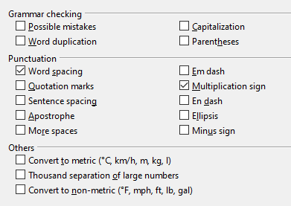
Figure 23: Choosing options for checking sentences in English

Grammar checking
Possible mistakes
Checks for things such as subject-verb conflict, mood, tense; “with it’s”, “he don’t”, “this things” and so on.
Capitalization
Checks for the capitalization of sentences. The sentence boundary detection depends on abbreviations.
Word duplication
Checks for all word duplication, rather than just the default words ‘and’, ‘or’, ‘for’, and ‘the’.
Parentheses
Checks for pairs of parentheses and quotation marks.

Punctuation
Word spacing
This option is selected by default. It checks for single spaces between words, indicating instances of double or triple spaces, but not of more spaces than that.
Quotation marks
Checks for correct typographical double quotation marks.
Sentence spacing
Checks for a single space between sentences, indicating when one or two extra spaces are found.
Apostrophe
Replaces an apostrophe with the correct typographical character.
More spaces
Checks word and sentence spacing for more than two extra spaces.
Em dash; En dash
These options force a non-spaced em dash to replace a spaced en dash, or force a spaced en dash to replace a non-spaced em dash.
Multiplication sign
This option is selected by default. It replaces an ‘x’ used as a multiplication symbol with the correct typographical symbol.
Ellipsis
Replaces three consecutive periods (full stops) with the correct typographical symbol.
Minus sign
Replaces a hyphen with the correct minus typographical character.

Others
Convert to metric; Convert to non-metric
Converts quantities in a given type of unit to quantities in the other type of unit: metric to imperial or imperial to metric.
Thousands separation of large numbers
Converts a number with five or more significant digits to a common format, depending on the locale setting for the document. One uses the comma as a thousands separator; the other is ISO format, which uses a narrow space as a separator.

Sentence checking in other languages
LibreOffice can check sentences in many languages. These checkers are enabled by default if the language is the computer’s default language, and others can be added using the Extension Manager. The set of rules available for these sentence checkers depends on the language.

Choosing Internet options
The Internet options available found in the Internet settings depend on your operating system.
Use the Proxy page (if available) to save proxy settings for use with LibreOffice.
If you are using Linux or macOS, an additional page of Email options is available, where you can specify the program to use when you send the current document as email. Under Windows, your default email program is always used.
To suppress (exclude) hidden elements such as tracked changes, hidden sections, hidden tabs in a spreadsheet, or hidden layers in a drawing, select the Suppress hidden elements of documents option.
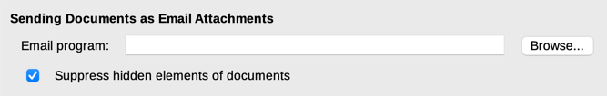
Figure 24: Internet options, showing Email page available to Linux and macOS users
A MediaWiki publisher is included on Windows and Linux. To enable it, select MediaWiki in the Internet options, then click the Add button to open a dialog where you can specify the address (URL) and login information for a wiki. You can add several wikis to the list. A JRE (Java Runtime Environment) is needed for this feature to work.

Controlling LibreOffice’s AutoCorrect functions
LibreOffice’s AutoCorrect functions automatically detect and replace common symbols, spelling mistakes, and grammar mistakes. Sometimes, AutoCorrect changes something that should have been kept. If unexplained changes appear in your document, the AutoCorrect settings are often the cause.
Click Tools > AutoCorrect > AutoCorrect Options to customize AutoCorrect. You must have a document open for this menu item to appear. Use the tabs to add, edit, and delete AutoCorrect options. In Writer, this dialog has five tabs. In other components of LibreOffice, the dialog has only four tabs. Find more details in the relevant component guides.

