LibreOffice
Version 7.0
Writer
Envelope

Copyright
This document is copyright © 2010-[2020]. The contributors are listed below. You may modify and/or distribute this document under the terms of the GNU General Public License (http://www.gnu.org/licenses/gpl.html), version 3 or later, or the Creative Commons Attribution License (http://creativecommons.org/licenses/by/3.0/), version 3.0 or later.
Product names are used without guarantee of free usability.
Almost all hardware and software designations as well as other keywords and other information used in this publication are protected as registered trademarks.
Since it is not possible to determine promptly in all cases whether trademark protection exists, the symbol (R) is not used in this writing.

Note for Macintosh users
Some key assignments and menu items differ between the Macintosh version and those for Windows and Linux computers. The table below gives you some basic information on this. A more detailed list can be found in the help of the respective module.
Windows / Linux | Corresponds on the Mac | Effect
Menu Tools>Options... | LibreOffice>Settings | Access to the programme options
Right click | Control+Klick | opens a context menu
Ctrl (Steuerung) | ⌘ (Command) | (in conjunction with other keys)
F5 | Ctrl+⌘+F5 | opens the navigator
F11 | ⌘+T | opens the Format templates dialog

Sources
Help for LibreOffice 7.0 - Envelope
Envelope
Writer manual
Chapter 7, Printing, Exporting, E-Mailing, Signing
Chapter 14, Mail Merge

Contributors
Edited: Harald Berger

Content
Copyright 2
Note for Macintosh users 2
Sources 2
Contributors 2
Content 3
Envelope 4
Create an envelope in Writer 4
Tab "Envelope" 4
Tab "Format" 5
Tab "Printer" 7
Horizontal left 7
Horizontal centre 7
Horizontal right 7
Vertical left 7
Vertical centre 7
Vertical right 7
Print from top 7
Print from bottom 7
Shift right 7
Shift down 7
Current printer 7
Setup... 7
Finish envelope 8
Envelope printout 8
Printer Setup using the example Brother MFC-J5320DW 9
Setup... 9
Properties 9
Paper size and orientation when loading (manual feeder) 10
Print preview 10
Further Informations 11

Envelope

Create an envelope in Writer
Select Insert > Envelope from the menu.

Tab "Envelope"
In the "Envelope" dialog that opens, you can check the information in the "Sender" and "Adressee" areas in the "Envelope" tab, Abbildung 1.
If you have saved your data (surname, Forename, address) under Tools > Options > LibreOffice > User Data you have saved your data, Abbildung 2, the sender will automatically be filled with this data, provided you have ticked "Sender".
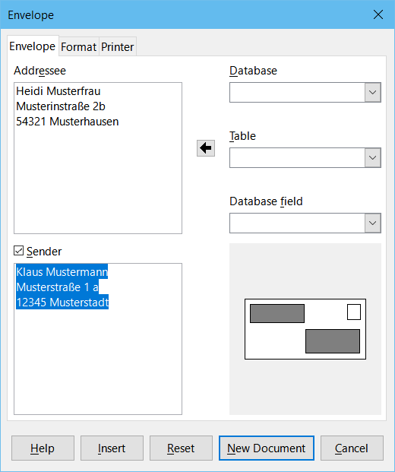Abbildung 1: Sender and addressee for the envelope

You can accept or change this data for the sender. You can write the information for the Sender and Adressee directly in the windows or you can use the addresses from an existing database, which you can select on the right side of the dialogue (selection list Database and Table).
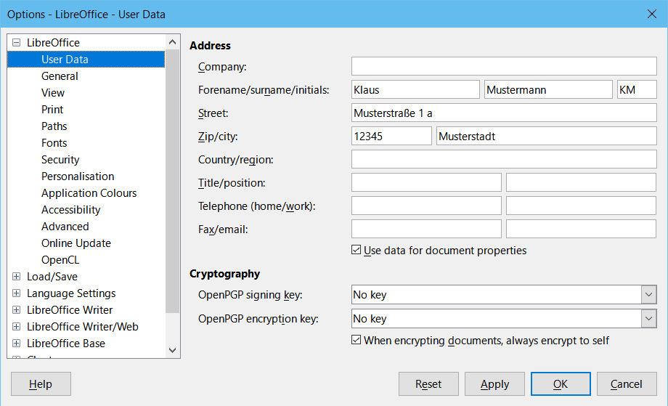Abbildung 2: LibreOffice User Data

Tab "Format"
In the "Format" tab, check or change the position of the Adressee and Sender fields, Abbildung 3. The area at the bottom right shows you a preview of the fields on the envelope. To change the paragraph or character formatting of the sender and recipient details, click Edit for each.

Select Character... to change the font, font size, font effects and other properties as you would with character formatting in a document, Abbildung 4.
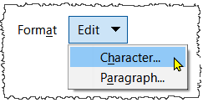Abbildung 4: Edit Format
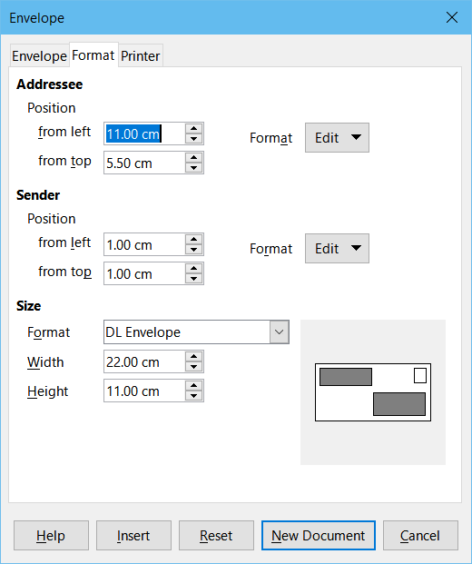Abbildung 3: Position and size of the sender and addressee fields
Select Paragraph... to change indents, spacing, text flow, tabs, initials, borders and backgrounds, Abbildung 4
In the "Size" area, Abbildung 5,use the Format drop-down list to specify the envelope. The height and width are displayed in the fields below. If you select the "user-defined" format, you can set the size of the envelope according to your wishes.
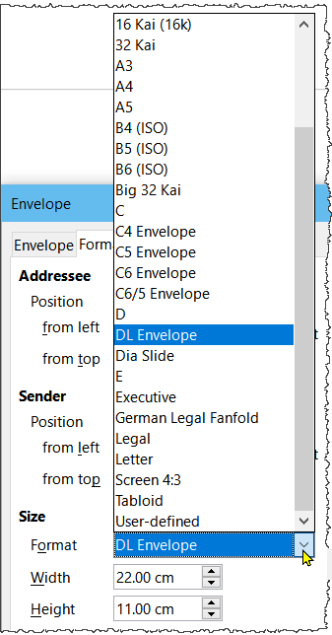Abbildung 5: Size

Tab "Printer"
After formatting, switch to the "Printer" tab, Abbildung 6,
to set the indent for the envelope. Here you may have to experiment a little to get the desired printout for your printer. Your printer Manual should tell you how and where to load envelopes.

Horizontal left
Feeds the envelope horizontally from the left edge of the printer tray.

Horizontal centre
Feeds the envelope horizontally from the centre of the printer tray.

Horizontal right
Feeds the envelope horizontally from the right edge of the printer tray.

Vertical left
Feeds the envelope vertically from the left edge of the printer tray.

Vertical centre
Feeds the envelope vertically from the centre of the printer tray.
(Envelope for Brother)

Vertical right
Feeds the envelope vertically from the right edge of the printer tray.

Print from top
Feeds the envelope with the print side face up in the printer tray.

Print from bottom
Feeds the envelope with the print side face down in the printer tray.

Shift right
Enter the amount to shift the print area to the right.

Shift down
Enter the amount to shift the print area down.

Current printer
Displays the name of the current printer. You can change the current printer in your operating system.

Setup...
Opens the Print Setup dialog in which you can define additional printer settings, such as paper format and orientation. Check these settings. Select the required/desired settings.

Finish envelope
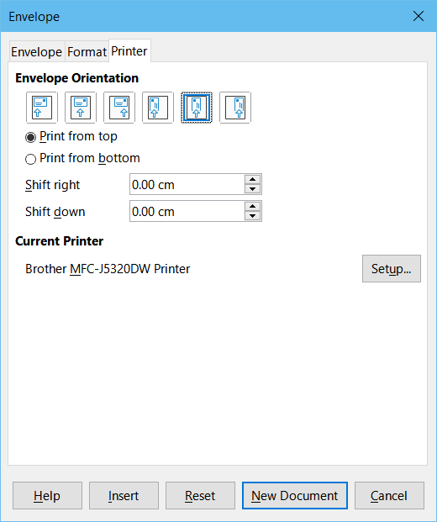Abbildung 6: Printer settings for envelopes
After finishing the formatting, you can finish the envelope by pressing either the New Document or Insert button.
- New Document creates the envelope as a new document in the page format Envelope.
- Insert inserts the envelope in front of the existing document in page format envelope as the first page.
To cancel the creation of the envelope, click Cancel or press the ESC key. You can also click the Reset button to undo the previous changes and return to the settings before opening the dialog.
When the "Envelope" dialog closes, you return to your document.
Save your document, which now also contains the envelope.

Envelope printout
Select File > Print... from the menu.
In the "Print" dialog, in the "Range and Copies" area, enter "1" in the "Pages:" field and click Print.

Printer Setup using the example Brother MFC-J5320DW

Setup...
Further settings can also be made here via the Setup... button, Abbildung 6, for example, the paper format used and the orientation. Select the required/desired settings.

Properties
Select the Properties... button in the "Printer Setup" dialog, Abbildung 7.
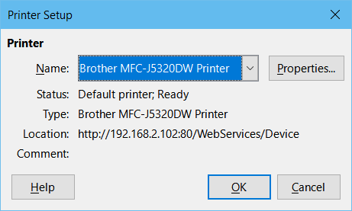Abbildung 7: "Printer Setup" Dialog
The Brother "Brother MFC-J5320DW Printer Properties" dialog appears. Select the paper size "Envelope DL (110 x 220 mm)" in the tab "Basic settings", Abbildung 8.

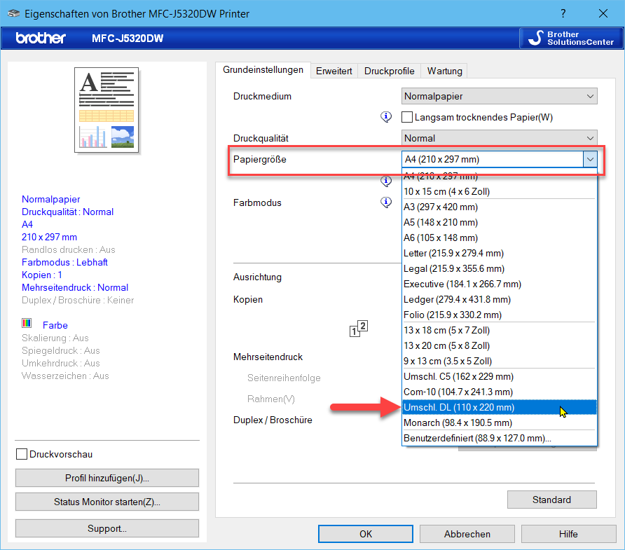Abbildung 8: Brother Dialog

Paper size and orientation when loading (manual feeder)
From the Manual Brother - Feeding Paper "Brother MFC-J5320DW - Briefumschlag im Hochformat", Abbildung 9

Print preview
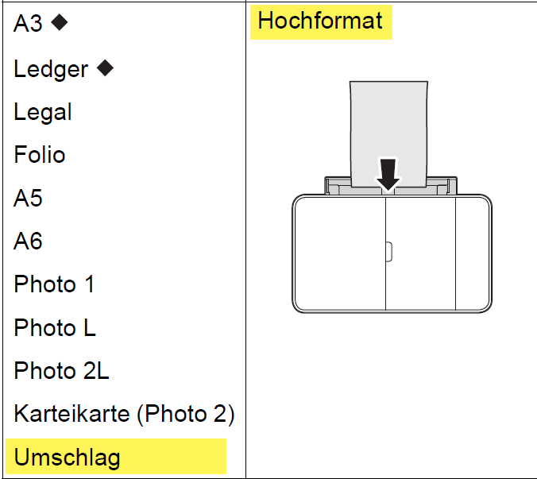Abbildung 9: Paper size Alignment
Labelled letter in the print preview, Abbildung 10.
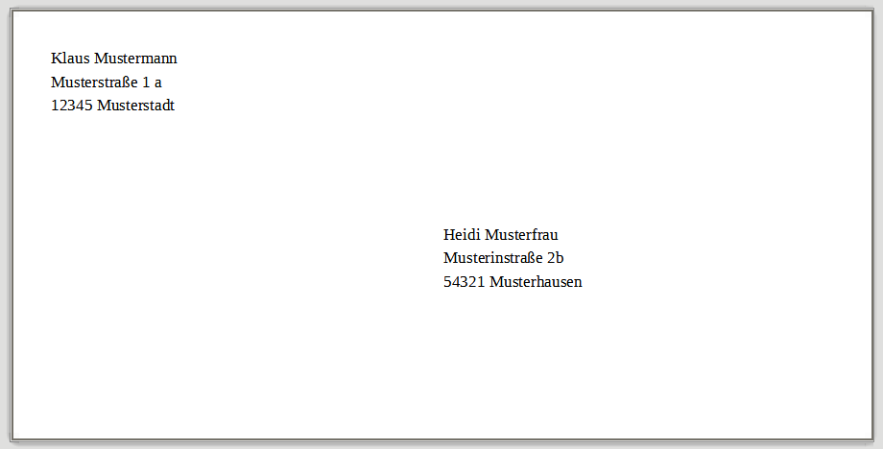Abbildung 10: Envelope in Print preview

Further Informations
The Documentation / Manuals can be found at:
Documentation / Manuals
See the Writer manual:
Kapitel 5, Drucken, Faxen, Exportieren und E-Mailen
Kapitel 11, Serien-E-Mails und Serienbriefe

