
Getting Started Guide
Chapter 4
Getting Started with Writer
Word Processing with LibreOffice

Copyright
This document is Copyright © 2010–2013 by its contributors as listed below. You may distribute it and/or modify it under the terms of either the GNU General Public License (http://www.gnu.org/licenses/gpl.html), version 3 or later, or the Creative Commons Attribution License (http://creativecommons.org/licenses/by/3.0/), version 3.0 or later.
All trademarks within this guide belong to their legitimate owners.
Contributors
Ron Faile Jr.
Hazel Russman
Jean Hollis Weber
John A Smith
Feedback
Please direct any comments or suggestions about this document to: documentation@global.libreoffice.org
Acknowledgments
This chapter is based on Chapter 4 of Getting Started with OpenOffice.org 3.3. The contributors to that chapter are:
Jean Hollis Weber Michele Zarri Agnes Belzunce
Daniel Carrera Spencer E. Harpe Peter Hillier-Brook
Peter Kupfer Gary Schnabl Janet Swisher
Linda Worthington
Publication date and software version
Published 15 January 2013. Based on LibreOffice 3.5.

Note for Mac users
Some keystrokes and menu items are different on a Mac from those used in Windows and Linux. The table below gives some common substitutions for the instructions in this chapter. For a more detailed list, see the application Help.
Windows or Linux | Mac equivalent | Effect
Tools > Options menu selection | LibreOffice > Preferences | Access setup options
Right-click | Control+click | Opens a context menu
Ctrl (Control) | z (Command) | Used with other keys
F5 | Shift+z+F5 | Opens the Navigator
F11 | z+T | Opens the Styles and Formatting window

Contents
Copyright 2
Note for Mac users 2
What is Writer? 5
The Writer interface 5
Status bar 6
Changing document views 7
Moving quickly through a document 8
Working with documents 9
Saving as a Microsoft Word file 9
Working with text 10
Selecting items that are not consecutive 10
Selecting a vertical block of text 11
Cutting, copying, and pasting text 11
Finding and replacing text and formatting 12
Inserting special characters 13
Inserting dashes and non-breaking spaces and hyphens 14
Setting tab stops and indents 14
Changing the default tab stop interval 15
Checking spelling and grammar 15
Using built-in language tools 16
Using AutoCorrect 17
Using word completion 17
Using AutoText 17
Formatting text 18
Using styles is recommended 18
Formatting paragraphs 18
Formatting characters 19
Autoformatting 19
Creating numbered or bulleted lists 20
Hyphenating words 21
Formatting pages 22
Which layout method to choose? 22
Creating headers and footers 24
Numbering pages 25
Changing page margins 26
Adding comments to a document 27
Creating a table of contents 27
Creating indexes and bibliographies 28
Working with graphics 28
Printing 28
Using mail merge 29
Tracking changes to a document 29
Using fields 29
Linking to another part of a document 29
Using hyperlinks 30
Using cross-references 31
Using bookmarks 32
Using master documents 32
Creating fill-in forms 32

What is Writer?
Writer is the word processor component of LibreOffice. In addition to the usual features of a word processor (spelling check, thesaurus, hyphenation, autocorrect, find and replace, automatic generation of tables of contents and indexes, mail merge and others), Writer provides these important features:
- Templates and styles (see Chapter 3)
- Page layout methods, including frames, columns, and tables
- Embedding or linking of graphics, spreadsheets, and other objects
- Built-in drawing tools
- Master documents—to group a collection of documents into a single document
- Change tracking during revisions
- Database integration, including a bibliography database
- Export to PDF, including bookmarks (see Chapter 10)
- And many more
These features are covered in detail in the Writer Guide.

The Writer interface
The main Writer workspace is shown in Figure 1. The menus and toolbars are described in Chapter 1, Introducing LibreOffice.
Some other features of the Writer interface are covered in this chapter.
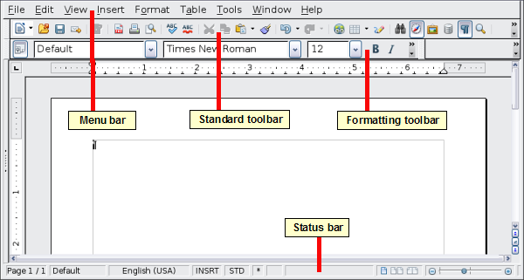
Figure 1: The main Writer workspace in Print Layout view

Status bar
The Writer status bar provides information about the document and convenient ways to quickly change some document features.
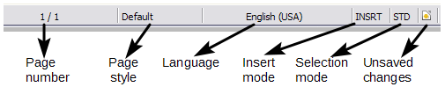
Figure 2: Left end of status bar
Page number
Shows the current page number, the sequence number of the current page (if different), and the total number of pages in the document. For example, if you restarted page numbering at 1 on the third page, its page number is 1 and its sequence number is 3.
If any bookmarks have been defined in the document, a right-click on this field pops up a list of bookmarks; click on the required one.
To jump to a specific page in the document, double-click on this field. The Navigator opens. Click in the Page Number field, type the sequence number of the required page, and press Enter.
Page style
Shows the style of the current page. To change the page style, right-click on this field. A list of page styles pops up; choose a different style by clicking on it.
To edit the current page style, double-click on this field. The Page Style dialog opens.
Language
Shows the language for the selected text.
Click to open a menu where you can choose another language for the selected text or for the paragraph where the cursor is located. You can also choose None (Do not check spelling) to exclude the text from a spelling check or choose More... to open the Character dialog.
Insert mode
Click to toggle between Insert and Overwrite modes when typing.
Selection mode
Click to toggle between STD (Standard), EXT (Extend), ADD (Add) and BLK (Block) selection. EXT is an alternative to Shift+click when selecting text. See “Working with text” on page 10 for more information about ADD and BLK.
Unsaved changes
This icon replaces the default icon here if changes to the document have not been saved.
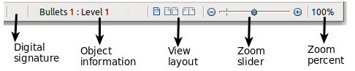
Figure 3: Right end of status bar
Digital signature
If the document has been digitally signed, an icon shows here. You can double-click the icon to view the certificate.
Section or object information
When the cursor is on a section, heading, or list item, or when an object (such as a picture or table) is selected, information about that item appears in this field. Double-clicking in this area opens a relevant dialog. For details, consult the Help or the Writer Guide.
View layout
Click an icon to change between single page, side-by-side, and book layout views. The effect varies with the combination of window width and zoom factor in use. You can edit the document in any view.
Figure 4: View layouts: single, side-by-side, book.
Zoom
To change the view magnification, drag the Zoom slider, or click on the + and – signs, or right-click on the zoom level percent to pop up a list of magnification values from which to choose. Zoom interacts with the selected view layout to determine how many pages are visible in the document window.

Changing document views
Writer has several ways to view a document: Print Layout, Web Layout, and Full Screen. To access these and other choices, go to the View menu and click on the required view. (When in Full Screen view, press the Esc key to return to either Print or Web Layout view.)
When in Print Layout, you can use both the Zoom slider and the View Layout icons on the status bar. In Web Layout, you can use only the Zoom slider.
You can also choose View > Zoom from the menu bar to display the Zoom & View Layout dialog, where you can set the same options as on the Status bar. In Web Layout view, most of the choices are not available.
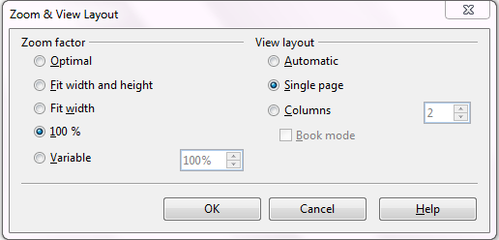Figure 5: Choosing Zoom and View Layout options.

Moving quickly through a document
In addition to the navigation features of the Status bar (described above), you can use the main Navigator window and the Navigation toolbar as described in Chapter 1, Introducing LibreOffice.
In Writer, you can also display the Navigation toolbar by clicking on the small Navigation icon near the lower right-hand corner of the window below the vertical scroll bar, as shown in Figure 6.
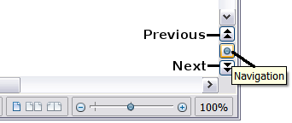
Figure 6: Navigation icons
The Navigation toolbar (Figure 7) shows icons for all the object types shown in the Navigator, plus some extras (for example, the results of a Find command).
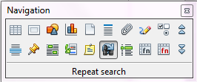Figure 7: Navigation toolbar
Click an icon to select that object type. Now all the Previous and Next icons (in the Navigator itself, in the Navigation Toolbar, and on the scroll bar) will jump to the next object of the selected type. This is particularly helpful for finding items like index entries, which can be difficult to see in the text. The names of the icons (shown in the tooltips) change to match the selected category; for example, Next Graphic, Next Bookmark, or Continue search forward.
For more uses of the Navigator in Writer, see the Writer Guide.

Working with documents
Chapter 1, Introducing LibreOffice, includes instructions on starting new documents, opening existing documents, saving documents, and password-protecting documents. Chapter 3, Using Styles and Templates, covers how to create a document from a template.

Saving as a Microsoft Word file
If you need to exchange documents with users of Microsoft Word who are unwilling or unable to receive *.odt files, you can save a document as a Microsoft Word file.
- Important—First save your document in the file format used by LibreOffice Writer (.odt). If you do not, any changes you made since the last time you saved will appear only in the Microsoft Word version of the document.
- Then choose File > Save As. On the Save As dialog, in the File type (or Save as type) drop-down menu, select the type of Word format you need. Click Save.
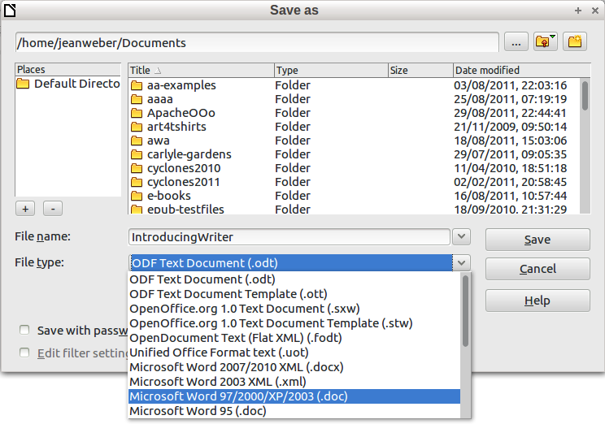Figure 8. Saving a file in Microsoft Word format
From this point on, all changes you make to the document will occur only in the new document. You have changed the name and file type of your document. If you want to go back to working with the .odt version of your document, you must open it again.
Caution   | It is recommended that if you use a Microsoft Word format, you use the .doc and not the .docx format. Saving first in .odt format gives you the option to redo the document if the recipient of your document experiences trouble with the Microsoft format.
Tip | To have Writer save documents by default in the Microsoft Word file format, go to Tools > Options > Load/Save > General. In the section named Default file format and ODF settings, under Document type, select Text document, then under Always save as, select your preferred file format.

Working with text
Working with text (selecting, copying, pasting, moving) in Writer is similar to working with text in any other program. LibreOffice also has some convenient ways to select items that are not next to each other, select a vertical block of text, and paste unformatted text.

Selecting items that are not consecutive
To select nonconsecutive items (as shown in Figure 9) using the mouse:
- Select the first piece of text.
- Hold down the Ctrl key and use the mouse to select the next piece of text.
- Repeat as often as needed.
Now you can work with the selected text (copy it, delete it, change the style, or whatever).
Note | Macintosh users: substitute the Command key when instructions in this chapter say to use the Ctrl key.

Figure 9: Selecting items that are not next to each other
To select nonconsecutive items using the keyboard:
- Select the first piece of text. (For more information about keyboard selection of text, see the topic “Navigating and selecting with the keyboard” in the Help.)
- Press Shift+F8. This puts Writer in “Add” mode. The word ADD appears on the status bar, replacing STD.
- Use the arrow keys to move to the start of the next piece of text to be selected. Hold down the Shift key and select the next piece of text.
- Repeat as often as needed.
Now you can work with the selected text.
Press Esc to exit from this mode.

Selecting a vertical block of text
You can select a vertical block or “column” of text that is separated by spaces or tabs (as you might see in text pasted from e-mails, program listings, or other sources), using LibreOffice’s block selection mode. To change to block selection mode, use Edit > Selection Mode > Block Area, or press Ctrl+F8, or click several times in the status bar on STD until it changes to BLK.
Now highlight the selection, using mouse or keyboard, as shown below.
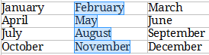
Figure 10: Selecting a vertical block of text

Cutting, copying, and pasting text
Cutting and copying text in Writer is similar to cutting and copying text in other applications. You can use the mouse or the keyboard for these operations. You can copy or move text within a document, or between documents, by dragging or by using menu selections, icons, or keyboard shortcuts. You can also copy text from other sources such as Web pages and paste it into a Writer document.
To move (drag and drop) selected text using the mouse, left-click it and drag it to the new location and release it. To copy selected text, hold down the Ctrl key while dragging. The text retains the formatting it had before dragging.
To move (cut and paste) selected text, use Ctrl+X to cut the text, insert the cursor at the paste-in point and use Ctrl+V to paste. Alternatively, use the icons on the Standard toolbar.
When you paste text, the result depends on the source of the text and how you paste it. If you click on the Paste icon, any formatting the text has (such as bold or italics) is retained. Text pasted from Web sites and other sources may also be placed into frames or tables. If you do not like the results, click the Undo icon or press Ctrl+Z.
To make the pasted text take on the formatting of the surrounding text where it is being pasted:
- Choose Edit > Paste Special, or
- Click the triangle to the right of the Paste icon, or
- Click the Paste icon without releasing the left mouse button.
Then select Unformatted text from the resulting menu.
The range of choices on the Paste Special menu varies depending on the origin and formatting of the text (or other object) to be pasted. See Figure 11 for an example with text on the clipboard.
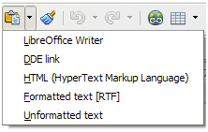
Figure 11: Paste Special menu

Finding and replacing text and formatting
Writer has two ways to find text within a document: the Find toolbar for fast searching and the Find & Replace dialog. In the dialog, you can:
- Find and replace words and phrases
- Use wildcards and regular expressions to fine-tune a search
- Find and replace specific formatting
- Find and replace paragraph styles

Using the Find toolbar
If the Find toolbar is not visible, you can display it by choosing View > Toolbars > Find from the menu bar or by pressing Ctrl+F. The Find toolbar is shown docked at the bottom of the LibreOffice window (just above the Status Bar) in Figure 12, but you can float it or dock it in another location. For more information on floating and docking toolbars, see Chapter 1, Introducing LibreOffice.
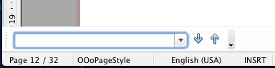
Figure 12: Docked position of Find toolbar
To use the Find toolbar, click in the box and type your search text, then press Enter to find the next occurrence of that term. Click the Find Next or Find Previous buttons as needed.

Using the Find & Replace dialog
To display the Find & Replace dialog (Figure 13), use the keyboard shortcut Ctrl+H or choose Edit > Find & Replace from the menu bar. Optionally, click the More Options button to expand the dialog; the button changes to Fewer Options.
To use the Find & Replace dialog:
- Type the text you want to find in the Search for box.
- To replace the text with different text, type the new text in the Replace with box.
- You can select various options such as matching the case, matching whole words only, or doing a search for similar words.
- When you have set up your search, click Find. To replace the found text, click Replace.
For more information on using Find & Replace, see the Writer Guide.
Tip | If you click Find All, LibreOffice selects all instances of the search text in the document. Similarly, if you click Replace All, LibreOffice replaces all matches.
Caution | Use Replace All with caution; otherwise, you may end up with some hilarious (and highly embarrassing) mistakes. A mistake with Replace All might require a manual, word-by-word, search to fix.
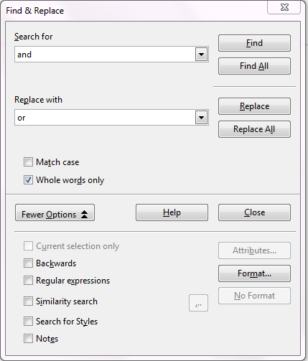
Figure 13: Expanded Find & Replace dialog

Inserting special characters
A special character is one not found on a standard English keyboard. For example, © ¾ æ ç ñ ö ø ¢ are all special characters. To insert a special character:
- Place the cursor where you want the character to appear.
- Choose Insert > Special Character to open the Special Characters dialog.
- Select the characters (from any font or mixture of fonts) you wish to insert, in order, then click OK. The selected characters are shown in the lower left of the dialog. As you select a character, it is shown on the lower right, along with its numerical code.
Note | Different fonts include different special characters. If you do not find a particular special character, try changing the Font selection.
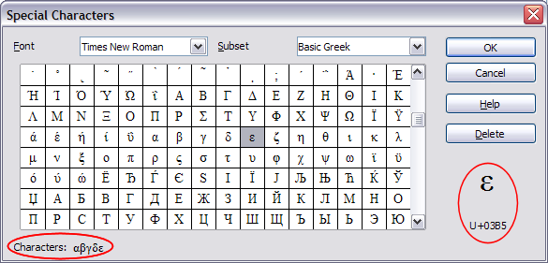
Figure 14: The Special Characters dialog, where you can insert special characters

Inserting dashes and non-breaking spaces and hyphens
To prevent two words from being separated at the end of a line, press Ctrl+Shift when you type the space between the two words.
In cases where you do not want the hyphen to appear at the end of a line, for example in a number such as 123-4567, you can press Shift+Ctrl+minus sign to insert a non-breaking hyphen.
To enter en and em dashes, you can use the Replace dashes option on the Options tab under Tools > AutoCorrect Options. This option replaces two hyphens, under certain conditions, with the corresponding dash.
– is an en-dash; that is, a dash the width of the letter “n” in the font you are using. Type at least one character, a space, one or two hyphens, another space, and at least one more letter. The one or two hyphens will be replaced by an en-dash.
— is an em-dash; that is, a dash the width of the letter “m” in the font you are using. Type at least one character, two hyphens, and at least one more character. The two hyphens will be replaced by an em-dash.
See the Help for more details. For other methods of inserting dashes, see the Writer Guide.

Setting tab stops and indents
The horizontal ruler shows both the default tab stops and any tab stops that you have defined. Tab settings affect indentation of full paragraphs (using the Increase Indent and Decrease Indent icons on the Formatting toolbar) as well as indentation of parts of a paragraph (by pressing the Tab key on the keyboard).
Using the default tab spacing can cause formatting problems if you share documents with other people. If you use the default tab spacing and then send the document to someone else who has chosen a different default tab spacing, tabbed material will change to use the other person’s settings. Instead of using the defaults, define your own tab settings, as described in this section.
To define indents and tab settings for one or more selected paragraphs, double-click on a part of the ruler that is not between the left and right indent icons to open the Indents & Spacing page of the Paragraph dialog. Double-click anywhere between the left and right indent icons on the ruler to open the Tabs page of the Paragraph dialog.
A better strategy is to define tabs for the paragraph style. See Chapters 6 and 7 in the Writer Guide for more information.
Tip | Using tabs to space out material on a page is not recommended. Depending on what you are trying to accomplish, a table is usually a better choice.

Changing the default tab stop interval
Note | Any changes to the default tab setting will affect the existing default tab stops in any document you open afterward, as well as tab stops you insert after making the change.
To set the measurement unit and the spacing of default tab stop intervals, go to Tools > Options > LibreOffice Writer > General.

Figure 15: Selecting a default tab stop interval
You can also set or change the measurement unit for rulers in the current document by right-clicking on the ruler to open a list of units. Click on one of them to change the ruler to that unit. The selected setting applies only to that ruler.
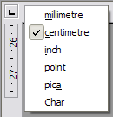
Figure 16: Changing the measurement unit for a ruler

Checking spelling and grammar
Writer provides a spelling checker, which can be used in two ways.
AutoSpellcheck checks each word as it is typed and displays a wavy red line under any misspelled words. When the word is corrected, the line disappears.
To perform a separate spelling and grammar check on the document (or a text selection) click the Spelling and Grammar button. This checks the document or selection and opens the Spelling and Grammar dialog if any unrecognized words are found. In order to use this, the appropriate dictionaries must be installed. By default, four dictionaries are installed: a spelling checker, a grammar checker, a hyphenation dictionary, and a thesaurus.
Here are some more features of the spelling checker:
- You can right-click on a word with a wavy underline to open a context menu. If you select from the suggested words on the menu, the selection will replace the misspelled word in your text. Other menu options are discussed below.
- You can change the dictionary language (for example, Spanish, French or German) on the Spelling and Grammar dialog.
- You can add a word to the dictionary. Click Add in the Spelling and Grammar dialog and pick the dictionary to add it to.
- Click the Options button on the Spelling and Grammar dialog to open a dialog similar to the one in Tools > Options > Language Settings > Writing Aids described in Chapter 2. There you can choose whether to check uppercase words and words with numbers, and you can manage custom dictionaries, that is, add or delete dictionaries and add or delete words in a dictionary.
- On the Font tab of the Paragraph Styles dialog, you can set paragraphs to be checked in a specific language (different from the rest of the document). See Chapter 7, Working with Styles, in the Writer Guide for more information.
Writer includes a grammar checker (LightProof), which you can access from Tools > Spelling and Grammar.

Using built-in language tools
Writer provides some tools that make your work easier if you mix multiple languages within the same document or if you write documents in various languages.
The main advantage of changing the language for a text selection is that you can then use the correct dictionaries to check spelling and apply the localized versions of Autocorrect replacement tables, thesaurus, and hyphenation rules.
You can also set the language for a paragraph or a group of characters as None (Do not check spelling). This option is especially useful when you insert text such as web addresses or programming language snippets that you do not want to check for spelling.
Specifying the language in character and paragraph styles is the preferred method, because styles allow a greater level of control and make changing the language much faster. On the Font tab of the Paragraph Styles dialog, you can specify that certain paragraphs be checked in a language that is different from the language of the rest of the document. See Chapter 7, Working with Styles, in the Writer Guide for information on how to manage the language settings of a style.
You can also set the language for the whole document, for individual paragraphs, or even for individual words and characters, from Tools > Language on the menu bar.
Another way to change the language of a whole document is to use Tools > Options > Language Settings > Languages. In the Default languages for documents section, you can choose a different language for all the text that is not explicitly marked as a different language.
The spelling checker works only for those languages in the list that have the symbol next to them. If you do not see the symbol next to your preferred language, you can install the additional dictionary using Tools > Languages > More dictionaries online.
The language used for checking spelling is also shown in the status bar, next to the page style in use.

Using AutoCorrect
Writer’s AutoCorrect function has a long list of common misspellings and typing errors, which it corrects automatically. For example, “hte” will be changed to “the”.
AutoCorrect is turned on when Writer is installed. To turn it off, uncheck Format > AutoCorrect > While Typing.
Choose Tools > AutoCorrect Options to open the AutoCorrect dialog. There you can define which strings of text are corrected and how. In most cases, the defaults are fine.
To stop Writer replacing a specific spelling, go to the Replace tab, highlight the word pair, and click Delete.
To add a new spelling to the list, type it into the Replace and With boxes on the Replace tab, and click New.
See the different tabs of the dialog for the wide variety of other options available to fine-tune AutoCorrect.
Tip | AutoCorrect can be used as a quick way to insert special characters. For example, (c) will be autocorrected to ©. You can add your own special characters.

Using word completion
If Word Completion is enabled, Writer tries to guess which word you are typing and offers to complete the word for you. To accept the suggestion, press Enter. Otherwise, continue typing.
To turn off Word Completion, select Tools > AutoCorrect Options > Word Completion and deselect Enable word completion.
You can customize word completion from the Word Completion page of the AutoCorrect dialog:
- Add (append) a space automatically after an accepted word
- Show the suggested word as a tip (hovering over the word) rather than completing the text as you type
- Collect words when working on a document, and then either save them for later use in other documents or select the option to remove them from the list when closing the document
- Change the maximum number of words remembered for word completion and the length of the smallest words to be remembered
- Delete specific entries from the word completion list
- Change the key that accepts a suggested entry—the options are Right arrow, End key, Return (Enter), and Space bar
Note | Automatic word completion only occurs after you type a word for the second time in a document.

Using AutoText
Use AutoText to store text, tables, graphics and other items for reuse and assign them to a key combination for easy retrieval. For example, rather than typing “Senior Management” every time you use that phrase, you can set up an AutoText entry to insert those words when you type “sm” and press F3.
AutoText is especially powerful when assigned to fields. See Chapter 14, Working with Fields, in the Writer Guide for more information.

Creating AutoText
To store some text as AutoText:
- Type the text into your document.
- Select the text.
- Choose Edit > AutoText (or press Ctrl+F3).
- In the AutoText dialog box, type a name for the AutoText in the Name box. Writer will suggest a one-letter shortcut, which you can change.
- In the large box to the left, choose the category for the AutoText entry, for example My AutoText.
- Click the AutoText button on the right and select New (text only) from the menu.
- Click Close to return to your document.
Tip | If the only option under the AutoText button is Import, either you have not entered a name for your AutoText or there is no text selected in the document.

Inserting AutoText
To insert AutoText, type the shortcut and press F3.

Formatting text

Using styles is recommended
Styles are central to using Writer. Styles enable you to easily format your document consistently, and to change the format with minimal effort. A style is a named set of formatting options. When you apply a style, you apply a whole group of formats at the same time. In addition, styles are used by LibreOffice for many processes, even if you are not aware of them. For example, Writer relies on heading styles (or other styles you specify) when it compiles a table of contents.
Caution | Manual formatting (also called direct formatting) overrides styles, and you cannot get rid of the manual formatting by applying a style to it.
Writer defines several types of styles, for different types of elements: characters, paragraphs, pages, frames, and lists. See Chapter 3, Using Styles and Templates, in this book and Chapters 6 and 7 in the Writer Guide.

Formatting paragraphs
You can apply many formats to paragraphs using the buttons on the Formatting toolbar. Figure 17 shows the Formatting toolbar as a floating toolbar, customized to show only the icons for paragraph formatting. The appearance of the icons may vary with your operating system and the selection of icon size and style in Tools > Options > LibreOffice > View.
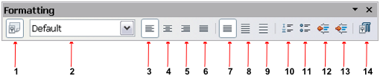
1 | Open Styles and Formatting Window | 5 | Align Right | 10 | Numbering On/Off
 | Open Styles and Formatting Window | 6 | Justified | 11 | Bullets On/Off
2 | Apply Style | 7 | Line Spacing: 1 | 12 | Decrease Indent
3 | Align Left | 8 | Line Spacing: 1.5 | 13 | Increase Indent
4 | Centered | 9 | Line Spacing: 2 | 14 | Paragraph format dialog
Figure 17: Formatting toolbar, showing icons for paragraph formatting

Formatting characters
You can apply many formats to characters using the buttons on the Formatting toolbar. Figure 18 shows the Formatting toolbar, customized to include only the icon for character formatting.
The appearance of the icons may vary with your operating system and the selection of icon size and style in Tools > Options > LibreOffice > View.
1 | Open Styles and Formatting Window | 6 | Italic | 12 | Font Color
 | Open Styles and Formatting Window | 7 | Underline | 13 | Highlighting
2 | Apply Style | 8 | Superscript | 14 | Background Color
3 | Font Name | 9 | Subscript | 15 | Open Character Format Dialog
4 | Font Size | 10 | Increase Font |  | Open Character Format Dialog
5 | Bold | 11 | Reduce Font
Figure 18: Formatting toolbar, showing icons for character formatting
Tip | To remove manual formatting, select the text and choose Format > Clear Direct Formatting from the menu bar, or right-click and choose Clear Direct Formatting from the context menu, or use Ctrl+M from the keyboard.

Autoformatting
You can set Writer to automatically format parts of a document according to the choices made on the Options page of the AutoCorrect dialog (Tools > AutoCorrect Options).
Tip | If you notice unexpected formatting changes occurring in your document, this is the first place to look for the cause.
The Help describes each of these choices and how to activate the autoformats. Some common unwanted or unexpected formatting changes include:
- Horizontal lines. If you type three or more hyphens (---), underscores (___) or equal signs (===) on a line and then press Enter, the paragraph is replaced by a horizontal line as wide as the page. The line is actually the lower border of the preceding paragraph.
- Bulleted and numbered lists. A bulleted list is created when you type a hyphen (-), star (*), or plus sign (+), followed by a space or tab at the beginning of a paragraph. A numbered list is created when you type a number followed by a period (.), followed by a space or tab at the beginning of a paragraph. Automatic numbering is only applied to paragraphs formatted with the Default, Text body or Text body indent paragraph styles.
To turn autoformatting on or off, choose Format > AutoCorrect and select or deselect the items on the list.

Creating numbered or bulleted lists
There are several ways to create numbered or bulleted lists:
- Use autoformatting, as described above.
- Use list (numbering) styles, as described in Chapter 6, Introduction to Styles, and Chapter 7, Working with Styles, in the Writer Guide.
- Use the Numbering and Bullets icons on the paragraph formatting toolbar (see Figure 17): select the paragraphs in the list, and then click the appropriate icon on the toolbar.
Note | It is a matter of personal preference whether you type your information first, then apply Numbering/Bullets, or apply them as you type.

Using the Bullets and Numbering toolbar
You can create nested lists (where one or more list items has a sub-list under it, as in an outline) by using the buttons on the Bullets and Numbering toolbar (Figure 19). You can move items up or down the list, or create sub-points, and even change the style of bullets. Use View > Toolbars > Bullets and Numbering to see the toolbar.
The appearance of the icons may vary with your operating system and the selection of icon size and style in Tools > Options > LibreOffice > View.
Note | If numbering or bullets are being applied automatically in a way that you find inappropriate, you can switch them off temporarily by unchecking Format > AutoCorrect > While Typing.

1 | Bullets On/Off | 6 | Promote One Level with Subpoints | 10 | Move Down
2 | Numbering On/Off | 6 | Promote One Level with Subpoints | 11 | Move Up with Subpoints
3 | Numbering Off | 7 | Demote One Level with Subpoints | 12 | Move Down with Subpoints
4 | Promote One Level | 8 | Insert Unnumbered Entry | 13 | Restart Numbering
5 | Demote One Level | 9 | Move Up | 14 | Bullets and Numbering
Figure 19: Bullets and Numbering toolbar

Hyphenating words
You have several choices regarding hyphenation: let Writer do it automatically (using its hyphenation dictionaries), insert conditional hyphens manually where necessary, or don’t hyphenate at all.

Automatic hyphenation
To turn automatic hyphenation of words on or off:
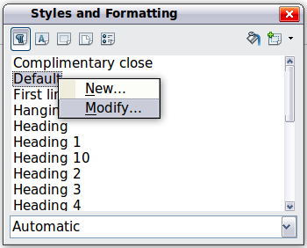
Figure 20: Modifying a style
- Press F11 (z+T on Mac) to open the Styles and Formatting window.
- On the Paragraph Styles page (Figure 20), right-click on Default and select Modify.
- On the Paragraph Style dialog (Figure 21), go to the Text Flow page.
- Under Hyphenation, select or deselect the Automatically option. Click OK to save.
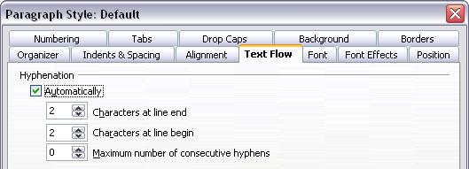
Figure 21: Turning on automatic hyphenation
Note | Turning on hyphenation for the Default paragraph style affects all other paragraph styles that are based on Default. You can individually change other styles so that hyphenation is not active; for example, you might not want headings to be hyphenated. Any styles that are not based on Default are not affected. See Writer Guide Chapter 3, Styles and Templates, for more about styles based on other styles.
You can also set hyphenation choices through Tools > Options > Language Settings > Writing Aids. In Options, near the bottom of the dialog, scroll down to find the hyphenation settings.

Figure 22: Setting hyphenation options
To change the minimum number of characters for hyphenation, the minimum number of characters before a line break, or the minimum number of characters after a line break, select the item, and then click the Edit button in the Options section.
Hyphenation options set on the Writing Aids dialog are effective only if hyphenation is turned on through paragraph styles.

Manual hyphenation
To manually hyphenate words, do not use a normal hyphen, which will remain visible even if the word is no longer at the end of a line when you add or delete text or change margins or font size. Instead, use a conditional hyphen, which is visible only when required.
To insert a conditional hyphen inside a word, click where you want the hyphen to appear and press Ctrl+hyphen. The word will be hyphenated at this position when it is at the end of the line, even if automatic hyphenation for this paragraph is switched off.

Formatting pages
Writer provides several ways for you to control page layouts: page styles, columns, frames, tables, and sections. For more information, see Chapter 4, Formatting Pages, in the Writer Guide.
Tip | Page layout is usually easier if you show text, object, table, and section boundaries in Tools > Options > LibreOffice > Appearance, and paragraph ends, tabs, breaks, and other items in Tools > Options > LibreOffice Writer > Formatting Aids.

Which layout method to choose?
The best layout method depends on what the final document should look like and what sort of information will be in the document. Here are some examples.
For a book similar to this user guide, with one column of text, some figures without text beside them, and some other figures with descriptive text, use page styles for basic layout, and tables to place figures beside descriptive text when necessary. | 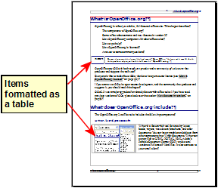
For an index or other document with two columns of text, where the text continues from the left-hand column to the right-hand column and then to the next page, all in sequence (also known as “snaking columns” of text), use page styles (with two columns). If the title of the document (on the first page) is full-page width, put it in a single-column section. | 
For a newsletter with complex layout, two or three columns on the page, and some articles that continue from one page to some place several pages later, use page styles for basic layout. Place articles in linked frames and anchor graphics to fixed positions on the page if necessary. | 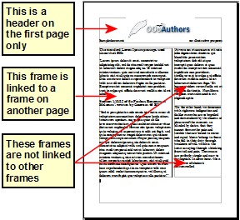
For a document with terms and translations to appear side-by-side in what appear to be columns, use a table to keep items lined up, and so you can type in both “columns”. | 

Creating headers and footers
A header is an area that appears at the top of a page. A footer appears at the bottom of the page. Information such as page numbers inserted into a header or footer displays on every page of the document with that page style.

Inserting a header or footer
To insert a header, you can either:
- Choose Insert > Header > Default (or the page style, if not Default), or
- Hover the mouse over the top of the text area until the Header marker appears (Figure 23), and then click on the +.
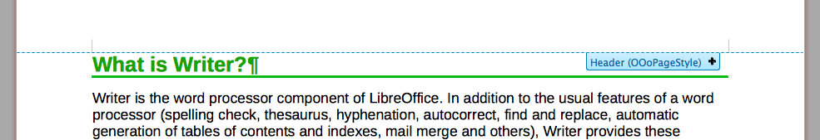
Figure 23: Header marker at top of text area
After a header has been created, a down-arrow appears on the header marker. Click on this arrow to drop down a menu of choices for working with the header (Figure 19).
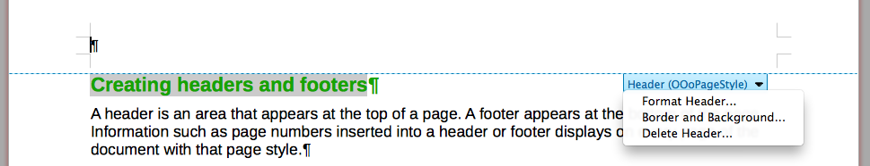Figure 24: Header menu
To format a header, you can use either the menu item shown in Figure 19 or Format > Page > Header. Both methods take you to the same tab on the Page Style dialog.

Inserting header and footer contents
Other information such as document titles and chapter titles is often put into the header or footer. These items are best added as fields. That way, if something changes, the headers and footers are updated automatically. Here is one common example.
To insert the document title into the header:
- Choose File > Properties > Description and type a title for your document.
- Add a header (Insert > Header > Default).
- Place the cursor in the header part of the page.
- Choose Insert > Fields > Title. The title should appear on a gray background (which does not show when printed and can be turned off).
- To change the title for the whole document, go back to File > Properties > Description.
Fields are covered in detail in Chapter 14, Working with Fields, in the Writer Guide.
For more about headers and footers, see Chapter 4, Formatting Pages, and Chapter 6, Introduction to Styles, in the Writer Guide.

Numbering pages

Displaying page numbers
To automatically display page numbers:
- Insert a header or footer, as described in “Creating headers and footers” above.
- Place the cursor in the header or footer where you want the page number to appear and choose Insert > Fields > Page Number.

Including the total number of pages
To include the total number of pages (as in “page 1 of 12”):
- Type the word “page” and a space, then insert the page number as above.
- Press the space bar once, type the word “of” and a space, then choose Insert > Fields > Page Count.
Note | The Page Count field inserts the total number of pages in the document, as shown on the Statistics tab of the document’s Properties window (File > Properties). If you restart page numbering anywhere in the document, then the total page count may not be what you want. See Chapter 4, Formatting Pages, in the Writer Guide for more information.

Restarting page numbering
Often you will want to restart the page numbering at 1, for example on the page following a title page or a table of contents. In addition, many documents have the “front matter” (such as the table of contents) numbered with Roman numerals and the main body of the document numbered in Arabic numerals, starting with 1.
You can restart page numbering in two ways.
Method 1:
- Place the cursor in the first paragraph of the new page.
- Choose Format > Paragraph.
- On the Text Flow tab of the Paragraph dialog (Figure 21 on page 21), select Breaks.
- Select Insert and then With Page Style and specify the page style to use.
- Specify the page number to start from, and then click OK.
Tip | Method 1 is also useful for numbering the first page of a document with a page number greater than 1. For example, you may be writing a book, with each chapter in a separate file. Chapter 1 may start with page 1, but Chapter 2 could begin with page 25 and Chapter 3 with page 51.
Method 2:
- Insert > Manual break.
- By default, Page break is selected on the Insert Break dialog (Figure 25).
- Choose the required page Style.
- Select Change page number.
- Specify the page number to start from, and then click OK.
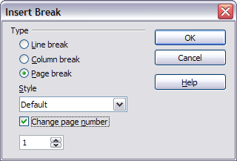
Figure 25: Restarting page numbering after a manual page break

Changing page margins
You can change page margins in two ways:
- Using the page rulers—quick and easy, but does not have fine control
- Using the Page Style dialog—can specify margins to two decimal places
Note | If you change the margins using the rulers, the new margins affect the page style and will be shown in the Page Style dialog the next time you open it.  Because the page style is affected, the changed margins apply to all pages using that style.
To change margins using the rulers:
- The gray sections of the rulers are the margins. Put the mouse cursor over the line between the gray and white sections. The pointer turns into a double-headed arrow.
- Hold down the left mouse button and drag the mouse to move the margin.

Figure 26: Moving the margins
Caution | The small arrowheads on the ruler are used for indenting paragraphs. They are often in the same place as the page margins, so you need to be careful to move the margin marker, not the arrows.
To change margins using the Page Style dialog:
- Right-click anywhere in the text area on the page and select Page from the pop-up menu.
- On the Page tab of the dialog, type the required distances in the Margins boxes.

Adding comments to a document
Authors and reviewers often use comments (formerly called “notes”) to exchange ideas, ask for suggestions, or mark items needing attention.
To insert a comment in the text, place the cursor in the place the comment refers to and choose Insert > Comment or press Ctrl+Alt+C. The anchor point of the comment is connected by a dotted line to a box on the right-hand side of the page where you can type the text of the comment. Writer automatically adds at the bottom of the comment the author’s name and a time stamp indicating when the comment was created. Figure 27 shows an example of text with comments from two different authors.
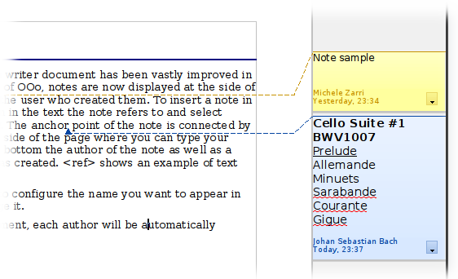Figure 27: Example of comments
Choose Tools > Options > User Data to configure the name you want to appear in the Author field of the comment, or to change it.
If more than one person edits the document, each author is automatically allocated a different background color.
Right-clicking on a comment pops up a menu where you can delete the current comment, all the comments from the same author, or all the comments in the document. From this menu, you can also apply some basic formatting to the text of the comment. You can also change the font type, size, and alignment from the main menu.
To navigate from one comment to another, open the Navigator (F5), expand the Comments section, and click on the comment text to move the cursor to the anchor point of the comment in the document. Right-click on the comment to quickly edit or delete it.
You can also navigate through the comments using the keyboard. Use Ctrl+Alt+Page Down to move to the next comment and Ctrl+Alt+Page Up to move to the previous comment.

Creating a table of contents
Writer’s table of contents feature lets you build an automated table of contents from the headings in your document. Before you start, make sure that the headings are styled consistently. For example, you can use the Heading 1 style for chapter titles and the Heading 2 and Heading 3 styles for chapter subheadings.
Although tables of contents can be customized extensively in Writer, often the default settings are all you need. Creating a quick table of contents is simple:
- When you create your document, use the following paragraph styles for different heading levels (such as chapter and section headings): Heading 1, Heading 2, Heading 3, and so on. These are what will appear in your table of contents.
- Place the cursor where you want the table of contents to be inserted.
- Choose Insert > Indexes and Tables > Indexes and Tables.
- Change nothing in the Insert Index/Table dialog. Click OK.
If you add or delete text (so that headings move to different pages) or you add, delete, or change headings, you need to update the table of contents.
To do this:
- Place the cursor within the table of contents.
- Right-click and choose Update Index/Table from the pop-up menu.
Note | If you cannot place your cursor in the table of contents, choose Tools > Options > LibreOffice Writer > Formatting Aids, and then select Enable in the Cursor in protected areas section.
You can customize an existing table of contents at any time. Right-click anywhere in it and choose Edit Index/Table from the pop-up menu. Chapter 12, Creating Tables of Contents, Indexes and Bibliographies, of the Writer Guide describes in detail all the customizations you can choose.

Creating indexes and bibliographies
Indexes and bibliographies work in a similar way to tables of contents. Chapter 12, Creating Tables of Contents, Indexes and Bibliographies, in the Writer Guide describes the process in detail.
In addition to alphabetical indexes, other types of indexes supplied with Writer include those for illustrations, tables, and objects, and you can even create a user-defined index. For example, you might want an index containing only the scientific names of species mentioned in the text, and a separate index containing only the common names of species. Before creating some types of indexes, you first need to create index entries embedded in your Writer document.

Working with graphics
Graphics in Writer are of three basic types:
- Image files, including photos, drawings, scanned images, and others
- Diagrams created using LibreOffice’s drawing tools
- Charts created using LibreOffice’s Chart component
See Chapter 11, Graphics, the Gallery, and Fontwork, in this book and Chapter 8, Working with Graphics, in the Writer Guide.

Printing
See Chapter 10, Printing, Exporting, and E-mailing, in this book and Chapter 5, Printing, Exporting, Faxing, and E-mailing, in the Writer Guide for details on previewing pages before printing, selecting print options, printing in black and white on a color printer, printing brochures, and other printing features.

Using mail merge
Writer provides very useful features to create and print:
- Multiple copies of a document to send to a list of different recipients (form letters)
- Mailing labels
- Envelopes
All these facilities use a registered data source (a spreadsheet or database containing the name and address records and other information). Chapter 11, Using Mail Merge, in the Writer Guide describes the process.

Tracking changes to a document
You can use several methods to keep track of changes made to a document.
- Make your changes to a copy of the document (stored in a different folder, or under a different name, or both), then use Writer to combine the two files and show the differences. Choose Edit > Compare Document. This technique is particularly useful if you are the only person working on the document, as it avoids the increase in file size and complexity caused by the other methods.
- Save versions that are stored as part of the original file. However, this method can cause problems with documents of non-trivial size or complexity, especially if you save a lot of versions. Avoid this method if you can.
- Use Writer’s change marks (often called “redlines” or “revision marks”) to show where you have added or deleted material, or changed formatting. Choose Edit > Changes > Record before starting to edit. Later, you or another person can review and accept or reject each change. Choose Edit > Changes > Show. Right-click on an individual change and choose Accept Change or Reject Change from the pop-up menu, or choose Edit > Changes > Accept or Reject to view the list of changes and accept or reject them. Details are in the Writer Guide.
Tip | Not all changes are recorded. For example, changing a tab stop from align left to align right, and changes in formulas (equations) or linked graphics are not recorded.

Using fields
Fields are extremely useful features of Writer. They are used for data that changes in a document (such as the current date or the total number of pages) and for inserting document properties such as name, author, and date of last update. Fields are the basis of cross-referencing (see below); automatic numbering of figures, tables, headings, and other elements; and a wide range of other functions—far too many to describe here. See Chapter 14, Working with Fields, in the Writer Guide for details.

Linking to another part of a document
If you type in cross-references to other parts of a document, those references can easily get out of date if you reorganize the order of topics, add or remove material, or reword a heading. Writer provides two ways to ensure that your references are up to date, by inserting links to other parts of the same document or to a different document:
- Hyperlinks
- Cross-references
The two methods have the same result if you Ctrl+click the link when the document is open in Writer: you are taken directly to the cross-referenced item. However, they also have major differences:
- The text in a hyperlink does not automatically update if you change the text of the linked item (although you can change it manually), but changed text does automatically update in a cross-reference.
- When using a hyperlink, you do not have a choice of the content of the link (for example text or page number), but when using a cross-reference, you have several choices, including bookmarks.
- To hyperlink to an object such as a graphic, and have the hyperlink show useful text such as Figure 6, you need to give such an object a useful name (instead of a default name like Graphics6), or use the Hyperlink dialog to modify the visible text. In contrast, cross-references to figures with captions automatically show useful text, and you have a choice of several variations of the name.
- If you save a Writer document to HTML, hyperlinks remain active but cross-references do not. (Both remain active when the document is exported to PDF.)

Using hyperlinks
The easiest way to insert a hyperlink to another part of the same document is by using the Navigator:
- Open the document containing the items you want to cross-reference.
- Open the Navigator by clicking its icon, choosing View > Navigator, or by pressing F5.
- Click the arrow next to the Drag Mode icon, and choose Insert as Hyperlink.
- In the list at the bottom of the Navigator, select the document containing the item that you want to cross-reference.
- In the Navigator list, select the item that you want to insert as a hyperlink.
- Drag the item to where you want to insert the hyperlink in the document. The name of the item is inserted in the document as an active hyperlink.
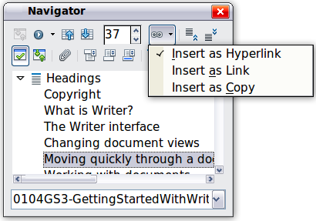
Figure 28: Inserting a hyperlink using the Navigator
You can also use the Hyperlink dialog to insert and modify hyperlinks within and between documents. See Chapter 12, Creating Web Pages.

Using cross-references
If you type in references to other parts of the document, those references can easily get out of date if you reword a heading, add or remove figures, or reorganize topics. Replace any typed cross-references with automatic ones and, when you update fields, all the references will update automatically to show the current wording or page numbers. The Cross-references tab of the Fields dialog lists some items, such as headings, bookmarks, figures, tables, and numbered items such as steps in a procedure. You can also create your own reference items; see “Setting References” in Chapter 14, Working with Fields, in the Writer Guide for instructions.
To insert a cross-reference to a heading, figure, bookmark, or other item:
- In your document, place the cursor where you want the cross-reference to appear.
- If the Fields dialog is not open, click Insert > Cross-reference. On the Cross-references tab (Figure 29), in the Type list, select the type of item to be referenced (for example, Heading or Figure). You can leave this page open while you insert many cross-references.
- Click on the required item in the Selection list, which shows all the items of the selected type. In the Insert reference to list, choose the format required. The list varies according to the Type. The most commonly used options are Reference (to insert the full text of a heading or caption), Category and Number (to insert a figure number preceded by the word Figure or Table, but without the caption text), Numbering (to insert only the figure or table number, without the word “Figure” or “Table”), or Page (to insert the number of the page the referenced text is on). Click Insert.
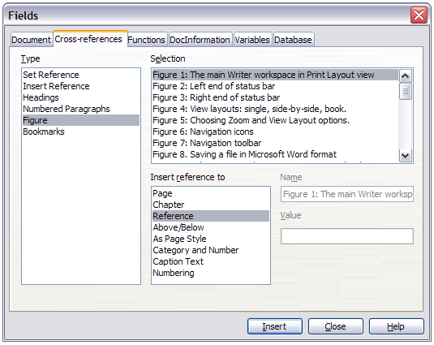
Figure 29: The Cross-references tab of the Fields dialog

Using bookmarks
Bookmarks are listed in the Navigator and can be accessed directly from there with a single mouse click. You can cross-reference to bookmarks and create hyperlinks to bookmarks, as described above.
- Select the text you want to bookmark. Click Insert > Bookmark.
- On the Insert Bookmark dialog, the larger box lists any previously defined bookmarks. Type a name for this bookmark in the top box, and then click OK.
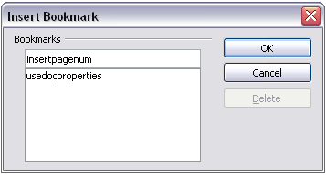Figure 30: Inserting a bookmark

Using master documents
Master documents are typically used for producing long documents such as a book, a thesis, or a long report; or when different people are writing different chapters or other parts of the full document, so you don’t need to share files. A master document joins separate text documents into one larger document, and unifies the formatting, table of contents (TOC), bibliography, index, and other tables or lists.
Yes, master documents do work in Writer. However, until you become familiar with them, you may think that master documents are unreliable or difficult to use. See Chapter 13, Working with Master Documents, in the Writer Guide.

Creating fill-in forms
A standard text document displays information: a letter, report, or brochure, for example. Typically the reader may either edit everything or nothing in any way. A form has sections that are not to be edited, and other sections that are designed for the reader to make changes. For example, a questionnaire has an introduction and questions (which do not change) and spaces for the reader to enter answers.
Forms are used in three ways:
- To create a simple document for the recipient to complete, such as a questionnaire sent out to a group of people who fill it in and return it.
- To link into a database or data source and allow the user to enter information. Someone taking orders might enter the information for each order into a database using a form.
- To view information held in a database or data source. A librarian might call up information about books.
Writer offers several ways to fill information into a form, including check boxes, option buttons, text boxes, pull-down lists and spinners. See Chapter 15, Using Forms in Writer, in the Writer Guide.

