Students’ Guide to
OpenOffice Writer

IMPRESSUM
I first wrote this guide in the summer of 2008 in German for students of the Department of Social Work at the University of Applied Sciences in Frankfurt, Germany. Questions and answers over the years have all found their way into this guide, which I continuously update and have now for the first time translated into English. Any comments and criticisms are welcome and will be taken account of in future releases of this document. Please write to: paenson@fb4.fh-frankfurt.de. This document is released under Creative Commons License (see http://creativecommons.org/​)

by David Paenson, B. A. Hons.
October 2011

CONTENTS

1 Introduction 1
2 Automation 1
3 Document structure 2
4 First Steps 3
5 Headings 3
6 Chapter numbering 5
7 Navigating through your text 7
8 Group Work 8
9 Table of Contents 9
10 Paragraph style “Text Body” 11
11 More on Styles 13
12 MS-Word 13
13 Unnumbered pages 14
14 Title page 16
15 Numbered Default Page 17
16 Literature List 19
17 Bullets and Numbering 19
18 Cross-references 20
19 Footnotes 22
20 Quotes 23
21 Line Numbering 24
22 Tables 24
23 Charts 25
24 Snapshot 27
25 Pictures 28
26 Cross Tables (Statistics) 28
27 Extra Long Web Addresses 32
28 Fonts 32
29 Emphasis 34
30 Special Characters 34
31 Mouse Clicks 35
32 Shortcuts 35
33 Saving your work 36
34 PDFs 37
35 Search and Replace 37
36 Auto Spell Check 37
37 Synonyms 37
38 Document Infos 38
39 Labels and Form Letters 38
40 Help 39
41 Practice 39
42 Three Taboos 40

Introduction
I first wrote this short guide in the summer of 2008 (in German) and have been updating it ever since. My aim is to help students over the typical hurdles they invariably come up against as soon as they are confronted with the task of writing lengthy documents – especially their thesis.
So my aim is precisely not to detail all the numerous functions OpenOffice Writer has in store, but instead to focus on typical real life situations from the point of view of the student.
Nevertheless, a general understanding of the programme is important. It’s a bit like trying of operate a complex machine. If you want it to behave as you expect it to, then you have to master its basic mechanisms. So some theory is necessary in order to tackle the individual problems.
I would therefore strongly recommend the reader to take his or her time and read through the whole document before trying anything out in practice. Having obtained a general overview, he or she can then later go back to individual chapters as the need arises.
Experience has shown that students often leave formatting to the last minute. Also they don’t take advantage of the many automatic features available. So for instance they write the table of contents manually instead of letting the programme do it for them. This not only wastes time, it also leads to easily avoidable mistakes.

Automation
Any typical document, book or magazine has a number of recurring elements such as headings, footnotes, page layouts, the main text body, quotations, literature lists etc.
All these elements need to be formatted uniformly.
Additionally many of these elements, such as headings or illustrations, will be accompanied by ascending numbers.
Lastly, the table of contents, table of illustrations and other such tables can be generated automatically on the basis of existing chapter and section headings and existing illustration captions.
These various decisions or settings are all recorded in a few central locations and apply uniformly to the whole document.

Document Structure
When conceiving an essay or thesis you will invariably have in your mind’s eye not only its contents but also its overall structure.
The contents consist in the main of the actual text. It is the text body which makes up the bulk of the document. The Text Body has its own formatting style, appropriately called just that: “Text Body”. But we will go into that in more detail in section 10.
For now we want to deal with the structure of a document. The main means to make the underlying structure visible for the reader is of course the use of chapter and section headings.
Imagine for a second walking into your favourite bookshop and stumbling onto an attractive looking book. You open it and see only text, not a single heading. You will very likely feel quite exasperated. This simple anecdote demonstrates how important headings are. They are a kind of key to the text which you as the author want the reader to get stuck into.
There are of course first and foremost the main chapter headings, that is Level 1. Then you might want section headings, that would be Level 2, and so on, right down to a theoretical Level 10.
These various Levels are usually optically distinguishable one from the other by:
- font (e.g. Times/Arial/Garamond/Futura etc.)
- typeface (regular/bold/italic)
- font size (measured in points, abbreviated as “pt”)
- spacing above paragraph
- spacing below paragraph
- breaks (e.g. main chapter headings to all begin on a new page)
- numbering (optional)
It’s best to type in all the headings and sub-headings right from the start and activate their numbering too. Then you have a structure which you can fill in little by little with Text Body.
Note that the table of contents is only a reflection of the document’s structure. First come the headings, and then, based on the existing headings, the programme generates the table of contents – including page numbers and so on.
Note also that the decision, what is a heading, what is text body, what is a quotation and so on, and what these various elements look like, are two separate decisions. The primary decision is of course what it is, more precisely, which style attaches to the paragraph in question. The actual appearance, the way you want, say, your footnotes to look like, can be varied as you wish by changing the applied footnote style. But more on Styles later on.

First Steps
When embarking on a new text you will invariably pose yourself the question: should I concentrate just on the content and leave the formatting till later? Or should I try to format the text properly right from the beginning?
The second approach is the right one. Using Styles is so easy there is really no reason why you shouldn’t apply them right from the start. Here some of the advantages of this way of going about things:
- save time
- using the Navigator (see section 7) you can jump to any chapter you wish to edit without having to scroll up or down to it
- chapters and sections can – again using the Navigator – be reordered with just one mouse click
- you’ll have a better idea of what the final result of your efforts is going to look like

Headings
As mentioned above you have to tell the programme what is a Heading and what is Text Body.
For that you use the following keyboard shortcuts:
- Ctrl + 0 for Text Body (ground level)
- Ctrl + 1 for Chapter Headings (level 1)
- Ctrl + 2 for Section Headings (level 2)
- Ctrl + 3 for Subsection Headings (level 3)
Note: It isn’t necessary to mark the whole paragraph beforehand – just place the cursor anywhere within the paragraph and apply the shortcut. Try it out!
For those of you who use Macs (I happen to be one of them): it’s not the Ctrl-Key but the Cmd-Key instead. But I’ll leave it up to you to figure out the variations.

Making Headings Look Nice
If you right click on, say, any level 1 heading, a menu pops up. One of its options is Edit Paragraph Style. Any changes made here will apply to all other Level 1 Headings. Same goes of course for other levels, indeed for any paragraph style.
Here my formatting suggestions for the first three levels of headings:
Style | Font | Size | Typeface | Spacing above | Spacing below
Chapter headings (level 1) | Garamond | 16pt | Bold | 1.6 cm | 0.8 cm
Section headings (level 2) | Garamond | 13pt | Bold Italic | 1.2 cm | 0.6 cm
Subsection headings (level 3) | Garamond | 13pt | Italic | 0.8 cm | 0.4 cm
Table 1: Styles for Headings (a suggestion)
Generally headings should be
- left aligned
- hyphenation turned off
- short

New Page for Each Chapter Heading?
If you want each chapter to begin on a new page, then in your style for Level 1 go to the tab Text Flow and check box Breaks Insert.
If you would like to avoid chapter headings in the bottom quarter of the page, you can insert a page break beforehand using the shortcut Ctrl + Return to shift the heading to the beginning of the following page.
Alternatively you could right click the paragraph immediately following the heading and choose Paragraph › Text Flow › Options › Do not split paragraph. Providing the paragraph in question has a certain length (i.e. just about a quarter page), it will “pull” the heading immediately above itself along to the next page. Note: you’ve changed the formatting of this one paragraph here, not the overall Paragraph Style!
Using this method consistently avoids the necessity to keep on checking the text after adding bits or taking bits out to see if any headings might have landed too low on the page.
If the paragraph in question is too short, you can include the one following it by ticking also Keep with next paragraph.

Blank Lines?
When in a hurry it’s tempting to just add a couple of blank lines before a heading and another blank line following a heading. This is definately not the right way to go about things! It really is paramount to work systematically in the way described above. If not, the “sticking” effect, which is standard for all headings, will simply loose its purpose.

Some Settings
Under Tools › Options › OpenOffice.org Writer › Compatibility I would recommend unchecking three choice boxes:
- Add spacing between paragraphs and tables; unchecking this option ensures that the set spacing below a paragraph and the set spacing above the paragraph immediately following it do not get added together; instead only the larger of the two spacings takes effect
- Add paragraph and table spacing at tops of pages; unchecking this option ensures that headings appear right at the top the page, without the usual set spacing separating them from a previous paragraph
- Expand word space on lines with manual line breaks in justified paragraphs; unchecking this option ensures that inserting a new line using shortcut Shift + Return will not expand the words on the previous line right up to the right margin; instead they will be left aligned even in a paragraph with justified alignment
Having removed these three ticks don’t forget to press the button Use as Default so that these changes apply also to any future documents.

How Many Levels?
I would recommend a maximum of three (numbered) heading levels. If you are going to use a fourth level, mainly for optical reasons, then leave that one unnumbered and don’t include it in the table of contents. The number of levels you include in the table of contents is your free choice (see section 9). I myself have used two levels in this document, but only actually included the first one in my table of contents.

Chapter Numbering
Numbering of headings can and should be completely automated. This has for one the advantage that if you decide to add or remove headings or move chapters and sections around or even change the level of a heading from level 1 to level 2 or the other way round, you won’t have to renumber them manually. Furthermore you can do this moving around of chapters and sections using the Navigator – you don’t have to mark text, cut it out and reinsert it in its new location! Another advantage is when working in groups. The various participants all activate automatic numbering, then they all get together and insert their various contributions into a new, empty document and finally, with the help of the Navigator, they order the chapters into their final positions.
Automated numbering is switched on using the menu Tools › Outline Numbering (see illustration 1). Normally you will opt for simple 1, 2, 3 style, but it could be just as easily A, B, C style or Roman style. It’s also possible to mix styles, that is, have Arabic for the first two levels and a), b), c) for the third – whereby the closing bracket is simply a “Separator After”.
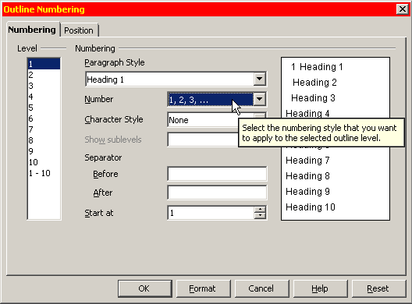Illustration 1: Activating Outline Numbering
When using 1, 2, 3 style it is common to Show sublevels. This means that heading 5.2.7 for instance will appear exactly as “5.2.7” and not simply as “7”. When mixing styles, you could have level 2 with sublevels shown (for instance “5.2”), but leave level 3 without showing sublevels (just “c)” for instance).
You might want to turn numbering off for particular headings, for example your introduction at the beginning and your literature list at the end of your thesis. You can achieve this by pressing the third button on the pop-up menu (see illustration 2). Be careful not to press the second button, because this would switch on/off numbering for all headings of that particular level!
Note: For chapter and section headings it is important to use the method described above. Do not simply activate numbering (or bullets) directly in the menu as suggested in illustration 3! This latter alternative is useful only for short lists, but not for chapter or section headings!
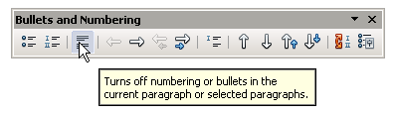Illustration 2: Turning off numbering for a particular chapter
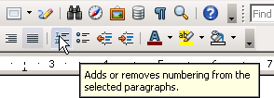Illustration 3: Activating numbering directly from the menu - good for lists, not for chapters
As a general rule, any one level within a section should contain at least two headings of that level, better still three. For instance, if you have a section 5.7.1 but no 5.7.2, then something’s gone wrong.
Under Position (see illustration 4) make sure Width of numbering is sufficient to contain the whole number (e.g. “5.7.2”) plus some spacing so that the heading number stands out nicely from the heading text – even if you happen to have a heading spanning several lines.
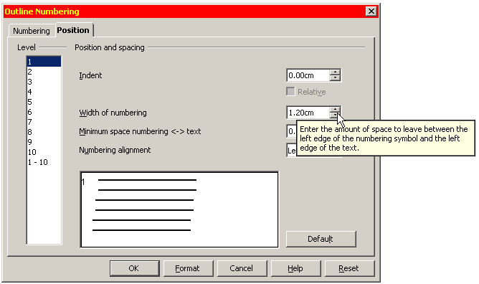Illustration 4: Make sure "width of numbering" is large enough

Wordy Headings?
Try to avoid headings that span more than one line. If a heading needs added explanation, let a short paragraph immediately following the heading take care of that. Long headings are also a problem in the table of contents.

Several Headings in Succession?
It’s not a good idea to have for example a 5.2 immediately followed by a 5.2.1. At least a short paragraph explaining what 5.2 is all about should be inserted in between.

Navigating Through Your Text
From the menu View choose Navigator (or simply press F5). The Navigator looks a bit like a table of contents, but it serves a completely different purpose. Whereas the table of contents is part of the document and will get printed along with all the rest, the navigator is not part of the document. Rather it is an electronic key which allows you to navigate through the document and even change the ordering of chapters around.
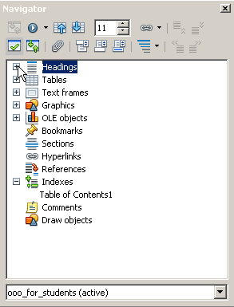Illustration 5: The Navigator (F5)
Now press the + next to the category Headings. Now you can see all your existing chapter Headings. Clicking on any one of them will highlight it. Double-clicking on it will bring you right to the corresponding passage in the text. So it’s not necessary any more to scroll down (or up) to it.
A click on the Double Arrow Up-Icon will move the whole chapter including footnotes, illustrations etc. up – what OpenOffice calls promoting a chapter (see illustration 6). So chapter 5 for example will swap its place with chapter 4. Conversely using the Double Arrow Down. Using the Double Arrow Right will lower the level of a chapter heading down to a section heading, for instance a chapter 5 to a section 4.x. Conversely using the Double Arrow Left.*
Apart from headings, the navigator also lists graphics, tables, hyperlinks and many other objects you can easily jump to with a double-click. Note though that graphics are automatically named “graphics1, graphics2, graphics3” and so on, so it’s difficult to keep track of what these names stand for exactly. But you can right click any graphic and choose Picture › Options. Here you can replace the given name “graphicsX” with a more descriptive one. The list is ordered according to placing in text, not alphabetically.
Unlike the table of contents, the Navigator updates itself automatically.
The Navigator is especially useful in the context of group work – see section 8.

Group Work
More and more students have to give in group papers. Up to four or even more authors might be involved.
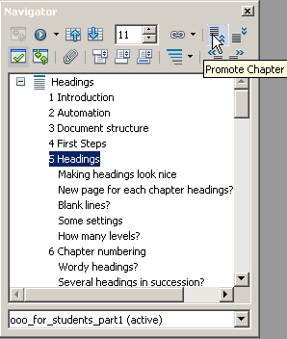Illustration 6: Here you see all your headings, which you can move up or down
To facilitate the joining together of the various contributions please do the following:
- enable automatic chapter numbering (see section 6)
- make sure all participants use the “Text body”-style for the Text Body and under no circumstances the “Default”-style!
- be sure to completely avoid any manual formatting, always apply styles and make sure all members of the group apply the same styles with the same names for the same purposes and with the same formatting (just a matter of one off coordination within the group when you set off – though adjustments can of course be made later on)
- dump all the contributions in any order into an new, empty document
- using the Navigator change the ordering of the chapters as appropriate

Individual Headers for Each Contributor?
Generally the lecturer will want to know at a glance who has made what contribution. To achieve this give each of the authors their own Page Style and name them accordingly – “Shila” for Shila, “Leila” for Leila, “Mark” for Mark and also one for the whole group called “Group”. Activate the Header for each of these styles. This involves the following steps:
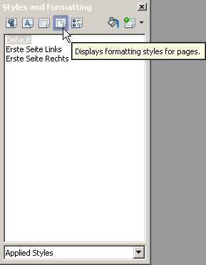Illustration 7: 4th icon to the right for page formatting
- open Menu Format › Styles and Formatting (F11)
- click on the 4th icon to the right for page styles
- change the selection Applied Styles to All – so now you see all existing styles pertaining to your document including unused ones
- right-click on the Default-Style and select New…
- under Organiser change the name, e.g. to “Leila”; ensure the Next Style is also “Leila” (otherwise the programme would only allow for one single “Leila” page)
- under the tab Header tick Header on
- go back to your document and place the cursor at the very end of the last piece of text belonging to the whole group
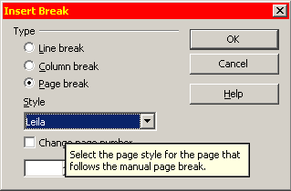Illustration 8: Choose your newly created page style "Leila"
- go to menu Insert › Manual Break and choose the newly created Style “Leila” (see illustration 8)
- place cursor in Leilas Page Header and write her name, press the tabulator one or two times to move the cursor to the right margin and Insert › Fields › Page Number

Correcting Other People’s Texts
You will probably want someone to have a look at your thesis or any other important paper before handing it in. At the same time you would most likely also want to see any changes or suggestions he or she might have made before either accepting or rejecting them, and not simply rely on blind faith. I myself do that regularly with other translators I cooperate with. This function is called Edit › Changes › Record. After getting your document back you can then Edit › Changes › Accept or Reject any changes made to your document.
If several people are involved in the production of one document, each one should have registered their forename under Tools › Options › OpenOffice.org › User Data. Any changes made by any one of the correctors will carry not only date and time of the change but also the name of the corrector. Each corrector will have his or her own colour marking.

Table of Contents
Having told the programme what are your headings and having activated their automatic numbering, you can now go on to inserting an automatically generated Table of Contents: Insert › Indexes and Tables › Indexes and Tables.
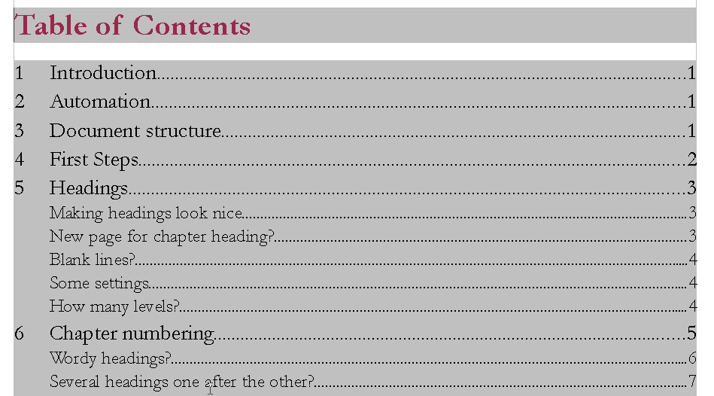Illustration 9: Note the alignment
In the pop-up menu you can Evaulate up to Level of your choice. In this present document I have chosen to evaluate only up to Level 1 and so to ignore section headings.
To update your table of contents simply right-click on it and choose Update Table/Index.

Alignment
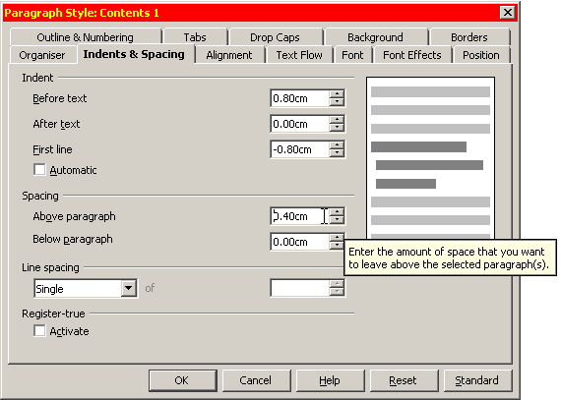Illustration 10: Setting the amount of indenting needed in "Contents 1"-style
As you can see in illustration 11, the table of contents by default contains the following four entries:
- Chapter number: E#
- Entry: E
- Tab stop (usually right aligned and with dots as filling): T
- Page number: #
So as to achieve an even alignment as in illustration 9 you add a Tab stop in between the E# and the E, leaving the Tab stop position at 0.00cm (the actual position will be defined in the style pertaining to that table of contents’ level). Note: If you happen to inadvertently insert an entry you don’t want, just click on it once and press Del.
The next step is then to right-click all the Contents levels of your table of contents one after the other and to Modify the Indents & Spacing both Before text and that of First line. The individual settings for indenting will depend on the kind of chapter numbering you have chosen. For instance if you have a), b), c) style for your third level, that is subsections, and have decided not to Show sublevels, then of course you will need less room than for example for the much longer “5.7.2” kind of numbering. The important concept to keep in mind is that you need the positive indenting to bring the cursor to its first position for the actual entry E, and a negative indenting to accommodate the chapter number E# (see illustration 12). Using this method, even headings spanning more than one line (not really to be recommended) will align nicely: the second and subsequent lines of the entry will all appear below each other and not below the number of the entry. Note also that when choosing your indentation it’s better to go for generous values. If you choose too small values, then your numbering won’t fit in and you will find your right dotted tab will appear before the entry instead of between entry and page number. For optical reasons you might also want to insert a blank space before and after the dotted tab so that the latter doesn’t “stick” to the entry respectively to the page number.
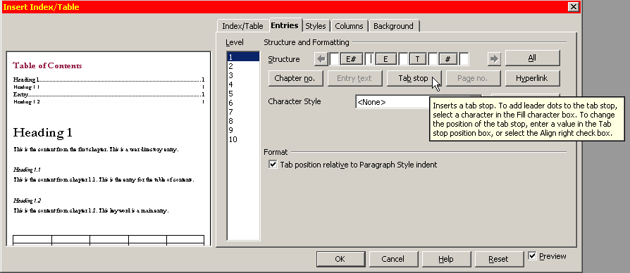Illustration 11: The 4 standard entries. Add a Tab stop between E# and E.
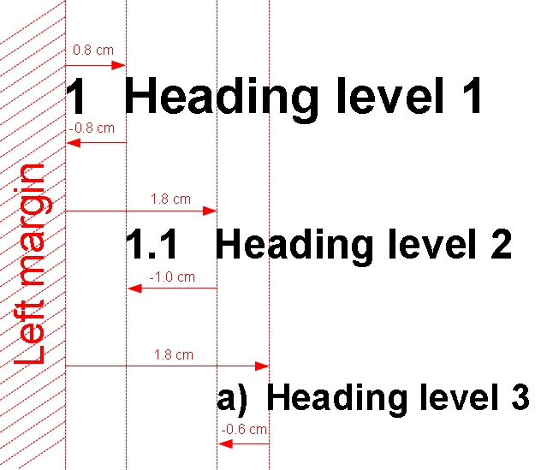Illustration 12: Abstract view of indenting – indentation depends on width of chapter number
 | Indent before text | Negative indent First line | Spacing before paragraph
1st level | 0.80 cm | -0.80 cm | 0.4 cm
2nd level | 1.80 cm | -1.00 cm | 0.1 cm
3rd level | 3.00 cm | -1.20 cm | 0.1 cm
Table 2: Indentation needed for first three levels if using full sublevels like "5.7.2"

Other Indices and Tables
Other indices can be generated apart from the table of contents. The same steps apply – you only need to change the Type to whatever is required, e.g. an Index of tables or an Illustration index. The various tables, illustrations and so on need to have a caption, which will then appear in the index.

Paragraph Style “Text Body”
Now at last we can talk about the Text Body, the real substance of any text.
Like all other elements, the text body has its own specific paragraph style, appropriately named Text body.
By default Text body allows for a Spacing below paragraph of 0,21mm, which is exactly 6pt – which in turn is exactly half the hight of a standard 12pt font. This very modest spacing is nevertheless enough to highlight the start of a new paragraph. It helps to lighten the overall impression.*
Other settings for your body text might well be Line spacing of 1.5 lines, Alignement justified and Text flow › Hyphenation › Automatically. Two rather enigmatic concepts are those of Orphan control and Widow control. The former stands for the minimum number of lines a paragraph at the bottom of a page must contain if it is not to move in toto to the following page. The latter stands conversely for the minimum number of lines a paragraph appearing at the very top of a page must contain below which it will “pull” lines from the previous page.
Note: Do not use the paragraph style Default for your text body. Default in fact should not be used at all! It’s there to fix general settings applying to all text, amongst other things headings and table text. For the latter you simply wouldn’t want a Line spacing of 1.5 lines, Alignement justified and Text flow › Hyphenation › Automatically.
Styles can be arranged hierarchically, the one inheriting its settings from the other and thus building a kind of dependency tree, though dependencies can be broken at any point, allowing for full flexibility.

More on Styles
We have already applied paragraph styles for headings and for the text body. Other elements such as footnotes, footnote numbers (those in the text as well as those in the footnote), quotes, literature lists and so on all have their own styles. You can also create new styles as the need arises.
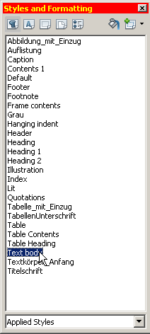Illustration 13: Here you see a list of all Applied Styles, i.e. those actually used in my text
Paragraph Styles make life so much easier. They allow for complete uniformity of all types of text. So for instance all your indented quotes will look the same. Time saving is immeasurable: instead of having to scan the whole text for possible formatting mistakes you simply change the style in one central location, and all the elements of that name get changed with it.
You get to the style list through Format › Styles and Formatting or else simply by pressing F11.
You can change any existing style by right-clicking it and choosing Modify. You can create a new style by right-clicking on any existing style and choosing New.
Paragraph styles are no doubt the category most commonly used. But there are other categories: Character Styles (which I use here to highlight Menus), Frame Styles, Numbering Styles and – most importantly as you shall discover later – Page Styles (for instance for landscape format or for the first non-numbered page or pages).

“Default Formatting”?
Under the menu Format you will see the option Default Formatting (Ctrl + m). This term should not be confused with Default style! If you apply Default Formatting to any marked text, it will loose any formatting you may have applied to it manually and take all its formatting exclusively from the Paragraph style of the same name. This is very practical for “cleaning” purposes, e.g. after having imported a file from Word full of hidden formattings you want to get rid of.

MS-Word
I absolutely recommend not using Microsoft Word. We all know how popular MS Word is, almost everybody has it though not necessarily bought it. Some people will argue, “Well, you must use it, because it’s the ‘standard’.” Or they might say: “Well, you know, later on in my work place I will probably have to use it, so I might as well get used to it now.”
All these arguments are easily countered:
- first Word is not a standard; in fact the programmers have practically trampled on long existing standards developed over the centuries; instead Word menus offer a whole palette of pretty buttons you can press, with such non-committal names as “intensive quote” which are anything but standard concepts in typography
- there’s no reason to waste your time now using an inadequate programme simply because later on in life you might have to any way; it’s a bit like the kindergarten argument: “Get the kids used to harsh discipline now because life will have it in for them sooner or later anyway.” I for one see it the other way round: enjoy life as much and as long as you can, and that will give you greater stamina to resist any misery in store for you at some later point in time
- the formatting of Word documents is pretty printer dependent, so printing it at home could lead to different results from printing it at work
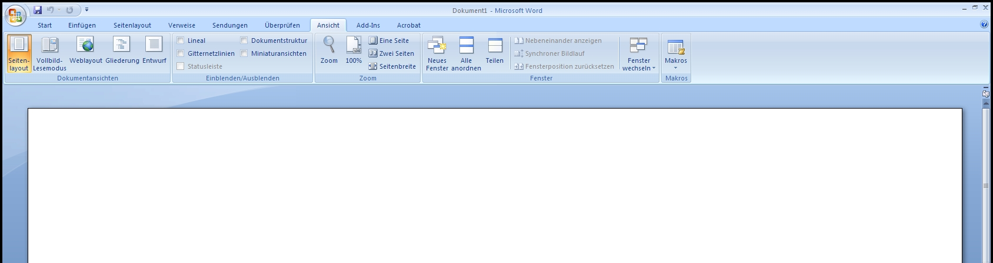Abbildung 14: Microsoft Word: Lots of buttons which change around “dynamically” depending on what you are doing (German version)
In case your lecturer insists on being provided with a Word document, do so from within OpenOffice simply by choosing File › Save as and then selecting File type › Microsoft Word 97/2000/XP.
If on the other hand you have just imported a Word document full of inconsistent formatting, mark the whole thing with Ctrl + a, turn the whole text into Text body with Ctrl + 0, then make sure all old formattings disappear completely with Ctrl + m and finally build your text formatting using styles up from scratch. Note that instead of starting completely from scratch, you can delete or replace existing styles with others. For that just go to Edit › Find & Replace › More Options and tick Styles.

Unnumbered Pages

Problem:
You want your text pages to be numbered but need to leave your first page(s) unnumbered. Also you would like your first text page to start with number 1. The solution is really quite simple. All you need are two page styles – the Default page style with activated header or footer to accomodate the page number, and a First Page style with no header or footer. There is one little catch though, and that is that the First Page style normally expects to be immediately followed by a Default Page. You have to change this setting. Also this Default Page would automatically be numbered according to the physical number of pages going before it, but you want it to be number 1. Here is the solution:
- go to menu Format › Styles and Formatting (F11)
- press the 4th icon from the left to open the list of Page Styles
- right click First Page and choose Modify
- under the tab Organiser › Next Style change the Default to First Page; this means that our very first First Page will be followed by an endless number of First Pages until you choose otherwise
- right click the page style Default and choose Modify
- under the tab Header tick Header on (alternatively choose the tab Footer and tick Footer on)
- having completed this preliminary work, place the cursor in your very first page and double-click the page style First page you have just modified (styles all must be applied with a double-click – changing a style doesn’t necessarily mean you actually have to use it!)
- then go to your last First Page, that could be the one with the table of contents for example, and place your cursor at the very bottom of any text on this page
- go to menu Insert › Manual Break and choose Default Style
- choose Change page number starting from 1
It’s basically the same method we have already come across in section 8 on Group Work in which we described how to use individual page styles for each author in a work group. Similarly you could create a completely new page style and call it Roman and change the numbering style from Arabic to Roman to accommodate a forward or an introduction (see illustration 18).
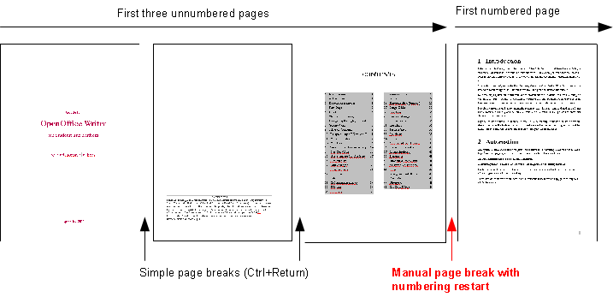Illustration 15: Here an example with two simple page breaks followed by a manual page break to switch from First Page Style to Default Style and restart numbering beginning with 1

Separate Document for the First Page?
Now that you’ve seen how easy it is to insert simple page breaks using Ctrl + Return as well as to switch page styles and restart numbering using Manual Page Breaks it is quite obvious you don’t need separate documents for the different parts of your text. In fact, separate documents have a whole number of serious disadvantages:
- you can easily loose track of which documents belong to each other on your hard disk
- it makes it very difficult to create a single final PDF-document for publication or mailing purposes
- most of the automation possibilities cannot be put to use

Title Page
The title page is the only page where you won’t need to use styles and can, and indeed should do everything manually. This is because the title page is unique. Using styles would only create extra work. The only exception would be if you were working in a publishing house producing loads of optically identical title pages – but this is not the kind of situation we are dealing with here.
I would go for the following settings:
- choose a base font Garamond size 14pt
- 24pt bold should be fine for the main title, 20pt standard for the subtitle
- reduce Line spacing to 1 and any Spacing Above paragraph or Below paragraph to 0 – just press a number of Returns to regulate the placing of lines

Papers Without Title Page
For short papers, say 6 to 10 pages, you will probably not need a title page. Instead you will simply reserve the first quarter or so of the first page for general information on the document:
  - title
  - course number
  - lecturer’s name
  - author(s)
  - student id
  - date
  - and lastly a separator line
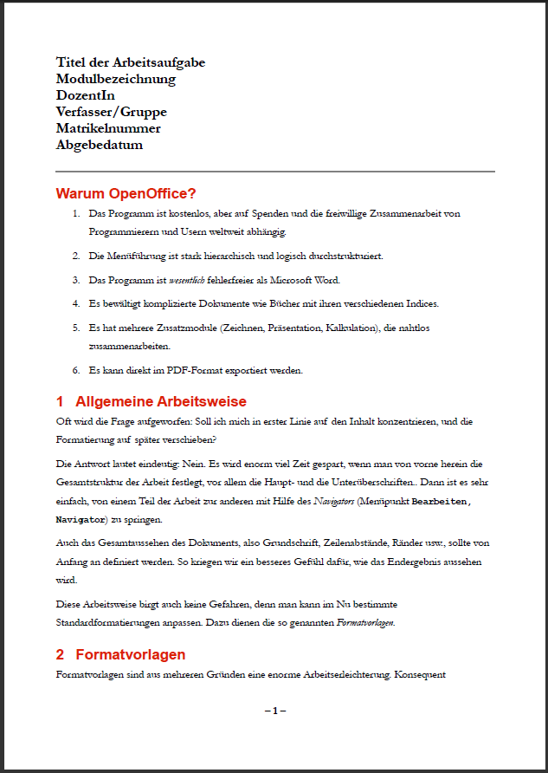
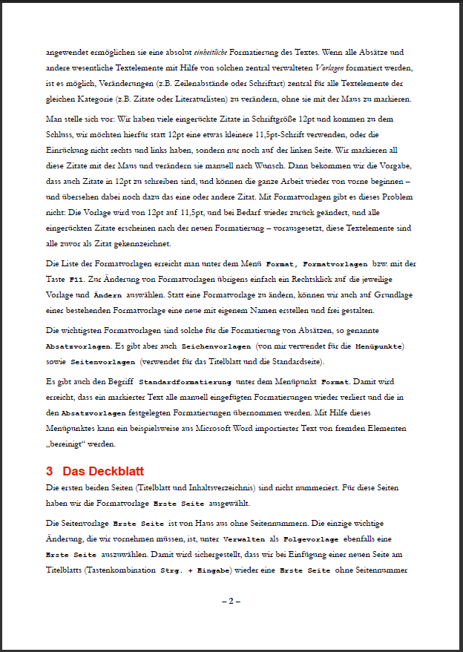
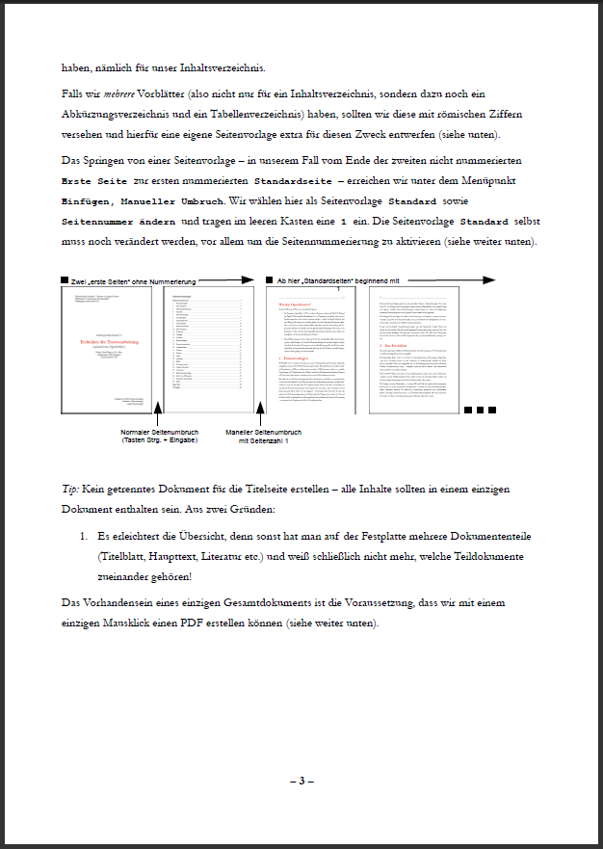
In this case all pages get numbered and you only need one page style, namely Default.
Illustration 16: A short paper without a title page
All pages are Default and have a footer to accommodate the page number
This is a lead paragraph, not a header
Please do not confuse this leading paragraph with a Header. A Header gets repeated on each page, your lead paragraph only appears once on the first page and not on subsequent pages (see illustration 16).

Numbered Default Page
As already mentioned, the Default Page needs to be modified in order to accommodate page numbering. For this you can either activate a Header or a Footer. Footers used to be very popular, but many students now prefer headers to accommodate not only the page number but also extra information such as the author’s name and matriculation number.
There are a few things you can do to make the header look nicer such as adding a line between header and text: go to menu Format › Styles and Formatting, choose the 4th icon for Page styles, select Modify, go to the tab Header and then press More.
Other important page settings pertain to the margins. Click on the tab Page and set the margins to the following values: 3cm for Left margin (to make room for perforation), and 2cm for all other margins.*
Having done this, your page will now have an empty Header (or Footer). To insert the page number in the Header, place your cursor inside it and go to Menu Insert. Choose Fields › Page Number. Note that you do want Page Number and not Page Count – the latter stands for the total number of pages your document contains. You will probably want your Page number to be right aligned. In this case just click on it once and press the button for right alignment in the menu (see illustration 17).
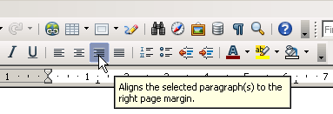Illustration 17: The 4 alignment buttons: left, centre, right and justified
The Header can contain other information besides the Page number. You might want to Insert › Fields › Other › Document › Chapter › Chapter number as well as Chapter name. You would leave this information left aligned and press the Tab key to shift the page number to the right margin. Every time a new chapter starts, the Header will change along with it.
Roman page numbering for the introductory pages following the title page is quite easy. Just right click the Default page style, choose New and name it “Roman”. Choose as Next Style also “Roman” so as to allow for several Roman style pages in succession. Then activate the Header as you did for the Default page style. Finally, under the tab Page select Format i, ii, iii, … (see illustration 18). As soon as you insert Page numbers in the Headers of your newly created Roman style page, these will appear as expected as “i, ii, iii, …”. The Table of contents will also display Roman numbers for these pages.
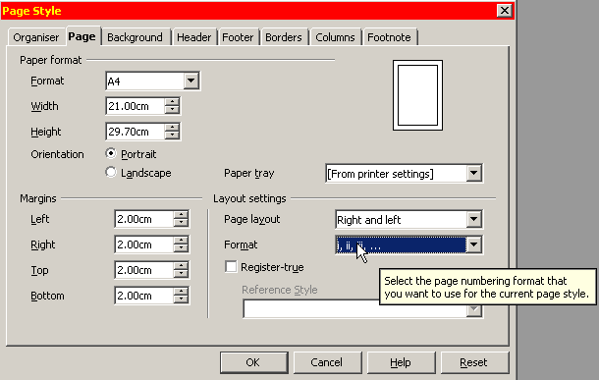Illustration 18: As numbering Format choose Roman
This is basically the same method we already came across in section 8 on Group Work when you wanted unique Headers for each member of the work group.
Note: OpenOffice insists on making any page with an uneven page number into a right page just like in any magazine. So if you insert, say, a manual page break at the end of page 3 and tell the programme to restart page numbering with a 1, it will insert a blank page to “carry” the page number 4. You can choose, if you want, not to print this blank page by unchecking Print automatically inserted blank pages under the tab OpenOffice.org Writer in the print pop-up menu, but you can’t actually delete this page.

Literature List
When quoting literature in your text, it usually isn’t necessary to type out the complete reference. All you need is the author’s name followed by the page number, in brackets: (Callinicos 27f.). Further bibliographic information will be taken up in the Literature list at the end of your thesis. This also avoids the need for any footnotes to accommodate this information, thus making the page layout less cumbersome. It also makes life easier for the reader, who doesn’t have to switch his or her attention from the text down to the footnote and back up again.
A literature list could look something like this:
Fredrickson, George M., “Racism: A Short History”, Princeton, 2002
Keevak, Michael, “Becoming Yellow: A Short History of Racial Thinking”, Princeton, 2011
Thielen, Marc, “Jenseits von Tradition – Modernität und Veränderung männlicher Lebensweisen in der Migration als Provokation für die (Sexual-)Pädagogik”, in: Zeitschrift für Pädagogik 6/​2010, Beltz-Verlag
Note the indented first line? For that you could just use the style Text body indent. I myself prefer creating a new style called “Lit”, so I know exactly what it’s there for. To do that, right click on the style Text body and choose New. Go to the tab Indents & Spacing and set the Indent Before text to 0.75cm and the Indent First line to -0.75cm (i.e. a negative number). This way the author’s name stands out more clearly. It’s also possible to sort this list alphabetically by marking it with the mouse and going to the menu Tools › Sort and pressing OK.
Note you can use this feature of Negative indent for other kinds of lists, dictionaries or even interviews. Having the name of the interviewer and that of the interviewed person stand out makes it easier to locate the beginning and the end of each part of the dialogue.

Bullets and Numbering
Listings can be really nerve wracking. You write a “1.” at the beginning of a paragraph, write some text and then press Return, and off you go: an indented list gets launched and you have no idea how to get out of it. So out of sheer exasperation under the menu Tools you go to AutoCorrect Options › Options and uncheck the box Apply numbering – symbol: * and the programme stops bothering you.
That is actually a pity, because this automation can make life easier, not more difficult. The main advantage is you can add elements in the middle of your list, and they get correctly numbered, or you can move elements up or down, and here again the numbering is automatically updated. Also you can move elements to a lower level in the numbering hierarchy or up one level with just one mouse click. So leave the aforementioned box checked. Here in detail:
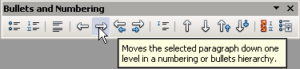Illustration 19: The pop-up menu allows you to change the level of a paragraph
- Tools › AutoCorrect Options › Options check the box Apply numbering – symbol: *
- after typing “1.” and some text and pressing return, the next paragraph automatically begins with “2.”
  - you can of course move a paragraph or even a selection of paragraphs down one level, like here
  - and you are by no means obliged to stick to a 1., 2., 3.… style of numbering; instead you could choose a., b., c.… style like here
  - in order to move down one level, choose the right arrow as in illustration 20; the left arrow moves it up one level
  - using the double arrow up or the double arrow down you can move a paragraph including all its sublevels up or down
- to stop automatic bulleting/numbering press the first/second button in the pop-up menu
and to insert a new paragraph without a number choose the symbol in the middle (as in illustration 20)
… and to insert a new line without creating a new paragraph simply press Shift + Return
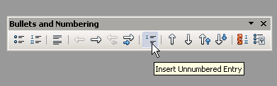Illustration 20: Press this button for an unnumbered entry
- just pressing a simple Return will resume numbering where last left off

Cross-References
During the winter semester of 2010 two students came along with an extremely voluminous thesis. Though their greatest worry was not so much the main text as their 300 page annex, consisting of many interviews they had conducted. The problem was that they had loads of references in the main text pointing to interview passages in the annex. They decided to print the annex separately a few weeks before the deadline, so as to leave enough time to be able to deal with the references in the text and make sure they got the page numbers of the pointers right. All this work was completely superfluous and could have been avoided using Cross-references.
Pointing to an existing chapter Heading is the easiest kind of Cross-reference. Simply go to Insert › Cross-reference › Cross-references and choose Headings in the left hand column. In the top right-hand column pick out the Chapter Heading you would like to refer to. In the bottom right-hand column you can select whether to refer to the page number the heading is situated on or the number of the heading itself (provided you have activated numbering for headings of course) or even both, then confirm with Insert and Close.
If, however, you want to refer to a specific passage in one of the interviews, you need to Insert › Bookmark somewhere in this passage – appropriately at the beginning – to which you can point to from somewhere else in your text. Give your bookmark a meaningful name (perhaps a good numbering system might come in handy here if you have too many bookmarks). Then go to the place in your text from which you wish to point to this bookmark, Insert › Cross-reference › Bookmarks and choose the one you want to point to from the list in the top right column.
If you have very many bookmarks you might easily loose track of them. So, for one, be very careful to always place them systematically, e.g. at the very beginning of a paragraph. If you want to see a list of all your bookmarks, just View › Navigator › Bookmarks. Double-click on any one of them and your cursor will jump directly to it in the text.
In similar fashion you can point to tables or illustrations, as I have done here, choosing either the number of the illustration or the number of the page it’s on or even both as in: “Please see illustration Number on page Page”. For this to work meaningfully you need of course to provide your illustrations and other objects with numbers, which is done quite automatically by simply right-clicking them and choosing Caption. Write a short text, the programme will take care of the correct numbering (so Cross-references will always point to the right object, even if you add other objects in the meantime).

Footnotes
You add a footnote from the menu Insert › Footnote/Endnote › Automatic. This way the programme takes care of numbering automatically. Even if you move footnotes around, their numbering will be automatically updated.
On the whole it’s best to do without footnotes. You might want to use them to point to further reading or arguments by other authors, which you don’t want to deal with directly in your main text. For this endnotes might be a better solution than footnotes. What you most certainly won’t need footnotes for is for literature sources. Just put these in the shortest form possible in brackets, not forgetting page number, and that’s it. Then have a literature list at the very end of your thesis with all required information.
So in your text you might write:
  - (Wilson, p 27) in case you are only referring to one of his writings
  - (Wilson 2005, p 57) in case you are referring to several of his writings, and at this point to the one published in 2005
  - (Wilson 2005a, p 89) in case you are referring to several of his writings of the year 2005
  - (Wilson et al., p 99) in case you are referring to a work co-authored by Wilson
All further information such as:
Wilson, John, “The Role of Early Kindergarten Education” in: Quarterly Journal for Child Pedagogy, 2005-3, Frankfurt am Main, Germany
you would then put in your literature list at the end of your paper. Avoiding footnotes has the advantage of not forcing the reader to jump to the bottom of the page and back again thus interrupting the flow of reading. Pages without footnotes are also optically more pleasing. Last but not least it means less typing for you and reduced likelihood of making mistakes.
Footnotes have their own Paragraph Style, based on Default. So they will appear with Single Line Spacing. This exemplifies why it is indeed best not to have used Default for your Text Body.
In OpenOffice Writer you can jump from one footnote to the next using the up and down arrow keys.
In case you only have a couple of footnotes, it’s better to use a single Character instead of Automatic Numbering, e.g. a *.

Quotes
Short quotes need “double quotation marks” to set them off from the rest of the text. Longer ones need a paragraph of their own – usually indented and possibly in slightly smaller font size. If you have a line spacing of 1.5 for your Body Text, you might want to choose a slightly smaller one of say 130% for your quotes.
Ellipsis in square brackets: […] are used as a stand-in for left-out parts of your quote. Marx, in a footnote to chapter 31 of Capital, Vol. 1 quotes a certain T. J. Dunning:
Capital is said […] to fly turbulence and strife, and to be timid, which is very true; but this is very incompletely stating the question. Capital eschews no profit, or very small profit, just as Nature was formerly said to abhor a vacuum. With adequate profit, capital is very bold. A certain 10 per cent will ensure its employment anywhere; 20 per cent certain will produce eagerness; 50 per cent, positive audacity; 100 per cent will make it ready to trample on all human laws; 300 per cent., and there is not a crime at which it will scruple, nor a risk it will not run, even to the chance of its owner being hanged. If turbulence and strife will bring a profit, it will freely encourage both. Smuggling and the slave-trade have amply proved all that is here stated. (T. J. Dunning, l. c., pp. 35, 36.)
Square brackets can also be used to insert explanatory words into your quote, but which are not actually part of the original.
In the social production of their existence, men inevitably enter into definite relations, which are independent of their will, namely [the] relations of production appropriate to a given stage in the development of their material forces of production. The totality of these relations of production constitutes the economic structure of society, the real foundation, on which arises a legal and political superstructure, and to which correspond definite forms of consciousness. The mode of production of material life conditions the general process of social, political, and intellectual life. It is not the consciousness of men that determines their existence, but their social existence that determines their consciousness. (Karl Marx, Preface to A Contribution to the Critique of Political Economy, 1859)
Take care that these fill-in words don’t in any way alter the meaning of the quote!
An ellipsis without square brackets you would use for words left out already in the original quote. ‘Single quotation marks’ you would use for quotes within a quote.

When to Quote?
Use quotes sparingly. If you are say simply reproducing the views of an author on child upbringing in your own words, then there might well be no reason for any direct quotes. If on the other hand you want to dwell on one of his or her theses or formulations which you find especially controversial or difficult to interpret or even in contradiction with other statements by the same author, then you do want to quote the passage in question.

Line Numbering
Line Numbering comes in handy for interviews. The stumbling block here is: How do you get only the interview text numbered but not the rest? Also, you don’t want a number for every single line, but probably only for every fifth line. Lastly, you might possibly want numbering to restart from 1 at the top of a page.
Here is how to go about it:
- change the Paragraph Style of Default by right clicking on it and choosing Modify; go to the tab Outline & Numbering and untick the box Include this paragraph in line numbering; this ensures that as a general standard you don’t want lines to be numbered
- create a new Paragraph Style by right clicking on your Body Text Style and name it “Interview”; modify your new style by going to the tab Outline & Numbering and ticking the box Include this paragraph in line numbering; this ensures that only lines in your “Interview” Style paragraphs get numbered
- lastly go to Menu Tools › Line Numbering and tick the box Show numbering; here you can also change the Interval from 3 to 5 lines, untick the box Blank lines and choose, if you want, to Restart numbering with every new page
- in case you have several interviews, you would very probably want each one to begin line numbering at 1. For this, just right click on the first paragraph of each of your interviews and choose the menu Paragraph (not Edit Paragraph Style!). Go to the tab Outline & Numbering and tick the box Restart at this paragraph. In this case you probably wouldn’t want line numbering to start anew at the top of each page

Tables
You insert a Table under the menu Table › Insert › Table. You will be asked to determine the number of Columns and the number of Rows. Though you can always add or remove columns later on, it’s best to choose the right number of columns right from the start so as to avoid extra work. How wide or how narrow you would like each individual column to be, you can vary using the mouse pointer. As for the number of lines, it really doesn’t matter, because adding or removing a line (clicking on the green line of the automatic pop-up menu as in illustration 21) doesn’t affect the overall formatting of your table.
Other decisions which you can take are if you want the table to be “splittable” in case of a page break. Whereas it is advisable not to split very small tables containing only a few lines, you would in case of a table with a large number of lines want to Allow table to split across pages and columns so that it can overflow onto the following page. In this case you would also want the first (title) line(s) to be repeated on each page by ticking the box next to Repeat Heading.
If you happen to insert a table you don’t need and want to delete it, just right click on it and choose the menu Table › Delete › Table.
Branch | Great importance | Lesser Importance | No Deployment
All branches | 83.8 | 15.2 | 1
Education and Research | 91.6 | 7.5 | 0.9
Software & Consulting | 91 | 8 | 1
Telecommunications | 89.6 | 9.1 | 1.3
Media & Marketing | 83.3 | 16.7 | 0
Social & Welfare Departments | 75 | 25 | 0
Administration | 70.8 | 26.1 | 3.1
Banking & Insurance | 69.7 | 27.3 | 3
Industry | 67 | 31.9 | 1.1
Table 3. Source: http://www.heise.de/open/artikel/Open-Source-ist-in-den-Unternehmen-angekommen-224504.html (Extract of survey carried out by the magazine Heise on the deployment of open source software based on 1312 valid records from 3500 companies asked to participate in the year 2009 – answers in percent)
In order to insert a caption at the bottom of the table, simply right click it and choose Caption. This Caption will automatically be provided with an incremental number, making it easy to insert cross-references to it from other places in your text.
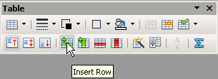Illustration 21: As long as your cursor remains inside the table, this little pop-up menu will keep you company. Clicking on the green bar inserts a new line
You can also create tables without visible borders, for instance for your curriculum vitae (date in the left column, rest of text in the right column) or for the purpose of excerpting.
If you want several adjacent columns to all be of the same width, mark them with the mouse, right click on the greyed out surface and choose Column › Space equally.

Charts
We can present the same information contained in Table 3 in the shape of a Chart as in illustration 24. Here is how to go about it:
- mark the whole table using mouse and press Ctrl + c in order to copy its contents to computer memory
- in the Button Toolbar click on the arrow pointing downward next to the symbol for New File and choose Spreadsheet (see illustration 22)
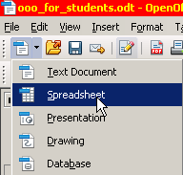Illustration 22: The small triangle pointing downwards opens up a list of new document types to choose from
- in your empty spreadsheet insert the contents of computer memory using Ctrl + v
- mark the newly inserted contents and press the Button for Chart as in illustration 23
- in this example I selected as Chart Type the second option Bar instead of Column; this way the descriptions, being placed to the left of the bars, accommodate more easily than if placed at the bottom of columns
- under 4. Chart Elements write out a Title and press Finish
- next click anywhere on an empty space in the spreadsheet so as to escape this work modus
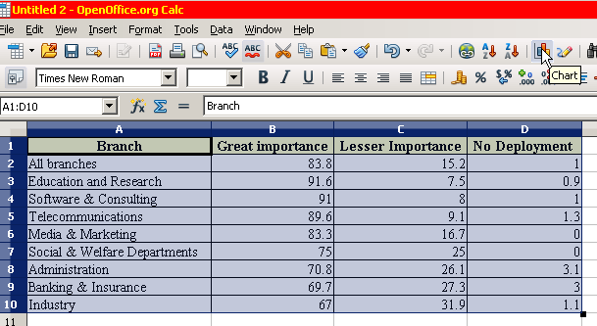Illustration 23: Mark the contents and press the symbol for "Chart"
- then again click on the chart, so that it gets marked by six green handles on corners and sides
- copy the thus marked chart into computer memory using Ctrl + c
- go back to your thesis and insert your graph from memory using Ctrl + v
- if you would like a light yellow coloured background like in illustration 24, triple click anywhere on the area (until it appears with a grey border), then right click on same area and choose Format Chart Area; under the tab Area you can choose a colour, and under the tab Transparency you can make it lighter by applying say 80%; on the whole, light colours are better, especially if you are printing on a transparency
- don’t forget to add a caption using a right click
- and finally you can increase the distance between the Frame surrounding your graph plus caption by clicking on its edge once so that it is marked by six green handles and then right clicking anywhere on the area and choosing Frame; under the tab Wrap you can increase the Top and Bottom Spacing.
Illustration 24: Source: See table 3
Note that as soon as you click on a graph, the symbols on your menu change, offering you a number of shortcuts.
Be careful not to clutter your page with too many graphs and illustrations. OpenOffice Writer is not a programme for designing magazines – use the freeware “Scribus” for that. Its great strengths lie in dealing with lots of text with a few graphs thrown in. In case you do come across the problem of one graph partly covering another, add one empty line below the first graph and make your second graph Anchor onto this new empty paragraph. Every graph or frame needs a separate anchor point. Anchoring graphs to paragraphs is the standard behaviour. But you could anchor it to the Page, so that it stays fixed and doesn’t move up or down with the paragraph.

Snapshot
Illustration 25 on potential reasons for slipping into poverty is not a diagram taken directly from the internet using a right click. Rather it is part of a larger page, in fact a PDF document, so no right clicking on it is going to be of any use. Instead you need to position the document on your screen so you see the whole of the relevant part you would like to later cut out and insert. Then press the Print Screen button on your keyboard to send a copy of your screen to computer memory. Then launch the freeware programme “xnview” (very useful, fast and simple programme for all sorts of photo manipulation) and insert your screen from memory (menu Edit › Insert as new Picture). Within xnview you can now mark with your mouse pointer the rectangle you actually need and press Shift + x. This shortcut has the effect of cutting everything out outside your marked rectangle and leaving only the part you need. Then press Ctrl + a to mark all that remains and Ctrl + c to copy that into memory. Go back to your thesis and press Ctrl + v to insert it into your text. Finally add a Caption.
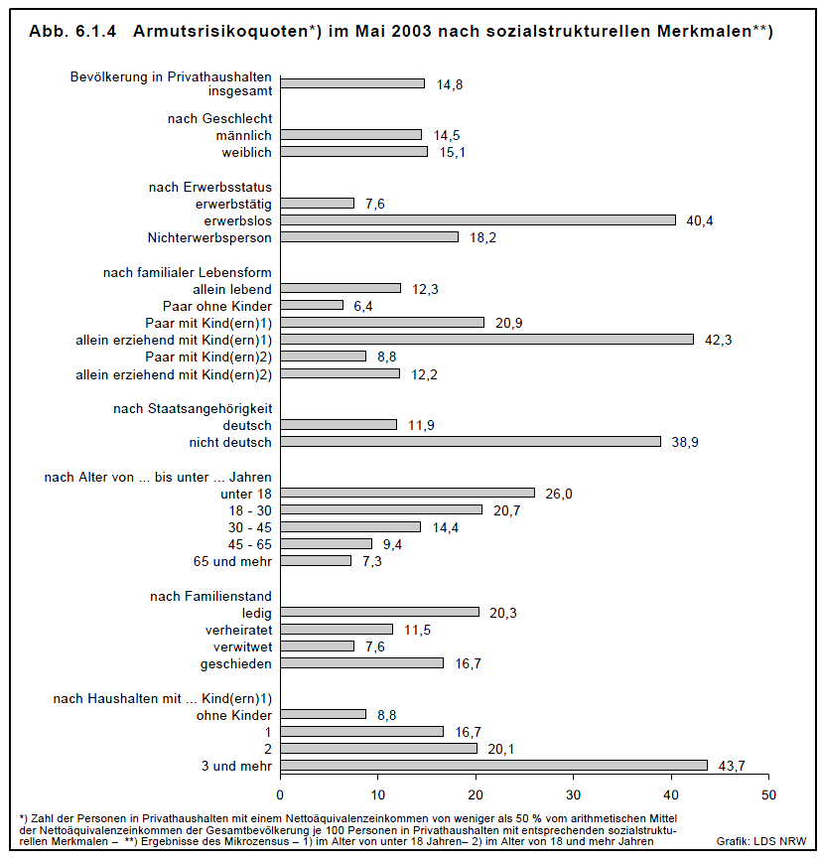Illustration 25: Source: Sozialbericht Nordrhein-Westfalen 2004, S. 205, http://​www.mags.nrw.de/​sozber/​sozialberichterstattung_nrw/​sozialberichte_seit_1992/​

Pictures
In a similar way you can insert pictures from your hard disk: go to Insert › Picture › From File and choose the picture you want. You can also directly scan a picture, though I would suggest you do this via the freeware programme “xnview” we talked about in section 24, which allows you much more freedom to manipulate your picture, for instance increase contrast or get rid of parts you don’t want.
You can also insert a picture directly from the internet by right clicking it and choosing Copy. Back in your text simply insert it using shortcut Ctrl + v.
Again, don’t forget to give all your pictures a Caption, so you can easily refer to them from within your text (Cross-reference) and have them added to your table of illustrations.

Cross Tables (Statistics)
OpenOffice Calc is not in the league of a specialised statistics programme like SPSS or Stata. Nevertheless you can use it for statistical purposes, one of the most popular being Cross Tables. Cross Tables are used to illustrate the (presumed) dependency of one variable upon another. In a fictional survey we asked 12 people, men and women, to tell us on a scale from 1 to 10 how much they abhorred violent videos. We expressed the scale of 1 to 10 in percent. The aim was to see if there was any significant variance between women and men. The raw results are listed in table 4, and the dependency table appears in illustration 26. Here is how to go about it:
Illustration 26: This Cross Table shows that women reject violent videos to a greater degree than men
- mark the two columns of interest (sex and extent of rejection), copy them into memory, go to the module Spreadsheet (see illustration 22 on how to open a new spreadsheet) and there insert the contents of computer memory (as you know by now using shortcut Ctrl + v)
- in your spreadsheet you again mark the two columns and go to menu Data › DataPilot › Start and confirm Current selection
- drag and drop the button “Sex” onto the white area Row Fields
- drag and drop the button “Level of rejection …” onto the white area Data Fields
- press Options and choose Average. Confirm OK and again OK
- your new Cross Table makes it appearance on your spreadsheet
- mark it and go to menu Format › Cells and open tab Numbers; here choose Category Numbers with Decimal place of “1” and Leading zero also of “1”; confirm with OK (see illustration 28)
- in order to add a title “Level of rejection in %” above the results’ column you will have to mark the Cross Table yet again, cut it out into memory using shortcut Ctrl + x, and reinsert it in some empty area on your spreadsheet; then you can double click the title cell and write in “Level of rejection in %”; unfortunately you can’t do this directly in the original Cross Table generated by the programme
- now again mark you newly inserted Cross Table and open menu Format › Columns › Optimal width; this will make sure that columns adapt their width to the longest length of text in any one cell within that column, so that no text gets accidentally truncated
- finally once again mark your newly formatted Cross Table, copy it into computer memory, go to your thesis and insert it into your text
Questionnaire | Sex | Level of rejection in %
1 | M | 20
2 | F | 80
3 | F | 70
4 | M | 30
5 | F | 90
6 | F | 80
7 | M | 80
8 | F | 100
9 | M | 0
10 | F | 60
11 | M | 40
12 | F | 90
Table 4: Results of a fictional survey of men and women as to the degree of their rejection of violent videos in percent
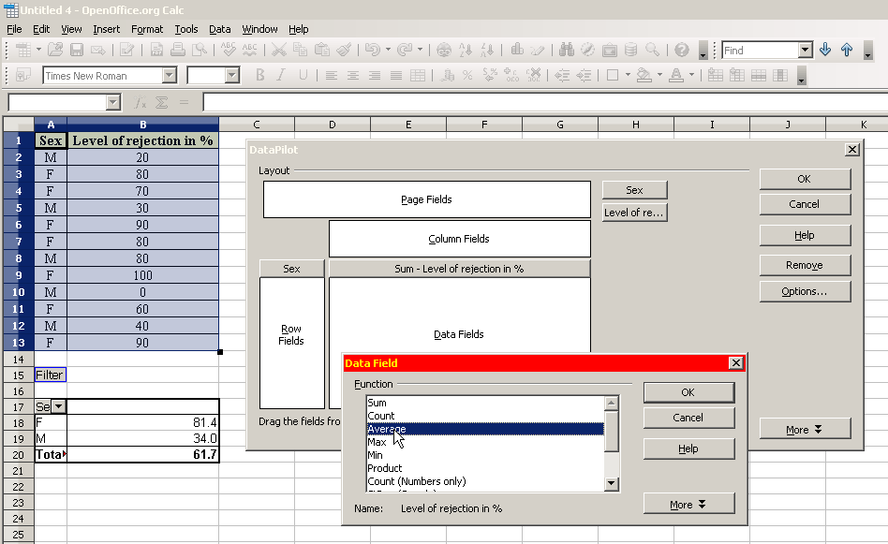Illustration 27: After having dragged the two buttons “Sex” and “Level of …” into their appropriate fields, go to Options and choose Average
If it had been a YES/NO survey, for example to the question “are you right or left handed?”, as in table 5, then you’d do the following:
- copy the two right columns into memory and insert them into your spreadsheet
- in your spreadsheet again mark these same two columns and go to the menu Data › DataPilot › Start and confirm Current Selection
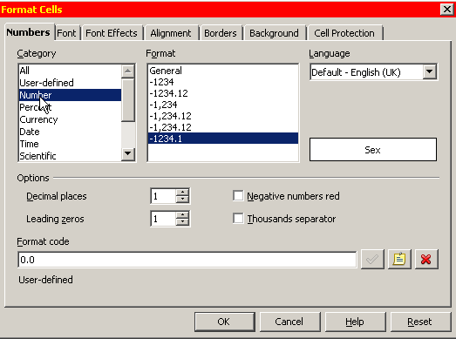Illustration 28: The number of decimal places is reduced to 1
- Drag & Drop the button “Sex” onto the white area Row Fields
- Drag & Drop the button “Handedness” onto the white area Column Fields and also onto the white area Data Fields
- under Options choose Count instead of Sum
- copy the resulting Cross Table back into your text; it should look something like in illustration 29
- if you prefer to show the results as in illustration 30, you need to not only choose Count instead of Sum under options as shown above, but also to press More and there choose as Type the option % of row; at the same time you can make your columns all aligned left for better readability
Questionnaire | Sex | Handedness
1 | M | R
2 | F | R
3 | F | L
4 | M | R
5 | F | R
6 | F | R
7 | M | L
8 | F | R
9 | M | L
10 | F | R
11 | M | L
12 | F | R
Table 5: Right- and Left-Handedness and Sex
Illustration 29: Distribution of handedness between men and women

Illustration 30: Same result as above, but this time expressed in "% of row"

Extra Long Web Addresses
Web addresses tend to get longer by the day. So you could end up with a line like the following:
Please refer to: http://uk.search.yahoo.com/long_chain/long_chain/long_chain/long_chain/long_chain/long_chain/
The way the three words “Please refer to:” have been spread out over the whole line is not really very pleasing. You would rather prefer the URL to start on the same line, and not one line below. So it would be nicer to instead have:
Please refer to: http://de.search.yahoo.com/long_chain/long_chain/long_chain/long_chain/​long_chain/long_chain/
To achieve this please do the following:
- under Tools › Options › Language Settings › Languages tick the box next to Enabled for complex text layout (CTL)
- place the cursor after any “/” where you would like to have a new line inserted and activate the menu Insert › Formatting Mark › No-width optional break
- if you have loads of URLs you can automate the process by Finding & Replacing (in the menu Edit) all occurrences of “/” with your new combination of “/No-width optional break”; conversely, in order to prevent “http://” from breaking at the end of the line, you can Find & Replace all double occurrences of “/No-width optional break” with a “//”; you could apply the same logic to the underscore “_” and other such typical URL characters

Fonts
Fonts play an important role in making the text more readable. There are millions of them around, but two main categories always come up as alternatives for Text Body. On the one hand there are the Serif Fonts, then you have the Sans Serif Fonts.
The Serif Fonts are characterized by semi-structural details at the tips of some of the strokes. These have the effect of reducing the optical gaps between letters, thus making them to a degree “fuse together”. This fusing in turn has the effect of making a word more compact. So using a serif font increases the reading speed, because you tend to seize the word as a complete unit, your eyes jumping from one word to the next rather than from one letter to the next. So, for Text Body, do use a Serif font such as Times New Roman or Garamond.
For large titles, posters, flyers etc. on the other hand, fonts without serifs such as Arial or Futura (Futura comes in all sorts of varieties) are very elegant.
Times New Roman 40 pt
Garamond 40 pt
Arial 40 pt
Futura Lt BT 40 pt
AaBbCcDdEeFfGg (Times New Roman 12 pt)
AaBbCcDdEeFfGg (Garamond 12 pt)
AaBbCcDdEeFfGg (Arial 11 pt)
AaBbCcDdEeFfGg (Futura Lt BT 12 pt)

Taking a closer look at our two Serif Fonts, Times New Roman and Garamond, you will notice that the latter is somewhat finer and rounder in overall shape. This increases the legibility even more. A page full of Garamond text will appear lighter than one full of Times.
On the whole avoid using different fonts. In fact you can stick to just one font for the whole text and use Garamond even for Headings – just varying size and Typeface (Regular, Italic, Bold and Bold Italic).
If you are using a page format of A4, you will probably want a font size of 12pt (or 11pt in case you do opt for Arial, which is by nature larger). If producing a pamphlet size A5 you can reduce the font size down to 11pt or even 10.5pt. The better the printer and the quality of paper, the more you can reduce the font size without the text becoming illegible.
Some teachers – at least over here in Germany – insist on very detailed specifications so as to force students to produce only a certain amount of text. Instead of saying: “Please write 10,000 to 12,000 characters, they specify font size, font type, margins and number of pages. This is really an unfortunate misuse of formatting for control purposes.
Combinations such as “P. 145”, “§ 33a”, “$ 120” and so on can be a nuisance. What you definitely want to avoid, is the first part appearing at the end of a line, and the second part at the beginning of the following line – instead you want both parts to stick together. You achieve this by Insert › Formatting Mark › Non-breaking space between the two, instead of an ordinary space. The shortcut for this is Ctrl + Shift + Space.
A simpler method would be simply to have no space at all, as in “P.145”, “$33a” and “$120”. But that doesn’t look too good. On the other hand, if you find your Non-breaking spaces to be too large and want to narrow them down (so they look more like “P. 145”, “§ 33a”, “$ 120” instead of “P. 145”, “§ 33a”, “$ 120”), then after inserting them you can mark them using the mouse and go to Format › Character › Scale width and choose 50%.
If you need to repeat this last step very often, that could be annoying. You can automate the process by creating a macro under Tools › Macros › Record Macro. Then you left mark an already existing Non-breaking space using Shift + Arrow left and reduce its breadth to 50% as described above. You then immediately stop the macro and give it a name, e.g. “space” and save it under My Macros › Standard › Modul1. As a last step you can assign your new macro to a key shortcut by going to the menu Tools › Customize › Keyboard. There choose the Category › OpenOffice.org Macros and look for your macro under User > Standard > Modul1 > space. Having clicked on it, choose an appropriate shortcut key such as Ctrl + Shift + s. In future, immediately after having inserted a Non-breaking space using shortcut Ctrl + Shift + Space you can reduce its width by pressing Ctrl + Shift + s.
Now, this all seems like rather a lot of work, and indeed it is. But if you are writing long texts for a book, then the effort is worth your while.

Emphasis
If you want to emphasise a passage, use Italics. In the old days of mechanical typewriters you couldn’t do that. So instead people would type over the text two or three times to achieve boldness, or they would underline their text, or possibly choose to s p a c e o u t the passage or opt for CAPITAL LETTERS. Theoretically they could use any combination of these. Nowadays this is no more necessary and it moreover disturbs the flow of reading. Italics have the advantage of sticking out just enough to be noticed without disturbing the overall picture.

Special Characters
To insert Special Characters, go to menu Insert › Special Character. If you need a particular character or even a complete string of characters very often, say “[…]”, and don’t want to keep on typing the sequence out, you can mark it once, go to Tools › AutoCorrect Options and type in on the left hand side under Replace a simple sequence of simple letters such as “xxx”. Then press New and confirm with OK. Now your off. Every time you write “ xxx ” with a leading space and a space after, it will automatically get replaced by a “[…]”.

Mouse Clicks
- a double-click will mark a whole word
- a triple-click will mark a complete sentence
- a quadruple-click will mark a complete paragraph
- a right-click will offer you a context menu
- click-hold-and-pull on a marked area allows you to relocate it
- in combination with Ctrl you can mark several non-adjacent passages
- in combination with Alt you can mark a rectangular text block

Shortcuts
OpenOffice Writer has a bunch of shortcuts to make life easier:
- Ctrl + 0 the paragraph in which the cursor is standing will change to Text Body
- Ctrl + 1 the paragraph in which the cursor is standing will change to Heading 1
- Ctrl + 2 the paragraph in which the cursor is standing will change to Heading 2
- Ctrl + 3 the paragraph in which the cursor is standing will change to Heading 3
- Ctrl + 4 the paragraph in which the cursor is standing will change to Heading 4
- Ctrl + i marked text will change to italics
- Ctrl + b marked text will change to bold
- Ctrl + m marked text will loose all individual formatting – only the paragraph style will remain active
- Ctrl + s save file
- Ctrl + p print file
- Ctrl + f find or replace text
- Ctrl + c copy marked text to computer memory
- Ctrl + v insert contents of computer memory
- Ctrl + shift + v same as above, only you can choose to insert text without formatting
- Ctrl + x cut out and move marked text to computer memory
- Ctrl + Return start a new page
- Shift + Return start a new line (but not a new paragraph)
- Ctrl + - insert an optional hyphen – the word will be hyphenated here only if required
- Ctrl + Shift + Space insert a non-breaking space
- Ctrl + Shift + - insert a non-breaking hyphen
- – + Space long hyphen “–”
- . + . + . + space ellipse “…”

Saving your work
Here you really can’t be careful enough. Please pay head to the following rules:
- limit yourself to alphanumeric characters and underscores and only use minuscules; avoid spaces; the reason is, different countries and different operating systems can have problems displaying, ordering, saving and opening files if you use non-basic characters, spaces and capitalization*
- save your work regularly, about every five minutes; save your work each time with ascending number appended (my_thesis_01, my_thesis_02, my_thesis_03 …); mail your text to yourself regularly; don’t rely on memory sticks – they easily get lost or suddenly stop functioning for no special reason; if you are using a stick, do so only to transport data; don’t write and save directly onto a stick; instead always use your hard disk and at the end of your work day, after having closed all files and programmes, you can copy your stuff from the hard disk to the stick – and vice versa at the beginning of a work day in a different location; note: ascending numbers are extremely useful if you are working together with someone; you send him or her your file_05 and they send you back file_06 (with their name as part of file name); that way you know that the file has been through their hands and has been changed since last version 05
- use file names which you will recognize even three months later; a name such as “essay” is not specific enough; “essay_child_poverty_prof_brown_stud_marie_05” is much better; this example specifies the kind of document (essay), the subject (child poverty), the name of the professor you are writing for (brown), your own name (marie) and the latest version number (05); also store your files in appropriate subdirectories (/uni, /personal etc.)
- if your teacher wants a Word file, that’s no problem; just go to File › Save as and choose as File type “Microsoft Word 97/2000/XP”; newer versions of MS Word by the way can open OpenOffice files

PDFs
PDF (Portable Data Format) developed by Adobe is an open, operating system independent format. It is very popular for distributing documents, because they can’t be so easily manipulated and – at least most of the time – come out the same on all printers and look the same on all screens. PDF files can even be further protected from being printed or saved to a local file or even from being opened without a password. To create a PDF file from your document, just press the PDF symbol in the bar.
Using freeware PDF24 you can further manipulate PDF documents, for instance delete individual pages or insert additional pdf-files.

Search and Replace
Under Edit › Find & Replace (Ctrl + f) you can search through your whole document for a particular string of text. If you happen to have mistyped a complicated name, you can use the menu to replace the wrong spelling with the correct one.
I myself often use the search tool to find markers in my text, where I’ve left off late the evening before or where bits are still missing (I like to use “###” for that purpose).
You can also use this menu to replace a style with another style (select More Options).
Using More Options you can also search for and delete specific text elements such as empty lines. You use Regular expressions to accomplish this task. So in the search field you would type the regular expression “^$” and then press Replace all.

Auto Spell Check
In the menu bar you can activate AutoSpellCheck (the ABC-Button or using F7). Any misspelled words will appear underlined in red. Lots of these words are in fact not necessarily misspelled, the programme simply does not have them in its dictionary. To add an unknown word to the standard dictionary right-click it and choose Add › Standard.dic.

Synonyms
Under Tools › Language › Thesaurus (Ctrl + F7) the programme lists quite a few alternatives. If you want more, go to woxikon.de.

Document Infos
Sometimes you might want to store general information about your file, such as author names. To do this, go to File › Properties › Description/Custom Properties. Also you might want statistical information on your file, such as number of words or number of characters. Choose the tab Statistics for that.

Labels and Form Letters
This is not what you are going to need for your studies. But perhaps in the course of a traineeship or at your work place you might be asked to organise a bulk mailing. It’s really quite easy:
- first open an empty spreadsheet and use the first line for the Column Headings; these could be “Name”, “Street”, “City”, “Telephone number”, “Mobile number” and “E-Mail”; the lines below you fill out with all relevant information; when done, save the spreadsheet under some meaningful name such as “addresses”; the file ending .ods will get attached automatically
- now again open a New File, only this time a Database; choose the option Connect to an existing database and select Spreadsheet from the drop-down menu; confirm Next, locate the spreadsheet you saved in previous step and open it; confirm Yes, register the database for me (this only means that you can communicate with the database from any open file); remove the tick from Open the database for editing, since we don't want to edit our addresses but simply read the information contained in the database; press Finish, give your new database the same name as your spreadsheet (the file ending .odb will get attached automatically, so the two are separate files in spite of having the same name) and save; now close your new database, which doesn't contain anything anyway, but is rather just a “window” through which you can reach your addresses listed in the actual spreadsheet
- go to the menu File › New and select Labels; under the tab Labels select your Database from the drop-down list and again the pertaining Table from the next drop-down list just underneath the first one; at this point you will be presented with only one option, namely “sheet1”, because your spreadsheet only contains one flat list of addresses); now choose your first Database Field (most likely “Name”) and transport it with the left arrow to the white area on the left; press Return for a new line, then transport your next Database Field (this time “Street”), and press Return twice to leave an empty line before inserting your last Database Field, which is “City”; the other fields (Telephone, Mobile and Mail) are of no interest to you for the purpose of your bulk mail; now comes the difficult part, which is the actual formatting; the sizes listed in the following table are OK for an A4 sized paper containing 3 x 8 labels – but keep in mind you might have to fiddle a bit with these parameters because it depends partly on the way your printer handles the sheets of paper; now Save your formatting under any appropriate name and press New document; at this point a new page will appear full of Field names, which, as soon as you choose to print your document, will get replaced by the actual names, streets and cities of your spreadsheet
Horizontal pitch | 7,00 cm
Vertical pitch | 3,70 cm
Width | 7,00 cm
Height | 3,70 cm
Left margin | 1,20 cm
Top margin | 0,60 cm
Columns | 3
Rows | 8
Table 6: Sizes and spacing for a 3x8 layout
To create a bulk letter you basically follow the same steps. So for instance after writing “Dear ”, you simply go to Insert › Fields › Other › Database. Under Type select Mail merge fields and under Database selection select your address database › sheet1. Pressing the + next to sheet1 will open a list of all your fields (Name, Street etc.). Click on Name and now all the names will be inserted automatically one after the other, one per each copy of your letter, after the “Dear ”.

Help
Under the menu Help you will find all you need. While hovering with your mouse pointer over any button or menu, you will also be offered shorter or longer “tips” depending on your settings in Tools › Options › OpenOffice.org › General. Using Google you will very often find very useful and concise help.

Practice
- Go to www.fb4.fh-frankfurt.de/tips/openoffice/dokumentation and download the file ooo_for_students_unformated.txt. Open it with a right-click and choose “swriter” as programme. If asked, confirm “West European Encoding”.
- Mark the whole text and apply the paragraph style Text Body (Ctrl + 0). While text remains marked and to make absolutely sure that all manual formatting is definitely removed go to menu Format › Default Formatting or press Ctrl + m.
- Now modify your paragraph style Text Body in following respects: increase line spacing to 1.5 lines, change alignment to Justified, activate automatic Hyphenation (under tab Text Flow) as well as Orphan and Widow Control.
- Activate automatic Outline Numbering for the first three levels of your Headers (menu Tools). Make sure to Show Sublevels.
- Use following parameters to format your three Header Levels:
 | Spacing Above | Spacing Below | Font Size | Typeface
Level 1 | 1.8 cm | 0.9 cm | 16 pt | Bold
Level 2 | 1.2 cm | 0.6 cm | 14 pt | Bold and Italics
Level 3 | 0.8 cm | 0.4 cm | 12 pt | Italics
Table 7: Style recommendations for Headers (first three levels)
- Go to the beginning of the text and delete the whole table of contents. Insert a new table of contents, limiting yourself to only the first level.
- Modify your table of contents by adding – under the tab Entries – a tab stop between Chapter Number (E#) and Entry (E). Modify the width of this tab stop as described in section “Table of Contents”.
- Modify your default page by activating a Header and inserting Page Numbering.
- Modify your style for First Page so as to allow several “First Pages” in succession.
- Apply the style First Page to your Title page. Format title page nicely and at bottom of page insert a page break (Ctrl + Return). At the bottom of your Table of Contents also insert a page break, only this time a Manual Break (menu Insert) choosing Style Default and Change Page Number “1”. Delete the superfluous empty page thus created.
- Go to the section on Tables and reconstruct the table using Copy & Paste.
- Create a Chart based on this table as described in the section on Charts.
- Reinsert the footnote in section Footnote.
- Format the list in section Bullets and Numbering.
- Format the literature list with indenting.
- Find out how many words and characters your document contains.
- Export your document as PDF.
- Save your document in Microsoft Word Format.

Three Taboos
- Avoid empty lines. Any spacing must be done using paragraph styles.
- No two consecutive spaces.
- Don’t manually format text – always use styles.
Enjoy the programme!

* For practice, try using the original of this document: http://www.fb4.fh-frankfurt.de/tips/openoffice/dokumentation/ooo_for_students.odt
* Another alternative – one often used in books – is instead to indent the first line by say 3mm. But then you would need an extra paragraph style for those paragraphs immediately following a heading, which don’t need any indentation.
* It is possible to create pamphlets with left and right pages quite easily using OpenOffice. In this case you would opt for Page layout mirrored. Then instead of left and right margins, you are offered Inner and Outer margins. You would choose a smaller page size of A5 and a smaller font size of 11pt or even 10.5pt and, when it comes to printing, tick the option Brochure under the tab Page Layout. If your printer supports duplex printing, then you won’t even need two separate print runs for the rectos and versos.
* Umberto Eco’s “How to Write a Thesis” is a wonderfully inspiring guide for anyone wishing to embark on such a journey. Unfortunately it doesn’t seem to be available in English. His “Name of the Rose” is probably his best known work. Sean Connery played the main part in the film version.
* Just to illustrate the problem: Linux, unlike Windows, will treat “Thesis.doc”, “THESIS.DOC” and “thesis.doc” as three separate files. Linux will also order all capitals before minuscules.

