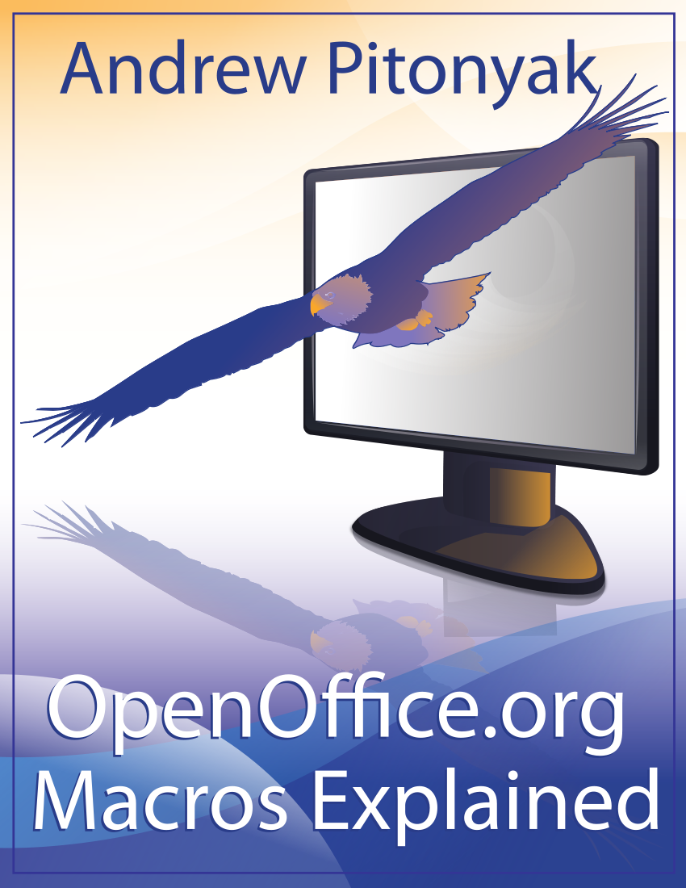
OpenOffice.org Macros Explained
OOME Third Edition

Last Modified
Wednesday, May 30, 2012 at 01:06:24 PM
Document Revision: 450

General Information
The contents of this document is Copyright 2011 - 2012 by Andrew D. Pitonyak. I will make a final license decision when I am finished.
I created a second edition that was never released, which is why I refer to this book as the third edition.
I have been repeatedly asked about the cover page so.... I am neither an artist nor a designer, so, I hired Amanda Barham (see http://www.amandabarham.com). She did an awesome job.

Table of Contents
General Information 1
Table of Contents i
1. Introduction and housekeeping 2
1.1. Comments from the author 2
1.2. OpenOffice.org Bug 2
1.3. Environment and comments 2

Introduction and housekeeping
First, there was the first edition of OpenOffice.org Macros Explained (OOME). A few years later I produced the second edition, updated to match OpenOffice.org (OOo) version 2.x, but the second edition was never released. Now, I feel that it is time for a third edition.
Most of the content from previous editions is still here. The initial chapters dealing with language syntax are mostly unchanged except for new features added to the language.
The number of services supported by OOo has more than doubled since I last published, and there is significant new capability. There is, unfortunately, more capability than I have time or room to document. Unfortunately, as extensive as this book is, much is missing. You should use this book, therefore, as a reference with numerous examples, but, always remember that OOo is constantly changing and supporting more features.
The document contains buttons that trigger the macros in the text. This is fabulous while reading the original source, but it provides for undesirable artifacts in printed form; sorry about that.

Comments from the author
I am the primary author of this document. I do not make a living working with OOo, and nothing in here is related to my primary day job. In other words, I am simply another member of the OOo community who does this mostly without remuneration.
I receive numerous requests for help because I am highly visible in the OOo community. Unfortunately, I am over-time-committed, and it is difficult to provide personal help to all. I enjoy helping people in my non-existent spare time, but, be certain to use existing material, mailing lists, and forums if possible. I occasionally provide solutions on a commission basis, but I lack the time for large tasks.
I appreciate comments and bug reports. If you have something interesting that you think should be included, let me know. If you want to write an entire section or chapter, do so. I will likely highly edit what you produce. Please, provide feedback and suggestions by sending an email to andrew@pitonyak.org.

OpenOffice.org Bug
OOo uses styles to perform formatting. When something changes in the formatting, therefore, you can assume that a different style is used. I use nicely formatted code listings, but, every time the formatting changes, this is a style change. OOo has a bug when a style changes more than 64K times that causes OOo to crash (see http://www.openoffice.org/issues/show_bug.cgi?id=84159), which is why AndrewMacro.odt causes OOo to crash when the document is closed. I expect that this document will have the same problem. When I reach that point, this document will become mostly useless. So, if you have votes available, vote for issue 84159.
Tip | A fix is scheduled to be released in OOo version 3.4. I should personally thank Bartosz, a community member, and all the others who worked for a resolution of this bug.

Environment and comments
The primary work on this book was performed using the 64-bit Official Linux version running on Fedora Linux. Although I use both LibreOffice and Apache OpenOffice, I use the term OOo to generically refer to the product.

