
Draw Guide
Chapter 1
Introducing Draw
Drawing Vector Graphics in LibreOffice

Copyright
This document is Copyright © 2011–2014 by the LibreOffice Documentation Team. Contributors are listed below. You may distribute or modify it under the terms of either the GNU General Public License (http://www.gnu.org/licenses/gpl.html), version 3 or later, or the Creative Commons Attribution License (http://creativecommons.org/licenses/by/4.0/), version 4.0 or later.
All trademarks within this guide belong to their legitimate owners.

Contributors
Martin Fox John Cleland Jean Hollis Weber
John A Smith Peter Schofield

Feedback
Please direct any comments or suggestions about this document to the Documentation Team’s mailing list: documentation@global.libreoffice.org
Note: Everything you send to a mailing list, including your email address and any other personal information that is written in the message, is publicly archived and cannot be deleted.

Acknowledgments
This chapter is based on an original French document written for OpenOffice.org 1.x by Michel Pinquier (translated into English by Alex Thurgood) and previous content revised by Jim Taylor. The chapter was revised for OpenOffice.org 2.0 by Linda Worthington, Daniel Carrera, Jean Hollis Weber, and Agnes Belzunce, and later translated into German by Wolfgang Uhlig. The German revisions were then translated into English and revised for OpenOffice.org 3.3 and LibreOffice 3.3 by Martin Fox. Other contributors included Peter Hillier-Brook, Hazel Russman, Gary Schnabl, and Claire Wood.

Publication date and software version
Published 12 September 2014. Based on LibreOffice 4.3.

Note for Mac users
Some keystrokes and menu items are different on a Mac from those used in Windows and Linux. The table below gives some common substitutions for the instructions in this chapter. For a more detailed list, see the application Help.
Windows or Linux | Mac equivalent | Effect
Tools > Options menu selection | LibreOffice > Preferences | Access setup options
Right-click | Control+click and/or right-click depending on computer system | Open a context menu
Ctrl (Control) | ⌘ (Command) | Used with other keys
F5 | Shift+⌘+F5 | Open the Navigator
F11 | ⌘+T | Open the Styles and Formatting window

Contents
Copyright 2
Contributors 2
Feedback 2
Acknowledgments 2
Publication date and software version 2
Note for Mac users 2
Introduction 4
Draw workplace 4
Workspace 4
Page Pane 5
Sidebar 5
Properties 5
Styles and Formatting 6
Gallery 6
Navigator 6
Rulers 6
Status bar 7
Toolbars 8
Standard toolbar 9
Drawing toolbar 9
Line and Filling toolbar 9
Text Formatting toolbar 9
Options toolbar 10
Floating and moving toolbars 10
Available toolsets 10
Default toolbars 11
Customizing toolbars 11
Choosing and defining colors 12
Grid, snap, and help lines 14

Introduction
Draw is a vector graphics drawing tool, although it can also perform some operations on raster graphics (pixels) such as photographs. Using Draw, you can quickly create a wide variety of graphical images.
Vector graphics store and display a picture as simple geometric elements such as lines, circles, and polygons rather than as a collection of pixels (picture elements or points on the screen). This permits simpler storage and supports precise scaling of the picture elements.
Draw is fully integrated into the LibreOffice suite and this simplifies exchanging graphics with all components of the suite. For example, if you create an image in Draw, reusing it in a Writer document is as simple as copying and pasting the image. You can also work with drawings directly from within Writer or Impress using a subset of the functions and tools from Draw.
The functionality of LibreOffice Draw is extensive and, even though it was not designed to rival high-end graphics applications, it possesses significantly more functionality than the drawing tools that are generally integrated with most office productivity suites.
A few examples of the drawing functions are: layer management, magnetic grid-point system, dimensions and measurement display, connectors for making organization charts, 3D functions that enable small three-dimensional drawings to be created (with texture and lighting effects), drawing and page-style integration, and Bézier curves.
This Draw Guide is not a course book to be worked through from beginning to end. Rather, it is a reference work in which you can browse for guidance on particular topics.
This document describes only the functions associated with Draw. Some concepts, such as file management or the way the LibreOffice environment works, are mentioned only briefly; they are covered in more detail in the Getting Started Guide.

Draw workplace
The main components of the Draw interface are shown in Figure 1.
Note | The maximum size of a drawing page in LibreOffice Draw is limited by your computer setup and the page size that you can set and use in your printer.

Workspace
The large area in the center of the window is where you make the drawings and is called the Workspace. You can surround this drawing area with toolbars and information areas. The number and position of the visible tools vary with the task in hand and user preferences. Therefore your setup may look different. For example, some users put the main Drawing toolbar on the left-hand side of the Workspace and not in the default position at the bottom of the Workspace, as shown in Figure 1.
By default, the Workspace consists of three layers (Layout, Controls and Dimension Lines) and the tabs for these default layers appear in the bottom left corner of the Workspace. The default layers cannot be deleted or renamed, but you can add layers as and when necessary. For more information on layers, see Chapter 11 Advanced Draw Techniques.
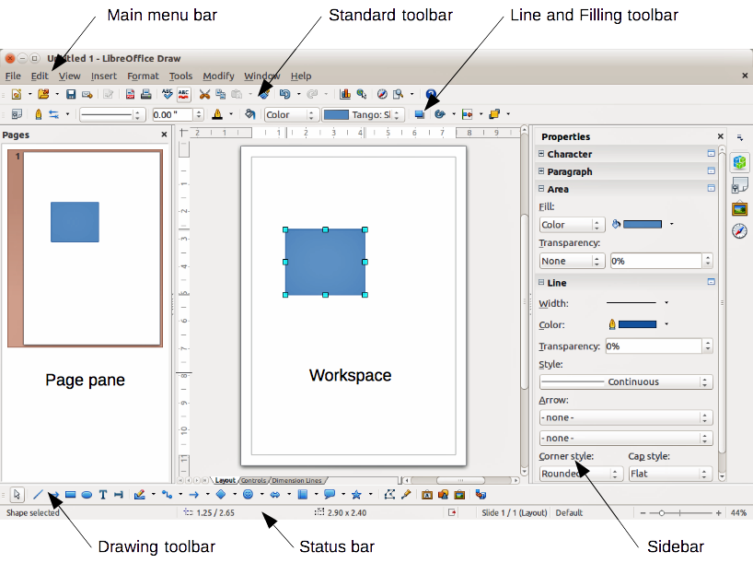
Figure 1: LibreOffice Draw workspace

Page Pane
You can split drawings in Draw over several pages. Multi-page drawings are used mainly for presentations. The Page Pane, on the left side of the Draw workspace in Figure 1 gives an overview of the pages that you create. If the Page Pane is not visible on your setup, you can enable it by going to View > Page Pane on the main menu bar. To make changes to the page order, just drag and drop one or more pages into a new position.

Sidebar
On the right of the Workspace is the Sidebar, which gives you quick access to object properties and options. If the Sidebar is not visible on your setup, you can enable it by going to View > Sidebar on the main menu bar.
The Sidebar has four sections and to expand a section, either click on its icon or click on the small triangle at the top of the icons and select a section from the drop-down list. Only one section at a time can be open.

Properties
Clicking on the Properties icon opens the Properties section of the Sidebar showing the options that are available for a selected object in your drawing. These options are similar to the options available when you use a Draw dialog.

Styles and Formatting
Clicking on the Styles and Formatting icon opens the Styles and Formatting section of the Sidebar showing the image styles that are available for a selected object in your drawing. Here you can edit and apply image styles. When you edit a style, the changes are automatically applied to all of the elements formatted with this style in your drawing.

Gallery
Clicking on the Gallery icon opens the Gallery section of the Sidebar opens the Draw gallery where you can insert an object into your drawing as a copy. This copy is independent of the original object in the Gallery.

Navigator
Clicking on the Navigator icon opens the Navigator section of the Sidebar opens the Draw navigator, in which you can quickly move to another object or another page in your drawing. It is recommended to give objects and pages in your drawing meaningful names so that you can easily identify them when using the Navigator.

Rulers
You should see rulers (bars with numbers) on the upper and left-hand sides of the Workspace. If they are not visible, you can enable them by selecting View > Ruler in the main menu bar. The rulers show the size of a selected object on the page using double lines (highlighted in Figure 2). When no object is selected, they show the location of the mouse pointer, which helps to position drawing objects more accurately.
You can also use the rulers to manage object handles and guide lines, making it easier to position objects.
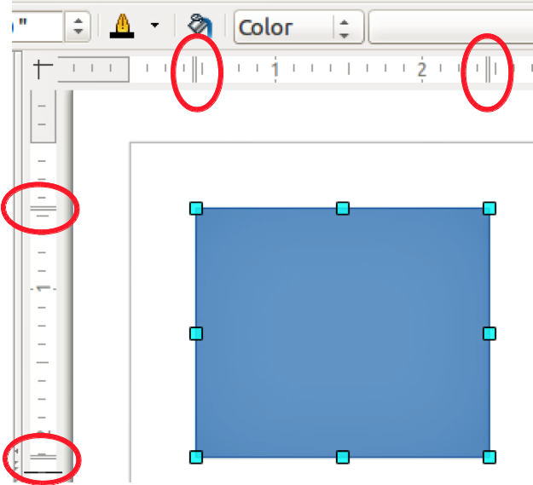
Figure 2: Rulers showing size of a selected object
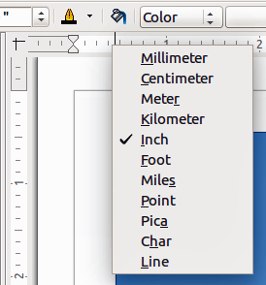
Figure 3: Ruler units
The page margins in the drawing area are also represented on the rulers. You can change the margins directly on the rulers by dragging them with the mouse. The margin area is indicated by the grayed out area on the rulers as shown in Figure 2.
To modify the measurement units of the rulers, which can be defined independently, right-click on the desired ruler, as illustrated for the horizontal ruler in Figure 3.
The default position of the zero for each of the rulers is located in the top left corner of the page where the left and top margins start. This zero position can be adjusted by clicking in the top left corner of the workspace (Figure 2) where the horizontal and vertical rulers meet and dragging to a new zero position.

Status bar
The Status bar is located at the bottom of the Draw window and includes several Draw-specific fields.
- Information area shows which action is being carried out, or which object type is selected.
- Position and Object size show different information depending on whether objects are selected or not.
- When no object is selected, the position numbers show the current position (X and Y coordinates) of the mouse cursor.
- When an object is selected and being resized with the mouse, the object size numbers show the size of the object (width and height).
Note | The sizes are given in the current measurement unit (not to be confused with the ruler units). This measurement unit is defined in Tools > Options > LibreOffice Draw > General.
- If an object is selected, the position numbers shows the X and Y coordinates of the upper-left corner and the object size number pair displays the size of the object. These numbers do not relate to the object itself, but to the selection outline, which is the smallest possible rectangle that can contain the visible part or parts of the object; see Chapter 3 Working with Objects and Object Points for more information.
- When an object is selected, a double-click in either of these areas opens the Position and Size dialog; see Chapter 4 Changing Object Attributes for more information.
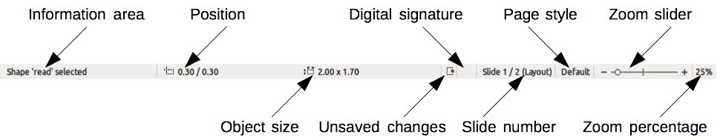
Figure 4: Draw status bar
- Unsaved changes are indicated whenever any change is made to the document but not yet saved to disk.
- Digital signature indicates if the document has been digitally signed. A double-click or right-click in this area opens the Digital Signatures dialog. A document must be saved at least once before it can be digitally signed. After a document is digitally signed, an indicator appears in this area.
- Slide number shows the sequence number for the current drawing page and the total number of pages created for the drawing. If you select an object, the information enclosed by parentheses indicates on which layer the object is placed within the drawing. In the example shown in Figure 4, the object is on the Layout layer of Slide 1 and there is a total number of one slide in the drawing.
- Page style shows which template is being used for the drawing.
- Zoom slider changes the zoom percentage of how the drawing appears on the computer display. Clicking on the plus (+) sign increases zoom and on the minus (-) sign decreases zoom. You can also drag the slider to increase or decrease the zoom percentage. The vertical bar in the middle of the Zoom slider represents a zoom percentage of 100%.
- Zoom percentage shows the level of zoom as a percentage. Double-clicking on the zoom percentage opens the Zoom & View Layout dialog. Right-clicking on the zoom percentage opens a menu where you can select a zoom level. See Chapter 3 Working with Objects and Object Points for more information on working with the zoom functions.

Toolbars
You can display or hide the various Draw toolbars, according to your needs. To display or hide a toolbar, click View > Toolbars. On the menu that appears, select which toolbar you want to display.
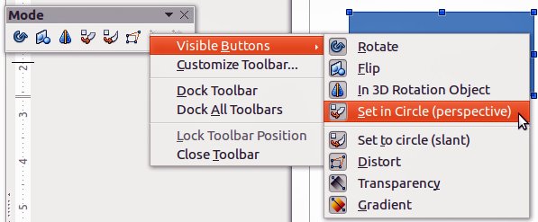
Figure 5: Selection of visible toolbar icons
You can also select the icons or buttons that you want to appear on toolbars. To change the visible icons or buttons on any toolbar, right-click in an empty area on the toolbar and select Visible Buttons from the context menu. Visible icons or buttons are indicated by a shaded outline around the icon as shown by the icons in Figure 5. Click on an icon to hide or show it in the toolbar.

Standard toolbar
The Standard toolbar (Figure 6) is the same for all LibreOffice components and is described in detail in the Getting Started Guide.
Figure 6: Standard toolbar

Drawing toolbar
The Drawing toolbar (Figure 7) is the most important toolbar in Draw. It contains all the necessary functions for drawing various geometric and freehand shapes, and for organizing them in the drawing. It is described in detail in Chapter 2 Drawing Basic Shapes.
Figure 7: Drawing toolbar

Line and Filling toolbar
The Line and Filling toolbar (Figure 8) lets you modify the main properties of a drawing object. The icons and pull-down lists vary according to the type of object selected. For example, to change the style of a line, click on the up and down arrows for Line Style and select the required style.
The functions on the Line and Filling toolbar let you change the color, style, and width of the line drawn, the fill color and style, and other properties of an object. The object must first be selected with a mouse click. If the selected object is a text frame, the Line and Filling toolbar changes to the Text Formatting toolbar (Figure 9).
Figure 8: Line and Filling toolbar

Text Formatting toolbar
The Text Formatting toolbar (Figure 9) is similar to the Formatting toolbar in Writer and only appears when a text object has been selected in your drawing. For an explanation of the functions on this toolbar, see Chapter 4 Changing Object Attributes. For information on adding and formatting text, see Chapter 9 Adding and Formatting Text.
Figure 9: Text Formatting toolbar
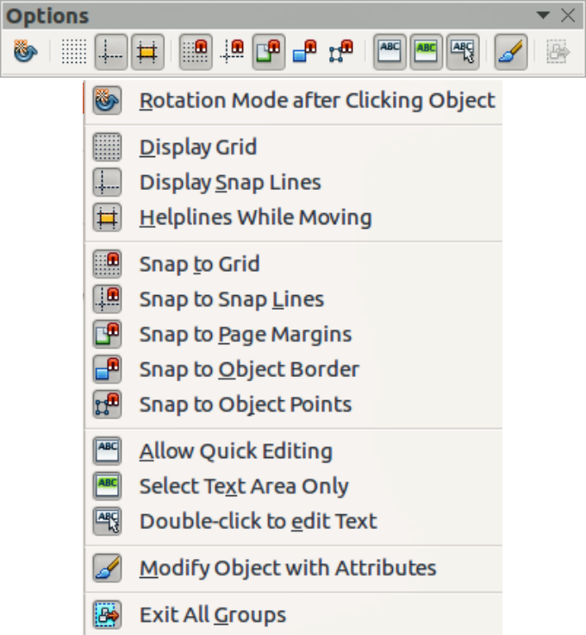
Figure 10: Options toolbar

Options toolbar
Use the Options toolbar (Figure 10) to activate or deactivate various drawing aids. The Options toolbar is not displayed by default. To display it, go to View > Toolbars > Options on the main menu bar. The tools available on this toolbar are shown in Figure 10 and described in greater detail in other chapters of this Draw Guide.

Floating and moving toolbars

Available toolsets
Many icons have a small triangle pointing downward to the right side of the icon. This triangle indicates that the icon has additional tools available. Click on the triangle to display the full set of tools (Figure 11).
You can “tear off” this toolset so it becomes a floating toolbar. Click the area at the bottom of the toolset, drag it across the screen to a location you want and then release the mouse button. To close a floating toolbar, click on the X on the right of the toolbar title.
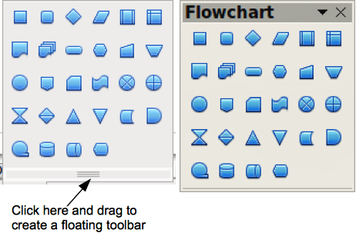
Figure 11: Available toolset and floating toolbar
Note | When a toolset is made into a floating toolbar, the icon on the existing toolbar remains in the toolbar and always shows the last tool you used. This means that the icon you see on your screen may differ from the icon shown in this guide.
Tip | When you double-click on an icon on a toolbar, the command corresponding to that icon will become active and remain active. You can then repeat this action as often as you like. To exit from this mode, press the Esc key or click on another icon. Please note that this may not work for every icon on every toolbar.

Default toolbars
When you open Draw, the default set of toolbars are already docked or fixed in their positions at the top and bottom of the workspace. This default set of toolbars normally consist of the Standard, Line and Filling, and Drawing toolbars. These toolbars can be undocked and become floating toolbars.
- To undock a toolbar, move the mouse cursor to the far left of the toolbar and over the toolbar handle (Figure 12). The cursor will change shape, normally to a grabbing hand, but this is dependent on computer setup and operating system. Click and drag on the toolbar handle to move the toolbar until it becomes a floating toolbar. This floating-toolbar capability is common to all components of LibreOffice.
- To dock a floating toolbar at the top of the Draw workspace, press and hold the Ctrl key then double click on the title of the toolbar. The toolbar will move into available space at the top of the Draw workspace.
- An alternative method of docking a toolbar is to click in the toolbar title and drag the toolbar to the docked position that you require. This can be the top, bottom or one of the sides of the Draw workspace.
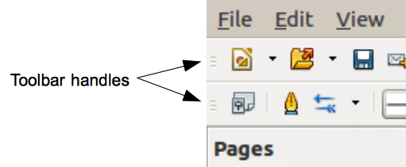
Figure 12: Toolbar handles

Customizing toolbars
You can customize toolbars in several ways to show or hide icons defined for a toolbar, see “Toolbars” and Figure 5 on page 8.
To add functions to a toolbar, move tools between toolbars, or create new toolbars:
- Select View > Toolbars > Customize on the main menu bar, or right click in an empty area on a toolbar and select Customize Toolbar from the context menu to open the Customize dialog (Figure 13).
- Select the Toolbars tab and the toolbar you want to change from the Toolbar drop-down list.
- Select the desired function for that toolbar from the Commands list.
- If necessary, reposition the new function on the Commands list using the up and down arrows.
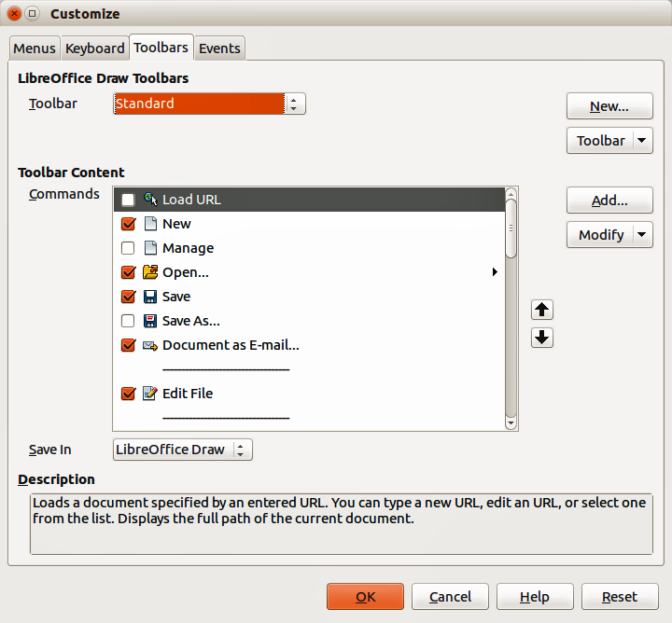
Figure 13: Customize dialog – Toolbars page
- Click Toolbar and select how you want the toolbar to appear in Draw from the context menu – Icons Only, Text Only, Icons & Text, or Restore Default Settings.
- Click OK to save your changes and close the dialog.
For more information when adding a new function, or modifying a toolbar, see the Getting Started Guide.

Choosing and defining colors
The Color dialog (Figure 14) displays the current color palette. It lets you rapidly select the color of the various objects (lines, areas, and 3D effects) in your drawing. The first box in the panel corresponds to none or no color. If the Color dialog is not displayed go to View > Toolbars > Color Bar. By default, the Colors dialog appears at the bottom of the Workspace and displays the current color palette. To make this dialog a floating dialog, hold down the Ctrl key and click at the top of the Colors dialog.
You can access several specialized color palettes in Draw, as well as change individual colors to your own taste. This is done using the Colors page in the Area dialog by selecting Format > Area on the main menu bar or clicking the Area icon on the Line and Filling toolbar, then selecting the Colors tab (Figure 15).
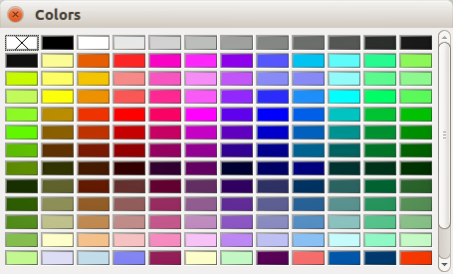
Figure 14: Colors dialog
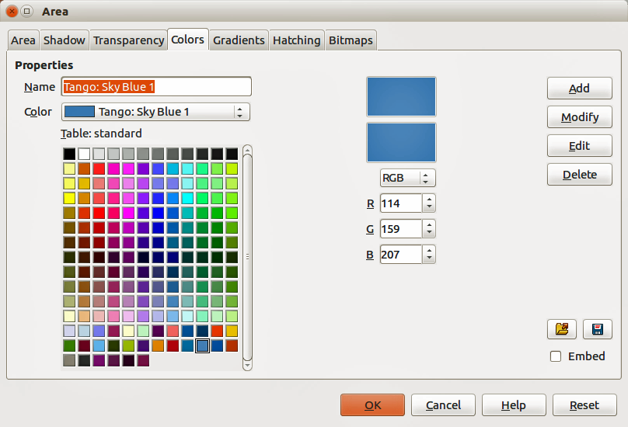
Figure 15. Area dialog – Colors page
To load another palette, click on the Load Color List icon . The file selector dialog asks you to choose one of the standard LibreOffice palettes (files with the file extension *.soc). For example, web.soc is a color palette that is adapted to creating drawings for placing in web pages. These colors will display correctly on workstations with screens capable of at least 256 colors.
The color selection box also lets you individually change any color by modifying the numerical values in the fields provided to the right of the color palette. You can use the color schemes known as CMYK (Cyan, Magenta, Yellow, Black) or RGB (Red, Green, Blue).
Click on the Edit button to open the Color dialog, where you can set individual colors, see the Getting Started Guide for more information. A more detailed description of color and options can also be found in Chapter 11 Advanced Draw Techniques in this guide.

Grid, snap, and help lines
Draw provides a grid and snap lines as drawing aids and these can be turned on or off by clicking on the Display Grid or Display Snap Lines icons on the Options toolbar. The grid and snap lines are displayed only on the screen and are not shown on a printed drawing or when the drawing is used in another LibreOffice module. The color, spacing and resolution of the grid points can be individually chosen for each axis.
Help lines when moving objects can be displayed and these are turned on or off by clicking on the Helplines While Moving icon on the Options toolbar. Showing the position of the object while moving it makes positioning the object much easier. If this function is activated, pairs of vertical and horizontal lines enclosing the object are shown while moving the object. These lines extend to the edges of the drawing area.
Draw also offers several snap functions to help you can position objects exactly in a drawing.
For more information on the grid, snap lines, snap functions, and help lines, see Chapter 3 Working with Objects and Object Points.

