
Calc Guide
Chapter 2
Entering, Editing, and Formatting Data

Copyright
This document is Copyright © 2005–2013 by its contributors as listed below. You may distribute it and/or modify it under the terms of either the GNU General Public License (http://www.gnu.org/licenses/gpl.html), version 3 or later, or the Creative Commons Attribution License (http://creativecommons.org/licenses/by/3.0/), version 3.0 or later.
All trademarks within this guide belong to their legitimate owners.

Contributors
Barbara Duprey Christian Chenal Jean Hollis Weber
Shelagh Manton John A Smith Peter Schofield

Feedback
Please direct any comments or suggestions about this document to: documentation@global.libreoffice.org

Acknowledgments
This chapter is adapted and updated from Chapter 2 of the OpenOffice.org 3.3 Calc Guide. The contributors to that chapter are:
Peter Kupfer Andy Brown Stephen Buck
Iain Roberts Hazel Russman Barbara M. Tobias
Jean Hollis Weber Jared Kobos

Publication date and software version
Published 12 July 2013. Based on LibreOffice 4.0.4.

Note for Mac users
Some keystrokes and menu items are different on a Mac from those used in Windows and Linux. The table below gives some common substitutions for the instructions in this chapter. For a more detailed list, see the application Help.
Windows or Linux | Mac equivalent | Effect
Tools > Options menu selection | LibreOffice > Preferences | Access setup options
Right-click | Control+click and/or right-click depending on computer setup | Opens a context menu
Ctrl (Control) | ⌘ (Command) | Used with other keys
F5 | Shift+⌘+F5 | Opens the Navigator
F11 | ⌘+T | Opens the Styles and Formatting window

Contents
Copyright 2
Contributors 2
Feedback 2
Acknowledgments 2
Publication date and software version 2
Note for Mac users 2
Introduction 6
Using the keyboard 6
Numbers 6
Negative numbers 6
Leading zeroes 6
Numbers as text 7
Text 7
Date and time 7
Special characters 8
Autocorrection options 8
Inserting dashes 9
Speeding up data entry 10
Fill tool 10
Using a fill series 10
Defining a fill series 11
Selection lists 12
Merging and splitting cells 13
Merging 13
Splitting 13
Sharing content between sheets 13
Validating cell contents 14
Defining validation 14
Criteria options 14
Input Help options 15
Error Alert options 16
Calc detective 16
Editing data 17
Deleting data 17
Deleting data only 17
Deleting data and formatting 17
Replacing data 17
Editing data 18
Using the keyboard 18
Using the mouse 18
Paste Special function 18
Paste Special dialog 18
Paste Special options 18
Paste Only options 20
Insert cell fields 20
Formatting data 20
Multiple lines of text 20
Automatic wrapping 21
Manual line breaks 21
Shrinking text to fit a cell 21
Formatting numbers 22
Formatting fonts 22
Font effects 23
Text direction 24
Formatting cell borders 25
Formatting cell backgrounds 26
AutoFormat of cells and sheets 26
Using AutoFormat 26
Defining a new AutoFormat 27
Using themes 27
Value highlighting 28
Using conditional formatting 29
Setting up conditional formatting 29
Types of conditional formatting 30
Condition 30
Color scale 30
Data bars 30
Icon sets 30
Conditional formatting management 31
Copying cell styles 31
Conditional formatting example 31
Defining conditions 31
Generating number values 31
Defining cell styles 32
Calculating average 32
Applying cell styles 32
Hiding and showing data 32
Hiding data 33
Sheets, rows, and columns 33
Cells 33
Showing data 34
Sheets, rows, and columns 34
Cells 34
Group and outline 34
Grouping 34
Hiding details 35
Showing details 35
Ungrouping 35
AutoOutline 35
Removing 36
Filtering 36
Applying a standard filter 36
Applying an AutoFilter 37
Applying an advanced filter 38
Sorting records 39
Sort dialog 39
Sort options 40
Quick sort 41
Find and replace 41
Find toolbar 41
Find & Replace dialog 41
Finding 41
Replacing 42
Find & Replace options 43

Introduction
You can enter data into Calc in several ways: using the keyboard, dragging and dropping using the mouse, the Fill tool, and selection lists. Calc also provides the ability to enter information into multiple sheets of the same spreadsheet at the same time. After entering data, you can format and display it in various ways.

Using the keyboard
Most data entry in Calc can be accomplished using the keyboard.

Numbers
Click in the cell and type in the number using the number keys on either the main keyboard or the numeric keypad.

Negative numbers
To enter a negative number, either type a minus (–) sign in front of the number or enclose the number in parentheses (), for example (1234). The result for both methods of entry will be the same, for example -1234.

Leading zeroes
To retain a minimum number of characters in a cell when entering numbers and retain the number format, for example 1234 and 0012, leading zeroes have to be added as follows:
- With the cell selected, right-click on the cell and select Format Cells from the context menu, or go to Format > Cells on the menu bar, or use the keyboard shortcut Ctrl+1 to open the Format Cells dialog (Figure 1).
- Make sure the Numbers page is selected, then select Number in the Category list.
- In Options > Leading Zeros, enter the minimum number of characters required. For example, for four characters, enter 4. Any number less than four characters will have leading zeroes added, for example 12 becomes 0012.
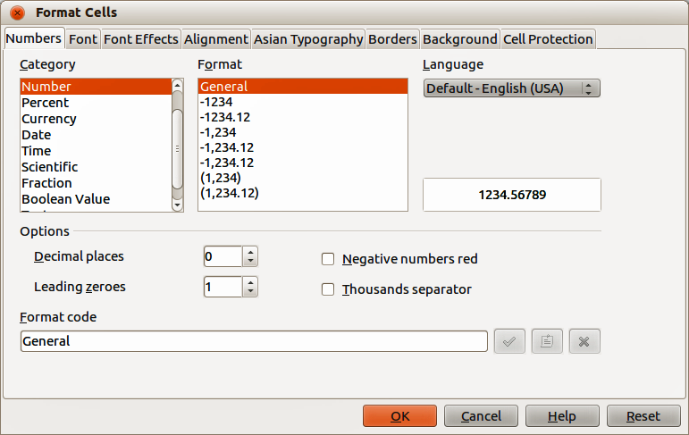
Figure 1: Format Cells dialog – Numbers page
- Click OK. The number entered retains its number format and any formula used in the spreadsheet will treat the entry as a number in formula functions.
If a number is entered with leading zeroes, for example 01481, by default Calc will automatically drop the leading 0. To preserve leading zeroes in a number:
- Type an apostrophe (') before the number, for example '01481.
- Move the cell focus to another cell. The apostrophe is automatically removed, the leading zeroes are retained and the number is converted to left-aligned text.

Numbers as text
Numbers can also be converted to text as follows:
- With the cell selected, right-click on the cell and select Format Cells from the context menu, or go to Format > Cells on the menu bar, or use the keyboard shortcut Ctrl+1 to open the Format Cells dialog (Figure 1).
- Make sure the Numbers page is selected, then select Text from the Category list.
- Click OK. The number is converted to text and, by default, is left-aligned. You can change the formatting and alignment of any text numbers just as you would with normal text.
Note | Any numbers that have been formatted as text in a spreadsheet will be treated as a zero by any formulas used in the spreadsheet. Formula functions will ignore text entries.

Text
Click in a cell and type the text. The text is left-aligned by default. Cells can contain several lines of text. If you want to use paragraphs, press Ctrl+Enter to create another paragraph.
On the Formula Bar, you can extend the Input Line if you are entering several lines of text. Click on the Extend Formula Bar icon located on the right of the Formula Bar and the Input Line becomes multi-line, as shown in Figure 2. Click the Extend Formula Bar icon again to return to a single input line.
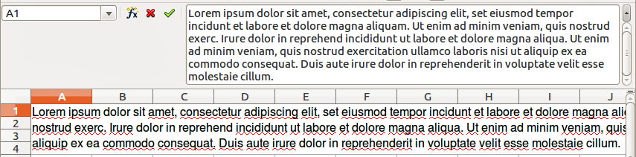
Figure 2: Extended input line on Formula Bar

Date and time
Select the cell and type the date or time. You can separate the date elements with a slash (/) or a hyphen (–) or use text, for example 10 Oct 2012. The date format automatically changes to the selected format used by Calc.
When you enter a time, separate time elements with colons, for example 10:43:45. The time format automatically changes to the selected format used by Calc.
To change the date or time format used by Calc:
- With the cell selected, right-click on the cell select Format Cells from the context menu or go to Format > Cells on the menu bar or use the keyboard shortcut Ctrl+1 to open the Format Cells dialog (Figure 1).
- Make sure the Numbers page is selected, then select Date or Time from the Category list.
- Select the date or time format you want to use from the Format list.
- Click OK to save the changes and close the dialog.

Special characters
A special character is a character not normally found on a standard keyboard, for example, © ¾ æ ç ñ ö ø ¢. To insert a special character:
- Place the cursor in the cell where you want the character to appear.
- Go to Insert > Special Character on the menu bar to open the Special Characters dialog (Figure 3).
- Select in order the special characters you want to insert into the cell. The special characters selected will appear at the bottom left of the Special Characters dialog. The last character selected is shown on the right of the Special Characters dialog along with its numerical code.
- Click OK to close the dialog and the special characters are inserted into the selected cell.
Note | Different fonts include different special characters. If you do not find a particular special character you want, try changing the Font and Subset selection.
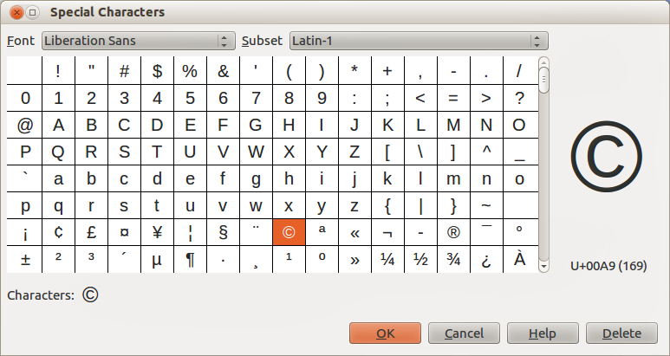
Figure 3: Special Characters dialog

Autocorrection options
Calc automatically applies many changes during data input using autocorrection, unless you have deactivated any autocorrect changes. You can also undo any autocorrection changes by using the keyboard shortcut Ctrl+Z or manually by going back to the change and replacing the autocorrection with what you want to actually see.
To change the autocorrect options, go to Tools > AutoCorrect Options on the menu bar to open the AutoCorrect dialog (Figure 4).
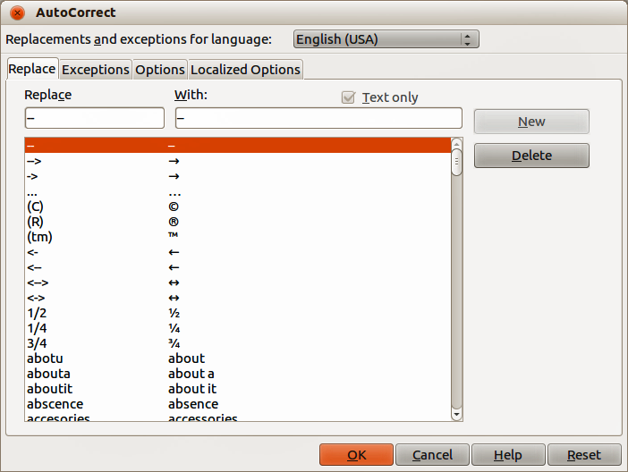
Figure 4: AutoCorrect dialog
- Replace – edits the replacement table for automatically correcting or replacing words or abbreviations in your document.
- Exceptions – specify the abbreviations or letter combinations that you do not want LibreOffice to correct automatically.
- Options – select the options for automatically correcting errors as you type and then click OK.
- Localized Options – specify the AutoCorrect options for quotation marks and for options that are specific to the language of the text.
- Reset – resets modified values back to the LibreOffice default values.
- Deactivating automatic changes – some AutoCorrect settings are applied when you press the spacebar after you enter data. To turn off or on Calc AutoCorrect, go to Tools > Cell Contents on the menu bar and deselect or select AutoInput.

Inserting dashes
Calc provides text shortcuts so that you can quickly insert dashes into a cell. See Table 1.
Table 1: Inserting dashes
Text that you type | Result
A - B (A, space, hyphen, space, B) | A – B (A, space, en-dash, space, B)
A -- B (A, space, hyphen, hyphen, space, B) | A – B (A, space, en-dash, space, B)
A--B (A, hyphen, hyphen, B) | A—B (A, em-dash, B)
A-B (A, hyphen, B) | A-B (unchanged)
A -B (A, space, hyphen, B) | A -B (unchanged)
A --B (A, space, hyphen, hyphen, B) | A –B (A, space, en-dash, B)

Speeding up data entry
Entering data into a spreadsheet can be very labor-intensive, but Calc provides tools for removing some of the drudgery from input. These tools include drag and drop to move or copy contents of one cell to another using a mouse, an AutoInput tool, the Fill tool, and selection lists.
The Fill tool and selection lists automate input of repetitive material into cells. Calc also has the ability to input information into multiple sheets of the same spreadsheet at the same time.

Fill tool
You can use the Calc Fill tool to duplicate existing content or create a series in a range of cells in your spreadsheet (see Figure 5).
- Select the cell containing the contents you want to copy or start the series from.
- Drag the cursor in any direction or hold down the Shift key and click in the last cell you want to fill.
- Go to Edit > Fill on the menu bar and select the direction in which you want to copy or create data (Up, Down, Left Right, Sheet or Series) from the context menu. A direction will be grayed out if it is not available.
Alternatively, you can use a shortcut to fill cells:
- Select the cell containing the contents you want to copy or start the series from.
- Move the cursor over the small selection handle in the bottom right corner of the selected cell. The cursor will change shape.
- Click and drag in the direction you want the cells to be filled. If the original cell contained text, then the text will automatically be copied. If the original cell contained a number, a series will be created.
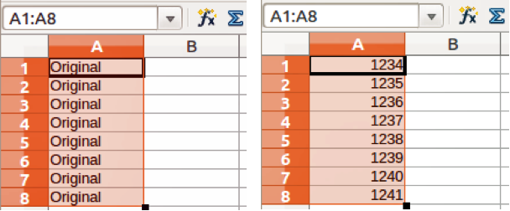
Figure 5: Using the Fill tool
Note | When you are selecting cells so you can use the Fill tool, make sure that none of the cells contain data, except for the cell data you want to use. When you use the Fill tool, any data contained in selected cells is overwritten.

Using a fill series
When you select a series fill from Edit > Fill > Series on the menu bar, the Fill Series dialog (Figure 6) opens. Here you can select the type of series you want or create your own list.
- Direction – determines the direction of series creation.
- Down – creates a downward series in the selected cell range for the column using the defined increment to the end value.
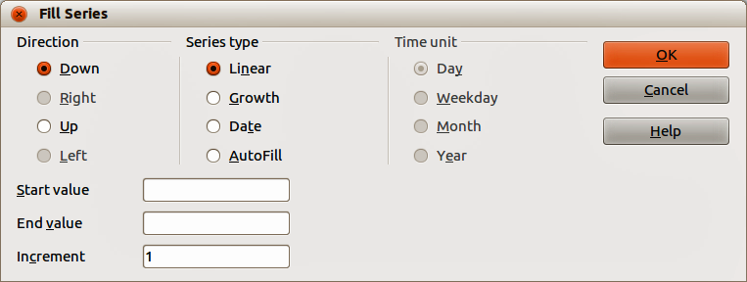
Figure 6: Fill Series dialog
- Right – creates a series running from left to right within the selected cell range using the defined increment to the end value.
- Up – creates an upward series in the cell range of the column using the defined increment to the end value.
- Left – creates a series running from right to left in the selected cell range using the defined increment to the end value.
- Series Type – defines the series type.
- Linear – creates a linear number series using the defined increment and end value.
- Growth – creates a growth series using the defined increment and end value.
- Date – creates a date series using the defined increment and end date.
- AutoFill – forms a series directly in the sheet. The AutoFill function takes account of customized lists. For example, by entering January in the first cell, the series is completed using the list defined in LibreOffice > Tools > Options > LibreOffice Calc > Sort Lists. AutoFill tries to complete a value series by using a defined pattern. For example, a numerical series using 1,3,5 is automatically completed with 7,9,11,13; a date and time series using 01.01.99 and 15.01.99, an interval of fourteen days is used.
- Unit of Time – in this area you specify the desired unit of time. This area is only active if the Date option has been chosen in the Series type area.
- Day – use the Date series type and this option to create a series using seven days.
- Weekday – use the Date series type and this option to create a series of five day sets.
- Month – use the Date series type and this option to form a series from the names or abbreviations of the months.
- Year – use the Date series type and this option to create a series of years.
- Start Value – determines the start value for the series. Use numbers, dates or times.
- End Value – determines the end value for the series. Use numbers, dates or times.
- Increment – determines the value by which the series of the selected type increases by each step. Entries can only be made if the linear, growth or date series types have been selected.

Defining a fill series
To define your own fill series:
- Go to Tools > Options > LibreOffice Calc > Sort Lists to open the Sort Lists dialog (Figure 7). This dialog shows the previously-defined series in the Lists box on the left and the contents of the highlighted list in the Entries box.
- Click New and the Entries box is cleared.
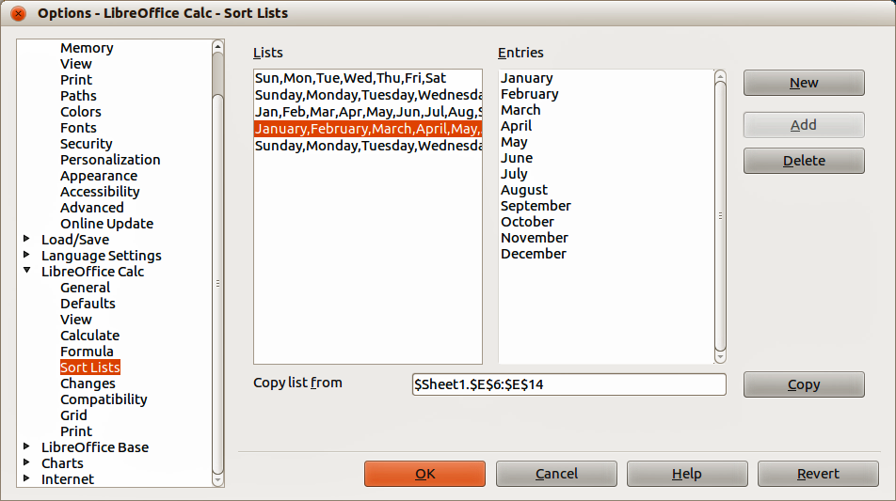
Figure 7: Sort Lists dialog
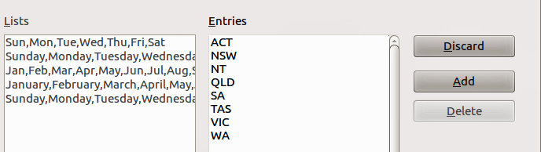
Figure 8: Creating new sort list
- Type the series for the new list in the Entries box (one entry per line) (Figure 8).
- Click Add and the new list will now appear in the Lists box.
- Click OK to save the new list and close the dialog.

Selection lists
Selection lists are available only for text and are limited to using only text that has already been entered in the same column.
- Select a blank cell in a column that contains cells with text entries.
- Right-click and select Selection Lists from the context menu, or use the keyboard shortcut Alt+↓. A drop-down list appears listing any cell in the same column that either has at least one text character or whose format is defined as text.
- Click on the text entry you require and it is entered into the selected cell.

Merging and splitting cells

Merging
You can select contiguous cells and merge them into one as follows:
- Select the range of contiguous cells you want merge.
- Go to Format > Merge cells > Merge cells or Merge and Center Cells on the menu bar, or right-click and select Merge cells or Merge and Center Cells from the context menu, or click on the Merge and Center Cells icon on the Formatting toolbar. Using Merge and Center Cells will center align any contents in the cells.
- If the cells contain contents, click Yes on the confirmation dialog that opens to move the contents of the hidden cells into the first cell.
Note | Merging cells can lead to calculation errors if formulas have used in the spreadsheet.

Splitting
You can reverse or split only a cell that was created from several cells by merging.
- Select a merged cell.
- Go to Format > Merge cells > Split cells on the menu bar, or right-click and select Split Cells from the context menu, or click on the Merge and Center Cells icon on the Formatting toolbar.
- Any contents in the cell will appear in the first cell. If the hidden cells did have any contents, then you have to manually move the contents in to the correct cell.

Sharing content between sheets
You might want to enter the same information in the same cell on multiple sheets, for example to set up standard listings for a group of individuals or organizations. Instead of entering the list on each sheet individually, you can enter the information in several sheets at the same time.
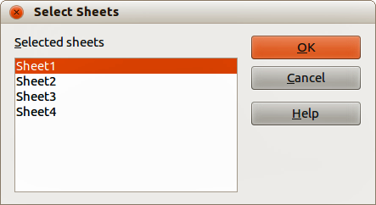
Figure 9: Select Sheets dialog
- Go to Edit > Sheet > Select on the menu bar to open the Select Sheets dialog (Figure 9).
- Select the individual sheets where you want the information to be repeated.
- Click OK to select the sheets and the sheet tabs will change color.
- Enter the information in the cells on the sheet where you want the information to first appear and the information will repeated in the selected sheets.
Note | This technique automatically overwrites, without any warning, any information that is already in the cells on the selected sheets. Make sure you deselect the additional sheets when you are finished entering information to be repeated before continuing to enter data into your spreadsheet.

Validating cell contents
When creating spreadsheets for other people to use, you may want to make sure they enter data that is valid or appropriate for the cell. You can also use validation in your own work as a guide to entering data that is either complex or rarely used.
Fill series and selection lists can handle some types of data, but are limited to predefined information. For example, a cell may require a date or a whole number with no alphabetic characters or decimal points, or a cell may not be left empty.
Depending on how validation is set up, it can also define the range of contents that can be entered, provide help messages explaining the content rules set up for the cell and what users should do when they enter invalid content. You can also set the cell to refuse invalid content, accept it with a warning, or start a macro when an error is entered.

Defining validation
To validate any new data entered into a cell:
- Select a cell and go to Data > Validity on the menu bar to open the Validity dialog.
- Define the type of contents that can be entered in that cell using the options given on the tabbed pages for Criteria, Input Help and Error Alert. The options available are explained below.

Criteria options
Specify the validation rules for the selected cells (Figure 10). For example, you can define criteria such as: Numbers between 1 and 10 or Texts that are no more than 20 characters.
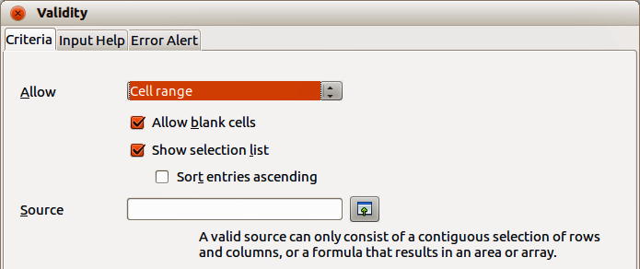
Figure 10: Validity dialog – Criteria page
The options available will depend on what has been selected in the Allow drop-down list.
- Allow – select a validation option for the selected cells from the drop-down list.
- All values – no limitation.
- Whole number – only whole numbers allowed.
- Decimal – all numbers correspond to decimal format.
- Date – all numbers correspond to date format. The entered values are formatted the next time the dialog is called up.
- Time – all numbers correspond to time format. The entered values are formatted the next time the dialog is called up.
- Cell range – allow only values that are given in a cell range. The cell range can be specified explicitly, or as a named database range, or as a named range. The range may consist of one column or one row of cells. If you specify a range of columns and rows, only the first column is used.
- List – allow only values or strings specified in a list. Strings and values can be mixed. Numbers evaluate to their value, so if you enter the number 1 in the list, the entry 100% is also valid.
- Text length – entries whose length corresponds to the number of characters that have been set.
- Allow blank cells – in conjunction with Tools > Detective > Mark invalid Data, this defines that blank cells are shown as invalid data (disabled) or not shown (enabled).
- Show selection list – shows a list of all valid strings or values to select from. The list can also be opened by selecting the cell and pressing Ctrl+D.
- Sort entries ascending – sorts the selection list in ascending order and filters duplicates from the list. If not checked, the order from the data source is taken.
- Source – enter the cell range that contains the valid values or text.
- Entries – enter the entries that will be valid values or text strings.
- Data – select the comparative operator that you want to use from the drop-down list. The available operators depend on what you have selected in the Allow drop-down list. For example, if you select between or not between, the Minimum and Maximum input boxes appear. Otherwise, only the Minimum, the Maximum, or the Value input boxes appear.
- Value – enter the value for the data validation option that you selected in the Allow drop-down list.
- Minimum – enter the minimum value for the data validation option that you selected in the Allow drop-down list.
- Maximum – enter the maximum value for the data validation option that you selected in the Allow drop-down list.

Input Help options
Enter the message to be displayed when the cell or cell range is selected in the spreadsheet (Figure 11).
- Show input help when cell is selected – displays the message that you enter in the Title and Contents boxes when the cell or cell range is selected in the sheet. If you enter text in the Title and Contents boxes and then deselect this option, the text will be lost.
- Title – enter the title to be displayed when the cell or cell range is selected.
- Input help – enter the message to be displayed when the cell or cell range is selected.
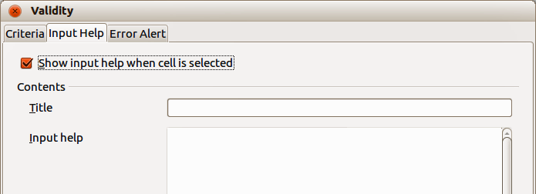
Figure 11: Validity dialog – Input Help page
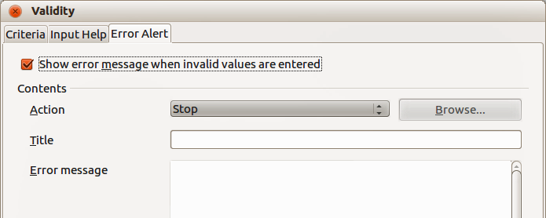
Figure 12: Validity dialog – Error Alert page

Error Alert options
Define the error message that is displayed when invalid data is entered in a cell (Figure 12).
- Show error message when invalid values are entered – when selected, displays the error message that you enter in the Contents area when invalid data is entered in a cell.
- Action – select the action that you want to occur when invalid data is entered in a cell. The Stop action rejects the invalid entry and displays a dialog that you have to close by clicking OK. The Warning and Information actions display a dialog that can be closed by clicking OK or Cancel. The invalid entry is only rejected when you click Cancel.
- Browse – opens the Macro dialog where you can select the macro that is executed when invalid data is entered in a cell. The macro is executed after the error message is displayed.
- Title – enter the title of the macro or the error message that you want to display when invalid data is entered in a cell.
- Error message – enter the message that you want to display when invalid data is entered in a cell.

Calc detective
The Detective is a tool within Calc that you can use to locate any cells in a spreadsheet that contain invalid data if the cells are set to accept invalid data with a warning.
- Go to Tools > Detective > Mark Invalid Data on the menu bar to locate any cells containing invalid data. The Detective function marks any cells containing invalid data.
- Correct the data so that it becomes valid.
- Go to Tools > Detective > Mark Invalid Data on the menu bar again and any cells that were previously marked as containing invalid data have the invalid data mark removed.
Note | A validity rule is considered part of the format for a cell. If you select Delete All from the Delete Contents window, then it is removed. If you want to copy a validity rule with the rest of the cell, use Edit > Paste Special > Paste Formats or Paste All.

Editing data

Deleting data

Deleting data only
Data can be deleted from a cell without deleting any of the cell formatting. Click in the cell to select it and then press the Delete key.

Deleting data and formatting
Data and cell formatting can be deleted from a cell at the same time.
- Click in the cell to select it.
- Press the Backspace key, or right-click in the cell and select Delete Contents from the context menu, or go to Edit > Delete Contents) on the menu bar to open the Delete Contents dialog (Figure 13). Here you can choose to delete the different aspects of the data in the cell or delete everything in the cell.
- Select the delete options.
- Click OK to delete the contents and close the dialog.
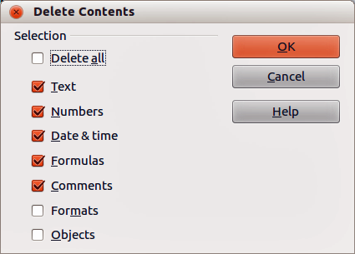
Figure 13: Delete Contents dialog

Replacing data
To completely replace data in a cell and insert new data, select the cell and type in the new data. The new data will replace the data already contained in the cell and will retain the original formatting used in the cell.
Alternatively, click in the Input Line on the Formula Bar then double-click on the data to highlight it completely and type the new data.

Editing data
Sometimes it is necessary to edit the contents of cell without removing all of the data from the cell. For example, changing the phrase “Sales in Qtr. 2” to “Sales rose in Qtr” can be done as follows.

Using the keyboard
- Click in the cell to select it.
- Press the F2 key and the cursor is placed at the end of the cell.
- Press the Backspace key to delete any data up to the point where you want to enter new data.
Alternatively, use the keyboard arrow keys to reposition the cursor where you want to start entering the new data in the cell.
- Press the Delete key or Backspace key to delete any unwanted data, then type the new data.
- When you have finished editing, press the Enter key to save the changes.
Note | Each time you select a cell, the contents are displayed in the Input Line on the Formula Bar. Using the Input Line maybe easier to carry out editing data.

Using the mouse
- Double-click on the cell to select it and place the cursor in the cell for editing.
- Reposition the cursor to where you want to start editing the data in the cell.
- Alternatively, single-click to select the cell.
- Move the cursor to the Input Line on the Formula Bar and click at the position where you want to start editing the data in the cell.
- When you have finished, click away from the cell to deselect it and your editing changes are saved.

Paste Special function
You can use the Paste Special function to paste into another cell selected parts of the data in the original cell or cell range, for example its format or the result of its formula.

Paste Special dialog
- Select a cell or a cell range.
- Go to Edit > Copy on the menu bar, right-click and select Copy from the context menu.
- Select the target cell or cell range.
- Go to Edit > Paste Special from the menu bar, or use the keyboard shortcut Ctrl+Shift+V, or right-click and select Paste Special from the context menu to open the Paste Special dialog (Figure 14).
- Select the options for Selection, Operations, Options and Shift cells. The Paste Special options are explained below.
- Click OK to paste the data into to the target cell or range of cells and close the dialog.

Paste Special options
- Selection – select a format for the clipboard contents that you want to paste.
- Paste all – pastes all cell contents, comments, formats, and objects into the current document.
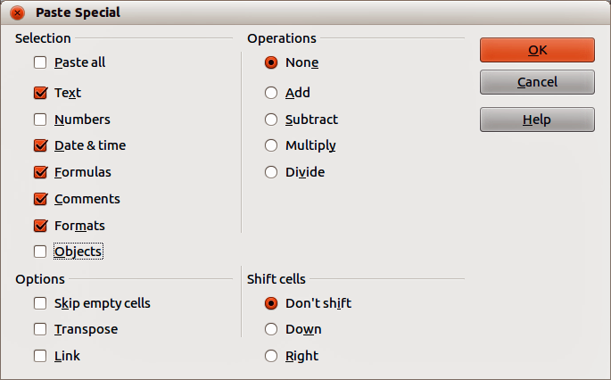
Figure 14: Paste Special dialog
- Text – pastes cells containing text.
- Numbers – pastes cells containing numbers.
- Date & Time – pastes cells containing date and time values.
- Formulas – pastes cells containing formulas.
- Comments – pastes comments that are attached to cells. If you want to add the comments to the existing cell content, select the Add operation.
- Formats – pastes cell format attributes.
- Objects – pastes objects contained within the selected cell range. These can be OLE objects, chart objects, or drawing objects.
- Operations – select the operation to apply when you paste cells into your sheet.
- None – does not apply an operation when you insert the cell range from the clipboard. The contents of the clipboard will replace existing cell contents.
- Add – adds the values in the clipboard cells to the values in the target cells. Also, if the clipboard only contains comments, adds the comments to the target cells.
- Subtract – subtracts the values in the clipboard cells from the values in the target cells.
- Multiply – multiplies the values in the clipboard cells with the values in the target cells.
- Divide – divides the values in the target cells by the values in the clipboard cells.
- Options – sets the paste options for the clipboard contents.
- Skip empty cells – empty cells from the clipboard do not replace target cells. If you use this option in conjunction with the Multiply or the Divide operation, the operation is not applied to the target cell of an empty cell in the clipboard. If you select a mathematical operation and deselect the Skip empty cells, empty cells in the clipboard are treated as zeroes. For example, if you apply the Multiply operation, the target cells are filled with zeroes.
- Transpose – the rows of the range in the clipboard are pasted to become columns of the output range. The columns of the range in the clipboard are pasted to become rows.
- Link – inserts the cell range as a link, so that changes made to the cells in the source file are updated in the target file. To ensure that changes made to empty cells in the source file are updated in the target file, ensure that the Paste All is also selected. You can also link sheets within the same spreadsheet. When you link to other files, a DDE link is automatically created. A DDE link is inserted as a matrix formula and can only be modified as a whole.
- Shift cells – set the shift options for the target cells when the clipboard content is inserted.
- Don't shift – inserted cells replace the target cells.
- Down – target cells are shifted downward when you insert cells from the clipboard.
- Right – target cells are shifted to the right when you insert cells from the clipboard.

Paste Only options
If you only want to copy text, numbers or formulas to your target cell or cell range:
- Select the cell or cell range and copy the data.
- Select the target cell or cell range.
- Right-click on the target cell or cell range and select either Text, Number or Formula from the context menu.

Insert cell fields
You can insert a field linked to the date, sheet name, or document name in a cell.
- Select a cell and double-click to activate edit mode.
- Right-click and select Insert Fields > Date or Sheet Name or Title from the context menu.
Note | The Insert Fields > Title command inserts the name of the spreadsheet and not the title defined in the Description page in the Properties dialog for the file.
Tip | The fields are refreshed when the spreadsheet is saved or recalculated when using the Ctrl+Shift+F9 shortcut.

Formatting data
Note | All the settings discussed in this section can also be set as a part of the cell style. See Chapter 4 Using Styles and Templates in Calc for more information.
The data in Calc can be formatted in several ways. Formatting can either be defined as part of a cell style so that it is automatically applied, or it can be applied manually to the cell. For more control and extra options, select a cell or cell range and use the Format Cells dialog. All of the format options are discussed below.

Multiple lines of text
Multiple lines of text can be entered into a single cell using automatic wrapping or manual line breaks. Each method is useful for different situations.

Automatic wrapping
To automatically wrap multiple lines of text in a cell:
- Select a cell or cell range.
- Right-click on the selection and select Format Cells from the context menu, or go to Format > Cells on the menu bar, or press Ctrl+1 to open the Format Cells dialog.
- Click on the Alignment tab (Figure 15).
- Under Properties, select Wrap text automatically and click OK.
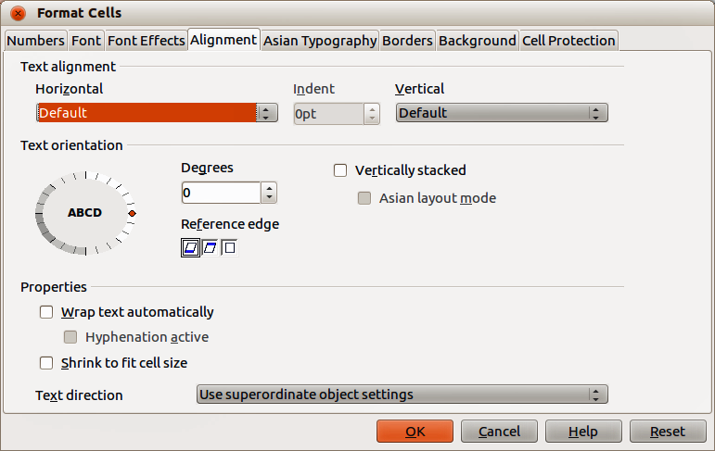
Figure 15: Format Cells dialog – Alignment page

Manual line breaks
To insert a manual line break while typing in a cell, press Ctrl+Enter. This method does not work with the cursor in the input line. When editing text, double-click the cell, then reposition the cursor to where you want the line break.
When a manual line break is entered, the cell width does not change and your text may still overlap the end of the cell. You have to change the cell width manually or reposition your line break so that your text does not overlap the end of the cell.

Shrinking text to fit a cell
The font size of the data in a cell can automatically adjust to fit inside cell borders.
- Select a cell or cell range.
- Right-click on the selection and select Format Cells from the context menu, or go to Format > Cells on the menu bar, or press Ctrl+1 to open the Format Cells dialog.
- Click on the Alignment tab (Figure 15).
- Under Properties, select Shrink to fit cell size and click OK.
Figure 16: Number icons on Formatting toolbar

Formatting numbers
Several different number formats can be applied to cells by using icons on the Formatting toolbar (highlighted in Figure 16). Select the cell, then click the relevant icon to change the number format.
For more control or to select other number formats, use the Numbers page of the Format Cells dialog (Figure 1 on page 6 and “Numbers” on page 6):
- Apply any of the data types in the Category list to the data.
- Control the number of decimal places and leading zeros in Options.
- Enter a custom format code.
- The Language setting controls the local settings for the different formats such as the date format and currency symbol.

Formatting fonts
To select a font and format it for use in a cell:
- Select a cell or cell range.
- Click the small triangle on the right of the Font Name box on the Formatting toolbar (highlighted in Figure 17) and select a font from the drop-down list. The font can also be changed using the Font page on the Format Cells dialog.
- Click on the small triangle on the right of the Font Size box on the Formatting toolbar and select a font size from the drop-down list. The font size can also be changed using the Font page on the Format Cells dialog.
- To change the character format, click on the Bold, Italic, or Underline icons.
- To change the paragraph alignment of the font, click on one of the four alignment icons (Left, Centre, Right, Justified) .
Figure 17: Font Name and Size on Formatting toolbar
Note | To specify the language used in the cell, open the Font page on the Format Cells dialog. Changing language in a cell allows different languages to exist within the same document. For more changes to font characteristics, see “Font effects” below for more information.
Tip | To choose whether to show the font names in their font or in plain text, go to Tools > Options > LibreOffice > View and select or deselect the Show preview of fonts option in the Font Lists section. For more information, see Chapter 14 Setting Up and Customizing Calc.

Font effects
- Select a cell or cell range.
- Right-click on the selection and select Format Cells from the context menu, or go to Format > Cells on the menu bar, or press Ctrl+1 to open the Format Cells dialog.
- Click on the Font Effects tab (Figure 18).
- Select the font effect you want to use from the options available. The options available are described below.
- Click OK to apply the font effects and close the dialog.
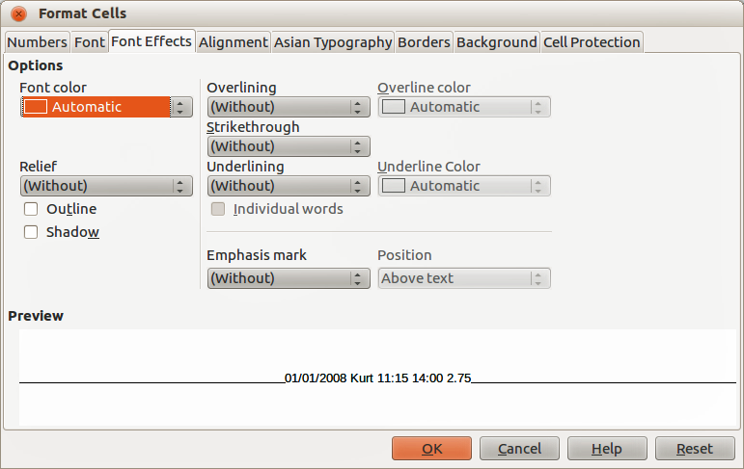
Figure 18: Format Cells dialog – Font Effects page
Any font effect changes are applied to the current selection, or to the entire word that contains the cursor, or to any new text that you type.
- Font Color – sets the color for the selected text. If you select Automatic, the text color is set to black for light backgrounds and to white for dark backgrounds. Also yo can change the font color by clicking on the triangle to right of the Font Color icon to display the color palette, then select the desired color.
- Relief – select a relief effect to apply to the selected text. The embossed relief makes the characters appear as if they are raised above the page. The engraved relief makes the characters appear as if they are pressed into the page.
- Outline – displays the outline of the selected characters. This effect does not work with every font.
- Shadow – adds a shadow that casts below and to the right of the selected characters.
- Overlining – select the overlining style that you want to apply. To apply overlining to words only, select Individual Words.
- Overline color – select the color for the overlining.
- Strikethrough – select a strikethrough style for the selected text. If you save your document in MS Word format, all of the strikethrough styles are converted to the single line style.
- Underlining – select the underlining style that you want to apply. To apply the underlining to words only, select Individual Words. If you apply underlining to a superscript text, the underlining is raised to the level of the superscript. If the superscript is contained in a word with normal text, the underlining is not raised.
- Underline color – select the color for the underlining.
- Individual words – applies the selected font effect only to words and ignores spaces.
- Emphasis mark – select a character to display over or below the entire length of the selected text.
- Position – specify where to display the emphasis marks.
- Preview – displays a preview of the current selection.

Text direction
To change the text direction within a cell, you can use the Alignment page on the Format Cells dialog (Figure 15 on page 21) or the icons on the Formatting toolbar.
- On the Alignment page of the Format Cells dialog, select the Reference edge from which to rotate the text as follows:
- Text Extension From Lower Cell Border – writes the rotated text from the bottom cell edge outwards.
- Text Extension From Upper Cell Border – writes the rotated text from the top cell edge outwards.
- Text Extension Inside Cells – writes the rotated text only within the cell.
- Click on the small indicator at the edge of the Text orientation dial and rotate it until you reach the required degrees.
- Alternatively, enter the number of degrees to rotate the text in the Degrees box.
- Select Vertically stacked to make the text appear vertically in the cell. Only select Asian layout mode if you are using an Asian language in the cell.
- The icons on the Formatting toolbar can be used as follows after the cell has been selected:
- To change the text direction from horizontal (default direction) to vertical, click on the Text direction from top to bottom icon .
- To change text direction from vertical to horizontal (default), click on the Text direction from left to right icon .
- To change text direction from left to right, which is the default direction for Western fonts, to a right to left direction used in some fonts, for example Arabic, the click on the Right-To-Left icon . This only works if a font has been used that requires a right to left direction.
- To change text direction back to the default left to right direction used for Western fonts, click on the Left-To-Right icon .
Note | If the text direction icons are not available on the Formatting toolbar, then right-click in an empty area on the toolbar and select Visible Buttons from the context menu. Click on the icon you require and it will be placed on the Formatting toolbar.

Formatting cell borders
To format the borders of a cell or a group of selected cells (see Chapter 4 Using Styles and Templates in Calc for more information). The border icons on the Formatting toolbar only apply the default styles to borders, but the Format Cells dialog provides greater control over of how the cell borders will look.
- Select a cell or a range of cells.
- Right-click on the selection and select Format Cells from the context menu, or go to Format > Cells on the menu bar, or press Ctrl+1 to open the Format Cells dialog.
- Click on the Borders tab (Figure 19).
- Select the options from the Borders page. The options available are given below.
- Click OK to close the dialog and save your changes.
- Alternatively, use the icons on the Formatting to apply default styles to borders.
- Click on the Borders icon and select one of the border options displayed in the Borders palette.
- Click on the Border Style icon and select one of the line styles from the Border Style palette.
- Click on the Line Color icon and select a color from Border Color palette.
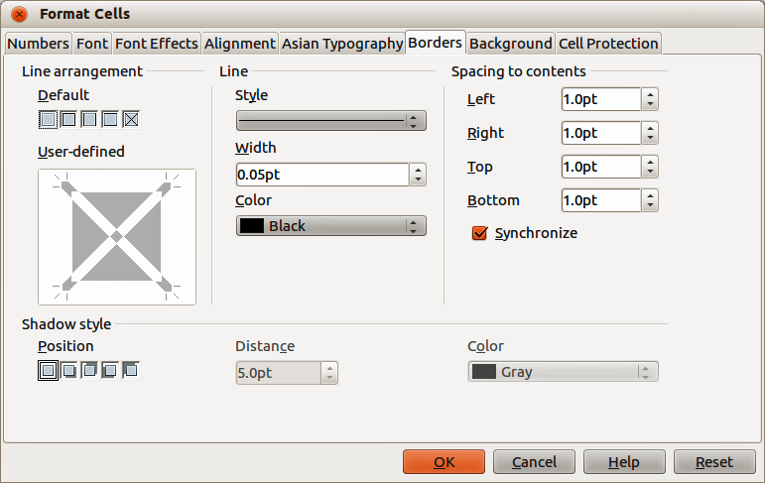
Figure 19: Format Cells dialog – Borders page
Note | Cell border properties apply only to the selected cells and can only be changed if you are editing those cells. For example, if cell C3 has a top border, that border can only be removed by selecting C3. It cannot be removed in C2 it appears to be the bottom border for cell C2.
Note | When entering borders with the Border icons on the Formatting toolbar, you have two choices: click the required icon to add a border to the present borders or shift-click to add a border and remove the present borders.
The border options available in the Format Cells dialog are as follows.
- Line arrangement – select the style of cell borders.
- Default – select a predefined border style to apply.
- User defined – click on the diagram to apply a border to one of the edges or diagonal lines across the cell.
- Line – select the line style for the cell borders.
- Style – select the line style to be used for the border.
- Width – enter a width to be used for the border line.
- Color – select a color to be used for the border line.
- Spacing to contents – specify the amount of space that you want to leave between the border and the contents of the selection.
- Left – enter the distance between the left border and the contents of the selection.
- Right – enter the distance between the right border and the contents of the selection.
- Top – enter the distance between the top border and the contents of the selection.
- Bottom – enter the distance between the bottom border and the contents of the selection.
- Synchronize – applies the same spacing to contents setting to all four borders when you enter a new distance.
- Shadow style – applies a shadow effect to borders. For the best results, only apply this effect when all four borders are visible.
- Position – select a shadow style for the selected borders.
- Distance – enter the width of the shadow.
- Color – select a color for the shadow.

Formatting cell backgrounds
To format the background color for a cell or a group of cells (see Chapter 4 Using Styles and Templates in Calc for more information):
- Select a cell or a range of cells.
- Right-click on the selection and select Format Cells from the context menu, or go to Format > Cells on the menu bar, or press Ctrl+1 to open the Format Cells dialog.
- Click on the Background tab.
- Select ta color from the color palette.
- Click OK to save your changes and close the dialog.
- Alternatively, click on the Background Color icon on the Formatting toolbar and select a color from the Background color palette.

AutoFormat of cells and sheets

Using AutoFormat
You can use AutoFormat to format a group of cells.
- Select the cells in at least three columns and rows, including column and row headers, that you want to format.
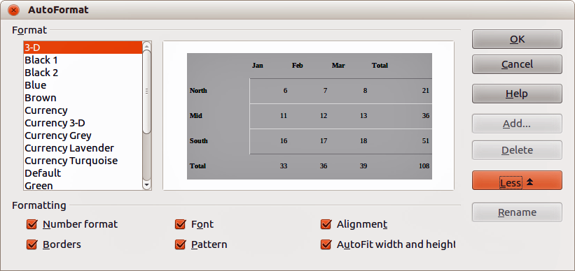
Figure 20: AutoFormat dialog
- Go to Format > AutoFormat on the menu bar to open the AutoFormat dialog (Figure 20).
- Select the type of format and format color from the list
- If necessary, click More to open Formatting if Formatting is not visible.
- Select the formatting properties to be included in the AutoFormat function.
- Click OK to apply the changes and close the dialog.

Defining a new AutoFormat
You can define a new AutoFormat so that it becomes available for use in all spreadsheets.
- Format the data type, font, font size, cell borders, cell background, and so on for a group of cells.
- Go to Edit > Select All on the menu bar to select the whole spreadsheet.
- Go to Format > AutoFormat to open the AutoFormat dialog and the Add button is now active.
- Click Add.
- In the Name box of the Add AutoFormat dialog that opens, type a meaningful name for the new format and click OK.
- Click OK to close the dialog. The new AutoFormat is now available in the Format list in the AutoFormat dialog.

Using themes
Calc comes with a predefined set of formatting themes that you can apply to spreadsheets. It is not possible to add themes to Calc and they cannot be modified. You can modify their styles after you apply them to a spreadsheet, but the modified styles are only available for use for that spreadsheet when you save the spreadsheet.
To apply a theme to a spreadsheet:
- Click the Choose Themes icon in the Tools toolbar to open the Theme Selection dialog (Figure 21). If the Tools toolbar is not visible, go to View > Toolbars on the menu bar and select Tools. The Theme Selection dialog lists the available themes for the whole spreadsheet.
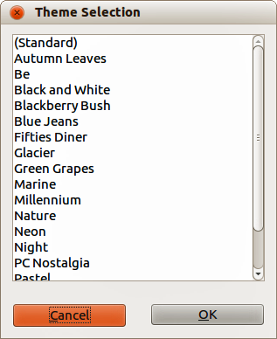
Figure 21: Theme Selection dialog
- Select the theme that you want to apply. As soon as you select a theme, the theme styles are applied to the spreadsheet and are immediately visible.
- Click OK.
- If you wish, you can now open the Styles and Formatting window to modify specific styles. These modifications do not modify the theme; they only change the appearance of the style in th specific spreadsheet you are creating. For more about modifying styles, see Chapter 4 Using Styles and Templates in Calc.

Value highlighting
The value highlighting function displays cell contents in different colors, depending on the type of content. An example of value highlighting is shown in Figure 22.
- Text is shown in black.
- Formulas are shown in green.
- Numbers are shown in blue.
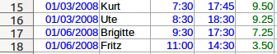
Figure 22: Example of value highlighting
The value highlighting colors override any colors used in formatting. This color change applies only to the colors seen on a display. When a spreadsheet is printed, the original colors used for formatting are printed.
Go to View > Value Highlighting on the menu bar, or use the keyboard shortcut Ctrl+F8 to turn the function on or off. When value highlighting is switched off, the original formatting colors are used for display.
You can make value highlighting the default when opening a spreadsheet in Calc, by selecting Tools > Options > LibreOffice Calc > View > Value Highlighting. This default mode for value highlighting may not be what you want if you are going to format the cells for printing.

Using conditional formatting
You can set up cell formats to change depending on conditions that you specify. Conditional formatting is used to highlight data that is outside the specifications that you have set. It is recommended not to overuse conditional formatting as this could reduce the impact of data that falls outside the specifications that you have set.
See “Conditional formatting example” on page 31 for an example on how to use conditional formatting.
Note | Conditional formatting depends upon the use of styles and the AutoCalculate feature must be enabled. If you are not familiar with styles, see Chapter 4 Using Styles and Templates in Calc for more information.

Setting up conditional formatting
- Ensure that AutoCalculate is enabled: Tools > Cell Contents > AutoCalculate.
- Select the cells where you want to apply conditional formatting.
- Go to Format > Conditional Formatting > Condition (Figure 23), Color scale (Figure 24) or Data Bar (Figure 25) on the menu bar to open the Conditional Formatting dialog. Any conditions already defined are displayed.
- Click Add to create and define a new condition. Repeat this step as necessary.
- Select a style from the styles already defined in the Apply Style drop-down list. Repeat this step as necessary.
- Alternatively, select New Style to open the Cell Style dialog (Figure 26) and create a new cell style. Repeat this step as necessary.
- Click OK to save the conditions and close the dialog. The selected cells are now set to apply a result using conditional formatting.
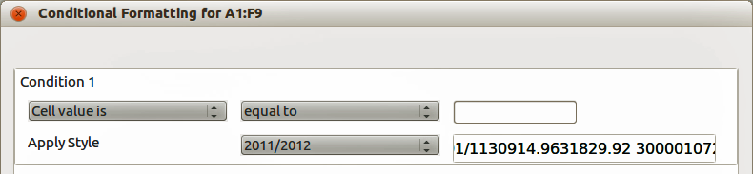
Figure 23: Conditional Formatting dialog – Condition
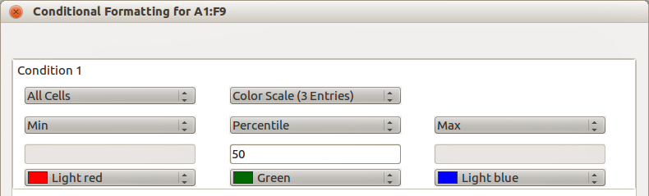
Figure 24: Conditional Formatting dialog – Color Scale
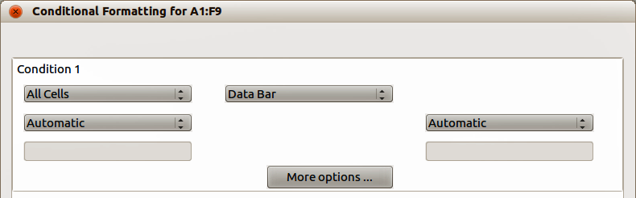
Figure 25: Conditional Formatting dialog – Data Bar
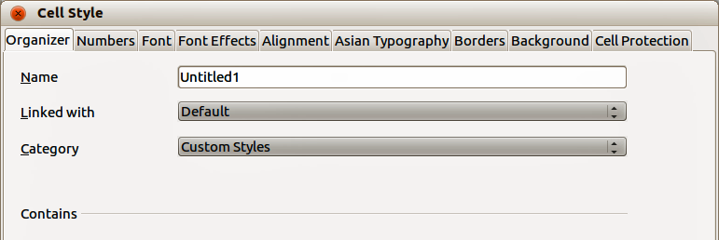
Figure 26: Cell Style dialog

Types of conditional formatting

Condition
Condition is the starting point when using conditional formatting. Here you can define what formats to use to highlight any data in your spreadsheet that falls outside the specifications that you have defined.

Color scale
Use Color scale to set the background color of cells depending on the value of the data in a spreadsheet cell. Color scale can only be used when All Cells has been selected for the condition. You can use either two or three colors for your color scale.

Data bars
Data bars provide a graphical representation of data in your spreadsheet. The graphical representation is based on the values of data in a selected range. Click on More Options in the Conditional Formatting dialog to define how your data bars will look. Data bars can only be used when All Cells has been selected for the condition.

Icon sets
Icon sets display an icon next to your data in each selected cell to give a visual representation of where the cell data falls within the defined range that you set. The icons sets available are colored arrows, gray arrows, colored flags, colored signs, symbols, bar ratings and quarters. Icon sets can only be accessed when the Conditional Formatting dialog has been opened and All Cells has been selected for the condition.

Conditional formatting management
To see all the conditional formatting defined in your spreadsheet and any styles used:
- Go to Format > Conditional Formatting > Manage on the menu bar to open the Manage Conditional Formatting dialog (Figure 27).
- Select a range from the Range list and click Edit to redefine the conditional formatting.
- Select a range from the Range list and click Remove to delete the conditional formatting. The deletion is immediate with no confirmation.
- Select Add to create a new definition of conditional formatting.
- Click OK to save your changes and close the dialog.
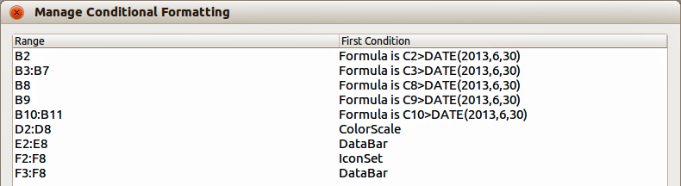
Figure 27: Manage Conditional Formatting dialog

Copying cell styles
To apply the style used for conditional formatting to other cells later:
- Click one of the cells that has been assigned conditional formatting and copy the cell to the clipboard.
- Select the cells that are to receive the same formatting as the copied cell.
- Go to Edit > Paste Special on the menu bar to open the Paste Special dialog.
- Make sure that only Formats is selected and click OK to paste the conditional formatting into the cell.

Conditional formatting example
With conditional formatting, you can, for example, highlight the totals that exceed the average value of all totals. If the totals change, the formatting changes correspondingly, without having to apply other styles manually. It is recommended that the Styles and Formatting dialog is open and visible before proceeding.

Defining conditions
- Select the cells where you want to apply a conditional style.
- Go to Format > Conditional Formatting > Condition, Color scale or Data bar from the menu bar to open the Conditional Formatting dialog.
- Enter the conditions you want to use for conditional formatting.

Generating number values
You may want to give certain values in your tables particular emphasis. For example, in a table of turnovers, you can show all the values above the average in green and all those below the average in red. This is possible with conditional formatting.
- Create a table in which a few different values occur. For your test you can create tables with any random numbers. In one of the cells enter the formula =RAND(), and you will obtain a random number between 0 and 1. If you want integers of between 0 and 50, enter the formula =INT(RAND()*50).
- Copy the formula to create a row of random numbers.
- Click the bottom right corner of the selected cell, and drag to the right and downward until the desired cell range is selected.

Defining cell styles
The next step is to apply a cell style to all values that represent above-average turnover and one to cells that are below the average.
- Right-click in a blank cell and select Format Cells in the context menu to open the Format Cells dialog.
- Click the Background tab and select a background color, then click OK.
- In the Conditional Formatting dialog, select New Style from the Apply Style drop-down list to open the Cell Style dialog.
- Enter a name of the new style. For this example, name the style Above.
- Define a second style, click again in a blank cell and proceed as described above. Assign a different background color to the cell and assign a name. For this example, name the style Below.

Calculating average
In our particular example, we are calculating the average of the random values. The result is placed in a cell:
- Click in a blank cell, for example, J14, and go to Insert > Function on the menu bar, or click the Function Wizard icon on the Formula bar to open the Function Wizard dialog.
- Select AVERAGE from the Function list.
- Use the cursor to select all your random numbers.
- Click OK to the Function Wizard.

Applying cell styles
Now you can apply the conditional formatting to the sheet:
- Select all cells containing the random numbers.
- Go to the Format > Conditional Formatting on the menu bar to open the Conditional Formatting dialog.
- Define the condition for each cell as follows: if cell value is less than J14, format with cell style Below OR if cell value is greater than or equal to J14, format with cell style Above.

Hiding and showing data
In Calc you can hide elements so that they are neither visible on a computer display nor printed when a spreadsheet is printed. However, hidden elements can still be selected for copying if you select the elements around them; for example, if column B is hidden, it is copied when you select columns A and C. When you require a hidden element again, you can reverse the process and show the element.

Hiding data

Sheets, rows, and columns
- Select the sheet, row, or column you want to hide.
- Go to Format on the menu bar and select Sheet, Row or Column.
- Select Hide from the menu and the sheet, row, or column can no longer viewed or printed.
Alternatively, right-click on the sheet tab, row header, or column header and select Hide from the context menu.
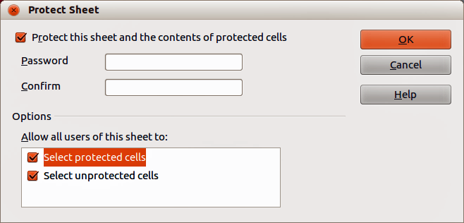
Figure 28: Protect Sheet dialog
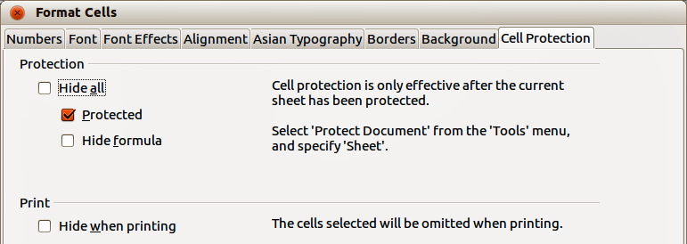
Figure 29: Format Cells dialog – Cell Protection page

Cells
- Go to Tools > Protect Document > Sheet on the menu bar to open the Protect Sheet dialog dialog (Figure 28).
- Select Protect this sheet and the contents of protected cells.
- Create a password and then confirm the password.
- Select or deselect the options for Allow all users of this sheet to: so users can select protected or unprotected cells.
- Click OK to save the changes and close the dialog.
- Select the cells you want to hide.
- Go to Format > Cells on the menu bar, or right-click and select Format Cells from the context menu, or use the keyboard shortcut Ctrl+1 to open the Format Cells dialog (Figure 29).
- Click the Cell Protection tab and select an option for hiding and printing the cells.
- Click OK to save the changes and close the dialog.
Note | When data in cells are hidden, it is only the data contained in the cells that are hidden and the protected cells cannot be modified. The blank cells remain visible in the spreadsheet.
Note | When data in cells are hidden, it is only the data contained in the cells that are hidden and the protected cells cannot be modified. The blank cells remain visible in the spreadsheet.

Showing data

Sheets, rows, and columns
- Select the sheets, rows or columns each side of the hidden sheet, row or column.
- Go to Format on the menu bar and select Sheet, Row or Column.
- Select Show from the context menu and the sheet, row or column will be displayed and can be printed.
- Alternatively, right-click on the sheet tabs, row headers or column headers and select Show from the context menu.

Cells
- Go to Tools > Protect Document > Sheet on the menu bar to open the Protect Sheet dialog dialog (Figure 28).
- Enter the password to unprotect the sheet and click OK.
- Go to Format > Cells on the menu bar, or right-click and select Format Cells from the context menu, or use the keyboard shortcut Ctrl+1 to open the Format Cells dialog (Figure 29).
- Click the Cell Protection tab and deselect the hide options for the cells.
- Click OK.

Group and outline
If you are continually hiding and showing the same cells, you can create an outline of your data and group rows or columns together so that you can collapse a group to hide it or expand a group to show it using a single click.
The basic controls for grouping and outlining show plus (+) or minus (-) signs on the group indicator to show or hide rows or columns. However, if there are groups nested within each other, the basic controls have numbered buttons so you can hide the different levels of nested groups.

Grouping
To group rows or columns:
- Select the cells you want to group in your spreadsheet.
- Go to Data > Group and Outline > Group on the menu bar, or press the F12 key.
- In the Group dialog that opens, select either Rows or Columns and click OK. A group indicator appears to the left of any rows grouped or above any columns grouped. Figure 30 shows a group indicator on the left of the first two rows of the spreadsheet have been grouped.
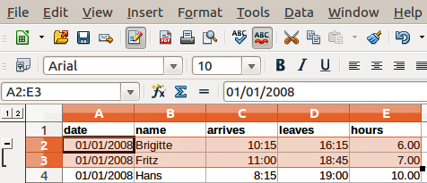
Figure 30: Group indicator

Hiding details
To hide the details of any group of rows or columns:
- Click on the minus (-) sign on the group indicator.
- Alternatively, select a cell within the group and go to Data > Group and Outline > Hide Details on the menu bar.
- The rows or columns are hidden and the minus (-) sign becomes a plus (+) sign on the group indicator.

Showing details
To show the details of any hidden groups or rows or columns:
- Click on the plus (+) sign on the group indicator.
- Alternatively, select a cell on each side of the hidden group and go to Data > Group and Outline > Show Details on the menu bar.
- The hidden rows or columns are displayed and the plus (+) sign becomes a minus (-) sign on the group indicator.

Ungrouping
To ungroup any groups of rows or columns:
- Make sure the grouped rows or columns are displayed.
- Go to Data > Group and Outline > Ungroup on the menu bar, or use the keyboard combination Ctrl+F12.
- Select either Rows or Columns to ungroup and click OK.
Note | Any hidden groups of rows or columns must be displayed. If they are hidden, then the grouped rows or columns are deleted from your spreadsheet.
Note | If there are nested groups, only the last group of rows or columns created is ungrouped.

AutoOutline
If a selected cell range contains formulas or references, Calc automatically outlines the selection. For example, in Figure 31 the cells for the 1st and 2nd quarters each contain a sum formula for the three cells to their left. If you apply the AutoOutline command, the columns are grouped into two quarters.
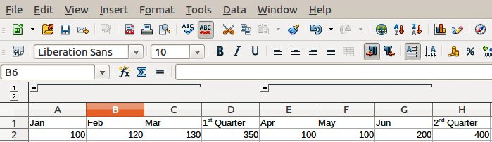
Figure 31: Example of AutoOutline
To apply the AutoOutline function, go to Data > Group and Outline > AutoOutline on the menu bar. Calc will then check for cells that contain formulas or references and automatically group the cells as necessary.

Removing
To remove any cell groups of rows or columns, go to Data > Group and Outline > Remove on the menu bar and any groups are removed.
Any cell group of rows or columns that are hidden, the grouping is removed from the cells and the cells are displayed in your spreadsheet.

Filtering
A filter is a list of conditions that each entry has to meet to be displayed. Calc provides three types of filter:
- Standard – specifies the logical conditions to filter your data.
- AutoFilter – filters data according to a specific value or string. Automatically filters the selected cell range and creates one-row list boxes where you can choose the items that you want to display.
- Advanced – uses filter criteria from specified cells.

Applying a standard filter
A standard filter is more complex than AutoFilter. You can set as many as eight conditions as a filter, combining them with the operators AND or OR. Standard filters are mostly useful for numbers, although a few of the conditional operators can also be used for text.
- Select a cell range in your spreadsheet.
- Go to Data > Filter > Standard Filter on the menu bar to open the Standard Filter dialog (Figure 32).
- Specify the filter criteria and filtering options that you want to use.
- Click OK to carry out standard filtering and close the dialog. Any records that match the filter criteria and options that you specified are shown.
The filter criteria used in standard filtering defines a filter by indicating the type of line, the name of the field, a logical condition and a value or a combination of arguments.
- Operator – for the following arguments, you can choose between the logical operators AND / OR.
- Field name – specifies the field names from the current table to set them in the argument. You will see the column identifiers if no text is available for the field names.
- Condition – specifies the comparative operators through which the entries in the Field name and Value fields can be linked.
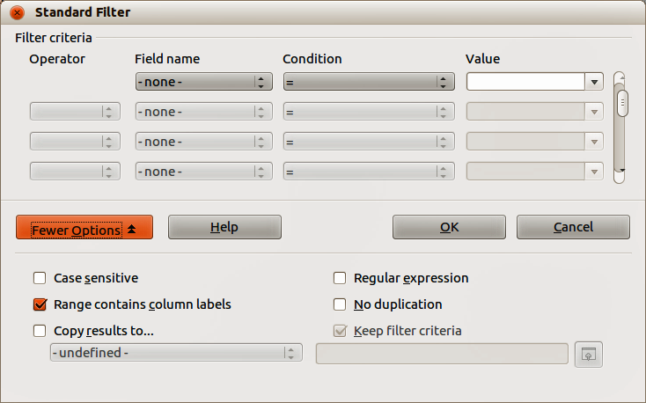
Figure 32: Standard Filter dialog
- Value – specifies a value to filter the field. The Value list box contains all possible values for the specified Field name. Select a value to be used in the filter, including Empty and Not Empty entries.
- Case sensitive – distinguishes between uppercase and lowercase letters when filtering the data.
- Range contains column labels – includes the column labels in the first row of a cell range.
- Copy results to – select the check box and then select the cell range where you want to display the filter results. You can also select a named range from the list.
- Regular expression – select to use wildcards in the filter definition. See LibreOffice Help for a list of the regular expressions that LibreOffice supports. If selected, you can use regular expressions in the Value field if the Condition list box is set to '=' EQUAL or '<>' UNEQUAL. This also applies to the respective cells that you reference for an advanced filter.
- No duplication – excludes duplicate rows from the list of filtered data.
- Keep filter criteria – select Copy results to and then specify the destination range where you want to display the filtered data. If this box is checked, the destination range remains linked to the source range. You must have defined the source range under Data > Define range as a database range. You can also reapply the defined filter at any time by clicking into the source range and then go to Data > Refresh Range.

Applying an AutoFilter
An AutoFilter adds a drop-down list to the top row of one or more data columns which lets you select the rows to be displayed. The list includes every unique entry in the selected cells sorted into lexical order (see http://sheepsystems.com/bookdog/HelpBook/LexicalOrder.html for an explanation of lexical order). AutoFilter can be used on multiple sheets without first defining a database range.
- Click in a cell range on your spreadsheet. If you want to apply multiple AutoFilters to the same sheet, you must first define database ranges, then apply the AutoFilters to the database ranges.
- Go to Data > Filter > AutoFilter on the menu bar. An arrow button is added to the head of each column in the database range.
- Click the arrow or small triangle in the column that contains the value or string that you want to set as the filter criteria (shown in Figure 33).
- Select the value or string that you want to use as the filter criteria. The records that match the filter criteria that you selected are then shown.
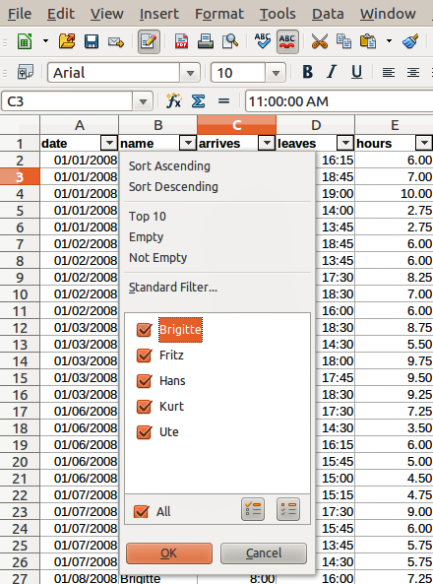
Figure 33: AutoFilter example

Applying an advanced filter
An advanced filter has a structure similar to a standard filter. The difference is that the Advanced Filter arguments are not entered in a dialog. Instead, filters can be entered in a blank area of a spreadsheet, then referenced by the filter dialog to apply the filters.
- Select a cell range in your spreadsheet.
- Go to Data > Filter > Advanced Filter on the menu bar to open the Advanced Filter dialog (Figure 34).
- In Read filter criteria from, select the named range, or enter the cell range that contains the filter criteria that you want to use
- Click OK to carry out advanced filtering and close the dialog. Any records that match the filter criteria and options that you specified are shown.
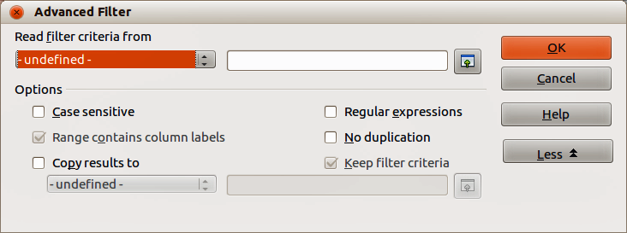
Figure 34: Advanced Filter dialog
Note | The options for advanced filtering are the same as those used for standard filtering, see “Applying a standard filter” on page 36 for more information.

Sorting records
Sorting within Calc arranges the cells in a sheet using the sort criteria that you specify. Several criteria can be used and a sort applies each criteria consecutively. Sorts are useful when you are searching for a particular item and become even more useful after you have filtered data.
Also, sorting is useful when you add new information to a spreadsheet. When a spreadsheet is long, it is usually easier to add new information at the bottom of the sheet, rather than adding rows in their correct place. After you have added information, you can then sort the records to update the spreadsheet.

Sort dialog
To sort cells in a spreadsheet using the Sort dialog (Figure 35):
- Select the cells to be sorted.
- Go to Data > Sort on the menu bar to open the Sort dialog. Make sure the Sort Criteria page is open.
- Select the sort criteria from the drop-down lists. The selected lists are populated from the selected cells.
- Select either ascending order (A-Z, 1-9) or descending order (Z-A, 9-1).
- Click OK and the sort is carried out on your spreadsheet.
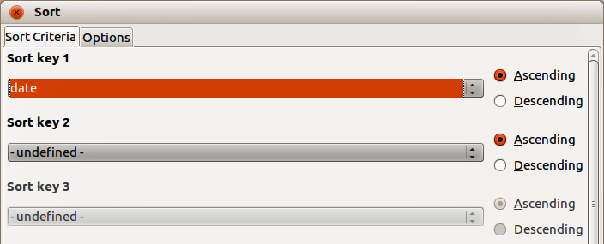
Figure 35: Sort dialog – Sort Criteria page
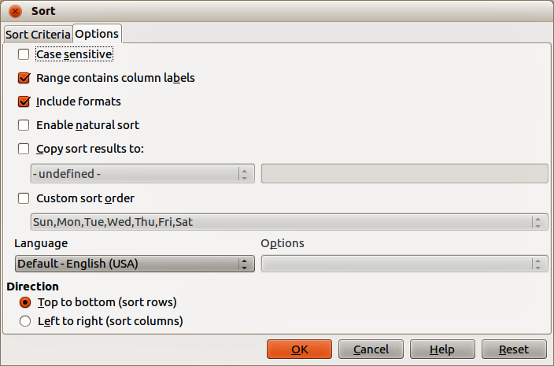
Figure 36: Sort dialog – Options page

Sort options
On the Options page of the Sort dialog (Figure 36), you can set additional options:
- Case Sensitivity – sorts first by uppercase letters and then by lowercase letters. For Asian languages, special handling applies.
Note | For Asian languages, select Case Sensitivity to apply multi-level collation. With multi-level collation, entries are first compared in their primitive forms with their cases and diacritics ignored. If they evaluate as the same, their diacritics are taken into account for the second-level comparison. If they still evaluate as the same, their cases, character widths, and Japanese Kana difference are considered for the third-level comparison.
- Range contains column/row labels – omits the first row or the first column in the selection from the sort. The Direction setting at the bottom of the dialog defines the name and function of this check box.
- Include formats – preserves the current cell formatting.
- Enable natural sort – natural sorting is a sort algorithm that sorts string-prefixed numbers based on the value of the numerical element in each sorted number, instead of the traditional way of sorting them as ordinary strings. For instance, assume you have a series of values such as, A1, A2, A3, A4, A5, A6, ..., A19, A20, A21. When you put these values into a range of cells and run the sort, it will become A1, A11, A12, A13, ..., A19, A2, A20, A21, A3, A4, A5, ..., A9. While this sorting behavior may make sense to those who understand the underlying sorting mechanism, to the rest of the population it seems completely bizarre, if not outright inconvenient. With natural sorting selected, values such as the ones in the above example are sorted correctly, which improves the convenience of sorting operations in general.
- Copy sort results to – copies the sorted list to the cell range that you specify. Select a named cell range where you want to display the sorted list, or enter a cell range in the input box.
- Custom sort order – select this option and then select the custom sort order that you want to apply. To define a custom sort order, go to LibreOffice > Preferences > LibreOffice Calc > Sort Lists.
- Language – select the language for the sorting rules.
- Options – select a sorting option for the language. For example, select the "phonebook" option for German to include the umlaut special character in the sorting.
- Top to Bottom (Sort Rows) – sorts rows by the values in the active columns of the selected range.
- Left to Right (Sort Columns) – sorts columns by the values in the active rows of the selected range.

Quick sort
If the columns in your spreadsheet have a header with a text format, you can use a quick sort.
- Select a cell or a cell range to be sorted.
- Click the Sort Ascending or Sort Descending icons on the Standard toolbar.

Find and replace
Calc has two ways to find text within a document: the Find toolbar and the Find & Replace dialog.

Find toolbar
- Go to View > Toolbars > Find on the menu bar, or go to Edit > Find on the menu bar, or use the keyboard shortcut Ctrl+F to open the Find toolbar (Figure 37). By default the Find toolbar is docked in the lower left-corner of the Calc window. You can undock the toolbar and move it to where you choose.
- Type a search term in the Find box, and then click the Find Next or Find Previous icons. To find other occurrences of the same term, continue clicking the icon.
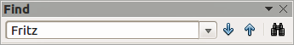
Figure 37: Find toolbar

Find & Replace dialog

Finding
- Go to Edit > Find & Replace on the menu bar, or use the keyboard shortcut Ctrl+H, or select the Find & Replace icon on the Find toolbar to open the Find & Replace dialog (Figure 38).
- Enter or select the search criteria in the Search for box.
- Click Find to locate the first instance of the search criteria you entered.
- Click Find again to locate the next instance of your search criteria.
- Click Find All to locate all instances of your search criteria. The instances of your search criteria will be highlighted in the spreadsheet.
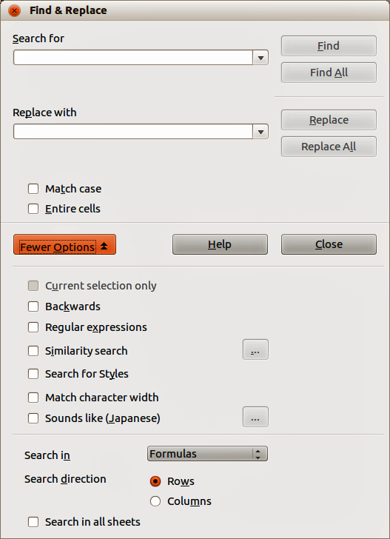
Figure 38: Find & Replace dialog

Replacing
- Go to Edit > Find & Replace on the menu bar, or use the keyboard shortcut Ctrl+H, or select the Find & Replace icon on the Find toolbar to open the Find & Replace dialog (Figure 38).
- Enter or select the search criteria in the Search for box.
- Enter or select the replace criteria in the Replace with box.
- Click Replace to locate and replace the first instance of the search criteria you entered with your replacement criteria.
- Click Replace again to locate and replace the next instance of the search criteria you entered with your replacement criteria.
- Click Replace All to locate and replace all instances of the search criteria you entered with your replacement criteria.
Note | Use Replace All with caution; otherwise, you may end up with some highly embarrassing mistakes. A mistake with Replace All might require a manual, word-by-word search to fix, if it is not discovered in time to undo it.

Find & Replace options
The options available to refine your find and replace are as follows:
- Search for – enter the text that you want to search for, or select a previous search from the list.
- Replace with – enter the replacement text, or select a recent replacement text or style from the list.
- Match case – distinguishes between uppercase and lowercase characters.
- Entire Cells – searches for whole words or cells that are identical to the search text.
- Current selection only – searches only the selected text or cells.
- Backwards – search starts at the current cursor position and goes backwards to the beginning of the file.
- Regular expressions – select to use wildcards in your search. See LibreOffice Help for more information on the use of regular expressions.
- Similarity Search – find terms that are similar to the Search for text. Select this checkbox, and then click the ... button to define the similarity options.
- Search for Styles – searches for text formatted with the style that you specify. Select this option and then select a style from the Search for list. To specify a replacement style, select a style from the Replace with list.
- Match character width – distinguishes between half-width and full-width character forms; only available if Asian languages are enabled.
- Sounds like (Japanese) – specify the search options for similar notation used in Japanese text. Select this option, and then click the ... button to specify the search options. This option is only available if Asian languages are enabled.
- Search in – select either Formulas, Values, or Notes to search for the characters that you specify in values, in the results of formulas, or in notes.
- Search direction – determines the order for searching the cells.
- Search in all sheets – searches through all of the sheets in the current spreadsheet file.

