
Writer Guide
Chapter 11
Using Mail Merge
Form Letters, Mailing Labels, and Envelopes

Copyright
This document is Copyright © 2011–2012 by its contributors as listed below. You may distribute it and/or modify it under the terms of either the GNU General Public License (http://www.gnu.org/licenses/gpl.html), version 3 or later, or the Creative Commons Attribution License (http://creativecommons.org/licenses/by/3.0/), version 3.0 or later.
All trademarks within this guide belong to their legitimate owners.
Contributors
Ron Faile Jr.
Jean Hollis Weber
John A Smith
Feedback
Please direct any comments or suggestions about this document to: documentation@global.libreoffice.org
Acknowledgments
This chapter is based on Chapter 11 of the OpenOffice.org 3.3 Writer Guide. The contributors to that chapter are:
Agnes Belzunce Dick Detwiler Peter Hillier-Brook
Peter Kupfer Alan Madden Iain Roberts
Barbara M. Tobias Jean Hollis Weber Michele Zarri
Publication date and software version
Published 15 February 2012. Based on LibreOffice 3.4.5.

Note for Mac users
Some keystrokes and menu items are different on a Mac from those used in Windows and Linux. The table below gives some common substitutions for the instructions in this chapter. For a more detailed list, see the application Help.
Windows or Linux | Mac equivalent | Effect
Tools > Options menu selection | LibreOffice > Preferences | Access setup options
Right-click | Control+click | Opens a context menu
Ctrl (Control) | z (Command) | Used with other keys
F5 | Shift+z+F5 | Opens the Navigator
F11 | z+T | Opens the Styles and Formatting window

Contents
Copyright 2
Note for Mac users 2
What is mail merge? 4
Creating the data source 4
Registering a data source 4
Creating a form letter 7
Editing merged documents 10
Printing mailing labels 11
Preparing for printing 11
Removing blank lines from labels 13
Printing 14
Editing a saved file of mailing labels 15
Printing envelopes 15
Setting up envelopes for printing 15
Merging and printing the envelopes 18
Creating an envelope template 19
Using the Mail Merge Wizard to create a form letter 19
Step 1: Select starting document 19
Step 2: Select document type 20
Step 3: Insert address block 20
Selecting the data source (address list) 21
Selecting the address block 22
Matching the fields 23
Step 4: Create salutation 24
Step 5: Adjust layout 25
Step 6: Edit document and insert extra fields 26
Step 7: Personalize documents 27
Step 8: Save, print or send 28

What is mail merge?
LibreOffice Writer provides very useful features to create and print:
- Multiple copies of a document to send to a list of different recipients (form letters)
- Mailing labels
- Envelopes
All these facilities, though different in application, are based around the concept of a registered data source, from which is derived the variable address information necessary to their function.
This chapter describes the entire process. The steps include:
- How to create and register a data source.
- How to create and print form letters, mailing labels, and envelopes.
- Optionally, how to save the output in an editable file instead of printing it directly.

Creating the data source
A data source is a database containing the name and address records (and optionally other information) from which a mailing list may be derived. Although you can create and print mailing labels and envelopes without using a data source, in most cases using one is the best approach. This chapter assumes that you are using a data source.
LibreOffice can access a wide variety of data sources, including spreadsheets, text files and databases such as MySQL, Adabas, and ODBC. If the information to be used in the mail merge is currently in a format that LibreOffice cannot access directly, you need to convert it, for example by exporting it to a comma-separated values (CSV) file.
For the following example we use a spreadsheet with the following column (field) headers: Title, First name, Last name, Address, State/County, Country, Post Code, Sex, Points. A sample data source is shown in Figure 1.
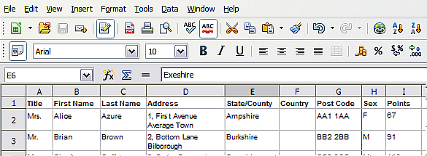
Figure 1: Spreadsheet data source

Registering a data source
For a data source to be directly accessible from within a Writer document, it must first be registered as described below. You only need to do this once; after that, the data source is available to all documents in LibreOffice.
- From within any Writer document, or from the LibreOffice Start Center, choose File > Wizards > Address Data Source.
- The choices on the first page of the wizard vary with your operating system. Select the appropriate type of external address book. In this example, it is Other external data source. Click Next.
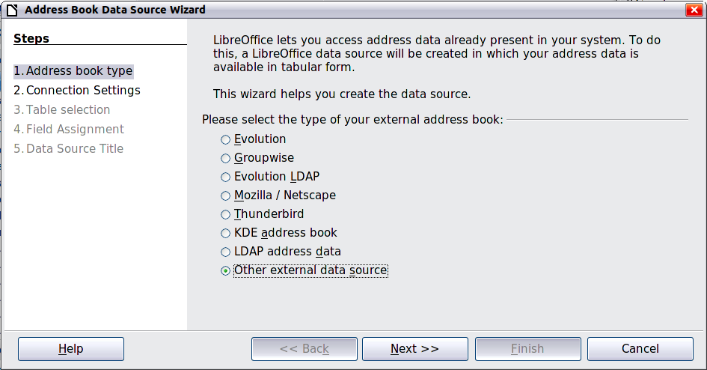
Figure 2: Select type of external address book
- On the next page of the Wizard, click the Settings button.
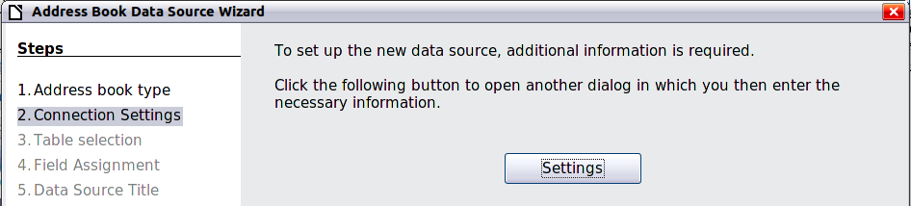
Figure 3: Starting the Settings part of the Wizard
- In the Data Source Properties page, select the Database type. In our example, it is Spreadsheet. Click Next.
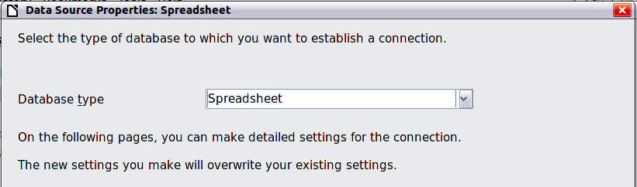
Figure 4: Selecting the database type
- In the next dialog box, click Browse and navigate to the spreadsheet that contains the address information. Select the spreadsheet and click Open to return to this dialog box. At this time you may wish to test that the connection has been correctly established by clicking on the Test Connection button (not shown in illustration).
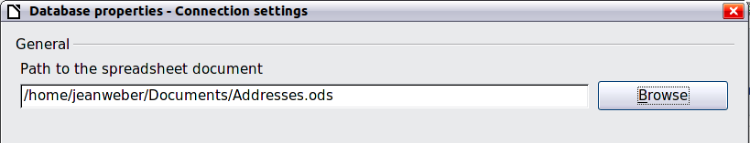
Figure 5: Selecting the spreadsheet document
- Click Finish.
- On the following page, click Next. Because this is a spreadsheet, do not click Field Assignment.
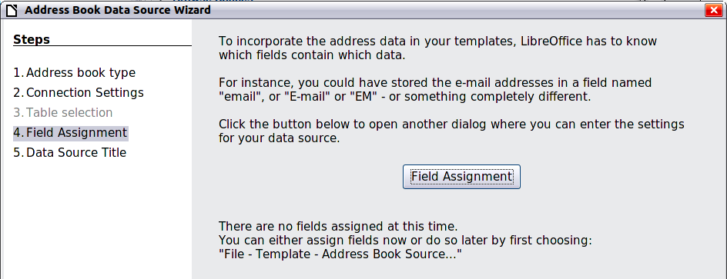
Figure 6: Because this is a spreadsheet, do not click Field Assignment
- Name the file in the Location field. The default is ...\Addresses.odb; but you may replace Addresses with another name if you wish. You may also change the name in the “Address book name” field. In our example, the name “Points” was used for both.
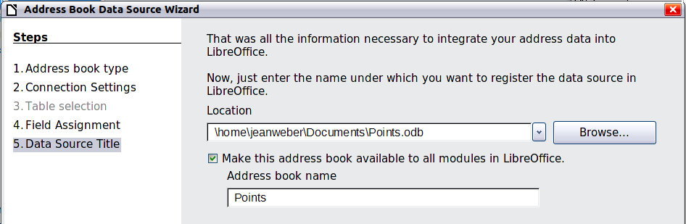
Figure 7: Name the .odb file and the address book
- Click Finish. The data source is now registered.

Creating a form letter
Example: Sending a letter to your customer base
A mail order company organized a campaign to assign credit points to their customers according to the quantity of goods they buy during one year.
At the end of the year, they want to send a letter to each customer to show the total of credit points collected.
You can create a form letter manually, which is the simplest and most comprehensive method and is described here, or you can use the Mail Merge wizard as described in “Using the Mail Merge Wizard to create a form letter” starting on page 19. If you elect to use the wizard, pay close attention to its current limitations, as identified within its description.
- Create a new text document: File > New > Text Document, or open a pre-existing form letter with File > Open.
- Display the registered data sources: View > Data sources (or press F4).
- Find the data source that you wish to use for the form letter, in this case Points. Expand the Points and Tables folders, and select Sheet1. The address data file is displayed.
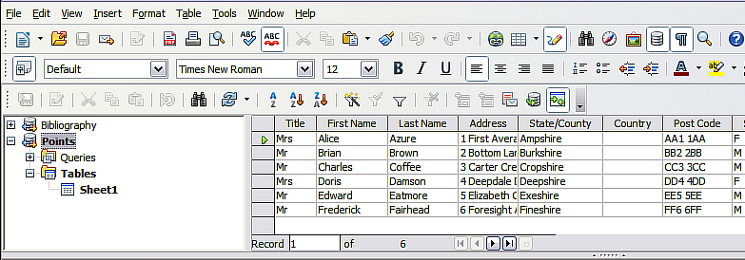
Figure 8: Selecting the data source
- Now create or modify the form letter by typing in the text, punctuation, line breaks, and so on that will be present in all of the letters.
To add the mail-merge fields where needed (such as names and addresses), click in the field heading and drag it to the appropriate point in the letter.
Note that address lines should be in individual paragraphs, not separated by line breaks as might seem preferable. The reason for this will be made clear in the next step.
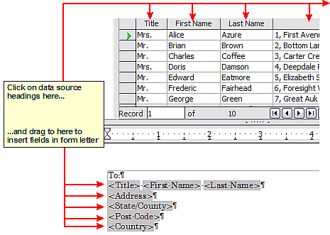
Figure 9: Dragging fields to the body of the form letter
- Continue until you have composed the entire document. At this time you may wish to consider suppressing any blank lines that may appear in the resulting letters. If not, skip ahead to Step 7.
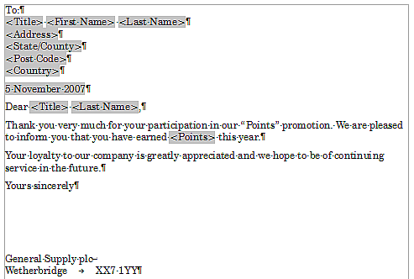
Figure 10: The completed form letter
- To suppress blank lines:
  - Click at the end of the first paragraph to be suppressed and then choose Insert > Fields > Other.
  - Select the Functions tab and then click on Hidden Paragraph in the Type column.
  - Now click in the Condition box and enter the details of the condition that defines a blank address field. It has the general form of:
![Database.Table.Database field]
where the ‘!’ (NOT) character indicates the negative case and the square brackets indicate the condition.
For example, in our Points database the condition to test if the Company field is empty would be:
![Points.Sheet1.Last Name] as illustrated in Figure 11.
To test for multiple conditions use the operators AND and/or OR between the conditional statements, for example:
![Points.Sheet1.Title]AND![Points.Sheet1.Last Name]
  - Click Insert, but do not close the dialog box until you have amended all the lines that should be suppressed.
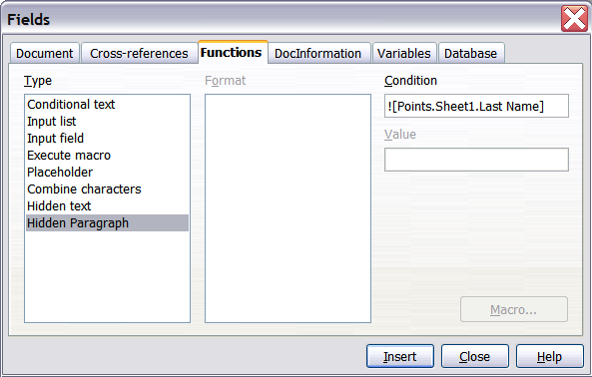
Figure 11: Hidden paragraph insertion
- The document is now ready to be printed.
- Choose File > Print and respond with Yes in the message box.
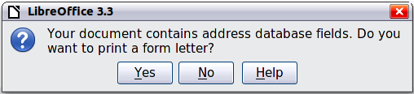Figure 12: Mail merge confirmation message
- In the Mail Merge dialog box (Figure 13), you can choose to print all records or selected records. To select records to be printed, use Ctrl+click to select individual records. To select a block of records, select the first record in the block, scroll to the last record in the block, and Shift+click on the last record.
- Click OK to send the letters directly to the printer. Or, you can save the letters to a file for further editing or formatting; see “Editing merged documents” below.
- If you have not saved the original, prototype form letter document (template) previously, then you should do so now. Having a form letter template could greatly simplify the creation of other form letters in the future and is highly recommended.
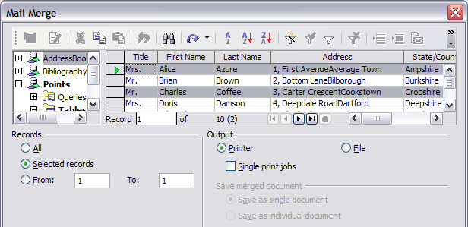Figure 13: The Mail Merge dialog box

Editing merged documents
You may prefer to save the letters to a file, to allow for proofreading or some later formatting. To do this:
- In the Mail Merge dialog box (Figure 13), select File in the output section, instead of using the default Printer selection.
- This changes the dialog box to display the Save merged document section, where Save as single document is pre-selected. You can choose to save each letter as an individual document instead.
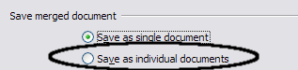
- Click OK. In the Save as dialog box, enter a file name for the saved letters and choose a folder in which to save them. The letters will be saved consecutively as separate pages in the single document, or numbered consecutively in individual files if saved as single documents.
You can now open the letters and edit them individually as you would edit any other document.

Printing mailing labels
Before beginning this process, note the brand and type of labels you intend to use.

Preparing for printing
To prepare mailing labels for printing:
- Choose File > New > Labels.
- On the Options tab, ensure that the Synchronise contents option is selected.
- On the Labels tab (Figure 16), select the Database and Table. Select the Brand of labels to be used, and then select the Type of label.
- If you are unable to identify your label product in the list, then you can define the labels you have. Click on the Format tab of the Labels dialog box. Set values for the columns and rows first. Take a ruler and measure on your labels, those dimensions illustrated in the window of the graphic, and enter them into the respective boxes on the left side.
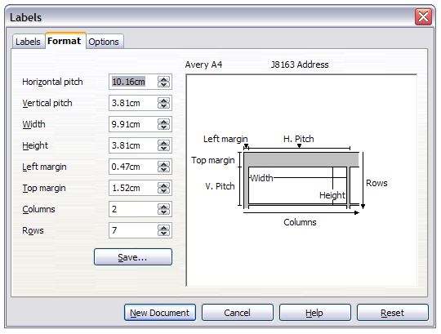Figure 14: Determining label dimensions
- You can now save your label template if you are likely to use it again. Click Save.
- In the box that opens, enter names for your label Brand and Type.
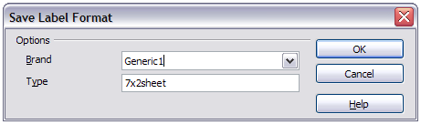Figure 15: Name and save the label.
- Click the Labels tab.
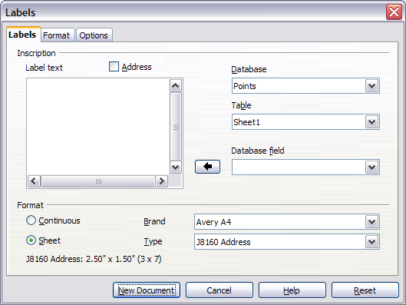
Figure 16: Select Database, Table, label Brand, and label Type
- Click the drop-down arrow under Database field. Select the first field to be used in the label (in this example, Title). Click the left arrow button to move this field to the Label text area, as shown in Figure 17.
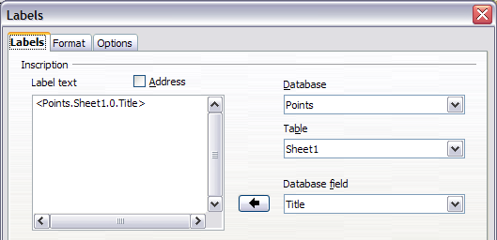
Figure 17: Move fields from Database field list to Label text area
- Continue adding fields and inserting desired punctuation, spaces, and line breaks until the label is composed. Figure 18 shows the completed label.
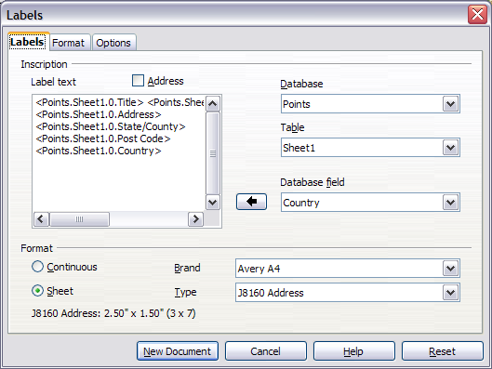
Figure 18: The completed label
- Click New Document. You now have a new, single-page document containing a series of frames, one for each label of the selected type and filled with the data source address fields that you selected. Quite often some of the fields in your address data source will be unused, leading to blank lines in your labels. If this is not important, go to “Printing” on page 14; otherwise, continue with “Removing blank lines from labels”.

Removing blank lines from labels
- First ensure that the label frames are showing the field contents (data source headings), rather than their underlying field names. If this is not the case, then either press Ctrl+F9 or choose View > Field Names to toggle the view.
- Next, ensure that you can see non-printing characters, such as paragraph marks, line breaks and so on. If these are not already visible, choose View > Nonprinting Characters from the menu bar, or press Ctrl+F10, or click on the Nonprinting Characters icon on the Standard toolbar.
You will now see that address field separation is created by line breaks , rather than paragraphs . As the suppression of blank address fields depends on hiding paragraphs, not lines, you need to replace line breaks with paragraphs as follows.
- Click in the first label, at the end of the last data source address field in the first line of the label. Press Delete to remove the new line character and then press Return (or the Enter key) to insert a paragraph marker. Repeat this action for each line in the address.
If the line spacing in the first label is not satisfactory, you may wish to correct this before proceeding, by modifying the paragraph style associated with the address. Unless you have changed it, the address uses the Default style.
Caution   | The objective of step 3) is to replace all line breaks at the end of data source address fields with paragraphs. Sometimes the address data field may be longer than the width of the label and will wrap to the next physical line: make sure that you are not misled by this into deleting and replacing anything other than line break characters.
- Click again at the end of the first paragraph to be conditionally suppressed and then choose Insert > Fields > Other. Select the Functions tab and then click on Hidden Paragraph in the Type column. Now click in the Condition box and enter the details of the condition that defines a blank address field. It has the general form of:
![Database.Table.Database field]
where the ‘!’ (NOT) character indicates the negative case and the square brackets indicate the condition.
For example, in our Points database the condition to test if the Last Name field is empty would be
![Points.Sheet1.Company] as illustrated in Figure 11.
To test for multiple conditions, use the operators AND and/or OR between the conditional statements, for example:
![Points.Sheet1.Title]AND![Points.Sheet1.Last Name]
Click Insert, but do not close the dialog box until all lines have been amended.
- Repeat for each paragraph to be conditionally suppressed, remembering to advance the cursor to the end of the line in question before changing the last element of the condition and Inserting the result.
Caution | The last paragraph of the label address block ends with a special field, Next record:Database.Table (Next record:Points.Sheet1 in our example), and the Hidden paragraph field must be inserted before this field. This can generally be accomplished by clicking at the end of the paragraph and then using the Left Arrow key once to skip back over it.  A clue that you omitted this action is the observation that some records have been skipped and are missing from the final output.
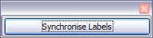
- Remembering that we selected Synchronise contents earlier, you should now be able to see a small window containing a Synchronise Labels button. Click on this button and the hidden paragraph fields are propagated to all the labels in your document.
You now have a template suitable for future use with the same data source and type of label. If you wish to save it, use File > Templates > Save as to save it as an Open Document Text Template (.ott) into the private template directory (folder) that you have previously defined in Tools >Options > LibreOffice > Paths > Templates.

Printing
- Choose File > Print. The message shown in Figure 12 appears. Click Yes to print a form letter.
- In the Mail Merge dialog box (Figure 13), you can choose to print all records or selected records. To select records to be printed, use Ctrl+click to select individual records. To select a block of records, select the first record in the block, scroll to the last record in the block, and Shift+click on the last record.
- Click OK to send the labels directly to the printer.
If you prefer to save the labels to a file, perhaps to allow some later editing such as changing the typeface or paragraph format, then you should select File in the output section of the Mail Merge dialog box, rather than using the default Printer selection. This changes the dialog box to highlight the Save merged document section, where Save as single document is pre-selected.
In this case, clicking OK brings up the Save as dialog box, where a file name can be entered for the saved labels.
If you did not save the prototype label fields document (template) in step 6f, then you are prompted to do so now by another Save as dialog box.
In either case, whether printing or saving to file, despite there apparently being only one page of labels, the printed or saved output will be expanded to include all of the selected records from the data source.

Editing a saved file of mailing labels
To edit a saved file of mailing labels, open the saved label file in the normal way. You will be prompted to update all links. Choose No for the following reason: The first label on the page is termed the “Master Label” and all other labels are linked to it. If you update the links, then all labels will end up containing the same data, which may not be what you want.
You can edit individual records in the normal way, by highlighting and changing the font name, for example.
However, you cannot edit all labels globally (for example, to change the font name for all records) by the technique of selecting the entire document. To achieve this result you have to edit the paragraph style associated with the label records as follows:
- Right-click any correctly spelled word in a label record. Select Edit Paragraph Style from the pop-up menu. (Note: If you click on a misspelled word, a different menu appears.)
- Then from the Paragraph Style dialog box, you can make changes to the font name, the font size, the indents, and other attributes.

Printing envelopes
Instead of printing mailing labels, you may wish to print directly onto envelopes. There are two basic ways to create envelopes, one where the envelope is embedded within a letter, generally as the first page (Insert in the Envelope dialog box), and another where the envelope is an independent document (New Doc. in the dialog box). In each case the addressing data may be manually entered, for example by copying and pasting from the letter with which it is associated, or it may originate within an address data source.
This section assumes the use of an address data source and, for convenience, a free-standing envelope. The production of envelopes involves two steps, setup and printing.

Setting up envelopes for printing
- Choose Insert > Envelope from the menu bar.
- In the Envelope dialog box, select the Format tab (Figure 19), where you can select the envelope format to use. You can then arrange the layout of the envelope to suit your requirements, together with the character and paragraph attributes to be used in the Sender and Addressee areas. These attributes are accessed using the Edit buttons to the right of the dialog box, next to the word Format.
Note | If the list of envelope formats in the Size section of this dialog box does not include the size you need, choose User Defined (at the bottom of the list) and specify the envelope size using the Width and Height boxes.
Tip | At this stage it is only possible to vary the position of the origin points (upper left corners) of the frames that will hold the Sender and Addressee information, but once the envelope has been created full adjustment of size and position will become possible and you may wish to make some cosmetic adjustments.
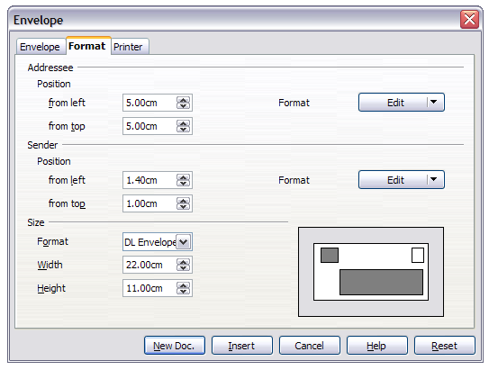
Figure 19: Envelope formatting dialog box
- The next step is to select the Printer tab (Figure 20), from where you may choose the printer you intend to use, its setup—for example, specification of the tray holding envelopes—and other printer-related options such as envelope orientation and shifting. You may need to experiment with these settings to achieve the best results with your printer.
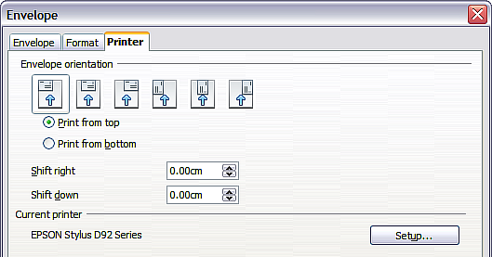
Figure 20: Choosing printer options for an envelope
- Select the Envelope tab (Figure 21).
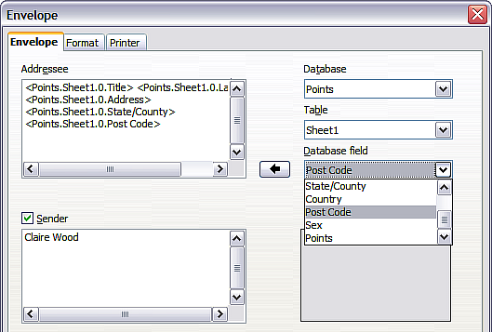
Figure 21: Choosing addressee and sender information for envelopes
- Choose whether or not to add Sender information to the envelope by selecting or deselecting the Sender option. If wanted, edit the information in the Sender box (Sender is the “from” on the envelope).
- You now have the choice of creating the Addressee fields by dragging and dropping from the data source headings (as described in “Creating a form letter” on page 7, and in particular in Figure 9) or using the facilities of the Envelope tab.
If you prefer dragging and dropping, then click New Doc., drag your data source headings into the Addressee area on your new envelope and skip to step 10), otherwise continue with the next step.
- Verify, add, or edit the information in the Addressee box. You can use the right-hand drop-down lists to select the database and table from which you can access the Addressee information, in a similar fashion to that described for “Printing mailing labels”, paragraphs 3, 4 and 5. The similarity of the method with Figure 17 and Figure 18 will be clear.
- When you have finished formatting, click either the New Doc. or Insert button to finish. As might be expected, New Doc creates only the envelope template in a new document, whereas Insert inserts the envelope into your current document as page 1.
If you don’t want to proceed with this envelope, click Cancel or press the Esc key. You can also click Reset to remove your changes and return to the original settings extant when the dialog box opened.
You can now modify the placement of the frames containing the sender and addressee information, or make further changes to the character and paragraph attributes (for example, the font) or add a logo or other graphic to the envelope.
Tip | If you frequently print envelopes from the same database onto the same size envelopes, at this point you may wish to create a template from this setup. See “Creating an envelope template” on page 19.
- Quite often some of the fields in your address data source will be unused, leading to blank lines in your envelope Addressee area. If this is not important, you can skip the next few paragraphs and go straight to “Merging and printing the envelopes” on page 18, otherwise continue as described here.
Tip | The following procedure is very similar to that used for a similar purpose in the section on printing mailing labels. It is reproduced here for ease of reference.
  - First ensure that the envelope is showing the field contents (data source headings), rather than their underlying field names. If this is not the case, then either press Ctrl+F9 or choose View > Field Names to toggle the view.
  - Next, ensure that you can see non-printing characters, such as paragraph marks, line breaks and so on. If these are not already visible, choose View > Nonprinting Characters from the menu bar, or press Ctrl+F10, or click on the Nonprinting Characters icon on the Standard toolbar.
You will now see that address field separation is created by line breaks , rather than paragraphs . As the suppression of blank address fields depends on hiding paragraphs, not lines, you need to replace line breaks with paragraphs as follows.
  - Click at the end of the last data source address field in the first line of the envelope. Press Delete to remove the new line character and then press Return (or the Enter key) to insert a paragraph. Repeat this action for each line of the envelope.
If the line spacing in the Addressee area is not satisfactory, you may wish to correct this before proceeding, by modifying the paragraph style associated with the address. Unless you have changed it, the address uses the Default style.
  - Click again at the end of the first paragraph to be conditionally suppressed and then choose Insert > Fields > Other. Select the Functions tab and then click on Hidden Paragraph in the Type column. Now click in the Condition box and enter the details of the condition that defines a blank address field. It has the general form of:
![Database.Table.Database field]
where the ‘!’ (NOT) character indicates the negative case and the square brackets indicate the condition.
For example, in our Points database the condition to test if the Last Name field is empty would be:
![Points.Sheet1.Last Name] as illustrated in Figure 11.
To test for multiple conditions, use the operators AND and/or OR between the conditional statements, for example:
![Points.Sheet1.Title]AND![Points.Sheet1.Last Name]
Click Insert, but do not close the dialog box until all lines have been amended.
  - Repeat for each paragraph to be conditionally suppressed, remembering to advance the cursor to the end of the line in question before changing the last element of the condition and Inserting the result.

Merging and printing the envelopes
To merge addresses and print the envelopes:
- Choose File > Print. A message box (Figure 12) appears. Click Yes to print a form letter.
- The Mail Merge dialog box (Figure 13) appears. As with form letters and mailing labels, you can choose to print envelopes for one, several or all address records in the database.
- Make your selections and then click OK to print direct to the printer. To check the envelopes before printing them, see “Editing merged documents” on page 10 for instructions.

Creating an envelope template
When your envelope layout and fields are complete to your satisfaction, you can save the result as a template.
- Choose File > Templates > Save.
- On the Templates dialog box, type a name for the new template and choose a category in which to store your template.
- Click OK to save the template.

Using the Mail Merge Wizard to create a form letter
The manual method of creating a form letter described in “Creating a form letter” on page 7 provides the most control over the result and is therefore recommended. If you prefer to use the Mail Merge wizard, the technique is described below.
Before starting you should note the following limitations:
- In Step 4 creating the salutation only allows the sex-related Mr. and Mrs. It makes no allowance for Miss or Ms, nor does it permit sexless addressing such as Dr.
- Again in Step 4, the General salutation is not editable and the default values are somewhat limited.
- In Step 5 the layout is idiosyncratic, with paragraph marks all over the place so as to space the address block frame and salutation. Creating a professional looking document requires significant editing.
If the above limitations are not a hindrance to you, then open a new document with File > New > Text Document and start the Mail Merge wizard using Tools > Mail Merge Wizard. The wizard opens, as shown in Figure 22.

Step 1: Select starting document
The wizard gives various options to select your starting document:
- Use the current document.
- Create a new document.
- Start with an existing document.
- Start from a template.
For the purposes of this description, we assume that you opened a new text document. This will ensure that all the steps in the wizard are fully explored, although with experience you may find it more practical to use a draft you prepared earlier, which will allow skipping some steps.
Select Use the current document and click Next.
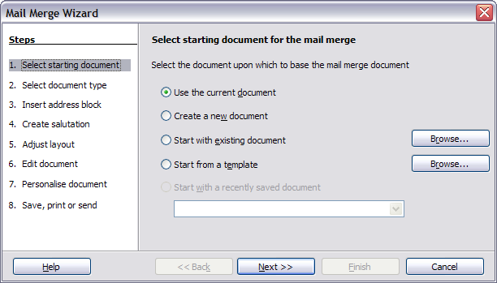Figure 22: Select starting document

Step 2: Select document type
The wizard can produce letters or, if a Java Mail connection exists, email messages. In this example, we are producing a letter. Select Letter and click Next.
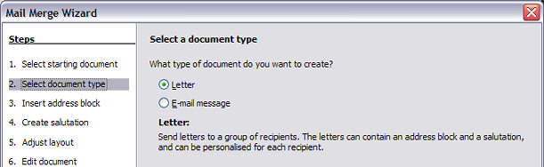
Figure 23: Choose document type

Step 3: Insert address block
This is the most complex step in the wizard. In this step (Figure 24) you will do three things:
- Tell the wizard which data source to use. The data source must be an existing file; in this example it is the “Points” spreadsheet created earlier.
- Select the address block to use in the document. This means choosing which fields appear (for example, whether the country is included) and how they look.
- Make sure that the fields all match correctly. This is very important. For example, the UK English version of the wizard has a field called <Surname>. If your spreadsheet has a column called “Last Name”, you need to tell the wizard that <Surname> and “Last Name” are equivalent. This is described in “Matching the fields” on page 23.
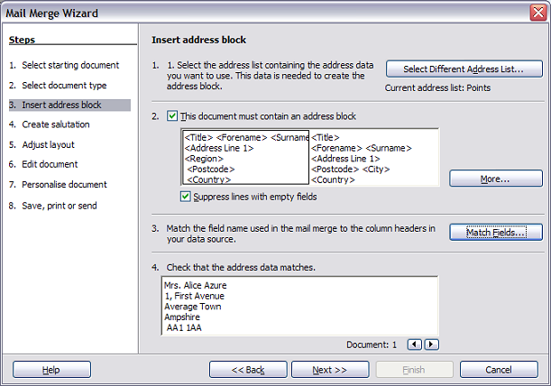
Figure 24: Insert address block

Selecting the data source (address list)
- If the current address list, identified beneath the Select Different Address List button in section 1, is not the one you wish to use, click the button to open the Select Address List dialog box (Figure 25) for choosing a data source.
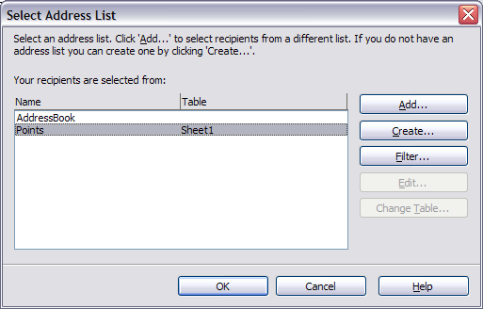
Figure 25: Select address list dialog box
- If you have not already created the address list, you may click Create to do so now. This step will allow you to create a CSV (Comma Separated Values) file with a new list of address records.
If you have an address list that is not registered in LibreOffice, but which you wish to use, click Add and select the file from the location in which it is saved.
In each of the above cases a new data source will be created and registered.
- Select the address list and click OK to return to step 3 of the wizard. We retain “Points” as our address book for this example. The wizard can also exclude certain records; click Filter to choose them.

Selecting the address block
- In section 2 (shown in Figure 24), select the address block to appear on the letter, define its appearance, and choose the fields it contains. The main page gives two choices. Click More to open the Select Address Block dialog box for more choices.
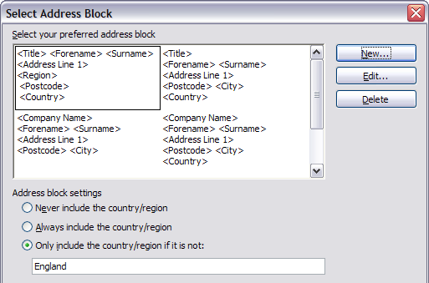
Figure 26: Select address block
- The Select Address Block dialog box displays the original two blocks plus other choices for the format of the address block (you may need to scroll down to see all of the choices). You can also optionally include or exclude the country (for example, only include the country if it is not England) in the Address block settings. The formats provided are relatively common, but they might not exactly match your preference. If this is the case, select the address block that is closest to what you want and click Edit, which opens the New Address Block dialog box.
- In the New Address Block dialog box, you can add or delete address elements using the arrow buttons on the left. To move elements around, use the arrow buttons on the right. For example, to add an extra space between forename and surname in Figure 27, click <Surname> and then click the right arrow button.
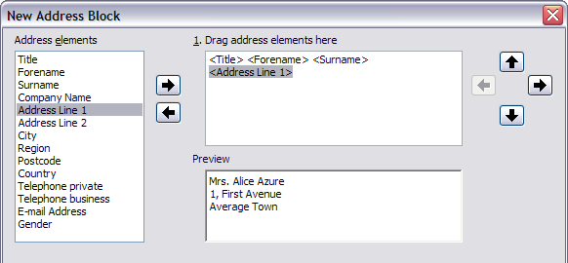
Figure 27: New address block

Matching the fields
Finally, it is time to match the wizard’s fields with the spreadsheet fields, so that items like <Surname> and “Last Name” match correctly.
- Look at section 3 of the wizard (shown in Figure 24 on page 21). The box at the bottom displays one record at a time, using the address block format you selected. Use the right and left arrow buttons below that address box to step through the addresses, checking that they display correctly. Do not assume that all the records display correctly, just because one or two do. Check them all if you can, or at least a good proportion.
- If the addresses do not display correctly (and they probably will not right away), click Match Fields.
- The Match Fields dialog box (Figure 28) has three columns:
- Address Elements are the terms the wizard uses for each field, such as <Forename> and <Surname>.
- Use the Matches to Field column to select, for each address element, the field from your data source that matches it.
- The Preview column shows what will be shown for this field from the selected address block, so you can double-check that the match is correct.
- When you have matched all the fields, click OK to return to step 3 of the wizard. Now, when you use the arrow buttons to look at all the addresses, they should all look correct. If not, go back and change anything you’re not happy with, before clicking Next to move to step 4.
Note that you will not be able to continue until you have correctly matched all the fields in your chosen address block. If you see <not yet matched> in a field position it indicates that the field in question is not correctly matched.
- Notice the option for Suppress lines with empty fields in section 2 of Figure 24. Using the Wizard, you do not have to create your own conditional suppression fields.
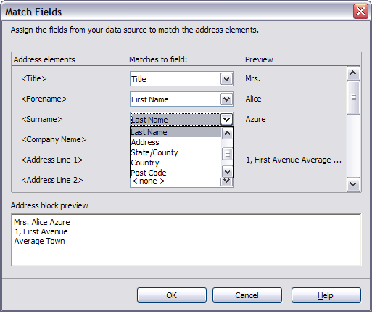
Figure 28: Match fields dialog box

Step 4: Create salutation
The salutation is the initial greeting, for example, Dear Mr Jones. In step 4, select the salutation that will appear in the letter.
You can use a different greeting for men and women. To do this, Writer must have some way of knowing whether a person is male or female. In our spreadsheet we had a column called Sex. In the section Address list field indicating a female recipient, set the field name to Sex and the field value to F. The male salutation is then printed for all men and the female salutation for all women.
Note | You do not need to tell LibreOffice who is a male, because it assumes that all non-female records are males.
If you do not select Insert Personalized Salutation, you can use a more general salutation without referring to the recipient directly, such as To whom it may concern.
As in step 3, step 4 of the wizard has a preview pane at the bottom. You should check more than one record to ensure that other records look the way you expect.
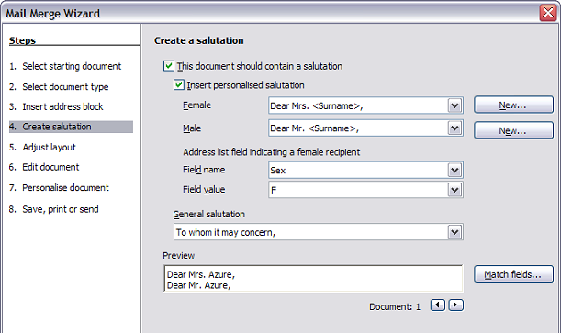
Figure 29: Create a salutation

Step 5: Adjust layout
In step 5, you can adjust the position of the address block and salutation on the page. You can place the address block anywhere on the page. The salutation is always on the left, but you can move it up and down the page. Use the buttons shown in Figure 30 to move the elements.
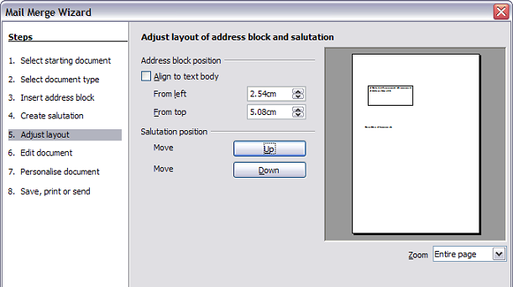
Figure 30: Adjust layout

Step 6: Edit document and insert extra fields
In step 6 you have another opportunity to exclude particular recipients from the mail merge, as shown in Figure 31.
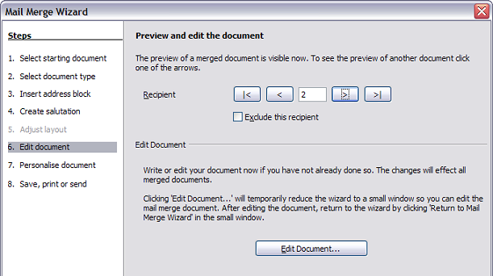
Figure 31: Edit document
You can also edit the body of the document. If you started with a blank document, you can write the whole letter in this step. Click Edit Document to shrink the wizard to a small window (Figure 32) so you can easily edit the letter.
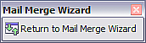
Figure 32: Minimized mail merge wizard
You need to perform another important task in this step. The wizard only inserts information from the name and address fields, but you may wish to add additional data. In our example, we want to tell each person how many points they had accumulated during the year; that information is in the spreadsheet. To do this:
- Click Edit Document in step 6 of the wizard.
- Choose Insert > Fields > Other. The Fields dialog box opens.
- Click the Database tab.
- On the left hand side, select Mail merge fields.
- Under Database selection find your data source (in this example, it is a spreadsheet). Expand it to see the fields.
- Click the field you want to insert, then click Insert to insert the field.
- You can insert any number of fields any number of times into your mail merge document.
- Click Close when you are done.
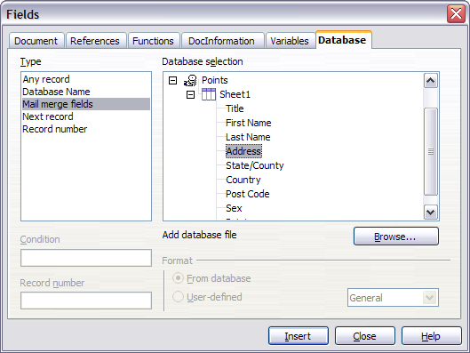
Figure 33: Insert mail merge fields dialog box
Note | The Database selection lists the data source you selected in step 3. All the information you need for the letter must be contained in that data source.

Step 7: Personalize documents
This step creates all your letters, one per recipient.
Clicking the Edit individual Document button here is similar to step 6. The difference is that you now edit a long file containing all of the letters, so you can make changes to a particular letter to one person. In this step of the Mail Merge wizard, click Find to open a dialog box that allows searches within the document, perhaps for an individual addressee.
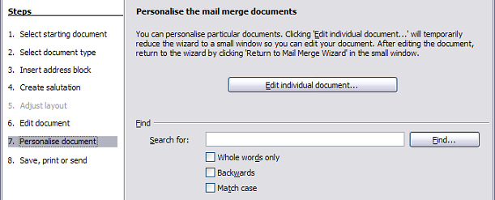
Figure 34: Personalize document
As with step 6, when editing the document, the wizard shrinks to a small window (Figure 32). Click on this window to expand the wizard to its full size.

Step 8: Save, print or send
You have now completed the mail merge process. The last step is to do something with it. In step 8, you can save the original sample letter, save the merged document, print the letters right away or, if you created email messages, send them.
You probably want to save the starting (prototype) document and the merged document. To do this, select Save starting document to reveal the Save starting document section containing the Save starting document button. This button will be active only if the document has not already been saved. Clicking on this button brings up the standard Save as dialog box. Once you have named and saved the document you return to the Step 8 dialog box as shown in Figure 36.
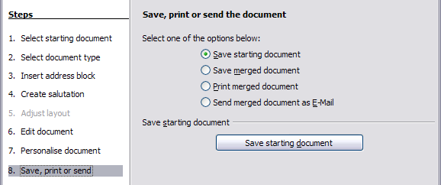
Figure 35: Step 8: Save, print or send
The merged document can now be saved by selecting Save merged document. This will reveal the Save merged document settings section, from which you can select to save either as one large file containing all the individual, generated letters or as a separate file for each letter.
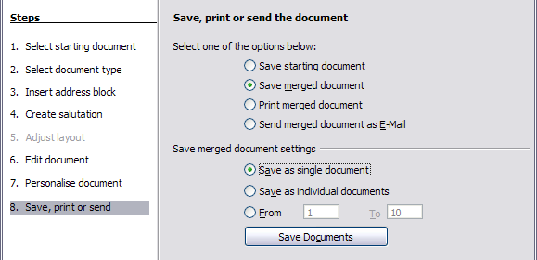
Figure 36: Saving a merged document
When you have saved the merged document, you can print the final letters now or later; and you can still manually check and edit the letters if necessary. If you elect to print at this stage, the dialog box shown in Figure 37 appears; it should be self-explanatory.
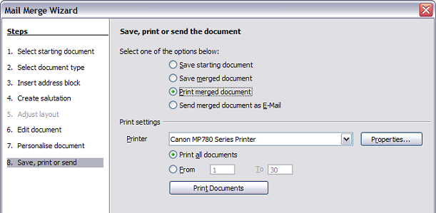
Figure 37: Printing the merged document

