Shapes
original horizontally mirrored

Usage Example

The graph is to be drawn for .
Because the parabola is very wide a shape with symmetric points cannot be used. The shape would be so wide, that its left edge is far beyond the left edge of the content area. That might work in Draw/Impress but not in Writer and Calc.
Calculate the coordinates for , and for a value between them, e.g.
, and
Set snap points for these points into your coordinate system.
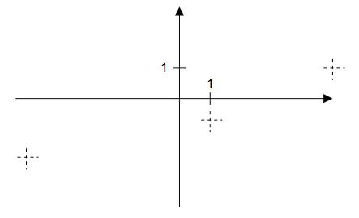
The left point is lower than the right point, so the mirrored shape has to be used.
Enable “Snap to Snap Guides”.
Insert the shape and drag its top right corner to the right snap point and drag its bottom left corner to the left snap point.
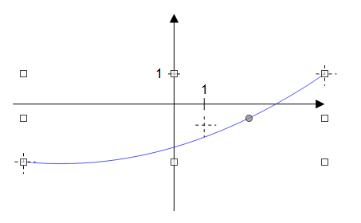
Now drag the handle to the third snap point. Unfortunately handle do not snap to snap points. But using a large zoom helps to position it.
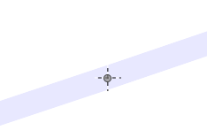
This is a screen shot from 3000% zoom. The line style is temporarily set to 90% transparency. That way the snap point and the handle is better visible.
Another way to position and size the shape is using the ‘Position and Size’ dialog. Assuming the unit of the coordinate system is 10 mm, you get custom shape width=100 mm and height≈29.17 mm. If the position of the origin is (100 mm|40 mm), then the right top point is at (150 mm|30 mm).
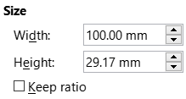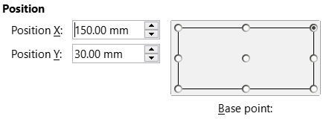
The fields for the handle are on tab ‘Slant and Corner Radius’. The values are relative to the top and to the left edge of the shape. Therefore the handle needs X=60 mm and Y=16.67 mm.
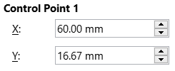
In case you need negative values, you can enter them, only the dialog does not show negative values.
The final parabola segment is then
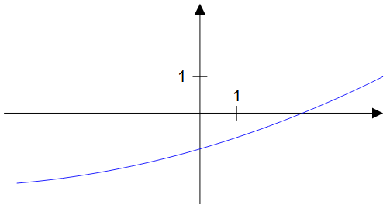
Design
If a parabola is given by a function term and has the two points and , then the intersection point Z of the tangents in points A and B has the coordinates .
For defining the parabola in the draw:enhanced-path, we are free to set points A and B. The actual needed points in the document are achieved by scaling and positioning the custom shape. So we use A(0|0) and B(40|40) here. That is no restriction. If the user needs a parabola segment, where the right point is higher than the left point, he can use the custom shape horizontally mirrored.
With these points the formulas become less complex: and .
To totally determine the parabola a third point is needed. That point shall be given by an XY-handle. With the handle in position the value for parameter b is then

We will restrict the handle to the range ]0;40[. The values 0 and 40 need to be excluded, otherwise there will be a division by zero in the calculation for parameter . We will use the range [0.001; 39.999].
Markup
Handle
<draw:handle
draw:handle-position="$0 $1"
draw:handle-range-x-minimum="0.001"
draw:handle-range-x-maximum="39.999" />
draw:modifiers="10 20" arbitrary start values inside the range
Equations
<draw:equation draw:name="f0"
draw:formula="$0*$0" />
<draw:equation draw:name="f1"
draw:formula="(?f0-40*$1)/(?f0-40*$0)"
<draw:equation draw:name="f2"
draw:formula="20*?f1" />
Path
M 0 0 initial point A(0|0), start point of Bézier curve
Q 20 ?f2 point Z(20|20 b), control point of Bézier curve
40 40 point B(40|40), end point of Bézier curve
So we get all together
<draw:enhanced-geometry
draw:type="non-primitive"
svg:viewBox="0 0 40 40"
draw:modifiers="10 20"
draw:enhanced-path="M 0 0 Q 20 ?f2 40 40">
<draw:equation draw:name="f0" draw:formula="$0*$0" />
<draw:equation draw:name="f1" draw:formula="(?f0-40*$1)/(?f0-40*$0)" />
<draw:equation draw:name="f2" draw:formula="20*?f1" />
<draw:handle draw:handle-position="$0 $1"
draw:handle-range-x-minimum="0.001"
draw:handle-range-x-maximum="39.999" />
</draw:enhanced-geometry>

