
OpenOffice.org Macros Explained
OOME Third Edition

Last Modified
Monday, May 28, 2012 at 01:04:26 AM
Document Revision: 449

General Information
The contents of this document is Copyright 2011 - 2012 by Andrew D. Pitonyak. I will make a final license decision when I am finished.
I created a second edition that was never released, which is why I refer to this book as the third edition.
I have been repeatedly asked about the cover page so.... I am neither an artist nor a designer, so, I hired Amanda Barham (see http://www.amandabarham.com). She did an awesome job.

Table of Contents
General Information 1
Table of Contents i
3. Language Constructs 3
3.1. Compatibility with Visual Basic 4
3.2. Compiler options and directives 5
3.3. Variables 5
3.3.1. Constant, subroutine, function, label, and variable names 5
3.3.2. Declaring variables 6
3.3.3. Assigning values to variables 8
3.3.4. Boolean variables are True or False 8
3.3.5. Numeric variables 9
Integer variables 10
Long Integer variables 11
Currency variables 11
Single variables 12
Double variables 12
3.3.6. String variables contain text 12
3.3.7. Date variables 13
3.3.8. Create your own data types 15
3.3.9. Declare variables with special types 16
3.3.10. Object variables 16
3.3.11. Variant variables 16
3.3.12. Constants 17
3.4. The With statement 18
3.5. Arrays 19
3.5.1. Changing the dimension of an array 21
3.5.2. The unexpected behavior of arrays 23
3.6. Subroutines and functions 25
3.6.1. Arguments 26
Pass by reference or by value 26
Optional arguments 29
Default argument values 30
3.6.2. Recursive routines 30
3.7. Scope of variables, subroutines, and functions 31
3.7.1. Local variables defined in a subroutine or function 31
3.7.2. Variables defined in a module 32
Global 33
Public 33
Private or Dim 34
3.8. Operators 34
3.8.1. Mathematical and string operators 35
Unary plus (+) and minus (-) 36
Exponentiation (^) 36
Multiplication (*) and Division (/) 37
Remainder after division (MOD) 37
Integer division (\) 38
Addition (+), subtraction (-), and string concatenation (& and +) 39
3.8.2. Logical and bit-wise operators 39
AND 42
OR 42
XOR 43
EQV 43
IMP 44
NOT 45
3.8.3. Comparison operators 45
3.9. Flow control 46
3.9.1. Define a label as a jump target 46
3.9.2. GoSub 46
3.9.3. GoTo 47
3.9.4. On GoTo and On GoSub 47
3.9.5. If Then Else 48
3.9.6. IIf 49
3.9.7. Choose 49
3.9.8. Select Case 50
Case expressions 50
If Case statements are easy, why are they frequently incorrect? 51
Writing correct Case expressions 52
3.9.9. While ... Wend 54
3.9.10. Do ... Loop 54
Exit the Do Loop 55
Which Do Loop should I use? 55
3.9.11. For ... Next 56
3.9.12. Exit Sub and Exit Function 57
3.10. Error handling using On Error 57
3.10.1. CVErr 59
3.10.2. Ignore errors with On Error Resume Next 60
3.10.3. Clear an error handler with On Error GoTo 0 60
3.10.4. Specify your own error handler with On Error GoTo Label 60
3.10.5. Error handlers — why use them? 63
3.11. Conclusion 65

Language Constructs
The OpenOffice.org macro language is similar to the one in Microsoft Office because they are both based on BASIC. Both macro languages access the underlying implementation structures, which differ significantly and are therefore incompatible. This chapter emphasizes the portions of the language that do not access the underlying implementation.
This chapter shows how to assemble different components to produce an OOo macro that will compile and run. In a word: syntax. Correct syntax does not imply that the macro does what you want, only that the pieces are put together in a correct way. The phrases “Can I drive?” and “May I drive?” are both syntactically correct. The first phrase is about ability, and the second phrase is about permission. In speech, these two questions may be understood to have the same meaning. The computer, on the other hand, does exactly what you ask, rather than what you mean.
The primary components that syntactically constitute an OpenOffice.org macro are statements, variables, subroutines, and functions, and flow-control constructs. A statement is a small, runnable portion of code that is usually written as a single line of text. Variables are containers that hold values that can change during macro execution. Subroutines and functions separate a macro into functional named groups of statements, allowing for better organization. Flow control directs which statements run and how many times.
OOo runs one line of a macro at a time. Each line of a macro is delimited exactly the way it sounds; by a new line (see Listing 1).
Listing 1. Two line macro
Print "This is line one"
Print "This is line two"
Lines that are too long may use more than one line by appending an underscore (_) to the end of the line (see Listing 2). The underscore must be the last character on the line for it to act as a line-continuation character. The underscore has no special meaning when it isn’t the last character of a line, allowing it to be used inside strings and in variable names. When used as a continuation character, spaces may precede the underscore and are in some cases required to separate the underscore from what precedes it. For example, splitting the line “a+b+c” after the b requires a space between the b and the underscore, or the underscore is considered part of the variable name. Spaces that inadvertently follow a continuation character may cause a compile-time error. Unfortunately, the error does not state that something follows the underscore, but that the next line is invalid.
Listing 2. Append an underscore to the end of a line to continue on the next line.
Print "Strings are concatenated together " & _
"with the ampersand character"
TIP | When anything follows a line-continuation character, the next line is not taken as its continuation. Sometimes, when I copy code listings from web sites and paste them into the IDE, an extra space is added at the end of a line, which breaks line continuation.
You can place multiple statements on a single line by separating them with colons. This is usually done for improved code readability. Each of the combined statements act as a single line of code while debugging the macro in the Integrated Development Environment (IDE). Listing 3, therefore, acts like three separate statements while using the IDE to single-step through the macro.
Listing 3. Set the variables x, y, and z to zero.
x = 0 : y = 0 : z = 0
You should liberally add remarks, which are also called comments, to all of the macros that you write. While writing a macro, remember that what is clear today may not be clear tomorrow, as time passes and new projects arise and memory fades all too quickly. You can start a comment with either the single quotation character, or the keyword REM. All text on the same line following a comment indicator is ignored. Comments are not considered runnable statements; they are ignored while single-stepping a macro.
Listing 4. Add comments to all of the macros that you write.
REM Comments may start with the keyword REM.
ReM It is not case-sensitive so this is also a comment.
' All text following the start of the comment is ignored
X = 0 ' A comment may also start with a
' single quote
z = 0 REM All text following the start of the comment is ignored
TIP | Keywords, variables, and routine names in OOo Basic are not case-sensitive.  Therefore, REM, Rem, and rEm all start a comment.
Nothing can follow a line-continuation character, and this includes comments. All text following a comment indicator is ignored — even the continuation character. The logical result from these two rules is that a line-continuation character can never occur on the same line as a comment.

Compatibility with Visual Basic
With respect to syntax and BASIC functionality, OOo Basic is very similar to Visual Basic. The two Basic dialects are nothing alike when it comes to manipulating documents, but the general command set is very similar. Steps were taken to improve the general compatibility between the two dialects. Many enhancements were released with OOo 2.0. Many of the changes are not backward compatible with existing behavior. To help resolve these conflicts, a new compiler option and a new run-time mode were introduced to specify the new compatible behavior.
The compiler option “Option Compatible” directs some features. This option affects only the module in which it is contained. Because a macro calls different modules during its execution, both the old and new behavior may be used, depending upon the existence of “Option Compatible” in each called module. Setting the option in one module and then calling another module has no effect in the called module.
A run-time function, CompatibilityMode( True/False ), allows the behavior of run-time functions to be modified during the execution of a macro. This provides the flexibility to enable the new run-time behavior, perform some operations, and then disable the new run-time behavior. CompatibilityMode(False) overrides Option Compatible for the new runtime behavior. Hopefully, some method of probing the current mode will be provided.
Visual basic allows any Latin-1 (ISO 8859-1) character as a valid variable name, OOo does not. Setting “Option Compatible” allows “ä” to be considered a valid variable name. This is just one of many changes that use “Option Compatible.” The CompatibilityMode() function neither enables nor disables the new extended identifier names because CompatibilityMode() is not called until run time and variable names are recognized at compile time.
Both Visual Basic and OOo Basic support the rmdir() command to remove a directory. VBA can remove only empty directories, but OOo Basic can recursively remove an entire directory tree. If CompatibilityMode(True) is called prior to calling rmdir(), OOo Basic will act like VBA and generate an error if the specified directory is not empty. This is just one of many changes that use CompatibilityMode().
StarBasic is much more forgiving than VBA. It is easier, therefore, to convert simple macros from VBA to OOo Basic. A few examples, in OOo Basic, “set” is optional during assignment. Therefore, “set x = 5” works in both VBA and OOo Basic, but “x = 5” fails in VBA and works with OOo Basic.
Another example is that array methods are far more stable and forgiving in OOo than in VBA; for example, the functions to determine array bounds (LBound and UBound) work fine with empty arrays, whereas VBA crashes.

Compiler options and directives
A compiler converts a macro into something that the computer is able to run. Compiler behavior can be controlled through commands such as “Option Explicit” at the top of a module before all variables, subroutines, and functions. A compiler option controls the compilers behavior for the module containing the option.
Table 1. Compiler options and directives.
Option | Description
Def | Give a default type to undeclared variables based on the variables name.
Option Base | Control whether the first array index is 0 or 1; assuming it is not specified.
Option Compatible | Cause Star Basic to act more like VB.
Option Explicit | Force all variables to be defined. While the macro runs, if a variable that has not yet been defined is used, an error occurs.

Variables
Variables are containers that hold values. OpenOffice.org supports different types of variables designed to hold different types of values. This section shows how to create, name, and use variables. Although OOo Basic does not force you to declare variables, you should declare every variable that you use. The reasons for this are developed throughout this section.

Constant, subroutine, function, label, and variable names
Always choose meaningful names for your variables. Although the variable name “var1” requires little thought during creation, “FirstName” is more meaningful. Some variable names are not particularly descriptive but are commonly used by programmers anyway. For example, “i” is commonly used as a shortened version of “index,” for a variable that is used to count the number of times a repetitive task is executed in a loop. OOo Basic imposes restrictions on variable names, including the following:
- A variable name cannot exceed 255 characters in length. Well, officially a variable name cannot exceed 255 characters. I tested names with more than 300 characters with no problems, but I don’t recommend this!
- The first character of a variable name must be a letter: A-Z or a-z. If Option Compatible is used, then all characters defined as letters in the Latin-1 (ISO 8859-1) character set are accepted as part of an identifier name.
- The numbers 0-9 and the underscore character (_) may be used in a variable name, but not as the first character. If a variable name ends with an underscore, it won’t be mistaken for a line-continuation character.
- Variable names are not case sensitive, so “FirstName” and “firstNAME” both refer to the same variable.
- Variable names may contain spaces but must be enclosed in square brackets if they do. For example, [First Name]. Although this is allowed, it is considered poor programming practice.
TIP | These restrictions also apply to constant, subroutine, function, and label names.

Declaring variables
Some programming languages require that you explicitly list all variables used. This process is called “declaring variables.” OOo Basic does not require this. You are free to use variables without declaring them.
Although it is convenient to use variables without declaring them, it is error-prone. If you mistype a variable name, it becomes a new variable rather than raising an error. Place the keywords “Option Explicit” before any runnable code in every module to cause OOo Basic to treat undeclared variables as run-time errors. Comments may precede Option Explicit because they are not runnable. Although it would be even better if this became a compile-time error, OOo Basic does not resolve all variables and routines until run time.
Listing 5. Use Option Explicit before the first runnable line in a module.
REM ***** BASIC *****
Option Explicit
TIP | Use “Option Explicit” at the top of every module that you write; it will save you a lot of time searching for errors in your code. When I am asked to debug a macro, the first thing I do is add “Option Explicit” at the top of each module.
The scope for options is the module which contains the option. In other words, setting option explicit in one module, then calling another module, will not cause undeclared variables in the called module to cause a runtime error; unless the called module also has “option explicit”.
You can declare a variable with or without a type. A variable without an explicit type becomes a Variant, which is able to take on any type. This means that you can use a Variant to hold a numeric value and then, in the next line of code, overwrite the number with text. Table 2 shows the variable types supported by OOo Basic, the value that each type of variable contains immediately after declaration (“initial value”), and the number of bytes that each type uses. In OOo Basic, a variable's type can be declared by appending a special character to the end of the name when it is declared. The Post column in Table 2 contains the supported characters that can be post-fixed to a variable's name when the variable is declared.
Table 2. Supported variable types and their initial values.
Type | Post | Initial | Bytes | Convert | Description
Boolean |  | False | 1 | CBool | True or False
Currency | @ | 0.0000 | 8 | CCur | Currency with 4 decimal places
Date |  | 00:00:00 | 8 | CDate | Dates and times
Double | # | 0.0 | 8 | CDbl | Decimal numbers in the range of  +/-1.79769313486232 x 10E308
Integer | % | 0 | 2 | CInt | Integer from -32,768 through 32,767
Long | & | 0 | 4 | CLng | Integer from -2147483648 through 2147483647
Object |  | Null | varies |  | Object
Single | ! | 0.0 | 4 | CSng | Decimal numbers in the range of  +/-3.402823 x 10E38
String | $ | "" | varies | CStr | Text with up to 65536 characters
Variant |  | Empty | varies | CVar | May contain any data type

Although OOo Basic supports a Byte variable type, you can’t directly declare and use one. The function CByte, as discussed later, returns a Byte value that may be assigned to a variable of type Variant. With OOo version 2.0, you can declare a variable of type Byte, but the variable is assumed to be an externally defined object of type Byte rather than an internally defined Byte variable.
Use the DIM keyword to explicitly declare a variable before use (see Table 3). You can declare multiple variables on a single line, and you can give each variable a type when it is declared. Variables with no declared type default to type Variant.
Table 3. Declaring simple variables.
Declaration | Description
Dim Name | Name is type Variant because no type is stated.
Dim Name As String | Name is type String because the type is explicitly stated.
Dim Name$ | Name$ is type String because Name$ ends with a $.
Dim Name As String, Weight As Single | Name is type String and Weight is type Single.
Dim Width, Length | Width and Length are type Variant.
Dim Weight, Height As Single | Weight is type Variant and Height is type Single.

TIP | When multiple variables are declared in a single line, the type for each variable must be  listed separately. In the last line of Table 5, Weight is a Variant, even though it looks like it may be of type Single.
Much of the available literature on OOo macro programming uses a variable naming scheme based on Hungarian notation. With Hungarian notation, you can determine a variable’s type from its name. In practice, everyone does this differently and with differing levels of adherence. This is a stylistic decision that some people love and some people hate.
OOo Basic uses Def<type> statements to facilitate the use of Hungarian notion. The Def statements, which are local to each module that uses them, provide a default type for an undeclared variable based on its name. Normally, all undeclared variables are of type Variant.
The Def statement is followed by a comma-separated list of character ranges that specify the starting characters (see Listing 6).
Listing 6. Declare untyped variables starting with i, j, k, or n to be of type Integer.
DefInt i-k,n
Table 4 contains an example of each supported Def statement. Def statements, like Option statements, are placed in the module before any runnable line or variable declaration. The Def statement does not force a variable with a specific first letter to be of a certain type, but rather provides a default type other than Variant for variables that are used but not declared. I have never seen the Def statement used and I recommend that you do not use the Def statement.
TIP | If you use “Option Explicit,” and you should, you must declare all variables. This renders the Def<type> statements useless because they affect only undeclared variables.
Table 4. Examples of supported Def statements in OpenOffice.org.
Def Statement | Type
DefBool b | Boolean
DefDate t | Date
DebDbl d | Double
DefInt i | Integer
DefLng l | Long
DefObj o | Object
DefVar v | Variant

Assigning values to variables
The purpose of a variable is to hold values. To assign a value to a variable, type the name of the variable, optional spaces, an equals sign, optional spaces, and the value to assign to the variable, like so:
X = 3.141592654
y = 6
The optional keyword Let may precede the variable name but serves no purpose other than readability. A similar optional keyword, Set, meant for Object variables, serves no purpose other than readability. These keywords are rarely used.

Boolean variables are True or False
Boolean variables have two valid values: True or False. They are internally represented by the Integer values -1 and 0, respectively. Any numeric value assigned to a Boolean that does not precisely evaluate to 0 is converted to True. The macro in Listing 7 introduces a few new concepts. A string variable, s, accumulates the results of the calculations, which are displayed in a dialog (see Figure 1). Adding CHR$(10) to the string causes a new line to be printed in the dialog. Unfortunately, accumulating the results in a string provides a more complicated macro than using simple statements such as “Print CBool(5=3)”, but the results are easier to understand (see Figure 1). In the OOo version of the document, a button is frequently available that allows you to run the macro immediately.
Listing 7. Demonstrate conversion to type boolean.
Sub ExampleBooleanType
Dim b as Boolean
Dim s as String
b = True

b = False
b = (5 = 3) REM Set to False
s = "(5 = 3) => " & b
b = (5 < 7) REM Set to True
s = s & CHR$(10) & "(5 < 7) => " & b
b = 7 REM Set to True because 7 is not 0
s = s & CHR$(10) & "(7) => " & b
MsgBox s
End Sub

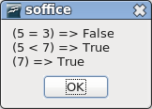
Figure 1. The dialog displayed by Listing 7.
The internal binary representation of True as -1 has all of the bits set to 1. The internal binary representation of False as 0 has all of the bits set to 0.

Numeric variables
Numeric variables contain numbers. OOo Basic supports integers, floating-point, and currency numbers. Integers may be expressed as hexadecimal (base 16), octal (base 8), or the default decimal numbers (base 10). In common practice, OOo users almost always use decimal numbers, but the other types are presented here as well, for completeness.
A discussion of other number bases is important because internally, computers represent their data in binary format. It is easy to convert between the binary, hexadecimal, and octal number bases; and for humans it may be easier to visualize binary numbers when represented in other number bases.
Decimal numbers, base 10, are composed of the 10 digits 0, 1, 2, 3, 4, 5, 6, 7, 8, and 9. Add 1 to 9 in decimal and the result is 10. Binary (base 2), octal (base 8), and hexadecimal (base 16) numbers are also commonly used in computing. Octal numbers are composed of the numbers 0, 1, 2, 3, 4, 5, 6, and 7. In octal, add 1 to 7 and the result is 10 (base 8). Hexadecimal numbers are composed of the 16 digits 0, 1, 2, 3, 4, 5, 6, 7, 8, 9, A, B, C, D, E, and F. Binary numbers are composed of the two digits 0 and 1. Table 5 contains the numbers from 0 through 18 in decimal, and their corresponding values in binary, octal, and hexadecimal bases.
Table 5. Numbers in different bases.
Decimal | Binary | Octal | Hexadecimal
0 | 0 | 0 | 0
1 | 1 | 1 | 1
2 | 10 | 2 | 2
3 | 11 | 3 | 3
4 | 100 | 4 | 4
5 | 101 | 5 | 5
6 | 110 | 6 | 6
7 | 111 | 7 | 7
8 | 1000 | 10 | 8
9 | 1001 | 11 | 9
10 | 1010 | 12 | A
11 | 1011 | 13 | B
12 | 1100 | 14 | C
13 | 1101 | 15 | D
14 | 1110 | 16 | E
15 | 1111 | 17 | F
16 | 10000 | 20 | 10
17 | 10001 | 21 | 11
18 | 10010 | 22 | 12

Integers are assumed to be expressed as decimal numbers. Commas are not allowed. Hexadecimal numbers are preceded by “&H” and octal numbers are preceded by “&O” (letter O, not a zero). Unfortunately, there is no easy method to enter binary numbers. Table 6 presents a few simple guidelines for entering numbers.
Table 6. A few guidelines for entering numbers in OOo Basic.
Example | Description
Use 1000 not 1,000 | Write numbers without a thousands separator; do not use commas.
+ 1000 | A space is permitted between a leading plus or minus sign and the number.
&HFE is the same as 254 | Precede a hexadecimal number with &H.
&O11 is the same as 9 | Precede an octal number with &O.
Use 3.1415 not 3,1415 | Do not use commas for the decimal.
6.022E23 | In scientific notation, the “e” can be uppercase or lowercase.
Use 6.6e-34 not 6.6e -34 | Spaces are not allowed in a number. With the space, this evaluates as 6.6 - 34 = -27.4.
6.022e+23 | The exponent may contain a leading plus or minus sign.
1.1e2.2 evaluates as 1.1e2 | The exponent must be an integer. The fractional portion is ignored.

In general, assigning a String to a numeric variable sets the variable to zero and does not generate an error. If the first characters in the string represent a number, however, then the string is converted to a number and the non-numeric portion of the string is ignored — numeric overflow is possible.

Integer variables
An integer is a whole number that may be positive, negative, or equal to zero. Integer variables are a good choice for numbers representing non-fractional quantities, such as age or number of children. In OOo Basic, Integer variables are 16-bit numbers supporting a range from -32768 through 32767. Floating-point numbers assigned to an integer are rounded to the nearest Integer value. Appending a variable name with “%” when it is declared is a shortcut to declaring it as type Integer.
Listing 8. Demonstrate integer variables.
Sub ExampleIntegerType
Dim i1 As Integer, i2% REM i1 and i2 are both Integer variables
Dim f2 As Double
Dim s$
f2= 3.5
i1= f2 REM i1 is rounded to 4

s = "3.50 => " & i1
f2= 3.49
i2= f2 REM i2 is rounded to 3
s = s & CHR$(10) & "3.49 => " & i2
MsgBox s
End Sub
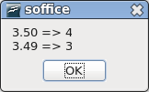
Figure 2. Demonstrating integer variables in Listing 8.

Long Integer variables
“Long” is an integer type that has a greater range than type Integer. Long variables are 32-bit numbers supporting a range from -2,147,483,648 through 2,147,483,647. Long variables use twice as much memory as Integer variables but they can hold numbers that are much larger in magnitude. Floating-point numbers assigned to type Long are rounded to the nearest Long value. Appending a variable name with “&” when it is declared is a shortcut to declaring it as type Long. The output from Listing 9 is the same as Listing 8 (see Figure 2).
Listing 9. Demonstrate long variables.
Sub ExampleLongType
Dim NumberOfDogs&, NumberOfCats As Long ' Both variables are Long
Dim f2 As Double
Dim s$
f2= 3.5
NumberOfDogs = f2 REM round to 4
s = "3.50 => " & NumberOfDogs
f2= 3.49
NumberOfCats = f2 REM round to 3
s = s & CHR$(10) & "3.49 => " & NumberOfCats
MsgBox s
End Sub

Currency variables
Currency variables, as the name implies, are designed to hold financial information. The Currency type was originally introduced to avoid the rounding behavior of the floating-point types Single and Double. Visual Basic .NET removed the Currency type in favor of the Decimal type.
Currency variables are 64-bit, fixed-precision numbers. Calculations are performed to four decimal places and 15 non-decimal digits accuracy. This yields a range from -922,337,203,658,477.5808 through +922,337,203,658,477.5807. Appending a variable name with “@” when it is declared is a shortcut to declaring it as type Currency.
Listing 10. Demonstrate currency variables.
Sub ExampleCurrencyType
Dim Income@, CostPerDog As Currency
Income@ = 22134.37
CostPerDog = 100.0 / 3.0
REM Prints as 22134.3700
Print "Income = " & Income@
REM Prints as 33.3333
Print "Cost Per dog = " & CostPerDog
End Sub

Single variables
Single variables, unlike Integer variables, can have a fractional portion. They are called “floating-point numbers” because, unlike Currency variables, the number of decimals allowed is not fixed. Single variables are 32-bit numbers that are accurate to about seven displayed digits, making them suitable for mathematical operations of average precision. They support positive or negative values from 3.402823 x 10E38 to 1.401298 x 10E-45. Any number smaller in magnitude than 1.401298 x 10E-45 becomes zero. Appending a variable name with “!” when it is declared is a shortcut to declaring it as type Single.
Listing 11. Demonstrate single variables.
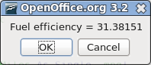
Sub ExampleSingleType
Dim GallonsUsed As Single, Miles As Single, mpg!
GallonsUsed = 17.3
Miles = 542.9
mpg! = Miles / GallonsUsed
Print "Fuel efficiency = " & mpg!
End Sub

Double variables
Double variables are similar to Single variables except that they use 64 bits and have about 15 significant digits. They are suitable for high-precision mathematical operations. Double variables support positive or negative values from 1.79769313486232 x 10E308 to 4.94065645841247 x 10E-324. Any number smaller in magnitude than 4.94065645841247 x 10E-324 becomes zero. Appending a variable with “#” when it is declared is a shortcut to declaring it as type Double.
Listing 12. Demonstrate double variables.
Sub ExampleDoubleType
Dim GallonsUsed As Double, Miles As Double, mpg#
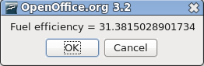
GallonsUsed = 17.3
Miles = 542.9

mpg# = Miles / GallonsUsed
Print "Fuel efficiency = " & mpg#
End Sub

String variables contain text
String variables are used to hold text. In OOo, text is stored as Unicode version 2.0 values, which provides good support for multiple languages. Each String variable can hold up to 65,535 characters. Appending a variable with “$” when it is declared is a shortcut to declaring it as type String.
Listing 13. Demonstrate string variables.
Sub ExampleStringType
Dim FirstName As String, LastName$
FirstName = "Andrew"
LastName$ = "Pitonyak"
Print "Hello " & FirstName & " " & LastName$
End Sub
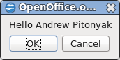
Figure 3. Demonstrating string variables in Listing 13.
Always remember that strings are limited to 65,535 characters. A macro counted the number of characters in a text document by converting the document to a string and then taking the length. The macro worked until the document contained more than 65,535 characters. In Visual Basic .NET, String variables may contain approximately 2 billion Unicode characters.
Place two double quote characters in a row to insert a double quotation character into a string.
S = "She said ""Hello""" REM She said "Hello"
Visual Basic string constants are available when using “Option Compatible” (see Table 7). You must use Option Compatible for the module rather than using CompatibilityMode(True) because the string constant is recognized at compile time rather than run time.
Table 7. Visual Basic-compatible string constants.
Constant | Value | Description
vbCr | CHR$(13) | Carriage return
vbCrLf | CHR$(13) & CHR$(10) | Carriage return/linefeed combination
vbFormFeed | CHR$(12) | Form feed
vbLf | CHR$(10) | Line feed
vbNewLine | CHR$(13) & CHR$(10) or CHR$(10) | Platform-specific newline character — whatever is appropriate
vbNullChar | CHR$(0) | Character with ASCII value 0
vbNullString | "" | Empty string. This is a string with a terminating null.
vbTab | CHR$(9) | Horizontal tab
vbVerticalTab | CHR$(11) | Vertical tab

The string constants in Table 7 allow you to define constant strings with special characters. Previously, you had to define the string by using code that called the CHR$() function.
Option Compatible
Const sGreeting As String = "Hello" & vbCr & "Johnny" ' This contains a CR.

Date variables
Date variables contain date and time values. OOo Basic stores dates internally as a Double. Dates, like all numerical types, are initialized to zero, which corresponds to December 30, 1899 at 00:00:00. Adding or subtracting 1 to/from a date corresponds to adding or subtracting a day. One hour, one minute, and one second correspond to the numbers 1/24, 1/(24 * 60), and 1/(24 * 60 * 60), respectively. The date functions supported by OOo Basic are introduced in Table 8 and fully discussed later.
Listing 14. Demonstrate date variables.
Sub ExampleDateType
Dim tNow As Date, tToday As Date
Dim tBirthDay As Date
tNow = Now()
tToday = Date()
tBirthDay = DateSerial(1776, 7, 4)
Print "Today = " & tToday
Print "Now = " & tNow
Print "A total of " & (tToday - tBirthDay) &_
" days have passed since " & tBirthDay
End Sub
Negative numbers are valid and correspond to dates before December 30, 1899. January 1, 0001, corresponds to the floating-point number -693,595. Continuing backward produces dates that are B.C. (Before Christ, sometimes also referred to as B.C.E., meaning Before the Christian Era, or Before the Common Era) rather than A.D. (Anno Domini). A thorough discussion of date handling is presented later.
Table 8. Functions and subroutines related to dates and times.
Function | Type | Description
CDate(expression) | Date | Convert a number or string to a date.
CDateFromIso(string) | Date | Convert to a date from an ISO 8601 date representation.
CDateToIso(date) | String | Convert a date to an ISO 8601 date representation.
Date() | String | Return the current date as a String.
DateSerial(yr, mnth, day) | Date | Create a date from component pieces: Year, Month, Day.
DateValue(date) | Date | Extract the date from a date/time value by truncating the decimal portion.
Day(date) | Integer | Return the day of the month as an Integer from a Date value.
GetSystemTicks() | Long | Return the number of system ticks as a Long.
Hour(date) | Integer | Return the hour as an Integer from a Date value.
IsDate(value) | Boolean | Is this a date?
Minute(date) | Integer | Return the minute as an Integer from a Date value.
Month(date) | Integer | Return the month as an Integer from a Date value.
Now() | Date | Return the current date and time as a Date object.
Second(date) | Integer | Return the seconds as an Integer from a Date value.
Time() | String | Return the time as a String.
Timer() | Date | Return the number of seconds since midnight as a Date. Convert to a Long.
TimeSerial(hour, min, sec) | Date | Create a date from component pieces: Hours, Minutes, Seconds.
WeekDay(date) | Integer | Return the integer 1 through 7, corresponding to Sunday through Saturday.
Year(date) | Integer | Return the year as an Integer from a Date value.

Create your own data types
In most implementations of the BASIC programming language, you can create your own data types. OOo Basic allows you to define and use your own data types.
Listing 15. Demonstrate user defined types.
Type PersonType
FirstName As String
LastName As String
End Type

Sub ExampleCreateNewType
Dim Person As PersonType
Person.FirstName = "Andrew"
Person.LastName = "Pitonyak"
PrintPerson(Person)
End Sub

Sub PrintPerson(x)
Print "Person = " & x.FirstName & " " & x.LastName
End Sub
TIP | Although user-defined types cannot directly contain an array, you can manage them in a variant type.
In OOo version 3.2, there are three ways that you can instantiate an instance of a user defined type. In the following example, the colon (:) is used to place two statements on the same line.
Dim x As New PersonType ' The original way to do it.
Dim y As PersonType ' New is no longer required.
Dim z : z = CreateObject("PersonType") ' Create the object when desired.
When you create your own type, you create a structure (frequently called a struct). OOo has many predefined internal structures. A commonly used structure is “com.sun.star.beans.PropertyValue”. The internal OOo structures can be created in the same way as user defined types, and also using CreateUnoStruct (see Erro: Origem da referência não encontradaErro: Origem da referência não encontrada on page Erro: Origem da referência não encontrada).
Dim a As New com.sun.star.beans.PropertyValue
Dim b As New com.sun.star.beans.PropertyValue
Dim c : c = CreateObject("com.sun.star.beans.PropertyValue")
Dim d : d = CreateUnoStruct("com.sun.star.beans.PropertyValue")
Although the structure's type is “com.sun.star.beans.PropertyValue”, it is common to abbreviate the type name as the last portion of the name — in this case, “PropertyValue”. Many of the objects in OOo have similar, long, cumbersome names, which are similarly abbreviated in this book.
Most variables copy by value. This means that when I assign one variable to another, the value from one is placed into the other. They do not reference the same data; they contain their own copy of the data. This is also true of user-defined types and internal OOo structures. Variables that can be defined in this way are copied by value. Other types used internally by OOo, called Universal Network Objects, are copied by reference. Although these are discussed later, it is important to start thinking about what happens when one variable is assigned to another. If I assign one variable to another and it is copied by reference, then both variables refer to the same data. If two variables refer to the same data, and if I change one variable, then I change both.

Declare variables with special types
You can use the keywords “As New” to define a variable as a known UNO struct. The word “struct” is an abbreviated form of the word “structure” that is frequently used by computer programmers. A struct has one or more data members, each of which may have different types. Structs are used to group associated data together.
Option Compatible provides a new syntax to define variables of known and unknown types. A simple example is declaring a variable of a specific type even if the type is not known to OOo Basic.
Option Compatible 'Supported in OOo 2.0
Sub Main
Dim oVar1 As Object
Dim oVar2 As MyType
Set oVar1 = New MyType 'Supported in OOo 2.0
Set oVar2 = New MyType 'Supported in OOo 2.0
Set oVar2 = New YourType 'Error, declared as MyType not YourType.
A new OLE object factory was introduced with OOo 2.0, which allows new types to be created. The new functionality allows OOo Basic to manipulate Microsoft Word documents on Microsoft Windows operating systems if Microsoft Office is also installed on the computer.
Sub Main
Dim W As Word.Application
Set W = New Word.Application
REM Dim W As New Word.Application 'This works in OOo 2.0
REM W = CreateObject("Word.Application") 'This works in OOo 2.0
W.Visible = True
End Sub
The use of CreateObject() does not rely on “Option Compatible” because this functionality is provided by the new OLE object factory released with OOo 2.0.

Object variables
An Object is a complex data type that can contain more than a single piece of data. The code in Listing 15 shows an example of a complex data type. In OpenOffice.org, Object variables are intended to hold complex data types created and defined by OOo Basic. When a variable of type Object is first declared, it contains the special value Null, which indicates that no valid value is present.
Use the Variant type, not Object, to refer to OpenOffice.org internals. This is discussed later.

Variant variables
Variant variables are able to hold any data type. They take on the type of whatever is assigned to them. When a variable of type Variant is first declared, it contains the special value Empty, which indicates that no value has been assigned to the variable. A Variant may be assigned an integer in one statement and then assigned text in the next. No typecasting occurs when assigning data to a Variant; it simply becomes the appropriate type.
The chameleon-like behavior of Variant variables allows them to be used as any other variable type. However, this flexibility comes with a cost: time. One final problem is that it isn’t always obvious what type a Variant will become after making some assignments.
Listing 16. Demonstrate variant types.
Sub ExampleTestVariants
DIM s As String
DIM v As Variant
REM v starts Empty
s = s & "1 : TypeName = " & TypeName(v) & " Value = " & v & CHR$(10)
v = "ab217" : REM v becomes a String
s = s & "2 : TypeName = " & TypeName(v) & " Value = " & v & CHR$(10)
v = True : REM v becomes a Boolean
s = s & "3 : TypeName = " & TypeName(v) & " Value = " & v & CHR$(10)
v = (5=5) : REM v becomes an Integer rather than a Boolean
s = s & "4 : TypeName = " & TypeName(v) & " Value = " & v & CHR$(10)
v = 123.456 : REM Double
s = s & "5 : TypeName = " & TypeName(v) & " Value = " & v & CHR$(10)
v =123 : REM Integer
s = s & "6 : TypeName = " & TypeName(v) & " Value = " & v & CHR$(10)
v = 1217568942 : REM This could be a Long but it turns into a Double
s = s & "7 : TypeName = " & TypeName(v) & " Value = " & v & CHR$(10)
MsgBox s, 0, "The Variant Takes Many Types"
End Sub
Visual Basic .NET does not support type Variant. Undeclared variables are of type Object.
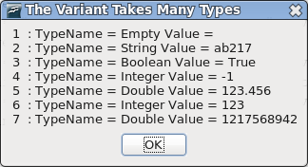
Figure 4. Variant takes the assigned type.
When data is assigned to a Variant, the data is not converted to an appropriate type, but rather the Variant becomes the type of the data. In line 6 of Figure 4, the Variant is an Integer. In line 7, the number is too large to be an Integer, but it is small enough to be a Long. OOo Basic chooses to convert whole numbers larger than an integer and all floating-point numbers into a Double, even if they can be expressed as a Single or a Long.

Constants
A constant is a variable with no type, and that cannot change value. The variable is defined to be a placeholder that is substituted by the expression that defines the constant. Constants are defined with the keyword Const. The constant name can be any valid variable name.
Const ConstName=Expression
Constants improve macros in many ways. Consider a Gravity constant frequently used in physics. Physics scholars will recognize this as the acceleration due to gravity in meters per second squared.
Const Gravity = 9.81
Here are some specific benefits of using constants:
- Constants improve the readability of a macro. The word Gravity is easier to recognize than the value 9.81.
- Constants are easy to manage. If I require greater precision or if the gravitational pull changes, I have to change the value in only one location.
- Constants help prevent difficult-to-find errors by changing run-time errors into compile-time errors. Typing “Grevity” rather than “Gravity” is a compile-time error, while mistyping “9.81” as “9.18” is not.
- While a value like 9.81 may be obvious to you, it may not be as obvious to others reading your code later. It becomes what programmers call a “magic number,” and experienced programmers try to avoid magic numbers at all costs. Their unexplained meanings make for difficulties in maintaining code later, when the original programmer is not available to explain — or has forgotten the details entirely.
TIP | OpenOffice.org defines the constant Pi. This is a mathematical constant with a value of approximately 3.1415926535897932385.

The With statement
The With statement is used to simplify accessing complex data types. Listing 15 defines a data type that contains two different variables: FirstName and LastName. You can access these variables by placing a period between the variable name and the data item.
Sub ExampleCreateNewType
Dim Person As PersonType
Person.FirstName = "Andrew"
Person.LastName = "Pitonyak"
...
End Sub
Or... the With statement provides a shortcut for accessing multiple data elements from the same variable.
Sub ExampleCreateNewType
Dim Person As PersonType
With Person
.FirstName = "Andrew"
.LastName = "Pitonyak"
End With
...
End Sub
Similarly:
Dim oProp As New com.sun.star.beans.PropertyValue
oProp.Name = "Person" 'Set Name Property
oProp.Value = "Boy Bill" 'Set Value Property
Using With:
Dim oProp As New com.sun.star.beans.PropertyValue
With oProp
.Name = "Person" 'Set Name Property
.Value = "Boy Bill" 'Set Value Property
End With

Arrays
An array is a data structure in which similar elements of data are arranged in an indexed structure — for example, a column of names or a table of numbers. See Table 9. An array allows you to store many different values in a single variable, and uses parentheses to define and access array elements. OOo Basic does not support the use of square brackets as used by other languages such as C and Java.
Array variables are declared using the Dim statement. Think of a one-dimensional array as a column of values and a two-dimensional array as a table of values. Higher dimensions are supported but difficult to visualize. An array index may be any Integer value from -32,768 through 32,767.
Table 9. Declaring an array is easy!
Definition | Elements | Description
Dim a(5) As Integer | 6 | From 0 through 5 inclusive.
Dim b(5 To 10) As String | 6 | From 5 through 10 inclusive.
Dim c(-5 To 5) As String | 11 | From -5 through 5 inclusive.
Dim d(5, 1 To 6) As Integer | 36 | Six rows with six columns from 0 through 5 and 1 through 6.
Dim e(5 To 10, 20 To 25) As Long | 36 | Six rows with six columns from 5 through 10 and 20 through 25.

TIP | You must declare array variables before using them, even if you don’t use “Option Explicit.”
If the lower dimension of an array is not specified, the default lower bound of an array is zero. (Programmers call these arrays “zero-based.”) Thus, an array with five elements will have elements numbered a(0) through a(4). Use the keywords “Option Base 1” to change the default lower bound of an array to start at 1 rather than 0. This must be done before any other executable statement in the program.
Option Base { 0 | 1 }
TIP | Specify the lower bound of an array rather than relying on the default behavior. This is more portable and it will not change when the Option Base statement is used.
Dim a(3) allows for four elements: a(0), a(1), a(2), and a(3). Option Base does not change the number of elements that an array can store; it changes only how they are indexed. Using Option Base 1, the same statement still allows for four elements: a(1), a(2), a(3), and a(4). I consider this behavior unintuitive and recommend against using Option Base. If you want specific array bounds, the preferred option is to explicitly declare the array bounds. For example, Dim a(1 To 4). Option Base has risks in terms of communicating clear documentation and ensuring portability.
Visual Basic handles Option Base 1 differently from OOo Basic; VB changes the lower bound to 1 but does not change the upper bound. Visual Basic .NET no longer supports Option Base. With “Option Compatible,” “Option Base 1” does not increase the upper bound by 1. In other words, OOo Basic acts like VB.
Accessing and changing the values in an array is easy. Initializing an array this way is tedious.
Listing 17. Demonstrate simple array.
Sub ExampleSimpleArray1
Dim a(2) As Integer, b(-2 To 1) As Long
Dim m(1 To 2, 3 To 4)

REM Did you know that multiple statements can be placed
REM on a single line if separated by a colon?
a(0) = 0 : a(1) = 1 : a(2) = 2
b(-2) = -2 : b(-1) = -1 : b(0) = 0 : b(1) = 1
m(1, 3) = 3 : m(1, 4) = 4
m(2, 3) = 6 : m(2, 4) = 8
Print "m(2,3) = " & m(2,3)
Print "b(-2) = " & b(-2)
End Sub
To quickly fill a Variant array, use the Array function (see Listing 18), which returns a Variant array with the included data. The functions LBound and Ubound return the lower bound and upper bound of an array. Routines supported by OOo Basic are summarized in Table 10, and discussed thoroughly later.
Listing 18. Use Array() to quickly fill an array.
Sub ExampleArrayFunction
Dim a, i%, s$
a = Array("Zero", 1, Pi, Now)
Rem String, Integer, Double, Date
For i = LBound(a) To UBound(a)
s$ = s$ & i & " : " & TypeName(a(i)) & " : " & a(i) & CHR$(10)
Next
MsgBox s$, 0, "Example of the Array Function"
End Sub
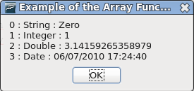
Figure 5. Different variable types in the same array.
A variable defined as an array but not dimensioned, such as Dim a(), is called an empty array. Test for an empty array by comparing the upper bound of the array to the lower bound. If the upper bound is less than the lower bound, the array is empty and no dimensions have been set. An array that has been dimensioned, such as Dim a(5), is not empty.
The behavior for LBound and UBound has changed over time. Some releases of OOo produce an error for UBound(b) and some do not. All versions should work correctly with UBound(b()). At the time of this writing, the upper and lower array bounds for c (in Listing 19) fails because c is an empty object.
Listing 19. Parentheses are not always required but are always allowed.
Sub ArrayDimensionError
On Error Goto ErrorHandler
Dim a(), b(1 To 2), c
Dim iLine As Integer
Dim s$
REM Valid constructs
iLine = 1 : s = "a = (" & LBound(a()) & ", "
iLine = 2 : s = s & UBound(a) & ")"d
iLine = 3 : s = s & CHR$(10) & "b = (" & LBound(b()) & ", "
iLine = 4 : s = s & UBound(b) & ")"
iLine = 5 : s = s & CHR$(10) & "c = (" & LBound(c()) & ", "
iLine = 6 : s = s & UBound(c) & ")"
MsgBox s, 0, "LBound and UBound"
Exit Sub
ErrorHandler:
s = s & CHR$(10) & "Error " & Err & ": " & Error$ & " (line : " & iLine & ")"
Resume Next
End Sub
Table 10. Summary of subroutines and functions related to arrays.
Function | Description
Array(args) | Return a Variant array that contains the arguments.
DimArray(args) | Return an empty Variant array. The arguments specify the dimension.
IsArray(var) | Return True if this variable is an array, False otherwise.
Join(array)  Join(array, delimiter) | Concatenate the array elements separated by the optional string delimiter and return as a String. The default delimiter is a single space.
LBound(array)  LBound(array, dimension) | Return the lower bound of the array argument. The optional dimension specifies which dimension to check. The first dimension is 1.
ReDim var(args) As Type | Change the dimension of an array using the same syntax as the DIM statement. The keyword Preserve keeps existing data intact — ReDim Preserve x(1 To 4) As Integer.
Split(str)  Split(str, delimiter)  Split(str, delimiter, n) | Split the string argument into an array of strings. The default delimiter is a space. The optional argument “n” limits the number of strings returned.
UBound(array)  UBound(array, dimension) | Return the upper bound of the array argument. The optional dimension specifies which dimension to check. The first dimension is 1.

Changing the dimension of an array
The desired dimension of an array is not always known ahead of time. Sometimes, the dimension is known; but it changes periodically, and the code must be changed. An array variable can be declared with or without specifying the dimensions. OOo Basic provides a few different methods to set or change the dimensions of an array.
The Array function generates a Variant array that contains data. This is a quick way to initialize an array. You are not required to set the dimension of the array, but, if you do, it will change to become the array returned by the Array function.
Dim a()
a = Array(3.141592654, "PI", 9.81, "Gravity")
The arguments passed to the Array function become data in the returned Variant array. The DimArray function, on the other hand, interprets the arguments as the dimensions of an array to create (see Listing 20). The arguments can be expressions, so a variable can be used to set the dimension.
Listing 20. Redimension array.
Sub ExampleDimArray
Dim a(), i%
Dim s$
a = Array(10, 11, 12)
s = "" & LBound(a()) & " " & UBound(a()) Rem 0 2
a() = DimArray(3) REM the same as Dim a(3)
a() = DimArray(2, 1) REM the same as Dim a(2,1)
i = 4
a = DimArray(3, i) Rem the same as Dim a(3,4)
s = s & CHR$(10) & LBound(a(),1) & " " & UBound(a(),1) Rem 0, 3
s = s & CHR$(10) & LBound(a(),2) & " " & UBound(a(),2) Rem 0, 4
a() = DimArray() REM an empty array
MsgBox s, 0, "Example Dim Array"
End Sub
The Array and DimArray functions both return an array of Variants. The ReDim statement changes the dimension of an existing array. This can change both individual dimensions and the number of dimensions. The arguments can be expressions because the ReDim statement is evaluated at run time.
Dim e() As Integer, i As Integer
i = 4
ReDim e(5) As Integer REM Dimension is 1, a size of 0 To 5 is valid.
ReDim e(3 To 10) As Integer REM Dimension is 1, a size of 3 To 10 is valid.
ReDim e(3, i) As Integer REM Dimension is 2, a size of (0 To 3, 0 To 4) is valid.
Some tips regarding arrays:
- LBound and UBound work with empty arrays.
- An empty array has one dimension. The lower bound is zero and the upper bound is -1.
- Use ReDim to cause an existing array to become empty.
The ReDim statement supports the keyword Preserve. This attempts to save the data when the dimensions of an array are changed. Increasing the dimension of an array preserves all of the data, but decreasing the dimension causes data to be lost by truncation. Data can be truncated at either end. If an element in the new array existed in the old array, the value is unchanged. Unlike some variants of BASIC, OOo Basic allows all dimensions of an array to be changed while still preserving data.
Dim a() As Integer
ReDim a(3, 3, 3) As Integer
a(1,1,1) = 1 : a(1, 1, 2) = 2 : a(2, 1, 1) = 3
ReDim preserve a(-1 To 4, 4, 4) As Integer
Print "(" & a(1,1,1) & ", " & a(1, 1, 2) & ", " & a(2, 1, 1) & ")"
ReDim specifies both the dimensions and an optional type. If the type is included, it must match the type specified when the variable is declared or OOo generates a compile-time error.
Listing 21 is a utility function that accepts a simple array and returns a string with all of the elements in the array. The ReDim example code, also in Listing 21, uses ArrayToString.
Listing 21. Utility function array to string.
REM ArrayToString accepts a simple array and places the value
REM of each element in the array into a string.
Function ArrayToString(a() As Variant) As String
Dim i%, s$
For i% = LBound(a()) To UBound(a())
s$ = s$ & i% & " : " & a(i%) & CHR$(10)
Next
ArrayToString = s$
End Function

Sub ExampleReDimPreserve
Dim a(5) As Integer, b(), c() As Integer
a(0) = 0 : a(1) = 1 : a(2) = 2 : a(3) = 3 : a(4) = 4 : a(5) = 5
Rem a is dimensioned from 0 to 5 where a(i) = i
MsgBox ArrayToString(a()), 0 , "a() at start"

Rem a is re-dimensioned from 1 to 3 where a(i) = i
ReDim Preserve a(1 To 3) As Integer
MsgBox ArrayToString(a()), 0 , "a() after ReDim"

Rem Array() returns a Variant type
Rem b is dimensioned from 0 to 9 where b(i) = i+1
b = Array(1, 2, 3, 4, 5, 6, 7, 8, 9, 10)
MsgBox ArrayToString(b()), 0 , "b() at initial assignment"

Rem b is dimensioned from 1 to 3 where b(i) = i+1
ReDim Preserve b(1 To 3)
MsgBox ArrayToString(b()), 0 , "b() after ReDim"

Rem The following is NOT valid because the array is already dimensioned
Rem to a different size
Rem a = Array(0, 1, 2, 3, 4, 5)

Rem c is dimensioned from 0 to 5 where c(i) = i
Rem If "ReDim" had been done on c, then this would NOT work
c = Array(0, 1, 2, "three", 4, 5)
MsgBox ArrayToString(c()), 0 , "Integer array c() Assigned to a Variant"

Rem Ironically, this is allowed but c will contain no data!
ReDim Preserve c(1 To 3) As Integer
MsgBox ArrayToString(c()), 0 , "ReDim Integer c() after assigned Variant"
End Sub
Visual Basic has different rules for changing the dimensions of an array, and these rules change between versions of Visual Basic. As a general rule, OOo Basic is more flexible.

The unexpected behavior of arrays
Assigning one Integer variable to another copies the value, and the variables are not related in any other way. In other words, if you change the first variable’s value, the second variable’s value does not change. This is not true for array variables. Assigning one array variable to another makes a reference to the first array rather than copying the data. All changes made to either are automatically seen by the other. It doesn’t matter which one is changed; they are both affected. This is the difference between “pass by value” (integers) and “pass by reference” (arrays).
Listing 22. Arrays copy as references.
Sub ExampleArrayCopyIsRef
Dim a(5) As Integer, c(4) As Integer, s$
c(0) = 4 : c(1) = 3 : c(2) = 2 : c(3) = 1 : c(4) = 0
a() = c()
a(1) = 7
c(2) = 10
s$ = "**** a() *****" & CHR$(10) & ArrayToString(a()) & CHR$(10) &_
CHR$(10) & "**** c() *****" & CHR$(10) & ArrayToString(c())
MsgBox s$, 0 , "Change One, Change Both"
End Sub
To illustrate that arrays are assigned by reference, create three arrays — a(), b(), and c() — as shown in Figure 6. Internally, OOo Basic creates three arrays that are referenced by a(), b(), and c().
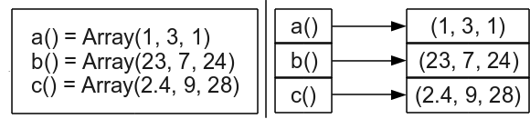
Figure 6. Assigning an array assigns a reference.
Assign array a() to array b(), and both a() and b() reference the same data. The variable a() does not reference the variable b(), it references the same data referenced by b() (see Figure 7). Therefore, changing a() also changes b(). The original array referenced by a() is no longer referenced.
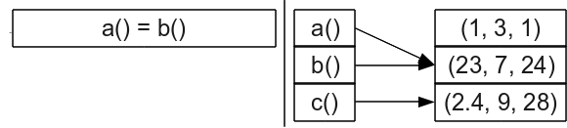
Figure 7. Assigning an array assigns a reference.
Assign array b() to array c(), and both b() and c() reference the same data. The variable a() remains unchanged, as shown in Figure 8.
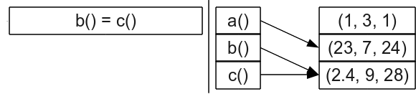
Figure 8. Assigning an array assigns a reference.
TIP | Type checking is not performed when an array is assigned to another array. Do not assign arrays of different types to each other.
Because no type checking is performed when an array is assigned to another array, unexpected and obscure problems can occur. The Array function returns a Variant array, and is the quickest method to assign multiple values to an array variable. An obvious problem is that an Integer array may contain String values if it references a Variant array. A less obvious problem is that the ReDim statement works based on the declared type. The statement “ReDim Preserve” on an Integer array assigned to a Variant array fails to preserve the data.
Dim a() As Integer REM Declare a() as an Integer()
a() = Array(0, 1, 2, 3, 4, 5, 6) REM Assign a Variant() to an Integer()
ReDim Preserve a(1 To 3) As Integer REM This wipes the array
To safely assign arrays while maintaining the correct data type, another method is required. Copy each element in the array individually. This also prevents two array variables from referencing the same array.
Listing 23. More complex array example.
Sub ExampleSetIntArray
Dim iA() As Integer
SetIntArray(iA, Array(9, 8, "7", "six"))
MsgBox ArrayToString(iA), 0, "Assign a Variant to an Integer"
End Sub

REM Dimension the first array to have the same dimensions as the second.
REM Perform an element-by-element copy of the array.
Sub SetIntArray(iArray() As Integer, v() As Variant)
Dim i As Long
ReDim iArray(LBound(v()) To UBound(v())) As Integer
For i = LBound(v) To UBound(v)
iArray(i) = v(i)
Next
End Sub

Subroutines and functions
Subroutines are used to group lines of code into meaningful pieces of work. A function is a subroutine that returns a value. The use of subroutines and functions facilitates testing, code reuse, and readability. This in turn reduces errors.
The keyword Sub defines the beginning of a subroutine, and End Sub defines the end of a subroutine.
Sub FirstSub
Print "Running FirstSub"
End Sub
To use a subroutine, place the name of the subroutine that you want to call on a line. The name can optionally be preceded by the keyword Call.
Sub Main
Call FirstSub ' Call Sub FirstSub
FirstSub ' Call Sub FirstSub again
End Sub
Subroutine and function names must be unique in a module. They are subject to the same naming conventions as variables, including the use of spaces in their names.
Sub One
[name with space]
End Sub
Sub [name with space]
Print "I am here"
End Sub
Visual Basic allows a subroutine to be preceded by optional keywords such as Public or Private. Starting with OOo 2.0, you can define a routine as public or private, but the routine is always public unless CompatibilityMode(True) is used first.
Declare a subroutine as private by preceding Sub with the keyword Private.
Private Sub PrivSub
Print "In Private Sub"
bbxx = 4
End Sub
Using Option Compatibile is not sufficient to enable Private scope, CompatibilityMode(True) must be used.
Sub TestPrivateSub
CompatibilityMode(False) 'Required only if CompatibilityMode(True) already used.
Call PrivSub() 'This call works.
CompatibilityMode(True) 'This is required, even if Option Compatible is used
Call PrivSub() 'Runtime error (if PrivSub is in a different module).
End Sub
The keyword Function is used to declare a function which, like a variable, can define the type it returns. If the type is not declared, the return type defaults to Variant. You can assign the return value at any point and as many times as you want before the function ends. The last value assigned is returned.
Sub test
Print "The function returns " & TestFunc
End Sub
Function TestFunc As String
TestFunc = "hello"
End Function

Arguments
A variable that is passed to a routine is called an argument. Arguments must be declared. The same rules for declaring variable types apply to declaring argument types.
A routine name can optionally be followed by parentheses, both when it is defined and when it is called. A routine that accepts arguments can optionally enclose the argument list in parentheses. The argument list follows the routine name on the same line. Blank space is allowed between the name of the routine and the argument list.
Listing 24. Simple argument testing.
Sub ExampleParamTest1()
Call ParamTest1(2, "Two")
Call ParamTest1 1, "One"
End Sub
Sub ParamTest1(i As Integer, s$)
Print "Integer = " & i & " String = " & s$
End Sub

Pass by reference or by value
By default, arguments are passed by reference rather than by value. In other words, when the called subroutine modifies an argument, the caller sees the change. You can override this behavior by using the ByVal keyword. This causes a copy of the argument (rather than a reference to the argument) to be sent (see Listing 25 and Figure 9).
TIP | Constants passed as arguments by reference cause unexpected behavior if their value is modified in the called routine. The value may arbitrarily change back inside the called routine. For example, I had a subroutine that was supposed to decrement an Integer argument in a loop until it was zero; the argument never became zero.
Listing 25. Arguments by reference and by value.
Sub ExampleArgumentValAndRef()
Dim i1%, i2%
i1 = 1 : i2 = 1
ArgumentValAndRef(i1, i2)
MsgBox "Argument passed by reference was 1 and is now " & i1 & CHR$(10) &_
"Argument passed by value was 1 and is still " & i2 & CHR$(10)
End Sub
Sub ArgumentValAndRef(iRef%, ByVal iVal)
iRef = iRef + 1 ' This will affect the caller
iVal = iVal - 1 ' This will not affect the caller
End Sub
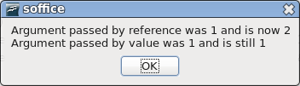
Figure 9. Pass by reference allows changes to be passed back to the caller.
Visual Basic supports the optional keyword ByRef. This keyword was introduced into OOo Basic starting with OOo 2.0. Note that pass by reference is the default behavior.
A variable cannot be passed by value if the type does not match. The macros in Listing 26 and Listing 27 differ in the type used to declare the argument.
Listing 26. Simple swap with a string argument.
Sub sSwap( sDatum As String )
Dim asDatum(1 to 3) As String
Dim sDummy As String

asDatum=Split(sDatum, ".")
sDummy=asDatum(0)
asDatum(0)=asDatum(2)
asDatum(2)=sDummy
sDatum=Join(asDatum,"-")
End Sub
Listing 27. Simple swap with a variant argument.

Sub vSwap( vDatum As Variant )
Dim asDatum(1 to 3) As String
Dim sDummy As String

asDatum=Split(vDatum, ".")
sDummy=asDatum(0)
asDatum(0)=asDatum(2)
asDatum(2)=sDummy
vDatum=Join(asDatum,"-")
End Sub
The following macro uses a variant and a string to call a macro that accepts a variant, and the macro that accepts the string. Passing a variant to a method that accepts a string argument basses the value by reference. The unexpected thing is that passing a string to the method that accepts a variant, passes the value by reference.
Listing 28. Test reference by argument type.
Sub passByReferenceTester
Dim vVar As Variant
Dim sVar As string
Dim s As String

vVar="01.02.2011"
sVar="01.02.2011"

s = vVar & " sSwap( variant var string param ) ==> "
sSwap(vVar)
s = s & vVar & CHR$(10)

s = s & sVar & " sSwap( string var string param ) ==> "
sSwap(sVar)
s = s & sVar & CHR$(10)

vVar="01.02.2011"
sVar="01.02.2011"
s = s & vVar & " vSwap( variant var variant param ) ==> "
vSwap(vVar)
s = s & vVar & CHR$(10)

s = s & sVar & " vSwap( string var variant param ) ==> "
vSwap(sVar)
s = s & sVar & CHR$(10)

MsgBox(s)
End Sub
It is important that you understand when a variable is passed to a method as a reference or a value. It is equally important to understand when the value contained in a variable is copied by value or copied by reference.
- Variables with simple types copy by value; for example, assigning one integer variable to another.
- Arrays always copy by reference. If you assign one array to another, both variables reference and modify the same array.
- UNO Services copy by reference. This means that you can do things such as oDoc = ThisComponent, and both variables reference the same object.
- Structs copy by value. This frustrates many people when they first encounter the behavior, but there is a very good reason for it. First, the problem; oBorder.TopLine.OuterLineWidth = 2 fails because TopLine is a struct and the value is returned as a copy rather than a reference. The code as shown changes the outer line width on a copy of the struct rather than the struct associated with the border object. The correct way to change the border is (v = oBorder.TopLine : v.OuterLineWidth = 2 : oBorder.TopLine = v).
A lead developer claimed that one or two services and strutcs do not assign / copy as expected, but he could not remember which. I have not encountered the objects that violate the guidelines, but, I try to remember the problem so that I am not taken unaware.

Optional arguments
You can declare arguments as optional by preceding them with the keyword Optional. All of the arguments following an optional argument must also be optional. Use the IsMissing function to determine if an optional argument is missing.
Listing 29. Optional arguments.
REM Make test calls with optional arguments.
REM Calls with Integer and Variant arguments should yield the same result.
REM Unfortunately, they do not.
Sub ExampleArgOptional()
Dim s$
s = "Variant Arguments () => " & TestOpt() & CHR$(10) &_
"Integer Arguments () => " & TestOptI() & CHR$(10) &_
"---------------------------------------------" & CHR$(10) &_
"Variant Arguments (,,) => " & TestOpt(,,) & CHR$(10) &_
"Integer Arguments (,,) => " & TestOptI(,,) & CHR$(10) &_
"---------------------------------------------" & CHR$(10) &_
"Variant Arguments (1) => " & TestOpt(1) & CHR$(10) &_
"Integer Arguments (1) => " & TestOptI(1) & CHR$(10) &_
"---------------------------------------------" & CHR$(10) &_
"Variant Arguments (,2) => " & TestOpt(,2) & CHR$(10) &_
"Integer Arguments (,2) => " & TestOptI(,2) & CHR$(10) &_
"---------------------------------------------" & CHR$(10) &_
"Variant Arguments (1,2) => " & TestOpt(1,2) & CHR$(10) &_
"Integer Arguments (1,2) => " & TestOptI(1,2) & CHR$(10) &_
"---------------------------------------------" & CHR$(10) &_
"Variant Arguments (1,,3) => " & TestOpt(1,,3) & CHR$(10) &_
"Integer Arguments (1,,3) => " & TestOptI(1,,3) & CHR$(10)
MsgBox s, 0, "Optional Arguments of Type Variant or Integer"
End Sub

REM Return a string that contains each argument. If the argument
REM is missing, then an M is used in its place.
Function TestOpt(Optional v1, Optional v2, Optional v3) As String
TestOpt = "" & IIF(IsMissing(v1), "M", Str(v1)) &_
IIF(IsMissing(v2), "M", Str(v2)) &_
IIF(IsMissing(v3), "M", Str(v3))
End Function

REM Return a string that contains each argument. If the argument
REM is missing, then an M is used in its place.
Function TestOptI(Optional i1%, Optional i2%, Optional i3%) As String
TestOptI = "" & IIF(IsMissing(i1), "M", Str(i1)) &_
IIF(IsMissing(i2), "M", Str(i2)) &_
IIF(IsMissing(i3), "M", Str(i3))
End Function
You can omit any optional arguments. Listing 29 demonstrates two functions that accept optional arguments. The functions are the same except for the argument types. Each function returns a string containing the argument values concatenated together. Missing arguments are represented by the letter “M” in the string. Although the return values from TestOpt and TestOpt1 should be the same for the same argument lists, they are not (see Figure 10). This is a bug.
TIP | The IsMissing function returns incorrect results for variables that are not of type Variant when the missing argument is followed by a comma.
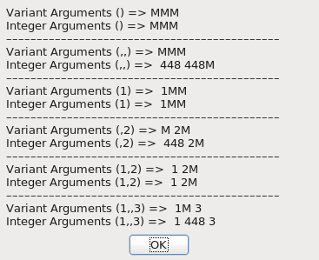
Figure 10. In rare cases, non-Variant optional arguments fail.

Default argument values
OOo version 2.0 introduced default values for missing arguments. This allows a default value to be specified if an optional argument is missing. You must use the keywords “Option Compatible” for default values to work.
Option Compatible
Sub DefaultExample(Optional n as Integer=100)
REM If IsMissing(n) Then n = 100 'I will not have to do this anymore!
Print n
End Sub

Recursive routines
A recursive routine calls itself. Consider calculating the mathematical function Factorial for positive integers. The usual definition is recursive.
Listing 30. Recursively generate factorial.
Sub DoFactorial
Print "Recursive Factorial = " & RecursiveFactorial(4)
Print "Iterative Factorial = " & IterativeFactorial(4)
End Sub

Function IterativeFactorial(ByVal n As Long) As Long
Dim answer As Long
answer = 1
Do While n > 1
answer = answer * n
n = n - 1
Loop
IterativeFactorial = answer
End Function

' This finally works in version 1.1
Function RecursiveFactorial(ByVal n As Long) As Long
RecursiveFactorial = 1
If n > 1 Then RecursiveFactorial = n * RecursiveFactorial(n-1)
End Function
Computers use a data structure called a stack. At home, I have a stack of books that I want to read. When I receive a new book, I place it on top of the stack. When I have time to read, I take the top book from the stack. This is similar to the data structure that a computer uses: a section of memory in a computer for temporary storage in which the last item stored is the first retrieved. Stacks are usually used when a computer calls a routine and passes arguments. A typical procedure follows:
- Push the current run location onto the stack.
- Push each argument onto the stack.
- Call the desired function or subroutine.
- The called routine uses the arguments from the stack.
- The called routine frequently uses the stack to store its own variables.
- The called routine removes the arguments from the stack.
- The called routine removes and saves the caller’s location from the stack.
- If the called routine is a function, the return value is placed on the stack.
- The called routine returns to the caller from the saved location on the stack.
- If the called routine is a function, the return value is taken from the stack.
Although various optimizations are used, there is always some overhead associated with calling subroutines and functions. There is overhead in running time and in the memory required. The recursive version of Factorial continually calls itself. While calculating the factorial of four, there is one point at which the stack contains information for calls for 4, 3, 2, and 1. For some functions — the Fibonacci series, for example — this call behavior may be prohibitive, and a non-recursive algorithm should be used instead.

Scope of variables, subroutines, and functions
The idea of scope deals with the lifetime and visibility of a variable, subroutine, or function in OOo Basic. The scope depends on the location of the declaration, and the keywords Public, Private, Static, and Global. Dim is equivalent to Private, but variables are Private only if CompatibilityMode(True) is used.

Local variables defined in a subroutine or function
Variables declared inside a subroutine or function are called local variables. It is also commonly said that a variable is local to a routine if the variable is declared inside that routine.
You can declare a variable inside a subroutine or function by using the Dim keyword. Variables defined inside a routine are visible only inside that routine. It is not possible to directly access a variable defined inside a routine from outside the routine. However, it is possible to access a variable defined outside any routine — for example, in a module header — from inside a routine. When a variable or routine name is encountered inside a routine, OOo Basic starts looking for the variable or routine in the following order: current routine, module, library, and other open libraries. In other words, it starts inside and works its way out.
Variables defined in a routine are created and initialized each time the routine is entered. The variables are destroyed every time the routine is exited because the routine is finished. Leaving the routine to call another routine does not cause the variables to be reinitialized.
Use the keyword Static to change a variable’s creation and destruction times to the calling macro’s start and finish times, respectively. Although the variable is visible only in the routine containing the variable, the variable is initialized once when the macro starts running, and the variable's values are retained through multiple calls to the same routine. In other words, you start with no macro running. The first time that a subroutine or function that contains a static variable is called, the static variables contain initial values based on their types. The static variables retain their values between calls as long as the macro as a whole did not stop running. The keyword Static uses the same syntax as the keyword Dim, and is valid only inside a subroutine or function. Listing 31 calls a routine that uses a static variable.
Listing 31. Static example.
Sub ExampleStatic
ExampleStaticWorker()
ExampleStaticWorker()
End Sub

Sub ExampleStaticWorker
Static iStatic1 As Integer
Dim iNonStatic As Integer

iNonStatic = iNonStatic + 1
iStatic1 = iStatic1 + 1
Msgbox "iNonStatic = " & iNonStatic & CHR$(10) &_
"iStatic1 = " & iStatic1
End Sub

Variables defined in a module
The Dim, Global, Public, or Private statements are used to declare variables in a module header. Global, Public, and Private use the same syntax as the Dim statement, but they can’t declare variables inside a subroutine or function. Each variable type has a different life cycle, as summarized in Table 11.
The keywords Static, Public, Private, and Global are not used as modifiers to the keyword Dim; they are used instead of the keyword Dim.
Although it is sometimes necessary to define a variable in a module header, you should avoid it if possible. Variables defined in the header can be seen in other modules that don’t expect them. It’s difficult to determine why the compiler claims that a variable is already defined if it is defined in another library or module. Even worse, two working libraries may stop working because of naming conflicts.
Table 11. Life cycle of a variable defined in a module header.
Keyword | Initialized | Dies | Scope
Global | Compile time | Compile time | All modules and libraries.
Public | Macro start | Macro finish | Declaring library container.
Dim | Macro start | Macro finish | Declaring library container.
Private | Macro start | Macro finish | Declaring module.

Global
Use Global to declare a variable that is available to every module in every library. The library containing the Global variable must be loaded for the variable to be visible.
When a library is loaded, it is automatically compiled and made ready for use; this is when a Global variable is initialized. Changes made to a Global variable are seen by every module and are persisted even after the macro is finished. Global variables are reset when the containing library is compiled. Exiting and restarting OpenOffice.org causes all libraries to be compiled and all Global variables to be initialized. Modifying the module containing the Global definition also forces the module to be recompiled.
Global iNumberOfTimesRun
Variables declared Global are similar to variables declared Static, but Static works only for local variables, and Global works only for variables declared in the header.

Public
Use Public to declare a variable that is visible to all modules in the declaring library container. Outside the declaring library container, the public variables aren’t visible. Public variables are initialized every time a macro runs.
An application library is a library that is declared in the “OpenOffice.org” library container. This is available when OOo is running, is stored in its own directory, and every document can view it. Document-level libraries are stored in OOo documents. The libraries are saved as part of the document and are not visible outside the document.
Public variables declared in an application library are visible in every OOo document-level library. Public variables declared in a library contained in an OOo document are not visible in application-level libraries. Declaring a Public variable in a document library effectively hides a Public variable declared in an application library. Simply stated (see Table 12), if you declare a Public variable in a document, it is visible only in the document and it will hide a Public variable with the same name declared outside the document. A Public variable declared in the application is visible everywhere — unless a variable declaration with more local scope takes priority over the declaration with more global scope.
Public oDialog As Object
Table 12. The scope of a Public variable depends on where it is declared.
Declaration Location | Scope
Application | Visible everywhere.
Document | Visible only in the declaring document.
Application and Document | Macros in the document are unable to see the application-level variable.

Private or Dim
Use Private or Dim to declare a variable in a module that should not be visible in another module. Private variables, like Public variables, are initialized every time a macro runs. A single variable name may be used by two different modules as their own variable if the variable is declared Private.
Private oDialog As Variant
- Declaring a variable using Dim is equivalent to declaring a variable as Private.
- Private variables are only private, however, only with CompatibilityMode(True).
- Option Compatible has no affect on private variables.
A Private variable is visible outside the declaring module unless CompatibilityMode(True) is used. To see for yourself, create two modules — Module1 and Module2 — in the same library. In Module1, add the declaration “Private priv_var As Integer”. Macros in Module2 can use the variable “priv_var”. Even if Module2 is located in a different library in the same document, the variable “priv_var” is visible and usable. If CompatibilityMode(True) is used, however, then the private variable is no longer visible outside of the declaring module.
In Module1, declare a variable “Private priv_var As Double”. A variable of the same name is declared in Module2, but it is an Integer variable. Each module sees its own Private variable. Changing these two variables to have Public scope rather than Private introduces an ugly situation; only one of these is visible and usable, but you don’t know which one it is without performing a test. Assign the value 4.7 to the variable, and see if it is an Integer or a Double.

Operators
An operator is a symbol that denotes or performs a mathematical or logical operation. An operator, like a function, returns a result. For example, the + operator adds two numbers. The arguments to the operator are called operands. Operators are assigned a precedence. An operator with a precedence of 1 is said to have a high precedence level; it is, after all, number 1!
TIP | While typesetting mathematical equations, the minus sign (−) is represented using the Unicode character U+2212. With OOo Basic, however, ASCII code 45 (-) must be used instead.
In OOo Basic (see Table 13), operators are evaluated from left to right with the restriction that an operator with a higher precedence is used before an operator with a lower precedence. For example, 1 + 2 * 3 evaluates to 7 because multiplication has higher precedence than addition. Parentheses may be used to modify the order of evaluation. For example, (1+2) * 3 evaluates to 9 because the expression inside the parentheses is evaluated first.
Table 13. Operators supported by OpenOffice.org Basic.
Precedence | Operator | Type | Description
1 | NOT | Unary | Logical or bit-wise NOT
1 | - | Unary | Leading minus sign, negation
1 | + | Unary | Leading plus sign
2 | ^ | Binary | Numerical exponentiation. Standard mathematical precedence would have exponentiation higher than negation.
3 | * | Binary | Numerical multiplication
3 | / | Binary | Numerical division
4 | MOD | Binary | Numerical remainder after division
5 | \ | Binary | Integer division
6 | - | Binary | Numerical subtraction
6 | + | Binary | Numerical addition and string concatenation
7 | & | Binary | String concatenation
8 | IS | Binary | Do both operands reference the same object?
8 | = | Binary | Equals
8 | < | Binary | Less than
8 | > | Binary | Greater than
8 | <= | Binary | Less than or equal to
8 | >= | Binary | Greater than or equal to
8 | <> | Binary | Not equal
9 | AND | Binary | Bit-wise for numerics and logical for Boolean
9 | OR | Binary | Bit-wise for numerics and logical for Boolean
9 | XOR | Binary | Exclusive OR, bit-wise for numerics and logical for Boolean
9 | EQV | Binary | Equivalence, bit-wise for numerics and logical for Boolean
9 | IMP | Binary | Implication bit-wise for numerics and logical for Boolean.

TIP | OOo Precedence does not follow standard mathematical rules; for example, negation should have a lower precedence than exponentiation so -1^2 should be -1, not 1.
Visual Basic uses a different precedence for operators — for example, numerical exponentiation and negation are switched, as are integer division and remainder after division.
The word “binary” means something made of or based on two things. “Unary” means something made of or based on one thing. A binary operator, not to be confused with a binary number, is placed between two operands. For example, the addition operator uses two operands with 1+2. In OOo Basic, binary operators are always evaluated from left to right based on operator precedence. A unary operator requires one operand that is placed directly to the right of the operator. For example, - (1 + 3). By necessity, a series of unary operators are evaluated right to left. For example, + - (1+3) must evaluate the rightmost negation operator first.

Mathematical and string operators
Mathematical operators can be used with all numerical data types. When operands of different types are mixed, a conversion is made to minimize the loss of precision. For example, 1 + 3.443 causes a conversion to a floating-point number rather than a conversion to an Integer. If the first operand is a number and the second operand is a string, the string is converted to a number. If the string does not contain a valid numerical value, a zero is returned and no error is generated. Assigning a string directly to a numeric variable, however, always assigns the value zero and no errors are generated.
Listing 32. Strings are automatically converted to numbers when required.
Dim i As Integer
i = "abc" 'Assigning a string with no numbers yields zero not an error
Print i '0
i = "3abc" 'Assigns 3, automatically converts as it can.
Print i '3
Print 4 + "abc" '4
OOo Basic tries to automatically convert types. No errors are generated when a string is used where a number is required. This is discussed in depth later.

Unary plus (+) and minus (-)
OOo Basic allows unary operators to have spaces between the operator and the operand (see Table 6). Unary operators also have the highest precedence and are evaluated from right to left. A leading plus sign is arguably useless — it emphasizes that a constant is not negative but is otherwise effectively ignored. A leading minus sign indicates numeric negation.

Exponentiation (^)
Numerical exponentiation supports integer and floating-point exponents. The exponentiation operator can operate on a negative number only if the exponent is an integer.
result = number^exponent
A positive integer exponent has a conceptually simple representation. The number is multiplied by itself exponent times. For example, 2^4 = 2 * 2 * 2 * 2.
- OOo does not follow standard mathematical rules for exponentiation:
- Exponentiation has a lower precedence than negation, so -1^2 incorrectly evaluates to 1.
OOo Basic evaluates multiple exponents (2^3^4) left to right ((2^3)^4), while standard mathematical precedence evaluates right to left. (2^(3^4)).
Listing 33. Demonstrate exponentiation.
Sub ExampleExponent
Dim s$
s = "2^3 = " & 2^3 REM 2*2*2 = 8
s = s & CHR$(10) & "3^2 = " & 3^2 REM 3 *3 = 9
s = s & CHR$(10) & "-3^2 = " & -3^2 REM (-3) * (-3) = 9
s = s & CHR$(10) & "2^3^2 = " & 2^3^2 REM 2^3^2 = 8^2 = 64
s = s & CHR$(10) & "4^0.5 = " & 4^.5 REM 2
s = s & CHR$(10) & "4^-0.5 = " & 4^-.5 REM .5
s = s & CHR$(10) & "-1^2 = " & -1^2 REM 1
s = s & CHR$(10) & "-(1^2) = " & -(1^2) REM -1
MsgBox s
End Sub
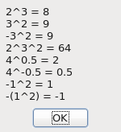
Figure 11. Using the exponentiation operator.

Multiplication (*) and Division (/)
Multiplication and division have the same precedence.
Listing 34. Demonstrate multiplication and division.
Sub ExampleMultDiv
Print "2*3 = " & 2*3 REM 6
Print "4/2.0 = " & 4/2.0 REM 2
Print "-3/2 = " & -3/2 REM -1.5
Print "4*3/2 = " & 4*3/2 REM 6
End Sub

Remainder after division (MOD)
The MOD operator is also called “remainder after division.” For example, 5 MOD 2 is 1 because 5 divided by 2 is 2 with a remainder of 1. All operands are rounded to Integer values before the operation is performed.
Listing 35. Definition of the MOD operator for integer operands x and y.
x MOD y = x - (y * (x\y))
Listing 36. Demonstrate mod operator.
REM x MOD y can also be written as
REM CInt(x) - (CInt(y) * (CInt(x)\CInt(y)))
REM CInt is used because the numbers must be rounded
REM before the operations are performed.
Sub ExampleMOD
Dim x(), y(), s$, i%
x() = Array (4, 15, 6, 6.4, 6.5, -15, 15, -15)
y() = Array (15, 6, 3, 3, 3, 8, -8, -8)
For i = LBound(x()) To UBound(x())
s = s & x(i) & " MOD " & y(i) & " = " & (x(i) MOD y(i)) & CHR$(10)
Next
MsgBox s, 0, "MOD operator"
End Sub
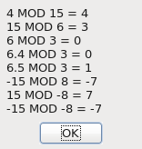
Figure 12. Using the MOD operator.
TIP | The operands for MOD are rounded to Integer values before the division is done.

Integer division (\)
Regular division expects to divide a Double by a Double, and it returns a Double as an answer. For example, 7.0 / 4.0 is 1.75. Integer division, on the other hand, expects to divide two Integers, and it returns an Integer as an answer. For example, 7.2 \ 4.3 converts the operands to 7 \ 4 and then returns 1. The numeric constant operands used with the Integer division operator are truncated to Integer values, and then Integer division is performed. The result is a truncated result, not a rounded result. Listing 37 compares the difference between Integer division and regular division.
Listing 37. Demonstrate integer division.
Sub ExampleIntDiv
Dim f As Double
Dim s$
f = 5.9
s = "5/2 = " & 5/2 REM 2.5
s = s & CHR$(10) & "5\2 = " & 5\2 REM 2
s = s & CHR$(10) & "5/3 = " & 5/3 REM 1.666666667
s = s & CHR$(10) & "5\3 = " & 5\3 REM 1
s = s & CHR$(10) & "5/4 = " & 5/4 REM 1.25
s = s & CHR$(10) & "5\4 = " & 5\4 REM 1
s = s & CHR$(10) & "-5/2 = " & -5/2 REM -2.5
s = s & CHR$(10) & "-5\2 = " & -5\2 REM -2
s = s & CHR$(10) & "-5/3 = " & -5/3 REM -1.666666667
s = s & CHR$(10) & "-5\3 = " & -5\3 REM -1
s = s & CHR$(10) & "-5/4 = " & -5/4 REM -1.25
s = s & CHR$(10) & "-5\4 = " & -5\4 REM -1
s = s & CHR$(10) & "17/6 = " & 17/6 REM 2.83333333333333
s = s & CHR$(10) & "17\6 = " & 17\6 REM 2
s = s & CHR$(10) & "17/5.9 = " & 17/5.9 REM 2.88135593220339
s = s & CHR$(10) & "17\5 = " & 17\5 REM 3
s = s & CHR$(10) & "17\5.9 = " & 17\5.9 REM 3 because 5.9 was truncated to 5.
s = s & CHR$(10) & "17\f = " & 17\f REM 2 because f was rounded up to 6.
s = s & CHR$(10) & "17\(11.9/2) = " & 17\(11.9/2) REM 3 because 11.9/2 truncated to 5.
MsgBox s
End Sub
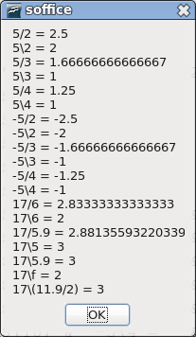
Figure 13. Integer division.
With integer division, constant numeric operands are truncated to Integer values before the division is done. When variables are part of an operand, the operand's result is rounded, otherwise truncated.

Addition (+), subtraction (-), and string concatenation (& and +)
Addition and subtraction have the same precedence, which is higher than the string concatenation operator. Care must be taken while adding numerical values because the plus operator can also signify string concatenation. When the first operand for the plus operator is a number, and the second is a string; the string is converted to a number. When the first operand for the plus operator is a string, and the second is a number; the number is converted to a string.
Print 123 + "3" REM 126 (Numeric)
Print "123" + 3 REM 1233 (String)
The string operator tries to convert the operands to strings if at least one operand is a string.
Print 123 & "3" REM 1233 (String)
Print "123" & 3 REM 1233 (String)
Print 123 & 3 REM Use at least one string or it will not work!
Mixing string manipulations and numerical manipulations may lead to confusing results, especially because string concatenation with the & operator has lower precedence than the + operator.
Print 123 + "3" & 4 '1264 Do addition then convert to String
Print 123 & "3" + 4 '12334 Do addition first but first operand is String
Print 123 & 3 + "4" '1237 Do addition first but first operand is Integer

Logical and bit-wise operators
Each logical operator asks a simple question and provides a True or False answer. For example, is it true that (you have money) AND (you want to purchase my book)? These types of operations are simple and are frequently used in OOo Basic. Less frequently used, and provided for completeness to keep the computing professionals happy, are the bit-wise operators. Bit-wise operators are not difficult, but if you don’t understand them, it isn’t likely to affect your usage of OOo Basic.
A logical operator is usually thought to operate on True and False values. In OOo Basic, logical operators also perform bit-wise operations on Integer values. This means that each bit of the first operand is compared to the corresponding bit in the second operand to form the corresponding bit in the result. For example, the binary operands 01 and 10 use the 0 from 01 and the 1 from 10 to produce the first bit of the result.
The unusual thing about logical and bit-wise binary operators in OOo Basic is that their precedence is the same. In other languages, AND typically has greater precedence than OR.
Table 14 illustrates the logical and bit-wise operators supported by OOo. True and False represent logical values, and 0 and 1 represent bit values.
Table 14. Truth table for logical and bit-wise operators.
x | y | x AND y | x OR y | x XOR y | x EQV y | x IMP y
True | True | True | True | False | True | True
True | False | False | True | True | False | False
False | True | False | True | True | False | True
False | False | False | False | False | True | True
1100 | 1010 | 1000 | 1110 | 0110 | 1001 | 1011

Internally, the logical operators cast their operands to type Long. An unexpected side effect is that a floating-point operand is converted to a Long, which might cause numerical overflow. The conversion from a floating-point number to a long integer number is done by rounding the value, not by truncating. The values chosen for True (-1) and False (0) allow this to work, but the return type with two Boolean operands is still sometimes of type Long.
Listing 38. Logical operands are of type long integer.
Sub LogicalOperandsAreLongs
Dim v, b1 As Boolean, b2 As Boolean
b1 = True : b2 = False
v = (b1 OR b2)
Print TypeName(v) REM Long because operands are converted to Long.
Print v REM -1 because the return type is Long.
Print (b2 OR "-1") REM -1 because "-1" is converted to a Long.
End Sub
For some logical expressions, not all operands need to be evaluated. For example, the expression (False AND True) is known to be False by looking at the first operand and the operator AND. This is known as “short-circuit evaluation.” Sadly, this isn’t available in OOo Basic; instead, all operands are evaluated.
TIP | OOo Basic does not support short-circuit evaluation, so (x <> 0 AND y/x > 3) causes a division-by-zero error when x is zero.
The bit-wise operators are all illustrated the same way. Two arrays are filled with Boolean values and two integers are given an Integer value.
xi% = 12 : yi% = 10
x() = Array(True, True, False, False)
y() = Array(True, False, True, False)
The decimal number 12 is represented in base 2 as 1100, which corresponds to the values in x(). The decimal number 10 is represented in base 2 as 1010, which corresponds to the value in y(). The operator is then applied to “x(0) op y(0)”, “x(1) op y(1)”, “x(2) op y(2)”, “x(3) op y(3)”, and “xi op yi”. The result is displayed in a message box. The integers are displayed as base 2 to emphasize that a bit-wise operation is performed. Listing 39 demonstrates how an integer is converted to a stream of bits. This uses many techniques that are discussed later in this chapter.
Listing 39. Convert an integer to binary.
Sub TestIntoToBinary
Dim s$
Dim n%
Dim x%
x = InputBox("Enter an integer")
If x <> 0 Then
n = Log(Abs(x)) / Log(2) + 1
If (x < 0) Then
n = n + 4
End If
Else
n = 1
End If
print "s = " & IntToBinaryString(x, n)
End Sub

REM Convert an Integer value to a string of bits
REM x is the integer to convert
REM n is the number of bits to convert
REM This would be easier if I could shift out the lowest while
REM retaining the sign bit of the number, but I cannot.
REM I emulate this by dividing by two, but this fails for negative
REM numbers. To avoid this problem, if the number is negative
REM I flip all of the bits, which makes it a positive number and
REM then I build an inverted answer
Function IntToBinaryString(ByVal x%, ByVal n%) As String
Dim b0$ 'Bit 0 (the right most bit) for positive numbers.
Dim b1$ 'Bit 1 for positive numbers.
If (x >= 0) Then 'Not negative so the algorithm will work.
b1 = "1" : b0 = "0" 'Use the standard bit values.
Else 'A negative number so
x = NOT x 'flip all of the bits.
b1 = "0" : b0 = "1" 'Invert bit 0 and invert bit 1.
End If
Dim s$ 'Accumulate bits as a string in s$.
Do While n > 0 'n is the number of bits to return.
If (x AND 1) = 1 Then 'AND with 1 to find bit 0 (the right most bit).
s = b1$ & s 'Bit 1 set so add a 1 (if x was negative add 0).
Else
s = b0$ & s 'Bit 1 clear so add a 0 (if x was negative add 1).
End If
x = x\2 'Integer division by 2.
n = n - 1 'Decrement n by 1, just finished a bit.
Loop 'Back to the top of the While.
IntToBinaryString = s 'Assign the return value to the Function.
End Function

AND
Perform a logical AND operation on Boolean values, and a bit-wise AND on numerical values. Consider the phrase, “You can go to the movie if you have money AND if you have transportation.” Both conditions must be true before you are able to go to the movie. If both operands are True, then the result is True; otherwise the result is False.
Listing 40. Operator AND.
Sub ExampleOpAND
Dim s$, x(), y(), i%, xi%, yi%
xi% = 12 : yi% = 10
x() = Array(True, True, False, False)
y() = Array(True, False, True, False)
For i = LBound(x()) To UBound(x())
s = s & x(i) & " AND " & y(i) & " = " & CBool(x(i) AND y(i)) & CHR$(10)
Next
s = s & IntToBinaryString(xi, 4) & " AND " & IntToBinaryString(yi, 4) &_
" = " & IntToBinaryString(xi AND yi, 4) & CHR$(10)
MsgBox s, 0, "Operator AND example"
End Sub
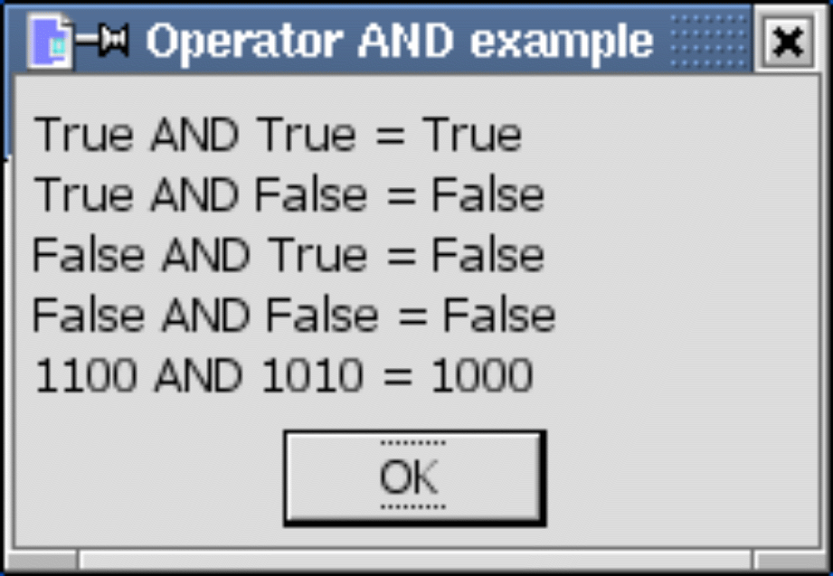
Figure 14. Using the AND operator.

OR
Perform a logical OR operation on Boolean values, and a bit-wise OR on numerical values. Consider the phrase, “You can purchase that if you have cash OR your friend has cash.” It does not matter who has cash. If either operand is True, then the result is True; otherwise the result is False.
Listing 41. Operator OR.
Sub ExampleOpOR
Dim s$, x(), y(), i%, xi%, yi%
xi% = 12 : yi% = 10
x() = Array(True, True, False, False)
y() = Array(True, False, True, False)
For i = LBound(x()) To UBound(x())
s = s & x(i) & " OR " & y(i) & " = " & CBool(x(i) OR y(i)) & CHR$(10)
Next
s = s & IntToBinaryString(xi, 4) & " OR " & IntToBinaryString(yi, 4) &_
" = " & IntToBinaryString(xi OR yi, 4) & CHR$(10)
MsgBox s, 0, "Operator OR example"
End Sub
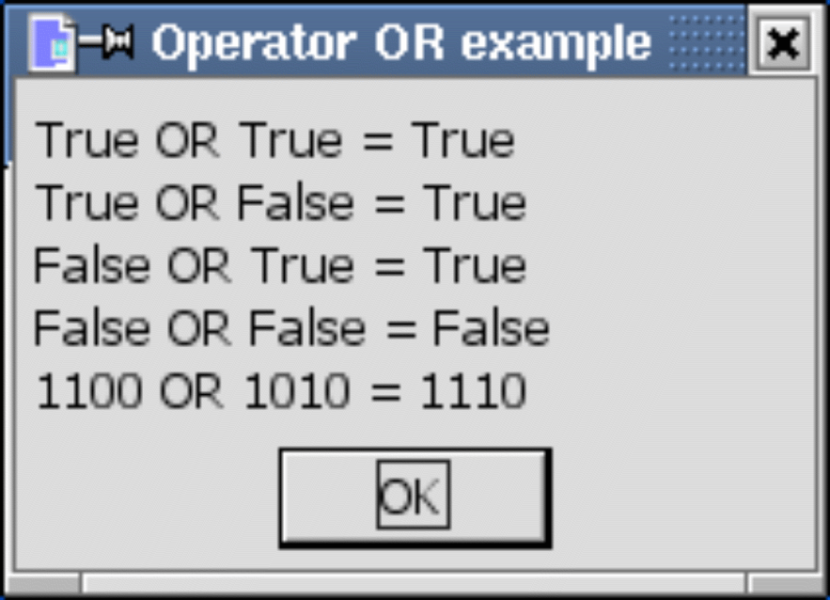
Figure 15. Using the OR operator.

XOR
The XOR operator is called “exclusive or”; this is a question of non-equivalence. The result is True if the operands have different values. The result is False if both operands have the same value. A logical XOR operation is performed on Boolean values, and a bit-wise XOR is performed on numerical values.
Listing 42. Operator XOR.
Sub ExampleOpXOR
Dim s$, x(), y(), i%, xi%, yi%
xi% = 12 : yi% = 10
x() = Array(True, True, False, False)
y() = Array(True, False, True, False)
For i = LBound(x()) To UBound(x())
s = s & x(i) & " XOR " & y(i) & " = " & CBool(x(i) XOR y(i)) & CHR$(10)
Next
s = s & IntToBinaryString(xi, 4) & " XOR " & IntToBinaryString(yi, 4) &_
" = " & IntToBinaryString(xi XOR yi, 4) & CHR$(10)
MsgBox s, 0, "Operator XOR example"
End Sub
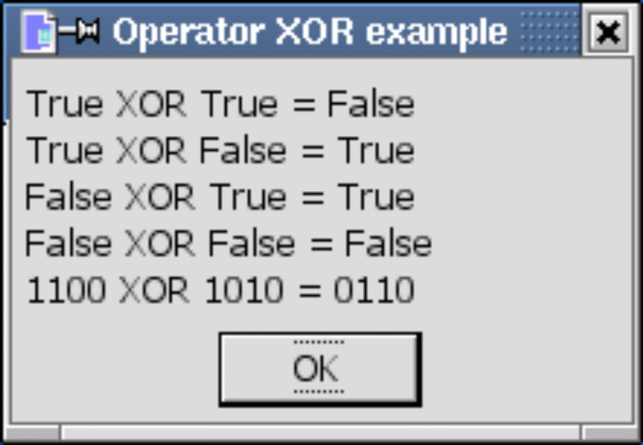
Figure 16. Using the XOR operator.

EQV
The EQV operator is a question of equivalence: Are the two operands the same? A logical EQV operation is performed for Boolean values, and a bit-wise EQV on numbers. If both operands have the same value, the result is True. If the operands don’t have the same value, the result is False.
Listing 43. Operator EQV.
Sub ExampleOpEQV
Dim s$, x(), y(), i%, xi%, yi%
xi% = 12 : yi% = 10
x() = Array(True, True, False, False)
y() = Array(True, False, True, False)
For i = LBound(x()) To UBound(x())
s = s & x(i) & " EQV " & y(i) & " = " & CBool(x(i) EQV y(i)) & CHR$(10)
Next
s = s & IntToBinaryString(xi, 4) & " EQV " & IntToBinaryString(yi, 4) &_
" = " & IntToBinaryString(xi EQV yi, 4) & CHR$(10)
MsgBox s, 0, "Operator EQV example"
End Sub
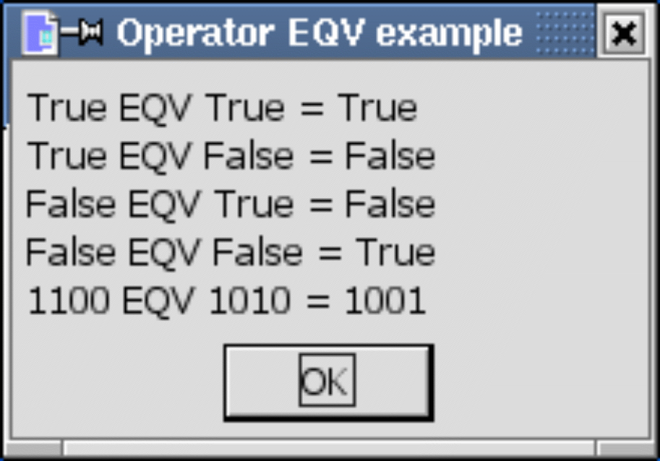
Figure 17. Using the EQV operator.

IMP
The IMP operator performs a logical implication. A logical IMP operation is performed on Boolean values, and a bit-wise IMP on numbers. As the name implies, “x IMP y” asks if the statement that “x implies y” is a true statement. To help understand logical implication, define x and y as follows:
x = The sky is cloudy
y = The sun is not visible
If x Then y
If both x and y are true — the sky is cloudy and the sun is not visible — the statement can be considered true. This statement makes no claim about y if x is not true. In other words, if the sky is not cloudy, this statement does not imply that the sun is, or is not, visible. For example, it might be a clear night, or (like a good computer geek) you might be inside a room without any windows. This explains why the entire statement is always considered valid when x is false. Finally, if x is true and y is not, the entire statement is considered false. If the sky is cloudy, and the sun is visible, the statement cannot possibly be correct; a cloudy day could not imply that the sun is visible.
Listing 44. Operator IMP.
Sub ExampleOpIMP
Dim s$, x(), y(), i%, xi%, yi%
xi% = 12 : yi% = 10
x() = Array(True, True, False, False)
y() = Array(True, False, True, False)
For i = LBound(x()) To UBound(x())
s = s & x(i) & " IMP " & y(i) & " = " & CBool(x(i) IMP y(i)) & CHR$(10)
Next
s = s & IntToBinaryString(xi, 4) & " IMP " & IntToBinaryString(yi, 4) &_
" = " & IntToBinaryString(xi IMP yi, 4) & CHR$(10)
MsgBox s, 0, "Operator IMP example"
End Sub
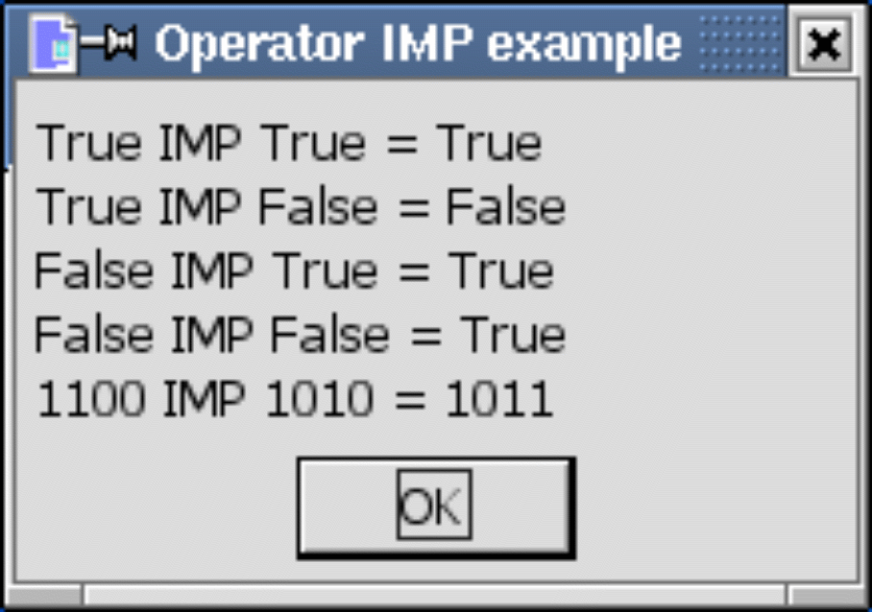
Figure 18. Using the IMP operator.

NOT
The NOT operator performs a logical NOT operation on Boolean values, and a bit-wise NOT on numerical values. This means that “Not True” is False and “Not False” is True. For bit-wise operations, a 1 becomes a 0 and a 0 becomes a 1.
Print NOT True REM 0, which is False
Print NOT False REM -1, which is True
Print NOT 2 REM -3, which took the bits 0010 to 1101

Comparison operators
The comparison operators work with numerical, Date, Boolean, and String data types.
Print 2 = 8/4 AND 0 < 1/3 AND 2 > 1 '-1=True
Print 4 <= 4.0 AND 1 >= 0 AND 1 <> 0 '-1=True
String comparisons are based on their internal representations as numbers and are case sensitive. The letter “A” is less than the letter “B”. The uppercase characters are less than the lowercase letters.
Dim a$, b$, c$
a$ = "A" : b$ = "B" : c$ = "B"
Print a$ < b$ 'True
Print b$ = c$ 'True
Print c$ <= a$ 'False
Strange problems occur when all of the operands are string constants. If at least one operand is a variable, the expected results are achieved. This is likely related to how the operands are recognized and converted for use.
Print "A" < "B" '0=False, this is not correct
Print "B" < "A" '-1=True, this is not correct
Print 3 = "3" 'False, but this changes if a variable is used
When variables are used rather than string constants, the numerical values are converted to string types for the comparison.
Dim a$, i%, t$
a$ = "A" : t$ = "3" : i% = 3
Print a$ < "B" 'True, String compare
Print "B" < a$ 'False, String compare
Print i% = "3" 'True, String compare
Print i% = "+3" 'False, String compare
Print 3 = t$ 'True, String compare
Print i% < "2" 'False, String compare
Print i% > "22" 'True, String compare
TIP | When comparing operands of different types, especially when mixing numeric and string types, it is safer to explicitly perform a type conversion. Either convert the string to a number, or the number to a string. The functions to do this are discussed later.
OOo recognizes the Visual Basic statement Option Compare { Binary | Text}, but as of OOo version 3.20, the statement still does nothing. The current behavior is a binary comparison of strings.

Flow control
Flow control is about deciding which line of code runs next. Calling a subroutine or function is a simple form of unconditional flow control. More complicated flow control involves branching and looping. Flow control allows macros to have complicated behavior that changes based on the current data.
Branching statements cause the program flow to change. Calling a subroutine or function is an unconditional branch. OOo Basic supports conditional branching statements such as “if x, then do y”. Looping statements cause the program to repeat sections of code. Looping statements allow for a section to be repeated a specific number of times or until a specific “exit” condition has been achieved.

Define a label as a jump target
Some flow control statements, such as GoSub, GoTo, and On Error, require a label to mark a point in the code. Label names are subject to the same rules as variable names. Label names are immediately followed by a colon. Remember that a colon is also used as a statement separator that allows multiple statements to occupy the same line. Space between the label name and the colon causes the colon to be used as a statement separator, which means the label won’t be defined. The following lines all represent valid OOo Basic code.
<statements>
i% = 5 : z = q + 4.77

MyCoolLabel:
<more statements>

JumpTarget: <more statements> REM no space between label and colon
TIP | Inserting a space between a label and the colon causes the colon to be used as a statement separator, and the label is not defined.

GoSub
The GoSub statement causes execution to jump to a defined label in the current routine. It isn’t possible to jump outside of the current routine. When the Return statement is reached, execution continues from the point of the original call. A Return statement with no previous GoSub produces a run-time error. In other words, Return is not a substitute for Exit Sub or Exit Function. It is generally assumed that functions and subroutines produce more understandable code than GoSub and GoTo.

TIP | GoSub is a persistent remnant from old BASIC dialects, retained for compatibility. GoSub  is strongly discouraged because it tends to produce unreadable code. Use a subroutine or  function instead. In fact, Visual Basic .NET no longer supports the GoSub keyword.
Listing 45. Example GoSub.
Sub ExampleGoSub
Dim i As Integer
GoSub Line2 REM Jump to line 2 then return, i is 1
GoSub [Line 1] REM Jump to line 1 then return, i is 2
MsgBox "i = " + i, 0, "GoSub Example" REM i is now 2
Exit Sub REM Leave the current subroutine.
[Line 1]: REM this label has a space in it
i = i + 1 REM Add one to i
Return REM return to the calling location
Line2: REM this label is more typical, no spaces
i = 1 REM Set i to 1
Return REM return to the calling location
End Sub

GoTo
The GoTo statement causes execution to jump to a defined label in the current routine. It isn’t possible to jump outside of the current routine. Unlike the GoSub statement, the GoTo statement doesn’t know from where it came. GoTo is a persistent remnant from old BASIC dialects, retained for compatibility. GoTo is strongly discouraged because it tends to produce unreadable code. Use a subroutine or function instead.
Listing 46. Example GoTo.
Sub ExampleGoTo
Dim i As Integer
GoTo Line2 REM Okay, this looks easy enough
Line1: REM but I am becoming confused
i = i + 1 REM I wish that GoTo was not used
GoTo TheEnd REM This is crazy, makes me think of spaghetti,
Line2: REM Tangled strands going in and out; spaghetti code.
i = 1 REM If you have to do it, you probably
GoTo Line1 REM did something poorly.
TheEnd: REM Do not use GoTo.
MsgBox "i = " + i, 0, "GoTo Example"
End Sub

On GoTo and On GoSub
These statements cause the execution to branch to a label based on a numeric expression N. If N is zero, no branching occurs. The numeric expression N must be in the range of 0 through 255. This is sometimes called a “computed goto,” because a computation is used to direct the program flow. It isn’t possible to jump outside of the current subroutine.
Syntax: On N GoSub Label1[, Label2[, Label3[,...]]]
Syntax: On N GoTo Label1[, Label2[, Label3[,...]]]
To reiterate how this works, if N = 1 then branch to Label 1, if N = 2 then branch to Label 2... If N is less than 1 or if N is greater than the number of labels, then the branch is not taken; it is simply ignored.
Listing 47. Example On GoTo.
Sub ExampleOnGoTo
Dim i As Integer
Dim s As String
i = 1
On i+1 GoSub Sub1, Sub2
s = s & Chr(13)
On i GoTo Line1, Line2
REM The exit causes us to exit if we do not continue execution
Exit Sub
Sub1:
s = s & "In Sub 1" : Return
Sub2:
s = s & "In Sub 2" : Return
Line1:
s = s & "At Label 1" : GoTo TheEnd
Line2:
s = s & "At Label 2"
TheEnd:
MsgBox s, 0, "On GoTo Example"
End Sub

If Then Else
The If construct is used to execute a block of code based on an expression. Although you can use GoTo or GoSub to jump out of an If block, you cannot jump into an If block. The simplest If statement has the following form:
If Condition Then Statement
The condition can be any expression that either evaluates to — or is convertible to — True or False. Use a slightly more complicated version to control more than a single statement.
If Condition Then
Statementblock
[ElseIf Condition Then]
Statementblock
[Else]
Statementblock
End If
If the first condition evaluates to True, the first block runs. The ElseIf statement allows multiple If statements to be tested in sequence. The statement block for the first true condition runs. The Else statement block runs if no other condition evaluates to True.
Listing 48. Example If.
Sub ExampleIf
Dim i%
i% = 4
If i = 4 Then Print "i is four"
If i <> 3 Then
Print "i is not three"
End If
If i < 1 Then
Print "i is less than 1"
elseif i = 1 Then
Print "i is 1"
elseif i = 2 Then
Print "i is 2"
else
Print "i is greater than 2"
End If
End Sub
If statements can be nested.
If i <> 3 THEN
If k = 4 Then Print "k is four"
If j = 7 Then
Print "j is seven"
End If
End If

IIf
The IIf (“Immediate If”) function returns one of two values based on a conditional expression.
Syntax: object = IIf (Condition, TrueExpression, FalseExpression)
This is very similar to the following code:
If Condition Then
object = TrueExpression
Else
object = FalseExpression
End If
This works as a great single-line If-Then-Else statement.
max_age = IIf(johns_age > bills_age, johns_age, bills_age)

Choose
The Choose statement selects from a list of values based on an index.
Syntax: obj = Choose (expression, Select_1[, Select_2, ... [,Select_n]])
The Choose statement returns a null if the expression is less than 1 or greater than the number of selection arguments. Choose returns “select_1” if the expression evaluates to 1, and “select_2” if the expression evaluates to 2. The result is similar to storing the selections in an array with a lower bound of 1 and then indexing into the array.
Listing 49. A division-by-zero error occurs even though 1/(i-2) should be returned.
i% = 3
Print Choose (i%, 1/(i+1), 1/(i-1), 1/(i-2), 1/(i-3))
Selections can be expressions and they can contain function calls. Every function is called and every expression is evaluated in the argument list for the call to the Choose statement. The code in Listing 49 causes a division-by-zero error because every argument is evaluated, not just the argument that will be returned. Listing 50 calls the functions Choose1, Choose2, and Choose3.
Listing 50. Example Choose statement.
Sub ExampleChoose
Print Choose(2, "One", "Two", "Three") 'Two
Print Choose(2, Choose1(), Choose2(), Choose3()) 'Two
End Sub
Function Choose1$()
Print "I am in Choose1"
Choose1 = "One"
End Function
Function Choose2$()
Print "I am in Choose2"
Choose2 = "Two"
End Function
Function Choose3$()
Print "I am in Choose3"
Choose3 = "Three"
End Function
TIP | All arguments in a Choose statement are evaluated. If functions are used in the arguments for Choose, they are all called.

Select Case
The Select Case statement is similar to an If statement with multiple Else If blocks. A single-condition expression is specified and this is compared against multiple values for a match as follows:
Select Case condition_expression
Case case_expression1
StatementBlock1
Case case_expression2
StatementBlock2
Case Else
StatementBlock3
End Select
The condition_expression is compared in each Case statement. The first statement block to match is executed. The optional Case Else block runs if no condition matches. It is not an error if nothing matches and no Case Else block is present.

Case expressions
The conditional expression is evaluated once and then it is compared to each case expression until a match is found. A case expression is usually a constant, such as “Case 4” or “Case "hello"”.
Select Case 2
Case 1
Print "One"
Case 3
Print "Three"
End Select
You can specify multiple values by separating them with commas: “Case 3, 5, 7”. The keyword To checks a range of values — for example, “Case 5 To 10”. Open-ended ranges are checked as “Case < 10” or as “Case IS < 10”.
TIP | The Case IS statement is different than the IS operator that decides if two objects are the same.
Every Case statement written “Case op expression” is shorthand for writing “Case IS op expression”. The form “Case expression” is shorthand for “Case IS = expression”. For example, “Case >= 5” is equivalent to “Case IS >= 5”, and “Case 1+3” is equivalent to “Case IS = 1+3”.
Select Case i
Case 1, 3, 5
Print "i is one, three, or five"
Case 6 To 10
Print "i is a value from 6 through 10"
Case < -10
Print "i is less than -10"
Case IS > 10
Print "i is greater than 10"
Case Else
Print "No idea what i is"
End Select
A Case statement can contain a list of expressions separated by commas. Each expression can include an open-ended range. Each expression can use the statement Case IS (see Listing 51).
Listing 51. The keyword IS is optional.
Select Case i%
Case 6, Is = 7, Is = 8, Is > 15, Is < 0
Print "" & i & " matched"
Case Else
Print "" & i & " is out of range"
End Select

If Case statements are easy, why are they frequently incorrect?
I frequently see incorrect examples of Case statements. It’s instructive to see what is repeatedly done incorrectly. Consider the simple examples in Table 15. The last examples are written correctly in Table 17.
Table 15. Case statements are frequently written incorrectly.
Example | Valid | Description
Select Case i  Case 2 | Correct | The Case expression 2 is evaluated as two. Two is compared to i.
Select Case i  Case Is = 2 | Correct | The Case expression 2 is evaluated as two. Two is compared to i.
Select Case i  Case Is > 7 | Correct | The expression 7 is evaluated as seven. Seven is compared to i.
Select Case i  Case 4, 7, 9 | Correct | The conditional expression i is compared individually to 4, 7, and 9.
Select Case x  Case 1.3 TO 5.7 | Correct | You can specify a range and use floating-point numbers.
Select Case i  Case i = 2 | Incorrect | The Case expression (i=2) is evaluated as True or False. True or False is compared to i. This is reduced to “IS = (i=2)”.
Select Case i  Case i<2 OR i>9 | Incorrect | The Case expression (i<2 OR 9<i) is evaluated as True or False. True or False is compared to i. This is reduced to “IS = (i<2 OR 9<i)”.
Select Case i%  Case i%>2 AND i%<10 | Incorrect | The Case expression (i>2 AND i < 10) is evaluated as True or False. True or False is compared to i. This is reduced to “IS = (i>2 AND i<10)”.
Select Case i%  Case IS>8 And i<11 | Incorrect | Again, True and False are compared to i. This is reduced to “IS > (8 AND i<11)”. The precedence rules cause this to be reduced to “IS > (8 AND (i<11))”. This is usually not what’s intended.
Select Case i%  Case IS>8 And IS<11 | Incorrect | Compile error. The keyword IS must immediately follow Case.

I have seen OOo examples with incorrect examples such as “Case i > 2 AND i < 10”. This fails. Don’t believe it even though you see it in print. Understand why this fails and you have mastered Case statements.
The next to the last incorrect example in Table 15 demonstrates the most common error that I see with Case expressions. Listing 52 considers the case when i is less than 11, and the case when i is greater than or equal to 11. To put it simply, IS>8 AND i<11 has the Case statement comparing the value of i to the result of a Boolean expression, which can be only 0 or -1. The big difficulty with Case statements is that they look like If statements, which are looking for a True or False, but Case statements are looking for a particular value against which to match the conditional, and 0 or -1 is not helpful.
Consider the second case in Listing 52, i >= 11. The operator < has higher precedence than the operator AND, so it is evaluated first. The expression i<11 evaluates to False (because I assumed that i>=11). False is internally represented as 0. Zero has no bits set, so 8 AND 0 evaluates to zero. For values of i greater than or equal to 11, the entire expression is equivalent to “IS > 0”. In other words, for i = 45, this Case statement is incorrectly accepted.
A similar argument for values of i less than 11, left as an exercise for the reader, demonstrates that the Case statement is equivalent to “Case IS > 8”. Therefore, values of i less than 11 are correctly evaluated, but values of i greater than or equal to 11 are not.
Listing 52. “Case IS > 8 AND i < 11” reduces incorrectly.
IS > (8 AND i < 11) => IS > (8 AND -1) => IS > 8 'Assume i < 11 is correct.
IS > (8 AND i < 11) => IS > (8 AND 0) => IS > 0 'Assume i >= 11 is unwanted.

Writing correct Case expressions
After you learn a few simple examples, it’s easy to write correct Case expressions. Table 16 abstractly enumerates the varieties, and Listing 56 concretely demonstrates the varieties.
Table 16. Simple Case varieties.
Example | Description
Case IS operator expression | This is both the simplest case and the most difficult case. If the expression is a constant, it is easy to understand. If the expression is more complicated, the only difficult part is building the expression.
Case expression | This is a reduction of “Case IS operator expression” when the operator checks for equality.
Case expression TO expression | Check an inclusive range. This is usually done correctly.
Case expression, expression, | Each expression is compared. This is usually done correctly.

For the difficult cases, it suffices to produce an expression that evaluates to the Case condition expression if it is correct, and anything else if it is not. In other words, for Select Case 4, the expression must evaluate to 4 for the statement block to run.
Listing 53. If x is a String value, this will work for any Boolean expression.
Select Case x
Case IIF(Boolean expression, x, x&"1") ' Assumes that x is a string
In Listing 53, x is returned if the Boolean expression is True. The expression x=x is True, so the Case statement passes. If the Boolean expression is False, x&"1" is returned. This is not the same string as x, so the Case statement will not pass. A similar method is used for numerical values.
Listing 54. If x is a numerical value, this will work for any Boolean expression.
Select Case x
Case IIF(Boolean expression, x, x+1) ' Assumes that x is numeric
In Listing 54, x is returned if the Boolean expression is True. The expression x=x is True, so the Case statement passes. If the Boolean expression is False, x+1 is returned. For numerical values, x=x+1 is not True, so the Case statement will not pass. There is a possibility of numerical overflow, but in general this works. A brilliant and more elegant solution for numerical values is provided by Bernard Marcelly, a member of the OOo French translation project.
Case x XOR NOT (Boolean Expression)
This assumes that the Boolean expression returns True (-1) if it should pass and False (0) if it should not.
Listing 55. This code uses XOR and NOT in a Case statement.
x XOR NOT(True) = x XOR NOT(-1) = x XOR 0 = x
x XOR NOT(False) = x XOR NOT( 0) = x XOR -1 <> x
After my initial confusion, I realized how brilliant this really is. There are no problems with overflow and it works for all Integer values of x. Do not simplify this to the incorrect reduction “x AND (Boolean expression)” because it fails if x is 0.
Listing 56. Select Case example.
Sub ExampleSelectCase
Dim i%
i = Int((20 * Rnd) -2) 'Rnd generates a random number between zero and one
Select Case i%
Case 0
Print "" & i & " is Zero"
Case 1 To 5
Print "" & i & " is a number from 1 through 5"
Case 6, 7, 8
Print "" & i & " is the number 6, 7, or 8"
Case IIf(i > 8 And i < 11, i, i+1)
Print "" & i & " is greater than 8 and less than 11"
Case i% XOR NOT(i% > 10 AND i% < 16)
Print "" & i & " is greater than 10 and less than 16"
Case Else
Print "" & i & " is out of range 0 to 15"
End Select
End Sub
ExampleSelectCase in Listing 56 generates a random integer from -2 through 18 each time it runs. Run this repeatedly to see each Case statement used. Each of the cases could have used the IIF construct.
Now that I’ve explained the different methods to deal with ranges, it’s time to reevaluate the incorrect cases in Table 15. The solutions in Table 17 are not the only possible solutions, but they use some of the solutions presented.
Table 17. Incorrect examples from Table 15 — now corrected.
Incorrect | Correct | Description
Select Case i  Case i = 2 | Select Case i  Case 2 | The variable i is compared to 2.
Select Case i  Case i = 2 | Select Case i  Case IS = 2 | The variable i is compared to 2.
Select Case i  Case i<2 OR i>9 | Select Case i  Case IIf(i<2 OR i>9, i, i+1) | This works even if i is not an integer.
Select Case i%  Case i%>2 AND i%<10 | Select Case i%  Case 3 TO 9 | i% is an integer so the range is from 3 through 9.
Select Case i%  Case IS>8 And i<11 | Select Case i%  Case i XOR NOT(i>8 AND i< 11) | This works because i% is an integer.

While ... Wend
Use the While ...Wend statement to repeat a block of statements while a condition is true. This construct has limitations that do not exist with the Do While ... Loop construct and offers no particular benefits. The While ... Wend statement does not support an Exit statement. You cannot use GoTo to exit a While ... Wend statement.
While Condition
StatementBlock
Wend
Visual Basic .NET does not support the keyword Wend. This is another reason to use the Do While ... Loop instead.

Do ... Loop
The Loop construct has different forms and is used to continue executing a block of code while, or until, a condition is true. The most common form checks the condition before the loop starts, and repeatedly executes a block of code as long as the condition is true. If the initial condition is false, the loop is never executed.
Do While condition
Block
[Exit Do]
Block
Loop
A similar, but much less common form, repeatedly executes the code as long as the condition is false. In other words, the code is executed until the condition becomes true. If the condition evaluates to true immediately, the loop never runs.
Do Until condition
Block
[Exit Do]
Block
Loop
You can place the check at the end of the loop, in which case the block of code is executed at least once. With the following construct, the loop runs at least once and then repeatedly runs as long as the condition is true:
Do
Block
[Exit Do]
Block
Loop While condition
To execute the loop at least once and then continue as long as the condition is false, use the following construct:
Do
Block
[Exit Do]
Block
Loop Until condition

Exit the Do Loop
The Exit Do statement causes an immediate exit from the loop. The Exit Do statement is valid only within a Do ... Loop. Program execution continues with the statement that follows the innermost Loop statement. The subroutine ExampleDo in Listing 57 demonstrates a Do While Loop by searching an array for a number.
Listing 57. Do Loop example.
Sub ExampleDo
Dim a(), i%, x%
a() = Array(2, 4, 6, 8, 10, 12, 14, 16, 18, 20, 22, 24, 26, 28, 30)
x = Int(32 * Rnd) REM random integer between 0 and 32
i = LBound(a()) REM i is the lower bound of the array.
Do While a(i) <> x REM while a(i) is not equal to x
i = i + 1 REM Increment i
If i > UBound(a()) Then Exit Do REM If i is too large, then exit
Loop REM Loop back to the Do While
If i <= UBound(a()) Then REM If i is not too large then found x
MsgBox "Found " & x & " at location " & i, 0, "Example Do"
Else
MsgBox "Could not find " & x & " in the array", 0, "Example Do"
End If
End Sub

Which Do Loop should I use?
OOo Basic supports four variants of the Do Loop construct. Each variant has a particular purpose and time for use. The most common problem is that the loop runs one time too few or one time too many because the conditional expression was incorrectly placed at the wrong location.
When deciding where to place the conditional expression of a Do Loop, ask yourself this question: “Must the loop always run at least once?” If the answer is no, the conditional expression must be at the top. This will prevent the code in the loop from running if the conditional expression fails. Consider, for example, printing all of the elements in an array of unknown size. The array might contain no elements at all, in which case the code in the loop shouldn’t run (see Table 18).
Table 18. While and Until loops are very similar.
Do While | Do Until
i% = LBound(a())  Do While i% <= UBound(a())  Print a(i%)  i% = i% + 1  Loop | i% = LBound(a())  Do Until i% > UBound(a())  Print a(i%)  i% = i% + 1  Loop

In each case in Table 18, if the array is empty, the loop never runs. Before the condition is evaluated, i% is set to the lower bound of the array. In each case, the loop continues to run while i% is not larger than the upper bound.
Consider the difference between a While loop and an Until loop with a simple example. While the car has gas, you may drive it. Until the car does not have gas, you may drive it. The primary difference between the While and the Until is the word NOT. Tending more toward OOo Basic, I can write “Until NOT (the car has gas).” The choice between While and Until is usually based on which one you can write without the NOT.
If the loop should run at least once, move the conditional expression to the end of the Do Loop. Consider requesting user input until a valid value has been entered. The most natural choice is to place the conditional expression at the end.
Dim s$, x As Double
Do
s$ = InputBox("Enter a number from 1 through 5")
x = CDbl(s$) 'Convert the string to a Double
Loop Until x >= 1 AND x <= 5
The loop must run at least once so that at least one number is entered. The loop repeats until a valid value is entered. As an exercise, consider how to write this as a While loop.

For ... Next
The For ... Next statement repeats a block of statements a specified number of times.
For counter=start To end [Step stepValue]
statement block1
[Exit For]
statement block2
Next [counter]
The numeric “counter” is initially assigned the “start” value. When the program reaches the Next statement, the counter is incremented by the “step” value, or incremented by one if a “step” value is not specified. If the “counter” is still less than or equal to the “end” value, the statement blocks run. An equivalent Do While Loop follows:
counter = start
Do While counter <= end
statement block1
[Exit Do]
statement block2
counter = counter + step
Loop
The “counter” is optional on the “Next” statement, and it automatically refers to the most recent “For” statement.
For i = 1 To 4 Step 2
Print i ' Prints 1 then 3
Next i ' The i in this statement is optional.
The Exit For statement leaves the For statement immediately. The most recent For statement is exited. Listing 58 demonstrates this with a sorting routine. An array is filled with random integers, and then sorted using two nested loops. This technique is called a “modified bubble sort.”
First, iOuter is set to the last number in the array. The inner loop, using iInner, compares every number to the one after it. If the first number is larger than the second number, the two numbers are swapped. The second number is then compared to the third number. After the inner loop is finished, the largest number is guaranteed to be at the last position in the array.
Next, iOuter is decremented by 1. The inner loop this time ignores the last number in the array, and compares every number to the one after it. At the end of the inner loop, the second-highest number is second from the end.
With each iteration, one more number is moved into position. If no numbers are exchanged, the list is sorted.
Listing 58. Modified bubble sort.
Sub ExampleForNextSort
Dim iEntry(10) As Integer
Dim iOuter As Integer, iInner As Integer, iTemp As Integer
Dim bSomethingChanged As Boolean

' Fill the array with integers between -10 and 10
For iOuter = LBound(iEntry()) To Ubound(iEntry())
iEntry(iOuter) = Int((20 * Rnd) -10)
Next iOuter

' iOuter runs from the highest item to the lowest
For iOuter = UBound(iEntry()) To LBound(iEntry()) Step -1

'Assume that the array is already sorted and see if this is incorrect
bSomethingChanged = False
For iInner = LBound(iEntry()) To iOuter-1
If iEntry(iInner) > iEntry(iInner+1) Then
iTemp = iEntry(iInner)
iEntry(iInner) = iEntry(iInner+1)
iEntry(iInner+1) = iTemp
bSomethingChanged = True
End If
Next iInner
'If the array is already sorted then stop looping!
If Not bSomethingChanged Then Exit For
Next iOuter
Dim s$
For iOuter = LBound(iEntry()) To Ubound(iEntry())
s = s & iOuter & " : " & iEntry(iOuter) & CHR$(10)
Next iOuter
MsgBox s, 0, "Sorted Array"
End Sub

Exit Sub and Exit Function
The Exit Sub statement exits a subroutine, and the Exit Function statement exits a function. The routine is exited immediately. The macro continues running at the statement following the statement that called the current routine. These statements work only to exit the currently running routine, and they are valid only in their respective types. For example, you can’t use Exit Sub in a function.

Error handling using On Error
Errors are usually placed into three “categories” — compile time, run time, and logic. Compile-time errors are typically syntax errors such as missing double quotation marks that prevent your macro from compiling. Compile-time errors are the easiest to deal with because they are found immediately and the IDE shows you which line caused the problem. Run-time errors compile properly but cause an error when the macro runs. For example, dividing by a variable that at some point evaluates to zero will cause a run-time error. The third type, logic errors, are mistakes in the business logic of the program: They compile and run okay, but generate the wrong answers. They’re the worst kind because you have to find them yourself — the computer won’t help you at all. This section is about run-time errors: how to deal with them and how to correct them.
An error handler is a piece of code that runs when an error occurs. The default error handler displays an error message and stops the macro. OOo Basic provides a mechanism to modify this behavior (see Table 19). The first form, On Error Resume Next, tells OOo to ignore all errors: No matter what happens, keep running and pretend everything is fine. The second form, On Error GoTo 0, tells OOo to stop using the current error handler. Ignoring error handler scope issues, as explained later, think of On Error GoTo 0 as restoring the default method of handling errors: Stop running and display an error message. The final form, On Error GoTo LabelName, allows you to define code to handle errors the way that you want. This is called “setting up an error handler.”
Table 19. Supported On Error forms.
Form | Usage
On Error Resume Next | Ignore errors and continue running at the next line in the macro.
On Error GoTo 0 | Cancel the current error handler.
On Error GoTo LabelName | Transfer control to the specified label.

When an error occurs, the code that was running stops running, and control is transferred to the current error handler. The error handlers use the functions in Table 20 to determine the cause and location of the error. Visual Basic uses an Error object and does not support the functions in Table 20.
Table 20. Error-related variables and functions.
Function | Use
CVErr | Convert an expression to an error object.
Erl | Integer line number of the last error.
Err | Integer error number of the last error.
Error | Error message of the last error.

All error handlers must be declared in a routine and are local to the containing subroutine or function. When an error occurs, OOo Basic starts working backward through the call stack until it finds an error handler. If it doesn’t find an error handler, it uses the default handler. The default handler prints an error message and halts the program. The error information, such as Erl, indicates the line number in the current routine that caused the error. For example, if the current routine calls the function b() at line 34 and an error occurs in b(), the error is reported as occurring at line 34. Listing 59 contains an example of this, and Figure 19 shows the call stack. Another example is shown in Listing 63.
Listing 59. Use Erl to get the line number.
x = x + 1 'Assume that this is line 33
Call b() 'Error in b() or something b() calls (line 34)
Exit Sub 'Leave the subroutine
ErrorHandler: 'No other handlers between here and the error
Print "error at " & Erl 'Prints line 34
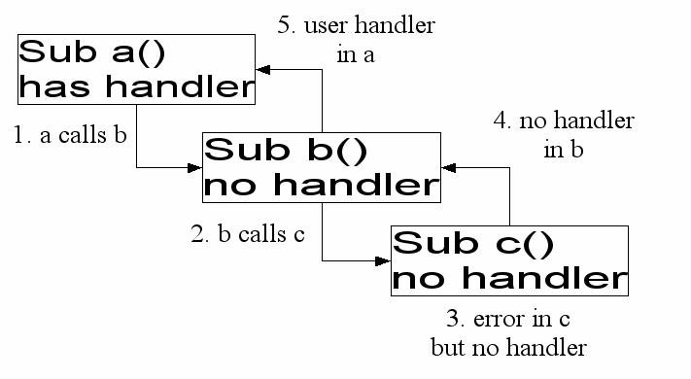
Figure 19. Walk the call stack to find a handler.
You cannot catch errors that occur in a DLL. Check the return code from the called DLL instead.

CVErr
Use CVErr (as mentioned in Table 20) to create an OOo specific internal data type that represents an error. I have never seen this done, but it can be useful for a very robust function.
CVErr returns an internal OOo type that should be assigned to a variant variable. Why?
- Use VarType to check the type of the returned value. A VarType of 10 means that an error object was returned (see Erro: Origem da referência não encontrada).
- CVErr accepts an integer, which represents the internal error code that occurred. The internal error object casts to an integer and returns that internal error code.
The following example demonstrates CVErr.
Listing 60. Using CVErr
Sub CallNotZero
Dim xVar As Variant
Dim xInt As Integer
Dim i As Integer
Dim s As String
For i = -1 To 1
xInt = NotZero(i)
xVar = NotZero(i)
s = s & "NotZero(" & i & ") = [" & xInt & "] when assigned to an Integer"
s = s & CHR$(10)
s = s & "NotZero(" & i & ") = [" & xVar & "] VarType=" & VarType(xVar)
s = s & CHR$(10)
Next
MsgBox s
End Sub

Function NotZero(x As Integer)
If x <> 0 Then
NotZero = x
Else
' 7 is an arbitrary number meaning nothing.
NotZero = CVErr(7)
End If
End Function
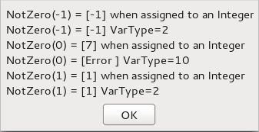
Figure 20. Return values using CVErr.

Ignore errors with On Error Resume Next
Error handling, in some cases, means ignoring errors. The On Error Resume statement tells OOo Basic that if a standard error occurs, it should ignore the error and resume running the code at the next line in the macro (see Listing 61). The error information is cleared, so it isn’t possible to check if an error occurred following the statement.
Listing 61. The error is cleared by the Resume Next statement.
Private zero%
sub ExampleErrorResumeNext
On Error Resume Next
Print 1/Zero%
If Err <> 0 Then Print Error$ & " at line " & Erl 'Err was cleared
End Sub

Clear an error handler with On Error GoTo 0
Use the statement On Error GoTo 0 to clear an installed error handler. This is usually done inside an error handler or after the code that used one. If an error occurs inside an error handler, it isn’t handled and the macro stops.
Listing 62. The error handler is cleared with the statement On Error GoTo 0.
Private zero%
sub ExampleErrorResumeNext
On Error Resume Next
Print 1/Zero%
On Error GoTo 0
...
End Sub
Some versions of Visual Basic also support On Error GoTo -1, which is equivalent to On Error GoTo 0.

Specify your own error handler with On Error GoTo Label
To specify your own error handler, use On Error GoTo Label. To define a label in OOo Basic, type some text on a line by itself and follow it with a colon. Line labels are no longer required to be unique; they must be unique only within each routine. This allows for consistency in naming error-handling routines rather than creating a unique name for every error handler (see Listing 63 and Figure 21). When an error occurs, execution is transferred to the label.
Listing 63. Error Handling.
Private zero%
Private error_s$
Sub ExampleJumpErrorHandler
On Error GoTo ExErrorHandler
JumpError1
JumpError2
Print 1/Zero%
MsgBox error_s, 0, "Jump Error Handler"
Exit Sub
ExErrorHandler:
error_s = error_s & "Error in MainJumpErrorHandler at line " & Erl() &_
" : " & Error() & CHR$(10)
Resume Next
End Sub
Sub JumpError1
REM Causes a jump to the handler in ExampleJumpErrorHandler.
REM The main error handler indicates that the error location is
REM at the call to JumpError1 and not in JumpError1.
Print 1/zero%
error_s = error_s & "Hey, I am in JumpError1" & CHR$(10)
End Sub

Sub JumpError2
On Error GoTo ExErrorHandler
Print 1/zero%
Exit Sub
ExErrorHandler:
error_s = error_s & "Error in JumpError2 at line " & Erl() &_
" : " & Error() & CHR$(10)
Resume Next
End Sub
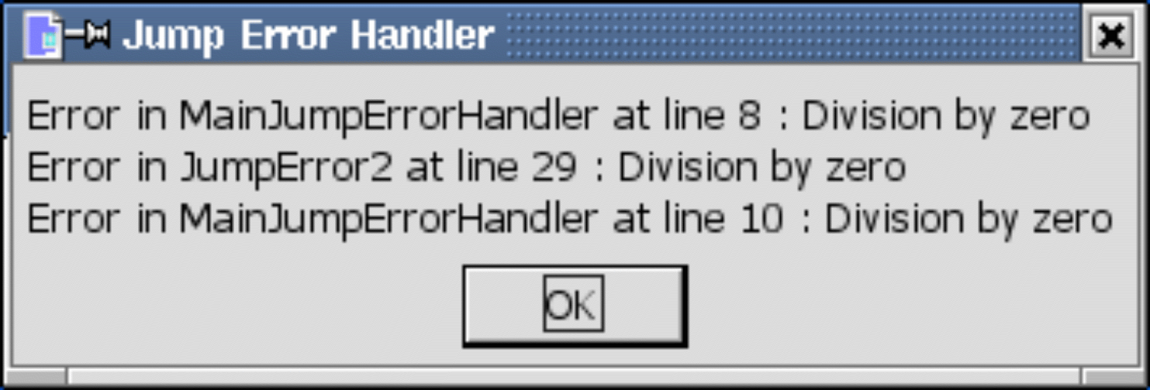
Figure 21. The last error handler declared is used.
A routine can contain several On Error statements. Each On Error statement can treat errors differently. The error handlers in Listing 63 all used Resume Next to ignore the error and continue execution at the line following the error. Using multiple error handlers, it is possible to skip sections of code when an error occurs (see Listing 64).
TIP | The OOo version 3.20 help still incorrectly states that error handling must occur at the start of a routine.
Listing 64. Skip sections of code when an error occurs.
On Error GoTo PropertiesDone 'Ignore any errors in this section.
a() = getProperties() 'If unable to get properties then
DisplayStuff(a(), "Properties") 'an error will prevent getting here.
PropertiesDone:
On Error GoTo MethodsDone 'Ignore any errors in this section.
a() = getMethods()
DisplayStuff(a(), "Methods")
MethodsDone:
On Error Goto 0 'Turn off current error handlers.
When you write an error handler, you must decide how to handle errors. The functions in Table 20 are used to diagnose errors and to display or log error messages. There is also the question of flow control. Here are some error-handling guidelines:
Exit the subroutine or function using Exit Sub or Exit Function.
Let the macro continue to run and ignore the error (see Listing 64).
Use Resume Next to continue running the macro at the line following the error (see Listing 65 and Figure 22).
Use Resume to run the same statement again. If the problem is not fixed, the error will occur again.
This will cause an infinite loop.
Use Resume LabelName to continue running at some specified location.
Listing 65. Resume next error handler.
Sub ExampleResumeHandler
Dim s$, z%
On Error GoTo Handler1 'Add a message, then resume to Spot1
s = "(0) 1/z = " & 1/z & CHR$(10) 'Divide by zero, so jump to Handler1
Spot1: 'Got here from Handler1
On Error GoTo Handler2 'Handler2 uses resume
s = s & "(1) 1/z = "&1/z & CHR$(10) 'Fail the first time, work the second
On Error GoTo Handler3 'Handler3 resumes the next line
z = 0 'Allow for division by zero again
s = s & "(2) 1/z = "&1/z & CHR$(10) 'Fail and call Handler3
MsgBox s, 0, "Resume Handler"
Exit Sub
Handler1:
s = s & "Handler1 called from line " & Erl() & CHR$(10)
Resume Spot1
Handler2:
s = s & "Handler2 called from line " & Erl() & CHR$(10)
z = 1 'Fix the error then do the line again
Resume
Handler3:
s = s & "Handler3 called from line " & Erl() & CHR$(10)
Resume Next
End Sub
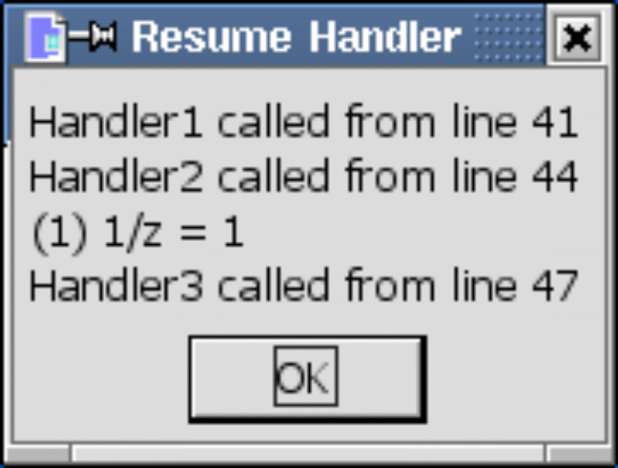
Figure 22. The last error handler declared is used.
TIP | Errors that occur in an error handler are not handled; the macro just stops running.

Error handlers — why use them?
When I run a macro and it crashes, I usually understand the sometimes cryptic error messages and recognize how to deal with them. When others run my macros and an error occurs, I usually hear about it because they don’t know how to handle it. This is a good indicator that I have not used proper error handling.
You do not have to write an error handler for each routine. If the current routine doesn’t have an error handler, but the routine that called it does, the caller’s error handler is called. For example, imagine that sub1 has an error handler and it calls sub2 that does not. If an error occurs in sub2, the error handler in sub1 is called.
When you use an error handler, you control how and when a user is notified of an error. Error handlers have uses other than controlling when a user is informed of an error. A properly used error handler can reduce the size of your macro. Consider, for example, the mathematical operations. It is cumbersome to check every mathematical operation before it is used.
If x <> 0 Then y = z / x
If x > 0 Then y = Log(x)
If i% < 32767 Then i% = i% + 1
Even with my paranoid code checking the arguments, I might still have a numeric overflow. Even worse, nothing is done if an error occurs, and processing continues as normal. Sometimes you can’t check anything to avoid the error. For example, prior to OOo version 2.0, the DimArray function returned an invalid empty array. The LBound and UBound functions generate exceptions with these invalid empty arrays. Error handling was used to safely generate the LBound and UBound even if an error occured. Consider the following cases:
- The argument is not an array.
- In an empty array, UBound < LBound; -1 and 0, for example.
- There are no problems if the array is not an invalid empty array.
- Should the optional dimension be considered?
The code in Listing 66 demonstrates a simple error handler that is able to simply ignore errors. The function returns True if the lower bound is less than or equal to the upper bound — in other words, if the array contains data. If an error occurs, either because the argument is not an array or because this is an invalid empty array, the line does not finish running so the assignment never takes place. If the assignment never takes place, the original default Boolean value of False is used. This is the correct answer. Writing a safe upper-bound or lower-bound routine is left as an exercise for the reader — the safe versions are not required with the fixed UBound and LBound functions released with OOo 2.0.
Listing 66. Determine if an array has stuff.
Sub ExampleArrayHasStuff
Dim a(), b(3), v
Print ArrayHasStuff(a()) 'False, because empty
Print ArrayHasStuff(v) 'False, not an array, so use error handler
Print ArrayHasStuff(DimArray()) 'False, bad array, so error handler called
Print ArrayHasStuff(DimArray(3))'True, this is not empty
Print ArrayHasStuff(b()) 'True, this is not empty
End Sub

Function ArrayHasStuff(v) As Boolean
REM default value for a Boolean is False, so the default answer is False
REM If an error occurs, then the statement never completes!
REM This is a good time to use On Error Resume Next
On Error Resume Next
ArrayHasStuff = CBool(LBound(v) <= UBound(v))
End Function
An error handler can even be interactive. The code in Listing 67 attempts to copy a file that doesn’t exist to a location that doesn’t exist. Needless to say, an error is generated. An error message is displayed and the user is asked if the copy should be tried again. The user is given an opportunity to correct any errors and continue.
Listing 67. Copy a file.
Sub ExampleCopyAFile()
CopyAFile("/I/do/not/exist.txt", "/neither/do/I.txt")
End Sub

Sub CopyAFile(Src$, Dest$)
On Error GoTo BadCopy: 'Set up the error handler
TryAgain:
FileCopy(Src$, Dest$) 'Generate the error

AllDone: 'If no error, then continue here
Exit Sub 'Resume to the AllDone label from the handler

BadCopy: 'Display an error dialog
Dim rc% 'Ask if should try again
rc% = MsgBox("Failed to copy from " & Src$ & " to " & Dest$ & " because: "&_
CHR$(10) & Error() & " at line " & Erl & CHR$(10) &_
"Try again?", (4 OR 32), "Error Copying")
If rc% = 6 Then 'Yes, try the command again
Resume
End If
If rc% = 7 Then 'No
Resume AllDone 'Go to the AllDone label
End If
End Sub

Conclusion
Building any significant OOo macro requires understanding the syntax of OOo Basic. This chapter covered the key elements:
- The syntax of a macro determines valid and invalid constructs.
- The logic of a macro determines what the macro does.
- Flow control directs the macro as it runs.
- Error handling directs the macro when it does something unexpected.
A complete, well-constructed macro that accomplishes any significant function will most likely use all of these characteristics of OOo programming. The specific elements within OOo that one uses to build a specific program depend on the application, the desired logical behavior of the program, and the best judgment of the programmer. One major part of successful programming is developing the experience to apply the ideas of this chapter in the most effective way.

