- - - - - - - - - - - - - - - - - - - - - - - - - - - - - - - - - - - - - - - - - - - - - - - - - - - - - - - - - - - - - - - - - - - - - - - - - - - - - - - - - - - - - - - - - - - - - - - - - - - - - -
File |  | Edit |  | Help
Create a new drawing Ctrl + N |  | Cut selected items Ctrl + X |  | Help F1
Open a drawing Ctrl + O |  | Copy selected items Ctrl + C |  | What's This? Shift + F1
Save the current drawing Ctrl + S |  | Paste from clipboard Ctrl + V |  | Show tip for selected item Shift + F2
Print a drawing Ctrl + P |  | Paste Special Ctrl + Shift + V
Close the current drawing Ctrl + F4 |  | Select all Ctrl + A
- - - - - - - - - - - - - - - - - - - - - - - - - - - - - - - - - - - - - - - - - - - - - - - - - - - - - - - - - - - - - - - - - - - - - - - - - - - - - - - - - - - - - - - - - - - - - - - - - - - - - -
File |  | Edit |  | Help
Create a new database Ctrl + N |  | Cut selected items Ctrl + X |  | Help F1
Open a database Ctrl + O |  | Copy selected items Ctrl + C |  | What's This? Shift + F1
Save the current database Ctrl + S |  | Paste from clipboard Ctrl + V |  | Show tip for selected item Shift + F2
Print Ctrl + P |  | Paste Special Ctrl + Shift + V
Close the current database Ctrl + F4 |  | Select all Ctrl + A
- - - - - - - - - - - - - - - - - - - - - - - - - - - - - - - - - - - - - - - - - - - - - - - - - - - - - - - - - - - - - - - - - - - - - - - - - - - - - - - - - - - - - - - - - - - - - - - - - - - - - -
File |  | Edit |  | Help
Create a new formula Ctrl + N |  | Cut selected items Ctrl + X |  | Help F1
Open a formula Ctrl + O |  | Copy selected items Ctrl + C |  | What's This? Shift + F1
Save the current formula Ctrl + S |  | Paste from clipboard Ctrl + V |  | Show tip for selected item Shift + F2
Print a formula Ctrl + P |  | Paste Special Ctrl + Shift + V
Close the current formula Ctrl + F4 |  | Select all Ctrl + A
- - - - - - - - - - - - - - - - - - - - - - - - - - - - - - - - - - - - - - - - - - - - - - - - - - - - - - - - - - - - - - - - - - - - - - - - - - - - - - - - - - - - - - - - - - - - - - - - - - - - - -
Instructions:
- Print the reference card on card stock or paper
- Fold along the dotted lines
- Tape the top and bottom ends together to form a triangular tube
- Display

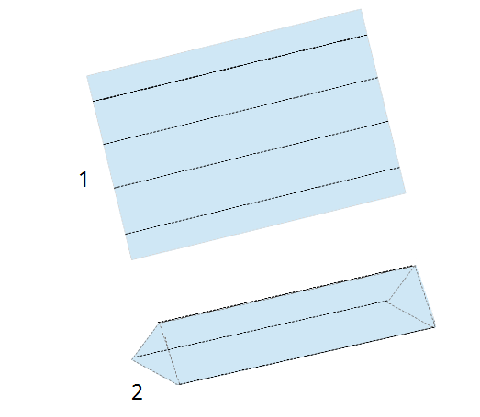
Contributors:
Ron Faile Jr.

License:
This work is licensed under three licenses, to be used alternatively or in combination depending on the user's needs:
- Creative Commons Attribution Share-Alike 3.0 Unported (CC-by-sa)
- GNU Lesser General Public License version 3 or any later version (LGPL 3+)
- Mozilla Public License version 1.1 (MPL 1.1),

Contact:
Send comments or suggestions to: documentation@global.libreoffice.org

Version: 3/18/2012

