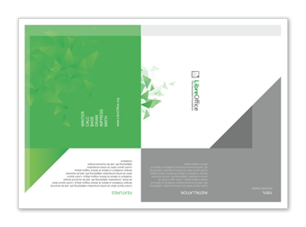 | Overview  While most of these instructions show the printed-side face-up, you will probably need to have the un-printed side facing you for most of the folds. It is just easier to provide steps this way. The part which currently needs folding is shown highlighted in red in each step.
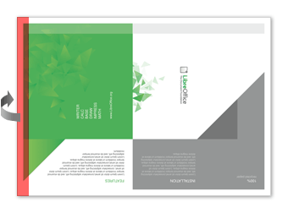 | Step one: fold the left edge  Fold the left edge of the paper along the line where the colours are intentionally faded to provide a folding-guide. Fold away from the printed side so you can no longer see the left edge.
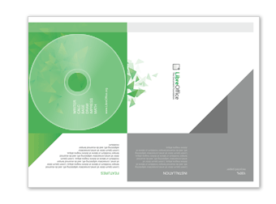 | Step two: Place CD under first fold  If you place a CD/DVD in under the first fold it will make it easier to ensure you are folding it tightly/loosely enough. The position of the CD is shown here, but remember that the CD would be placed on the un-printed side of the paper.
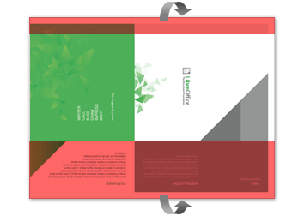 | Step three: Fold the brackets  Next, you will need to fold the top and bottom of the paper backwards so that it wraps around the disc. These large folds will bracket the disc and hold it in place.
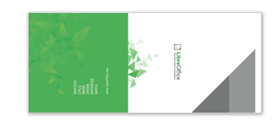 | Checkpoint  Here is how the printed side should look so far.
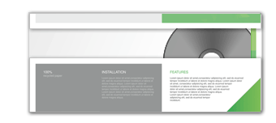 | And here is how the un-printed side should look so far, with the disc visible through a narrow gap.
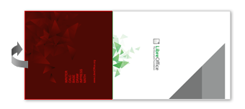 | Step four: Fold at half-way mark  Where the green space and the white space meet marks the edge where the front and back faces join. Fold the green side over at this delineation. (the green side is covered here in red)
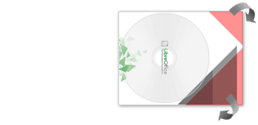 | Step five: Folding the "flap"  The next folds are diagonal because we need to make a point on the right-hand side so that it becomes a flap that we can insert into the other(green) side to close the case. Notice that one diagonal fold is larger than the other, to create the "document corner" look. Don't try and fold the paper exactly along the line where the grey and white edges meet, as the diagram to the left shows, some grey needs to be visible to create the impression of a "separated" green corner. And the disc is intentionally bigger than where this edge is placed.
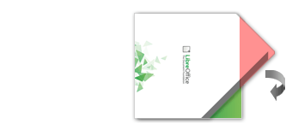 | Step six: close the seal  Tuck the flap (seen here in red) into the opening between the inside brackets on the green side of the package to seal the case. The flap should tuck in neatly like an envelope. And the green corner should be showing through as a result of the bigger diagonal fold.
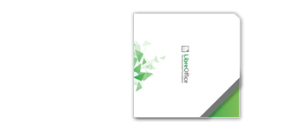 | Done!  And you're finished. Hope that was easy enough to follow.

