
Installing Extensions in LibreOffice

Copyright
This document is Copyright © 2010 by its contributors as listed below. You may distribute it and/or modify it under the terms of either the GNU General Public License (http://www.gnu.org/licenses/gpl.html), version 3 or later, or the Creative Commons Attribution License (http://creativecommons.org/licenses/by/3.0/), version 3.0 or later.
All trademarks within this guide belong to their legitimate owners.
Contributors
Ron Faile Jr.
Andreas Mantke
Gustavo Buzzatti Pacheco
Luis Fernando Heckler
Feedback
Please direct any comments or suggestions about this document to: documentation@global.libreoffice.org
Acknowledgments
This chapter is based on Chapter 14 of Getting Started with LibreOffice. The contributors to that chapter are:
Peter Hillier-Brook
Jean Hollis Weber
Michele Zarri
Publication date and software version
Published 12 August 2011. Based on LibreOffice 3.3.

Note for Mac users
Some keystrokes and menu items are different on a Mac from those used in Windows and Linux. The table below gives some common substitutions for the instructions in this chapter. For a more detailed list, see the application Help.
Windows/Linux | Mac equivalent | Effect
Tools → Options menu selection | LibreOffice → Preferences | Access setup options
Right-click | Control+click | Opens a context menu
Ctrl (Control) | z (Command) | Used with other keys
F5 | Shift+z+F5 | Opens the Navigator
F11 | z+T | Opens the Styles & Formatting window

Contents
Copyright 2
Note for Mac users 2
Introduction 4
Installing extensions 4
Some popular extensions 7

Introduction
This chapter describes the installation of extensions in LibreOffice, that you can get from the LibreOffice extension site or from other providers.
An extension is a package that can be installed into LibreOffice to add new functionality.
The official extension repository is located at http://extensions.libreoffice.org/. These extensions are free of charge.

Installing extensions
To install an extension, follow these steps:
- Download an extension and save it anywhere on your computer.
- In LibreOffice, select Tools → Extension Manager from the menu bar.
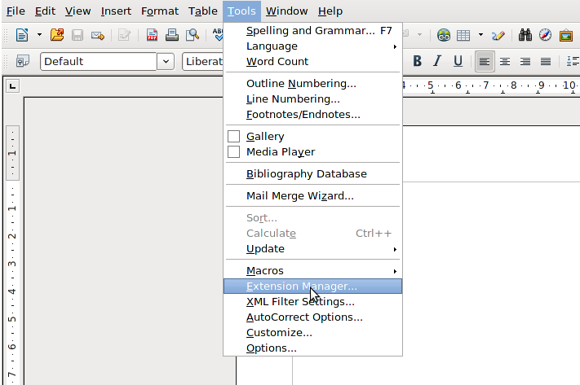Figure 1: Tools > Extension Manager...
- In the Extension Manager dialog (Figure 2), click Add.
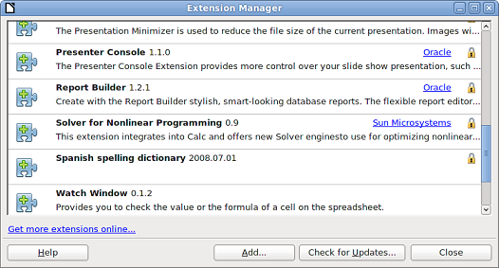Figure 2: Using the Extension Manager

- A file browser window opens. In Add Extension(s) dialog, you can find the extension's files in your system folders. The extension's files have OXT file extension.
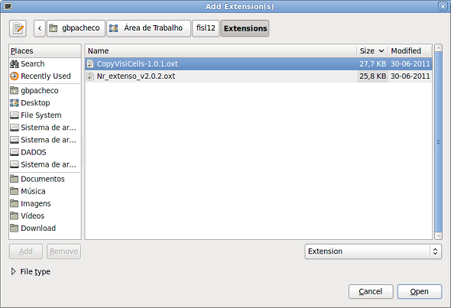Figure 3: Add Extension(s) dialog
- Find and select the extension you want to install and click Open.
- If this extension it is already installed, you'll be prompted to press OK to confirm whether to overwrite the current version by the new one, or press Cancel to stop the installation.
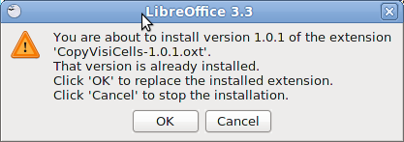Figure 4: Replacing an extension.
- After, you are asked whether to install the extension only for your user or for all users.
If you choose Only for me option, the extension is installed only for your user (the extension will be stored in your user profile and other users will not have access to it).
If you choose For all users, you must have system administrator rights. In this case, the extension is installed in LibreOffice system folder and will be available for all users.
In general, choose Only to me, that doesn't require administration rights on the operating system.
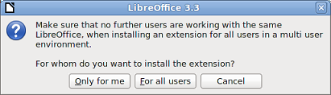Figure 5: Installation options: Only for me or For all users

- After, you may be asked to accept a license agreement.
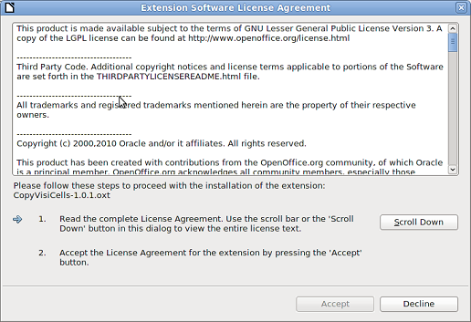Figure 6: Use Scroll Down button to verify the license
- Use Scroll Down button to read the license agreement. At the end of license text, the Accept button will be enabled.
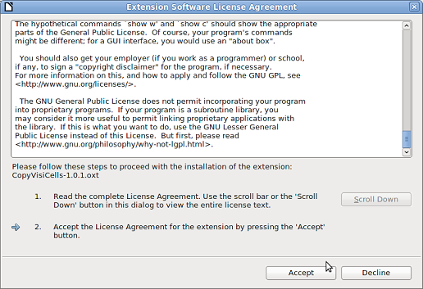Figure 7: Click Accept button to proceed the installation
- Click Accept to proceed the installation.
- When the installation is complete, the extension is listed in the Extension Manager dialog.
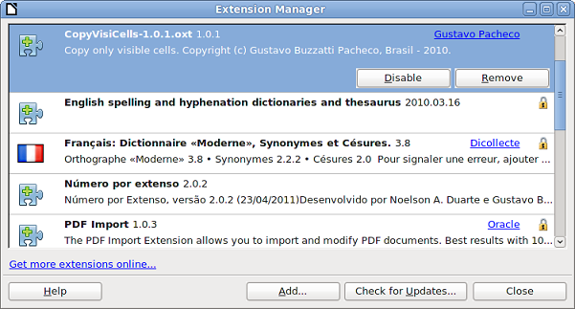Figure 8: Extension Manager dialog
Tip | To download extensions that are listed in the repository, open the Extension Manager and click the Get more extensions online... link.
- To complete the procedure, click Close to close the dialog and, after, close LibreOffice, including quickstarter. The quickstarter, when enabled, is on the right corner of the program bar and can be closed with the right mouse button.
- Next time you open LibreOffice, the extension is already available for use. Please check the documentation of the extension, and the application on it is available.

Note | To install a shared extension, you will need write access to the LibreOffice installation directory.
Note | The OXT file type is linked to LibreOffice. Double click on the OXT file opens the Extension Manager and starts the installation.

Some popular extensions
This section describes a few of the more popular extensions to LibreOffice. Some are installed by default. If the extension is not already installed on your system, see Installing extensions in the previous section for step-by-step instructions. All tools listed here are open source and free of charge.
PDF Import
Enables you to make minor modifications to the text of existing PDF files when the original source files do not exist or you are unable to open the source files. (Whenever possible, modify the source and regenerate the PDF to obtain the best results.)
When the extension is installed, PDF is listed as a choice in the File Type drop-down list in the File → Open dialog.
Best results can be achieved with the PDF/ODF hybrid file format, which this extension also enables. A hybrid PDF/ODF file is a PDF file that contains an embedded ODF source file. Hybrid PDF/ODF files will be opened in LibreOffice as an ODF file without any layout changes.
Non-hybrid PDF documents open in Draw. Depending on the complexity of the layout, changes may be easy or difficult to make, and the saved result may or may not preserve the original layout. Font substitution may occur.
Documents with more sophisticated layouts, such as those created with professional desktop publishing applications that use special fonts and complex vector graphics, are not suitable for the PDF Import Extension. Similarly, importing large documents may cause performance issues.
Presenter Console
Provides extra control over Impress presentations; for example, the presenter has ability to see the upcoming slide, the slide notes, and a presentation timer—while the audience sees only the current slide. The Presenter Console displays the elements in three easily changeable views:
- The first view displays the current slide, including the effects, and the upcoming slide.
- The second view shows the speaker's notes in large, clear, and scalable type, plus the current and upcoming slide.
- The third view is a slide sorter view with the slide thumbnails.
Note | The Presenter Console works only on operating systems that support multiple displays.
Report Builder
Creates professional database reports from Base. You can define group and page headers, group and page footers, and calculation fields. Export your reports to PDF or OpenDocument formats, or send them as email attachments.
Professional Template Pack II
Provides more than 120 templates for Writer, Calc, and Impress. Available in several languages. After you have installed this extension, you will find the templates under File → New → Templates and Documents.
Template Changer (for Writer)
Adds two new items to the File → Templates menu in Writer that allow you to assign a new template to the current document or to a folder of documents. All styles and formatting will be loaded from that template and the document will behave as it was created using that template.
Solver for Nonlinear Programming (for Calc)
Calc ships with a solver engine for linear programming only. This extension adds more solvers, which are capable of handling nonlinear problems as well as linear ones:
- DEPS - Differential Evolution & Particle Swarm Optimization
- SCO - Social Cognitive Optimization
DataPilot Tools for Calc
Adds some utility functions that make using the Calc DataPilot easier:
- Display the current source range for a DataPilot
- Change the source range for a DataPilot
- Refresh all DataPilots on the current sheet

