
Impress Guide
Chapter 9
Slide Shows
Transitions, animations, and more

Copyright
This document is Copyright © 2007–2012 by its contributors as listed below. You may distribute it and/or modify it under the terms of either the GNU General Public License (http://www.gnu.org/licenses/gpl.html), version 3 or later, or the Creative Commons Attribution License (http://creativecommons.org/licenses/by/3.0/), version 3.0 or later.
All trademarks within this guide belong to their legitimate owners.
Contributors
Elliot Turner Jean Hollis Weber Peter Schofield
Feedback
Please direct any comments or suggestions about this document to: documentation@global.libreoffice.org
Acknowledgments
This chapter is based on Chapter 8 of the OpenOffice.org 3.3 Impress Guide. The contributors to that chapter are:
Peter Hillier-Brook Nicole Cairns Jean Hollis Weber
Claire Wood Michele Zarri
Publication date and software version
Published 25 April 2012. Based on LibreOffice 3.5.

Note for Mac users
Some keystrokes and menu items are different on a Mac from those used in Windows and Linux. The table below gives some common substitutions for the instructions in this chapter. For a more detailed list, see the application Help.
Windows or Linux | Mac equivalent | Effect
Tools > Options menu selection | LibreOffice > Preferences | Access setup options
Right-click | Control+click | Opens a context menu
Ctrl (Control) | z (Command) | Used with other keys
F5 | Shift+z+F5 | Opens the Navigator
F11 | z+T | Opens the Styles and Formatting window

Contents
Copyright 2
Note for Mac users 2
Putting together a slide show 4
Basic settings for a slide show 4
Hiding slides 6
Showing slides in a different order 6
Setting up a custom slide show 6
Editing, deleting, or copying a custom slide show 8
Using slide transitions 8
Setting the timing of automatic slide changes 9
Playing a sound throughout a presentation 10
Removing a transition effect 10
Using slide animation effects 10
Applying an animation effect 11
Starting an animation effect 12
Choosing additional properties of an animation effect 13
Example: Using multiple animation effects 13
Example: Setting up a motion path 14
Advanced animation effects 15
Removing animation effects 16
Using interactions 16
Running a slide show 17
Navigating using the right-click menu 17
Controlling a slide show using the Presenter Console 18

Putting together a slide show
LibreOffice Impress gives you the tools to organize and display a slide show, including:
- Which slides to show and in what sequence
- Whether to run the show automatically or manually
- Transitions between slides
- Animations on individual slides
- Interactions: what happens when you click a button or link
Most tasks associated with putting together a slide show are best done in Slide Sorter view. Choose View > Slide Sorter from the main menu or click the Slide Sorter tab at the top of the Workspace pane. All of your slides appear in the workspace; you may need to scroll to see them all.

Basic settings for a slide show
Basic settings for a slide show include which slide to start from, the way you advance the slides, the type of presentation, and pointer options.
Select Slide Show > Slide Show Settings. From the main menu to open the Slide Show dialog (Figure 1).
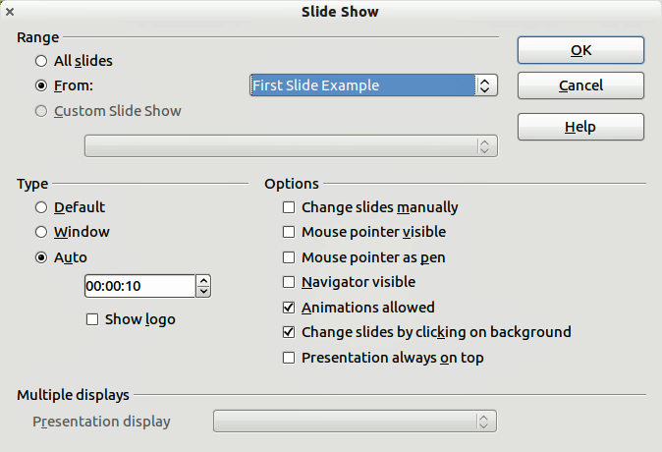
Figure 1: Selecting slide show settings
In the Range section, select which slides to include in the slide show:
- All slides: includes all of the slides except for those marked Hidden (see “Hiding slides” on page 6). Slides are shown in the sequence they occur in the file. To change the sequence, either rearrange the slides in the slide sorter or choose a custom slide show (see below).
- From: starts the show at a slide other than the first. For example, you might have several slides at the beginning that describe you and your company, but when you present this show to your work colleagues, you want to skip that introduction.
- Custom Slide Show: shows the slides in a different sequence that you have previously set up. This setting is not available until you have set up a custom slide show (see “Showing slides in a different order” on page 6). You can set up as many different custom shows as you wish from one set of slides; they will appear in the drop-down list under this choice.
In the Type section, select how the slides will be displayed:
- Default: shows the slides full screen, without the LibreOffice program controls visible, and exits the show after the last slide.
- Window: runs the slide show in the LibreOffice program window and exits the show after the last slide.
- Auto: restarts the slide show after the last slide. A pause slide is displayed between the last slide and the start slide. Press the Esc key to stop the show. In the box, specify the length of time before the show restarts. If you enter zero, the show restarts immediately without showing a pause slide. The Show Logo option shows the LibreOffice logo on the pause slide.
In the Options section:
- Change slides manually: prevents slides from changing automatically even if an automatic transition has been set up.
- Mouse pointer visible: shows the mouse pointer during a slide show. If you do not have a laser pointer or other device to highlight items of interest during the show, this can be useful.
- Mouse pointer as pen: enables you to write or draw on slides during the presentation. Anything you write with the pen is not saved when you exit the slide show. The color of the pen cannot be changed.
- Navigator visible: displays the Navigator during the slide show. For more information on the Navigator, see Chapter 1 Introducing Impress of this guide.
- Animations allowed: displays all frames of animated GIF files during the slide show. If this option is not selected, only the first frame of an animated GIF file is displayed. This has nothing to do with the slide animations described in “Using slide animation effects” on page 10.)
- Change slides by clicking on background: advances to the next slide when you click on the background of a slide. You can also press the spacebar on the keyboard to advance to the next slide.
- Presentation always on top: prevents any other program window from appearing on top of the presentation.
In the Multiple displays section:
- You can select which display to use for full screen slide show mode. Only available if the current desktop is displayed on more than one monitor.
- If the current desktop is displayed on only one monitor, or if the multiple-display feature is not supported on the current system, you cannot select another display.
- By default the primary display is used for slide show mode.
Note | This multiple displays setting is not a property saved in the document, but is instead saved as a local setting in the user configuration. This means that if you open the presentation on a different computer the local settings are applied.

Hiding slides
You may not want to show all of the slides in a particular slide show. You can either hide some of the slides or set up a custom slide show; whichever method suits your requirements. For example, you may have draft slides that you do not want to show until they are finished, or you may have some slides that contain information for yourself, but not your audience.
To hide a slide:
- In the Slides pane, or in Slide Sorter view, select the slides that you want to hide.
- Click the Hide Slide icon on the Slide View toolbar (Figure 2), right-click and select Hide Slide from the context menu, or select Slide Show > Hide Slide on the main menu. The slide is now displayed greyed out to indicate that it is hidden (Figure 3). The slide is not deleted and remains in the file.
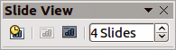
Figure 2: Slide View toolbar
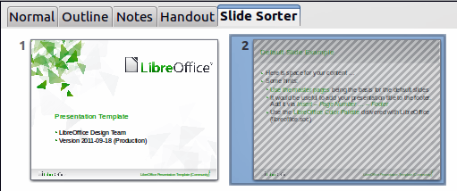
Figure 3: Slide 2 is hidden
To show a hidden slide:
- In the Slides pane, or in Slide Sorter view, select the hidden slides that you want to show.
- Click the Show Slide icon on the Slide View toolbar (Figure 2), right-click and select Show Slide from the context menu, or select Slide Show > Show Slide on the main menu.

Showing slides in a different order
To show the slides in a different order, you can either rearrange them in the slide sorter, or set up a custom slide show. You can define as many custom slide shows as you require from one set of slides.
In a custom slide show, you can select which slides to include as well as the order in which they are shown. Any slides marked Hidden will not appear in a custom show.

Setting up a custom slide show
To set up a new custom slide show:
- Choose Slide Show > Custom Slide Show from the main menu to open the Custom Slide Shows dialog (Figure 4).
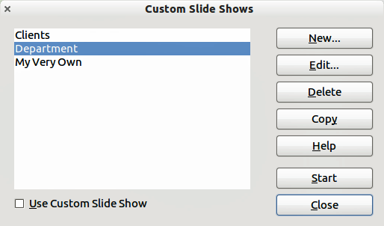
Figure 4: Custom Slide Shows dialog
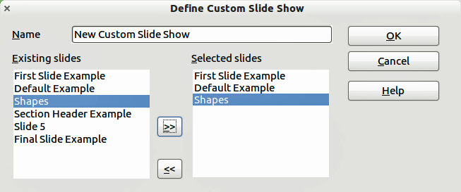
Figure 5: Defining a custom slide show
- Click on New and the the Define Custom Slide Show dialog opens (Figure 5).
- Type a name for the new custom show in the Name text box.
- In the Existing slides list, select the slides to include in the show. Click the >> button to include the slides in the Selected slides list. In Figure 5, the first three slides have been selected.
- You can select and include several slides at the same time. Hold down the Shift key and click the first and last slide in a group to select that group, or hold down the Control key and click on individual slides to select them.
Note | If you include several slides at the same time, they are added to the Selected slides list in the order they appear in your presentation regardless of the order in which you selected them. To put the selected slides in a different order, either select and include each slide individually or select a slide and drag it up or down in the selected slide list. You can also use the Slide Sorter view to rearrange the order of slides before making your selection.
Tip | Slides are added to the Selected slides list after whichever slide is currently highlighted in the list. By default, the last slide added is highlighted unless you have selected a different one. For example, in Figure 5, to add the slide Final Slide Example after the Default Example and before Shapes, make sure that Default Example is highlighted before moving Final Slide Example into Selected slides.
- When you have finished arranging the order of the slides, click OK to save this custom show and return to the Custom Slide Shows dialog box.
- To activate a custom show, select it in the list in the Custom Slide Shows dialog box and then select the Use Custom Slide Show option at the bottom.

Editing, deleting, or copying a custom slide show
To edit a custom slide show (add, remove, or change the order of slides, or change the name of the show), select it in the Custom Slide Shows dialog (Figure 4) and click Edit.
To delete a custom slide show, select it in the Custom Slide Shows dialog and click Delete. Deletion is immediate; no confirmation message appears.
To create a copy of a slide show, select it in the Custom Slide Shows dialog and click Copy. You can now edit the copy by renaming and adding, removing, or changing the order of slides in it.
You can run or test your custom slide show from the Custom Slide Shows dialog, if the Use Custom Slide Show checkbox is selected. Select the slide show from the list and click on Start.
When you have finished working with custom slide shows, click Close to save all changes and close the Custom Slide Shows dialog.

Using slide transitions
Slide transitions are the effects that take place between slides when slides change in a presentation. Transitions add dynamic flair to a slide show, smoothing the change over between slides.
- In the Tasks pane, choose Slide Transition (Error: Reference source not found).
- In the Slides pane or Slide Sorter view, select the slides to which you want to apply the transition. If you want the transition to apply to all slides, do not select any slides.
- In the Apply to selected slides list, select a transition.
- Modify the selected transition by changing the speed or adding a sound, in the Modify transition section. If you decide to play a sound during transitions, select a sound from the Sound list. The Loop until next sound option now becomes active. Select this option to play the sound repeatedly until another sound starts. If there are no subsequent sounds in your slide show, the selected sound will play continuously for the remainder of the show.
- Select how to advance to the next slide: manually (on mouse click) or automatically. If you choose automatically, you can specify how long the slide remains visible before it automatically advances to the next slide.
- If you want the transition to apply to all slides, click the Apply to All Slides button.
- To start the slide show from the current slide so you can check your transitions, click the Slide Show button.
- If the Automatic preview checkbox is marked, the effect of a selected transition is immediately displayed in the work area. You can replay the effect at any time by pressing the Play button.
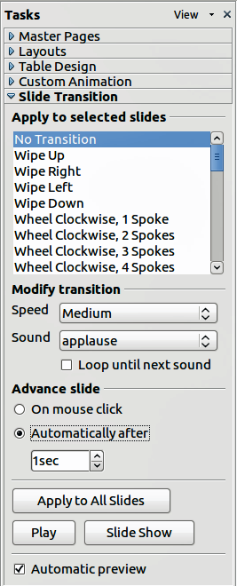
Figure 6: Slide transitions
Tip | You can apply a single type of transition to all slides in the presentation or apply a different transition to any single slide, even having a different transition for every slide in the show. While using many different transitions may be fun to do, it may not give your slide show a professional appearance.
Tip | If you want most of the slides to have the same transition with a few different transitions, you may find it easier to apply one transition to all slides and then change only the ones you want to be different.

Setting the timing of automatic slide changes
You can set up a slide show to run automatically, either unattended or while you speak.
To set the default time for slides to be displayed before changing to the next slide:
- Go to Slide Transition in the Tasks pane (Figure 6).
- Leave the transition effect set to No Transition.
- Select Automatically after in the Advance slide section.
- Set a time and click the Apply to All Slides button.
To vary the timing for some of the slides in your slide show:
- Select Slide Show > Rehearse Timings from the main menu, or click the Rehearse Timings icon on the Slide Show toolbar. The slide show begins in full-screen mode, and a timer appears in the lower left-hand corner of the screen.
- When you want to advance to the next slide, click the timer. To keep the default setting for this slide, click the slide, not the timer.
- Continue until you have set the timing for all slides in your presentation. Impress records the display time for each slide. When you next look at the time set under Automatically after, you will see that the times have changed to match what you set when rehearsing.
- To exit from the rehearsal, press the Escape key or right click on the slide and select End Show.
If you want the whole presentation to auto-repeat, open the Slide Show dialog (Figure 1) by going to Slide Show > Slide Show Settings on the main menu. Click on Auto and then OK.

Playing a sound throughout a presentation
You can use the Slide Transition pane so that a sound or a song is played throughout the presentation.
- Select the slide where you want the sound to start and go to the Slide Transition pane.
- In the Modify transition section, select Other sound from the Sound drop-down list.
- Select Loop until next sound checkbox if you want the sound to restart once it is finished.
Caution   | Do not click the Apply to all button; otherwise your selected sound will restart at every slide.
Note | The sound file is linked to a presentation rather than embedded; therefore if you plan to display the presentation on a different computer, remember that you also have to make the sound file available on the computer where the presentation will be played, and re-establish the link to the local sound file before starting the slideshow.

Removing a transition effect
- Select the desired slides.
- Choose No Transition in the list on the Slide Transition page of the Tasks pane.

Using slide animation effects
Slide animations are similar to transitions, but they are applied to individual elements on a single slide: title, chart, shape, or individual bullet point. Animations can make a presentation more lively and memorable. Just as with transitions, heavy use of animations can be fun, but distracting and even annoying for an audience expecting a professional presentation.
Animation effects need to be applied from Normal view so that you can select individual objects on a single slide.
Note | At present it is not possible to apply animation effects to the slide master elements. This means that if you want to display the items in a text box one by one, and use the same animation on more than one slide, you need to apply the effects to each slide, or alternatively copy the text box from one slide to another.

Applying an animation effect
In Normal view, display the desired slide and then select the text or object you want to animate. An object such as a graphic or an entire text box will have selection handles around it when selected. If you choose only a portion of the text in a text box, you may not see any selection handles.
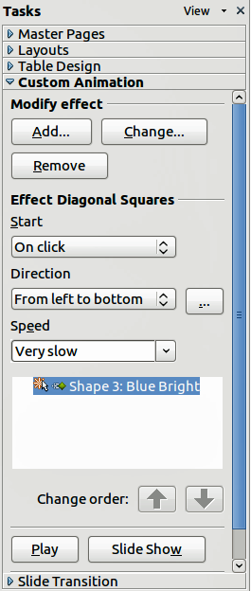
Figure 7: Custom Animation on Task pane
- In the Tasks pane, select Custom Animation (Figure 7).
- Click Add to open the Custom Animation dialog (Figure 8).
- Select an effect from one of the tabbed pages of this dialog, and choose the speed or duration of that effect.
- Select an animation to be applied from the Entrance page when an object is placed on the screen.
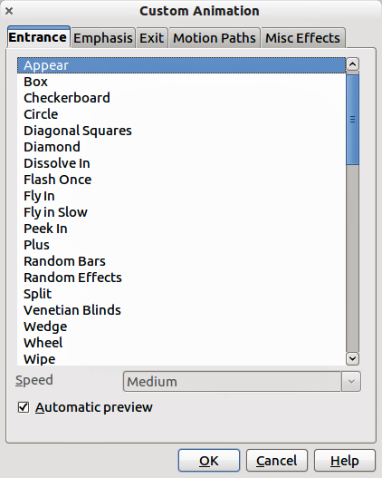
Figure 8: Custom Animation dialog
- Use the Emphasis page to apply a basic effect to an object, for example changing font color, or adding special effects such as blinking text.
- Use the Exit page to apply an effect when an object leaves the screen.
- If you want the object to move along a line or curve, select an animation from the Motion Paths page. An example of this type of animation is provided in “Example: Setting up a motion path” on page 14.
- If required, change the speed of an effect from the Speed drop-down list before moving to another tabbed page.
- Select Automatic preview if you want to see how the effect works with having to run the whole slide show.
- Click OK to save the animation effects and return to the Custom Animation page on the Task pane. Here you can choose how to start the animation, change the overall speed, and apply some additional properties to the selected effect.

Starting an animation effect
You have three options from the Start drop-down list for starting an animation effect:
On click − the animation does not start until you click the mouse.
With previous − the animation runs at the same time as the previous animation.
After previous − the animation runs as soon as the previous animation ends.

Choosing additional properties of an animation effect
Many animations have a set of properties that you can set or change. For example, for the Change Font Color effect on the Emphasis page, you can specify the font color. If you select Fly In on the Entrance page, you can specify the direction from which the object flies in.
The label on the Effect properties section changes depending on the effect selected. Also, the options available in this section change depending on the selected effect. For example, a Fly In effect has an option labelled Direction and a Change Font Color effect has an option labelled Font color.
Clicking on the … button opens the Effect Options dialog giving you additional options to customize the animation effect you have selected. An example of this dialog is shown in Figure 9.
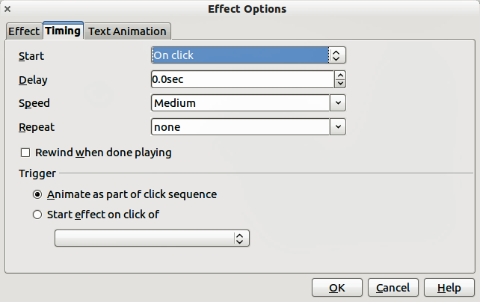
Figure 9: Example of the Effect Options dialog

Example: Using multiple animation effects
To illustrate how you can set up multiple effects, we shall use a common animation: list items fly in one at a time from the bottom of the slide, and as each new item appears, the previous items change to a different color. Here is an example on how to create these effects:
Step 1. Apply the Fly in effect to all the items.
- Display the Custom Animation page of the Task pane.
- Create a slide with several items in a bullet list.
- Select all items. Click Add on the Custom Animation in the Tasks pane.
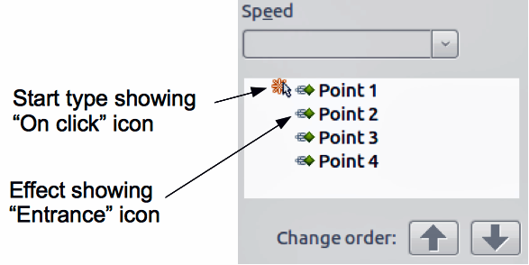
Figure 10: Example of animated points
- On the Entrance page of the Custom Animation dialog select Fly In, change the Speed to Medium, and click OK.
- The four animation effects set up are listed in the Custom Animation page (Figure 10).
Step 2. Apply the Change Font Color effect to some items.
Now the first three list items are going to change color when the following item appears on the slide. To do this:
- Select the first three items on the slide (not in the animations list) and click Add in the Custom Animation pane.
- Go to the Emphasis page of the Custom Animation dialog and select Change Font Color. Click OK to save this effect.
- Notice that three new animations are listed at the bottom of the animations list, and the icon for type of effect is now is different from the icon for the first four effects (Figure 11).
- You could, if you wish, select any of the last three items and choose a different color from the Font color list on the Custom Animation pane.
- Use the Change order: up-arrow button to move each of the last three items up the list so that they are under the other item with the same name.
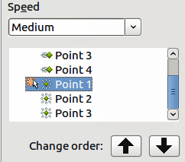
Figure 11: Second animation added
Step 3. Change timing of some list items from With previous to On click.
All of the items on the animations list (except for the two “Point one” items) are set to start at the same time as the previous item. However, it is best that when you click to make the next point appear the previous point is dimmed. Therefore to set the color change of the previous point and the entrance of the new point to run on mouse click simultaneously.
- Select the color change animations and choose On click from the Start list, then select the entrance animations (except the first) and choose With Previous from the Start list.
- Test this set of animations by clicking the Slide Show button.

Example: Setting up a motion path
The Motion path effect moves an object along a path consisting of a combination of straight and curved lines. Several pre-packaged paths are provided in LibreOffice, but it is not difficult to create your own custom path. Start by selecting the object you want to animate and selecting a pre-packaged motion path animation that is similar to the effect you want to obtain. Alternatively use the Polygon or Curve animation to create a new path.
Select the object to show the animation path, which will be displayed as a thin gray line with a triangle showing the starting point and another indicating the end point. Click on any point on the line so that selection handles are displayed around it. When the selection handles are shown, you can move or resize the path the same way you would perform these operations on a graphic object.
Note | When moving a path, remember to also move the object on that path; otherwise the animation will start with a jump. Currently it is not possible to rotate a path.
If instead you want to modify the individual points on the line, select the Points icon from the Drawing toolbar while the path is selected. The Edit Points toolbar (Figure 12) is displayed; if not, select it from View > Toolbars > Edit Points. The number of icons available in the Edit Points toolbar will depend on the type of motion path and object selected.
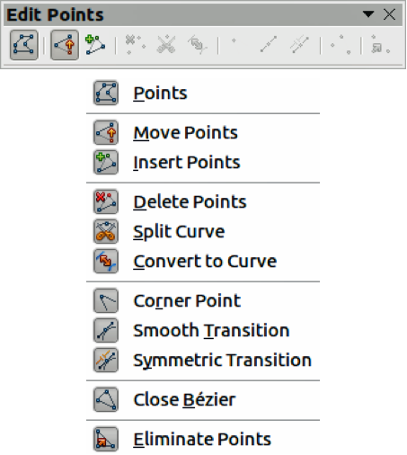
Figure 12: Edit Points toolbar and icons
Once a point is selected, you can add an additional point, delete it, move it and so on. For a detailed explanation on how to manipulate the points on a curve, see the Draw Guide. Once you are satisfied with the shape of the curve and its speed, click anywhere on the screen to deselect the object and continue normal editing.
You can combine a motion path with other effects such as spinning or changing of size or colors to create dramatic effects.

Advanced animation effects
Click the Effect Options button [...] next to the Properties drop-down list to display the Effect Options dialog (Figure 9 on page 13).
What you see in the Effect Options dialog depends on the type of object selected. When a text object is selected, the dialog has three pages: Effect, timing, and Text Animation. When a graphical object is selected, the dialog has two pages: Effect and Timing.
The options available on the Effect page also vary depending on the type of object selected and the type of animation selected, such as Direction effect or a Font Color effect. For graphical objects, the Text animation box on the Effect page is unavailable.
On the Effect page, you can select a sound to play, whether to dim or hide the object after animation, and (in the case of text objects) whether to animate the text all at once or word by word or letter by letter.
On the Text Animation page of the Effect Options dialog (Figure 13), you can group text as one object, all paragraphs at once, or by first-level paragraphs (that is, one list item together with its sub-items, if any).
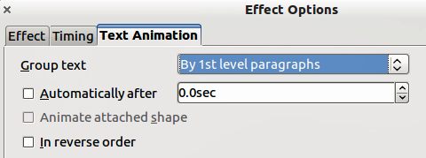
Figure 13: Text Animation page of Effect Options dialog
On the Timing page of the Effect Options dialog (Figure 14) you to change the speed, delay, and other aspects of the timing of the effect.
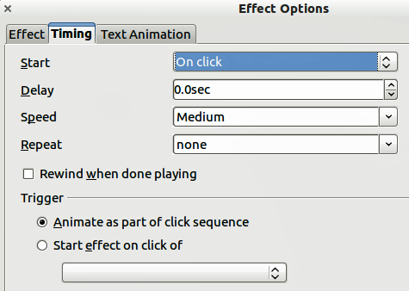
Figure 14: Timing page of Effect Options dialog

Removing animation effects
- On the Custom Animation page of the Task pane, select the desired object.
- Click the Remove button.

Using interactions
Interactions are things that happen when you click on an object in a slide. They are typically used with buttons or images, but text objects can also have interactions.
To apply an interaction to an object (or change an interaction applied to an object), right-click on the object and choose Interaction from the pop-up menu to open the Interaction dialog (Figure 15). Select an interaction from the Action at mouse click drop-down list. With some interactions the Interaction dialog changes to offer more options.
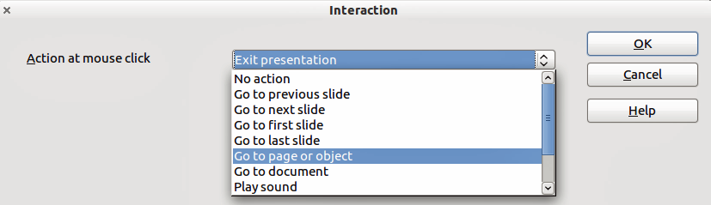
Figure 15: Dialog box before choosing an interaction
Tip | A sound interaction can be also applied using the Effect Options dialog (Figure 9 on page 13).

Running a slide show
To run the slide show, do one of the following:
- Press F5.
- Click Slide Show > Slide Show on the main menu.
- Click the Slide Show icon on the Presentation toolbar or the Slide Sorter toolbar.
If the slide transition is Automatically after x seconds, let the slide show run by itself.
If the slide transition is On mouse click, do one of the following to advance from one slide to the next.
- Press the down arrow key, the right arrow key, or the Page Down key on the keyboard.
- Click the left mouse button.
- Press the Spacebar.
To go backwards through the show one slide at a time, press the up arrow key, the left arrow key, or the Page Up key. For more complex navigation, use the right-click menu (see “Navigating using the right-click menu”).
Custom animations on a slide are run in the specified order when performing one of the above actions.
When you advance past the last slide, the message Click to exit presentation... appears. Click the left mouse button or press any key to exit the presentation.
To exit the slide show and return to the Impress workspace at any time, including at the end, press the Esc key.

Navigating using the right-click menu
If your presentation consists of more than one slide, right-clicking anywhere on the screen brings up a menu. The choices are:
- Next: moves to the next slide in the defined sequence.
- Previous: moves to the previous slide in the defined sequence.
- Go to Slide: displays a submenu allowing to quickly navigate through the presentation. Options on the submenu include First slide, Last Slide, or any slide in the show. This illustrates why giving the slides meaningful names, rather than leaving them at the default Slide 1, Slide 2, and so on, can be very helpful.
- Screen: displays a submenu with two options. Each option blanks the screen, showing it as either all black or all white. This can be useful if you want to pause the show for awhile, perhaps during a break or to demonstrate something on another computer.
- End Show: ends the presentation and returns you to the Impress workspace. This is the same effect as pressing the Esc key.

Controlling a slide show using the Presenter Console
Most installations of LibreOffice Impress come with the Presenter Console extension built in. If it is not included, you can also get the extension and install it as described in Chapter 11, Setting up and Customizing Impress.
The Presenter Console provides extra control over slide shows (presentations) through different views on the computer screen the presenter is using and on the projection that the audience sees. The presenter’s view includes the current slide, the upcoming slide, the slide notes, and a presentation timer.
Note | The Presenter Console works only on operating systems that support two displays, and only when two displays are connected (one may be the laptop display).
The Presenter Console provides three easily changeable views:
- First view displays the current slide, including the effects, and the upcoming slide.
- Second view shows the notes for the speaker in large, scalable type, plus the current and upcoming slide.
- Third view is a slide sorter view with the slide thumbnails where you can select a thumbnail to jump to a slide out of sequence.
- Lastly, the presenter can display a set of help notes with navigational and other information.

