
Draw Guide
Chapter 6
Editing Pictures
Raster Graphics

Copyright
This document is Copyright © 2005–2012 by its contributors as listed below. You may distribute it and/or modify it under the terms of either the GNU General Public License (http://www.gnu.org/licenses/gpl.html), version 3 or later, or the Creative Commons Attribution License (http://creativecommons.org/licenses/by/3.0/), version 3.0 or later.
All trademarks within this guide belong to their legitimate owners.
Contributors
Martin Fox John Cleland Jean Hollis Weber
John A Smith Peter Schofield
Feedback
Please direct any comments or suggestions about this document to: documentation@global.libreoffice.org
Acknowledgments
This chapter is based on an original French document written for OpenOffice.org 1.x by Michel Pinquier (translated into English by Alex Thurgood) and previous content revised by Jim Taylor. The chapter was revised for OpenOffice.org 2.0 by Linda Worthington, Daniel Carrera, Jean Hollis Weber, and Agnes Belzunce, and later translated into German by Wolfgang Uhlig. The German revisions were then translated into English and revised for OpenOffice.org 3.3 and LibreOffice 3.3 by Martin Fox. Other contributors included Peter Hillier-Brook, Hazel Russman, Gary Schnabl, and Claire Wood.
Publication date and software version
Published 10 August 2012. Based on LibreOffice 3.5.

Note for Mac users
Some keystrokes and menu items are different on a Mac from those used in Windows and Linux. The table below gives some common substitutions for the instructions in this chapter. For a more detailed list, see the application Help.
Windows or Linux | Mac equivalent | Effect
Tools > Options menu selection | LibreOffice > Preferences | Access setup options
Right-click | Control+click | Open a context menu
Ctrl (Control) | z (Command) | Used with other keys
F5 | Shift+z+F5 | Open the Navigator
F11 | z+T | Open the Styles and Formatting window

Contents
Copyright 2
Note for Mac users 2
Introduction 5
Importing graphics 5
Inserting 5
Embedding 5
Linking 6
Scanning 7
Copying and pasting 7
Dragging and dropping 7
File inserting 7
Exporting graphics 8
Exporting the entire file 8
Exporting objects 9
Formatting raster objects 9
Picture toolbar 10
Cropping 11
Crop 12
Scale 12
Image size 12
Graphic filter toolbar 12
Invert graphic filter 13
Smooth graphic filter 14
Sharpen graphic filter 14
Remove noise graphic filter 14
Solarization graphic filter 15
Aging graphic filter 15
Posterize graphic filter 16
Pop art graphic filter 16
Charcoal sketch graphic filter 17
Relief graphic filter 17
Mosaic graphic filter 17
Replacing colors 18
Replacing colors 18
Replacing transparent areas 19
Tolerance parameter 19
Conversion 19
Convert to a contour 19
Convert to a polygon 20
Converting 20
Conversion options and controls 21
Breaking 21
Splitting 21
Convert to a bitmap 21
Print options 22

Introduction
Earlier chapters of the Draw Guide have dealt only with vector graphics. However, Draw also contains a number of functions for handling raster graphics (bitmaps) such as photographs and scanned pictures, including import, export, and conversion from one format to another.
Draw can read all the majority of graphic file formats. It has a subset of capabilities similar to raster graphics programs like Adobe Photoshop or Gimp.

Importing graphics

Inserting
To import graphic files into your drawing, go to Insert > Picture > From File on the main menu bar or click the From File icon on the Drawing toolbar to open the Insert Picture dialog (Figure 1).
Draw contains import filters for the majority of graphic formats. If the file you want to import has a graphic format not covered by the import filters, then it is recommended to use one of the many graphic conversion programs that are freely to convert the file into a format that Draw recognizes.
If you select the Preview option in the Insert picture dialog, a preview of the file is shown in the box on the right-hand side. This makes it much easier to choose the file you want and also checks that Draw can import the file format used .
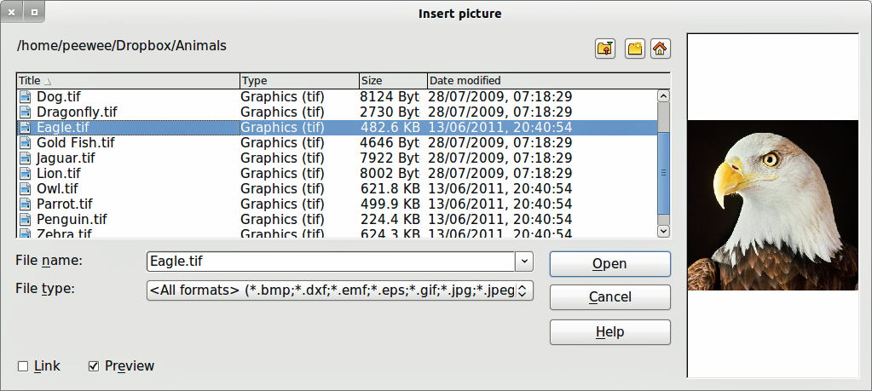
Figure 1: Insert Picture dialog

Embedding
Embedding a graphic into your drawing makes the graphic a permanent part of your drawing. Any changes you make to an embedded graphic will only appear in your drawing and the original graphic file will not affected.
Embedding happens when you import a graphic into your drawing using the Insert File command, copying and pasting, scanning a graphic, or dragging and dropping.
The main advantage of embedding graphics into your drawing is that the graphic is always available no matter what computer is used to open the drawing.
The main disadvantage of embedding graphics is that it creates large file sizes, which may not be desirable if you have limited capacity for storing computer files. Also, if the original graphic is altered, then your drawing will not have an up to date version each time you open your drawing.
Note | When a raster graphic is embedded into a LibreOffice document or drawing, then the format of that graphic is automatically changed to PNG format.

Linking
Linking a graphic to your drawing does not insert the graphic into your drawing, but a link is created to where the graphic file is located on your computer. Each time your drawing is opened, any linked graphics will be displayed in your drawing.
The main advantage of linking a graphic file to your drawing is if the original graphic file is altered or replaced by a new graphic with the same filename, then the next time you open your drawing, the latest version of the graphic will also open in your drawing.
The main disadvantage of linking graphics is that the link between your drawing and the graphic file must be maintained for linking to work correctly. If you move your drawing to another computer, then any linked files must also be moved to the same computer and the same folder on that computer.
To link a graphic file to your drawing, select the Link option in the Insert Picture dialog (Figure 1) before selecting the file and clicking on the Open button.
Note | When a graphic file is linked to a LibreOffice document or drawing, the format of the linked graphic is not changed.
Any changes made to a linked graphic within your LibreOffice drawing will only apply to your drawing and will not affect the original graphic file that has been linked to your drawing.
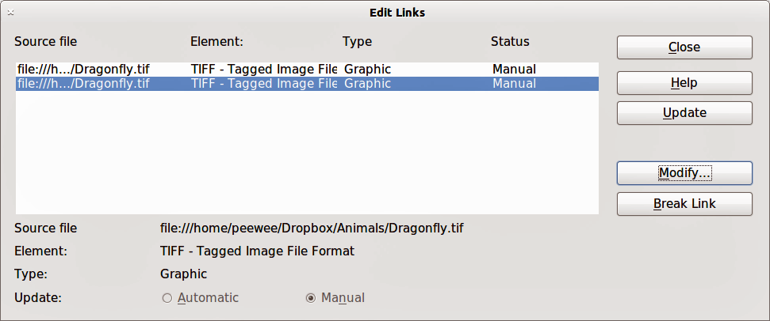
Figure 2: Edit Links dialog
Links can be updated, modified or broken by going to Edit > Links on the main menu bar to open the Edit Links dialog (Figure 2). Select the link to be updated, modified or broken and then click on the appropriate button. If you break a link, then the linked graphic becomes embedded in your drawing and the graphic format is converted to PNG.

Scanning
With most scanners you can directly insert a scanned image into a drawing or document. Scanned images are embedded using PNG format.
Make sure that your scanner is configured for the computer and supported by the SANE system for a Linux operating system, or TWAIN for a Windows or Mac operating system.
To insert an image from the scanner:
- Place a document, drawing, or photograph in the scanner and make sure that the scanner is ready.
- Go to Insert > Picture > Scan > Select Source on the main menu bar to select the scanner if this is the first time the scanner has been used OR go to Insert > Picture > Scan > Request on the main menu bar is the scanner has been used before.
Note | If there is more than one scanning device connected to the computer, you will be able to select the device when you select the source. This selection will then become the default source when using scan requests until another device is used as the scanning source.
- The rest of the procedure depends on the scanner driver, interface and computer operating system. You will normally be required to specify scanning options such as resolution, scan window, and so on. Consult the documentation that came with the scanner for more information.
- When the image has been scanned, Draw places it in the drawing. At this point it can be edited like any other graphic.

Copying and pasting
Copying a graphic and then pasting the graphic is another way of embedding graphics into a drawing (this is also called using the clipboard). The copied graphic can be an image already embedded in another document or drawing, or it can be a graphic file such as a drawing, document or photograph.
After copying you can also choose the format when you paste a graphic into Draw using Edit > Paste Special from the main menu bar. Available formats will depend on the type of image copied onto the clipboard.

Dragging and dropping
Dragging and dropping is another method of embedding graphics into a drawing and can be used on graphics that have been embedded or linked. The way that dragging and dropping works is determined by the computer operating system. Behavior of dragging and dropping is normally controlled using the Ctrl or Ctrl+Shift keys in combination with the mouse.
Objects and images which are used frequently can be stored in the Draw Gallery. From the Gallery a copy of the object or image can be simply dragged onto the drawing. Working with the Gallery is dealt with in Chapter 10 Advanced Draw Techniques.

File inserting
On the main menu bar there is an option to insert a file (Insert > File). This option allows you to insert from an existing Draw drawing (*.ODG), an Impress presentation (*.ODP), a Writer document (*.ODT), or a document in Rich Text Format (RTF), HTML format or plain text. Any text will be contained within a text frame with paragraph and character formatting options available. When inserting a file, normally the complete file will be inserted into your drawing.
However, when choosing a Draw or Impress file you can also select individual slides or individual objects for insertion into your drawing.
After selecting a Draw or Impress file and clicking on Insert, the Insert Slides/Objects dialog (Figure 3) opens. To access individual slides or objects, click on the expansion symbol (usually a + or a small triangle, depending operating system) to the left of the file name in the selection area.
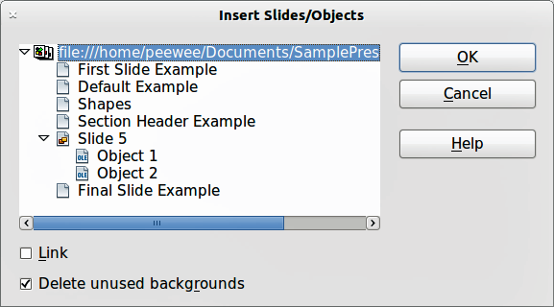
Figure 3: Inserting slides or objects
Select the slides or objects you want to insert and click OK to insert the selected items into your drawing.
If the inserted object was named in the source document, it keeps its original name unless the name already exists in the current document. If there is a name clash, you must give the object a new name before it is inserted. To rename an inserted object, right-click and choose Name from the context menu. Renaming has the advantage that the object is then listed in the Navigator.

Exporting graphics

Exporting the entire file
By default Draw saves drawings in the *.ODG format and some software programs cannot open these files. To make your drawings available for other programs, you can export the file in various formats.
- Select your file and go to File > Export on the main menu bar
- Select the required format from the upper section of the File format drop down list (Figure 4).
- Click on the Export button.
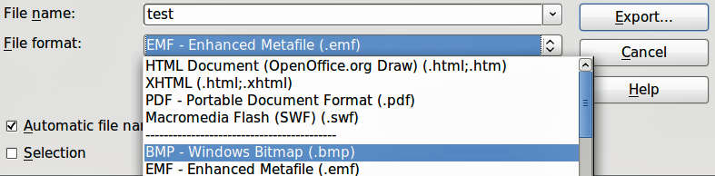
Figure 4: Exporting graphics
- Depending on the format selected, another dialog will open allowing you to select the required options for the selected graphic format.
- Click on the Export, Create or OK button and your file will be exported as a new file in its new format.
Note | The format options in the upper section of the File format drop down list (EMF, HTML, XHTML, PDF, and SWF) only apply to complete files.

Exporting objects
To export individual objects from your drawing:
- Select the objects and then go to File > Export on the main menu bar.
- Select the required graphic format from the lower section of the File format drop down list.
- Select the Selection option on the Export dialog (Figure 4).
- Click on the Export button.
- Depending on the graphic format selected another dialog will open allowing you to select the required options for that graphic format.
- Click on the Export, Create or OK button and your selected objects will be exported as a new file in its new format.

Formatting raster objects
Objects that are raster graphics can be formatted using the Format or context menus. The Picture toolbar is used to add or change filters and adjust the properties of lines, areas and shadows.
The Transparency property in the Format menu does not relate to the transparency of the raster graphic itself but to the background area. To change the transparency of a raster graphic, you must use the Picture toolbar, see “Picture toolbar” on page 10.
Some raster graphics may have a text element and for more information on formatting text, see Chapter 10 Advanced Draw Techniques.
You can change position and size or rotate rotate raster graphics and for more information see Chapter 3 Working with Objects and Object Points. Raster graphics can also be flipped (Modify > Flip on the main menu bar), but some metafile graphic formats may have problems flipping if they contain text.
Raster graphics included in a group behave like other objects when the properties of the group are modified.
It is recommended to name raster graphics using Modify > Name from the main menu bar or the context menu. Only named objects are visible in the Navigator and only named objects can be directly imported from another file.

Picture toolbar
The Picture toolbar will automatically appears when you select a picture (Figure 5). This can be in the main menu bar or as a floating toolbar.
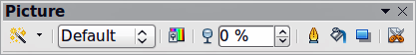
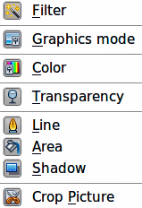
Figure 5: Picture toolbar
The tools available from left to right on the Picture toolbar are as follows:
- Filter: opens the Graphic Filter toolbar which is described in “Graphic filter toolbar” on page 12.
- Graphics mode: changes the display of the graphic from color to grayscale, black and white, or a watermark. This setting affects only the display and printing of the picture; the original picture file remains unchanged.
  - Default: the graphic is displayed unaltered in color.
  - Grayscale: the graphic is displayed in 256 shades of gray.
  - Black/White: the graphic is displayed in black and white.
  - Watermark: the brightness and contrast of the graphic are reduced to the extent that the graphic can be used as a watermark (background).
- Color: opens the Color toolbar (Figure 6) to adjust the values of the three RGB colors, brightness, contrast and Gamma. These adjustments do not affect the original picture, but the values are stored in Draw as a separate formatting set.
  - Red, Green, Blue: select values between -100% (no color) to +100% (full intensity); 0% represents the original color value of the graphic.
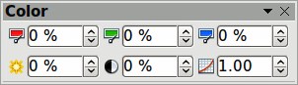
Figure 6: Color toolbar
  - Brightness: select a value between –100% (totally black) and +100% (totally white).
  - Contrast: select a value between –100% (minimum) and +100% (maximum).
  - Gamma: this affects the brightness of the middle color tones. Select a value between 0.10 (minimum) to 10 (maximum) Try adjusting this value if changing brightness or contrast does not give you the required result.
- Transparency: adjust the degree of transparency of the picture between 0% (opaque) and 100% (fully transparent).
- Line: opens the Line dialog. In this context, line refers to the outline of the border. See Chapter 4 Changing Object Attributes for more information.
- Area: opens the Area dialog allowing you to edit color, gradient, hatching and fills of the background area that contains the picture — not the picture itself. To see the background, you must set the transparency of the picture to a suitably high value.
- Shadow: sets the default shadow effect around the picture.
- Crop Picture: crops (trims) a picture. When you click on this tool, crop marks appear around the picture. Drag one or more of these marks to crop the picture to your desired size. For more accurate cropping, see “Cropping” on page 11.

Cropping
For more control and accuracy over cropping functions, select the picture and go to Format > Crop Picture, or right-click and select Crop Picture from the context menu to open the Crop dialog (Figure 7).
Any changes made in the Crop dialog change only the display of the graphic. The original graphic file is not changed. If you want to export a cropped graphic, you must do it through File > Export. If you use Save as Picture from the context menu, the changes are not exported.
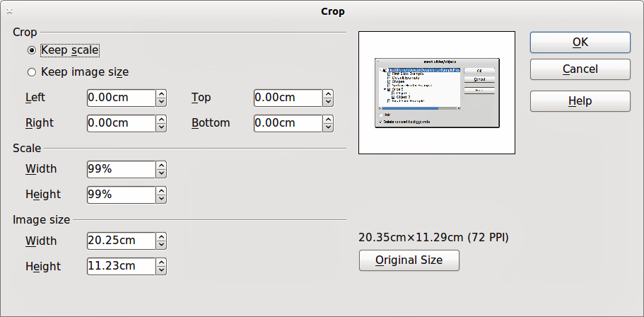
Figure 7: Crop dialog
Note | As an alternative to cropping, the Position and Size dialog has an option for keeping the width and height ratio fixed while changing one of the two dimensions. Changing values in one area (Scale or Image Size) will show up correspondingly in the other area.
Caution   | Take care with cropping operations. In the Crop dialog, the width and height are treated as independent values. Changing one without the other can result in significant distortion of the image and this may not be what you want.

Crop
This section of the Crop dialog allows you to trim or scale the selected graphic, or to add white space around the graphic.
- Selecting Keep scale maintains the original scale of the graphic when cropping so that only the size of the graphic changes.
- Selecting Keep image size maintains the original size of the graphic when you crop so that only the scale of the graphic changes. To reduce the scale of the graphic, select this option and enter negative values in the cropping boxes. To increase the scale of the graphic, enter positive values in the cropping boxes.
- For Left and Right, if Keep Scale is selected, enter a positive amount to trim the left or right edge of the graphic, or a negative amount to add white space to the left or right of the graphic. If Keep image size is selected, enter a positive amount to increase the horizontal scale of the graphic, or a negative amount to decrease the horizontal scale of the graphic.
- For Top and Bottom, if Keep Scale is selected, enter a positive amount to trim the top or bottom of the graphic, or a negative amount to add white space above or below the graphic. If Keep image size is selected, enter a positive amount to increase the vertical scale of the graphic, or a negative amount to decrease the vertical scale of the graphic.

Scale
This section of the Crop dialog allows you to change the scale of the selected graphic. In the Width and Height fields enter a value for the width or height of the selected graphic as a percentage.

Image size
This section of the Crop dialog allows you to change the size of the selected graphic. In the Width and Height fields enter a value for the width or height of the selected graphic.
Above the Original Size button, the original size of the graphic is displayed. Clicking on this button and then clicking OK button resets the inserted image to the original image size.

Graphic filter toolbar
After selecting a graphic and the Picture toolbar (Figure 5) has opened, click on the Filter icon to open the Graphic Filter toolbar (Figure 8). Draw offers eleven filter effects. Filters work on the current view of a graphic and they can be combined. Filters always apply to the entire graphic and it is not possible to use filters to edit only a part of the object.
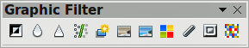
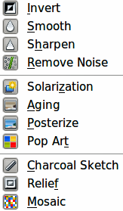
Figure 8: Graphic filter toolbar
Note | If your graphic is linked, any graphic filters used are only applied to the current view. The original graphic is not changed. When you close your drawing, any filtering applied is lost. To keep a copy of your filtered graphic, export the graphic to create a copy with all the filters applied (File > Export).  If your graphic is embedded, all graphic filters are applied directly on the embedded graphic and cannot be undone in a subsequent session. After you save and close your drawing, the graphic filter effects become permanent. If you do not want to retain a graphic filter, you must use Edit > Undo to return to cancel the filter effect.

Invert graphic filter
Inverts or reverses the color values of a color image (similar to a color negative), or the brightness values of a grayscale image. Apply the filter again to revert to the original graphic (Figure 9).
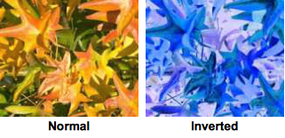
Figure 9: Invert graphic filter

Smooth graphic filter
Softens or blurs the image by applying a low pass filter reducing the contrast between neighboring pixels and produces a slight lack of sharpness. If you use the filter several times, the effect will be strengthened (Figure 10).
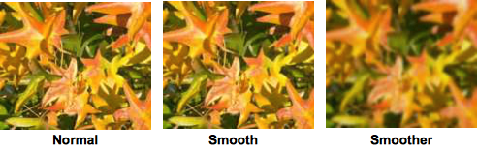
Figure 10: Smooth graphic filter

Sharpen graphic filter
Sharpens the image by applying a high pass filter increasing the contrast between neighboring pixels emphasizing the difference in brightness. This will accentuate the outlines and the effect will be strengthened if you apply the filter several times (Figure 11).
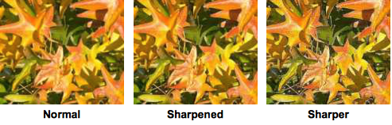
Figure 11: Sharpen graphic filter

Remove noise graphic filter
Removes noise by applying a median filter by comparing every pixel with its neighbors. It then replaces extreme values of those pixels that deviate in color by a large amount from a mean value by a pixel with a mean color value. The amount of picture information does not increase, but because there are fewer contrast changes resulting in a graphic that looks smoother (Figure 12).
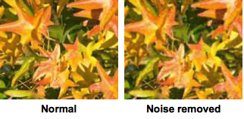
Figure 12: Remove Noise graphic filter

Solarization graphic filter
Solarization is a phenomenon in photography in which the image recorded on a negative or on a photographic print is wholly or partially reversed in tone. Dark areas appear light or light areas appear dark. Solarization was originally a photochemical effect used during photographic film development and is now used in the digital world of computing to create a change or reversal of color (Figure 13 and Figure 14).
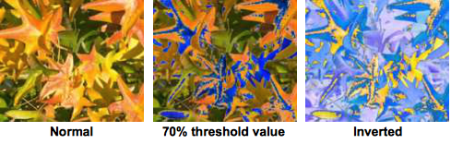
Figure 13: Solarization graphic filter
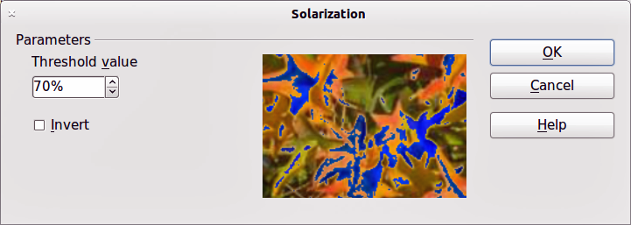
Figure 14: Solarization dialog
Clicking on the Solarization tool opens a dialog allowing you to define the threshold value for solarization. Entering a threshold value above 70% reverses the color values (center picture in Figure 13). Selecting the Invert option, all the colors are inverted (right picture in Figure 13).

Aging graphic filter
Aging creates a look that resembles photographs developed in the early days of photography. All pixels are set to their gray values and then the green and blue color channels are reduced by the amount specified in the Aging dialog. The red color channel is not changed (Figures 15 and 16).
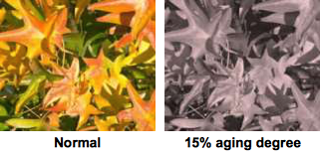
Figure 15: Aging graphic filter
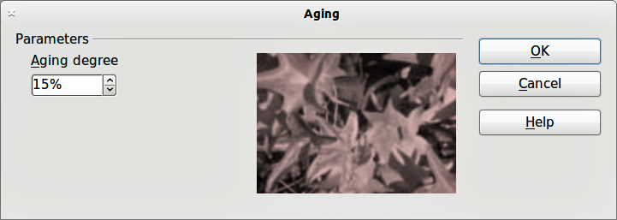
Figure 16: Aging dialog

Posterize graphic filter
Posterizing reduces the number of colors in a graphic making it look flatter. When used on a photograph, posterizing can make the photograph look like a painting. Clicking on the Posterize tool opens a dialog allowing you to define the number of poster colors to produce the effect you want (Figure 17 and Figure 18).
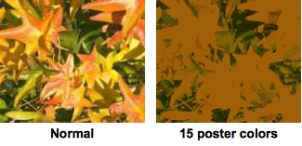
Figure 17: Posterize graphic filter
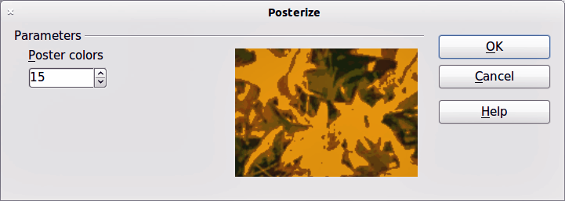
Figure 18: Posterize dialog

Pop art graphic filter
Changes the colors of a graphic to a pop-art format (Figure 19).
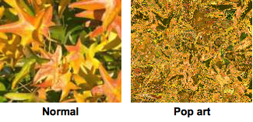
Figure 19: Pop Art graphic filter

Charcoal sketch graphic filter
Displays the graphic as a charcoal sketch. The contours of the graphic are drawn in black and the original colors are suppressed (Figure 20).
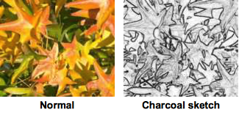
Figure 20: Charcoal Sketch graphic filter

Relief graphic filter
The Relief graphic filter calculates the edges of a graphic in relief as if the graphic is illuminated by a light source. The position of the light source is selectable producing shadows that differ in direction and magnitude (Figure 21 and Figure 22).
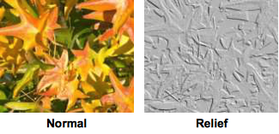
Figure 21: Relief graphic filter
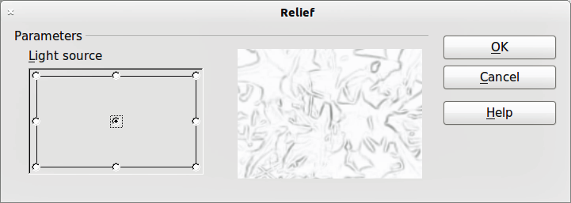
Figure 22: Relief dialog

Mosaic graphic filter
The Mosaic graphic filter joins groups of pixels and converts them into a rectangular tile in a single color creating a graphic that appears to be a mosaic. The larger the individual rectangles created, the fewer details the mosaic graphic has.
Clicking on the Mosaic tool opens a dialog allowing you to set the number of pixels used to create the width and height of the new tile created. The edges of each tile created can also be enhanced to create a sharper definition (Figure 23 and Figure 24).
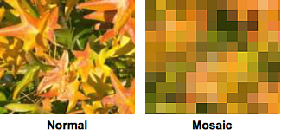
Figure 23: Mosaic graphic filter
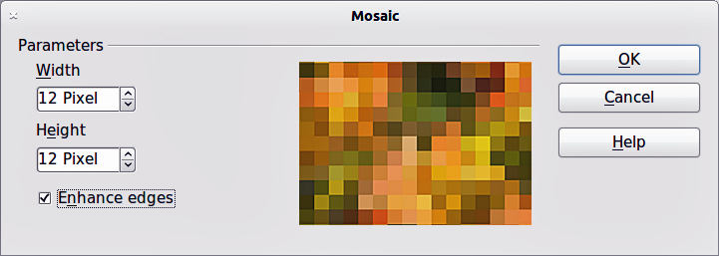
Figure 24: Mosaic dialog

Replacing colors
The Color Replacer allows you to replace or change a color in a graphic for another color or set the color as transparent. Up to four colors can be replaced at once. The tool works on the entire graphic and you cannot select an area of the graphic for editing.
The Color Replacer can only be used on embedded graphics. If you try to use the Color Replacer on a linked graphic, you will get the following error message “This graphic is linked to a document. Do you want to unlink the graphic in order to edit it?”.
The selection list for replacement colors shows all the available colors in the current color palette of the drawing. You cannot define any new colors here but you can add colors to the available palette before using the Replace Color tool. For more information on this topic, see Chapter 8 Tips and Tricks.

Replacing colors
A color is replaced in a graphic as follows:
- Go to Tools > Color Replacer on the main menu bar to open the Color Replacer dialog (Figure 25).
- Select a graphic to start using the Color Replacer.
- Click on the pipette icon to activate the color selection mode.
- Move the cursor over the color you want to replace in the selected graphic and click on the color to be replaced.
- A check box is now marked and the selected color appears in Source color.
- Enter the amount of tolerance required for replacing the color in the Tolerance box. The default selection is 10% tolerance.
- In Replace select a color from the drop down list. Transparent is the default selection.
- Click on the Replace button to replace the colors in the selected graphic.
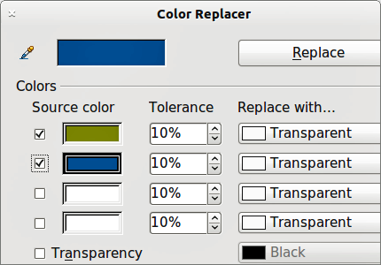
Figure 25: Color Replacer dialog
- There is no preview of the effect. If the result is not what you required, select Edit > Undo in the main menu bar and repeat the color replacement.

Replacing transparent areas
It is also possible to replace transparent areas in a graphic with a color.
- Go to Tools > Color Replacer on the main menu bar to open the Color Replacer dialog. (Figure 25).
- Make sure the graphic is NOT selected.
- Select Transparency in the Color Replacer dialog.
- Select a color from the drop down list next to Transparency.
- Click on the Replace button to replace the transparent areas with the selected color.

Tolerance parameter
The tolerance parameter is used to set how much of the source color in the graphic is replaced by another color. To replace colors that are similar to the color you are replacing, enter a low value for the tolerance parameter. To replace a wider range of colors, enter a higher value for the tolerance parameter.

Conversion

Convert to a contour
Converts a selected graphic to a contour by creating a polygon, or a group of polygons. If the conversion creates a group of polygons (for example a text object), then press the F3 key to enter the group before selecting an individual polygon.
To convert a graphic to a contour:
- Select the graphic in your drawing.
- Go to Modify > Convert > To Contour, or right click on the graphic and select Convert > To Contour.
Note | Make sure you have finished all your editing to your graphic before converting to a contour as the graphic cannot be edited after conversion.

Convert to a polygon
Converts a selected graphic to a collection of polygons filled with color. The graphic also becomes a vector graphic and can be resized with no loss of image quality or distortion of any text. After conversion, you can break your graphic into groups of polygons and then split these groups into individual polygons. Breaking and splitting allows you to edit or delete individual colors within your graphic.

Converting
To convert a graphic to a polygon:
- Select the graphic in your drawing.
- Go to Modify > Convert > To Polygon, or right click on the graphic and select Convert > To Polygon and the Convert to Polygon dialog opens (Figure 26).
- Select the Number of colors and Point reduction in the Settings section.
- To prevent any blank areas appearing in your graphic, select the Fill holes option and Tile size.
- Click on the Preview button to check how your converted graphic will look.
- Make any necessary changes to the settings and check the preview again.
- If you are satisfied, click on the OK button to convert your graphic to polygons.
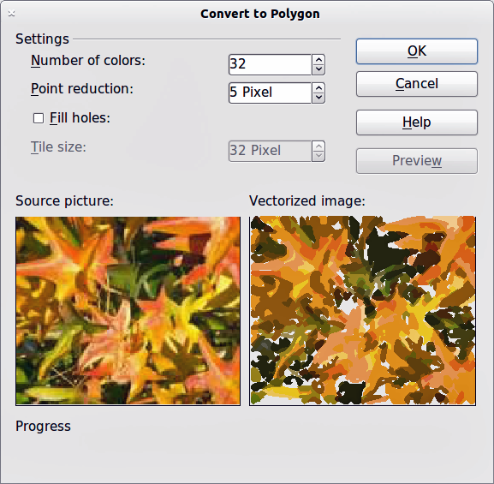
Figure 26: Convert to Polygon dialog

Conversion options and controls
- Number of colors: enter the number of colors to be displayed in the converted image. LibreOffice generates a polygon for each occurrence of a color in the image. The range for the number of colors is between 8 and 32.
- Point reduction: removes color polygons that are smaller than the pixel value you enter. The range for point reduction is between 0 and 32 pixels.
- Fill holes: fills the blank areas in the graphic that can be created when applying a point reduction.
- Tile size: enter the size of the rectangle for the background fill. The range of tile sizes is between 8 and 128 pixels.
- Source picture: preview of the original image.
- Vectorized image: preview of the converted image. Click on the Preview button to generate the vectorized image.
- Progress: displays a progress bar during conversion.
- Preview: Creates a preview of the converted image without applying any changes.
- OK: converts your graphic to polygons.

Breaking
After converting your graphic to polygons, you can break your graphic into groups of polygons. Each group of polygons consists of one color.
- Convert your graphic to polygons, see “Converting” on page 20.
- Make sure your graphic is selected and go to Modify > Break on the main menu bar to break your converted graphic into groups of polygons.
- Click on a color in your graphic then drag the group of polygons filled with that color out of your graphic to create a new graphic OR press the Delete key and delete the color from your graphic.

Splitting
After converting your graphic to polygons and breaking your graphic into groups of polygons, you can then split these groups into individual polygons.
- Convert your graphic to polygons, see “Converting” on page 20.
- Break your graphic into groups of polygons, see “Breaking” on page 21.
- Make sure your graphic is selected and go to Modify > Split on the main menu bar or use the keyboard shortcut Ctrl+Alt+Shift+K to split groups of polygons into individual polygons.
- Click on an individual polygon in your graphic and drag it out of your graphic or a polygon group OR press the Delete key and delete the polygon from your graphic.

Convert to a bitmap
All drawing objects placed into a LibreOffice drawing are vector graphics and these vector graphics can be converted to a bitmap in PNG format. Any transparency effects in the original vector graphic are lost during conversion even though the PNG format used does support transparencies.
To convert a vector graphic to a bitmap, go to Modify > Convert > To Bitmap on the main menu bar or right click on the graphic and select Convert > To Bitmap from the context menu.

Print options
If you have only a monochrome (single color) printer or are experiencing problems with printing, then the following settings may help with printing your drawing. You can set up printing so that all text and all graphics are printed either in grayscale or black and white.
The general settings are in Tools > Options > LibreOffice Draw > Print (Figure 27) and will apply to all drawings that you print using LibreOffice Draw.
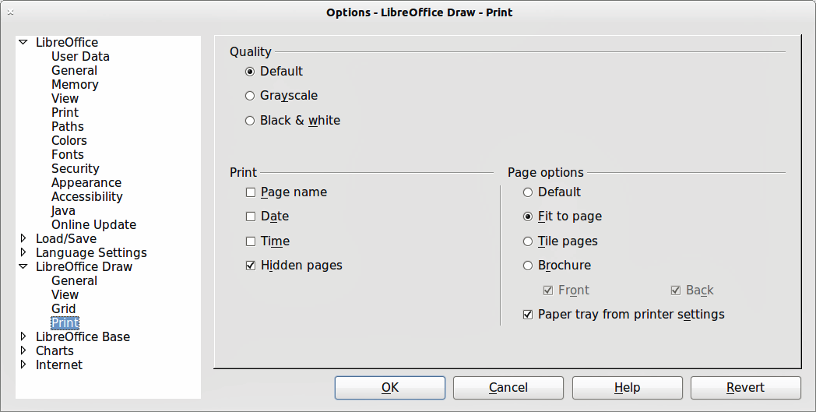
Figure 27: Options - LibreOffice Draw - Print
To set printing options for the current document only, go to File > Print and click on the Options tab in the Print dialog (Figure 28).
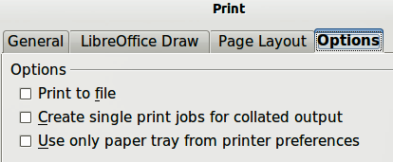
Figure 28: Print dialog - Options
To set printing options for all the modules in LibreOffice, go to Tools > Options > LibreOffice > Print (Figure 29). These printing options allow you to reduce print data sent to a printer or file, and to give any printer warnings if the wrong paper size or orientation and transparency is set.
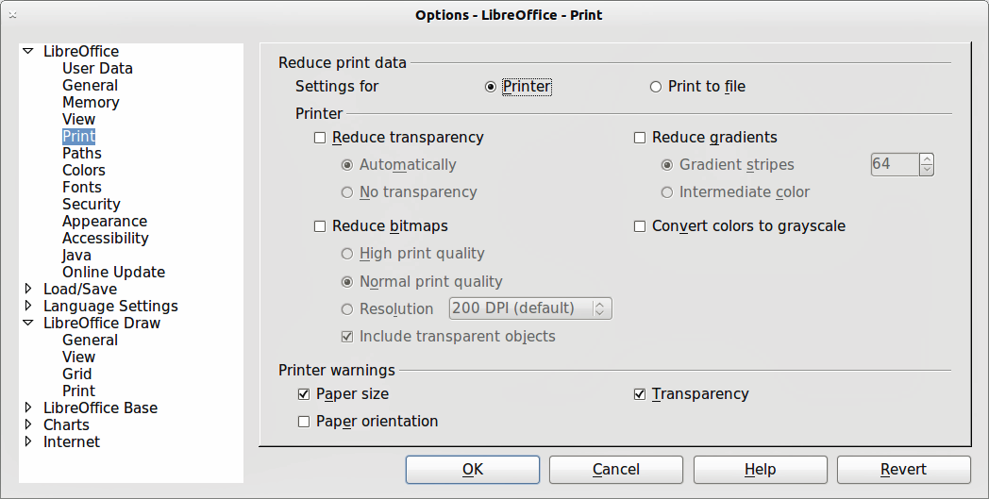
Figure 29: Options - LibreOffice - Print

