Some Data concerning Regression Handling

Most information has already been published in other documents, here information has been assembled.

Inhaltsverzeichnis
Some Data concerning Regression Handling 1
Facts 2
Situation for 3.4 2
Situation for 3.5 2
Situation 2012 3
Success Regression Fixing 4
Fixes January … March 2011 (2 ones) 4
Fixes April … June 2011 (34 ones) 5
Fixes July … September 2011 (34 ones) 6
Fixes October … December-31 2011 (115 ones) 7
Fixes in 2012 (45 until 2012.02.10) 8
Some Data concerning relative frequency of Regressions in the different Components 10
Facts 10
Data Collection 10

This document contains several data what will be updated from the WEB, please be patient!

May be you want to check the old bugs still waiting for a developer while contents will become updated?

Facts
Update 2012-February-19

Situation for 3.4
- With 3.4 we got 140 regressions compared to 3.3, 15 unfixed ones were known when 3.4.0 became released.
- Until now 90 ones have been fixed
  - 10 ones for master, not for 3.4
- You can argue that 525 3.3 Bugs fixed for 3.4 (but 20 of them only for Master) are good progress (I did not check fixes until 3.5), but there are remaining 50 ugly regressions compared to 3.3. A pessimistic user will count 1700 possible unfixed regressions compared to 3.3. (ok, only 40 ones are really confirmed regressions).

Situation for 3.5
- For upcoming 3.5 we now still have more than 40 known new (possibly) unfixed regressions to 3.3 and/or 3.4 reported for Version „Master“ or 3.5. That means 50 unfixed 3.4 regressions will have to be added so that we get a total amount of 90 unfixed regressions in 3.5 (here the direct link to unfixed regressions). Bigger number of unfixed Regressions than in December 2011!
  - Please keep in mind that there might be until much more than 600 candidates for bugs that might be unrecognized regressions (December 2011: 160). Tests have to be proceeded to sort out bugs that have been reported with Version “Master”, but appeared in 3.4 branch, and others that are no regression. Further information concerning these tests you find here.
- Lots of regressions have been fixed, see charts and links on following pages.
- We hear lots of general criticism, but not much info concerning concrete regression problems!

Situation 2012
It's looking bad, no progress, looking simply at the numbers situation is becoming worse.

Tables will be updated automatically from Bugzilla database.

Dobule click + “Edit Links” to update tables
Many Regressions have been fixed in 2012  Details here | Bug unfortunately we got many new ones in 2012  Details here

Next Pages will show some charts concerning regression fixing.

Success Regression Fixing

Fixes January … March 2011 (2 ones)
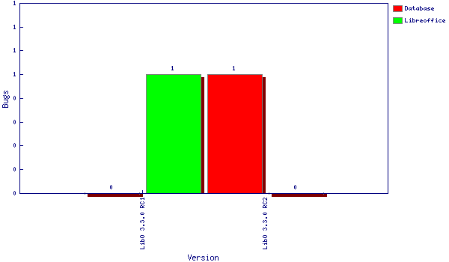

Fixes April … June 2011 (34 ones)
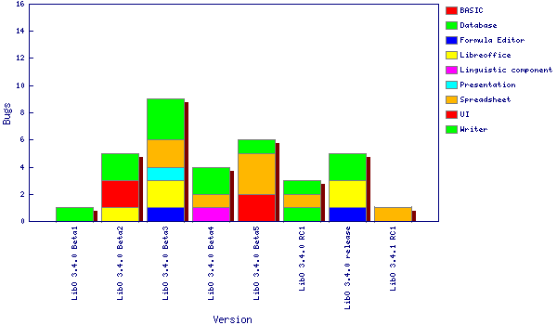

Fixes July … September 2011 (34 ones)
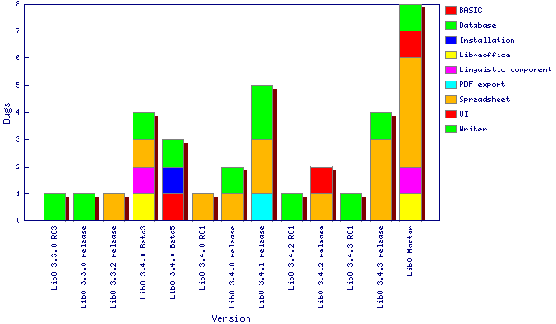

Fixes October … December-31 2011 (115 ones)
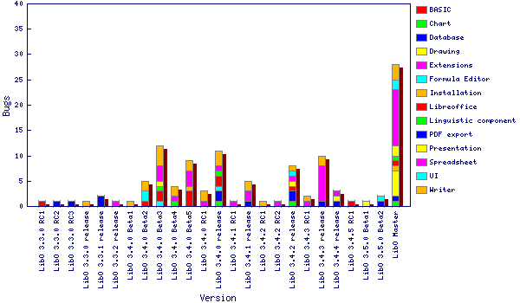

Fixes in 2012 (45 until 2012.02.10)

Major bugs still waiting for a developer

(not only regression bugs)

Some Data concerning relative frequency of Regressions in the different Components
All data without warranty from January 2012

Facts
At a short view Bugzilla data seems to show that WRITER and CALC are terrible buggy, because most of the bugs are concerning WRITER and CALC. Thus for these Components there seem to be the most regressions in the code.
But do those charts show reliable and realistic data? Of course, also the absolute number of bugs and regressions is interesting, it shows how much it work will be to fix the bugs and particularly the regressions. I thought it might be interesting (and more fair) to check what a part of regression there is weighted to the part with what the components are represented in Bugzilla. That might be a guide concerning the quality of the code base and its vulnerability concerning Regressions.

Data Collection
I did 2 queries checking total number of bugs divided to the components and same Query but with additional condition “Keyword Regression”
Then I simply divided the number of regression bugs by total Number of Bugs (first chart).
What can those charts tell us? Of course, WRITER and CALC have a lot of bug reports, but the proportional number of regressions is more or less average. Bug the situation for Database is really unsatisfying, my results seem to underpin Michaels concern because of “some pretty incompletely tested code”.
Of course, that all is not an “absolute truth”, but may be, an interesting alternative view.
You find my spreadsheet attached as a separate document. All Data is from Januafry 2011 an might be outdated

Kind regards

Rainer

