
Draw Guide
Chapter 10
Advanced Draw Techniques

Copyright
This document is Copyright © 2005–2012 by its contributors as listed below. You may distribute it and/or modify it under the terms of either the GNU General Public License (http://www.gnu.org/licenses/gpl.html), version 3 or later, or the Creative Commons Attribution License (http://creativecommons.org/licenses/by/3.0/), version 3.0 or later.
All trademarks within this guide belong to their legitimate owners.
Contributors
Martin Fox
John Cleland
Jean Hollis Weber
John A Smith
Feedback
Please direct any comments or suggestions about this document to: documentation@global.libreoffice.org
Acknowledgments
This chapter is based on an original French document written for OpenOffice.org 1.x by Michel Pinquier (translated into English by Alex Thurgood) and previous content revised by Jim Taylor. The chapter was revised for OpenOffice.org 2.0 by Linda Worthington, Daniel Carrera, Jean Hollis Weber, and Agnes Belzunce, and later translated into German by Wolfgang Uhlig. The German revisions were then translated into English and revised for OpenOffice.org 3.3 and LibreOffice 3.3 by Martin Fox. Other contributors included Peter Hillier-Brook, Hazel Russman, Gary Schnabl, and Claire Wood.
Publication date and software version
Published 13 October 2012. Based on LibreOffice 3.5.

Note for Mac users
Some keystrokes and menu items are different on a Mac from those used in Windows and Linux. The table below gives some common substitutions for the instructions in this chapter. For a more detailed list, see the application Help.
Windows or Linux | Mac equivalent | Effect
Tools > Options menu selection | LibreOffice > Preferences | Access setup options
Right-click | Control+click and/or right-click depending on computer system | Open context menu
Ctrl (Control) | z (Command) | Used with other keys
F5 | Shift+z+F5 | Open the Navigator
F11 | z+T | Open Styles and Formatting window

Contents
Copyright 2
Note for Mac users 2
Multi-page documents 5
Using the page pane 5
Master pages 6
Master page view 6
Creating master pages 6
Renaming master pages 7
Deleting master pages 7
Inserting fields 7
Assigning master pages 7
Multiple layers 8
Default layers 8
Inserting layers 9
Modifying layers 9
Working with layers 10
Selecting a layer 10
Hiding layers 10
Showing hidden layers 10
Locking layers 10
Unlocking layers 10
Renaming layers 10
Deleting layers 10
Dimensioning 11
Configuring dimensioning 11
Configuring using graphic styles 11
Configuring using context menu 11
Dimensioning options 12
Dimensioning objects 13
Drawing to scale 13
Gallery images 14
Using the Gallery 14
Adding images to My themes 15
Deleting graphics 16
Adding a new theme 16
Colors and color palettes 17
Using colors 17
Selecting colors 19
Color palettes 19
Creating colors 19
Using color values 19
Using the color picker 19
Deleting colors 20
Bézier curves 20
Drawing a Bézier curve 21
Edit Points tools 22
Adding comments to a drawing 24
Connecting and breaking lines 24

Multi-page documents
Draw documents, like Impress presentation documents, can consist of multiple pages. This allows you to create a drawing that has several sections, but is stored as one file on a computer.
When pages are inserted into a drawing, they are automatically named as Slide 1, Slide 2, and so on. As you change page order, the pages are automatically renumbered. However, if you want to easily identify each page, then it is recommended to give each page a memorable name.

Using the page pane
By default the Page Pane (Figure 1) appears docked on the left of the workspace when you open Draw. It shows every page in a drawing as a thumbnail. If the Page Pane is not displayed, go to View > Page Pane on the main menu bar.
Note | The Page Pane is called Pages when it is in its docked position on the left of the workspace.
- Select a thumbnail in the Page Pane and the corresponding page is loaded in the workspace. Click on the page in the workspace to activate it for editing. Alternatively, click on the Navigator icon or press the F5 key or go to View > Navigator on the main menu bar to open the Navigator dialog (Figure 2) and select pages using this dialog.
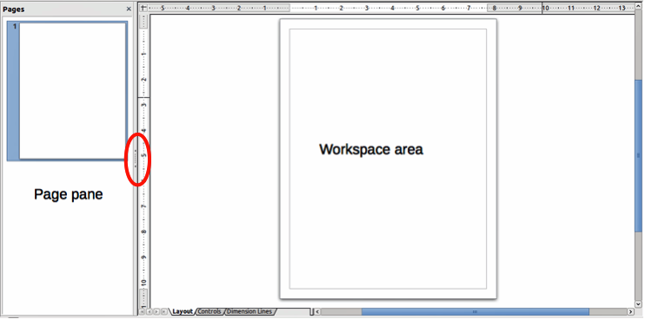
Figure 1: Page pane and workspace
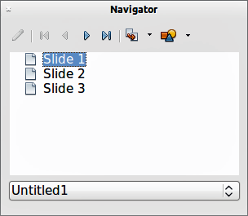
Figure 2: Navigator dialog
- Select a thumbnail In the Page pane, then drag and drop a thumbnail to change the order of pages in the document.
- Click and drag on the separator line between the Page pane and workspace to change the width of the Page pane.
- Click on the middle of this line to show or hide the Page pane (highlighted in Figure 1).
- Press and hold the Ctrl key, then double-click in the title bar of the Page pane to undock it and turn it into a floating window.
- Press and hold the Ctrl key, then double-click in the title bar of the undocked Page pane to dock it back into its default position on the left of the workspace.
- Right-click in the page pane and, using options in the context menu, you can insert, delete or rename pages and cut, copy and paste pages.
- Go to Insert > Slide on the main menu bar to insert a new page or Insert > Duplicate Slide to insert a duplicate page.

Master pages
A master page is a page that is used as the starting point for other pages in your drawing. It is similar to a page style in Writer: it controls the basic formatting of all pages based on it. A drawing can have more than one master page so that you can assign a different to look to other pages in your drawing.
A master page has a defined set of characteristics, including the background color, graphic, or gradient; objects (such as logos, decorative lines, and other graphics) in the background, the formatting of text, blocks of standard text, and insert fields such as page numbering, date and filename.
Note | LibreOffice uses interchangeable terms for one concept: slide master, master slide, and master page. All refer to a page which is used to create other pages. When searching for information in Draw Help, it may be necessary to use alternative search terms.

Master page view
To add objects and fields to a master page, go to View > Master to open the master page view. The Master View toolbar (Figure 3) also opens when you switch to master view. If this toolbar does not appear, go to View > Toolbars > Master View.
To return to normal page mode, click on Close Master View in the Master View toolbar or go to View > Normal on the main menu bar.
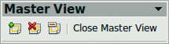
Figure 3: Master View toolbar

Creating master pages
Each drawing you create already has a default master page, but you can create extra master pages to change the look of some of the pages in your multi-page drawing.
Switch to Master View and then click on the New Master icon in the Master View toolbar to create a new master page. The new master page is automatically selected allowing you to add a new set of items to create a new look for your pages.

Renaming master pages
Each new master page created has the default name of Default 1, Default 2, and so on. It is recommended to rename your new master page with a more meaningful name. The default master page that was created when you first created your drawing can also be renamed.
Switch to Master View and then right-click on a master page in the Page pane and select Rename Page from the context menu or click on the Rename Master icon on the Master View toolbar. This opens a dialog where you can type a new name. Click on the OK button to save the new name.

Deleting master pages
Switch to Master View and then select on the master page you want to delete. Right-click on a master page that you created in the Page pane and select Delete Page from the context menu or click on the Delete Master icon on the Master View toolbar.
The delete option and delete icon are only available when there is more than master page in your drawing. You cannot delete the default master page that was created when you first created your drawing.

Inserting fields
You can insert fields on each master page by going to Insert > Fields on the main menu bar and selecting a field from the context menu. The following fields can be inserted into a master page.
- Date (fixed) – inserts the current date into your master page as a fixed field. The date is not automatically updated.
- Date (variable) – inserts the current date into your master page as a variable field. The date is automatically updated when you reload the file.
- Time (fixed) – inserts the current time into your master page as a fixed field. The time is not automatically updated.
- Time (variable) – inserts the current time into your master page as a variable field. The time is automatically updated when you reload the file.
- Author – inserts the first and last names listed in the LibreOffice user data into the active page.
- Page Number – inserts the page number into every page of your drawing. To change the number format, go to Format > Page on the main menu bar and select a format from the drop down list in Layout Settings.
- File name – inserts the name of the active file. The name only appears after you save the file.

Assigning master pages
When your drawing has more than one master page, you can assign different master pages to different pages.
- Make sure you are in normal page view by going to View > Normal on the main menu bar and select the page you want to assign a new master page to it.
- Right-click on the page in the workspace area and select Page > Slide Design from the context menu to open the Slide Design dialog (Figure 4).
- Click the Load button to open the Load Slide Design dialog and use any predefined master pages. All Draw and Impress templates can be used for this purpose.
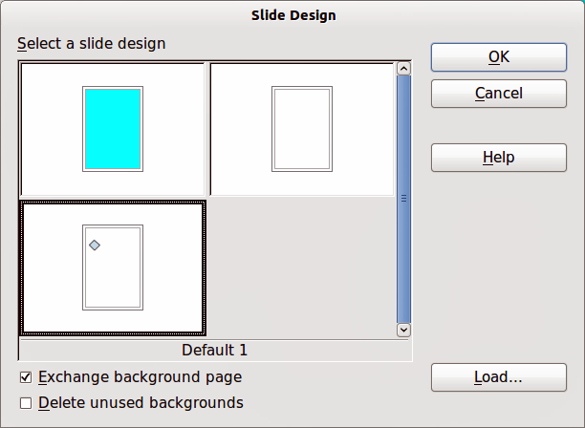
Figure 4: Slide design dialog
- Select the Exchange background page option and the selected master page will be used on all pages of the drawing.
- Select the Delete unused backgrounds option to delete any master pages shown in the Slide Design dialog that have not been assigned to a page.
- Click on the OK button to assign the selected master page to you page.

Multiple layers
Layers in LibreOffice Draw allow you to assemble elements on a drawing page that are related. Think of layers as individual workspaces that you can hide from view, hide from printing, or lock. Any layers that do not contain any objects are transparent.
Note | You can lock a layer to protect its contents, or hide a layer and its contents from view or from printing. When you add a new layer, the layer is added to all of the pages in your drawing. However, when you add an object to a layer, it is only added to the current drawing page.  If you want the object to appear on all of the pages (for example, a company logo), add the object to the master page by going to View > Master. To return to your drawing, go to View > Normal.
Layers do not determine the stacking order of objects on your drawing page, except for the Controls layer which is always in front of all other layers. The stacking order of objects on your drawing page is determined by the sequence in which you add the objects. You can rearrange the stacking order by going to Modify > Arrange on the main menu bar.

Default layers
LibreOffice Draw provides three default layers, which cannot be deleted or renamed.
- Layout – is the default workspace and determines the location of title, text and object placeholders on your drawing page.
- Controls – used for buttons that have been assigned an action, but should not be printed and the layer properties are set to not printable. Objects on this layer are always in front of objects on other layers.
- Dimension Lines – is where the dimension lines are drawn. By switching the layer to show or hide, you can easily switch dimension lines on and off.

Inserting layers
- Right-click the layer tab area at the bottom and select Insert Layer from the context menu, or go to Insert > Layer on the main menu bar to open the Insert Layer dialog (Figure 5).
- Type a meaningful name for the layer in the Name text box.
- Type a meaningful title for the layer in the Title text box.
- If necessary, type a description for the layer in the Description text box.
- Select Visible if you want the layer to be visible in your drawing. When Visible is not selected, a layer is hidden and the title in the layer tab changes color to blue.
- Select Printable if you want the layer to print when you print your drawing. Not printing is useful if you want use a draft layer for guides or annotations that you use in making the drawing, but do not want to appear in the final output.
- Select Locked to prevent any objects on this layer from deletion, editing, or moving. No additional objects can be added to a locked layer. Locking a layer is useful, for example, when a base plan is to be protected while adding a new layer with other details.
- Click OK and the new layer automatically becomes active.
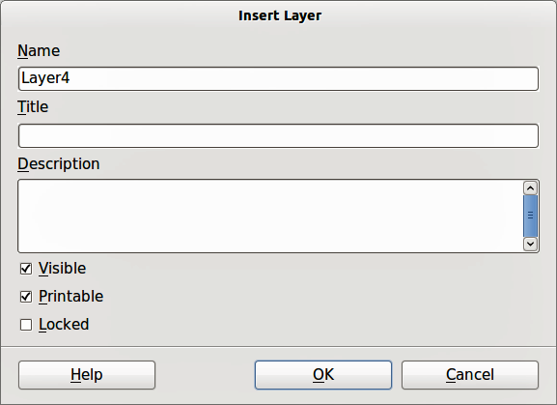
Figure 5: Insert Layer dialog

Modifying layers
- Right-click on the name tab of the layer and select Modify Layer from the context menu or double-click on the name tab to open the Modify Layer dialog. This dialog is similar to the Insert Layer dialog in Figure 5.
- Make your changes to the layer, then click OK to save the changes and close the dialog.

Working with layers

Selecting a layer
To select a layer, click on the name tab of the layer at the bottom of the drawing workspace.

Hiding layers
- Select a layer, and right-click on the name tab of the layer and select Modify Layer from the context menu or double-click on the name tab to open the Modify Layer dialog.
- Clear the Visible check box and click OK. The text for the name tab changes color to blue. Any objects placed on a hidden layer will no longer be visible on the other layers in your drawing.
- Alternatively, hold down the Shift key and click on the name tab.

Showing hidden layers
- Select a hidden layer, and right-click on the name tab of the layer and select Modify Layer from the context menu or double-click on the name tab to open the Modify Layer dialog.
- Check the Visible check box and click OK. The text for the name tab changes to the default color for text for your computer setup. Any objects placed on a hidden layer will now become visible on the other layers in your drawing.
- Alternatively, hold down the Shift key and click on the name tab.

Locking layers
- Select a layer, and right-click on the name tab of the layer and select Modify Layer from the context menu or double-click on the name tab to open the Modify Layer dialog.
- Check the Locked check box and click OK to prevent any modification of the layer.

Unlocking layers
- Select a layer, and right-click on the name tab of the layer and select Modify Layer from the context menu or double-click on the name tab to open the Modify Layer dialog.
- Uncheck the Locked check box and click OK to allow modification of the layer.

Renaming layers
To rename a layer that you have added to your drawing:
- Right-click on the name tab of the layer and select Rename Layer from the context menu.
- Type a new name for your layer and click outside the tab area to save the change.
Note | You can also rename a layer using “Modifying layers” on page 9.

Deleting layers
To delete a layer that you have added to your drawing:
- Right-click on the name tab of the layer and select Delete Layer from the context menu.
- Confirm the deletion and the layer and all its objects are deleted.

Dimensioning
Draw allows you to dimension objects and display these dimensions to make your drawing look more like an engineering drawing. When you create dimensions, they are automatically placed on the Dimension Lines layer (see “Default layers” on page 8 for more information).

Configuring dimensioning
Two ways are available to access the options to configure dimensioning. Both methods use a similar dialog to set the dimensioning options where you can change length, measurement and guide properties of a dimension line.

Configuring using graphic styles
- Go to Format >Styles and Formatting or press the F11 key on your keyboard to open the Styles and Formatting dialog.
- Select Dimension Line in the Styles and Formatting dialog.
- Right-click on Dimension Line and select Modify from the context menu to open the Graphics Styles dialog (Figure 6). See the Impress Guide for more information about graphic styles.
- Click on the Dimensioning tab to open the Dimensioning options page.
- To reset the dimensioning options to the default properties of the template, click Standard.
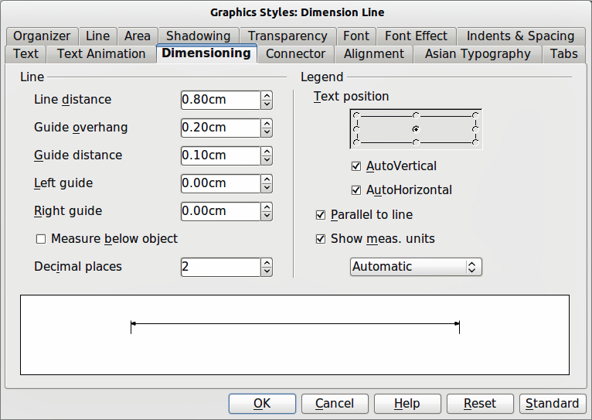
Figure 6: Graphic Styles Dimensioning dialog

Configuring using context menu
- Draw a dimension line. See “Dimensioning objects” on page 13 for more information.
- Right-click on the dimension line and select Dimensions from the context menu to open the Dimensioning dialog (Figure 7).
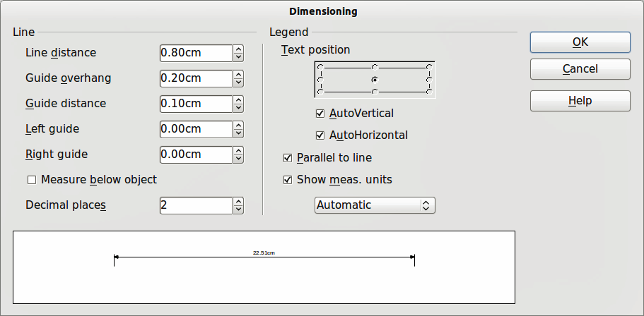
Figure 7: Context menu Dimensioning dialog

Dimensioning options
With reference to Figure 6 and Figure 7, the dimensioning options are as follows.
- Line – sets the distance properties of the dimension line and the guides with respect to each other and to the baseline.
- Line distance – specifies the distance between the dimension line and the baseline (line distance = 0).
- Guide overhang – specifies the length of the left and right guides starting at the baseline (line distance = 0). Positive values extend the guides above the baseline and negative values extend the guides below the baseline.
- Guide distance – specifies the length of the right and left guides starting at the dimension line. Positive values extend the guides above the dimension line and negative values extend the guides below the dimension line.
- Left guide – specifies the length of the left guide starting at the dimension line. Positive values extend the guide below the dimension line and negative values extend the guide above the dimension line.
- Right guide – specifies the length of the right guide starting at the dimension line. Positive values extend the guide below the dimension line and negative values extend the guide above the dimension line.
- Measure below object – reverses the properties set in the Line options.
- Decimal places – specifies the number of decimal places used for the display of line properties.
- Legend – sets the properties of the dimension text.
- Text position – determines the position of the dimension text with respect to the dimension line and the guides. The AutoVertical and AutoHorizontal checkboxes must be cleared before you can assign a text position.
- AutoVertical – determines the optimal vertical position for the dimension text.
- AutoHorizontal – determines the optimal horizontal position for the dimension text.
- Parallel to line – displays the text parallel to or at 90 degrees to the dimension line.
- Show meas. units – shows or hides the dimension measurement units. You can also select a measurement unit you want to display from the list.
Note | The dimensioning style Dimension Line is always linked and stored with the current work page. All the changes that you make apply only to this page. New drawings are started with the standard properties of Draw. If you want to use the amended style for future drawings, save your drawing as a template.
Tip | When dimensioning objects, it is recommended to use the zoom function, guide lines and snap functions so that you can accurately place dimension lines on an object. See Chapter 3 Working with Objects and Object Points for more information.

Dimensioning objects
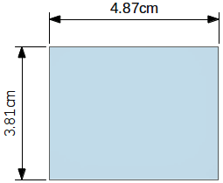
Figure 8: Dimensioning objects
- Click on the small triangle next to the Lines and Arrows icon on the Drawing toolbar to open the Arrows pop-up toolbar. Note that this icon changes depending on the last Lines and Arrows tool used. Also, this toolbar can become a floating toolbar by clicking on the bottom of the pop-up toolbar and dragging it into your workspace.
- Click on the Dimension Line icon on the Arrows toolbar and the cursor normally changes to a cross.
- Position the cursor at one corner of your object, then click and drag the cursor to the other corner of your object to draw the dimension line. To restrict drawing your dimension line in the horizontal or vertical direction, press and hold the Shift key while dragging the cursor.
- Release the mouse button when you reached the other corner of your object and the dimension line is drawn with the dimension automatically added. The dimension line is also placed automatically on the Dimension Lines layer; see “Default layers” on page 8 for more information.
- If you want to edit the text of the dimension, double-click on an unselected dimension line to enter text edit mode and make your changes. Click outside the dimension line to save the changes.
- If you want to configure your dimension line, see “Configuring dimensioning” on page 11.

Drawing to scale
In Draw a drawing is made on a predefined drawing area. This is normally Letter or A4 page size depending on your locale, computer setup and the default printer connected to your computer. However, depending on the actual size of the drawn objects, it is often convenient to reduce or enlarge the drawing by scaling (for example 1:10 or 2:1).
You can specify a scale value by going to Tools > Options > LibreOffice Draw > General and selecting a value from the Drawing scale drop down list. The default setting for this option is 1:1. When you make a change to the drawing scale, it is reflected in the rulers at the top and left side of your drawing.
Any change in the drawing scale has no effect on the basic drawing operations. Draw automatically calculates the necessary values (for example, dimension lines). The spacing of the grid points is independent of drawing scale as the grid is an optical drawing aid and not a drawing element.
An increase in scale (for example 1:4) allows you to draw objects that would not fit into the paper size for your drawing. A decrease in drawing scale (for example 4:1) allows you to draw small objects accurately at an increased size to make them easier to understand.
- An example of drawing to scale is shown in Figure 9. All three rectangles are the same size.
- The left rectangle was drawn at the default 1:1 scale and dimensioned.
- The drawing scale was then changed to 1:4 and the dimensions were automatically increased by Draw to reflect the decrease in scale for the center rectangle.
- The drawing scale was then changed to 4:1 and the dimensions were automatically decreased by Draw to reflect the increase in scale for the right rectangle.
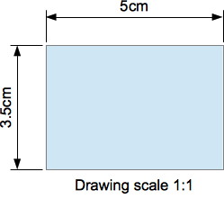 | 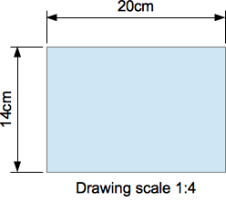 | 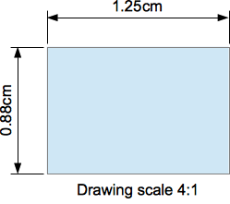
Figure 9: Examples of drawing to scale

Gallery images
Draw includes several images in a Gallery which are grouped in themes: Bullets; Rulers; Homepage; Rulers; Sounds. The left pane of the gallery window lists the available themes. Click on a theme to see its images displayed in the right pane of the Gallery dialog (Figure 10).
The default themes are read only; no images can be added to or deleted from these themes. The default themes are easily recognizable by right-clicking on each category and the only available option in the pop-up menu is Properties.
In a default installation of LibreOffice, the My themes is the only category that is customizable and allows you add or delete your own graphics. You can also create new theme categories where you can add or delete your own images and this is explained in “Adding a new theme” on page 16.

Using the Gallery
- Click on the Gallery icon on the Drawing toolbar or go to Tools > Gallery on the main menu bar to open the Gallery dialog.
- Choose a theme in the left pane of the Gallery dialog.
- Click on an image in the right pane of the Gallery dialog and drag the image into your drawing.
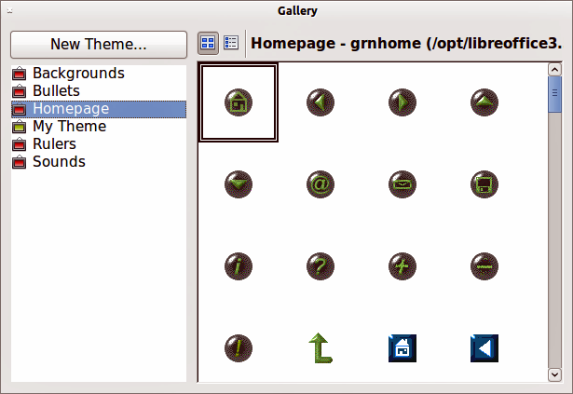
Figure 10. Gallery dialog
- Alternatively, right-click on a gallery image and select Insert > Copy from the context menu.
- Move to your drawing and paste the gallery image into your drawing.

Adding images to My themes
You can add images only to My themes or themes that you have created.
- Right-click on My themes or a theme name that you created in the list of theme categories and choose Properties from the pop-up menu to open the Properties of My Theme dialog (Figure 11).
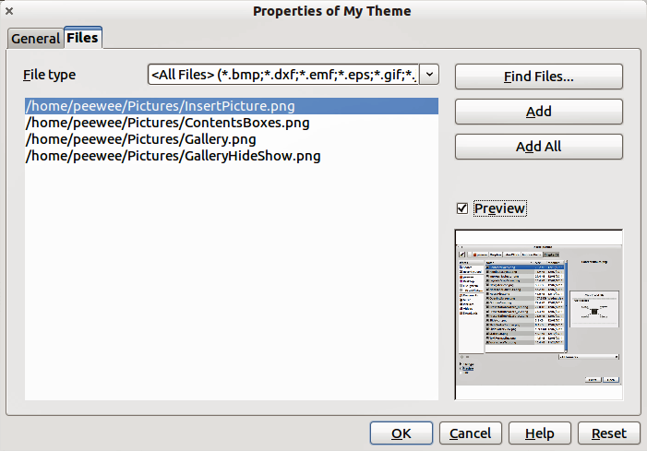
Figure 11. Properties of My Theme dialog
- Click on the Files tab.
- Click on Find Files to open the Select Path dialog (Figure 12).
- Browse to the folder that contains the images you want to use.
- Click OK to select the files contained in the folder and the Select Path dialog closes. The list of files contained in the folder now appear in the Theme Properties dialog.
- Select the files you want to use in My themes and click on Add. The added files will disappear from the file list and the images will appear in the Gallery.
- If you want to add all the files in the list, then click on Add All. All the files will disappear from the list and the images will appear in the Gallery.
- Click OK when finished and the Properties of My Theme dialog will close.
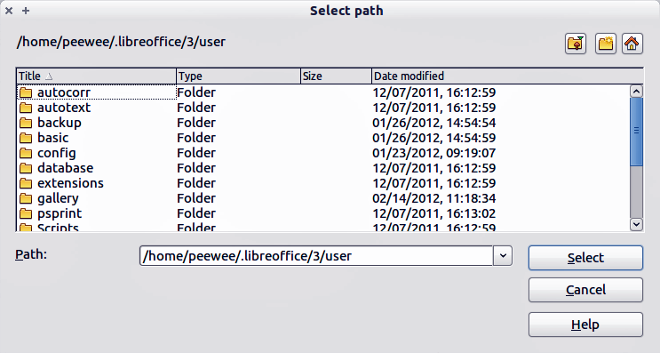
Figure 12. Selecting path for new images in themes

Deleting graphics
You can delete images only from My themes or themes that you have created.
- Right-click on the image in the Gallery window.
- Choose Delete from the pop-up menu.
- A confirmation message appears, asking if you want to delete this object. Click Yes.
Note | The image is a linked file and is deleted from the Gallery only. The original image file is not deleted.
All the images in a gallery are linked files. From time to time it is beneficial to update the gallery theme to make sure that all the files are still there. To do so, right-click on the theme where you added at least one file and then select Update from the pop-up menu.

Adding a new theme
You can add a new theme to the list of theme categories in the gallery as follows:
- Click the New Theme button above the list of theme categories and the Properties dialog opens.
- Click the General tab and type a name for the new theme in the text box (Figure 13).
- Click the Files tab and follow Steps 3 through to 8 in “Adding images to My themes” on page 15.
- The new theme will now be displayed in the list of theme categories in the Gallery.
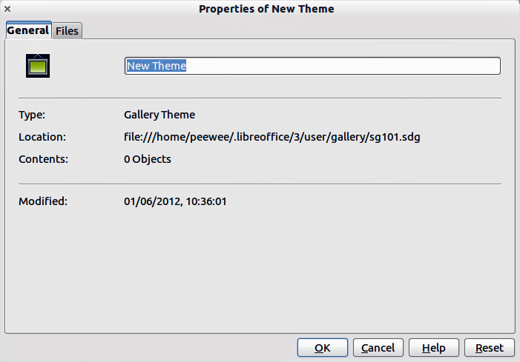
Figure 13. Adding new theme to the Gallery
Note | If you wish, you can rename this new theme by manually by right-clicking the theme name and selecting Rename.

Colors and color palettes
Draw (like all LibreOffice components) uses color palettes for the representation of colors. Also, you can customize the color palette to suit your own needs by modifying colors in a palette, adding other colors, or creating new color palettes.
Note | LibreOffice uses the RGB color model internally for printing in all of its software modules. The CMYK controls are provided only to ease the input of color values using CMYK notation.

Using colors
Two color dialogs are available where you can select, add, modify, edit or delete colors. Go to Tools > Options > LibreOffice > Colors (Figure 14) or Format > Area > Colors (Figure 15) on the main menu bar to open these color dialogs. Also, if you right-click on a selected object and go to Area in the context menu, then click on the Colors tab, you will open the Area dialog in Figure 15.
Each color value has a numeric value and can be input directly as numbers. The color values for the RGB color model (Red, Green and Blue) can be any integer value between 0 and 255. The color values for the CMYK color model (Cyan, Magenta, Yellow and Black (K)) are percentages. When selecting between the RGB and CMYK color models in both dialogs, the value boxes automatically change to show RGB or CMYK.
When using CMYK values, the conversion to RGB values used in LibreOffice is made automatically. Any modifications made to colors apply only to the active palette in your drawing unless you save the modified color palette for future use.
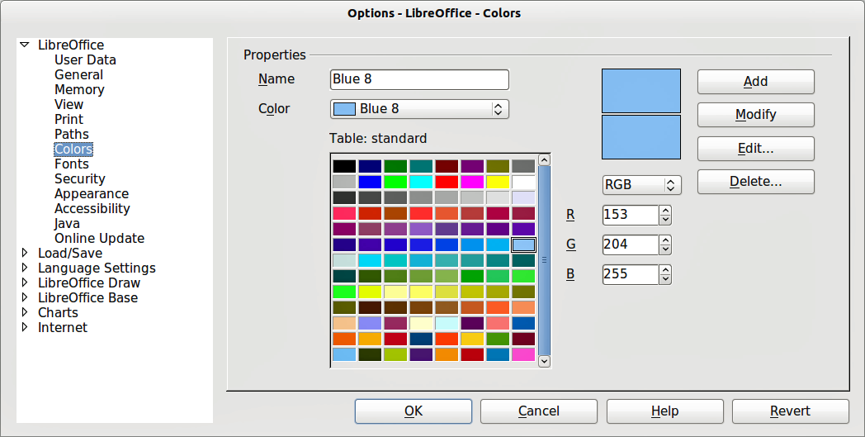
Figure 14: Options LibreOffice Colors dialog
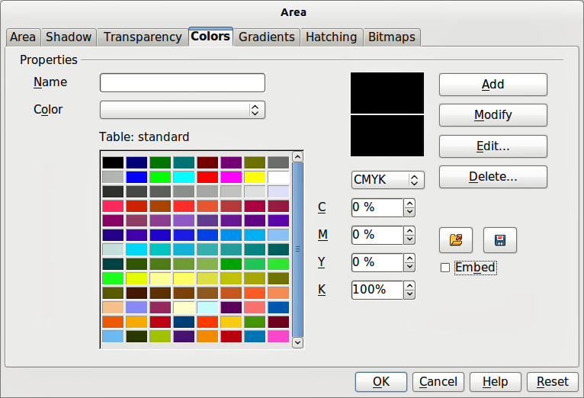
Figure 15: Format Area Colors dialog
Tip | For more information about color models, go to http://en.wikipedia.org/wiki/Color_model

Selecting colors
- Go to Tools > Options > LibreOffice > Colors (Figure 14) or Format > Area > Colors (Figure 15) on the main menu bar to open a color dialog.
- Alternatively, right-click on a selected object and select Area from the context menu, then click on the Colors tab to open the color dialog (Figure 15).
- Select a color from the Color drop down list, or select a color from the color table, or enter the RGB or CMYK values if you know these values for the color you want to use.
- Click OK to use the selected color and close the dialog.

Color palettes
Using the Format > Area Colors dialog (Figure 15) allows you to load color palettes and create then save color palettes for future use.
- Click on the Load Color List icon to open a dialog where you can select a color palette to use in Draw.
- If you have made any changes to the color palette, click on the Save Color List icon to open a dialog where you can save your color palette for future use in Draw. The file format used in LibreOffice for color palettes is .soc.
Note | The Load Color List and Save Color List icons are only available if you select the color dialog using the Format > Area > Colors command or right-clicking on a selected object and selecting Area from the context menu.

Creating colors

Using color values
- Select either RGB or CMYK from the drop down options on the color dialog.
- Enter integer values or percentage values in each of the RGB or CMYK boxes or use the spinners at the right of each box.
- The original color is shown the top color sample and the new color is shown in the lower color sample.
- Either, click Modify to apply and store the new setting in the color palette without changing the color name.
- Or, click Add and you will be prompted to give the color a new name. Entering a new name and clicking OK will add the new color to the end of the color list and store it in the currently active palette.
- Click OK to use the modified or new color and close the dialog.
Note | To store your new color in a color palette for future use in Draw, see “Color palettes” on page 19.

Using the color picker
You can define colors using the Color Picker dialog (Figure 16).
- Go to Format > Area > Colors on the main menu bar or right-click on a selected object and go to Area in the context menu to open the Area dialog and then click on the Colors tab to open the colors dialog (Figure 15).
- Click Edit to open the Color Picker dialog where you will have three ways of selecting a color to create and use.
- Click on the colored bar to the right of the color sample area to select a color. The values in the RGB, HSB (Hue, Saturation and Brightness) and CMYK boxes will change.
- Or, enter values in either the RGB, HSB or CMYK boxes to create the color. Entering values in one set of value boxes will change the values in the other two sets of boxes.
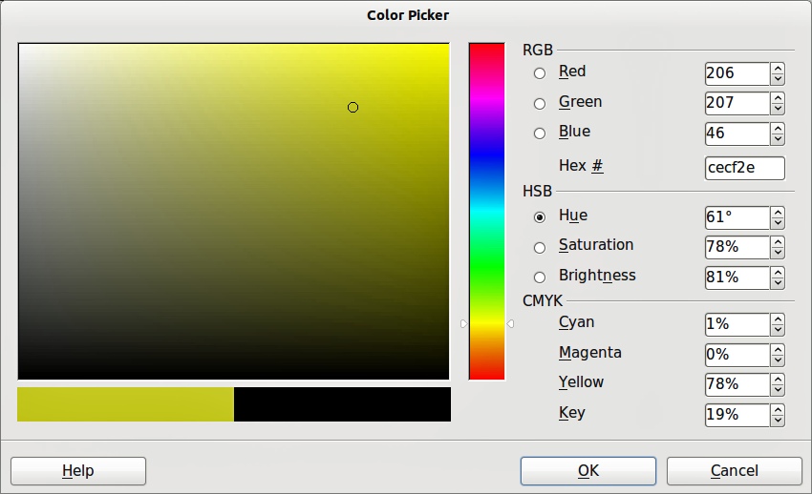
Figure 16: Color Picker dialog
- Or, click on the small circle in the color sample area and drag it to a new position to create a new color.
- The color bar below the sample color area will show the new color on the left half of this bar so that you can compare it with the original color on the right half of this bar.
- If you are satisfied with the color created, click OK to use the color.
- See “Using color values” on page 19 to save the color.

Deleting colors
- To delete a color from a color palette, open the color dialog (Figure 14 or Figure 15).
- Select the color from the Color drop down list or the color table and click Delete.
- Click Yes to confirm the deletion of the color.
- Click OK to close the color dialog.

Bézier curves
In LibreOffice you can use Bézier curves in your drawing. A curve is defined by means of a start point P₀, an end point P₃, and two control points P1 and P2 (Figure 17). For points on the curve the terms nodes or anchors are often used. For the mathematical background of Bézier curves, see http://en.wikipedia.org/wiki/Bezier_curve.
Bézier curves are very useful for experimenting with the shape and form of curves. In point mode you can change the curve alignment by dragging the points with the mouse. The curve leaves the start point P0 in the direction of the control point P1 and arrives at the end point P3 from the direction of the control point P2. The more distant a control is from its start or end point the smaller the curvature at that point. If a control point lies directly on one of these points, it has no influence on the curve.
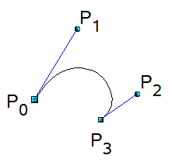
Figure 17: Points in Bézier curves

Drawing a Bézier curve
- Click on the small triangle to the right of the Curve icon on the Drawing toolbar to open the Lines toolbar (Figure 18). The Curve icon will show the last tool selected from the Lines toolbar. To make this toolbar a floating toolbar, click at the bottom of the pop-up toolbar and drag it onto your workspace.
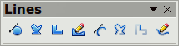
Figure 18: Lines toolbar
- Click on the Curve icon on the Lines toolbar. Note that this maybe a different icon to the Curve icon on the Drawing toolbar.
- Click at the start point where you want to draw the curve and, keeping the mouse button pressed, drag the cursor to the approximate the position of the end point for the curve.
- Double-click when you have reached the end position of your curve and a curve is drawn. The arc of the curve is determined by the distance you have dragged to create the end point.
Note | If you single-click when you have reached the end point of your curve, you will continue drawing straight lines until you double-click to end the drawing of a curve.
- Click on the Points icon on the Drawing toolbar or press the F8 key to open the Edit Points toolbar (Figure 19).
- Click once on your curve to display the start and end points. The start point of the curve is larger than the end point.
- Move cursor over the start or end point and drag the control point to its correct position, if necessary. As you drag a start or end point, a control point appears at the end of a dashed line connected to the point you have selected (Figure 21).
- When you have the position for your start or end point, release the cursor and the control point remains active.
- Click on the control point and drag it to change the shape of the curve.
- When you have finished editing your curve, click anywhere on your workspace to deselect the curve and stop editing points.
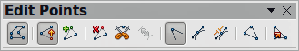
Figure 19: Edit Points toolbar
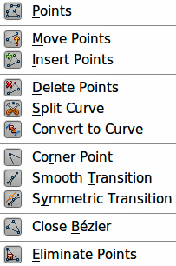
Figure 20: Edit Points tools
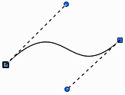
Figure 21: Control points on a curve

Edit Points tools
With reference to Figure 19 and Figure 20, the tools available on the Edit Points toolbar allow you to edit and change the shape of a Bézier curve and are explained as follows:
- Points – allows you to activate or deactivate the edit mode for Bézier objects. In the edit mode, individual points of the drawing object can be selected.
- Move Points – activates a mode in which you can move points. The mouse pointer displays a small empty square when resting on a point. Drag that point to another location. The curve on both sides of the point follows the movement; the section of the curve between points changes shape. Point at the curve between two points or within a closed curve and drag the mouse to shift the entire curve without distorting the form.
- Insert Points – activates the insert mode and allows you to insert points. You can also move points, just as in the move mode. If, however, you click at the curve between two points and move the mouse a little while holding down the mouse button you insert a new point. The point is a smooth point, and the lines to the control points are parallel and remain so when moved. If you wish to create a corner point you must first insert either a smooth or a symmetrical point which is then converted to a corner point by using Corner Point.
- Delete Points – used to delete one or several selected points. If you wish to select several points click the appropriate points while holding down the Shift key. First select the points to be deleted, and then click this icon or press Delete key.
- Split Curve – this tool splits a curve. Select the point or points where you want to split the curve, then click.
- Convert To Curve – converts a curve into a straight line or converts a straight line into a curve. If you select a single point, the curve before the point will be converted. If two points are selected, the curve between both points will be converted. If you select more than two points, each time you click this icon, a different portion of the curve will be converted. If necessary, round points are converted into corner points and corner points are converted into round points. If a section of the curve is straight, the end points of the line have a maximum of one control point each. They cannot be modified to control points unless the straight line is converted back to a curve.
- Corner Point – converts the selected point or points into corner points (Figure 22). Corner points have two movable control points, which are independent from each other. A curved line, therefore, does not go straight through a corner point, but forms a corner.
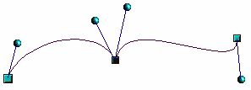
Figure 22: Corner point
- Smooth Transition – converts a corner point or symmetrical point into a smooth point (Figure 23). Both control points of the corner point are aligned in parallel and can only be moved simultaneously. The control points may differentiate in length, allowing you to vary the degree of curvature.
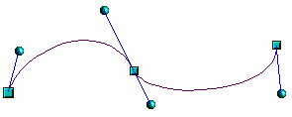
Figure 23: Smooth transition point
- Symmetric Transition – converts a corner point or a smooth point into a symmetrical point (Figure 24). Both control points of the corner point are aligned in parallel and have the same length. They can only be moved simultaneously and the degree of curvature is the same in both directions.
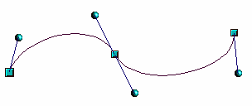
Figure 24: Symmetric transition point
- Close Bézier – closes a line or a curve. A line is closed by connecting the last point with the first point, indicated by an enlarged square.
- Eliminate Points – marks the current point or the selected points for deletion. This happens in the event that the point is located on a straight line. If you convert a curve or a polygon with the Convert to Curve tool into a straight line or you change a curve with the mouse so that a point lies on the straight line, it is removed. The angle from which the point reduction is to take place can be set by going to Tools > Options > LibreOffice Draw > Grid.

Adding comments to a drawing
Draw supports comments similar to those in Writer and Calc.
- Go to Insert > Comment the main menu bar. A comment box appears with a small marker box containing your initials in the upper left-hand corner of your drawing. Draw automatically adds your name and the date at the bottom of the comment (Figure 25).
- Type or paste your comment into the text box.
- To apply basic formatting to the text, right-click and select the formatting option from the context menu.
- To delete a comment, right-click on the comment or marker box and select an option from the context menu or click on the small triangle in the bottom right of the comment and select an option from the context menu.
- To move a comment, click on the small marker box and drag it to a new position on your drawing.
- To show or hide the comments, go to View > Comments.
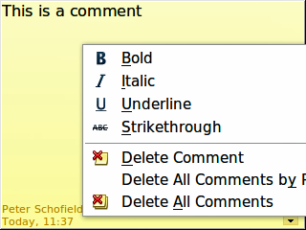
Figure 25: Comment in a drawing
Note | For your initials and name to appear in a comment, you have to enter your user data. Go to Tools > Options > LibreOffice > User Data and enter all the necessary data.  If more than one person edits the document, each author is automatically allocated a different background color.

Connecting and breaking lines
It is possible in Draw to connect separate line elements together making one line, break a line that is composed of separate elements.
Select a number of lines and go to Modify > Connect. The lines are converted to curves and adjacent end points are joined together. The resulting shape is a polyline, not a closed shape.
Select a line that is composed of separate elements and go to Modify > Break. Each separate element is now indicated with start and end points. Click on an element and drag it to a new position.

