
Draw Guide
Chapter 1
Introducing Draw
Drawing Vector Graphics in LibreOffice

Copyright
This document is Copyright © 2012 by its contributors as listed below. You may distribute it and/or modify it under the terms of either the GNU General Public License (http://www.gnu.org/licenses/gpl.html), version 3 or later, or the Creative Commons Attribution License (http://creativecommons.org/licenses/by/3.0/), version 3.0 or later.
All trademarks within this guide belong to their legitimate owners.
Contributors
Martin Fox John Cleland Jean Hollis Weber
John A Smith Peter Schofield
Feedback
Please direct any comments or suggestions about this document to: documentation@global.libreoffice.org.
Acknowledgments
This chapter is based on an original French document written for OpenOffice.org 1.x by Michel Pinquier (translated into English by Alex Thurgood) and previous content revised by Jim Taylor. The chapter was revised for OpenOffice.org 2.0 by Linda Worthington, Daniel Carrera, Jean Hollis Weber, and Agnes Belzunce, and later translated into German by Wolfgang Uhlig. The German revisions were then translated into English and revised for OpenOffice.org 3.3 and LibreOffice 3.3 by Martin Fox. Other contributors included Peter Hillier-Brook, Hazel Russman, Gary Schnabl, and Claire Wood.
Publication date and software version
Published 24 June 2012. Based on LibreOffice 3.5.

Note for Mac users
Some keystrokes and menu items are different on a Mac from those used in Windows and Linux. The table below gives some common substitutions for the instructions in this chapter. For a more detailed list, see the application Help.
Windows or Linux | Mac equivalent | Effect
Tools > Options menu selection | LibreOffice > Preferences | Access setup options
Right-click | Control+click | Open a context menu
Ctrl (Control) | z (Command) | Used with other keys
F5 | Shift+z+F5 | Open the Navigator
F11 | z+T | Open the Styles and Formatting window

Contents
Copyright 2
Note for Mac users 2
Introduction 4
The Draw workplace 5
Rulers 5
Status bar 6
Toolbars 7
Standard toolbar 8
Drawing toolbar 8
Line and Filling toolbar 8
Text Formatting toolbar 8
Color bar 8
Choosing a color palette 9
Options toolbar 9
Drawing grid and guides 10
Floating and moving toolbars 10
Available toolsets 10
Standard toolbars 11
Customizing toolbars 12
Quick printing 12
Controlling printing 13
General printing 13
Printing options 14
Printing multiple pages on a single sheet 14
Selecting pages to print 14
Printing a brochure or booklet 15
Single sided printer 15
Double sided or duplex printer 16
Printing in black and white or grayscale 16
Exporting to PDF 17
Export directly as PDF 17
Controlling PDF content and quality 18
Exporting to other formats 18
Exporting Draw documents as web pages 18
E-mailing documents 18

Introduction
Draw is a vector graphics drawing tool, although it can also perform some operations on raster graphics (pixels). Using Draw, you can quickly create a wide variety of graphical images.
Vector graphics store and display a picture as simple geometric elements such as lines, circles, and polygons rather than as a collection of pixels (picture elements or points on the screen). This permits simpler storage and supports precise scaling of the picture elements.
Draw is fully integrated into the LibreOffice suite and this simplifies exchanging graphics with all components of the suite. For example, if you create an image in Draw, reusing it in a Writer document is as simple as copying and pasting the image. You can also work with drawings directly from within Writer or Impress using a subset of the functions and tools from Draw.
The functionality of LibreOffice Draw is extensive and, even though it was not designed to rival high-end graphics applications, it possesses significantly more functionality than the drawing tools that are generally integrated with most office productivity suites.
A few examples of the drawing functions are: layer management, magnetic grid-point system, dimensions and measurement display, connectors for making organization charts, 3D functions that enable small three-dimensional drawings to be created (with texture and lighting effects), drawing and page-style integration, and Bézier curves.
This Draw Guide is not a course book to be worked through from beginning to end. Rather, it is a reference work in which you can browse for guidance on particular topics.
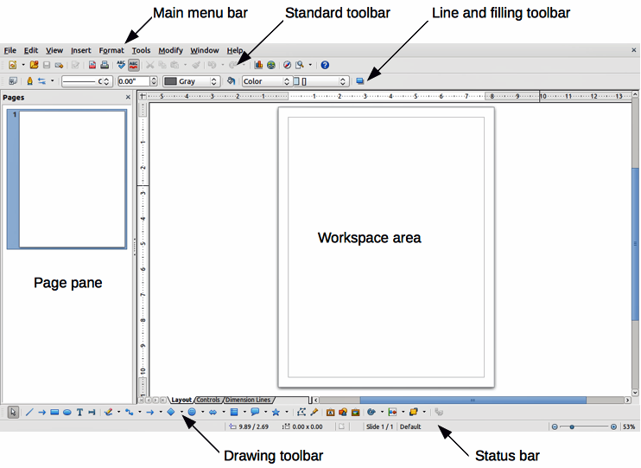
Figure 1: LibreOffice Draw workplace
This document describes only the functions associated with Draw. Some concepts, such as file management or the way the LibreOffice environment works, are mentioned only briefly; they are covered in more detail in the Getting Started guide.

The Draw workplace
The main components of the Draw interface or workplace are shown in Figure 1.
The large area in the center of the window is where you make the drawings. You can surround the drawing area with toolbars and information areas. The number and position of the visible tools vary with the task in hand and user preferences. Therefore, your setup may look different. For example, many users put the main Drawing toolbar on the left-hand side of the workspace and not at the bottom, as shown in Figure 1.
You can split drawings in Draw over several pages. Multi-page drawings are used mainly for presentations. The Pages pane, on the left side of the Draw window in Figure 1 gives an overview of the pages that you create. If the Pages pane is not visible on your setup, you can enable it from the View menu (View > Page Pane). To make changes to the page order, just drag and drop one or more pages.
In LibreOffice Draw, the maximum size of a drawing page is 300 cm by 300 cm.

Rulers
You should see rulers (bars with numbers) on the upper and left-hand sides of the workspace. If they are not visible, you can enable them by selecting View > Ruler in the main menu bar.
The rulers show the size of a selected object on the page using double lines (highlighted in Figure 2). When no object is selected, they show the location of the mouse pointer, which helps to position drawing objects more accurately.
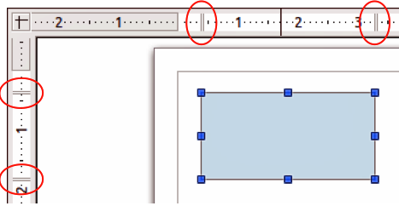
Figure 2: Rulers showing size of a selected object
You can also use the rulers to manage object handles and guide lines, making it easier to position objects.
The page margins in the drawing area are also represented on the rulers. You can change the margins directly on the rulers by dragging them with the mouse. The margin area is indicated by the grayed out area on the rulers as shown in Figure 2.
To modify the measurement units of the rulers, which can be defined independently, right-click on the desired ruler, as illustrated for the horizontal ruler in Figure 3.
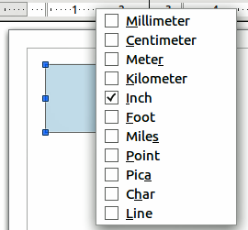
Figure 3: Ruler units

Status bar
The Status bar is located at the bottom of the Draw window and includes several Draw-specific fields (Figure 4).
Information area shows which action is being carried out, or which object type is selected.
Position and Object size show different information depending on whether objects are selected or not.
  - When no object is selected, the position numbers show the current position (X and Y coordinates) of the mouse cursor.
  - When an object is selected and being resized with the mouse, the object size numbers show the size of the object (width and height).
Note | The sizes are given in the current measurement unit (not to be confused with the ruler units). This unit is defined in Tools > Options > LibreOffice Draw > General.
  - If an object is selected, the position numbers shows the X and Y coordinates of the upper-left corner and the object size number pair displays the size of the object. These numbers do not relate to the object itself, but to the selection outline, which is the smallest possible rectangle that can contain the visible part or parts of the object; see Chapter 3 Working with Objects and Object Points for more information.
  - When an object is selected, a double-click in either of these areas opens the Position and Size dialog, see Chapter 4 Changing Object Attributes for more information.
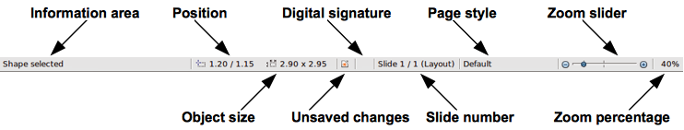
Figure 4: Draw status bar
Unsaved changes are indicated whenever any change is made to the document but not yet saved to disk.
Digital signature indicates if the document has been digitally signed. A double-click or right-click in this area opens the Digital Signatures dialog. A document must be saved at least once before it can be digitally signed. After a document is digitally signed, an indicator appears in this area.
Slide number shows the sequence number for the current drawing page and the total number of pages created for the drawing. If you select an object, the information enclosed by parentheses indicates on which layer the object is placed within the drawing. In the example shown in Figure 4, the object is on the Layout layer of Slide 1 and there is a total number of one slide in the drawing.
Page style shows which template is being used for the drawing.
Zoom slider changes the zoom percentage of how the drawing appears on the computer display. Clicking on the plus (+) sign increases zoom and on the minus (-) sign decreases zoom. You can also drag the slider to increase or decrease the zoom percentage. The vertical bar in the middle of the Zoom slider represents a zoom percentage of 100%.
Zoom percentage shows the level of zoom as a percentage. Double-clicking on the zoom percentage opens the Zoom & View Layout dialog. Right clicking on the zoom percentage opens a menu where you can select a zoom level.

Toolbars
You can display or hide the various Draw toolbars, according to your needs. To display or hide a toolbar, click View > Toolbars. On the menu that appears, choose which toolbars you want to display.
You can also select the icons or buttons that you want to appear on the toolbars. To change the visible icons or buttons on any toolbar, click the arrow at the right-hand end of that toolbar and choose Visible Buttons from the drop-down menu. Visible icons or buttons are indicated by a shaded outline around the icon. Icons or buttons not visible are indicated by a plain icon as shown by the lower three icons in Figure 5. Click on an icon to hide or show it in the toolbar.
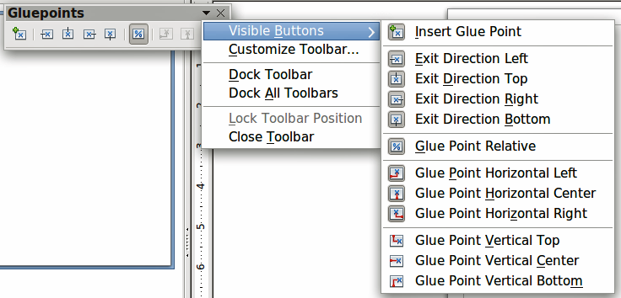
Figure 5: Selection of visible toolbar icons

Standard toolbar
The Standard toolbar is the same for all LibreOffice components and is described in detail in the Getting Started Guide.
Figure 6: Standard toolbar

Drawing toolbar
The Drawing toolbar is the most important toolbar in Draw. It contains all the necessary functions for drawing various geometric and freehand shapes, and for organizing them on the page. It is described in detail in Chapter 2, Drawing Basic Shapes.
Figure 7: Drawing toolbar

Line and Filling toolbar
The Line and Filling toolbar lets you modify the main properties of a drawing object. The icons and pull-down lists vary, according to the type of object selected. For example, to change the style of a line, click on the up and down arrows for Line Style and select the required style.
Figure 8: Line and Filling toolbar
The available functions on the Line and Filling toolbar let you to change the color, style, and width of the line drawn, the fill color and style, and other properties of an object. The object must first be selected with a mouse click. If the selected object is a text frame, the Line and Filling toolbar changes to the Text Formatting toolbar..

Text Formatting toolbar
The Text Formatting toolbar is very similar to the Formatting toolbar in Writer. A more detailed explanation of the functions on this toolbar can be found in Chapter 4, Changing Object Attributes.
Figure 9: Text Formatting toolbar

Color bar
To display the Color bar, use View > Toolbars > Color Bar. The toolbar appears at the bottom of the workspace and displays the current color palette. This toolbar lets you rapidly choose the color of the various objects (lines, areas, and 3D effects) in your drawing. The first box in the panel corresponds to invisible (no color).
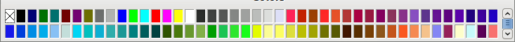
Figure 10: Color bar

Choosing a color palette
You can access several specialized color palettes in Draw, as well as change individual colors to your own taste. This is done using the Area dialog by selecting Format > Area on the main menu bar or the Area icon on the Line and Filling toolbar (Figure 8). On the Area dialog, select the Colors tab (Figure 11).
.
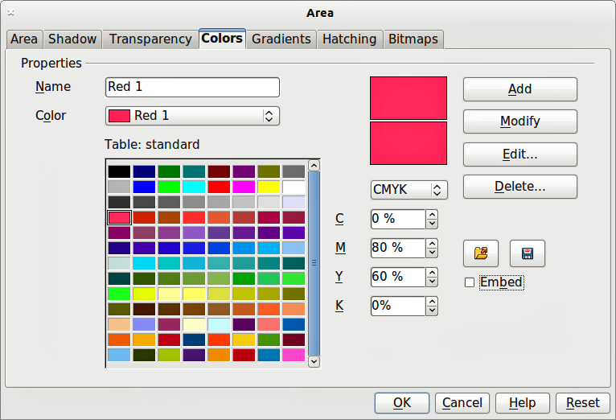
Figure 11. Changing the color palette
To load another palette, click on the Load Color List icon . The file selector dialog asks you to choose one of the standard LibreOffice palettes (files with the file extension *.soc). For example, web.soc is a color palette that is adapted to creating drawings for placing in web pages. These colors will display correctly on workstations with screens capable of at least 256 colors.
A more detailed description of color palettes and their options can be found in Chapter 8, Tips and Tricks.

Options toolbar
The Options toolbar lets you activate or deactivate various drawing aids. The Options Bar is not one of the toolbars displayed by default. To display it, select View > Toolbars > Options. The options are described briefly in Figure 13 and in greater detail in other chapters of this Draw Guide.
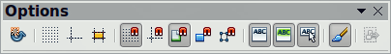
Figure 12: Options toolbar
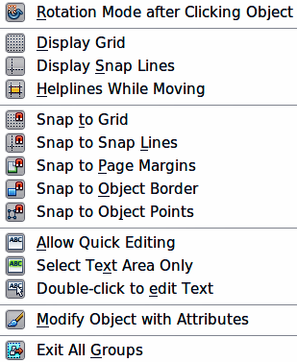
Figure 13: Functions available in Options toolbar

Drawing grid and guides
Draw offers a grid and snap lines as drawing aids and these can be turned on or off by clicking on the Display Grid or the Display Snap Lines icons on the Options toolbar. The grid points and the snap lines are displayed only on the screen and are not shown on a printed drawing or when the drawing is used in another LibreOffice program. The color, spacing, and resolution of the grid points can be individually chosen for each axis. This is described in more detail in Chapter 8, Tips and Tricks.
Help lines when moving objects can be displayed and these are turned on or off by clicking on the Helplines While Moving icon on the Options toolbar. Showing the position of the object while moving it makes positioning the object much easier. If this function is activated, pairs of vertical and horizontal lines enclosing the object are shown while moving the object. These lines extend to the edges of the drawing area. This function is also described in detail in Chapter 8, Tips and Tricks.
Draw also offers several snap functions to help you can position objects exactly in a drawing and these snap functions are described in detail in Chapter 8, Tips and Tricks.

Floating and moving toolbars

Available toolsets
Many icons have a small triangle or arrowhead pointing downward to the right side of the icon. This indicates that this icon has additional tools available. Click on the triangle to display the full set of tools (Figure 14). You can “tear off” this toolset so it becomes a floating toolbar. Click the area at the bottom of the toolset, drag it across the screen to a location you want, and then release the mouse button.
To close a toolset floating toolbar, click on the X on the right of the toolbar title.
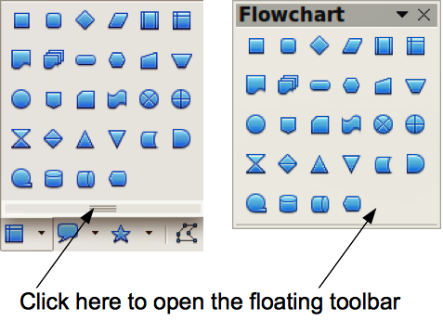
Figure 14: Available additional tools and floating toolbar
Note | When a toolset is made into a floating toolbar, the icon on the existing toolbar remains in the toolbar and always shows the last command you used. This means that the icon you see on your screen may differ from the icon shown in this Guide.
Tip | When you double-click on an icon on a toolbar, the command corresponding to that icon will become active. You can then repeat this action as often as you like. To exit from this mode, press the Esc key or click on another icon. Please note that this may not work for every icon on every toolbar.

Standard toolbars
When you open Draw, the default set of toolbars are already docked or fixed in their positions at the top and bottom of the workspace. This default set of toolbars normally are the Standard, Line and Filling, Drawing toolbars. These toolbars can be undocked and become floating toolbars.
To undock a toolbar, move the mouse cursor to the far left of the toolbar and is over the toolbar handle (Figure 15). The cursor will change shape, which is normally a grabbing hand and is dependent on computer setup and operating system. Click and drag on the toolbar handle to move the toolbar until it becomes a floating toolbar. This floating-toolbar capability is common to all components of LibreOffice.
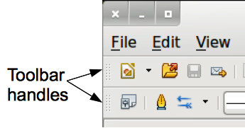
Figure 15: Toolbar handles
To dock a floating toolbar at the top of the Draw workspace, press and hold the Ctrl key then double click on the title of the toolbar. The toolbar will move into available space at the top of the Draw workspace.
An alternative method of docking a toolbar is to click in the toolbar tile and drag the toolbar to the docked position that you require. This can be the top, bottom or one of the sides of the Draw workspace.

Customizing toolbars
You can customize toolbars in several ways. To show or hide icons defined for a toolbar, see Figure 5 on page 7.
To add functions to a toolbar, move tools between toolbars, or create new toolbars., select View > Toolbars > Customize, then select the Toolbars tab (Figure 16) and the toolbar you want to change. You can then select the desired tools for that toolbar.
Each toolbar has a different list of functions. For details, see Chapter 14, Customizing LibreOffice in the Getting Started Guide, which also describes how to customize menus.
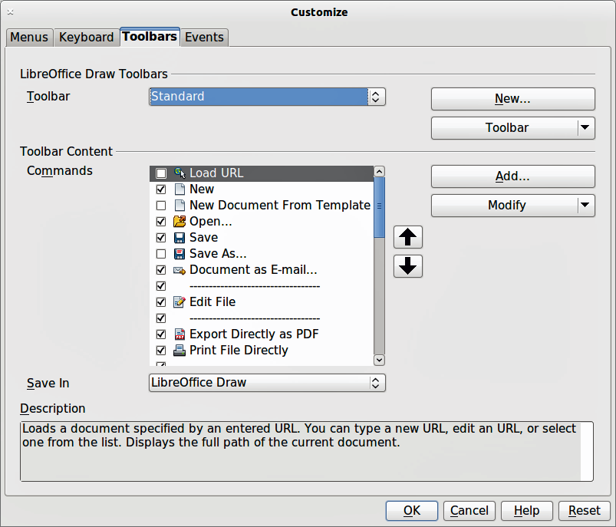
Figure 16: Customizing toolbars

Quick printing
To quickly print a document or drawing, click on the Print File Directly icon to send the entire document to the default printer that is defined for your computer.
Note | You can change the action of the Print File Directly icon to send the document to the printer defined for the document instead of the default printer for the computer. Go to Tools > Options > Load/Save > General and select the Load printer settings with the document option.

Controlling printing
For more control over printing, use the Print dialog (File > Print or Ctrl+P). The Print dialog (Figure 17) has four tabs where you can choose a range of options and these are described in the following sections.
Note | The options selected on the Print dialog apply to this printing of this document only. To specify default print settings for LibreOffice, go to Tools > Options > LibreOffice > Print.
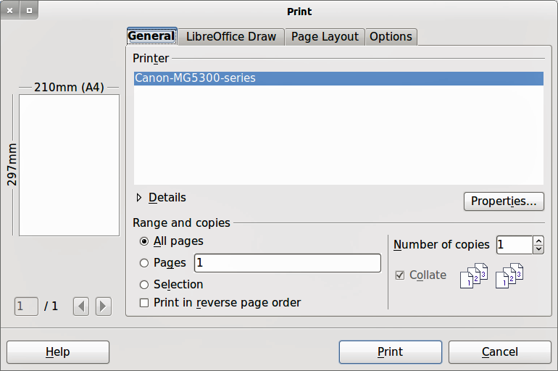
Figure 17. Print dialog

General printing
On the General tab of the Print dialog (Figure 17), you can select:
- Which printer to use from the printers available in the Printer section.
- Which pages to print, number of copies to print, whether to collate multiple copies, and page order for printing in the Range and copies section.

Printing options
To access the more printing options, click on the Options tab of the Print dialog (Figure 18). These printing options are self explanatory..
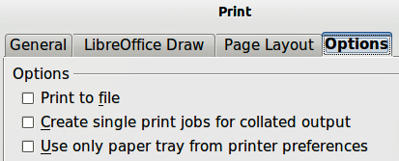
Figure 18: Printing Options dialog
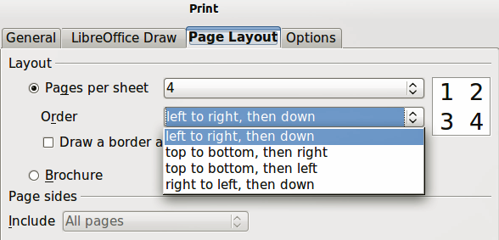
Figure 19: Page Layout dialog

Printing multiple pages on a single sheet
You can print multiple pages of a document on one sheet of paper. To do this:
- Open the Print dialog and select the Page Layout tab (Figure 19).
- In the Layout section, select from the drop-down list the number of pages to print per sheet. The preview panel on the right shows how the pages will look in the printed document.
- When printing more than two pages per sheet, you can choose the order in which they are printed across and down the paper from the Order drop down list.
- To distinguish each page on a sheet, select the Draw a border around each page option.
- Click the Print button.

Selecting pages to print
In addition to printing a full document, you can choose whether to print individual pages, a range of pages, or a highlighted selection within a document.
To print an individual page:
- Choose File > Print from the main menu bar or use the Ctrl+P key combination and select the General tab in the Print dialog (Figure 17).
- In the Ranges and copies section, select the Pages option.
- Enter the number of the page to print.
- Click the Print button.
To print a range of pages:
- Choose File > Print from the main menu bar or use the Ctrl+P key combination and select the General tab in the Print dialog (Figure 17).
- In the Ranges and copies section, select the Pages option.
- Enter the number of the pages to print (for example 1-4 or 1,3,7,11), or any combination of the two (for example: 1-4,5-9,10).
- Click the Print button.
To print a selection from a page or multiple pages:
- In the document, highlight the section of the page or pages to print.
- Choose File > Print from the main menu bar or use the Ctrl+P key combination and select the General tab in the Print dialog (Figure 17).
- In the Ranges and copies section, select the Selection option.
- Click the Print button.

Printing a brochure or booklet
In Writer, Impress, and Draw, you can print a document with two pages on each side of a sheet of paper, arranged so that when the printed pages are folded in half, the pages are in the correct order to form a booklet or brochure.
Tip | Plan your document so it will look good when printed half size; choose appropriate margins, font sizes, and so on. You may need to experiment.

Single sided printer
To print a brochure or booklet on a printer only capable of single sided printing:
- Choose File > Print and in the Print dialog, click on the Properties button to open the Properties dialog (Figure 20).
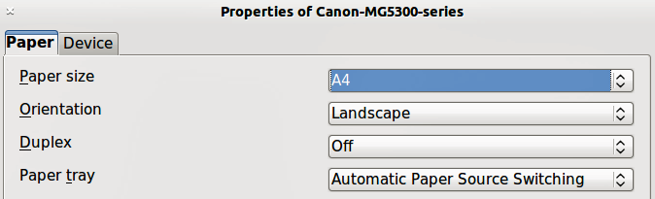
Figure 20: Printer Properties dialog
- Check the printer is set to the same orientation (portrait or landscape) as specified in the page setup for your document. Usually the orientation does not matter, but it does for brochures and booklets.
- Click OK to return to the Print dialog.
- Select the Page layout tab in the Print dialog (Figure 19).
- Select the Brochure option (Figure 21).
- In the Page sides section, select Back sides / left pages option from the drop-down list.
- Click the Print button.
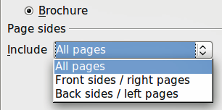
Figure 21: Printing a brochure or booklet
- Take the printed pages out of the printer, turn the pages over, and put them back into the printer in the correct orientation to print on the blank side. You may need to experiment a bit to find out what the correct arrangement is for your printer.
- In the Page sides section, select Front sides / right pages option from the drop down list.
- Click the Print button.

Double sided or duplex printer
To print a brochure or booklet on a printer that is capable of double or duplex sided printing:
- Choose File > Print and in the Print dialog, click on the Properties button to open the Properties dialog (Figure 20).
- Check the printer is set to the same orientation (portrait or landscape) as specified in the page setup for your document. Usually the orientation does not matter, but it does for brochures and booklets.
- From the Duplex drop down list, select Long Edge or Long Side printing. Actual options available for duplex printing do depend on printer model and the computer system being used.
- Click OK to return to the Print dialog.
- Select the Page layout tab in the Print dialog (Figure 19).
- Select the Brochure option (Figure 21).
- In the Page sides section, select All pages option from the drop-down list.
- Click the Print button.

Printing in black and white or grayscale
You may wish to print documents in black and white or grayscale on a color printer. However, some color printers may only you to print in color regardless of the settings you choose. More details can be found in the information that came with your printer.
To change the printer settings to print in black and white or grayscale:
- Choose File > Print to open the Print dialog (Figure 17).
- Click Properties to open the Properties dialog for the printer. The available choices available do depend on printer model and computer operating system, but you should easily find options for the Color settings. An example of what you may see is shown in Figure 22.
- The choices for color may include black and white or grayscale. Choose the required setting.
- Click OK to confirm your choice and return to the Print dialog,
- Click the Print button to print the document.
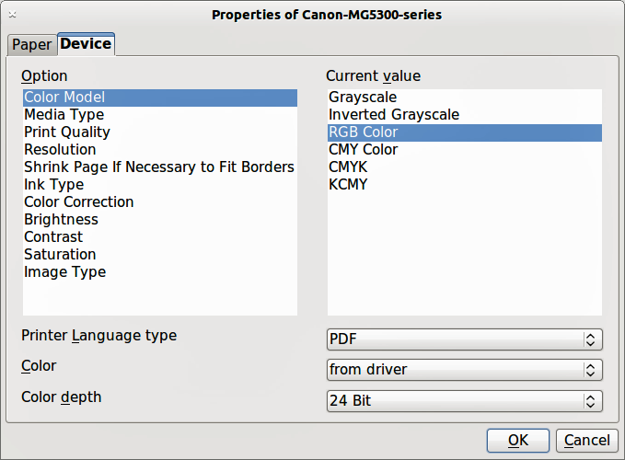
Figure 22: Printer Properties dialog
Tip | Grayscale is the best option if you have any colored text or graphics in the document. Colors will print in shades of gray giving more detail. When printing color in black and white some of this detail maybe lost.
To change the LibreOffice settings to print all color text and graphics as grayscale:
- Choose Tools > Options > LibreOffice > Print.
- Select the Convert colors to grayscale option. Click OK to save the change.
- Open the Print dialog (File > Print).
- Click the Print button to print the document.
To change the Draw settings to print all color text and graphics as black and white or grayscale:
- Choose Tools > Options > LibreOffice Draw > Print.
- In the Quality section, select either Grayscale or Black & white option.
- Click OK to save the change.
- Open the Print dialog (File > Print).
- Click the Print button to print the document.

Exporting to PDF
LibreOffice can export documents to PDF (Portable Document Format). This industry-standard file format is ideal for sending a file for someone else to view using either Adobe Reader or other PDF viewer. The process and dialogs are the same for Writer, Calc, Impress, and Draw, with a few minor differences mentioned in this section.

Export directly as PDF
Click on the Export Directly as PDF icon on the Standard toolbar to export the entire document using your default PDF settings. You are asked to enter the file name and location for the PDF file, but you cannot choose page range, image compression, or other options.

Controlling PDF content and quality
For more control over the content and quality of the resulting PDF, go to File > Export as PDF to open the PDF Options dialog. Using this dialog you select the options using different pages for General, Initial View, User Interface, Links, and Security. When you have selected the appropriate settings, click on Export. In the following dialog, enter the location and file name of the PDF to be created, then click Save to export the file. See Chapter 10, Printing, Exporting, Emailing in the Getting Started guide for details.

Exporting to other formats
LibreOffice uses the term “export” for some file operations involving a change of file type. If you cannot find what you want in File > Save As, look in File > Export. LibreOffice can export files in various formats and these are listed in the drop down list for File format.
To export a file in another format:
- Specify a file name for the exported document in the File name text box.
- Select the required format from the File format drop down list.
- Click the Export button.
See Chapter 6 Editing Pictures for more information on exporting graphics.
Note | The content of the exported file will depend on the element(s) selected on the page. No selection results in the entire image being exported. For most export formats only the image on the current page will be exported.

Exporting Draw documents as web pages
To export a multi-page Draw document to a series of web pages, choose File > Export and select HTML Document as the file type. The HTML Export wizard opens. Follow the prompts to create the web pages. If you wish, the wizard can generate a navigation aid to help in moving from page to page.

E-mailing documents
LibreOffice provides several ways to send documents quickly and easily as an e-mail attachment in OpenDocument format (LibreOffice default format), or as a PDF.
Note | Documents can only be sent from the LibreOffice menu if a mail profile has been set up.
To email the current document in OpenDocument format:
- Choose File > Send > Document as E-mail. LibreOffice opens your default e-mail program with the document attached.
- In your e-mail program, enter the recipient, subject, and any text you want to add, then send the e-mail.
To email the current document as a PDF, choose File > Send >-E-mail as PDF. LibreOffice creates a PDF using the default PDF settings and then opens your email program with the PDF file attached.
You can email a document to several recipients. For details, see Chapter 10 Printing, Exporting, Emailing in the Getting Started guide.

