
Writer Guide
Chapter 1
Introducing Writer

Copyright
This document is Copyright © 2011–2014 by the LibreOffice Documentation Team. Contributors are listed below. You may distribute it and/or modify it under the terms of either the GNU General Public License (http://www.gnu.org/licenses/gpl.html), version 3 or later, or the Creative Commons Attribution License (http://creativecommons.org/licenses/by/4.0/), version 4.0 or later.
All trademarks within this guide belong to their legitimate owners.

Contributors
John A Smith Jean Hollis Weber Barbara Duprey
Hazel Russman John M. Długosz Ron Faile Jr.

Feedback
Please direct any comments or suggestions about this document to the Documentation Team’s mailing list: documentation@global.libreoffice.org
Note: Everything you send to a mailing list, including your email address and any other personal information that is written in the message, is publicly archived and cannot be deleted.

Acknowledgments
This chapter is adapted and updated from Chapter 1 of the OpenOffice 3.3 Writer Guide. The contributors to that chapter are:
Agnes Belzunce Daniel Carrera Laurent Duperval
Stefan A. Keel Peter Kupfer Carol Roberts
Joe Sellman Gary Schnabl Janet M. Swisher
Jean Hollis Weber Linda Worthington Michele Zarri

Publication date and software version
Published 21 March 2014. Based on LibreOffice 4.2.

Note for Mac users
Some keystrokes and menu items are different on a Mac from those used in Windows and Linux. The table below gives some common substitutions for the instructions in this chapter. For a more detailed list, see the application Help.
Windows or Linux | Mac equivalent | Effect
Tools > Options menu selection | LibreOffice > Preferences | Access setup options
Right-click | Control+click and/or right-click depending on computer setup | Opens a context menu
Ctrl (Control) | ⌘ (Command) | Used with other keys
F5 | Shift+⌘+F5 | Opens the Navigator
F11 | ⌘+T | Opens the Styles and Formatting window

Contents
Copyright 2
Contributors 2
Feedback 2
Acknowledgments 2
Publication date and software version 2
Note for Mac users 2
What is Writer? 5
Parts of the main Writer window 5
Title bar 5
Menus 6
Toolbars 6
Displaying or hiding toolbars 6
Submenus and tear-off toolbars 6
Moving toolbars 7
Floating toolbars 7
Docking/floating windows and toolbars 7
Docking (AutoHide) 8
Customizing toolbars 8
Right-click (context) menus 9
Rulers 9
Status bar 10
Sidebar 12
Changing document views 15
Starting a new document 16
From the Start Center 16
From the Quickstarter 16
From the operating system menu 17
From the menu bar, toolbar, or keyboard 17
From a template 17
Opening an existing document 18
Saving a document 19
Saving a document automatically 19
Saving as a Microsoft Word document 19
Password protection 20
Changing the password for a document 21
Closing a document 22
Closing LibreOffice 22
Using the Navigator 22
Moving quickly through a document 24
Using the Navigation toolbar 24
Rearranging chapters using the Navigator 25
Setting reminders 26
Choosing drag mode 26
Undoing and redoing changes 26

What is Writer?
Writer is the word processor component of LibreOffice. In addition to the usual features of a word processor (spelling check, thesaurus, hyphenation, autocorrect, find and replace, automatic generation of tables of contents and indexes, mail merge, and others), Writer provides these important features:
- Templates and styles (see Chapters 6 and 7)
- Page-layout methods, including frames, columns, and tables (Chapter 4)
- Embedding or linking of graphics, spreadsheets, and other objects (Chapter 8)
- Built-in drawing tools (Chapter 8)
- Master documents, to group a collection of shorter documents into a single long document (Chapter 13)
- Change tracking during revisions (Chapter 3)
- Database integration, including a bibliography database (Chapters 11, 12, 15)
- Export to PDF, including bookmarks (Chapter 5)
- And many more

Parts of the main Writer window
The main Writer workspace is shown in Figure 1. Its features are described in this section.
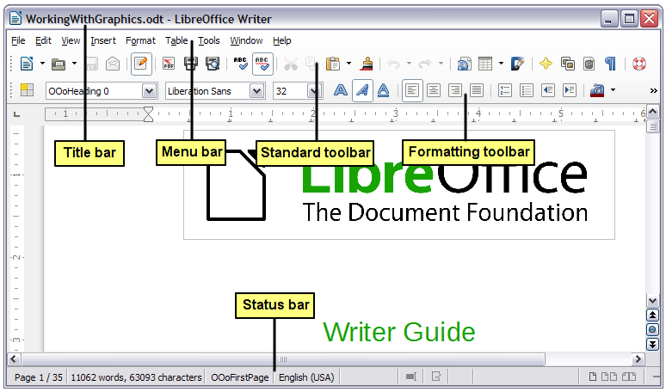
Figure 1: Parts of the main Writer window (without sidebar)

Title bar
The Title bar is located at the top of the Writer window, and shows the file name of the current document. When the document is newly created, the document name will appear as Untitled X, where X is a number.

Menus
The Menu bar is located just below the Title bar. When you select one of the menus, a submenu drops down to show further options such as:
- Executable commands, such as Close or Save, found in the File menu.
- Commands to open dialogs, indicated by the command being followed by an ellipsis (…), such as Find or Paste Special found in the Edit menu.
- Further submenus, indicated by a right-pointing black arrow, such as Toolbars and Zoom found in the View menu. Moving the cursor onto these causes them to open.

Toolbars
Writer displays toolbars in different ways: docked (fixed in place), or floating. Some toolbars have sections which you can tear off. Docked toolbars can be moved to different locations or made to float, and floating toolbars can be docked.
The top docked toolbar, just under the Menu bar, is called the Standard Toolbar. It is consistent across all the LibreOffice applications (Writer, Calc, Draw, Impress).
The second toolbar at the top is context sensitive. For example, when working with text, the Formatting toolbar is displayed. When the cursor is on a graphic (image type), the Graphics toolbar is displayed, and the Pictures toolbar is displayed docked at the bottom of the screen. An additional toolbar (Bullets and Numbering) is displayed next to the Formatting toolbar, when for example, the cursor is in a numbered/bulleted list.

Displaying or hiding toolbars
To display or hide toolbars, choose View > Toolbars, then click on the name of a toolbar in the list. An active toolbar shows a check mark beside its name. Tear-off toolbars are not listed in the View menu.

Submenus and tear-off toolbars
Combination toolbar buttons having a down arrow will display submenus, tear-off toolbars, and other ways of selecting things, depending on the toolbar.
Figure 2 shows a tear-off toolbar from the Drawing toolbar. Once removed from the parent toolbar it displays a title bar.
Tear-off toolbars can be floating or docked along an edge of the screen or in one of the existing toolbar areas. To move a floating tear-off toolbar, drag it by the title bar, as shown in Figure 4.
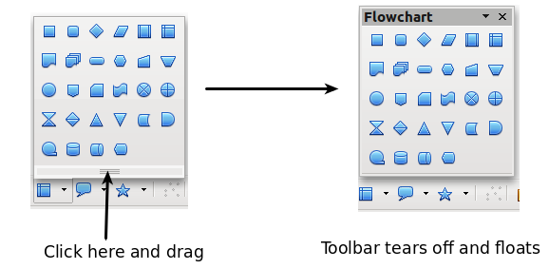
Figure 2: Example of a tear-off toolbar

Moving toolbars
To move a docked toolbar, place the mouse pointer over the toolbar handle (the small vertical bar to the left of the toolbar), hold down the left mouse button, drag the toolbar to the new location, and then release the mouse button.
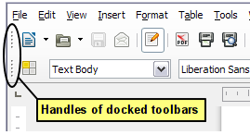
Figure 3: Moving a docked toolbar
To move a floating toolbar, click on its title bar and drag it to a new location.
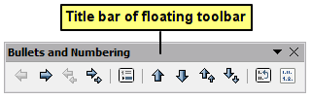
Figure 4: Moving a floating toolbar

Floating toolbars
Some toolbars activated from the View menu may appear as floating toolbars, for example the Insert toolbar. Writer also includes several additional context-sensitive toolbars, whose defaults may appear as floating toolbars in response to the cursor’s current position or selection. You can dock these toolbars to the top, bottom, or side of the window, if you wish (see “Moving toolbars” above).

Docking/floating windows and toolbars
Toolbars and some windows, such as the Navigator and the Styles and Formatting window, are dockable. You can move, resize, or dock them to an edge.
To dock a window or toolbar, hold down Ctrl and double-click on the frame of the floating window (or in a vacant area near the buttons at the top of the floating window) to dock it in its last position.
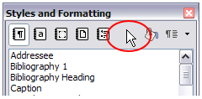
Figure 5: Ctrl+double-click to dock or undock
To undock a window, hold down Ctrl and double-click on the frame (or a vacant area near the buttons at the top) of the docked window.

Docking (AutoHide)
On any window edge where another window is docked you will see a button which allows you to show or hide the window.
- If you click the button on the window edge to show the window, the window will remain visible until you manually hide it again (with the same button).
- If you show the window by clicking the window border, but not the button, you activate the AutoHide function. The AutoHide function allows you to temporarily show a hidden window by clicking on its edge. When you click in the document, the docked window hides again.
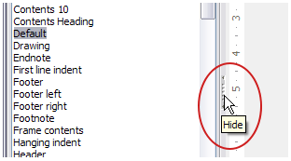
Figure 6: The Hide button
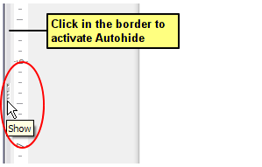
Figure 7: Show button and Autohide

Customizing toolbars
You can customize toolbars in several ways, including choosing which buttons are visible and locking the position of a docked toolbar.
To access a toolbar’s customization options, right-click between the buttons on the toolbar to open a context menu.
The context menu lists the buttons defined for the selected toolbar but not visible on it. To show or hide buttons defined for the selected toolbar, choose Visible Buttons from the context menu. Visible buttons are indicated by being highlighted (Figure 8) or by a check mark beside the button, depending on your operating system. Click on buttons to hide or show them on the toolbar.
You can also add buttons and create new toolbars, as described in Chapter 16, Customizing Writer.
Note | In earlier versions of LibreOffice, these options were accessed by clicking on an arrow at the end of the toolbar. The arrow is still present on floating toolbars, but not on docked ones. However, the arrow has no effect.
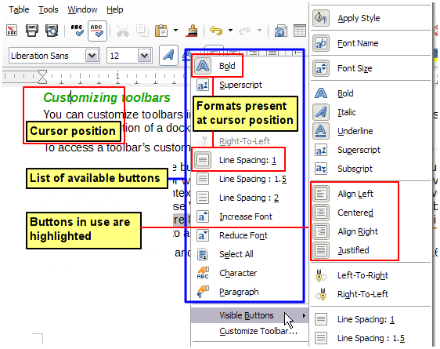
Figure 8: Selection of visible toolbar buttons

Right-click (context) menus
Right-click on a paragraph, graphic, or other object to open a context menu. Often the context menu is the fastest and easiest way to reach a function. If you’re not sure where in the menus or toolbars a function is located, you can often find it by right-clicking.

Rulers
Rulers are enabled by default. To show or hide the rulers, choose View > Ruler. To disable the rulers, choose Tools > Options > LibreOffice Writer > View and deselect either or both rulers. The horizontal ruler has a comments button on its right side to show or hide comments.
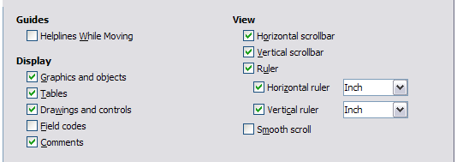
Figure 9: Accessing the ruler settings

Status bar
The Writer status bar is located at the bottom of the workspace. It provides information about the document and convenient ways to quickly change some document features. It can be hidden by deselecting it in the View menu.
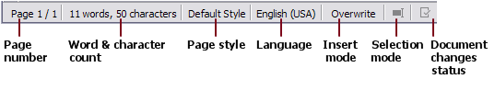
Figure 10: Left end of Status bar
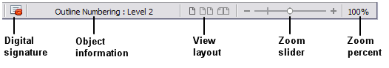
Figure 11: Right end of Status bar
Page number
Shows the current page number, the sequence number of the current page (if different), and the total number of pages in the document. For example, if you restarted page numbering at 1 on the third page, its page number is 1 and its sequence number is 3.
If any bookmarks have been defined in the document, a right-click on this field pops up a list of bookmarks; click on the required one.
To jump to a specific page in the document, double-click on this field. The Navigator opens (see page 24). Click in the Page Number field in the Navigator, type the sequence number of the required page, and press Enter.
Word and character count
The word and character count of the document is shown in the status bar, and is kept up to date as you edit. Any text selected in the document will be counted and this count will replace the displayed count.
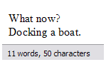 | 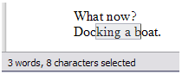
To display extended statistics such as character counts excluding spaces, double-click the word count in the status bar, or choose Tools > Word Count.
Page style
Shows the style of the current page. To change the page style, right-click on this field. A list of page styles pops up; click on one to select a different style.
To edit the current page style, double-click on this field. The Page Style dialog opens. See Chapters 6 and 7 for more information about styles.
Language
Shows the language at the cursor position, or for the selected text, that is used for checking spelling, hyphenation, and thesaurus. Click to open a menu where you can choose another language for the selected text or for the paragraph where the cursor is located. You can also choose None (Do not check spelling) to exclude the text from a spelling check or choose More to open the Character dialog. Any directly formatted language settings can be reset to the default language from this menu. See Chapter 3, Working with Text, for more information.
Insert mode
This area is blank when in Insert mode. Double-click to change to Overwrite mode; single-click to return to Insert mode. In Insert mode, any text after the cursor position moves forward to make room for the text you type; in Overwrite mode, text after the cursor position is replaced by the text you type. This feature is disabled when in Edit > Changes > Record mode.
Selection mode
Click to choose different selection modes. The icon does not change, but when you hover the mouse pointer over this field, a tooltip indicates which mode is active.
When you click in the field, a context menu displays the available options.
Mode | Effect
Standard selection | Click in the text where you want to position the cursor; click in a cell to make it the active cell. Any other selection is then deselected.
Extending selection (F8) | Clicking in the text extends or crops the current selection.
Adding selection (Shift+F8) | A new selection is added to an existing selection. The result is a multiple selection.
Block selection (Ctrl+Shift+F8) | A block of text can be selected.
On Windows systems, you can hold down the Alt key while dragging to select a block of text. You don't need to enter the block selection mode.
See Chapter 3, Working with Text, for more information about these modes.
Document changes status
The icon that is displayed here changes from this one () if the document has no unsaved changes, to this one () if it has been edited and the changes have not been saved.
Digital signature
If the document has been digitally signed, this icon () is displayed here; otherwise, it is blank. To view the certificate, double-click the icon.
Section or object information
When the cursor is in a section, heading, or list item, or when an object (such as a picture or table) is selected, information about that item appears in this field. Double-clicking in this area opens a relevant dialog.
Object | Information shown | Dialog opened
Picture | Size and position | Picture
List item | Level and list style | Bullets and Numbering
Heading | Outline numbering level | Bullets and Numbering1
Table | Name or number and cell reference of cursor | Table Format
Section | Name of section | Edit Sections
Other | (Blank) | Fields
View layout
Click an icon to change between single page, side-by-side, and book layout views (see Figure 12). You can edit the document in any view. Zoom settings (see below and next page) interact with the selected view layout and the window width to determine how many pages are visible in the document window.
Zoom
To change the view magnification, drag the Zoom slider, or click on the + and − signs, or right-click on the zoom level percent to pop up a list of magnification values from which to choose.

Figure 12: View layouts: single, side-by-side, book

Sidebar
To activate the Sidebar, select View > Sidebar from the Menu Bar. The sidebar is located on the right side of the edit view. The sidebar (Figure 13) contains four decks: Properties, Styles and Formatting, Gallery, and Navigator. Each deck has a corresponding icon on the Tab bar to the right of the sidebar, allowing you to switch between them.
Each deck consists of a title bar and one or more content panels. A panel is like a combination of toolbar and dialog. Toolbars and sidebar panels share many functions. For example, the buttons for making text bold or italic exist in both the Formatting toolbar and the Character panel of the Properties deck.
Some panels contain a More button () which when clicked opens a dialog to give greater choice of editing controls.The dialog that opens locks the document for editing until the dialog is closed.
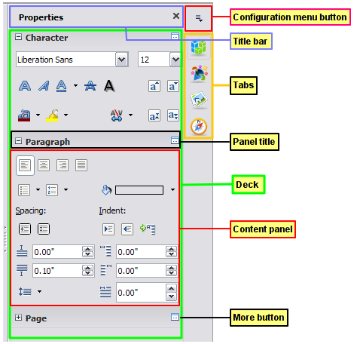
Figure 13: Sidebar Properties deck and text context panels
The decks are described below.
- Properties: Contains tools for direct formatting within the document. The tools are separated into three panels for text editing:
- Character: Modify text by the font type, size, color, weight, style and spacing.
- Paragraph: Style the paragraph by alignment, lists or bullets, background color, indent, and spacing.
- Page: Format the page by orientation, margin, size, and number of columns.
If a graphic is selected, then the following panels open:
- Graphic: Modify the graphic's brightness, contrast, color mode and transparency.
- Position: Modifications to width and height.
- Wrap: Permits wrap modifications where these are available.
If a drawing object is selected, then the following panels are available;
- Area: Fill and transparency edits are available.
- Line: Permits edits to the line style, width, color, arrows, corners and cap styles.
- Position and Size: Enables edits to width, height, rotation and flip attributes.
If a frame is selected, then the wrap panel opens but may be grayed-out if frame wrap is not available.
Caution   | Be aware that by changing the options on the Page panel you will change the page style in use, modifying not only the current page but all pages using the same page style.
- Styles and Formatting: Manage the styles used on the document, applying existing styles, creating new ones or modifying them. This deck is also a floating toolbar that can be accessed from Format > Styles and Formatting from the Menu bar.
- Gallery: Add images and diagrams included in the Gallery themes. The Gallery displays as two sections; the first lists the themes by name (Arrows, Background, Diagrams, etc.) and the second displays the images in the selected category. Select the New Theme button to create new categories. To insert an image, or add a new image to the gallery, drag and drop the selected image. This deck is also a docked toolbar that can be accessed from Tools > Gallery or the Gallery button on the Standard Toolbar.
- Navigator: Browse the document and reorganize its content by selecting different content categories, such as headings, tables, frames, graphics, etc. The Sidebar Navigator does not contain a List Box On/Off button. This deck is also a floating toolbar that can be accessed from View > Navigator or the Navigator button on the Standard Toolbar.
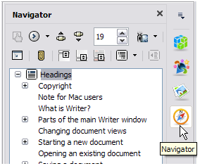
Figure 14: The Navigator deck
The Sidebar has on its left edge a Hide button (see Figure 15); click this button to hide the panel by collapsing it to the right edge of the window. Click the button on a collapsed panel to reopen it.
To adjust the width of the panel, place the cursor on the left edge of the panel, click and drag to right or left depending on the starting width. With the Properties deck selected, you cannot drag to less than a certain width. With any of the other decks selected, you can drag the panel width to a minimum useable width; an arrow then indicates that when you release the mouse button, the Sidebar will collapse to the width of the Tab bar (see Figure 16).
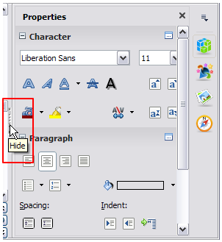
Figure 15: Sidebar Hide button
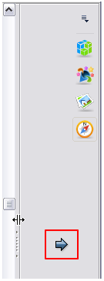
Figure 16: Panel dragged past minimum useable width showing arrow

Changing document views
Writer has three ways to view a document: Print Layout, Web Layout, and Full Screen. To change the view, go to the View menu and click on the required view.
Print Layout is the default view in Writer. In this view, you can use the Zoom slider and the View Layout icons on the Status bar to change the magnification.
You can also choose View > Zoom > Zoom from the Menu bar to display the Zoom & View Layout dialog, where you can set the same options as on the Status bar.
In Web Layout view, you can use only the Zoom slider; the View Layout buttons on the Status bar are disabled, and most of the choices on the Zoom & View Layout dialog are not available.
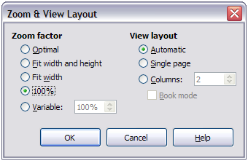
Figure 17: Choosing Zoom and View Layout options
In Full Screen view, the document is displayed using the zoom and layout settings previously selected. To exit Full Screen view and return to either Print or Web Layout view, press the Esc key or toggle the Full Screen button on the floating toolbar in the top left-hand corner. You can also use Ctrl+Shift+J to enter or exit Full Screen view.

Starting a new document
You can start a new, blank document in Writer in several ways. If a document is already open in LibreOffice, the new document opens in a new window.

From the Start Center
When LibreOffice is open but no document is open, the Start Center is shown. Click the Create: Writer Document button to create a new text document, or click the Templates button to start a new document using a template.
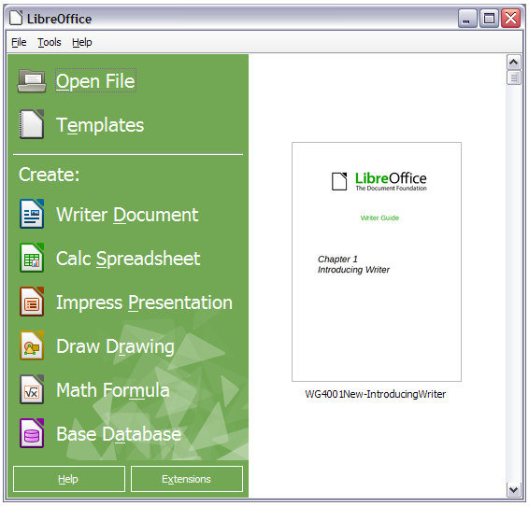
Figure 18: LibreOffice Start Center

From the Quickstarter
When LibreOffice is installed on computers running Windows or Linux, a Quickstarter feature may also be installed. Computers with a Mac operating system do not have a Quickstarter.
The Quickstarter is an icon that is placed in the system tray during system startup. It indicates that LibreOffice has been loaded and is ready to use. The Quickstarter must be enabled in Tools > Options > LibreOffice > Memory by selecting the checkbox.
Right-click the Quickstarter icon (Figure 19) in the system tray to open a pop-up menu from which you can create a new document, or open the Template Manager dialog. You can also double-click the Quickstarter icon to display the Template Manager dialog.
See Chapter 1, Introducing LibreOffice, in the Getting Started guide for more information about starting Writer and using the Quickstarter.
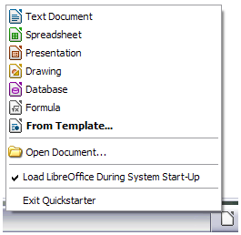
Figure 19: Quickstarter pop-up menu

From the operating system menu
You can open the LibreOffice Start Center or the Writer component from the operating system menu in the same way that you start other programs. When LibreOffice was installed on your computer, in most cases a menu entry for each component was added to your system menu. If you are using a Mac, you should see the LibreOffice icon in the Applications folder. When you double-click this icon, LibreOffice opens at the Start Center (Figure 18).

From the menu bar, toolbar, or keyboard
When LibreOffice is open, you can also start a new document in one of the following ways.
- Press the Ctrl+N keys.
- Use File > New > Text Document.
- Click the New button on the Standard Toolbar.

From a template
You can use templates to create new documents in Writer. A template is a set of predefined styles and formatting. Templates serve as the foundation of a set of documents, to make sure they all have a similar layout. For example, all the documents of the Writer Guide are based on the same template. As a result, all the documents look alike; they have the same headers and footers, use the same fonts, and so on.
A new LibreOffice installation does not contain many templates. It is possible for you to add new templates to your installation and use them for new documents. This is explained in Chapter 10, Working with Templates. More templates can be downloaded from http://templates.libreoffice.org/ and other websites.
Once you have templates on your system, you can create new documents based on them by using File > Templates > Manage (Ctrl+Shift+N), File > New > Templates or click the arrow button next to the New Document button on the Standard Toolbar and select Templates from the drop-down list. This opens the Template Manager dialog where you can choose the template you want to use for your document.
The example shown in Figure 20 uses a template in the Documents > My Templates folder. Double-click on the required template. A new document is created based on the styles and formats defined in the template.
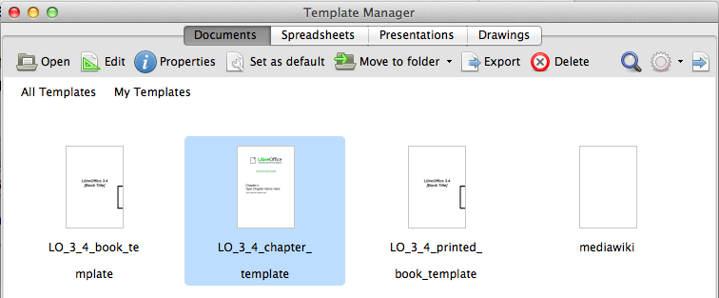
Figure 20: Creating a document from a template

Opening an existing document
When no document is open, the Start Center (Figure 18) provides an Open File button for navigating to saved files. It also displays, in the right pane, recently opened documents; click one to open it.
You can also open an existing document in one of the following ways. If a document is already open in LibreOffice, the second document opens in a new window.
- Choose File > Open.
- Click the Open button on the Standard Toolbar.
- Click the down-arrow on the Open button on the Standard Toolbar to select a recent document.
- Press Ctrl+O on the keyboard.
- Use File > Recent Documents to make a selection.
- Use Open Document on the Quickstarter.
Except for the selection of recent documents, the actions above launch the Open dialog. Select the file you want, filtering by version if required and available, and then click Open. If a document is already open in LibreOffice, the second document opens in a new window.
In the Open dialog, you can reduce the list of files by selecting the type of file you are looking for. For example, if you choose Text documents as the file type, you will only see documents Writer can open (including ODT, DOC, TXT). This method opens Word (DOC and DOCX) files as well as LibreOffice files and other formats.
You can also open an existing Writer document using the same methods you would use to open any document in your operating system.
If you have associated Microsoft Office file formats with LibreOffice, you can also open these files by double-clicking on them.

Saving a document
To save a new document in Writer, do one of the following:
- Press Ctrl+S.
- Choose File > Save.
- Click the Save button on the Standard Toolbar.
When the Save As dialog appears, enter the file name, verify the file type, and click Save.
To save an opened document with the current file name, select one of the above options. This will overwrite the last saved state of the file.
To save an opened document with a different file name in order to preserve the original and have edits saved in another version, choose File > Save As, give it another name and/or select a different file type. A document can be saved with the same file name if the file type is changed, but must have a different name if the same file type is retained. File > Save a Copy behaves in a similar fashion.

Saving a document automatically
You can choose to have Writer save your document automatically in a temporary file at regular intervals. Automatic saving, like manual saving, overwrites the last saved state of the target file in the temporary file. To set up automatic file saving:
- Select Tools > Options > Load/Save > General.
- Click on Save AutoRecovery information every and set the time interval. The default value is 15 minutes. Enter the value you want by typing it or by pressing the up or down arrow keys.

Saving as a Microsoft Word document
If you need to exchange files with users of Microsoft Word who are unwilling or unable to receive Open Document Format (ODF) files, you can save a document as a Microsoft Word file.
- Important—First save your document in the file format used by LibreOffice Writer, ODT. If you do not, any changes you made since the last time you saved will only appear in the Microsoft Word version of the document.
- Then click File > Save As.
- On the Save As dialog, in the File type (or Save as type) drop-down menu, select the type of Word format you need. You may also choose to change the file name.
- Click Save.
From this point on, all changes you make to the document will occur only in the new (Microsoft Word) document. You have changed the name and file type of your document. If you want to go back to working with the ODT version of your document, you must open it again.
Tip | To have Writer save documents by default in the Microsoft Word file format, go to Tools > Options > Load/Save > General. In the section named Default file format and ODF settings, under Document type, select Text document, then under Always save as, select your preferred file format.
Caution | It is recommended that if you use a Microsoft Word format, you use the DOC and not the DOCX (XML) format. There is anecdotal evidence that the DOCX format experiences problems even within native Microsoft applications. Saving in ODF format gives you the option to redo the document if the recipient of your document experiences trouble with the Microsoft format.
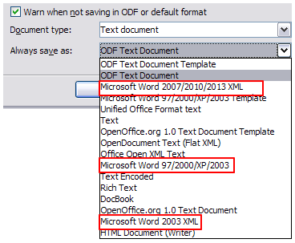
Figure 21: Saving a file in Microsoft Word format

Password protection
Writer provides two levels of document protection: read-protect (file cannot be viewed without a password) and write-protect (file can be viewed in read-only mode but cannot be changed without a password). Thus you can make the content available for reading by a selected group of people and for reading and editing by a different group. This behavior is compatible with Microsoft Word file protection.
- Use File > Save As when saving the document. (You can also use File > Save the first time you save a new document.)
- On the Save As dialog, select the Save with password option, and then click Save.
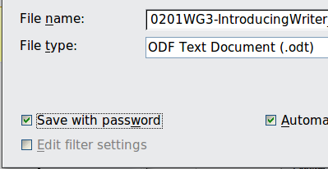
- The Set Password dialog opens.
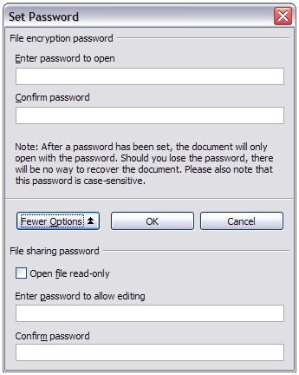
Figure 22: Two levels of password protection
Here you have several choices:
  - To read-protect the document, type a password in the two fields at the top of the dialog.
  - To write-protect the document, click the More Options button and select the Open file read-only checkbox.
  - To write-protect the document but allow selected people to edit it, select the Open file read-only checkbox and type a password in the two boxes at the bottom of the dialog.
- Click OK to save the file. If either pair of passwords do not match, you receive an error message. Close the message box to return to the Set Password dialog and enter the password again.
In LibreOffice 3.5, a different encryption was introduced to replace the previously used one. In consequence, files encrypted with LibreOffice 3.5 or later can not be opened by earlier versions of LibreOffice. Files with the old encryption can be used in LibreOffice 3.5 and later.
Caution | LibreOffice uses a very strong encryption mechanism that makes it almost impossible to recover the contents of a document if you lose the password.

Changing the password for a document
When a document is password-protected, you can change the password while the document is open. Choose File > Properties > General and click the Change Password button.

Closing a document
If only one document is open and you want to close that document, go to File > Close on the Menu bar or click on the X on the Title bar. The X may be located on either the right or left end of the Title bar.
If more than one document is open and you want to close one of them, go to File > Close on the Menu bar or click on the X on the Menu bar of that document’s window. When only the last document is open, the X on the Menu bar disappears.
If the document has not been saved since the last change, a message box is displayed. Choose whether to save or discard your changes.

Closing LibreOffice
To close LibreOffice completely, go to File > Exit on the menu bar in Windows and Linux operating systems. In a Mac operating system, go to LibreOffice > Quit LibreOffice on the menu bar.
When you close the last document using the X on the Title bar of the window, then LibreOffice will close completely. A Mac operating system does not have this function; instead, you need to go to LibreOffice > Quit LibreOffice on the menu bar.
You can also use a keyboard shortcut as follows:
- In Windows and Linux – Ctrl+Q
- In Mac OS X – Command ⌘+Q
If any documents have not been saved since the last change, a message box is displayed. Choose whether to save or discard your changes.

Using the Navigator
In addition to the Page Number field on the Status bar (described on page 11), Writer provides other ways to move quickly through a document and find specific items by using the many features of the Navigator, the Navigation toolbar, and related buttons.
The Navigator lists all of the headings, tables, text frames, graphics, bookmarks, and other objects contained in a document.
To open the Navigator do one of the following;
- Click its button () on the Standard Toolbar.
- Press F5.
- Choose View > Navigator on the Menu bar.
- Double-click on the Page number field on the status bar.
- Click the Navigator tab () on the Sidebar (View > Sidebar to open it).
You can dock the Navigator to either side of the main Writer window or leave it floating, even from the Sidebar, (see “Docking/floating windows and toolbars” on page 8).
To hide the list of categories and show only the buttons at the top, click the List Box On/Off button (). Click this button again to show the list. The Sidebar Navigator does not have this button. Click the + sign or triangle by any of the lists to display the contents of the list.
Table 1 summarizes the functions of the buttons at the top of the Navigator.
Note | The Navigator has different functions in a master document. See Chapter 13, Working with Master Documents.
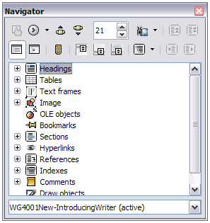
Figure 23: The Navigator
Table 1: Function of buttons in the Navigator
 | Toggle: Not active in ordinary documents (left image). In a master document (right image), switches between the master document file and its subdocuments.
 | Navigation: Opens the Navigation toolbar (see page 26).
 | Previous, Next: Jumps to the previous or next item in the selected category (page, graphic, hyperlink, comment, and so on). To select the category of items, see “Using the Navigation toolbar“ on page 26.
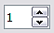 | Page number: Jumps to the page sequence number showing in the box. Type the required page number or select it using the up and down arrows.
 | Drag Mode: Select Hyperlink, Link, or Copy. See “Choosing drag mode” on page 28 for details.
 | List Box On/Off: Shows or hides the list of categories. (Not Sidebar).
 | Content View: Switches between showing all categories and showing only the selected category.
 | Set Reminder: Inserts a reminder (see page 28).
 | Header/Footer: Jumps between the text area and the header or footer area (if the page has them).
 | Anchor <–> Text: Jumps between a footnote anchor and the corresponding footnote text.
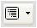 | Heading Levels Shown: Choose the number of heading levels to be shown.

Moving quickly through a document
The Navigator provides several convenient ways to move around a document and find items in it:
- To jump to a specific page in the document, type its sequence number in the box at the top of the Navigator and press Enter. The sequence number may be different from the page number if you have restarted numbering at any point.
- When a category is showing the list of items in it, double-click on an item to jump directly to that item’s location in the document. For example, you can jump directly to a selected heading, graphic, or comment by using this method.
To see the content in only one category, highlight that category and click the Content View button. Click the button again to display all the categories. You can also change the number of heading levels shown when viewing Headings.
- Use the Previous and Next buttons to jump to other objects of the type selected in the Navigation toolbar. (See next page for details.)
Note | A hidden section (or other hidden object) in a document appears gray in the Navigator, and displays the word “hidden” as a tooltip. For more about hidden sections, see Chapter 4, Formatting Pages.
Tip | Objects are much easier to find if you have given them names when creating them, instead of keeping LibreOffice’s default names of graphics1, graphics2, Table1, Table2, and so on—which may not correspond to the position of the object in the document.  To rename an image, right-click on the image, select Picture > Options, and then edit the name in the dialog. Similarly, to rename a table, right-click on the table, select Table > Table, and then edit the name.

Using the Navigation toolbar
To display the Navigation toolbar (Figure 24), click the Navigation button (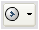) (second button from the left at the top of the Navigator, Figure 23) or the small Navigation button near the lower right-hand corner of the document window below the vertical scroll bar (Figure 25).
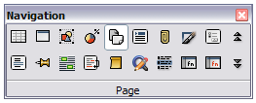
Figure 24: Navigation toolbar
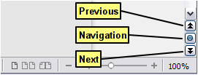
Figure 25: Previous, Navigation, and Next buttons
The Navigation toolbar has buttons for all the object types shown in the Navigator, plus some extras (for example, the results of a Find command).
Click a button to select that object type. Now all the Previous and Next buttons (in the Navigator itself, in the Navigation toolbar, and on the scroll bar) will jump to the previous or next object of the selected type. This is particularly helpful for finding items like index entries, which can be difficult to see in the text. The names of the buttons (shown in the tooltips) change to match the selected category; for example, Next Graphic, Next Bookmark, or Continue search forward.

Rearranging chapters using the Navigator
You can rearrange chapters and move headings in the document by using the Navigator.
- Click the Content View button to expand the headings, if necessary.
- (Optional) If you have several subheading levels, you can more easily find the headings you want, by changing the Heading Levels Shown selection to show only 1 or 2 levels of headings.
- Click on the heading of the block of text that you want to move and drag the heading to a new location on the Navigator, or click the heading in the Navigator list, and then click either the Promote Chapter or Demote Chapter button. All of the text and subsections under the selected heading move with it.
To move only the selected heading and not the text associated with the heading, hold down Ctrl, and then click the Promote or Demote button.
Tip | The tooltips Promote Chapter and Demote Chapter can be misleading; all headings—whether at Level 1 (chapter) or lower—can be rearranged using this function; and the feature might be better described as Move Up or Move Down (within the document, without changing the heading level) to distinguish it more clearly from Promote Level and Demote Level, which change the heading level within the document (see below).
- To quickly change the outline level of a heading and its associated subheadings, select the heading in the Navigator, and then click either the Promote Level or Demote Level button. This action does not change the location of the heading, only its level.
To increase the outline level of only the selected heading, but not its associated subheadings, hold down Ctrl, and then click the button.
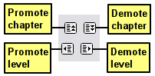
Figure 26: Reorganizing with the Navigator
Note | Users of Microsoft Word will note the similarity between this functionality and Word's Outline View.

Setting reminders
One of the little-known features of Writer that you may find quite useful is the possibility of jumping between reminders. Reminders let you mark places in your document that you want to return to later on, to add or correct information, make some other change, or simply mark where you finished editing. The possible uses of reminders are limited only by your imagination.
To set a reminder at the cursor's current location, click on the () button in the Navigator. You can set up to 5 reminders in a document; setting a sixth causes the first to be deleted.
Reminders are not highlighted in any way in the document, so you cannot see where they are, except when you jump from one to the next—the location of the cursor then shows the location of the reminder.
To jump between reminders, first select the Reminder button on the Navigation toolbar. Then click the Previous and Next buttons. Reminders are not saved with the document.

Choosing drag mode
To select the drag and drop options for inserting items such as other documents and images, into a document using the Navigator, choose one of the following from the drop-down menu of the Drag Mode button.
Insert As Hyperlink
Creates a hyperlink when you drag and drop an item into the current document.
Insert As Link
Inserts the selected item as a link where you drag and drop in the current document. Text is inserted as protected sections. However, you cannot create links for graphics, OLE objects, references, or indexes using this method.
Insert As Copy
Inserts a copy of the selected item where you drag and drop in the current document. You cannot drag and drop copies of graphics, OLE objects, or indexes.

Undoing and redoing changes
When a document is open, you can undo the most recent change by pressing Ctrl+Z, or clicking the Undo button () on the Standard Toolbar, or choosing Edit > Undo from the Menu bar.
The Edit menu shows the latest changes that can be undone.
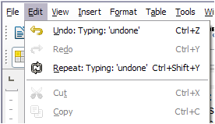
Figure 27: Edit > Undo last action
Click the down arrow button of the Undo combination button to get a list of all the changes that can be undone. You can select multiple changes and undo them at the same time (see Figure 28).
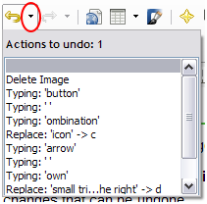
Figure 28: List of actions that can be undone
After changes have been undone, Redo becomes active. To redo a change, select Edit > Redo, or press Ctrl+Y or click on the Redo button (). As with Undo, click on the down arrow button of the combination button to get a list of the changes that can be restored.

If a list style was used with a list item or heading, no dialog appears.

