
Calc Guide
Chapter 6
Printing, Exporting, and E-mailing

Copyright
This document is Copyright © 2005–2013 by its contributors as listed below. You may distribute it and/or modify it under the terms of either the GNU General Public License (http://www.gnu.org/licenses/gpl.html), version 3 or later, or the Creative Commons Attribution License (http://creativecommons.org/licenses/by/3.0/), version 3.0 or later.
All trademarks within this guide belong to their legitimate owners.

Contributors
Barbara Duprey
Jean Hollis Weber
John A Smith
Christian Chenal
Martin Saffron

Feedback
Please direct any comments or suggestions about this document to: documentation@global.libreoffice.org

Acknowledgments
This chapter is adapted and updated from Chapter 6 of the OpenOffice.org 3.3 Calc Guide. The contributors to that chapter are:
Jean Hollis Weber Emma Kirsopp Peter Kupfer
Shelagh Manton Kashmira Patel Linda Worthington

Publication date and software version
Published 24 November 2013. Based on LibreOffice 4.1.2.

Note for Mac users
Some keystrokes and menu items are different on a Mac from those used in Windows and Linux. The table below gives some common substitutions for the instructions in this chapter. For a more detailed list, see the application Help.
Windows or Linux | Mac equivalent | Effect
Tools > Options menu selection | LibreOffice > Preferences | Access setup options
Right-click | Control+click | Opens a context menu
Ctrl (Control) | ⌘ (Command) | Used with other keys
F5 | Shift+⌘+F5 | Opens the Navigator
F11 | ⌘+T | Opens the Styles and Formatting window

Contents
Copyright 2
Contributors 2
Feedback 2
Acknowledgments 2
Publication date and software version 2
Note for Mac users 2
Quick printing 5
Controlling printing 5
Selecting general printing options 6
Printing multiple pages on a single sheet of paper 6
Selecting sheets to print 7
Using print ranges 8
Defining a print range 8
Adding to the print range 8
Removing print ranges 8
Editing a print range 9
Viewing print ranges 10
Printing rows or columns on every page 11
Defining a named print range 11
Deleting a named print range 12
Page breaks 12
Inserting a page break 12
Row break 13
Column break 13
Deleting a page break 13
Removing multiple page breaks 13
Printing options setup in page styles 13
Headers and footers 15
Setting a header or a footer 15
Header or footer appearance 16
Setting the contents of the header or footer 16
Exporting to PDF 17
Quick export to PDF 17
Controlling PDF content and quality 18
General page of PDF Options dialog 18
Initial View page of PDF Options dialog 19
User Interface page of PDF Options dialog 20
Links page of PDF Options dialog 21
Security page of PDF Options dialog 21
Exporting to other formats 22
Exporting to XHTML 22
E-mailing spreadsheets 22
E-mailing a spreadsheet to several recipients 23
Digital signing of documents 23
Removing personal data 24

Quick printing
Click the Print File Directly icon to send the entire document to the default printer defined for your computer.
Note | You can change the action of the Print File Directly icon, to send the document to the printer defined for the document, instead of the default printer for the computer. Choose Tools > Options > Load/Save > General and select the Load printer settings with the document option.

Controlling printing
For more control over printing, use the Print dialog (File > Print or Ctrl+P).
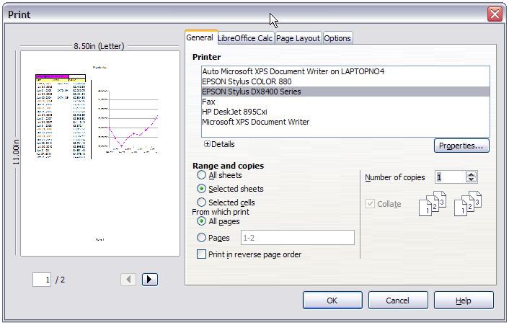
Figure 1. The Print dialog
The Print dialog has four tabs, from which you can choose a range of options, as described in the following sections.
Note | The options selected on the Print dialog apply to this printing of this document only.  To specify default printing settings for LibreOffice, go to Tools > Options > LibreOffice – Print and Tools > Options > LibreOffice Calc – Print. For details, see Chapter 14 Setting Up and Customizing Calc.

Selecting general printing options
On the General tab of the Print dialog (Figure 1), you can choose:
- The printer (from the printers available)
- Which sheets and pages to print, the number of copies to print, whether to print in reverse page order and whether to collate multiple copies (Range and copies section)
Click the Properties button to display a printer-specific dialog where you can choose portrait or landscape orientation, which paper tray to use, and the paper size to print on.
To print a range of pages, separate the range with a hyphen; for example, enter 3-6 to print pages 3 to 6. To print single pages, use a semi-colon to separate the pages; for example, enter 7;9;11 to print pages 7, 9, and 11. You can also print a combination of page ranges and single pages by combining these methods; for example, enter 3-6;8;10;12 to print pages 3, 4, 5, 6, 8, 10, and 12.
On the Options tab of the Print dialog (Figure 2), you can choose to print to a file (instead of to a printer) and to create a single print job containing several copies of the document (instead of a separate print job for each copy).
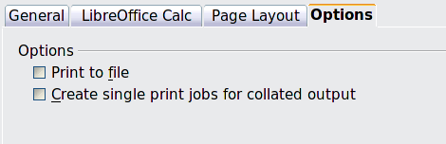
Figure 2: General print options

Printing multiple pages on a single sheet of paper
You can print multiple pages of a document on one sheet of paper. To do this:
- In the Print dialog, select the Page Layout tab (Figure 3).
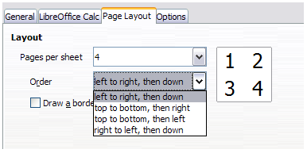
Figure 3: Printing multiple page per sheet of paper
- In the Layout section, select the number of pages to print per sheet. The preview panel on the left of the Print dialog shows how the printed document will look.
When printing more than 2 pages per sheet, you can choose the order in which they are printed across and down the paper. The pictures above and below show the difference.
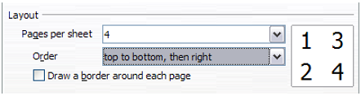
- You can choose to draw a border around each page.
- In the From which print choices on the General tab (Figure 4), select whether to print all pages or only some pages.
- Click the OK button to print.

Selecting sheets to print
In addition to printing a full document, you can choose to print individual sheets, ranges of sheets, or a selection of cells in a document.
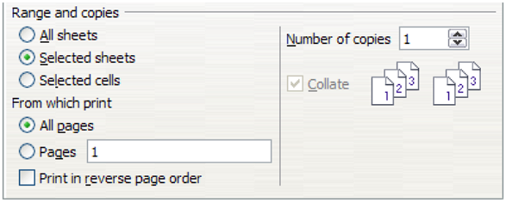
Figure 4: Choosing what to print in Calc
Printing an individual sheet:
- In the spreadsheet, click on the sheet tab to select the sheet you want to print.
- Choose File > Print from the menu bar.
- In the Ranges and copies section of the Print dialog, choose the Selected sheets option.
- Click the OK button.
Printing a range of sheets:
- In the spreadsheet, select the sheets to print.
  - Select the first sheet.
  - Hold down the Ctrl key.
  - Click on the additional sheet tabs.
  - Release the Ctrl key when all required sheets are selected.
- Choose File > Print from the menu bar.
- In the Ranges and copies section of the Print dialog, choose the Selected sheets option.
- Click the OK button.
Printing a selection of cells:
- In the document, select the section of cells to print.
- Choose File > Print from the menu.
- In the Ranges and copies section of the Print dialog, select the Selected cells option.
- Click the OK button.
The Print in reverse page order option can be selected with any of the above options.
Caution   | After printing, be sure to deselect the extra sheets. If you keep them selected, the next time you enter data on one sheet, you enter data on all the selected sheets. This might not be what you want.

Using print ranges
Print ranges have several uses, including printing only a specific part of the data or printing selected rows or columns on every page.

Defining a print range
To set a user-defined print range, which will replace any existing defined print range:
- Highlight the range of cells that are to comprise the print range.
- Choose Format > Print Ranges > Define from the menu bar.
The automatic page break lines are then displayed on the screen.
Tip | You can check the print range by using File > Page Preview in the menu bar, or by clicking the Page Preview icon in the Standard toolbar. Calc will only display the cells in the print range.  You can also use the View > Page break preview mode to see the print range without going to the page preview. See “Viewing print ranges” on page 10.

Adding to the print range
After defining a print range, you can add more cells to it. This allows multiple, separate areas of the same sheet to be printed, while not printing the whole sheet. After you have defined a print range:
- Highlight the range of cells to be added to the print range.
- Choose Format > Print Ranges > Add from the menu bar. This adds the extra cells to the print range.
The page break lines display on the screen around this new addition.
Note | The additional print range will print as a separate page, even if both ranges are on the same sheet.

Removing print ranges
It may become necessary to remove a user-defined print range, for example if the whole sheet needs to be printed later, or you no longer wish to print some of the added ranges.
Choose Format > Print Ranges > Remove from the menu bar. This removes all defined print ranges on the sheet, except those in named ranges. After the print range is removed, the default page break lines will appear on the screen.
To remove only certain print ranges, see “Editing a print range” below.

Editing a print range
At any time, you can directly edit the print range, for example to add to, remove, or resize part of the print range. Choose Format > Print Ranges > Edit from the menu bar. If you have already selected a print range, the Edit Print Ranges dialog looks something like Figure 5.
In this example, three rectangles are selected, each separated by a comma. The first is bounded by cell A3 ($A$3) in the top left and cell C9 ($C$9) in the bottom right corner. The others being D12:F23 and H24:I25.
If only a single range is defined, then clicking anywhere in the text entry box shows the selected print range on the screen, bounded in blue, as shown in Figure 6.
To directly add new cells to the print range:
- Type a comma in the text box as the separator for the ranges.
- Select the cell range using the mouse cursor, or directly type in the cell references using the format of the selection already in the text box. Remember to separate the cell references with a colon.
To remove a print range, select the range in the text box and delete it. Make sure the remaining ranges only have a single comma as a separator and that there is not a comma at the end of the sequence.
To resize a print range, edit the data in the text box for the range.
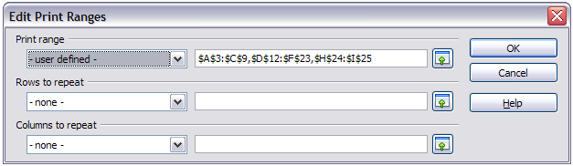
Figure 5: Edit a print range
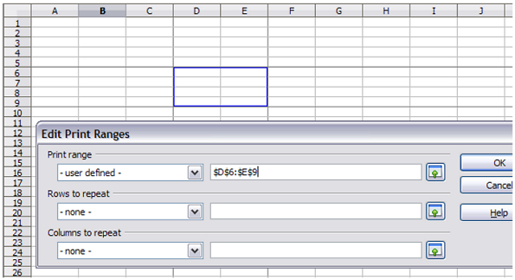
Figure 6: Print range marked by colored box; page break lines visible around the selection

Viewing print ranges
Because defined print ranges are formatted with automatic page breaks, they can be viewed by using the Page Break Preview screen, select View > Page Break Preview from the menu bar.
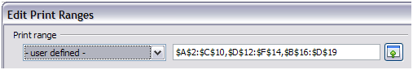Figure 7: The defined print range
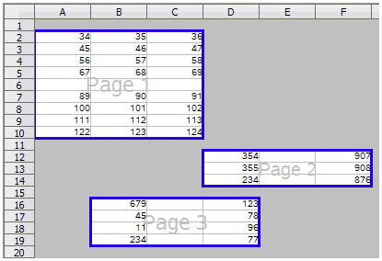Figure 8: The preview screen for the defined print range.
The print ranges are outlined by default with a blue border, and contain a centered page number in gray. The nonprinting area has a gray background.
To exit the Page Break Preview screen, select View > Normal from the menu bar.

Printing rows or columns on every page
If a sheet is printed on multiple pages, you can set up certain rows or columns to repeat on each printed page.
For example, if the top two rows of the sheet as well as column A need to be printed on all pages, do the following:
- Choose Format > Print Ranges > Edit from the menu bar. On the Edit Print Ranges dialog, type the rows in the text entry box under Rows to repeat. For example, to repeat rows 1, 2 and 3, type $1:$3. This automatically changes Rows to repeat from - none - to - user defined -.
- To repeat columns, type the columns in the text entry box under Columns to repeat. For example, to repeat column A, type $A. This automatically changes Columns to repeat from - none - to - user defined -.
- Click OK.
Note | You can also use the mouse to select the rows or columns to repeat. To do this, click the corresponding text entry box and select the desired cell range in the sheet. You do not need to select the entire range of the rows to be repeated; simply select one cell in each row.
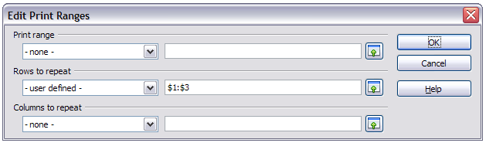
Figure 9: Specifying repeating rows
Rows to repeat and Columns to repeat can also be defined as named ranges using the method described below, but by selecting Repeat column or Repeat row, instead of selecting Print range (see Figure 10). These may then be selected from the list box entries in the Edit Print Ranges dialog shown in Figure 9.

Defining a named print range
In addition to highlighting a print range for each print job, you can define a range of cells to be used repeatedly. This may be useful if different areas of a large spreadsheet need to be printed for different reports. Several named print ranges can be defined to meet this need.
- To define a named print range, highlight the cells you want to define as a print range and select Insert > Names > Define from the menu bar, to open the Define Names dialog (Figure 10). Alternatively the cells can be highlighted after opening the Define Names dialog.
- Type a name for the range in the Name box. The name of the range cannot contain any spaces.
- Edit or set the cell selection range for the print range in the Range box if needed.
- Ensure Document (Global) is selected in the Scope box.
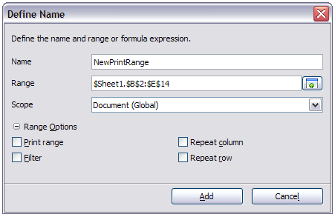
Figure 10: Define Names dialog
- Click the plus symbol by Range Options to show more choices. Select the Print range option to define the settings as a print range. Click the Add button to accept the data and close the dialog.
To select this range to print:
- Choose Format > Print Ranges > Edit from the menu bar (Figure 5). The previously defined name now appears in the Print range list box.
- Select the defined print range and click OK.
This method can be useful to quickly change the print range without highlighting a large area of cells every time.

Deleting a named print range
To delete a named print range if it is no longer required:
- Select Insert > Names > Manage from the menu bar or use Ctrl+F3.
- In the Manage Names dialog which opens, select the named range you want to delete.
- Click the Delete button.
- Click OK to close the dialog.
You can click the Range Options button in the Manage Names dialog to confirm that the selected name is a print range before clicking Delete.

Page breaks
While defining a print range can be a powerful tool, it may sometimes be necessary to manually adjust Calc’s printout. To do this, you can use a manual break. A manual break helps to ensure that your data prints properly.
You can insert a horizontal page break above, or a vertical page break to the left of, the active cell.

Inserting a page break
To insert a page break:
- Navigate to the cell where the page break will begin.
- Select Insert > Page Break from the menu bar.
- Select Row Break or Column Break depending on your need.
The break is now set.

Row break
Selecting Row Break creates a page break above the selected cell. For example, if the active cell is H15, then the break is created between rows 14 and 15.

Column break
Selecting Column Break creates a page break to the left of the selected cell. For example, if the active cell is H15, then the break is created between columns G and H.
Tip | To see page break lines more easily on screen, you can change their color. Choose Tools > Options > LibreOffice > Appearance and scroll down to the Spreadsheet section.

Deleting a page break
To remove a page break:
- Navigate to a cell that is next to the break you want to remove.
- Select Edit > Delete Manual Break.
- Select Row Break or Column Break depending on your need.
The break is removed.

Removing multiple page breaks
Multiple manual row and column breaks can exist on the same page. When you want to remove all of them, do as follows:
- On the menu bar, select View > Page Break Preview.
- Right-click in the document and select Delete All Manual Breaks from the context menu.
All manual breaks are removed.
- Select View > Normal to return to the standard document view.

Printing options setup in page styles
Several printing options are set in the page style for sheets. These include the page order, details, and scale to be printed, Because these options are set in the page style, different page styles can be set up to quickly change the print properties of the sheets in the spreadsheet. See Chapter 4 Using Styles and Templates in Calc for more about page styles.
The Sheet tab of the Page Style dialog (Figure 11) provides the following options.
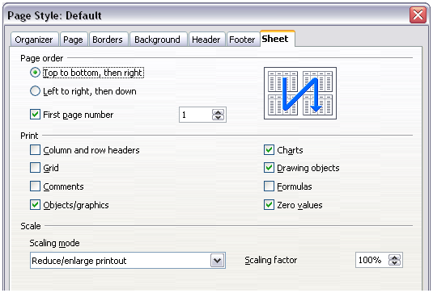
Figure 11. The Sheet tab of the Page Style dialog
Page Order
You can set the order in which pages print. This is especially useful in a large document; for example, controlling the print order can save time if you have to collate the document a certain way.
Where a sheet prints to more than one piece of paper, it can be printed either by column, where the first column of pages prints, and then the second column and so on, or by row as shown in the graphic on the top right of the dialog in Figure 11.
Print
You can specify which details to print. These details include:
  - Row and column headers
  - Sheet grid—prints the borders of the cells as a grid
  - Comments—prints the comments defined in your spreadsheet on a separate page, along with the corresponding cell reference
  - Objects and graphics
  - Charts
  - Drawing objects
  - Formulas—prints the formulas contained in the cells, instead of the results
  - Zero values—prints cells with a zero value
Scale
Use the scale features to control the number of pages the data will print on.
  - Reduce/Enlarge printout—scales the data in the printout either larger or smaller. For example, if a sheet would normally print out as four pages (two high and two wide), a scaling of 50% would print as one page (both width and height are halved).
  - Fit print range(s) on number of pages—defines exactly how many pages the printout will take up. This option will only reduce a printout; it will not enlarge it. To enlarge a printout, the reduce/enlarge option must be used.
  - Fit print range(s) to width/height—defines how high and wide the printout will be, in number of pages.

Headers and footers
Headers and footers are predefined pieces of text that are printed at the top or bottom of a sheet outside of the sheet area. Headers are set the same way as footers.
You can choose to have different content on left and right pages of the same page style.
Headers and footers are assigned to a page style. You can define more than one page style for a spreadsheet and assign different page styles to different sheets. For more about page styles, see Chapter 4.

Setting a header or a footer
To set a header or footer:
- Navigate to the sheet for which you want to set the header or footer. Select Format > Page from the menu bar.
- Select the Header (or Footer) tab.
- Select the Header on option.
- Make other selections according to your requirements, using the More button to reveal other options. Click OK.
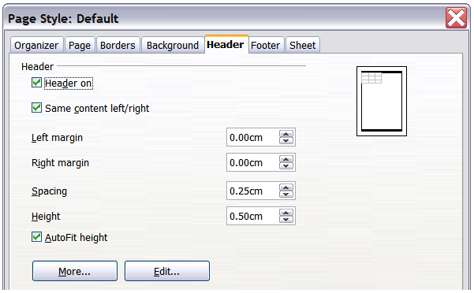
Figure 12: Header dialog
You can set the margins, the spacing, and height for the header or footer. To automatically adjust the height of the header or footer, select the AutoFit height box. You can also select to have different content for left and right pages.
Margin
Changing the size of the left or right margin adjusts how far the header or footer is from that side of the page.
Spacing
Spacing affects how far above or below the sheet the header or footer will print. So, if spacing is set to 1.00", then there will be 1 inch between the header or footer and the sheet.
Height
Height affects how big the header or footer will be.

Header or footer appearance
To change the appearance of the header or footer, click the More button in the dialog. This opens the Border/Background dialog.
From this dialog you can set the background and border style of the header or footer. See Chapter 4 Using Styles and Templates in Calc for more information.
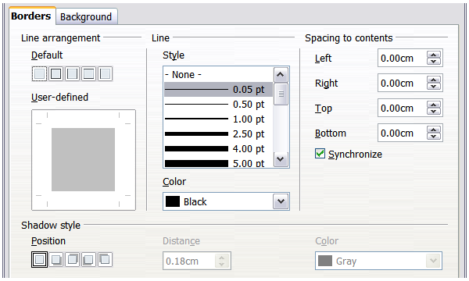
Figure 13: Header/Footer Border/Background dialog

Setting the contents of the header or footer
The header or footer of a Calc spreadsheet has three columns for text. Each column can be empty or have different contents.
To set the contents of the header or footer, click the Edit button in the header or footer dialog shown in Figure 12 to display the dialog shown in Figure 14.
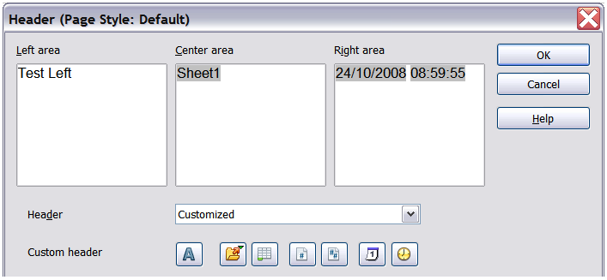
Figure 14: Edit contents of header or footer
Areas
Each area in the header or footer is independent and can have different information in it.
Header
You can select from several preset choices in the Header drop-down list, or specify a custom header using the buttons below the area boxes. (To format a footer, the choices are the same.)
Custom header
Click in the area (Left, Center, Right) that you want to customize, then use the buttons to add elements or change text attributes.
Opens the Text Attributes dialog.
Inserts the File Name field.
Inserts the Sheet Name field.
Inserts the current page number.
Inserts the total number of pages.
Inserts the Date field.
Inserts the Time field.

Exporting to PDF
Calc can export documents to PDF (Portable Document Format). This industry-standard file format is ideal for sending the file to someone else to view using Adobe Reader or other PDF viewers.

Quick export to PDF
Click the Export Directly as PDF icon to export the entire document using your default PDF settings. You are asked to enter the file name and location for the PDF file, but you do not get a chance to choose a page range, the image compression, or other options.

Controlling PDF content and quality
For more control over the content and quality of the resulting PDF, use File > Export as PDF from the menu bar. The PDF Options dialog opens. This dialog has five pages (General, Initial View, User Interface, Links, and Security). Select the appropriate settings on each page, and then click Export. You are then asked to enter the location and file name of the PDF to be created. Click Save to export the file.

General page of PDF Options dialog
On the General page, you can choose which pages to include in the PDF, the type of compression to use for images (which affects the quality of images in the PDF), and other options.
Range section
- All: Exports the entire document if no print range has been defined or otherwise the print range content.
- Pages: To export a range of pages, use the format 3-6 (pages 3 to 6). To export single pages, use the format 7;9;11 (pages 7, 9, and 11). You can also export a combination of page ranges and single pages, by using a format like 3-6;8;10;12.
Caution | The numbers used above are related to the page numbers and not the sheet numbers in your spreadsheet. To find these page numbers, select all the sheets in your spreadsheet and click the Preview button.
- Selection: Exports whatever content is selected.
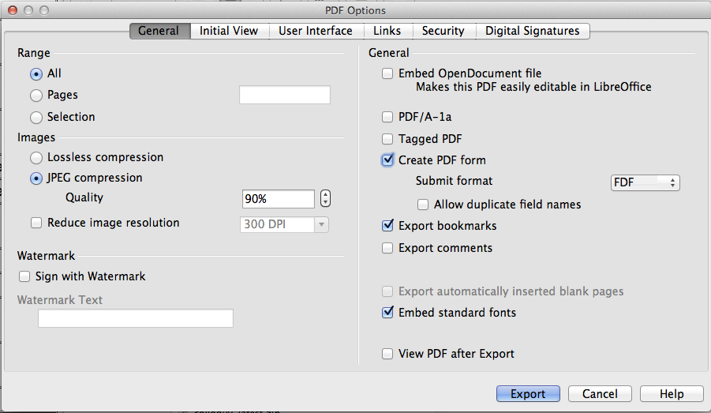
Figure 15: General page of PDF Options dialog
Images section
- Lossless compression: Images are stored without any loss of quality. Tends to make large files when used with photographs.
- JPEG compression: Allows for varying degrees of quality. A setting of 90% works well with photographs (small file size, little perceptible loss).
- Reduce image resolution: Lower DPI (dots per inch) images have lower quality. Higher DPI settings greatly increase the size of the exported file. The end-purpose of the file will dictate the resolution you find acceptable.
Note | EPS (Encapsulated PostScript) images with embedded previews are exported only as previews. EPS images without embedded previews are exported as empty placeholders.
Watermark section
- Sign with Watermark: When this option is selected, a transparent overlay of the text you enter into the Watermark Text box will appear on each page of the PDF file.
General section
- Embed OpenDocument file: This setting enables you to export the document as a PDF file containing two file formats: .pdf and .odf. In PDF viewers it behaves like a normal .pdf file and it remains fully editable in LibreOffice. Selecting this option inhibits the use of the Range options and grays them out.
- PDF/A-1a: PDF/A is an ISO standard for long-term preservation of documents, by embedding all the information necessary for faithful reproduction (such as fonts) while forbidding other elements (including forms, security, and encryption). PDF tags are written. If you select PDF/A-1a, the forbidden elements are grayed-out (not available).
- Tagged PDF: Tagged PDF contains information about the structure of the document’s contents. This can help to display the document on devices with different screens, and when using screen reader software. Some tags that are exported are table of contents, hyperlinks, and controls. This option can increase file sizes significantly.
- Create PDF form - Submit format: Choose the format for submitting forms from within the PDF file. This setting overrides the control’s URL property that you set in the document. There is only one common setting valid for the whole PDF document: PDF (sends the whole document), FDF (sends the control contents), HTML, and XML. Most often you will choose the PDF format.
- Export bookmarks: Exports sheet names in Calc documents as “bookmarks” (a table of contents list displayed by most PDF readers, including Adobe Reader).
- Export comments: Exports comments in Calc documents as PDF notes. You may not want this.
- Export automatically inserted blank pages: Not available in Calc.
- Embed standard fonts: Enable this option to embed the standard fonts that are installed on your system and that are used in the document. Use this option if you expect to have a better looking or more useful standard font than the font that is available in the recipients' PDF reader software.
- View PDF after Export: When this option is selected, the exported PDF document will be opened in a PDF viewer.

Initial View page of PDF Options dialog
On the Initial View page (Figure 16), you can choose how the PDF opens by default in a PDF viewer. The selections are self-explanatory.
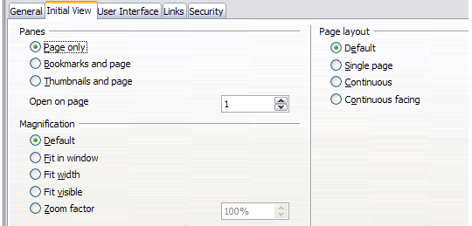
Figure 16: Initial View page of PDF Options dialog

User Interface page of PDF Options dialog
On the User Interface page (Figure 17), you can choose more settings to control how a PDF viewer displays the file. Some of these choices are particularly useful when you are creating a PDF to be used as a presentation or a kiosk-type display.
Window options section
- Resize window to initial page: Causes the PDF viewer window to resize to fit the first page of the PDF.
- Center window on screen: Causes the PDF viewer window to be centered on the computer screen.
- Open in full screen mode: Causes the PDF viewer to open full-screen instead of in a smaller window.
- Display document title: Causes the PDF viewer to display the document’s title in the title bar.
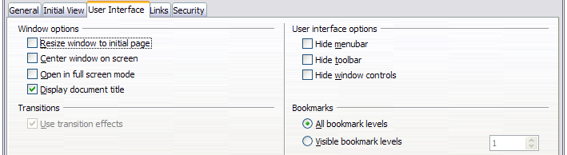
Figure 17: User Interface page of PDF Options dialog
User interface options section
- Hide menubar: Causes the PDF viewer to hide the menu bar.
- Hide toolbar: Causes the PDF viewer to hide the toolbar.
- Hide window controls: Causes the PDF viewer to hide other window controls.
Transitions
- Not available in Calc.
Bookmarks
Only one bookmark level (sheet names) is available in Calc, regardless of the setting selected here.

Links page of PDF Options dialog
On this page you can choose how links are exported to PDF.
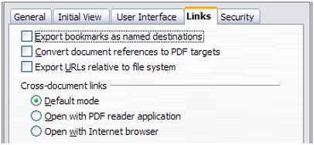
Figure 18: Links page of PDF Options dialog
Export bookmarks as named destinations
If you have defined Writer bookmarks, Impress or Draw slide names, or Calc sheet names, this option exports them as “named destinations” to which Web pages and PDF documents can link.
Convert document references to PDF targets
If you have defined links to other documents with OpenDocument extensions (for example, .odt, .ods, and .odp), this option converts the extensions of file names to .pdf in the exported PDF document.
Export URLs relative to file system
If you have defined relative links in a document, this option exports those links to the PDF.
Cross-document links
Defines the behavior of links clicked in PDF files.

Security page of PDF Options dialog
PDF export includes options to encrypt the PDF (so it cannot be opened without a password) and apply some digital rights management (DRM) features.
- With an open password set, the PDF can only be opened with the password. Once opened, there are no restrictions on what the user can do with the document (for example, print, copy, or change it).
- With a permissions password set, the PDF can be opened by anyone, but its permissions can be restricted. See Figure 19. After you set a password for permissions, the other choices on the Security page become available.
- With both the open password and permission password set, the PDF can only be opened with the correct password, and its permissions can be restricted.
Note | Permissions settings are effective only if the user’s PDF viewer respects the settings.
Figure 20 shows the dialog displayed when you click the Set passwords button on the Security page of the PDF Options dialog.
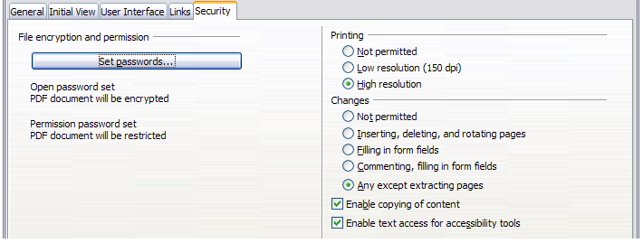
Figure 19: Security page of PDF Options dialog
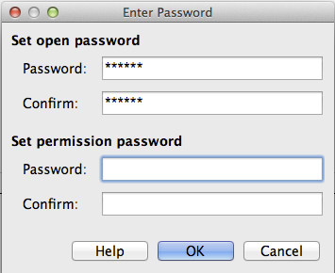
Figure 20: Setting a password to encrypt a PDF

Exporting to other formats
LibreOffice uses the term “export” for some file operations involving a change of file type. Select File > Save As from the menu bar, look in the File type list box in the Save As dialog for a wide range of file types.

Exporting to XHTML
Calc can export spreadsheets to XHTML. Choose File > Export from the menu bar. On the Export dialog, specify a file name for the exported document, then select the XHTML in the File format list and click the Export button.

E-mailing spreadsheets
LibreOffice provides several quick and easy ways to send spreadsheets as an e-mail attachment in one of three formats: OpenDocument Spreadsheet (LibreOffice’s default format), Microsoft Excel, or PDF.
To send the current document in OpenDocument format:
- Choose File > Send > Document as E-mail from the menu bar. LibreOffice opens your default e-mail program with the spreadsheet (*.ods) document attached.
- In your e-mail program, enter the recipient, subject, and any text you want to add, then send the e-mail.
File > Send > E-mail as OpenDocument Spreadsheet has the same result.
If you choose E-mail as Microsoft Excel, LibreOffice first creates a file in Excel format and then opens your e-mail program with the (*.xls) file attached.
If you choose E-mail as PDF, LibreOffice opens the PDF Options dialog for you to select the parameters you want, as previously described for exporting to PDF, clicking Send on the dialog then opens your email program with the PDF file attached.

E-mailing a spreadsheet to several recipients
To e-mail a document to several recipients, you can use the features in your e-mail program or you can use LibreOffice Writer’s mail merge facilities to extract email addresses from an address book.
For details, see Chapter 10 Printing, Exporting, and E-mailing in the Getting Started guide.

Digital signing of documents
To sign a document digitally, you need a personal key, also known as a certificate. A personal key is stored on your computer as a combination of a private key, which must be kept secret, and a public key, which you add to your documents when you sign them. You can get a certificate from a certification authority, which may be a private company or a governmental institution.
When you apply a digital signature to a document, a checksum is computed from the document’s content plus your personal key. The checksum and your public key are stored together with the document.
When someone later opens the document on any computer with a recent version of LibreOffice, the program will compute the checksum again and compare it with the stored checksum. If both are the same, the program will signal that you see the original, unchanged document. In addition, the program can show you the public key information from the certificate. You can compare this key with the public key that is published on the web site of the certificate authority.
Whenever someone changes something in the document, this change breaks the digital signature.
On Windows operating systems, the Windows features of validating a signature are used. On Linux systems, files that are supplied by Mozilla Thunderbird or Firefox are used. For a more detailed description of how to get and manage a certificate, and signature validation, see “Using Digital Signatures” in the LibreOffice Help.
To sign a document:
- Choose File > Digital Signatures.
- If the document contains comments, a warning dialog appears stating this and asking if you wish to continue. Click Yes if you wish to continue, or click No to exit and take appropriate action to remove them and restart this procedure from step 1.
- If you have not saved the document since the last change, a message box appears. Click Yes to save the file. If you click No, the procedure exits.
- After saving, you see the Digital Signatures dialog. Click Add to add a public key to the document.
- In the Select Certificate dialog, select your certificate and click OK.
- You see again the Digital Signatures dialog, where you can add more certificates if you want. Click OK to add the public key to the saved file.
A signed document shows an icon in the status bar. You can double-click the icon to view the certificate.

Removing personal data
You may wish to ensure that personal data, versions, notes, hidden information, or recorded changes are removed from files before you send them to other people or create PDFs from them.
In Tools > Options > LibreOffice > Security > Options, you can set Calc to remind (warn) you when files contain certain information and remove personal information automatically on saving.
To remove personal and some other data from a file, go to File > Properties. On the General tab, uncheck Apply user data and then click the Reset button. This removes any names in the created and modified fields, deletes the modification and printing dates, and resets the editing time to zero, the creation date to the current date and time, and the version number to 1.
To remove version information, either go to File > Versions, select the versions from the list and click Delete, or use Save As and save the file with a different name.

