
Calc Guide
Chapter 5
Using Graphics in Calc

Copyright
This document is Copyright © 2006–2013 by its contributors as listed below. You may distribute it and/or modify it under the terms of either the GNU General Public License (http://www.gnu.org/licenses/gpl.html), version 3 or later, or the Creative Commons Attribution License (http://creativecommons.org/licenses/by/3.0/), version 3.0 or later.
All trademarks within this guide belong to their legitimate owners.

Contributors
Barbara Duprey
Jean Hollis Weber
John A Smith
Christian Chenal
Martin Saffron

Feedback
Please direct any comments or suggestions about this document to: documentation@global.libreoffice.org

Acknowledgments
This chapter is based on Chapter 5 of the OpenOffice.org 3.3 Calc Guide. The contributors to that chapter are:
Jean Hollis Weber Emma Kirsopp Peter Kupfer
Alexandre Martins Kashmira Patel Iain Roberts

Publication date and software version
Published 25 November 2013. Based on LibreOffice 4.1.2.

Note for Mac users
Some keystrokes and menu items are different on a Mac from those used in Windows and Linux. The table below gives some common substitutions for the instructions in this chapter. For a more detailed list, see the application Help.
Windows or Linux | Mac equivalent | Effect
Tools > Options menu selection | LibreOffice > Preferences | Access setup options
Right-click | Control+click | Opens a context menu
Ctrl (Control) | ⌘ (Command) | Used with other keys
F5 | Shift+⌘+F5 | Opens the Navigator
F11 | ⌘+T | Opens the Styles and Formatting window

Contents
Copyright 2
Contributors 2
Feedback 2
Acknowledgments 2
Publication date and software version 2
Note for Mac users 2
Graphics in Calc 5
Adding graphics (images) 5
Inserting an image file (picture) 5
Insert Picture dialog 5
Linking an image file 6
Embedding linked images 7
Inserting an image from the clipboard 8
Inserting an image from the Gallery 8
Modifying images 9
Using the Picture toolbar 9
Choosing a graphics mode 11
Using graphic filters 11
Adjusting colors 12
Setting transparency 12
Customizing lines, areas, and shadows 12
Cropping pictures 12
Resizing an image 13
Rotating a picture 14
Using the picture context menu 14
Text 14
Position and Size 15
Original Size 15
Description 15
Name 15
Flip 15
Assign Macro 16
Group 16
Hyperlink 16
Compress a picture 16
Edit with an external tool 16
Using Calc’s drawing tools 16
Set or change properties for drawing objects 18
Resizing a drawing object 19
Grouping drawing objects 19
Positioning graphics 19
Arranging graphics 19
Anchoring graphics 20
Aligning graphics 21
Creating an image map 22

Graphics in Calc
Calc is often used to present data and make forecasts and predictions. Graphics can turn an average document into a memorable one. Calc can import various vector (line drawing) and raster (bitmap) file formats. The most commonly used graphic formats are GIF, JPG, PNG, and BMP. See the Help for a full list of the formats LibreOffice can import.
Graphics in Calc are of three basic types:
- Image files, such as photos, drawings, and scanned images
- Diagrams created using LibreOffice’s drawing tools
- Charts and graphs created using LibreOffice’s Chart facility
This chapter covers images and diagrams. Charts are described in Chapter 3, Creating Charts and Graphs.
Although using graphics in Calc is very similar to using graphics in any other component of LibreOffice, this chapter explains some of the differences in their use. It also covers some of the more advanced graphics functions and how they can further enhance your spreadsheet.
Note | The term graphics refers to both pictures and drawing objects. Often the word images is used when referring to pictures and other graphics that are not drawing objects.

Adding graphics (images)
Images (also called pictures in LibreOffice), such as corporate logos and photographs of people and products, are probably the most common types of graphics added to a Calc document. They may be downloaded from the Internet, scanned, or created with a graphics program; or they may be photos taken with a digital camera.
Images can be inserted in three ways:
- Using the Insert Picture dialog
- From the gallery
- From the clipboard by copying and pasting

Inserting an image file (picture)
Perhaps the most common source of graphics is existing files.
To insert an image from a file, use the Insert Picture dialog.

Insert Picture dialog
- Click in the location in the Calc document where you want the image to appear. Do not worry too much about the exact placement of the image at this stage; placement can be changed easily as described in “Positioning graphics” on page 19.
- Choose Insert > Picture > From File from the Menu bar, or click the Insert Picture icon on the Insert toolbar).
- On the Insert Picture dialog, navigate to the file to be inserted, select it, and click Open.
Note | The picture is inserted into Calc floating above the cells and anchored to the cell in which the cursor was placed. See “Positioning graphics” on page 19 for more about positioning and anchoring graphics.
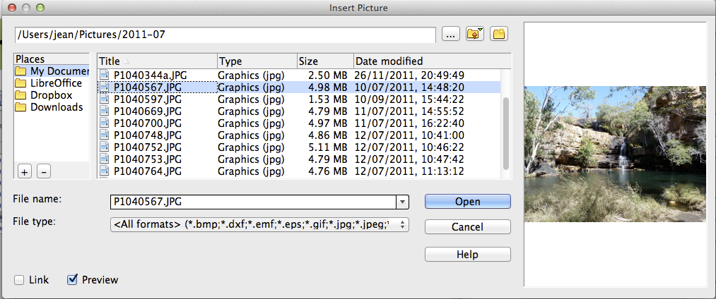
Figure 1: Inserting a picture from a file
At the bottom of the dialog are two options, Link and Preview. Select Preview to view a thumbnail of the selected image on the right, so you can verify that you have the correct file. The Link option is discussed below. When the Link option is not selected, the picture is embedded in the Calc document.
Note | Your Insert Picture dialog may look different from the one shown here, depending on your operating system and your choice in Tools > Options > LibreOffice > General of whether to use the LibreOffice Open and Save dialogs.

Linking an image file
To create a link to the file containing the image instead of saving a copy of the image in the Calc document, use the Insert picture dialog and select the Link option. A warning dialog opens informing you of the hazards of linking a file and asks you to confirm you want to Link or change to Embed Graphic. The image is then displayed in the document, but when the document is saved, it contains only a reference to the image file—not the image itself. The document and the image remain as two separate files, which are merged temporarily only when you open the document again.
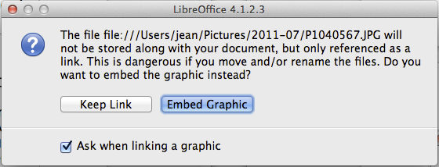
Figure 2: Linking warning dialog
Linking an image has two advantages and one disadvantage:
- Advantage – You can modify the image file separately without changing the document because the link to the file remains valid, and the modified image will appear when you next open the document. This can be a big advantage if you (or someone else, perhaps a graphic artist) is updating images.
- Advantage – Linking can reduce the size of the document when it is saved, because the image file itself is not included. The file size is usually not a problem on a modern computer with a reasonable amount of memory, unless the document includes many large graphics files. Calc can handle quite large files.
- Disadvantage – If you send the document to someone else, or move it to a different computer, you must also send the image files, or the receiver will not be able to see the linked images. You need to keep track of the location of the images and make sure the recipient knows where to put them on another machine, so the Calc document can find them. For example, you might keep images in a subfolder named Images (under the folder containing the Calc document); the recipient of the Calc file needs to put the images in a subfolder with the same name (under the folder containing the Calc document).
Note | When inserting the same image several times in the document, it might appear beneficial to create links. However, this is not necessary, as LibreOffice embeds only one copy of the image file in the document. (Deleting one or more of the copies does not affect the others.)

Embedding linked images
If you originally linked the images, you can easily embed (save in the Calc document) one or more of them later if you wish. To do so:
- Open the document in Calc.
- Choose Edit > Links from the Menu bar.
The Edit Links dialog shows all the linked files. In the Source file list, select the files you want to change from linked to embedded.
- Click the Break Link button.
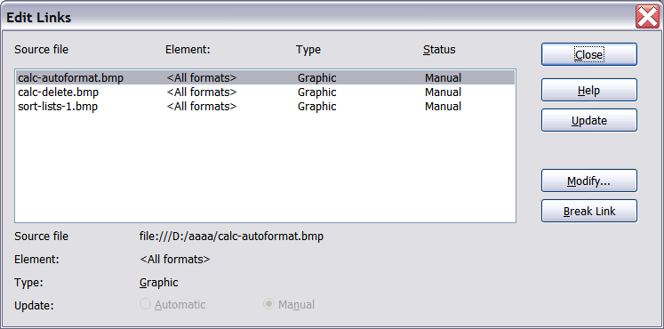
Figure 3: The Edit Links dialog
Note | Going the other way, from embedded to linked, is not so easy—you must delete and reinsert each image, one at a time, selecting the Link option when you do so.

Inserting an image from the clipboard
Using the clipboard, you can copy images into a Calc document from another Calc document, from another component of LibreOffice (Writer, Draw, and so on), and from other programs.
To do this:
- Open both the source document and the Calc document into which you want to copy the image.
- In the source document, select the image to be copied.
- Press Control+C to copy the image to the clipboard.
- Switch to the Calc window.
- Click to place the cursor where the graphic is to be inserted.
- Press Control+V to insert the image.
Caution   | If the application from which the graphic was copied is closed before the graphic is pasted into Calc, the image stored on the clipboard could be lost from the clipboard.

Inserting an image from the Gallery
The Gallery provides a convenient way to group reusable objects such as graphics and sounds that you can insert into your documents.
The Gallery is available in all components of LibreOffice. It does not come with many graphics, but you can add your own pictures or find extensions containing more graphics. The Gallery is explained in more detail in Chapter 11, Graphics, the Gallery, and Fontwork, in the Getting Started guide. For more about extensions, see Chapter 14, Setting Up and Customizing Calc, in this book.
This section explains the basics of inserting a Gallery image into a Calc document.
- To open the Gallery (Figure 4), click on the Gallery icon (located in the right side of the Standard toolbar) or choose Tools > Gallery from the Menu bar.
- Navigate through the Gallery to find the desired picture.
- To insert the picture, either right-click on the picture and choose Insert > Copy or click and drag the picture from the Gallery into the Calc document.
By default, the Gallery is docked above the Calc workspace. To expand the Gallery, position the pointer over the line that divides it from the top of the workspace. When the pointer changes to parallel lines with arrows, item 2 in Figure 4, click and drag downward. The workspace re-sizes in response.
To expand the Gallery without affecting the workspace, undock it so it floats over the workspace. To do so, hold down the Control key and double-click on the upper part of the Gallery next to the View icons, or press the Ctrl+Shift+F10 keys. Double-click in the same area while holding down the Control key to dock it again (restore it to its position over the workspace).
When the Gallery is docked, to hide it and view the full Calc workspace, click the Hide/Show button, item 1 circled in Figure 4, in the middle of the thin bar separating the Gallery from the workspace.
To close the Gallery, choose Tools > Gallery to uncheck the Gallery entry, or click on the Gallery icon again.
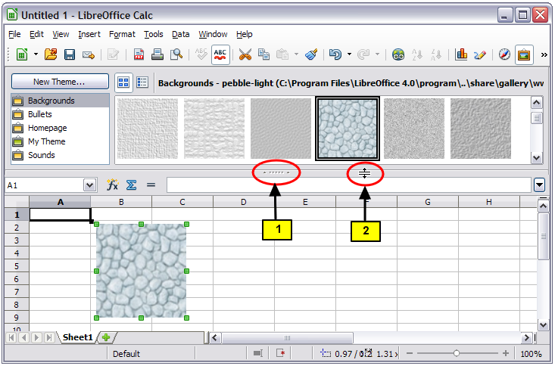Figure 4: Gallery in Calc

Modifying images
When you insert a new image, you may need to modify it to suit the document. This section describes the use of the Picture toolbar, resizing, cropping, and rotating a picture. Changes made in Calc do not affect the original picture, whether it is embedded or linked.
Calc provides many tools for working with images. These tools are sufficient for most people’s everyday requirements. However, for professional results it is generally better to use an image manipulation program such as GIMP to modify images (for example, to crop, resize, rotate, and change color values) and then insert the result into Calc. GIMP is an open-source graphics program that can be downloaded from http://www.gimp.org/downloads/.

Using the Picture toolbar
When you insert an image or select one already present in the document, the Picture toolbar appears. You can set it to always be present (View > Toolbars > Picture). Picture control buttons from the Picture toolbar can also be added to the Standard Toolbar. See Chapter 14, Setting Up and Customizing Calc, for more information.
This toolbar can be either floating or docked. Figure 5 shows the Picture toolbar when it is floating. A brief explanation of the tools is given in Table 1. See the Draw Guide for a more detailed explanation.
Three other toolbars can be opened from this one: the Graphic Filter toolbar, which can be torn off and placed elsewhere on the window, the Color toolbar, which opens as a separate floating toolbar, and the Alignment toolbar, which also can be torn off.
From these four toolbars, you can apply small corrections to the graphic or obtain special effects.
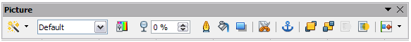Figure 5: The Picture Toolbar
Table 1: Picture toolbar functions (from left to right)
Icon | Name | Behavior
 | Filter | Displays the Graphic Filter toolbar. See page 11.
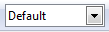 | Graphics Mode | Provides several color modes in the drop-down list. See page 11.
 | Color | Opens the Color toolbar, described on page 12.
 | Transparency | Sets the transparency of the selected image. See page 12.
 | Line | Adjusts the border style of the selected image.
 | Area | Fills an area with the selected color or pattern.
 | Shadow | Adds a drop shadow to the edges of the picture.
 | Crop | Opens the Crop dialog, where you can remove a selected part of the picture. See page 12.
 | Anchor | Toggles between anchoring the image to the cell or to the page. See page 20.
 | Bring to Front | Brings the selected image to the front of the stack. See page 19.
 | Send to Back | Pushes the selected image to the rear of the stack. See page 19.
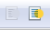 | To Foreground / Background | Allows image to float in the foreground or makes it part of the background (behind the cells). See page 19.
 | Alignment | If two or more pictures are selected, adjusts the horizontal and vertical alignment of the pictures in relation to each other. See page 21.

Choosing a graphics mode
You can change color images to grayscale by selecting the image and then selecting Grayscale from the Graphics mode list.
Table 2: Graphics modes
Graphics mode | Behavior
Default | Keeps the picture the same as it was inserted.
Grayscale | Shows the picture in gradual shades of gray.
Black / White | Converts the picture into a monochromatic black and white image.
Watermark | Makes the picture into a watermark that blends into the background.

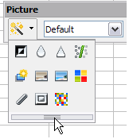
Using graphic filters
Click the Filter icon to display the Graphic Filter toolbar, which provides options for applying basic photographic and effect filters to images from within Calc. To “tear off” this toolbar and place it anywhere on the screen, click on the three parallel lines and drag it away.
Table 3: Graphic filters and their effects
Icon | Name | Behavior
 | Invert | Inverts the colors in the picture like a negative.
 | Smooth | Applies a Gaussian Blur to the image which softens edges.
 | Sharpen | Sharpens the image.
 | Remove Noise | Applies crude noise reduction.
 | Solarization | Reverses a portion of the tones, then produces pronounced outlines of the highlights.
 | Aging | Applies a Sepia filter.
 | Posterize | Opens a dialog to determine the number of poster colors. This effect is based on the reduction of the number of colors. It makes photos look like paintings.
 | Pop Art | Applies a Pop Art style to the image.
 | Charcoal Sketch | Applies a Charcoal Sketch look to the image.
 | Relief | Displays a dialog for creating reliefs. The position of the imaginary light source that determines the type of shadow can be chosen.
 | Mosaic | Joins small groups of pixels into rectangular areas of the same color. The larger the individual rectangles are, the fewer details the graphic image has.
Caution | Applying LibreOffice picture filters to any image consecutively will progressively degrade the quality of the image. The picture filters used in Calc utilize what is known as a Destructive Editing algorithm, whereby each filter is applied to the image immediately, changing the original data of the image. Successive transformations result in less and less original data remaining, thus compromising the quality of the inserted picture. While this might be acceptable for use in simple documents, it is still recommended that dedicated photo or image editing software be used to perform anything but the simplest of manipulations.

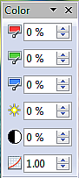
Adjusting colors
Use the Color toolbar to adjust an image’s red, green, and blue channels independently, as well as its brightness, contrast and gamma.

Setting transparency
Modify the percentage value in the Transparency box on the Picture toolbar to make the image more transparent. This is particularly useful when creating a watermark or when wrapping an image in the background.

Customizing lines, areas, and shadows
The Line, Area, and Shadow icons open dialogs where you can customize these elements. Details are in the Draw Guide.

Cropping pictures
When you are only interested in a section of the image for the purpose of your document, you may wish to crop (hide) parts of it. If you wish to remove (delete) areas of the image it may be a better choice to use Draw or a graphics package.
Click the Crop icon to open a dialog where you can select which portion of the image you want to remove from view.
It is not possible to use the mouse to select the area to be cropped, as you can in Draw. Instead, in the Crop dialog, specify how far from the top, bottom, left and right borders of the image the crop should be, as illustrated in Figure 6. On the thumbnail in the figure, notice that the cropped selection is highlighted with an inner rectangle.
On the Crop dialog, you can control the following parameters:
Keep scale / Keep image size
When Keep scale is selected (default), cropping the image does not change the scale of the picture.
When Keep image size is selected, cropping enlarges (for positive cropping values), shrinks (for negative cropping values), or distorts of the image so that the image size remains constant.
Left, Right, Top, and Bottom
The image is cropped by the amount entered in these boxes. For example, a value of 3cm in the Left box cuts 3 cm from the left side of the picture.
- When Keep scale is selected, the size of the image also changes, so in this example the width will be reduced by 3 cm.
- When Keep image size is selected, the remaining part of the image is enlarged (when you enter positive values for cropping) or shrunk (when you enter negative values for cropping) so that the width and height of the image is not changed.
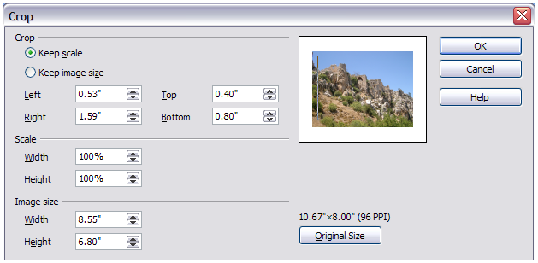Figure 6: The Crop dialog
Width and Height
The Width and Height fields under either Scale or Image size change as you enter values in the Left, Right, Top, and Bottom fields. Use the thumbnail next to these fields to determine the correct amount by which to crop.
The original image size is indicated above the Original Size button. The bitmap image density is shown alongside this dimension.
The cropped shape is always a rectangle; more complex cropped shapes are not possible in Calc. Instead, use a dedicated photo or image editing software for the job, then import the image into Calc.
Note | If you crop an image in Calc, the picture itself is not affected. Only the area displayed is altered. If you export the document to HTML, the full original image is exported, not the cropped image.

Resizing an image
To resize an image:
- Click the picture, if necessary, to show the colored resizing handles.
- Position the pointer over one of the colored resizing handles. The pointer changes shape giving a graphical representation of the direction of the resizing.
- Click and drag to resize the picture.
- Release the mouse button when satisfied with the new size.
The corner handles resize both the width and the height of the graphic object simultaneously, while the other four handles only resize one dimension at a time. For more accurate resizing, use the Position and Size dialog, described on page 15.
Tip | To retain the original proportions of the graphic, Shift+click one of the corner handles, then drag.

Rotating a picture
Select the image, then choose Format > Graphic > Position and Size from the Menu bar, or right-click the image and select Position and Size from the context menu.
- Select the Rotation tab on the dialog (Figure 7).
- In the Pivot point section of the page, select the x-y co-ordinates of the pivot point, from the left and top edges, using the spin box settings, or set the pivot point in one of the default positions shown in the selection graphic.
- In the Rotation angle section, either set the number of degrees for the rotation angle in the Angle spin box, or click in the rotation grid.
- If you change your mind, click the Reset button to return the settings to what they were when the dialog opened.
- Click OK to rotate the image.
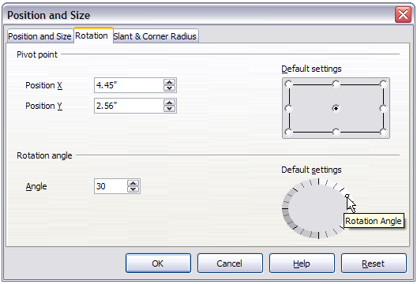Figure 7: Rotation settings page

Using the picture context menu
Many of the options accessible from the Picture toolbar can also be reached by right-clicking on an image to open a context menu. Some additional options are only available from the context menu; these are described in this section.

Text
Opens a dialog where you can set the options for text that goes over a picture. Press OK when your options have been set. To write text over a graphic, either, click on the graphic to select it, and then press Enter, or double-click on the picture. A blinking cursor then appears inside the graphic. Type the text and then click outside the graphic to complete the entry. Any text entered is part of the graphic, so if the graphic is moved the text will move with it.

Position and Size
Opens the dialog shown below where you can change the size, location, rotation, slant and corner radius of the image.
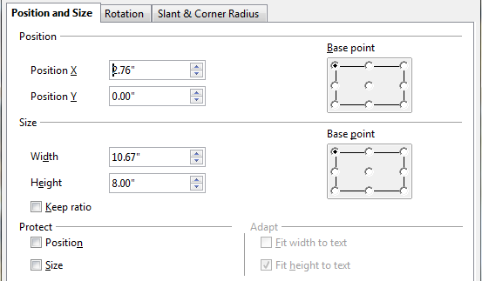
Figure 8: Position and Size dialog

Original Size
Resets the dimensions of the image to the values when it was originally inserted into the document.

Description
You can add metadata in the form of a title and description to the image. This information is used by accessibility tools (such as screen reader software) and as ALT (alternative) attributes if you export the document to HTML.

Name
You can add a custom name to be assigned to the image, to make it easier to find in the Navigator.
Tip | When collaborating with a team on a large, multi-page publication, it may be beneficial to give graphics, figures, and other objects meaningful names and descriptions to aid in clear communication.

Flip
Flips the image either horizontally or vertically. Any text inserted as described above will change orientation with the picture only when the picture is flipped vertically.

Assign Macro
Adds programmable functionality to the image. Calc provides rich macro functionality. Macros are introduced in Chapter 12, Calc Macros.

Group
To group images:
- Select one image, then hold down the Shift key and click in turn on each of the others that you want to include in the group. The invisible “bounding box” (with the 8 colored handles) expands to include all the selected images.
- With the images selected, choose Format > Group > Group from the Menu bar.
Or hover the mouse pointer over one of the images. When the pointer changes shape from an arrow to a hand, right-click and choose Group > Group from the context menu.
After images are grouped, the context menu provides other choices (Ungroup and Edit Group) and the Format > Group menu includes Ungroup and Enter Group. For more information about grouping, see the Draw Guide.

Hyperlink
You can define a picture as a hyperlink to another location in your spreadsheet, to another document or to a web page. To do this, select the picture, right-click and choose Hyperlink in the context menu. The Hyperlink dialog opens. See Chapter 10 for more information.

Compress a picture
You can compress a picture in order to reduce the size of your document. To do this, select the picture, right-click and choose Compress graphic in the context menu. The dialog which opens shows the original and displayed size and resolution, with the quality of the picture in kibibytes (kilobytes).
You can choose between a JPEG compression and a lossless compression (PNG), with the ability to select a quality or compression level. You can also edit the size and the resolution of the picture along with the choice of an interpolation algorithm.
Once these modifications are entered, use the Calculate button to calculate the new picture quality. Click OK to accept the settings.

Edit with an external tool
You can edit a picture with an external tool, in order to use more advanced tools. To do this, select the picture, right-click and choose Edit with an external tool in the context menu.

Using Calc’s drawing tools
Calc, like the other components of LibreOffice, has a range of tools to create custom drawings. This chapter covers the default options in Calc. For a more detailed explanation of the drawing tools and their uses, see the Draw Guide.
In general, if you need to create complex drawings, it is recommended to use LibreOffice Draw or another drawing program.
To begin using the drawing tools, choose View > Toolbars > Drawing. The Drawing toolbar appears at the bottom of the screen. You can tear off this toolbar and move it to a convenient place on the window.
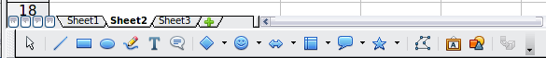
Figure 9: The Drawing toolbar showing default icons
Table 4: Drawing toolbar functions (from left to right)
Icon | Name | Behavior
 | Select | Selects objects.
 | Line | Draws a line.
 | Rectangle | Draws a rectangle. To draw a square, hold down Shift while you drag.
 | Ellipse | Draws an ellipse. To draw a circle, hold down Shift while you drag.
 | Freeform Line | Draws a freeform line.
 | Text | Draws a text box with no border.
 | Callouts | Draws a line that ends in a rectangular callout.
 | Basic Shapes | Opens the Basic Shapes toolbar.
 | Symbol Shapes | Opens the Symbol Shapes toolbar.
 | Block Arrows | Opens the Block Arrows toolbar of shapes.
 | Flowcharts | Opens the Flowchart toolbar of shapes.
 | Callouts | Opens the Callouts toolbar of shapes.
 | Stars | Opens the Stars toolbar of shapes.
 | Points | Allows editing of the points of a selected polygon.
 | Fontwork Gallery | Opens the Fontwork Gallery.
 | From File | Inserts a picture using the Insert Picture dialog.
 | Extrusion On/Off | Opens the 3-D Setting toolbar and converts the selected shape (if any) to 3-D.
To display other icons, right-click the toolbar, select Visible Buttons, and then choose the tools you want to appear on the toolbar.
Icon | Name | Behavior
 | Polygon | Draws a line composed of a series of straight line segments. Hold down the Shift key to position new points at 45 degree angles.
 | Curve | Draws a smooth Bézier curve.
 | Arc | Draws an arc.
 | Ellipse Pie | Draws a filled shape that is defined by the arc of an oval and two radius lines in the current document. To draw a circle pie, hold down Shift while you drag.
 | Circle Segment | Draws a filled shape that is defined by the arc of a circle and a diameter line in the current document. To draw an ellipse segment, hold down Shift while you drag.
 | Text Animation | Inserts animated text.
If support for Asian languages has been enabled (in Tools > Options > Language Settings > Languages), two more tools can be added to the Drawing toolbar: Vertical Text and Vertical Callouts.
To use a drawing tool:
- Click in the document where you want the drawing to be anchored. You can change the anchor later, if necessary.
- Select the tool from the Drawing toolbar (Figure 9). The mouse pointer changes to a cross-hair pointer.
- Move the cross-hair pointer to the place in the document where you want the graphic to appear and then click-and-drag to create the drawing object. Release the mouse button. (Some tools have other requirements; see the Help or the Draw Guide for details.)
The selected drawing function remains active, so you can draw another object of the same type.
- To cancel the selected drawing function, press the Esc key or click on the Select icon (the arrow) on the Drawing toolbar.
- You can now change the properties (fill color, line type and weight, anchoring, and others) of the drawing object using either the Drawing Object Properties toolbar (Figure 10) or the choices and dialog boxes reached by right-clicking on the drawing object.

Set or change properties for drawing objects
To set the properties for a drawing object before you draw it:
- On the Drawing toolbar (Figure 9), click the Select tool.
- On the Drawing Object Properties toolbar (Figure 10), click on the icon for each property and select the value you want for that property.
- For more control, or to define new attributes, you can click on the Area or Line icons on the toolbar to display detailed dialogs.
These default properties are applied only to the current document and session. They are is not retained when you close the document, and they do not apply to any other document. The defaults apply to all the drawing objects except text objects.
To change the properties for an existing drawing object, select the object and continue as described above.
Other tools and methods for modifying and positioning graphics are described in “Positioning graphics” below.
1 | Line | 5 | Line Color | 9 | Change Anchor | 13 | Alignment
2 | Arrow Style | 6 | Area | 10 | Bring to Front
3 | Line Style | 7 | Area Style / Filling | 11 | Send to Back
4 | Line Width | 8 | Rotate | 12 | To Foreground / To Background
Figure 10. Drawing Object Properties toolbar

Resizing a drawing object
Select the object, click on one of the eight handles around it and drag it to its new size. For a scaled resizing, select one of the corner handles and keep the Shift key pressed while dragging the handle.
For more control of the size of the object, use the Position and Size dialog (see “Position and Size” on page 15) to set the width and height independently. If the Keep ratio option is selected, then the two dimensions change so that the proportion is maintained, allowing for a scaled resizing.

Grouping drawing objects
To group drawing objects:
- Select one object, then hold down the Shift key and select the others you want to include in the group. The bounding box expands to include all the selected objects.
- With the objects selected, hover the mouse pointer over one of the objects and choose Format > Group > Group from the menu bar or right-click and choose Group > Group from the context menu.

Positioning graphics
Graphics can be positioned in LibreOffice Calc to work together and build more complex features.

Arranging graphics
Graphics in a Calc document are maintained in a similar manner to a deck of cards. As you add more images to the document, each image occupies a new layer at the top of the stack. To arrange graphics, you tell Calc to change the order of layers in the stack.
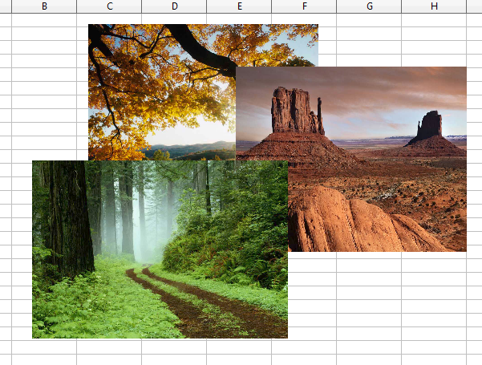
Figure 11: Layering effect
Calc provides several options to re-arrange the order of images. These options can be accessed from both the Picture toolbar and the picture context menu:
Bring to Front
Places the selected image on top of any other graphics or text.
Bring Forward
Brings the selected image one level up in the stack (z-axis). Depending on the number of overlapping objects, you may need to apply this option several times to obtain the desired result.
Send Backward
The opposite of Bring Forward; sends the selected image one level down in the object stack.
Send to Back
Sends the selected graphic to the bottom of the stack, so that other graphics and text cover it.
To Background and To Foreground
An image or a drawing object can be sent to the background as well. This is not the same as Bring Forward and Send Backward, which set the order of a number of overlapping graphics. This feature pushes a graphic behind the cells, allowing cells to be edited without affecting the graphic.
A graphic in the background will have To Foreground as a menu item, instead of To Background. To select a background graphic (to modify or replace it), you need to use the Navigator. Other methods, such as clicking or double-clicking, do not work.

Anchoring graphics
Anchors tell a graphic where to stay in relation to other items.
Anchor to page
Anchoring a graphic to the page allows it to be positioned in a specific place on the page. The graphic does not move when cells are added or deleted. This is equivalent to an absolute reference. The graphic will always stay in the position on the page where it is placed.
Anchor to cell
Anchoring a graphic to a cell ensures that the graphic always stays with the content it is originally anchored to. If a graphic is anchored to cell B10, and a new row is inserted, the graphic will then be anchored to cell B11. This is equivalent to a relative reference.
For example, in Figure 12 the picture on the left is anchored To Cell B2 (XXX shows where the picture is anchored). The picture on the right is anchored to the page.
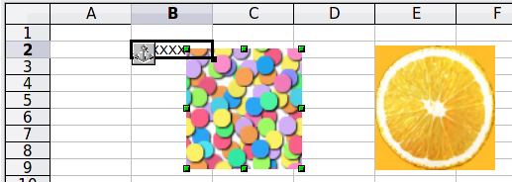
Figure 12: Anchoring 1
If two rows are inserted above the pictures, the picture anchored to a cell will shift down two rows and the anchor will change. The picture anchored to the page will not move. This is illustrated in Figure 13. Note that the anchor symbol and the XXX have moved down to cell B4.
.
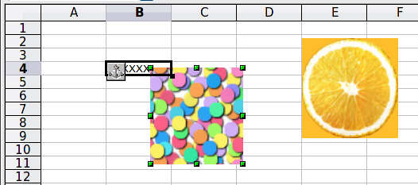
Figure 13: Anchoring

Aligning graphics
You can align several graphics relative to each other. To do this:
- Select all of the graphics to be aligned (Shift+click on each in turn). The graphics will be surrounded by an invisible bounding box with 8 colored handles.
- On the Picture toolbar, click on the Alignment icon and select one of the six options.
Or, position the mouse pointer over any of the graphics. When the pointer changes shape from an arrow to a hand, right-click and choose Alignment, then select from the six options.
The six options include three for aligning the graphics horizontally (left, center, right) and three for aligning the graphics vertically (top, center, bottom).

Creating an image map
An image map defines areas of an image (called hotspots) with hyperlinks to web addresses, other files on the computer, or parts of the same document. Hotspots are the graphic equivalent of text hyperlinks. Ctrl+Clicking on a hotspot causes Calc to open the linked page in the appropriate program (for example, the default browser for an HTML page; LibreOffice Calc for an ODS file; a PDF viewer for a PDF file). You can create hotspots of various shapes, and include several hotspots in the same image.
To use the image map editor:
- In your spreadsheet, select the picture where you want to define the hotspots.
- Choose Edit > ImageMap from the Menu bar. The ImageMap Editor (Figure 14) opens.
- Use the tools and fields in the dialog (described below) to define the hotspots and links necessary.
- Click the Apply icon to apply the settings.
- When done, click the Save icon to save the image map to a file, then click the X in the upper right corner to close the dialog.
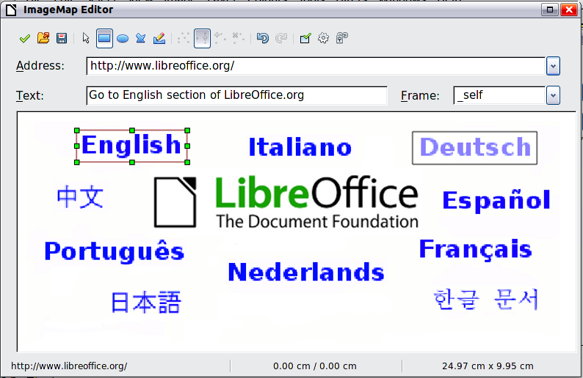
Figure 14: The dialog to create or edit an image map
The main part of the dialog shows the image on which the hotspots are defined. A hotspot is identified by a line indicating its shape.
The toolbar at the top of the dialog contains the following tools:
- Apply button: click this button to apply the changes.
- Open, Save, and Select icons. Use Open to load an existing image map, Save to save an ImageMap file. Use the Select tool to select the different hotspots for further editing.
- Tools for drawing a hotspot shape: these tools work in exactly the same way as the corresponding tools in the Drawing toolbar.
- Edit, Move, Insert, Delete Points: advanced editing tools to manipulate the shape of a polygon hotspot. Select the Edit Points tool to activate the other tools.
- Undo and Redo: edits the last action.
- Active icon: toggles the status of a selected hotspot between active and inactive.
- Macro: associates a macro with the hotspot instead of just associating a hyperlink.
- Properties: sets the hyperlink properties and adds the Name attribute to the hyperlink.
Below the toolbar, specify for the selected hotspot:
- Address: the address pointed to by the hyperlink. You can also point to an anchor in a document; to do this, write the address in this format: file:///<path>/document_name#anchor_name
- Text: type the text that you want to be displayed when the mouse pointer is moved over the hotspot.
- Frame: where the target of the hyperlink will open: pick among _blank (opens in a new browser window), _self (opens in the active browser window), _top or _parent.
Notes | Image Map is not appropriate when the whole picture is a hotspot defining a single link: if such is the case, right-click the picture and choose Hyperlink in the context menu.  The value _self for the target frame will work in the vast majority of occasions. It is therefore not recommended to use the other choices unless absolutely necessary.
Tip | The Image Map editor has no explorer to find and select the target document. Two methods you can use are:  - Click the Open icon in the ImageMap editor, select the document and copy-paste the Url from the Open dialog to the ImageMap editor dialog, remembering to add the file name to the pasted path.  - Open, then close, the target document and its address will appear in the ImageMap editor Address drop-down listings, from which it can be selected.

