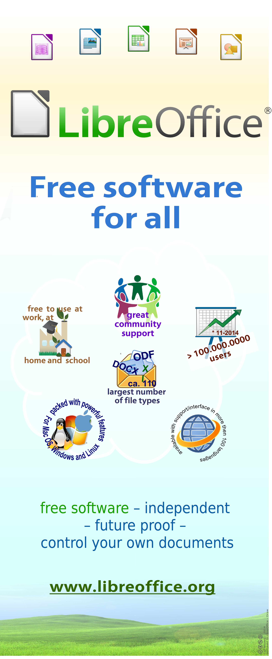
version 2014-10-30

LibreOffice is the software for all office-documents. Free to use at home, at school or in the office, without having to pay for licenses. This is possible because the development is supported by many people and companies. You too can join in extending, improving, supporting and promoting LibreOffice, just as many others do. You can help by showing LibreOffice to other people.
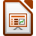
The program has a well known appearance; it does also offer well known functions and many handy features. You can continue to use files created in Word, Excel and Powerpoint. Also documents from many other programs open fine in LibreOffice .
Modern means: keeping control over your own documents, and make sure that you're not locked-in by a single vendor. So save your files as ODF - the modern Open-Document File format. It's ISO-certified.
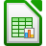
Sharing a document with someone who is using an older version of Word can be simply done by saving as .doc. You may also directly mail as .doc. Really handy is saving or sending it as PDF with just a few clicks. You can start to work immediately .
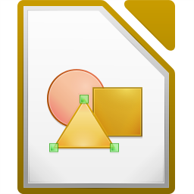
For everyone as private user you take a 'bleeding edge' or a stable version. As an organization you take one of the two available stable versions. And businesses can rely on a supported version with one of the companies that helps developing LibreOffice .
Best successor LibreOffice offers the most and the best features of all free office suites. During the last four years more then four hundred unique features and enhancements have been added.
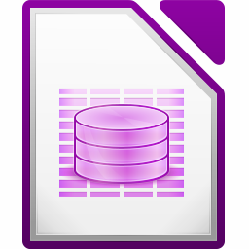
Help with installing, the use or the new features? Find it at http://www.libreoffice.org under Support. Tips, documentation, mailing lists and more options are available!

