Scripting dialogs with tabs
importing dialogs content

1. Let’s clone ”Basic Macro Organizer”

Python version is WiP

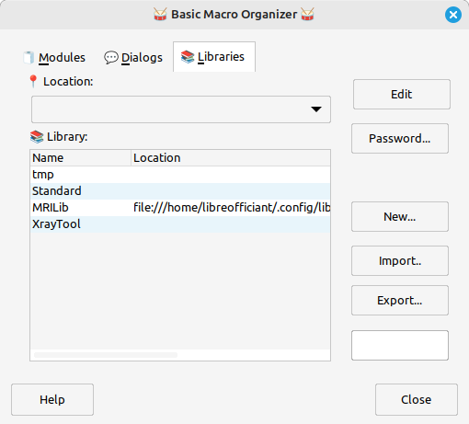Figure 1: Basic Macro Organizer reproduced layout
The above tabbed dialog embeds three pre-defined dialogs –﻿ ’Dialogs’, ’Libraries’ and ’Modules' ﻿–﻿ for the sake of design simplicity. Basic scripts are adapted from ”Query and update events actions” by JesperB and rewritten using ScriptForge. Routines are grouped in modules figuring out the Model-View- Controller design pattern. Tab click events are handled, tabs keys shortcuts are not supported. Most buttons controls are intentionnaly left unset.

Embedded controls versus Imported Controls

Using Abstract Windowing Toolkit tabbed dialog Uno Api requires to build a dynamic dialog in order to embed controls in API defined tabs. This is tedious and subject to numerous graphical adjeustments.

An alternative is to design each tab as individual dialogs via Basic IDE dialog editor. Dialog controls can be imported – using ScriptForge facilities - including associated event routines.

.2. Sub-Dialogs Design
’Modules’, ’Dialogs’ and ’Libraries’ tabs are edited as separate dialogs in order to be dynamically imported in main tabbed dialog. They are designed and tested individually, then embedded in the main tabbed dialog.
’Modules’ and ’Dialogs’ tree controls and ’Libraries’ grid control contents are set using ScriptForge. Associated event routines transfer seamlessly when imported with ScriptForge.

3. Handling of Events
Dialog Editor Events
Events defined with Basic IDE Dialog Editor – during individual dialog tests - are incompatible with ScriptForge. They need to be removed from dialogs – before import – and their content may require minor ScriptForge adaptation.
Dialog Event Handlers
Dialog Editor event handlers can not be used, although they offer coding advantages.
Controls Listeners
API listeners can be used. However ScriptForge ’SFDialogs’ library simplifies the management of events.

4. some links of interest
LibreOffice Dev's Guide: Chapter 11 - Basic – Dialogs & Dialog Controls
Forcer selection dans un TreeControl
LibreOffice Tree with columns - Stack Overflow
Contrôle d'arborescence (TreeView) avec listener
Going further with Dialog and Component

