Using ODF Custom Shapes to Draw Parabolas

Introduction
This document contains some custom shapes of a parabola. If you want to use one of the shapes below, you can simply copy&paste it into your document. For frequent use of the shapes in other documents, you should consider dragging them into your Gallery, so that you don’t need to open this document to get them.
The shapes here are all created by directly editing the file source. The document contains some explanations about that, but you can use the shapes without understanding the explanations or having any knowledge on how to create your own custom shape.
The last section in the document describes how to place a parabola shape numerically correctly in a coordinate-system. That might be useful for you in any case.

General
A custom shape uses in its enhanced geometry a local coordinate-system given in the attribute svg:viewBox. The y-axis points down as usual in 2D computer graphics. The shapes here use a coordinate-system with origin left-top and range 0..21600 on both axes. This square is then stretched to the current width and height of the shape.
The enhanced-path is the essential part of the enhanced-geometry of a custom shape. It describes how to draw the geometry. It uses commands like
M x y Move pen to point (x|y), put down the pen and start a new sub-path.
L x y Draw a line from the current point to point (x|y).
Q xc yc x y Draw a quadratic Bézier curve from the current point to point (x|y) using the control point (xc|yc).
N End the sub-path and lift off the pen.
The coordinates in these commands can be given as direct values, or as reference to a formula result or to an adjustment value. Adjustment values are connected to the handles of the custom shape.
You will find details about the file format of custom shapes in the ODF 1.3 specification.
Some hints and tricks for editing the file source are collected on page ODF_Markup in the “The Document Foundation Wiki”.

Simple Parabola

Area fill and line styles are set the same way as for predefined shapes, and transformations (e.g. flip or rotation) work the same way too.
The outline of a quadratic Bézier curve is a parabola. Therefore the shapes use the Q command of the enhanced-path to draw a parabola. We only need to calculate its control point. The straight line from start point to control point and the straight line from end point to control point are tangents to the curve in start and end point, respectively. With a little mathematics, we get for start point (0|0) and endpoint (21600|0) the control point (10800|43200). So the shape has in file source the attribute draw:enhanced-path="M 0 0 Q 10800 43200 21600 0 N".
The nice thing about quadratic Bézier curves is that the curve keeps being a parabola, when you scale the shape to different width and height.

Adding Focus
The relationship between parameter p of the parabola, directrix and focus F to width w and height h can be seen in the following illustration
From that you get the equation . The focus F has the coordinates
directrix
height h
width w
F
To get the true width and height of the shape, formulas in the enhanced geometry from file source can use the parameters logwidth and logheight. They give the length in 1/100mm. Because this value is then interpreted as value in the local coordinate-system, my shape uses the ratio of width and height. So coordinates of focus F are . The point is drawn as cross of two short lines.

The enhanced geometry for this is
<draw:enhanced-geometry
svg:viewBox="0 0 21600 21600"
draw:type="non-primitive"
draw:enhanced-path="M 0 0 Q 10800 43200 21600 0 N
M 10700 ?f3 L 10900 ?f2 N
M 10700 ?f2 L 10900 ?f3 N">
<draw:equation draw:name="f0" draw:formula="logwidth/(4*logheight)"/>
<draw:equation draw:name="f1" draw:formula="21600*(1-?f0*?f0)"/>
<draw:equation draw:name="f2" draw:formula="?f1+100"/>
<draw:equation draw:name="f3" draw:formula="?f1-100"/>
</draw:enhanced-geometry>
Besides use-cases where the focus is topic, you can use this point to get the correct position of the parabola in the target document.

Tangent
Being a tangent does not change when stretching the parabola to a new width or height. Therefore we can use the local coordinate-system for calculation.
We want to make the point of contact drag-able. So we need a handle and a connected adjustment value.
<draw:handle
draw:handle-position="$0 ?f4"
draw:handle-range-x-minimum="0"
draw:handle-range-x-maximum="21600" />
This tells that the x-value of the handle will be used as first adjustment value and it will be limited to the range of [0..21600], and the y-value will be the result of formula f4.
<draw:modifiers="16200" />
The default adjustment value is 16200, which will be used when creating the shape. When you drag the handle this value will change. The handle can be dragged horizontally and the y-position will be calculated automatically.
To make this work, we need some formulas to calculate the point of contact and the start and end point of the drawn segment of the tangent.
The parabola has the function and the derivative
The point of contact B is .
The tangent in point B has slope and intersection .
That gives the start point L of the segment of the tangent as and the end point R as .
But we do not want to draw far larger than the shape rectangle and therefore limit the segment to a maximal y-value . The associated x-value is calculated as
So the needed formulas are
$0
f4 (-1/5400*$0+4)*$0
m f5 -1/2700*$0+4
b = y-value of point L f6 1/5400*$0*$0
y-value of point R f7 1/5400*($0-21600)*($0-21600)
f8 32400
f9 (?f8-?f6)/?f5
final x-value of point L f10 if(?f6-?f8,?f9,0)
final y-value of point L f11 if(?f6-?f8,?f8,?f6)
final x-value of point R f12 if(?f7-?f8,?f9,21600)
final y-value of point R f13 if(?f7-?f8,?f8,?f7)
An expression if(c,a,b) has the same meaning as the function =IF(c>0;a;b) in Calc.
The limit is set to 32400 here in formula f8. You can search this value in the file source and replace it with a value that meets your use-case.
Try it out! Click the parabola and drag the handle. Notice how the tangent moves to the new position.
And we add a small dash to make it easier to locate the point of contact.
x-value of left of dash f14 $0-100
y-value of left of dash f15 ?f4+100/?f5
x-value of right of dash f16 $0+100
y-value of right of dash f17 ?f4-100/?f5

Variants of the Shapes
You want a parabola without focus or a parabola with larger point marks? Here are some variants of the shape:

Using the Shape in a Coordinate-System
This section describes with an example how to calculate the size and position of the parabola shape in order to place it correctly into a coordinate system.
The coordinate system has on both axes a unit of 5 mm length, and its origin has the position x = 90 mm and y = 120 mm on the page.
You want to draw the function graph of the function f with the function term . The vertex of the parabola has the coordinates ; this is the position x = 85 mm and y = 127.5 mm on the page.
The left edge of the parabola is set to abscissa −6. The top edge of the parabola is then at ordinate .
The needed width of the shape is then
The needed height of the shape is then .
Now you use the “Position and Size” page of the “Position and Size” dialog. Notice, that the “Base point” is set to middle-bottom. That corresponds to the vertex of the parabola.
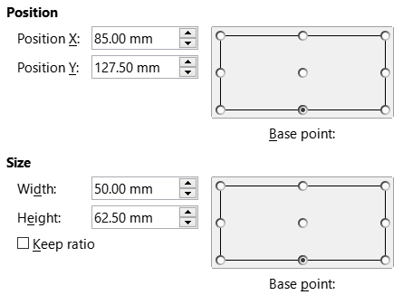
We want a tangent with point of contact at abscissa 2. The position of a handle is set in the fields of section “Control Point 1” in page “Slant & Corner Radius” of the “Position and Size” dialog. The values are relative to the left and top edge of the shape. For the parabola only the X value is needed. The abscissa 2 has a distance of 8 to the left edge at abscissa −6. So the X value is .
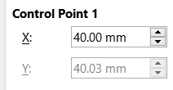
The next illustration shows the resulting drawing whereby the grid is enabled.
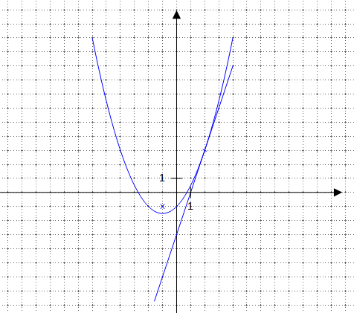
Enjoy the parabolas!
My thanks go to Karnotcycle and to Olivier Hallot for proofreading the document.
With kind regards,
Regina Henschel

