Improving the Usability of Draw

LibreOffice Draw being part of an office suite means that it should compete with similar office apps that do diagrams like Microsoft Visio and Calligra Flow. Though Draw does have some features that are found in other raster drawing apps (GIMP, Pinta, Photoshop, Paintshop Pro) and vector graphics apps (Inkscape, Illustrator, Corel Draw), it would take a huge overhaul to attempt to compete with such apps.
Note: If you’d like to make changes to this document for sending me (Yousuf Philips) feedback, please enable track changes. :D

Symbol Library
In order to expand the possible diagrams a user can create, Draw must bundle more symbol collections that users can easily use, rather than rely on a user to find them or create their own. (tdf#87892)
- The symbol collections could be accessible in the Sidebar (tdf#87643) [design session mockups] or could be its own separate left panel (e.g. Dia) in place of the Page pane, which would allow access to both inserting symbols and sidebar properties at the same time (Calligra Flow has this layout, while Visio has the ribbon for properties, and yEd can be customized to appear like this).
  - Symbol collections can be displayed either in Folder/File view, similar to the Gallery, or in the Accordion view.
  - Templates should have the ability to select a particular symbol collection to be preselected, so once the template is loaded, the symbol library is ready for the user to start adding symbols from it. Templates should also have the ability to bundle new symbol collections with them.
- With the availability of a symbol library, users will be able to share user created symbol collections (e.g. VRT Network Equipment, extension) as long as they are easy to modify, import and export into LibreOffice, so the symbol library files should be organized in a folder structure similar to the Gallery.
- Symbol collections by Competitors
  - Calligra Flow - Assorted, BPMN, Flowchart, Building Site, CMOS, Central Data Processing, ChemEng, Chemistry Lab, Circuit, Cisco, Civil, Contact, Cybernetics, Digital, Edpc, Electric, Electronic, Gane and Sarson, Jigsaw, LST, Lights, Logic, MSE, Map, Misc, Network, Optics, Pneumatic, RDP, Racks, Renewable Energy, SDL, Scenegraph, Sybase, Value Stream Mapping
  - Dia - AADL, Assorted, BPMN, ChemEng, Chronogram, Circuit, Cisco, Civil, Cybernetics, Database, Electric, ER, Flowchart, FS, Gane and Sarson, GRAFCET, Jigsaw, Ladder, Lights, Logic, Map/Isometric, Misc, MSE, Network, Pneumatic/Hydraulic, Re-i*, RE-Jackson, RE-KAOS, SADT/IDEFO, SDL, Sybase, UML
  - yEd - Shape Nodes, Modern Nodes, Edge Types, Group Nodes, Swimlane Nodes and Table Nodes, People, Computer Network, UML, Flowchart, BPMN, Entity Relationship, Current Elements
  - Visio - General Basic, Flowchart, Electrical Engineering, Mechanical Engineering, Process Engineering, Network, Software, Database (full list)
- Needed symbol collections
  - Mockup - This would assist novice users in creating UI mockups, as an alternative to using more specialized/complex tools like pencil and balsamiq. Michel Renon has suggested the Design team use Draw to do so and Heiko has done a proposal on how to make Draw suitable for mockup designing. In order to reduce the resizing of standard vector symbols, another type of symbol could be created which has points/parts that are fixed in size and others that are resizable. I’m currently working on a symbol collection.
- Some symbols shouldnt have text written to its center, so the text boxes should be position below the symbol (e.g. shape of a computer) so a user doesn’t think he needs to add a textbox below the symbol to get this functionality and doesnt have to manually go into Format > Text dialog and setting Text Anchor to bottom-center and Bottom to a negative value.
- Possibly need a collection of non-standard vector graphic symbols like the Rounded Rectangle, Circle Segment or Smile symbols, which has easily editable control points.
- Outside of the standard vector graphic symbols in SVG files, Draw should be able to insert vector graphic symbols found in ODG files (tdf#87906), so the behaviour would be the same as if the symbol was created in Draw.
- Users were asked in a 2015 survey, which symbol collections should be available by default and the top 5 most voted categories were - Flowchart, UML, Cisco, Network, BPMN. http://user-prompt.com/de/libreoffice-design-session-shapes/ [results]

Templates
Useful set of basic templates to showcase what Draw can do as well as assist in the creation of new documents of the same type.
- Basic Templates - Organization Chart, Flow Chart, Family Tree, Network
- Template Manager should be redesigned [link]
- Template categories by Competitors
  - Visio - Business, Engineering, Flowchart, General, Maps and Floor Plans, Network, Schedule, SDK, Software and Database. [full list, list per version]

Page Navigation
The left page page takes up useful real estate and should be hidden by default and Navigator can be improved to provide the needed functionality of jumping from page to page as well as accessing objects (tdf#90244). Visio features a Drawing Explorer that provides some of these features.

Terminology
LibreOffice uses the word ‘Snap Lines’ while other apps use ‘Guides’, like GIMP, Inkscape, Visio, and even LibreOffice 3.3. ‘Master Pages’ would be confusing to many users so an alternative like ‘Background Pages’ is used in Visio.

Better Defaults
Having good defaults results in the user having less things to configure and results in the user focusing on his work.

- ‘Grid’ on - Snap to grid is on by default, so having this on as well (still contemplating this)
- ‘Snap to Snap Lines’ on - Snap Lines are visible by default and if a user uses Snap Lines in his document, of course he’d want to be able to snap to it
- ‘Snap Position when Rotating’ on - As it snaps every 15 degrees, it will be good for most situations and a user can use shift to do it per degree.
- Start with no margins - When creating a drawing, this is the default in Visio, Dia (still contemplating this)
- Grid - As the grid does not adapt when changing zoom levels, the #C0C0C0 (~Gray 3) color at 100% zoom looks noticeable but is pretty much invisible at 250%, so we have to change it to Gray 6 or a dark color like Blue 2 or Magenta 4 and increase horizontal and vertical resolution to half of what it is now.

UX Improvements

Snapping
- Helplines when resizing or moving a shape when it aligns up with other shapes or page margins or the center of the page (yEd calls this feature Snap Lines and Visio call this Dynamic Grid, and this feature is useful in all apps/modules of LO). There should be a visual indication of where the snapping is taking places so users can visually see it.
- Various snap related bugs
  - Snap to Snap Lines not working correctly (tdf#97892)
  - Snap Lines being hidden when enabling Snap to Snap Lines (tdf#97893)

Page and Layer Management
When dealing with a large number of objects and layers, it is useful to be able to see them in a tree like view to know their placement. Some of this functionality is available in the Navigator sidebar tab (objects are displayed and sorted based on arrangement), but needs to be improved on to bring it to its full potential (e.g. objects cant be dragged or dropped to change their order, no context menu to rename/reorder/delete/etc the object). (tdf#90244)

Shortcut Keys
For users who are heavy into designing, keyboard shortcuts are a must to speed up interaction, so that the mouse doesnt have to constantly be going to the toolbar to change the tool, zoom.
- Select - Inkscape (F1)
- Zoom
  - Inkscape: Zoom (F3), Zoom In (+), Zoom Out (-), 100% (1), 50% (2)
  - GIMP: Zoom (Z), Zoom In (+), Zoom Out (-), 100% (1), 200% (2)
- Shapes - Inkscape: Square (F4), Circle (F5), Star/Polygon (*),
- Lines - Inkscape: Freehand (F6), Bezier (Shift+F6)
- Textbox - Inkscape (F8)
- Edit Points - Inkscape (F2), Draw (F8)
- Connector - Inkscape (Shift+F2),

Pixel Measurement
Many users are more interested in the amount of pixels their drawing takes up than how many centimeters or inches it takes (e.g. opening an SVG where the SVG dimensions are in pixels), so for such users, people able to set a document’s dimensions in pixel is essential (OOo#35835, htdf#86856). As the behaviour of user to change measurement systems happens regularly, a measurement drop down menu should be available within the toolbar.

Features from Other Apps
Visio has a feature called ‘Shape Data’ that allows users to add data/metadata to shapes, similar to being able to assign a data table/range to a chart. The data fields can have data types (string, number, boolean, etc) which allows Visio to do data validation on input and predefined shapes come with a preset of data shape fields. This data is available to the user in a panel for editing and the data can be displayed on the diagram within a shape’s text field using the Insert > Field dialog.

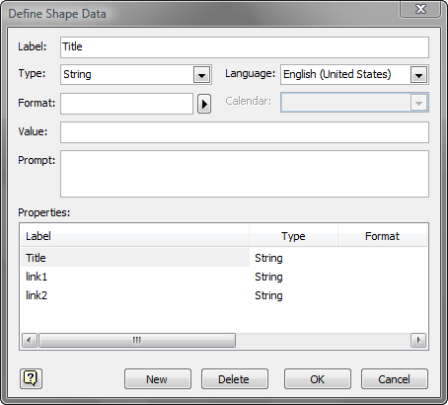 | 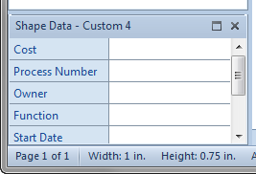

Videos: Work with and Customize Shape Data, Dynamically Link Business Data to Shapes, Expose Dynamic Data with Text Fields

With the availability of ‘Shape Data’, Visio has a feature called ‘Data Graphics’ which allows the use of shape data in conditional formatting, which can be used to change the fill color of a shape or add a particular icon from an conditional formatting icon set to be shown in the shape’s textbox.

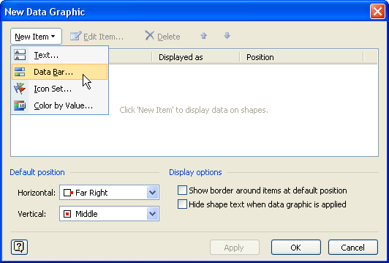
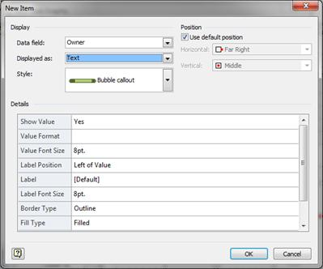 | 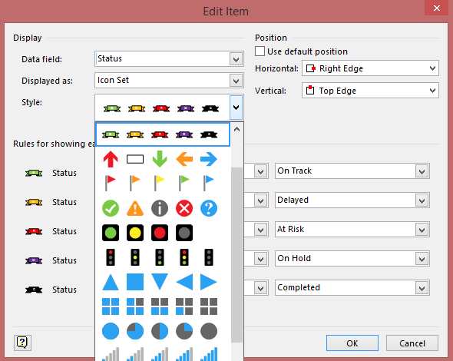

Videos: Visualize Business Data with Data Graphics, Create and Modify Custom Data Graphics

Full Visio Category Breakdown
- Business
  - Brainstorming
  - Business Process
  - Charts and Graphs
  - Organization Chart
  - PivotDiagram
- Engineering
  - Electrical Engineering - Analog and Digital Logic, Composite Assemblies, Fundamental Items, Integrated Circuit Components, Maintenance Symbosl, Maps and Charts, Qualifying Symbols, Rotating Equip and Mech Functions, Semiconductors and Electron Tubes, Switches and Relays, Telecom Switch and Peripheral Equip, Terminals and Connectors, Transformers and Windings, Transmission Paths, VHF-UHF-SHF
  - Mechanical Engineering - Fasteners 1, Fasteners 2, Fluid Power - Equipment, Fluid Power - Valve Assembly, Fluid Power - Valves, Geometric Dimensioning and Tolerancing, Springs and Bearings, Welding Symbols
- Process Engineering - Equipment - General, Equipment - Heat Exchangers, Equipment - Pumps, Equipment - Vessels, Instruments, Pipelines, Process Annotations, Vavles and Fittings
- Flowchart - Arrow Shapes, Basic Flowchart Shapes, Cross Functional Flowchart Shapes Horizontal, Cross Functional Flowchart Shapes Vertical, Data FLow Diagram Shapes, Department, IDEFO Diagram Shapes, Miscellaneous Flowchart Shapes, SDL Diagram Shapes, Work Flow Objects, Work Flow Steps
- General Basic - Shapes, Blocks, Blocks Raised, Blocks With Perspective
- Maps and Floor Plans
  - Building Plan
  - Maps
- Network
  - Network - Active Directory Objects, Active Directory Sites and Services, Computers and Monitors, Detailed Network Diagram, Exchange Objects, Free-standing Rack Equipment, LDAP Objects, Network and Peripherals, Network Locations, Network Room Elements, Network Symbols, Rack Mounted Servers, Rack-mounted Equipment, Servers
  - Web Diagram
- Schedule
- Software and Database
  - Database - Entity Relationship, Express-G, Object Relational, ORM Diagram
  - Software - COM and OLE, Common COntrols, Enterprise Application, Gane-Sarson, Icons, Jackson, Language Level Shapes, Memory Objects, ROOM, Toolbars and Menus, UML Activity, UML Collaboration, UML Component, UML Deployment, UML Sequence, UML Statechart, UML Static Structure, UML Use Case, Windows and Dialogs, Wizards
  - Web Diagram
- Visio Extras

Survey Results: Which category of shapes should be added by default?
Flowchart (56%, 37 Votes)
UML (39%, 26 Votes)
Cisco (Computer, Network, Switch, Telephony) (36%, 24 Votes)
Network (35%, 23 Votes)
BPMN (35%, 23 Votes)
Entity-relationship (30%, 20 Votes)
Logic (29%, 19 Votes)
Database (27%, 18 Votes)
Circuit (21%, 14 Votes)
Electrical (20%, 13 Votes)
Function Structure Diagram (18%, 12 Votes)
Building site (18%, 12 Votes)
Electronic (17%, 11 Votes)
Gradient (15%, 10 Votes)
Chronogram (14%, 9 Votes)
EPC (14%, 9 Votes)
Civil Engineering (14%, 9 Votes)
Optics (12%, 8 Votes)
Isometric Map (12%, 8 Votes)
Automata (12%, 8 Votes)
Chemistry lab (12%, 8 Votes)
Requirements Engineering (12%, 8 Votes)
Assorted (12%, 8 Votes)
Digital Electric (12%, 8 Votes)
Chemical Engineering (11%, 7 Votes)
Problem analysis (Jackson) (11%, 7 Votes)
CH-1 notation (11%, 7 Votes)
Pneumatic (9%, 6 Votes)
Renewable Energy (9%, 6 Votes)
Cybernetics (9%, 6 Votes)
AUTOSAR (9%, 6 Votes)
Value Stream Mapping (9%, 6 Votes)
CMOS (9%, 6 Votes)
HVAC (9%, 6 Votes)
GRAFCET (9%, 6 Votes)
Central data processing (9%, 6 Votes)
Gane and Sarson (9%, 6 Votes)
Lights (8%, 5 Votes)
SADT/IDEF0 (8%, 5 Votes)
AADL (8%, 5 Votes)
Racks (8%, 5 Votes)
Ladder logic (8%, 5 Votes)
Jigsaw (6%, 4 Votes)
MSE (6%, 4 Votes)
Scenegraph (6%, 4 Votes)
Sybase (6%, 4 Votes)
Living Systems Theory (6%, 4 Votes)

Research Stuff Below

Getting Started with Visio 2010 - https://www.youtube.com/playlist?list=PLTtplW6mJ7fWSIvHScqHCkaA4T0HhaWU-

ConceptDraw Pro - http://www.conceptdraw.com/products/drawing-tool

https://support.office.com/en-us/article/A-beginner-s-guide-to-Visio-2010-88D2A308-7283-4981-839D-86E2ACA8C456

http://screenshots.en.sftcdn.net/en/scrn/117000/117800/yed-23.png

Competitor Software

Enterprise Architect
http://www.sparxsystems.com.au/products/ea/

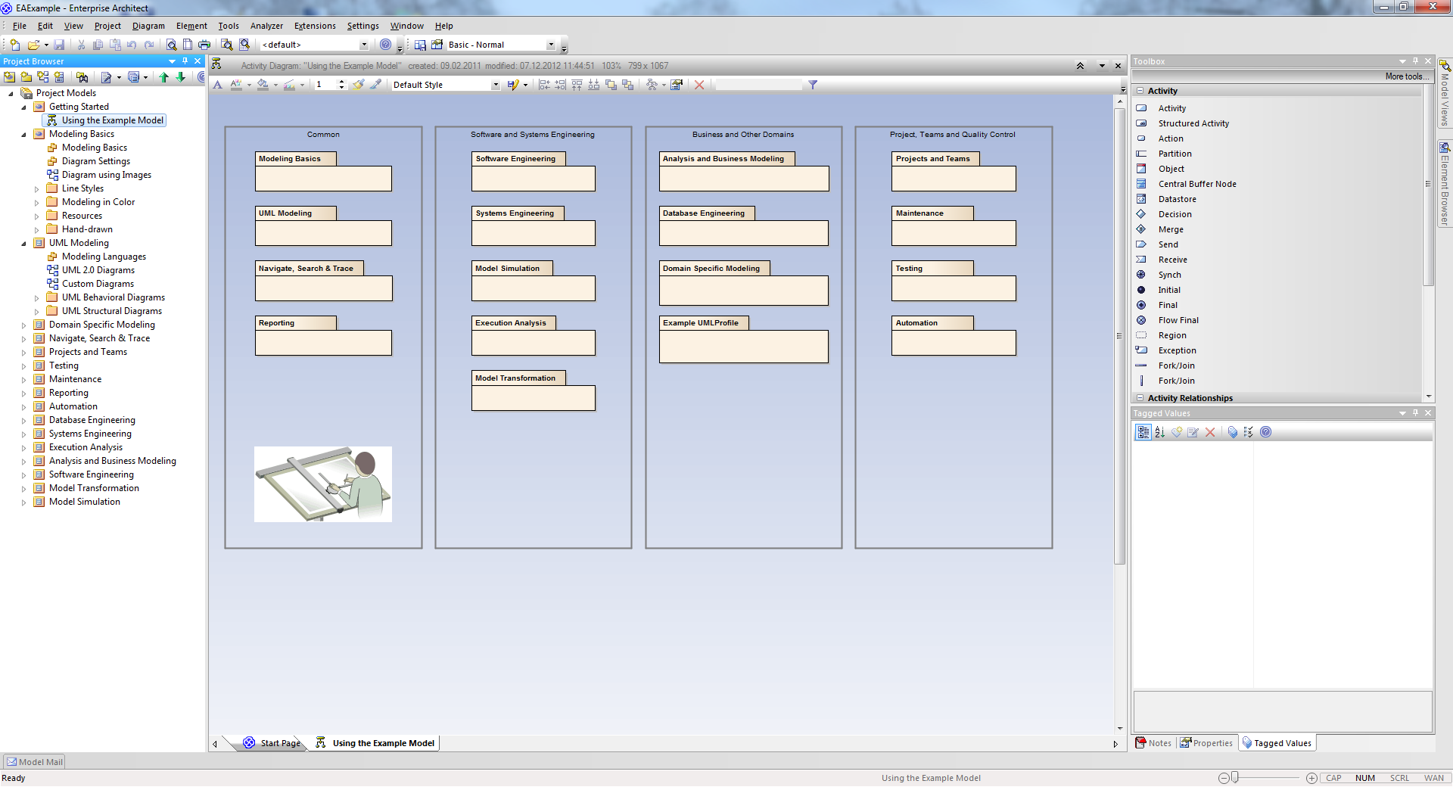

- Focus on UML modeling
- Full support of BPMN
- Model validation
- (Many features can be added to Visio per plugin)

Corel Draw
www.coreldraw.com/

Adobe Illustrator
http://www.adobe.com/products/illustrator.html

Omnigraffle
https://www.omnigroup.com/omnigraffle

Dia
http://dia-installer.de/

...

