
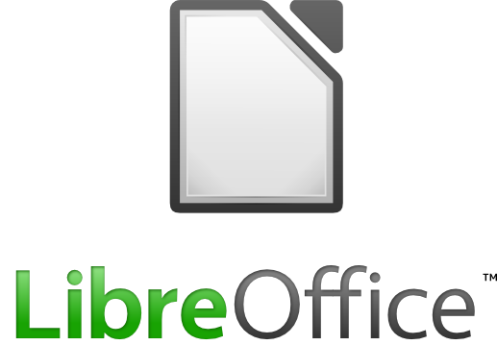

An Office Suite available for many languages and platforms

Microsoft Windows

GNU/Linux

Mac OS X

BSD
You are free and welcome to reuse
the text of this document under the
Creative Commons License
http://creativecommons.org/licenses/by-sa/3.0

The free power-packed, Open Source personal productivity suite for:

Windows, Linux, Mac OS X, BSD

LibreOffice gives you six feature-rich applications for all your document production and data processing needs:

Writer, Calc, Impress, Draw, Base and Math
Designed to address your office needs whether the office is you, doing it all or your part in a larger document production environment, with functionality included for master documents, networked printing services; even that quick web page.
LibreOffice uses Open Document Format, recognized by many governments worldwide, as the default format for office documents.

LibreOffice in Everyday Life
- Private Individuals
- Education (Teachers and Students)
- Academia (Universities and Colleges)
- Non-Profit Organizations
- Non Governmental Organizations
- Small and Medium Enterprises
- Large Companies and Organizations
- Authorities and Public Administrations

LibreOffice Has Many Advantages
- LibreOffice is easy to install and automatically adjusts to the operating system used for its visual appearance.
- LibreOffice is easy to use thanks to its clearly structured, intuitive menu.
- LibreOffice has all the features you'd expect from an office suite: word processing, spreadsheet, presentation design, formula editor, mail merge, database, and much more.
- LibreOffice is able to exchange documents with other Office programs.
- There are no license fees, and thus no administrative burden is necessary. Install LibreOffice as often and wherever you want.
- LibreOffice is licensed under the GNU LGPLv3 and MPL, and is provided for FREE. The availability of the source code allows the community to constantly expand and improve the software.

LibreOffice uses time based release schedule
LibreOffice is the result of a collaborative development effort, and adopts a time based release model (such as other collaborative development projects like GNOME and KDE). This is different from most, closed source, commercial product development models where the development happens inside a closed group, and time based releases frequently slip.
LibreOffice is free software, and is based on free tools. We are working to improve the day-to-day quality of our pre-release builds for Windows, with an ongoing migration to GNU Make as a first step to more reliable cross-compilations from Linux to Windows . Our aim, over time, is to make it easy to build releases for LibreOffice for anyone with some time and a PC. This is quite different from commercial, closed source, software where release builds come from a small team of build engineers.
Understanding the time based release model is critical to selecting the right release of LibreOffice for each situation:
For the most conservative users, we recommend a commercially supported version, which enables you to indirectly support the project’s development. Such stable versions will typically be based on a point release, such as LibreOffice 3.3.2 today;
For those interested in the bleeding edge, who want to enjoy new features and fixes, we recommend LibreOffice 3.4.0, release candidates, betas or even nightly builds, which enable a participation in the development, evaluation and quality control process;
Of course, as the 3.4 series matures, we will reach a point where we will recommend a 3.4.x release as being suitable even for the most conservative users.

Exchange Data With Other Suites
The default document format of LibreOffice is Open Document Format (ODF), which was approved by ISO on 30/11/2006 as an international standard (ISO / IEC 26300).
ODF is recommended by numerous governments and NGO's worldwide, with Indonesia, the European Commission, and NATO amongst other's supporting policies calling for ODF as the preferred document production, retention and exchange format.
In addition, LibreOffice supports document formats of many other office suites, from the most current to numerous legacy formats for extended interoperability.

License/Product key, Activation Code.
LibreOffice is Free Open Source Software- which gives you unusual liberties
- Freedom to run
- Freedom to study
- Freedom to redistribute
- Freedom to distribute copies you modified
and (unless indicated otherwise for any particular file), is licensed under the LGPLv3.

There are many ways to acquire LibreOffice - from the official “The Document Foundation” website, voluntary or commercially supported vendor offerings, Cds or Dvds from events. A single Cd or Dvd can be used many times on many machines by many different people. Most Gnu&Linux users will find LibreOffice in their Package Manager (roughly equivalent of the Add/remove Programs utility except that it can add).

LibreOffice doesn't need an activation code or product or license key. Just install and use straight away.

Available on Many Platforms
The Document Foundation offers normal installers for:

MS Windows
Gnu&Linux
Rpm & Deb format
Mac OS X.
The source code is also freely available, from the TDF website, which can be compiled for BSD platforms.

Operating System Distributions – Commercial support available
Canonical
RedHat
Novell (Linux)
With more coming..

Commercial support
Novell (MS Windows)
With more likely in the future...

LibreOffice Applications

WRITER - Word Processing
Writer has all the features you need from a modern, full-featured word processing or desktop publishing tool. It's simple enough for a quick memo, but powerful enough to create complete books with contents, diagrams and indexes. You're free to concentrate on your message, while Writer will make it look great.

CALC – Spreadsheet
Calc is the spreadsheet program you've always needed. Newcomers find it intuitive and easy to learn. Professional data miners and number crunchers will appreciate the comprehensive range of advanced functions.

IMPRESS – Presentations
Impress is an outstanding tool for creating effective multimedia presentations. Presentations can be enhanced with 2D and 3D clip art, special effects and transition styles, high-impact drawing tools and animations.

DRAW - Vector Drawings
Draw lets you produce anything from a quick sketch to a complex plan, and gives you the means to communicate with graphics and diagrams. With a maximum page size of 300cm by 300cm, Draw is a an excellent package for producing technical drawings, posters, and more.

BASE – Database
Base is a full-featured desktop database, designed to meet the needs of most users. It is a valuable asset for adding power to other LibreOffice applications. Base can also be used as a front end to most enterprise-class databases.

MATH - Formula Editor
Math is the formula editor that can be invoked to insert perfectly-formatted mathematical and scientific formulas into your text documents, spread-sheets, presentations and drawings.

LibreOffice is a trademark of the Document Foundation.
Windows is a registered trademark of Microsoft Corporation.
Mac and Mac OS are trademarks of Apple Inc.

The Document Founation
- Support and Documentation
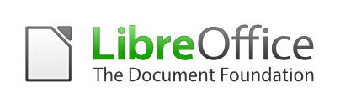Free from our large, dedicated community of developers, contributors and supporters the make up the Document Foundation
- http://www.libreoffice.org/support

Donate
You may support our work on LibreOffice and The Document Foundation with donations, details available
- http://donate.documentfoundation.org
or via PayPal:
- donations@documentfoundation.org
You, too, can get involved!
The LibreOffice community welcomes volunteers in all areas.
http://www.LibreOffice.org

